Original Research Article

GEOSPATIAL APPROACH IN ASSESSING LAND SUITABILITY FOR AGRO-HORTICULTURE

ABSTRACT
The study illustrates the use of Geographic Information System (GIS) tools and numerical Multi-Criteria Evaluation (MCE) techniques for selection of suitable sites for Agro-horticulture development of a Sitla rao watershed in Dehradun region at Indian Institute of Remote Sensing (IIRS),ISRO.This study was conducted to identify suitable sites for Agro-horticulture development of a Sitla rao watershed in Dehradun using GIS-based multi-criteria evaluation of slope, aspect, land use and land cover ,soil factors such as soil texture, depth, drainage, coarse fragments and erosion. Land use and land cover map (Sentinel 2A) and eight thematic information layers were analyzed using ArcGIS 10.8 software to identify suitable areas in Sitla rao region of Dehradun. It focuses on GIS based Overlay Weightage method. The undulating terrain, flat to moderate, well drained, varied depth and different soil characteristics give the impression to find out suitable sites for agro-horticulture. In this study nine factors (slope, aspect, land use and land cover, soil characteristics such as soil texture, depth, drainage, coarse fragments and erosion) were identified for criteria evaluation. Using physiographic map, respective soil texture, soil depth, soil drainage, coarse fragments and erosion map generated. With the generated criteria, maps are standardized using the pairwise comparison matrix method [19]. Weights for each criterion is generated by comparing with each other according to their importance. Criteria weights and maps are combined using weighted overlay method. Pair wise comparison matrix indicates weights for slope (=12.70%), aspect (4.83%), land use and land cover (=2.67%), soil drainage (=8.60%), soil texture (=13.07%), temperature (=23.47%), soil depth (=29.97%), coarse fragments (=2.80%) and soil erosion (=1.89%). Consistency Ratio CR (=0.09) <0.10 indicated a reasonable level of consistency in the pairwise comparisons. The final suitability map was obtained from both weighted sum overlay and Spatial Analyst Tools covering an area of 49 sq.km. After suitability analysis it was found from the available area 0.3921 sq km falls under unsuitable(N), 25.46 sq km under restricted, 2.149 sq km under highly suitable (S1), 14.694 sq km under moderately suitable (S2), and 5.329 sq km under marginally suitable (S3).
Keywords: Geographic Information System, Multicriteria Evaluation (MCE), Analytical Hierarchy Process (AHP), Agro-horticulture development, weighted Overlay Analysis
1.INTRODUCTION
Land suitability analysis for agricultural land use planning is very important and provides basic information for right decision making. Identification of suitable sites for Agro- horticulture development in Sitla rao watershed is one of the critical issues of planning. The various characteristics of a site (land use and land cover, slope, aspect, climate and soil) each influence its suitability for a specific purpose. A scoring and weighting system can be applied to the various aspects of suitability to assess the overall suitability for Agro-horticulture. A site suitability analysis adds importance to study by helping to identify suitable sites that meet specific criteria or restrictions. MCE techniques are numerical algorithms that characterize the suitability of a particular solution on the basis of the input criteria and weights together with some mathematical or logical means of determining trade - offs when conflicts arise. To meet a specific objective, it is frequently the case that several criteria will need to be evaluated. Such procedures are called Multicriteria Evaluation [5, 22]. During site selection, factor selection plays a vital role in the final output. Analytical Hierarchy Process (AHP) has been used for weight assigning according to the importance of each factor and comparing with each other.
AHP is a commonly used multi-criteria analysis technique to resolve complex decision -making processes which include multi criteria, scenarios and factors [7,17,18]. The AHP method has been developed by [19], southern western part of Iran [20], in the Darjeeling Himalayan region [14] and in the Jordan [2] for identifying the suitable agricultural land. [9] aimed to identify the potential land suitability for maize production in the Didessa watershed, Ethiopia using Multi-Criteria Evaluation (MCE) and geospatial technologies. The results showed that about 977.7 km2 (14.1%) is highly suitable, 4794.9 km2 (69.1%) is moderately suitable while 1118.8 km2 (16.1%) and 51.5 km2 (0.7%) of the study area were categorized under marginally and unsuitable areas for maize production and this information helped the farming community to utilize potential areas for maize cultivation.
[16] in Kadapa district of Andhra Pradesh, detailed study was taken up to promote agriculture as a source of income to boost the economy of the region. A combined RS, GIS and AHP techniques has been utilized for AHP hierarchy analysis, criteria specification, pairwise comparison and criterion map preparation. Land suitability comparison showed that an area of 4.42 km² (2.62%) is appropriate for irrigation, while an area of 54.39 km² (32.33%) is found to be moderately suitable for rainfed agriculture and 95.76 km² (56.93%) is marginally suitable for agricultural productions. About 13.64 km² (8.11%) land is currently not suitable for agricultural production. [23] in their study aimed to analyze the land potential for the development of vegetable commodity areas. The research was carried out in Banjarnegara and Wonosobo Regencies, at an altitude of more than 700 meters above sea level, from July to December 2020. The methodology used was Multi-Criteria Decision Making with Analytical Hierarchy Process structure and map overlay, using ArcGIS ver. 10.5. The results showed that land which is suitable for the highland vegetable commodities was at 33.52%, it was dominated by a class of moderately suitable (S2). Furthermore, the suitable and available land for vegetable cultivation covers an area of 16.03 %. Finally, there were 9,911.2 hectares of land that had not been optimally used and had the potential to become a development area for highland vegetable commodities in the future. Site selection assessment model for citrus cultivation using Geographic Information System (GIS) based Multi-Criteria Decision Analysis (MCDA) in the Mersin province of Turkey was undertaken which takes into account the opinions of local citrus farmers as well as those of experts. Preference factors (14) and exclusion factors (10) were determined for the analysis of land suitability for citrus farming. The weighting of preference factors for citrus cultivation was determined using the analytic hierarchy process and a land suitability map was generated using the weighted overlay method in the GIS environment. The final land suitability map shows that the most suitable and moderately suitable areas for citrus cultivation have surface areas of 85, 824 ha and 85 430 ha respectively.
Evaluation factors were derived through ArcGIS 10.8. Relevant criteria for Agro-horticulture and suitability levels were defined. This information was used to obtain the criteria maps which in turn were used as input into the MCE algorithm. Using weighted linear combination with the GIS data layers a certain suitability map could be produced. Geographic Information System (GIS) tools and numerical based Multi-Criteria Evaluation (MCE) techniques are used for selection of suitable sites.For this purpose different thematic information layers such as land use and land cover ,slope, aspect, soil etc are used for analysis with the help of Spatial Analytical Hierarchial Process – a tool of MCE to identify and rank areas that are suitable for Agro-horticulture development.In this study ,different scenarios are produced by giving different preference values to decision factors. The prime focus of the present study is Site Suitability Analysis for Agro-horticulture development of a Sitla rao watershed using GIS based Multi-criteria Evaluation technique inorder to characterize land use/land cover, terrain and soil characteristics of the study area and determine site suitability for Agro horticulture development using Multi Criteria Evaluation (AHP) method.
2. MATERIALS AND METHODS
2.1. Study Area
The experimental area selected for this study is Sitla Rao watershed (Figure 1) which is situated west of Dehradun in the lesser Himalayas of Uttarakhand. The geographical dimension extends from 30° 24′ 39″ to 30° 29′05″ N latitude and 77° 45′33″ to 77° 57′46″ E longitude and included in the SOI toposheet number 53 F/15. The district is bounded on the north-west by the district of Uttarkashi, in the east by the district of Tehri Garhwal and Pauri Garhwal, in the south by the district of Saharanpur (U.P) and at the southern tip touches the boundary of district Haridwar, its western boundary joins the Sirmur (Nahan) district of Himachal Pradesh. The study area is about 49 km² with an altitude varying from 900 to 2200 m above mean sea level. The slope of the terrain varies from moderate sloping (<15%) in the downstream part, to steep sloping (>45%) in the upper part. The soils generally have textures varying from loam to sandy loam. The annual rainfall depends on the elevation, but varies approximately between 1600– 2200 mm. The main cropping seasons are Kharif (June to September) and Rabi (December to March). Mostly rice and maize are grown in the Kharif season, whereas wheat is cultivated during the Rabi season. Erosion is a major problem for farmers, especially on the steeper slopes. Most farmers practice terrace farming for rice to reduce the erosion risk. The major land use and land cover of the study area is forest, agriculture, scrub and settlements.
2.2. Data Used
The present study was conducted based on primary and secondary data sources. To identify the potential areas for Agro-horticulture various thematic maps viz, slope, land use land cover (LULC), slope aspect, soil, precipitation and temperature data used and extracted using satellite images and ancillary data published in thematic maps. The land use and land cover data prepared based on Sentinel 2A satellite image accessed from Copernicus with 10 m spatial resolution. Besides, for evaluating topographic parameters such as elevation, slope, slope aspect analysed based on CARTODEM of 30 m resolution obtained from Bhuvan. Soil map with different physiographic units was digitized using ArcGIS 10.8. The climate parameters such as temperature and precipitation data extracted from BIOCLIM with 1 km spatial resolution (Table 1). To derive Agro-horticulture potential sites, all the factors were analysed based on criteria established by the [21] United States Department of Agriculture (USDA) by using Arc-GIS software.

Table 1. Details of data used and their sources

Data | Sources of Data | Scale
Digital Elevation Model (Carto-DEM) | Bhuvan | 30 meters
Sentinel 2A | Copernicus | 10 meters
Climate data (Average precipitation and temperature) | WorldClim | 1km

2.3. Field Work
In this study, the collected information on Land use and Land Cover (LULC), aspect, slope, soil depth, soil texture, drainage, coarse fragments, erosion class and temperature. A total of 30 locations were chosen for random soil sampling (Figure 2). These soil samples were analysed in the lab to determine their physicochemical properties.

Figure 1. Location of Sitla Rao region in Dehradun

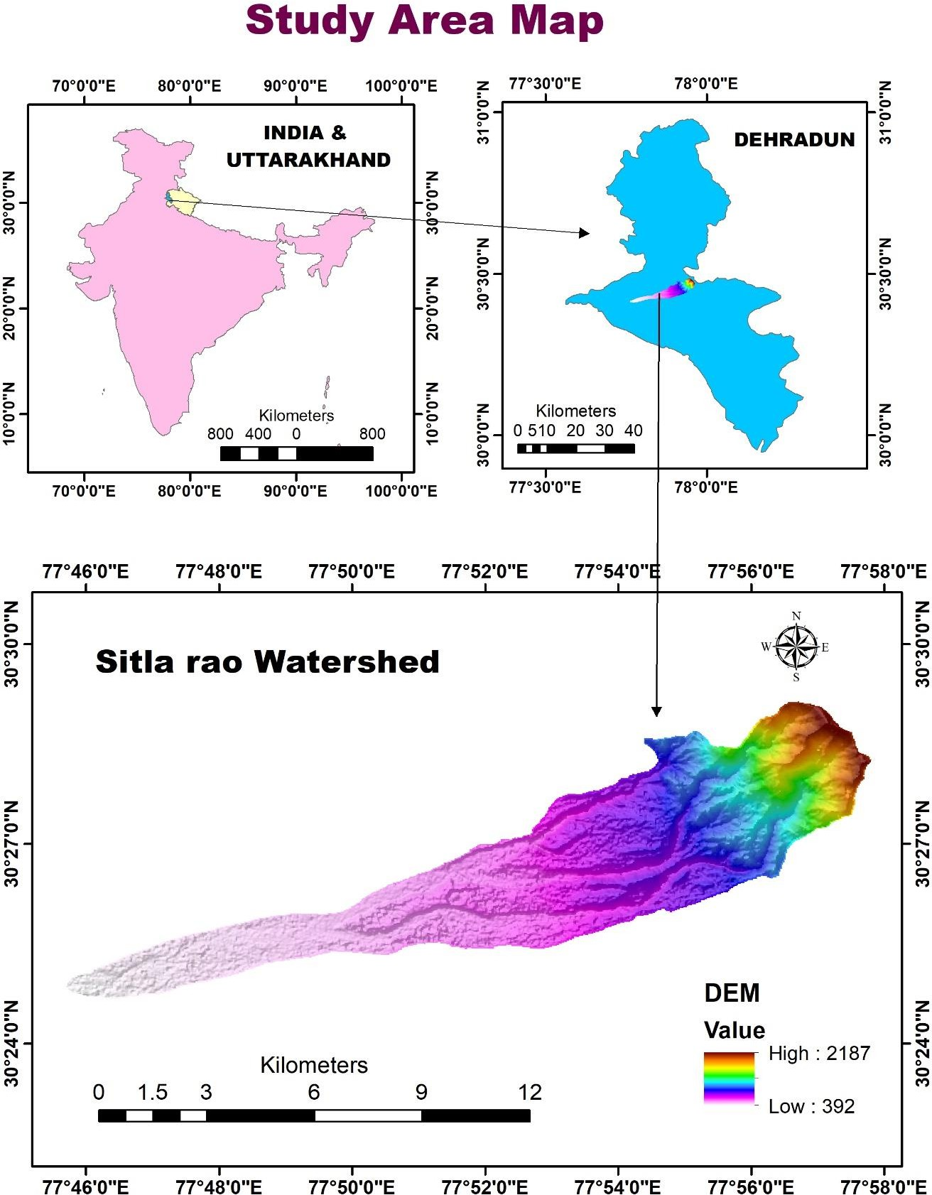

Topography (CartoDEM)
Slope Map
Aspect Map

Physiographic Map
Erosion class
Coarse fragments
Drainage
Soil depth
Texture

Figure 2. Methodology
Pairwise comparison (CR<0.1)
Land Use and Land cover Map(Sentinel 2A)
Reclassification of Map
Development of Hierarchy structure
Apply MCE
Weighted of each element in the hierarchy
Standardisation of Suitability
Overlaying (Weighted Sum)
Integrating MCE with GIS
Suitability Map
Temperature
Climate

3.Results

3.1. Criteria Maps

Physical components which are linked to Agro-horticulture productivity and its details are as follows. Land Use and Land Cover, Topographical parameters (Slope and Aspect), Climate parameter such as temperature and Soil characteristics (Soil Texture, Depth, Drainage, Coarse Fragments and Erosion) are widely used to evaluate the land’s attributes and suitability for Agro-horticulture. (Table 6).These parameters have varying degrees of influence and affluence depending on the geographical features. As a result, all criteria were chosen for LSA by Weighted Overlay Analysis (WOA) [13].
3.2. TOPOGRAPHICAL PARAMETERS

3.2.1. Slope

slope is one of the most prominent physiographic aspect influencing agriculture in mountain regions. The land proportion is larger than other land, with flat and very gentle slopes are observed in the study area. About 24.37 % of the areas has a nearly flat slope and 29.74% gentle slopes displays potentiality for Agro-horticulture. Moderate slope of 19.21 % is found to be marginally suitable and 26.69 % of the steep slope areas found to be unsuitable (Table 6 and Fig 3). It is observed that this results was similar to the findings of [3]. Large steep slopes in the region form a constraint for Agro-horticulture planning and development [14].

3.2.2. Aspect

The slope aspect was classified into nine aspects and further classified in four broad categories namely SW and flat, E and W, NW and NE, and N as per the availability of sunlight (Table 6 and Fig 4). A northward -facing slope may be partially exposed to sunshine whereas the southward facing slope may be aligned in such a way to receive enough sunshine. About 21.44% of the areas has a South direction (SW/flat) slope aspect, whereas northern aspects are only 8.29% in the study area for Agro-horticulture. Vegetation and plants usually exhibit most favourable growth in the western and southern aspects that receive more sunlight for an extensive period of the day [4].
3.3. CLIMATE PARAMETER

3.3.1. Temperature

In the study area annual average temperature varies from 21.43 to 30.6⁰C. Normally for the growth of agriculture crops and horticulture crops (Table 6 and Fig 5).The optimum temperature required is 15 to 30 ⁰C which prevails in the study area so it is suitable to grow any type of crops in this study area. Suitability of the crop increases as the optimum temperature prevails in the study area. Climate conditions such as precipitation, temperature are to be considered in the decision making process for land suitability evaluation as per [12].
3.4. VEGETATIVE COVER

3.4.1. Land Use and Land cover

The pattern of land use and land cover in Sitla Rao watershed varies due to adverse natural conditions. According to the physiographic characteristics the study area was divided into chain of hills in upper part, piedmonts and river valleys in the middle part and watershed in the lower part. Land use represents the way a piece of land is used such as agriculture, forest, fallow land, barren land and waterbodies. As per the study area agriculture crop lands, orchards, scrublands, forest, settlement and river bed channel has been digitized manually by using Sentinel 2A satellite image (Table 6 and Fig 6). About 40 % of the area was found to be highly suitable and 52.43% found to be restricted due to settlement, riverbed channel and forest areas. Land use can be interpretable by satellite imageries [15].
3.5. SOIL CHARACTERISTICS

3.5.1. Soil Texture

Soil texture is the base of plant growth and one of the major parameters for land suitability analysis.The study area soil was divided into six groups namely sandy clay loam (Scl), silty loam (Sil), sandy loam(Sl), fine sandy loam(fsl) and gravel clay loam(grcl).Out of total area sandy clay loam occupies 28.48%, silty loam (7.25%), sandy loam (61.61%) and gravel clay loam and fine sandy loam (2.13%). Since sandy clay loam (Scl), moderately fine textured soil it is highly suitable for Agro-horticulture (Table 6 and Fig 7). If the proportion of sand in the soil is higher, the texture of the soil becomes coarse, while the soil improves with an increase in the content of clay. In most of the soils confined in the valley sides are clay enriched and favourable for farming. Silty loam (Sil), medium textured soil which is moderately suitable, sandy loam(Sl) coarse textured soil marginally suitable and sandy loam(fsl) and gravel clay loam(grcl) unsuitable for Agro-horticulture.The study findings were more consistent with those of the prior study [6].

3.5.2. Soil Drainage

Soil drainage map of the study area is presented (Fig 8).There are four categories of drainage in the study area including well, moderate, somewhat excessive and excessive(Table 4.). Study by [1] prove that well and moderately drainage were suitable for Agro-horticulture. Results showed that 34288 sqm (79.48%) of entire area of watershed is highly suited for Agro-horticulture, whereas 3632 sqm (8.42%) is not suitable.

3.5.3. Soil Depth

The most essential soil property for determining viable land for Agro-horticulture development is soil depth [8].Agro-horticulture productivity benefits greatly from deep soil depth.Based on soil depth we can classify land suitability for certain crops.The soil depth class of the study area is presented (Table 6 and Fig 9).Soil depth ranging from 30 cm to greater than 90 cm.The results revealed that 33106 sqm (76.74%) is marginally suitable having shallow depth of 25-50 cm while 6539sqm (15.16%) of 90-150cm depth is highly suitable for Agro-horticulture.

3.5.4. Soil Erosion

Soil erosion is a naturally occurring process that affects all landforms. In agriculture, soil erosion refers to the wearing away of a field's topsoil by the natural physical forces of water and wind or through forces associated with farming activities such as tillage. In the study area soil erosion was categorized into slightly eroded (e1), moderately eroded (e2), severely eroded (e3) and Extremely severely eroded (e4) (Table 6 and Fig 10). About 38.77 % areas are unsuitable, 28.52% marginally suitable and 21.70 % highly suitable.

3.5.5. Coarse fragments

Coarse fragments in soil refer to particles larger than 2 mm and smaller than 25 cm in diameter. Soils with higher amounts of coarse fragments can also increase saturated hydraulic conductivity and macropores, decrease total porosity, water holding capacity, volumetric water content, water infiltration, and water retention capacity.In the study area coarse fragments was categorized into four namely few (2-10%), common (10-20%), many (20-50%) and abundant (>50%) (Table 6 and Fig 11). About 43.17% areas possess 3-10% of coarse fragments which is highly suitable(S1) for Agro-horticulture, 19.45% areas come under moderately suitable having 10-20% coarse fragments and 8.79% areas under unsuitability because of having 60-70% of coarse fragments.

Figure 3. slope map
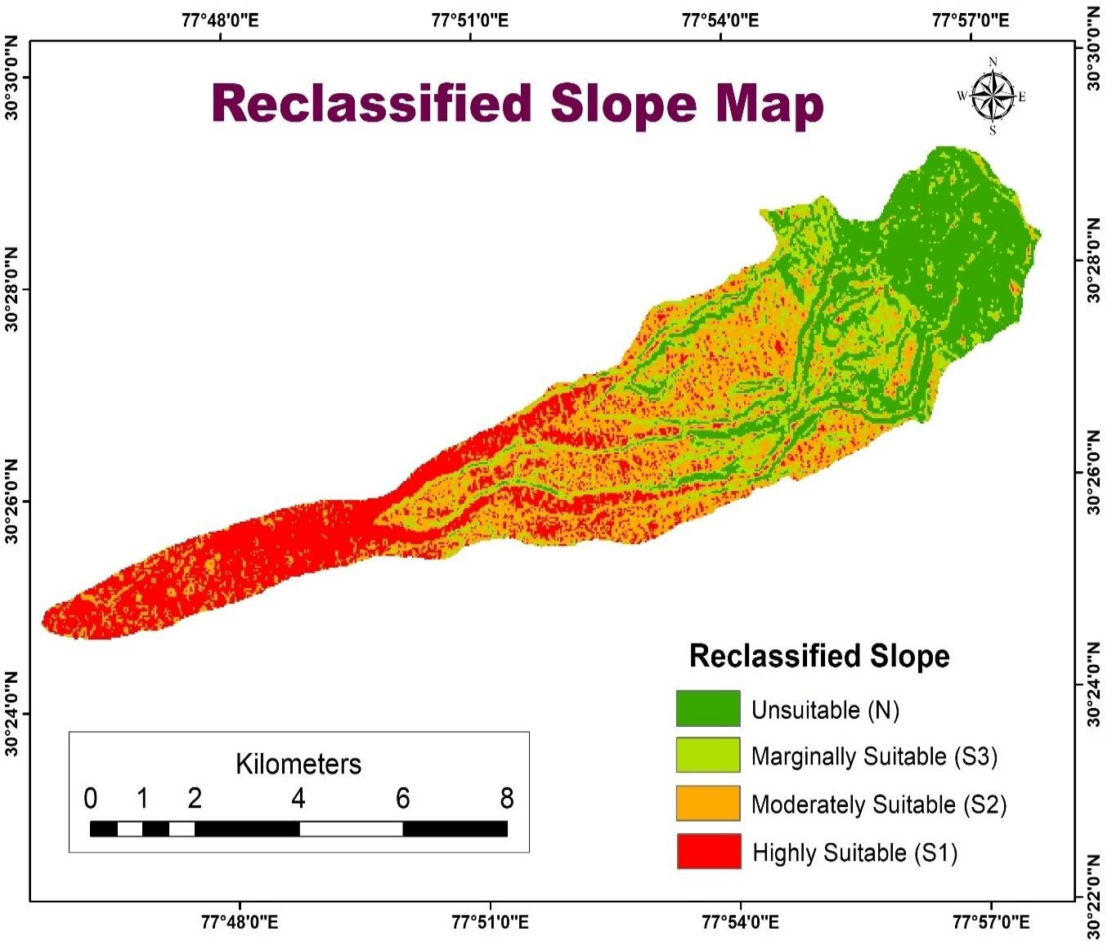
Figure 4. Aspect map

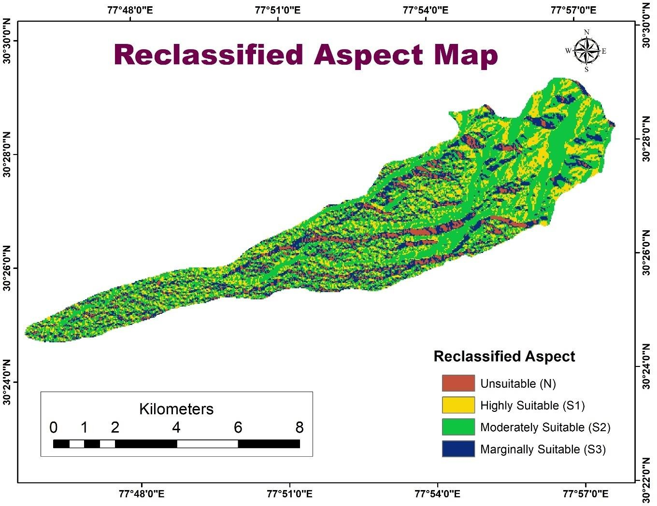

Figure 5. Temperature map
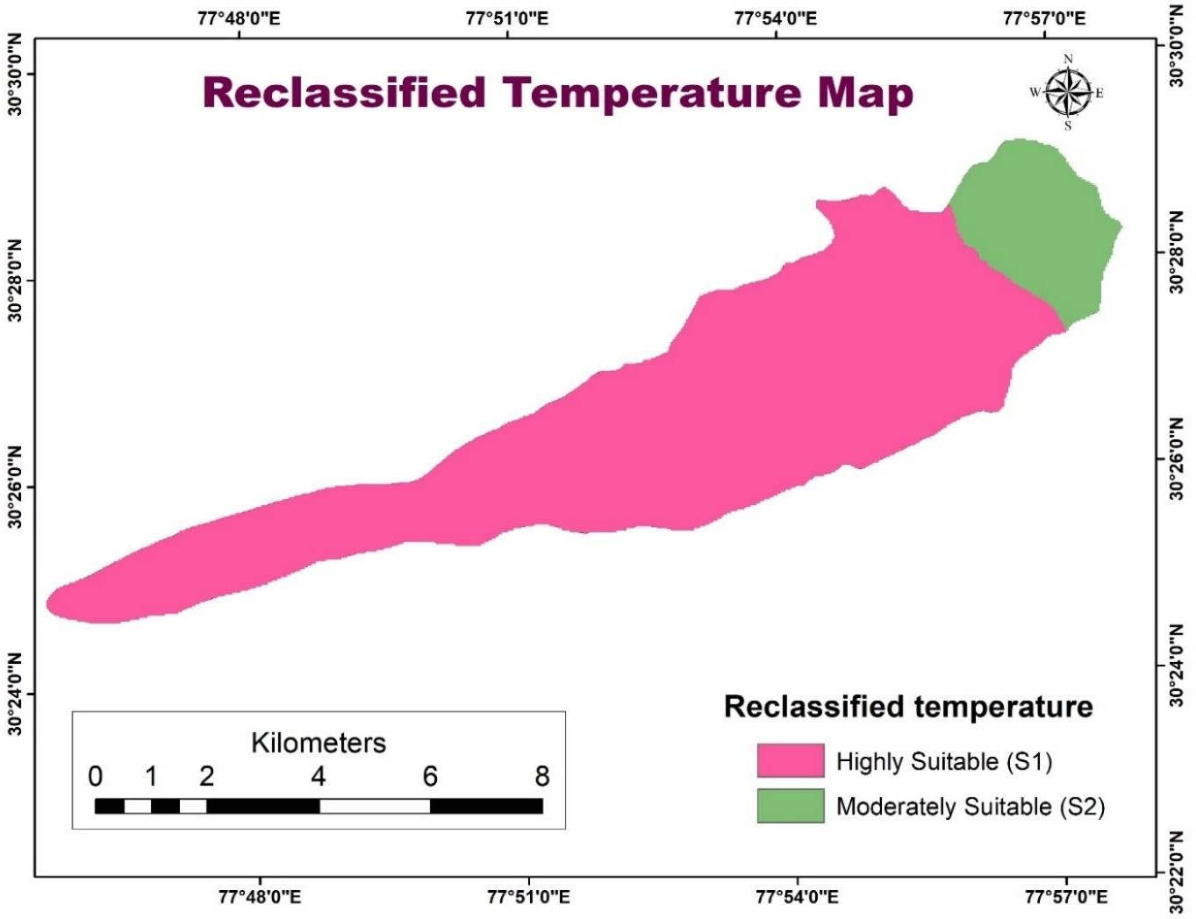
Figure 6. Land Use and Land Cover map

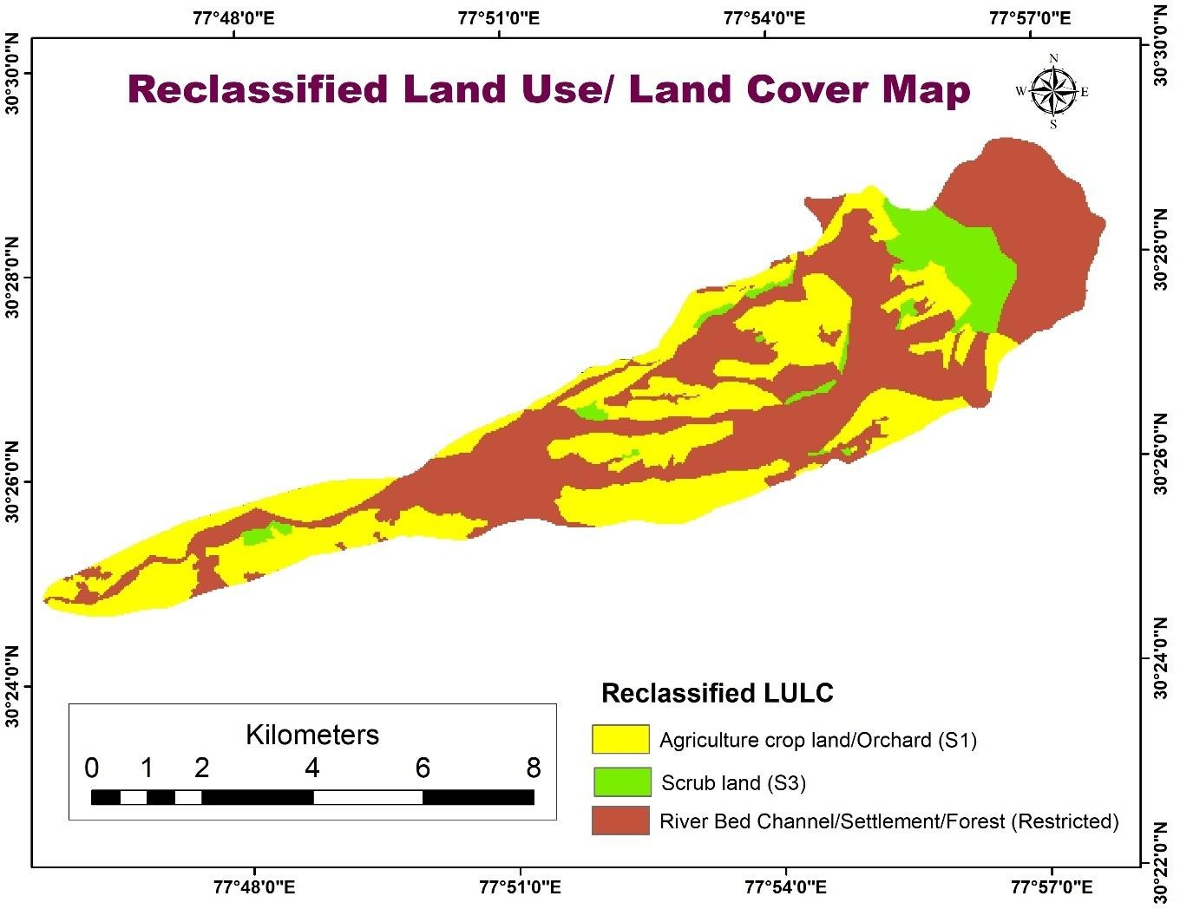

Figure 7. Soil Texture map

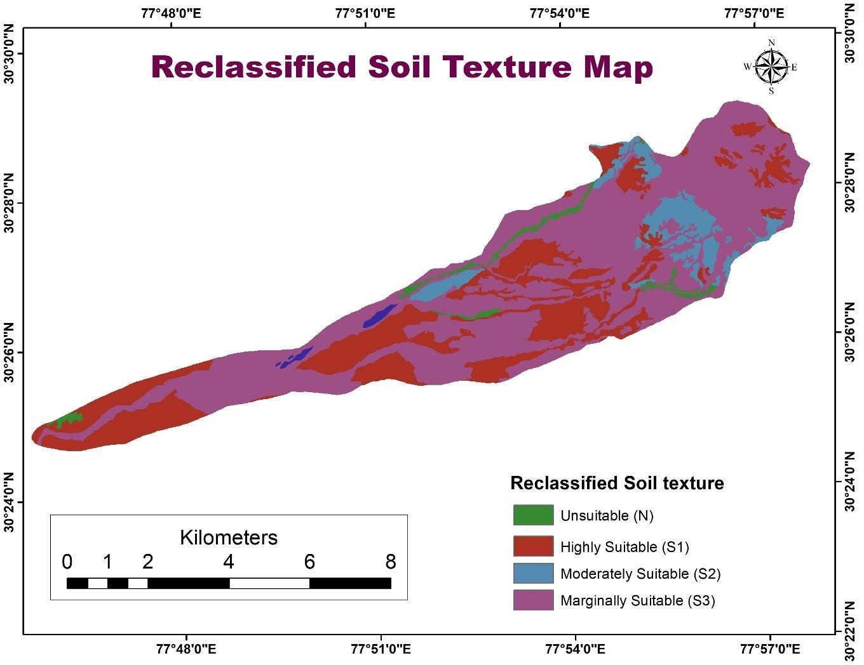

Figure 8. Soil Drainage map

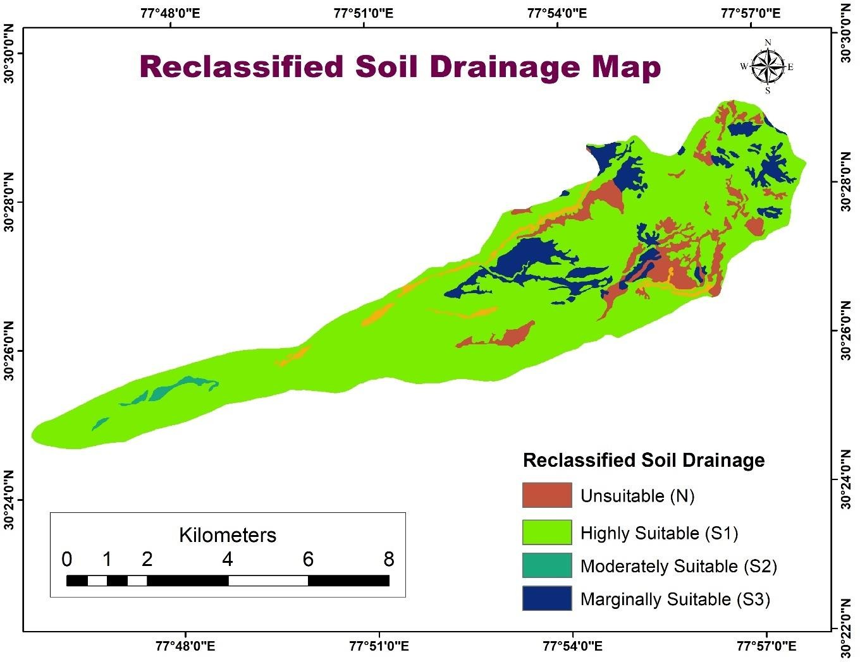

Figure 9. Soil Depth map
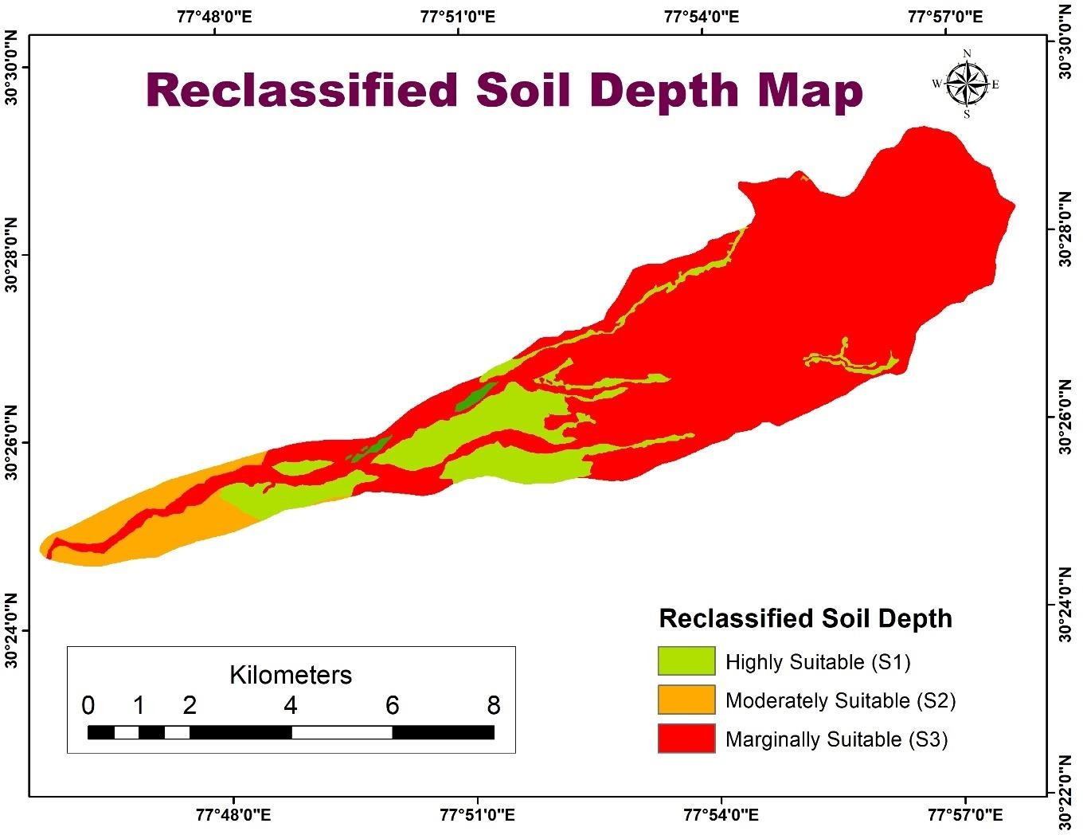

Figure 10. Erosion map

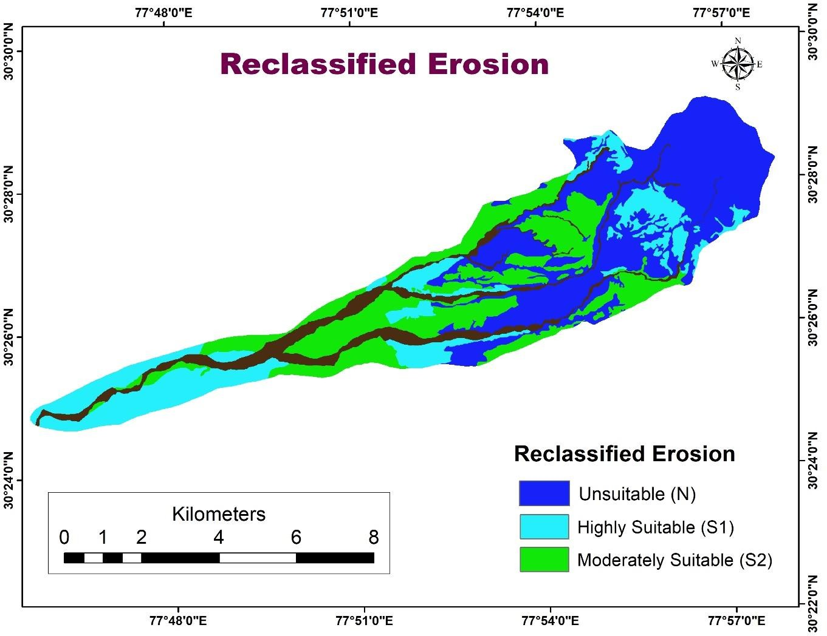

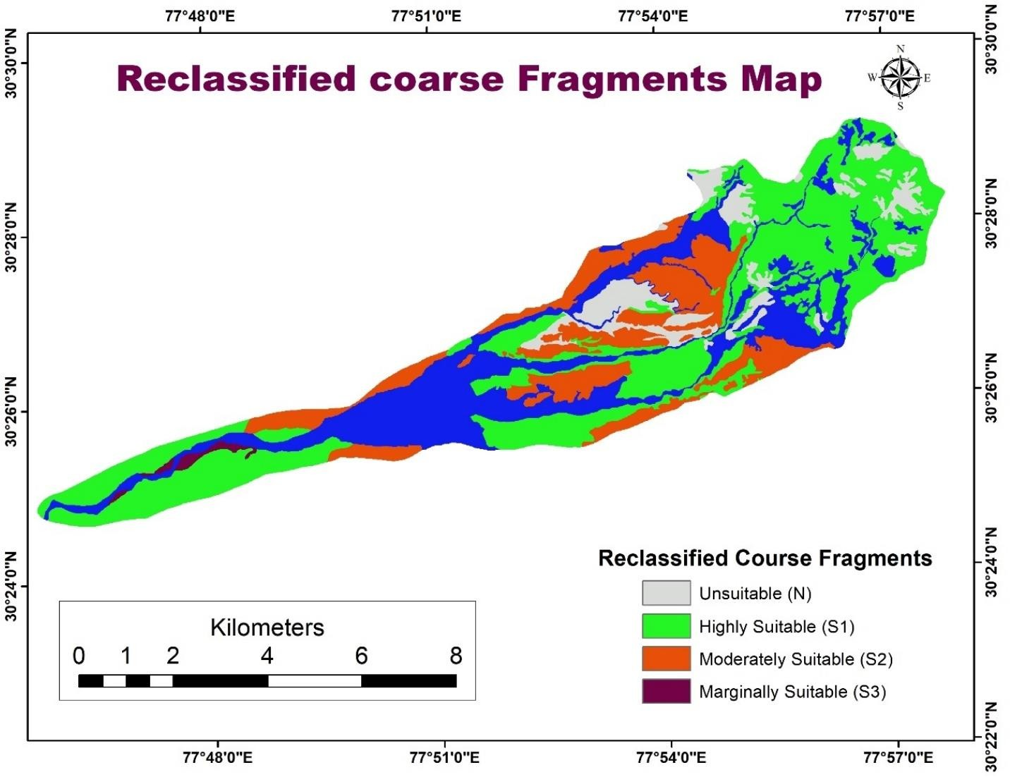
Figure 11. Coarse fragments map
3.6. AHP Technique:
High resolution images (Sentinel 2A satellite images 10m) was digitized and used for image interpretation.Spatial database of various thematic information of the study area is generated by using GIS Software (ArcGIS 10.8).Spatial Analyst was used for slope map generation from the DEM (30m) obtained from Cartosat-1 data.In this study of Sitla Rao watershed, formation of main factors uses the Saaty’s normal AHP technique.The assumption is that the weightings derived from hierarchical comparison in normal AHP would be influenced by the preferences given to a particular criterion factor. Therefore a sensitivity test was carried out on the criterion preferences. It was evaluated based on nine preference factors thought to influence weightings. The preferences given to the factors are slope, aspect, land use and land cover, soil erosion, depth, texture, drainage and coarse fragments.
Nine separate hierarchical pairwise comparisons of main criterion factors were made for each preference to analyze the sensitivity of the weights obtained (Table 3).The pairwise comparisons of criteria factors were carried out independently and given same judgements for all the preferences. To reflect the preferences towards a certain factor, a definite to very strong preferences was given to that in their pair wise comparison. The next stage in the analysis is that the consistency must be checked to verify the reliability of the judgement of the decision maker. In this study the CR=0.099 and depend on Saaty’s table if CR≤0.10, the ratio indicates a reasonable level of consistency in the pairwise comparisons. This study performs a GIS Spatial analysis which classification, reclassification and overlay techniques. Each of the input themes is assigned a weight influence based on its importance, then the result is successively multiplied with their factors. This process is often used in site suitability studies where several factors affect the suitability of a site.
3.7. Pair wise Comparison Matrix
The average of the elements in each row of the normalized matrix is calculated which provides an estimate of the relative weights of the nine criteria being compared.
Table 2. Normalized Pairwise Comparison Matrix

 | Depth | Temp | Slope | Texture | Drainage | Aspect | LULC | Coarse frag | Erosion | Weight
Depth | 0.35 | 0.43 | 0.33 | 0.43 | 0.38 | 0.17 | 0.18 | 0.24 | 0.11 | 0.299
Temp | 0.17 | 0.22 | 0.41 | 0.22 | 0.25 | 0.25 | 0.18 | 0.11 | 0.2 | 0.235
Slope | 0.09 | 0.04 | 0.08 | 0.11 | 0.13 | 0.21 | 0.18 | 0.13 | 0.2 | 0.127
Texture | 0.09 | 0.11 | 0.08 | 0.11 | 0.13 | 0.17 | 0.23 | 0.13 | 0.16 | 0.130
Drainage | 0.06 | 0.05 | 0.04 | 0.04 | 0.06 | 0.13 | 0.13 | 0.19 | 0.09 | 0.086
Aspect | 0.09 | 0.04 | 0.02 | 0.03 | 0.02 | 0.04 | 0.05 | 0.11 | 0.09 | 0.048
LULC | 0.05 | 0.03 | 0.01 | 0.01 | 0.01 | 0.02 | 0.03 | 0.05 | 0.04 | 0.027
Coarse frag | 0.04 | 0.05 | 0.02 | 0.02 | 0.008 | 0.01 | 0.01 | 0.03 | 0.09 | 0.028
Erosion | 0.07 | 0.02 | 0.009 | 0.02 | 0.02 | 0.01 | 0.01 | 0.006 | 0.02 | 0.019

After normalized Pairwise Comparison Matrix(Table 2) is obtained , then we require checking of comparisons if they are consistent. It involves the calculation of weighted sum vector, this is done by multiplying the weight of first criteria times the first column of original pairwise comparison matrix, then second weight times the second column , the third criteria times the third column of the original matrix and so on finally, summing these values over the rows , we get
Table 3. Showing different factors and weight assigned

Criteria | Weights | Weights (%)
Soil Depth | 0.2997 | 29.97
Temperature | 0.2347 | 23.47
Slope | 0.1270 | 12.70
Texture | 0.1307 | 13.07
Drainage | 0.086 | 8.60
Aspect | 0.0483 | 4.83
Land Use and Land Cover | 0.0267 | 2.67
Coarse Fragments | 0.028 | 2.80
Erosion | 0.0189 | 1.89
Total | 1.0 | 100%

Table 4. Consistency Index and Consistency ratio Calculation
 | Depth | Temp | Slope | Texture | Drainage | Aspect | LULC | Coarse frag | Erosion | (λ)
Depth | 0.299 | 0.47 | 0.508 | 0.52 | 0.516 | 0.192 | 0.189 | 0.252 | 0.095 | 10.170
Temp | 0.1495 | 0.235 | 0.635 | 0.26 | 0.344 | 0.288 | 0.189 | 0.112 | 0.171 | 10.142
Slope | 0.0747 | 0.047 | 0.127 | 0.130 | 0.172 | 0.24 | 0.189 | 0.14 | 0.171 | 10.163
Texture | 0.0747 | 0.1175 | 0.127 | 0.130 | 0.172 | 0.192 | 0.243 | 0.14 | 0.171 | 10.134
Drainage | 0.0508 | 0.0587 | 0.0635 | 0.065 | 0.086 | 0.144 | 0.135 | 0.196 | 0.076 | 10.174
Aspect | 0.0747 | 0.0399 | 0.0254 | 0.0325 | 0.083 | 0.048 | 0.054 | 0.112 | 0.076 | 10.158
LULC | 0.0418 | 0.0329 | 0.0177 | 0.0143 | 0.0172 | 0.024 | 0.027 | 0.056 | 0.038 | 10.142
Coarse frag | 0.0328 | 0.0587 | 0.0254 | 0.026 | 0.0120 | 0.012 | 0.0135 | 0.028 | 0.076 | 10.154
Erosion | 0.0598 | 0.0258 | 0.0139 | 0.0182 | 0.0215 | 0.012 | 0.0135 | 0.007 | 0.019 | 10.134

Table 5. Showing Consistency Vector

Criteria
Soil Depth | 10.170
Temperature | 10.142
Slope | 10.163
Texture | 10.134
Drainage | 10.174
Aspect | 10.158
Land Use and Land Cover | 10.142
Coarse Fragments | 10.154
Erosion | 10.134

Condition 1:
Λ should be equal or greater than the number of criteria under consideration. The value calculated above satisfies this condition.
Calculation of Consistency Index (CI) CI = (λ -n) /(n-1)
= (10.152-9)/(9-1)

= 0.144

Calculation of Consistency Ratio (CR), CR = CI/RI

= 0.144/1.45 (Since RI = 1.45 for n = 9)
CR =0.099

Condition 2:
If CR < 0.10, then the ratio indicates a reasonable level of consistency in pair wise comparisons. Therefore, the values obtained satisfy the said conditions, which denote that the weights obtained are agreeable. Each of the criterions has different attributes , which are ranked and then standardized.
As mentioned in the methodology, information on slope, aspect, temperature , land use and land cover, soil texture, soil depth, soil drainage, coarse fragments and erosion has been integrated into one. The normalized criteria maps mentioned above are combined by weighted linear combination rules by combining the criterion weights with individual layer weights.
4. DISCUSSIONS
The LSA was mapped using Weighed Overlay Analysis (WOA) with the weights of selected criteria obtained in the AHP analysis and the given scores of sub -criteria serving as the inputs. For Agro –Horticulture purposes, LSA is classified into four categories: highly suitable, moderately suitable, Marginally suitable and not suitable.
4.1. Highly Suitable
Approximately 4.47% (2.15Km²) of the land in the study region was assessed as highly suitable for Agro-Horticulture (Figure 12) with 33.81% of land under crop production. Nearly flat to gentle slope facing south direction having high temperature of 30.6⁰C, sandy clay loam with well drained soils,slight erosion, moderately shallow soil depth characterize this land type (Table 6) The nutrient status of the Sitla Rao region in Dehradun is influenced by soil erosion and varying soil fertility, with alluvial soils being moderately fertile. However, macronutrient deficiencies in nitrogen, phosphorus, and potassium, as well as variability in organic matter, can limit agricultural productivity. Soil pH may also vary, affecting the availability of micronutrients like iron and zinc, requiring careful management for optimal crop growth.
4.2. Moderately Suitable
According to the results of the study, about 30.60% (14.69 Km²) of the sites were rated as moderately Suitable for Agro-Horticulture (Table 6, Figure 12). These areas are characterized by gentle to moderate slope, sandy clay loam to sandy loam with shallow to moderately shallow depth. These regions are forests area of 21.77Km²(44.05%) and orchards occupying an area of 3.09 Km² (6.26%).
4.3. Marginally Suitable
On the whole ,11.10% of the study region (5.33 Km²) is classified as marginally suitable
(Table 6 ; Figure 12 ).This class shows shallow soils with steep slopes, higher erosion rates. Some of the steep slopes with deep soils and high rainfall may be terraced and grown agriculture crops such as wheat and rice while others occupied by Hill scrub, Hill open forest and Hill Dense forest because of coarse textured soil (Sandy loam).In Extreme soil erosion areas sowing grasses and planting Xerophytes ,contour bunding ,terrace farming and intensive cropping if followed will reduce erosion to some extent.
4.4. Not suitable
Steep slopes with coarse fragments (> 50 %), coarse textured soils, low temperature (21%) , that makes unsuitable for crop cultivation account for 0.82% (0.39Km²). (Table 6; Figure11).The study area was located in the northern region which doesnot receive enough sunlight for crop growth when compared to south region. Restricted areas occupy an area of 25.46 Km² (53.02%) due to settlement, River bed and Channel bar so not able to go for cultivation of crops.

Table 6. Criteria for land suitability assessment for Agro- horticulture
Criteria | Range | Suitability
Slope
Nearly Flat | 0-3 | Highly suitable (S1)
Gentle Slope | 3-10 | Moderately suitable(S2)
Moderate Slope | 10-20 | Marginally suitable(S3)
Steep Slope | >20 | Unsuitable (N)
Aspect
SW, Flat |  | Highly suitable (S1)
E,W |  | Moderately suitable(S2)
NW,NE |  | Marginally suitable(S3)
N |  | Unsuitable (N)
Land use and Land cover
Crop land |  | Highly suitable (S1)
Orchard |  | Highly suitable (S1)
Scrubland |  | Marginally suitable(S3)
Forest |  | Restricted
River bed channel |  | Restricted
Settlement |  | Restricted
Soil Drainage
Well drained |  | Highly suitable (S1)
Well/Moderately Well |  | Moderately suitable(S2)
Somewhat excessive drained |  | Marginally suitable(S3)
Excessive drained |  | Unsuitable (N)
Soil texture
Moderately fine textured(Scl) |  | Highly suitable (S1)
Medium Textured (Si) |  | Moderately suitable(S2)
Coarse textured (Sl) |  | Marginally suitable(S3)
Very coarse textured (Fsl/grcl) |  | Unsuitable (N)
Soil Depth
Deep | 90-150cm | Highly suitable (S1)
Moderately deep | 50-90cm | Moderately suitable(S2)
Shallow | 25-50cm | Marginally suitable(S3)
Very Shallow | <25cm | Unsuitable (N)
Temperature
Optimum temperature | 25-35⁰ C | Highly suitable (S1)
Medium temperature | 20-25 ⁰ C | Moderately suitable(S2)
Less temperature | 15-20⁰ C | Marginally suitable(S3)
Below temperature | >40⁰ C | Unsuitable (N)
Erosion
Slightly eroded | e1 | Highly suitable (S1)
Moderately eroded | e2 | Moderately suitable(S2)
Severely eroded | e3 | Marginally suitable(S3)
Extremely eroded | e4 | Unsuitable (N)
Coarse Fragments
Few | 2-10% | Highly suitable (S1)
Common | 10-20% | Moderately suitable(S2)
Many | 20-50% | Marginally suitable(S3)
Abundant | >50% | Unsuitable (N)

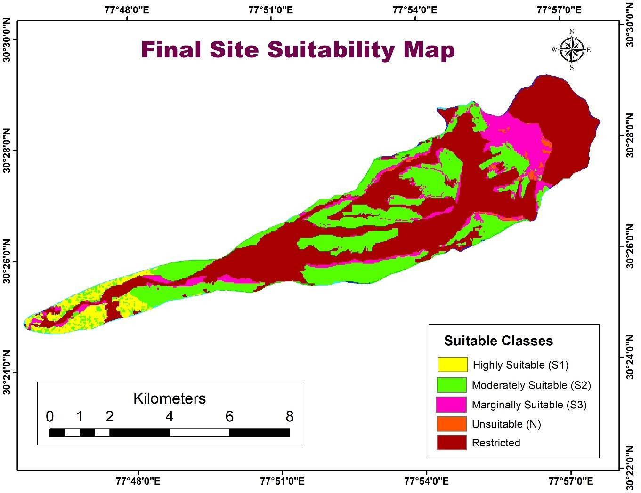

Figure12: Land Suitability Map for Agro-Horticulture

Table 7. Land Suitability for Agro-Horticulture
Suitability | Area in sq.km | Area in %
Unsuitable (N) | 0.39 | 0.82
Restricted | 25.46 | 53.02
Highly Suitable (S1) | 2.15 | 4.47
Moderately Suitable (S2) | 14.69 | 30.60
Marginally Suitable (S3) | 5.33 | 11.10

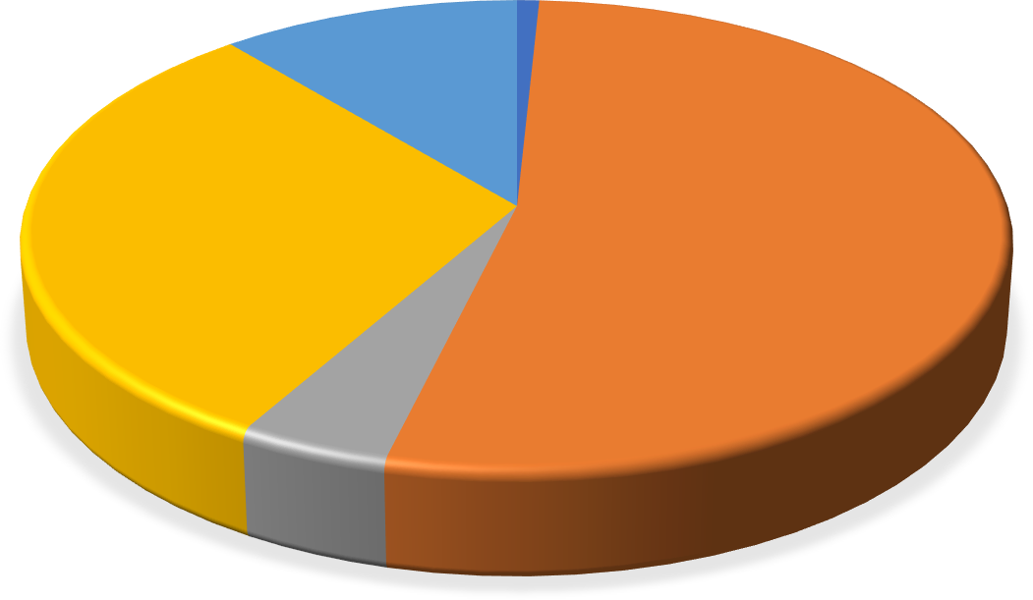
Marginally Suitable
(S3) 11%
Unsuitable (N)
1%
Moderately Suitable
(S2)
31%
Restricted
53%
Highly Suitable (S1)
4%

Figure 13. Pie Diagram showing Percentagewise Suitability
5. Conclusion
The study area is located in Sitla rao watershed in Dehradun and covers an area of 49 sq km (approximately). After suitability analysis it was found that from the available area 0.3921 sq km falls under unsuitable, 25.46 sq km under restricted, 2.149 sq km under highly suitable, 14.694 sq.km under moderately suitable and 5.329 sq km under marginal suitable. Percentage distribution of site suitability area shows that 53% of the total study area restricted, 15 unsuitable ,4% highly suitable,31% moderately suitable and 11% marginally suitable. Highly suitable areas should possess slope of (0-3%), soil depth 90-150 cm, land use is either cropland or orchard or land with scrub, well drained , moderately fine textured ,optimum temperature of 25-35⁰C ,2-10 % coarse fragments ,slightly eroded soils . The recommended process for the Sitla region in Dehradun reveals that the most appropriated site for Agro-horticulture development of the region is located in the lower to middle piedmont.This should be considered by decision makers to go for Agro-horticulture development.
To characterize land use and land cover ,terrain and soil characteristics of the study area and to determine site suitability for Agro-Horticulture development using Multi-criteria Evaluation (AHP) method. Seven factors involved -Soil, Slope, Aspect, Land use and Land cover and Climate.It was found that 2.15% of the study area suitable for Agro-Horticulture Production. The poor agricultural land availability in the Sitla region of Dehradun is primarily due to its hilly terrain and soil erosion, which limit the amount of arable land. Additionally, urbanization, land fragmentation, and inadequate irrigation facilities further reduce the land available for farming. The Sitla region of Dehradun is characterized by steep, undulating terrain of the Shivalik Hills, with significant soil erosion and alluvial deposits in river valleys. It also features a well-developed drainage system and is tectonically active, with frequent earthquakes influencing the region's landforms. In the Sitla region of Dehradun, alluvial soils in river valleys and loamy soils in certain areas are most suitable for agriculture, supporting crops like rice, wheat, and vegetables, although soil erosion poses a challenge. In the Sitla region of Dehradun, steep slopes and erosion lead to shallow soils and bare rock formations, reducing soil fertility and depth. These topographical issues limit the land use capacity, making much of the region unsuitable or marginal for agriculture. As a result of these factors, the study region contains only a limited amount of land that is highly suitable for agricultural growth.
Supplementary Materials:
Data Availability Statement: Not applicable
References

- Al-Mashreki, M.H.; Atroosh, K.B.; Muflahi, A.A.; Obaid, N.A.; Caoline,K.GIS- based asssessment of land suitability for industrial crops (cotton, sesame and groundnut) in the Abyan Delta, Yemen. Am. J. Exp. Agric. 2015, 8 (6), 384–405.
- Al-Taani, F.; Mourshed,M.;Omer,A.M.Multi-criteria decision analysis for the selection of sustainable building materials in the construction industry. Journal of Cleaner Production 2020, 276, 109-123.
- Atul,K.A.;Malay Pramanik,B.C.;Shairy Chaudhary,A.; Mahabir Singh,N.Land evaluation for sustainable development of Himalayan agriculture using RS-GIS in conjunction with analytic hierarchy process and frequency ratio. Journal of the Saudi Society of Agricultural Sciences 2021 ,20, 1–17
- Bozdag, F.; Guler, H.; Ozturk, M. Slope suitability analysis for agricultural land use using Multi-Criteria Evaluation (MCE) and Geographic Information Systems (GIS): A case study of the Western Anatolia region, Turkey. Computers, Environment and Urban Systems 2016,59, 139-147.
- Carver,S.Integrating multi-criteria evaluation with geographical information systems. International Journal of Geographical Information Systems 1991, 5(3), 321-339.
- Hussien, K.; Woldu, G.; Birhanu, S. A GIS-based multi-criteria land suitability analysis for surface irrigation along the Erer watershed, eastern Hararghe zone, Ethiopia. East Afr. J. Sci.2019, 13 (2), 169–184
- Kadam,A.K.; Umrikar,B.N.; Sankhua,R.N.Assessment of recharge potential zones for groundwater development and management using geospatial and MCDA technologies in semiarid region of Western India.SN Applied Sciences 2020,2(2),312.
- Kindu, M.; Kidanu, S.; Chernet,T. GIS-Based Agricultural Land Suitability for Target Crops.EIAR .Technical Report 2009.
- Mitiku, F.; Yitayew, M.; Dagnachew, S. Land suitability analysis for maize production using multi-criteria evaluation and geospatial technologies: A case study of the Didessa watershed, Ethiopia. Environmental Systems Research 2021,10(1),1-14.
- NBSSLUP. Soil Resource Mapping for Land Use Planning in India: A Literature and Data Compilation.2007.National Bureau of Soil Survey and Land Use Planning, Indian Council of Agricultural Research, Nagpur, India.
- Osman,O.Land suitability determination for citrus cultivation using GIS-based multi-criteria analysis in Mersin,Turkey.Computers and Electronics in Agriculture 2021,190,106433
- Pandey,A.;Sharma,S.;Kumar,R.LandSuitability Evaluation Using GIS and Multicriteria Analysis: A Case Study of Location Journal of Environmental Management 2017,45 (3): 231-245.
- Parry, J. A.; Ganaie, S. A.; Bhat, S. M. GIS based land suitability analysis using AHP model for urban services planning in Srinagar and Jammu urban centers of J&K, India. Journal of Urban Management 2018, 7(2), 46- 56.
- Pramanik, M.K.Site suitability analysis for agricultural land use of Darjeeling district using AHP and GIS techniques. Model. Earth Syst. Environ.2016,2,1–22.
- Rajasekhar, M.; Sudarsana Raju, G.; Siddi Raju, R.; Imran Basha U. Landuse and landcover analysis using remote sensing and GIS: A case study in Uravakonda,Anantapur District, Andhra Pradesh, India. International Research Journal of Engineering and Technology (IRJET) 2017, 4(9), 780-785
- Rajasekhar, M.; Sudarsana, R,G.; Nanabhau, K.; Ramachandra, M.; Pradeep, K, B.Multi-criteria Land Suitability Analysis for Agriculture in Semi-Arid Region of Kadapa District, Southern India: Geospatial Approaches.Remote Sensing of Land 2021, 5(2), 59-72.
- Rajasekhar, S.; Kumar, P.; Sharma, R.AHP and Multicriteria Analysis in Decision-Making: Applications and Case Studies.International Journal of Decision Sciences 2019,34 (2): 105-120.
- Rajasekhar,S.; Kumar, P.; Sharma, R.Application of AHP and Multicriteria Analysis in Decision-Making: A Review. International Journal of Decision Sciences 2020,35 (1): 25-40.
- Saaty, T.L. 1980.The analytical hierarchy process. New York : McGraw-Hill.
20.Tercan, G. S.; Dereli, T. A hybrid multi-criteria decision-making approach based on interval type-2 fuzzy sets and grey relational analysis for supplier selection. Computers & Industrial Engineering 2020,140, 106243.
21. U.S. Department of Agriculture (USDA), Natural Resources Conservation Service (NRCS). Soil Survey Manual 2021. U.S. Department of Agriculture.
22.Voogd, H. Multicriteria Evaluation for Regional Planning. European Journal of Operational Research 1983,12(3), 291-298
23.Yuniarti,W.; Sumardjo.; Widiatmaka,W,D.;Wibawa.Development of Highland vegetable Commodity Areas through Multi-Criteria Decision Making (MCDM) Analysis and Geographic Information Systems. IOP Conf. Series: Earth and Environmental Science 2022, 950.012074.

