Original Research Article

A Combined Statistical and Machine Learning Approach for Predicting Surface Water Quality in Burkina Faso

Abstract

Surface water in Burkina Faso is essential for domestic use, agriculture, and ecosystem services, yet it is increasingly impacted by human activities and climate variability. This study used the Water Quality Index (WQI), multivariate statistics and a Multilayer Perceptron (MLP) neural network to assess and predict water quality. A total of 139 samples were analyzed for 17 physicochemical parameters. The results revealed slightly alkaline waters (pH 6.04–9.23), low-to-moderate mineralization (electric conductivity [EC] 39–387 micro siemens per centimeter [µS/cm]; total dissolved solids [TDS] 39–1,100 milligrams per liter [mg/L]), and spatially variable nutrient concentrations (ammonium [NH₄⁺], nitrate [NO₃⁻], and phosphate [PO₄³⁻]), which are indicative of both natural and anthropogenic inputs. Correlation and factor analyses identified three main influences on water quality: geogenic weathering; nutrient and sediment inputs from human activities; and salinity and mineral contributions. MLP modelling showed that deeper architectures with two hidden layers (12,6 and 12,12) achieved the highest predictive accuracy (R² ≈ 0.825, RMSE ≈ 61, and MAE ≈ 40), and the best model generalized well to test data (R²_(Test) = 0.95, RMSE_(Test) = 37.3). This integrated approach shows the potential for combining statistical analysis and machine learning to monitor, manage, and predict surface water quality in Burkina Faso.

Keywords: Water Quality Index, Statistical Analysis, Multilayer Perceptron, Surface Water Prediction, Burkina Faso.

1. Introduction
Surface water resources play a vital role in Burkina Faso's domestic supply, agriculture, and livestock farming, as well as in maintaining the country's ecological balance. However, strong population growth, expanded irrigated areas, and increased mining and industrial activities are putting pressure on water quality. For instance, Ouagadougou, a city with a population of approximately 3 million in 2020, produced 680,000 to 700,000 tons of waste, nearly one-third of which was non-biodegradable plastic (UNEP, 2020). The accumulation of household and industrial waste promotes the proliferation of disease-carrying organisms, such as mosquitoes and rodents. In Burkina Faso, untreated industrial discharges are a major source of water pollution. For example, several industries in the Kossodo Industrial Zone of Ouagadougou, including breweries and tanneries, release untreated wastewater directly into the Massili River (Haro et al., 2013). More broadly, water pollution trends in West Africa suggest that surface waters are frequently contaminated by untreated wastewater from domestic and industrial sources (UNEP, 2016). In rural regions such as the Sourou Valley in Burkina Faso, households often rely on untreated river water due to limited access to safe drinking water and perceptions of water quality. Only about 37% of households in Burkina Faso have access to safe drinking water, compared to 62% in Ghana (Rodgers et al., 2007). Even where treated water is available, many people continue to use river water due to convenience and lower opportunity costs (Engel et al., 2005). Studies on urban water pollution also show that domestic and industrial effluents, along with fecal sludge, substantially contribute to the deterioration of rivers and other aquatic ecosystems (Kabore et al., 2023). According to the UNEP (2016) report, surface water quality in Mali and Burkina Faso is poor, characterized by high concentrations of coliform and bacillus bacteria. All these previous studied highlights the significant impact of anthropogenic activities and inadequate sanitation infrastructure on surface water quality and public health in Burkina Faso. This situation increases the risk of contamination for nearby populations and disrupts aquatic ecosystems. Therefore, continuous monitoring of surface water quality is essential to promote sustainable management and support the achievement of Sustainable Development Goal 6, which addresses access to clean water and sanitation (Maïga et al., 2020; Ouedraogo et al., 2024). Traditional assessment approaches based on comparing measured parameters to standards or computing basic indices are often insufficient for representing the complex interactions among chemical and biological factors. Multivariate analyses, such as principal component analysis (PCA) and clustering, help simplify these data sets and identify pollution sources (Shrestha & Kazama, 2007; Simeonov et al., 2003). Recently, combining these statistical tools with machine learning algorithms, such as multi-layer perceptrons (MLPs), has improved prediction accuracy and supported better decision-making in water quality management (Abu et al., 2024; Konaré et al., 2024). Advanced modeling using MLP networks captures complex nonlinear interactions between water quality parameters. Meanwhile, Geographic Information Systems (GIS) offer spatial insights and facilitate the mapping of water quality trends (Vega et al., 1998; Reghunath et al., 2002; Simeonov et al., 2004; Sofie et al., 2006). In this study, we applied GIS, WQI, and multivariate statistical methods to assess and characterize surface water quality in the Nakambé River Basin.

2. Materials and Methods

2.1 Study area overview

The study area is located in the Nakambé Basin in central Burkina Faso, spanning approximately 11°30′–13°30′ N and 0°30′–2°00′ W (Figure 1). The Nakambé Basin, a major sub-basin of the Volta River system covering roughly 62,000 km², is crucial for water supply, agriculture, and ecosystem regulation (Andreini et al., 2002; Gbohoui et al., 2021). The Nakambé River and its tributaries primarily drain surface water southward toward Ghana. Major reservoirs, such as the Ziga Dam (mainly supplying drinking water to Ouagadougou) and the Bagré Dam (supporting irrigation, hydropower, and fisheries), supplement this drainage (Gbohoui et al., 2021; Ibrahim, 2012). Smaller lakes and seasonal rivers also contribute to the region’s water resources (Descroix et al., 2009). For the climatic conditions, the basin belongs to the Sudanian zone, with a pronounced wet season from May to October and a dry season from November to April. Annual rainfall ranges from 700 to 1,200 mm, with strong interannual variability (Yangouliba et al., 2022; Mahe et al., 2005). Temperatures range from 18 to 22 °C during the cool season to 32 to 40 °C in the hot season, averaging around 28 °C annually. Surface water availability is highly seasonal, with high flows during the rainy season and reduced flows during the dry season, which can sometimes lead to water scarcity and competition among different uses (Gbohoui et al., 2021; Ibrahim, 2012).

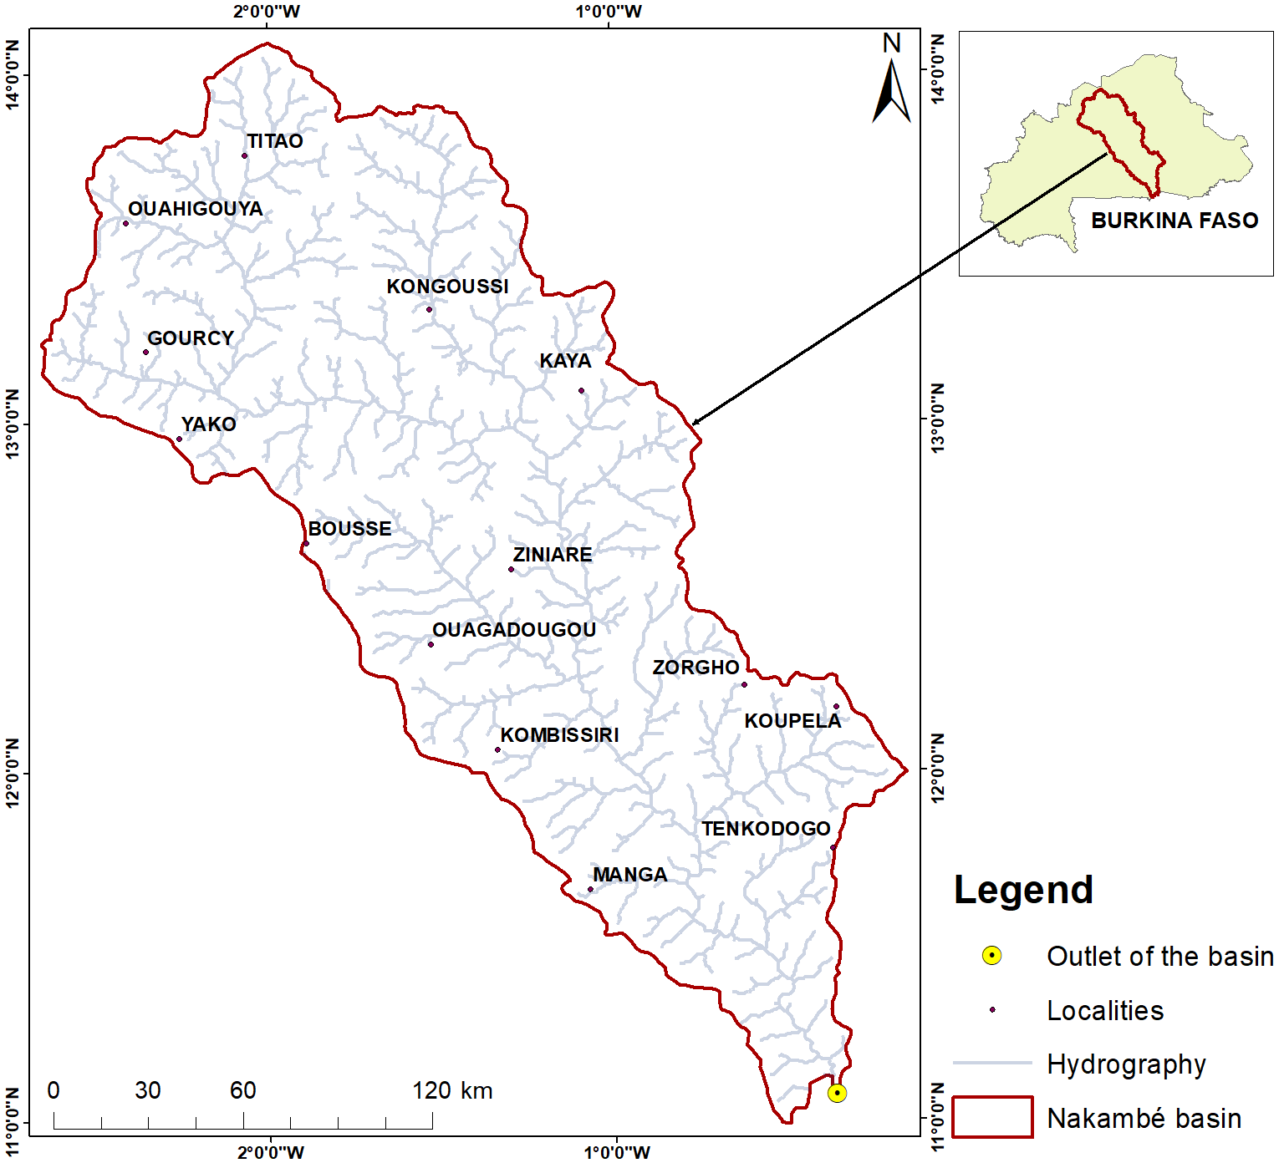
Figure 1: Hydrography map of Nakambe

2.2 Surface water dataset

To ensure good spatial distribution, a total of 139 surface water samples were collected throughout the Nakanbé Basin in Burkina Faso. Physicochemical parameters analyzed included pH, electrical conductivity (EC), total dissolved solids (TDS), turbidity, and major ions such as Ca²⁺, Mg²⁺, Na⁺, K⁺, NH₄⁺, HCO₃⁻, Cl⁻, SO₄²⁻, NO₃⁻, NO₂⁻, and PO₄³⁻. Spatial distribution analysis of water quality parameters was performed to identify areas at risk of pollution. This approach also enables tracing the origin of contaminants. Statistical analyses were conducted using Spyder (Python 3.12), an open-source software platform. To evaluate the basin's water quality, a Water Quality Index (WQI) was calculated and then predicted using neural network models in Python. This approach integrates multiple parameters into a single numerical score to provide a comprehensive evaluation of surface water quality across the basin. To develop the model, the dataset was randomly divided into training (70%) and testing (30%) subsets. This allows us to measure the performance of the model. The input variables consisted of selected water quality parameters, and the output variable was the computed WQI. Before training, the input features were normalized between 0 and 1 to improve model convergence. Feature scaling has been shown to enhance the stability and speed of training in machine learning models (Patro & Sahu, 2015). This study employed the Adam optimizer with early stopping during the training process to prevent overfitting (Heaton, 2017). Additionally, cross-validation was applied to ensure model robustness and generalization.

2.3 Water Quality Assessment

2.3.1 Water Quality Index (WQI) methodology
The Water Quality Index (WQI) integrates multiple physicochemical parameters into a single value representing overall water quality. Horton first introduced the concept of the WQI in the early 1970s as a method to summarize multiple water quality measurements into a single, interpretable value. The WQI represents the overall level of water quality in bodies of water such as ponds, lakes, rivers, and streams (Naik & Purohit, 1996; Iwuoha & Osuji, 2012). The WQI offers an easy way to evaluate the suitability of surface water for domestic use by converting complex physicochemical information into a single score. This approach simplifies understanding of water conditions while maintaining a scientifically sound assessment framework. In this study, fifteen key parameters were selected for the WQI calculation: pH, Na⁺, Ca²⁺, SO₄²⁻, Mg²⁺, Cl⁻, NO₃⁻, HCO₃⁻, PO₄³⁻, K⁺, NO₂⁻, turbidity, electrical conductivity (EC), total dissolved solids (TDS), and NH₄⁺ (see Table 1). These indicators were chosen based on their direct relevance to human health and inclusion in international water quality standards (WHO, 2011). Parameters showing weak sensitivity or redundancy were excluded to avoid overrepresentation. NO₃⁻ and PO₄³⁻ were given greater weights due to their potential health and eutrophication impacts, while variables such as turbidity, pH, and EC served as general indicators of natural geochemical processes and human influences (EPA, 2023). Individual sub-indices (QI) were calculated for each parameter, and the composite WQI was derived through the weighted arithmetic aggregation method. The resulting WQI values were categorized into the standard qualitative classes of excellent, good, poor, very poor, and unsuitable for drinking, as summarized in Table 2. The indices followed the parameters recommended by the World Health Organization (WHO).

Relative weight (Wi) is computed from the equation (1),

$Wi={wi}/{\sum{wi}}$…………………………… (1)
A quality rating scale (qi) for each parameter is calculated using equation (2) below
$qi=({Ci}/{Si})×100$………………….. (2)
Ci is the concentration of each parameter in the water sample in mg/L
Si is the Standards of each chemical parameter prescribed by WHO (2011).
Sub Index SIi is to be determined for each chemical parameter using equation (3)
$Sli=Wi×qi$…………………. (3)
Water Quality Index is then determined with equation (4)
$WQI=\sum{Sli}$………………………… (4)
Table 1. Physicochemical parameter relative weights
Physico-chemical parameters | WHO  standards (2011) | Weight (wi) | Relative weight (Wi)
pH (-) | 6.5 - 8.5 | 4 | 0.077
Na⁺ | 200 mg/L | 2 | 0.038
Ca²⁺ | 75 mg/L | 2 | 0.038
SO₄²⁻ | 250 mg/L | 4 | 0.077
Mg²⁺ | 50 mg/L | 2 | 0.038
Cl⁻ | 250 mg/L | 3 | 0.058
NO₃⁻ | 50 mg/L | 5 | 0.096
HCO₃⁻ | 120 mg/L | 1 | 0.019
PO₄³⁻ | 1 mg/L | 4 | 0.077
K⁺ | 12 mg/L | 2 | 0.038
NO₂⁻ | 3 mg/L | 5 | 0.096
Turbidity (Turb) | 5 NTU | 5 | 0.096
EC | 2500 µS/cm | 5 | 0.096
TDS | 500 mg/L | 4 | 0.077
NH₄⁺ | 1.5 mg/L | 4 | 0.077
Total | - | 52 | 1.000

Table 2: Classification of water according to the WQI
Water class | WQI
Excellent | < 50
Good | 50–100
Poor | 100–200
Very poor | 200–300
Unfit for drinking | > 300

2.3.2 Statistical analysis
Statistical methods were used to study the variability, relationships, and underlying structure of the dataset. First, descriptive statistics, including the mean, median, and standard deviation, were applied to summarize the distribution and variability of the measured water quality variables. Then, the Pearson correlation matrix was used to explore the relationships among the parameters to help identify potential common sources of pollution or natural geochemical control factors (Varol et al., 2012). Furthermore, to better interpret the dataset's structure and highlight the dominant processes influencing water chemistry, factor analysis (FA) was performed after data normalization. Only factors with eigenvalues greater than one were retained, and their loadings were analyzed to determine the primary geochemical and anthropogenic drivers of surface water quality (Shrestha & Kazama, 2007). All statistical analyses were conducted in Python 3.12 using the Spyder environment and the pandas, numpy, scikit-learn, matplotlib, and seaborn libraries. Spatial interpolation and cartographic representation of the WQI were carried out in ArcGIS 10.8 to visualize spatial patterns and generate water quality maps.

2.4 Machine Learning Prediction

2.4.1 Multi-Layer Perceptron (MLP) architecture
Artificial neural networks (ANNs) were also used to predict water quality indicators from the physicochemical dataset. The Multi-Layer Perceptron (MLP) architecture was chosen for its ability to represent nonlinear relationships. The MLP model consists of an input layer (predictor variables), one or more hidden layers (processing units), and an output layer (target variable, e.g., WQI). The network was trained using the backpropagation algorithm, which adjusts connection weights to minimize prediction error (Haykin, 1999; Maier & Dandy, 2000). Nonlinear activation was achieved using the rectified linear unit (ReLU) function, which accelerates convergence and improves performance compared to traditional sigmoid or tanh functions (Nair & Hinton, 2010).

2.4.2 Model performance metrics
We assessed the predictive performance of the MLP using statistical metrics, including the coefficient of determination (R²), root mean squared error (RMSE), and mean absolute error (MAE). R² shows the proportion of the variance in the observed data that the model explains. RMSE measures the average prediction error in units similar to those of the target variable. MAE evaluates the average magnitude of errors and is less sensitive to outliers than RMSE. High R² values coupled with low RMSE and MAE demonstrate strong predictive performance and validate the MLP’s ability to capture complex nonlinear relationships in surface-water quality data (Hameed et al., 2017; Setshedi et al., 2021).
.

3. Results and discussion

3.1 Physicochemical characteristics of surface water

Table 3 presents the descriptive statistics of the 17 measured physicochemical parameters (n = 139). Water temperature ranged from 21.5 to 32.5 °C, with an average of 26.5 °C, indicating warm tropical conditions. The pH values ranged from 6.04 to 9.23, averaging 7.67, indicating that most of the water is slightly alkaline. Electrical conductivity (EC) exhibited wide variation (39.2–387 µS/cm), with an average of 78.4 µS/cm, reflecting low overall mineralization. Turbidity exhibited considerable variability, ranging from 0.08 to 553.6 nephelometric turbidity units (NTU), with occasional extreme values indicating episodic inputs of sediments or organic matter. Total dissolved solids (TDS) also showed considerable variability, ranging from 39 to 1,100 mg/L, reflecting localized differences in mineral content. Among the major cations, calcium (Ca²⁺; mean 11.1 mg/L) and magnesium (Mg²⁺; mean 9.3 mg/L) predominated, while sodium (Na⁺; mean 5.5 mg/L, maximum 42 mg/L) and potassium (K⁺; mean 3.0 mg/L, maximum 30 mg/L) occurred at lower, despite its variability of concentrations. Bicarbonate (HCO₃⁻) was the predominant anion (mean 97.9 mg/L), consistent with carbonate weathering. Chloride and sulphate showed relatively low concentrations (mean 0.6 and 2.7 mg/L, respectively). Nutrient indicators exhibited high spatial variability, with concentrations ranging from 0.01–4.52 mg/L for NH₄⁺, 0.18–66 mg/L for NO₃⁻, and 0.06–5.58 mg/L for PO₄³⁻. These strong variations reflect both natural and anthropogenic inputs. In particular, within the Volta Basin, high nutrient loads have been reported in specific agricultural zones cultivating cotton, sugar cane and commercial oil palm plantations (Programme GIRE Burkina Faso, 2001; Samah, 2012), as well as in areas influenced by markets (Ofori, 2012). To a lesser extent, localized industrial activities, such as beverage and textile production, also contribute to nutrient enrichment (Gampson et al., 2014). Consequently, a major challenge affecting surface water in the basin is the deterioration of water quality resulting from elevated phosphate and nitrate inputs from agricultural activities (UNEP-GEF Volta Project, 2013).

Table 3: Descriptive statistics of physicochemical parameters (n=139)
 | Mean | Std | Min | 25% | 50% | 75% | Max
Temp | 26.506 | 2.589 | 21.5 | 24.95 | 26.4 | 28.3 | 32.5
pH | 7.671 | 0.431 | 6.04 | 7.475 | 7.7 | 7.87 | 9.23
EC | 78.376 | 48.199 | 39.2 | 56.3 | 66.7 | 82.2 | 387
Turb | 78.211 | 106.772 | 0.08 | 11.94 | 46.6 | 95.84 | 553.6
TDS | 100.309 | 156.596 | 39 | 56 | 67 | 82 | 1100
Ca²⁺ | 11.112 | 5.585 | 3.1 | 7.25 | 9.8 | 13.7 | 37.1
Mg²⁺ | 9.312 | 5.621 | 0.73 | 4.75 | 8.4 | 12.6 | 29.3
Na⁺ | 5.467 | 8.365 | 0 | 1.5 | 3.5 | 5.45 | 42
K⁺ | 2.952 | 2.906 | 0.2 | 1.7 | 2.5 | 3.3 | 30
NH₄⁺ | 0.538 | 0.807 | 0.01 | 0.12 | 0.22 | 0.73 | 4.52
HCO₃⁻ | 97.900 | 42.169 | 27.5 | 60.5 | 98.8 | 125.65 | 230.1
Cl⁻ | 0.597 | 0.273 | 0.25 | 0.41 | 0.53 | 0.675 | 1.78
SO₄²⁻ | 2.719 | 3.369 | 1 | 2 | 2 | 2 | 29
NO₂⁻ | 0.013 | 0.031 | 0.003 | 0.003 | 0.007 | 0.013 | 0.353
NO₃⁻ | 3.146 | 7.099 | 0.18 | 0.44 | 1.32 | 2.64 | 66
PO₄³⁻ | 0.456 | 0.726 | 0.06 | 0.2 | 0.29 | 0.41 | 5.58
P | 0.148 | 0.237 | 0.02 | 0.07 | 0.09 | 0.13 | 1.82

3.2 Water quality index (WQI) and spatial distribution
Figure 2 shows two maps of the Nakambé Basin in Burkina Faso that illustrate the spatial distribution of the Water Quality Index (WQI). The first map shows measured WQI values at sampling stations as green clusters. The second map provides a spatially interpolated representation of the WQI across the basin, which allows for estimation in unsampled areas. Both maps include major towns and the river network for geographic reference. The shared legend categorizes water quality into five levels: Excellent (dark blue), Good (green), Poor (yellow), Very Poor (orange), and Unsuitable (red). The observed WQI values ranged from 11 to 40. According to the WHO (1996) classification, this indicates excellent water quality overall (WQI < 50). The highest WQI values, close to 40, occurred mainly in southeastern Plateau Central and in localized zones within the Sanmatenga and Bam provinces (Mahamadou et al.2024). The lowest values, below 15, were recorded in the Kadiogo and Passoré areas. The spatial comparison of WQI reveals the following patterns: Excellent zones (blue): These are observed mainly in the west and central-west. The predicted values show a similar distribution, but they are slightly extended due to interpolation. Good zones (green), observed around Titao, Ouahigouya, and the central west. Predicted zones are more extensive, reflecting model generalization. Poor and very poor zones (yellow and orange): Observed in the central and eastern areas. Predicted zones maintain this trend, but have smoother boundaries. The "unsuitable" class (red areas) appears mainly in the eastern portion of the basin, particularly around Fada and Koupela. In the interpolated map, these zones are more widespread, which emphasizes the model’s ability to identify critical water quality hotspots. Overall, the interpolation technique effectively reproduces the spatial distribution of the WQI across the basin, though it tends to smooth out local fluctuations. The strong agreement between the measured and predicted WQI values confirms the robustness of the interpolation approach adopted, though caution remains necessary in regions with limited sampling density (Issoufou et al.2025). These spatial patterns suggest that water quality is influenced by natural hydrogeological factors and human activities (Mahamadou et al.2024; Millogo et al.2024). Localized deviations indicate potential anthropogenic impacts, such as those from agriculture or domestic inputs (Water Quality Overview Burkina Faso, 2023). This comparison is valuable for identifying risk zones, validating the model, and guiding water management decisions in the Nakambé Basin.

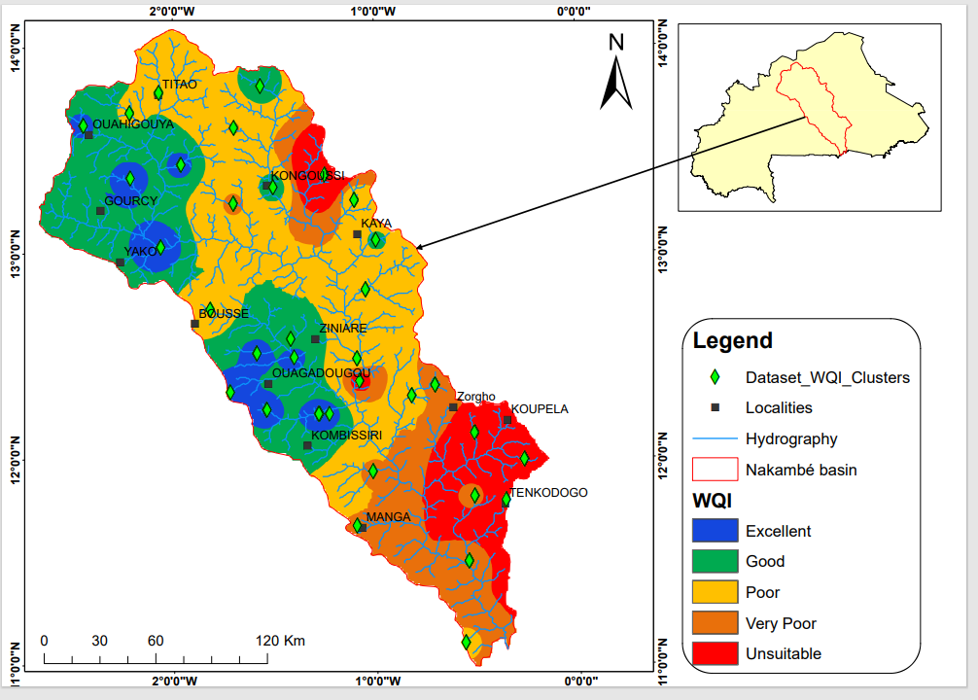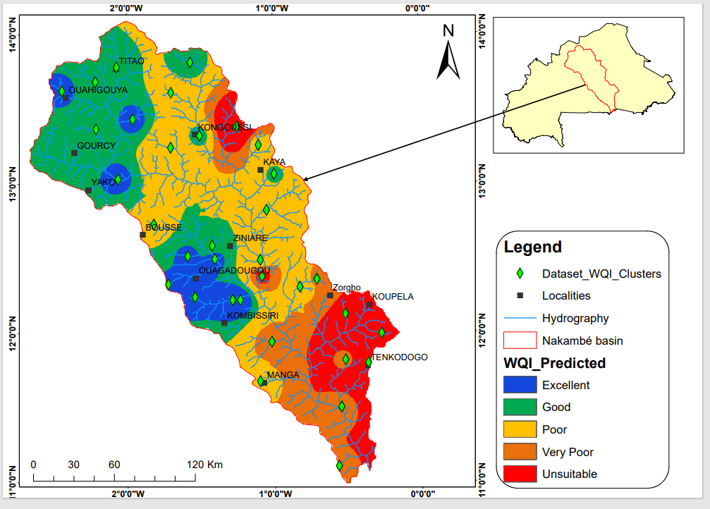

Figure 2: WQI values in the study area for the surface water samples

3.3 Multivariate statistical analysis

The Figure 3 presents the correlation coefficients of the surface water quality parameters, revealing several significant relationships among the measured variables. There is a strong positive correlation between turbidity and NH₄⁺ (r = 0.72), as well as between NH₄⁺ and NO₃⁻ (r = 0.60). This indicates that nitrogenous pollution and suspended matter are likely linked to domestic wastewater and agricultural activity observed in various region of Burkina Faso (Faye et al., 2022; Yaméogo et al., 2025). Significant positive relationships were identified between Na⁺ and K⁺ (r = 0.49), as well as between HCO₃⁻ and Mg²⁺ (r = 0.77). This suggests that these ions likely originate from similar geogenic processes, particularly the dissolution of carbonate minerals. Electrical conductivity (EC) showed a strong association with Na⁺ (r = 0.63) and moderate associations with K⁺ (r = 0.31) and HCO₃⁻ (r = 0.32). This implies that salinity levels in surface waters are primarily influenced by sodium and bicarbonate concentrations. The correlation between Ca²⁺ and HCO₃⁻ (r = 0.58) further supports the significance of carbonate weathering. Moderate correlations were also observed between SO₄²⁻ and Ca²⁺ (r = 0.43), SO₄²⁻ and turbidity (r = 0.42), and Cl⁻ and turbidity (r = 0.41). This indicates the combined influence of natural geochemical reactions and human-derived inputs. A negative association between pH and EC (r = -0.48) reveals that elevated ionic content tends to coincide with slightly more acidic conditions. We observed that the three dominant trends emerge: first, nitrogen-related species show strong connections with turbidity, reflecting contamination sources, the second, carbonate minerals exert significant geogenic control, as evidenced by correlations among HCO₃⁻, Ca²⁺, and Mg²⁺, and the third, salinity patterns are primarily regulated by Na⁺, with secondary influence from K⁺ and HCO₃⁻. These relationships suggest that natural geogenic processes and human activities, such as domestic sewage and agriculture, primarily drive surface water chemistry in the study area in the Nakambe Basin in Burkina Faso (Mahe, 2009; Gaëtan et al., 2023).
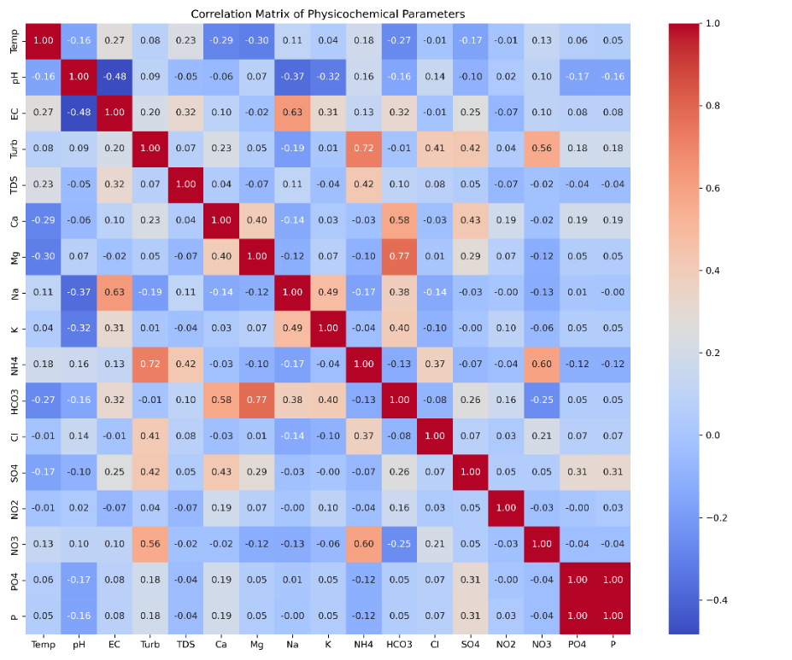
Figure 3: Heatmap of correlation matrix between the physicochemical parameters
A factor analysis was performed on 17 physicochemical variables to identify the underlying compositional patterns in the surface water samples and to determine also the main sources of variation. Three factors with eigenvalues greater than one were retained, accounting for 100% of the total variance. Factor 1 explained 38.07% of the variance, Factor 2 accounted for 34.77%, and Factor 3 contributed 27.16% (see Table 4). Analysis of the factor loadings (Table 5) revealed that Factor 1 is strongly associated with Mg²⁺ (0.772), Ca²⁺ (0.570), and HCO₃⁻ (0.998). This indicates geogenic influences, particularly from carbonate and silicate weathering. Factor 2 is primarily driven by turbidity (0.983), NH₄⁺ (0.718), NO₃⁻ (0.562), and Cl⁻ (0.419), suggesting inputs from domestic wastewater and agricultural runoff. Factor 3 is dominated by Na⁺ (0.836), EC (0.656), and K⁺ (0.405), reflecting the combined effects of salinity, mineral dissolution, and anthropogenic activities. These three factors collectively represent the principal processes influencing surface water quality, i.e. natural geochemical weathering, human-related nutrient and sediment inputs, and salinity or mineral contributions from natural and anthropogenic sources.
Table 4: Extracted values of different analyses for surface water samples
Component | Sum_of_Squared_Loadings | Eigenvalue | % Variance | Cumulative %
Factor1 | 2.63731407 | 2.63731407 | 38.0669274 | 38.0669274
Factor2 | 2.40883844 | 2.40883844 | 34.7691157 | 72.8360431
Factor3 | 1.88194558 | 1.88194558 | 27.1639569 | 100

Table 5: Factor analysis results of surface water samples
 | Factor1 | Factor2 | Factor3
Temp | -0.266 | 0.057 | 0.306
pH | -0.161 | 0.111 | -0.381
EC | 0.326 | 0.169 | 0.656
Turb | -0.016 | 0.983 | 0.065
TDS | 0.101 | 0.081 | 0.164
Ca | 0.570 | 0.259 | -0.287
Mg | 0.772 | 0.096 | -0.458
Na | 0.387 | -0.248 | 0.836
K | 0.406 | -0.018 | 0.405
NH4 | -0.136 | 0.718 | 0.089
HCO3 | 0.998 | 0.004 | -0.006
Cl | -0.086 | 0.419 | -0.020
SO4 | 0.263 | 0.422 | -0.039
NO2 | 0.162 | 0.044 | -0.056
NO3 | -0.255 | 0.562 | 0.108
PO4 | 0.055 | 0.181 | 0.033
P | 0.049 | 0.182 | 0.030

3.4 Machine learning prediction of WQI
In Table 6, we showed how the architecture of the MLP models affects their predictive performance. The initial MLP model with a single hidden layer and six neurons exhibited poor predictive capability, as indicated by the negative R² value (-0.27) and large error metrics (RMSE ≈ 190 and MAE ≈ 124). These results suggest underfitting and an inability to capture primary data patterns (Goodfellow et al.2016). Increasing the hidden layer size to twelve neurons improved performance (R² = 0.46); however, RMSE and MAE remained relatively high (approximately 114 and 77, respectively). Adding a second hidden layer markedly enhanced model accuracy. For example, the (6, 6) architecture achieved an R² value of 0.74 with lower prediction errors (RMSE of approximately 81 and MAE of approximately 56), demonstrating the advantage of deeper networks in capturing nonlinear relationships (Tian et al.,2023; Elmotawakkila et al.,2025). The MLP of (12, 6) and (12, 12) configurations produced optimal results, yielding R² values around 0.825 and the lowest RMSE (approximately 61) and MAE (approximately 40). These configurations were superior for modelling WQI. The marginal difference between these two architectures suggests that adding more depth beyond the (12, 6) configuration provides minimal improvement, reflecting diminishing returns with increasing complexity. These results demonstrate that deeper MLP architectures outperform shallower ones and that the (12, 6) configuration strikes an optimal balance between predictive accuracy and model complexity.

Table 6: MLP model performance (mean values across architectures)
Architecture | Mean_R² | Mean_RMSE | Mean_MAE
(6,) | -0.26851 | 189.759 | 123.5608
(12,) | 0.455339 | 113.6913 | 77.12502
(6, 6) | 0.742994 | 81.03689 | 56.36357
(12, 6) | 0.824804 | 61.32561 | 40.81357
(12, 12) | 0.825752 | 60.9269 | 40.04839

Table 7 summarizes the performance of the most advanced MLP model using both the training and testing datasets. With a model architecture defined by two hidden layers of 12 neurons each and a ReLU activation function, the model achieved excellent predictive ability during training (R² = 0.983, RMSE = 28.67, and MAPE = 24.93%), experiencing only a slight reduction in accuracy on the test dataset (R² = 0.950, RMSE = 37.30, and MAPE = 40.24%). This decrease is normal when evaluating unseen data and suggests that the model generalizes well without severe overfitting. The consistency between the training and testing metrics confirms the reliability of the developed MLP model. These findings are consistent with previous research showing that MLP architectures can achieve strong predictive accuracy and generalization performance across diverse datasets. However, as highlighted by Elmotawakkila et al. (2025), even greater improvements may be possible by incorporating more sophisticated deep learning architectures such as convolutional neural networks (CNNs) and recurrent neural networks (RNNs), which can capture more complex spatial and temporal patterns in water quality data.
Table 7: Training and testing performance of the best MLP model
R2_Train | R2_Test | RMSE_Train | RMSE_Test | MAPE_Train (%) | MAPE_Test (%)
0.982671 | 0.950102 | 28.66905 | 37.30273 | 24.92473 | 40.24275

Figure 4 shows a comparison of the actual and predicted WQI values for the training and test sets using an MLP model with 12 neurons in two hidden layers. The model’s predictions closely align with the observed WQI values, suggesting its ability to accurately capture the relationships between water quality parameters and WQI (Najah et al.2013). In the training dataset, the points are tightly clustered along the 1:1 reference line, suggesting that the model aeffectively learned the primary patterns. For the test dataset, a slightly wider spread of points is observed, which is typical when predicting previously unseen data. A few outliers at higher WQI values (>100) reveal instances of under- or overestimation, which is a common challenge for neural networks when handling extreme cases (Ghoochani et al., 2023). These observations suggest that expanding the training data or applying regularization strategies could enhance prediction accuracy further. The scatter plot confirms that the MLP (12, 12) architecture reliably and consistently predicts the WQI across both datasets. These results support using neural networks to model complex, nonlinear relationships in water quality assessment.
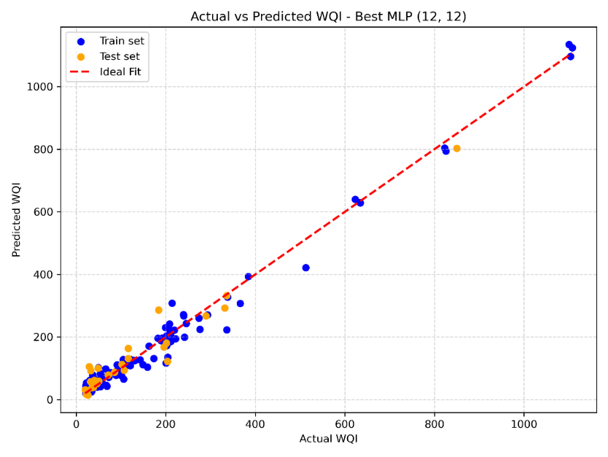
Figure 4: Actual vs Predicted WQI (MLP1) - Train & Test
Figure 5 shows the comparison of the observed and predicted Water Quality Index (WQI) values for the test dataset using the Multi-Layer Perceptron (MLP) model with a (12,12) configuration, which showed the best performance. The scatter plot shows a strong fit for low-to-moderate WQI values (below 200), with most predictions closely following the 1:1 reference line. However, at higher WQI levels, especially above 400, the model tends to underestimate the values. This highlights the difficulty in capturing extreme observations. This limitation likely stems from the low occurrence of high WQI values in the training data and the model's representational constraints (Ghoochani et al., 2023). Despite this limitation, the MLP model reliably predicts most WQI values, and additional targeted strategies may improve accuracy for extreme water quality conditions.
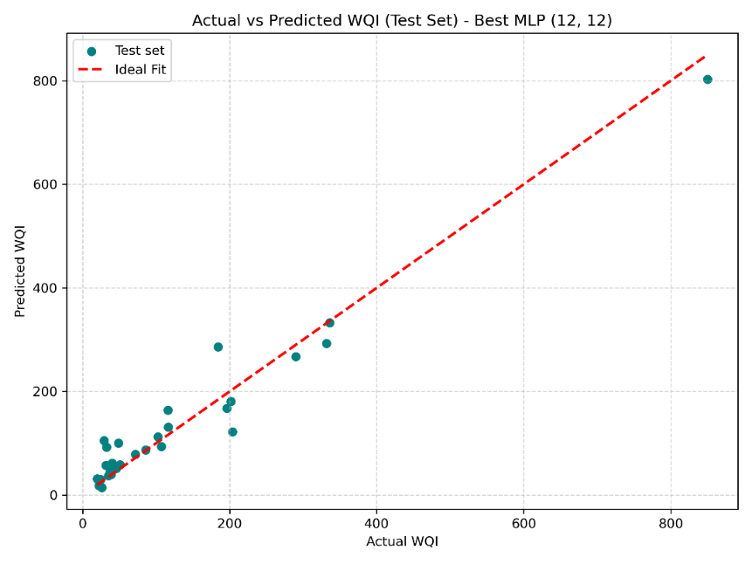
Figure 5: Actual vs Predicted WQI (MLP1) - Test Set Only

4. Conclusion
The assessment of surface water quality in the Nakambé Basin indicates generally favorable conditions. Water Quality Index (WQI) values ranged from 11 to 40, with most sites falling into the “Excellent” category according to World Health Organization (WHO) standards. Descriptive statistics show that the waters are slightly alkaline and low in salinity. However, turbidity and nutrient levels vary considerably across the basin, reflecting localized contamination and natural geochemical influences. Correlation analysis revealed significant relationships between nitrogen species, turbidity, and the contribution of geogenic minerals, such as carbonates and silicates. Salinity is primarily influenced by sodium and bicarbonate concentrations. Factor analysis corroborated these findings by identifying three principal factors that shape water quality: (i) natural mineral inputs from geological processes, (ii) increased nutrient and turbidity levels associated with human activities, and (iii) salinity and mineral dissolution resulting from a combination of natural and anthropogenic influences. The Multi-Layer Perceptron (MLP) model demonstrated strong predictive performance, achieving R² = 0.916 on the training dataset and R² = 0.810 on the test dataset. Scatter plots comparing observed and predicted WQI values show that the model effectively reproduces general trends, though a few deviations appear at extreme WQI levels. These findings highlight the advantages of using a combination of traditional water quality assessments, multivariate statistics, and machine learning approaches to understand spatial and compositional variations. These methods provide a scientific basis for water management and pollution mitigation. Future work could improve predictions and management strategies further by expanding monitoring, considering seasonal and hydrological changes, and including additional contaminants. In addition, Moreover, future research could explore the use of more advanced deep learning approaches. Coupling MLP models with geospatial decision-support tools could enable near real-time forecasting and help prioritize interventions, particularly in areas experiencing increased human pressure.

Disclaimer (artificial intelligence)

Author(s) hereby declare that NO generative AI technologies such as Large Language Models (ChatGPT, COPILOT, etc.) and text-to-image generators have been used during the writing or editing of this manuscript.

5. References

Abu, M., Musah, R., & Zango, M. S. (2024). A Combination of Multivariate Statistics and Machine Learning Techniques in Groundwater Characterization and Quality Forecasting. Geosystems and Geoenvironment, 3(1), 100261. https://doi.org/10.1016/j.geogeo.2024.100261
Aller L., Bennett T., Lehr J., Petty R.J., Hackett G. 1987. DRASTIC: A standardized system for evaluating ground water pollution potential using hydrogeologic settings. US Environ.
Andreini, M.; Giesen, N.; Edig, A.; Fosu, M.; Andah, W. (2000) : Volta basin water balance, ZEF Discussion Papers on Development Policy, No. 21, University of Bonn, Center for Development Research (ZEF), Bonn. https://www.econstor.eu/bitstream/10419/84715/1/zef_dp21.pdf
Barry, B., Obuobie, E., Andreini, M., Andah, W., & Pluquet, M. (2005). The Volta River Basin: Comprehensive assessment of water management in agriculture. IWMI.
Brown, R. M., McClelland, N. I., Deininger, R. A., & Tozer, R. G. (1970). A water quality index do we dare? Water & Sewage Works, 117(10), 339–343.
Cude, C. G. (2001). Oregon water quality index: a tool for evaluating water quality management effectiveness. Journal of the American Water Resources Association, 37(1), 125–137. https://doi.org/10.1111/j.1752-1688.2001.tb05480.x
Descroix, L., Mah´e, G., Lebel, T., Favreau, G., Galle, S., Gautier, E., Olivry, J., Albergel, J., Amogu, O., Cappelaere, B., et al., 2009. Spatio-temporal variability of hydrological regimes around the boundaries between Sahelian and Sudanian areas of West Africa: a synthesis. J. Hydrol. 375, 90–102. https://doi.org/10.1016/j. jhydrol.2008.12.012.
Elmotawakkil, A., Enneya, N., Bhagat, S. K., Ouda, M. M., & Kumar, V. (2025). Advanced machine learning models for robust prediction of water quality index and classification. Journal of Hydroinformatics, 27(2), 299-319. doi: 10.2166/hydro.2025.290
Engel, S., Iskandarani, M., & del Useche, M. (2005). Improved water supply in the Ghanaian Volta Basin: Who uses it and who participates in community decision-making? EPT Discussion Paper 129.
Faye, M. D., Kafando, M. B., Sawadogo, B., et al. (2022). Groundwater characteristics and quality in the Cascades region of Burkina Faso. Resources, 11(7), 61. https://doi.org/10.3390/resources11070061
Gaëtan, S. É. S., Zacharie, D. L., & Michelle, C. H. M. (2023). Contribution of end-member mixing analysis model to characterize the sources responsible for urban river water quality: Case of Houet River in Burkina Faso. American Journal of Water Resources, 11(1), 1–10. https://doi.org/10.12691/ajwr-11-1-1
Gampson, E.K., Nartey, V.K., Golow, A.A., & Akiti, T.T. (2014): Hydrochemical study of water collected at a section of the Lower Volta River (Akuse to Sogakope Area), Ghana. Applied Water Science 4(2): 129–143.
Gbohoui, Y. P., Paturel, J. E., Tazen, F., Mounirou, L. A., Yonaba, R., Karambiri, H., & Yacouba, H. (2021). Impacts of climate and environmental changes on water resources: A multi-scale study based on Nakanbé nested watersheds in West African Sahel. Journal of Hydrology: Regional Studies, 35, 100828.
Ghoochani, O., Alavi, M., & Shafiee, M. (2023). Challenges in neural network modeling: Underfitting, overfitting, and regularization strategies. Preprints, 2023081636. https://www.preprints.org/manuscript/202308.1636/v1
Goodfellow, I., Bengio, Y., & Courville, A. (2016). Deep Learning. MIT Press. https://www.deeplearningbook.org/
Hameed, M., Sharqi, S. S., Yaseen, Z. M., Afan, H. A., Hussain, A., & Elshafie, A. (2017).
Application of artificial intelligence (AI) techniques in water quality index prediction: A case study in tropical region, Malaysia. Neural Computing and Applications, 28(Suppl 1), 893–905.
https://doi.org/10.1007/s00521-016-2404-7
Haro, M., Guiguemde, I., Diendere, F., Bani, I., Kone, M., Soubeiga, M., ... & Bary, A. (2013). Effect of the Kossodo Industrial wastewater discharges on the physico-chemical quality of Massili River in Burkina Faso. Research Journal of Chemical Sciences, ISSN 2231-606X.
Haykin, S. (1994). Neural networks: a comprehensive foundation. Prentice hall PTR. ISBN: 0023527617. Published: 01 October 1994Pages: 768
Heaton, J. (2017). Ian Goodfellow, Yoshua Bengio, and Aaron Courville: Deep learning: The MIT Press, 2016, 800 pp, ISBN: 0262035618. Genetic Programming and Evolvable Machines, 19(1–2), 305–307. https://doi.org/10.1007/s10710-017-9314
Ibrahim, B., Polcher, J., Karambiri, H. et al. Characterization of the rainy season in Burkina Faso and it’s representation by regional climate models. Clim Dyn 39, 1287–1302 (2012). https://doi.org/10.1007/s00382-011-1276-x
Issoufou Ouedraogo, W. J. P. Sandwidi, Fatoumata Kabore, Mahamadou Konare and Cheick Abdramane Ouattara (2025). Predictive Modelling of Groundwater Quality in the Nakanbé River Basin Using Machine Learning Techniques. American Journal of Water Resources. 2025; 13(3):86-96. doi: 10.12691/ajwr-13-3-3
Iwuoha, G. and Osuji, L.C. (2012). Changes in Surface Water Physico-Chemical Parameters Following the Dredging of Otamiri and Nworie Rivers, Imo State of Nigeria. Research Journal of Chemical Science, 2, 7-11.
Kabore, I., Bance, V., Zangre, T.D. R., and Oueda, A. (2023). Influence of municipal discharges on the physico-chemical and biological quality of urban aquatic ecosystems: Case of the Massili River (Burkina Faso, West Africa), International Journal of Innovation and Applied Studies, vol. 40, no. 4, pp. 1281–1291.
Konaré, M., Adama, T., Wendpagnagda, C., Zoma, I. E., Boulama, O. Y., & Mamannan Hassan, A. (2024). Groundwater Quality Assessment and Modeling Using Water Quality Index and Mathematical Models: Case Study of Bam Province, Burkina Faso. International Journal of Environment and Climate Change, 14(12), 740–756. https://doi.org/10.9734/ijecc/2024/v14i124659
Loucks, D. P., & Van Beek, E. (2017). Water resource systems planning and management: An introduction to methods, models, and applications. Springer. http://library.oapen.org/handle/20.500.12657/27934
Mahamadou, Konare, Traore Adama, Combere Wendpagnagda, Zoma Isabelle Eulodie, Boulama Omar Yacine Lawan Ibrahim, and Abdourazakou Maman Hassan. 2024. “Groundwater Quality Assessment and Modeling Using Water Quality Index and Mathematical Models: Case Study of Bam Province, Burkina Faso”. International Journal of Environment and Climate Change 14 (12):740-56. https://doi.org/10.9734/ijecc/2024/v14i124659.
Mahe, G, Paturel, J.E., Servat, E., Conway, D., Dezetter, A. (2005). The impact of land use change on soil water holding capacity and river flow modelling in the Nakambe River, Burkina-Faso. J Hydrol 300(1–4):33–43. https://doi.org/10.1016/j.jhydrol.2004.04.028
Mahe, G. I. L. (2009). Surface/groundwater interactions in the Bani and Nakambe rivers, tributaries of the Niger and Volta basins, West Africa. Hydrological Sciences Journal, 54(4), 704–712. https://doi.org/10.1623/hysj.54.4.704
Maier, H. R., & Dandy, G. C. (2000). Neural networks for the prediction and forecasting of water resources variables: a review. Environmental Modelling & Software, 15(1), 101–124.
Maïga, Yaleu, S., Djibo Hahiou, A., & Guel, B. (2020). Assessment of Surface Water Contamination by Heavy Metals Due to Agricultural Practices in the Northern Part of Burkina Faso. International Research Journal of Pure and Applied Chemistry, 21(10), 85–98. https://doi.org/10.9734/irjpac/2020/v21i1030211
Millogo, C., Sagnon, B., Kafando, S., & Nakolendoussé, S. (2024). Hydrochemical Assessment of Groundwater Quality in the City of Manga and the Surrounding Area, Burkina Faso, West Africa. AMERICAN JOURNAL OF WATER RESOURCES. Science and Education Publishing Co., Ltd., 12(4), 139-148. DOI:10.12691/ajwr-12-4-4
Naik, S. and Purohit, K. (1996). Physico-Chemical Analysis of Some Community Ponds of Rourkela. Indian Journal of Environmental Protection, 16, 679-684.
Nair, V., & Hinton, G. E. (2010). Rectified linear units improve restricted Boltzmann machines. In Proceedings of the 27th International Conference on Machine Learning (ICML-10) (pp. 807–814). https://www.cs.toronto.edu/~fritz/absps/reluICML.pdf
Najah, A., El-Shafie, A., Karim, O. A., & El-Shafie, A. H. (2013). Application of artificial neural networks for water quality prediction. Neural Computing and Applications, 22(Suppl 1), 187-201.
Ofori, B. (2012): Effects of marketing and trading activities on the Volta Lake shore environment in Ghana, Environment Development and Sustainability 14(5): 783–806.
Ouedraogo, I., Lankoande, S., Konate, Y., Sawadogo, B., Kagambega, N., & Lompo, M. (2024). Assessing the impact of gold mining on the quality of water resources in the Commune of Meguet, Burkina Faso. Journal of Water Resource and Protection, 16(4), 281-292.
Patro, S. G. K., & Sahu, K. K. (2015). Normalization: A Preprocessing Stage. arXiv preprint arXiv:1503.06462. https://doi.org/10.48550/arXiv.1503.06462
Programme GIRE Burkina Faso, (2001): L’impact des engrais et des pesticides sur les ressources en eau au Burkina Faso, 46pp
Ramesh, K., Elango L. (2012). Groundwater quality and its suitability for domestic and agricultural use in Tondiar river basin, Tamil Nadu, India. Environmental Monitoring and Assessment, 184(6), 3887–3. https://doi.org/10.1007/s10661-011-2231-3
Rodgers, C., van de Giesen, N., Laube, W., Vlek, P. L. G., & Youkhana, E. (2007). The GLOWA Volta Project: A framework for water resources decision-making and scientific capacity building in a transnational West African basin. Water Resource Management, 21, 295–313.
Samah, O.H. (2012): Microbiological and Physico-Chemical Assessment of Surface Water Quality along Asukawkaw River in the Volta Region, Master of Science Thesis, Kwame Nkrumah University of Science and Technology, Kumasi.
Setshedi, K. J., Mutingwende, N., & Ngqwala, N. P. (2021). The use of artificial neural networks to predict the physicochemical characteristics of water quality in three district municipalities, Eastern Cape Province, South Africa. International Journal of Environmental Research and Public Health, 18(10), 5248. https://doi.org/10.3390/ijerph18105248
Shrestha, S., & Kazama, F. (2007). Assessment of surface water quality using multivariate statistical techniques: A case study of the Fuji river basin, Japan. Environmental Modelling & Software, 22(4), 464–475. https://doi.org/10.1016/j.envsoft.2006.02.001
Simeonov, V., Stratis, J. A., Samara, C., Zachariadis, G., Voutsa, D., Anthemidis, A., … Kouimtzis, T. (2003). Assessment of the surface water quality in Northern Greece. Water Research, 37(17), 4119–4124. https://doi.org/10.1016/S0043-1354(03)00398-1
Sinha, S.K. (1995). Potability of Some Rural Ponds Water at Muzaffarpur (Bihar)—A Note on Water Quality Index. Journal of Pollution Research, 14, 135-140
Tano, A.R., Bouo, F.-X.D.B., Kouamé, J.K., Tchétché, Y., Zézé, S.D. and Ouattara, B. (2023) Rainfall Variability and Trends in West Africa. Atmospheric and Climate Sciences, 13, 72-83. doi: 10.4236/acs.2023.131006.
Tian, Y., Zhao, Y., Son, S., Luo, J., Oh, S. & Wang, Y. (2023) A deep-learning ensemble method to detect atmospheric rivers and its application to projected changes in precipitation regime, Journal of Geophysical Research: Atmospheres, 128(12). https://doi.org/10. 1029/2022JD037041.
U.S. Environmental Protection Agency. (2023). National Primary Drinking Water Regulations. https://www.epa.gov/ground-water-and-drinking-water/national-primary-drinking-water-regulations
UNEP (2016). A Snapshot of the World’s Water Quality: Towards a global assessment. United Nations Environment Programme, Nairobi, Kenya. 162 pp.
UNEP-GEF Volta Project (2013). Volta Basin transboundary diagnostic analysis. UNEP/GEF/Volta/RR 4/2013. Accra, Ghana: United Nations Environment Programme (UNEP).
Varol, M., Gökot, B., Bekleyen, A., & Şen, B. (2012). Water quality assessment and apportionment of pollution sources of Tigris River (Turkey) using multivariate statistical techniques—A case study. River Research and Applications, 28(9), 1428–1438. https://doi.org/10.1002/rra.1533.
Water Quality Overview – Burkina Faso. (2023). Water Action Hub. Retrieved from https://wateractionhub.org/geos/country/35/d/burkina-faso. (accessd online 19th September , 2025)
WHO (2017). Guidelines for drinking-water quality: fourth edition incorporating the first addendum. Geneva: World Health Organization; 2017. Licence: CC BY-NC-SA 3.0 IGO.
Yaméogo, J., Rouamba, S., Koala, S., & Zongo, R. (2025). Trends and temporal variability of rainfall-induced erosion in the Nakambè watershed, Burkina Faso. Journal of Atmospheric Science Research, 8(2), 65–85. https://doi.org/10.30564/jasr.v8i2.10301
Yangouliba, G. I., Zoungrana, B. J. B., Hackman, K. O., Koch, H., Liersch, S., Sintondji, L. O., ... & Koffi, B. (2023). Modelling past and future land use and land cover dynamics in the Nakambe River Basin, West Africa. Modeling Earth Systems and Environment, 9(2), 1651-1667.

