Original Research Article
Morpho-physiological Recital of [Glycine Max (L.) Merrill] Genotypes in Veneration to Drought

Abstract
Glycine max L. is a key oilseed crop of global significance, providing a vivacious source of edible oil and high-quality protein for both human consumption and livestock feed. However, its productivity is severely constrained by drought stress, particularly in rainfed agro-ecosystems, leading to significant yield reductions. The present investigation was conducted to identify putative drought-tolerant soybean genotype (s) based on a comprehensive evaluation of different morpho-physiological traits. A total of 53 soybean genotypes were assessed under drought stress conditions. The morpho-physiological analysis revealed presence of substantial genetic variability among the genotypes for the traits associated with drought tolerance. Drought stress adversely affected plant growth and metabolic activities, indicating the sensitivity of soybean to water deficit at different phenological stages. However, certain genotypes demonstrated adaptive responses enabling better performance under stress. Based on overall tolerance indices and trait performance, four genotypes including JS 97-52, AMS 2014-1, RVS-14 and NRC-147 were identified as putative drought tolerant. These genotypes exhibited superior morpho-physiological resilience and thus hold promise for utilization in breeding programmes aimed to breed drought-resilient soybean cultivars.
Keywords: Climate change, Diversity, Drought, Morpho-physiological traits, Soybean.
Introduction
Drought represents one of the most severe abiotic constraints, negatively influencing plant growth, metabolic processes and productivity throughout the entire life cycle (Asati et al., 2022; Asati et al., 2024). Among leguminous crops, soybean (Glycine max L.) exhibits a comparatively higher susceptibility to drought and other abiotic stresses (Mishra et al., 2021a; Mishra et al., 2021b; Mishra et al., 2024a; Jhariya et al., 2025a) than crops such as cowpea (Vigna unguiculata) and common bean (Kachare et al., 2019; Mishra et al., 2021c; Mishra et al., 2024b; Gautam et al., 2025a), as well as other major crops including sorghum, cotton and chickpea (Sahu et al., 2020; Gupta et al., 2021; Asati et al., 2023; Jhariya et al., 2025b; Mishra et al., 2024c). Globally, soybean is recognized as a vital oilseed crop, contributing significantly to edible oil supply and serving as a major source of high-quality protein for food and feed industries (Mishra et al., 2020; Mishra et al., 2025a; Jhariya et al., 2025c; Gautam et al., 2025b; Mishra et al., 2025b). However, its productivity is highly vulnerable to moisture deficit conditions, particularly during critical phenological stages such as pod filling, when drought can cause yield reductions of up to 40% annually and lead to a decline in seed quality parameters (Mishra et al., 2021d; Sharma et al., 2021; Mishra et al., 2025c; Jhariya et al., 2025d; Gautam et al., 2025c). Water scarcity not only limits soil moisture availability but also hampers nutrient uptake, leading to impaired physiological functions and reduced biomass accumulation (Moradi et al., 2015; Mishra et al., 2021d; Mishra et al., 2021e; Sistu et al., 2023; Tiwari et al., 2023a). The severity of drought-induced production losses is expected to escalate due to increasing global population pressure and growing competition for freshwater resources between agricultural, domestic and industrial sectors (Sharma et al., 2021; Yadav et al., 2022; Tiwari et al., 2023b; Mishra et al., 2025d; Jhariya et al., 2025e). Given the economic importance of soybean and its role in livelihood security for millions of smallholder farmers, the development and deployment of drought-tolerant cultivars remain a strategic priority to ensure sustainable productivity and stability of soybean-based agro-ecosystems (Upadhyay et al., 2020a; Upadhyay et al., 2020b; Tripathi et al., 2022; Tripathi et al., 2023; Gautam et al., 2025d).
Drought tolerance is a complex quantitative trait governed by the coordinated action of diverse genetic, morphological, physiological, biochemical, and molecular processes (Sharma et al., 2023a; Tiwari et al., 2023c; Yadav et al., 2023; Yadav et al., 2024a). The degree of tolerance to water deficit not only differs across plant species but also exhibits considerable variation among genotypes within the same species (Sepanlo et al., 2014; Zia et al., 2021; Haghpanah et al., 2024; Yadav et al., 2024b). Under drought conditions, plants activate a series of adaptive responses that encompass alterations in stomatal behaviour, gas exchange efficiency, cellular osmotic adjustment, metabolic reprogramming, antioxidant defence, enzyme activities, and the expression of stress-responsive regulatory genes (Mishra et al., 2021e; Tiwari et al., 2023b; Asati et al., 2024). These adaptive mechanisms collectively contribute to maintaining cellular homeostasis and sustaining growth under limited moisture availability. For soybean improvement programmes, the identification and utilization of morpho-physiological traits associated with drought resilience are essential to formulate efficient selection strategies and accelerate the development of drought-tolerant cultivars (Kachare et al., 2019; Mishra et al., 2022; Sharma et al., 2023b).

Drought adaptation in crops is predominantly governed by key traits such as root and shoot length, root-to-shoot biomass ratio, vigor index, relative water content, turgor maintenance, and stomatal conductance, which collectively determine a plant’s capacity to sustain growth and yield under water-limited conditions (Hossain et al., 2015; Kachare et al., 2019; Sahu et al., 2020; Shoaib et al., 2022; El-Saadony et al., 2024). Under drought stress, plants often activate specialized physiological and morphological strategies to enhance survival and maintain metabolic function. Although soybean is extensively cultivated across varied agro-climatic regions, comprehensive information on the organ-specific morphological and physiological responses to water deficit is still limited (Rasheed et al., 2022; Mishra et al., 2024d; Mishra et al., 2024e; Sharma et al., 2025). Consequently, the present study was undertaken to assess the effects of drought on multiple morpho-physiological traits of soybean genotypes, generating critical insights for breeding programmes aimed to develop drought-resilient cultivar (s).
2. Material & Methods
2.1 Experimental site
The field investigation was carried out during the Kharif 2018-19 at the Research Farm, Department of Genetics & Plant Breeding, College of Agriculture, Rajmata Vijayaraje Scindia Agricultural University, Gwalior, Madhya Pradesh, India. The experimental site is located at 22°43′ N latitude and 76°54′ E longitude, with an elevation of 618 m above mean sea level. The region lies within the hot arid agro-climatic zone and exhibits a semi-arid climate with pronounced seasonal fluctuations in temperature. Summer temperatures, particularly in June, may reach up to 48°C, while winter temperatures can decline to approximately 4°C, with an overall annual temperature range of 2°C to 50°C. The area receives an average annual rainfall of 750-800 mm, predominantly concentrated during the southwest monsoon from late June to September, though sporadic light precipitation occurs during winter. The climatic conditions of the site are characteristic of rainfed soybean-producing regions of central India, making it suitable for the assessment of drought tolerance and related physiological and agronomic traits.
2.2 Experimental details
The present investigation was carried out employing a total of 60 soybean genotypes exhibiting varying levels of drought tolerance, ranging from susceptible to highly tolerant types (Table 1). The experimental material was obtained from three sources: Department of Genetics and Plant Breeding, College of Agriculture, Jawaharlal Nehru Krishi Vishwa Vidyalaya (JNKVV), Jabalpur; RAK College of Agriculture, Sehore and ICAR-National Institute of Soybean Research (NISR), Indore, Madhya Pradesh, India. The field experiment was conducted during the Kharif 2018 under field conditions and was laid out in a Randomized Block Design (RBD) with two replications. Each genotype was sown in three rows of 3 m length, maintaining a row-to-row distance of 30 cm and a plant spacing of 10 cm within rows. The crop was sown on 27 July 2018, and a recommended dose of fertilizers (20:60:20:20 kg ha⁻¹ N:P₂O₅: K₂O:S) was applied as a basal application during seedbed preparation to ensure adequate nutrient supply. To impose drought stress effectively, no irrigation was provided during the crop growth period, and natural rainfall was absent between the 60th and 70th days after sowing, coinciding with the mid-reproductive stage. This period of water deficit created a controlled drought stress environment suitable for screening genotypes for physiological and agronomic responses to moisture stress. All other standard agronomical practices were performed uniformly to raise and maintain a healthy crop stand.
Table 1 List of soybean genotypes with their source/parentage
S. No. | Genotypes | Source/parentage | S. No. | Genotypes | Source/parentage
 | RVS2011-76 | RVSKVV, Gwalior | 31. | Bragg | USA
 | RVS2011-35 | RVSKVV, Gwalior | 32. | Hardee | USA
 | RVS 28 | RVSKVV, Gwalior | 33. | Gaurav | JNKVV, Jabalpur
 | RVS2011-10 | RVSKVV, Gwalior | 34. | DS3106 | Delhi
 | RVS2012-15 | RVSKVV, Gwalior | 35. | DS3105 | Delhi
 | RVS2011-77 | RVSKVV, Gwalior | 36. | JSM240*SL517 | JNKVV, Jabalpur
 | RVS2011-73 | RVSKVV, Gwalior | 37. | HIMSO-16 | JNKVV, Jabalpur
 | RVS2011-74 | RVSKVV, Gwalior | 38. | PS1225 | GBPUA&T, Pantnagar
 | RVS2011-21 | RVSKVV, Gwalior | 39. | CAT87 | JNKVV, Jabalpur
 | RVS2012-01 | RVSKVV, Gwalior | 40. | RSC1052 | Raipur
 | RVS2011-32 | RVSKVV, Gwalior | 41. | BAUS102 | Ranchi
 | RVS2011-04 | RVSKVV, Gwalior | 42. | PK885 | GBPUA&T, Pantnagar
 | RVS2011-75 | RVSKVV, Gwalior | 43. | Shivalika | JNKVV, Jabalpur
 | NRC136 | NRCS, Indore | 44. | AUKS-174 | JNKVV, Jabalpur
 | NRC37 | NRCS, Indore | 45. | SP-37 | Not known selection
 | NRC7 | NRCS, Indore | 46. | JS335 | JNKVV, Jabalpur
 | SL688 | PAU, Ludhiana | 47. | AMS475 | PDKV, Akola
 | SL958 | PAU, Ludhiana | 48. | AMS243 | PDKV, Akola
 | SL96 | PAU, Ludhiana | 49. | AMS-MB5-18 | PDKV, Akola
 | SL953 | PAU, Ludhiana | 50. | JS2009*PS1475 | JNKVV, Jabalpur
 | SL983 | PAU, Ludhiana | 51. | JS2063*JS9560 | JNKVV, Jabalpur
 | SL995 | PAU, Ludhiana | 52. | JS2053*JS2034 | JNKVV, Jabalpur
 | SL525 | PAU, Ludhiana | 53. | JS20-90 | JNKVV, Jabalpur
 | SL1074 | PAU, Ludhiana | 54. | JS97-52 | JNKVV, Jabalpur
 | EC602288 | Exotic collection | 55. | JS21-17 | JNKVV, Jabalpur
 | EC538828 | Exotic collection | 56. | JS20-78 | JNKVV, Jabalpur
 | EC46728 | Exotic collection | 57. | JS93-05 | JNKVV, Jabalpur
 | Young | JNKVV, Jabalpur | 58. | AMS100-39 | PDKV, Akola
 | C-2797 | JNKVV, Jabalpur | 59. | RVS2001-04 | RVSKVV, Gwalior
 | PK472 | GBPUA&T, Pantnagar | 60. | JS16-11 | JNKVV, Jabalpur

2.3 Statistical analysis
Observations were recorded at 70 days after sowing (DAS) from five randomly selected plants from each row of every genotype and replication to assess various morpho-physiological traits. Data were collected on root morphology, plant height, root and shoot length, root-to-shoot ratio, canopy temperature, fresh weight (FW), dry weight (DW), turgid weight (TW), relative water content (RWC), and saturation water deficit (SWD). The procedures for measuring these traits were followed the standard methodologies as described by Kachare (2017). The data were analyzed as per method recommended by Snedecor and Cochran (1997). The similarity matrices were used to construct a dendrogram for all the genotype for each trait employing NTSYS-pc V 2.0 (Rohlf’s et al., 2000) based on Unweighted Pair Group Method with Arithmetic Mean UPGMA.
3. Results & Discussion
The analysis of variance (Table 2) revealed highly significant differences among the 60 soybean genotypes for all evaluated morpho-physiological traits, indicating the presence of substantial genetic variability within the experimental material. Plant height exhibited considerable variation, ranging from 60.54 cm to 127.08 cm, with an overall mean of 86.62 cm. The tallest genotype was Gaurav (127.08 cm), closely followed by RVS2011-04 (121.36 cm) and Hardee (119.60 cm), demonstrating superior vegetative growth under the given conditions. In contrast, genotype viz., JS 16-11 recorded the minimum plant height (60.54 cm). Genotypes JS 21-17 (62.94 cm) and HIMSO-16 (63.16 cm) were also grouped among the dwarf genotypes, indicating inherent genetic differences influencing plant stature among the soybean lines studied.
A well-developed root system with greater root length enhances the plant’s capacity to extract water from deeper soil layers, making rapid and early root elongation a key indicator of drought tolerance (Kalra et al., 2024; Voothuluru et al., 2024). In the present study, significant genotypic variation was observed for root length among the genotypes evaluated. Root length ranged between 16.5 cm to 36.0 cm, with a mean value of 23.49 cm (Fig. 1). The longest root system was recorded for the genotype SL-525 (36.0 cm) followed by Hardee (34.1cm) and Shivalika and PS 1225 (32.0 cm each), indicating their strong potential for drought avoidance through enhanced water uptake. Conversely, the shortest root length (16.5 cm) was observed for the genotypes RVS 2011-74 and RVS 2011-32 tracked by HIMSO-16, RSC 10-52 and JS 20-78 (17.5 cm), suggesting limited adaptability under moisture-deficit circumstances. The preeminence of certain genotypes with respect to root elongation advised that deeper rooting may assist as a vivacious adaptive mechanism to uphold water balance under drought stress. Enhanced root growth improves access to subsoil moisture, thereby improving plant survival and physiological functioning during water scarcity (Kou et al., 2022; Zhang et al., 2025). These findings are consistent with earlier studies conducted by Kachare (2017), Hanum and Meiriani (2020), Bukan et al. (2024), Kodadinne Narayana et al. (2024) and Wang et al. (2024), who also investigated a positive association between increased root length and drought tolerance in soybean.
Shoot length among the evaluated soybean genotypes exhibited considerable variability, ranging from 42.94 cm to 98.64 cm with a mean value of 63.13 cm (Table 2). The highest shoot length was observed in genotype Gaurav (98.64 cm) closely followed by RVS 2011-73 (98.20 cm) and RVS 2011-04 (97.43 cm). In contrast, the shortest shoot length (42.94 cm) was recorded in genotype RVS 2001-04 followed by AMS 100-39 (44.33 cm) and JS 16-11 (44.37 cm), reflecting their reduced vegetative growth under limited moisture availability. Drought stress is known to restrict shoot elongation while promoting root extension as a survival strategy (Seleiman et al., 2021; Zia et al., 2021). In the present investigation, a strong negative association was evident between shoot length and drought intensity, suggesting that enhanced root proliferation under stress conditions occurred at the expense of shoot growth (Mishra et al., 2021b). Similar trends have also been reported by Fuganti-Pagliarini et al. (2017), Mangena (2018), Bukan et al. (2024) and Sharmin et al. (2024), who also observed significantly greater shoot length under well-watered conditions compared to drought-imposed environments in soybean. This reduction in shoot growth under stress may be attributed to disrupted physiological processes and osmotic imbalance, which constrain cellular expansion and biomass accumulation (Kapoor et al., 2020; Alharbi et al., 2023; Khatri & Rathore, 2024).
The root-to-shoot (R/S) ratio is a key physiological indicator for identifying drought-tolerant soybean genotypes, as it reflects the balance between below-ground and above-ground biomass allocation. Previous studies have established that genotypes capable of maintaining a higher or balanced R/S ratio under water-limited conditions are generally better adapted to drought stress (Yan et al., 2020; Sanushi et al., 2025; Abdullah et al., 2025). In the current investigation, the R/S ratio speckled substantially among the 60 soybean genotypes, arraying from 0.117 to 0.778. The highest R/S ratio was recorded in genotype NRC127 (0.7777) followed by genotypes JS 97-52 (0.6416), NRCSL-1 (0.6273) and NRC 132 (0.6130), signifying their superior allocation of assimilates to root development under stress conditions. Conversely, the lowest R/S ratio was observed in genotype AMS 100-39 (0.1174) along with MACS 1520 (0.1594) and RSC 10-52 (0.1461), suggesting a comparatively weaker root system development under drought. These findings suggested that genotypes with a higher R/S ratio demonstrate better drought adaptation as they invest more biomass in root proliferation to enhance water uptake (Mishra et al., 2024a). Similar observations were also reported by Gargallo-Garriga et al. (2014), Dong et al. (2019), Nur’aini and Diah (2022) and Kodadinne Narayana et al. (2024), who also noted that drought stress tends to increase the R/S ratio due to a greater reduction in shoot growth relative to root growth. The altered biomass distribution under stress conditions is primarily due to osmotic adjustments that disturb the physiological equilibrium, promoting deeper root growth for water acquisition while limiting shoot elongation to reduce transpirational water loss.
On the basis of cluster analysis of morpho-physiological traits including plant height, shoot and root length and root/shoot ratio dendrogram, soybean genotypes outlined two clusters (Fig. 2). Major cluster consisted 50 genotypes while minor cluster had only 10 genotypes including RVS 2011-21, EC-46728, RVS 2011-32, NRC-136, BRAGG, CAT 87, Hardee, RVS 2011-73, RVS 2011-04 and Gaurav. The major cluster further divided into two groups. Major sub group consisted 36 genotypes, however minor sub group had 14 genotypes, namely RVS 2011-74, JSM 240 * SL 517, RSC 10-52, SL 958, DS 3106, RVS 28, RVS 2012-01, BAUS 102, NRC 37, SP 37, RVS 2011-75, DS 3105, AUKS-174 and Young. While the major sub group consisted 36 genotypes including NRC 7, SL 953, RVS 2011-35, RVS 2011-10, PK 885, SL 968, C-2797, JS2009*PS1475, SL983, EC 602288, EC538828, RVS2012-76, SL 96, AMS-MB 5-18, AMS 475, JS 93-05, RVS 2012-15, JS 2053*JS20-34, JS2063*JS95-60, JS 20-78, SL 995, SL 525, RVS 2011-77, PK 472, JS 97-52, AMS 243, PS 1225, Shivalika, SL 1074, JS 335, AMS 100-39, HIMSO-16, JS 21-17, JS 16-11, JS 20-90 and RVS 2001-04.

Lepekhov et al. (2022), Bernacchi et al. (2023) and Yu et al. (2025) reported that canopy temperature assessment using infrared thermometry is a reliable approach for evaluating plant water status, particularly under semi-arid and arid environments. In soybean, the optimal canopy temperature for maximum photosynthetic efficiency is approximately 27 °C, corresponding to the temperature range that supports peak activity of photosynthetic enzymes (Thenveettil et al., 2024; Ding et al., 2024). In the present investigation, canopy temperature among the soybean genotypes demonstrated noticeable variation, ranging from 32.3°C to 36.0 °C under drought stress conditions. The highest canopy temperature was recorded in genotype RVS 2011-35 (36.0 °C), closely followed by genotypes RVS-24 (35.4 °C), RVS 2007-6 (35.25 °C), JS 97-52 (35.15 °C) and RVS 2001-4 (35.10 °C). In contrast, the lowest canopy temperature (32.30 °C) was observed for the genotype SL-1068, indicating its relatively superior capacity for transpirational cooling and better physiological regulation under moisture-deficit conditions. These differences in canopy temperature reflect varying drought adaptive responses among the genotypes, making canopy temperature a useful selection criterion for screening drought tolerance in soybean.
Water saturation deficit, relative water content (RWC), and leaf water loss are key physiological indicators that regulate plant water balance and are widely employed to assess drought tolerance in crop species (Soltys-Kalina et al., 2016; Haghpanah et al., 2024). In the present investigation, remarkable variation was evident among soybean genotypes for biomass-related traits under drought stress. Fresh weight ranged from 29.30 g to 194.66 g, with NRC-86 exhibiting the highest fresh weight (194.66 g) tracked by AMS100-39 (152.50 g) and NRC-131 (147.50 g). Whereas the lowest fresh weight was recorded for the genotype AMSMBC-18 (29.30 g). Similarly, turgid weight varied between 34.15 g and 229.00 g, with NRC-86 (229.00 g) again outperforming other genotypes, followed by NRC-131 (177.02 g), AMS 100-39 (165.50 g), RVS 2001-4 (154.15 g) and AGS111 (151.16 g). While the minimum turgid weight was recorded for the genotype AMSMBC-18 (34.15 g). Dry weight arrayed between 24.30 g to 178.00 g, with NRC-86 registering the highest dry biomass (178.00 g) followed by NRC-131 (134.16 g) and AMS 100-39 (130.33 g). In contrast, the lowest dry weight was observed in genotype NRC-2 (24.30 g) tracked by AMSMBC-18 (26.50 g) and MACS-58 (27.07 g). The reduction in biomass parameters under drought stress suggests a negative impact on plant growth and metabolic activity. Water deficit leads to stomatal closure, restricting CO₂ entry into leaves, which reduces photosynthetic efficiency and subsequently limits dry matter accumulation (Wijewardana et al., 2019; Xu et al., 2023; Zhou et al., 2024). In addition to suppression of cell division and expansion, drought imposes constraints on various cellular processes, resulting in significant reductions in biomass and yield. These findings are consistent with earlier reports of Bárzana and Carvajal (2020) and Tenorio Berrío et al. (2022). Osmotic stress has also been shown to substantially reduce fresh weight in soybean, as observed in previous studies conducted by Sarkar et al. (2016), Pane et al. (2020) and Hossain et al. (2024), which corroborates the results of the present investigation.
Relative water content (RWC) is widely recognized as a key physiological indicator for assessing plant water status and drought tolerance. It reflects the balance between water supply to plant tissues and transpiration demand. Under drought stress, cellular dehydration leads to a marked reduction in RWC, making it one of the most reliable parameters for evaluating plant sensitivity or tolerance to water deficit (Abbasi et al., 2014; Kardile et al., 2018; Amoah & Soe, 2021). In the present study, substantial variation was observed among soybean genotypes for RWC under drought conditions. The highest RWC was recorded in genotype JS 97-52 (68.72%) closely followed by AMS 2014-1 (65.86%), PS 1613 (64.88%), NRC-147 (64.77%) and RVS-24 (64.08%). Additionally, eight genotypes included JS 93-05 (61.99%), JS 95-60 (63.04%), AMS 100-39 (63.01%), KDS 980 (60.96%), RSC 10-70 (60.31%), RSC 10-52 (60.24%), MACS-58 (60.16%) and JS 20-94 (60.38%) also maintained RWC values above 60%, indicating their better capacity to maintain tissue hydration under moisture deficit circumstances. Conversely, the lowest RWC was observed in genotype PS 1092 (17.06%) tracked by JS 20-34 (19.47%), JS 20-71 (21.27%) and RVS 2001-4 (22.74%), indicating a higher degree of susceptibility to drought-induced dehydration. Overall, drought-tolerant genotypes maintained relatively higher RWC, suggesting their superior osmotic adjustment and water retention capacity. In contrast, susceptible genotypes exhibited a sharp decline in RWC due to reduced external water potential and impaired cellular hydration. The significant genotypic differences in RWC observed in this study indicated differential adaptive strategies among soybean genotypes to cope with drought stress. These findings are consistent with earlier reports by Chowdhury et al. (2018), Coutinho et al. (2021), Ashwin et al. (2023), de Paula et al. (2024) and Alzahrani (2024), who also reported genotypic variability for RWC as a reliable selection criterion in drought tolerance screening programmes.

Table 2: Mean performance of different drought parameters of soybean genotypes

S.No. | Genotypes | Root types and morphology | Plant  Height in cm | Shoot  Length in cm | Root  Length in cm | Root /shoot  ratio | Canopy Temperature  in °C | Fresh  Weight (g) | Dry  Weight (g) | Turgid  Weight  (g) | RWC% | SWD%
1. | RVS 2011-76 | Highly branched tap root and lateral root | 82.72 | 62.46 | 20.5 | 0.33 | 30.56 | 127.95 | 79.2 | 119.4 | 56.07 | 43.93
2. | RVS 2011-35 | Highly branched tap root and lateral root | 82.48 | 59.14 | 23.5 | 0.40 | 30.06 | 111 | 65.5 | 103.7 | 46.27 | 53.73
3. | RVS 28 | Highly branched tap root and lateral root | 86.06 | 68.43 | 20 | 0.29 | 30.58 | 96.5 | 68.45 | 111.6 | 51.89 | 48.11
4. | RVS 2011-10 | Highly branched tap root and lateral root | 80.4 | 57.8 | 24.5 | 0.42 | 29.92 | 128.4 | 96.45 | 148.3 | 56.03 | 43.97
5. | RVS 2012-15 | Branched tap root and lateral root | 71.98 | 55.89 | 18 | 0.32 | 31.3 | 132.85 | 85.6 | 129.8 | 62.02 | 37.98
6. | RVS 2011-77 | Branched tap root and lateral root | 81.48 | 52.84 | 30 | 0.57 | 31.16 | 108.45 | 59.5 | 102.4 | 59.96 | 40.04
7. | RVS2011-73 | Branched tap root and lateral root | 114.8 | 98.2 | 18.5 | 0.19 | 29.89 | 139.95 | 88.1 | 125 | 60.68 | 39.32
8. | RVS 2011-74 | Branched tap root and lateral root | 89.44 | 74.52 | 16.5 | 0.22 | 30.25 | 89.15 | 52.25 | 98.8 | 61.91 | 38.09
9. | RVS 2011-21 | Branched tap root and lateral root | 109.72 | 89.91 | 20 | 0.22 | 30.18 | 71.7 | 45.5 | 62.7 | 52.95 | 47.05
10. | RVS 2012-01 | Highly branched tap root and lateral root | 86.26 | 67.78 | 20.5 | 0.30 | 30.75 | 94.8 | 60.9 | 97 | 60.33 | 39.67
11. | RVS 2011-32 | Highly branched tap root and lateral root | 102.08 | 86.79 | 16.5 | 0.19 | 30.71 | 78.4 | 55.7 | 79.2 | 45.35 | 54.65
12. | RVS 2011-04 | Branched tap root and lateral root | 121.36 | 97.43 | 24 | 0.25 | 30.00 | 90 | 52.9 | 86.4 | 60.18 | 39.82
13. | RVS 2011-75 | Highly branched tap root and lateral root | 95.56 | 73.63 | 22.75 | 0.31 | 30.53 | 85.05 | 64.2 | 93.4 | 50.97 | 49.03
14. | NRC 136 | Highly branched tap root and lateral root | 104.7 | 81.95 | 21 | 0.26 | 30.58 | 87.7 | 48.3 | 83.5 | 51.10 | 48.90
15. | NRC 37 | Branched tap root and lateral root | 92.28 | 67.54 | 24.5 | 0.36 | 31.62 | 114.35 | 74.05 | 134.4 | 53.97 | 46.03
16. | NRC 7 | Highly branched tap root and lateral root | 79.93 | 53.82 | 25.85 | 0.48 | 32.11 | 87.4 | 64.3 | 93.7 | 58.68 | 41.32
17. | SL 688 | Highly branched tap root and lateral root | 77.26 | 58.93 | 20 | 0.34 | 33.13 | 96.1 | 72.75 | 104.9 | 55.95 | 44.05
18. | SL 958 | Branched tap root and lateral root | 90.02 | 70.06 | 22.5 | 0.32 | 31.93 | 88.5 | 52.9 | 103.1 | 55.55 | 44.45
19. | SL 96 | Highly branched tap root and lateral root | 78.88 | 50.04 | 28 | 0.56 | 32.05 | 79.2 | 58 | 104.6 | 48.99 | 51.01
20. | SL 953 | Highly branched tap root and lateral root | 79.96 | 54.93 | 24.8 | 0.45 | 31.15 | 86.8 | 55.4 | 102.4 | 63.68 | 36.32
21. | SL 983 | Highly branched tap root and lateral root | 74.58 | 57.69 | 18.4 | 0.32 | 31.95 | 95.9 | 72.1 | 108.4 | 60.20 | 39.80
22. | SL 995 | Highly branched tap root and lateral root | 68.66 | 50.43 | 20 | 0.40 | 31.96 | 97.28 | 61.45 | 112.2 | 62.36 | 37.64
23. | SL 525 | Branched tap root and lateral root | 95.9 | 59.05 | 36 | 0.61 | 30.94 | 122.5 | 69 | 123.4 | 61.39 | 38.61
24. | SL 1074 | Branched tap root and lateral root | 66.56 | 46.68 | 22.2 | 0.48 | 30.10 | 95 | 65.5 | 102.5 | 54.76 | 45.24
25. | EC 602288 | Branched tap root and lateral root | 81.13 | 62.47 | 23.35 | 0.38 | 31.82 | 78.6 | 52.6 | 97 | 60.24 | 39.76
26. | EC 538828 | Branched tap root and lateral root | 78.52 | 64.11 | 22.35 | 0.36 | 33.28 | 92.1 | 64.65 | 95.6 | 62.25 | 37.75
27. | EC 46728 | Branched tap root and lateral root | 109.68 | 84.69 | 26.45 | 0.31 | 31.7 | 53.8 | 23.9 | 47.1 | 59.04 | 40.96
28. | YOUNG | Branched tap root and lateral root | 97.5 | 71.7 | 30.35 | 0.42 | 32.78 | 124.6 | 64.8 | 129.7 | 61.19 | 38.81
29. | C-2797 | Branched tap root and lateral root | 76.54 | 57.87 | 21.3 | 0.37 | 32.85 | 152.2 | 84.25 | 190.2 | 61.26 | 38.74
30. | PK 472 | Highly branched tap root and lateral root | 85.24 | 55.97 | 28.85 | 0.52 | 32.17 | 151.2 | 97.6 | 157.4 | 62.37 | 37.63
31. | BRAGG | Highly branched tap root and lateral root | 106.83 | 76.315 | 31.7 | 0.42 | 31.68 | 117.1 | 88.6 | 120.5 | 57.13 | 42.87
32. | HARDEE | Branched tap root and lateral root | 119.6 | 82.3 | 34.1 | 0.41 | 32.98 | 166.5 | 80.95 | 170.7 | 64.01 | 35.99
33. | GAURAV | Highly branched tap root and lateral root | 127.08 | 98.64 | 28 | 0.28 | 32.03 | 181.4 | 101.3 | 159.2 | 61.97 | 38.03
34. | DS 3106 | Highly branched tap root and lateral root | 92.74 | 71.57 | 21.5 | 0.30 | 32.89 | 197.9 | 128.4 | 165.3 | 59.60 | 40.4
35. | DS 3105 | Highly branched tap root and lateral root | 96.44 | 74.12 | 22.75 | 0.31 | 31.51 | 212.2 | 105.45 | 208.3 | 63.04 | 36.96
36. | JSM240*SL517 | Highly branched tap root and lateral root | 88.44 | 69.82 | 19.5 | 0.28 | 31.67 | 123.65 | 85.3 | 148.3 | 58.61 | 41.39
37. | HIMSO-16 | Highly branched tap root and lateral root | 63.16 | 45.68 | 17.5 | 0.38 | 32.61 | 65.6 | 49.3 | 71.3 | 52.10 | 47.90
38. | PS 1225 | Branched tap root and lateral root | 88.7 | 58.75 | 32 | 0.54 | 31.46 | 118.55 | 70.2 | 133.3 | 63.62 | 36.38
39. | CAT 87 | Branched tap root and lateral root | 107.91 | 78.35 | 30 | 0.38 | 31.47 | 108.25 | 78.65 | 123.8 | 52.53 | 47.47
40. | RSC 1052 | Branched tap root and lateral root | 88.28 | 71.29 | 17.5 | 0.25 | 32.21 | 107.95 | 79.1 | 112.2 | 63.18 | 36.82
41. | BAUS 102 | Branched tap root and lateral root | 86.22 | 65.21 | 21.5 | 0.33 | 33.58 | 160 | 107.6 | 199 | 60.58 | 39.42
42. | PK 885 | Branched tap root and lateral root | 80.14 | 59.02 | 22.25 | 0.38 | 33.87 | 88.6 | 64 | 93.15 | 49.21 | 50.79
43. | SHIVALIKA | Highly branched tap root and lateral root | 89.42 | 58.11 | 32 | 0.55 | 31.74 | 222.55 | 137.5 | 247 | 61.12 | 38.88
44. | AUKS-174 | Highly branched tap root and lateral root | 97.16 | 74.38 | 23.5 | 0.32 | 30.48 | 277.8 | 168.4 | 282.1 | 61.86 | 38.14
45. | SP-37 | Branched tap root and lateral root | 90.08 | 64.19 | 26.5 | 0.41 | 31.99 | 185.75 | 72.7 | 185.8 | 61.87 | 38.13
46. | JS 335 | Branched tap root and lateral root | 68.1 | 45.65 | 24 | 0.53 | 32.49 | 107.6 | 76.9 | 106.6 | 54.33 | 45.67
47. | AMS 475 | Highly branched tap root and lateral root | 73.8 | 51 | 24.5 | 0.48 | 31.06 | 84.7 | 64.2 | 91 | 60.17 | 39.82
48. | AMS 243 | Branched tap root and lateral root | 83.32 | 54.76 | 27.5 | 0.50 | 31.39 | 146.95 | 77.5 | 142.2 | 62.90 | 37.10
49. | AMS-MB 5-18 | Branched tap root and lateral root | 76.48 | 50.39 | 26.5 | 0.53 | 30.71 | 77.95 | 45 | 84.6 | 62.97 | 37.03
50. | JS2009*PS1475 | Highly branched tap root and lateral root | 76.5 | 55.9 | 20.5 | 0.37 | 31.95 | 76.2 | 51.9 | 81.4 | 61.78 | 38.22
51. | JS2063*JS95-60 | Highly branched tap root and lateral root | 70.84 | 52.97 | 18.5 | 0.35 | 31.98 | 105.15 | 61.6 | 108.5 | 63.75 | 36.25
52. | JS20-53*JS20-34 | Highly branched tap root and lateral root | 72.44 | 54.32 | 20 | 0.37 | 31.82 | 103.65 | 56.3 | 106.5 | 61.30 | 38.7
53. | JS 20-90 | Highly branched tap root and lateral root | 64.16 | 44.68 | 20.5 | 0.46 | 31.36 | 88.45 | 57.1 | 106.1 | 58.37 | 41.63
54. | JS 97-52 | Highly branched tap root and lateral root | 85.58 | 55.34 | 30.95 | 0.56 | 31.98 | 63.25 | 31.1 | 73.1 | 64.13 | 35.87
55. | JS 21-17 | Highly branched tap root and lateral root | 62.94 | 44.57 | 18.5 | 0.42 | 31.61 | 67.75 | 31.3 | 74.1 | 56.33 | 43.67
56. | JS 20-78 | Branched tap root and lateral root | 69.48 | 52.84 | 17.5 | 0.33 | 30.98 | 94.1 | 45.5 | 101.5 | 52.42 | 47.58
57. | JS 93-05 | Highly branched tap root and lateral root | 76.44 | 53.27 | 23.5 | 0.44 | 32.67 | 90.4 | 42.25 | 94.7 | 45.70 | 54.30
58. | AMS100-39 | Highly branched tap root and lateral root | 68.06 | 44.33 | 25.5 | 0.58 | 30.11 | 56.7 | 23 | 62 | 59.66 | 40.34
59. | RVS 2001-04 | Branched tap root and lateral root | 63.78 | 42.94 | 22.2 | 0.52 | 29.66 | 85.8 | 57.3 | 89.2 | 54.58 | 45.42
60. | JS 16-11 | Branched tap root and lateral root | 60.54 | 44.37 | 18 | 0.41 | 32.49 | 127.4 | 78.4 | 139.9 | 47.36 | 52.64
Maximum |  |  | 60.54 | 42.94 | 16.5 | 0.19 | 29.66 | 53.8 | 23 | 47.1 | 45.35 | 33.95
Minimum |  |  | 127.08 | 98.64 | 30.95 | 0.58 | 33.87 | 277.8 | 168.4 | 282.1 | 66.05 | 54.65
Mean |  |  | 86.62 | 63.13 | 23.49 | 0.39 | 31.54 | 112.79 | 69.54 | 118.82 | 57.9 | 42.10
SEm |  |  | 1.57 | 1.49 | 0.93 | 0.02 | 0.44 | 2.25 | 2.58 | 5.96 | 0.83 | 0.83
CD_{0.05} |  |  | 4.45 | 4.21 | 2.63 | 0.06 | 1.24 | 6.36 | 7.30 | 16.84 | 2.34 | 2.34

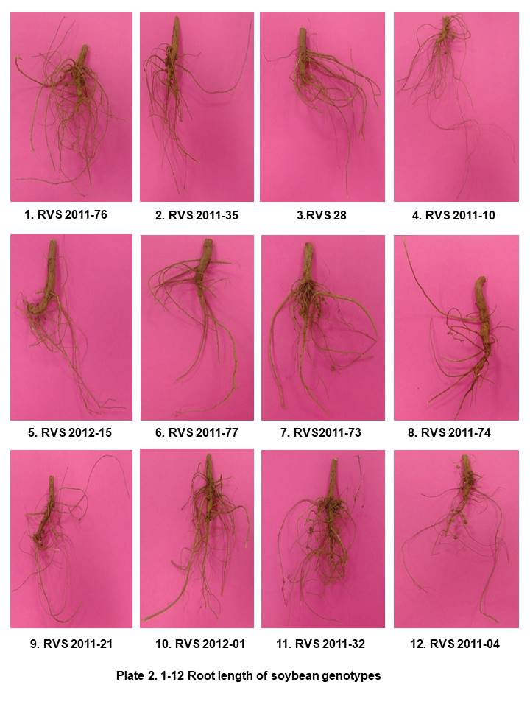 | 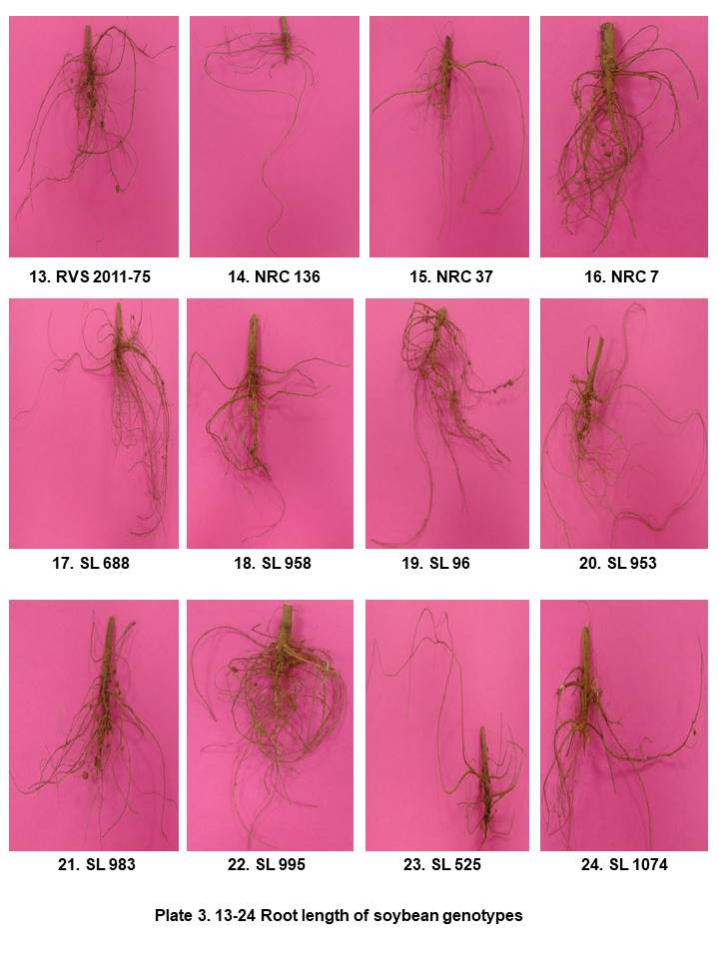 |  | 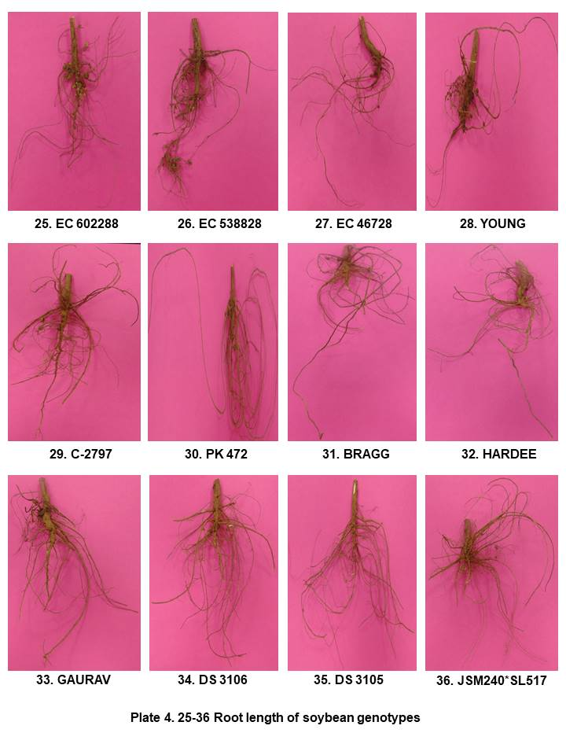
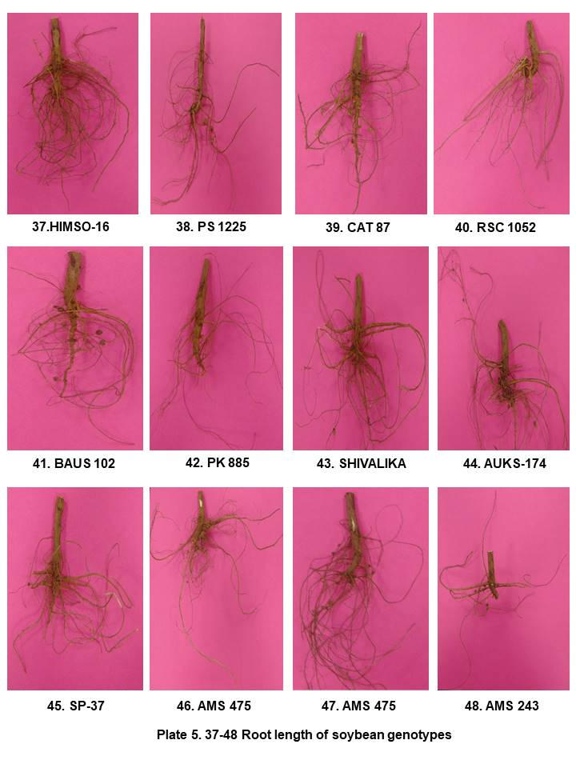 |  | 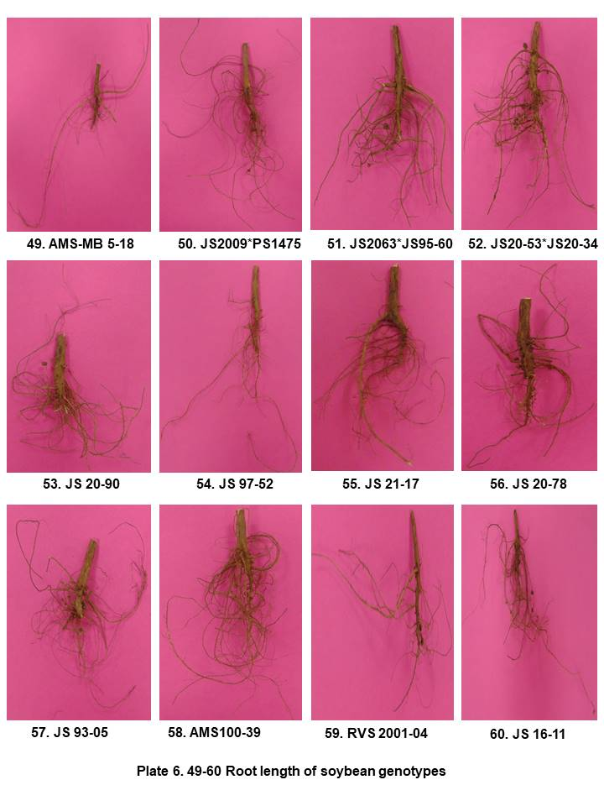
Fig.1: Root length of the soybean genotypes

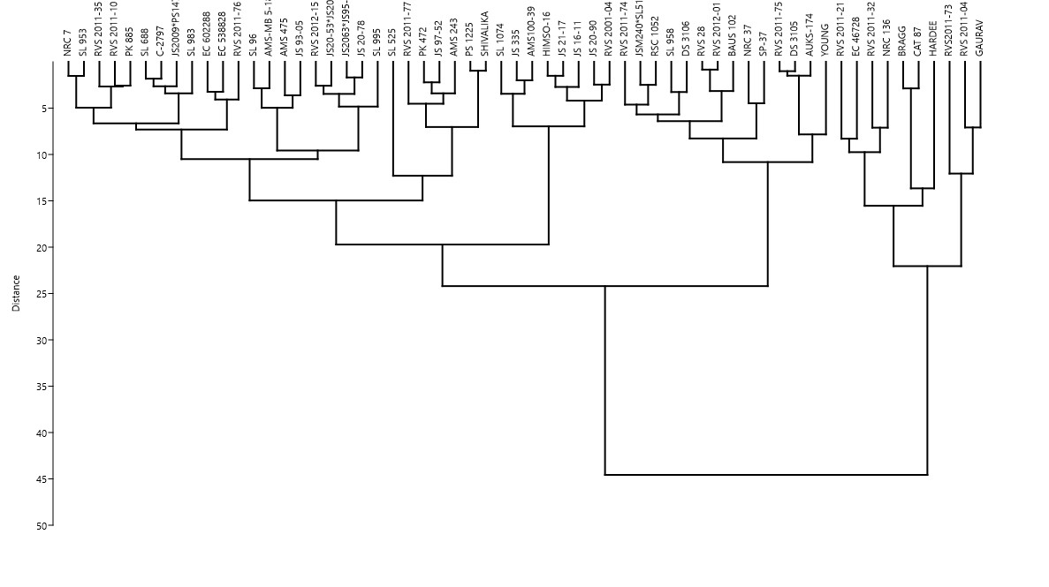
Fig. 2: Dendrogram showing relationship among soybean genotypes based on different morpho-physiological traits viz., plant height, shoot and root length and root/shoot ratio
Based on cluster analysis of morpho-physiological traits including canopy temperature, turgid, fresh and dry weights, RWC% and SWD% all 60 soybean genotypes structured in to two groups. Major cluster consisted 59 genotypes while AUKS-174 grouped distantly. The major cluster further divided into two groups. Major sub group consisted 51 soybean genotypes while minor sub group had 8 genotypes, including C-2797, Hardee, SP-37, BAUS 102, Gaurav, DS3106, DS3105 and shivalika. The major sub group further divided into two groups. Large major sub group consisted 37 genotypes, however small major sub group consisted 14 genotypes, viz., RVS 2011-10, JSM240*SL517, JS 16-11, RVS 2012-15, RVS 2011-73, BRAGG, RVS 2011-76, NRC 37, CAT 87, SL 525, Young, PS 1225, PK 472 and AMS 243. The large major subgroup further divided into two groups. major group consisted 30 genotypes, however minor group consisted 7 genotypes, included RVS 2011-21, HIMSO-16, RVS 2011-32, EC 46728, AMS 100-39, JS 97-52 and JS 21-17. The major group consisted 30 genotypes i.e., RVS 2011-74, SL 953, SL 958, JS 20-90, EC 602288, RVS 2012-01, EC 538828, NRC 7, AMS 475, RVS 2011-75, PK 885, SL 96, RVS 2011-04, RVS 2001-04, NRC 136, AMSMB5-18, JS2009*PS1475, JS 20-78, JS 93-05, RVS 28, SL 688, SL 983, SL 1074, RVS 2011-77, JS2063*JS95-60, JS20-53*JS20-34, SL 995, RSC 1052, JS 335 and RVS 2011-35 (Fig 3).
During the present investigation the genotypes grouped in different clusters having large genetic distance can be employed as parental candidates for cross breeding to produce progeny with added value or heterosis effect from each parent. In contrast, the genotypes grouped in the same cluster demonstrated their close genetic relation and should not be used as parents in cross-breeding to prevent the occurrence of inbreeding depression. Inbreeding depression, the opposite of heterosis, is the decreased progeny vigour because of the increased homozygosity level as a result of crosses between two individuals with close genetic relationship (Pandin, 2009). Inbreeding depression in plants may cause the plants to be stressed, which is recognized by the decrease of plant height, less vigour, sensitive to pest and disease attack, decrease of pod number and increased pod shattering, and the appearance of various unwanted characters owing to the combination of recessive alleles (Simiqueli et al., 2018).
Conclusion
Based on the findings of the present study, it is evident that drought stress adversely affects the growth and metabolic activities of soybean genotypes. The evaluated morpho-physiological traits demonstrated existence of substantial genetic variability among the investigated genotypes under moisture stress conditions at different growth stages. This variability indicated that soybean genotypes employed diverse adaptive mechanisms to withstand drought, emphasizing the importance of these traits as useful selection criteria in drought tolerance breeding programmes. Overall, genotypes such as JS 97-52, AMS 2014-1, RVS-14 and NRC-147 proved superior drought tolerance genotypes based on their consistent performance under water deficit conditions. However, the relatively narrow genetic base evident among the evaluated soybean genotypes in this study, highlights the need to broaden the genetic diversity of breeding materials. Incorporation of exotic germplasm lines and wild relatives is thus, recommended to introduce novel alleles associated with stress resilience. The promising genotype (s) identified in this investigation may serve as valuable donors in future breeding programmes aimed to develop high-yielding, drought-tolerant soybean cultivar (s) by means of conventional and molecular breeding approaches.

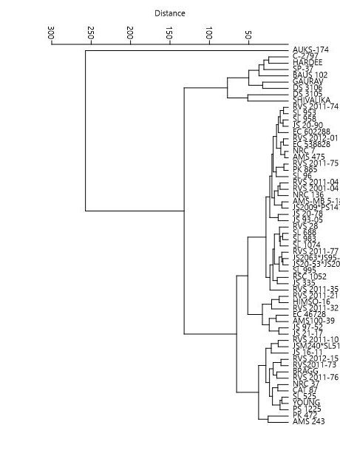
Fig. 3: Dendrogram showing relationship among soybean genotypes based on different morpho-physiological traits viz., canopy temperature, turgid, fresh and dry weights, RWC% and SWD%
Disclaimer (Artificial Intelligence)
Author(s) hereby declare that No generative AI technologies such as Large Language Models (ChatGPT, COPILOT, etc.) and text-to-image generators have been used during the writing or editing of this manuscript.
References
- Abbasi, A. R., Sarvestani, R., Mohammadi, B., & Baghery, A. (2014). Drought stress-induced changes at physiological and biochemical levels in some common vetch (Vicia sativa L.) genotypes. Journal of Agricultural Science and Technology, 16, 505–516.
- Abdullah, M. M., Waraich, E. A., Ahmad, M., Hussain, S., Asghar, H. N., Haider, A., Zulfiqar, U., Ahmad, Z., Soufan, W., Prasad, P. V., & Djalovic, I. (2025). Improving soybean drought tolerance via silicon-induced changes in growth, physiological, biochemical, and root characteristics. Plant Signalling & Behavior, 20(1). https://doi.org/10.1080/15592324.2025.2465232
- Alharbi, K., Hafez, E. M., Omara, A. E.-D., & Osman, H. S. (2023). Mitigating osmotic stress and enhancing developmental productivity processes in cotton through integrative use of vermicompost and cyanobacteria. Plants, 12(9), 1872. https://doi.org/10.3390/plants12091872
- Alzahrani, Y. (2024). Evaluation of drought and salinity tolerance potentials of different soybean genotypes based upon physiological, biochemical, and genetic indicators. Frontiers in Plant Science, 15. https://doi.org/10.3389/fpls.2024.1466363
- Amoah, J. N., & Seo, Y. W. (2021). Effect of progressive drought stress on physio-biochemical responses and gene expression patterns in wheat. 3 Biotech, 11(10), 440. https://doi.org/10.1007/s13205-021-02991-6
- Asati, R., Tripathi, M.K., Tiwari, S., Yadav, R.K., & Tripathi, N. (2022), Molecular breeding and drought tolerance in chickpea. Life, 12, 1846.
- Asati, R., Tripathi, M.K., Tiwari, S., Yadav, R.K., Chauhan, S., Tripathi, N., Solanki, R.S., & Sikarwar, R.S. (2023). Screening of chickpea (Cicer arietinum L.) genotypes against drought stress employing polyethylene glycol 6000 as selecting agent. Int. J. Plant Soil Sci. 35(19): 2155–2169.
- Asati, R., Tripathi, M.K., Yadav, R.K., Tripathi, N., Sikarwar, R.S., & Tiwari, P.N. (2024). Investigation of drought stress on chickpea (Cicer arietinum L.) genotypes employing various physiological enzymatic and non-enzymatic biochemical parameters. Plants, 13(19):2746. https://doi.org/10.3390/plants13192746
- Ashwin, R., Bagyaraj, D. J., & Mohan Raju, B. (2023). Ameliorating the drought stress tolerance of a susceptible soybean cultivar, MAUS 2 through dual inoculation with selected rhizobia and AM fungus. Fungal Biology and Biotechnology, 10(1), 10. https://doi.org/10.1186/s40694-023-00157-y
- Bárzana, G., & Carvajal, M. (2020). Genetic regulation of water and nutrient transport in water stress tolerance in roots. Journal of Biotechnology, 324, 134–142. https://doi.org/10.1016/j.jbiotec.2020.10.003
- Bernacchi, C. J., Ruiz-Vera, U. M., Siebers, M. H., DeLucia, N. J., & Ort, D. R. (2023). Short- and long-term warming events on photosynthetic physiology, growth, and yields of field grown crops. Biochemical Journal, 480(13), 999–1014. https://doi.org/10.1042/BCJ20220433
- Bukan, M., Kereša, S., Pejić, I., Sudarić, A., Lovrić, A., & Šarčević, H. (2024). Variability of root and shoot traits under PEG-induced drought stress at an early vegetative growth stage of soybean. Agronomy, 14(6), 1188. https://doi.org/10.3390/agronomy14061188
- Chowdhury, J., Karim, M., Khaliq, Q., Ahmed, A., & Mondol, A. M. (2018). Effect of drought stress on water relation traits of four soybean genotypes. SAARC Journal of Agriculture, 15(2), 163–175. https://doi.org/10.3329/sja.v15i2.35146
- Coutinho, F. S., Rodrigues, J. M., Lima, L. L., Mesquita, R. O., Carpinetti, P. A., Machado, J. P. B., Vital, C. E., Vidigal, P. M., Ramos, M. E. S., Maximiano, M. R., Mehta, A., Oliveira, M. G. A., Fontes, E. P. B., & de Oliveira Ramos, H. J. (2021). Remodeling of the cell wall as a drought-tolerance mechanism of a soybean genotype revealed by global gene expression analysis. ABIOTECH, 2(1), 14–31. https://doi.org/10.1007/s42994-021-00043-4
- de Paula, R. G., da Silva, M. F., Amaral, C., de Sousa Paula, G., da Silva, L. J., Pessoa, H. P., & da Silva, F. L. (2024). Leveraging leaf spectroscopy to identify drought-tolerant soybean cultivars. Smart Agricultural Technology, 9, 100626. https://doi.org/10.1016/j.atech.2024.100626
- Ding, C., Alghabari, F., Rauf, M., Zhao, T., Javed, M. M., Alshamrani, R., Ghazy, A.-H., Al-Doss, A. A., Khalid, T., Yang, S. H., & Shah, Z. H. (2024). Optimization of soybean physiochemical, agronomic, and genetic responses under varying regimes of day and night temperatures. Frontiers in Plant Science, 14. https://doi.org/10.3389/fpls.2023.1332414
- Dong, S., Jiang, Y., Dong, Y., Wang, L., Wang, W., Ma, Z., Yan, C., Ma, C., & Liu, L. (2019). A study on soybean responses to drought stress and rehydration. Saudi Journal of Biological Sciences, 26(8), 2006–2017. https://doi.org/10.1016/j.sjbs.2019.08.005
- El-Saadony, M. T., Saad, A. M., Mohammed, D. M., Fahmy, M. A., Elesawi, I. E., Ahmed, A. E., Algopishi, U. B., Elrys, A. S., Desoky, E.-S. M., Mosa, W. F. A., Abd El-Mageed, T. A., Alhashmi, F. I., Mathew, B. T., AbuQamar, S. F., & El-Tarabily, K. A. (2024). Drought-tolerant plant growth-promoting rhizobacteria alleviate drought stress and enhance soil health for sustainable agriculture: A comprehensive review. Plant Stress, 14, 100632. https://doi.org/10.1016/j.stress.2024.100632
- Fuganti-Pagliarini, R., Ferreira, L. C., Rodrigues, F. A., Molinari, H. B. C., Marin, S. R. R., Molinari, M. D. C., Marcolino-Gomes, J., Mertz-Henning, L. M., Farias, J. R. B., de Oliveira, M. C. N., Neumaier, N., Kanamori, N., Fujita, Y., Mizoi, J., Nakashima, K., Yamaguchi-Shinozaki, K., & Nepomuceno, A. L. (2017). Characterization of soybean genetically modified for drought tolerance in field conditions. Frontiers in Plant Science, 8. https://doi.org/10.3389/fpls.2017.00448
- Gargallo-Garriga, A., Sardans, J., Pérez-Trujillo, M., Rivas-Ubach, A., Oravec, M., Vecerova, K., Urban, O., Jentsch, A., Kreyling, J., Beierkuhnlein, C., Parella, T., & Peñuelas, J. (2014). Opposite metabolic responses of shoots and roots to drought. Scientific Reports, 4(1), 6829. https://doi.org/10.1038/srep06829
- Gautam, Y., Mohbe, G., Bishnoi, L., Sharma, A., Mishra, R., Sharma, S., Singh, J., & Tripathi, M. K. (2025d). Genetic diversity assessment of soybean genotypes using D² and principal component analysis for breeding advancements. International Journal of Plant & Soil Science, 37(6), 581–593. https://doi.org/10.9734/ijpss/2025/v37i65537
- Gautam, Y., Tripathi, M. K., Mishra, R., Bishnoi, L., Mohbe, G., Singh, J., Sharma, S., Mahkul, A., & Sharma, A. (2025c). Screening of soybean genotypes against yellow mosaic virus disease under field conditions. Plant Cell Biotechnology and Molecular Biology, 26(7–8), 224–234. https://doi.org/10.56557/pcbmb/2025/v26i7-89449
- Gautam, Y., Tripathi, M. K., Mishra, R., Mohbe, G., Sharma, A., Sharma, S., Singh, J., & Bishnoi, L. (2025b). Genetic evaluation and trait association analysis for yield enhancement in soybean (Glycine max L. Merrill). Archives of Current Research International, 25(6), 589–603. https://doi.org/10.9734/acri/2025/v25i61304
- Gautam, Y., Tripathi, M. K., Mishra, R., Singh, J., Payasi, D. K., Sharma, S., Tomar, S. S., Sharma, A., & Bishnoi, L. (2025a). Distinctness, uniformity and stability characterization of soybean (Glycine max [L.] Merrill) genotypes. Archives of Current Research International, 25(8), 852–867. https://doi.org/10.9734/acri/2025/v25i81465
- Gupta, N., Tiwari, S., Tripathi, M. K., & Bhagyawant, S. S. (2021). Antinutritional and protein based profiling of diverse desi and wild chickpea accessions. Current Journal of Applied Science and Technology, 7–18. https://doi.org/10.9734/cjast/2021/v40i631312
- Haghpanah, M., Hashemipetroudi, S., Arzani, A., & Araniti, F. (2024). Drought tolerance in plants: Physiological and molecular responses. Plants, 13(21), 2962. https://doi.org/10.3390/plants13212962
- Hanum, C., & Meiriani. (2020). Characteristics of root growth and soybean yield on drought stress. IOP Conference Series: Earth and Environmental Science, 454(1), 012183. https://doi.org/10.1088/1755-1315/454/1/012183
- Hossain, Md. M., Lam, H.-M., & Zhang, J. (2015). Responses in gas exchange and water status between drought-tolerant and -susceptible soybean genotypes with ABA application. The Crop Journal, 3(6), 500–506. https://doi.org/10.1016/j.cj.2015.09.001
- Jhariya, R., Tripathi, M. K., Mishra, R., Sharma, S., Sikarwar, R. S., & Solanki, R. (2025e). Investigation of genetic variability and character connotation for yield augmentation in soybean (Glycine max [L.] Merrill). Journal of Experimental Agriculture International, 47(7), 85–98. https://doi.org/10.9734/jeai/2025/v47i73549
- Jhariya, R., Tripathi, M. K., Mishra, R., Sharma, S., Solanki, R., & Sikarwar, R. S. (2025d). Appraisal of variability across soybean genotypes based on qualitative traits. Journal of Biology and Nature, 17(2), 58–72. https://doi.org/10.56557/joban/2025/v17i29443
- Jhariya, R., Tripathi, M. K., Mishra, R., Sharma, S., Solanki, R., & Singh, J. (2025c). Assessment of genetic divergence in soybean (glycine max [l.] Merrill) using Mahalanobis D² statistics and principal component analysis. Journal of Advances in Biology & Biotechnology, 28(8), 346–360. https://doi.org/10.9734/jabb/2025/v28i82711
- Jhariya, R., Tripathi, M. K., Mishra, R., Solanki, R., & Sharma, S. (2025a). Assessment of soybean (Glycine max L.) genotypes on the basis of biochemical parameters. Plant Cell Biotechnology and Molecular Biology, 26(7–8), 212–223. https://doi.org/10.56557/pcbmb/2025/v26i7-89433
- Jhariya, R., Tripathi, M. K., Mishra, R., Solanki, R., & Sharma, S. (2025b). Field based disease indexing of soybean genotypes against yellow mosaic virus. Journal of Scientific Research and Reports, 31(6), 719–728. https://doi.org/10.9734/jsrr/2025/v31i63167
- Kachare, S. (2017). Studies on morpho-physiological changes and gene expression under drought condition in soybean (Glycine max L. Merrill) (Doctoral thesis, Jawaharlal Nehru Krishi Vishwa Vidyalaya, Jabalpur).
- Kachare, S., Tiwari, S., Tripathi, N., & Thakur, V. V. (2019). Assessment of genetic diversity of soybean (Glycine max) genotypes using qualitative traits and microsatellite markers. Agricultural Research, 9(1), 23–34. https://doi.org/10.1007/s40003-019-00412-y
- Kalra, A., Goel, S., & Elias, A. A. (2024). Understanding role of roots in plant response to drought: Way forward to climate‐resilient crops. The Plant Genome, 17(1). https://doi.org/10.1002/tpg2.20395
- Kapoor, D., Bhardwaj, S., Landi, M., Sharma, A., Ramakrishnan, M., & Sharma, A. (2020). The impact of drought in plant metabolism: How to exploit tolerance mechanisms to increase crop production. Applied Sciences, 10(16), 5692. https://doi.org/10.3390/app10165692
- Kardile, P. B., Dahatonde, K. N., Rakshe, M. V., & Burondkar, M. M. (2018). Effect of moisture stress on leaf relative water content (RWC) of four cowpea (Vigna unguiculata L. walp.) genotypes at different stages of growth. International Journal of Current Microbiology and Applied Sciences, 7(04), 2645–2649. https://doi.org/10.20546/ijcmas.2018.704.301
- Khatri, K., & Rathore, M. S. (2022). Salt and osmotic stress-induced changes in physio-chemical responses, PSII photochemistry and chlorophyll a fluorescence in peanut. Plant Stress, 3, 100063. https://doi.org/10.1016/j.stress.2022.100063
- Kodadinne Narayana, N., Wijewardana, C., Alsajri, F. A., Reddy, K. R., Stetina, S. R., & Bheemanahalli, R. (2024). Resilience of soybean genotypes to drought stress during the early vegetative stage. Scientific Reports, 14(1), 17365. https://doi.org/10.1038/s41598-024-67930-w
- Kou, X., Han, W., & Kang, J. (2022). Responses of root system architecture to water stress at multiple levels: A meta-analysis of trials under controlled conditions. Frontiers in Plant Science, 13. https://doi.org/10.3389/fpls.2022.1085409
- Lepekhov, S. B. (2022). Canopy temperature depression for drought and heat stress tolerance in wheat breeding. Vavilov Journal of Genetics and Breeding, 26(2), 196–201. https://doi.org/10.18699/VJGB-22-24
- Mangena, P. (2018). Water Stress: Morphological and anatomical changes in soybean (Glycine max L.) plants. In Plant, Abiotic Stress and Responses to Climate Change. InTech. https://doi.org/10.5772/intechopen.72899
- Mishra., R., Yamini, G., Goutam, M., Sanjeev, S., Singh., J., Tripathi, N., Payasi, D. K., Tomar, S. S., Tripathi, M. K., & Tiwari, S., (2025a). Unlocking qualitative traits diversity in soybean [Glycine max (L.) Merrill] genotypes. Plant Science Today, 12(sp4). https://doi.org/10.14719/pst.8144
- Mishra., R., Shrivastava, M. K., Pawan, K. A., Jayesh, G., Anita, K. P., Sanjeev, S., Yogendra, S., Tripathi, M. K., Payasi, D. K., & Ankit, P. (2025b). Resistance profiling of soybean RILs against yellow mosaic virus and charcoal rot under field conditions. Plant Science Today. https://doi.org/10.14719/pst.9379
- Mishra, R., Shrivastava, M. K., Amrate, P. K., Sharma, S., Singh, Y., & Tripathi, M. K. (2025c). Phenotypic diversity and trait analysis of soybean recombinant inbred lines. Plant Cell Biotechnology and Molecular Biology, 26(7–8), 32–52. https://doi.org/10.56557/pcbmb/2025/v26i7-89345
- Mishra, R., Shrivastava, M. K., Tripathi, M. K., Amrate, P. K., Singh, Y., Solanki, R., Sharma, S., & Shukla, S. (2025d). Unravelling soybean yield potential: Exploring trait synergy, impact pathways, multidimensional patterns and biochemical insights. Plant Science Today. https://doi.org/10.14719/pst.6401
- Mishra, R., Tripathi, M.K., Tripathi, N., Singh, J., Yadav, P.K. & Sikarwar, R.S. (2024a). Breeding for major genes against drought stress in soybean. In: Tripathi MK, Tripathi N, editors. Advances in Plant Biotechnology. Cornous Publications LLP, Puducherry, India. p. 22–68. https://doi.org/https://doi.org/10.37446/volbook032024/22-68
- Mishra, R., Tripathi, M. K., Sikarwar, R. S., Singh, Y., & Tripathi, N. (2024b). Soybean (Glycine max L. Merrill): A multipurpose legume shaping our world. Plant Cell Biotechnology and Molecular Biology, 25(3–4), 17–37. https://doi.org/10.56557/pcbmb/2024/v25i3-48643
- Mishra, R., Tripathi, M., Tripathi, N., Singh, J. & Tiwari S. (2024c). Nutritional and anti-nutritional factors in soybean. Acta Scientific Agriculture. 3: 8(11):46–63. https://doi.org/10.31080/ASAG.2024.08.1432
- Mishra, R., Tripathi, M. K., Shrivastava, M. K., Amrate, P. K., Singh, J., & Singh, Y. (2024d). From conventional to modern plant breeding - how far have we come? In Recent Advances in Plant Breeding-Volume 1 (pp. 1–20). Cornous Publications LLP. https://doi.org/10.37446/volbook102024/1-20
- Mishra, R., Tripathi, M.K., Shrivastava, M.K., & Amrate, P.K. (2024e). Genetic diversity in crop improvement: A cornerstone for sustainable agriculture and global food security. In: Tripathi MK, Tripathi N, editors. Advances in Plant Biotechnology. Cornous Publications LLP; p. 1–21. https://doi.org/https://doi.org/10.37446/volbook032024/1-21
- Mishra, N., Tripathi, M. K., Tiwari, S., Tripathi, N.& Sikarwar, R. S. (2022). Evaluation of qualitative trait based variability among soybean genotypes. The Pharma Innovation. 11(9):1115-1121.
- Mishra, N., Tripathi, M. K., Tiwari, S., Tripathi, N., Sapre, S., Ahuja, A., & Tiwari, S. (2021a). Cell suspension culture and in vitro screening for drought tolerance in soybean using poly-ethylene glycol. Plants, 10(3), 517. https://doi.org/10.3390/plants10030517
- Mishra, N., Tripathi, M. K., Tiwari, S., Tripathi, N., Gupta, N., & Sharma, A. (2021b). Morphological and physiological performance of Indian soybean [Glycine max (L.) Merrill] genotypes in respect to drought. Legume Research - An International Journal. https://doi.org/10.18805/LR-4550
- Mishra, N., Tripathi, M. K., Tripathi, N., Tiwari, S., Gupta, N., & Sharma, A. (2021c). Validation of drought tolerance gene-linked microsatellite markers and their efficiency for diversity assessment in a set of soybean genotypes. Current Journal of Applied Science and Technology, 48–57. https://doi.org/10.9734/cjast/2021/v40i2531515
- Mishra, N., Tripathi, M. K., Tiwari, S., Tripathi, N., Gupta, N., Sharma, A.& Solanki, R. S. (2021d). Evaluation of diversity among soybean genotypes via yield attributing traits and SSR molecular markers. Current Journal of Applied Science and Technology, 40(21): 9-24.
- Mishra N, Tripathi MK, Tripathi N, Tiwari S, Gupta N, Sharma A, et al. (2021e). Changes in biochemical and antioxidant enzymes activities play significant role in drought tolerance in soybean. Int. J Agric. Technol. 17:1425-46. 41.
- Mishra, N., Tripathi, M. K., Tiwari, S., Tripathi, N., & Trivedi, H. K. (2020). Morphological and molecular screening of soybean genotypes against yellow mosaic virus disease. Legume Research - An International Journal. https://doi.org/10.18805/LR-4240
- Moradi, Z., Farshadfar, E., & Shirvani, H. (2015). Screening of drought tolerant genotypes in bread wheat (Triticum aestivum) using morpho-physiological traits and integrated selection index. Biological Forum – An International Journal, 7(1), 163–172).
- Nur’aini, N., & Diah Rachmawati. (2022). Physiological response and growth of soybean [Glycine max (L.) Merr.] “Dega 1” in different water availability. Biogenesis: Jurnal Ilmiah Biologi, 10(1). https://doi.org/10.24252/bio.v10i1.27827
- Pandin, D. S. (2009). Depresi silang-dalam kelapa dalam Mapanget berdasarkan penanda mikrosatelit (SSR) Bul. Palma, 37, 127–37.
- Pane, R. F., Damanik, R. I., & Khardinata, E. H. (2018). Germinaton performance of selected local soybean (Glycine max (L.) Merrills) cultivars during drought stress induced by polyethylene glycol (PEG). IOP Conference Series: Earth and Environmental Science, 122, 012054. https://doi.org/10.1088/1755-1315/122/1/012054
- Rasheed, A., Mahmood, A., Maqbool, R., Albaqami, M., Sher, A., Sattar, A., Bakhsh, G., Nawaz, M., Hassan, M. U., Al-Yahyai, R., Aamer, M., Li, H., & Wu, Z. (2022). Key insights to develop drought-resilient soybean: A review. Journal of King Saud University - Science, 34(5), 102089. https://doi.org/10.1016/j.jksus.2022.102089
- Rohlf, F. J. (2000). NTSYS pc numerical taxonomy and multivariate analysis system version 2.0 user guide. Applied Biostatistics Inc., Setauket, New York. Pp. 37
- Sahu, V. K., Tiwari, S., Gupta, N., Tripathi, M. K., & Yasin, M. (2020). Evaluation of physiological and biochemical contents in desi and Kabuli chickpea. Legume Research - An International Journal. https://doi.org/10.18805/LR-4265
- Sanusi, B., Inyass, A. Z., Zubaidatu, S., Barbra, T. E., Saleh, H., & Umar, M. L. (2025). Effect of drought stress on some morphological, physiological and biochemical parameters in soybean (TGX-1835-10E) variety. Discover Plants, 2(1), 164. https://doi.org/10.1007/s44372-025-00221-4
- Sarkar, K., Mannan, M., Haque, M., & Ahmed, J. (2016). Physiological basis of water stress tolerance in soybean. Bangladesh Agronomy Journal, 18(2), 71–78. https://doi.org/10.3329/baj.v18i2.28908
- Seleiman, M. F., Al-Suhaibani, N., Ali, N., Akmal, M., Alotaibi, M., Refay, Y., Dindaroglu, T., Abdul-Wajid, H. H., & Battaglia, M. L. (2021). Drought stress impacts on plants and different approaches to alleviate its adverse effects. Plants, 10(2), 259. https://doi.org/10.3390/plants10020259
- Sepanlo, N., Talebi, R., Rokhzadi, A., & Mohammadi, H. (2014). Morphological and physiological behavior in soybean (Glycine max) genotypes to drought stress implemented at pre- and post-anthesis stages. Acta Biologica Szegediensis, 58(2), 109–113.
- Sharma, A., Das, N., Pandey, P., & Shukla, P. (2025). Plant-microbiome responses under drought stress and their metabolite-mediated interactions towards enhanced crop resilience. Current Plant Biology, 43, 100513. https://doi.org/10.1016/j.cpb.2025.100513
- Sharma, A., Tripathi, M. K., Tiwari, S., Gupta, N., Tripathi, N., & Mishra, N. (2021). Evaluation of soybean (Glycine max L.) genotypes on the basis of biochemical contents and anti-oxidant enzyme activities. Legume Research. https://doi.org/10.18805/LR-4678
- Sharma, N., Tiwari, S., Tripathi, M.K., Gupta, N., Singh, S.& Sikarwar, R.S. (2023a). Selection of groundnut germplasm lines based on yield, nutritional, antinutritional and antioxidant parameters. Scientist. 2(1): 96-105.DOI: https://doi.org/10.5281/zenodo.7536324
- Sharma, A., Mishra, N., Tripathi, N., Nehra, S., Singh, J., & Tiwari S. et al. (2023b). Qualitative trait based variability among soybean genotypes. Acta Scientific Agriculture. 1;02–13. https://doi.org/10.31080/ASAG.2023.07.1212
- Sharmin, R. A., Karikari, B., Bhuiyan, M. R., Kong, K., Yu, Z., Zhang, C., & Zhao, T. (2024). Comparative morpho-physiological, biochemical, and gene expressional analyses uncover mechanisms of waterlogging tolerance in two soybean introgression lines. Plants, 13(7), 1011. https://doi.org/10.3390/plants13071011
- Shoaib, M., Banerjee, B. P., Hayden, M., & Kant, S. (2022). Roots’ drought adaptive traits in crop improvement. Plants, 11(17), 2256. https://doi.org/10.3390/plants11172256
- Simiqueli, G. F., de Resende, M. D. V., Motoike, S. Y. & Henriques, E. (2018). Inbreeding depression as a cause of fruit abortion in structured populations of macaw palm (Acrocomia aculeata): implications for breeding programs Ind. Crops Prod. 112, 652–9
- Sistu, R., Tiwari, S., Tripathi, M.K., Singh, S., Gupta, N., Tripathi, N., Asati, R., &Yadav, R.K. (2023). Effect of different biochemical parameters and antioxidant enzymes activities on drought indices in chickpea (Cicer arietinum L.). Legume Research. DOI: 10.18805/LR-5204
- Soltys-Kalina, D., Plich, J., Strzelczyk-Żyta, D., Śliwka, J., & Marczewski, W. (2016). The effect of drought stress on the leaf relative water content and tuber yield of a half-sib family of ‘Katahdin’-derived potato cultivars. Breeding Science, 66(2), 328–331. https://doi.org/10.1270/jsbbs.66.328
- Snedecor, G., & Cochran, W.G. Statistical Methods. (1997). VI Ed. Oxford IBH Pub. Co. Delhi.
- Tenorio Berrío, R., Nelissen, H., Inzé, D., & Dubois, M. (2022). Increasing yield on dry fields: molecular pathways with growing potential. The Plant Journal, 109(2), 323–341. https://doi.org/10.1111/tpj.15550
- Thenveettil, N., Bheemanahalli, R., Reddy, K. N., Gao, W., & Reddy, K. R. (2024). Temperature and elevated CO₂ alter soybean seed yield and quality, exhibiting transgenerational effects on seedling emergence and vigor. Frontiers in Plant Science, 15. https://doi.org/10.3389/fpls.2024.1427086
- Tiwari, P.N., Tiwari, S., Sapre, S., Babbar, A., Tripathi, N., Tiwari, S., & Tripathi, M.K. (2023a). Screening and selection of drought-tolerant high-yielding chickpea genotypes based on physio-biochemical selection indices and yield trials. Life. 13, 1405.
- Tiwari, P.N., Tiwari, S., Sapre, S., Tripathi, N., Payasi, D.K., Singh, M., Thakur, S., Sharma, M., Tiwari, S., & Tripathi, M.K. (2023b). Prioritization of physio-biochemical selection indices and yield-attributing traits toward the acquisition of drought tolerance in chickpea (Cicer arietinum L.). Plants 12: 3175. https://doi.org/ 10.3390/plants12183175
- Tiwari, P.N., Tiwari, S., Sapre, S., Babbar, A., Tripathi, N., Tiwari, S., & Tripathi, M.K. (2023c). Prioritization of microsatellite markers linked with drought tolerance associated traits in chickpea (Cicer arietinum L.). Leg Res. 46:1422?30. https://doi.org/10.18805/LR-5191
- Tripathi, M.K., Tripathi, N., Tiwari, S., Mishra, N., Sharma, A., & Tiwari, S, et al. (2023). Identification of Indian soybean (Glycine max [L.] Merr.) genotypes for drought tolerance and genetic diversity analysis using SSR markers. Scientist, 3(3), 31-46.
- Tripathi, N., Tripathi, M. K., Tiwari, S., & Payasi, D. K. (2022). Molecular breeding to overcome biotic stresses in soybean: update. Plants, 11(15), 1967. https://doi.org/10.3390/plants11151967
- Upadhyay, S., Singh, A. K., Tripathi, M. K., Tiwari, S., & Tripathi, N. (2020a). Validation of simple sequence repeat markers for charcoal rot and Rhizoctonia root rot resistance in soybean genotypes. International Journal of Advanced Biological Research, 10(2), 137–144).
- Upadhyay, S., Singh, A. K., Tripathi, M. K., Tiwari, S., Tripathi, N., & Patel, R. P. (2020b). In vitro selection for resistance against charcoal rot disease of soybean [Glycine max (L.) Merrill] caused by Macrophomina phaseolina (Tassi) Goid. Legume Research - An International Journal. https://doi.org/10.18805/LR-4440
- Voothuluru, P., Wu, Y., & Sharp, R. E. (2024). Not so hidden anymore: Advances and challenges in understanding root growth under water deficits. The Plant Cell, 36(5), 1377–1409. https://doi.org/10.1093/plcell/koae055
- Wang, X., Zhao, W., Wei, X., Sun, Y., & Dong, S. (2024). Molecular mechanism of drought resistance in soybean roots revealed using physiological and multi-omics analyses. Plant Physiology and Biochemistry, 208, 108451. https://doi.org/10.1016/j.plaphy.2024.108451
- Wijewardana, C., Alsajri, F. A., Irby, J. T., Krutz, L. J., Golden, B. R., Henry, W. B., & Reddy, K. R. (2019). Water deficit effects on soybean root morphology and early-season vigor. Agronomy, 9(12), 836. https://doi.org/10.3390/agronomy9120836
- Xu, Y., Song, D., Qi, X., Asad, M., Wang, S., Tong, X., Jiang, Y., & Wang, S. (2023). Physiological responses and transcriptome analysis of soybean under gradual water deficit. Frontiers in Plant Science, 14. https://doi.org/10.3389/fpls.2023.1269884
- Yadav, P.K., Tripathi, M.K., Singh, A.K., Yadav, S. K., Sikarwar, R.S.& Tripathi, N. (2024a). Alteration in proline and sugar content in maize (Zea mays L.) genotypes under drought condition. In book Advances in Biotechnology & Bioscience, 16, 179-196.
- Yadav, P.K., Tripathi, M.K., Tripathi, N., Sikarwar, R.S.& Yadav, S. K. (2024b). Biochemical characterization of maize (Zea mays L.) genotypes under different irrigation circumstances. In book Advances in Biotechnology & Bioscience, Volume 16, 133-165.
- Yadav, P.K., Tripathi, M.K., Tiwari, S., Chauhan, S., Tripathi, N. & Sikarwar, R.S. (2023). Biochemical characterization of parental inbred lines and hybrids of maize (Zea mays L.) under different irrigation conditions. International Journal of Plant & Soil Science, 35(18):1743-1762.
- Yadav, P.K., Singh, A.K., Tripathi, M.K., Tiwari, S., Yadav, S. K., Solanki, R.& Tripathi, N. (2022). Assessment of maize (Zea mays L.) genotypes on the basis of biochemical contents in respect to drought. The Pharma Innovation, 11(6): 1996-2002
- Yan, C., Song, S., Wang, W., Wang, C., Li, H., Wang, F., Li, S., & Sun, X. (2020). Screening diverse soybean genotypes for drought tolerance by membership function value based on multiple traits and drought-tolerant coefficient of yield. BMC Plant Biology, 20(1), 321. https://doi.org/10.1186/s12870-020-02519-9
- Yu, Y., Li, C., Shen, W., Yan, L., Zheng, X., Yao, Z., Cui, S., Cui, C., Hu, Y., & Yang, M. (2025). Correlation study between canopy temperature (CT) and wheat yield and quality based on infrared imaging camera. Plants, 14(3), 411. https://doi.org/10.3390/plants14030411
- Zhang, Y., Wu, X., Wang, X., Dai, M., & Peng, Y. (2025). Crop root system architecture in drought response. Journal of Genetics and Genomics, 52(1), 4–13. https://doi.org/10.1016/j.jgg.2024.05.001
- Zhou, C., Mughal, N., Zhang, X., Chen, J., Shoaib, N., Wang, X., Yong, T., Yang, F., Liu, W., Wu, X., Wu, Y., Guo, J., Yang, W., Zhang, J., & Liu, J. (2024). Soybean plants enhance growth through metabolic regulation under heterogeneous drought stress. Agricultural Water Management, 303, 109029. https://doi.org/10.1016/j.agwat.2024.109029
- Zia, R., Nawaz, M. S., Siddique, M. J., Hakim, S., & Imran, A. (2021). Plant survival under drought stress: Implications, adaptive responses, and integrated rhizosphere management strategy for stress mitigation. Microbiological Research, 242, 126626. https://doi.org/10.1016/j.micres.2020.126626

