Challenges in climate change mitigation and net zero achievement in India

Abstract: The continuous increase in the global mean-surface temperature due to increasing concentrations of greenhouse gases in the atmosphere, and the noticeable adverse impact of global warming across the world, have resulted in high incidences of disasters and vulnerability of human beings. In this context, the manuscript describes India's updated Intended Nationally Determined Contribution (INDC) targets submitted to the United Nations Framework Convention on Climate Change (UNFCCC) in August 2022, and provides a detailed analysis of the progress made so far to reduce global warming and the major concerning issues. It provides an in-depth analysis of the achievements vis-à-vis the more inclusive global Environmental Performance Index (EPI) ranking 2024 from the overall environmental scenario. The way forward has been suggested based on the policy analysis of climate change and personal opinion. It concludes that though India has done remarkably well in achieving its Nationally Determined Contribution (NDC) targets in containing and mitigating the rise of greenhouse gases, it also requires to address the root cause of the problem such as high population along with the other social issues such as lack of awareness, public participation, and environmental responsibility for improvement in global ranking from the overall environmental perspective.

Keywords: Global Warming, Greenhouse Gases (GHG), India, Intended Nationally Determined Contributions (INDC), Decarbonisation, Environmental Performance Index (EPI).

Introduction
The State of the Global Climate Report 2023, published by the World Meteorological Organization (WMO), stated that 2023 was the warmest year, with the global mean near-surface temperature at 1.45 ± 0.12 °C, since the pre-industrial era (1850-1900). In its recently published 2024 Report, the WMO concluded that 2024 was the warmest year, with the average temperature exceeding even the once-agreed-upon desirable target of 1.5°C, as set out in the Paris Agreement (2015). The global mean near-surface temperature in 2024 was 1.55 ± 0.13 °C above the pre-industrial average. The concentration of the 12-month running average of the most abundant atmospheric greenhouse gas, i.e., carbon dioxide (CO₂), has increased from 278 parts per million (ppm) in 1750 to 320 ppm in 1958, and thereafter substantially to 425 ppm by the start of 2025. Concentration of the other two primary GHG gases, i.e., methane (CH₄) and nitrous oxide (N₂O), also increased from 729 to 1924 ppb (265 %) and 270 to 336 ppb (124 %), respectively, since the pre-industrial level [1, 2, 3].

Studies of climate change by other reputed scientific agencies, such as the National Oceanic and Atmospheric Administration (NOAA) and the Intergovernmental Panel on Climate Change (IPCC), also support the notion that human-induced climate change, driven by a rise in greenhouse gas emissions, is affecting every region across the globe (Vicedo-Cabrera et al., 2021; Li & Otto, 2022; Reed et al., 2022). The global surface temperature was around 1.1°C above 1850–1900. The progressive increase has resulted in the melting of arctic glaciers, rise in sea level, increased incidences of floods, flash floods, cyclones, landslides, droughts, drying up of surface water bodies, extreme heatwaves, and a reduction in biodiversity. The adverse impacts of global warming are manifested in the loss of lives, vulnerability of crop productivity, health, and longevity, as well as changes in weather patterns. The Intergovernmental Panel on Climate Change (IPCC) reported that the number of “climatically stressful” workdays has exceeded 200 and may reach nearly 250 per year. It is predicted that at 1.5°C, there will be more severe heatwaves and longer warm seasons, and at 2°C, heatwaves would frequently cross the limits of human survivability [4, 5].
As agreed under the legally binding Paris Agreement, adopted by the 196 Parties of the Conference of the Parties (COP) of the United Nations Framework Convention on Climate Change (UNFCCC) in December 2015, and signed by 175 countries on 22nd April 2016, the countries prepared their respective Intended Nationally Determined Contribution (INDCs) targets. The goal is to check the rise in the global average temperature to well below 2°C before 2100, and simultaneously pursue the efforts to limit the temperature increase to a maximum of 1.5°C. The INDC has been transitioned into the NDC since 2020, following the acceptance of the targets. By 2020, more than 110 countries had committed to the UNFCCC to a net-zero emissions target by 2050. India has committed to a net-zero carbon by 2070. The NDCs are reviewed and updated every five years.

Current scenario in India
The updated Intended Nationally Determined Contributions (INDC) targets submitted to the United Nations Framework Convention on Climate Change (UNFCCC) in August 2022 feature the following targets:
1. To put forward and further propagate a healthy and sustainable way of living based on traditions and values of conservation and moderation, including through a mass movement for ‘LIFE’– ‘Lifestyle for Environment’ as a key to combating climate change. 2. To adopt a climate-friendly and cleaner path than the one followed hitherto by others at a corresponding level of economic development. 3. To reduce the Emissions Intensity of its GDP by 45 percent by 2030, from the 2005 level. 4. To achieve about 50 percent cumulative electric power installed capacity from non-fossil fuel-based energy resources by 2030, with the help of transfer of technology and low-cost international finance, including from the Green Climate Fund (GCF). 5. To create an additional carbon sink of 2.5 to 3 billion tonnes of CO₂ equivalent through additional forest and tree cover by 2030. 6. To better adapt to climate change by enhancing investments in development programmes in sectors vulnerable to climate change, particularly agriculture, water resources, the Himalayan region, coastal regions, health, and disaster management. 7. To mobilize domestic and new & additional funds from developed countries to implement the above mitigation and adaptation actions, given the resources required and the resource gap. 8. To build capacities, create a domestic framework and international architecture for quick diffusion of cutting-edge climate technology in India and joint collaborative R&D for such future technologies [6].

As per the Fourth Biennial Update Report to the United Nations Framework Convention on Climate Change (2024) by the Ministry of Environment, Forest & Climate Change (MoEF & CC), Government of India, carbon dioxide accounts for much of the GHGs (80.53%), followed by methane (13.32%), nitrous oxide (5.13%), and others (1.02%) amongst the contributory GHG gases emission in India [7]. The energy sector has the highest contributing sector (75.66%), followed by agriculture (13.72%), industrial process and product use (IPPU) (8.06%), and waste (2.56%). The total greenhouse gas emissions of India from 1994 to 2020 are presented in Figures 1 & Table 2.

Challenges
India accounts for approximately 8 percent of the total greenhouse gases. It ranks third after China (11.47 BMt CO₂ eq) and the USA (5.007 BMt CO₂ eq) [8, 9]. The total carbon emissions from India have risen consistently from 14 Mt CO₂e in 1994 to 2929 Mt CO₂ in 2020. While the progress in achieving NDCs is remarkable, the cumulative carbon emission, driven mainly by the high population, remain high. The growing carbon emissions are also an indicator of the economic growth of the country, since per capita consumption is less than desirable. Furthermore, the overall performance of India in terms of the Environmental Performance Index (EPI) 2024 ranking remains extremely unsatisfactory. As per the report released by the Yale Centre for Environmental Law & Policy, India is in 178th position with a very low score of 27.6 [10]. The consistently poor ranking of the country in EPI opens a very realistic window for reflection. While the NDC targets aim to check the rise in GHGs, the EPI is a more inclusive environmental indicator. The EPI is based on 58 important indicators across 11 environmental issues for 180 countries. It states about each country's progress towards mitigating climate change, improving environmental health, and protecting ecosystem vitality. A huge population, a lack of public awareness and public participation, and only infrastructure creation with a lack of accountability are the major problems. The huge population is offsetting all the developments and putting enormous pressure on natural resources. We see several flyovers built, metro trains started in many metro cities, new expressways and roads built, but over time, everything becomes saturated due to an increase in population as well as migration towards cities. It is like a cat-and-mouse game. The high population (1.464 billion as on 25.07.2025) and the rise in industrial activities have resulted in increased demand. The urban and rural areas are not capable for treatment of enormous solid and liquid wastes generated per day. As per the population forecast, the population in India will keep on rising at least till 2050, though at a slower pace and likely to reach 1.67 billion [11]. This will pose immense pressure on natural resources and offset climate change mitigation achievements.

Our behavioural patterns are also not fully commensurate with our intentions to become an environmentally friendly nation. Some sections of our societies are not aware of our social responsibility, some are reluctant to contribute, and some are awfully sort and lack even the basic civic sense. Our lack of civic sense and ignorance of the environment in daily life is already costing us dearly, as the effects of pollution are manifested in various health problems, including increasing cases of cancer.

The net-zero target is highly unlikely to be achieved by 2070, despite attempts by the government, due to a lack of environmental ownership and a lack of public awareness. Carbon credit trading, as envisaged earlier, after the Kyoto protocol has failed to achieve desirable results, primarily due to the complex procedure. Furthermore, the net zero target is about achieving net zero (neutrality) for all the GHG gases and not just about carbon dioxide. To achieve net-neutrality, the sink for GHGs should be either equal to the emission or less than the emission. The majority of the industries in India still see environmental management as an external requirement meant only for compliance with pollution control norms rather than a pathway for resource efficiency and sustainability. If manufacturing industries could be placed under five categories depending on the scale of production/turnover or number of employees, from ascending to descending order, then the problem lies mostly in the last 3 categories of industries, which are unorganized and unprofessionally managed. While the big industries have largely an established system of emission and effluent monitoring and strive to follow the norms, a significant percentage of medium or small industries across the various sectors, especially in the unorganised sectors, are lax due to a lack of establishment of a dedicated environmental cell. Field experiences reveal that there are several industries for which emission norms are just the numerical values, and they do not monitor the stack emission. When compliance is required to be submitted to the concerned authorities, they provide unreliable documents from a third party. Having spent significant time managing continuous real-time water quality monitoring activities, I can say that even the continuous real-time pollution monitoring is subject to manipulation and can be set as per the desired level, as seen in the field. No system in the world will work effectively if that is not implemented in the true spirit. The personal experiences state that there are three types of scenarios in industrial pollution: one, where there is an established and regular system of pollution monitoring and continuous effort to improve environmental compliance and sustainability; two, where there is willingness but there is little financial and technical capacity; and three, neither is there any willingness nor capability -gross violators. In addition to this, it is also important to understand that industrial willingness alone is not enough; the external factors, for which other agencies are responsible, are also extremely important. The basic infrastructure around many industrial setups/clusters in the country is pathetic. The industries struggle for these basic amenities, such as good quality of road, lack of adequate drainage system, management of sewage, continuous disruption of production due to power outage, and many other factors in many areas. So even for industrial decarbonization, there are external factors that either facilitate it or play a role in overall emission reduction and the net-zero target.

Way forward
The per capita carbon emission in India is one of the lowest (1.94) in the world, as compared to other countries such as the USA (15.04), Russia (12.03), and EU countries (7-12). India is one of the top performers in achieving the NDC targets. The fourth updated Report (BUR-4), released by the MoEF &CC, Government of India, in December 2024, reveals the following achievements:
- India’s forest and tree cover has consistently increased and currently stands at 25.17% of the total geographical area of the country. Creation of additional carbon sink through its afforestation programme has resulted in an increase of 160 Mt coverage from 7,044 million metric tons (Mt) in 2015 to 7,204 Mt in 2021. During 2005 to 2021, an additional carbon sink of 2.29 billion tons of CO₂ equivalent has been created.
- Increased share of electricity generation from non-fossil fuels from 32 % in 2014 to 38 % by November 2020 and 46.52 % in October 2024. (mainly due to a major fillip in the promotion of solar energy and expansion of wind energy activities). Of the set target of producing 500 GW of power from non-fossil fuel by 2030, India has already achieved 203.22 GW (46.52%) in October 2024 from 35 GW in 2014. It has reached 50 % as per information in The Times of India, dated 15.07.2025.
- More than 24 % reduction in emission intensity (excluding agriculture) in terms of GDP was achieved between 2005- 2016, which rose to 36 % in 2020. The progress in emission intensity reduction is way ahead, to achieve 45 % by 2030 as per the INDC goal for SDG.
- India’s total GHG emissions, excluding LULUCF, amounted to 2,959 Mt CO2e and, including LULUCF, amounted to 2,437 Mt CO2e in 2020. Total national emissions (including LULUCF) have decreased by 7.93 per cent concerning 2019 and increased by 98.34 per cent since 1994. The LULUCF sector remained a net sink during the inventory period 2020.

The industries need to set quantitative and measurable targets for emission reduction each year. The first and foremost step is hiring suitably qualified people and setting up a dedicated environmental cell. The industries need to be sensitised not only about emission control but also about the potential benefits of Carbon Capture, Storage, and Use (CCUS). The Carbon Capture, Utilization & Storage (CCUS) offers not just a solution for emission control but also provides an opportunity to gain profits by utilizing productive uses of CO₂. CCUS is most relevant for the industrial and manufacturing sector, especially the large ones. It is also imperative that other sectors, such as the transportation, construction, and agriculture sectors, mitigate their carbon footprints.

Concrete (cement) is the most widely used material on the planet after water. It is also the second-largest industrial emitter of CO₂ all over the world. Globally, the construction ecosystem accounts for about 45 percent of GHG. Concrete, especially the cement, accounts for 4.5 % of global GHG emissions and 7.0% of CO₂ emissions. For mitigating emissions from the construction industry, which accounts for the second-highest GHG emissions, the following are the ways forward:
- Redesign the building and infrastructure: This could be done by designing a green building concept, alternative building materials such as Cross-laminated Timber (CLT), Glue Laminated Timber (GLT), Laminated Veneer Lumber, Cassettes, and Hybrid Timber. The wood material emits about 20 to 60 percent less carbon than steel and concrete. The concept of only adopting the green building concept could be useful in reducing emissions to some extent, but not adequate because it does not reduce the consumption of concrete much.
- Reduction of emissions by using additives, clinker substitution, alternative binders, and recycling building materials. Concept of electric kilns, 3D Printing, and climate-neutral cements.
Furthermore, the productive uses of carbon dioxide in feedstock of chemical processes (H₂ Production), cement curing agents, concrete curing agents, fertilisers such as biochar, amine solvent technology, growth of microalgae, and recarbonizing of miners could be economically profitable for the industries.

Realising the lacunae and in order to promote efficiency as well as to bring clarity, the Government of India notified the Carbon Credit Trading Scheme (CCTS), 2023, vide S.O. 2825(E) dated 28th June 2023 under section 14 of the Energy Conservation Act, 2001 (52 of 2001). The notification establishes the Indian carbon market framework for trading carbon credit certificates to reduce, remove, or avoid greenhouse gas emissions (MoEF&CC, Government of India) [12]. The Bureau of Energy Efficiency (BEE) published a draft version of the regulations in November 2023 and refined them through an extensive stakeholder consultation process. In July 2024, the Indian government adopted detailed regulations for the planned compliance carbon market under the Carbon Credit Trading Scheme (CCTS) [13]. These new regulations set out the key design elements of the compliance mechanism under the CCTS, marking a significant advancement in India's emerging carbon pricing framework. The Carbon Credit Trading Scheme specifies the compliance mechanism, whereby the registered entities that are notified under the compliance mechanism are called ‘obligated entities’. The obligated entities were proposed to be notified further of an annual target for a trajectory period before its commencement. Upon completion of the trajectory period, the targets shall be revised for the subsequent trajectory period. It was proposed that an obligated entity, once notified in any trajectory period, must comply with the assigned GHG emission intensity targets for each annual year, known as the compliance year. An obligated entity that reduces its GHG emission intensity beyond the target GHG emission intensity in a compliance year is entitled to the issuance of Carbon Credit Certificates (CCC). An obligated entity failing to meet the target GHG emission intensity in a compliance year must surrender Carbon Credit Certificates (CCC). The greenhouse gases covered under the compliance mechanism are carbon dioxide (CO₂) and perfluorocarbons (PFCs) from the operations of obligated entities (Figure 2). Greenhouse gas emissions are converted to carbon dioxide equivalent (CO2e) based on their Global Warming Potential (GWP).

The pathways to achieve net-zero in India have been analysed in detail by some scholars. M. Ahluwalia and U. Patel presented a detailed analysis and suggested a range of measures, including levying a marginal carbon tax and sector-specific interventions. Key interventions are required in the area of (i) accelerated expansion of various forms of renewable energy capacity, (ii) electrification of transport, and (iii) a shift from private to public transport in urban areas and from road to rail for freight. They suggested a well-thought-out strategy for industry, agriculture, transportation, and construction [14, 15].
The Ministry issued a draft notification in April 2025 to establish India’s first compliance-based domestic carbon market, which is known as the Greenhouse Gas Emission Intensity (GEI) Target Rules, 2025. and is being applied to potentially high-polluting sectors such as aluminium, cement, chlor-alkali, and pulp and paper. These targets include specific reduction goals for the financial years 2025-26 and 2026-27, aimed at enabling year-wise sectoral decarbonisation. A total of over 290 entities operating in traditionally high-emission sectors are covered under the draft. A uniform formula has been proposed to calculate and verify emissions, alongside sectoral benchmarking applicable to both integrated operations and standalone units.

India has also achieved remarkable success in many other programs; the most prominent among them is targeting to provide potable drinking water to the 193.6 million rural households within their premises. The IMIS dashboard of the Department of Drinking Water & Sanitation's daily progress reveals that, as of 15.07.2025, 156.7 million rural households (i.e., 80.93%) have been provided with a tap water connection [16]. Eleven States and Union Territories–Goa, Andaman & Nicobar Islands, Dadra & Nagar Haveli Islands, Haryana, Telangana, Puducherry, Gujarat, Punjab, Himachal Pradesh, Arunachal Pradesh, and Mizoram have already achieved 100% coverage, and seven more States have achieved more than 90 % coverage. Water is the most abundantly used natural resource, and the water & wastewater sector is one of the most important sectors for reducing carbon footprints from both effluent generation and the emission control perspective.

It is also essential to plan to mitigate other greenhouse gases apart from carbon dioxide. Of the eight types of gases/chemicals responsible for global warming, emission of Sulphur Hexafluoride (SF6) has the highest GHG potential, while CO₂ has the lowest potential. The World Bank has also suggested focusing on reducing nitrogenous emissions in the agriculture and waste sectors. The Global Warming Potential (GWP) of the leading gases/chemicals responsible for global warming is presented in Table 1.

Conclusion
India has been a leading country in the Climate Change Performance Index (CCPI) due to its notable achievements in the Nationally Determined Contributions (NDCs). It ranked 7th in 2023 and 10th position in in CCPI in 2025 [17]. Many countries have committed to achieving net-neutrality by 2050, and India has set a realistic target to achieve it by 2070. It is now the fourth-largest producer of wind power and solar power in the World. In terms of Gross Domestic Product (GDP), India now ranks 4th in the world. India is also focusing on other components of the Environmental Performance Index (EPI), a more comprehensive indicator of overall environmental performance. The EPI indicators are, for the most part, covered under the Sustainable Development Goals (SDGs). It is expected that the country's rank will improve by nearly 50-75 points in 5 years and will be reflected progressively in the upcoming Environmental Performance Reports (EPRs). The pathway adopted, which involves encouraging Carbon Capture, Storage, and Use (CCUS), and legalizing targets for 290 entities through the issuance of a draft notification in April 2025 for industries, as well as sector-specific approaches in construction, transportation, agriculture, and waste management, is crucial in achieving net-zero neutrality. The water sector plays a critical role in our daily lives and is linked directly and indirectly to achieving net carbon neutrality. All programmes related to the water sector are essential in reducing the carbon footprint. Water itself is the most natural sink for CO₂ due to its high solubility in water. The river linking projects could be a very effective tool for channelizing water from water-rich areas to water-deficient and barren areas, thereby increasing the possibility of converting barren and semi-barren areas for enhanced agricultural productivity, as well as increasing the green areas. As suggested by Ahluwalia M and Utkarsh Patel in their analysis in the article “Managing climate change: A Strategy for India (2024)’, India needs to achieve growth of 7–8 percent per annum in its Gross Domestic Product (GDP) over the next 10 years to meet legitimate expectations of higher income levels. The rise in living standards of the people in India will inevitably lead to an increase in total energy consumption. However, this increase will not be substantial and will not be detrimental to climate change, as India's per capita energy consumption is already very low.

The adoption of e-offices in government institutions has resulted in reduced paper consumption and, consequently, a decrease in carbon footprints, while also increasing efficiency in work. However, States have yet to adopt the use of e-offices, and require the fast-tracking of their adoption. As reported on the portal https://net0.com/blog/net-zero-countries, Bhutan and Suriname have become carbon-neutral countries. It is reported that they now have more carbon sinks than their respective emissions. It is, however, noteworthy that these countries already had a substantial amount of forest cover and a relatively small population compared to India. India is a large country in terms of geographical area, terrain, population, and climatic conditions. Several other countries, including Sweden, the UK, France, Denmark, New Zealand, and Hungary, have legalized binding agreements to achieve net neutrality. The responsibilities of attaining genuine environmental improvement and striving for net-zero achievement lie with the contribution of a larger section of the people in India, not just the government. Behavioural changes are critical for bringing about positive changes in society. The campaign, such as ‘Mission Life’ and ‘Plant4Life’, encourages people to adopt an environmentally friendly lifestyle. It is paramount to instil a sense of attachment to the ecosystem and the environment. Public participation and awareness programmes should especially target children and students. The campaigns and events should not be limited to a few specific days, such as World Water Day (March 22), World Earth Day (April 22), and World Environment Day (June 5), but should run throughout the year. Although the population growth trend now shows signs of stabilization and abatement in a few states, the rate is not yet satisfactory and calls for stringent population control policies, public awareness, and enforcement of the infrastructure's upkeep after its creation.

Statement and Declaration:

Data availability: The data presented in this article have been obtained from the website in the public domain, which has been duly referred to/quoted in the reference section. The opinion expressed is personal and in no way reflects the view of the institution.

References :

World Meteorological Organization (2024). State of the Global Climate 2024. WMO No 1347. ISBN 978-92-63-11347-4 (https://library.wmo.int/viewer/69075/download?file=State-Climate-2024-Update-COP29_en.pdf&type=pdf&navigator=1)

World Meteorological Organization (2023). State of the Global Climate 2023. WMO No 1347.
ISBN 978-92-63-11347 (https://library.wmo.int/viewer/68835/download?file=1347Global- statement N2023_en.pdf&type=pdf&navigator=1).

Global Climate Dashboard (2025), Tracking climate change and natural variability over time https://www.climate.gov/climatedashboard.

National Oceanic and Atmospheric Administration (NOAA) 2024. Climate Change Impacts- Our changing climate. https://www.noaa.gov/education/resource-collections/climate/climate-change-impacts .
- Intergovernmental Panel on Climate Change (2023). Climate Change 2023: Synthesis Report. Contribution of Working Groups I, II, and III to the Sixth Assessment Report of the Intergovernmental Panel on Climate Change [Core Writing Team, H. Lee and J. Romero (eds.)]. IPCC, Geneva, Switzerland, 184 pp. doi: 10.59327/IPCC/AR6-9789291691647.
- India’s Updated First Nationally Determined Contribution Under Paris Agreement (2021-2030), Working towards climate justice (August 2022).Submission to UNFCCC https://unfccc.int/sites/default/files/NDC/202208/India%20Updated%20First%20Nationally%20Determined%20Contrib.pdf
- MoEF&CC (2024). India: Fourth Biennial Update Report to the United Nations Framework Convention on Climate Change. Ministry of Environment, Forest and Climate Change, Government of India.
- Crippa, M., Guizzardi, D., Pagani, F., Banja, M., Muntean, M., Schaaf E., Becker, W., Monforti-Ferrario, F., Quadrelli, R., Risquez Martin, A., Taghavi-Moharamli, P., Köykkä, J., Grassi, G., Rossi, S., Brandao De Melo, J., Oom, D., Branco, A., San-Miguel, J., Vignati, E., JRC Science for Policy Report (2023). GHG emissions of all world countries, Publications Office of the European Union, Luxembourg, 2023, doi:10.2760/953322, JRC134504. EU Science Hub Online https://joint-research-centre.ec.europa.eu
- EDGAR (Emissions Database for Global Atmospheric Research) Community GHG Database (2023) European Commission, JRC (Datasets).
- Block, S., Emerson, J. W., Esty, D. C., de Sherbinin, A., Wendling, Z. A., et al. (2024). 2024 Environmental Performance Index. New Haven, CT: Yale Center for Environmental Law & Policy.
- Worldometer (www.Worldometers.info). Elaboration of data by United Nations, Department of Economic and Social Affairs, Population Division. World Population Prospects:The 2022 Revision. (Medium-fertility variant).
- Bureau of Energy Efficiency (2024), India, Detailed Procedure for Compliance Mechanism under the Indian Carbon Market, Version 1.0, July 2024. (https://beeindia.gov.in/sites/default/files/Detailed%20Procedure%20for%20Compliance%20Procedure%20under%20CCTS.pdf).
- MoEF & CC (2025). Greenhouse Gas Emission Intensity Target Rules, 16th April 2025., Gazette Notification G.S.R. 234(E). https://egazette.gov.in/WriteReadData/2025/262568.pdf
- Ahluwalia, Montek Singh and Patel Utkarsh (2024), How India can reach net zero: a strategy for 2025–35, Oxford Review of Economic Policy, Volume 40, Issue 2, Summer 2024, Pages 350–365, https://doi.org/10.1093/oxrep/grae016
- Ahluwalia, M. S. and Patel, U. (2023): Managing climate change: A strategy for India. https://www.brookings.edu/wp-content/uploads/2023/02/Chapter-4.-Managing-climate-change-A-strategy-for-India.pdf
- Jal Jeevan Mission. Har Ghar Jal. Functional Household Tap Connection (FHTC) in every rural home. India, Status of tap water supply in rural homes. https://ejalshakti.gov.in/jjmreport/JJMIndia.aspx, (last accessed on 15th July 2025).
- Burck J., Uhlich T., Bals C., Höhne N., and Nascimento L. (2024), Monitoring Climate Mitigation Efforts of 63 Countries plus the EU – covering more than 90% of the Global Greenhouse Gas Emissions, Climate Change Performance Index (CCPI).
- Vicedo-Cabrera, A. M., Scovronick, N., Sera, F., Royé, D., Schneider, R., Tobias, A., ... & Gasparrini, A. (2021). The burden of heat-related mortality attributable to recent human-induced climate change. Nature climate change, 11(6), 492-500.
- Li, S., & Otto, F. E. (2022). The role of human-induced climate change in heavy rainfall events such as the one associated with Typhoon Hagibis. Climatic Change, 172(1), 7.
- Reed, K. A., Wehner, M. F., & Zarzycki, C. M. (2022). Attribution of 2020 hurricane season extreme rainfall to human-induced climate change. Nature communications, 13(1), 1905. 20.

Table 1. Global Warming Potential (GWP) of major contributing gases/chemicals

S. No. | Gas | GWP (100 years)
1 | CO₂ | 1
2 | CH₄ | 21
3 | N₂O | 310
4 | HFC-23 | 11700
5 | HFC-134a | 1300
6 | CF₄ | 6500
7 | C₂F₆ | 9200
8 | C₄F₁₀ | 7000
9 | C₆H₁₄ | 7400
10 | SF₆ | 23900
(Source: Fourth BUR to the UNFCCC, MoEF&CC, 2024
Table 2 . Sector-wise National GHG emissions in million tonnes CO₂ eq from 1994- 2020 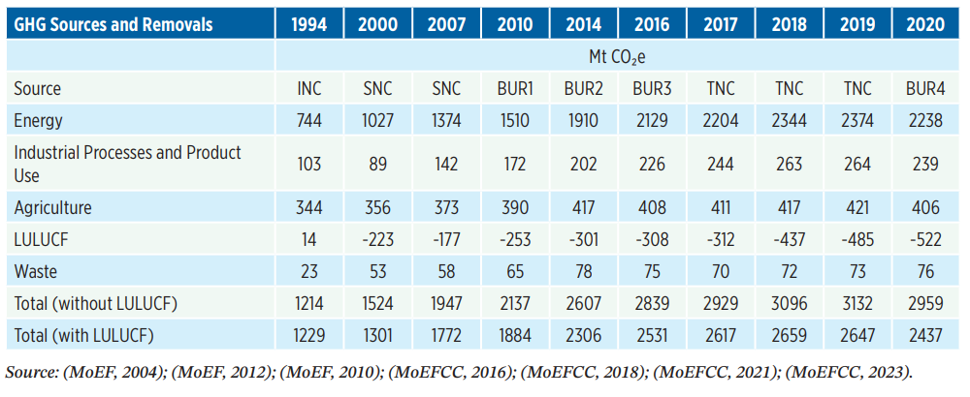
(Source: Fourth BUR to the UNFCCC, MoEF&CC, 2024)

Figure 1. Graphical representation of the total greenhouse gas emission of India in million tonnes CO2-e from 1994 to 2020 (Source: MoEF & CC)
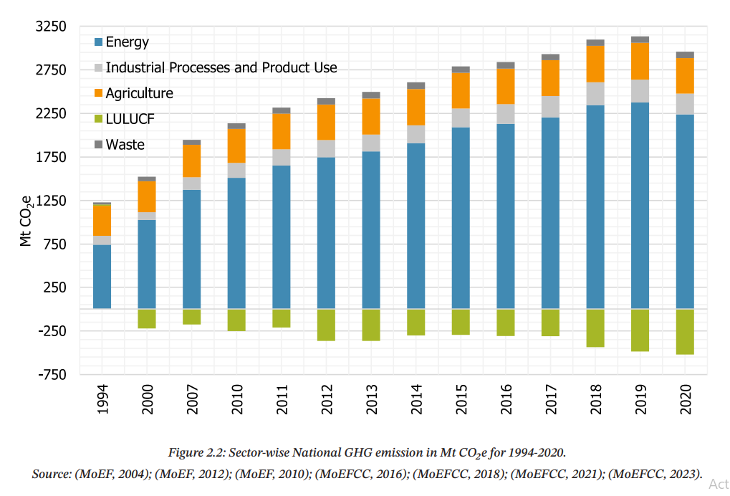
(Source: Fourth BUR to the UNFCCC, MoEF&CC, 2024)

Figure 2. Mechanism of compliance for obligated entities under the Carbon Credit Trading Scheme (CCTS) (Source: BEE, Government of India)
