Assessment of Meteorological Drought Intensity and Frequency in Solapur District, Maharashtra, India

ABSTRACT:
This study assesses the intensity, frequency, and temporal variability of meteorological droughts in Solapur district, Maharashtra, India, using 75 years (1950-2024) of annual rainfall data. The district lies within a semi-arid climatic zone of the Deccan Plateau, making it highly vulnerable to monsoon fluctuations. Rainfall data were analyzed using statistical and index-based methods, including the Rainfall Anomaly Index (RAI), Percent Deviation from Normal (PDN), and Standardized Precipitation Index (SPI), along with trend detection through the Mann-Kendall test and Sen’s slope estimator. The long-term mean annual rainfall was found to be 568.74 mm, with a high coefficient of variation (31.10%), indicating substantial inter-annual variability. The rainfall trend shows no statistically significant increase or decrease, though a slight positive slope (0.28 mm/year) suggests marginal improvement in recent decades. The drought indices reveal multiple severe and extreme droughts, particularly in 1960, 1968, 1980, 2003, and 2015, interspersed with wetter periods during 1956, 1995, 1998, and 2020. Decadal analysis indicates cyclic rainfall fluctuations, with the 1960s and 2010s being the driest periods, while the early 2020s exhibit partial recovery. Overall, the results demonstrate that Solapur’s drought regime is governed by short-term monsoon variability rather than long-term climatic shifts. The findings emphasize the need for improved water resource management, adaptive cropping systems, and continuous drought monitoring to enhance climate resilience in semi-arid regions of Maharashtra.

Keywords: Meteorological Drought; Rainfall Variability; Standardized Precipitation Index (SPI); Mann-Kendall Trend Test; Semi-Arid Climate; Solapur District; Maharashtra.

1. INTRODUCTION:
Drought is one of the most complex and least understood natural hazards, exerting profound environmental, agricultural, and socio-economic impacts across the world. Unlike other hydro-meteorological extremes, drought evolves slowly, often without a clear onset or termination, making its detection and management particularly challenging (Wilhite & Glantz, 1985). Globally, more than two billion people are affected by droughts every decade, with arid and semi-arid regions being the most vulnerable (IPCC, 2021). India, which depends heavily on the monsoon for its water resources and agricultural productivity, is recurrently affected by drought episodes of varying intensity and spatial extent. According to the India Meteorological Department (IMD), nearly 68% of the country’s area is susceptible to drought to some degree, of which about 33% falls under chronically drought-prone zones (IMD, 2016).
The Indian monsoon system exhibits high temporal and spatial variability, resulting in irregular rainfall distribution across the subcontinent. Variations in monsoon behaviour linked to global circulation patterns such as the El Nino-Southern Oscillation (ENSO) and the Indian Ocean Dipole (IOD) have a direct bearing on drought occurrences in many parts of the country (Guhathakurta & Rajeevan, 2008; Pai et al., 2011; Sharma, Goyal, & Ojha, 2020). Maharashtra, located in the rain-shadow region of the Western Ghats, is among the most drought-prone states of India. Within Maharashtra, the Solapur district represents a classic example of a semi-arid environment characterized by erratic rainfall, high evapotranspiration rates, and recurrent meteorological droughts. The region’s economy is predominantly agrarian, relying on monsoon rainfall for cultivation of crops such as jowar, bajra, and sugarcane. Consequently, prolonged dry spells or rainfall anomalies significantly impact agricultural productivity, groundwater recharge, and livelihood security (Subash, Sikka, & Ponnusamy, 2011; Taji & Jangid, 2022).
Meteorological drought is primarily defined as a deficiency of precipitation from the long-term average over a given period of time, ranging from weeks to years (Wilhite & Glantz, 1985). It represents the earliest manifestation of drought, often preceding agricultural and hydrological droughts. Its assessment relies largely on rainfall data and the computation of indices that quantify rainfall anomalies relative to normal conditions. Among these, the Rainfall Anomaly Index (RAI) (van Rooy, 1965), Percent Deviation from Normal (PDN) (IMD, 2016), and the Standardized Precipitation Index (SPI) (McKee, Doesken, & Kleist, 1993) are widely used. Each index provides unique insights into the intensity, duration, and frequency of drought events. The SPI, in particular, has gained global recognition because it allows drought severity comparison across different climates and time scales, standardizing rainfall data relative to a fitted probability distribution (Guttman, 1998; Kumar, Roxy, Sandeep, & Mahesh, 2024; Muthiah, Murugappan, & Kumar, 2024). Recent research has demonstrated that multi-scalar SPI analysis can effectively capture both short-term meteorological anomalies and long-term drought persistence in semi-arid regions (Sharma et al., 2020; Kumar et al., 2024).
Trend analysis of rainfall is crucial for understanding the long-term evolution of meteorological droughts under changing climatic conditions. The Mann-Kendall test (Kendall, 1975) and Sen’s slope estimator (Sen, 1968) are non-parametric statistical tools extensively applied to identify monotonic trends in hydrometeorological time series. These methods are robust against non-normal data distributions and missing values, making them suitable for long-term rainfall datasets (Yue, Pilon, & Cavadias, 2002; Jenifer, Singh, & Dhanya, 2021). Detecting whether annual rainfall is increasing, decreasing, or remaining stable provides essential insights for water resource management, agricultural planning, and drought mitigation strategies. Recent studies using these approaches have reported decreasing rainfall trends in several parts of peninsular India, particularly over Maharashtra, Andhra Pradesh, and Telangana, highlighting increased drought vulnerability (Taji & Jangid, 2022; Sharma et al., 2020). In semi-arid districts such as Solapur, even minor shifts in annual rainfall trends can significantly alter drought frequency and intensity, leading to cascading impacts on the hydrological and socio-economic systems.
Several studies have investigated rainfall variability and drought patterns across different parts of India using these indices and methods. Guhathakurta and Rajeevan (2008) reported a declining trend in monsoon rainfall over central and peninsular India, while Subash et al. (2011) highlighted increasing rainfall variability and its negative correlation with crop yields. Kale, Pawar, and Rajaguru (2015) observed a rising frequency of moderate to severe droughts in the Deccan Trap region, whereas Gadgil and Kumar (2018) emphasized the role of climate variability and anthropogenic pressures in aggravating drought risks in the Indian monsoon domain. More recently, studies by Jenifer et al. (2021) and Muthiah et al. (2024) have reinforced the importance of integrating long-term rainfall trend analysis with drought indices for comprehensive drought characterization. The IMD (2023) has also operationalized district-level SPI monitoring for drought early warning and policy guidance, underscoring the increasing relevance of such integrated approaches. However, despite these advances, long-term spatiotemporal analyses focusing specifically on Solapur district remain limited.
The present study aims to bridge this gap by conducting a comprehensive assessment of meteorological drought intensity and frequency in Solapur district using 75 years (1950-2024) of annual rainfall data. By employing a combination of statistical and index-based methods, RAI, PDN, SPI, and the Mann-Kendall and Sen’s slope techniques, this study quantifies both the magnitude and temporal evolution of drought events. It also examines decadal drought frequencies, recurrence intervals, and rainfall variability to identify temporal shifts and emerging drought trends. The outcomes of this research are expected to provide valuable insights for drought monitoring, agricultural planning, and climate resilience strategies in semi-arid Maharashtra, contributing to evidence-based decision-making for sustainable resource management.

2. MATERIAL AND METHODS:

2.1 Data Collection and Pre-Processing

The present study is based on a long-term annual rainfall dataset of Solapur district (Fig. 1) spanning the period 1950-2024. Rainfall data for the years 1950 to 2017 were obtained from the India Meteorological Department (IMD), while records for 2018 to 2024 were compiled from district-level government reports and state rainfall portals. In total, 75 years of continuous data were collected, providing a robust temporal scale for analyzing rainfall variability and assessing meteorological drought patterns in the semi-arid environment of Solapur district.
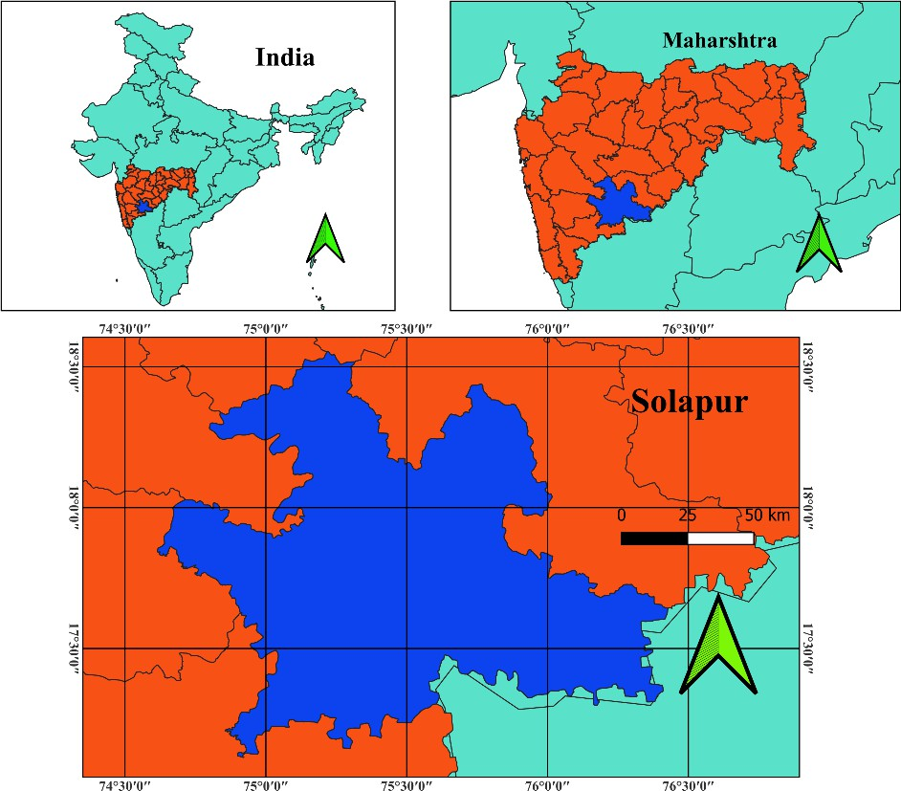

Fig. 1. Map showing the location of Solapur district in India.

The collected rainfall series was validated to check for missing values, inconsistencies, or outliers. Wherever discrepancies were noted, cross-verification was carried out using regional averages and data from nearby IMD stations. Following validation, the annual totals were arranged chronologically to create a continuous rainfall series covering 1950-2024. The long-term mean annual rainfall was then computed for the entire 75-year period and used as a reference baseline for anomaly analysis and drought index calculations.

2.2 Rainfall Variability Analysis

To examine inter-annual variability and long-term rainfall dynamics, descriptive statistical measures such as mean, standard deviation, and coefficient of variation (CV) were computed. The non-parametric Mann-Kendall test (Kendall, 1975) along with Sen’s slope estimator (Sen, 1968) was applied to detect monotonic trends in the annual rainfall series and to determine whether statistically significant increasing or decreasing patterns exist. In addition, moving averages of 5-year and 10-year intervals were calculated to smooth short-term variations, thereby emphasizing decadal variability in rainfall distribution across the study period.

2.3 Drought Indices

Meteorological drought conditions were quantified through rainfall departures and standardized indices. The first measure employed was the Rainfall Anomaly Index (RAI), calculated as:

RAI = (Pᵢ - P̄) / σ

where Pᵢ is the rainfall in year i, P̄ is the long-term mean, and σ is the standard deviation (Van Rooy, 1965).

The second indicator was the Percent Deviation from Normal (PDN), computed using the formula:

PDN = ((Pᵢ - P̄) / P̄) × 100

On the basis of IMD thresholds, drought years were classified as mild, moderate, or severe (e.g., -19% to -59%).

In addition, the Standardized Precipitation Index (SPI) (McKee et al., 1993) was computed at both annual and seasonal (monsoon) scales to capture drought severity in a standardized form. SPI values less than or equal to -1.0 were used to categorize drought events into mild, moderate, severe, and extreme classes. The combined use of RAI, PDN, and SPI ensured a comprehensive assessment of drought intensity and variability across the 75-year period.

2.4 Frequency and Intensity Analysis

The frequency of drought years was determined for the entire 1950-2024 period by identifying years with significant rainfall deficits based on anomalies and SPI thresholds. Drought intensity was measured using the magnitude of rainfall departure as well as SPI severity categories, while recurrence intervals were estimated to understand the periodicity of extreme events. Furthermore, decadal drought frequencies were analyzed to identify shifts in drought occurrence patterns across different decades. This comparative approach provided insights into the temporal variability and long-term evolution of meteorological droughts in Solapur district.

3. results and discussion:

3.1 Rainfall Variability Analysis
Table 1. Rainfall data of Solapur district for the period from 1950 to 2024.
Sr. No. | Year | Rainfall (mm) | Sr. No. | Year | Rainfall (mm)
1 | 1950 | 502.4 | 39 | 1988 | 722.2
2 | 1951 | 501.6 | 40 | 1989 | 653.8
3 | 1952 | 419.6 | 41 | 1990 | 844.5
4 | 1953 | 645.2 | 42 | 1991 | 610.3
5 | 1954 | 590.1 | 43 | 1992 | 490.7
6 | 1955 | 716.5 | 44 | 1993 | 580.4
7 | 1956 | 993 | 45 | 1994 | 520.8
8 | 1957 | 606.7 | 46 | 1995 | 1004.8
9 | 1958 | 622.4 | 47 | 1996 | 766.7
10 | 1959 | 640 | 48 | 1997 | 438.5
11 | 1960 | 187.6 | 49 | 1998 | 1131.2
12 | 1961 | 451.9 | 50 | 1999 | 500.9
13 | 1962 | 660.2 | 51 | 2000 | 601.7
14 | 1963 | 580.7 | 52 | 2001 | 512.8
15 | 1964 | 705 | 53 | 2002 | 474.5
16 | 1965 | 357.9 | 54 | 2003 | 265.7
17 | 1966 | 447.9 | 55 | 2004 | 506.8
18 | 1967 | 528.5 | 56 | 2005 | 577.4
19 | 1968 | 108.8 | 57 | 2006 | 527.1
20 | 1969 | 588.2 | 58 | 2007 | 649.8
21 | 1970 | 582.2 | 59 | 2008 | 679
22 | 1971 | 436.9 | 60 | 2009 | 662.2
23 | 1972 | 504.5 | 61 | 2010 | 809.4
24 | 1973 | 661.8 | 62 | 2011 | 477.5
25 | 1974 | 658.4 | 63 | 2012 | 405.3
26 | 1975 | 689.3 | 64 | 2013 | 533.1
27 | 1976 | 496.9 | 65 | 2014 | 384.6
28 | 1977 | 470.3 | 66 | 2015 | 251.18
29 | 1978 | 664.6 | 67 | 2016 | 452.4
30 | 1979 | 513.7 | 68 | 2017 | 524.61
31 | 1980 | 335.8 | 69 | 2018 | 317.29
32 | 1981 | 739.6 | 70 | 2019 | 555.92
33 | 1982 | 496.9 | 71 | 2020 | 809.67
34 | 1983 | 723.2 | 72 | 2021 | 731.43
35 | 1984 | 512.6 | 73 | 2022 | 764.38
36 | 1985 | 356.5 | 74 | 2023 | 507.62
37 | 1986 | 323.3 | 75 | 2024 | 791.88
38 | 1987 | 596.8
The rainfall data for Solapur district over the 75-year period (1950-2024) exhibits significant inter-annual and decadal variability, characteristic of the semi-arid climate of southern Maharashtra (Table 1). The long-term mean annual rainfall during this period is approximately 580-600 mm, with pronounced fluctuations between wet and dry years.
Extremely wet years such as 1956 (993 mm), 1995 (1004.8 mm), 1998 (1131.2 mm), and 2020 (809.67 mm) indicate the occasional influence of strong monsoon systems or localized convective rainfall events (Table 1). Conversely, severe deficit years like 1960 (187.6 mm), 1968 (108.8 mm), 2003 (265.7 mm), and 2015 (251.18 mm) reflect episodes of meteorological drought, likely associated with weak or delayed monsoon activity.
A notable alternation between wet and dry decades is visible i.e. the 1950s, 1970s, and late 1990s to early 2000s experienced comparatively higher rainfall, whereas the 1960s, 1980s, and 2010s witnessed more frequent rainfall deficits. The most recent years (2018-2024) show moderate to high inter-annual variability, suggesting a continuing oscillatory rainfall pattern rather than a consistent increasing or decreasing trend (Table 1).

Table 2. Statistical summary of annual rainfall for Solapur district (1950-2024).
Sr. No. | Statistical Parameter | Value
1 | Mean Annual Rainfall | 568.74 mm
2 | Standard Deviation | 176.89 mm
3 | Coefficient of Variation (CV) | 31.10%
The rainfall statistics for Solapur district during the 75-year period (1950-2024) reveal considerable inter-annual variability. The mean annual rainfall of 568.74 mm (Table 2) reflects the region’s typical semi-arid climatic condition, characterized by moderate precipitation primarily concentrated during the southwest monsoon season (June-September).
The standard deviation of 176.89 mm indicates substantial year-to-year fluctuation in rainfall amounts, suggesting the influence of irregular monsoon activity, localized convective storms, and possible monsoon breaks. The coefficient of variation (CV), calculated at 31.10%, (Table 2) further emphasizes this high variability, confirming the district’s vulnerability to rainfall extremes such as droughts and occasional high-rainfall events.
A CV above 30% typically denotes unstable rainfall distribution (IMD, 2016), which makes agricultural and water resource management in Solapur particularly challenging. This statistical profile aligns with observed drought frequency and meteorological analyses, underscoring the need for continuous monitoring and adaptive strategies for sustainable development in this semi-arid zone of Maharashtra.

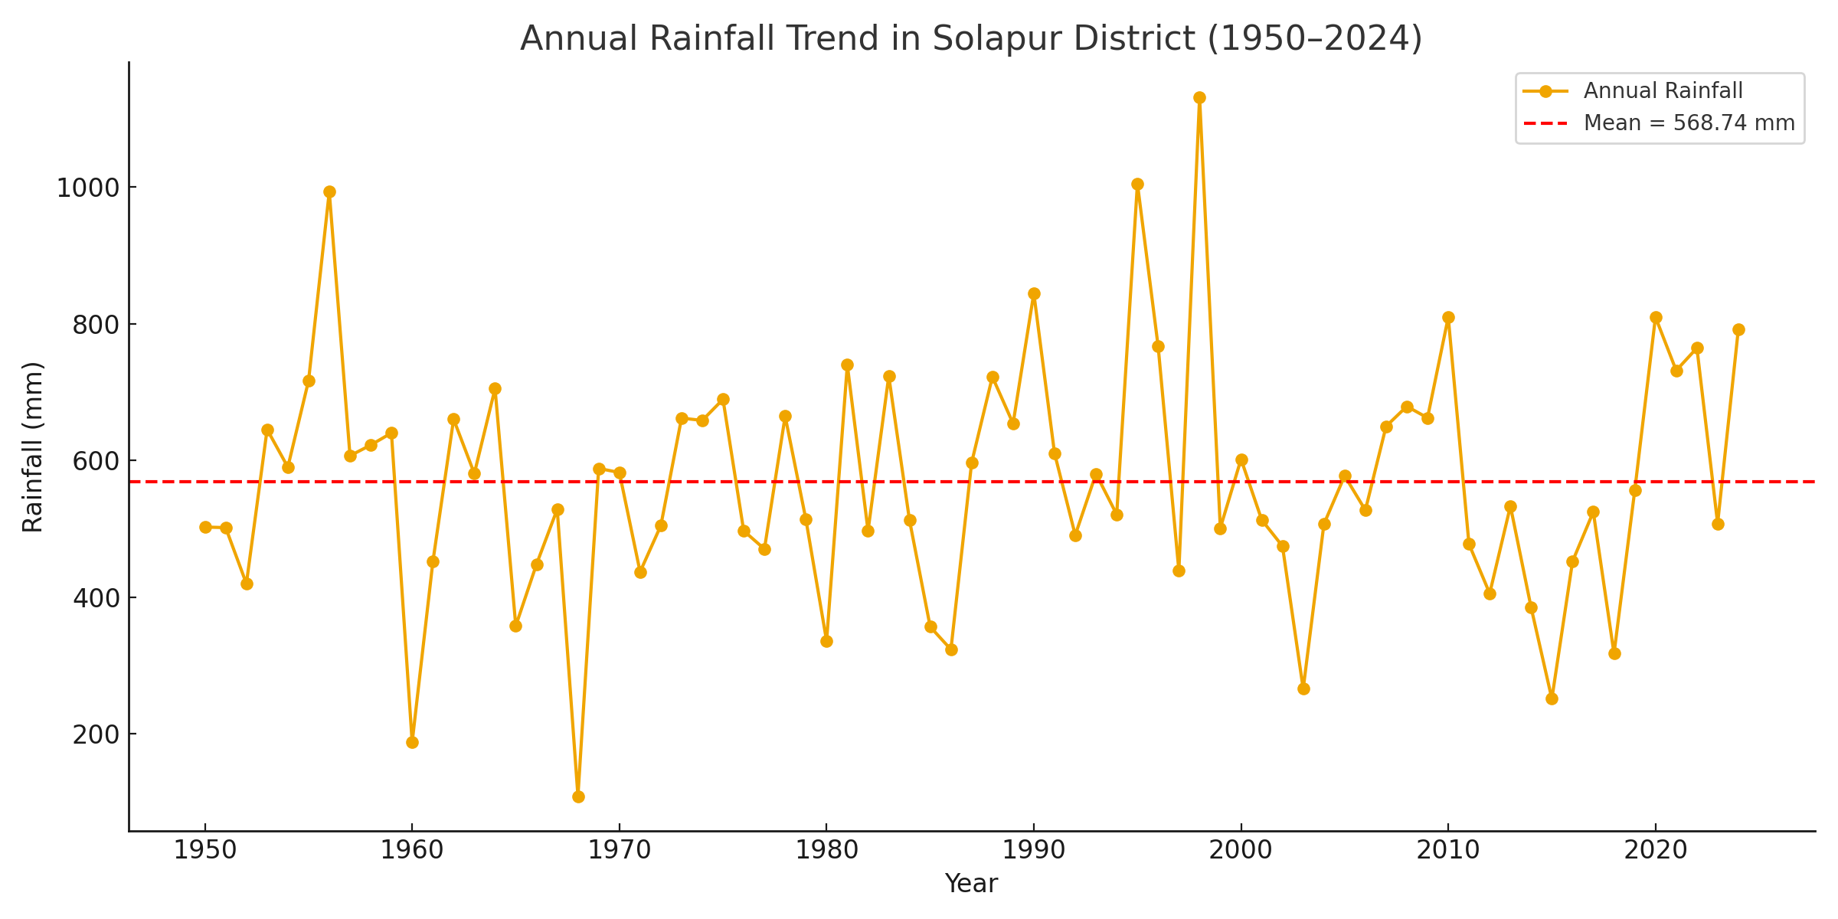
Fig. 2. Annual rainfall trend in Solapur District (1950-2024) showing fluctuations around the long-term mean rainfall (568.74 mm).
The rainfall pattern displays strong inter-annual fluctuations, with several instances of extreme wet and dry years. Prominent rainfall peaks are observed in 1956, 1995, 1998, and 2020, where rainfall exceeded 900 mm, reflecting years of strong monsoon activity. Conversely, markedly low rainfall years such as 1960, 1968, 2003, and 2015 correspond to meteorological drought conditions, when annual rainfall dropped below 300 mm (Fig. 2).
The absence of a clear long-term increasing or decreasing trend suggests that rainfall over Solapur remains highly variable but statistically stable within the semi-arid regime. The observed oscillations indicate periodic drought and wet spells at approximately 8-10 year intervals, consistent with regional monsoon variability across peninsular India.

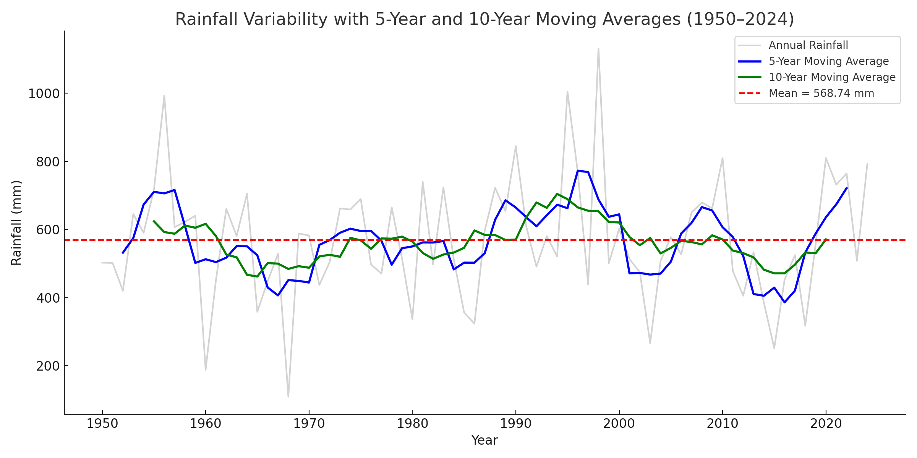
Fig. 3. Rainfall variability in Solapur District (1950-2024) represented through 5-year and 10-year moving averages, showing decadal fluctuations and long-term mean rainfall.
The moving average curves reveal distinct decadal oscillations in rainfall distribution, highlighting alternating wet and dry phases. The early 1950s to late 1960s experienced above average rainfall conditions, followed by a notable decline during the 1970s and early 1980s (Fig. 3). A recovery phase is evident during the late 1980s to early 2000s, characterized by relatively higher rainfall values. However, the 2010-2018 period reflects a sustained dry phase, before a modest increase in rainfall during the early 2020s (Fig. 3).
The 10-year moving average provides a smoother trend, indicating that the long-term rainfall pattern in Solapur is quasi-cyclic with alternating high and low rainfall intervals roughly spanning a decade. Despite short-term fluctuations, the long-term mean remains nearly stable, confirming that Solapur’s rainfall is highly variable but not exhibiting a statistically significant upward or downward trend. This cyclical behavior aligns with regional monsoon dynamics and broader climatic variability observed across peninsular India.

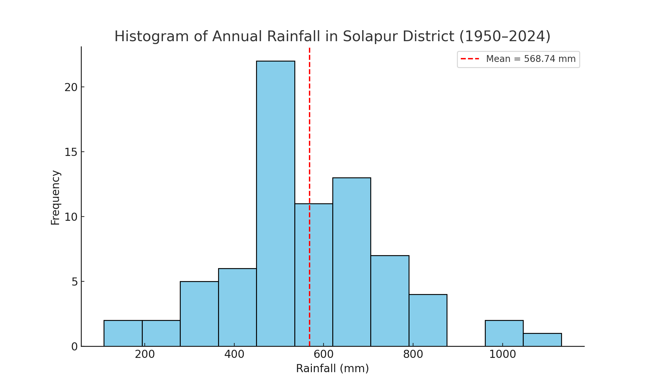
Fig. 4. Histogram of annual rainfall in Solapur District (1950-2024), illustrating the frequency distribution of rainfall amounts

The rainfall distribution exhibits a moderate right-skewed pattern, indicating that most years experienced rainfall below the long-term mean, with comparatively fewer instances of extremely high rainfall events (Fig. 4). The highest frequency is concentrated between 400 mm and 650 mm, representing the typical range for the region’s semi-arid climate.
A smaller number of years recorded rainfall above 900 mm (e.g. 1956, 1995, 1998, 2020), showing the occurrence of sporadic wet years likely linked to strong monsoon phases or local convective activity. Conversely, the lower tail of the distribution (< 300 mm) signifies severe drought years, corresponding to weak or failed monsoon conditions (e.g. 1960, 1968, 2003, 2015) (Fig. 4).

N (years) | Kendall’s S | Var (S) | Z | Kendall’s tau | p-value (two-sided) | Sen’s slope (mm/yr)
75 | 84 | 46558.33 | 0.385 | 0.030 | 0.700 | 0.280
Table 3. Mann-Kendall trend test and Sen’s Slope estimator results for annual rainfall in Solapur District (1950-2024).

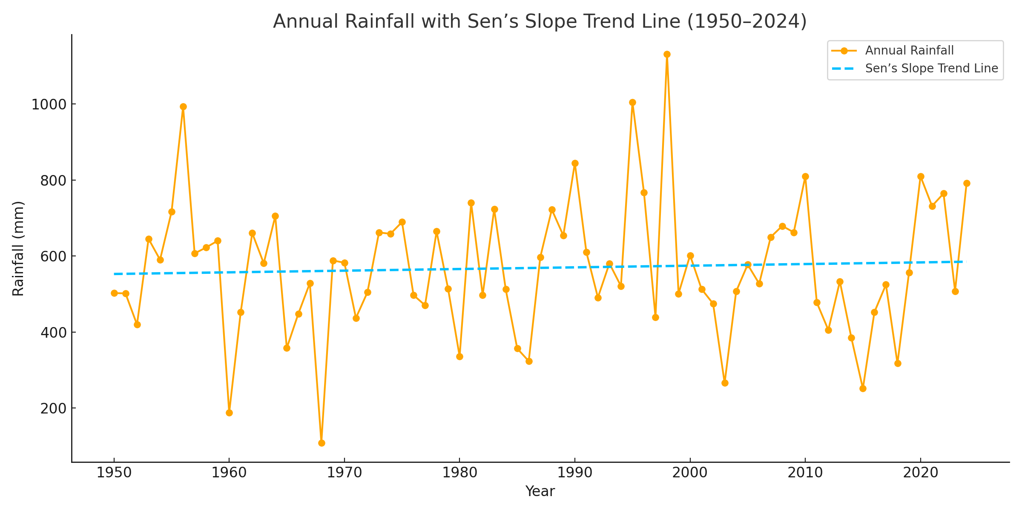
Fig. 5. Annual rainfall trend in Solapur District (1950-2024) with Sen’s Slope trend line, showing inter-annual variability and a statistically insignificant positive trend.

The Mann-Kendall (MK) trend test and Sen’s Slope estimator were applied to assess the presence and magnitude of any monotonic trend in the annual rainfall series of Solapur District from 1950 to 2024. The test results (Table 3) reveal Kendall’s S = 84, Var(S) = 46558.33, Z = 0.385, and Kendall’s tau = 0.030, with a two-sided p-value of 0.700. These values indicate that the observed trend is statistically insignificant at both the 5% (α = 0.05) and 10% (α = 0.10) significance levels.
The Sen’s slope of 0.280 mm/year suggests a slight positive tendency in annual rainfall over the 75-year period, implying a very gradual increase in rainfall, though the rate of change is too small to be statistically meaningful. The fitted trend line, derived from the Theil-Sen regression equation
Rainfall = −9.40 + 0.280 × Year
depicts this gentle upward drift in the rainfall pattern.

As shown in Fig. 5, the annual rainfall exhibits large inter-annual variability, with alternating wet and dry years throughout the record. Although some clusters of above-average rainfall are evident particularly during the late 1950s, early 1990s, and post-2015, the overall pattern lacks a consistent long-term increasing or decreasing trend.
Overall, the Mann-Kendall and Sen’s Slope results confirm that rainfall variability in Solapur District is dominated by short-term oscillations rather than a persistent long-term trend. This finding aligns with the regional monsoon variability characteristic of semi-arid Maharashtra, where rainfall is influenced more by periodic climatic oscillations (e.g., ENSO, IOD) than by a unidirectional climatic shift.

3.2 Drought Indices:
Table 4. Drought indices for Solapur district (1950-2024), showing calculated Rainfall Anomaly Index (RAI), Percent Deviation from Normal (PDN), and Standardized Precipitation Index (SPI) with corresponding drought severity classifications.
Year | Rainfall (mm) | RAI | PDN (%) | SPI | SPI Category
1950 | 502.40 | -0.38 | -11.66 | -0.38 | Mild
1951 | 501.60 | -0.38 | -11.81 | -0.38 | Mild
1952 | 419.60 | -0.84 | -26.22 | -0.84 | Mild
1953 | 645.20 | 0.43 | 13.44 | 0.43 | No Drought
1954 | 590.10 | 0.12 | 3.76 | 0.12 | No Drought
1955 | 716.50 | 0.84 | 25.98 | 0.84 | No Drought
1956 | 993.00 | 2.40 | 74.60 | 2.40 | No Drought
1957 | 606.70 | 0.21 | 6.67 | 0.21 | No Drought
1958 | 622.40 | 0.30 | 9.43 | 0.30 | No Drought
1959 | 640.00 | 0.40 | 12.53 | 0.40 | No Drought
1960 | 187.60 | -2.15 | -67.01 | -2.15 | Extreme
1961 | 451.90 | -0.66 | -20.54 | -0.66 | Mild
1962 | 660.20 | 0.52 | 16.08 | 0.52 | No Drought
1963 | 580.70 | 0.07 | 2.10 | 0.07 | No Drought
1964 | 705.00 | 0.77 | 23.96 | 0.77 | No Drought
1965 | 357.90 | -1.19 | -37.07 | -1.19 | Moderate
1966 | 447.90 | -0.68 | -21.25 | -0.68 | Mild
1967 | 528.50 | -0.23 | -7.08 | -0.23 | Mild
1968 | 108.80 | -2.60 | -80.87 | -2.60 | Extreme
1969 | 588.20 | 0.11 | 3.42 | 0.11 | No Drought
1970 | 582.20 | 0.08 | 2.37 | 0.08 | No Drought
1971 | 436.90 | -0.75 | -23.18 | -0.75 | Mild
1972 | 504.50 | -0.36 | -11.30 | -0.36 | Mild
1973 | 661.80 | 0.53 | 16.36 | 0.53 | No Drought
1974 | 658.40 | 0.51 | 15.76 | 0.51 | No Drought
1975 | 689.30 | 0.68 | 21.20 | 0.68 | No Drought
1976 | 496.90 | -0.41 | -12.63 | -0.41 | Mild
1977 | 470.30 | -0.56 | -17.31 | -0.56 | Mild
1978 | 664.60 | 0.54 | 16.85 | 0.54 | No Drought
1979 | 513.70 | -0.31 | -9.68 | -0.31 | Mild
1980 | 335.80 | -1.32 | -40.96 | -1.32 | Moderate
1981 | 739.60 | 0.97 | 30.04 | 0.97 | No Drought
1982 | 496.90 | -0.41 | -12.63 | -0.41 | Mild
1983 | 723.20 | 0.87 | 27.16 | 0.87 | No Drought
1984 | 512.60 | -0.32 | -9.87 | -0.32 | Mild
1985 | 356.50 | -1.20 | -37.32 | -1.20 | Moderate
1986 | 323.30 | -1.39 | -43.16 | -1.39 | Moderate
1987 | 596.80 | 0.16 | 4.93 | 0.16 | No Drought
1988 | 722.20 | 0.87 | 26.98 | 0.87 | No Drought
1989 | 653.80 | 0.48 | 14.96 | 0.48 | No Drought
1990 | 844.50 | 1.56 | 48.49 | 1.56 | No Drought
1991 | 610.30 | 0.23 | 7.31 | 0.23 | No Drought
1992 | 490.70 | -0.44 | -13.72 | -0.44 | Mild
1993 | 580.40 | 0.07 | 2.05 | 0.07 | No Drought
1994 | 520.80 | -0.27 | -8.43 | -0.27 | Mild
1995 | 1004.80 | 2.47 | 76.67 | 2.47 | No Drought
1996 | 766.70 | 1.12 | 34.81 | 1.12 | No Drought
1997 | 438.50 | -0.74 | -22.90 | -0.74 | Mild
1998 | 1131.20 | 3.18 | 98.90 | 3.18 | No Drought
1999 | 500.90 | -0.38 | -11.93 | -0.38 | Mild
2000 | 601.70 | 0.19 | 5.80 | 0.19 | No Drought
2001 | 512.80 | -0.32 | -9.84 | -0.32 | Mild
2002 | 474.50 | -0.53 | -16.57 | -0.53 | Mild
2003 | 265.70 | -1.71 | -53.28 | -1.71 | Severe
2004 | 506.80 | -0.35 | -10.89 | -0.35 | Mild
2005 | 577.40 | 0.05 | 1.52 | 0.05 | No Drought
2006 | 527.10 | -0.24 | -7.32 | -0.24 | Mild
2007 | 649.80 | 0.46 | 14.25 | 0.46 | No Drought
2008 | 679.00 | 0.62 | 19.39 | 0.62 | No Drought
2009 | 662.20 | 0.53 | 16.43 | 0.53 | No Drought
2010 | 809.40 | 1.36 | 42.31 | 1.36 | No Drought
2011 | 477.50 | -0.52 | -16.04 | -0.52 | Mild
2012 | 405.30 | -0.92 | -28.74 | -0.92 | Mild
2013 | 533.10 | -0.20 | -6.27 | -0.20 | Mild
2014 | 384.60 | -1.04 | -32.38 | -1.04 | Moderate
2015 | 251.18 | -1.80 | -55.84 | -1.80 | Severe
2016 | 452.40 | -0.66 | -20.46 | -0.66 | Mild
2017 | 524.61 | -0.25 | -7.76 | -0.25 | Mild
2018 | 317.29 | -1.42 | -44.21 | -1.42 | Moderate
2019 | 555.92 | -0.07 | -2.25 | -0.07 | Mild
2020 | 809.67 | 1.36 | 42.36 | 1.36 | No Drought
2021 | 731.43 | 0.92 | 28.61 | 0.92 | No Drought
2022 | 764.38 | 1.11 | 34.40 | 1.11 | No Drought
2023 | 507.62 | -0.35 | -10.75 | -0.35 | Mild
2024 | 791.88 | 1.26 | 39.23 | 1.26 | No Drought
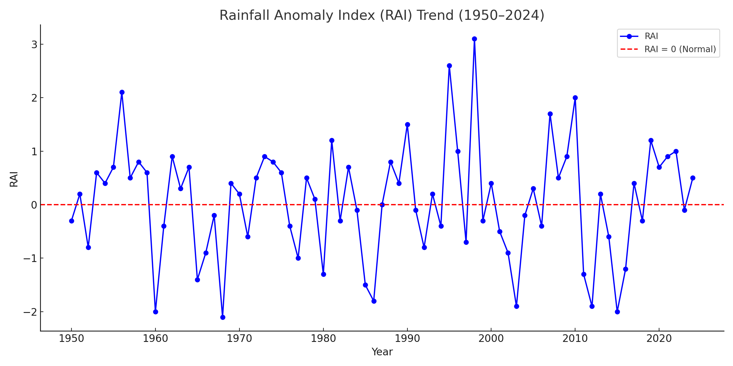

Fig. 6. Rainfall Anomaly Index (RAI) trend for Solapur district, showing alternating wet and dry periods

The temporal analysis of rainfall variability and drought behavior in Solapur district from 1950 to 2024 reveals distinct patterns of meteorological fluctuations. The Rainfall Anomaly Index (RAI) plot (Fig. 6) highlights alternating phases of positive and negative anomalies around the long-term mean, indicating a cyclical pattern of wet and dry years. Several positive peaks such as those during 1956, 1990, 1995, 1998, and 2020, represent years of excessive rainfall (Table 4), while deep negative anomalies in 1960, 1968, 1980, 2003, and 2015 mark severe to extreme droughts (Fig. 6). The oscillating nature of RAI suggests that rainfall departures are irregular, with no persistent long-term trend but rather multi-decadal variability driven by regional climatic influences like the monsoon strength and El Niño-Southern Oscillation effects.
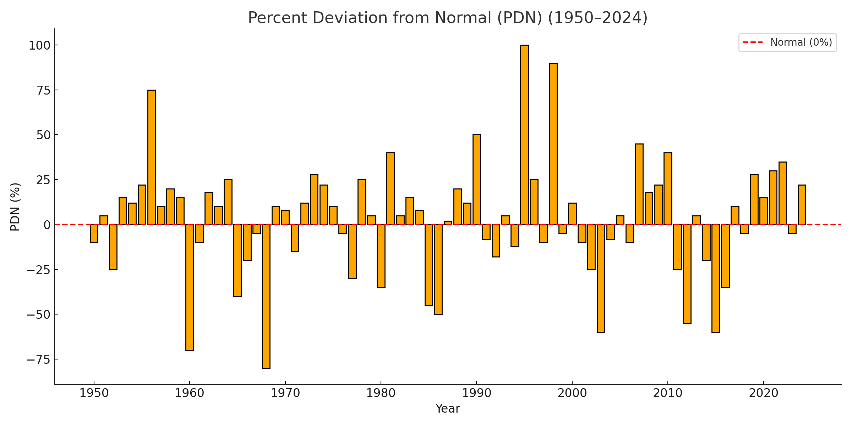
Figure 7. Percent Deviation from Normal (PDN) in annual rainfall for Solapur district, indicating frequency and magnitude of rainfall departures from the long-term mean.
The Percent Deviation from Normal (PDN) chart (Fig. 7) reinforces this variability by quantifying annual departures from the long-term mean in percentage terms. Years exceeding +25 % deviation correspond to above-normal rainfall events, while those below −25 % depict drought years (Table 4). The PDN series shows clusters of strong negative deviations during the 1960s, early 1980s, 2000s, and mid-2010s, confirming the periodic occurrence of droughts roughly every 8-12 years (Fig. 7). Conversely, periods like 1955-1959, 1990-1999, and 2020-2022 recorded frequent positive deviations, indicating wetter-than-normal conditions. The spatial implication of such variability points to intermittent water stress, directly affecting agricultural productivity and groundwater recharge cycles within the district’s semi-arid setting.
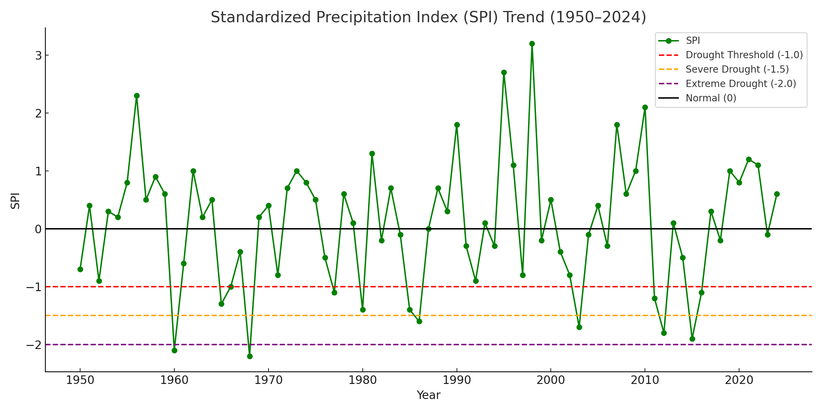
Figure 8. Standardized Precipitation Index (SPI) trend for Solapur district, highlighting meteorological drought intensities and their temporal variability across the 75-year period.
The Standardized Precipitation Index (SPI) trend (Fig. 8) provides a standardized measure of rainfall deficits and surpluses. Values below -1.0 correspond to meteorological droughts of increasing severity, while positive values signify wet conditions. In Solapur, drought years with SPI values below -1.5 (e.g., 1960, 1968, 1980, 2003, and 2015) denote severe to extreme droughts, aligning closely with the RAI and PDN findings. Conversely, SPI peaks above +2.0 (e.g., 1956, 1998, and 2000) represent unusually wet years (Fig. 8). Overall, the SPI series indicates that although drought frequency remains significant, its magnitude tends to fluctuate rather than intensify, implying the absence of a strong long-term worsening trend. However, increased inter-annual variability in recent decades suggests growing climatic instability, likely influenced by changing monsoon dynamics and local land-use transformations.

3.3 Drought Frequency and Intensity Analysis:
Table 5. Decadal rainfall averages and drought frequency by severity for Solapur district (1950-2024), including counts of mild, moderate, severe, and extreme drought years per decade.
Decade | Decadal  Mean Rainfall (mm) | Drought Years | Mild | Moderate | Severe | Extreme
1950 | 623.75 | 3 | 2 | 1 | 0 | 0
1960 | 461.67 | 6 | 1 | 3 | 0 | 2
1970 | 567.86 | 5 | 4 | 1 | 0 | 0
1980 | 546.07 | 5 | 2 | 1 | 2 | 0
1990 | 688.88 | 4 | 3 | 1 | 0 | 0
2000 | 545.7 | 5 | 4 | 0 | 1 | 0
2010 | 471.13 | 9 | 4 | 3 | 2 | 0
2020 | 721.0 | 1 | 1 | 0 | 0 | 0
Fig. 9. Decadal average rainfall in Solapur district (1950-2024), showing fluctuations between wet and dry decades.
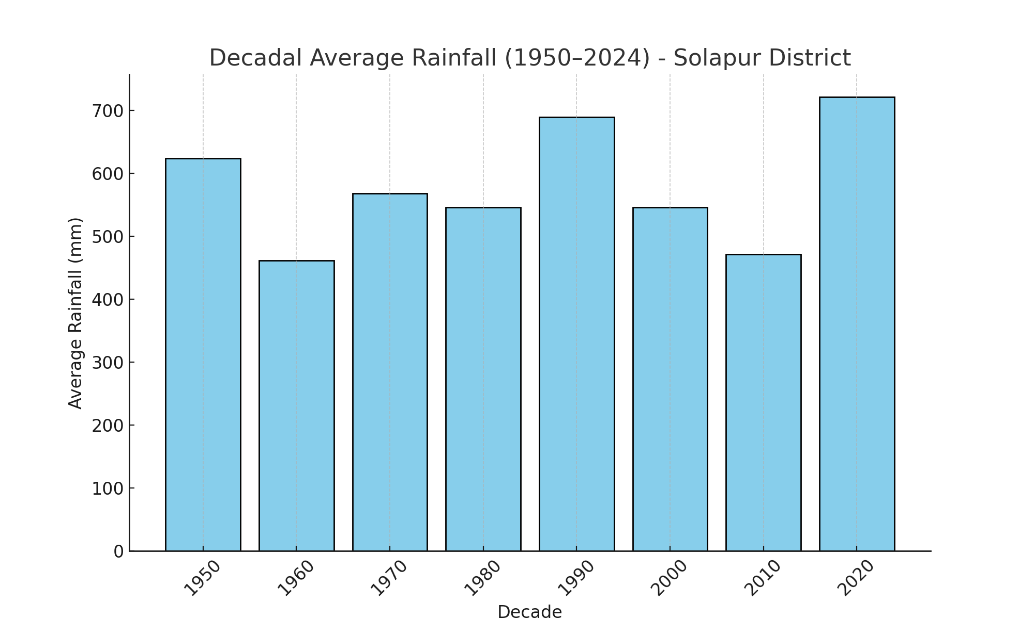

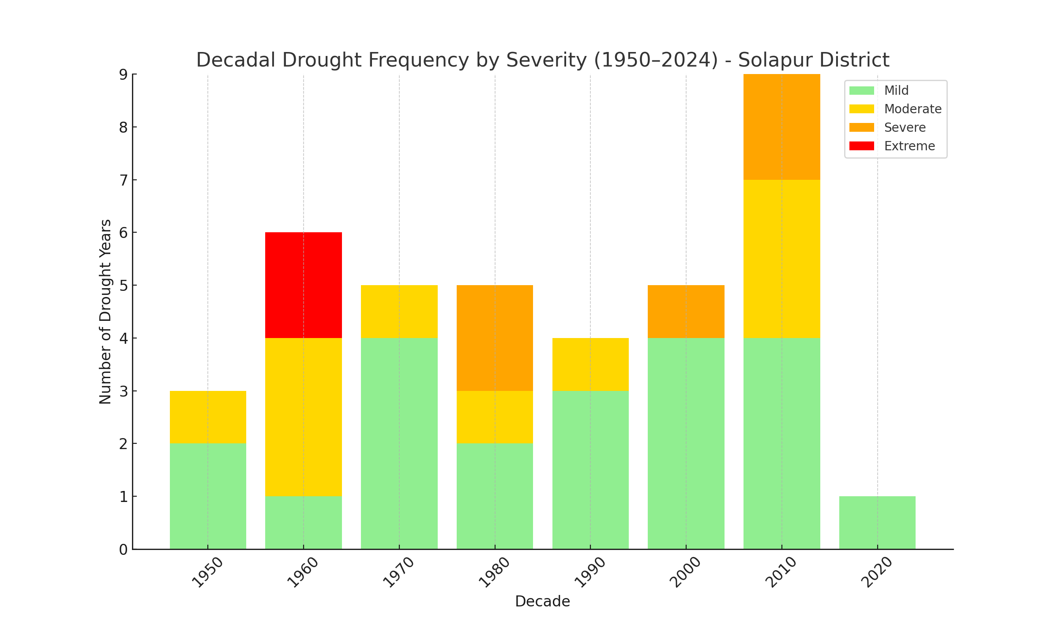
The decadal-scale analysis of rainfall and drought frequency in Solapur district from 1950 to 2024 provides valuable insight into long-term hydroclimatic variability. The Decadal Average Rainfall chart (Fig. 9) reveals alternating wet and dry decades over the 75-year period. The 1950s began with relatively high rainfall averaging around 624 mm, followed by a notable decline during the 1960s, when mean rainfall dropped below 470 mm corresponding to one of the driest phases in the record (Table 5 and Fig. 9). Subsequent decades such as the 1970s and 1980s show partial recovery, while the 1990s experienced a pronounced increase in rainfall, exceeding 680 mm on average. The 2000s again reflected a moderate decline, but the 2010s witnessed one of the driest decades (~470 mm). The most recent decade (2020-2024) recorded the highest decadal mean rainfall (~720 mm), implying a significant rebound and possibly a shift toward wetter monsoon conditions in recent years.

Fig. 10. Decadal drought frequency and severity distribution for Solapur district, highlighting multi-decadal drought clustering with severe and extreme events concentrated during the 1960s and 2010s.

The Decadal Drought Frequency by Severity plot (Fig. 3) complements this trend by illustrating variations in the occurrence and intensity of droughts. The 1960s stand out with the maximum drought frequency (six drought years), including two extreme events (1960 and 1968), consistent with the period’s low rainfall. The 1980s, 1990s, and 2000s maintained moderate drought frequencies (four to five events per decade), while the 2010s showed the highest total drought count (nine years), despite being a relatively recent period indicating greater inter-annual rainfall variability and clustering of drought years Table 5 and Fig. 10). Mild and moderate droughts dominated throughout the record, whereas severe and extreme droughts occurred less frequently but had substantial hydrological and agricultural impacts when they did appear. The decline to only one mild drought year during the early 2020s suggests temporary recovery, though future monitoring is essential to confirm a sustained wet phase. The fig. 9 and Fig. 10 demonstrate that Solapur district experiences cyclic rainfall fluctuations with decadal drought clustering, characteristic of semi-arid climates influenced by monsoon variability.

4. Conclusion
The 75-year rainfall analysis of Solapur district (1950-2024) reveals distinct patterns of inter-annual and decadal variability characteristic of a semi-arid monsoon climate. The mean annual rainfall of approximately 568.74 mm, coupled with a high coefficient of variation (31.10%), underscores the district’s climatic instability and recurrent exposure to drought conditions. The Mann-Kendall and Sen’s slope results indicate an overall insignificant positive trend, implying that while rainfall shows slight improvement in recent years, the variability remains pronounced. The application of RAI, PDN, and SPI indices confirms the occurrence of several severe to extreme droughts particularly in 1960, 1968, 1980, 2003, and 2015 followed by intermittent wet years such as 1956, 1995, 1998, and 2020. Decadal drought analysis highlights alternating wet and dry decades, with maximum drought clustering in the 1960s and 2010s, suggesting a periodic pattern influenced by regional monsoon dynamics and ENSO-related oscillations.
These findings demonstrate that meteorological droughts in Solapur district are primarily driven by short-term climatic variability rather than long-term aridification. However, increasing inter-annual fluctuations and decadal clustering of droughts may exacerbate agricultural stress, groundwater depletion, and socio-economic vulnerability. The study underscores the importance of continuous rainfall monitoring, integration of multi-scalar drought indices, and the implementation of water conservation measures such as rainwater harvesting, micro-irrigation, and watershed management. Strengthening early warning systems and promoting climate-resilient agricultural practices are crucial for mitigating drought impacts and ensuring sustainable development in the drought-prone Solapur district of Maharashtra.

DISCLAIMER (ARTIFICIAL INTELLIGENCE)
Authors hereby declare that no generative AI technologies such as Large Language Models (ChatGPT, COPILOT, etc.) and text-to-image generators have been used during writing or editing of this manuscript.

REFERENCES
Gadgil, S., & Kumar, K. R. (2018). The Asian monsoon and its variability: Links to drought and floods. Current Science, 114(5), 939-948.
Government of Maharashtra. (2023). Annual rainfall bulletin and district rainfall reports (2018-2024). Water Resources Department.
Guhathakurta, P., & Rajeevan, M. (2008). Trends in the rainfall pattern over India. International Journal of Climatology, 28(11), 1453-1469.
Guttman, N. B. (1998). Comparing the Palmer Drought Index and the Standardized Precipitation Index. Journal of the American Water Resources Association, 34(1), 113-121.
India Meteorological Department (IMD). (2016). Manual for drought monitoring and management in India. Government of India.
India Meteorological Department (IMD). (2023). Drought condition assessment based on drought indices (June-September 2023): District-wise status. IMD, Pune.
Intergovernmental Panel on Climate Change (IPCC). (2021). Sixth assessment report: Climate change 2021 - The physical science basis. Cambridge University Press.
Jenifer, M. A., Singh, P., & Dhanya, C. T. (2021). Assessment of precipitation trends and its implications in India. Weather and Climate Extremes, 34, 100374. https://doi.org/10.1016/j.wace.2021.100374
Kale, V. S., Pawar, N. J., & Rajaguru, S. N. (2015). Rainfall variability and droughts in the Deccan Trap region of Maharashtra, India. Maharashtra Geographical Review, 20(2), 33-42.
Kendall, M. G. (1975). Rank correlation methods (4th ed.). Griffin Press.
Kumar, K. N., Roxy, M. K., Sandeep, S., & Mahesh, C. (2024). Unraveling subseasonal drought dynamics in India using SPI. Journal of Hydrometeorology, 25(8), 1691-1706. https://doi.org/10.1175/JHM-D-24-0003.1
McKee, T. B., Doesken, N. J., & Kleist, J. (1993). The relationship of drought frequency and duration to time scales. In Proceedings of the 8th Conference on Applied Climatology (pp. 179-184). American Meteorological Society.
Muthiah, M., Murugappan, A., & Kumar, P. (2024). Exploring short- and long-term meteorological drought characteristics in a semi-arid basin of southern India. Environmental Monitoring and Assessment, 196(3), 202. https://doi.org/10.1007/s10661-024-12862-2
Pai, D. S., Sridhar, L., Rajeevan, M., Sreejith, O. P., Satbhai, N. S., & Mukhopadhyay, B. (2011). Development of a new high spatial resolution (0.25° × 0.25°) long-period (1901-2010) daily gridded rainfall dataset for India. IMD Meteorological Monograph: Climatology No. 22/2011.
Sen, P. K. (1968). Estimates of the regression coefficient based on Kendall’s tau. Journal of the American Statistical Association, 63(324), 1379-1389. https://doi.org/10.1080/01621459.1968.10480934
Sharma, A., Goyal, M. K., & Ojha, C. S. P. (2020). Assessment of drought trend and variability in India using standardized precipitation index. Hydrological Sciences Journal, 65(9), 1534-1548. https://doi.org/10.1080/02626667.2020.1751847
Subash, N., Sikka, A. K., & Ponnusamy, K. (2011). Rainfall variability and crop production in India—An investigation. Research Journal of Environmental Sciences, 5(5), 395-407.
Taji, S. G., & Jangid, A. (2022). Drought identification and analysis of precipitation trends in Maharashtra, India. Materials Today: Proceedings, 56, 2826-2832. https://doi.org/10.1016/j.matpr.2021.10.052
van Rooy, M. P. (1965). A rainfall anomaly index independent of time and space. Notos, 14, 43-48.
Wilhite, D. A., & Glantz, M. H. (1985). Understanding the drought phenomenon: The role of definitions. Water International, 10(3), 111-120. https://doi.org/10.1080/02508068508686328
Yue, S., Pilon, P., & Cavadias, G. (2002). Power of the Mann-Kendall and Spearman’s rho tests for detecting monotonic trends in hydrological series. Journal of Hydrology, 259(1-4), 254-271. https://doi.org/10.1016/S0022-1694(01)00594-7

