Original Research Article

The delicate balancing of oxidative stress and accumulation of antioxidants in finger millet under high temperature stress and elevated CO₂ x drought stress interactions

ABSTRACT

Aims:
The study aimed to evaluate the oxidative stress responses and antioxidant regulation in four finger millet genotypes (GPU 28, ML 365, GPU 66, and GPU 67) under high temperature and elevated CO₂ x drought stress interaction.
Study Design:
A controlled pot experiment was conducted with two-factorial Completely Randomized Design (CRD) to assess oxidative stress indicators and antioxidant activity under varied environmental stress combinations.
Place and Duration of Study:
The experiment was carried out at the College of Agriculture, Vellayani, using Polyhouse and Open Top Chamber (OTC) facilities during the 2023–2025 cropping seasons.
Methodology:
Four finger millet genotypes were exposed to high temperature and elevated CO₂ with drought treatments. Hydrogen peroxide (H₂O₂) accumulation in leaves was detected by 3,3′-diaminobenzidine (DAB) staining to visualize oxidative damage, while total antioxidant activity was estimated using the ferric reducing antioxidant power (FRAP) assay. The intensity of DAB staining and FRAP values were compared among genotypes and treatments to assess stress-induced variations in reactive oxygen species (ROS) accumulation and antioxidant defence.
Results:
High temperature stress caused intense DAB staining in all genotypes, indicating severe oxidative stress, with GPU 67 showing the highest H₂O₂ accumulation and GPU 28 the lowest. Under elevated CO₂ x drought interaction, lighter staining patterns were observed, suggesting reduced ROS buildup due to CO₂-induced mitigation of oxidative injury. Antioxidant activity increased significantly under both stress conditions, with the maximum increase recorded in ML 365 (522%) and GPU 28 (403.78%) under heat stress. Elevated CO₂ and drought also enhanced antioxidant levels, though to a lesser degree.
Conclusion:
High temperature imposed the greatest oxidative load on finger millet, while elevated CO₂ alleviated stress effects. Genotypes GPU 28 and ML 365 exhibited superior oxidative stress tolerance through efficient antioxidant regulation, indicating their potential resilience and productivity under future climate change scenarios.

Key words: DAB staining; total antioxidants; finger millet; high temperature; elevated CO₂ and drought

1. INTRODUCTION

Plants grow and reproduce in a complex environment shaped by both abiotic and biotic factors. Biotic stresses such as pathogen infection, insect attack, and herbivore damage, along with abiotic stresses including heat, salinity, drought, cold, and heavy metal toxicity, significantly reduce crop productivity worldwide. Fluctuations in these factors induce a generalized defense response in plants known as oxidative stress, which can disrupt normal cellular functions by damaging biomolecules and organelles. This oxidative stress is primarily triggered by the overproduction of reactive oxygen species (ROS), including superoxide anion (O₂•⁻), hydroxyl radical (OH•), hydrogen peroxide (H₂O₂), nitric oxide (NO), and singlet oxygen (¹O₂) (Apel and Hirt, 2004). ROS is highly reactive due to their short-lived unpaired electrons. In addition to oxygen-centered radicals, some carbon-centered radicals also contribute to oxidative damage. Both ROS and free radicals are generated through the action of enzymes such as NADPH oxidase and peroxidases (Hasanuzzaman and Fujita (2022)).
Under stress conditions, ROS levels increase drastically within cellular organelles—H₂O₂ accumulates in peroxisomes, while O₂•⁻ is generated via the electron transport chains of chloroplasts and mitochondria (Apel and Hirt, 2004). The plasma membrane also acts as a major site of ROS production in response to both internal and external stimuli. To mitigate oxidative damage, plants possess a comprehensive antioxidant defense system, comprising both enzymatic and non-enzymatic components. The enzymatic antioxidants—including superoxide dismutase (SOD), ascorbate peroxidase (APX), peroxidase (POX), catalase (CAT), and glutathione reductase (GR)—play a crucial role in ROS detoxification. Additionally, the alternative oxidase (AOX) pathway in mitochondria helps minimize ROS formation by maintaining electron transport balance (Cannea et al., 2025). Alongside these enzymes, non-enzymatic antioxidants such as ascorbate, glutathione, vitamins, flavonoids, phenolic acids, and anthocyanins also play significant roles in scavenging ROS.
For ROS detection in plants, several analytical and histochemical methods have been developed, each with specific advantages and limitations. Among these, 3,3′-diaminobenzidine (DAB) staining is commonly used to visualize H₂O₂ accumulation, where the appearance of brown-coloured precipitates indicates ROS production (Ramel et al., 2009).

2. material and methods

The impact of high temperature, elevated CO₂, and drought stress was assessed in four finger millet genotypes GPU 28, ML 365, GPU 66, and GPU 67 using the Polyhouse and Open Top Chamber system (OTCs) facilities available at the Department of Plant Physiology, College of Agriculture, Vellayani. Pot experiments were conducted under three environmental conditions: ambient (with a maximum temperature of 35°C), high temperature in the polyhouse (up to 40°C), and elevated CO₂ (500 ppm) combined with drought stress (maintained at 60% field capacity using the gravimetric method) in the OTCs facility.

2.1 Estimation of H₂O₂ by DAB Staining
H₂O₂ generation in plant samples were determined by 3, 3-Diaminobenzidine (DAB) staining technique described by (Kumar et al., 2014). The treatmented and control leaves after 60 days of planting were dipped in DAB solution prepared by dissolving 50 mg DAB in 45 ml distilled water in an amber-coloured bottle. The pH was adjusted to 3.8 using 0.l N HCl while mixing properly on a magnetic stirrer, the volume was made to 50 ml to get 1 mg ml⁻¹ solution. DAB staining solution was prepared freshly before use. Chlorophyll was removed for proper visualization of the stain. This was done by immersing the leaves in 3:1 (ethanol: glacial acetic acid (85 %)) and heating in a boiling water bath at 50-55°℃. The stained leaves were photographed against a contrast background for proper documentation.

2.2 Estimation of total antioxidants
Total antioxidant activity was measured by the ferric reducing antioxidant power (FRAP) assay of Benzie and Strain (1999). FRAP assay uses antioxidants as reductants in a redox-linked colourimetric method, employing an easily reduced oxidant system in stoichiometric excess. 0.5 g of leaf tissue samples were collected from middle portion of index leaf was macerated with acetate buffer (pH 3.6), centrifuged, and the supernatant was taken. 250 µl of the sample was mixed with 3 ml of working FRAP reagent, and absorbance (593 nm) was measured at 0 minutes after vortexing absorption was again measured after 4 minutes. Ascorbic acid standards were used, and they were processed in the same way at different concentrations (100µM-1000µM).

3. results and discussion

Visualization of hydrogen peroxide accumulation using DAB (3,3′-diaminobenzidine) staining revealed distinct differences among the finger millet genotypes GPU 28, ML 365, GPU 66, and GPU 67 when exposed to high temperature and elevated CO₂ x drought interaction. The extent of brown coloration, indicative of H₂O₂ accumulation and oxidative stress, varied both across genotypes and treatments.
Under high temperature stress, the degree of DAB staining increased sharply in all genotypes, signifying an elevated level of oxidative stress. The brown coloration was particularly intense in GPU 67, followed by GPU66, ML365 and GPU 28 (fig1). The darker brown deposits in GPU 67 indicate excessive H₂O₂ accumulation, which may be attributed to enhanced ROS generation through heat-induced disruption of chloroplast and mitochondrial electron transport chains. The comparatively lighter staining in GPU 28 suggests better maintenance of redox homeostasis and indicates its relative tolerance to thermal stress.
Leaf tissues collected from all the genotypes under elevated CO₂ x drought interaction exhibited relatively lighter brown colouration compared to those collected from the experimental plants maintained under high temperature stress. This indicated reduced accumulation of H₂O₂, suggesting that elevated CO₂ potentially alleviated oxidative stress through enhanced carbon assimilation and downregulation of photorespiration. Among these, GPU 66 showed slightly higher brown colouration compared to other genotypes, suggesting relatively greater ROS accumulation, while GPU 28 and ML 365 showed visibly lighter staining, indicating more efficient oxidative balance (fig 2). Overall, the DAB staining pattern demonstrated that high temperature stress imposed the most severe oxidative load, while in the case of elevated CO₂ x drought interaction, elevated CO₂ was found to exerted a protective effect by minimizing ROS buildup.
The quantitative estimation of total antioxidant activity provided insight into the capacities of different genotypes to counteract oxidative stress. Marked increases in total antioxidant activities were observed under all stress conditions, though the magnitude varied among genotypes and treatments.
Under high temperature stress, all genotypes exhibited a substantial increase in total antioxidant content compared to ambient condition. The maximum increase was recorded in ML 365 (522.40%) and GPU 28 (403.78%), followed by GPU 66 (366.94%) and GPU 67 (311.11%) (Table1). The strong antioxidant enhancement in ML 365 and GPU 28 corresponds with their relatively lower DAB staining intensity, indicating efficient activation of antioxidant defence mechanisms that could effectively scavenge H₂O₂ and other ROS. In contrast, the intense DAB staining in GPU 67, despite a moderate increase in antioxidant levels, suggested that ROS production outpaced detoxification capacity, leading to cellular oxidative damage. Such observations imply that the inherent thermotolerance of finger millet genotypes is closely linked to their ability to upregulate antioxidant metabolism in response to heat-induced oxidative stress.
Under elevated CO₂ and drought conditions, total antioxidant content also increased substantially, though to a lesser extent than under high temperature. GPU 66 recorded the highest increase (260%), followed by GPU 67 (180.19%), GPU 28 (158.36%), and ML 365 (158.14%). This pattern partially aligns with the DAB staining results, where GPU 66 showed slightly higher staining intensity under elevated CO₂ x drought interaction, indicating moderate ROS accumulation and corresponding antioxidant activation. The general reduction in staining in the presence of elevated CO₂ confirmed the mitigating power of CO₂ enrichment on oxidative stress which could be through improving carbon fixation efficiency, lowering photorespiration, and enhancing the production of non-enzymatic antioxidants such as ascorbate, glutathione, and phenolic compounds (Xu et al., 2015; Manik et al., 2025).
The differential response among genotypes suggests a complex interplay between ROS generation and antioxidant defence. Elevated CO₂ appears to induce a mild oxidative signal that may act as a regulatory mechanism, triggering adaptive antioxidant responses (Liang et al., 2021). Conversely, high temperature likely overwhelms antioxidant systems, resulting in visible H₂O₂ accumulation as seen through intense DAB staining (Mhamdi et al., 2016). GPU 28’s strong antioxidant response coupled with lower staining intensity suggests a pre-emptive activation of ROS-scavenging enzymes and non-enzymatic antioxidants, conferring it a protective advantage. GPU 67, on the other hand, exhibited higher oxidative stress, reflecting its relatively weaker antioxidant defence system and reduced capacity to limit H₂O₂ buildup.
Collectively, these findings demonstrate a clear relationship between ROS visualization and total antioxidant accumulation in finger millet under combined abiotic stresses. High temperature stress emerges as the most potent inducer of oxidative imbalance, while elevated CO₂ exerts a mitigating influence. The genotypic differences highlight that GPU 28 and ML 365 possess superior oxidative stress management capacity compared to GPU 66 and GPU 67. This enhanced antioxidant capacity is likely linked to their physiological resilience and may contribute to better photosynthetic stability and cellular integrity under combined stress environments.

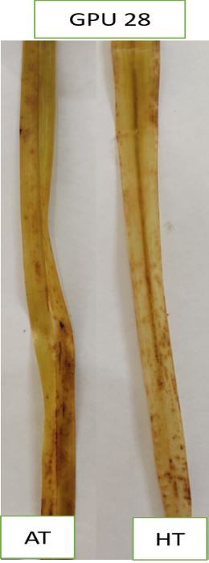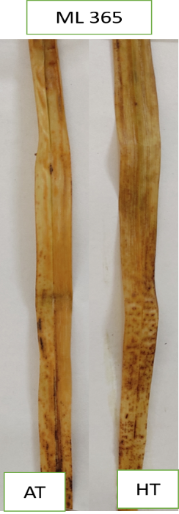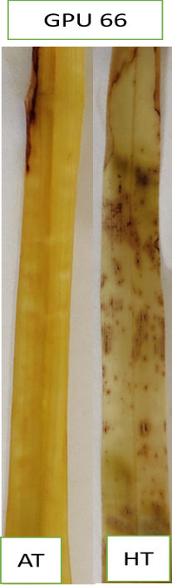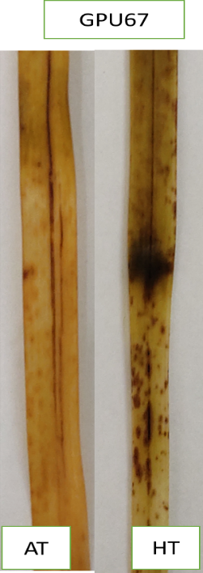

Figure 1: Determination of H₂O₂ by 3,3-Diaminobenzidine staining at flowering stage under high temperature stress condition (AT-ambient temperature, HT-high temperature)

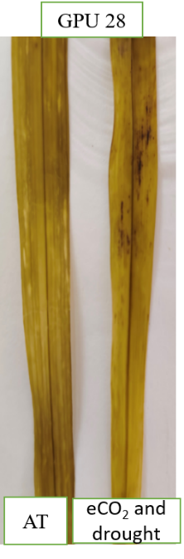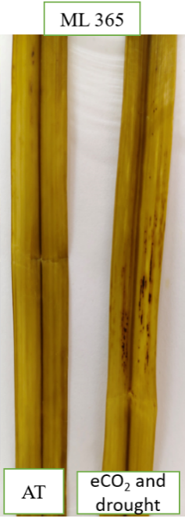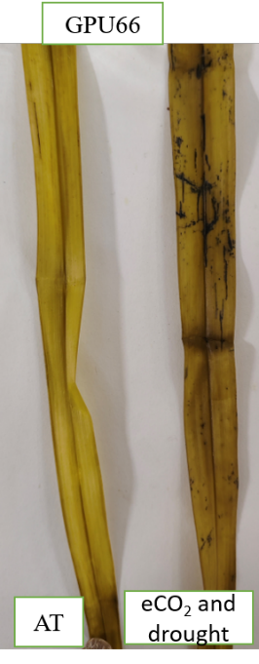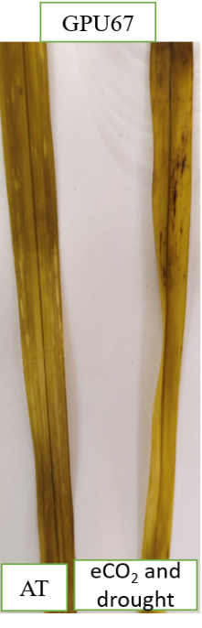
Figure 2: Determination of H₂O₂ by 3,3-Diaminobenzidine staining at flowering stage under elevated CO₂ and drought stress interaction (AT-ambient condition)

Total antioxidants (U/mg protein)
Genotypes | Ambient | HT | % Fold change | Genotypes | Ambient | Elevated CO₂ and drought | % Fold change
GPU28 | 1.32±0.01^{d} | 6.65±0.11ª | 403.78 | GPU28 | 3.05±0.06 | 7.88±0.52 | 158.36
ML365 | 1.25±0.01^{d} | 7.78±0.01^{b} | 522.40 | ML365 | 3.01±0.07 | 7.77±1.04 | 158.14
GPU66 | 1.21±0.11e | 5.65±0.06^{c} | 366.94 | GPU66 | 1.75±0.63 | 6.30±0.10 | 260.00
GPU67 | 1.35±0.01^{d} | 5.55±0.03^{c} | 311.11 | GPU67 | 2.02±0.06 | 5.66±0.32 | 180.19
Mean | 1.28±0.09^{b} | 6.40±0.60ª |  |  | 2.46±0.66^{b} | 6.90±1.12ª
 | SEm± | CD (0.05) |  |  | SEm± | CD (0.05)
Genotype | 0.02 | 0.07 |  |  | 0.19 | 0.59
Treatment | 0.02 | 0.05 |  |  | 0.14 | 0.42
GxT | 0.03 | 0.1 |  |  | 0.28 | NS
Table 1: Effect of high temperature stress and elevated CO₂ x drought interaction on total antioxidants of finger millet genotypes at flowering stage

4. Conclusion

The DAB staining pattern and total antioxidant response together illustrate the contrasting oxidative stress dynamics in finger millet genotypes under high temperature and elevated CO₂ x drought interaction. The intense brown coloration under high temperature stress confirmed higher H₂O₂ accumulation, indicating severe oxidative stress, whereas lighter staining under elevated CO₂ and drought reflected an alleviation of ROS production. The corresponding increase in total antioxidant content across treatments suggested an adaptive enhancement of the antioxidant defence system to mitigate oxidative damage. Among the genotypes, GPU 28 and ML 365 displayed greater antioxidant induction and lower DAB staining intensity, signifying superior oxidative stress management and higher tolerance potential. In contrast, GPU 67 exhibited pronounced H₂O₂ accumulation with comparatively weaker antioxidant enhancement, indicating limited detoxification efficiency under heat stress. The integration of these results clearly establishes a genotype-dependent balance between ROS generation and antioxidant defence, emphasizing the central role of antioxidant metabolism in stress adaptation. This relationship is further substantiated by the subsequent analysis of enzymatic antioxidants such as catalase, peroxidase, and superoxide dismutase, which provide deeper insights into the biochemical mechanisms conferring stress resilience in finger millet. Variation exhibited by selected genotypes in terms of oxidative stress levels experienced and activation of antioxidant mechanism clearly shows the possibilities for selection of genotypes suitable for different stress situation which are unique features of the changing climate.

References

Apel K, Hirt H. Reactive oxygen species: metabolism, oxidative stress, and signal transduction. Annu. Rev. Plant Biol. 2004;55(1):373-399.

Benzie IF, Strain JJ. Ferric reducing/antioxidant power assay: direct measure of total antioxidant activity of biological fluids and modified version for simultaneous measurement of total antioxidant power and ascorbic acid concentration. Methods Enzymol. 1999; 299:15-27.

Cannea FB, Padiglia A. Antioxidant defense systems in plants: mechanisms, regulation, and biotechnological strategies for enhanced oxidative stress tolerance. Life. 2025;15(8):1293.

Daudi A, O’Brien JA. Detection of hydrogen peroxide by DAB staining in Arabidopsis leaves. Bio-Protoc. 2012;2(18): e263.

Hasanuzzaman M, Fujita M. Plant oxidative stress: biology, physiology and mitigation. Plants. 2022;11(9):1185. https://doi.org/10.3390/plants11091185

Kumar D, Yusuf M, Singh P, Sardar M. Histochemical detection of superoxide and H2O2 accumulation in Brassica juncea seedlings. Bio-Protoc. 2014;4(8):1-5. doi:10.21769/BioProtoc.1108.

Liang, Z, Luo Z, Li W, Yang M, Wang L, Lin X, and Li, L. Elevated CO2 enhanced the antioxidant activity and downregulated cell wall metabolism of wolfberry (Lycium barbarum L.). Antioxidants. 2021;11(1):16.

Manik S, Mondal P, Roy B, Madhu J, Acharya LK. Biotechnological approaches for improving plant disease resistance in climate changing scenario. Adv. Environ. Biotechnol. 2025;266.

Mhamdi A, Noctor G. High CO2 primes plant biotic stress defences through redox-linked pathways. Plant Physiol. 2016;172(2):929-942.

Ramel F, Sulmon C, Bogard M, Gouesbet G, Couée I. Differential patterns of reactive oxygen species and antioxidative mechanisms during atrazine injury and sucrose-induced tolerance in Arabidopsis thaliana plantlets. BMC Plant Biol. 2009;9(28):220-228.

Xu Z, Jiang Y, Zhou G. Response and adaptation of photosynthesis, respiration, and antioxidant systems to elevated CO2 with environmental stress in plants. Front. Plant Sci. 2015; 6:701.

