HEALTHCARE, SANITATION, AND PUBLIC HEALTH IN THE COMMUNITY OF NATITINGOU IN NORTHWEST BENIN: CURRENT IMPACTS, ADOPTION HURDLES, AND OUTLOOK FOR 2050

Abstract
The study aims to analyze the up-to-date state of hygiene and sanitation in the community of Natitingou, highlighting barriers to sustainable adoption. A random sample of 271 people were interviewed through a semi-structured survey, with data entered and analyzed via Excel 2016 and SPSS 17.0 software. Findings reveal a predominance of informal practices in solid waste and domestic wastewater management. In fact, 74% of the respondents throw their household waste directly into the environment, 11% subscribe to pre-collection services, 10% and 5% burn and bury it respectively. This practice of illegal waste disposal is most prevalent in outlying neighborhoods, where collection systems are almost non-existent. Furthermore, wastewater management involves individual, often rudimentary methods, with direct discharge into the environment or waterways, increasing the risk of pollution and diseases spreading. Open defecation is another major problem. The highest rates are observed in the districts of Kotapounga (65%), Tchoumi-Tchoumi (64%), Kouaba (63%), Kouandata (60%) and Perma (60%), while lower rates are found in the urban districts of Natitingou 1, 2 and 3. This widespread practice contributes to soil and groundwater contamination and promotes the resurgence of waterborne diseases such as cholera and diarrhea, mainly among children, as well as typhoid fever. Several constraints hinder the adoption of improved hygiene and sanitation practices. Socio-economic obstacles, cited by 35% of respondents, include poverty and the high cost of sanitation infrastructure. Another 23% cited cultural constraints, referring to deeply rooted social norms and habits. Added to these are infrastructure and institutional limitations (30%), such as the lack of sanitation networks and weak local governance. Finally, climatic constraints (12%), including flooding, erosion, and heavy rainfall, increase the vulnerability of populations and compromise existing facilities’ durability. Long-term interventions are therefore essential to address these challenges. To achieve its 2050 vision, the municipality of Natitingou must commit to developing resilient sanitation infrastructure that is accessible and adapted to local realities. Strengthening governance at both the municipal and state levels is vital to ensure effective coordination of actions. In addition, community awareness and hygiene education should be stepped up to promote lasting behavioral change. Finally, addressing climate issues in sanitation policies will help anticipate risks and strengthen people’s and systems’ resilience.
Keywords: Natitingou municipality, adoption, constraints, hygiene, and sanitation

Introduction
Sanitation of the living environment is an essential prerequisite for the economic and sociocultural development of all nations worldwide [1]. Currently, more than 2.5 billion people-approximately 38% of the global population-lack access to adequate sanitation facilities. Moreover, 13% of this population, or 884 millions individuals, consume water from unimproved sources [2]. Yet, proper hygiene practices remain the simplest and most effective means of preventing the spread of disease [3]. A child requires a healthy environment to thrive. The degradation of such an environment has detrimental effects on children, who represent the most vulnerable segment of the population [4]. Each year, 14 millions children under the age of five die in developing countries due to environmental hazards such as pollution, malaria, malnutrition, diarrheal diseases, and measles. These environmental factors, which threaten the health of school-aged children, can be mitigated through a well-structured health education program involving all stakeholders [5]. Today, African cities are among the spaces where environmental management challenges are particularly acute. Environmental degradation is widespread and escalating. In Benin, with regard to hygiene-particularly handwashing practices-only 9% of the total population (14% in urban areas and 6% in rural areas) have access to a handwashing facility equipped with water and soap [6]. This limited access to water, hygiene, and sanitation contributes to numerous deaths. Approximately 7,000 people die from diarrhea annually in Benin [7], with nearly 90% of these deaths directly linked to water contamination and inadequate hygiene and sanitation [8]. Globally, diarrhea claims the lives of 760,000 children under five each year. Every 40 seconds, a child under five dies from a disease related to poor sanitation. Diarrhea is the second leading cause of death in low-income countries and, in 2015, accounted for 57.2 deaths per 100,000 inhabitants [9]. Access to water and sanitation facilities is also problematic in schools, particularly in rural areas [10]. The consumption of untreated water is a major cause of waterborne diseases in Beninese cities. The near absence of sanitation systems in these urban areas further compromises water quality and contributes to poor environmental management [11]. More than 70% of children living in households lack access to adequate toilets, and barely 1% of women and caregivers of children under five wash their hands with soap before feeding them. Poor sanitation, malnutrition, undernourishment, and entrenched habits foster the spread of infections and diseases [12]. Cultural practices and beliefs influence how communities perceive and manage hygiene. In certain cultures, sanitation is associated with taboos or religious beliefs, which affect the use of latrines [13]. Social norms-whether implicit or explicit-play a central role in shaping hygiene and sanitation behaviors. In rural communities, open defecation is often culturally accepted, yet it poses serious public health risks, particularly the spread of waterborne diseases [14]. Financing hygiene and sanitation infrastructure remains a major challenge in low- and middle-income countries [15]. Public funds allocated to these services are often insufficient, resulting in gaps in the construction and maintenance of sanitation facilities [16]. In the Commune of Natitingou, local authorities are actively engaged in waste management efforts. Nevertheless, waste continues to be dumped indiscriminately, with adverse consequences for both the environment and public health. Despite the development and implementation of the Communal Hygiene and Sanitation Plan (PHAC), anthropogenic practices that undermine both health promotion and environmental preservation persist [17].

1. Materials et methods
1.1. Background to the study
The municipality of Natintingou is located in northwestern Benin, in the center of Atacora Department, between 10°0' and 10°25' north latitude and between 1°10' and 1°35' east longitude. Figure 3 shows that it is bordered to the north by the municipality of Toucountouna, to the east and southeast by the municipality of Kouandé, to the southwest by the municipality of Copargo, and to the west by the municipality of Boukombe (Figure 1). It extends over an area of 3,045 km², or 12.8% of the total area of the department. Natitingou has 76 villages and urban districts spread across nine (09) districts, including three (03) urban districts, Natitingou 1, Natitingou 2, and Natitingou 3, and six (06) rural districts, Perma, Kouandata, Tchoumi-Tchoumi, Kotopounga, Péporiyakou, and Kouaba. Located in a valley at the foot of the Atacora mountain range, with plateaus and hills in places, this municipality faces significant challenges in terms of hygiene and sanitation. The rugged terrain makes the wastewater drainage and solid waste management systems less effective.
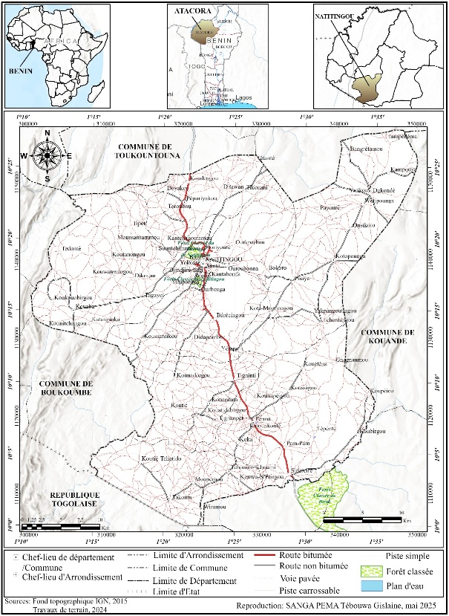
Fig 1. Administrative and geographical location of the municipality of Natitingou

1.2. Method
Data collection, data processing, and analysis of results form the basis of the methodology applied in this research. Several techniques and tools have been used. The data collection techniques include documentary research, fieldwork through interviews, and direct observation in real-life settings. Tools such as questionnaire for heads of households and an interview guide for decision-makers have been employed. Field surveys have been carried out with a well-defined sample. A number of 271 people have been interviewed. Various factors that make it difficult to ensure hygiene and sanitation in the Natitingou Commune have been analyzed. To achieve this, six (06) types of variables have been identified based on existing literature. The ESPECT approach identifies these elements by locating specific factors at each level. These include economic, social, political, environmental, cultural, and technological variables, as well as sociodemographic determinants (gender, marital status, and educational level of the head of household; educational level of the female head of household; and household size). In addition, a binary logistic regression was performed with the desire for good hygiene and sanitation practices as the dependent variable and age and gender as independent variables. Marital status, ethnicity, religion, and schooling level as independent variables have been performed to analyze factors (sociodemographic and cultural characteristics) that influence respondents’ desire to undertake CSTP or not. Descriptive statistics and statistical tests have been used to analyze the data. Frequencies of responses have been calculated for qualitative variables, while means and standard errors have been calculated for quantitative variables. Databases are exported to SPSS version 17.0 for tabulation. SPSS software is used because of its versatility in data processing. Descriptive statistics are used for data processing once data have been entered and validated. Positive and negative responses to a question are determined based on the actual score for each section of the questionnaire, not on the overall number of respondents. Statistical protocol is used to express the number of responses per question type: P₁$=\frac{n}{N} X 100$; where n is the number of people who gave positive responses and N is the communal sample size. The main topics covered during the investigations are constraints to hygiene and sanitation adoption.

2. Results
2.1. Hygiene and sanitation conditions in households in the municipality of Natitingou
This covers household waste, wastewater, and excreta management, and access to drinking water.
2.1.1. Household waste management practices in the municipality of Natitingou
The shortage of structured waste collection and treatment systems in the municipality of Natitingou has worrying impacts on public health, ecosystems, and people's livelihoods. Traditional practices mainly involve dumping waste in open areas or illegal dumps on the outskirts of towns, or even using individual pits for organic waste. The uncontrolled dumping of household waste in the environment, mainly in the city's rivers, is a major source of environmental pollution. This increases health risks, especially waterborne and infectious diseases, in a climate change context that further weakens sanitation systems and increases people's vulnerability. Results show that 74% of respondents dump their household waste in the environment, 11% subscribe to pre-collection services, 10% burn their waste, and 5% bury it (Figure 2). Thus, dumping waste in the environment remains the most widespread practice (Photo 1). Waste accumulates in the absence of effective collection systems, forming piles that become sources of unsanitary conditions, attract pests, and promote the spread of disease (Figure 3). The proliferation of illegal dumps affects all districts of Natitingou, with a higher concentration in Kotapounga, Perma, and Natitingou 3 (Figure 4). Waste management in the municipality is therefore a real challenge, with uncontrolled dumping and insufficient collection coverage. As a result, waterborne and infectious diseases are on the rise in an environment already weakened by the effects of climate change.
2.1.2. Wastewater disposal system in the municipality of Natitingou
Domestic wastewater management in the municipality of Natitingou is governed by various practices, most of which are informal. There is no widespread collective sanitation system outside the town center, forcing residents to resort to individual, often rudimentary solutions. In all, 63% of respondents discharge their wastewater directly into the environment or rivers, 13% discharge it into their yards, 10% use septic tanks or cesspools, 7% use open gutters, 4% use closed gutters, and 3% use soakaways (Figure 5). Direct discharge onto the ground or into the environment is therefore a standard practice, mainly in rural areas and outlying neighborhoods. This mishandling of wastewater has a significant impact on environmental pollution. Wastewater accumulates or seeps into the ground in the absence of sewerage systems, promoting the spread of disease and the degradation of local ecosystems. This is compounded by climate change, increasing the vulnerability of populations and highlighting the urgent need for an appropriate institutional response to sanitation issues.
2.1.3. Excreta management in the municipality of Natitingou
Household sanitation practices in the municipality of Natitingou include open defecation, which remains widespread. The highest rates of open defecation are observed in the districts of Kotapounga (65%), Tchoumi-Tchoumi (64%), Kouaba (63%), Kouandata (60%), and Perma (60%). Conversely, the districts of Natitingou 1, Natitingou 2, and Natitingou 3 have much lower rates. Overall, 40% of districts have a high DAL rate (Figure 6). Meanwhile, some residents use latrines, whether modern or traditional. However, the ongoing practice of open defecation is a main source of soil and groundwater contamination, with worrisome health and environmental effects.
2.1.4. Safe drinking water availability
A mixed drinking water supply system combining SONEB (Benin National Water Company) network for urban and semi-urban areas is available in the municipality of Natitingou. The coverage rate is 28.4%. It ranges from 21% to 61% in the municipality of Natitingou. SONEB covers a very high percentage of the urban districts and a very low percentage of the rural districts (Figure 7). AEV coverage is 4.45% and FPM is at 100% coverage. There are many AEVs with standpipes, FPMs, and PEAs in the municipality of Natitingou. All districts are served by these water facilities. There is an inequitable distribution of water facilities in the municipality of Natitingou. Water scarcity forces residents to use unsafe sources such as backwaters and ponds. Such practices increase waterborne disease risks, mainly among children.
2.2. Current impacts on public health in the municipality of Natitingou
Sanitation and hygiene remain critical public health issues in the municipality of Natitingou, heavily influenced by persistent human behavior. A large part of the population still has limited access to drinking water: around 65% of respondents use unsafe sources such as unprotected wells and ponds. As a result, people are at risk of drinking contaminated water, which can spread waterborne diseases like cholera, typhoid fever, and acute diarrhea. It also leads to dehydration and malnutrition, especially in kids, and affects household and healthcare maternal and child health. Likewise, poor sanitation infrastructure is reflected in the persistence of open defecation in several villages due to a lack of adequate public or family latrines. Excreta, often carried away by runoff, pollutes the soil and groundwater, which are the main drinking water sources. This results in an upsurge in infectious and parasitic diseases such as amoebiasis, helminthiasis, and gastroenteritis, while increasing the risk of epidemics during the rainy season. It also undermines people's livelihoods and human dignity, especially women and children. Solid waste management is another major challenge. The lack of adequate collection and disposal systems leads to garbage accumulating in streets, gutters, and unregulated dumpsites. Such areas become hotbeds of pollution and breeding grounds for disease vectors. The overgrowth of mosquitoes, flies, and rodents fosters malaria and other vector-borne diseases, while decomposing waste lowers air quality and causes respiratory problems. People living near dumps are also exposed to risks of poisoning and injury. The overall public health effects of these problems lead to high morbidity within the population. Water- and environment-related diseases account for a sizeable percentage of visits to health facilities. These conditions also reduce economic productivity and undermine collective well-being, thereby compromising the municipality’s sustainable development efforts.
2.3. Population pathological risks in the municipality of Natitingou
Severe malaria, acute respiratory infections (ARI), and diarrhea are among the leading causes of death in health facilities in the municipality of Natitingou. Cases of uncomplicated and severe malaria have fluctuated, falling from 35,674 in 2003 to 25,466 in 2024, with a 28.61% decrease. The curve's coefficient of determination is -451.77 (Figure 8). The emergence of malaria cases is due to poor sanitation practices, including inadequate drainage of rainwater and wastewater, and the accumulation of waste that creates obstacles to drainage and promotes the formation of stagnant water. These water collections are ideal breeding grounds for Anopheles mosquitoes, which transmit malaria. Flooding caused by poor storm drainage leaves behind large areas of standing water, boosting mosquito numbers and, as a result, malaria cases.
2.4. Barriers to sanitation and hygiene practices in the municipality of Natitingou
Several factors impede effective solutions. Socio-economic constraints (35% of respondents), cultural constraints (23%), infrastructural and institutional constraints (30%), and climatic constraints (12%) hinder sanitation and hygiene practices in the municipality of Natitingou (Figure 9). Low household incomes prevent investment in individual sanitation infrastructure (improved latrines, septic tanks). New practices are influenced by customs and beliefs. A major obstacle is the lack of strong public policies, allocated budgets, and qualified personnel for waste and wastewater management. Cooperation between different stakeholders (government, NGOs, communities) can also be a challenge. Global warming caused by greenhouse gas emissions leads to a global temperature rise and more frequent, intense, and longer heat waves. High temperatures obviously increase water demand for drinking, personal hygiene (more showers), and household activities. These further strain water supply systems. Heat waves are often coupled with droughts or declining groundwater levels and the drying up of surface water bodies (backwaters, traditional wells). This limits water availability, making access more difficult and costly.
​2.5. Foresight measures for 2050
​ Sanitation and public health in Natitingou lie within a context of profound climatic and demographic change. Located in an ecologically fragile area in the northwest, the municipality remains vulnerable to the effects of climate change. Extended droughts tend to reduce water availability and quality, while increasingly frequent floods exacerbate water source contamination and damage existing sanitation infrastructure. These phenomena, combined with weak local adaptation capacities, expose the population to increased health risks. Planning and implementing more resilient infrastructure is vital to address these threats. This involves designing water supply, sanitation, and waste management systems that can withstand climate hazards while meeting the growing needs of an expanding population. The city's rapid urbanization is a further exacerbating factor, with considerable pressure on basic infrastructure and essential social services. Unless integrated urban planning is implemented, this demographic and spatial growth could exacerbate environmental degradation and increase health risks linked to unsanitary conditions, pollution, and vector-borne diseases.
To ensure sustainability, projections for 2050 should be based on multisectoral and integrated strategies, including:
- promoting innovative, accessible, and environmentally sustainable sanitation technologies;
- investing in climate-resilient infrastructure, such as stormwater drainage systems and secure boreholes;
- Strengthening local and institutional governance by promoting coordination between public, private, and community actors;
- increasing community awareness and hygiene education to promote lasting behavioral change;
- incorporating climate issues into sanitation policies to forestall risks and strengthen system and community resilience.

Fig 2. Household waste management practices in the municipality of Natitingou
Source : Field survey, april 2025
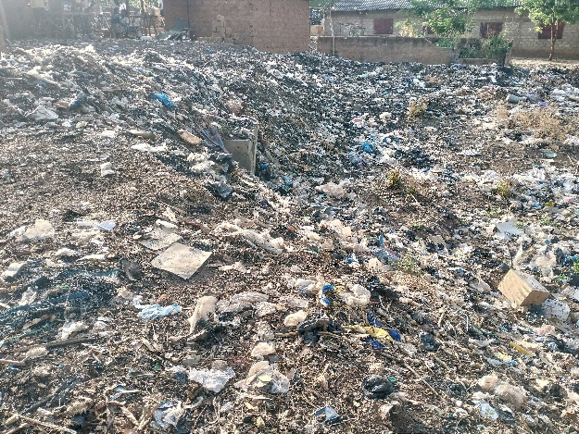
Photo 1. Portion of garbage piles in Boriyouré and Perma
Shooting : Sanga Pema, april 2025

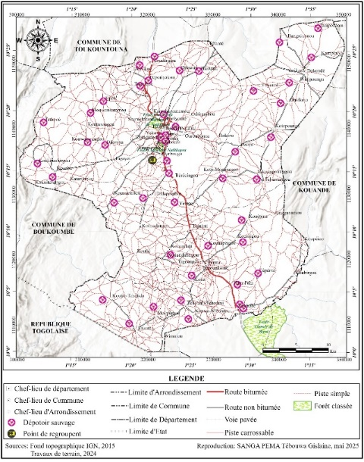
Fig 3. Spatial distribution of illegal dumpsites in the municipality of Natitingou

Fig 4. Wastewater management systems in the municipality of Natitingou
Source : Field survey, april 2025

Fig 5. Excreta management techniques in the municipality of Natitingou
Source : Field survey, april 2025

Fig 6. DAL rate by district in the municipality of Natitingou
Source : Field survey, april 2025

Fig 7. SONEB water coverage rate in the municipality of Natitingou
Source : Field survey, april 2025

Fig 8. Simple and severe malaria trends in the municipality of Natitingou from 2003 to 2024
Source : MS Data Processing, April 2025

Fig 9. Barriers to sanitation and hygiene practices in the municipality of Natitingou
Source : Field survey, april 2025

3. Discussion
It results from this study that domestic wastewater management in the municipality of Natitingou is largely informal, with 63% of households discharging wastewater directly into the environment or rivers. This is especially prevalent in urban outskirts and rural areas, due to the lack of a widespread public sanitation system outside the city center. 13% pour it into their yards, 10% use septic tanks or cesspools, 7% use open gutters, 4% use closed gutters, and 3% use cesspools. People also use modern and traditional latrines. Open defecation is a widespread practice, raising concerns about soil and groundwater contamination. Whilst localized, these practices are part of a broader trend in many African cities, where poor sanitation infrastructure and socio-economic and cultural constraints shape human behavior.
These results tie in with those from [7] and [9], who have shown that people's daily practices around sanitation and their relationship with latrines are guided both by habits within the home and public sphere, and by specific individual logic and strategies. latrine usage (or non-usage) practices are governed by contextual references (cultural, symbolic, etc.) and individual rationales and strategies that need to be deciphered.
Low household incomes prevent investment in individual sanitation infrastructure (improved latrines, septic tanks) in the municipality of Natitingou. New practices are hindered by some habits and beliefs. Thus, the shortage of robust public policies, allocated budgets, and qualified personnel for waste and wastewater management is a major hurdle. Cooperation between different stakeholders (government, NGOs, communities) can also be a challenge. According to [18], issues related to waste management and, by extension, environmental planning and management, are some of the most complex issues that environmental managers encounter owing to their impact on human health and sustainable development. In the words of [19], dysfunctional management often undermines local development efforts. This is generally due not only to the stakeholders involved in local government management, but also to the state's lack of support, as the transfer of powers and resources provided for by law is inadequate. Another factor, he notes, is the quantitative and qualitative deficit among governance stakeholders. All this is due to the failure of local governments to implement the necessary measures.

Conclusion
The results of this research clearly show that low household incomes hinder investment in individual sanitation infrastructure such as improved latrines and septic tanks. This is compounded by deeply rooted habits and sociocultural beliefs that negatively influence the adoption of recommended hygiene practices. The lack of resilient public policies, insufficient budgets, and the absence of an effective solid waste and wastewater management system exacerbate hygiene and sanitation problems. In addition, recurring floods, exacerbated by the lack of effective storm drainage, create vast areas of stagnant water. These environments foster the proliferation of mosquitoes and promote climate-related diseases, with direct repercussions on public health and productivity. These findings underscore the urgent need for a multisectoral approach that combines technical, institutional, and behavioral solutions to achieve lasting sanitation and hygiene improvements in the municipality of Natitingou.

References
[1] EHOU S. O. T., 2016, Drinking Water and Population Health in the Commune of Dangbo: Cases of the Districts of Kessounou and Houédomey. Master's Thesis II in Risk Prevention and Disaster Management. UAC/FLASH/MIRD, 128 p.

[2] WHO/UNICEF, 2019, UN Report on New Global Statistics on Household Access to Drinking Water, Sanitation, and Hygiene, 56 p.
https://www.unicef.org/media/71151/file/unicef-rapport-annuel-2019.pdf
[3] IIED, 2010, Participatory Learning and Action, Report, 230 p.
https://www.iied.org/sites/default/files/pdfs/migrate/14579FIIED.pdf
[4] UNICEF and WHO, 2018, Drinking Water, Sanitation and Hygiene in Schools: Global Baseline Report 2018. WHO/UNICEF Joint Monitoring Programme for Water Supply, Sanitation and Hygiene (JMP), 84 p.
https://www.pseau.org/outils/ouvrages/jmp_eau_potable_assainissement_hygiene_milieu_scolaire_2018.pdf
[5] UNICEF, 2015, Children and Water: Unite for Children. Report, 3 p. https://www.unicef.fr/wp-content/uploads/2022/08/UNICEF_AGIR_9.pdf
[6] WHO, 2017, 2.1 billion people lack access to safe drinking water at home and more than twice as many lack safe sanitation services, Geneva, 78 p.
https://www.unicef.org/fr/communiqu%C3%A9s-de-presse/21-milliards-de-personnes-n%E2%80%99ont-pas-acc%C3%A8s-%C3%A0-l%E2%80%99eau-potable-salubre-%C3%A0-leur
[7] WSP, 2017, Economic Impacts of Poor Sanitation in Africa: Benin loses 52 billion XOF each year due to poor sanitation. [Accessed April 20, 2024] Available at https://www.wsp.org/sites/wsp/files/publications/WSP-ESI-Benin-french brochure.pdf.
[8] SALOU BACHIROU Z., 2019, Water, Hygiene, and Sanitation in the Municipality of Zè in Southern Benin: Current Situation and Effects on Human Health. Doctoral Thesis, EDP/GEN/FLASH/UAC, 456 p.

[9] GABERT J., 2018, Sanitation Handbook: Implementing a Complete, Sustainable, and Appropriate Sanitation Service. 848 p.
https://memento-assainissement.gret.org/IMG/pdf/memento-assainissement.pdf

[10] Hygi.Ass/Rural, 2015, Manual for Implementing Appropriate Approaches to Promoting Hygiene and Sanitation in Rural Areas. 84 p.
https://www.pseau.org/outils/ouvrages/jica_da_mha_msas_manuel_de_mise_en_uvre_d_approches_appropriees_de_promotion_de_l_hygiene_et_de_l_assainissement_en_milieu_rural_2015.pdf
[11] ODOULAMI L., 2009, The Problem of Drinking Water and Human Health in the City of Cotonou (Republic of Benin). Doctoral Thesis in Geography and Environmental Management, EDP/UAC, 230 p.
https://www.pseau.org/outils/ouvrages/universite_d_abomey_calavi_la_problematique_de_l_eau_potable_et_la_sante_humaine_dans_la_ville_de_cotonou_odoulami_leocadie_2009.pdf
[12] MS, 2014, Report of the CLTS support mission in Benin. 17 p. https://archive.ids.ac.uk/clts/sites/communityledtotalsanitation.org/files/media/Rapport_de_la_Mission_de_formation_ATPC.docx
[13] BA Aïssatou, 2021, On-site sanitation in Senegal, between principles and practices: the example of the neighborhoods of Goumel, Kenia Belfort, commune of Ziguinchor, Master's thesis to be specified here, UCAD 144 p. http://rivieresdusud.uasz.sn:8080/bitstream/handle/123456789/1206/ba_m%C3%A9moire_2021.pdf?sequence=1&isAllowed=y
[14] Join For Water, 2022, Working Together for Water for a Sustainable Future. Final Evaluation Report, 66 p. https://joinforwater.ngo/wp-content/uploads/2022/10/Evaluatie-programma-2017-21-Benin.pdf
[15] STURMA, Aude, 2013, Sanitation Challenges in Mayotte: Dynamics of Social Change and the Perverse Effects of Public Action, Doctoral Thesis in Sociology, University of Toulouse, 458 p. https://www.pseau.org/outils/ouvrages/universite_de_toulouse_sturma_les_defis_de_l_assainissement_a_mayotte_dynamiques_de_changement_social_et_effet_pervers_de_l_action_publique_2013.pdf
[16] SOSSOU A. N., 2018, Hygiene and Sanitation in Primary and Secondary Schools in the Municipality of Bohicon in Benin. Master's Thesis. University of Abomey-Calavi. 68 p.
[17] SANGA PEMA T. G., 2018, Decentralization and Promotion of Local Development: Implementation of the Toucountouna Municipal Hygiene and Sanitation Plan. Master's Thesis in Environment, Health and Sustainable Development, CIFRED/UAC, 90 p.
[18] GANDAHO H., 2015, Basic sanitation in the commune of Aguégués. Master's thesis in Geography, specializing in Regional Planning, DGAT/FLASH/UAC, 55 p.
[19] ALI A., 2010, Local governance in the urban commune of Bouza in Niger. Master's thesis, specializing in urban planning, Niger, 89 p. https://www.memoireonline.com/06/11/4564/m_Le-developpement-local-face-a-la-politique-de-decentralisation30.html

