ESTIMATION OF CROP WATER REQUIREMENT (CWR) AND REFERENCE EVAPOTRANSPIRATION OF CHICKPEA CROP USING CROPWAT 8.0 MODEL FOR PRAYAGRAJ

Abstract
This research evaluates the water requirements of chickpea cultivation in the semi-arid agroclimatic conditions of Prayagraj, Uttar Pradesh, using the CROPWAT model over a climatic baseline period from 1993 to 2023. The study aimed to determine both the crop water requirement (CWR) and irrigation water requirement (IWR) by incorporating monthly reference evapotranspiration (ET₀) and effective rainfall data. Analysis revealed that the annual ET₀ totaled 1727.91 mm, with peak values occurring during the pre-monsoon months—particularly in May. In contrast, effective rainfall was predominantly confined to the monsoon season, offering minimal contribution during the rabi growing season. Chickpea, cultivated primarily between November and February, exhibited a seasonal CWR of 182.12 mm, with the mid-season stage—corresponding to flowering and pod development—demonstrating the highest water demand. Owing to limited winter precipitation, the total IWR was calculated at 153.56 mm, indicating a substantial need for irrigation to support optimal crop performance. These outcomes emphasize the necessity for strategic irrigation management to enhance water-use efficiency and sustain chickpea productivity under rainfed-deficit conditions.

KEY WORDS: CWR, IWR, ET_{o}, CROPWAT, CHICKPEA, PRAYAGRAJ
1. Introduction
Chickpea (Cicer arietinum L.) is a key pulse crop in India, serving as an essential component of nutritional security, soil fertility enhancement, and rural livelihood sustainability. As a protein-rich legume, it forms a dietary staple across the Indian subcontinent, while its biological nitrogen fixation contributes significantly to soil health and sustainable cropping systems. India remains the global leader in chickpea production, accounting for approximately 70% of global output (ICAR, 2024). Despite its agronomic and economic importance, chickpea cultivation is frequently hampered by climatic uncertainties, including erratic rainfall, limited winter precipitation, and poor irrigation practices, particularly in semi-arid regions like Prayagraj, Uttar Pradesh. These challenges often result in inefficient water use and reduced crop yields (Singh et al., 2023).

Given that agriculture consumes nearly 81% of India’s total freshwater resources, optimizing water use in farming is critical (Surendran et al., 2013). The growing competition for water among agriculture, industry, and domestic sectors, compounded by population growth, demands a shift towards precision water management. As emphasized by Kamel et al. (2012), accurate estimation of crop evapotranspiration (ETc) is indispensable for effective irrigation scheduling and water resource planning. Traditional irrigation approaches often lack the spatial and temporal resolution to respond to crop-specific water needs under variable climatic conditions. Consequently, data-driven tools are required to determine reference evapotranspiration (ET₀), crop water requirement (CWR), and irrigation water requirement (IWR) with greater accuracy. To address these needs, the Food and Agriculture Organization (FAO) developed the CROPWAT 8.0 model, which provides a robust scientific framework for computing ET₀ and CWR using the FAO Penman-Monteith equation. This method, regarded as the international standard, relies on meteorological inputs such as temperature, humidity, wind speed, and solar radiation (FAO, 2009). CROPWAT has been widely adopted in irrigation and agronomic studies across different agroecological zones for crops such as maize, rice, and pulses (Dechmi et al., 2003; Martyniak et al., 2006; Kuo et al., 2006; Gowda et al., 2013; Bhat et al., 2017; Navatha et al., 2020; Roja et al., 2020). Its application facilitates the development of crop- and region-specific irrigation schedules, thereby enhancing water use efficiency and mitigating production risks under climate variability.

In light of the above, the present study aims to support evidence-based irrigation planning for chickpea in Prayagraj by employing the CROPWAT 8.0 model. The specific objectives are: (1) to estimate the reference evapotranspiration (ET₀) for chickpea, and (2) to calculate the crop water requirement (CWR) based on long-term climatic data (1993–2023), thereby informing sustainable water management strategies for rabi season cultivation.

2. MATERIALS AND METHODS
2.1 Study area and Weather Data collection
The study was carried out in Prayagraj district, located in southeastern Uttar Pradesh, India, between 24°47′N to 25°47′N latitude and 81°19′E to 82°21′E longitude. The region falls under the semi-arid agroclimatic zone, characterized by hot summers, monsoonal rainfall, and dry winters—conditions that significantly affect rabi crop performance, including chickpea. Weather data for the period 1993–2023 were sourced from the NASA POWER database. The dataset included daily maximum and minimum temperatures (°C), relative humidity (%), and rainfall (mm), which served as essential inputs for the CROPWAT 8.0 model to estimate reference evapotranspiration and crop water requirements.
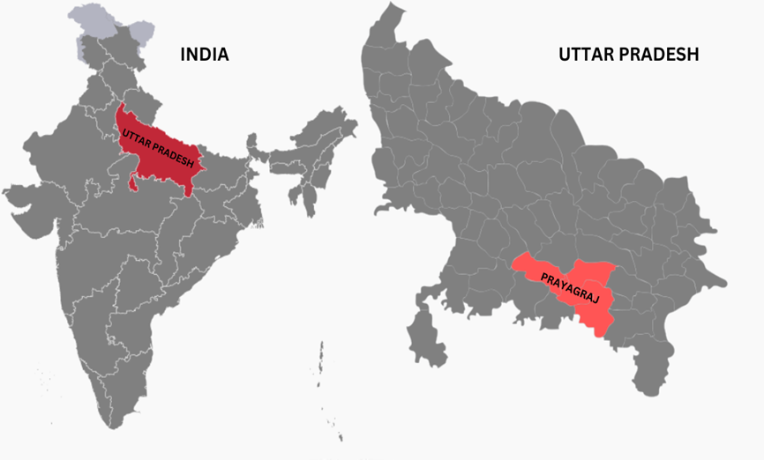
Fig. 1 Study Area Map of Prayagraj Region

2.2 CROPWAT 8.0 Model
CROPWAT 8.0 is a decision support tool developed by the Land and Water Development Division of the Food and Agriculture Organization (FAO) of the United Nations. It is designed to assist in the estimation of key parameters necessary for effective irrigation planning and water resource management. The model facilitates the computation of:
- Reference evapotranspiration (ET₀)
- Crop water requirement (CWR)
- Crop irrigation requirement (IWR)
These estimations enable the development of irrigation schedules under various management scenarios (FAO, 1992). In addition to irrigation planning, CROPWAT is also employed for:
- Designing irrigation schedules tailored to different management practices
- Assessing scheme water supply
- Evaluating rainfed production potential and the impacts of drought
- Analysing the efficiency of irrigation systems and estimating crop performance under rainfed or deficit irrigation conditions (Marica et al., 1999)
The computational procedures implemented in CROPWAT 8.0 are based on the standard methodologies outlined in the FAO Irrigation and Drainage Papers, particularly those related to the estimation of crop evapotranspiration and irrigation scheduling using the FAO Penman-Monteith approach.

2.3 Crop coefficients data
Table 1. Crop coefficients of Chickpea crop
Crop | Crop Coefficients
Crop | Initial (Kc1) | Development (Kc2) | Late Season (Kc3)
Chickpea | 0.10 | 0.95 | 0.25
Source: FAO Irrigation and drainage, paper no.56, FAO

2.4 Soil data
Table 2. Different types of Soil data
S. No | Soil description | Red Sandy Loamy soil
1 | Total available soil moisture (FC-WP), mm/m | 100
2 | Maximum rain infiltration rate, mm/day | 30
3 | Maximum rooting depth, cm | 90
4 | Initial soil moisture depletion (as % TAM), % | 0
5 | Initial available soil moisture, mm/m | 100
Source: FAO Irrigation and drainage, paper no.24, FAO

2.5 Calculation of Reference Evapotranspiration (ET₀)
Reference evapotranspiration (ET₀) represents the rate of evapotranspiration from a hypothetical, well-watered grass surface with standardized characteristics. Unlike the ambiguous term "potential ET," ET₀ provides a consistent measure of atmospheric evaporative demand, independent of specific crop types or management practices. In this study, ET₀ was computed using the FAO Penman-Monteith equation, as recommended by (Allen et al., 1998). This method integrates key climatic parameters—temperature, humidity, wind speed, and solar radiation—allowing accurate estimation of ET₀. Since the reference surface is assumed to have unlimited water availability, ET₀ serves as a benchmark for comparing crop water use across locations and time periods (FAO 56, 1998).

2.6 Effective Rainfall (ER)
Effective rainfall refers to the portion of total precipitation that is actually available for crop use after accounting for losses due to surface runoff, deep percolation, and other inefficiencies (Babu et al., 2015). According to (Dastane, 1974), effective rainfall includes all rainfall that contributes either directly or indirectly to crop growth at the site of occurrence. Accurate estimation of effective rainfall is crucial for improving the precision of crop water requirement calculations. Several factors influence effective rainfall, including the amount and intensity of precipitation, evapotranspiration rates, soil infiltration capacity, and crop and irrigation management practices. In this study, the USDA Soil Conservation Service method, as described by (Smith, 1991), was employed to estimate effective rainfall. This method, commonly integrated into the CROPWAT model, provides a reliable approach for determining rainfall contributions to crop water supply under varying agroclimatic conditions.

2.7 Estimation of Crop Water Requirement (ETc)
Crop Water Requirement (CWR) represents the total quantity of water needed to offset losses from evapotranspiration and to ensure optimal crop growth and development. It is estimated as the product of reference evapotranspiration (ET₀) and the crop coefficient (Kc), which reflects the specific water needs of the crop at different growth stages. In this study, ET₀ was calculated using the FAO Penman-Monteith method, based on long-term climatic data, as recommended by (FAO, 1998). This method ensures standardized and accurate estimation of water demand across varying agroecological conditions.

3. RESULTS AND DISCUSSION
3.1 Reference Evapotranspiration (ET₀) for Prayagraj Region
The reference evapotranspiration (ET₀) for Prayagraj was estimated using the CROPWAT 8.0 model over a 30-year climatic period from 1993 to 2023. The monthly ET₀ values, summarized in Table 4, reflect the seasonal dynamics of atmospheric water demand under the region’s subtropical climate. The total annual ET₀ was calculated to be 1727.91 mm, with pronounced seasonal variation. The pre-monsoon season (March–May) exhibited the highest ET₀ values, averaging 200.58 mm/month, primarily due to elevated air temperatures, lower humidity, and increased solar radiation. Within this period, month of May recorded the peak ET₀ at 226.73 mm, representing the month of highest evaporative demand. In contrast, during the monsoon season (June–September), ET₀ values declined substantially, averaging 148.78 mm/month, likely due to increased cloud cover, higher relative humidity, and reduced solar input.

The lowest monthly ET₀ was observed in December (88.91 mm), reflecting cooler temperatures and limited solar radiation. The winter months (January–February) showed relatively low evapotranspiration rates, with an average of 104.31 mm/month and the minimum value of 89.7 mm in January. ET₀ values began to rise again in the post-monsoon season (October–December), averaging 107.46 mm/month, with October (125.65 mm) exhibiting the highest value in this period. These results indicate distinct seasonal patterns in atmospheric evaporative demand. The high ET₀ during the pre-monsoon months underscores the critical need for supplemental irrigation during the early growth stages of summer crops. Conversely, lower ET₀ values during the monsoon season suggest reduced irrigation requirements for kharif crops like rice. The findings provide essential inputs for irrigation planning, crop calendar optimization, and resource-efficient water management in the region. Overall, the evapotranspiration profile of Prayagraj, as modelled through CROPWAT using the FAO Penman-Monteith method (FAO, 1998; FAO Irrigation and Drainage Paper No. 56), demonstrates the influence of climatic factors on seasonal water loss. Understanding these patterns is vital for aligning irrigation schedules with crop water demand across different stages of growth.

3.2 Effective Rainfall (ER) for Prayagraj
Effective rainfall (ER) for Prayagraj, estimated using the CROPWAT 8.0 model over the 30-year period from 1993 to 2023, exhibits a distinct seasonal trend consistent with the region’s monsoonal climate. Based on the USDA Soil Conservation Service method embedded within the model (FAO, 1998; FAO Irrigation and Drainage Paper No. 56), the total annual effective rainfall was calculated at 558.98 mm. The data reveals a highly uneven distribution, with the majority of effective rainfall concentrated during the monsoon months (June–September). July recorded the highest ER at 136.96 mm, followed by August (132.50 mm), September (102.68 mm), and June (81.03 mm). Together, these four months accounted for approximately 80% of the annual effective rainfall, highlighting their critical role in meeting the water requirements of kharif crops, particularly rice, which demands high moisture during its peak vegetative and reproductive stages. In contrast, November through June exhibited significantly lower effective rainfall, with November (3.93 mm), December (7.05 mm), and April (9.62 mm) contributing minimally to crop water availability. This seasonal scarcity underlines the necessity for supplemental irrigation during the rabi season, as rainfall alone is insufficient to fulfill crop evapotranspiration demands. The seasonal variability in effective rainfall has crucial implications for irrigation scheduling and agricultural water resource management in Prayagraj. During the dry season (October to May), precise irrigation planning is essential to prevent moisture stress in water-sensitive crops such as wheat and mustard. Conversely, during the monsoon season, irrigation requirements for crops like rice can be substantially reduced, although early-season irrigation in June and pre-monsoon supplementation in early July may still be required to bridge rainfall gaps. Notably, October’s effective rainfall suggests residual soil moisture availability post-monsoon, which, if managed efficiently, could support the establishment of short-duration rabi crops. These findings emphasize the importance of season-wise water budgeting and crop planning to optimize irrigation use and ensure sustainable crop production under variable rainfall conditions.
Table 3. Monthly reference evapotranspiration (ETo) (mm/month) estimated by CROPWAT for Prayagraj from 1993-2023

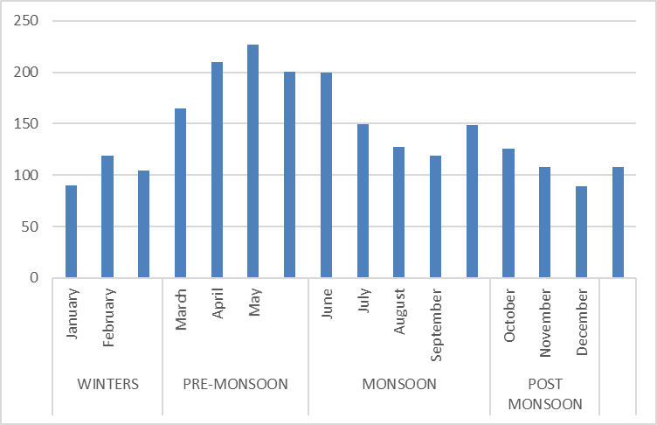

Fig 2. Graph of Monthly Reference Evapotranspiration

Table 4. Effective rainfall(mm/month) estimated by CROPWAT for Prayagraj from 1993- 2023

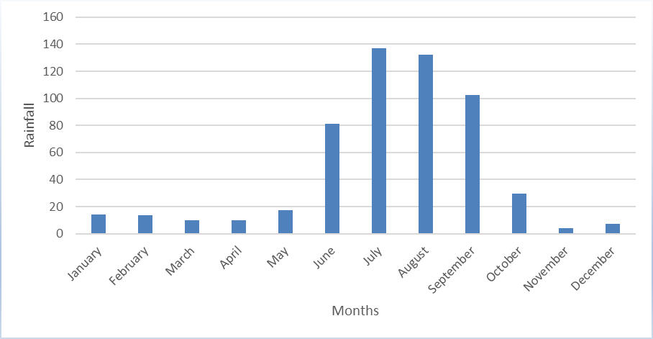

Fig 3. Graph of Monthly Effective rainfall

3.3 Estimation of Crop Water Requirement and Irrigation Water Requirement for Chickpea in Prayagraj Region
The seasonal crop water requirement (CWR) of chickpea in Prayagraj, as estimated using the CROPWAT 8.0 model for the period 1993–2023, was found to be 182.12 mm. The crop’s water demand exhibited notable variation across its growth stages. During the initial stage, the requirement was minimal at 2.09 mm, primarily due to residual soil moisture from the preceding monsoon season. As the crop progressed into the development stage, the cumulative water need increased to 32.02 mm. The mid-season stage, encompassing flowering and pod formation, exhibited the highest water demand (83.28 mm)—a critical phase for determining yield potential. In the late stage, which corresponds to grain filling and maturity, the requirement was 64.73 mm. These findings underscore the mid and late growth stages as the most water-sensitive periods in chickpea development, highlighting the necessity for precise irrigation to avoid yield penalties. Complementary to the CWR findings, the Irrigation Water Requirement (IWR) was assessed on a decadal basis from November to February, aligning with chickpea’s typical growing window. In the early phase (November), the irrigation need was low—only 1.73 mm—attributed to residual monsoonal moisture and low evaporative demand (FAO, 2020). Chickpea’s deep rooting system and robust seedling vigor further reduce dependence on external water input during this stage.
However, as the crop advanced into the vegetative and early reproductive stages, irrigation needs rose sharply. Notably, during bud initiation, water demand peaked at 16.54 mm, with an average of 9.12 mm across the stage. This aligns with findings by (Singh et al., 2017), who emphasized the significance of adequate moisture during early reproductive phases for achieving optimal pod set. The mid-season stage, covering late December to January, marked the peak irrigation requirement, averaging 23.98 mm. This stage is the most crucial for irrigation scheduling, as water deficits during flowering and pod formation can severely impact yield. These observations are consistent with (Tiwari et al., 2006), who reported similar patterns under Eastern Indian agro-climatic conditions. Toward the late stage, water demand gradually declined, with average irrigation needs reducing to 17.5 mm. This reduction corresponds to natural plant senescence and reduced metabolic activity, during which the crop shifts reliance to stored reserves rather than continued water uptake. In summary, chickpea in Prayagraj exhibits a moderate total water requirement, but with peak irrigation needs concentrated during its reproductive phase—particularly from late December to mid-January. Efficient water management during this window is critical to ensure successful pod development and optimal grain yield under semi-arid conditions.
Table 5. Crop water requirement & Irrigation water requirement(mm/dec) of chickpea for Prayagraj from 1993-2023

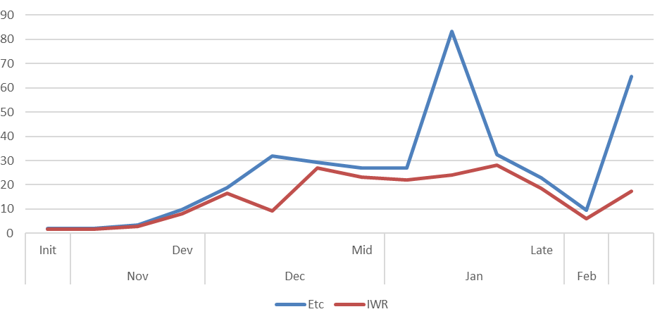
Fig 4. Graph Representation of IWR vs ETc

Conclusion

The study demonstrates a pronounced seasonal variability in evapotranspiration and rainfall patterns in Prayagraj, with the pre-monsoon months exhibiting the highest reference evapotranspiration (ET₀) values. Analysis of effective rainfall indicates that precipitation during the rabi season is insufficient to meet the water demands of chickpea, thereby necessitating supplemental irrigation. The estimated irrigation water requirement (IWR) of 153.56 mm closely approximates the total crop water requirement (CWR), underscoring the crop’s high dependency on irrigation in this semi-arid region. Among the various phenological stages, the mid and late growth phases—particularly flowering to pod development—emerge as the most water-sensitive, where timely irrigation is crucial to prevent moisture stress and ensure optimal yield. These findings reinforce the need for season-specific irrigation planning and the adoption of efficient water management strategies to enhance the sustainability and productivity of chickpea cultivation in the Prayagraj region.

COMPETING INTERESTS DISCLAIMER:
Authors have declared that they have no known competing financial interests OR non-financial interests OR personal relationships that could have appeared to influence the work reported in this paper.

REFERENCES
- A review. British Journal of Nutrition. 2012;108(Suppl 1). doi: 10.1017/S0007114512000797.
- Allen, R. G., Pereira, L. S., Raes, D., & Smith, M., (1998). Crop Evapotranspiration: Guidelines for computing crop water requirements. Irrigation and Drainage Paper 56, FAO of the United Nations, Rome. 300 pp.
- Allen, R.G., Pereira, L.S., Raes, D., & Smith, M., (1998). “Crop Evapotranspiration: Guidelines
- Banik, P., Tiwari, N. K., & Ranjan, S. (2014). Comparative crop water assessment using CROPWAT. International Journal of Sustainable Materials, Processes & ECO- efficient-IJSMPE, 1 (3).
- Bemal, S., Singh, D., & Singh, S. (2012). Rainfall variability analysis over eastern agroclimatic zone of Haryana. Journal of Agrometeorology, 14 (1), 88-90.
- Chauhan, A. S., Singh, S., Maurya, R. K. S., Kisi, O., Rani, A., & Danodia , A. (2022). Spatio - temporal analysis of rainfall dynamics of 120 years (1901–2020) using innovative trend methodology: A case study of Haryana, India. Sustainability, 14(9), 4888.
- Christiansen, J. E., (1968). Pan evaporation and evapotranspiration from climatic data. J. Irrig.Drain.Divis., ASCE 94: 243-265.
- for computing crop water requirements”, Irrigation and Drainage Paper, 56, pp. 300
- Gadge, S.B., Gorantiwar, S.D., Kumar, V., & Kothari, M., (2011). “Estimation of crop water requirement based on Penman-Monteith approach under micro-irrgation system”, J.Agrometeorol., 13, 1 pp. 58-61
- Gangwar, A., Nayak, T. R., Singh, R. M., & Singh, A. (2017). Estimation of crop water requirement using CROPWAT 8.0 model for Bina command, Madhya Pradesh. Indian journal of Ecology, 44(4), 71-76.
- Halimi, A. H., & Tefera, A. H. (2019). Application of CROPWAT model for estimation of irrigation scheduling of Tomato in changing climate of Eastern Europe: the case study of Godollo, Hungary. Int J Agric Environ Sci, 6, 1-11.
- Hargreaves G.H., & Samani, Z.A., (1985). “Reference crop evapotranspiration from temperature” Applied Engg. Agri., 1, pp. 96-99.
- Hargreaves, G.H., & Samani, Z.A., (1985). Reference evapotranspiration from temperature. American Soc.Agril. Engg.,1(2):96-99.
- Irmak, S., Allen, R. G., & Whitty, E. B., (2003). Daily grass and alfalfa-reference evapotranspiration estimates and alfalfa to grass evapotranspiration ratios in Florida. J. Irrig.Drain. Engg.129(5):360-370.
- Jukanti AK, Gaur PM, Gowda CL, Chibbar RN. Nutritional quality and health benefits of chickpea (Cicer arietinum L.):
- Mehanuddin, H., Nikhitha, G. R., Prapthishree, K. S., Praveen, L. B., & Manasa, H. G. (2018). Study on water requirement of selected crops and irrigation scheduling using CROPWAT 8.0. International Journal of Innovative Research in Science, Engineering and Technology, 7 (4), 3431-3436.
- Mehta R., & Pandey V., (2015). “Reference evapotranspiration (ETo) and crop water requirement (ETc) of wheat and maize in Gujarat”, J. Agrometeorol. 17, 1 pp. 107-113
- Mehta, R., & Pandey, V., (2015). Reference evapotranspiration (ETo) and crop water requirement (ETc) of wheat and maize in Gujarat. J. Agrometeorol.,17(1):107-113.
- Moreno MT, Cubero JI. Variation in Cicer arietinum L. Euphytica. 1978;27:465-485.
- Pandey, V., Patel, V.J., Vadodaria, R.P., Patel, H.R., & Shekh, A.M., (2008). “Irrigation water requirement and production potentials of major crops over Narmada canal command area in Gujarat”, J. Agrometeorol. 10, special issue-2, pp. 341-320.
- Pandith, V., Kour, H., Singh, S., Manhas, J., & Sharma, V. (2020). Performance evaluation of machine learning techniques for mustard crop yield prediction from soil analysis. Journal of scientific research, 64 (2), 394-398.
- Patel, A., Sharda, R., Patel, S., & Meena, P. (2017). Reference evapotranspiration estimation using CROPWAT model at Ludhiana district (Punjab). International Journal of Science, Environment and Technology, 6 (1), 620-629.
- Patil, P.D., &Gorantiwar, S.D., (2009). “Probability analysis of weekly crop evapotranspiration of Rahuri region”, International J. of Agril. Engg., 2, 1 pp. 68-71
- Patle, G. T., Singh, D.K., Sarangi, A., Rai, A., Khanna, M., & Sahoo, R. N. (2013). Temporal variability of climatic parameters and potential evapotranspiration. Indian J. Agric. Sci, 83 (4), 518-524.
- Ratna Raju, C., Yella Reddy, K., Satyanarayana, T. V., & Yogitha, P. (2016). Estimation of crop water requirement using CROPWAT software in Appapuram channel command under Krishna western delta. Int. J. Agric. Sci, 8, 1644-1649.
- Surendran, U., Sushanth, C. M., Mammen, G., & Joseph, E. J. (2017). FAO-CROPWAT model-based estimation of crop water need and appraisal of water resources for sustainable water resource management: Pilot study for Kollam district–humid tropical region of Kerala, India. Current Science, 76-86.
- Tripathi, K. B., & Mani, A. K. (2021). Influence of different net sowing dates and varieties on entire shriveled substance and its separation in distinct plant parts and yield of Indian mustard. International Journal of Ecology and Environmental Sciences, 3, 446-450.
- Turc, L., (1961). “Estimation of irrigation water requirements, potential evapotranspiration: A Simple climatic formula evolved up to date”, Ann. Agron. 12, pp. 13-49.
- Tyagi, N.K,.Sharma D.K., & Luthara, H.K., (2000). “Evapotranspiration and crop-coefficients of wheat and sorghum”, J. Irrig. Drain.Engg., ASCE. 126(4): 215-222.
- USDA/Foreign Agricultural Service, Global Market Analysis (2024). World Agricultural Production | USDA Foreign Agricultural Service.
- Verma, R., & Singh, R. M. (2019). Water Requirement of Sugarcane Using CropWat 8.0 Model: A Case Study of North India. Int. J. Curr. Microbiol. App. Sci8 (10): 1452, 1459.

