Organic farming as a climate change adaptation and mitigation strategy

Abstract
Recent decades have transformed Indian agriculture from traditional methods to a mechanized system reliant on fossil fuels, chemical fertilizers and pesticides, increasing greenhouse gas emissions and impacting global climate. Higher greenhouse gas levels, including carbon dioxide, methane and ozone are likely, causing the observed rise in air temperatures and leading to significant climate shifts. In most subtropical regions, a 4°C rise in global temperatures is anticipated to reduce groundwater and surface water, heightening food demand and threatening global food security. Climate change denotes long-term, significant alterations in climate measurements. A production system that maintains the health of ecosystems, soils and human populations is known as organic farming (IFOAM, 2006). Organic farming is energy-efficient and reduces greenhouse gas emissions by minimizing chemical and fossil fuel use, while enhancing soil carbon, biodiversity and fertility. It reuses plant and animal waste to restore soil nutrients, relies on renewable resources and supports sustainable, low-pollution management. Organic farming not only helps to mitigate climate change but also provides lasting benefits as an adaptation strategy. Effective nutrient management and carbon sequestration in soils are crucial for adapting and mitigating climate change across diverse temperature zones and local conditions.
Keywords: Greenhouse gas, Adaptation, Climate change, Mitigation and Organic farming.
Introduction:
Codex Alimentarius Commission (FAO/WHO) defines “Organic farming is a system, which avoids or largely excludes the use of synthetic inputs (such as fertilizers, pesticides, hormones, feed additives etc.,) and to the maximum extent feasible relies upon crop rotations, crop residues, animal manures, off-farm organic waste, mineral grade rock additives and biological system of nutrient mobilization and plant protection”. According to Eyhorn (2007), organic farming addresses socio cultural, economic, and physical issues that affect vulnerability and sustainable development. A workable path to resilient food systems and climate change is provided by organic farming (Delate et al., 2013). Approximately half of the population depends on agriculture for their livelihoods, and it accounts for 14% of GDP and 11% of exports, making it vital to national economies (MOA, 2012). Additionally, it provides raw materials to a range of industries. Climate change has a considerable impact on crop productivity, water availability, and food security. Agriculture is particularly sensitive to these effects (Goyal, 2004). From 13.5% to 30% of the world's greenhouse gas emissions are caused by agriculture (Foereid et al., 2008). It accounts for about 17.6% of the country's emissions in India (INCCA, 2010). Emissions have increased due to conventional practices that rely heavily on fossil fuels and intensive inputs (West and Marland, 2002). Reducing inputs and increasing carbon sequestration are two ways that organic farming can reduce greenhouse gas emissions and promote climate resilience (Gattinger et al., 2012). According to several emission scenarios, the IPCC predicts that global temperatures would rise by 1.1 to 6.4 °C by 2100 (IPCC, 2007a). It is predicted that temperatures in India would climb by 1.7°C to 2.0°C, and that rainfall will increase by 3% to 7%. Climate-induced extinctions and reductions in species distribution are already evident, with significant local population losses across diverse habitats (Patle et al., 2014) extreme weather events are intensifying, negatively affecting agriculture, forestry, fisheries, and aquaculture. Greenhouse gas emissions from agriculture contribute 10–12% of total anthropogenic CO₂-equivalent emissions (IPCC, 2007). Organic farming has potential for both reducing greenhouse gas emission and enhancing soil carbon sequestration. It offers resilience against climate variability and aligns with sustainable development goals, making it a crucial focus for adaptation and mitigation strategies in the face of climate change.
Greenhouse gas emission from global agriculture:
Monitoring for greenhouse gas (GHG) emissions across all relevant sectors is essential, as they occur across the food chain from agricultural production to consumption. Perhaps 25–30% of greenhouse gas emissions worldwide are related to agriculture. Each year, human activities release more carbon dioxide into the atmosphere than natural processes can remove, causing the amount of carbon dioxide in the atmosphere to increase. The amount of CO₂ in the atmosphere as of 2022 was 417 parts per million (ppm), (Fig:6). However, the Annual Greenhouse Gas Index (AGGI) indicates an equivalent concentration of 523 ppm CO₂ when taking into account the cumulative warming effect of all greenhouse gases (Fig:1, Fig:2 and Fig:5). Greenhouse gases have a considerable impact on global warming. A little over 36 billion metric tons of CO₂ are released into the atmosphere each year from a variety of sources, such as energy generation, cement production, deforestation, transportation, and agriculture. For more than a millennium, a considerable amount of CO₂ is retained in the atmosphere. Seventy-seven percent of the heat rise monitored by the AGGI since 1990 can be attributed to increases in atmospheric CO₂ levels of 63ppm. The global average carbon dioxide set a new record high in 2023, 419.3 parts per million. Atmospheric carbon dioxide is now 50 percent higher than it was before the industrial revolution. The annual rate of increase in atmospheric carbon dioxide over the past 60 years is about 100 times faster than previous natural increases, such as those occurred at the end of the last ice age 11,000-17,000 years ago,(Fig:11). Global average surface temperature has increased, (Fig:4). The ocean has absorbed enough carbon dioxide to lower its pH by 0.1 units, a 30% increase in acidity.
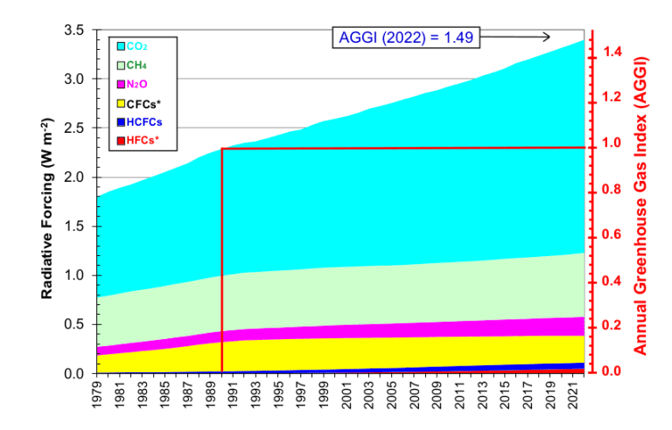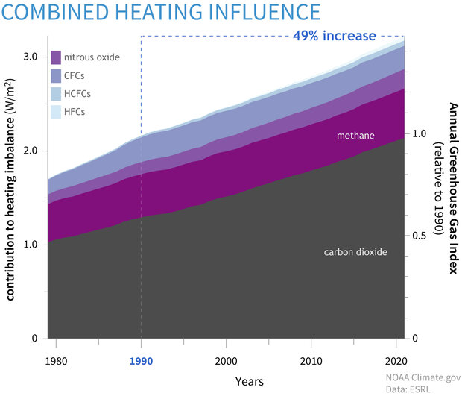
Fig:1 NOAA Annual Greenhouse Gas Index Fig:2 Greenhouse gas heating imbalance Source: NOAA Global Monitoring Laboratory. Source: NOAA Global Monitoring Laboratory
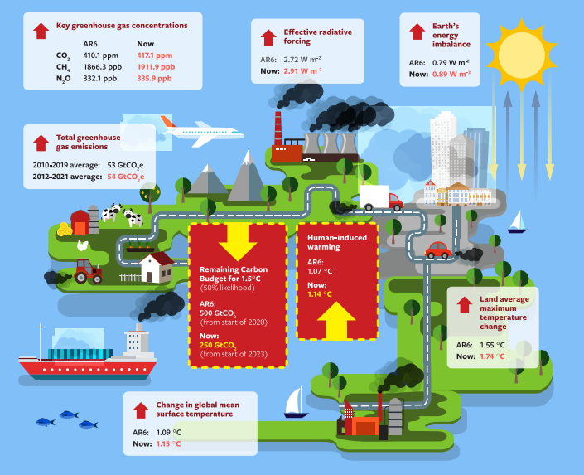
Fig:3 Indicators of Global Climate Change (IGCC) initiative. Source: essd.coprincus.org
Methane (CH₄) is the second most significant contributor after carbon dioxide. In 2022, the amount of heat trapped in the atmosphere by greenhouse gases caused by human activity was 49% higher than in 1990, as per the NOAA's Annual Greenhouse Gas Index, (Fig:3). A total of fifteen gases, including CO₂, methane, nitrous oxide, chlorofluorocarbons, and other heat-trapping gases, are tracked and their warming influence is measured by the AGGI. Methane in the atmosphere averaged 1,911.8 parts per billion (ppb) in 2022, which is almost 2.5 times more than pre-industrial levels (Fig:8). Furthermore, methane emissions from fossil fuels have increased. The concentration of nitrous oxide, the third most significant greenhouse gas produced by humans, increased by 24% from pre-industrial levels to 335.7 parts per billion in 2022(Fig:7). Due mostly to increased usage of nitrogen fertilizers and manure brought on by agricultural intensification and expansion, last year's 1.25 ppb growth was the third-largest since 2000. This emphasizes the continued influence of farming methods on greenhouse gas emissions and the requirement for focused mitigation plans.
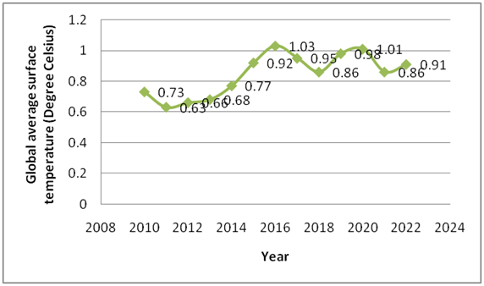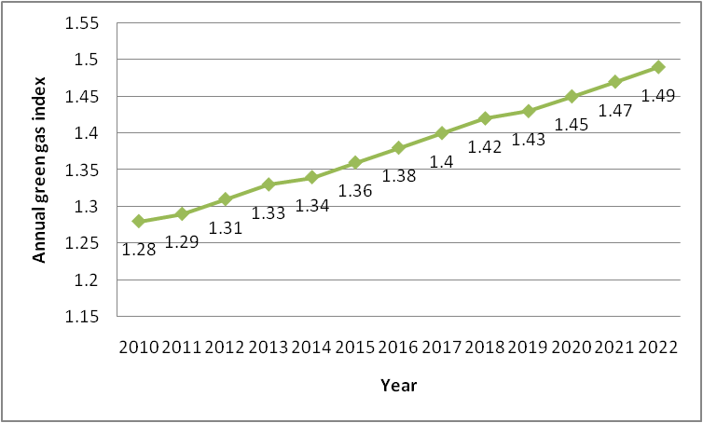
Fig 4: Global average surface temperature (ºc ) Fig 5: Annual greenhouse gas index.
Source: essd.coprincus.org Source: essd.coprincus.org
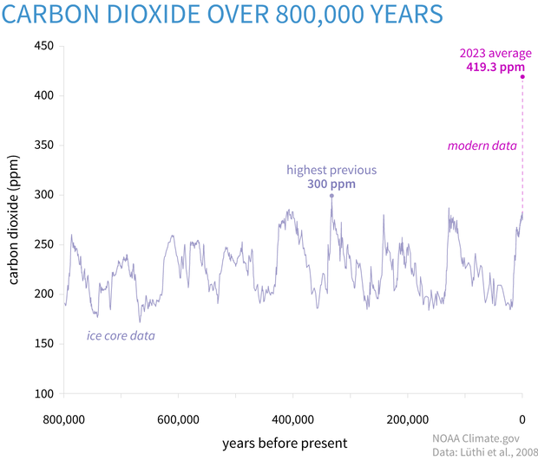
Fig 6: Global carbon dioxide concentration (ppm) Source: NOAA Global Monitoring Laboratory.
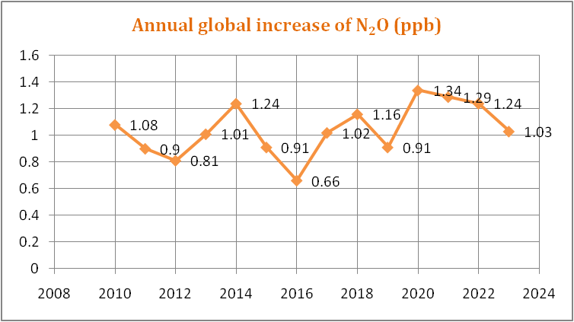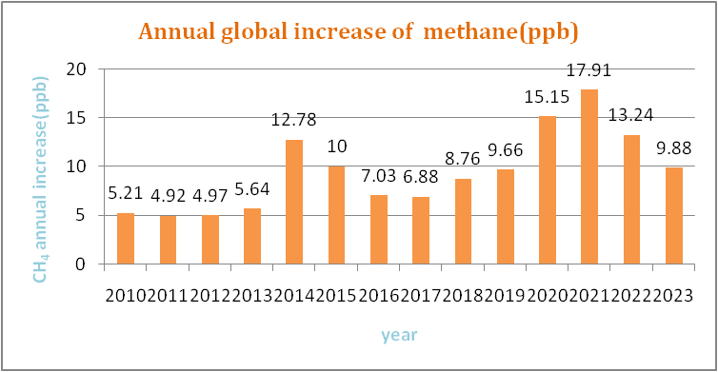
Fig:7 Annual global increase of N₂O(ppb) Fig:8 Annual global increase of CH₄(ppb) Source: NOAA Global Monitoring Laboratory Source: NOAA Global Monitoring Laboratory.
Emissions and removals of the greenhouse gases:
Gases that trap heat in the atmosphere are called greenhouse gases. Greenhouse gas consist of CO₂, methane, nitrous oxide, chlorofluorocarbons, and other heat-trapping gases (Fig:9).
- Carbon dioxide (CO₂): Carbon dioxide enters the atmosphere through burning fossil fuels (coal, natural gas, and oil), solid waste, trees and other biological materials, and also as a result of certain chemical reactions (e.g., cement production) (Fig:10). Carbon dioxide is removed from the atmosphere (or "sequestered") when it is absorbed by plants as part of the biological carbon cycle.
- Methane (CH₄): Methane is emitted during the production and transport of coal, natural gas and oil. Methane emissions also result from livestock and other agricultural practices, land use, and by the decay of organic waste in municipal solid waste landfills.
- Nitrous oxide (N₂O): Nitrous oxide is emitted during agricultural, land use, and industrial activities; combustion of fossil fuels and solid waste; as well as during treatment of wastewater.
- Fluorinated gases: Hydro fluorocarbons, per fluorocarbons, sulfur hexafluoride, and nitrogen tri fluoride are synthetic, powerful greenhouse gases that are emitted from a variety of household, commercial, and industrial applications and processes. Fluorinated gases (especially hydro fluorocarbons) are sometimes used as substitutes for stratospheric ozone-depleting substances (e.g., chlorofluorocarbons and hydro chlorofluorocarbons). Fluorinated gases are typically emitted in smaller quantities than other greenhouse gases, but they are potent greenhouse gases. They are sometimes referred as high global warming potentials gases because, for a given amount of mass, they trap substantially more heat than CO₂.
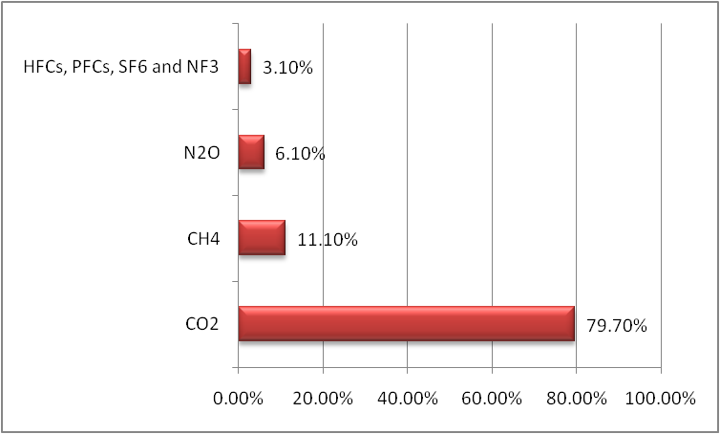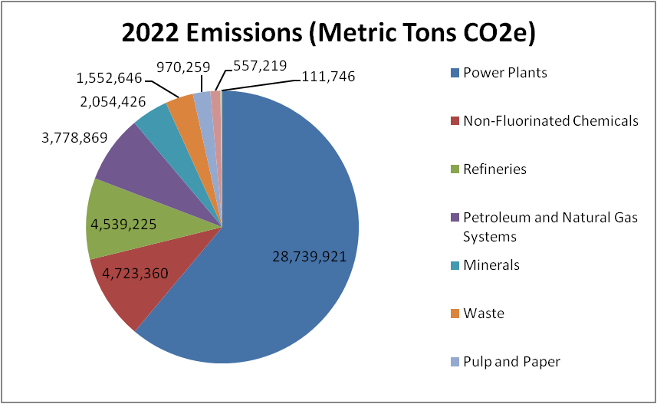
Fig:9 Green house gas composition Fig:10 Global CO₂ emissions from various sources Source: essd.coprincus.org Source: essd.coprincus.org

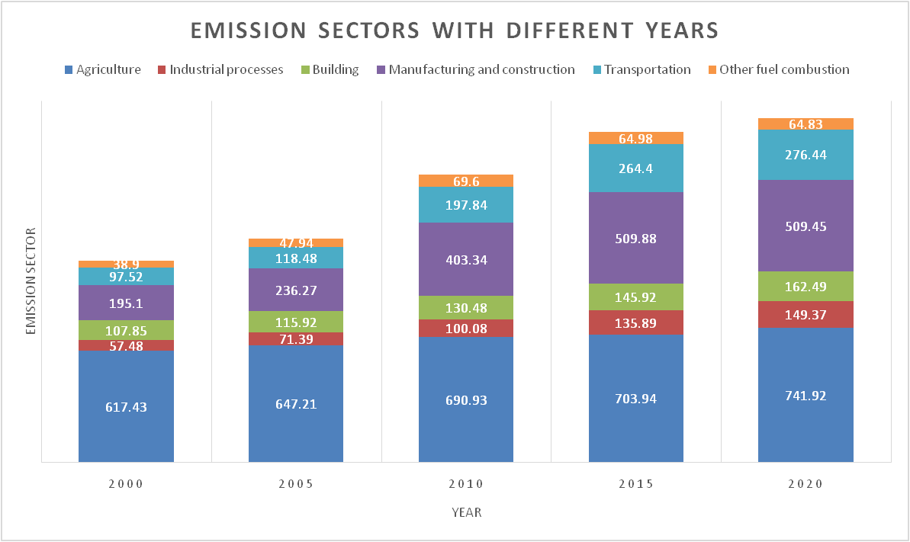
Fig: 11 Various sector annual greenhouse gas emissions worldwide(million metric tons of CO₂e).Source: Statista,2024
Impacts of climate change on the agricultural sector:
Climate change is one major obstacle to sustainable development. Global temperatures have risen by 1.0°C over pre-industrial levels due to anthropogenic greenhouse gas emissions. Between 2030 and 2052, it is predicted that global warming will increase by 1.5°C, which will increase the frequency of extreme weather events including heat waves, floods, and droughts, and impair ecosystem function. Climate change impacts agriculture through primary and secondary effects. Agriculture is impacted by both primary and secondary effects of climate change. Primary effects include crop growth effects, changes to the energy and moisture balances in farming, and atmospheric changes brought on by an increase in greenhouse gases. Changes in the physical and chemical qualities of agricultural soil and adjustments to the best places for production are examples of secondary effects that arise from these primary changes. Producing agricultural products using suitable farming systems and choosing crops that are adaptable to local conditions. Climate change affects temperature, precipitation, and sunshine in agricultural ecosystems, changing biodiversity and increasing pest and disease incidence. Crop growth and maturity are directly impacted by temperature and rainfall variations, which expose crops to both biotic and abiotic stresses. According to a recent study, 30–50% of losses in agricultural productivity worldwide are attributed to these stresses. It alters pasture growth patterns and biological processes in cattle, such as fertilization and breeding. Due to changes in water sources, climate change has a substantial impact on agricultural infrastructure, farm household incomes, asset values, and agricultural production in rural areas. Climate change not just shifts in temperature, precipitation, and rising atmospheric CO₂, but also extreme scenarios like glacial melt, permafrost melting, and rising sea levels.

Status of organic farming in India:
As per the Agricultural and Processed Food Products Export Development Authority,(APEDA) India's rank second in terms of World's Organic Agricultural land and first in terms of total number of producers. India has lot of potential to produce all varieties of organic products due to its various agro climatic conditions. This holds promise for the organic producers to tap the market which is growing steadily in the domestic and export sector. In several parts of the country, the inherited tradition of organic farming is an added advantage. . About 30% of global crop production and global food supply is provided by small land holdings, less than 2 hectares, using around 25% of agricultural land, and in a way that usually maintains rich agro-biodiversity. As on 31st March 2024 total area under organic certification process is 7.3 million ha. This includes 44.75 million ha cultivable area and another 28.50 million ha for wild harvest collection. Among all the states, Madhya Pradesh has covered largest area under organic certification followed by, Maharashtra, Rajasthan, Gujarat, Odisha, Sikkim, Uttar Pradesh, Uttarakhand, Kerala, Karnataka and Andhra Pradesh. India produced around 3.6 million metric tons of certified organic products. The total volume of export during 2023-24 was 2,61,029 MT. Organic production is governed by UK and EU legislation
Organic farming as adaptation to climate change:
The objective of adaptation strategies is to restore ecological resilience and production, which is essential for long-term, sustainable economic growth. Agriculture is extremely vulnerable to climate change, thus in order to guarantee food supplies, it needs to use workable adaptation strategies, (Tab:1). According to Ensor (2009), organic farming encourages resilient farming systems that withstand harsh weather conditions, droughts, and soil erosion—all of which contribute to agriculture being a more sustainable and ecologically friendly industry. Agro-ecosystems that practice organic farming are more resilient to the impacts of climate change. The adaptation costs associated with organic farming is minimal and mostly relate to information, education, and extension services.
Table:1 Types of adaptation to climatic changes.
Aspect | Adaptation Measure | Description
Physical Adaptations
Erosion Control | Contour farming, terracing. Wind breaks, cover crops. | Reduces soil erosion by slowing water runoff and increasing water infiltration. Protects soil from wind erosion and improves soil structure
Soil Moisture Management | Mulching, irrigation improvements.  Rainwater harvesting. | Helps retain soil moisture and reduces evaporation.  Collects and stores rainwater for agricultural use, reducing dependency on irregular rainfall
Temperature Regulation | Agro forestry.  Conservation tillage. | Incorporates trees into agricultural systems to provide shade and reduce soil temperature. Minimizes soil disturbance, preserving soil moisture and structure.
Chemical Adaptations
Nutrient Management | Organic amendments, crop rotation.  Precision agriculture. | Enhances soil fertility and nutrient cycling.  Utilizes technology to optimize fertilizer application and reduce chemical runoff.
pH Regulation | Liming acidic soils.  Gypsum application on sodic soils. | Increases soil pH to improve nutrient availability.  Helps reclaims sodic soils by improving soil structure and reducing salinity.
Biological Adaptations
Enhancing Soil Biodiversity | Cover cropping, green manures.  Reduced pesticide. | Improves soil health by increasing organic matter and supporting diverse microbial communities.  Use Protects beneficial soil organisms and promotes a healthy soil ecosystem.
Promoting Soil Fauna | Habitat creation, reduced tillage. | Supports earthworms and other beneficial soil fauna that enhance soil structure and fertility.
Plant-Soil Interaction | Mycorrhizal inoculation. | Improves plant tolerance and enhances plant nutrient uptake through beneficial fungal relationships.

Organic farming as mitigation of climate change:
Organic farming mitigates climate change by emitting fewer greenhouse gases and sequestering more carbon in soil (IFOAM, 2009). Increasing soil organic carbon in farming systems has also an important mitigation option by IPCC (2007b). About 32 percentage of all current man-made greenhouse gases emissions can be sequester through adaption of organic farming globally (Jordan et al., 2009). According to FAO, organic systems emit fewer greenhouse gases due to lower energy inputs and sequester more carbon in biomass compared to conventional systems, (Ziesemer, 2007). Soil organic carbon sequestration potential in global grasslands is 2.3 to 7.3 billion tons of carbon dioxide equivalents per year (CO₂e year⁻¹) for biodiversity restoration, 148 to 699 megatons of CO₂e year⁻¹ for improved grazing management, and 147 megatons of CO₂e year⁻¹ for sown legumes in pasturelands. Organic farming minimizes N₂O emissions and reduces CO₂ emissions due to improved soil structure, increased plant cover, and lower fossil fuel use. Soils are the major sink for atmospheric CO₂, soil organic carbon increased through organic manures, crop cover and crop rotation and restores it for the longer duration in organic farming. Aher et al., (2012) found that organic yields are comparable to conventional yields while using 45% less energy, demonstrating greater efficiency in mitigation efforts. Organic farming systems use 20 to 50% less energy compared to the conventional farming system (Muller et al., 2012). It also enhances resilience through water efficiency, better handling of extreme weather, and reduced risk of crop failure.
Benefits of organic farming regarding climate change:
According to Wani et al., (2013) the numerous benefits of organic farming practices is its contribution to climate change. The following benefits are:
47WANI
et al.
- Reduction in greenhouse gas emissions and decreased need for fossil fuels per acre and kilogram as a result of not using synthetic fertilizers. The successful sequestration of carbon dioxide into the soil reduces soil erosion, a significant source of CO₂ losses.
- Leguminous crops, agricultural residues, cover crops, and the stability of soil organic matter all contribute to better soil fertility and nitrogen availability. Increases the soil's ability to hold on water in the face of erratic weather that brings greater temperatures and erratic precipitation amounts. Retaining soil carbon aids in resilience to climate change.
- Largely in agro forestry production methods made feasible by farming. Highly adaptable systems due to applications of farmers traditional skills, soil fertility-building strategies, and a high level of diversity.
- Enrichment of soil, management of temperature, conservation of rain water, maximum harvesting of sun energy, self reliance in inputs, maintenance of natural cycles and life forms, integration of animals and maximum reliance on renewable energy sources, such as solar power and animal power.
- The foundation of organic farming lies in the health of the soil. A fertile soil provides essential nutrients to a growing crop plant, and helps support a diverse and active biotic community. Strategies to build soil fertility are crop rotations, animal and green manures, and cover cropping.

Conclusion:
An increasing population has put a lot of pressure on agriculture to ensure the food and nutritional security of the world, which is further worsening with climate change. The future climate scenario report that climate change will decrease agricultural productivity in the coming years. A number of mitigation and adaptation strategies have been developed to offset the deleterious impact of climate change on agricultural sustainability. Mitigation and adaptation strategies are expected to increase farmers income without compromising agricultural-production sustainability. Organic farming aims at cultivating the land and crops raising in such a way, as to keep the soil alive and in good health conditions by use of wastes that are organic such as (crop, animal and farm wastes, aquatic wastes) and other biological materials along with beneficial micro organisms (bio fertilizers and bio pesticides) to grow and protect the crops for increased sustainable production in an ecologically friendly and pollution free environment. Effective adaptation and mitigation strategies must be widely disseminated in order to improve the ecology and soil health of the environment and stop the impending negative consequences of climate change and variability. Suitable varieties need to be developed that could adapt to climatic variations, along with planned agronomic management and crop pest control. Farmers need to be educated regarding various climate-smart technologies, and be provided training to simplify their use at the field level.
References:
- Aher, S. B., Sengupta, B. and Bhaveshanada, S. (2012). Organic agriculture: way towards sustainable development. ARPN Journal of Science and Technology, 2:318-324.
- Delate, Kathleen, Cynthia Cambardella, Craig Chase, Ann Johanns, and Robert Turnbull. 2013. “The Long-Term Agroecological Research (LTAR) Experiment Supports Organic Yields, Soil Quality, and Economic Performance in Iowa.” Crop Management.
- Ensor, J. 2009. Biodiverse agriculture for a changing climate. Practical Action, UK.
- Eyhorn, F. 2007. “Organic Farming for Sustainable Livelihoods in Developing Countries: The Case of Cotton in India.”PhD diss. Department of Philosophy and Science, University of Bonn.
- FAO/WHO (Food and Agriculture Organization/World Health Organization). 1999. Codex Alimentarius: Guidelines for the Production, Processing, Labelling and Marketing of Organically Produced Foods.
- Foereid, B., Hastings, A. and Smith, P. (2008). Cool farming: Climate impacts of agriculture and mitigation potential (p. 28). Amsterdam: Greenpeace International.
- Forster, P. M., Smith, C. J., Walsh, T., Lamb, W. F., Lamboll, R., Hauser, M., Ribes, A., Rosen, D., Gillett, N., Palmer, M. D., Rogelj, J., von Schuckmann, K., Seneviratne, S. I., Trewin, B., Zhang, X., Allen, M., Andrew, R., Birt, A., Borger, A., Boyer, T., Broersma, J. A., Cheng, L., Dentener, F., Friedlingstein, P., Gutiérrez, J. M., Gütschow, J., Hall, B., Ishii, M., Jenkins, S., Lan, X., Lee, J.-Y., Morice, C., Kadow, C., Kennedy, J., Killick, R., Minx, J. C., Naik, V., Peters, G. P., Pirani, A., Pongratz, J., Schleussner, C.-F., Szopa, S., Thorne, P., Rohde, R., Rojas Corradi, M., Schumacher, D., Vose, R., Zickfeld, K., Masson-Delmotte, V., and Zhai, P.: Indicators of Global Climate Change 2022: annual update of large-scale indicators of the state of the climate system and human influence, Earth Syst. Sci. Data, 15, 2295–2327.
- Gattinger, A., Muller, A., Haeni, M., Skinner, C., Fliessbach, A., Buchmann, N., Mader, P., Stolze, M., Smith, P., Scialabba, N. E. and Niggli, U. (2012). Enhanced top soil carbon stocks under organic farming. Proceedings of the National Academy of Sciences, 109(44): 18226- 18231.
- Global GHG emissions by sector 1990-2022 | Statista.
- Goyal, R. K. (2004). Sensitivity of evapotranspiration to global warming: a case study of arid zone Rajasthan. Agricultural Water Management, 69 (1): 1-11.
- G. T. Patle, K. K. Badyopadhyay and Mukesh Kumar.2014. An overview of organic agriculture: A potential strategy for climate change mitigation. Journal of Applied and Natural Science 6 (2): 872 - 879.
- IFOAM (2009). High sequestration low emission food secures farming. Organic agriculture a guide to climate change and food security.
- IFOAM (International Federation for Organic Agriculture Movements)., “Mitigation and Adaptation to Climate Change: The Role of Organic Agriculture.” IFOAM side event to the 24th Session of the Subsidiary Bodies, Bonn,Germany, May 24, 2006.
- INCCA (2010). Indian Network for Climate Change Assessment, Climate Change and India: A 4x4 Assessment, Ministry of Environment and Forests, Government of India.
- IPCC (2007a). Climate Change 2007: The Physical Science Basis. Contribution of working group I to the fourth assessment report of the Intergovernmental Panel on Climate Change. Cambridge University Press, Cambridge, United Kingdom and New York, NY, USA.
- IPCC (2007b). Climate Change 2007: Impacts, Adaptation and Vulnerability. Working group II contribution to the fourth assessment report. Cambridge Univ. Press, Cambridge, UK.
- IPCC.2007. Climate Change 2007b: Synthesis Report. United Nations Environment Programme,:Ch5, 8, and 10.
- Jorden, R., Muller, A. and Oudes, A. (2009). High carbon sequestration, low emission food secure farming. Organic Agriculture- a guide to climate change and Food Security.
- MOA (2012). State of Indian Agriculture 2012-13. Ministry of Agriculture, GOI, Department of agriculture and co operation, Directorate of Statistics and economics, New Delhi.
- Muller, A., Olesen, J., Davis, J., Smith, L., Dytrtová, K., Gattinger, A., Lamp-kin, N. and Niggli, U. (2012). Reducing global warming and adapting to climate change: The potential of organic agriculture. Working paper, draft version, 2012.
- Lan, X., K.W. Thoning, and E.J. Dlugokencky: Trends in globally-averaged CH4, N2O, and SF6 determined from NOAA Global Monitoring Laboratory measurements. Version 2024-08.
- Treadwell, D., W. Klassen, and M. Alligood. 2008. Annual cover crops in Florida vegetable systems Part I. Objectives: Why grow cover crops? HS387. Institute of Food and Agricultural Sciences, University of Florida, Gainesville.
- Wani SA, Chand S, Najar GR and Teli MA 2013. Organic Farming: As a Climate Change Adaptation and Mitigation Strategy. Current Agriculture Research Journal 1(1): 45-50.
- West, T. O. and Marland, G. (2002). A synthesis of carbon sequestration, carbon emissions, and net carbon flux in agriculture: comparing tillage practices in the United States. Journal of Agriculture Ecosystems and Environment, 91:217-232.
- Ziesemer, J. (2007). Energy use in organic food systems. Natural Resources Management and Environment Department Food and Agriculture Organization of the United Nations, Rome.

