Analysis of Climate Change Indicators in the Niger Delta Region

Abstract

Climate change is considered to be a change in the climatic conditions over a period due to anthropogenic or natural causes and is considered as one of the natural factors which affect landscape patterns. Therefore, this study assessed the fluctuation and trend in climate change indicators in the Niger Delta Region. This study adopted a cross-sectional research design method while the data set of thirty years from NIMET (Nigeria Meteorological Agency) of 1986 - 2016 were employed in the study, both, descriptive and inferential statistics and student t-test with the aid of graphs and charts were also reflected in the study. The results shows that years with maximum temperature above the mean annual value includes, 1987, 1995, 1998, 2000, 2002, 2003, 2004, 2008, 2009, 2010, 2016. 2016 and 2006 had the maximum and minimum temperature record of 31.76 and 30.25 °C respectively. The average temperature and rainfall increased by 27 °C and 2700 mm, respectively, from 1986 to 2016. By correlation analysis of changes with meteorological factors from 1986 to 2016, the results indicated that changes might be not directly related to temperature and rainfall changes with other land use change. This study concludes that among other things to promote in climate change study is to build resilience, policy reform in climate change awareness.

Keywords: Climate Change, Fluctuation, Trend, Variables.

Introduction
Climate change in IPCC usage refers to a change in the state of the climate that can be identified (e.g., using statistical tests) by changes in the mean and/or the variability of its properties, and that persists for an extended period, typically decades or longer. It refers to any change in climate over time, whether due to natural variability or as a result of human activity (IPCC, 2014).Intergovernmental Panel on Climate Change (IPCC) regards climate as the statistical description in terms of the mean and variability of the relevant atmospheric quantities, such as temperature and precipitation over a long period of time, which could range from months to thousands or millions of years (IPCC, 2014).In this respect, climate change is considered to be a change in the climatic conditions over a period due to anthropogenic or natural causes which this study adopted as a working definition on climate change. Climate change has become one of the most essential concerns in all fields dealing with atmospheric interactions and sustainable development. It is recognized as a major threat to the survival of species and wetland ecosystems. Climate change is defined as the long-term shift in the statistics of the weather for a given place and time of year, from one decade to the next. Climate change is defined using weather elements that serve as indicators. IPCC contemporary report on climate change and global warming IPCC (2013 and 2018) has evaluated the average trend of global temperature over the period of years 1880- 2012, it being equal to 0.85°C, with a degree of uncertainty ranging of 0.65°C - 1.06 °C. The rise occurred during the years 2003-2012 is +0.78°C - for a minimum of 0.72°C and a maximum of 0.85 °C (IPCC, 2018; Wali et al., 2020). National Climatic Data Centre (NCDC) deliberates 2014 as the warmest year ever documented, with an anomaly of + 0.69 °C, calculated for the period of the years 1880- 2014 (NOAA, 2015).
The variability in the climate of the Niger Delta region have been affirmed by different researches across disciplines, for example, Wali et al., (2020) analyses temperature and precipitation fluctuation in the Niger Delta region of Nigeria. The outcome shows that temperature and precipitation in the investigation zone are conversely related. This implies that as the temperature expands, precipitation diminishes in the investigation zone. However, the outcome is measurably insignificant (p > 0.05). Definitively the information shows that impact of environmental change is mostly influencing temperature in the region. Also, in a like mind manner, Odigwe et al., (2020) investigate the climate of the Niger Delta Region of Nigeria to ascertain the variations in rainfall and temperature of the region over 94 years. The study revealed that the mean distribution of rainfall and temperature in the region for the past ninety-four (94) years showed a downward and upward trend with a mean of 2238.3mm and 26.7ºC in rainfall and temperature respectively. While, the highest and lowest rainfall (2600.7mm and 1854mm), was recorded in 1955 and 1984 which indicates an increase of 746.7mm. The highest and lowest temperature (27.4ºC and 25.9ºC) was recorded in 2017, 1977 and 1976 respectively which indicate a rise of 1.5ºC. Nwafor et al., (2018) using vector auto regressive techniques modeled meteorological data in selected states in Southern Nigeria with emphasis on monthly rainfall and temperature a period of 1972 – 2011. The predicted value from the modeled data suggests continues increase in amount of monthly rainfall and temperature at different confidence interval.
Also, Abdullahi et al., (2020) noted that proximity to the Atlantic Ocean and topography contributed greatly to variation in rainfall characteristics in Nigeria. Despite the spatial differences in rainfall trends, rainfall received across the study period in Nigeria is consistent. Akwa-Ibom and Rivers state are two states in the Niger Delta that has very close proximity to the Atlantic Ocean. However there seem to be noticeable variation in the characteristic of temperature and rainfall characteristics especially at the annual scale. This variation despite having similar geographical characteristics calls for probing in order to identify where changes is more pronounced. To solve this dilemma, this study seeks to analyze temperature and rainfall variability over the two coastal states in the Niger delta region of Nigeria.
In this study, our aim is to see whether the Niger Delta region has experienced phenomenon of climate change. The aim is not to predict future precipitations and temperatures but to observe the evolution of the indicators of climate change during the period (1986 to 2016) over the study region.

Materials and Methods
The secondary data include raw NIMET climatic data of temperature and rainfall from 1986-2016. A simple linear regression analysis, namely the least square, multiple linear regression, ANOVA, method or linear regression, correlation analysis and Student’s T-test were used to detect climatic trends over time series. Student T-test was employed to test the significance of the obtained climatic trend. Also, descriptive statistical techniques were employed to summarize the characteristics of temperature and rainfall in the study area. Ordinary least square regression method was used to estimate trend in the time series data. Person product moment correlation technique was used to establish the relationship between temperature and rainfall.
The study Area
The area of study is Niger Delta Region of Nigeria, itself is an intricate of wetlands covering about 76,000sq km a brief description of the geography is given below (Okonkwo et al.,2015; Iza, 2018). For the purpose of this study, the Niger Delta region is defined as comprising the area covered by the natural delta of the Niger River and the areas to the east and west of it. The natural limit of the Niger River Delta has been defined by its geology and hydrology (ERML, 1997; UNDP, 2006). Its northern boundaries are located close to the bifurcation of the Niger River at Aboh, while the western boundaries are around the Benin River respectively. The entire region covers 2,370 square kilometers includes rivers, creeks and estuaries and 8,600 square kilometers is made up of stagnant swamp (Akachi, 2011; Okonkwo et al., 2015; Iza, 2018). Possibly due to the nature of the area, the major distinct ecosystem found in the zone include barrier islands, estuaries, mangroves, freshwater swamps, lowland rainforests, creeks and creek- lets (Ajao et al., 2002; Iza et al., 2017) Specifically, studies have mentioned the presence of six different ecological zones including rainforest, mangrove, flood forest zone, eastern flank, marsh forest zone and barrier islands (Blench, 2007; Ayanlade, 2014; Iza, 2018). Another study has classified the ecosystem to include rainforest, mangrove, freshwater swamps, mountain region and derived savanna (Ayanlade, 2014). This suggests slight variation in author’s opinion about different ecological zone in the Niger Delta. Typically, with the major ecological zones previously mentioned, many of them fall within the mangroves (estuarine, marine, barrier Island), freshwater forest and low land rainforest ecosystem. According to Akachi (2011) noted in Iza, (2018), the Niger Delta ecosystem is highly diverse and can support several terrestrial and aquatic life forms. In a broader sense Niger Delta region, consists of six states (See Fig.1) (Akwa Ibom, Bayelsa, Cross River, Delta, Edo, and Rivers) and 185 local governments (UNDP, 2016).

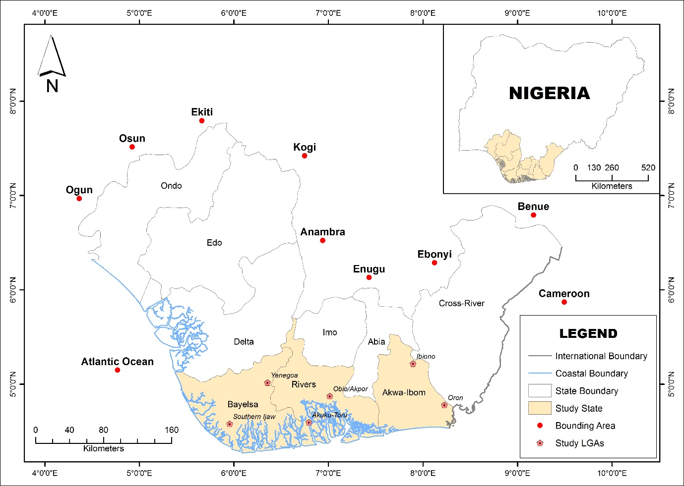

Figure 1: Niger Delta Region Showing Study States and Sampling LGAs.
(Source: Cartography and GIS Unit, Dept. of Geography and Environmental Sustainability, UNN, 2024).
Location/Extent
From Geographical positioning, Niger Delta region of Nigeria is located along the Gulf of Guinea (Enaruvbe et al., 2014). It is the world’s third largest and Africa’s largest Delta. It is also West and Central Africa’s most extensive wetland (Akegbejo–Samsons&Omoniyi, 2009). The region extends from Aboh (5°33′49″ N and 6°31′38″ E) in the North to palm point (4°16′22″ N and 6°05′27″ E) in the South. The East-West limit is between Benin River estuary (5°44′11″ N and 5°3′49″ E) in the West and Imo River estuary (4°27′16″ N and 7°35′27″ E) to the East (Niger Delta Environmental Survey (NDES), 1997). The Niger Delta region extends over an area of about 75,000 square kilometers representing about 12 percent of Nigeria’s total surface area. The region situate along a coastline of 560 km, contains about two-thirds of the entire coastline of Nigeria and six of Nigeria’s constituent states.
The Niger Delta region of Nigeria features within a tropical monsoon climate of transitional zone of Koppen Af climatic types that varies from the hot equatorial forest type in the southern lowlands to the humid tropics in the northern highlands and the cool montane type in the Obudu plateau area with prolonged and heavy rainy season and very short dry season months in the region. Only the months of December and January truly qualifies as dry season months in the region. During the dry season, the northeast trade wind blowing over the Sahara Desert extends its dehydrating influence progressively towards the equator, reaching the southern coast of Nigeria in late December or early January. The period is known as the "Harmattan", which is more noticeable in some years than others. The harmattan, which climatically influences many cities in West Africa, is less pronounced in the Niger Delta. The heaviest precipitation in the region occurs between March and October (Oyegun and Adeyemo, 1999).
The mean annual rainfall is put at 2,000mm (Ayoade, 1993). But also ranges from over 4,000mm in the coastal towns of Bonny and Brass in Rivers and Bayelsa States respectively, and decreases inland to 3,000mm in the mid-delta around Ahoada in Rivers State, Yenagoa in Bayelsa State, and Warri in Delta States, respectively; and slightly less than 2,400mm in the northern parts of the region. In the north western portions including Edo and Ondo States, annual rainfall ranges from 1,500 -2,000mm. The Niger Delta region usually has a temporary cessation of rain commonly known as “August Break” (a dry spell) that comes in between the middle of the rainy season. The area has an average monthly temperature above 27⁰C and there is adequate moisture in virtually all the months. In the region, temperatures are relatively constant (high with a mean maximum of about 34ºC and a mean minimum of about 21⁰C); showing little variation throughout the course of the year. Relative humidity over Niger Delta is over 80-90% during the rainy season as a result of the prevalence of warm moist air mass and high evaporation from the numerous creeks and rivers during this season. In January, depicting the dry season, relative humidity is reduced considerably to about 50-60% as a result of the impact of the drier tropical continental air mass (Inyang, 1975).

Results and Discussion

Fluctuations and Trend in Climate Change Indicators in the Study Area
Temperature is an essential climate variable that directly affects human and natural systems and a key indicator of climate change. The fluctuation and trend in maximum temperature in the Niger Delta region is presented in Figure 2. It is observed that the values vary from year to year. The mean maximum temperature value during the time period is 31.09°C with an upward trend during the time under study. The years with maximum temperature above the mean annual value includes, 1987, 1995, 1998, 2000, 2002, 2003, 2004, 2008, 2009, 2010, 2016. 2016 and 2006 had the maximum and minimum temperature record of 31.76 and 30.25 °C respectively.

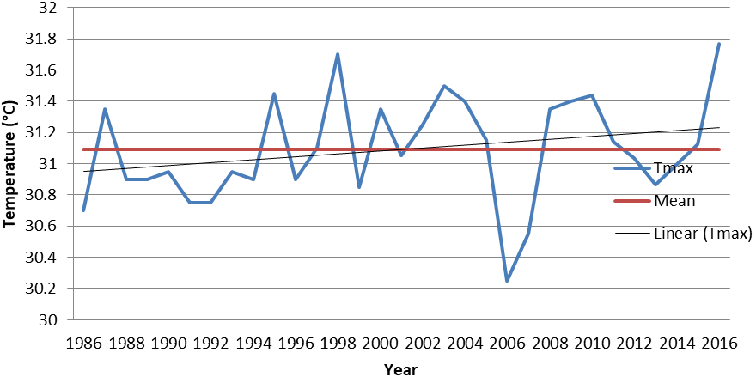

Figure 2: Fluctuations and trend in maximum temperature in the study area (1986-2016)
Figure 3 shows the variations and trend in minimum temperature in the Niger Delta region. During the study period the years with the lowest and highest temperature records are 1989 and 2009 respectively. It has a coefficient of variation of 1.24% and an increasing upward trend of 0.0117°C per year.
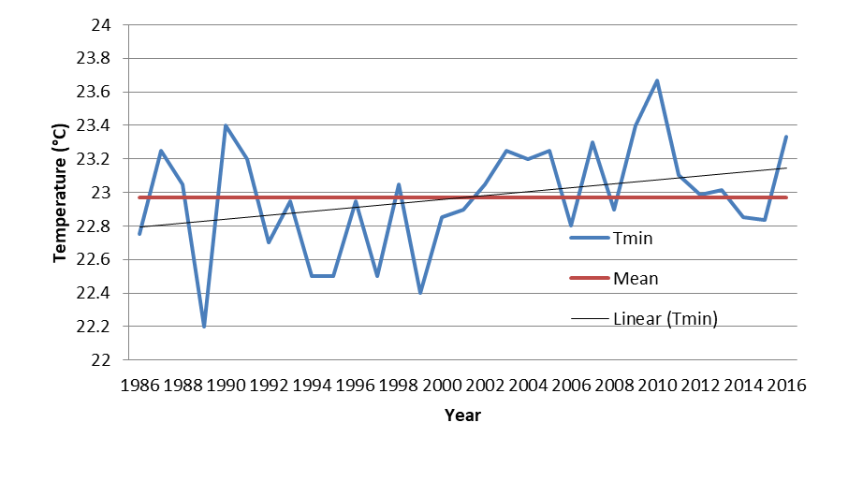

Figure 3: Fluctuations and trend in minimum temperature in the study area (1986-2016)

Fluctuation and trend in mean temperature in the study area is shown in figure 4. Mean temperature value varies from year to year, with the highest and lowest record observed in 2010 (27.55°C) and 2006 (26.52°C). The average temperature for the time period is 27.03°C with a standard deviation of 0.271°C and a Coefficient of variation of 1.00%. Years with above mean temperature includes 1987, 1990,1998, 2000, 2002, 2003,2004, 2005, 2008, 2009, 2010, 2011 and 2016.

Figure 4: Fluctuations and trends in mean temperature in the study area (1986-2016)

Fluctuation and trend in rainfall in the study area is shown in figure 5. The mean annual rainfall value is 2696.42mm with a standard deviation of 322.65mm and a coefficient of variation of 11.97%. Also increasing trend of 0.0106mm per year was observed in the region. The years with below mean rainfall includes 1986 to 1994, 1998, 2000 to 2006, 2008to 2010. The year with the lowest and highest rainfall amount are 2004 (2115.55mm) and 2012 (3483.45mm) respectively.

Figure 5: Fluctuations and trend in rainfall in the study area (1986-2016)
The linear trends in maximum, minimum, mean temperatures and rainfall have been assessed over the period from 1986 to 2016. Table 1 depicts the descriptive statistics, trend and T-test result for the analyzed climatic elements at the 95% significance level. Over all the results demonstrate that there is a significant upward trend in the entire elements with the exception of maximum Temperature. Also, the rate of increase varies from one element to the other. In terms of variability, rainfall is more variable than Temperature in the study region.

Table 1: Descriptive statistics and hypothesis test for change in climatic variables
Climate Element | Mean | Trend | R | Sig | Decision | Coefficient of variation (%)
Tmin | 22.75 | 0.0117 | 0.323 | 0.000 | Ho is rejected | 1.45
Tmax | 31.09 | 0.0094 | 0.26 | 0.214 | Ho is accepted | 1.08
Tmean | 27.03 | 0.0106 | 0.36 | 0.041 | Ho is rejected | 1.00
Rainfall | 2696.42 | 19.336 | 0.55 | 0.000 | Ho is rejected | 11.97

From the result presented in Table 1 above, it can be deduced that there have been significant changes in rainfall, minimum and mean temperature in the study region. This shows that the climate of the region has and is still undergoing changes especially towards higher day-time temperature and increasing rainfall amount.

Furthermore, we assessed decadal changes in climatic variables in the study area. Changes are calculated using the mean climatology as the baseline. Table 2 shows the result. It is deduced that temperature has been generally on the increase during the three decades under study with the exception of maximum and mean temperature during 1987 to 1996 period. In addition, there are changes in rainfall amount within this period, with decrease in rainfall noted in the first two decades.

Table .2: Decadal changes in climate variables in the Niger Delta
Decade | ΔT_Maximum (°C) | ΔT_Minimum (°C) | ΔT_Mean (°C) | ΔRainfall Total (mm)
1987-1996 | -0.12 | 0.12 | -0.105 | -119.91
1997-2006 | 0.06 | 0.175 | 0.0125 | -140.25
2007-2016 | 0.066 | 0.389 | 0.123 | 285.085

Among the temperature variables, minimum temperature had the highest level of change within the study area with reference to the baseline. The relationship between climate change indicators in the Niger Delta was determined using Pearson correlation and their level of significance tested using T-test. The relationship shows that there is a negative strong relationship between climatic elements in the study region. (i.e., as climate change indicators is increasing other factors is decreasing).
In the past 30 years, the climate in the study area has turned from Warm-Dry to Warm-Wet. The average temperature and rainfall increased by 27 °C and 2700 mm, respectively, from 1986 to 2016. By correlation analysis of climate changes indicators from 1986 to 2016, the results indicated that changes might be not directly related to temperature and rainfall alone. The regional differences and the interannual variation trend, caused by the change of rainfall pattern was the main driving factors for the dynamic variation of changes in the study area. Climate change dynamics are the consequence of the interactions among various factors, such as geological structure, climatic conditions and supplement patterns. Climate change, especially temperature and rainfall, observably impacts the human form. Therefore, understanding climate changes and their fluctuations and trends under anthropic disturbance is more complicated.

Conclusion and Recommendations

The result of the analysis showed that in the past 30 years, climate in the study area has turned from warm-dry to warm-wet which has impacted the Niger Delta environment. The mean maximum temperature during this period is 31.09°C with an upward trend. The years with maximum temperatures above the mean annual include 1987, 1995, 1998, 2000, 2002, 2003, 2004, 2008, 2009, 2010, and 2016 respectively. This present study concludes that among other things to promote in climate change study is to build resilience, policy reform in climate change awareness. Researching into climate change science scenario is worthwhile, since climate change science is gaining its ground in the study area. Therefore, this study recommends the following:
- Niger Delta region should be made to meet nature’s need and be consistent with sustaining resilient and functioning ecological systems under changing climate;
- There must be comprehensive and continuous monitoring of environmental resources of the country to provide up-to-date information required to manage the impact of changing climate.
- The country should advance policy reform (including sustainable implementation of the new policy) and champion a new Nigerian climate ethic in the face of changing climate.
- A climate change awareness Program should be developed that could be rolled out at local level to provide local government officials with the necessary tools to engage with this issue and implement the strategies that are identified.

References

Abdullahi, M., Wali, E., Nwankwoala, H.O., & Stephen, H. (2020). Rainfall Change Detection in Africa Using Remote Sensing and GIS between 1999-2018. Big Data in Water Resources Engineering (BDWRE) 1(2), 52-54.

Ajao, E.A; Anurigwo S. (2002): Land-based sources of pollution in the Niger Delta, Nigeria. Ambio. 2002; 31(5):442‒445.
Akachi.O. (2011): Social Consequences of Environmental Change in the Niger Delta of Nigeria. Journal of Sustainable Development. 2011; 4(2):123– 135.

Akegbejo-Samsons, Y., &Omoniyi, I. T. (2009): Management challenges of mangrove forests in Africa: A critical appraisal of the coastal mangrove ecosystem of Nigeria. Nature and Faune, 24, 50–55.

Ayanlade, A. (2014): Remote Sensing of Environmental Change in the Niger Delta, Nigeria. PhD thesis submitted to Department of Geography, School of Social Sciences and Public Policy, King’s College London, University of London; 2014.

Ayoade, J.O. (1993): The Introductory Climatology for the Tropics. Spectrum Books Ltd., Ibadan, Nigeria.

Blench, R. (2007): The mammals of the Niger Delta in Nigeria. The Kay Williamson Education.
Enaruvbe, G. O., &Ozien P. Atafo (2014): Analysis of deforestation pattern in the Niger Delta region of Nigeria. Journal of Land use Science. Taylor & Francis. http: //dx.doi.org/10.1080/1747423X.965279.

ERML (1997): Environmental and Socio-economic Characteristics of the Niger Delta Phase 1: Volume 1. A report submitted by environmental resources managers limited to the Niger Delta Environmental Survey (NDES), Lagos, Nigeria.

Inyang, P. B. E. (1975): “Climate” in OFOMATA G. E. K. (Ed), Nigeria in Maps, Eastern State. Ethiope Publish House, Benin City. Pp 25-26.

IPCC (2013): Summary for policymakers. In T. F. Stocker, D. Qin, G.-K. Plattner, M. Tignor, S. K. Allen, J. Boschung, A. Nauels, Y. Xia, V. Bex and P. M. Midgley (eds.), Climate Change 2013: The Physical science basis. Contribution of working group into the fifth assessment report of the intergovernmental panel on climate change. Cambridge University Press, Cambridge, United Kingdom and New York, NY, USA.

IPCC (2018): IPCC Special Report on the Impacts of Global Warming of 1.5 _C – Summary for Policy Makers. Incheon, Korea.

Izah S.C, Angaye C.N, Aigberua A.O (2017): Uncontrolled bush burning in the Niger Delta region of Nigeria: potential causes and impacts on biodiversity. International Journal of Molecular Ecology and Conservation. 2017; 7(1):1‒15

Izah, S.C (2018): Ecosystem of the Niger Delta Region of Nigeria: Potentials and Threats. Biodiversity International Journal.2018; 2(4): 338-345.DOI:10.15406/bij.2018.02.00084

NDES Niger Delta Environmental Survey (1997): Final Report. Phase One: “Environment and Socio-Economic Conditions”, NDES, Lagos.

NOAA (2015). National Centres for Environmental Information, State of the Climate: Global Climate Report for Annual 2015, published online January 2016

Nwafor G.O; Omini E.E; Odok E.O (2018). Modeling Metrological Parameter via Vector Autoregressive. Scholars Journal of Physics, Mathematics and Statistics. Scholars Academic and Scientific Publishers (SAS Publishers) (An International Publisher for Academic and Scientific Resources.

Odigwe, M., Efe, S.I. and Atubi, A. (2020): A statistical discourse of the climate of the Niger Delta Region of Nigeria. Journal of Management and Social Science Research, Volume 1, Numbers 1/2, pp. 15-33, 2020.
Okonkwo, C. N. P., Kumar, L. and Taylor, S. (2015). The Niger Delta wetland ecosystem: What threatens it and why should we protect it? African Journal Environmental Science Technology, Vol. 9(5), pp 451-463
Oyegun. C. U. and Adeyemo, A. (1999): “Port-Harcourt Region” (ed). Paragraphics Port Harcourt.pp.1-12.

UNITED NATIONS ENVIRONMENTAL PROGRAMMED (UNEP) (2007): The status of the Nigerian Coastal zone.

Wali, E., Abdullahi, M., Nwankwoala, H O, Ekwezuo, C., Hemba, S., &Johnmark, O. (2020). Analysis of Temperature and Rainfall Variability over two Coastal States in the Niger Delta, Nigeria, Annals of Geographical Studies, 3(2), 1-6.

