Physicochemical, phytochemical and antinutritional characterisation of seed shells from five clones of Hevea brasiliensis commonly used in Côte d'Ivoire

Abstract
In the context of diversifying rubber tree growers' incomes and promoting the circular bioeconomy, the valorisation of other products derived from rubber cultivation, particularly seeds, represents a major challenge for the sustainability of the sector. In Côte d'Ivoire, the National Agricultural Research Centre (CNRA) has developed a method for the mechanical extraction of oil and meal from rubber tree seeds (Hevea brasiliensis). The kernels are obtained by shelling the seeds, which generates an abundant co-product, the shell, which is not exploited in the country. This study focused on the physicochemical, phytochemical and antinutritional characterisation of the seed shells of five Hevea brasiliensis clones commonly used in Côte d'Ivoire. These are clones GT1, PB217, IRCA230, IRCA331 and IRCA41. Principal component analysis was used to classify the clones into two groups. The shells of clones IRCA230 and IRCA41 have higher lipid (9.84%), tannins (3.43 mg EAT/100 g) and polyphenols (5.20 mg EAG/100 g), indicating high potential for biochemical valorisation through the extraction of antioxidant and anti-inflammatory compounds for use in the cosmetics, pharmaceutical and agri-food industries. The GT1, PB217 and IRCA331 clones stood out for their high fibre content (83%) and total sugar content (23 mg/100 g) in their shells, confirming their suitability for energy or bio-based material applications, particularly in the production of biochar, biomaterials or fibre-rich food supplements. Overall, the shells have a low moisture content of around 10%, low ash content (1.13%) and low levels of anti-nutritional factors, suggesting strong potential for integrated recovery in a sustainable biorefinery approach. The recovery of rubber seed shells is a promising initiative that should be encouraged.
Keywords: Hevea brasiliensis, shells, recovery, phytochemistry, circular bioeconomy.
circular.

- Introduction
Native to the Amazon basin, Hevea brasiliensis (Euphorbiaceae) is now the world's main source of natural rubber. Rubber tree cultivation has spread to almost all tropical areas, supporting the economies of many producing countries (Rodrigo et al., 2011; Gohet et al., 2019). In Côte d'Ivoire, where it was introduced in the 1950s, this crop occupies a strategic position: national production reached approximately 1.68 million tonnes in 2024, ranking the country third in the world and first in Africa (APROMAC, 2024). Rubber cultivation contributes significantly to rural income, job creation and the socio-economic resilience of producers.
However, the volatility of international natural rubber prices is causing worrying economic instability for growers (Anon, 2021). Given this dependence, the valorisation of rubber tree by-products, particularly seeds, is emerging as a sustainable way to diversify sources of income (Ocho, 1999; Kannika et al., 1981).
In Côte d'Ivoire, a study was conducted by the CNRA on the use of rubber tree seeds as by-products. The extraction of oil from rubber tree seeds generates by-products, known as shells. These shells represent nearly 50% of the seed's mass and are often considered waste . However, in many oilseed industries, seed husks are an important source of fibre, polyphenols and functional compounds that can be used in the food, cosmetics and pharmaceutical industries (Peng et al., 2018; Zainuddin et al., 2021; Owolabi et al., 2023). The lack of utilisation of this co-product in the Ivorian rubber industry represents a significant economic and environmental loss.
This study therefore aims to characterise and compare the seed shells of five rubber tree clones commonly used in Côte d'Ivoire in order to assess their potential for agro-industrial use.
- MATERIALS AND METHODS
2.1. Plant material
The plant material used in this study consists of seed shells from five commonly used Hevea brasiliensis clones grown in Côte d'Ivoire. These seeds were collected from monoclonal plots belonging to three companies located in traditional and marginal rubber cultivation areas. These were the Société Africaine de Plantation d'Hévéa (SAPH), located in the Grands Ponts region, and the Société Coopérative Agricole Sud-Ouest (SCOOPS SO), located in the Bas-Sassandra region in a traditional area. The company EXAT Agriculture (Kouamé Koffikro plantation), located in the Prikro area, represented the marginal area. As rubber seed production is seasonal, from August to November, harvesting took place between August and November 2024. At each site, five one-hectare monoclonal plots were selected to form a composite sample representative of the national territory, incorporating both two marginal areas and one traditional cultivation area. The clones studied were GT 1 (Gondang Tapen code 1), PB 217 (Prang Besar code 217), IRCA 41 (Rubber Research Institute Code 41), IRCA 230 (Rubber Research Institute Code 230) and IRCA 331 (Rubber Research Institute Code 331).
2.2 Methods
2.2.1 Sampling
At each site, a composite sample of ten (10) kg of rubber seeds (Photo 1) was taken per clone from representative harvests in the monoclonal plots. This resulted in a total mass of thirty (30) kg of whole seeds obtained per clone. These seeds were then shelled using a shelling machine to separate the shells from the kernels. The shells (Photo 2) obtained for each clone were homogenised and then ground using a grinder. The ground material obtained was used as a matrix for all the physicochemical and biochemical analyses carried out as part of this study.
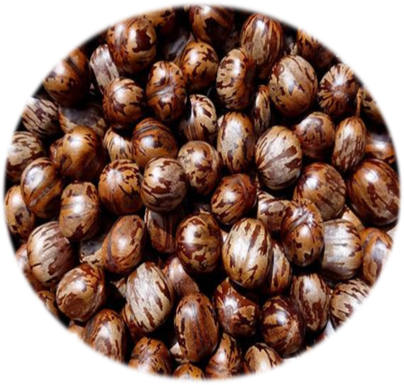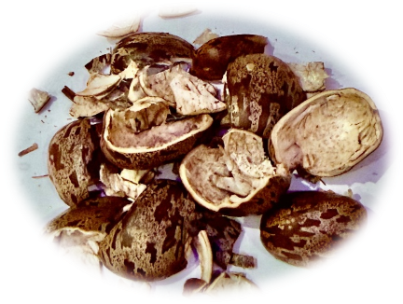
Photo 2: rubber seed kernels
Photo 1: rubber tree seeds

2.2.2 Physicochemical characterisation of the rubber seed shell
The method used to determine the moisture content is described by AOAC (1990) and is based on dehydration by drying 10 g of rubber seed shell sample in an oven (Memmert, Berlin, Germany) at 105 ± 2 °C for 24 hours. The sample was weighed in a glass capsule of known mass. The capsule was removed after 24 hours and placed in a desiccator to cool. The whole assembly (sample + capsule) was weighed after cooling in the desiccator. The moisture content was expressed as a percentage of the mass of the wet sample.
The ash content was determined using the method described by AOAC (1990). This involved eliminating all organic compounds contained in the rubber seed shell samples by incineration at 550°C for 12 hours in a VOLCA V 50 muffle furnace. The ash was expressed as a percentage of the dry sample mass.
The pH and acidity were determined using the AFNOR (1986) method. Ten (10) grams of shredded rubber seed shells were weighed and homogenised in 100 mL of distilled water with stirring. The mixture was filtered through Whatman filter paper, and the filtrate was collected in an Erlenmeyer flask. The hydrogen potential (pH) of the samples was assessed using a HANNA portable pH meter. The pH meter electrode was immersed directly in the filtrate to read the pH.
The total titratable acidity content was expressed as the mass of acid equivalents per mass of rubber seed shell sample. It was determined by titrimetric analysis using decinormal sodium hydroxide (NaOH 0.1 N) in the presence of a few drops of colour indicator (phenolphthalein).
The lipid content of the rubber seed shells studied, expressed as a percentage of oil relative to dry matter weight (% oil/dry), was determined using the Soxhlet method (AFNOR, 1984). Samples of shells were delipidised from their dry matter. Ten (10) g of dry shell matter was weighed into a pre-tared cellulose extraction cartridge. 61 The cartridge containing the sample was plugged with cotton wool and placed in the Soxhlet extractor. Delipidation was carried out by reflux heating using an organic solvent, hexane, for 8 hours. The hexane was evaporated using a rotary evaporator. The entire mixture (flask + lipids) of known mass was first dried in an oven at 100°C for 20 minutes before being weighed to a constant weight. The percentage of oil relative to the dry matter weight of the shells was obtained.
The crude protein content was obtained using the Kjeldahl method (AOAC 1990), by measuring the total nitrogen in the sample. This involves several steps, including mineralisation, distillation and titration with NaOH (0.1N). Fibre was determined using the Wolf method (1968). The sugar content of the rubber seed shell samples was determined by spectrophotometric analysis. The absorbances were read using a spectrophotometer (GENESYS TM5). The total sugar content was determined using the method described by Dubois et al. (1956) using phenol. The reduction sugar assay followed the method of Bernfeld (1955) using 3,5-dinitrosalicylic acid (DNS).
2.2.3 Characterisation of the phytochemical compounds in the seed coats of five rubber tree clones
The total polyphenols in the rubber seed coat samples were determined using the method described by Singleton and Rossi (1965), using Folin-Ciocalteu reagent. The optical density (OD) was measured at 760 nm using a spectrophotometer. The control contained distilled water instead of the sample. The difference between the OD values obtained with and without PVPP was used to determine the actual OD corresponding to the total polyphenols in the samples. A calibration curve, obtained from different concentrations of a standard phenolic compound, gallic acid (or 3,4,5-trihydroxybenzoic acid), at an initial concentration of 0.5 mg/mL, was used to determine the total polyphenol content of the rubber seed shells studied.
Flavonoids were determined using the method described by Meda et al. (2005).
A 1:10 diluted extract solution was prepared from 10 g of ground rubber seed shells dissolved in 90 mL of distilled water. Subsequently, 0.5 mL of this solution was added successively to a test tube, followed by 0.5 mL of distilled water, 0.5 mL of 10% (m/v) aluminium chloride, 0.5 mL of 1 M potassium acetate, and then 2 mL of distilled water. The tube was left to stand for 30 minutes in the dark, then the optical density was read at 415 nm against a blank.
A standard curve was established from a quercitrin stock solution (0.1 mg/mL), treated under the same conditions as the sample, in order to determine the flavonoid content of the samples analysed.
The tannin content was determined using the method described by Broadhurst and Jones (1978). The tannin content was determined by introducing 1 mL of methanolic extract into a test tube. After adding 5 mL of vanillin reagent (0.1% vanillin in 70% sulphuric acid), the tube was left to stand for 30 minutes in the dark and the optical density (OD) was read at 500 nm against a blank.
2.2.4 Characterisation of antinutritional compounds in the seed coats of five rubber tree clones
The oxalate and phytate contents of rubber tree seed coats were determined using the methods described by Day and Underwood (1986) and Latta and Eskin (1980), respectively.
The quantification of oxalates consisted mainly of dissolving two (02) grams of crushed rubber seed shells, which were homogenised in 75 mL of 3 M sulphuric acid. The mixture was stirred magnetically for one hour, then filtered. A 25 mL aliquot of the filtrate was titrated hot with a 0.05 M potassium permanganate solution until a persistent pale pink colour was obtained.
The phytate content was determined using the method described by Latta and Eskin (1980). One (1) gram of ground rubber seed shells was homogenised in 20 mL of 0.65 N hydrochloric acid. The mixture was stirred for 12 hours at room temperature, then centrifuged. A volume of 0.5 mL of the supernatant was transferred to a test tube and mixed with 3 mL of Wade's reagent (aqueous solution containing 0.03% FeCl₃·6H₂O and 0.3% sulfosalicylic acid). After 15 minutes of rest, the optical density was measured at 490 nm against a blank. The phytate concentration was determined from a calibration curve established with a standard sodium phytate solution (10 mg/ml).
The hydrocyanic acid (HCN) content was determined according to the AOAC method (1990). Ten (10) grams of ground rubber seed shells were placed in a distillation flask with 200 ml of distilled water. The mixture was distilled for three hours, and the distillate was collected in a 250 ml volumetric flask containing 50 ml of a 2.5% soda solution. The distillate was then made up to the mark with distilled water. A 100 ml aliquot of this mixture was taken, and 2 ml of a 5% potassium iodide (KI) solution was added. The solution was then titrated with a standard silver nitrate (AgNO₃) solution until a persistent turbidity appeared, indicating the end point.
2.2.5 Statistical analysis
The data were subjected to analysis of variance (one-factor ANOVA) to determine the effect of the clone on the various physicochemical, phytochemical and antinutritional parameters of rubber seed shells. Significant differences between means were evaluated at the 5% level using Duncan's test.
Principal component analysis (PCA) was performed to visualise the relationships between variables and identify clusters of clones according to their biochemical profiles. Correlations between variables were also examined to characterise positive and negative associations between the parameters studied.
All statistical analyses were performed using XLSTAT 2022 (Addinsoft, France) and R version 4.3.1 (R Core Team, 2023) software, using the FactoMineR and ggplot2 packages for graphical representation (PCA, correlation circle, dendrogram).

3. RESULTS
3.1 Physicochemical characteristics
Analysis of variance (ANOVA) revealed highly significant differences (p < 0.05) between clones for most of the physicochemical parameters studied (Table 1).
Moisture content ranged from 10.27 ± 0.12% (IRCA230) to 12.40 ± 0.17% (PB217), with a significant difference between these two clones.
The pH differed significantly (p < 0.05) between clones, ranging from 6.19 ± 0.01 (GT1) to 6.61 ± 0.01 (IRCA331).
Titratable acidity also varied from 0.20 ± 0.03 (GT1) to 0.47 ± 0.03 (IRCA41).
Lipids show the greatest inter-clonal variability (p < 0.001) with values ranging from 1.86 ± 0.08% (GT1) to 9.84 ± 0.12% (IRCA230).
Fibre content differed significantly (p < 0.05) between 69.49 ± 1.01% (PB217) and 82.84 ± 0.39% (IRCA331ᵃ).
Ash varied from 0.64 ± 0.12% (GT1) to 1.13 ± 0.08% (IRCA230), with a significant difference (p < 0.05).
Total sugars show significant differences (p < 0.05) between 8.33 ± 0.58 mg/100 g (IRCA41) and 23.00 ± 0.00 mg/100 g (IRCA331).
Reducing sugars varied significantly from 1.00 ± 0.00 mg/100 g (GT1) to 3.33 ± 0.58 mg/100 g (IRCA230).
Proteins show significant differences between clones (p < 0.05), ranging from 2.92 ± 0.10% (GT1) to 3.62 ± 0.10% (IRCA41).

Table 1: Physico-chemical composition of Hevea seed shells from five clones
 | GT1 | PB217 | IRCA41 | IRCA230 | IRCA331
Moisture content (%) | 11.41± 0.03b | 12.40± 0.17a | 11.28± 0.03b | 10.27± 0.12c | 12.36± 0.10a
Ph | 6.42± 0.01b | 6.61± 0.01a | 6.19± 0.01d | 6.23± 0.01c | 6.60± 0.03a
Titratable acidity | 0.20± 0.03c | 0.38± 0.03b | 0.47± 0.03a | 0.39± 0.03b | 0.23± 0.05c
Lipids (%) | 1.89± 0.04d | 3.38± 0.04c | 7.59± 0.08b | 9.84± 0.12a | 1.86± 0.08d
Fibre (%) | 80.13± 0.07b | 76.54± 0.31c | 77.21± 0.34c | 69.49± 1.01d | 82.84± 0.39a
Ash (%) | 0.64± 0.12b | 1.10± 0.12a | 0.81 ± 0.17b | 1.13± 0.08a | 0.82± 0.07b
Total sugars (mg/100g) | 16.00± 0.00c | 23.00 ± 0.00a | 8.33± 0.58d | 17.00± 0.00b | 23.00± 0.00a
Reducing sugars (mg/100g) | 1.67± 0.58bc | 2.67± 0.58ab | 2.33± 0.58ab | 3.33± 0.58a | 1.00± 0.00c
Protein (%) | 3.33± 0.00b | 3.62± 0.10a | 3.44± 0.10b | 2.92± 0.10c | 3.03± 0.10c
Values are means ± standard deviation (n = 3). Means followed by different superscript letters are significantly different (p < 0.05, Duncan’s multiple range test)

3.2 Phytochemical characteristics
The ANOVA results also show significant differences (p < 0.05) between clones for all phytochemical compounds (Table 2). Total polyphenols ranged from 3.10 ± 0.20 mg EAG/100g (PB217) to 5.20 ± 0.17mg EAG/100g (IRCA230). Flavonoids differed significantly (p < 0.05) between 2.33 ± 0.15 mg EQ/100 g (PB217) and 4.50 ± 0.10 mg EQ/100 g (GT1).
Condensed tannins ranged from 1.64 ± 0.00 mg CAT/100 g (GT1) to 3.43 ± 0.01 mg CAT/100 g (IRCA230).
Table 2: Phytochemical composition of Hevea seed shells from five clones
 | GT1 | PB217 | IRCA41 | IRCA230 | IRCA331
Polyphenols (mgEAG/100g) | 3.10± 0.20d | 3.20± 0.17cd | 4.57± 0.06b | 5.20± 0.17a | 3.43± 0.06c
Flavonoids (mgEQ/100g) | 4.50 0.10a | 3.70± 0.20b | 3.03± 0.21c | 2.33± 0.15d | 2.80± 0.17c
Tannins (mgEAT/100g) | 2.00± 0.00d | 2.13± 0.00c | 2.73± 0.00b | 3.43± 0.01a | 1.64± 0.00e
Values are means ± standard deviation (n = 3). Means followed by different superscript letters are significantly different (p < 0.05, Duncan’s multiple range test).

3.3 Antinutritional characteristics
Significant differences (p < 0.05) were observed for the three antinutritional factors analysed (Table 3). Phytates ranged from 30.56 ± 0.04 mg/100 g (GT1) to 186.87 ± 0.05 mg/100 g (IRCA331). Oxalates differed significantly (p < 0.05) from 55.00 ± 11.00 mg/100 g (PB217ᶜ) to 80.67 ± 6.35 mg/100 g (GT1ᵃ). Hydrocyanic acid content varies from 16.85 ± 0.14 mg/100 g (GT1) to 20.61 ± 0.16 mg/100 g (IRCA230ᵃ).
Table 3: Antinutritional factors in Hevea seed shells from five clones
mg/100g | GT1 | PB217 | IRCA41 | IRCA230 | IRCA331
Phytate | 186.87± 0.05a | 73.36± 0.20c | 64.53± 0.19d | 118.29± 0.03b | 30.56± 0.04e
oxalates | 55.00± 11.00b | 73.33± 6.35ab | 69.67± 6.35ab | 80.67± 6.35a | 77.00± 11.00a
Hydrocyanic acid | 16.85± 0.14d | 20.61± 0.16a | 18.81± 0.16c | 20.34± 0.16a | 19.62± 0.16b

Values are means ± standard deviation (n = 3). Means followed by different superscript letters are significantly different (p < 0.05, Duncan's multiple range test).

3.4 Multivariate analysis

3.4.1 Principal component analysis (PCA) and ascending hierarchical classification

This section presents the results of the Principal Component Analysis (PCA) and hierarchical classification (HCA) performed on the matrices of biochemical and physicochemical parameters of the seed coats of five rubber tree clones grown in Côte d'Ivoire. PCA reduced the data dimension to two principal axes, which together explain 78.50% of the total variance. Axis 1 (PC1) explains 52.82% and axis 2 (PC2) 25.68%. Axis 1 distinguishes clones rich in lipids, tannins and polyphenols (IRCA230 and IRCA41) from clones with high fibre content (PB217, GT1 and IRCA331). Axis 2 mainly separates clones according to their acidity and sugar content.

Fig .1 PCA - Rubber tree seed shells
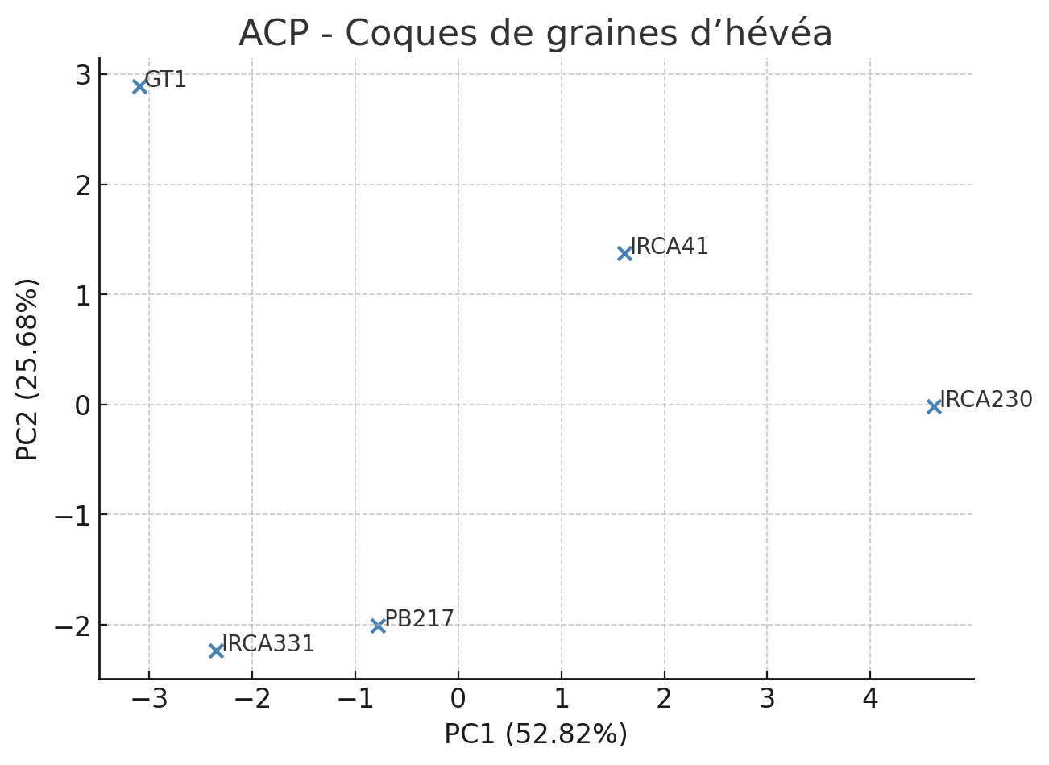

3.4.2 Correlation circle and factorial projection
In order to further interpret the Principal Component Analysis (PCA), a correlation circle and factorial projection of the clones were produced. These representations allow the contribution of the variables and the distribution of the clones to be visualised simultaneously in the plane formed by the first two principal axes. The correlation circle shows that the variables lipids, tannins and polyphenols are strongly positively correlated with axis 1 (PC1), indicating that it expresses a gradient of metabolic richness. In contrast, fibre and moisture are negatively correlated with this same axis. Axis 2 (PC2) is mainly influenced by pH and total sugars, reflecting a biochemical gradient linked to the preservation properties of the shells.

Fig .2 Correlation Circle of Variables (PCA)
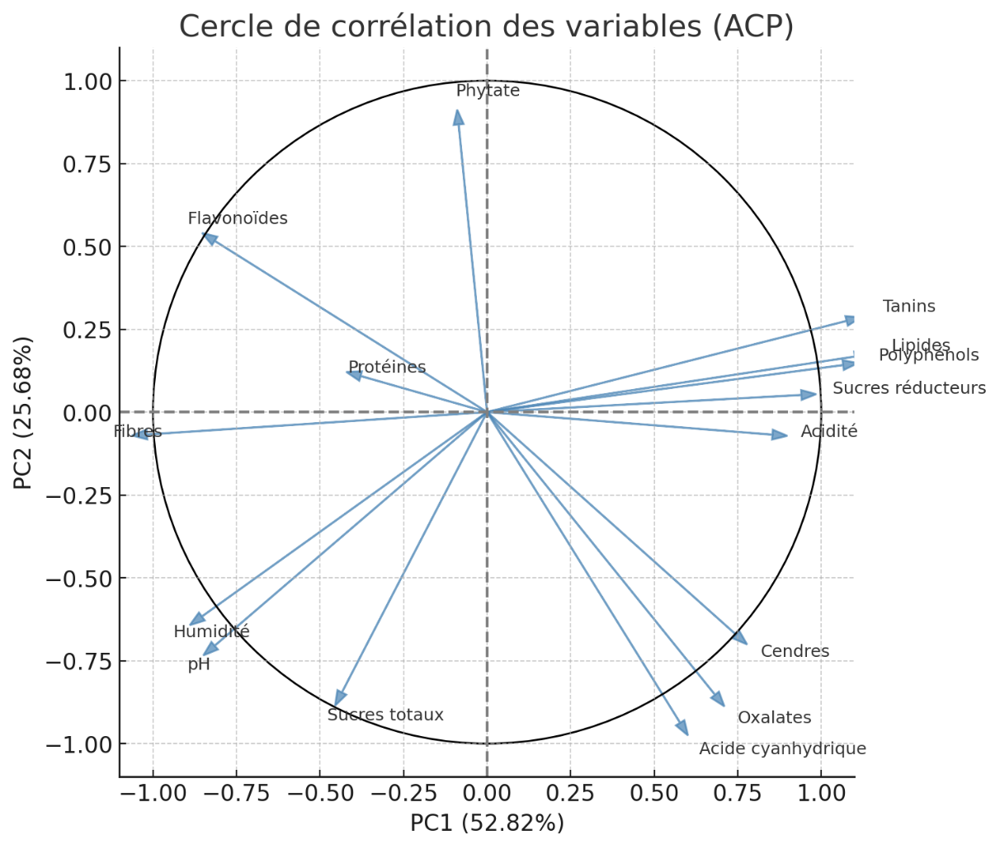
The projection of the clones on the factorial plane shows two distinct groups: the first, composed of IRCA230 and IRCA41, includes the clones richest in bioactive compounds; the second, formed by PB217, GT1 and IRCA331, includes the predominantly fibrous clones. This distribution confirms the results of the dendrogram and reinforces the consistency of the hierarchical classification.

Fig .3 Projection of the clones on the factorial plane (PCA)
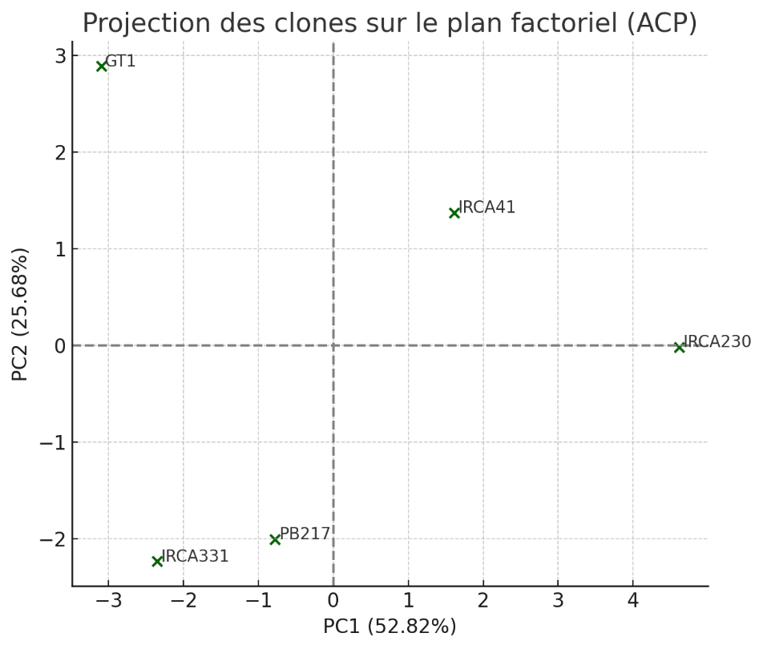

3.4.3 Hierarchical classification (CAH)
The ascending hierarchical analysis groups the clones into two main clusters: IRCA230 and IRCA41 (rich in bioactive compounds), and a second group consisting of PB217, GT1 and IRCA331, characterised by a more fibrous and less lipidic profile.
Fig.4 Dendrogram - Hierarchical Classification of rubber tree clones
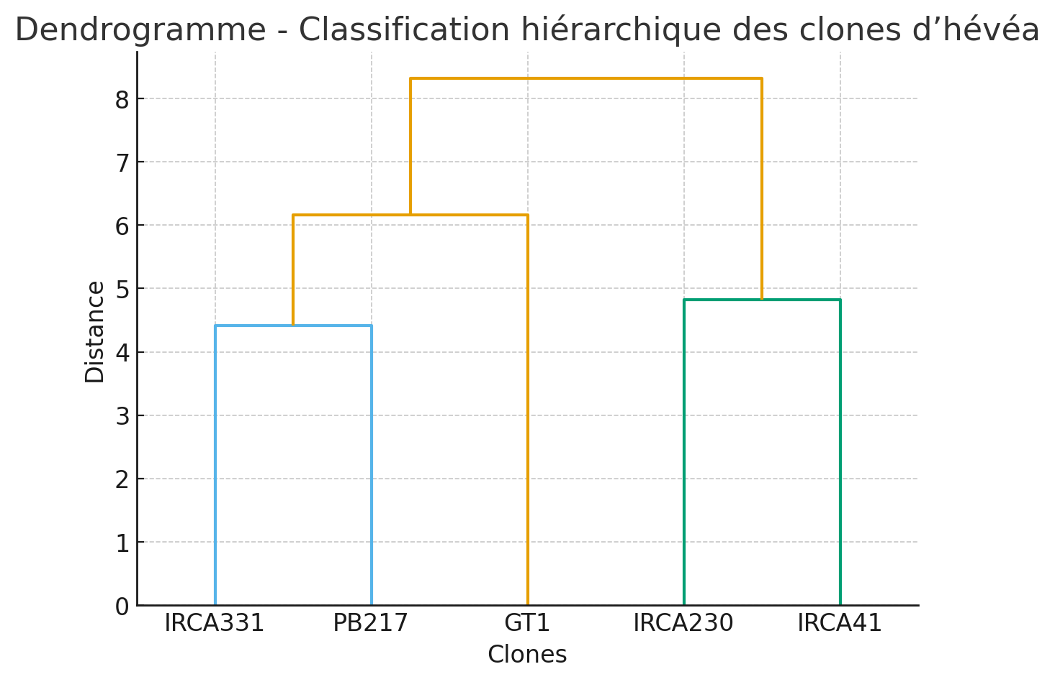

4. DISCUSSION
Factor and hierarchical analysis of the physicochemical and biochemical parameters of the seed coats of five rubber tree clones grown in Côte d'Ivoire reveals significant inter-clonal variability. Principal component analysis (PCA) revealed two axes that together explain 78.50% of the total variance, reflecting the biochemical complexity of these lignocellulosic matrices. The first axis (PC1), representing 52.82% of the variance, distinguishes clones IRCA230 and IRCA41, rich in lipids, tannins and polyphenols, from clones GT1 and IRCA331, characterised by a high fibre content. The second axis (PC2), explaining 25.68% of the variance, mainly separates the clones according to their acidity, ash content and total sugar content.
These observations corroborate the results obtained by Djenontin et al. (2012), Bamba et al. (2023) and Afolabi et al. (2025), who also showed that inter-clonal differentiation in products derived from Hevea brasiliensis is based on a balance between structural and metabolic compounds. Hierarchical ascending analysis (CAH) confirms this segmentation: clones IRCA230 and IRCA41 form a homogeneous group with high metabolic value, while GT1, PB217 and IRCA331 are grouped together in a set dominated by fibrous compounds.
Biochemically, the shells of clones IRCA230 and IRCA41 stand out for their high phenolic and antioxidant content, making them attractive for applications in the agro-industrial, pharmaceutical and cosmetic sectors. These results are consistent with those of Bahramsoltani et al. (2014) and Min et al. (2008), as well as more recent studies by Feng et al. (2022), Zhou , and et al. (2024), which have highlighted the antioxidant potential of Hevea brasiliensis shell extracts for stabilising biofuels and formulating dermo-cosmetic products.
The tannins, polyphenols and flavonoids detected exhibit marked biological activity: they play a role in plant defence (Agrawal, 1989; Khan et al., 2014) and are compounds of industrial interest for the design of green antioxidants (Rubber tree seed shell extracts as a promising green antioxidant alternative, ScienceDirect, 2024). Recent work by Olawoye et al. (2025) confirms the presence of bioactive secondary metabolites in rubber tree seeds and shells, with potential effects against cellular oxidative stress.
The shells of the five clones contain moderate levels of phytates (30–186 mg/100 g), oxalates (55–81 mg/100 g) and hydrocyanic acid (16–21 mg/100 g). These levels are comparable to those observed in the residues of other tropical oilseeds and do not reach the toxicity thresholds reported in the literature (Obanla et al., 2023).
However, clones IRCA230 and PB217 have slightly higher oxalate and cyanogen levels, probably due to higher activity of β-glucosidase, a key enzyme in the release of cyanogenic compounds.
These constituents can be effectively reduced by heating, fermentation or enzymatic treatment, as demonstrated for palm kernel shells (Adeoye et al., 2022).
On the other hand, clones GT1 and IRCA331, characterised by a high fibre and total sugar content, could be used in the animal feed industry or in the production of biomaterials (Quemere, 1990; Lebas et al., 1996; Diakité et al., 2022). Their fibrous composition and low energy density make them suitable for energy uses or incorporation into bio-based composites, as demonstrated by Nguyen et al. (2023) in formulations of eco-materials based on rubber tree residues. However, their direct use in monogastric feed must be modulated by technological treatments such as extrusion or enzymatic fermentation, which reduce anti-nutritional factors (Henry et al., 2001; Charrier et al., 2002).
Finally, the combination of ANOVA, PCA and CAH analyses highlights the complementarity of statistical approaches in the evaluation of intraspecific biochemical characteristics. These results confirm that the IRCA230 and IRCA41 clones are prime candidates for high value-added applications: extraction of active biomolecules, formulation of natural antioxidants and development of sustainable processes in the Ivorian rubber industry.
CONCLUSION
The objective of this study was to evaluate the physicochemical and biochemical properties of the seed shells of five rubber tree (Hevea brasiliensis) clones grown in Côte d'Ivoire, with a view to their potential use in the agro-industrial, food and energy sectors. To achieve this objective, biochemical and phytochemical composition analyses were carried out, supplemented by the quantification of antinutritional compounds. These data were then subjected to analysis of variance (ANOVA), principal component analysis (PCA) and ascending hierarchical classification (AHC) in order to identify similarities and differences between clones. The results showed significant biochemical variability between clones. Clones IRCA230 and IRCA41 are distinguished by their high lipid, tannin and polyphenol content, reflecting strong antioxidant and functional potential, while clones GT1, PB217 and IRCA331 clones have higher fibre and sugar contents, indicating their suitability for zootechnical and energy use. These results demonstrate that rubber tree shells, often considered waste, are in fact a valuable resource for the production of antioxidant bioproducts, biomaterials and animal feed. This study therefore lays the foundations for the integrated and sustainable use of rubber tree by-products, contributing to the transition to a competitive tropical bioeconomy and the diversification of income for Ivorian planters.

COMPETING INTERESTS
Authors have declared that no competing interests exist.
REFERENCES
Adeoye, A. O., Akintunde, O. O., & Ogunlade, I. (2022). Reduction of anti-nutritional factors in palm kernel shell by heat and fermentation treatments. Journal of Food Biochemistry, 46(12), e14472. https://doi.org/10.1111/jfbc.14472
Agrawal, A. A. (1989). Induced responses to herbivory in wild radish: Effects on several herbivores and plant fitness. Ecology, 80(5), 1713–1723. https://doi.org/10.1890/0012-9658(1999)080[1713:IRTHIW]2.0.CO;2
AFNOR. (1984). Collection of French standards: Fruit and vegetable products. Analysis of fruit and vegetables (Volume 2). French Standardisation Association.
AFNOR. (1986). Standard V03-707. Agricultural and food products. Determination of pH. French Association for Standardisation.
Afolabi, I. S., Oke, M. O., & Adedeji, M. A. (2025). Comparative biochemical profiling of Hevea brasiliensis clones in Nigeria. African Journal of Plant Science, 19(1), 22–34. https://doi.org/10.5897/AJPS2024.3001
AOAC. (1990). Official Methods of Analysis (15th ed.). Association of Official Analytical Chemists.
Anon. (2021). Global rubber market outlook: Challenges and resilience. Rubber Asia, 42(2), 11–19.
APROMAC. (2024). Annual report on natural rubber production in Côte d'Ivoire. Association of Natural Rubber Professionals of Côte d'Ivoire.
Bahramsoltani, R., Farzaei, M. H., & Rahimi, R. (2014). Medicinal plants and their natural components as future drugs for the treatment of burn wounds: An integrative review. BioMed Research International, 2014, 1–24. https://doi.org/10.1155/2014/314573
Bamba, S., Koné, D., & Koffi, K. (2023). Biochemical variability of Hevea brasiliensis seeds in Côte d'Ivoire. Revue Ivoirienne de Biotechnologie, 25, 45–60. https://doi.org/10.4314/rib.v25i1.5
Bernfeld, P. (1955). Amylases, alpha and beta. In S. P. Colowick & N. O. Kaplan (Eds.), Methods in Enzymology (Vol. 1, pp. 149–158). Academic Press. https://doi.org/10.1016/0076-6879(55)01021-5
Broadhurst, R. B., & Jones, W. T. (1978). Analysis of condensed tannins using acidified vanillin. Journal of the Science of Food and Agriculture, 29(9), 788–794. https://doi.org/10.1002/jsfa.2740290908
Charrier, B., Guibal, D., & Thibaut, B. (2002). Effect of heat treatments on the quality of lignocellulosic biomaterials. Annals of Forest Science, 59(5–6), 715–724. https://doi.org/10.1051/forest:2002056
Day, R. A., & Underwood, A. L. (1986). Quantitative analysis (5th ed.). Prentice-Hall.
Diakité, Y., Konan, Y. N., & Coulibaly, N. (2022). Use of lignocellulosic residues in animal feed: the case of rubber tree shells. Tropicultura, 40(4), 304–312. https://doi.org/10.25518/2295-8010.15253
Djenontin, S. T., Dangou, J. S., & Amoussou, L. (2012). Physicochemical characterisation of Hevea brasiliensis seeds grown in Benin. African Journal of Biotechnology, 11(8), 2001–2009. https://doi.org/10.5897/AJB11.1492
Dubois, M., Gilles, K. A., Hamilton, J. K., Rebers, P. A., & Smith, F. (1956). Colorimetric method for determination of sugars and related substances. Analytical Chemistry, 28(3), 350–356. https://doi.org/10.1021/ac60111a017
Feng, Y., Wang, L., & Zhang, Y. (2022). Antioxidant properties of Hevea brasiliensis seed shell extracts and their potential industrial applications. Industrial Crops and Products, 187, 115428. https://doi.org/10.1016/j.indcrop.2022.115428
Gohet, E., Lacote, R., & Eschbach, J. M. (2019). The contribution of rubber research to the development of sustainable production systems. IRRDB Bulletin, 5(1), 12–21.
Henry, Y., & Etienne, M. (2001). Plant by-products in animal feed in tropical areas. INRA Productions Animales, 14(3), 203–216. https://doi.org/10.20870/productions-animales.2001.14.3.3815
Kannika, K., Ramasamy, S., & Boonkerd, W. (1981). Oil extraction and composition of Hevea brasiliensis seeds. Journal of the Rubber Research Institute of Malaysia, 29(2), 106–114.
Khan, R. A., Khan, M. R., & Sahreen, S. (2014). Evaluation of phenolic contents and antioxidant activity of various solvent extracts of Sonchus asper (L.) Hill. Chemistry Central Journal, 6(1), 12. https://doi.org/10.1186/1752-153X-6-12
Latta, M., & Eskin, M. (1980). A simple and rapid colorimetric method for phytate determination. Journal of Agricultural and Food Chemistry, 28(6), 1313–1315. https://doi.org/10.1021/jf60232a049
Lebas, F., & Maitre, I. (1996). Nutritional value of rubber tree pods for ruminants. Revue d’Élevage et de Médecine Vétérinaire des Pays Tropicaux, 49(3), 220–228. https://doi.org/10.19182/remvt.9754
Meda, A., Lamien, C. E., Romito, M., Millogo, J., & Nacoulma, O. G. (2005). Determination of the total phenolic, flavonoid and proline contents in Burkina Faso honey, as well as their radical scavenging activity. Food Chemistry, 91(3), 571–577. https://doi.org/10.1016/j.foodchem.2004.10.006
Min, D. Y., Yu, S. H., & Lee, J. (2008). Antioxidative activity of natural rubber seed coat extract. Journal of Applied Polymer Science, 110(4), 2485–2491. https://doi.org/10.1002/app.28703
Nguyen, T. T., Tran, H. D., & Bui, Q. (2023). Rubber seed shell-derived biocomposites for sustainable material design. Materials Today Sustainability, 24, 100211. https://doi.org/10.1016/j.mtsust.2023.100211
Obanla, O. J., Adewusi, S. R. A., & Osundahunsi, O. F. (2023). Toxicological evaluation of rubber seed meal and its detoxified derivatives in albino rats. Toxicology Reports, 10, 712–721. https://doi.org/10.1016/j.toxrep.2023.05.021
Ocho, F. L. (1999). Potential of Hevea seed oil as a raw material for bio-industrial products. European Journal of Lipid Science and Technology, 101(5), 223–230. https://doi.org/10.1002/(SICI)1521-4133(199905)101:5<223::AID-EJLT223>3.0.CO;2-1
Olawoye, B. T., Adebayo, A. M., & Ajibola, R. O. (2025). Bioactive metabolites from Hevea brasiliensis seed and shell extracts: Antioxidant and anti-inflammatory potential. Plants, 14(1), 55. https://doi.org/10.3390/plants14010055
Owolabi, O. P., Adegbite, J. O., & Alabi, A. O. (2023). Phytochemical composition and antioxidant properties of rubber seed hull extracts. Heliyon, 9(3), e14135. https://doi.org/10.1016/j.heliyon.2023.e14135
Peng, W., Liu, Y., & Wang, X. (2018). Chemical composition and antioxidant activity of rubber seed shell extracts. Industrial Crops and Products, 112, 688–695. https://doi.org/10.1016/j.indcrop.2017.12.052
Quemere, J. P. (1990). Tropical crop by-products in ruminant feed. Revue Mondiale de Zootechnie, 72, 30–38.
R Core Team. (2023). R: A language and environment for statistical computing. R Foundation for Statistical Computing. https://www.R-project.org/
Rodrigo, V. H. L., Gonçalves, P. S., & Seneviratne, P. (2011). Natural rubber: Biology, cultivation and technology. Agricultural Sciences Review, 57(2), 88–102.
ScienceDirect. (2024). Rubber tree seed shell extracts as a promising green antioxidant alternative. Industrial Crops and Products, 198, 118114. https://doi.org/10.1016/j.indcrop.2024.118114
Singleton, V. L., & Rossi, J. A. (1965). Colorimetry of total phenolics with phosphomolybdic–phosphotungstic acid reagents. American Journal of Enology and Viticulture, 16(3), 144–158. https://doi.org/10.5344/ajev.1965.16.3.144
Wolf, W. J. (1968). Determination of crude fibre in oilseed meals. Journal of the American Oil Chemists' Society, 45(6), 532–534. https://doi.org/10.1007/BF02544420
Zainuddin, N., Wahab, R. A., & Rahman, M. F. A. (2021). Characterisation of rubber seed shell as lignocellulosic material for bio-based industries. Bioresource Technology Reports, 14, 100679. https://doi.org/10.1016/j.biteb.2021.100679
Zhou, T., Li, Z., & Wang, Y. (2024). Antioxidant and antimicrobial activity of rubber seed shell extract in cosmetic formulations. Journal of Cleaner Production, 438, 140562. https://doi.org/10.1016/j.jclepro.2024.140562

