Storage Stability and Sensory Quality Assessment of Value-Added Kokum Mukhwas Prepared from Rind Waste

ABSTRACT
The experiment was conducted in Completely Randomized Design (CRD), with four major treatment and at ambient storage conditions. At 0, 30, 60, 90 and 120 days in the storage, observations were conducted regarding changes in the physical, chemical, total plate count and sensory quality parameter of kokum mukhwas. In kokum mukhwas it was observed that all the chemical parameters such as reducing sugar, total sugar, total soluble solids, titratable acidity, moisture contents exhibit an increasing trend while decreasing trend was observed in protein, ash, fat, content of the kokum mukhwas during 120 days of storage period. As regards the organoleptic evaluation the kokum mukhwas prepared treatment T2 with (45% kokum rind and 20% rock sugar) with 35% constant: roasted fennel seeds (20%), muskmelon seeds (10%), black salt (1%), mulethi powder (4%), obtained highest sensory score at 120 days of storage.
Keywords: Kokum, Kokum rind waste, Rock sugar, Roasted funnel seeds, Mukhwas
- Introduction:
In the agricultural system, horticulture has always been important. It thrives in arid climates that are influenced by the weather. Fruits, vegetables, and processed foods are examples of horticultural products that significantly contribute to human nutrition and dietary needs. Global economy is thus supported by these plants. India's diverse tropical and subtropical agroclimatic conditions allow for the cultivation of a wide variety of fruits and vegetables. Thus, horticultural crops comprise 15.07 percent of the country's total land and constitute a substantial element of the agricultural industry.
Spice crops, which are also found in evergreen and semi-evergreen forests and as home garden trees, originated in India's Western Ghats, the South Konkan region of Maharashtra, Coorg, Wynad, and Goa. Although kokum trees can be found across Maharashtra, they are particularly prevalent in the low-lying areas of the Konkan region. One of the most important secondary crops of commercial value is kokum, which grows extensively in the forests of Maharashtra's Western Ghats. It is noted that kokum cultivation in this region occurred in the natural forest environment until the beginning of the final decade of the 20th century. Notwithstanding its importance in both commerce and medicine, this crop has not gotten much attention in research and development. According to survey data, 43,000 of the 46,000 kokum trees in the state of Maharashtra are located in the districts of Ratnagiri and Sindhudurg alone. Consequently, kokum fruit production is monopolized in the Konkan region. After recognizing the importance of the local kokum trees, the Maharashtra government began urging farmers in these districts to cultivate kokum. They accomplished this by methodically planting an orchard through the District Rural Development Agency and the Employment Guarantee Scheme. With a productivity of 4.5 t/ha, the present output level of kokum in Maharashtra is estimated to be 10,200 tonnes from 1200 hectares of land Karnik and Raorane (2001). Corporate activity has led to a concentration of kokum trees in Maharashtra's Ratnagiri and Sindhudurg districts, which together cover an area of about 1000 hectares and produce 4500 tonnes annually. Tripathi et al. (2014).
In the Konkan region, kokum is grown as a kitchen garden plant or as a mixed crop in orchards of cashew, coconut, arecanut, and mango. December to February is when kokum flowers, and April to May is when its fruits ripen. Round, oblong, or oval in shape, kokum fruits feature sharp points. The fruit is crowned by a four-part stigma on the stem. Raw kokum fruits are dark to light green and scarlet red with a touch of yellow to dark violet or purple when fully ripe. Chate et al. (2019).
When consumed alone, the fruits can aid in the treatment of dental diseases, indigestion, flatulence, excessive thirst, intoxication, and fluid retention. A common way to impart sourness to cuisine is to use dried kokum fruits. Kokum butter is an edible butter found in kokum fruit seeds. It is applied topically to treat dryness, chapped lips, and ulcers. According to Tripathi et al. (2014), kokum butter can be used as a substitute for animal fat and is taken three times a day in a single dose of 10 grams with a glass of milk for mucoid diarrhoea or dysentery. Because of dioecious habit and cross-pollination, naturally occurring kokum populations have a wide range of fruit quality. The ripe kokum fruit is reddish-yellow with a deep purple hue. It contains three to eight large seeds embedded in a red acid pulp in a regular pattern that resembles orange segments within a white pulpy material. Krishnamurthy (1984), Krishnamurthy et al. (1982). Fruits weigh from 21 to 85 grams and have a variety of shapes, from round to oval. The shelf life of this fruit is around one week. Sun drying is a common method of fruit preservation that takes six to eight days to complete.
The three main chemicals in kokum rinds are garcinol, hydroxycitric acid, and anthocyanin pigment. Garcinol is a yellow pigment that dissolves in fat; hydroxycitric acid is a physiologically active chemical that has been shown to significantly reduce body weight and is used as an acidulant. Anthocyanin pigment, a naturally occurring antioxidant, is present in kokum. This fruit is well renowned for its ability to prevent diabetes, defend against heart disease, and effectively heal gastrointestinal issues. According to Lim et al. (2021), kokum butter's moisturizing and protective qualities are beneficial to the skin. Additionally, the leaves of the kokum plant have traditionally been used to treat skin inflammation, haemorrhoids, dyspepsia, and hyperplasia Malar et al. (2022). Kokum fruit seeds are rich in stearic, oleic, and stearic triglycerides Dushyantha et al. (2010).
Kokum fruit has a cooling effect by nature. Amrit kokum, a high-antioxidant sherbet that helps slake thirst during the hot summer months, is one of the many well-known drinks made with Kokum fruits. Additionally, kokum juice is used as a natural remedy for stomach and liver problems. (Mishra et al. 2006).
Mukhwas is a vibrant South Asian Ayurvedic digestive aid or after-meal snack that is frequently used to refresh breath, particularly after meals (Patel, 1997). Originating from the Sanskrit words "mukha" (mouth) and "yāsa" (to stay/keep), "Mukhwas" refers to foods that are retained in the mouth to maintain their freshness.
Fruits with hydroxycitric acid promote the body's oxidation of fat, improve serotonin availability, and cause weight loss. Studies have been conducted on the anti-oxidative, anti-cancer, anti-ulcer, and anti-glycation qualities of garcinol (Nayak et al. 2010). Indian mouth fresheners called "Mukhwas" were previously standardized using a blend of seeds to address vitamin deficiencies (Nambiar and Ansari, 2020). Using foods high in iron and calcium, like roasted Bengal gramme, pale brown amaranth cereals, flax seeds, watermelon seeds, pumpkin seeds, sunflower seeds, black and white gingelly seeds, etc., they created several Mukhwas concoctions.

2. Material and Methods
2.1 Material Required
The kokum rind waste was produced from Vengurla, other ingredients required such as rock sugar, roasted funnel seeds, roasted muskmelon seeds, mulethi, black salt, were procured from local market, Roha.
List 1 : Treatment Details
Treatments | Details
T1 | 40% Kokum rind waste + 25% Rock sugar
T2 | 45% Kokum rind waste + 20% Rock sugar
T3 | 50% Kokum rind waste + 15% Rock sugar
T4 | 55% Kokum rind waste + 10% Rock sugar

2.2 Methods
Flow Chart 1 : Preparation of kokum mukhwas

Kokum fruits

Cleaned and peeled of rind

Grinded rind into a mixer

Extraction of juice by squeezing in muslin cloth

Drying the dehydrated kokum rind residue in a cabinet dryer at 60°C

Grinded the dehydrated kokum rind

Grinded mulethi/ liquorice root powder, rock sugar, roasted funnel seed, black salt

Added roasted muskmelon seeds

Packed

Stored at room temperature

2.3 Physical parameters of kokum mukhwas
The kokum mukhwas was analyzed for the physical parameters such as colour by using standard procedures as stated below.
2.3.1 Colour values
The colour values of kokum mukhwas was measured using colour reader (make Konica Minolta Japan CR-10) and expressed as L* (light to dark), a* (red to green), b* (yellow to blue) values.
2.4 Chemical parameters of kokum mukhwas
The kokum mukhwas was analysed for the chemical parameters such as the moisture, ash, TSS, Titratable acidity, reducing sugar, total sugar, protein, fat, content by using standard procedures as stated below.
2.4.1 Moisture %
In order to estimate the moisture content, 5 g of the sample was dried in pre-weighed aluminium moisture boxes in a hot air oven set at 130 ± 1 °C for two hours until the weight remained constant. The dried samples were then allowed to cool to room temperature by placing the boxes in a desiccator before being weighed AOAC (2002) and the weight difference was expressed as the percentage of moisture content using the following formula:
$$Moisture content (\%)=\frac{Loss in weight (g) }{weight of sample (g)}×100$$

2.4.2 TSS (°B)
Total soluble solids (TSS) were measured by using hand refractometer (Erma, Japan) and the results were expressed as percent (⁰B) according to standard procedure as given in Ranganna, (1986). The refractometer was calibrated with distilled water before use

2.4.3 Titratable acidity (%)
Titratable acidity was determined by titrating a known quantity of sample (10ml) against standard solution of 0.1 N Sodium hydroxide to a faint pink colour using phenolphthalein as an indicator. The results were expressed using per cent citric acid A.O.A.C. (1990).
Normality of alkali × Titre reading × Volume made × Equivalent weight of acid × 100

Weight of sample taken × Volume of sample taken for estimation × 1000
2.4.4 Sugar
2.4.4.1 Reducing sugars (% )
According to Ranganna (1986) the reducing sugars were ascertained using the Lane and Eynon (1923) approach. The material was weighed and placed in a 250 ml volumetric flask. After adding 100 milliliters of distilled water, 1 N sodium hydroxide was added to neutralize the contents. Two milliliters of 45% lead acetate were then added. After thoroughly mixing the ingredients, they were left for ten minutes. To precipitate the extra lead, two milliliters of potassium oxalate (22%), were added. The solution was filtered through Whatman No. 4 filter paper after the volume was adjusted to 250 ml using distilled water. Using methylene blue as an indicator to a brick red end point, this filtrate was titrated against the boiling mixture of Fehling "A" and Fehling "B" solutions (5 ml each) in order to determine the amount of reducing sugars. Percentage was used to express the results.
$$Reducing sugar \left(\%\right)=\frac{Factor×Dilution}{Titre reading×Weight of sample}×100$$

2.4.4.2 Total sugars (% )
A 50 ml aliquot of clarified deluded solution was placed in a 250 ml volumetric flask for inversion at room temperature. Ten milliliters of 50% HCl were then added, and the mixture was left to stand at room temperature for twenty-four hours. A 40% NaOH solution was then used to neutralize it. Using distilled water, the neutralized aliquot's volume was increased to 250 ml. Using methylene blue as an indication to a brick red end point, this aliquot was titrated against the boiling mixture of Fehling "A" and Fehling "B" (5 ml each) in order to determine the total sugars. Percentage was used to express the results.

Total sugar $(\%)=\frac{Factor× Dilution ×5}{Titre reading× Weight of sample}×100$
2.4.5 Protein (%)
Protein was calculated using the micro-Kjeldahl method, which converts nitrogen content into crude protein using a factor of 6.25 Sadasivam and Manickam (2008). A 2 g weighed sample was digested for 2 hours until it was carbon-free using 2 ml of concentrated sulphuric acid and 2 g of a catalyst mixture (K2SO4, CuSO4, and SeO2) in a long neck Kjeldahl flask. After cooling, the contents were moved to a 100 ml volumetric flask, and distilled water was added to get the volume down to 100 ml. The protein content was determined using the following equation after the measured aliquot was distilled with 40 percentage sodium hydroxide and the released ammonia was collected through a condenser in a flask containing 10 ml of 4 percentage boric acid solution and a few drops of mixed methyl red and bromocresol green indicator AOAC (2002). The aliquot was then titrated against standardised 0.1 N sulphuric acid. Alongside the sample, a blank sample was also run.
$Nitrogen \left(\%\right)=\frac{Titre value ×0.00014×volume made }{Aliquote taken\left(g\right)×weight of sample \left(g\right)}×100$
𝐏𝐫𝐨𝐭𝐞𝐢𝐧 (%) = Nitrogen (%) × 6.25
2.4.6 Fat (%)
Crude ether extract of the dry material was used to quantify fat. After precisely weighing the 5 g dry sample, it was placed in the thimble and sealed with cotton. After that, the thimble was extracted for three hours using anhydrous ether in a Soxhlet device. Following the ether's evaporation, the flask containing the residue was dried in an oven set between 80 and 100 degrees Celsius, cooled in a desiccator, and weighed. According to AOAC (1975) the fat content was stated as g/100 g.
$$Fat \left(\%\right)=\frac{weight of fat \left(g\right)}{weight of sample \left(g\right)}×100$$
2.4.7 Ash (%)
Ash was measured by placing 5 g of the sample in silica crucibles that had been previously weighed, burning it over a hot plate in an open atmosphere to remove any smoke, and then ashing it in a muffle furnace at 550 °C for 4–6 hours. Then let the crucibles cool down. The crucibles and ash were removed, placed in a desiccator, and weighed until they reached a steady weight. The amount of total ash was determined by comparing the weight of a silica crucible with and without ash AOAC (2002). The following calculation was used to determine the percentage of ash:
$$Ash \left(\%\right)=\frac{weight of ash \left(g\right)}{weight of sample \left(g\right)}×100$$
2.5 The microbial analysis of kokum mukhwas
The total plate count of the kokum mukhwas was carried out at 0 day initial up to 120 days of storage.
2.5.1 Total plate count (cfu/g)
According to APHA, 2001, the total number of plates was calculated and represented as colony forming units (cfu/g). Samples were weighed aseptically and then transferred to 225 millilitres of physiological saline in a homogeniser. Physiological saline (2 percent) was employed as a diluent for the homogenate preparation. A mortar and pestle were used to homogenise the samples. Using normal saline, the homogenate was diluted appropriately, and the pour plate method was used to plate it on plate count agar. The sample-containing petri plates were incubated for 24 to 48 hours at 37 °C. We counted and calculated the colonies that grew on agar plates. Colonies with dilutions ranging from 30 to 300 were chosen. The data obtained were reported in cfu/g.

Sensory evaluation of kokum mukhwas
The sensory quality of kokum candy and kokum mukhwas in terms of colour, taste, texture and overall acceptability was studied immediately after preparation and at 0 days up to 120 days of storage by the semi-trained panel of 9-10 judges on a 9-point Hedonic scale (Amerine et al. 1965) as given below:
List 2: Sensory Evaluation of Kokum Mukhwas based on a 9-point Hedonic scale
Sensory Score | Rating
9 | Like extremely
8 | Like very much
7 | Like moderately
6 | Like slightly
5 | Neither like nor dislike
4 | Dislike slightly
3 | Dislike moderately
2 | Dislike very much
1 | Dislike extremely

2.6 Experimental details
The experiment was conducted in Completely Randomized Design (CRD). The 4 treatments with different proportions of kokum rind waste % and refined rock sugar % with 5 months storage periods. The observations were recorded at the 0, 30, 60, 90 and 120 days of storage period was taken for the statistical analysis.
2.7 Storage behaviour of mukhwas
The kokum mukhwas was then stored at room temperature to study the storage behaviour of the candy with respect to the changes in chemical parameters during storage. The product was evaluated immediately after preparation and at an interval of 30, 60. 90, 120 days of storage.
2.8 Statistical analysis
The data collected on physical parameters of kokum mukhwas such as colour (L*, a*, and b* values) and chemical parameters such as moisture, ash, sugars, fat, protein, Titratable acidity and TSS were represented as mean values. The data collected on the changes in physico-chemical parameters, total plate count and sensory quality parameters of kokum mukhwas during storage were statistically analysed by standard procedure given by Panse and Sukhatme (1985) using Completely Randomised Design. The valid conclusions were drawn only on significant differences between treatment mean at 5 per cent level of significance.

3. Results and Discussion
List 3 : Effect of different concentrations of kokum rind waste and rock sugar on sensory parameters of kokum mukhwas

Treatments | Colour | Taste | Texture | Overall acceptability
T1 | 6.80 | 6.90 | 6.70 | 6.80
T2 | 8.10 | 8.40 | 8.40 | 8.10
T3 | 6.40 | 6.90 | 6.68 | 6.70
T4 | 7.20 | 7.30 | 7.10 | 7.20
S.E. m ± | 0.25 | 0.26 | 0.19 | 0.22
C.D. at 5 % | 0.75 | 0.79 | 0.58 | 0.68

T1: 40% Kokum rind waste + 25% Rock sugar
T2: 45% Kokum rind waste + 20% Rock sugar
T3: 50% Kokum rind waste + 15% Rock sugar
T4: 55% Kokum rind waste + 10% Rock sugar
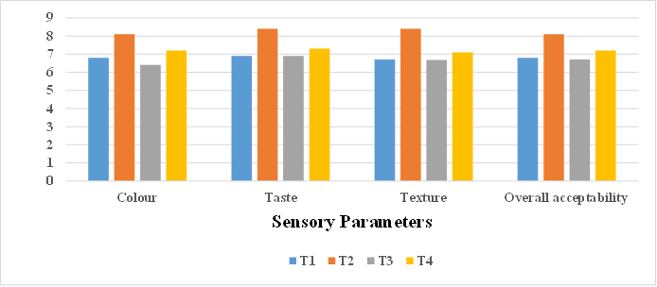

Fig.1 : Effect of different concentrations of kokum rind waste and rock sugar on sensory parameters of kokum mukwas
Plate 1: Treatment Details of the Kokum Rind Waste Production
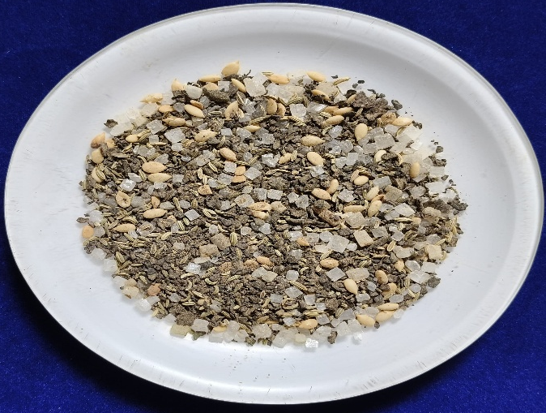
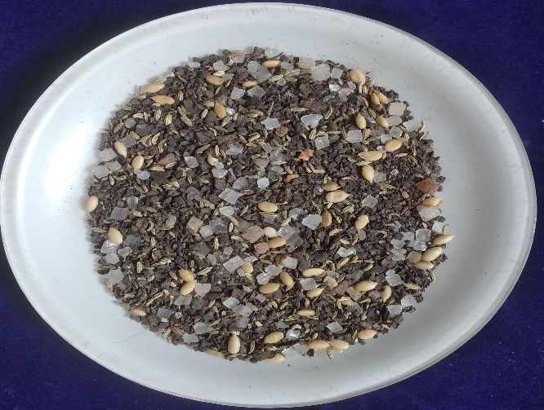
T1: Kokum rind waste 40%, Rock sugar 25%

T2: Kokum rind waste 45%, Crystal sugar 20%

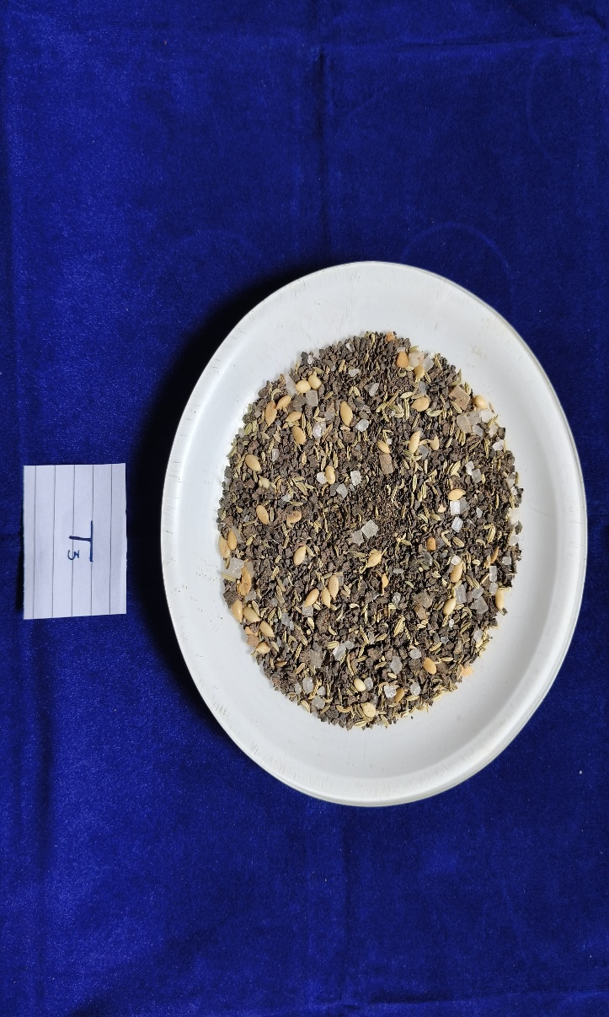
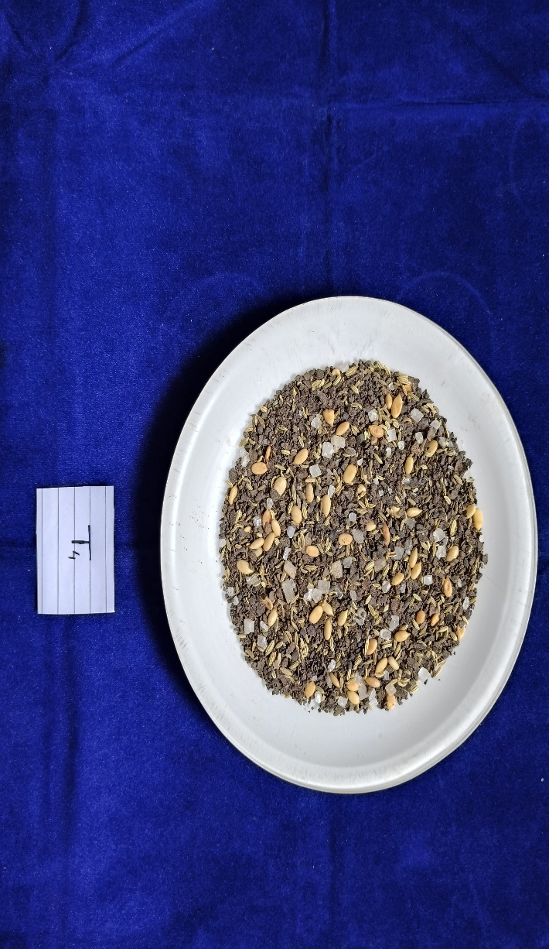

T4: Kokum rind waste 55%, Rock sugar 10%

T3: Kokum rind waste 50%, Rock sugar 15%

Kokum mukhwas prepared from different concentrations of kokum rind waste and rock sugar.

Standardization of best kokum rind waste and sugar combination for preparation of kokum mukhwas. Among the different combinations of kokum rind waste and rock sugar on the basis of sensory score for kokum mukhwas prepared by using (45% kokum rind waste and 20% rock sugar) with 35% constant is roasted funnel seeds (20%), muskmelon seeds (10%), black salt (1%), mulethi powder (4%), was found to be best which was used for further storage study. Sensory score of best treatment T2 was for colour (8.10), Taste (8.40%), Texture (8.40), Overall acceptability (8.10).
3.1 Effect of different storage period on physical parameters (L* a* b*) of kokum mukhwas.
3.1.1 Colour values (L* a* and b*)
L* value
According to table 1. the L* value decreased from 9.78 to 5.68 throughout the 120 days of storage under treatment T2 (45% kokum rind + 20% rock sugar) of kokum mukhwas.
Sugars (such as jagger, glucose, or sugar coatings) and amino acids (found in seeds, fennel, etc.) are frequently found in mukhwas. The Maillard reaction, a chemical reaction between amino acids and reducing sugars, takes place during storage, particularly in warm temperatures or high humidity levels. The L* value decreases as a result of the browning and darker colour. Similar trend followed in different dairy products Bhosale et al. (2020). The result is line with Hande et al. (2014) who noticed the dried kokum rind becomes less light as the storage time grows. Takale (2022) studied under ambient storage circumstances, treatment T5 (1500 ppm) had the highest color retention. The color L* value for treatment T5 (1500 ppm) was lower under refrigeration settings, although it was comparable to treatment T4. Therefore, after 90 days of refrigerated storage conditions, the dark color of kokum rind juice was preserved by a sodium benzoate concentration between 500 ppm and 1500 ppm.
a* value
As indicated in table 1. the a* value dropped from 3.48 to 2.46 throughout the course of the 120 days that the kokum mukhwas were stored under treatment T2(45% kokum rind + 20% rock sugar).
Kokum rind waste, Fennel or other colours can all be used as natural colourants in mukhwas. These pigments degrade with time as a result of exposure to heat, light, oxygen, and moisture. The a* value decreased as a result of the loss of red tones. Non-enzymatic browning may happen as the mukhwas contains sugars and amino acids. The Maillard reaction lowers the a* value by causing a colour shift from red to brown. Moisture absorption from improper storage can hasten microbial growth and pigment deterioration.This lessens red tones and deteriorates look. The results are in accordance with Hande et al. (2014) also noticed the 0th month have greatest redness scores across all treatments. The dried kokum rind's redness diminishes with longer storage. The kokum rind that was tray-dried showed the highest retention. Takale (2022) observed that regarding storage, it was observed that the color's a* value had decreased. The a* value for the color of kokum rind juice decreased more slowly under refrigeration storage conditions than under ambient storage conditions up to 90 days of storage, at 30-day intervals
b* value
Treatment T2 (45% kokum rind + 20% rock sugar) of kokum mukhwas as stated in table 1. the b* value increased from 3.16 to 4.42.
These components reducing sugars and amino acids may react over time, particularly in warm or humid environments.The b* value rises as a result of the brown/yellow pigments (melanoidins) produced by this Maillard process. Over time, the hue may change towards yellow due to pigment oxidation or degradation, particularly with regard to carotenoids or synthetic colours. Yellowing can also result from lipid oxidation in seeds that contain oil, such as fennel. When ambient moisture is absorbed, it can cause chemical reactions (Maillard/oxidation) and break down colour coatings, causing colours to leach and merge into a yellow tint. The results are in line with Hande et al. (2014) who observed yellowness rises with longer storage times. The yellowness of the tray-dried kokum rind increased from the first to the sixth month and then decreased in the ninth month. Takale (2022) reported thet impact on the kokum rind juice's b* value color.It was found that as the sodium benzoate content rise, the colour b* value increased as well.
3.2 Effect of storage periods on chemical parameters of kokum mukhwas.
3.2.1 Moisture (%)
As indicated in table 2. the moisture content in treatment T2(45% kokum rind + 20% rock sugar) rises from 4.38 percent to 4.78 percent throughout the course of 120 days of storage.
Sugars and salt, are used in kokum mukhwas. Many of these ingredients are hygroscopic, which means they naturally take in moisture from the atmosphere. These components attract moisture, which raises the overall moisture content during storage, particularly in humid conditions. Mukhwas and other food items have a tendency to balance with the ambient air. The product will absorb moisture until its moisture content equals the water activity of the surrounding air if the environment has a high relative humidity. The result is in line with Garg, (2003) who noticed for both cultivars, the moisture content increased noticeably during storage. The permeability of the packaging material to air and moisture may be the cause of the notable increase in moisture content in aonla mouth freshener.
3.2.2 Total soluble solids (°B)
The total soluble solids in treatment T2 (45% kokum rind + 20% rock sugar) of kokum mukhwas, as indicated in table 2. increased from 34.30°B to 34.98°B throughout the course of 120 days of storage.
Over time, sugars, particularly sucrose, can crystallise, particularly in environments with temperature fluctuations. Since crystallised sugars are no longer soluble, TSS tests cannot detect them. As sugars transition from a soluble to an insoluble (crystalline) state, TSS measurements decrease. Sugars can deteriorate during storage due to oxidation and non- enzymatic browning (Maillard reactions). TSS is further decreased as a result of the decrease in quantifiable soluble sugars. Heat, and light all speed up these processes.
Hande et al. (2014) noticed highest retention of TSS was observed in Tray dried kokum rind. Takale (2022) observed with an extended storage time of up to 90 days under both ambient and refrigerated storage settings, the TSS of kokum rind juice rise. However, during the 90 days of storage, different treatments had a substantial impact on the rate of growth in TSS. When compared to refrigeration storage conditions, the treatment T1 (500 ppm) in ambient storage had the highest TSS. Under both storage conditions, the kokum rind juice with a higher sodium benzoate content, T5 (1500 ppm), showed reduced change in TSS. This condition might result from the greater sodium benzoate levels reducing the biochemical change in kokum rind juice while it was being stored.
3.2.3 Titratable acidity (%)
According to table 2. the titratable acidity of kokum mukhwas in treatment T2(45% kokum rind + 20% rock sugar) rises from 1.58 percent to 2.38 percent.
Mukhwas reducing sugars, such as fructose and glucose, may experience Maillard reactions or oxidation, particularly if they are kept in warm, humid environment. The production of organic acids like lactic, acetic, or formic acid as a result of these processes might raise the titratable acidity. These substances have the potential to hydrolyze during storage, particularly in damp environments, producing free organic acids that increase the titratable acidity. The results are in line with,
Hande et al. (2014) who reported the quantity of components such water soluble that are found in kokum rind may be the cause of the rind's increased acidity after drying. Takale (2022) studied the titratable acidity of kokum rind juice rise during the course of the storage period, up to 90 days under both ambient and refrigerated storage settings. The rate at which the titratable acid content increased varied depending on the treatment. Treatment T1 (500 ppm) had the maximum titratable acidity (3.80 and 3.67 percent, respectively) at room temperature and in a refrigerator. However, treatment T5 (1500 ppm) showed the lowest titratable acidity at ambient and refrigeration (3.53% and 3.50%, respectively). Satish (2018) who noticed acidity increased slightly as the storage period went on, possibly as a result of moisture loss or the breakdown of cell wall components to produce organic acids.
3.2.4 Sugars (%)
3.2.4.1 Reducing sugars (%)
According to table 2. the decreasing sugar T2 (45% kokum rind + 20% rock sugar) of kokum mukhwas rises from 4.98% to 6.62% throughout the course of 120 days of storage.
Over time, sucrose, a non-reducing sugar that is frequently employed in mukhwas as a coating or flavoring, decomposes into fructose and glucose. This process, known as inversion, can be brought on by mild acidity found in natural components (such as flavorings or fennel seeds). High humidity or warm temperatures are ideal for storage. Over time, the levels of fructose and glucose rise since they are both lowering sugars. During storage, these enzymes help produce reducing sugars and can stay active at room temperature.
Hande et al. (2014) noticed the reducing sugar significantly increased in the tray dried kokum rind. The concentration of fruit flavours and calories after drying may be the cause of this rise in reducing sugar. Takale (2022) show that the reducing sugars in kokum rind juice rose as the storage period went on for all treatments, up to 90 days of both ambient and refrigerated storage. Regarding lowering the sugar content, it was found that there were notable differences amongst the treatments. In both settings, treatment T1 had the highest rise in reducing sugars (9.05% at ambient and 8.69% under refrigeration).
3.2.4.2. Total sugars (%)
According to table 2. the total sugar T2 (45% kokum rind + 20% rock sugar) of kokum mukhwas rises from 8.12% to 10.66%.
Complex carbohydrates or glycosides are present in a number of the seeds and plant- based components used in mukhwas, such as fennel. These can hydrolyse over time to produce simpler sugars (glucose, fructose, etc.), particularly if there is enzymes or residual moisture. Measurable total sugars rise as a result of this process. The overall sugar content seems higher as the number of sugar molecules rises. The lowest total sugars were noted in all interactions with storage conditions because spoiling and fermentation may have reduced the total sugar content of kokum fruits while they were being stored at room temperature. Similar results to these were found by Takale (2022) reported the highest rise in total sugars was noted in treatment T1 (500 ppm) (10.09 at ambient and 9.95 at refrigerated conditions). Total sugars increased by at least 9.58 at room temperature and 9.52 at refrigeration settings under treatment T5 (1500 ppm). A higher sodium benzoate concentration reduces the change in the kokum rind juice's overall sugar level.
3.2.5 Protein (%)
The protein in treatment T2 (45% kokum rind + 20% rock sugar) drops from 1.52 percent to 1.16 percent throughout the course of 120 days of storage in kokum mukhwas, as indicated in table 2.
Over time, proteins may degrade oxidatively, particularly in herbal or fruit-based products like kokum mukhwas. During storage, exposure to air, heat, and light can cause amino acids to break down, lowering the amount of detectable protein. During storage, particularly at room temperature, proteins in the mukhwas react with reducing sugars to generate brown Maillard products.These processes lower measured protein levels by binding protein amino groups, rendering them indigestible and undetectable. Polyphenolic substances, particularly hydroxycitric acid and garcinol, are abundant in kokum. These have the ability to attach to proteins and create insoluble complexes that may precipitate or become less extractable, hence reducing the amount of detectable protein. Same results are observed in Ray, (2004) during storage protein become decreases in kokum.
3.2.6 Fat (g/100g)
As seen in table 2. the fat drops from 0.88% to 0.48% throughout the course of 120 days of storage.
Kokum mukhwas lipids and oils, particularly the unsaturated fatty acids, oxidise over time. This lowers the quantifiable fat level by breaking down fats into volatile molecules (such as aldehydes, ketones, and peroxides). If leftover lipase enzymes are present in kokum or other plant materials, they may convert fats into free fatty acids and glycerol. Standard fat tests frequently fail to measure these breakdown products completely, which causes the appearance of fat loss.
Hande et al. (2014) reported fresh kokum rind had a fat level of 9.53% to 0.33%, but dried kokum rind had a lower fat percentage. When kokum rind was dried using the sun, solar drying, and tray drying methods, the fat percentage was 9.193±0.161, 9.383±0.35, and 9.283±0.09%, respectively. The lipid content decreased significantly.
3.2.7 Ash (%)
The ash, as indicated in table 2. drops from 0.34% to 0.14% in kokum mukhwas over the course of 120 days of storage.
Under storage conditions, some inorganic salts, particularly those that are volatile or hygroscopic, such as ammonium compounds or specific organic acid salts, can sublimate or evaporate gradually. As a result, less total ash the residue left over after burning the sample is produced. Hydroxycitric acid and other organic acids found in kokum have the ability to chelate or bind with minerals to form complexes that might not be present in the ash after burning. These complexes change the minerals' thermal stability, which lowers the amount of ash that can be detected.
Similar results were found in Kale and Waskar (2017) ash per cent were decreases in kokum during storage. Terde et al. (2022) when the amount of kokum syrup increased the amount of ash increased considerably, but when the amount of honey increased, the amount of ash decreased little. However, H2K0 (0.990%), a kokum whey beverage made with 16% honey and 0% kokum syrup, had the lowest total solids concentration. The results of the current study on the ash content of beverages are in good accordance with those published by Gond and Chavan (2015) and Bhavsagar et al. (2010).
3.3 Effect of different storage periods on microbial count of kokum mukhwas.
3.3.1 TPC (Total plat count) (cfu/g)
Table 3. provides information on the total plate count of kokum mukhwas throughout storage.
Data indicates that the total plate count of kokum mukhwas was not detected during the production of the mukhwas or at the end of its 120-day storage period at room temperature.
Microbes need water to grow, yet mukhwas is a dry substance.Fungal and bacterial development is inhibited by low water activity (aw < 0.6). Both sugar and kokum rind are hygroscopic, which helps to lower the amount of moisture that is available. Garcinol and hydroxycitric acid, two antimicrobials, are found in kokum rind. Essential oils and phenolics found in fennel seeds and liquorice (mulethi) powder have antibacterial, antifungal, and antioxidant qualities. Additionally, salt produces a hypertonic environment that suppresses the action of microorganisms. Mukhwas is kept at room temperature, frequently in airtight containers, where it lacks oxygen, moisture, and fresh nutrients, creating an environment that is inhospitable to microorganisms. The product would have a low or zero initial microbial load if it had been properly prepared and packed which remaining undetectable for 120 days.
Garg, (2003) is also noted that, for up to 60 days after storage, no microbial development was detected in any of the recipes for the Desi and Banarsi varieties of Aonla mouth freshener The mouth freshner of both cultivars showed the highest average total plate count of bacteria at 6-month storage intervals. Takale (2022) noted that, microbial growth in the kokum rind juice decreased as the sodium benzoate concentration rose. Although the microbial count in kokum rind juice was below the allowable safety level in both storage conditions, cooling also aids in limiting the growth of microorganisms in the juice over the course of the 90-day storage period
3.4 Effect of different storage periods on sensory parameters of kokum mukhwas.
3.4.1 Colour
The results of the sensory score of colour in the kokum mukhwas of treatment T2 (45% kokum rind + 20% rock sugar) throughout a 120-day storage period are shown in Table 4. where it drops from 8.10 to 6.34.
Kokum is abundant in anthocyanins, which give it its deep red to purple hue. These pigments are extremely sensitive to temperature, light, pH, and oxygen; oxidation during storage turns them into colourless or brownish substances; high temperatures hasten the breakdown of pigments; and exposure to light causes photo degradation.
Takale (2022) noted that the evaluators enjoyed the color of the kokum juice RTS across all treatments. Nonetheless, there was a noticeable difference between the treatments, and the various sodium benzoate concentrations displayed a declining trend in color. At 90 days of storage, the color's sensory score drastically decreased, and the color of kokum rind juice RTS also showed a loss in scores, which may have been caused by a decrease in anthocyanin concentration.
3.4.2 Taste
Over the course of a 120-day storage period, the sensory score of the taste in the kokum mukhwas of treatment T2 (45% kokum rind + 20% rock sugar) drops from 8.40 to 6.28, as shown in Table 4.
Unsaturated fatty acids found in muskmelon seeds have the potential to turn rancid when exposed to air. Fats that have been oxidised acquire off flavours, such as a soapy, stale, or bitter taste. One of the main causes of the reduction in the sensory quality of snacks made from seeds or nuts over time is lipid oxidation. Over time, acidity from kokum rind and salt may mix with sugar and liquorice, leading to browning or Maillard processes, particularly when stored in heated conditions, and the breakdown of sweet or fragrant substances. Bitter or off flavours may come from this. The perception of sweetness can change when acidic substances like kokum are present because sucrose can invert to glucose and fructose.Sugar crystallisation may also lessen the flavour of sweetness.
This could be because of the typical Kokum flavour combined with the sweetish acidic taste that is imparted by organic acids such as citric acid, malic acid, ascorbic acid, and hydroxycitric acid (HCA) (1,2 dihydroxypropane-1,2,3 tricarboxylic acid) Jayaprakasha and Sakariah (2002). Ramya and Anitha (2021) observed because of its highly sought-after natural flavour and sour or sweet taste, kokum rind was being employed. The presence of antioxidant anthocyanins gives kokum rind its dark red colour. According to the results of the sensory evaluation, the sensory panellists found all of the Kokum products to have very good taste, with scores ranging from 8.98 ± 0.21 to 7.11 ± 0.66 on a 9-point hedonic scale.
3.4.3 Texture
The results of the sensory score of the texture in the kokum mukhwas of treatment T2 (45% kokum rind + 20% rock sugar) are shown in Table 4. where it drops from 8.40 to 6.52.
When moisture is absorbed, crunchy ingredients become softer, sugar becomes sticky or clumpy, and the bite and crispness are lost. The texture becomes less attractive, softer, or wet. Crystal sugar may absorb moisture and recrystallise over time, creating textures that are uneven or gritty. Kokum rind and other acidic ingredients can invert sucrose into glucose and fructose, which makes the product sticky and alters its texture. Fats in muskmelon seeds have the potential to oxidise or migrate, particularly when stored in warm temperatures.This may result in a greasy, uneven feel or rancidity, which adversely impacts how texture is perceived.
Ramya and Anitha (2021) recived the products textures received similar sensory ratings, with KRP Kokum rind products (8.79 ± 0.31) scoring the highest, followed by KSDP (8.74 ± 0.32) and KDP (8.54 ± 0.23), all of which were rated low in comparison to the other Kokum products but nevertheless earned good ratings.
3.4.4 Overall acceptability
In the kokum mukhwas of treatment T2 (45% kokum rind + 20% rock sugar) the sensory score of overall acceptability drops from 8.10 to 6.80 as shown in table 4.
Salt and crystal sugar both collect moisture from the air because they are hygroscopic. Moisture absorption during storage causes stickiness, clumping, crunchiness loss, and mouthfeel changes. One important component of sensory appeal, texture, is adversely affected by this. Kokum, sweet root, and muskmelon seeds are examples of volatile flavour components that can oxidise, evaporate, and react with sugar and salt. This leads to a loss of freshness, a faded scent, and off flavours (bitterness, mustiness). This eventually lowers flavour quality, which is essential to acceptability in general. The anthocyanins found in kokum rind are sensitive to heat, light, and pH variations. This reduces visual appeal over time by causing colour fading or browning. Similar results were found by Garg, (2003) reported in both cultivars of Aonla mouth freshener showed a significant decline in their overall acceptability scores. Barwal, et al. (2010) noticed that mouth fresheners of both cultivars showed a decline in overall acceptability scores over storage. Ramya and Anitha (2021) observed the most crucial factor in determining a product's consumer acceptability is its overall acceptability. Every product created using kokum was extremely highly satisfactory, as shown by the scores obtained on a hedonic scale of 9 points. According to the results of the sensory score, KRP Kokum rind products was the most palatable of all the kokum products (8.98 ± 0.32). Takale (2022) observed the kokum RTS made from the kokum juice of treatment T5 outperformed treatments T3 and T4 in terms of general acceptability, achieving a maximum mean score of 6.81 at room temperature and 7.69 at refrigeration conditions. Although there was a noticeable drop in the overall acceptability scores at the end of the 90-day storage period for both storage conditions, the kokum RTS made from the kokum rind juices of all treatments remained acceptable for the duration of the 90-day refrigeration storage period.

Table 1. Effect of different storage periods on colour values (L* a* b*) of kokum mukhwas
Treatments  Storage period (Days) | L* | a* | b*
0 | 9.78 | 3.48 | 3.16
30 | 8.72 | 3.20 | 3.42
60 | 7.64 | 2.98 | 3.66
90 | 6.64 | 2.78 | 3.92
120 | 5.68 | 2.46 | 4.42
S.E. m ± | 0.14 | 0.12 | 0.09
C.D. at 5 % | 0.42 | 0.37 | 0.27

Table 2. Effect of different storage periods on chemical parameters of kokum mukhwas
Storage period  (days) | Moisture (%) | Total soluble solids (°B) | Titratable acidity (%) | Reducing sugars (%) | Total sugars (%) | Protein (%) | Fat (%) | Ash (%)
0 | 4.38 | 34.30 | 1.58 | 4.98 | 8.12 | 1.52 | 0.88 | 0.34
30 | 4.46 | 34.32 | 1.78 | 5.42 | 9.18 | 1.46 | 0.78 | 0.28
60 | 4.58 | 34.52 | 1.98 | 5.82 | 9.66 | 1.36 | 0.68 | 0.18
90 | 4.68 | 34.72 | 2.18 | 6.22 | 10.16 | 1.26 | 0.58 | 0.16
120 | 4.78 | 34.98 | 2.38 | 6.62 | 10.66 | 1.16 | 0.48 | 0.14
S.E. m  ± | 0.17 | 0.10 | 0.06 | 0.04 | 0.08 | 0.14 | 0.03 | 0.044
C.D. at 5 % | NS | 0.32 | 0.18 | 0.12 | 0.24 | NS | 0.11 | 0.13

Table 3. Effect of different storage periods on the total plate count of kokum mukhwas

Storage period (Days) | Total plate count cfu/100g
0 | ND
30 | ND
60 | ND
90 | ND
120 | ND

Table 4. Effect of different storage periods on sensory parameters of kokum mukhwas
Storage period  (Days) | Colour | Taste | Texture | overall acceptability
0 | 8.10 | 8.40 | 8.40 | 8.10
30 | 7.58 | 7.96 | 7.58 | 7.60
60 | 7.34 | 7.44 | 7.36 | 7.24
90 | 7.24 | 7.26 | 6.90 | 7.08
120 | 6.34 | 6.28 | 6.52 | 6.80
S.E. m ± | 0.25 | 0.15 | 0.27 | 0.29
C.D. at 5  % | 0.75 | 0.45 | 0.82 | 0.86

4. Conclusion
Kokum mukhwas prepared with 45% kokum rind and 20% rock sugar with 35% constant: Roasted fennel seeds (20%), muskmelon seeds (10%), Black salt (1%), mulethi powder (4%) was found to be best with 120 days of storage.

5. References
- A.O.A.C. (1990). Official Methods of Analysis. Association of Official Analytical Chemists. Washington, D.C. 15th edition.
- A.O.A.C. Official methods of analysis. 12th Ed. Washington, D.C.: Association of Official Analytical Chemists; c (1975).
- A.O.A.C. Official methods of analysis. 16th Ed. Washington, D.C.: Association of Official Analytical Chemists; c (2002).
- A.P.H.A. (2001). In F.P. Downes & K. Ito (Eds.), Compendium of methods for microbiological examination of foods. Washington: American Public Health Association.
- Amerine, M.A., Pangborn, R.M. and Rosseler, E.B. (1965). In: Principles of sensory evaluation of foods. Academic press. New York: 350-376.
- Barwal, V.S., Garg, V. and Sharma, R, (2010). Development and quality evaluation of aonla mouth freshner. Journal of food science and technology, 47,:.697-699.
- Bhavsagar, M.S., Awaz, H.B. and Patange, U.L. (2010). Manufacture of Pineapple Flavoured Beverage from Chhana Whey. J. Dairying, Foods and H.S. 29(2): 110-113.
- Bhosale, S., Desale, R.J. and Fulpagare, Y.G, (2020). Microencapsulation: applications in the different dairy products. International Journal Pharm. Biomed. Eng, 6,:.7-11.
- Chate, Manoj and Kakade, Subhash and Neeha, V. (2019). Kokum (Garcinia indica) Fruit: A Review.Asian Journal of Dairy and Food Research. 38. 10.18805/ajdfr. DR-1493.
- Dushyantha, D.K., Girish, D.N., Suvarna, V.C. and Dushyantha, D.K. (2010). Native lactic acid bacterial isolates of kokum for preparation of fermented beverage. Europ Journal of Biological Sciences 2: 21-4.
- Garg, V., (2003). Development and Evaluation of Aonla Based Fruit Drink and Mouth Freshner (Doctoral dissertation, College of Horticulture Dr. Yashwant Singh Parmar University of Horticulture and Forestry; Solan).
- Gond, B.B. and Chavan, K.R. (2015). Utilization of chhana whey for preparation of beverage by using sweet orange (Citrus sinensis L.) Juice. M.Sc. (Agri.) Thesis submitted to VNMKV. Parbhani. (Ms).
- Hande, A.R., Swami, S.B. and Thakor, N.J., (2014). Effect of drying methods and packaging materials on quality parameters of stored kokum rind. International Journal of Agricultural and Biological Engineering, 7(4), pp.114-126.
- Jayaprakasha GK, and Sakariah KK. (2002) Determination of organic acids in leaves and rinds of Garcinia indica (Desr.) by LC. Journal of Pharmaceutical and Biomedical Analysis; 28:379-384.
- Kale, S. J., and Waskar, D. P. (2017). Effect of processing on nutritional composition of kokum (Garcinia indica Choisy). Journal of Pharmacognosy and Phytochemistry, 6(6),1339– 1342.Benin. African Journal of food agriculture, nutrition and development, 6.
- Karnik, A.R. and G. P. Raorane (2001). Problems and future thrust areas of research in Kokum. Proceedings of the First National Seminar on Kokum held at Regional Fruit Research Station, Vengurle, Dist. Sindhudurg 416 516 on 12 -13th May 2001 :86- 88.
- Krishnamurthy, N. (1984). Chemical and technological studies on colouring matters from natural sources for use in foods (Doctoral dissertation, Central Food Technological Research Institute).
- Krishnamurthy, N., Lewis, Y.S. and Ravindranath, B. (1982). Chemical constituents of kokum fruit rind. Journal of Food Science and Technology, India,19(3) :97-100.
- Lane JH, Eynon. Determination of reducing sugars by means of Fehling’s solution with methylene blue as internal indicator. Journal of the Society of Chemical Industry. (1923); 17:32-7.
- Lim, S.H., Lee, H.S., Lee, C.H. and Choi, C.I. (2021). Pharmacological activity of Garcinia indica (Kokum): An updated review. Pharmaceuticals, 14(12): 1338.
- Malar, D.S., Prasanth, M.I., Tencomnao, T., Brimson, J.M. and Prasansuklab, A. (2022). Garcinia indica (Kokum) and Ilex aquifolium (European Holly). In Herbs, Shrubs, and Trees of Potential Medicinal Benefits. CRC Press. 427-446.
- Mishra A, Bapat MM, Tilak JC and Thomas PA. (2006). Antioxidant activity of Garcinia indica L.(kokum) and its syrup. Current Science, 91(1): 90-93.
- Nambiar, V. and Ansari, S.I. (2020). ‘MUKHWAS'MIX–Indian Mouth Fresheners and their potential role in reducing micronutrient malnutrition. International Journal Applied Home Science, 7, pp.7-12.
- Nayak, C.A., Srinivas, P. and Rastogi, N.K. (2010). Characterization of anthocyanin from Garcinia indica choisy. Food Chemistry. 118: 719"724 Nutrition, Income and Sustainable Development 2008;806:539-546, 22.
- Panse, V.G. and Sukhatme, P.V. (1985). Statistical methods of Agriculture workers, Indian Council of Agricultural Research, New Delhi: 70-72.
- Patel, Ramesh (1997). The Mandeer Ayurvedic Cookbook. Psychology Press. ISBN 978- 0-7007-0686-0.
- Ramya, H.N. and Anitha, S., (2021). Kokum value-added products and its sensory evaluation. International Journal of Chemical Studies, 9(1), :21-25.
- Ranganna S. Handbook of analysis and quality control for fruits and vegetables. New Delhi: Tata McGraw Hill Publishing Company Limited; (1986). p. 9-10.
- Ray, B., (2004). Fundamentals of Food microbiology. Journal of Pharmacognosy and Phytochemistry, 6(6),1339–1342.Benin. African Journal of food agriculture, nutrition and development, 6.
- Sadasivam, S. and Manickam, A. (2008). Biochemical methods, New Age International (P) Ltd, New Delhi, India.
- Satish, S.K. (2018) development of technology for beetroot (beta vulgaris) candy by using different types of sweeteners.
- Takale, M.S.R. (2022) studies on the preservation of kokum (garcinia indica) rind juice (Doctoral dissertation, Dr. Balasaheb Sawant Konkan Krishi Vidyapeeth).
- Terde, S.H., Lande, S.R., Ramod, S.S., Suryawanshi, N.A. and Dandekar, V.S., 2022. Studies on effect of kokum syrup on physico-chemical properties of herbal kokum whey beverage. Asian Journal of Dairy and Food Research, 41(2), pp.242-246.
- Tripathi, P.C., Senthilkumar, R., Sankar, V. and Karunakaran, G. (2014). Kokum (Garcinia india) A potential fruits of Western Ghats Bulletin. Central Horticultural Experiment Station Indian Institute of Horticultural Research Chettalli–571, 248.

