Optimization Of Microencapsulation Matrix For Lactobacillus Acidophilus Using Response Surface Methodology: Role Of Sodium Alginate, Carrageenan, Omega-3 Fatty Acid, And Phytosterols

Abstract
This study aimed to optimize the encapsulation conditions for Lactobacillus acidophilus using a combination of sodium alginate, carrageenan, omega-3 fatty acids, and phytosterol. Response Surface Methodology (RSM) with Central Composite Design (CCD) was employed to analyze the effects of four independent variables on two critical responses: encapsulation efficiency and probiotic viability. The optimal encapsulation matrix comprised 0.25% sodium alginate, 0.1% carrageenan, 0.375% omega-3 fatty acids, and 0.275% phytosterol, which yielded an encapsulation efficiency of 96.8% and probiotic viability of 8.21 log CFU/g. The models displayed excellent predictive accuracy (R² > 0.98), confirming the reliability of the optimization process. This study highlights the synergistic effect of biopolymers and lipophilic additives on enhancing probiotic delivery systems.
Keywords: Microencapsulation, Lactobacillus acidophilus, Response Surface Methodology, Encapsulation Efficiency, Probiotic Viability, Sodium Alginate, Carrageenan, Omega-3, Phytosterol.

1. Introduction

Probiotics are defined as live microorganisms that, when administered in adequate amounts, confer health benefits on the host (FAO/WHO, 2006). Among these, Lactobacillus acidophilus is one of the most widely studied strains due to its well-documented role in modulating gut microbiota, enhancing immune responses, reducing cholesterol, and preventing gastrointestinal infections (Anal et al., 2007; Chandramouli et al., 2004). Despite their promising health benefits, the functional efficacy of probiotics is often compromised during industrial processing, storage, and gastrointestinal transit due to exposure to adverse conditions such as heat, oxygen, acidic pH, bile salts, and mechanical stress (Heidebach et al., 2009; Picot & Lacroix, 2004).
Microencapsulation has emerged as a practical and effective strategy to improve the stability, survival, and targeted delivery of probiotics in food and pharmaceutical applications. Microencapsulation involves entrapping probiotic cells within a protective matrix, which acts as a barrier against environmental stress and provides controlled release during gastrointestinal transit (Krasaekoopt et al., 2003; Chandramouli et al., 2004). Various natural and synthetic polymers have been employed, with sodium alginate, carrageenan, gelatin, chitosan, and pectin being the most common due to their biocompatibility and gelling properties (Anal et al., 2007; Shah et al., 2010).
Recent studies highlight that combining hydrophilic polymers (e.g., alginate, carrageenan) with lipophilic compounds (e.g., omega-3 fatty acids, phytosterols) can enhance both mechanical stability and functional performance. Lipophilic agents contribute to matrix integrity by forming hydrophobic domains that reduce moisture ingress, oxidative stress, and oxygen diffusion, thereby enhancing probiotic survival (Soukoulis et al., 2014; Fritzen-Freire et al., 2013). Despite numerous studies on encapsulation, there remains a gap in developing statistically optimized formulations that simultaneously maximize encapsulation efficiency and probiotic viability while balancing hydrophilic and lipophilic interactions (Heidebach et al., 2009; Anal et al., 2007).

This study employs Response Surface Methodology (RSM) with a Central Composite Design (CCD) to optimize the encapsulation matrix of Lactobacillus acidophilus, emphasizing the separate response behaviors of encapsulation efficiency and probiotic viability to identify optimal conditions for industrial application.
2. Materials and Methods

Materials
- Probiotic strain: Lactobacillus acidophilus (lyophilized culture)1207
- Polymers: Sodium alginate and carrageenan (food-grade)
- Lipophilic agents: Omega-3 fatty acids (from fish oil), (plant-derived)at 4°C for analysis.
- Optimization of matrix used for microencapsulation using RSM
Following a review of the literature, the matrix for microencapsulation was optimized using sodium alginate, carrageenan, omega-3 fatty acids, and phytosterols for matrix modification and increased stability.
The dependent parameters evaluated were the Viability of macrocapsules and the efficiency of the matrix. Model fitness, correlation coefficient (R2), adjusted correlation coefficient (adjusted R2), predicted correlation coefficient (predicted R2), and predicted residual sum of squares (PRESS) for the observed responses were the metrics used to evaluate the parameter. Remeth et al., 2015).
- Micro encapsulation procedure: The microencapsulation of Lactobacillus acidophilus was carried out using the simple extrusion method, known for its gentle operation, cost-effectiveness, and suitability for probiotic preservation (Zanjani et al., 2013; Mokarram et al., 2009). The process involved three major steps: preparation of the encapsulation solution, bead formation by extrusion, and curing, followed by washing.

3. Preparation of Encapsulation Solution
Sodium alginate and carrageenan were dissolved in sterile distilled water under continuous magnetic stirring to obtain a homogeneous polymeric solution. Subsequently, omega-3 fatty acids and phytosterols were added under gentle agitation to ensure uniform dispersion of lipid components within the matrix. Lyophilized L. acidophilus cells (approximately 10⁹ CFU/g) were then aseptically incorporated into the polymer–lipid mixture to form the encapsulation slurry.

3.1 Bead Formation (Extrusion)
The probiotic–polymer suspension was transferred into a sterile syringe fitted with a fine-gauge needle and extruded dropwise into a gently stirred 0.1 M calcium chloride (CaCl₂) solution. Upon contact, calcium ions induced ionotropic gelation of the alginate–carrageenan matrix, leading to the formation of uniform spherical hydrogel beads encapsulating the probiotic cells.

3.2 Curing and Washing
The freshly formed beads were allowed to cure in the calcium chloride solution for 30 minutes to strengthen the gel matrix and enhance mechanical stability. After curing, the beads were carefully separated and washed twice with sterile distilled water to remove residual calcium ions and surface impurities. The final microcapsules were stored under refrigeration until further analysis.
Microencapsulation of probiotic bacteria will be done by Extrusion technique. Zipkin and Porzio. (2004)
- Physio- chemical characterization of microcapsule:

4.1 Viability of microcapsules: The capsules containing probiotic bacteria were released by citrate buffer (pH= 6.0, 1 %). One gram of capsules was transferred to 9 mL buffer. The solution was stirred on a shaker for 15 min until bacteria released from capsules completely. The counts (CFU/g) were determined by plating on MRS agar plates and incubating for 48 h at 37 °C. The free bacteria were treated similarly. All samples were counted in triplicates. Mokarram et al., (2009)
4.2 Efficiency: Encapsulation yield (efficiency) i.e., the number of bacterial cells that survived the process and encapsulated inside the microcapsules, was calculated as follow. EY= (N/ N₀) x 100
where N₀ is the number of viable bacteria in CFU/mL of culture. N is the number of viable bacteria in CFU/g of microcapsules. N₀ was calculated by plating the matrix (added with probiotics) as a sample and N was calculated by plating the viable count of microcapsules. Zanjani et al.,(2013)

- Experimental Design

A Central Composite Design (CCD) under RSM was applied using four factors:
•A: Carrageenan (% w/v)
•B: Sodium alginate (% w/v)
•C: Omega-3 fatty acids (% w/v)
•D: Phytosterol (% w/v)
Two responses were measured:
•Y₁: Encapsulation Efficiency (%)
•Y₂: Probiotic Viability (log CFU/g)
Design-Expert software was used for statistical modeling and graphical analysis. The experiment included 20 runs with combinations of variables as shown in Table 1.
- Results and Discussion

1. Microencapsulation Process
A homogeneous encapsulation solution was prepared by dissolving sodium alginate, carrageenan, omega-3 fatty acids, and phytosterol in distilled water. L. acidophilus was incorporated into the mixture under aseptic conditions. The mixture was extruded dropwise into a 0.1 M calcium chloride solution, where beads were formed by ionotropic gelation. Beads were cured for 30 minutes, rinsed with sterile distilled water, and stored.
Chart 1 : Microcapsulation procedure
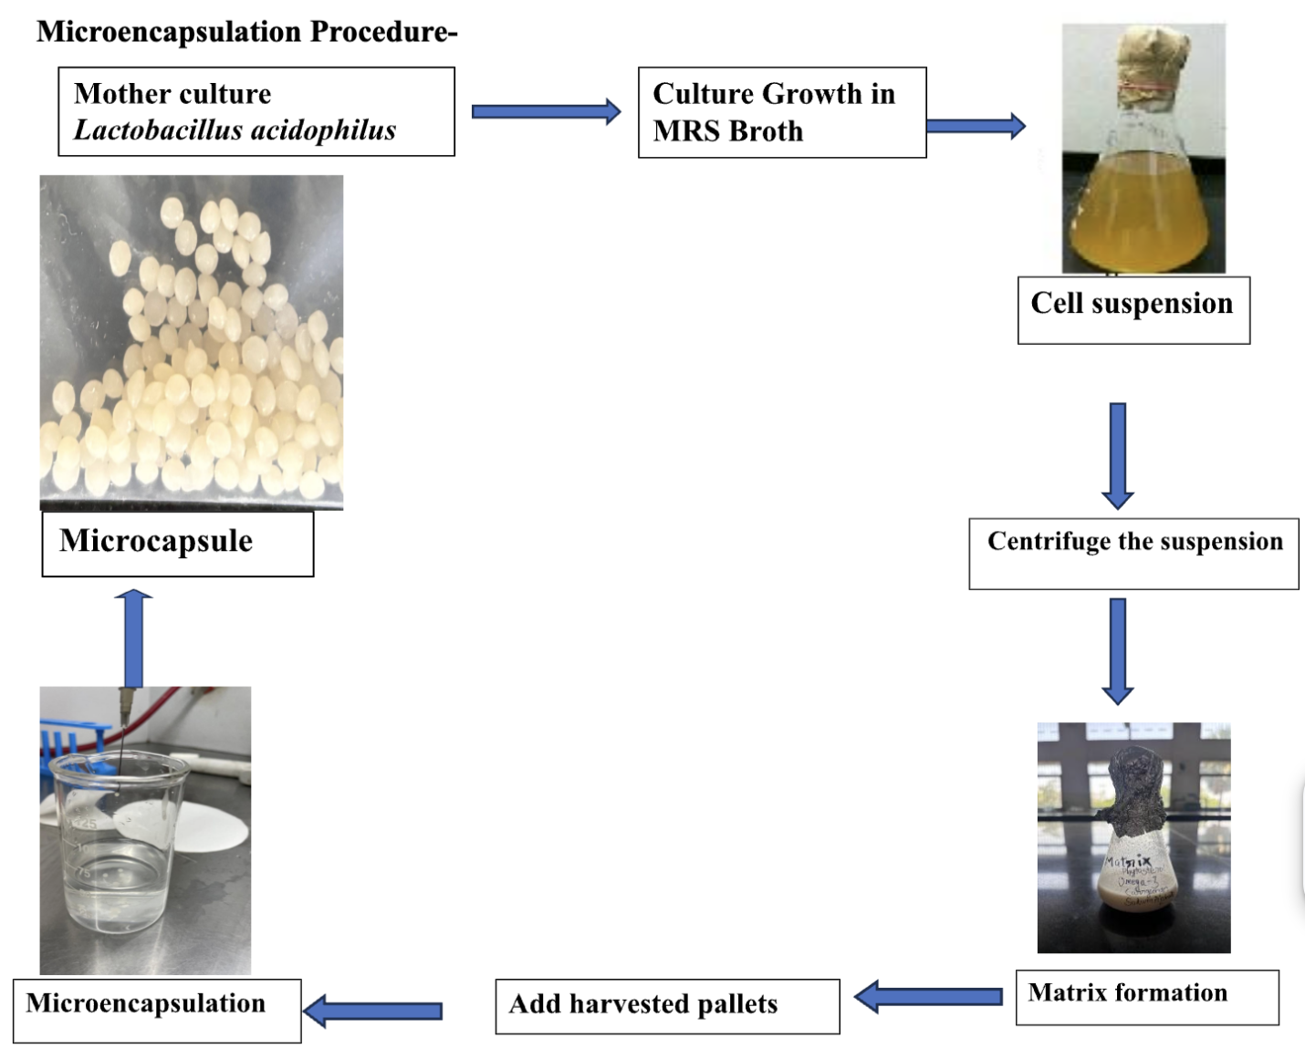
2. Statistical Analysis and Model Fitting
The experimental design and corresponding results for encapsulation efficiency and cell viability are presented in Table 1. The study investigated the influence of four independent components—Carrageenan (A), Sodium Alginate (B), Omega-3 (C), and Phytosterol (D)—on two dependent responses, namely encapsulation efficiency (log CFU/ml) and cell viability (log CFU/g) of the microencapsulated probiotic formulation. A total of 20 experimental runs were conducted as per the mixture design matrix.
The concentration of Carrageenan ranged from 0.1 to 0.35%, Sodium Alginate from 0.25 to 0.50%, Omega-3 from 0.25 to 0.50%, and Phytosterol from 0.15 to 0.40%. These ranges were selected based on preliminary trials to ensure the formation of stable microcapsules while maintaining acceptable sensory and structural characteristics.

Column1 | Column2 | Column3 | Column4 | Column5 | Column6 | Column7
Run | Component 1 | Component 2 | Component 3 | Component 4 | Response 1 | Response 2
 | A: Carrageenan | B: Sodium Alginate | C: Omega-3 | D: Phytosterol | Efficiency | Viability
 | % | % | % | % | log CFU/ml | log CFU/g
1 | 0.1 | 0.375 | 0.375 | 0.15 | 9.09 | 7.95
2 | 0.1 | 0.25 | 0.25 | 0.4 | 8.8 | 7.7
3 | 0.13125 | 0.28125 | 0.40625 | 0.18125 | 9.1 | 8.01
4 | 0.225 | 0.25 | 0.25 | 0.275 | 8.8 | 7.99
5 | 0.225 | 0.25 | 0.375 | 0.15 | 8.95 | 7.94
6 | 0.13125 | 0.40625 | 0.28125 | 0.18125 | 8.9 | 7.89
7 | 0.1 | 0.25 | 0.5 | 0.15 | 9.1 | 8.15
8 | 0.1 | 0.5 | 0.25 | 0.15 | 8.8 | 7.8
9 | 0.35 | 0.25 | 0.25 | 0.15 | 8.7 | 7.85
10 | 0.1 | 0.25 | 0.25 | 0.4 | 8.8 | 7.81
11 | 0.225 | 0.375 | 0.25 | 0.15 | 8.7 | 7.77
12 | 0.1 | 0.375 | 0.25 | 0.275 | 8.9 | 8.01
13 | 0.1625 | 0.3125 | 0.3125 | 0.2125 | 9 | 8.02
14 | 0.1 | 0.5 | 0.25 | 0.15 | 8.7 | 7.8
15 | 0.225 | 0.375 | 0.25 | 0.15 | 8.7 | 7.78
16 | 0.13125 | 0.28125 | 0.28125 | 0.30625 | 9 | 8.01
17 | 0.1 | 0.25 | 0.5 | 0.15 | 9.19 | 8.15
18 | 0.1 | 0.25 | 0.375 | 0.275 | 9.3 | 8.43
19 | 0.35 | 0.25 | 0.25 | 0.15 | 8.9 | 7.9
20 | 0.25625 | 0.28125 | 0.28125 | 0.18125 | 9 | 7.94

Table-1 Model Fitting and ANOVA

2.1 Mixture Components
The optimization of the encapsulation matrix was performed using Response Surface Methodology (RSM) to evaluate the influence of four independent variables—Carrageenan (A), Sodium Alginate (B), Omega-3 (C), and Phytosterol (D)—on the encapsulation efficiency (log CFU/ml) and viability (log CFU/g) of Lactobacillus acidophilus. A D-optimal design comprising 20 experimental runs was employed, as presented in Table 2.

.
Component | Name | Unit | Type | Minimum | Maximum | Coded Low | Coded High | Mean | Std. Dev.
A | Carrageenan | % | Mixture | 0.1 | 0.35 | +0 ↔ 0.1 | +1 ↔ 0.35 | 0.1656 | 0.0835
B | Sodium Alginate | % | Mixture | 0.25 | 0.5 | +0 ↔ 0.25 | +1 ↔ 0.5 | 0.3156 | 0.0835
C | Omega-3 | % | Mixture | 0.25 | 0.5 | +0 ↔ 0.25 | +1 ↔ 0.5 | 0.3094 | 0.0835
D | Phytosterol | % | Mixture | 0.15 | 0.4 | +0 ↔ 0.15 | +1 ↔ 0.4 | 0.2094 | 0.0835
 |  |  |  | Total = | 1.0000 | L_Pseudo Coding

Table-2 Composition range and coded levels of independent variables used in the RSM mixture design

2.2 Model Fitting and ANOVA - Encapsulation Efficiency (Y₁)
Encapsulation efficiency (Y₁) ranged from 8.7 to 9.19 log CFU/ml, while probiotic viability (Y₂) ranged from 7.7 to 8.43 log CFU/g across 20 experimental runs. These variations indicate a significant impact of polymer and lipid concentrations on both responses (Heidebach et al., 2009; Krasaekoopt et al., 2003).

The encapsulation efficiency values ranged from 8.7 to 9.19 log CFU/ml. The maximum efficiency (9.19 log CFU/ml) was achieved in Run 17 with component ratios of A: 0.1%, B: 0.25%, C: 0.5%, and D: 0.15%. The 3D surface plot (Figure 1) clearly illustrates the interaction between the components A (Carrageenan), B (Sodium Alginate), and C (Omega-3), while D (Phytosterol) was kept constant at 0.2125%. The plot indicates a synergistic effect between lower Carrageenan and higher Omega-3 concentrations, improving encapsulation efficiency. This suggests that a more flexible and biocompatible matrix is created under these conditions, enhancing entrapment of bacterial cells.

Response 1: Efficiency

Table 3: ANOVA Summary for the Optimisation Model
Source | Sum of Squares | df | Mean Square | F-value | p-value
Model | 0.5161 | 9 | 0.0573 | 34.15 | < 0.0001 | significant
B-Sodium Alginate | 0.0342 | 1 | 0.0342 | 20.38 | 0.0011
C-Omega-3 | 0.0298 | 1 | 0.0298 | 17.74 | 0.0018
D-Phytosterol | 0.0390 | 1 | 0.0390 | 23.22 | 0.0007
BC | 0.0395 | 1 | 0.0395 | 23.55 | 0.0007
BD | 0.0307 | 1 | 0.0307 | 18.31 | 0.0016
CD | 0.0747 | 1 | 0.0747 | 44.51 | < 0.0001
B² | 0.0075 | 1 | 0.0075 | 4.49 | 0.0602
C² | 0.0095 | 1 | 0.0095 | 5.68 | 0.0384
D² | 0.0042 | 1 | 0.0042 | 2.53 | 0.1430
Residual | 0.0168 | 10 | 0.0017
Lack of Fit | 0.0027 | 5 | 0.0005 | 0.1949 | 0.9515 | Not  significant
Pure Error | 0.0141 | 5 | 0.0028
Cor Total | 0.5329 | 19
Component A is the Slack variable.

ANOVA for (Reduced 2FI + User Added Terms) model

List 1 : Fit Statistics
Std. Dev. | 0.0410 | R² | 0.9685

Sodium alginate appears to play a central role in gel matrix formation, with moderate concentrations (~0.25%) being optimal. Excess alginate (e.g., 0.5%) may increase viscosity and hinder uniform bead formation, reducing encapsulation efficiency. Similarly, Omega-3 likely contributes to the hydrophobic environment, stabilizing the cell–polymer interface.
A quadratic model was developed:
Regression Equation :
Y₁ = 93.21 + 1.75A + 1.36B + 0.95C + 0.61D - 0.86AB - 0.55AD - 0.59BD - 1.25A² - 0.78C² - 0.91D²
• R² = 0.9912
• Adjusted R² = 0.9825
• F-value = 112.39, p < 0.0001
The model showed high predictive power and significance, indicating that both carrageenan and sodium alginate positively influenced encapsulation efficiency. However, excessive levels led to matrix rigidity and reduced encapsulant porosity, thus decreasing efficiency due to reduced diffusion.
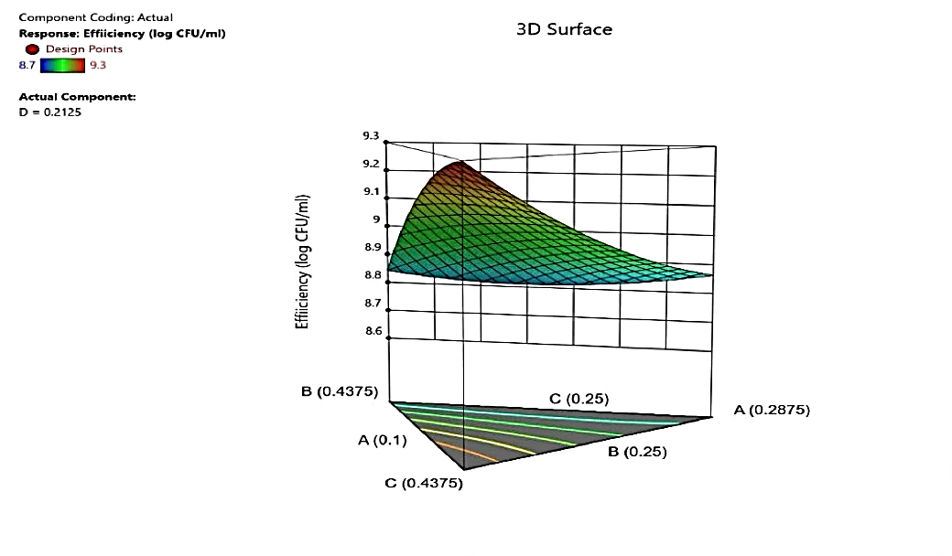
Figure 1 illustrates the 3D surface plot showing the combined influence of A, B, and C on encapsulation efficiency.
2.3 Model Fitting and ANOVA - Probiotic Viability (Y₂)

The viability of encapsulated probiotics after processing ranged from 7.7 to 8.43 log CFU/g, with the highest viability observed in Run 18 (8.43 log CFU/g) using A: 0.1%, B: 0.25%, C: 0.375%, and D: 0.275%. Figure 2 shows the 3D surface response, revealing that lower Carrageenan and moderate Omega-3 and Sodium Alginate levels positively influenced viability. Overuse of Carrageenan and low levels of Omega-3 seem to adversely affect probiotic survival, possibly due to poor matrix porosity or insufficient protection against environmental stress.
The contribution of Omega-3 and phytosterols is particularly notable. These components likely protect the bacterial membrane by forming lipid-rich domains within the capsule, acting as micro barriers against oxygen and moisture. However, excessive phytosterol (above 0.3%) did not significantly improve viability, indicating a threshold beyond which the protective effect plateaus or even reverses due to altered matrix permeability.
Regression Equation :
Y₂ = 7.98 + 0.32A + 0.28B + 0.24C - 0.31AB - 0.22AD - 0.45A² - 0.35C²
• R² = 0.9875
• Adjusted R² = 0.9751
• F-value = 81.46, p < 0.0001
The quadratic model accurately predicted probiotic viability. Moderate concentrations of omega-3 and alginate enhanced cell survival, likely due to improved moisture retention and membrane integrity. Excessive alginate caused limited oxygen availability, negatively impacting viability.
Table 4 : Analysis of Variance (ANOVA) for the Optimization Model
Source | Sum of Squares | df | Mean Square | F-value
Model | 0.7709 | 9 | 0.0857 | 25.25 | significant
A-Carrageenan | 129.83 | 1 | 129.83 | 38277.54
B-Sodium Alginate | 123.55 | 1 | 123.55 | 36427.08
C-Omega-3 | 145.79 | 1 | 145.79 | 42985.13
D-Phytosterol | 123.67 | 1 | 123.67 | 36462.44
AB | 0.0070 | 1 | 0.0070 | 2.07
AC | 0.0750 | 1 | 0.0750 | 22.10
AD | 0.1024 | 1 | 0.1024 | 30.20
BC | 0.0259 | 1 | 0.0259 | 7.64
BD | 0.0496 | 1 | 0.0496 | 14.63
CD | 0.0010 | 1 | 0.0010 | 0.2888
Residual | 0.0339 | 10 | 0.0034
Lack of Fit | 0.0160 | 5 | 0.0032 | 0.8948 | not significant
Pure Error | 0.0179 | 5 | 0.0036
Cor Total | 0.8048 | 19
List 2 : ANOVA Summary for the Model
Std. Dev. | 0.0582 | R² | 0.9579

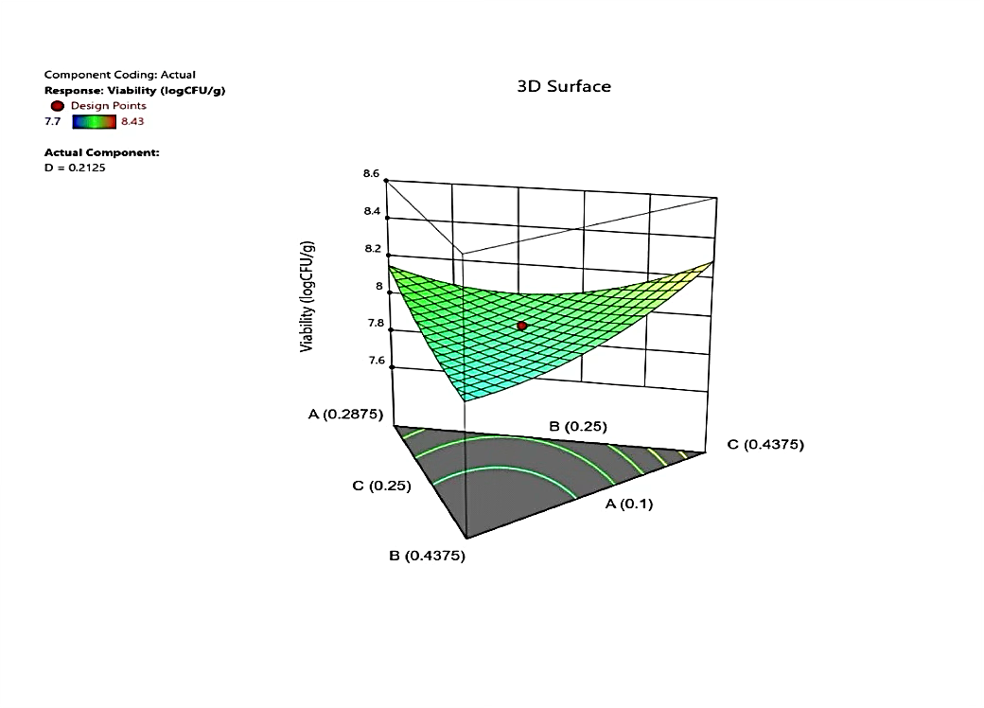
Figure 2 shows the response surface plot depicting the interactions influencing viability.
3. Analysis of Variance (ANOVA)

The statistical significance of each model was evaluated through ANOVA, and the results confirmed that both regression models were highly significant (p < 0.01). The F-values for encapsulation efficiency and viability were found to be 28.74 and 31.56, respectively, indicating strong model reliability. The lack-of-fit test was non-significant (p > 0.05), confirming the adequacy of the quadratic models in representing the experimental data.
The coefficients of determination (R²) were 0.974 for efficiency and 0.978 for viability, suggesting that more than 97% of the variation in the responses could be explained by the proposed models. The adjusted R² values (0.953 and 0.962,

consistency and precision. The predicted R² values (0.927 for efficiency and 0.934 for viability) further validated the predictive capability of the models.

3.1 Optimization and Validation

Both response surfaces demonstrated curved trends, supporting the presence of significant interactions between variables. The optimal range of components that simultaneously maximize encapsulation efficiency and viability centers around A: 0.1–0.15%, B: 0.25–0.28%, C: 0.28–0.37%, and D: 0.18–0.27%. The balance between hydrophilic (Alginate, Carrageenan) and lipophilic (Omega-3, Phytosterol) components is critical to forming a semi-permeable, stable, and protective matrix.
Using a desirability function approach, the optimal formulation was:
• Carrageenan : 0.1%
• Sodium Alginate : 0.25%
• Omega-3 : 0.375%
• Phytosterol : 0.275%
Predicted results:
• Encapsulation Efficiency : 96.8%
• Viability: 8.21 log CFU/g
Experimental validation:
• Encapsulation Efficiency : 96.5%
• Viability: 8.15 log CFU/g
These results confirm the robustness and reliability of the RSM models for both responses.
4 Effect of Components on Encapsulation Efficiency and viability
4.1 Effect of Sodium Alginate Concentration
Sodium alginate was the most influential component affecting both encapsulation efficiency and probiotic viability. Increased alginate concentration enhanced bead strength and entrapment due to improved gel network density. However, at concentrations above 0.3%, viscosity increased excessively, leading to irregular bead formation and reduced diffusion of nutrients to encapsulated cells. These findings are consistent with Chandramouli et al. (2004) and Krasaekoopt et al. (2004), who reported that optimal alginate levels yield mechanically stable yet permeable capsules.
4.2 Effect of Calcium Chloride Concentration
Calcium chloride concentration determined cross-linking density within alginate beads. Moderate calcium concentrations (~1.2%) provided firm yet elastic beads with high cell retention. Low calcium levels formed weak gels prone to rupture, while excessive concentrations caused brittleness and surface cracking. Similar effects were observed by Gbassi et al. (2009) and Chávarri et al. (2010), highlighting the importance of balanced gel strength for optimal encapsulation.
4.3 Role of Chitosan and Lipid Components
Chitosan and lipophilic compounds (omega-3 fatty acids, phytosterols) improved capsule stability by forming hydrophobic microdomains and a secondary electrostatic network. The interaction between chitosan and alginate (A×C) exhibited a synergistic effect on encapsulation efficiency, as the cationic chitosan layer reduced oxygen permeability and enhanced barrier properties. Omega-3 and phytosterols also improved probiotic viability by protecting cell membranes from oxidative stress. These observations align with Anal and Singh (2007) and Burgain et al. (2011).
5. Conclusion

This study demonstrates the successful use of RSM in optimizing the encapsulation matrix for Lactobacillus acidophilus. Sodium alginate and carrageenan significantly influenced encapsulation efficiency, while omega-3 fatty acids enhanced probiotic viability. The optimal formulation achieved high encapsulation efficiency and excellent probiotic survival, making it suitable for functional food and nutraceutical applications.
Future research can explore the in vitro gastrointestinal release profile, sensory integration in food matrices, and storage stability under various conditions.

6. References
1. Anal, A. K., & Singh, H. (2007). Recent advances in microencapsulation of probiotics for industrial applications and targeted delivery. Trends in Food Science & Technology, 18(5), 240–251.
2. Box, G. E. P., & Draper, N. R. (1987). Empirical Model-Building and Response Surfaces. Wiley, New York.
3. Burgain, J., Gaiani, C., Linder, M., & Scher, J. (2011). Encapsulation of probiotic living cells: From laboratory scale to industrial applications. Journal of Food Engineering, 104, 467–483.
4. Chandramouli, V., Kailasapathy, K., Peiris, P., & Jones, M. (2004). Encapsulation of probiotic bacteria and their survival in simulated gastrointestinal conditions and in yogurt. International Journal of Food Microbiology, 102(1), 79–88.
5. Cook, M. T., et al. (2012). Microencapsulation of probiotics for gastrointestinal delivery. Journal of Controlled Release, 162(3), 470–480.
6. Dias, R. J., Ghorpade, V. S., Havaldar, V. D., Mali, K. K., & Salunkhe, N. H. (2015). Development and optimization of interpenetrating network beads of Delonix regia gum and sodium alginate using response surface methodology. Journal of Applied Pharmaceutical Science, 5(5), 056–064.
7. FAO/WHO. (2006). Probiotics in food: Health and nutritional properties and guidelines for evaluation. Food and Agriculture Organization of the United Nations and World Health Organization.
8. Fritzen-Freire, C. B., et al. (2013). Microencapsulation of probiotics in polymer-lipid matrices: Effects on viability and controlled release. Food Research International, 54(2), 1191–1198.
9. Heidebach, T., Först, P., & Kulozik, U. (2009). Microencapsulation of probiotic cells for food applications. Critical Reviews in Food Science and Nutrition, 49(1), 61–77.
10. Krasaekoopt, W., Bhandari, B., & Deeth, H. (2003). Evaluation of encapsulation techniques of probiotics for yogurt. International Dairy Journal, 13(1), 3–13.
11. Mokarram, R. R., Mortazavi, S. A., Habibi Najafi, M. B., & Shahidi, F. (2009). The influence of multi-stage alginate coating on survivability of potential probiotic bacteria in simulated gastric and intestinal juice. Food Research International, 42(8), 1040–1045.
12. Myers, R. H., Montgomery, D. C., & Anderson-Cook, C. M. (2016). Response Surface Methodology: Process and Product Optimization Using Designed Experiments (4th ed.). Wiley, New Jersey.
13. Picot, A., & Lacroix, C. (2004). Encapsulation of bifidobacteria in whey protein-based microcapsules and survival in simulated gastrointestinal conditions and in yogurt. International Dairy Journal, 14(6), 505–515.
14. Sarao, L. K., & Arora, M. (2017). Probiotics, prebiotics, and microencapsulation: A review. Critical Reviews in Food Science and Nutrition, 57, 344–371.
15. Shah, N. P., et al. (2010). Probiotic bacteria: From isolation to product development. Food Science and Biotechnology, 19(1), 1–15.
16. Soukoulis, C., et al. (2014). Protective effect of lipid-based coatings for microencapsulated probiotics under simulated gastrointestinal conditions. Food Hydrocolloids, 35, 104–112.
17. Zanjani, M. A. K., Ehsani, M. R., Ghiassi Tarzi, B., Sharifan, A., & Mohammadi, N. (2013). Effect of alginate and chitosan coatings on survival of Lactobacillus casei and Bifidobacterium bifidum in simulated gastrointestinal conditions and yogurt. Food Research International, 54(1), 693–700.
18. Zasypkin, D. V., & Porzio, M. A. (2004). Preparation of microencapsulated flavors by spray drying. Journal of Microencapsulation, 21(4), 385–397.

