Original Research Article

Recycling Of Waste Electrical And Electronic Equipment: The Case Of Copper And Aluminum Recovery From Printed Circuit Board Of Used $B_{22}$Led Lamps

ABSTRACT
Electrowinning is a promising method for recovering critical metals such as aluminum and copper from e-waste. These strategic metals are increasingly at the center of geopolitics and economic development. In Togo, e-waste generation has grown rapidly, increasing from 6,400 tons in 2016 to approximately 8,392 tons in 2024. This study explores the recovery of aluminum and copper from printed circuit boards of $B_{22}$ type LED lamps, which are commonly used in the country. Using nitric and hydrochloric acids to dissolve the metals, electrowinning was carried out with specific electrodes under constant voltage. The process yielded 9.0% for copper at 0.008 A and 1.89 V, and 16.0% for aluminum at 8.7 A and 2.89 V. Although modest, these results demonstrate potential for optimization. Industrial scaling could lead to the recovery of 26.11 tons of copper and 281 tons of aluminum in 2023 from 1,243.4 tons of used lamps in Togo.
Keywords: e-waste, LED-$B_{22}$ lamps, metals, recycling, Togo
- INTRODUCTION
The rising standard of living and the growing global population are driving an increasing demand for electrical and electronic equipment (EEE), which requires the use of ever-greater amounts of mineral resources. This high demand for EEE generates significant quantities of waste electrical and electronic equipment (WEEE).
To meet these needs, the global population is consuming an increasing amount of various metals (Dedryver & Couric, 2020). Research conducted by the French Geological Survey (BRGM) shows, on the one hand, that there has been a widespread increase in global demand for metals since the 1960s, and on the other hand, that this growth is significantly faster than that of the world population. Three main factors explain this rise in raw material consumption:
Population growth, which leads to an increase in the number of metal consumers;
Rising living standards, reflected in higher individual demand;
Industrial development, evidenced by the growing quantity of metals used in production (Vidal, 2018).
The exponential growth in the consumption of electrical and electronic equipment (EEE), combined with the shortening of their useful lifespan, has led to a significant increase in the volume of waste electrical and electronic equipment (WEEE) (Dias et al., 2023). In 2016, the global volume of WEEE was estimated at 44.7 million tonnes (Baldé et al., 2017), rising to 53.6 million tonnes in 2019 (Forti et al., 2020), representing a 17% increase in just three years. However, according to Baldé et al. (2017), only 20% of WEEE was properly treated in 2016. As a result, the majority of this waste is dispersed into the environment, posing a threat due to the hazardous substances it contains.
The European Union Directive 2002/96/EC classified electrical and electronic equipment (EEE), specifying their composition when they become non-functional. Among WEEE, there are waste items such as lamps, mobile phones, computers, and large household appliances (refrigerators, washing machines, dishwashers, etc.) that contain metals such as mercury, lead, cadmium, chromium, barium, and zinc (El Bouchtioui, 2017), as well as copper, iron, and silver.
The management of WEEE remains largely informal, particularly in developing countries (Dieng et al., 2018). It is therefore essential to develop an official market focused on the recovery of metals contained in end-of-life EEE, in order to reduce the consumption of natural resources. According to Baldé et al., the total value of secondary raw materials contained in WEEE generated in 2016 was estimated at around €55 billion, including €9.6 billion for 2,164,000 tonnes of copper and €3.6 billion for 2,472,000 tonnes of aluminum (Baldé et al., 2017). Since EEE are mainly concentrated in urban areas, Arduin refers to WEEE as an “urban mine” (Arduin, 2019). Their recovery through recycling has thus become a necessity to preserve mineral resources for future generations.
Recycling thus appears as a relevant alternative to reduce the consumption of natural resources and as a solution to environmental and economic challenges (Harrou et al., 2020). It fits within a broader approach of sustainable resource management, particularly of minerals. The rarest metals (Rh, Ru, Os, Ir, Pt, Au) are very expensive, while the most common ones (Al, Fe, Mg...) are inexpensive. The demand for metals depends on the need for finished products containing them. The rise of technologies has driven strong demand for specific metals such as gallium, tantalum, and rare earth elements. However, these resources are exhaustible. It is therefore essential to adopt a circular economic model, capable of circulating materials in a closed loop (reuse for the same product) or an open loop (for another product). Circular economy aims to share, reuse, repair, refurbish, and recycle products and materials to extend their value in use (European Parliament, 2023). It allows minimizing inputs of virgin materials and energy (Hu et al., 2011), while reducing waste (Zeller et al., 2019). Reverse logistics, a concept close to but more limited than the circular economy, includes activities such as direct reuse, repair, refurbishment, reconditioning, recycling, incineration, or landfill disposal (Khouloud & Zouari, 2018). Recycling thus reduces risks related to raw material supply, notably by mitigating the effects of price fluctuations and geopolitical tensions.
Recycling of WEEE involves recovering their still-functional components or materials (Laliberté, 2020). In France, Récylum, an eco-organization established in 2006, manages the collection and recycling of used lamps. In 2010, the recycling rate reached a record 95%. Today, Récylum supports the continuous improvement of industrial recycling processes (Récylum, 2011). In developing countries, recycling of used lamps is often limited to metal recovery, with other materials being incinerated or discarded. However, some progress is notable. E-Waste Africa, founded in South Africa in 2014, is the continent’s first lamp recycling plant. In Morocco, Logipro specialized in 2018 in the pretreatment of mercury-containing lamps (Boulmerka & Kati, 2020).
For the selective recovery of metals contained in WEEE, hydrometallurgical and pyrometallurgical processes are the most commonly used, but other emerging techniques are gaining ground. Plasma treatment, for example, allows recovery of metallic and ceramic fractions while neutralizing toxic elements (Cramer, 2018). Green chemistry, according to Anastas and Warner (2000), aims to reduce the use or production of hazardous substances (Anastas & Warner, 2000). Within this framework, ionic liquids, environmentally friendly electrolytes, are replacing traditional leaching methods (Billy, 2012).
Disassembly of WEEE is a crucial step, particularly for extracting high-value components such as printed circuit boards, cables, and technical plastics. LED bulbs, for example, consist of an optical system, LED diodes, a printed circuit board (PCB), a lamp body, and a base. Some electronic components, like capacitors or coils, are mounted on the board. Studies conducted in Belgium by Van Eygen et al. in 2016 demonstrated that manual disassembly improves metal recovery, especially precious metals (Van Eygen et al., 2016). Research by Peeters et al. shows that advanced automated disassembly systems enable greater material recovery while reducing environmental impact (Peeters et al., 2018). The dismantling of PCBs can be carried out through thermal treatment (Charpentier, 2024), including infrared heaters (H. Duan et al., 2011), hot air (Wang & Xu, 2015), solder baths (Zhu et al., 2012), or heated centrifugation (Meng et al., 2018; Yi et al., 2019). Although these techniques are effective on a large scale, they are energy-intensive and may produce toxic gases (Charpentier, 2024). To overcome these limitations, chemical approaches have been developed, notably using acids (H₂SO₄, CuSO₄, NaCl) or solvents such as dimethyl sulfoxide and subcritical acetic acid (Xing et al., 2020). Another innovative method is the High Voltage Electric Pulse Crusher, which fragments PCBs by electric pulses (C. L. Duan et al., 2015; Martino et al., 2017).
Physicochemical analysis techniques such as X-ray diffraction, scanning electron microscopy, ICP (inductively coupled plasma), colorimetry, and cyclic voltammetry are used to determine the constituents of WEEE.
In Togo, as in many other African countries, the management of WEEE remains largely informal. The consumption of electronic equipment, whether new or second-hand, is rapidly growing in the country (Gnane, 2017). The Autonomous Port of Lomé serves as the main entry and transit point for this equipment, mostly originating from developed countries. The reuse of equipment that is nearly at the end of its life contributes to the increasing volume of waste generated in Togo. Repairers, collectors, and recyclers who handle EEE and WEEE often overlook the risks associated with poor practices in disassembly, dismantling, and metal recovery (copper, aluminum, silver, iron, etc.) contained in these items. It is therefore essential to initiate actions aimed at regulating this sector. While creating employment, the recovery of precious metals contained in this end-of-life waste would help preserve mineral resources for future generations, whereas the extraction of toxic metals would contribute to environmental protection and public health.
This work aims to contribute to the recovery of end-of-life $B_{22}$ type LED lamps in Togo.
- MATERIAL AND METHOD
In Togo, the quantity of lamp waste was estimated at approximately 1,243.4 tonnes in 2023. Given that metals represent about 5% of the total mass of these lamps, the tonnage of recoverable metals is estimated at 62.17 tonnes. It therefore appears relevant to implement a recycling process for this waste. This section describes the process of recovering copper and aluminum from a $B_{22}$ type LED lamp.
  - Dismantling LED bulbs: Isolation of component and metal acids leaching
Used bulbs were collected from EEE vendors. They were then manually disassembled using simple tools: pliers, a screwdriver, a knife, and a hammer. The metal parts as well as the printed circuit boards extracted from the bulbs were digested using:
aqua regia, a mixture of hydrochloric acid (HCl) and nitric acid (HNO₃) in a volumetric ratio of 3:1 (Aloueimine, 2006; Bonnah, 2018; Cortes & Patiño, 2016; Ropafadzo et al., 2014), and
a solution of hydrochloric acid alone.
Leaching consisted of immersing the metal-containing components of the bulbs in an oxidizing solution to extract the metals. For this, a mass of each component was placed in a beaker containing one of the oxidizing agents. The mixture was then placed under a fume hood, and the reaction continued until complete dissolution of the metals from the components. Once dissolution was complete, the volume of the digestate was adjusted with distilled water to obtain a solution with an appropriate pH. The pH of the solution was measured using a Sartorius brand pH meter.
Before analysis, the solution was tested with a base (sodium hydroxide), then subjected to cyclic voltammetry analysis using a homemade potentiostat. This analysis allowed identification of the metals present in each solution.
  - Electroextraction of metals: copper and aluminum
    - Experimental Setup
First, the masses of each metal to be deposited on the cathode were determined by gravimetric differentiation, that is, by comparing the mass of the metal support before and after digestion.
The electrowinning method was then applied to recover the pure solid metals. The leachate obtained during the leaching step served as the electrolyte in the electrochemical cell.
The cell consists of an anode and a cathode, separated by a distance of 1 cm, and connected to a TENMA brand direct current power supply (Figure 1), allowing the passage of the current necessary for electrodeposition. The electrodeposition of metals on the cathode as well as the oxidation reactions at the anode were visually observed during the experiment (Ratsimba et al., 2022).
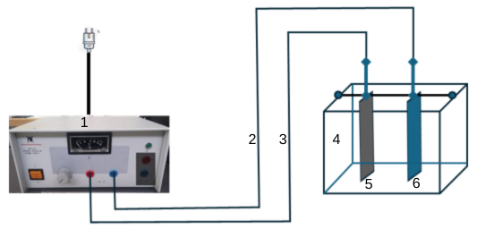
1: Generator
2: Connecting wire to the cathode
3: Connecting wire to the anode

4: Electrolytic cell
5: Anode
6: Cathode

Figure 1: Assembly of experimental device
    - Current Intensity and Voltage to Apply
Copper (Cu), atomic number 29 and molar mass 63.5 g·mol⁻¹, is an excellent conductor of heat and electricity (International Copper Study Group, 2020). The Pourbaix diagram of copper (see Figure 2) helps identify the stable species (Cu, Cu⁺, Cu²⁺) depending on the pH and electrochemical potential, which guides the optimal conditions for deposition during electrowinning. The Pourbaix diagram of copper shows that Cu²⁺ ions are stable at a pH range from -2 to 4 with a redox potential between 0.3 V and 1.3 V (relative to the standard hydrogen electrode).
Aluminum, with atomic number 13 and a molar mass of 27 g·mol⁻¹, is a highly reducing metal (INRS, 2021). According to its Pourbaix diagram (Figure 2), Al³⁺ ions are stable at a pH between approximately –2 and 2, and at a redox potential ranging from 0.2 V to 2.4 V (relative to the standard hydrogen electrode).
Current intensity I to be used:
I $= \frac{Q}{t}$ . According to Faraday’s law, I $= \frac{e{×N}_{A}×m_{o}(Metal)×Z_{Metal}}{t×M_{Metal}}$ = (0.23 A for copper and 2.91 A for aluminum for a duration of t = 1 hour), with I = current intensity, Q = quantity of electricity, t = deposition time, e = elementary charge (e = 1.6 × 10⁻¹⁹ C), $N_{A}$ = Avogadro's constant ($N_{A}$ = 6.02 × 10²³ mol⁻¹), $m_{o}(Metal)$ = mass of metal to be deposited, $M_{Metal}$ = molar mass of metal, and $Z_{Metal}$ = valence of metal ($Z_{Metal}$ = 2 for copper and 3 for aluminum).
Voltage to Apply to the Electrodes:
For copper, the expected reactions at the electrodes are:
Reduction at the cathode: ${Cu}^{2+}+2e^{-} → Cu$
Oxidation at the anode: $H_{2}O → \frac{1}{2}O_{2}+2H^{+}+2e^{-}$
Therefore, the minimum voltage to be applied across the electrodes for copper deposition should be at least: U = E⁰(O₂/H₂O) - E⁰(Cu²⁺/Cu) = 1.23 V - 0.34 V = 0.89 V.
For aluminum, the expected reactions at the electrodes are:
Reduction at the cathode: ${Al}^{3+}+3e^{-} → Al$
Oxidation at the anode: $H_{2}O → \frac{1}{2}O_{2}+2H^{+}+2e^{-}$
Therefore, the minimum voltage to be applied across the electrodes for aluminum deposition should be at least: U = E⁰(O₂/H₂O) - E⁰(${Al}^{3+}$/Al) = 1.23 V – (-1.66) V = 2.89 V.
The efficiency of copper electrodeposition is calculated using the formula: $r_{Metal}= \frac{∆m(Metal)}{m_{o}(Metal)}$ ,
where $r_{Metal}$ is the deposition efficiency of metal and Δm(Metal) is the mass of metal deposited on the cathode.
This section, which presented the experimental approaches used, led to the results obtained in this study.
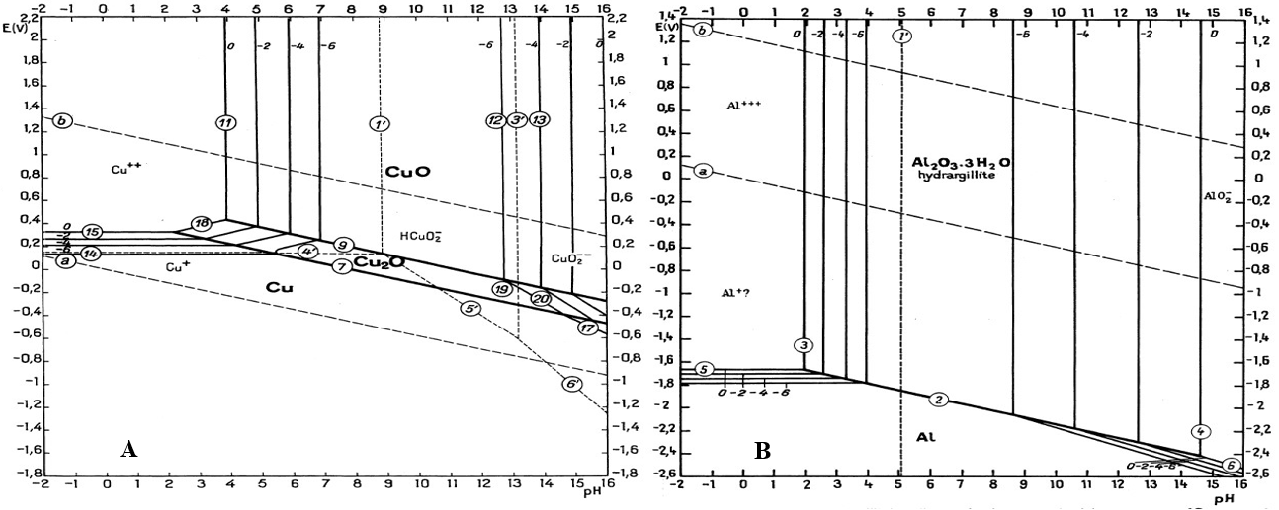
A: Pourbaix diagram for copper; B: Pourbaix diagram for aluminum
Figure 2: Pourbaix diagram of copper and aluminum (Pourbaix, 1974)
- RESULTS AND DISCUSSION
This section is dedicated to the presentation and discussion of the results obtained from the experiments.
  - Detection of metals in different part of a $B_{22}$ LED lamp
    - Detection by soda test
The LED support and the printed circuit board (PCB), after being treated with sodium hydroxide to remove resins, were then immersed, along with other components, in aqua regia. The characteristics of the resulting solutions, including color, pH, temperature, and the results of the sodium hydroxide test, are presented in Table 1.
Table 1: Soda test results of components’ solutions of $B_{22}$ LED bulb
Components | aqua regia | pH | Temperature | Soda test
LED | Blue | 1,59 | 26,6 | Blue precipitate
Bulb base,  Bar connecting the two sides of bulb base,  Connection wires, | Rust | 1,41  1,68  1,59 | 25,7  25,5  24,6 | Rust precipitate
CCI | Yellowish-green | 1,03 | 25,4 | Rust precipitate + blue
These results made it possible to conclude that the LED support contains copper, printed on one of the faces in contact with the diodes (Figure 3). The base, the bar connecting both sides of the base, and the connecting wires contain iron. The printed circuit board (PCB) contains both copper and iron. It also includes tin, used for soldering, which can be easily identified through simple observation. These findings fully support the integration of LED lamps into e-waste recycling strategies, particularly for the recovery of strategic metals valuable to the industry. These metals can be reintroduced into the production chain to manufacture new electronic or electrical equipment, thus reducing reliance on virgin raw materials.
Figure 3 shows some of the elements obtained after dismantling these lamps. Furthermore, visual observation of the LED support suggested the presence of other metals, such as aluminum or zinc (Figure 3). This hypothesis was confirmed by cyclic voltammetry analyses of the diode support, which revealed the presence of these metals.
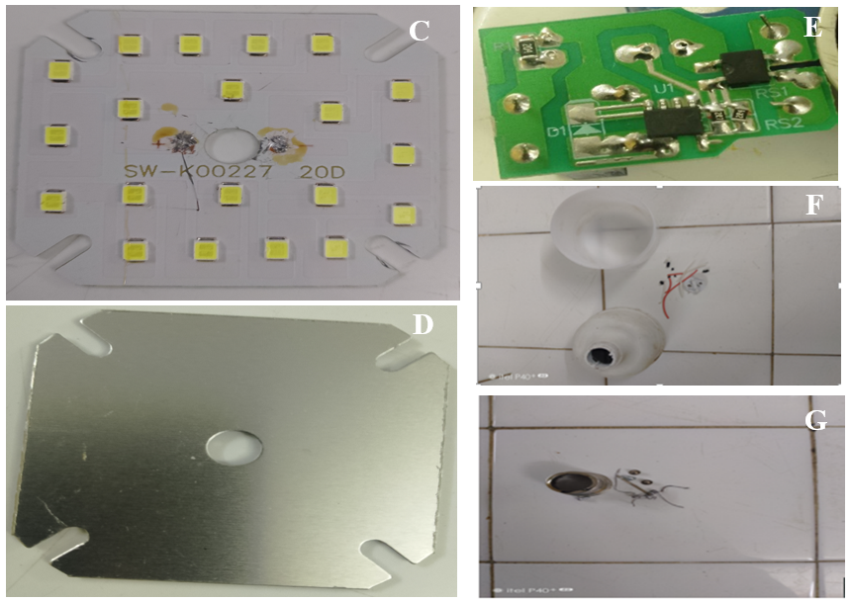
Figure 3: Main Components of a $B_{22}$ LED Bulb
C: LED support; D: Front of the LED support without diodes; E: Printed circuit board;
F: Plastics; G: Metals

    - Detection of copper and aluninum by cyclic voltammetry
Figure 4 shows the calibration curve of the potentiostat. The graph representing DAC as a function of voltage (DAC = f(Voltage)) is a straight line, indicating successful calibration of the digital-to-analog converter (DAC). The linear regression applied to the data yielded the equation: y = 822.06x + 2063.4, where x represents voltage and y the DAC signal.
The slope (822.06) and the y-intercept (2063.4) are very close to the expected theoretical values (830 and 2080, respectively), which also confirms the proper calibration of the analog-to-digital converter (ADC). These two parameters, the slope and the intercept, are used in lines 23 and 26 of the Python script to ensure accurate calibration. Thanks to this proper DAC and ADC configuration on the working computer, the measurements obtained during the analyses were reliable. It is important to note that any change of computer requires a new calibration of the DAC and ADC to ensure a stable 5 V supply for the potentiostat.
For the various electrochemical analyses, a glassy carbon working electrode was used, while the reference electrode was an Ag/AgCl electrode with a potential of 0.22 V relative to the standard hydrogen electrode. The counter electrode consisted of a pencil lead, an economical and efficient alternative for this type of setup.
Figure 4 also shows the voltammogram of aqua regia (a mixture of HNO₃ and 3HCl), used here as the electrolyte solvent. It is important to note that aqua regia is a chemically unstable medium, which rapidly decomposes according to the reaction: HNO₃ + 3HCl → NOCl + Cl₂ + 2H₂O (Guilhem, 2006).
The voltammogram obtained helps define the electrochemical stability window of the solvent, with a reduction wall observed at –1.85 V and an oxidation wall around 2 V. No significant current peaks were observed within this window, suggesting the absence of notable redox processes within these limits. This observation may be explained by a low concentration of labile protons (even though the medium is acidic, the protons available are not sufficiently free (labile) or accessible to undergo reduction at the electrode). This is typically due to the nature of aqua regia, which does not behave like pure acidified water; the chemical bonds are more complex and can inhibit the reduction of H⁺ to H₂, hence the absence of a peak even at –1.85 V.
A 0.1 M hydrogen chloride (HCl) solution was also used as a solvent, and its voltammogram is shown in Figure 4. As with aqua regia, no electrochemical peak was observed, although the electrochemical window, defined by a reduction wall at –1.8 V and an oxidation wall at 1.8 V, was clearly visible. The absence of a peak in this window can be explained by the fact that the 0.1 M HCl solution does not contain any electroactive species likely to undergo a detectable redox reaction within this potential range, aside from possibly the H⁺ protons. However, at this concentration, the protons are not significantly reduced on the glassy carbon electrode, or the current generated remains too low to produce a well-defined peak.
Moreover, the absence of metallic contaminants or reducible/oxidizable molecules makes the medium electrochemically inert within the studied window. This voltammogram therefore confirms the relative stability of the HCl solution as a reference solvent for voltammetric analyses, and serves to identify, by contrast, the electrochemical responses of metallic species when introduced.
Figure 4 also displays the voltammogram corresponding to the analysis of the mixture composed of aqua regia and the printed circuit board of the diode support. Two characteristic electrochemical peaks are clearly observed:
The cathodic peak C₁, located at –0.56 V, corresponds to the reduction of copper according to the reaction: Cu²⁺ + 2e⁻ → Cu.
The anodic peak A₁, located at 0.12 V, reflects the oxidation of metallic copper according to the reaction: Cu → Cu²⁺ + 2e⁻.
The distinct and well-defined appearance of both peaks (reduction and oxidation) suggests good ionic conductivity of the medium (thanks to the aqua regia), fast electrochemical kinetics, and a sufficient concentration of dissolved copper to be detected. These two well-defined peaks confirm the presence of copper in the analyzed printed circuit board, which is consistent with results from previous chemical tests (blue color, blue precipitate, etc.).
Figure 4 finally presents the voltammogram corresponding to the analysis of the mixture composed of 0.1 M HCl and the other face of the diode support not containing any diodes. This voltammogram reveals a reduction peak C₂ at –1.9 V, characteristic of the reduction of aluminum according to the reaction: Al³⁺ + 3e⁻ → Al.
This result confirms the presence of Al³⁺ ions in solution. In hydrochloric medium (0.1 M HCl), aluminum may be present as free Al³⁺ ions or as chloro-complexes such as AlCl₄⁻, which are electrochemically reduced at the electrode. The highly acidic pH (~1) makes this reduction possible, but requires a very negative potential, since aluminum is a strongly reducing metal.
However, no oxidation peak was observed during the reverse scan. This absence may be explained by several factors:
Electrode passivation: in 0.1 M HCl, although the medium is acidic, it may not be aggressive enough to prevent the formation of an oxide or hydroxide layer on aluminum, which inhibits reoxidation;
Limited reversibility of the Al/Al³⁺ redox couple: the metallic aluminum formed may not remain stable on the electrode surface or may become trapped in a passive layer, preventing clear oxidation.
Nature of the working electrode: while glassy carbon is inert, it may be less favorable for the oxidation of passivating metals such as aluminum;
It can thus be concluded that aluminum is present on the face of the diode support without diodes.
In general, the analyses revealed the presence of copper, aluminum, iron, and tin in $B_{22}$-type LED bulbs. Considering the progressive depletion of metal reserves, recovering them from waste bulbs is a necessity. Recycling these components therefore represents a sustainable and economically viable solution in the current context of resource scarcity.
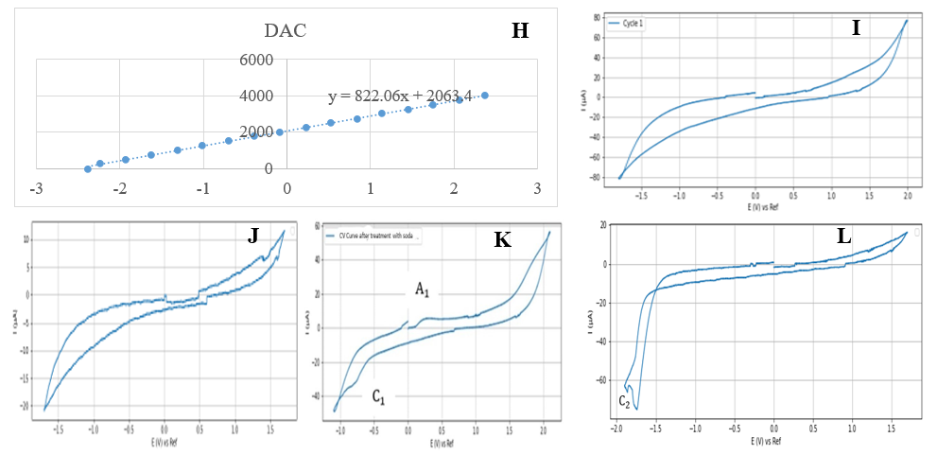
Figure 4: Calibration curves of the potentiostat and the cyclic voltammograms of the solutions
H: Calibration curve of DAC and ADC; I: Cyclic voltammogram of regal water; J: Cyclic voltammogram solution of HCL; K: Cyclic volatmmogram of regal water system + CCI diode support; L: Cyclic voltammogram system solution of HCL at 0.1 face of diodes support without diodes.

  - Analysis of B12 LED lamps composition
Figure 5 shows that plastics account for a very high proportion—about 70%—compared to other components. Their recycling could be considered for the manufacturing of other plastic objects. Metals, which make up approximately 22%, could also be recycled for the production of new equipment. The electronic components, estimated at 5%, consist of capacitors, ohmic conductors, and other elements. Some capacitors and resistors were tested using a multimeter and were found to be functional. Therefore, they could be reused in the manufacturing of electronic equipment. The remaining components are mainly composed of resins.
Figure 5 also shows the composition of metals identified through various tests and analyses. It reveals that aluminum is the most used metal, representing about 81% of the total, while tin is present in a very small amount, at around 0.54%.
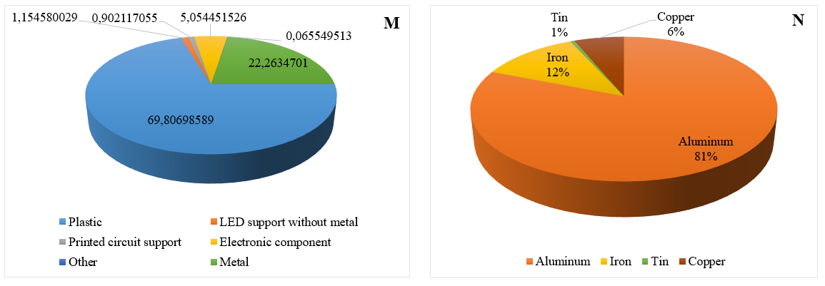
M: Average composition of a $B_{22}$ lamp marketed in Togo; N: Components of metal $B_{22}$ LED lamps
Figure 5: Component of a $B_{22}$ LED lamp sold in Togo
The identification of metals in the various components of $B_{22}$-type LED lamps has enabled the initiation of their recycling.
  - Effectiveness of electrochemical method used to recover copper and aluminium
There are several methods for metal recovery, which generally share common steps ranging from grinding to mineralization. The final step, which involves isolating the metal, can be carried out using various techniques such as precipitation, electrodeposition, and others. In this study, electrodeposition was chosen due to the availability of equipment in the laboratories where the work was conducted.
    - Analysis of the imposed physico-chemical parameters and process yield
The applied voltages, 1.89 V for copper and 2.89 V for aluminum, are all higher than or equal to the minimum voltages required to initiate the deposits, which shows that the potential conditions were adequate.
However, significant deviations are observed between the applied currents and the theoretically expected values:
For copper, the measured current (0.008 A for 2 hours and 30 minutes) is much lower than the expected value (0.23 A for 1 hour). This low current may be due to a low concentration of Cu²⁺ ions in the electrolyte, a reduced electrode surface area, significant polarization, or high ohmic resistance in the system.
In contrast, for aluminum, the measured current (8.7 A for 6 hours) is much higher than the expected value (2.91 A for 1 hour). Such a high current could result from excess conductivity in the solution. Since the aluminum was dissolved in hydrochloric acid, the very high conductivity may have facilitated the flow of a large current.
The pH of the solutions containing the species to be reduced ranges from 0.29 to 0.30 for Cu²⁺ ions and from 1.26 to 1.27 for Al³⁺ ions. The observed temperatures range between 26.1 and 27.8 °C for Cu²⁺ solutions and between 25.8 and 26.8 °C for Al³⁺ solutions. An applied voltage of 1.89 V for copper and 2.89 V for aluminum was maintained throughout the recovery operation. Under these conditions, the species present in the electrolyzer remain respectively in the form of Cu²⁺ and Al³⁺ ions.
Thus, Figure 6 shows the metal recovery setup and the reduced forms of the metals on the cathode: copper, identifiable by its reddish color, and aluminum, recognizable by its silvery appearance.
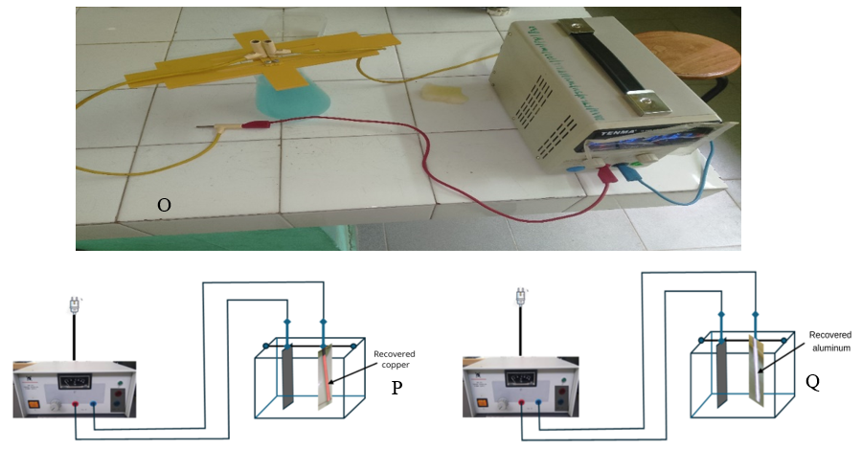
Figure 6: Recovery setup and metals recovered at the cathode
O: Copper recovery assembly; P: Recovered copper metal from cathode; Q: Recovered aluminum metal from cathode

The mass values and their variations at the electrodes were determined and recorded in Table 2. The change in the mass of the cathode between the beginning and the end of each recovery operation corresponds to the mass of the recovered metal.
Table 2: Electrode mass variation
 | Mass before deposition (g) |  | Masse after deposition (g) |  | Mass variation  $∆m$ (g) |  | Yield  (%)
Electrodes | Anode | Cathode | Anode | Cathode | Anode | Cathode | Cathode
Cu | 0,980 | 0,968 | 0,980 | 0,992 | 0 | 0,024 | 8,8
Al | 0,980 | 0,968 | 0,980 | 0,975 | 0 | 0,007 | 15,9
The metal recovery yields obtained in this study are generally low, suggesting that the operating conditions are not yet optimized. The presence of competing chemical species in the electrolyte may interfere with or limit the effective deposition of copper and aluminum onto the cathode.
However, the copper recovery yield (approximately 9%) (Table 3) is significantly higher than that obtained by Ratsimba et al., which was only 0.624% (Ratsimba et al., 2022). This represents a notable improvement, although still insufficient compared to the expected theoretical yield. This performance suggests that some process conditions (pH, voltage, duration, and nature of the electrolyte) have been partially optimized but could still be improved.
Aluminum shows a higher recovery yield (around 16%) (Table 2), which may seem surprising given its chemical reactivity and the stricter conditions normally required for its electrodeposition. This better performance appears to be linked to a longer recovery time compared to copper, highlighting the importance of electrolysis duration in the final yield. However, effective recovery of aluminum remains difficult in conventional aqueous media due to its highly negative standard potential, which suggests that other mechanisms or interfering phenomena may have influenced the result.
These findings demonstrate that partial recovery of copper and aluminum from electrolytic solutions derived from WEEE treatment is feasible. However, to achieve significant and economically viable yields at an industrial or semi-industrial scale, precise optimization of electrochemical parameters is essential. Further research is also needed to reduce the effects of competing chemical species and to better understand the deposition mechanisms involved.
    - Analysis of the process cost
The cost of the process depends on the consumables. In this study, the chemicals used and their respective quantities are: 500 mL of HNO₃ at 68%, 500 mL of HCl at 38%, 100 g of NaOH, and 5 liters of distilled water. These products are consumed throughout the different stages of the process, from mineralization to the recovery of copper and aluminum.
With a recovery duration of 9000 seconds for copper and 21600 seconds for aluminum, the energy consumed for copper recovery (0.038 Wh) is lower than that required for aluminum (151 Wh). This difference can be explained by several factors, notably the difference in electrochemical potential between the two metals, the nature of their complexes in solution, as well as the operating conditions (voltage, duration, pH, etc.). Indeed, copper electrodeposition generally occurs at lower voltages and with faster kinetics compared to aluminum, which often requires more stringent conditions for its reduction.
The energy cost and the cost of the chemical products can be evaluated based on the unit costs of each consumable.
    - Environmental impacts analysis
During the copper and aluminum recovery process, the chemicals were handled with care. Mineralization was carried out under a fume hood, and wastewater was disposed of through the laboratory’s drainage system.
Regarding environmental impact, although the chemicals used can be harmful, their low quantities limit negative effects. Moreover, electricity consumption remains moderate and depends on the national grid, primarily supplied by Togo’s electrical network. Compared to primary metal extraction, which is typically energy-intensive and polluting, this recovery process has a significantly lower environmental impact. Thus, recycling through this method contributes positively to the sustainable management of metallic resources.
These results confirm that, despite some limitations, notably the low recovery yield, the process offers a good balance between efficiency, energy cost, and environmental impact, justifying its potential for sustainable valorization of metal waste.
- CONCLUSION
This study dedicated to the recycling of waste from bulbs enabled the characterization of the metals present in $B_{22}$-type LED bulbs. It was found that these metals represent approximately 23% of the total mass of these devices, fully justifying the need for their recovery. The study also made it possible to recover copper and aluminum, with respective yields of 9% and 16%. Although these results can be improved, they demonstrate the potential for recovering valuable materials from this waste. To optimize the management of used bulbs, as well as all WEEE, it is essential to establish a structured national plan for the management and recovery of these wastes.
REFERENCES
Aloueimine, S. O. (2006, April 13). Methodology for Characterizing Household Waste in Nouakchott (Mauritania): Contribution to Waste Management and Management Support Tools. Limoges.
Anastas, P. T. & Warner, J. C. (2000). Green Chemistry: Theory and Practice. Oxford University Press.
Arduin, R. H. (2019). From Waste Management to Secondary Material Supply: Development of Indicators for WEEE Management—Focus on the French Sector (PhD Thesis). École Nationale Supérieure d’Arts et Métiers (ENSAM).
Baldé, C. P., Forti, V., Gray, V., Kuehr, R. & Stegmann, P. (2017). The Global E-Waste Monitor 2017: Quantities, Flows and Resources. United Nations University, International Telecommunication Union.
Billy, E. (2012). Application of Ionic Liquids for the Recovery of Precious Metals via Green Chemistry Routes (PhD Thesis). University of Grenoble.
Bonnah, M. (2018). Physicochemical Characterization of Household Solid Waste in Kara: Evaluation of Per Capita Ratio and Optimization of Technical Management System. Lomé, Togo.
Boulmerka, I. & Kati, N. E. (2020). Feasibility Study for Creating a Waste Treatment Enterprise: Used Lamps (PhD Thesis).
Charpentier, N. (2024). Electronic Waste Recycling: Sorting and Reuse (PhD Thesis). Université Paris-Saclay.
Cortes, M. A. & Patiño, M. L. D. (2016). Recycling of Electronic Waste Using Basic and Acid Leaching. Open Journal of Applied Sciences, 6(03), 169–176. Scientific Research Publishing.
Cramer, J. (2018, November 21). Study of a Thermal Plasma Process for Extraction, Recovery, and Valorization of Strategic Elements Contained in Waste Electrical and Electronic Equipment-Type Materials (Thesis). http://www.theses.fr. Paris Sciences et Lettres (ComUE).
Dedryver, L. & Couric, V. (2020). Metal Consumption in the Digital Sector: A Far from Dematerialized Industry. France Stratégie. Retrieved from https://www.strategie.gouv.fr/files/files/Publications/2020/DT%20num%C3%A9rique%20m%C3%A9taux/fs-2020-dt-consommation-metaux-du-numerique-juin.pdf
Dias, J., Silva, A. G. P., Holanda, J. N. F. de, Delatorre, F. M., Conceição, A. O. da, Miranda
Júnior, G. M. de, Futuro, A., et al. (2023). Environmental and Technological Assessment of Operations for Extraction and Concentration of Metals in Electronic Waste. Sustainability, 15(17), 13175. MDPI.
Dieng, D., Diop, C., Sonko, E. hadji M., Gning, J. B., Djitte, M. & Gassama, C. I. D. (2018). Management of Electrical and Electronic Equipment Waste in Senegal: Stakeholders and Organizational Strategy of the Sector. Int. J. Bio. Chem. Sci, 11(5), 2393. doi:10.4314/ijbcs.v11i5.35
Duan, C. L., Diao, Z. J., Zhao, Y. M. & Huang, W. (2015). Liberation of Valuable Materials in Waste Printed Circuit Boards by High-Voltage Electrical Pulses. Minerals Engineering, 70, 170–177. Elsevier.
Duan, H., Hou, K., Li, J. & Zhu, X. (2011). Examining the Technology Acceptance for Dismantling of Waste Printed Circuit Boards in Light of Recycling and Environmental Concerns. Journal of Environmental Management, 92(3), 392–399. Elsevier.
El Bouchtioui, L. (2017). Is Recycling the Only Solution for Sustainable Management of Electrical and Electronic Equipment Waste? Study of the Impact of Regulatory Context and Public Policies on the Sectors Developed in France. Environment, Engineering & Development. Episciences.org.
Forti, V., Baldé, C. P., Kuehr, R. & Bel, G. (2020). Global Monitoring of Electrical and Electronic Equipment Waste for 2020: Quantities, Flows and Opportunities Offered by the Circular Economy. United Nations University / United Nations Institute for Training and Research – SCYCLE Program Co-administered by the International Telecommunication Union and the International Solid Waste Association, Bonn/Geneva/Rotterdam. 123 p.
Gnane, N. M. (2017). Electronic Waste Management and Environmental Challenges in Togo. ResearchGate, 2(009 December 2017), 24.
Guilhem, B. (2006). Development and Characterization of a Hydrophobic Solid for the Study of Hydrodynamic Slip Conditions at the Solid-Liquid Interface. Final Year Physics Thesis, Université Claude Bernard Lyon 1.
Harrou, A., Gharibi, E. K., Taha, Y., Fagel, N. & El Ouahabi, M. (2020). Phosphogypsum and Black Steel Slag as Additives for Ecological Bentonite-Based Materials: Microstructure and Characterization. Minerals, 10(12), 1067. doi:10.3390/min10121067
Hu, J., Xiao, Z., Zhou, R., Deng, W., Wang, M. & Ma, S. (2011). Ecological Utilization of Leather Tannery Waste with Circular Economy Model. Journal of Cleaner Production, 19(2–3), 221–228. doi:10.1016/j.jclepro.2010.09.018
INRS. (2021). Aluminium and its Mineral Compounds.
International Copper Study Group. (2020). The World Copper Factbook 2020.
Khouloud, K. & Zouari, A. (2018). Management of Electrical and Electronic Equipment Waste in a Circular Economy Framework: Comparative Analysis Between Europe, China, and Tunisia. ResearchGate.
Laliberté, F. (2020). Smartphones and the Circular Economy in Quebec. Retrieved from https://savoirs.usherbrooke.ca/bitstream/handle/11143/16803 …
Martino, R., Iseli, C., Gaydardzhiev, S., Streicher-Porte, M. & Weh, A. (2017). Characteristics of End-of-Life Printed Wiring Boards Processed by Electrodynamic Fragmentation. Chemie Ingenieur Technik, 89(1–2), 152–160. doi:10.1002/cite.201600091
Meng, L., Zhong, Y., Guo, L., Wang, Z., Chen, K. & Guo, Z. (2018). High-Temperature Centrifugal Separation of Cu from Waste Printed Circuit Boards. Journal of Cleaner Production, 199, 831–839. Elsevier.
European Parliament. (2023, May 24). Circular Economy: Definition, Importance, and Benefits. Themes | European Parliament.
Peeters, J. R., Bracqguene, E., Nelen, D., Ueberschaar, M., Van Acker, K. & Duflou, J. R. (2018). Forecasting the Recycling Potential Based on Waste Analysis: A Case Study for Recycling Nd-Fe-B Magnets from Hard Disk Drives. Journal of Cleaner Production, 175, 96–108. Elsevier.
Pourbaix, M. (1974). Atlas of Electrochemical Equilibria in Aqueous Solutions. National Association of Corrosion Engineers.
Ratsimba, M. H., Rakotondranaly, H. S. & Rakotosaona, R. (2022). Valorization of Electrical and Electronic Equipment Waste from Madagascar: Recovery of Copper from Printed Circuit Board Waste by Hydrometallurgical Process. IJPSAT, 34(1), 496. doi:10.52155/ijpsat.v34.1.4562
Récylum. (2011, October). Glass, Metals...: Insights on Lamp Recycling. Recycling Recovery.
Ropafadzo, J., Tinevimbo, H., Tavonga, G., Kudakwashe, K., Jonathan, M., Effort, B. M. & Tinotenda, K. (2014). Recovery of Precious Metals from E-Waste, 59.
Van Eygen, E., De Meester, S., Tran, H. P. & Dewulf, J. (2016). Resource Savings by Urban Mining: The Case of Desktop and Laptop Computers in Belgium. Resources, Conservation and Recycling, 107, 53–64. Elsevier.
Vidal, O. (2018). Raw Materials and Energy: Challenges of Tomorrow. ISTE Group. Retrieved from https://books.google.com/books?hl=fr&lr=&id=1QpjDwAAQBAJ&oi=fnd&pg=PP1&dq=Raw+materials+and+energy&ots=hzcCjoyL90&sig=awt27Zg4ahmDsJusF5nlDiz5uM0
Wang, J. & Xu, Z. (2015). Disposing and Recycling Waste Printed Circuit Boards: Disconnecting, Resource Recovery, and Pollution Control. Environmental Science & Technology, 49(2), 721–733. doi:10.1021/es504833y
Xing, M., Li, Y., Zhao, L., Song, X., Fu, Z., Du, Y. & Huang, X. (2020). Swelling-Enhanced Catalytic Degradation of Brominated Epoxy Resin in Waste Printed Circuit Boards by Subcritical Acetic Acid under Mild Conditions. Waste Management, 102, 464–473. Elsevier.
Yi, S., Zhang, B. & Yuan, Y. (2019). A Kind of Recovery Method of Waste Printed Circuit Board Metals Resources. Chinese Patent CN10 6834.
Zeller, V., Towa, E., Degrez, M. & Achten, W. M. J. (2019). Urban Waste Flows and Their Potential for a Circular Economy Model at City-Region Level. Waste Management, 83, 83–94. doi:10.1016/j.wasman.2018.10.034
Zhu, P., Chen, Y., Wang, L. Y. & Zhou, M. (2012). Treatment of Waste Printed Circuit Board by Green Solvent Using Ionic Liquid. Waste Management, 32(10), 1914–1918. Elsevier.

