THE STRESS RESPONSE OF HUMAN HAND MUSCLES TO DIFFERENT TYPES OF SELECTED MANUAL TAILORS’ SCISSORS: AN ELECTROMYOGRAPHIC STUDY

ABSTRACT
The habitual usage of Manual Fabric Scissors (MFS) causes traumatic hand injuries in a large population of less represented workers in informal work-system. However, there is dearth of information on the biomechanical stresses of the fingers attributable to usage of Straight-cut MFS. Therefore, simulated field observations were explored for better understanding of hand muscular response of habitual MFS users. Surface Electromyography was used for collecting data on four hand muscles from twenty-four participants. Data was also collected for different scissors designs. The participants (age 25.58 ±3.62years; height 167.88 ±9.13cm; weight 74.25 ±17.14 kg) performed randomized twenty-four cutting tasks of four scissors designs (S₁-S₄), three table heights (H₁-H₃) and two different fabrics (F1-F2). There was significant difference in muscular response to scissors design’s workload. Small, closed-handle scissors designs placed higher demand on users leading to higher risk of contusions, while wide-handle scissors generated lower muscular activities with better user performance.
Practitioner summary: This study gives the simulated feedback from habitual users whose health protection need should guide scissors design. Its input to intellectual knowledge and benefits to human society at large is useful for both the manufacturers and the end users of manual fabric scissors.

Keywords: Fabric scissors, Informal work-system, Hand injuries, Hand muscular response, Ergonomic considerations

- Introduction
Increased comfort and reduced biomechanical stress solicitation with regard to users’ functional capacities have been introduced into tool design. This was as a result of the rise in work-related Musculoskeletal Disorders (WRMSD) of the upper limbs which are particularly widespread in hand tools users (Aptel et al., 2002). The WRMSD also known as Cumulative Trauma Disorders (CTD), accounted for 24% of all reported hand-tool injuries, and the use of non-powered hand tools contributes to injuries of the hand, finger, wrist and shoulder (Myers and Trent ,1988;Kong et al., 2008). According to Soussahn et al. (2024), the increase in workload demand and work hours in radiology practice has been attributed to musculoskeletal injuries during the use of tools. In order to minimize this work-related injuries, the authors advocated for strict adherence to ergonomic considerations in the design, fabrication and usage of working tools. This has been well corroborated in many other reported works ( Paul and Yadav, 2021; Darabont and Darabont, 2021; Mali et al., 2022; Akpan et al., 2023;Kim et al., 2023; Erliana et al., 2024; Sakinala et al., 2024; Torralba et al., 2024).Therefore, hand tools should be ergonomically designed to reduce user discomfort, biomechanical stresses, and demands on upper limbs as risk factors for CTD (Freivalds, 1996; Aptel et al., 2002; Li and Tang, 2007; Lee and Jung, 2015; Shimomura et al., 2015; Alastair et al., 2020; Draskovic et al., 2020; Soewardi and Kalsum, 2020). Some work-related factors for hand-tool design are age, gender, strength, body size, work technique, experience and posture (Dhara et al., 2015).

1.1 Hand tools
Hand tools are devices operated for carrying out tasks to augment the strength and effectiveness of the hand. Although hand tools could be manually, electrically or pneumatically powered, this study focuses on the manually powered ones. Some examples of hand tools in common use that have been subjected to scientific evaluation include pliers (Groenesteijn et al., 2004, Haque and Khan 2010), screwdrivers (Mital et al. 1986, Dempsey et al. 2004), scissors (Mitchell et al. 2012, Teodoroski et al. 2012; Adeleye and Akanbi 2015, Adeleye et. al., 2020), masons’ trowel (Dianat et al. 2015), farmers’ hand hoes (Vanderwal et al. 2011) and garden tools (Chang et al. 1999) among others. While some of these hand tool scientific studies addressed relevant issues like the grip strength and forces, user satisfaction, ergonomic effectiveness and productivity, others researched into the interrelationship between user preference, task performance and hand-tool design for effectiveness (Ortengren et al. 1991). Studies showed that the interaction of the hand, the tool and the task (hand-tool interface components) immediately affects productivity and influences the safety of the user (Kreifeldt and Hill 1975, Shih and Wang 1996). The MFS is a hand tool that has been found to generate finger contusions in frequent users (Adeleye and Akanbi, 2015).This suggests a problem in the hand-tool interface which could be ergonomically addressed. Moreover, Boyles et al., (2003) reported that the repetitive use of scissors places its operator at injury risk. Many other reported works on scissors have also provided useful insights for its enhanced ergonomic application (Ario et al., 2020; Ario et al., 2022; Dang and Nguyen,2023; Polteva 2023, Ogbemhe et al., 2024). Also, Shimomura et.al (2015) reported pain caused to the gripping fingers during the usage of surgical scissors. This pain results in inability to effectively apply grasping force to cutting tasks. The aim of this study is therefore to investigate the biomechanical stresses of the fingers attributable to the use of MS during fabric cutting and identify the manual fabric scissors design that gives the least finger stress.

1.2 Workload factors
Workload has been defined as the cost incurred by an individual while achieving a particular level of performance on a task with specific demands (Hart and Staveland, 1988; DiDomenico and Nussbaum, 2008). It may consist of several tasks to be completed within a specified period with most of the tasks involving repetitive motions, pressure points, work surface and forceful physical exertions, which may result in injury. The amount of muscular effort expended to perform tasks is its force. The amount of force exerted when handling tools depends on factors like load shape, weight, dimensions, grip type, duration of the task, frequency of task and the resistance associated with moving the load (Sjogaard and Jesen, 1999). In repetitive work, the same types of motions are performed over and over again using the same muscles, tendons, or joints. The risk of injury is greater when repetitive jobs are combined with low force exertions. Pressure points or local contact stress results from a body part pressing against hard surfaces. Fingers, palms, wrists, forearms and elbows are more susceptible since nerves, tendons, and blood vessels are here close to the skin and underlying bones. Moreover, these body parts only have a thin layer of subcutaneous tissue (Shimomura et al., 2015). The physical workload and the strain responses of a worker depends on individual characteristics, the intensity of muscle contractions and the size of the working muscle (Aminoff et al., 1996 and Louhevaara, et al., 1998).
1.3 The muscles of the arm and hand
The muscles of the body are the generators of the internal force that converts energy chemically stored in the body to mechanical work (Rasch, 1989). The muscles of the arm and hand are specifically designed to meet the body’s diverse needs of strength, speed, and precision while completing many complex tasks. (www.innerbody.com/image_musc05/musc50.html). For this study, the four basic hand-arm muscles chosen are the Flexor Pollicis Brevis (FPB), which flexes the thumb to grip objects, the Extensor Pollicis Brevis (EPB), which pulls the thumb away from the palm, the Flexor Digitorium Superficialis (FDS), which curls the fingers, and the Extensor Digitorium Muscle (EDM), which straightens the fingers. The performance of muscles under varying loads and velocities is determined by the four properties of the skeletal muscles, which are irritability, contractility, extensibility and elasticity. Irritability is the ability to respond to stimulation, contractility is the ability of the muscle to shorten when it receives sufficient stimulation, extensibility is the muscle’s ability to lengthen or stretch beyond the resting length while elasticity is the ability of the muscle fibre to return to its resting length once the stretch is removed (Hamil and Knutzen, 2003).
1.4 Electromyography
Electromyography (EMG) as the study of muscle function through analysis of the electrical signals emitted during muscular contractions could be used for movement analysis and strength examination. Clinically, EMG is used to study muscle force, muscle fatigue and gait analysis. In Ergonomics, however, EMG applications have been shown in studies investigating the effects of sitting postures, hand and arm movements, as well as the effects of armrests on the activity of the neck and shoulder muscles (Hamill and Knutzen, 2003; Reaz et al., 2006; Ngo and Wells, 2016). Surface electromyography (sEMG) is used for task analysis in Ergonomic and biomechanical research for insights into injury risk factors (Ngo and Wells, 2016).
Measurements by sEMG is an attractive method to measure muscle activity because they are non-invasive, cause no pain and are easy to apply to obtain signals of muscle action potentials (Nakajima et al., 2009). Surface electrodes are placed on the skin to study superficial muscles, while the EMG signals are collected using an analog-to-digital (A/D) converter in conjunction with a computer. Some of the several procedures used to quantify the EMG signals include rectification, linear enveloping, and integration. (Hamill and Knutzen, 2003). In this study, sEMG was therefore used as the objective method of collecting muscle data generated during the usage of different straight-cut MS designs.
1.5 Scissors
There are different types of MFS. Some known specialized scissors are used in agriculture and animal husbandry, grooming, medical-surgical practice, and clothes-making. The ones considered in this study are the conventional straight-cut MFS (Figure 1). For the purposes of Ergonomics improvements in the designs of the MS, the aim of this study is therefore to investigate the biomechanical stresses of the fingers attributable to MS usage during fabric cutting. To do this, a laboratory experimental analysis was designed to explore how different MS designs can affect the finger muscular responses of the users, while cutting fabrics of different thicknesses. The sEMG was employed in obtaining the muscular response data from participants as described in literature by Takala and Toivonen (2013).

- Methodology
2.1 Participants
Twenty-four volunteers from Virginia Tech University, USA, participated in the study. The exclusion criteria were left-handedness, impaired vision and reported musculoskeletal problems in the last one year preceding this study. The study protocols were approved by the Virginia Tech IRB, USA and all participants completed informed consent forms prior to experimental work. Only one participant was taken at a time and not more than 2 per day. Each was separately instructed and attended to.
2.2 Experimental design
Full factorial, counterbalancing, complete Latin square order and randomization were all employed in the experimental design. To avoid the pitfall of standard repeated measures designs, counterbalancing was used since all participants were exposed to the same experimental conditions. This was done to balance the strength of counterbalancing with financial and practical reality. Since numerous conditions were involved in the experiment, and there were questions of finance and practical reality, the number of participants was limited to 24. This helped to circumvent some of the complexities and keep the experiment within a reasonable size. A complete balanced Latin matrix square was used to randomly assign task-order to the 24 subjects in order to evenly distribute the tasks without any bias. The independent variables (height, scissors and fabric) were randomized with the random decimal fraction-generator from random.org. and using the Latin matrix above, the 3 independent variables were randomized to get the 24 tasks for each of the 24 participants without bias.
2.3 Tasks Description
The 24 tasks (Table 1) were developed from a combination of 4 scissors designs S1-S4, 3 different table heights (H1-H3) and 2 fabric types (F1, F2). Fig 1 shows the four scissors designs whose dimensions were taken and presented in table 2. Taking one scissors at a time, Scissors S1 was first combined with height H1 and fabric F1. Retaining S1 and H1, fabric F1 was changed to F2. Having exhausted the choices of fabric, S1 was retained and H1 was changed to H2 using F1. Next, retaining S1 and H2, F1 was changed to F2. Still retaining S1, H2 was changed to H3 combined with F1. Next, S1 and H3 were retained but F1 was changed to F2. These gave the first 6 combinations of tasks. The same order was followed for scissors S2, S3 and S4 to get the 6 combinations of grouped tasks- (GTasks) for each scissors giving a total of 24 different tasks (Table 1). Each task was made up of 3 digits: digit 1 is the scissors number (1-4), middle digit is the height number (1-3), while the last digit is the fabric type (1-2).

Table 1. Different group tasks showing the scissors, height and fabric digits

Scissors | GTask 1 | GTask 2 | GTask 3 | GTask 4 | GTask 5 | GTask 6
1 | 111 | 112 | 121 | 122 | 131 | 132
2 | 211 | 212 | 221 | 222 | 231 | 232
3 | 311 | 312 | 321 | 322 | 331 | 332
4 | 411 | 412 | 421 | 422 | 431 | 432

A  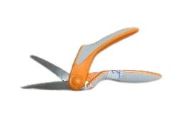 | B  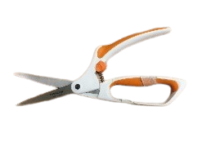 | C  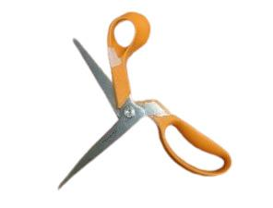 | D  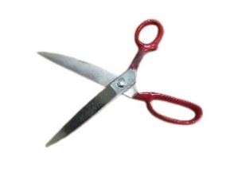
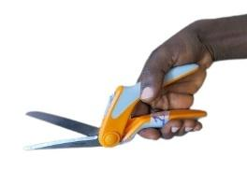 | 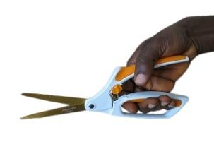 | 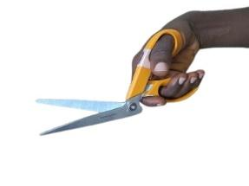 | 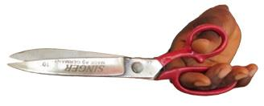
Fig. 1: The selected scissors designs and their professional grips (A) S1; (B) S2; (C) S3; (D) S4

Table 2 Working Dimensions of the scissors’ design-types used in this experiment
Scissors Dimension | S1 | S2 | S3 | S4
Total length from handle end to cutting tip X₁ (cm) | 24.0 | 26.6 | 23.7 | 25.4
Weight of scissors X₂ (g) | 100 | 100 | 150 | 250
Length from fulcrum to tip of scissors X₃(cm) | 9.3 | 9.8 | 11.3 | 13.1
Length from handle end to fulcrum X₁-X₃(cm) | 14.7 | 16.8 | 12.4 | 12.3
Handle space occupied by hand breadth X₄ (cm) | 9.8 | 9.5 | 8.1 | 6.4
Length of handle space occupied by thumb X₅ (cm) | 10.0 | 10.8 | 3.4 | 3.3
Breadth of blade 1cm from the fulcrum X₆ (cm) | 4.4 | 6.3 | 8.5 | 1.2
Widest Breadth of closed handles of scissors X₇ (cm) | 1.6 | 1.3 | 1.4 | 2.1
Diameter of fulcrum X₈(cm) | 2.2 | 0.7 | 1.2 | 8.7
$Mechanical Advantage MA=\frac{x_{1}-x_{3}}{x_{3}}$ | 1.58 | 1.71 | 1.10 | 0.94
Legend:
S1 = Scissors Design 1 – “Fiskars Razoredge” easy action scissors
S2 = Scissors Design 2 – “Fiskars easy action (wider finger clearance)” scissors
S3 = Scissors Design 3 – “ Fiskars Razoredge (angular)” scissors
S4 = Scissors Design 4 – “Singer 10 inch" scissors
Load (output) distance is X₃
Effort (input) distance is X₁-X₃
2.4 The cutting-fabric pattern
A uniform pattern was drawn on each of the 24 fabric pieces using a laser-cut stencil and special-cloth pen that did not blot but gave thin fine lines. The template pattern was a combination of letters C and S with an adjunct straight line. This shape was chosen to be able to replicate some intricate shapes, lines and contours frequently cut by CTs to produce body fitted garments.
Apart from the pieces used for the initial trial, provision was made for some extra pieces in case of discard caused by system error.

2.5 The data collection
This involved two different sessions (i) training and (ii) procedure
2.5.1 First session of experiment: training and EMG placement
This session lasted about 1 hour where a detailed explanation of the experimental procedure was given to each participant followed by a familiarization guide with the materials and equipment to be used. Afterwards came the participant’s paperwork and biodata collection. Here, the participant read through the consent form and signed if comfortable with the content; otherwise, the participant opted out of the experiment. Next was the location of the thumb and finger controlling muscles, followed by the skin preparation and placement of the EMG electrodes whose materials are shown in fig 3a. Prior to the placement of the electrodes, the skin was shaved, softly abraded, and cleaned using 70% alcohol pads and shaver (fig 2). Following the standard procedure (Rash 2016, Hamill and Knutzen 2003), pairs of bipolar Ag/AgCl electrodes (AccuSensor, Lynn Medical, MI, USA) with a 2.5-cm inter-electrode distance were placed on the skin surface of the participant (Fig 3b). Kitted with the aforementioned, the participant moved to the workstation for a fabric cutting trial.

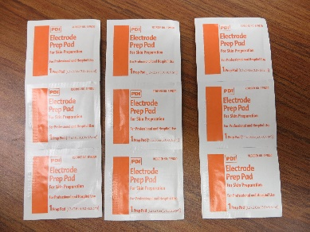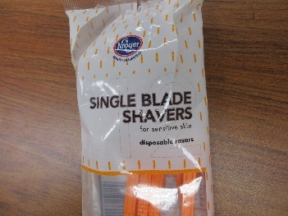
Fig. 2. Hair-shaving materials for skin preparation
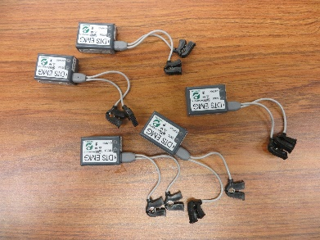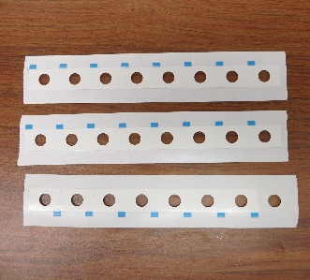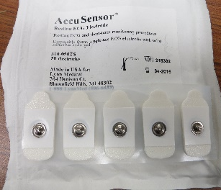
Fig 3a EMG Electrodes and accessories

Out of over 30 individual arm muscles that work together to achieve diverse movements in each upper limb, four basic muscles were selected because they control the abduction and extension motion of the thumb and the fingers (Delavier et.al., 2010) and were accessible to surface EMG. The Pollicis Brevis muscles control the thumb while the Digitorum muscles control the other four fingers. At the start of the testing session, surface electromyography (EMG) electrodes were placed over the four chosen muscles which were Extensor Pollicis Brevis (EPB), Flexor Pollicis Brevis (FPB), Extensor Digitorum Muscles (EDM), Flexor Digitorum Superficialis (FDS). Making no motion other than breathing, the participant’s hand muscles at rest were recorded thrice (each lasted 10 seconds) as R₁-R₃ and the average recorded as R_{av}. To record the maximum efforts in the tested muscles, each participant took the strength test by pulling on a hand dynamometer 78010-strength tester (fig 4a) for 10 seconds at three different times. Each grip force value was recorded and the average grip force as AGF in kg on the participant’s data sheet. For 10 seconds per grip, thrice recording of the maximum voluntary contraction (MVC) of the muscles were done using a MicroFET hand grip dynamometer and the wooden dowel (fig 4a). Their averages was coded MVC₁ and MVC₂ respectively. While the dynamometers were gripped with one hand, the dowel was squeezed with both hands in opposite motion (fig 4b).
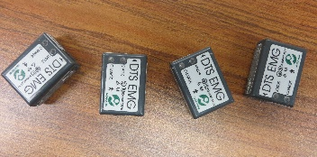 ii 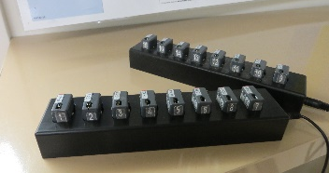 iii 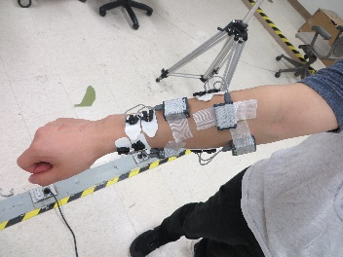
Fig 3b EMG electrodes (i) without cables (ii) on chargers (iii) on a participant’s right arm
i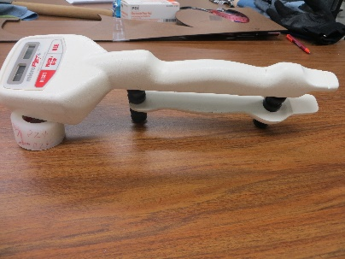 ii 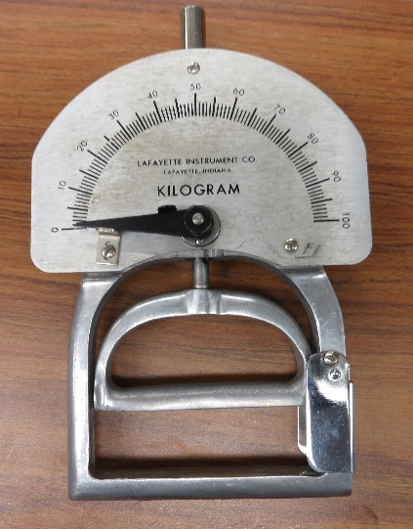 iii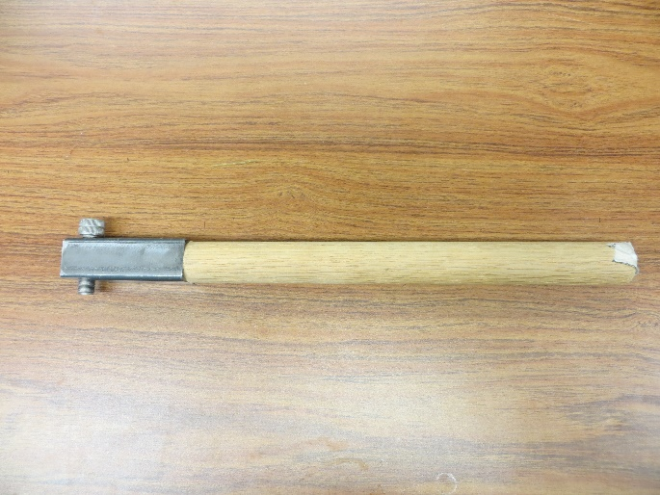
Fig 4a MVC tools (i) MicroFET dynamometer (ii) 78010-strength tester dynamometer and (iii) wooden dowel
i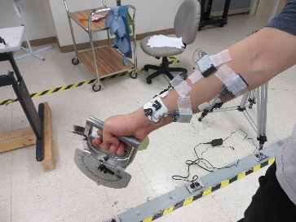 ii 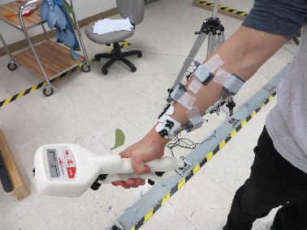 iii 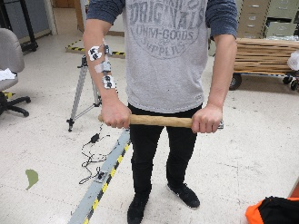
Fig 4b EMG kitted participant demonstrating the usage of the MVC tools

2.5.2 Second session of the experiment: Real Fabric Cutting procedure
This session lasted approximately two hours per participant, starting with the real data collection of the R₁-R₃ and the MVCs as described in 2.5.1. using a computer system equipped with the Myomuscle software for the EMG system. Each participant carried out 24 tasks involving cutting same pattern on 2 different kinds of fabric (12 each) using 4 different designs of MTS on 3 different table heights. This experimental design gave 2x4x3 task orders. The fabrics at different experimental work stages are shown in Fig 4c.
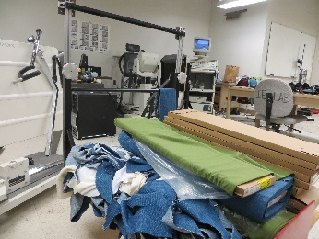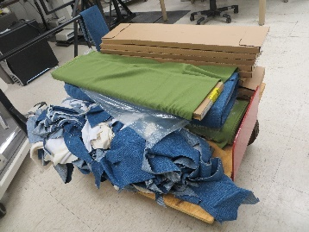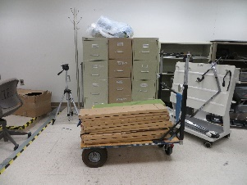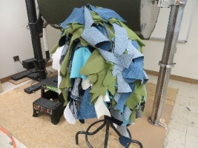
Fig 4c. Fabrics at the different stages of the experimental work

Each cutting task involved cutting of the traced template pattern and was immediately followed by filling of a questionnaire for each task by the participant. Every cutting session involved 4 different cutting tasks and there were 6 sessions, each separated by a 5-minute break. The participants stood all through the cutting tasks but sat during each 5-minute break. Considering the circumstances of using MTS, the volunteers adhered to the given instructions such as: pattern cutting on fabrics were unidirectional from the ‘S’ end of the diagram to the ‘C’ (there was no option of pattern cutting in the reverse direction). Also, fabrics could be turned on the table but not lifted from the worktop. Cutting was done only with the right hand and the volunteers worked, oblivious of the EMG systems on their right hand. Using a telemetered system (TeleMyo 900, Noraxon, AZ, USA), raw EMG signals were recorded at 1500 Hz (Fig 4d) on the computer with Myomuscle software.
i 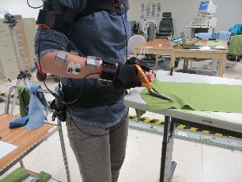 ii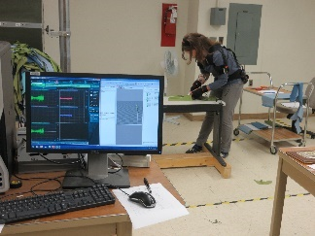
Fig 4d (i) EMG wearer at cutting task (ii) EMG signals on computer & wearer at cutting task
2.6 Data Processing
The four EMG data recorded in sinusoidal waves (fig 5) were translated into numeric values by Myomuscle MR3 software. The data showed the collection date, the time values at intervals of 7 x10⁻⁴ seconds, the respective values of EMG receivers 1,2,3 and 4 in μV. Each task had about 150000 rows by 6 columns of numeric figures and there were 24 tasks for each participant that gave about 84GB of data for processing. So, this huge data was first entered into the Matlab software where mean, median, mode, root mean square and maximum values were found for each task of every participant. These results were then transferred into excel sheets for further analysis and graphical representation
The following analyses were carried out on the collected data (i) Task description and scissors dimensions (ii) Muscular Responses to Scissors Designs (SD) workloads in Different Tasks (iii) P-Value Comparison of the Tasks (iv) SD pair comparison under the 6 different tasks was done to check the significance of the workload on the four muscles considered at 1% level of significance (v) Comparison of the EMG results of scissors

2.7 Precautions taken
As part of the precautions taken during the experiment, the researcher ensured the following:
To avoid bias, there was no group contact nor group training for participants. Not more than 2 participants were taken per day, and each had his/her time separately. All fabric pieces for each task were correctly labelled and arranged into their groups. Each participant’s data were correctly named in the myomuscle software as they got saved into the computer. Each pair of scissors was correctly labelled and strictly adhered to and each task was correctly input into the system as it was performed by the participant. Sensor numbers were strictly adhered to in terms of placements on the specific muscle number and each task corresponded to the scissors, fabric and table height in use. Any interruption caused by system error resulted in the discard of the task fabric in question with immediate replacement and a restart. Each participant followed the order of his/her task strictly. No participant was allowed to wear multiple clothes, and each bared his/her right forearm during the experimental procedure. Every participant gave permission to shave the 4 electrode placement points chosen on the right arm. The appropriate questionnaire was filled in for each task and correspondingly recorded against each participant’s data. The pattern and number of tasks for all the participants were equal. Recommended rest were duly observed and fabrics were cut in 10" X 25" pieces for pattern drawing. It was also ensured that the participants cut with the right hand only, starting from the "s" to the "c" point and did not lift the workpiece off the worktop while cutting.

- RESULTS & DISCUSSION

The participants’ mean age (standard deviation, SD), height, and weight were 25.58 (SD,3.62) years, 168.13 (SD, 9.19) cm and 74.25 (SD, 17.52) kg respectively. Some of their other anthropo-demographic details are as shown in table 3.

Table 3: Biodata of the study participants
Variables | Study subjects
Age | 25.58
Height (cm) | 167.88
Weight (kg) | 74.25
Exercise time days/weeks | 2.5
Grip force average (kg) | 23.92
Breadth at knuckles (cm) | 8.63
Maximum breadth of hand (cm) | 9.45
Length of hand (cm) | 18.15
Hand span (cm) | 17.71

Fig. 5: Typical EMG signals acquired for Participant (P1) using Scissor design (S3) at Height (H3) for cutting Fabric (F2)

Table 4 The corresponding statistical parameters for the typical EMG signals acquired for Participant (P1) using Scissor design (S3) at Height (H3) for cutting Fabric (F2)
EMG Signal /Parameter | Extensor Pollicis Brevis (EPB) | Flexor Pollicis Brevis (FPB) | Extensor Digitorium Muscle (EDM) | Flexor Digitorium Superficialis (FDS)
Median | -2.9686 | 1.8972 | 1.4210 | 0.0306
Mean | -0.2873 | -0.3470 | -0.2782 | -0.2802
Maximum | 0.6156e+03 | 1.0191e+03 | 0.5480e+03 | 0.2008e+03
Root mean square | 85.1507 | 131.9430 | 64.5187 | 20.1298

Table 5 Descriptive statistics of all the participants’ muscular responses.

Muscles | EPB | FPB | EDM | FDS
Rest Average, R_{av} | 2.33 | 2.60 | 2.35 | 2.65
Max Voluntary Contraction 1, MVC₁ | 108.1 | 184.3 | 184.0 | 140.7
Max Voluntary Contraction 2, MVC₂ | 95.7 | 166.6 | 116.6 | 147.0
Maximum at cutting task, Max | 761.7127 | 938.1723 | 570.5974 | 650.1057
Root Mean Square, RMS | 74.25524 | 56.31923 | 53.59307 | 43.63246
Average grip Force, AGF | 23.92kg

Table 6 Scissors comparison showing workload significance under different tasks
Scissors | Muscle | Task 1 | Task 2 | Task 3 | Task 4 | Task 5 | Task 6
S1vs S2 | EPB | 0.470 | 0.387 | 0.351 | 0.339 | 0.459 | 0.182
S1vs S2 | FPB | 0.174 | 0.176 | 0.216 | 0.138 | 0.171 | 0.157
S1vs S2 | EDM | 0.066 | 0.265 | 0.077 | 0.035 | 0.378 | 0.240
S1vs S2 | FDS | 0.825 | 0.235 | 0.771 | 0.737 | 0.210 | 0.869
S1 vs S3 | EPB | *0.000 | *0.000 | *0.000 | *0.000 | *0.000 | *0.000
S1 vs S3 | FPB | *0.000 | 0.416 | *0.007 | 0.048 | 0.847 | 0.229
S1 vs S3 | EDM | 0.019 | *0.001 | *0.000 | *0.000 | *0.005 | *0.000
S1 vs S3 | FDS | 0.012 | 0.106 | 0.100 | 0.089 | 0.073 | 0.012
S1 vs S4 | EPB | *0.000 | *0.000 | *0.000 | *0.000 | *0.000 | *0.000
S1 vs S4 | FPB | 0.014 | 0.501 | *0.002 | 0.329 | 0.613 | 0.024
S1 vs S4 | EDM | 0.011 | *0.000 | *0.000 | *0.000 | *0.000 | *0.000
S1 vs S4 | FDS | 0.049 | *0.008 | 0.108 | 0.011 | 0.011 | *0.004
S2 vs S3 | EPB | 0.020 | 0.149 | 0.141 | 0.128 | 0.013 | *0.001
S2 vs S3 | FPB | *0.002 | *0.008 | *0.001 | 0.022 | *0.000 | *0.001
S2 vs S3 | EDM | *0.000 | *0.000 | *0.000 | *0.000 | *0.000 | *0.000
S2 vs S3 | FDS | *0.002 | 0.141 | 0.012 | 0.071 | *0.005 | *0.003
S2 vs S4 | EPB | 0.030 | 0.160 | 0.208 | 0.167 | 0.014 | *0.000
S2 vs S4 | FPB | *0.000 | *0.000 | *0.001 | *0.000 | *0.001 | 0.018
S2 vs S4 | EDM | *0.000 | *0.000 | *0.000 | *0.000 | *0.000 | *0.000
S2 vs S4 | FDS | 0.024 | *0.008 | 0.015 | 0.014 | *0.000 | *0.007
S3 vs S4 | EPB | 0.088 | 0.504 | 0.241 | 0.313 | 0.610 | 0.841
S3 vs S4 | FPB | 0.344 | 0.913 | 0.943 | 0.562 | 0.375 | 0.176
S3 vs S4 | EDM | 0.330 | 0.515 | 0.248 | 0.505 | 0.175 | 0.674
S3 vs S4 | FDS | 0.169 | *0.000 | 0.435 | *0.004 | 0.074 | 0.176
* significant at 1% significant level
Table 7 Muscle-task Hotelling P values
 | T1 | T2 | T3 | T4 | T5 | T6
EPB | 0.0000 | 0.0000 | 0.0000 | 0.0000 | 0.0000 | 0.0000
FPB | 0.0001 | 0.0001 | 0.0007 | 0.0000 | 0.0027 | 0.0087
EDM | 0.0000 | 0.0000 | 0.0008 | 0.0000 | 0.0000 | 0.0001
FDS | 0.0168 | 0.0006 | 0.0849* | 0.0000 | 0.0108 | 0.0226
*not significant at α_{0.05}
Table 8 Average RMS values of each muscle for each scissors design
 | EPB | FPB | EDM | FDS
S₁ | 86.6834 | 60.8484 | 58.7337 | 49.3966
S₂ | 96.9199 | 68.7290 | 63.0157 | 52.6215
S₃ | 95.0281 | 69.7343 | 62.6123 | 53.1152
S₄ | 92.8771 | 66.4372 | 61.4539 | 51.7111

Table 9 Average RMS results of the muscle and scissors grouped by task number
Task | MUSCLE | S₁ | S₂ | S₃ | S₄
 | EPB | 39.71858 | 50.58065 | 97.96496 | 91.93617
1 | FPB | 48.22002 | 36.00827 | 65.5706 | 62.12753
1 | EDM | 46.9357 | 39.55858 | 61.53528 | 58.69841
1 | FDS | 33.49854 | 33.1861 | 41.14844 | 49.69273
2 | EPB | 44.13396 | 63.26607 | 101.1157 | 98.50914
2 | FPB | 60.20361 | 37.93647 | 67.16839 | 67.62086
2 | EDM | 49.97862 | 47.08062 | 63.42605 | 66.25128
2 | FDS | 38.03747 | 39.89548 | 47.84155 | 55.14195
3 | EPB | 39.56546 | 60.2627 | 98.31291 | 93.52942
3 | FPB | 48.78494 | 36.39465 | 65.38373 | 65.53373
3 | EDM | 43.62054 | 40.2317 | 58.78234 | 55.88149
3 | FDS | 37.90878 | 36.74544 | 46.80938 | 49.28816
4  5 | EPB | 45.26231 | 65.05855 | 102.1328 | 98.23077
4  5 | FPB | 58.62365 | 39.3861 | 74.45853 | 68.56254
4  5 | EDM | 47.4083 | 43.71829 | 62.41443 | 60.32631
4  5 | FDS | 40.43916 | 39.31909 | 47.91181 | 59.49047
4  5 | EPB | 42.51556 | 52.0535 | 97.25569 | 95.324
4  5 | FPB | 57.26607 | 32.3249 | 59.96355 | 62.99862
4  5 | EDM | 43.42195 | 41.80927 | 69.406 | 61.12123
4  5 | FDS | 36.45176 | 33.43598 | 44.4353 | 49.13196
6 | EPB | 45.34688 | 55.9736 | 102.5955 | 101.4809
6 | FPB | 54.57964 | 37.20649 | 65.71333 | 79.62538
6 | EDM | 48.42616 | 45.88785 | 64.22563 | 66.08764
6 | FDS | 39.17987 | 39.72175 | 51.14024 | 57.32768
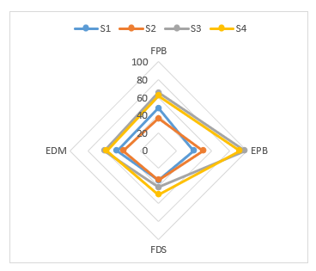
Fig 6a: Muscular response to scissors load during task 1
The EPB muscle had the heaviest workload from scissors S3 and S4. Scissors S2 had the lightest workload that was almost evenly distributed amongst the 4 muscles. Also, scissors S2 had its lightest workload on muscle EPB and a tie with S1 in FDS.

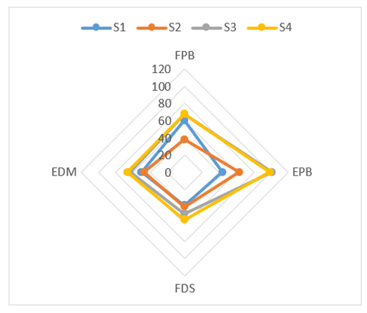
Fig 6b: Muscular response to scissors load during task 2
Muscular response to scissors load during task 2
Muscle EPB had the heaviest workload from Scissors S3 and S4 while the workload was not so heavy on EDM and FDS. Scissors S2 and S1 gave lesser muscular demand
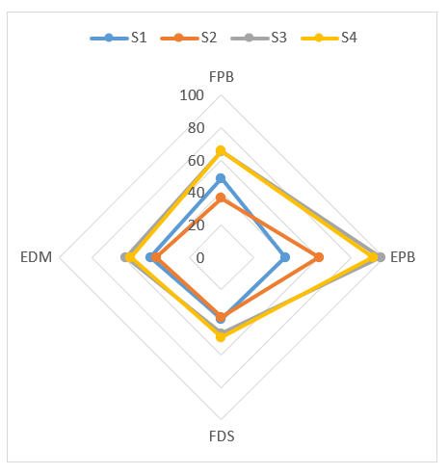
Fig 6c: Muscular response to scissors load during task 3
Scissors S3 and S4 had higher muscular demand on EPB followed by FPB. Scissors S1 and S2 had lesser demand. S1 and S2 place minimum load on muscle FDS

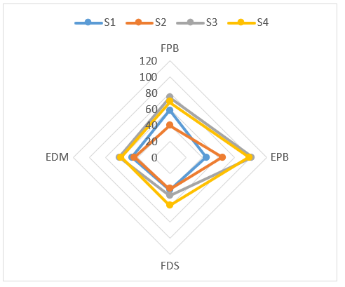
Fig 6d: Muscular response to scissors load during task 4
Scissors S3 and S4 placed higher demand on muscle EPB followed by FPB while scissors S2 and S1 placed lesser demand. EDM had the least workload in general

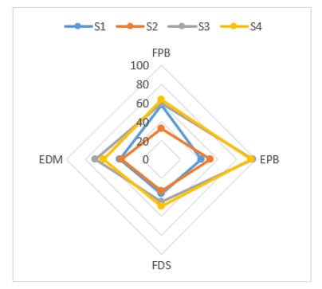
Fig 6e: Muscular response to scissors load during task 5
Muscle EPB had the highest workload from scissors S3 and S4 While scissors S2 gave the lowest demand on almost all the muscles. S1 had its highest load on FPB.

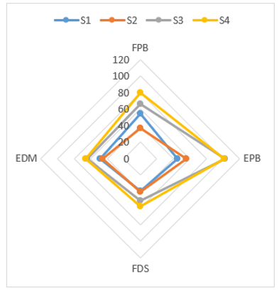
Fig 6f: Muscular response to scissors load during task 6
The highest muscular demand was from scissors S3 and S4 on muscle EPB followed by FPB. Lesser workload came from scissors S2 and S1 with a tie on muscle FDS.

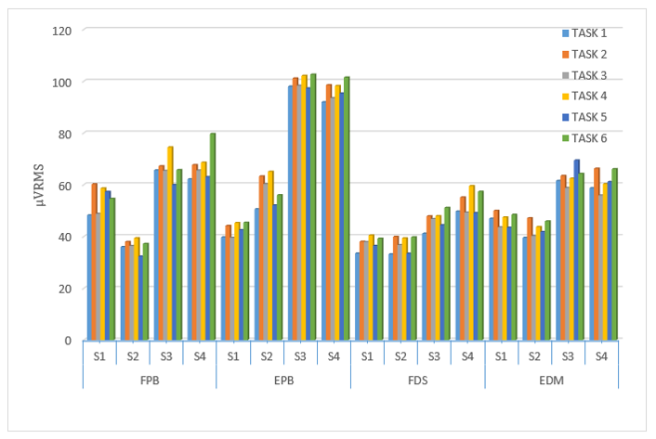
Fig 7: Workload placed by different scissors on each muscle during various task.

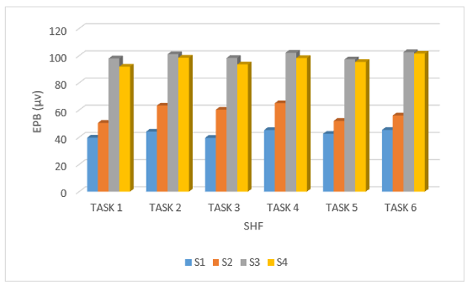
Fig 8a. EPB Scissors - task comparison
The lowest load came from S1 (about 38-42µV), followed by S2 in all 6tasks (about 48-61µV) and then S3 & S4 at a very close range of about (90-100µV).
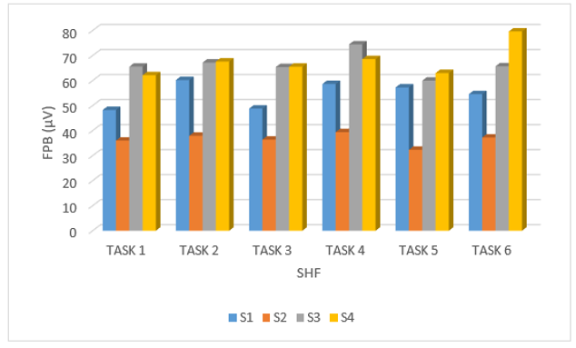
Fig 8b. FPB Scissors - task comparison
S2 had distinctively lowest load in all 6 tasks within the range of about 30-38µV. S1 had its load between 47-59µV. S3 & S4 had the relatively higher loads in all 6 tasks. However, S4 had the highest load of about 78µV and that in task 6.
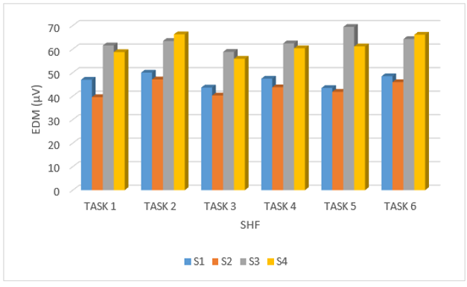
Fig 8c. EDM Scissors - task comparison
S2 gave the lowest load to EDM in all six tasks followed by S1 within the range of about 38 – 48µV. S3 & S4 applied a relatively high load within the range of about 55 - 68µV. Overall, S3 had the highest load of about 68µV and that in task 5.

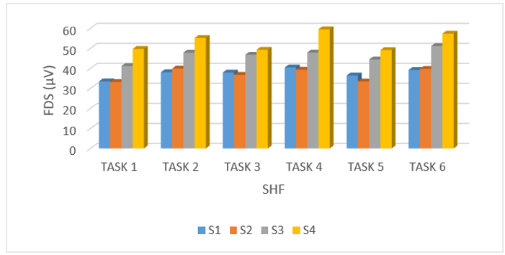
Fig 8d. FDS Scissors - task comparison
The highest load was from S4 followed by S3. S1 & S3 had a tie in tasks 1 & 6 but in tasks 3, 4 & 5, S1 placed a slightly higher load more than S2 which gave a higher value only in task 2.

Task Description and Scissors Design parameters
Each task was represented by 3 digits: The first digit is the scissors number (1-4), middle digit is the height number (1-3), while the last digit is the fabric type (1-2).
Fig 1 showed the four scissors designs whose dimensions were dully taken and shown in table 2.
Scissors S1 and S2 have wider hand–tool interface clearance which allows all finger digits to rest on the tool, thereby sharing the workload evenly unlike S4 that placed a high-pressure point on the digits. Also, workload was not evenly shared amongst the digits in S4 because its small, closed handle did not allow all fingers to participate in the cutting task (fig 1). Furthermore, scissors S1 and S2 have lighter stainless-steel cutting blade that afford a good quality for precision unlike the heavier iron blade of S4.
As seen in Table 2, scissors S₄ weighed the heaviest (250g) followed by S₃ (150g) while S₁ and S₂ weighed the same value (100g). The weight of any tool may contribute to its efficiency and user-friendliness. Scissors S₂ had the highest Mechanical Advantage (MA) followed by S₁ and S₃ while S₄ had the least. This has to do with the fact that MA increases with handle length (Rampudaruth, 2015). As a first-class lever, a pair of scissors has its ideal Mechanical Advantage (MA) as the ratio of the input- (effort)distance (X₁₋₃) to the output- (load) distance (X₃). The MA of each pair of scissors is directly proportional to its effort-distance. The S2 scissors had the highest (1.71) MA followed by S1 (1.58) and S3 (1.10) while S4 (0.94) had the least indicating that MA increases with handle length in conformation with the findings of Rampudaruth (2015). Therefore, if the applied force at the handles is twice as far away from the fulcrum as the cutting location, then the force at the cutting location will be twice that of the applied force at the handles. The diameter or length occupied by the four fingers was labelled X₄ while the one for the thumb was labelled X₅. The decreasing order of X₄ was S1 > S2 > S3 > S4 while that of X₅ was S2 > S1 > S3 > S4. Scissors S1 and S2 had larger handle diameters while S3 and S4 had small ones but S4 had the least. This implied that the highest finger contact pressure was from S₄ followed by S₃, while minimum finger contact pressure was observed in S₁ and S₂ (fig 1).
These findings are in line with the reported work of Rossi et. al., (2012) who noted a significant interaction between hand and handle diameter (p˂ 0.001). More so, the contribution of the thumb to gripping force increases with handle diameter and subjects applied their maximum grip force on tools with largest diameters.
Generally, greater muscular response was elicited from the flexor muscles but FPB had higher response than other muscles in the MVCs and Max (table 5). This could possibly be due to the type of the total grip force applied to the MVC tools. Although, the thumb muscles still had the highest values of muscular response in carrying out hand task but the thumb flexor muscle generated more force in dowel and dynamometer usage than its extensor muscle while the reverse is true for scissors usage. The thumb extensor muscle generated more response during scissors usage.

4.2 Muscular Responses to Scissors Designs workloads in Different Tasks
Workload on the muscles was relatively closely distributed in FPB, EDM and FDS within the range of 30-60μV. In EPB, the distribution margin was wide; S4 and S3 were in the range of 100 and 90 μV while S3 and S4 were in 50 and 40 μV range as shown in Figures 6a-f. Much of the workload was placed on the pollicis brevis (FPB) in all the 6 tasks. The brevis (thumb) had greater load when extending in agreement with Li & Tang (2007) and Gold et al. (2012). The load was more pronounced when using S3 and S4 because the thumb was confined to a small hole of little diameter in which case only limited part of the thumb was engaged in the cutting motion. However, in S1 and S2, the thumb completely rested on a large area of the scissors (larger space as compared to S3 and S4). This made the full thumb muscle to do the cutting job while using S1 & S2. The workload was lesser in EDM and FDS because the load was evenly spread amongst the other four fingers (index, middle, ring and little) sharing the 2nd scissors hole. It was also observed that S1 had its greatest workload on FPB in all the 6 tasks in contrast to S2, S3 and S4 that had their highest workload on EPB. This was possibly due to the angulation as well as the absence of a second scissors hole to enclose the four fingers. The lack of support for these four fingers placed additional workload on them thereby making finger extension more difficult. Since there was no extension-restriction for the fingers and thumb until the scissors reached its opening limit, more work had to be done in closing the scissors; hence the higher load on FPB (thumb flexion).
S1 and S2 had larger clearance for the thumb which made all the thumb length rests on one handle of the scissors to do the cutting job. Scissors 4 and 3 placed the highest workload on EPB in the muscular response to the different tasks (Fig 6a-f).
Considering the 4 muscles separately, scissors 4 in task 6 placed the highest workload on FPB at over 60μV value, both scissors 3 and 4 placed much workload on EPB at 80μV value, only scissors 4 placed highest load on FDS at 40μV value. Scissors 3 placed the highest load on EDM at almost 60μV value in task 5. Fig 7 showed the aforementioned points all combined. In all 6 tasks, S3 and S4 placed the highest workload on all four muscles. The peak workload was on EPB followed by FPB possibly because a much higher effort is needed to extend the thumb (brevis) in order to open the scissors. Scissors S1 and S2 elicited lower muscular responses.

4.3 P-Value Comparison of the Tasks
Grouping the 24 tasks into 6 (T1 - T6) according to the same working height and the fabric but different scissors, the multivariate (MV) test was carried out using Hotelling method and their P values are shown in Table 7 for the different muscles: T1 (111 211 311 411); T2(112 212 312 412); T3(121 221 321 421); T4(122 222 322 422); T5(131 231 331 431) T6(132 232 332 432).
Out of the 24 values, 15 were significant at α_{0.01} while 23 were significant α_{0.05}. This implied that the response of the muscles varied greatly as the scissors type changed. EPB and EDM had 100% significant values while FPB and FDS had 67% and 33% significance values respectively. Only T4 had all significant values for all 4 muscles at α_{0.01}. This further buttresses the fact that in scissors usage, extensor muscles elicited more response than the flexor muscles.
4.4 T-test Pair Comparative Analysis of the Four Scissors
The four types of scissors (S1, S2, S3 and S4) used in the experiment were compared in pairs under the 6 different tasks to check the significance of workload on the four muscles considered (EPB, FPB, EDM and FDS). The scissors were paired as follows: S1vsS2, S1vsS3, S1vsS4, S2vsS3, S2vsS4 and S3vsS4. Table 6 showed the result of the comparison with their significant values at 1% significance level.
S1 versus S2 resulted in no significant difference of workload on muscles EPB, FPB, EDM and FDS in all the 6 tasks.
S1 vs S3: All 4 muscles showed significant difference with FPB in tasks 1 and 3 only, EPB and EDM in all 6 tasks while FDS showed in tasks 1 and 6 only.
S1 vs S4: All 4 muscles showed significant difference with FPB in tasks 1 and 3 only, EPB and EDM in all 6 tasks while FDS showed in tasks 2,4, 5 and 6 only.
S2 vs S3: All 4 muscles showed significant difference with FPB in all tasks except task 4, EPB in tasks 5 and 6, EDM in tasks 1,3,5 and 6 while FDS showed its significant difference in tasks 1,4, and 6 only.
S2 vs S4: All 4 muscles showed significant difference with FPB in all tasks, EPB in tasks 5 and 6, EDM in all tasks except 1 while FDS showed its significant difference in all 6 tasks.
S3 vs S4: None of the 4 muscles showed significant difference at 1% level except FDS in tasks 2 and 4 only.
These results implied that while scissors 3 and 4 placed much workload on hand muscles during cutting tasks, scissors 1 and 2 had less muscle performance-demand on users.

4.5 Comparison of the EMG results of the different scissors designs
For all the 24 tasks combined in Table 8, the highest workload was on EPB followed by FPB and EDM while the lowest load was on FDS. This implies that in manual fabric scissors cutting task, the thumb had the highest load both in extension and flexion motions. Also, in the other four fingers, the extension motion carried more load than the flexion motion. It could thus be deduced that in TMS-usage, extension motion placed more load on all five fingers than the flexion motion. However, the load was greater on the thumb possibly because it worked alone while the other four fingers worked together to share the load placed on them.
In the six grouped tasks, scissors S₃ and S₄ placed much demand on the hand muscles while designs S₁ and S₂ placed relatively lower demand as shown in Table 9

- CONCLUSIONS and RECOMMENDATION
The putative characteristics of good manual tailors’ scissors that lead to less risks of CTDs of the hands were found in scissors S2: wide clearance of both handles with enclosed space for the four fingers but open space for the thumb as well as foamy thermoplastic material for the handles for soft grip. An intrinsic scissors’ weight of about 100g proved good in cutting tasks as it reduced additional load on the hand. The availability of an aided closing-opening mechanism to reduce manual force is also an advantage for S2. In terms of electro-muscular response to workload generated by the various scissors designs under the same conditions, scissors S2 elicited the least response because the workload placed on muscles during its usage was minimal. S2 was also found to be user-friendly because it gave no pressure points of discomfort. In contrast, scissors 3 and 4 placed so much workload at highly significant level on users’ muscles, thereby increasing the probability of developing hand CTD by the user. Therefore, the best design amongst the conventional scissors studied was found in S2 because its design allowed the optimum handle space for the four fingers and thumb to maximize finger force exertion, comfort, contact area and thus limiting the chances of CTD. Wide-handled scissors placed smaller workload on its user’s hand while the small-handle ones placed greater load on user’s hand. The latter had a higher risk of finger contusions while the former had a lower risk. The design of fabric scissors handles should be tilted towards wide handles to accommodate the users’ fingers with minimal compression and pressure points. This would help in maximizing the efficiency of cutting task performance with better pressure distribution to reduce finger contusions.
LIMITATIONS
The scissors used were not instrumented to measure their direct force
The experimental conditions were simulated; they may therefore not be exactly like what operates in a real-world working systems of the custom tailors.

REFERENCES

- Adeleye, A.A and Akanbi, O.G. 2015. Hand Cumulative Trauma Disorders in Nigerian custom Tailors: The Need for Redesign of Manual Scissors. Ergonomics 58:8, 1410-1423.
- Adeleye, A.A., Alabdulkarim, S.A. and Nussbaum, M.A. 2020. Impacts of Different Fabric Scissor Designs on Physical Demands and Performance in Simulated Fabric Cutting Tasks. Applied Ergonomics 89, 103219, https://doi.org/10.1016/j.apergo.2020.103219.
- Akpan, K.P., Anthony, U.C. and Abraham, U.P. 2023. Ergonomic Consideration as Panacea to Organisational Growth and Proficiency in the 21st Century. Journal of Education in Developing Areas (Special Edition) 31 (4): 52-60.
- Alastair, J.M.K., Ian, F., Robert, H. and Samantha, L.W. 2020. Muscle Recruitment and Stone Tool Use Ergonomics across Three Million Years of Pallaeolithic Technological Transitions. Journal of Human Evolution 144 (102796).
- Aminoff, T., Smolander, J., Korhonen, O., and Louhevaara, V. 1996. Physical Work Capacity in Dynamic Exercise with Different Muscle Masses in Healthy Young and Older Men. European Journal of Applied Physiology and Occupational Physiology 73: 180-185.
- Aptel, M., Claudon, L. and Marsot, J. 2002. Integration of Ergonomics into Hand Tool Design: Principle and Presentation of an Example. Safety and Ergonomics (JOSE) 8(1): 107-115.
- Ario, I., Hama, Y., Chanthamanivong, K., Chikahiro, Y., Fujiwara, A. and Ma, H. 2022. Influence Line-Based Design of Scissors-Type Bridge. Applied Sciences (MDPI) 12 (12170):1-16.
- Ario, I., Yamashita, T., Chikahiro, Y., Nakazawa, M., Fedor, K. , Graczykowski, C. and Pawlowski, P. 2020. Structural Analysis of a Scissor Structure. Bulleting of the Polish Academy of Sciences, Technical Sciences 68 (6): 1319-1332.
- Boyles, J.L., Yearout, R.D. and Rys, M.J. 2003. Ergonomic Scissors for Hairdressing. International Journal of Industrial Ergonomics 32: 199-207.
- Chang, S.R., Park, S. and Freivalds, A. 1999. Ergonomic Evaluation of the Effects of Handle Types on Garden Tools. International Journal of Industrial Ergonomics 24: 99-105.
- Dang, A.T. and Nguyen, T.T.T. 2023. Investigation on the Design of Double-Stage Scissor Lifts Based on Parametric Dimension Technique. Machines 11 (684): 1-19.
- Darabont, V.A. and Darabont, D.C. 2021. Considerations on Ergonomic Issues in Physiotherapy Activity. MATEC Web Conferences 343 (10004): 1-15.
- Dempsey, P.G., McGorry, R.W. and O’Brien, N. V. 2004. The Effects of Work Height, Workpiece Orientation, Gender, and Screwdriver Type on Productivity and Wrist Deviation. International Journal of Industrial Ergonomics 33: 339-346.
- Dhara, P.C., De, S., Sengupta, P., Maity, P. and Pal, A. 2015. An Ergonomic Approach for Designing Indian Traditional Vegetable Cutter. Vidyasagar University, West Bengal, India. Work, vol. 50, no. 2, pp. 177-186.
- Dianat, I., Nedaei, M. and Nezami, M.A.M. 2015. The Effects of Tool Handle Shape on Hand Performance. International Journal of Industrial Ergonomics 45:13-20.
- DiDomenico, A.and Nussbaum, M.A. 2008. Interactive Effects of Physical and Mental Workload on Subjective Workload Assessment. International Journal of Industrial Ergonomics 38:977-983.
- Draskovic, D., Prusa, P., Cicevic, S. and Jovcic, S. 2020. The Implementation of Digital Ergonomics Modeling to Design a Human-Friendly Working Process in a Postal Branch. Applied Sciences (MDPI): 10:1-13.
- Erliana, C.I., Abdullah, D., Ardian, Z and Siagian Y.Y. 2024. Design of an Ergonomic Tofu Cutting Tool in the Tofu Industry of Aceh. Edelweiss Applied Science and Technology 8(6): 8378-8386.
- Freivalds, A.1996. Tool Evaluation and Design. In: Bhattacharya, A., McGlothlin, J.D. (Eds.), Occupational Ergonomics: Theory and Applications. Marcel Dekker, Inc., New York, pp. 303-327.
- Groenesteijn, L., Eikhout, S.M. and Vink, P. 2004. One Set of Pliers for More Tasks in Installation Work: The Effects on (Dis) Comfort and Productivity. Applied Ergonomics 35 (5): 453-458.
- Hamill, J., and Knutzen, M. K. 2003. Biomechanical Basis of Human Movement (2nd ed.). Philadelphia, PA: Lippinott Williams & Wikins, United State of America.
- Haque, S and Khan, A.A. 2010. Ergonomic Design and Evaluation of Pliers. Work 27: 135-143.
- Hart, S.G., and Staveland, L.E.1988. Development of NASA-TLX (Task Load Index): Results of Empirical and Theoretical Research. In: Hancock, P.A., Meshkati, N. (Eds), Human Mental Workload. Elsevier Science Publishers, North-Holland, Amsterdam, pp 139-183.
- Kaydos, W. J. 1999. Operational Performance Measurement: Increasing Total Productivity. CRC Press LLC, 2000 Corporate Blvd., N.W., Boca Raton, Florida 33431.
- Kim, S., Lee, J.Y. and Yi, A.B. 2023. Evaluation of Ergonomic Design Based on Dynamic Model of Scissor. IEEE Access 11: 89958-89964.
- Kong, Y., Lowe, B.D, Lee, S and Krieg, E.F. 2008. Evaluation of Handle Shapes for Screwdriving. Applied Ergonomics 39:191-198.
- Lee, K.S. and Jung, M.C.2015. Ergonomic Evaluation of Biomechanical Hand Function. Safety and Health at Work 6:9-17.
- Li, Z. and Tang, J.2007. Coordination of Thumb Joints During Opposition. Journal of Biomechanics 40 (3): 502-510.
- Li, Z.M and Tang, J. 2007. Coordination of Thumb Joints During Opposition. Journal of Biomechanics 40:502-510.
- Louhevaara, V., Smolander, J., Aminoff, T. and Ilmarinen, J. 1998. Assessing Physical Work Load. Ergonomics in Manufacturing. Eds.W. Karwowski and G. Salvendy. SME Dearborn, Michigan, EMP Norcross, Georgia, 121-133.
- Mali, P.R., Aware ,V.V. and Shahare, P.U. et. al. 2022. Ergonomic Considerations for Development of Grass Cutter-Cum-Paddy Harvester. Journal of Biosystem Engineering 47: 468-479.
- Mital, A. and Sanghavi, N., 1986. Comparison of Maximum Volitional Torque Exertion Capabilities of Males and Females Using Common Hand Tools. Human Factors 28:3, 283-294.
- Mitchell, A.W., Hampton, C., Hanks, M., Miller, C. and Ray, N. 2012. Influence of Task and Tool Characteristics on Scissor Skills in Adults. The American Journal of Occupational Therapy 66:6 e89-e97.
- Myers, J.R. and Trent, R.B. (1988). Hand Tools Injuries at Work: A Surveillance Perspective. Journal of Safety Research, 19, 165-176.
- Nakajima, Y., Yoshinari, S. and Tadano, S. 2009. Surface Conduction Analysis of EMG Signal from Forearm Muscles. Lim C.T and Goh J.C.H (Eds); ICBME Proceedings 23, pp. 1904-1907.
- Ngo, B.P.T and Wells, R.P. 2016. Evaluating Protocols for Normalizing Forearm Electromyograms During Power Grip. Journal of Electromyography and Kinesiology 26:66-72.

- Ogbemhe, J., Ramatsetse, B., Mpofu, K. and George, O.A. 2024. Multi-Physical Modelling and Simulation of a Planar Translational Scissor Lift Mechanism for Maintenance of Rail Transmission Lines. Procedia CIRP 121:174-179.

- Ortengren, R., Cederqvist, T., Lindberg, M. and Magnusson, B.1991. Workload in Lower Arm and Shoulder When Using Manual and Powered Screwdrivers at Different Working Heights. International Journal of Industrial Ergonomics 8:225-235.

- Paul, D.R. and Yadav, E.B. 2021. Fabricate and Ergonomic Evaluation of Manually Operated Drumstick Cutter. The Pharma Innovation Journal 10(10): 34-40.

- Polteva, E.A., Mitroshin, D.I., Kormakov, A.A. and Sandler, I.L.2023. Software Modeling of Hydraulic Drive Guillotine Flying Scissors. AIP Conference Proceedings 2476 (1).

- Rash, G.S. Electromyography Fundamentals.http://faculty.educ.ubc.ca/sanderson/courses/HKIN563/pdf/EMGfundamentals.pdf downloaded on 4/7/16.

- Reaz, M.B.I., Hussain, M.S. and Mohd-Yasin, F. 2006. Techniques of EMG Signal Analysis: Detection, Processing, Classification and Applications. Biological Procedures Online 8 (1):11-35.

- Sakinala, V., Paul, P.S. and Fissha, Y. 2024. Promoting Safety of Underground Machinery Operators through Participatory Ergonomics and Fuzzy Model Analysis to Foster Sustainable Mining Practices. Scientific Reports 14 (16319): 1-16.

- Shih, Y. and Wang, M.J. 1996. Hand/Tool Interface Effects on Human Torque Capacity. International Journal of Industrial Ergonomics. 18:205-213.

- Shimomura, Y., Shirakawa, H., Sekine, M., Katsuura, T. and Igarashi, T. 2015. Ergonomic Design and Evaluation of New Surgical Scissors. Ergonomics 58 (11):1878-1884.

- Shimomura, Y., Shirakawa, H., Sekine, M., Katsuura, T. and Igarashi, T. 2015. Ergonomic Design and Evaluation of New Surgical Scissors. Ergonomics (Taylor and Francis) 1-8.

- Sjogaard, G. and Jesen, B.R. 1999. Low Level Static Exertions. The Occupational Ergonomics Handbook. Eds.W. Karwowski & W. Marras. CRC press. 247 – 259.

- Soewardi, H. and Kalsum, L.Z.2020. Ergonomic Design of the Machine for Chopping Cyperace Plant. Malaysian Journal of Public Health Medicine (Special) 1:83-87.

- Soussahn, S., Buckwalter, K., Sayegh, R., Soliman, S., Weadock, W. and Gaetke-Udager, K. 2024. Ergonomic Considerations for the Modern Radiology Practice: An Update. Current Problems in Diagnostic Radiology 53: 738-744.

- Takala, E. and Toivonen, R. 2013. Placement of Forearm Surface EMG Electrodes in the Assessment of Hand Loading in Manual Tasks. Ergonomics 56:7, 1159-1166.

- Teodoroski, R. C., Koppe, V. M. and Merino, E. A. 2012. Old Scissors to Industrial Automation: The Impact of Technological Evolution on Worker’s Health. Work 41:2349-2354.

- Torralba, V., Maradei, F. and Castellanos, J. 2024. Ergonomic Criteria Related to Perceived Comfort when Using By-Pass-Type Cutting Tools. A Journal of Prevention Assessment and Rehabilitation 1-13.

- Vanderwal, L., Rautiainen, R., Kuye, R., Peek-Asa, C., Cook, T., Ramirez, M., Culp, K and Donham, K. 2011. Evaluation of Long- and Short-Handled Hand Hoes for Land Preparation, Developed in a Participatory Manner Among Women Vegetable Farmers in the Gambia. Applied Ergonomics 42:749-756

