Original Research Article
Influence of geometrical characteristics in 5-story diagrid structures under a linear dynamic analysis

.
ABSTRACT

The angle of the perimeter grid is the property that determines the behavior of diagrid (DG) structures. This study compares 30 different DG models using different perimeter grid arrangements and different floor-to-floor dimensions, considering their dynamic properties to observe the behavior of each model under a modal-spectral analysis. For this purpose, three different floor-to-floor distances were determined for five-story DG structures, and all possible module sizes were analyzed for each floor-to-floor configuration. The analysis was performed using ETABS software. The results show a variation of up to 80% in the weight of the DG when varying the angle of the perimeter grid elements and around 93% in interstory drift values. A 5-story DG performs better with single-floor modules regardless of their slope, because there are models with the same perimeter grid slope but different behaviors, consequently, it is important to consider the geometry of the mezzanines as well as the density of diagonals in the perimeter grid. This study contributes to a better understanding of the behavior of medium-height DG under seismic loads, highlighting the importance of considering the distribution of structural elements that provide lateral stiffness.

Keywords: medium-height buildings, seismic performance, optimization, interstory drift, fundamental period of vibration.

1. INTRODUCTION

In recent decades, the population growth of large cities around the world has increased rapidly, and with it, the need for development not only horizontally, but vertically (Montejano-Castillo et al., 2020). This makes imperative the search for innovation in structural configurations, using all available materials, and keeping as the main objective the optimization of material and economic resources, this includes considering the sustainability of the structures, particularly in developing countries such as Mexico.

One of these resources is the diagrid structures (DG), that is, a model with two different structural systems: a non-rigid steel frame which supports gravitational loads, and a perimeter grid made by frames arranged in triangular modules as shown in figure 1 (Google Maps, 2025). The latter provides stability and absorbs lateral loads induced by earthquakes and wind (Mele et al., 2014). Such diagonals have proven to be efficient, saving approximately 20% of material compared to conventional moment resisting frame structures (Shah et al., 2016).

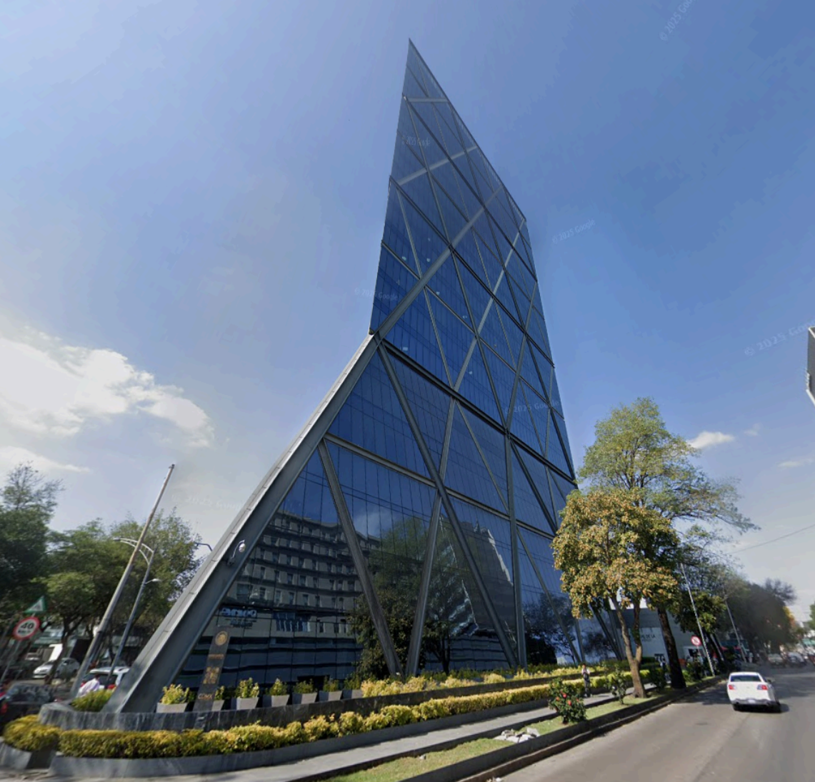

Fig. 1. Diagrid in Mexico City. Source: Google Maps (2025). Map data ©2025 Google.

DG has gained popularity in recent years, thanks to its cost-effectiveness and low material consumption, offering an opportunity to reduce greenhouse gas emissions by more than 50% (Ramírez et al., 2024).

The implementation of DG in areas where seismic and wind loads are high requires more advanced study than limiting itself exclusively to a static analysis by evaluating its lateral stiffness (Moon et al., 2007).

The study of lateral deformations under shear and bending effects is usually resisted by different structural elements such as bracings, walls, and columns; however, for the DG system, these effects are resisted by the diagonal elements of the grid (Lacidogna et al., 2020).

The phenomenon called shear lag is observed in closed or box-type elements, where we see a non-uniform distribution of axial forces due to lateral loads, where a “lag” is seen in the center of the structure with respect to the edges (Singh et al., 2024). This effect results in a decrease in structural efficiency, since there are more stressed elements that indicate the cross section to be used, causing waste of material.

Moon et al., (2007) analyzed buildings between 36 and 60 levels, and found that, for a 60-level building with an aspect ratio of 7, the angle with the best shown behavior is in the range between 65° and 75°, while for 42 levels with an aspect ratio of 5, a range between 55° and 65° was obtained.

There are two different types of configurations for DG. figure 2a) shows the “A” type configuration, while figure 2b) shows the “V” type configuration. In this article, we will focus on analyzing the “V” type. figures 2a) and 2b) show DG structures with one-story-high triangles. The size of these triangles will vary across all the models analyzed which from now on are going to be referred to as “modules”.

Additionally, in figures 2a) and 2b), there are four diagonals of different colors for each module, which from now on are going to be referred to as “grid”. According to the previous statements, both figures show 5 story DG with 1 module and 4 grids.

Fig. 2. a) DG “A” type 1-module array with 4 grids, b) DG “V” type 1-module array with 4 grids

Considering the above, there is solid research for tall buildings, with conclusions on the recommended geometry (Terán-Gilmore et al., 2020). However, there is an area of opportunity in the study of DG for low and medium heights. The present study provides an analysis of a 5-story diagrid “V” type, exploring 30 models varying their geometry and DG arrays, having the same assumptions, focusing only on a normalized behavior between different arrays, showing the possibility of having a variation of up to 80% in weight when arbitrarily choosing a DG configuration.

2. Theorical background

2.1 Stiffness-based formulation

Considering the formulation based on the stiffness of the structure where we know that the perimeter grid absorbs both bending and shear forces (Terán-Gilmore et al., 2020), we have a direct association as shown in Equation (1).

T_{T}² = T_{S}² + T_{B}² (1)

Where T_{T}² is the fundamental period of the structure, T_{S}² is the fundamental period associated with the shear and T_{B}² is the fundamental bending period.

For the shear stiffness, the contribution of the perimeter grid diagonals is established by their axial load properties, which are given in Equation (2).

${\text{K}}_{\text{Si}}\text{=}\sum_{\text{j=1}}^{{\text{N}}_{\text{i}}}{\frac{\text{E*}{\text{A}}_{\text{j}}}{{\text{L}}_{\text{j}}}\text{*}{\text{cos}}^{\text{2}}{{\text{θ}}_{\text{j}}}\text{*}{\text{cos}}^{\text{2}}{{\text{Φ} }_{\text{j}}}}$ (2)

Whereas E is the modulus of elasticity, N_{i} is the number of diagonals located in the i-th story, A_{j} is the cross-sectional area of each diagonal, θ_{j} the angle of the j-th diagonal with respect to the horizontal plane, Φ_{j} the angle of the plane of the j-th diagonal that is formed with the direction of analysis, and L_{j} is the length of the j-th diagonal in the i-th story.
The overall flexural behavior of the building is simplified in Equation (3) by considering a cantilever beam with the moment of inertia of each i-th level.

${\text{I}}_{\text{Bi}}\text{=}\sum_{\text{j=1}}^{{\text{N}}_{\text{i}}}{{\text{A}}_{\text{j}}\text{*}{\text{sin}}^{\text{2}}{{\text{θ}}_{\text{j}}}\text{*}{\text{d}}_{\text{j}}^{\text{2}}}$ (3)

Where d_{j}² is the distance that separates, in the direction of analysis, the centroidal axis with the axis of the j-th diagonal in the plane of the i-th story.

In this way, the fundamental period of the structure is found, and the displacement is checked with a one degree of freedom model (SDOF), considering the structure as a cantilever beam, developing in Equation (4), Equation (5) and Equation (6) where the behavior of the DG is explained using the analogy of the cantilever beam.

${\text{S}}_{\text{dS}}\text{=}\frac{\text{m*}{\text{S}}_{\text{a}}}{{\text{K}}_{\text{S}}}$ (4)
${\text{S}}_{\text{dB}}\text{=}\frac{\text{m*}{\text{S}}_{\text{a}}}{{\text{K}}_{\text{B}}}$ (5)
$\text{κ=}\frac{{\text{S}}_{\text{dS}}}{{\text{S}}_{\text{dB}}}\text{=}\frac{{\text{K}}_{\text{B}}}{{\text{K}}_{\text{S}}}$ (6)

Where S_{a} is the spectral pseudo acceleration corresponding to the calculated vibration period T_{T} of the DG structure, K_{s} is the lateral stiffness related to shear, K_{B} the lateral stiffness related to bending, m the mass, κ the ratio of the displacement demand between shear and bending, S_{dS} the global displacements due to shear, and S_{dB} the global displacements due to bending (Terán-Gilmore et al., 2014).

3. Methodology

A 5-story DG experiment was modeled, analyzed, and designed by software ETABS (Computers and Structures, Inc., 2006). Three different plan dimensions were analyzed, varying their configuration depending on the number of its levels. This research only considered arrays with 1 to 5 levels, connecting these triangles to the nodes of each story to avoid eccentricities in the perimetral beams. The design of the perimetral grid was made by AISC (American Institute of Steel Construction, 2022) assumptions.

3.1 Diagrid MOdels

All DG models analyzed will have 5 stories, each 4 m of height.

Three different sizes were considered for the floor plan, all square in shape. The first configuration is 10 m x 10 m, which gives a height-to-base ratio (h/b) of 2, considering a 4x4 and 6x6 span arrangement as seen in figure 3. This is to consider not only the h/b ratio, but also the saturation of diagonals that the structure may have.

Fig. 3. 10M X 10M DG models, a) 10X_10Y_5P_4X4_1M, b) 10X_10Y_5P_4X4_2M, c) 10X_10Y_5P_4X4_3M, d) 10X_10Y_5P_4X4_4M, e) 10X_10Y_5P_4X4_5M, f) 10X_10Y_5P_6X6_1M, g) 10X_10Y_5P_6X6_2M, h) 10X_10Y_5P_6X6_3M, i) 10X_10Y_5P_6X6_4M, j) 10X_10Y_5P_6X6_5M

The second plan configuration is 15m x 15m, with a height-to-base ratio (h/b) of 1.33, which is wider than the first configuration and is also analyzed with two 4x4 and 6x6 span arrangements as shown in figure 4.

Fig. 4. 15M X 15M DG models, a) 15X_15Y_5P_4X4_1M, b) 15X_15Y_5P_4X4_2M, c) 15X_15Y_5P_4X4_3M, d) 15X_15Y_5P_4X4_4M, e) 15X_15Y_5P_4X4_5M, f) 15X_15Y_5P_6X6_1M, g) 15X_15Y_5P_6X6_2M, h) 15X_15Y_5P_6X6_3M, i) 15X_15Y_5P_6X6_4M, j) 15X_15Y_5P_6X6_5M

The third configuration will have mezzanine dimensions of 30m x 30m with a height-to-base ratio (h/b) of 0.66 as seen in figure 5. This configuration will be wider than it is tall to determine the behavior of low-rise buildings, which tend to have similar structures in terms of width and height. This configuration will have different span arrangements, namely 6x6 and 8x8, this is because we would have an unstable configuration under gravitational loads if only 4x4 spans were considered.

Fig. 5. 30M X 30M DG models, a) 30X_30Y_5P_6X6_1M, b) 30X_30Y_5P_6X6_2M, c) 30X_30Y_5P_6X6_3M, d) 30X_30Y_5P_6X6_4M, e) 30X_30Y_5P_6X6_5M, f) 30X_30Y_5P_8X8_1M, g) 30X_30Y_5P_8X8_2M, h) 30X_30Y_5P_8X8_3M, i) 30X_30Y_5P_8X8_4M, j) 30X_30Y_5P_8X8_5M

Each model will have a gravitational system consisting of central columns, perimeter beams, internal beams and secondary beams.

The central columns will support most of the gravitational loads, although part of these will be transferred through the perimeter grid. The perimeter beams are located on the perimeter of each story and will be connected to the diagonals of the perimeter grid. The internal beams will connect the central columns to each other and to the perimeter beams. Finally, the secondary beams will be responsible for supporting the floor system, which will be steel deck. This will also be connected to the internal beams.

All profiles used for both the central columns and the perimeter grid will be hollow structural sections (HSS) made of ASTM A500 grade B structural steel, with a yield strength of 3160 kgf/cm². All profiles used for the perimeter beams, internal beams, and secondary beams will be W-shape profiles made of ASTM A992 structural steel with a yield strength of 3515 kgf/cm².

3.2 10m x 10m DG array

This configuration will have HSS6x6x1/8" for central columns, W12x26 for perimeter beams, W12x14 for internal beams, and W10x12 for secondary beams. Considering 10 models for this configuration, half of them are 4-grid structures, while the other half are 6-grid structures.

Table 1 shows the geometric properties of the models, as well as their identification code (ID), optimal design section of the perimeter grid, and degree of angle.

Table 1. Geometric properties of 10m x 10m DG models

ID | Module DG | Grid | Section | Angle (degrees)
10X_10Y_5P_4X4_1M | 1 | 4 | HSS10X10X5/16 | 57.99
10X_10Y_5P_4X4_2M | 2 | 4 | HSS14X14X3/8 | 72.65
10X_10Y_5P_4X4_3M | 3 | 4 | HSS12X12X5/8 | 78.23
10X_10Y_5P_4X4_4M | 4 | 4 | HSS16X16X3/4 | 81.12
10X_10Y_5P_4X4_5M | 5 | 4 | HSS20X20X5/8 | 82.87
10X_10Y_5P_6X6_1M | 1 | 6 | HSS10X10X5/16 | 67.38
10X_10Y_5P_6X6_2M | 2 | 6 | HSS10X10X5/8 | 78.23
10X_10Y_5P_6X6_3M | 3 | 6 | HSS12X12X5/8 | 82.09
10X_10Y_5P_6X6_4M | 4 | 6 | HSS16X16X5/8 | 84.05
10X_10Y_5P_6X6_5M | 5 | 6 | HSS20X20X5/8 | 85.24

3.3 15m x 15m DG array

This configuration will have HSS4x4x1/2" for central columns, W18x46 for perimeter beams, W12x19 for internal beams, and W10x12 for secondary beams. Considering 10 models for this configuration, half of them are 4-grid structures, while the other half are 6-grid structures.

Table 2 shows the geometric properties of the models, as well as their identification code (ID), optimal design section of the perimeter grid, and angle.

Table 2. Geometric properties of 15m x 15m DG models

ID | Module DG | Grid | Section | Angle (degrees)
15X_15Y_5P_4X4_1M | 1 | 4 | HSS14X14X3/8 | 46.85
15X_15Y_5P_4X4_2M | 2 | 4 | HSS10X10X5/8 | 64.89
15X_15Y_5P_4X4_3M | 3 | 4 | HSS16X16X5/8 | 72.65
15X_15Y_5P_4X4_4M | 4 | 4 | HSS20X20X3/4 | 76.81
15X_15Y_5P_4X4_5M | 5 | 4 | HSS22X22X3/4 | 79.38
15X_15Y_5P_6X6_1M | 1 | 6 | HSS12X12X5/16 | 57.99
15X_15Y_5P_6X6_2M | 2 | 6 | HSS10X10X5/8 | 72.65
15X_15Y_5P_6X6_3M | 3 | 6 | HSS16X16X5/8 | 78.23
15X_15Y_5P_6X6_4M | 4 | 6 | HSS20X20X5/8 | 81.12
15X_15Y_5P_6X6_5M | 5 | 6 | HSS22X22X3/4 | 82.88

3.4 30m x 30m DG array

This configuration will have HSS6x6x1/2" for central columns, W12x46 for perimeter beams, W12x19 for internal beams, and W10x12 for secondary beams. Considering 10 models for this configuration, half of them are 6-grid structures, while the other half are 8-grid structures.

Table 3 shows the geometric properties of the models, as well as their identification code (ID), optimal design section of the perimeter grid, and angle.

Table 3. Geometric properties of 30m x 30m DG models

ID | Module DG | Grid | Section | Angle (degrees)
30X_30Y_5P_6X6_1M | 1 | 6 | HSS16X16X7/8 | 38.66
30X_30Y_5P_6X6_2M | 2 | 6 | HSS16X16X7/8 | 57.99
30X_30Y_5P_6X6_3M | 3 | 6 | HSS22X22X7/8 | 67.38
30X_30Y_5P_6X6_4M | 4 | 6 | HSS25X25X7/8 | 72.65
30X_30Y_5P_6X6_5M | 5 | 6 | HSS25X25X1 | 75.96
30X_30Y_5P_8X8_1M | 1 | 8 | HSS14X14X5/8 | 46.85
30X_30Y_5P_8X8_2M | 2 | 8 | HSS18X18X5/8 | 64.89
30X_30Y_5P_8X8_3M | 3 | 8 | HSS18X18X1 | 72.65
30X_30Y_5P_8X8_4M | 4 | 8 | HSS22X22X1 | 76.81
30X_30Y_5P_8X8_5M | 5 | 8 | HSS25X25X1 | 79.38

3.5 dynamic parameters

The seismic analysis was made by the Modal-Spectral method, considering enough modal vibrations reaching at least 90% of mass participation in every model. The Collapse Design Spectrum (CDS) and Service Design Spectrum (SDS) are presented in figure 6, considering the pseudo-acceleration (1/g) on the vertical axis and the period on the horizontal axis.

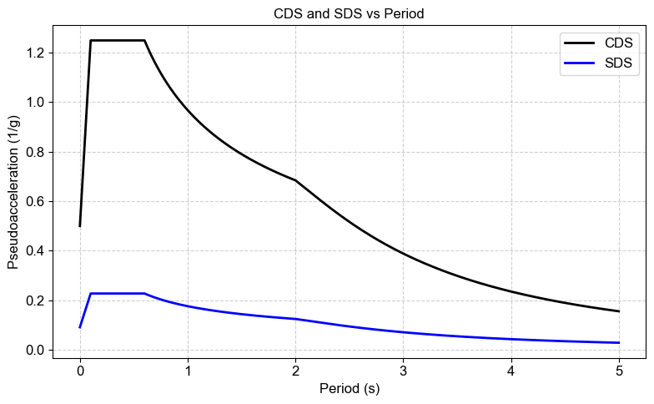
Fig. 6. Collapse design spectrum and service design spectrum

Seismic analysis considerations include the use of the transparent response spectrum, which is shown in figure 6 as the Collapse Design Spectrum (CDS). The spectrum was constructed in accordance with “Manual de Obras Civiles CFE” (Comisión Federal de Electricidad, 2015), following Equation (7). The choice of response spectrum for both collapse (CDS) and service (SDS) is arbitrary and only seeks to obtain a real spectrum that allows the behavior of a DG to be compared to.

$\text{Sa}〈{\text{T}}_{\text{e}}\text{,}\text{β}〉\text{=}\left\{\begin{matrix}\begin{matrix}{\text{a}}_{\text{0}}\text{+}\left[\text{c*}\text{β}〈{\text{T}}_{\text{e}}\text{,}{\text{ξ}}_{\text{e}}〉\text{-}{\text{a}}_{\text{0}}\right]\text{*}\frac{{\text{T}}_{\text{e}}}{{\text{T}}_{\text{a}}} & \text{ if }{\text{T}}_{\text{e}}\text{<}{\text{T}}_{\text{a}} \\ \text{c*}\text{β}〈{\text{T}}_{\text{e}}\text{,}{\text{ξ}}_{\text{e}}〉 & \text{ if }{\text{T}}_{\text{a}}\text{≤}{\text{T}}_{\text{e}}\text{<}{\text{T}}_{\text{b}}\end{matrix} \\ \begin{matrix}\text{c*}\text{β}〈{\text{T}}_{\text{e}}\text{,}{\text{ξ}}_{\text{e}}〉\text{*}{\left(\frac{{\text{T}}_{\text{b}}}{{\text{T}}_{\text{e}}}\right)}^{\text{r}} & \text{if }{\text{T}}_{\text{b}}\text{≤}{\text{T}}_{\text{e}}\text{<}{\text{T}}_{\text{c}} \\ \text{c*}\text{β}〈{\text{T}}_{\text{e}}\text{,}{\text{ξ}}_{\text{e}}〉\text{*}{\left(\frac{{\text{T}}_{\text{b}}}{{\text{T}}_{\text{c}}}\right)}^{\text{r}}\text{*}{\text{p}}_{\text{c}}〈{\text{T}}_{\text{e}}〉\text{*}{\left(\frac{{\text{T}}_{\text{c}}}{{\text{T}}_{\text{e}}}\right)}^{\text{2}} & \text{ if }{\text{T}}_{\text{e}}\text{≥}{\text{T}}_{\text{c}}\end{matrix}\end{matrix}\right.$ (7)

Where ${\text{a}}_{\text{0}}$ is the maximum acceleration on the ground (cm/s²), c is the maximum spectral acceleration (cm/s²),${\text{T}}_{\text{a}}$ is the lower limit of the design spectrum plateau (s), Tb is the upper limit of the design spectrum plateau (s), Tc is the structural period in the direction of analysis (s), $\text{β}〈{\text{T}}_{\text{e}}\text{,}{\text{ξ}}_{\text{e}}〉$ is the damping factor, which for a damping of 5% the value of $\text{β}〈{\text{T}}_{\text{e}}\text{,}\text{0.05}〉$ is equal to 1, r is the parameter that controls the fall of the spectral ordinate for ${\text{T}}_{\text{b}}\text{≤}{\text{T}}_{\text{e}}\text{<}{\text{T}}_{\text{c}}$, k is the parameter that controls the fall of the spectral ordinates for ${\text{T}}_{\text{e}}\text{≥}{\text{T}}_{\text{c}}$ and ${\text{p}}_{\text{c}}〈{\text{T}}_{\text{e}}〉$ is a factor used to define the variation of the spectrum in the descending branch calculated according to Equation (8).

$p_{c}〈T_{e}〉=k+\left(1-k\right)*{\left(\frac{T_{c}}{T_{e}}\right)}^{2}$ (8)

Equation (7) and Equation (8) are used to obtain the pseudo-acceleration spectrum in dimensionless units of acceleration relative to gravity (1/g), which is then multiplied by 9.81 m/s² to obtain the design spectrum.
Equation (7) is also used for obtaining SDS. In addition, the pseudo-acceleration values are divided by 5.5 and then multiplied by 9.81 m/s² to obtain SDS with which the maximum interstory drifts will be analyzed.

4. Results and discussion
4.1 10X_10Y_5P_4X4 and 10X_10Y_5P_6x6

The first typology to analyze is a 10m x 10m dimensions plan with a height-to-base ratio (h/b) of 2; considering 4 and 6 grids varying from a 1-module array to a 5-module array, each type.

When performing the structural design of the models with a floor plan measuring 10 m x 10 m, Table 4 shows the section resulting from the structural design as well as the volume of steel required for these sections, bearing in mind that each model has a different configuration and therefore a different volume.

Table 4. Results of 10m x 10m DG models

ID | Section | Steel volume (m³) | Angle (degrees) | Maximum interstory drift | Fundamental period of vibration (s)
10X_10Y_5P_4X4_1M | HSS10X10X5/16 | 2.702 | 57.99 | 0.00055 | 0.543
10X_10Y_5P_4X4_2M | HSS14X14X3/8 | 4.043 | 72.65 | 0.00160 | 0.765
10X_10Y_5P_4X4_3M | HSS12X12X5/8 | 5.420 | 78.23 | 0.00178 | 0.899
10X_10Y_5P_4X4_4M | HSS16X16X3/4 | 8.670 | 81.12 | 0.00227 | 1.165
10X_10Y_5P_4X4_5M | HSS20X20X5/8 | 9.217 | 82.87 | 0.00331 | 1.194
10X_10Y_5P_6X6_1M | HSS10X10X5/16 | 3.723 | 67.38 | 0.00053 | 0.458
10X_10Y_5P_6X6_2M | HSS10X10X5/8 | 7.414 | 78.23 | 0.00099 | 0.523
10X_10Y_5P_6X6_3M | HSS12X12X5/8 | 8.034 | 82.09 | 0.00182 | 0.954
10X_10Y_5P_6X6_4M | HSS16X16X5/8 | 10.897 | 84.05 | 0.00227 | 1.074
10X_10Y_5P_6X6_5M | HSS20X20X5/8 | 13.766 | 85.24 | 0.00298 | 1.273

The relationship between angle of perimeter grid and fundamental vibration period is shown in figure 7, where it can be observed that the greater the angle of the perimeter grid, the greater the fundamental vibration period. A higher vibration period value is due to lower structural rigidity, so we can directly relate the maximum inter-story drift shown in Table 4 with the period of vibration of the structure, where the largest values correspond to the DG of 5 modules.

The same inclination is found in the 4x4_3M model and 6x6_2m model, however they have a different fundamental vibration period, the first one is 0.899, while the second one is 0.523, this indicates a change in the stiffness of the system even with the same angle of perimeter grid, so it would be incorrect to state a conclusion based solely on this parameter.

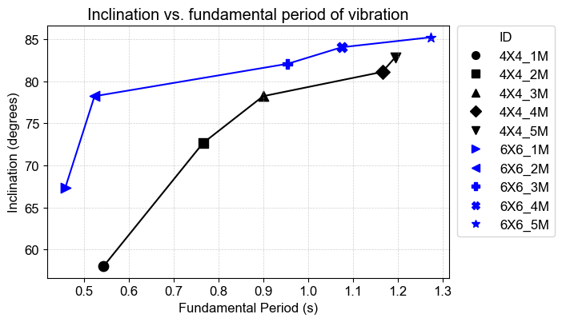
Fig. 7. Relation between DG angle and fundamental period of vibration in 10m x 10m array

The relationships in the drifts shown in figure 8 and the weights obtained through the steel volume shown in figure 9 are displayed in normalized form with respect to the maximum value in each case.

Drifts under SDS show a smooth distribution in figure 8, where DG arrangements with smaller modules show less displacement compared to arrangements with bigger modules. In addition, the lateral rigidity between the 4-grid and 6-grid models is very similar, with no significant difference between them.

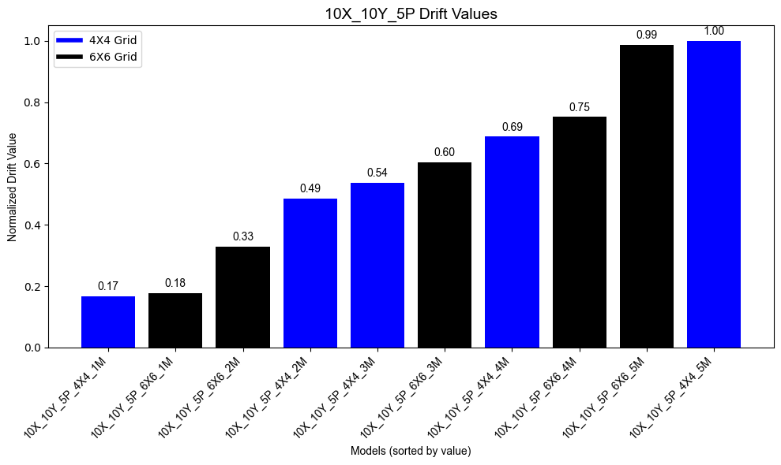
Fig. 8. Normalized drift values in 10m x 10m plan dimensions

The smooth and similar behavior of the drift changes when analyzing the weight of the perimeter grid in figure 8, where arrays with smaller modules weigh up to 80% less than those with larger ones. In addition, 4-grid models represent less weight than 6-grid models, which means that with similar drifts, using 4-grid models requires less steel than the 6-grid configuration.

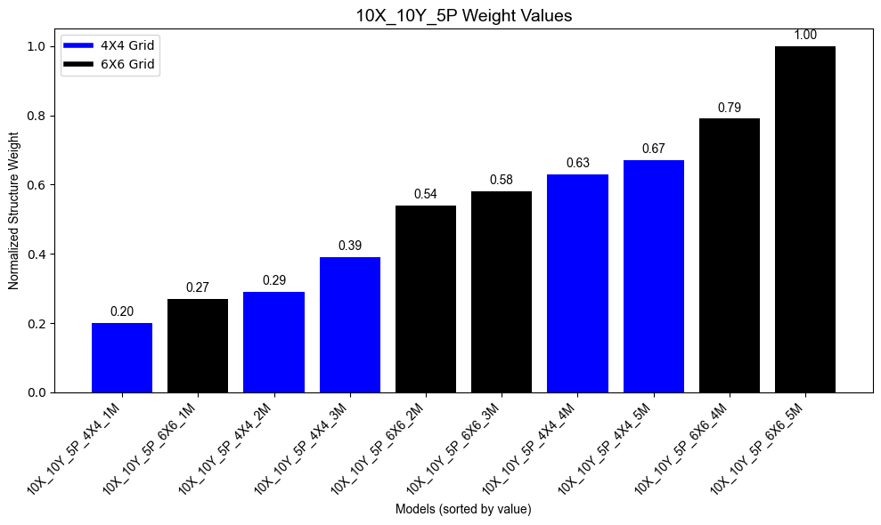
Fig. 9. Normalized weight in 10m x 10m plan dimensions

4.2 15X_15Y_5P_4X4 and 15X_15Y_5P_6x6

The second typology to analyze is a 15m x 15m dimensions plan with a ratio (h/b) of 1.33; considering 4 and 6 grids varying from a 1-module array to a 5-module array, each type.

Table 5 shows the ID of each model, the resulting section of the structural design, as well as the volume of steel required for these sections, the angle of inclination of each model, the maximum drift, and the fundamental vibration period.

Table 5. Results of 15m x 15m DG models

ID | Section | Steel volume (m³) | Angle (degrees) | Maximum interstory drift | Fundamental period of vibration (s)
15X_15Y_5P_4X4_1M | HSS14X14X3/8 | 5.290 | 46.85 | 0.00047 | 0.32
15X_15Y_5P_4X4_2M | HSS10X10X5/8 | 5.344 | 64.89 | 0.00174 | 0.395
15X_15Y_5P_4X4_3M | HSS16X16X5/8 | 7.570 | 72.65 | 0.00144 | 0.423
15X_15Y_5P_4X4_4M | HSS20X20X3/4 | 11.155 | 76.81 | 0.00192 | 0.432
15X_15Y_5P_4X4_5M | HSS22X22X3/4 | 12.225 | 79.38 | 0.00302 | 0.545
15X_15Y_5P_6X6_1M | HSS12X12X5/16 | 4.896 | 57.99 | 0.00043 | 0.31
15X_15Y_5P_6X6_2M | HSS10X10X5/8 | 7.604 | 72.65 | 0.00089 | 0.383
15X_15Y_5P_6X6_3M | HSS16X16X5/8 | 11.071 | 78.23 | 0.00122 | 0.432
15X_15Y_5P_6X6_4M | HSS20X20X5/8 | 13.885 | 81.12 | 0.00182 | 0.475
15X_15Y_5P_6X6_5M | HSS22X22X3/4 | 18.164 | 82.88 | 0.00240 | 0.525

Figure 10 shows that as the dimensions of the DG story increase, the stiffness increases and therefore the fundamental period decreases, with fundamental period values between 0.31 and 0.545, while in figure 7 we had values between 0.458 and 1.273. This shows the direct effect of decreasing the ratio (h/b) from 2 to 1.33, even when the angle of the perimeter grid remains at similar values between the 10m x 10m and 15m x 15m types.

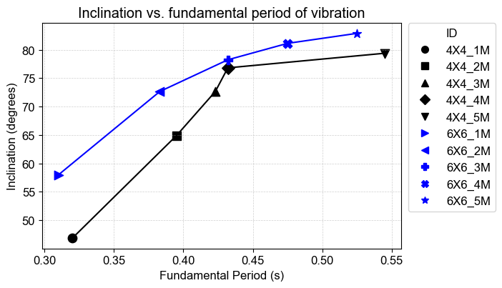
Fig. 10. Relation between DG angle and fundamental period of vibration in 15m x 15m array

In figure 11, drifts under SDS show an important difference between 4-grid and 6-grid models, varying their values up to 28%. These differences are due to an irregular stress distribution, which makes the 4-grid model option more rigid.

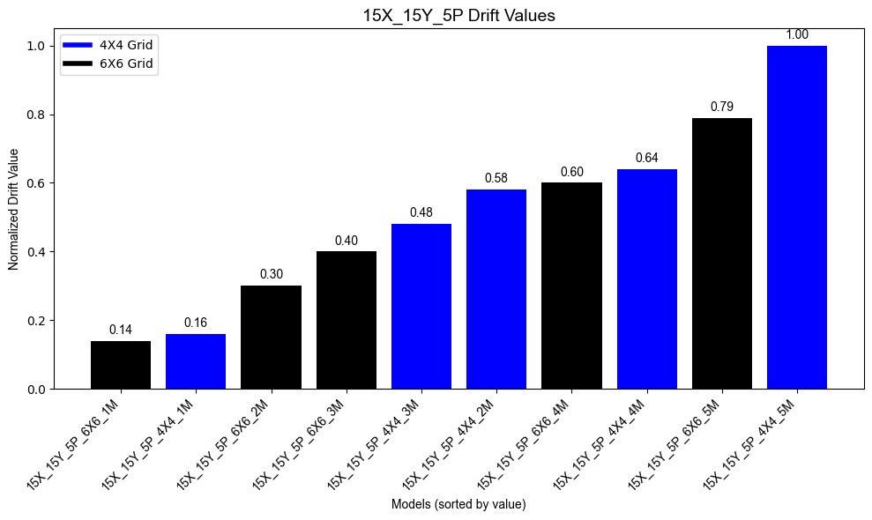
Fig. 11. Normalized drift values in 15m x 15m plan dimensions

However, in figure 12, the 6-grid array offers lighter options than the 4-grid array. Both 1-module array structures have similar weights and drifts, but as the module size increases, the 4-grid option needs less weight than the 6-grid to achieve an adequate ratio between capacity and demand.

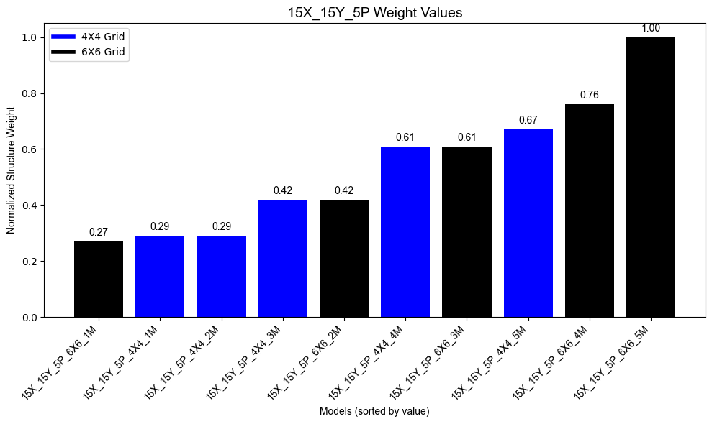
Fig. 12. Normalized weight in 15m x 15m plan dimensions

4.3 30X_30Y_5P_6X6 and 30X_30Y_5P_8x8

The third typology to analyze is a 30m x 30m dimensions plan with a ratio (h/b) of 0.67. This type is the only one that represents a building that is wider than taller, the spans of DG with a 4-grid array shouldn’t be adequate due to the dimension; due to this, the behavior of 6-grid and 8-grid models is analyzed.

Table 6 shows the ID of each model, the resulting section of the structural design, the volume of steel required for these DG types, angle of the perimeter grid of each model, the maximum interstory drift, and the fundamental vibration period.

Table 6. Results of 30m x 30m DG models

ID | Section | Steel volume (m³) | Angle (degrees) | Maximum interstory drift | Fundamental period of vibration (s)
30X_30Y_5P_6X6_1M | HSS16X16X7/8 | 23.643 | 38.66 | 0.00039 | 0.257
30X_30Y_5P_6X6_2M | HSS16X16X7/8 | 17.417 | 57.99 | 0.00382 | 0.47
30X_30Y_5P_6X6_3M | HSS22X22X7/8 | 22.578 | 67.38 | 0.00287 | 0.627
30X_30Y_5P_6X6_4M | HSS25X25X7/8 | 27.398 | 72.65 | 0.00216 | 0.509
30X_30Y_5P_6X6_5M | HSS25X25X1 | 30.646 | 75.96 | 0.00528 | 0.709
30X_30Y_5P_8X8_1M | HSS14X14X5/8 | 17.151 | 46.85 | 0.00035 | 0.271
30X_30Y_5P_8X8_2M | HSS18X18X5/8 | 18.059 | 64.89 | 0.00253 | 0.403
30X_30Y_5P_8X8_3M | HSS18X18X1 | 26.519 | 72.65 | 0.00237 | 0.565
30X_30Y_5P_8X8_4M | HSS22X22X1 | 32.315 | 76.81 | 0.00304 | 0.493
30X_30Y_5P_8X8_5M | HSS25X25X1 | 40.332 | 79.38 | 0.00435 | 0.642

Figure 13 shows the relationship between the angle of the perimeter grid and the fundamental vibration period. An increasing but irregular behavior can be observed as the modules grow. This suggests that because the DG are wider than taller, the DG system exhibits significant shear lag, which directly impacts its vibration pattern due to the abrupt change in stiffness at the end of each module. The 1-module configuration is more stable, even with a 6x6 or 8x8 grid.

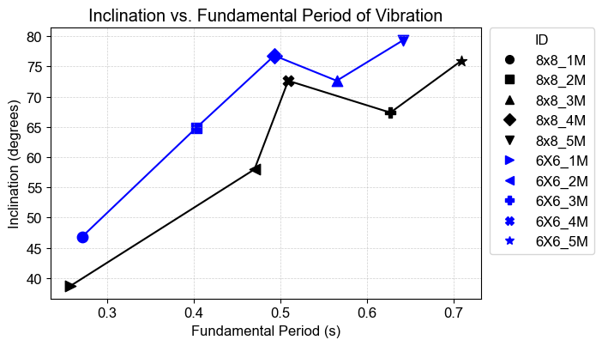
Fig. 13. Relation between DG angle and fundamental period of vibration in 30m x 30m array

In figure 14, the results for drifts under SDS show a difference of half the drift between the 1-module models and the 2-module models, which are the models with the closest behavior, and 80% with respect to the 5-module models. Figure 14 confirms what was established in figure 13, concluding that the behavior in response to lateral displacements is more stable in the 1-module configurations than in the others.

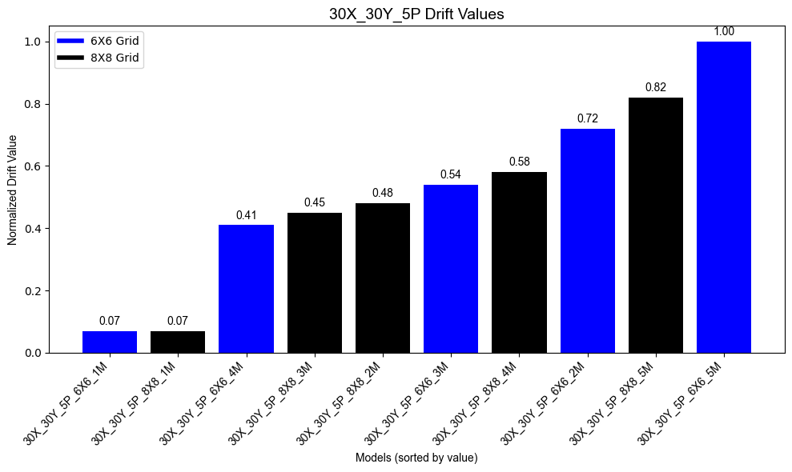
Fig. 14. Normalized drift values in 30m x 30m plan dimensions

Figure 15 shows the weights of all the different arrangements, where the difference in weight between the lightest and heaviest options is close to 50%. This configuration has the smallest difference between the extreme values because it is the configuration with the direction of analysis greater than the total height of the structure.

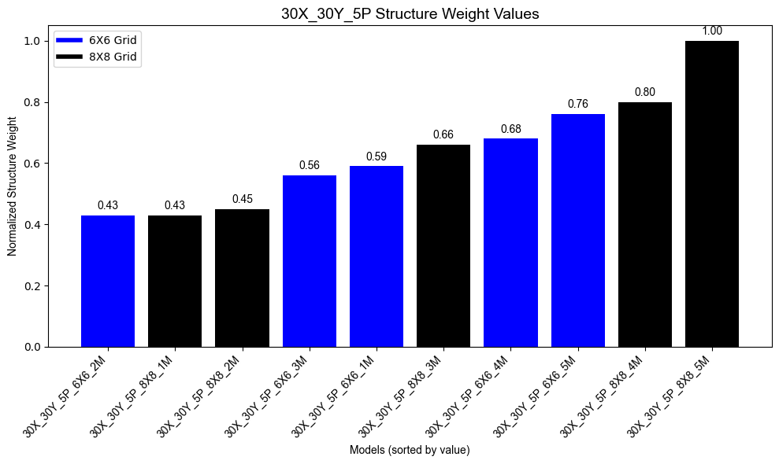
Fig. 15. Normalized weight in 30m x 30m plan dimensions

5. Conclusion

A comparative study of 5-story DG was developed. The following conclusions are established from the results obtained:

- It was observed that the arrangement that minimizes weight in the DG is the 1-module type.

- While the size of the module decreases, the fundamental vibration period decreases, and the DG becomes more rigid.

- In general, modifying the grid quantity determines the angle of inclination that each structure should have. There are DGs with the same angle in the perimeter grid and the same dimensions in plan, which behave differently due to the density of diagonals.

- DG with ratios (h/b) less than one has an irregular behavior and causes variations in the dynamic properties of the structure when modules greater than 1 are used.

- Finally, the 1-module arrangement is the option recommended by the authors in 5-story DG, due to the low ratio (h/b).

One of the main points of comparison in optimizing the structural design of DG is the angle of the perimeter grid. The authors consider that the geometry of each story, as well as the number of spans in the structure, modify the lateral stiffness and the behavior of the structure, even when the specimens have the same angle in the perimetral grid.

COMPETING INTERESTS DISCLAIMER:
Authors have declared that they have no known competing financial interests OR non-financial interests OR personal relationships that could have appeared to influence the work reported in this paper.

References

Montejano-Castillo, M., Moreno-Villanueva, M., & Espinosa-Jiménez, E. (2020). Mapping vertical urban growth in Mexico City in a seismic risk context. International Journal of Safety and Security Engineering, 10(1), 97–103. https://doi.org/10.18280/ijsse.100113

Mele, E., Toreno, M., Brandonisio, G., & De Luca, A. (2014). Diagrid structures for tall buildings: case studies and design considerations. The Structural Design of Tall and Special Buildings, 23(2), 124-145. https://doi.org/10.1002/tal.1029

Shah, M. I., Mevada, S. V., & Patel, V. B. (2016). Comparative study of diagrid structures with conventional frame structures. International Journal of Engineering Research and Applications, 6(5), 22-29.

Google. (2025). Google Maps [Map]. Retrieved October 30, 2025, from https://maps.app.goo.gl/CAWPSiTzv3sGqAYe6

Ramírez, A. Q., Gilmore, A. T., & Medrano, M. S. (2024). Earthquake-resistant and environmental advantages of diagrid systems in high seismicity zones. Journal of Building Technology, 6(1), 2717-5103. https://doi.org/10.32629/jbt.v6i1.2188

Moon, K.-S., Connor, J. J., & Fernandez, J. E. (2007). Diagrid structural systems for tall buildings: characteristics and methodology for preliminary design. The Structural Design of Tall and Special Buildings, 16(2), 205-230. https://doi.org/10.1002/tal.311

Lacidogna, G., Nisticò, G., Scaramozzino, D., & Carpinteri, A. (2020). Diagrid systems coupled with closed- and open-section shear walls: Optimization of geometrical characteristics in tall buildings. Procedia Structural Integrity, 25, 402-409. https://doi.org/10.1016/j.prostr.2020.04.035

Singh, A., Gaikwad, P., & Mandal, S. (2024). Effect of wind loading pattern on shear lag phenomenon in framed-tube building. Journal of Rehabilitation in Civil Engineering, 12(1), 1-17. https://doi.org/10.22075/jrce.2023.28689.1729

Terán-Gilmore, A., Roeslin, S., Tapia-Hernández, E., & Cuadros-Hipólito, E. (2020). Displacement-based design of tall earthquake-resistant diagrid systems. Journal of Building Engineering, 35, 102022. https://doi.org/10.1016/j.jobe.2020.102022

Terán-Gilmore, A., & Coeto, G. (2014). DIMENSIONADO PRELIMINAR BASADO EN RIGIDEZ DE EDIFICIOS ALTOS CON ESTRUCTURA DE ACERO RIGIDIZADOS CON DIAGONALES CONCÉNTRICAS. Revista Ingeniería Sísmica, 90, 34-54. http://www.scielo.org.mx/scielo.php?script=sci_arttext&pid=S0185-092X2014000100002

Computers and Structures, Inc. (2006). ETABS Nonlinear Ver. 9, Extended Three-Dimensional Analysis of Building Systems. Berkeley, CA, USA.

American Institute of Steel Construction. (2022). Specification for Structural Steel Buildings (ANSI/AISC 360-22). American Institute of Steel Construction.

Comisión Federal de Electricidad. (2015). Manual de diseño de obras civiles: Sección C: Estructuras, Tema 1: Criterios generales de análisis y diseño, Capítulo C.1.3: Diseño por sismo (Recomendaciones). México: Comisión Federal de Electricidad.

