Phytochemical and sensory analysis of developed Fortified rice cake

Abstract
The food sector has experienced significant transformation, primarily as a result of the creation and application of new technologies to satisfy consumers' growing needs for convenience foods. In recent years, there has been an increasing demand for healthier food products from consumers and health professionals. However, because many patrons tend to think that selecting wholesome meals directly contradicts enjoying oneself while eating. The methodology involve the development of the fortified rice cake by using different gram of fortified rice flour. Some phytochemicals like phenolic, tannin, glycoside, saponins and flavonoids are present and absent in the developed product. Organoleptic evaluation is completed by using composite score card the panelist for sensory evaluation are untrained. Sensory evaluation has been done by 30 peoples all the panelist members are untrained and there age is between 22 to 35 year old and the outcome of the result is the T1 sample is more acceptable between the peoples.
Key words – Fortified rice cake, sensory analysis, phytochemical analysis
Introduction
Consumers and health professionals have been calling for healthier food products more frequently in recent years. But because customers frequently believe that choosing nutritious food puts pleasure eating in direct conflict with health, food firms have tackled this challenge with relatively little success (Tuorila & Cardello, 2002). Around the world, a lot of bakery products are consumed. This enormous popularity among processed foods can be attributed to a number of factors, such as their affordable pricing, long shelf life, easy availability, and variety of tastes (Kohajdová et al., 2009). Their development has gone through several phases of advancement, leading to an increasing diversity in the present (Canja CM). Cakes and other bakery goods are frequently consumed and are high in calories, fats, and carbs but low in fiber, vitamins, and minerals (Tarrega et al., 2017). Providing wholesome food is a viable strategy for the food sector. As a result, meals that are enhanced with antioxidants and dietary fibers have been created, especially in baked goods like cakes, To improve cake quality and make up for the lack of functional and nutritional components, fortified cake goods with a lot of plants and acceptable organoleptic qualities would be required (Roni et al., 2021). The purpose of the current study is to evaluate how the functional, nutritional, and sensory qualities of the sponge cake are affected when jujube powder is substituted for wheat flour (Najjaa et al., 2020).
Numerous scientific studies have examined the beneficial association between diet and health in order to determine the impact of individual foods or dietary elements on various bodily processes. Foods with beneficial qualities are referred to as "functional food"(Canja CM). When looking at sustainable protein sources, pulses have garnered attention due to their high protein concentration (20–40%). Pulses are a great ingredient for gluten-free cooking and have been used to enhance the protein content of bread and pasta (Balasooriya & Wickramasinghe, 2018). Methods of wet and dry fractionation, along with bioprocessing techniques like germination and fermentation, offer valuable resources for creating novel functional pulse components (Bessada et al., 2019). Pulses will undoubtedly be used more in the future. Particularly when combined with cereal raw materials, they may find new uses that satisfy the dietary and sensory requirements of people on every continent (Sozer et al., 2016).
Over the previous few decades, the food industry has undergone tremendous change, mostly due to the development and use of new technology to meet consumers' rising demands for convenience foods (Alashbayeva et al., 2021). A growing number of bread products with high protein content are made with bean flours. Because the proteins found in legumes have a balanced amino acid composition and provide nutritional benefits, they are the ideal ingredient to increase the nutritional value of baked foods. A growing number of bread products with high protein content are made with bean flours (Yu & Beta, 2015). Because legume proteins have a balanced amino acid content and provide nutritional benefits, they are the ideal ingredient to increase the nutritional value of baked foods (Koubaier et al., 2015).
Developing a cake which is fusion of cereals and pulses and provide energy as well as health benefits. The objective of the is to perform organoleptic evaluation of the prepared product and observing the presence and absence of phytochemicals in the fortified rice cake.

2. Material and Method
The Food Science and Technology Laboratory (FSTL) of Babasaheb Bhimrao Ambedkar University in Lucknow successfully finished the research in nine months. Following the planning of a realistic meal that precisely reflects the desired measures, the primary school and an internet platform were used to gather and choose the ingredients (blink it).
The proportions of each component were chosen to ensure that the final product would have an adequate amount of nutrients without sacrificing texture or flavor.
2.1 Quantity of ingredients used in different sample
Table 1. Quantity of ingredients used in different sample
Ingredient | Sample
Ingredient | To | T1 | T2
Refined Flour  Fortified rice flour  Green gram flour  Dry fruit powder  Sugar  Cocoa powder  Vanilla essence  Butter  salt  Baking powder | 70g  0  10g  10g  40g  5g  2tsp  10g  0.30g  5g | 35g  35g  10g  10g  40g  5g  2tsp  10g  0.30g  5g | 45g  25g  10g  10g  40g  5g  2tsp  10g  0.30g  5g
Total | 150g | 150g | 150g

2.2 Preparation of product
Utilizing an electronic weighing balance, each ingredient was measured. After whisking butter and sugar to make a homogeneous batter, add one teaspoon of vanilla extract. The prepared batter is mixed with refined flour, fortified rice flour, green gram flour, dry fruit powder, cocoa powder, baking powder, and baking soda, sifted two or three times in total. After preparing the batter and lining a cake tin, butter paper was greased and the oven was preheated to 180°C for 15 minutes, followed by 25 minutes of baking at that temperature.
Chart 1. Flow chart of making Fortified rice cake

Weighed all the ingredients

Mixed sugar and butter together

Mixed sugar and butter together

Made a thick consistency

Greased aluminum tin

Poured the batter into the tin

Preheated the oven at 180°C for 15 min

Kept the tin into the oven at 180°C for 25 min

Took out the cake and packed it

2.3 Phytochemical Analysis

Table 2. Phytochemical Analysis
Phytochemical | Test performed | Methodology and expected observation
Phenolic Compounds | FeCl₃ test | In 1 ml of sample, added 2 ml distilled water followed by 3–4 drops of ferric chloride solution. Formation of blue-green color will give a positive result (Trease GE, 1989)
Tannins | Braemer’s test | Added 2 ml of 10% alcoholic ferric chloride to 2 ml of sample. Dark blue color will indicate its presence (Kumar et al., 2007).
Glycosides | Keller–Kiliani test | In 1 ml of sample, added 3 ml of chloroform and H2 SO4 to form a layer. Brown ring at interphase indicates positive result(Onwukaeme et al., 2007).
Saponins | Foam test | Took 1 ml of sample and added few drops of water, followed by vigorous shaking. Observed for the presence and persistence of froth for few minutes (Trease GE, 1989).
Flavonoids | NaOH test | To 1 ml of sample added few drops of 2N NaOH solution. Occurrence of yellow color will indicate a positive result (Trease GE, 1989).
Quinones | H₂ SO₄ | To 1 ml of sample added 1 ml of conc. H₂ SO₄ . Presence of red color will indicate a positive test (Trease GE, 1989).

2.4 Sensory Evaluation
The study was conducted in Food Sensory Lab in Babasaheb Bhimrao Ambedkar University, Lucknow. The sensory analysis was carried out in the Food Processing Lab in Department of Food and Nutrition in Babasaheb Bhimrao Ambedkar University, Lucknow. The sensory analysis is perform by 30 untrained panelist on composite scoring test on the basis of their colour, consistency, flavor, absence of defects and total score.
An overall assessment of the food product's sensory acceptability would be provided by the composite scoring test's total score. This thorough technique offers insightful information on consumer preferences and product quality as well as enables a thorough evaluation of a variety of sensory qualities. Because the panelists are not trained, the evaluations are guaranteed to represent the opinions of the general public, which extends the applicability of the findings to a larger group of consumers (Meilgaard et al., 2006).
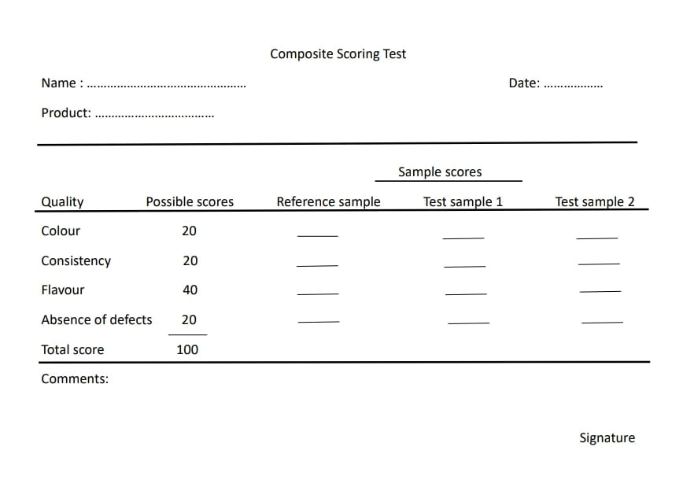
Fig 1. composite score card
3. Result and Discussion
Discussion
The naturally occurring compounds known as phytochemicals have demonstrated enormous health benefits for humans due to their high anti-inflammatory and antioxidant properties. The study of phytochemical of fortified rice cake with green gram pea, its revealed the presence and absence of phytochemicals.
Thirty untrained panelists were selected from inside the Department to participate in the sensory evaluation of the fortified rice cake. Each panelist received a sample of a fortified rice cake, and they were instructed to rate the rice cake according to its appearance, taste, aroma, and texture. A systematic questionnaire or rating scale was used to solicit feedback from the panelists, and the results were examined to ascertain the overall approval of the fortified rice cake.
Results
Table 3. Observation of phytochemicals
Sr. No | Phytochemicals | Observation(To, T1 & T2)
1 | Phenolic | +
2 | Tannin | -
3 | Glycoside | +
4 | Saponins | -
5 | Flavonoid | +
6 | Quinones | -

Where,
“+” shows the presence
“-” shows the absences
Sensory evaluation
The results of all the samples are presented in the form of table and graph by calculating the mean vale
The result of sample one is shown below:
Table 4. Average of sensory Evaluation of ample To
Sr. No | Parameters | Average Score
1 | colour | 17.96667
2 | Texture | 18.86667
3 | flavor | 19.86667
4 | Absence of defect | 20.86667
5 | Total Score | 77.56667

Fig 2 Mean Value of To
Table 5. Average of sensory Evaluation of sample T1
Sr. No | Parameters | Average
1 | Colour | 19.33333
2 | Texture | 19.33333
3 | flavor | 39.1
4 | Absence of defect | 19.33333
5 | Total score | 97.1

Fig 3. Mean Value of T1
Table 6. Average of sensory evaluation of sample T2
S.No | Parameter | Average
1 | colour | 17.66667
2 | Texture | 17.7
3 | Flavor | 37.8
4 | Absence of defect | 18.3
5 | Total score | 91.46667

Fig 4. Mean value of T2
In prepared samples the sample T1 is more acceptable than compare to other two sample (To & T2) by taste, texture, colour .
The overall presentation of samples which one is more acceptable.

Fig 5. Overall presentation of all sample
4. Conclusion
The aim of this study is to create a cake that is a healthy and nutritious treat in addition to being a mouthwatering delight. In order to do this, the emphasis is on including rice flour that has been fortified with vital vitamins and minerals to improve the nutritional content of the cake. In addition, adding protein-rich green gram peas to the cake improves its texture and nutritional value by adding more protein and other necessary elements. Dried fruits are also added, like raisins, apricots, or cranberries, which naturally increase the cake's sweetness and contribute vitamins, minerals, and antioxidants. Carefully balancing these components will result in a cake that is both aesthetically pleasing and compliant with nutritional requirements for general health maintenance. The phytochemicals which are naturally occur in plant some of them are present and absent. The sensory evaluation test is done, the panelist accurately differentiated between all the three samples based on sensory quality on a composite scoring and the most acceptable sample is T1.

Reference
- Najjaa, H., Ben Arfa, A., Elfalleh, W., Zouari, N., & Neffati, M. (2020). Jujube (Zizyphus lotus L.): Benefits and its effects on functional and sensory properties of sponge cake. PloS one, 15(2), e0227996.
- Tuorila, H. and Cardello, A. V. (2002) Consumer responses to an off-flavor in juice in the presence of specific health claims. Food Quality and Preference
- Canja CM, Mãzãrel A, Lupu MI, Mãrgean A, Pãdureanu V. Dietary fiber role and place in baking products. Bulletin of the Transilvania University of Brasov Forestry, Wood Industry, Agricultural Food Engineering Series II.
- Sozer, N., Holopainen‐Mantila, U., & Poutanen, K. (2017). Traditional and new food uses of pulses. Cereal Chemistry, 94(1), 66-73.
- Alashbayeva, L., Shansharova, D., Mynbayeva, A., Borankulova, A., & Soltybayeva, B. (2021). Development of technology for bakery products. Food Science and Technology, 41, 775-781.
- Koubaier HBH, Snoussi A, Essaidi, Chabir M, Bouzouita N. Cake quality evaluation made of wheat–lentil flour blends, J new sciences, Agri and Biotech. 2015; 17:937- 942.
- Trease GE, Evans WC. Pharmacognosy: A Physicians Guide to Herbal Medicine. 13th ed. London, UK: Bailliere Tindall; 1989.
- Kumar GS, Jayaveera KN, Kumar CK, Sanjay UP, Swamy BM, Kumar DV. Antimicrobial effects of Indian medicinal plants against acne-inducing bacteria. Trop J Pharm Res 2007;6:717-23
- Onwukaeme DN, Ikuegbvweha TB, Asonye CC. Evaluation of phytochemical constituents, antibacterial activities and effect of exudates of Pycanthus angolensis Weld Warb (Myristicaceae) on corneal ulcers in rabbits. Trop J Pharm Res 2007;6:725-30.
- Meilgaard, M. C., Carr, B. T., & Civille, G. V. (1999). Sensory evaluation techniques. CRC press.
- Singh, N., & Sudha, M. L. (2024). Natural food flavours: a healthier alternative for bakery industry—a review. Journal of food science and technology, 61(4), 642-650.
- Kohajdová, Z., Karovičová, J., & Schmidt, Š. (2009). Significance of emulsifiers and hydrocolloids in bakery industry. Acta Chimica Slovaca, 2(1), 46-61.
- Tarrega, A., Quiles, A., Morell, P., Fiszman, S., & Hernando, I. (2017). Importance of consumer perceptions in fiber-enriched food products. A case study with sponge cakes. Food & function, 8(2), 574-583.
- Bessada, S. M., Barreira, J. C., & Oliveira, M. B. P. (2019). Pulses and food security: Dietary protein, digestibility, bioactive and functional properties. Trends in Food Science & Technology, 93, 53-68.
- Balasooriya, R. N., & Wickramasinghe, I. (2018). Development and evaluation of physicochemical properties of pulse added protein rich pasta. European Journal of Engineering and Technology Research, 3(12), 56-59.
- Yu, L., & Beta, T. (2015). Identification and antioxidant properties of phenolic compounds during production of bread from purple wheat grains. Molecules, 20(9), 15525-15549.
- Roni, R. A., Sani, M. N. H., Munira, S., Wazed, M. A., & Siddiquee, S. (2021). Nutritional composition and sensory evaluation of cake fortified with moringa oleifera leaf powder and ripe banana flour. Applied Sciences, 11(18), 8474.

