Original Research Article
Electrocardiographic and echocardiographic characteristics of elite Moroccan football players: A sex-based cross-sectional study.

.
ABSTRACT

Objective: This study assessed the cardiac adaptation in elite Moroccan male and female football players using electrocardiography and echocardiography, with a focus on gender-specific similarities and differences.
Methods: Cross-sectional electrocardiography and echocardiography data from male and female athletes from football clubs in the Marrakech-Safi region, were collected at the Avicenna Military Hospital, Marrakech, during pre-competition assessments for Royal Moroccan Football Federation (RMFF) and FIFA competitions (2024-2025). Electrocardiography and echocardiography findings were interpreted according to international athlete-specific reference criteria.
Results: A total of 210 athletes were included (119 [56.1%] male; mean [SD] age, 22.5 [1.7] years). Female athletes showed a higher prevalence of normal training-related electrocardiography findings, while males displayed a slightly higher prevalence of mildly abnormal patterns (3.8% vs 2.8%, P < .001). Voltage criteria for left ventricular hypertrophy were present in 4.7% of males and 6.6% of females. No distinct electrocardiography abnormalities were detected. Echocardiography revealed no pathologic findings requiring restriction from sport, although some athletes exceeded ranges for exercise-induced remodeling defined in the guidelines. Increased left ventricular mass index was observed in 3 female athletes (3.1%) but in no males. Left ventricular wall thickness was normal in all athletes. Left ventricular cavity diameter >54 mm was observed in 6% of females, whereas no male athlete exceeded 60 mm.
Conclusions: Moroccan male and female football players exhibit limited electrocardiography and echocardiographic characteristics, consistent with physiological cardiac remodeling induced by intensive training. Accurate distinction between these benign adaptations and pathological findings is vital for reliable cardiovascular assessment and safe athletic performance.

Keywords: Athlete’s heart; football ; sex differences; Electrocardiography; Echocardiography.

- Introduction :

Athlete's heart is a well-documented physiological response to high-level training characterized by structural and electrical remodeling, which is detectable on electrocardiography (ECG) and echocardiography. These changes, although benign, may overlap with the features of pathologic disorders such as hypertrophic cardiomyopathy or dilated cardiomyopathy, and thus pose a challenge to clinical interpretation.
Past studies have demonstrated gender-specific differences in cardiac adaptation among athletes, including variation in left ventricular size, mass, and ECG patterns. The majority of the data, however, are from populations residing in Europe or North America, and little is available from North Africa. Given the increasing number of Moroccan soccer players competing in regional and international leagues, accurate characterization of cardiac adaptation in the population is of paramount importance.
The aim of the present study was to compare the electrocardiographic and echocardiographic parameters of elite Moroccan male and female football players, highlighting gender similarities and differences.
- Methods

- Study Design : It was a cross-sectional study during pre-competition assessments for the 2024/2025 season.
- Participants : Top male and female soccer players from Marrakesh-Safi region clubs that were preparing for competitions to be held by the Royal Moroccan Football Federation (RMFF) and FIFA were considered. Participants with a known history of cardiovascular disease, hypertension, or structural cardiac disease were excluded.
Each athlete completed a structured questionnaire covering training history and playing position. Mean weekly training time was 10.5 ± 2.1 hours, including field and gym sessions. Mean football experience was 9.3 ± 3.7 years with no sex difference (P = 0.214).

Player positions were goalkeepers 10.9% (n = 23), defenders 31.2% (n = 66), midfielders 35.8% (n = 75), and forwards 22.1% (n = 46). Training load and competition level were similar between male and female athletes. All were registered for national-level events under the RMFF.

- Setting : All the tests were done in the Department of Cardiology, Avicenna Military Hospital, Marrakech.
- Data Collection : Each participant was subjected to a standard 12-lead electrocardiogram (ECG) and transthoracic echocardiography according to international guidelines. ECG findings were graded according to the International Criteria for ECG Interpretation in Athletes. Echocardiographic measurements were interpreted according to European Society of Cardiology guidelines for evaluating athletes.
- Outcome Measures : The principal results were electrocardiographic and echocardiographic characteristics, analyzed independently for male and female sportsmen.
- Statistical Analysis : Continuous data were expressed as mean ± standard deviation (SD), while categorical data were expressed as frequency and percentages. Continuous variables were compared between sex groups using Student’s t tests and are expressed as mean SD. Categorical variables were compared using chi squared or Fisher’s exact test and are expressed as number (percent). A two-tailed P value of less than 0.05 was considered statistically significant.

- Results
- Participant Characteristics
A total of 212 elite soccer players were included in the study: 93 females and 119 males.
The mean age was similar in groups (22.1 ± 4.3 vs. 22.5 ± 1.7 years; P = 0.378). As expected, the men were significantly taller (178 ± 5.4 vs. 163 ± 5.9 cm; P < 0.001), heavier (72.5 ± 6.2 vs. 59.0 ± 8.5 kg; P < 0.001), and had a larger body surface area (1.89 ± 0.10 vs. 1.63 ± 0.14 m²; P < 0.001). The men's body mass index was slightly but significantly greater (22.7 ± 1.3 vs. 22.0 ± 2.6 kg/m²; P = 0.014).
No differences were significant regarding systolic blood pressure. Diastolic blood pressure was, however, slightly higher in female players(66.7 ± 6.8 vs. 63.7 ± 3.9 mmHg; P < 0.001), and the resting heart rate was lower in men(51.7 ± 9.9 vs. 64.6 ± 8.5 bpm; P < 0.001).(Table1)

- Electrocardiographic Findings
Men had longer PR and QRS intervals compared to women (both P < 0.001), while the corrected QT interval was slightly shorter in men (399 ± 26.6 vs. 411 ± 21.9 ms; P < 0.001).
With regard to international ECG criteria, early repolarization (26.9% vs. 3.8%; P < 0.001) and sinus bradycardia (44.8% vs. 13.2%; P < 0.001) were more frequent in men. First-degree atrioventricular block was also observed more often in men (6.6% vs. 1.4%; P = 0.023). The rest of the borderline or abnormal findings, such as incomplete right bundle branch block, axis abnormalities, or atrial enlargement, presented no sex-related differences relevant to the results. No high-risk ECG patterns such as ventricular pre-excitation, Brugada pattern, or significant repolarization abnormalities were observed in any of the players. (Table 2)

- Echocardiographic Findings
Male athletes also possessed significantly greater left ventricular size and wall thickness compared with female athletes (figure 1). LV end-diastolic diameter (50.1 ± 2.7 vs. 45.1 ± 4.4 cm), interventricular septal thickness (9.8 ± 0.7 vs. 7.3 ± 1.0 cm), posterior wall thickness (9.0 ± 1.0 vs. 7.5 ± 1.1 cm), and LV mass index (89.3 ± 13.2 vs. 63.7 ± 14.0 g/m²) were all significantly increased in men (P < 0.001 for all) (figure 2).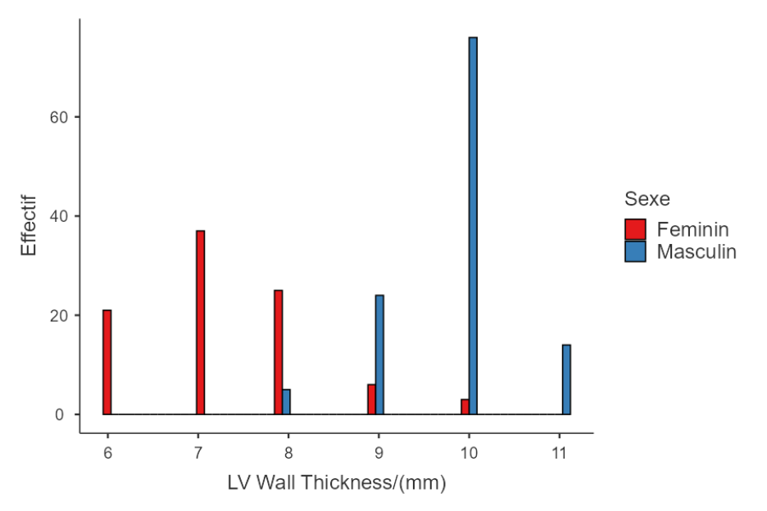
Fig 1 : Distribution of Left Ventricular Wall Thickness by Sex

LV end-diastolic volume, indexed and absolute, was greater in men (118 ± 16 vs. 79.9 ± 17.8 ml; P < 0.001). Ejection fraction was slightly elevated in men (62.9% vs. 59.7%; P = 0.004) (figure 2).
Left atrial end-systolic dimension and right atrial dimension also were larger in men, but indexed left atrial dimension and volume were similar between the sexes. Aortic root and proximal ascending aortic dimensions were also larger in men (P < 0.001) (figure2).
Doppler findings indicated elevated E/A ratio, elevated lateral e′ velocity, and elevated pulmonary artery acceleration time in men, whereas estimated pulmonary artery systolic pressure was comparable between the groups. Right ventricular function and size were normal in all players (Table 3).
- Discussion
This study provides new insights on the echocardiographic and electrocardiographic characteristics among elite Moroccan footballers, and highlights the sex-specific differences. Our studies show that the male and female athletes exhibit findings consistent with physiological remodeling and did not demonstrate any evidence for pathological alterations requiring sport restriction. Interestingly, sex-specific patterns were observed and are consistent with international literature while also providing new knowledge using a North African population.
Our findings support those produced by Churchill et al. [1] in presenting that elite female soccer players had decreased left ventricular (LV) cavity dimensions and decreased LV mass compared to men while retaining the same training intensity. Female athletes in the present study also had decreased diameters at the LV, and some values were higher than values recommended by the guidelines, once more highlighting the fact that sex-specific reference values should be employed while analyzing athletic data.
The African perspective matters particularly because there isn't much research targeting this population. Ngabea et al. [2], in their study of Nigerian national football players, they registered the occurrence of physiological ECG and echocardiographic patterns in the absence of pathologic findings. Similarly, the Ph.D. thesis done by P.Pambo [3] that investigated the patterns of echocardiography among the Ghana football team members emphasized the anticipated properties of the athlete’s heart and the need to establish the normative values adapted to African athletes. Our results among Moroccan football players confirm the trend and sustain the hypothesis that regional and racial differences may influence the range of the standard cardiac remodeling, as also suggested by Rawlins et al. [4] and Di Paolo et al. [5].
From a global perspective, our data support the findings of Sharma et al. [6] and Finocchiaro et al. [7] that the physiological limits of remodeling, particularly left ventricular hypertrophy and chamber size, are preserved in clearly defined borders for the majority of the athletes. No participants showed echocardiographic patterns suggestive of hypertrophic cardiomyopathy, dilated cardiomyopathy, or other pathological remodeling types, highlighting the importance of differentiating disease and benign adaptation to avoid unnecessary disqualification [8- 9]
The clinical implications are significant. Association with sudden cardiac death among young athletes is most commonly observed in football, as documented in previous studies [10-11].Systematic pre-competition medical assessments, therefore, as recommended by FIFA [12] cannot be overstated. Our study supports the inclusion of ECG and echocardiography in such screening, in line with international recommendations [13-14].
Strengths and Limitations
One important strength of this study lies in the large and sex-balanced population of North African athletes, who offer new perspectives on a population in sports cardiology research. A further strength is the systematic use of identical international standard criteria, enhances the comparability of our results with global literature.
Limitations exist. The cross-sectional design prevents tracking changes over time or after detraining. The single-center setting limits generalization to all Moroccan or African players. The absence of a non-athlete control group restricts comparison with the general population. Data on hormonal status and menstrual cycle in female athletes were not collected, which may influence some parameters. Examinations were reviewed independently by two cardiologists, but interobserver variability was not tested statistically.
Future studies should seek to establish normative reference values for North African athletes by multicenter and longitudinal studies covering both sexes and different sport activities.
- Conclusion
In summary, our research shows that elite Moroccan football players exhibit ECG and echocardiographic characteristics compatible with physiological cardiac remodeling and evidence subtle and significant differences by sex. In comparison to studies from Europe, North America, and Africa these results support the necessity of regionally adapted reference values and highlight the need for ongoing vigilance in distinguishing normal adaptation from pathology to ensure safe athletic participation.

Ethical approval

All authors declare that the study was reviewed and approved by the Ethics Committee of the Avicenna Military Hospital, Marrakech.
All procedures were conducted in accordance with the ethical standards of the institutional and national research committees and with the 1964 Declaration of Helsinki and its later amendments.
Verbal informed consent was obtained from all participants before inclusion. Data were collected anonymously, and confidentiality was maintained throughout the study.
Abbreviations

- AV – Atrioventricular
- BSA – Body surface area
- BMI – Body mass index
- DBP – Diastolic Blood pressure
- ECG – Electrocardiography / Electrocardiogram
- EF – Ejection fraction
- HR – Heart rate
- IVST – Interventricular septal thickness
- LA – Left atrium
- LA ESD – Left atrium end-systolic diameter
- LA ESV – Left atrium end-systolic volume
- LV – Left ventricle / ventricular
- LVEDD – Left ventricular end-diastolic diameter
- LVEDV – Left ventricular end-diastolic volume
- LVH – Left ventricular hypertrophy
- LV RWT – Left ventricular relative wall thickness
- PASP – Pulmonary artery systolic pressure
- PR – PR interval
- QTc – Corrected QT interval
- RA – Right atrium
- RAESA – Right atrium end-systolic area
- RBBB – Right bundle branch block
- RVH – Right ventricular hypertrophy
- SBP – Systolic blood pressure

References
1. Cardiac structure and function in elite female and male soccer players. Churchill TW, Petek BJ, Wasfy MM, Guseh JS, Weiner RB, Singh TK, et al. 2020, JAMA Cardiol. 2020;5(12):1419-25.
2. Pattern of electrocardiographic and echocardiographic findings amongst Nigeria national football team players. Ngabea MA, Oboirien IO, Ochayi OM. 2023, Niger Med J. 2023;66(2):97-104.
3. Prince Pambo. Electrocardiographic and echocardiographic findings in Ghanaian soccer players. s.l. : Saarbrücken: Saarland University, Institute of Sports and Preventive Medicine, 2020. [dissertation].
4. Ethnic differences in physiological cardiac adaptation to intense physical exercise in highly trained female athletes. Rawlins J, Carre F, Kervio G, Papadakis M, Chandra N, Edwards C, et al. 2010, Circulation. 2010;121(9):1078-85.
5. The athlete’s heart in adolescent Africans: an electrocardiographic and echocardiographic study. Di Paolo FM, Schmied C, Zerguini YA, Junge A, Quattrini FM, Culasso F, et al. 2012, J Am Coll Cardiol. 2012;59(11):1029-36.
6. Physiologic limits of left ventricular hypertrophy in elite junior athletes: relevance to differential diagnosis of athlete’s heart and hypertrophic cardiomyopathy. Sharma, et al. 2002, J Am Coll Cardiol.2002;40(8):1431-6.
7. Effect of sex and sporting discipline on LV adaptation to exercise. Finocchiaro G, Dhutia H, D’Silva A, Malhotra A, Steriotis A, Millar L, et al. 2017, JACC Cardiovasc Imaging. 2017;10(9):965-72.
8. Athlete’s heart in women: echocardiographic characterization of highly trained elite female athletes. Pelliccia A, Maron BJ, Culasso F, Spataro A, Caselli G. 1996, JAMA. 1996;276(3):211-5.
9. Recognition and significance of pathological T-wave inversions in athletes. Schnell F, Riding N, O’Hanlon R, Malhotra A, Papadakis M, Wilson M, et al. 2015, Circulation. 2015;131(2):165-73.
10. Soccer and sudden cardiac death in young competitive athletes: a review. Higgins JP, Andino A. 2013, J Sports Med (Hindawi Publ Corp). 2013;2013:967183.
11. promoting the prevention and management of sudden cardiac arrest in football. Kramer EB, Dvorak J, Schmied C, Meyer T. F-MARC. 2015, Br J Sports Med. 2015;49(9):597-8.
12. FIFA. Pre-competition medical assessment (PCMA). Fédération Internationale de Football Association; 2015. https://www.fifa.com/who-we-are/official-documents/#fifamedical. [En ligne] 2015. https://www.fifa.com/who-we-are/official-documents/#fifamedical.
13. International recommendations for electrocardiographic interpretation in athletes. Sharma S, Drezner JA, Baggish A, Papadakis M, Wilson MG, Prutkin JM, et al. 2017, J Am Coll Cardiol. 2017;69(8):1057-75.
14. Guidelines for performing a comprehensive transthoracic echocardiographic examination in adults: recommendations from the American Society of Echocardiography. Mitchell C, Rahko PS, Blauwet LA, Canaday B, Finstuen JA, Foster MC, et al. 2019, J Am Soc Echocardiogr. 2019;32(1):1-64.

APPENDIX
Data Collection Form
The standardized questionnaire included:
- Demographic information (age, sex, height, weight, body surface area).
- Training characteristics (years of practice, weekly training hours, playing position).
- Medical history (previous cardiovascular symptoms, family history of cardiac disease, medications).
- Pre-competition screening results (blood pressure, resting heart rate, ECG, echocardiographic parameters).
Measurement Standards
- ECGs were interpreted according to the International Criteria for ECG Interpretation in Athletes (2017).
- Echocardiographic parameters followed the European Society of Cardiology guidelines for athletes (2020)

