Case report
Interrupted Inferior Vena Cava Associated with Ebstein’s Anomaly: A Rare Case Report

Abstract
Background: Congenital interruption of the inferior vena cava (IVC) is an uncommon vascular anomaly caused by failure in embryonic development. It can occur in isolation or in association with congenital heart defects.
Case Presentation: We report a 53-year-old man presenting with progressive dyspnea. Clinical examination revealed signs of right-sided heart failure. Electrocardiography demonstrated atrial fibrillation with a ventricular rate of 100 bpm. Transthoracic echocardiography showed type I Ebstein’s anomaly, severe tricuspid regurgitation, hypoplastic pulmonary artery with severe valvular stenosis, and IVC interruption. CT angiography confirmed agenesis of the middle and lower IVC segments with collateral drainage via the azygos and hemiazygos systems. The patient underwent successful surgical management consisting of bioprosthetic tricuspid valve replacement, pulmonary artery patch augmentation, and atrial septal defect closure.
Conclusion: This rare association of interrupted IVC and Ebstein’s anomaly highlights the importance of multimodality imaging in identifying complex cardiovascular malformations and guiding surgical planning.
Keywords: Ebstein’s anomaly, inferior vena cava interruption, congenital heart disease, cardiac surgery, case report

Introduction
The inferior vena cava (IVC) is the largest vein in the body, located to the right of the abdominal aorta, and plays a vital role in venous return from the lower extremities. Congenital interruption of the IVC is a rare anomaly, usually resulting from failure of normal embryological development. It may occur in isolation or in association with heterotaxy syndromes and other congenital cardiovascular anomalies.
Ebstein’s anomaly, first described by Wilhelm Ebstein in 1866, accounts for approximately 1% of congenital heart defects and is characterized by apical displacement of the septal and posterior leaflets of the tricuspid valve. The association between IVC interruption and Ebstein’s anomaly is extremely rare and sparsely reported in the literature.

Case Presentation
A 53-year-old male with no significant medical history presented with progressive exertional dyspnea. He had no cardiovascular risk factors apart from male sex.
On admission, vital signs were as follows: blood pressure 110/70 mmHg, heart rate 100 bpm (irregular), respiratory rate 18 breaths/min, and temperature 36.7°C. Physical examination revealed a long holosystolic murmur of tricuspid regurgitation at the xiphoid area, fixed splitting of the first heart sound, elevated jugular venous pressure with spontaneous distension, hepatojugular reflux, and bilateral pitting edema of the lower limbs. Lungs were clear to auscultation.
Electrocardiogram (ECG): Atrial fibrillation with a mean ventricular rate of 100 bpm and complete right bundle branch block. Laboratory tests were within normal limits.
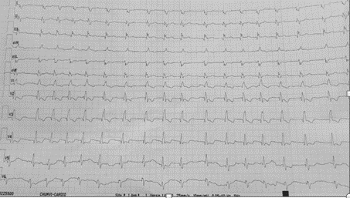
Figure 1: Electrocardiogram showing atrial fibrillation with mean ventricular rate of 100 bpm and complete right bundle branch block.
Transthoracic echocardiography with Doppler revealed: type I Ebstein’s anomaly (apical displacement of tricuspid valve >8 mm/m²), dysplastic tricuspid valve with rudimentary posterior leaflet causing torrential regurgitation, marked right atrial dilatation due to atrialization of the right ventricle, atrial septal defect (ASD) of 9 mm with left-to-right shunt, moderately dilated and highly trabeculated right ventricle with borderline systolic function (S’=9 cm/s), normal left ventricular size and function, hypoplastic pulmonary artery with dysplastic valve and severe stenosis, and interruption of the inferior vena cava.
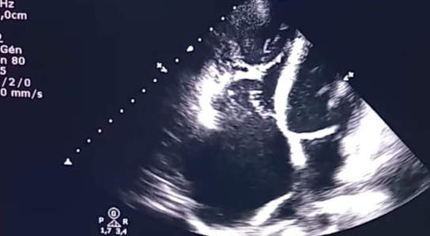
Figure 2: Apical four-chamber view demonstrating low insertion of the tricuspid valve, dilated right ventricle, and right atrial enlargement due to atrialization of the right ventricle, atrial septal defect (ASD) of 9 mm
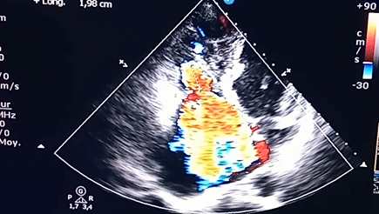
Figure 3: Apical four-chamber view showing dysplastic tricuspid valve with rudimentary posterior leaflet causing severe tricuspid regurgitation.
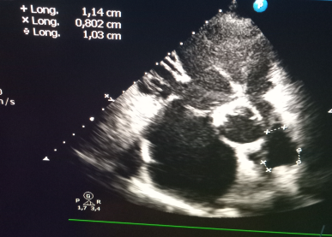
Figure 4: Parasternal short-axis view revealing hypoplastic pulmonary artery with dysplastic valve and severe stenosis.
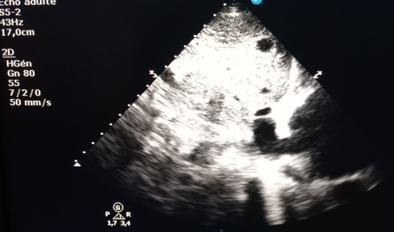
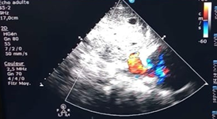
Figure 5&6: Subcostal views showing interruption of the inferior vena cava.

CT angiography of the thorax, abdomen, and pelvis demonstrated agenesis of the middle and lower segments of the IVC, marked dilation of the superior vena cava and hepatic segment of the IVC with cavo-hepatic reflux, and collateral drainage via dilated azygos and hemiazygos veins. The pulmonary artery trunk and both branches were hypoplastic.
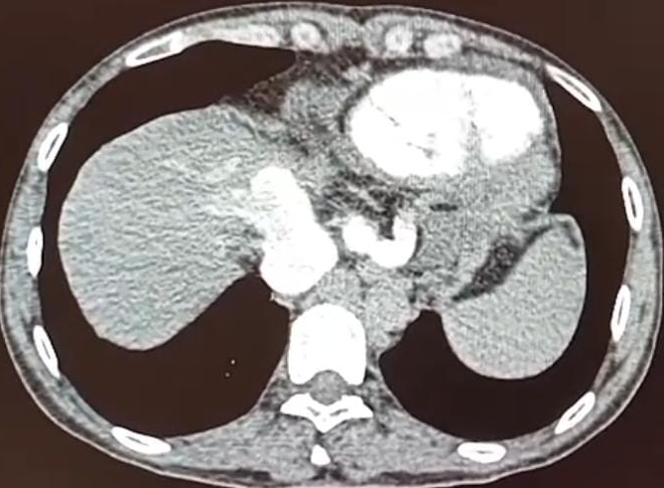
Figure 7: Axial CT image showing dilated IVC stump with enlarged hepatic and azygos veins.
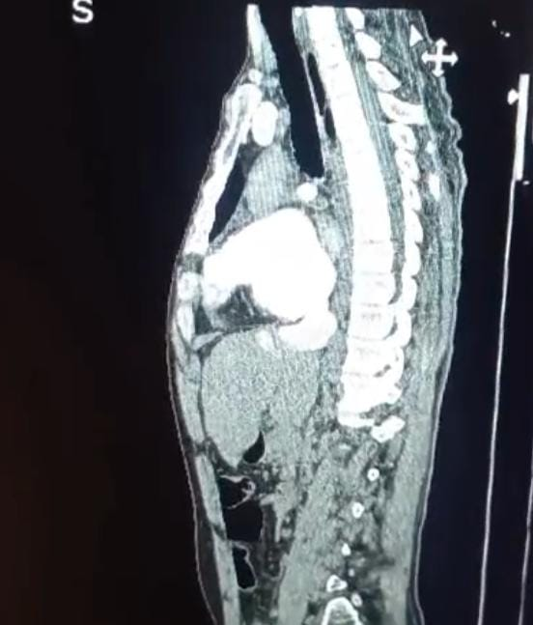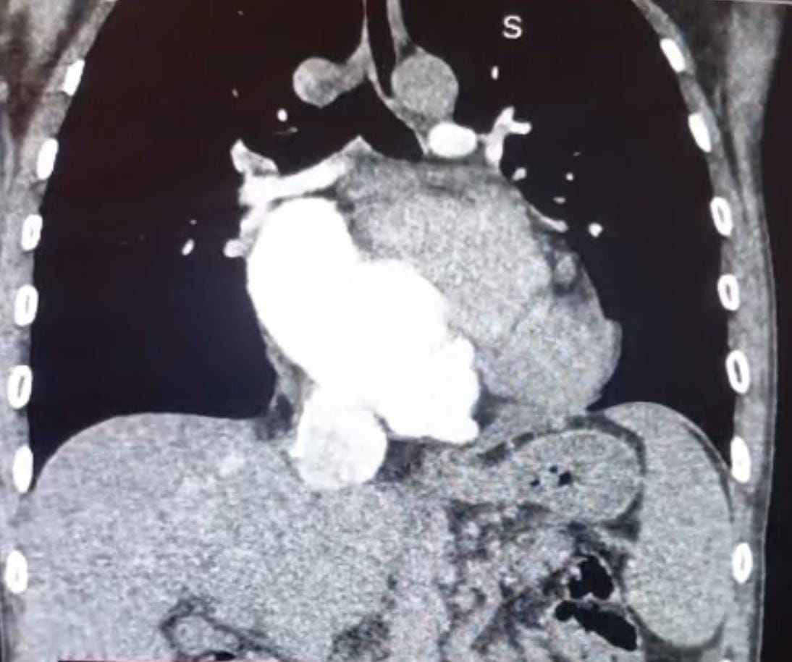
Figure 8 & 9: Sagittal and coronal CT images demonstrating dilated IVC stump receiving hepatic veins.
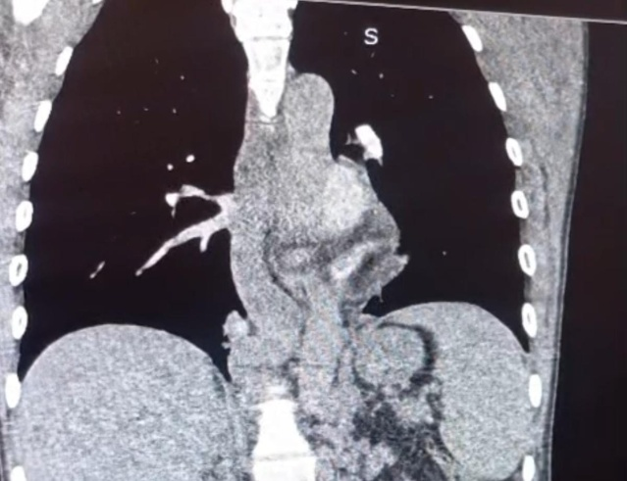
Figure 10: Coronal CT image showing marked dilation of the azygos vein.
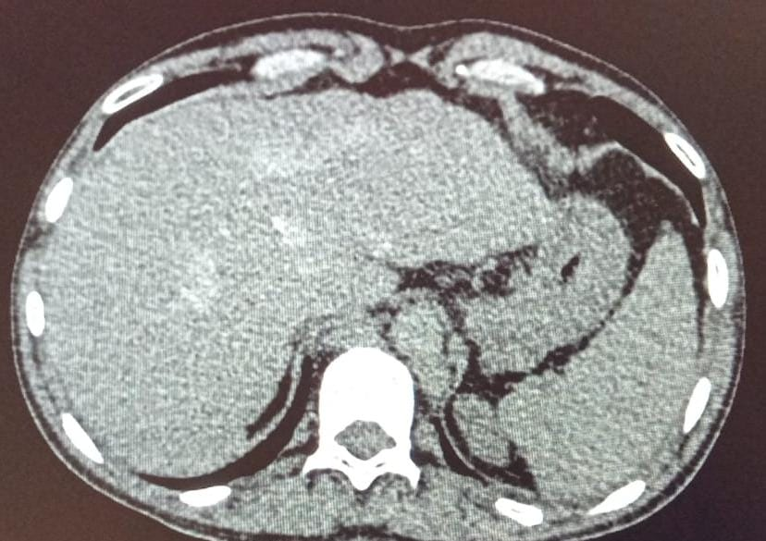
Figure 11: High abdominal axial CT slice demonstrating absence of the middle and lower IVC.
Management: The patient was started on heart failure therapy and anticoagulation, then referred for surgery. He underwent bioprosthetic tricuspid valve replacement, pulmonary artery augmentation with a patch, and ASD closure, with an uneventful postoperative course.

Discussion
The inferior vena cava (IVC) is a single vein located to the right of the abdominal aorta. Failure in the process of embryogenesis may lead to congenital IVC anomalies [1].
Ebstein’s anomaly: The first description dates back to 1866 by Wilhelm Ebstein. It accounts for approximately 1% of congenital heart diseases [2] and results from the absence of delamination of the valve leaflets, leading to adhesion of the septal and posterior leaflets of the tricuspid valve along the wall of the right ventricle (RV). The RV becomes atrialized, poorly compliant, and the prognosis largely depends on the severity of tricuspid regurgitation.
Interruption of the IVC is a rare condition. It is generally classified under congenital heart malformations, in association with heterotaxy or cardiosplenic syndromes, particularly when manifesting as left isomerism or polysplenia [3]. However, its isolated occurrence has been less frequently reported.
The prevalence of this anomaly is estimated at 0.6% in the general population and 1.3% among patients with congenital heart disease [4]. In the series by Bartan et al., associated cardiac malformations were observed in 31.3% of patients with IVC interruption, including atrial septal defect (ASD) in 10.5% of cases, persistent ductus arteriosus in 4.5% of cases, valvular pulmonary stenosis in 4.5% of cases, complete atrioventricular canal in 31% of cases, double outlet right ventricle in 3% of cases, and transposition of the great arteries in 3% of cases. In the cohort of Shyh-Jye Chen et al. [5], 11.8% of patients had a normal cardiac structure, 20.6% had a simple congenital heart defect, and severe congenital heart disease was observed in two-thirds of patients and constituted the only predictive factor for long-term prognosis.
Although uncommon, asymptomatic interruption of the IVC constitutes a significant obstacle to successful cardiac interventions, particularly interventional catheterization [6,7]. The presence of this anomaly makes cardiac catheterization from the lower limbs more difficult, and appropriate precautions must be taken during surgical intervention.
The only predictive factor for long-term prognosis of this anomaly lies in its association with complex congenital heart disease.

Conclusion
We report a rare case characterized by interruption of the IVC associated with Ebstein’s anomaly. Both conditions are extremely rare, and their association is scarcely described in the literature. This case highlights the importance of imaging in detecting complex vascular anomalies. Echocardiography can readily establish the diagnosis of IVC interruption [8], although Doppler ultrasound, MRI, and CT are also useful diagnostic tools.
References :
1. Papoutsis D, Tsatsali Foroglou E. Un cas rare de veine cave inférieuregauche avec continuation azygote et présence du segment surrénal d'une veine cave inférieure droite. Hippocratie 2015;19(1):95.

2. Baumgartner H., De Backer J., Babu-Narayan SV., et al. 2020 ESC guidelines for the Management of Adult Congenital Heart Disease : The Task Force for the Management of Adult Congenital Heart Disease of the European Society of Cardiology (ESC). Eur Heart J, 2021, 42 : 563-645.

3. Berg C, Geipel A, Smrcek J et al. Diagnostic prénatal des syndromes cardiospléniques : une expérience de 10 ans. Ultrasound Obstet Gynecol 2003 ; 22 : 451459

4. Mansour MM, Hussein O, Saad B, et al. A rare case of pulmonary embolism in a patient with interrupted inferior vena cava and polysplenia. Cureus 2022;14:e22323.

5. Clinical implications of congenital interruption of inferior vena cava ,Journal of the Formosan Medical Association 121 (2022) 1938e1944.

6. Fischer DR, Zuberbuhler JR. Anomalous systemic venous venous return.
In RH Anderson et al, eds. Paediatric cardiology, Vol. 1. Edinburgh: Churchill Livingstone; 2002: 851–866

7. Sharma S, Devine W, Anderson RH, Zuberbuhler JR. Identification and analysis of left atrial isomerism. Am J Cardiol 1987; 60: 1157–1160

8. Chen SJ, Wu MH, Wang JK. Clinical implications of congenital interruption of inferior vena cava. J Formos Med Assoc 2022;121: 1938–44.

