Case report

“From Parasite to Plaque? Acute Myocardial Infarction in Severe Plasmodium vivax Malaria”

Abstract
Background:
Although Plasmodium falciparum is classically associated with severe malaria, Plasmodium vivax—once thought to cause only benign disease—is now recognized as capable of producing life-threatening complications, including acute respiratory distress syndrome (ARDS), renal failure, shock, and severe hematological abnormalities [1–3]. Cardiac involvement in P. vivax infection is extremely uncommon, typically manifesting as myocarditis or conduction abnormalities [4]. Acute ST-elevation myocardial infarction (STEMI) secondary to P. vivax infection is exceedingly rare, with only a few angiographically confirmed cases reported globally [5–7].
Case Presentation:
We describe a 55-year-old female from Mumbai, India, who presented with high-grade fever, dyspnea, and hypotension. Peripheral smear confirmed P. vivax parasitemia. Laboratory evaluation revealed thrombocytopenia (22,000/µL), metabolic acidosis, and acute kidney injury. The patient developed ARDS requiring mechanical ventilation. Six hours after admission, she experienced acute chest pain, and ECG showed anterior wall STEMI with 4 mm ST elevation in leads V1–V5. Echocardiography demonstrated anterior wall hypokinesia with a left ventricular ejection fraction (LVEF) of 30–35%.
After high-risk informed consent, intravenous streptokinase was administered, achieving >70% ST-segment resolution. Coronary angiography performed after stabilization showed a recanalized left anterior descending (LAD) artery with TIMI-3 flow and no residual stenosis. She was managed with artesunate, doxycycline, cautious dual antiplatelet therapy, and supportive care. The patient recovered completely and was discharged on day 12 in stable condition.
Discussion:
This case illustrates a rare but serious cardiovascular manifestation of P. vivax malaria. Potential mechanisms include cytokine-mediated endothelial activation, coronary microvascular obstruction, catecholamine-induced vasospasm, and inflammatory endothelial injury [8–12]. The concurrence of STEMI in P. vivax infection presents diagnostic and therapeutic challenges, especially in the presence of thrombocytopenia. Despite the bleeding risk, timely reperfusion was lifesaving.
Conclusion:
P. vivax malaria can no longer be regarded as benign. Clinicians in endemic areas should maintain a high index of suspicion for acute coronary events when ECG changes or chest discomfort occur in malaria patients. Angiographic documentation, early diagnosis, and prompt reperfusion therapy are crucial for improved outcomes.

Keywords:
Plasmodium vivax, severe malaria, ST-elevation myocardial infarction, thrombocytopenia, angiography, reperfusion therapy, cardiac complications

Introduction
Malaria remains a major public health problem worldwide, with approximately 249 million cases and 608,000 deaths reported in 2022 [1]. India accounts for a substantial portion of global malaria morbidity, with Plasmodium vivax contributing to nearly 50% of cases [2]. Traditionally labeled as a cause of benign malaria, P. vivax has been increasingly recognized to produce severe manifestations comparable to P. falciparum infection, including multi-organ dysfunction, ARDS, hepatic impairment, shock, and severe thrombocytopenia [3,4].
Cardiac complications in malaria are infrequent and include myocarditis, pericardial effusion, arrhythmias, and conduction abnormalities [4,5]. Acute coronary syndromes (ACS), particularly ST-elevation myocardial infarction (STEMI), are exceedingly rare in association with malaria. Most reported cases involve P. falciparum, and P. vivax-related STEMI is an exceptional occurrence [5–7].
Herein, we present an unusual case of severe P. vivax malaria complicated by acute anterior wall myocardial infarction with angiographic documentation of LAD recanalization following successful thrombolysis. This case adds valuable evidence to the limited literature on cardiac involvement in P. vivax infection.

Case Presentation
A 55-year-old female from a malaria-endemic region in Mumbai presented with a 3-day history of high-grade fever with chills, followed by progressive breathlessness and weakness. She denied any previous history of hypertension, diabetes, or cardiac disease.
On admission:
- Temperature: 102°F
- Heart rate: 130/min
- Blood pressure: 80/50 mmHg
- Respiratory rate: 34/min
- SpO₂: 80% on room air
- Chest auscultation: bilateral crepitations
She was admitted to the Medical ICU with a provisional diagnosis of severe malaria with ARDS and septic shock. Intravenous artesunate and broad-spectrum antibiotics were initiated, along with mechanical ventilation and inotropic support.
Laboratory investigations:
- Hemoglobin: 9.2 g/dL
- Total WBC: 4,800/µL
- Platelet count: 22,000/µL
- Serum creatinine: 2.1 mg/dL
- Bilirubin: 2.3 mg/dL
- SGOT/SGPT: 105/98 IU/L
- Peripheral smear and antigen test: P. vivax positive
A chest X-ray revealed bilateral alveolar infiltrates, consistent with an ARDS pattern.

Cardiac Event
Six hours after admission, the patient complained of severe retrosternal chest pain radiating to the left arm, accompanied by diaphoresis.
ECG findings:
- Normal sinus rhythm
- 4 mm ST-segment elevation in leads V1–V5
- Reciprocal ST depression in inferior leads
Echocardiography showed anterior wall hypokinesia with an ejection fraction of 30–35%. Troponin-T was positive.
Given ongoing cardiogenic shock and high-risk features, intravenous streptokinase (1.5 million IU over 1 hour) was administered under high-risk consent despite thrombocytopenia. The procedure was tolerated well, with >70% resolution of ST-segment elevation on repeat ECG.

.

Discussion
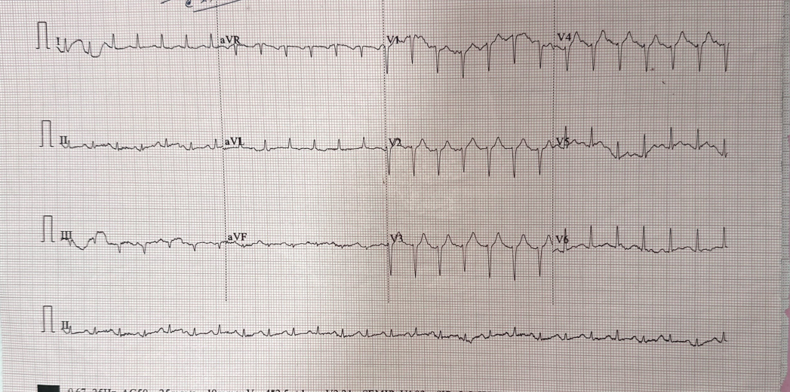
Figure1: Standardised 12 lead ECG:Normal sinus rhythm, ,poor R wave progression .

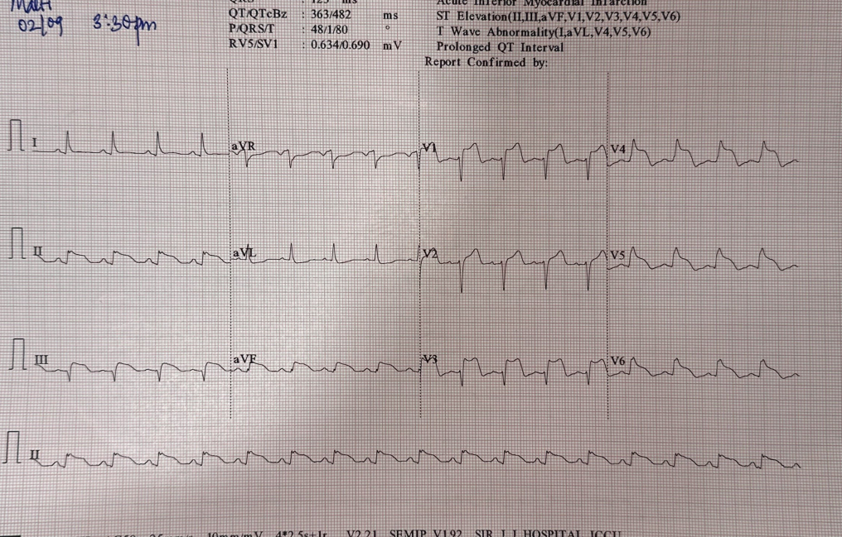
Figure2: Standardised 12 lead ECG:Normal sinus rhythm,ST elevation in V1 to V6 II,III,AVF .

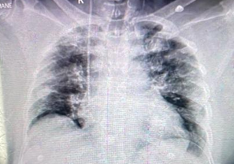
Figure: 3 Chest X ray PA view showing . Bilateral diffuse alveolar infiltrates, suggestive of Acute Respiratory Distress Syndrome (ARDS) pattern.

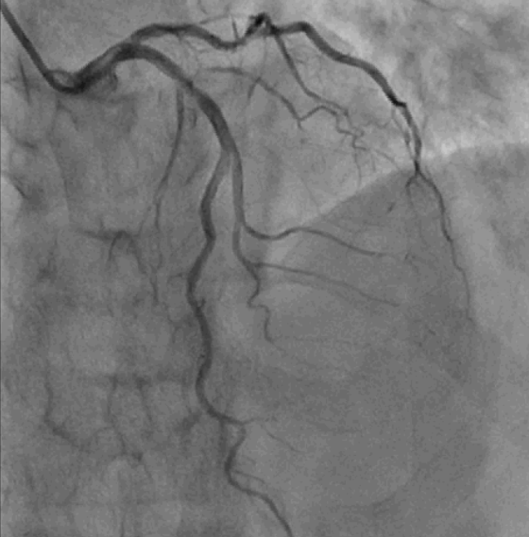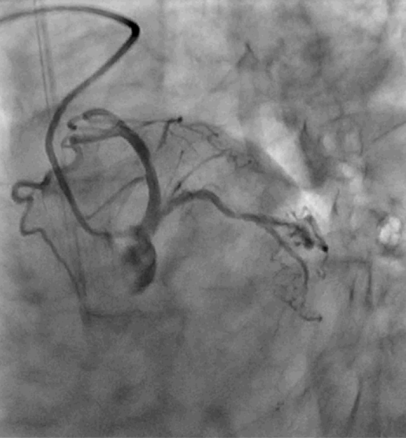
( a) (b)
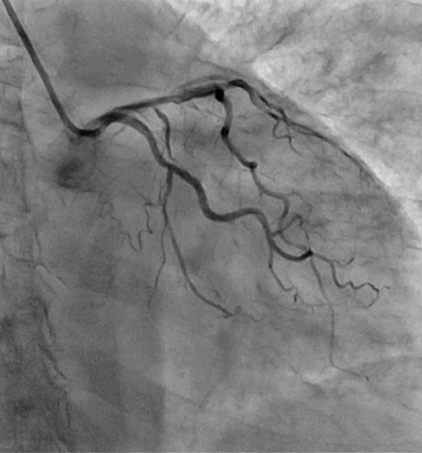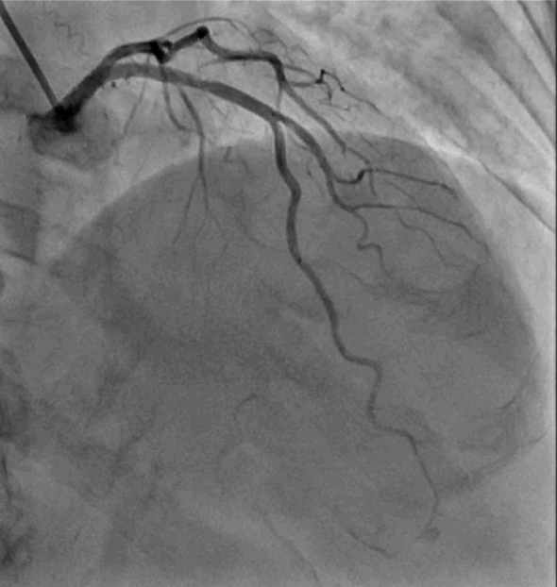
(c) (d)

Figure: 4 LAO analytical result
- LAO Cranial view : Left anterior descending artery (LAD): Shows good opacification up to the distal segment, with no critical stenosis visible. Several diagonal branches are seen filling well.
- LAO Caudal : proximal Dissection with thrombus with mild plaque
- RAO Cranial View: Recanalised LAD
- AP Cranial:Recanalised LAD

Cardiac Event and Hospital Course
Six hours after admission, the patient developed severe chest pain. ECG revealed acute anterior wall STEMI. Echocardiography showed anterior wall hypokinesia with EF 30–35%, and Troponin T was elevated.
Despite thrombocytopenia, intravenous streptokinase was administered after high-risk consent. Post-thrombolysis ECG demonstrated significant ST-segment resolution.
Subsequent course:
- Gradual recovery with withdrawal of ventilatory and inotropic support
- Post-stabilization coronary angiography: recanalized LAD, no residual stenosis
- Platelet count dropped to 65,000/µL; aspirin was withheld
- Artesunate and doxycycline continued
- Hydrocortisone used for refractory hypotension
- Discharged in stable condition after full recovery

Rarity and Significance
This case highlights a rare but life-threatening complication of P. vivax malaria—acute myocardial infarction. Although P. falciparum is more commonly implicated in cardiovascular manifestations, P. vivax is increasingly reported to cause severe disease, including ARDS, AKI, and shock [3,4]. The development of STEMI in P. vivax malaria is an extraordinary occurrence, making this case both clinically and academically significant.
A comprehensive literature review revealed only a few similar reports worldwide. Sharma et al. [5] described a case of anterior wall STEMI in a patient with P. vivax malaria managed with thrombolysis. Santos et al. [6] reported a case from Brazil presenting with inferior wall MI without angiographic confirmation. Kumar et al. [7] reported a case of STEMI associated with severe P. vivax malaria complicated by ARDS. However, angiographically proven LAD recanalization following thrombolysis in P. vivax malaria remains exceedingly rare.

Pathophysiological Insights
Several mechanisms may explain myocardial ischemia in malaria:
- Microvascular Obstruction:
Parasitized erythrocytes adhere to endothelial cells and form microthrombi, causing impaired coronary microcirculation [8].
- Endothelial Activation:
Cytokine storm involving TNF-α, IL-6, IL-10, and ICAM-1 leads to endothelial injury, promoting thrombosis and vasoconstriction [9].
- Inflammation and Oxidative Stress:
P. vivax infection triggers nitric oxide imbalance, endothelial apoptosis, and oxidative myocardial injury [10,11].
- Catecholamine Surge and Vasospasm:
Severe infection and systemic inflammatory response can cause coronary vasospasm and increased myocardial oxygen demand [12].
- Thrombocytopenia and Microthrombosis:
Platelet activation and release of microparticles contribute to local thrombus formation [13].
In this case, angiographic findings of LAD recanalization and the absence of significant atherosclerotic disease suggest an acute thrombotic mechanism rather than plaque rupture.

Therapeutic Dilemma
Managing AMI in severe malaria poses unique challenges due to thrombocytopenia and coagulopathy. The decision to administer thrombolytics must balance the risk of hemorrhage against the need for myocardial reperfusion. In this patient, despite platelet count <30,000/µL, thrombolysis was performed successfully under close monitoring.
Antiplatelet therapy was initiated cautiously after platelet recovery. This highlights that individualized, multidisciplinary decision-making is essential for favorable outcomes.

Table 1 : Comparative Review of Reported Cases
Author / Year | Country | Age/Sex | Clinical Features | Type of MI | Management | Outcome
Sharma et al., 2014 [5] | India | 42/M | Fever, chest pain, thrombocytopenia | Anterior STEMI | Thrombolysis (streptokinase) | Survived
Santos et al., 2016 [6] | Brazil | 34/M | Severe P. vivax, chest pain | Inferior STEMI | Supportive | Survived
Kumar et al., 2017 [7] | India | 18/M | ARDS, severe P. vivax | STEMI | Thrombolysis | Survived
Present case, 2025 | India | 55/F | ARDS, AKI, shock | Anterior STEMI | Thrombolysis + CAG (LAD recanalized) | Recovered fully

Prognostic and Clinical Implications
This case underscores the need for clinicians to consider cardiac complications in severe P. vivax malaria, particularly in patients with chest discomfort or ECG changes. Routine ECG and cardiac biomarker evaluation should be incorporated in severe malaria workup. Early identification and management of myocardial ischemia can prevent catastrophic outcomes.
Furthermore, this case demonstrates that with vigilant monitoring and collaborative care between infectious disease, cardiology, and critical care teams, aggressive interventions like thrombolysis can be safely executed even in complex hematologic settings.

Conclusion
Acute myocardial infarction secondary to P. vivax malaria is exceedingly rare but potentially fatal. The case presented provides angiographic evidence supporting the thrombotic pathophysiology of malaria-associated STEMI. Clinicians should recognize that P. vivax malaria is not benign—it can trigger multi-organ dysfunction and severe cardiovascular complications.
A high index of suspicion, early ECG monitoring, and judicious use of thrombolytics in selected patients, even with thrombocytopenia, may be lifesaving. This report enriches the existing literature by presenting an angiographically confirmed case of LAD recanalization following thrombolysis in severe P. vivax infection, emphasizing the importance of timely recognition and multidisciplinary management.

References
- World Health Organization. World Malaria Report 2023. Geneva: WHO; 2023.
- Singh B, Daneshvar C. Clin Microbiol Rev. 2013;26(2):165–184.
- Kochar DK, Das A, Kochar SK, et al. Am J Trop Med Hyg. 2009;80(2):194–198.
- Punukollu G, Gowda RM, Khan IA. Int J Cardiol. 2004;94(2–3):179–184.
- Sharma A, et al. J Assoc Physicians India. 2014;62(8):738–739.
- Santos JR, et al. Rev Inst Med Trop Sao Paulo. 2016;58:87.
- Kumar R, et al. Trop Doct. 2017;47(4):370–372.
- Yeo TW, et al. Proc Natl Acad Sci USA. 2008;105(44):17097–17102.
- Mohanty S, et al. Trends Parasitol. 2020;36(3):204–216.
- Schofield L, Grau GE. Nat Rev Immunol. 2005;5(9):722–735.
- Andrade BB, et al. Proc Natl Acad Sci USA. 2010;107(44):18833–18838.
- Bruneel F, et al. Crit Care Med. 2003;31(6):1470–1475.
- Jain V, et al. Malar J. 2013;12:406.

