Review Article
The Malnutrition–Infection Syndemic in Katsina State, Nigeria: Unravelling the Drivers and Catalysing Multi-Sectoral Public Health Action

Abstract
Background: Northern Nigeria, particularly Katsina State, bears a disproportionate burden of child malnutrition and infectious diseases. These conditions interact synergistically within a syndemic framework, exacerbated by social and environmental inequities, leading to worse outcomes than if they occurred independently.
Objective: This narrative review aimed to critically synthesize evidence on the biological and contextual drivers of the malnutrition-infection syndemic in Katsina State and to propose a multi-sectoral framework for public health action.
Methods: This narrative review conducted Scopus-indexed literature (2018-2025) and key policy documents, with a focus on contextual relevance to the Sahelian and Nigerian context.
Findings: The syndemic in Katsina is driven by a complex, self-reinforcing interplay of a biological vicious cycle, where malnutrition weakens immunity and infection depletes nutritional status, fueled by underlying drivers including severe food insecurity, gender inequity, poor Water, Sanitation, and Hygiene (WASH) access, climate shocks, and a fragile health system. Current interventions, often siloed and vertical, have proven insufficient to break this cycle.
Conclusion: A paradigm shift from vertical programming to a syndemic-aware, multi-sectoral approach is urgently needed. Katsina Multi-Sectoral Action Framework (K-MSAF) was proposed, which centered on three pillars: Foundational Governance and Financing; Integrated Service Delivery; and Cross-Sectoral Programmatic Convergence. This framework provides a roadmap for policymakers to catalyze effective action to mitigate the syndemic in Katsina State.
Keywords: Syndemic, Malnutrition, Infection, Nigeria, Katsina, Multi-sectoral, WASH, Food Security

1. Introduction
Nigeria faces a profound public health challenge, ranking among the countries with the highest burdens of childhood malnutrition and infectious diseases globally (United Nations Children's Fund [UNICEF], 2023). The 2018 Nigeria Demographic and Health Survey (NDHS) revealed that 37% of children under five are stunted, 7% are wasted, and 22% are underweight (National Population Commission [NPC] & ICF, 2019). These national figures, however, mask stark regional disparities. The northwestern states, including Katsina, are epicentres of this crisis, with child stunting rates consistently exceeding 50% (NPC & ICF, 2019). Katsina State, a Sahelian region characterized by subsistence agriculture, poverty, and environmental fragility, exemplifies this emergency. Alongside this nutritional deficit, the state grapples with a high prevalence of infectious diseases such as malaria, diarrhoea, and respiratory infections, which remain leading causes of child mortality (Federal Ministry of Health [FMOH], 2020).
Traditionally, public health programs have addressed malnutrition and infection as distinct entities. However, a growing body of evidence underscores that they are not merely co-occurring conditions but are deeply entangled in a syndemic (Singer et al., 2017). A syndemic refers to the synergistic interaction of two or more diseases or health conditions in a population, exacerbated by social, economic, and environmental inequities, resulting in an excess burden of disease (Singer & Erickson, 2019). In Katsina, chronic food insecurity, gender inequality, conflict, and poor WASH infrastructure create a permissive environment where malnutrition weakens a child's immune defences, and recurrent infections, in turn, impair nutrient absorption and increase metabolic demands. This creates a vicious, self-perpetuating cycle that produces worse health outcomes than if each condition were addressed in isolation (Bourke et al., 2021; Schaible & Kaufmann, 2018).
Despite awareness of these issues, progress in reducing malnutrition and infection rates in Katsina has been slow and fragmented. Interventions often operate in vertical silos—nutrition programs focused on supplementary feeding, health programs on disease-specific treatment—failing to confront the synergistic nature of the problem at its roots (Gillespie et al., 2019). There is, therefore, an urgent need for a reconceptualization of the problem and a corresponding shift in strategy. This narrative review has four primary objectives: first, to delineate the biological vicious cycle between malnutrition and common infections; second, to unravel the contextual, socio-economic, and environmental drivers that fuel this syndemic in Katsina State; third, to critically assess the limitations of current, siloed interventions; and fourth, to propose an evidence-informed, multi-sectoral framework for public health action and policy to catalyze effective action.
2. Methodology
This study employed a critical narrative review methodology. This approach was selected to allow for a comprehensive and interpretive synthesis of a wide and heterogeneous body of literature, facilitating the development of a novel conceptual model and actionable recommendations (Greenhalgh et al., 2018). A systematic literature search was conducted in Scopus, PubMed, and Web of Science databases for publications between January 2018 and May 2025. The search strategy combined key terms and Boolean operators, including “malnutrition” OR “undernutrition” AND “infection” OR “infectious disease” AND “syndemic” AND “Nigeria” OR “Katsina” AND “driver” OR “determinant” AND “multi-sectoral” OR “intervention”.
The initial search yielded over 1,200 records. After removing duplicates, titles and abstracts were screened for relevance. Full-text articles were assessed for inclusion based on their contribution to understanding the syndemic's drivers, dynamics, or solutions in contexts relevant to Katsina State. We prioritized peer-reviewed articles, systematic reviews, and meta-analyses. Given the policy-oriented aim, key grey literature documents from the Nigerian Federal Ministry of Health, the National Bureau of Statistics (NBS), UNICEF, and the World Bank were also incorporated. The synthesis was iterative and thematic, focusing on identifying the core components of the syndemic and the evidence base for potential solutions.
3. The Biological Vicious Cycle: Core of the Syndemic
At the heart of the malnutrition-infection syndemic lies a powerful biological feedback loop. Understanding this cycle is fundamental to appreciating why siloed interventions fail. Malnutrition acts as a precursor to immunodeficiency through several key mechanisms. Macro- and micronutrient deficiencies profoundly compromise the immune system, a state often termed "nutritionally acquired immunodeficiency disease" (Katona & Katona-Apte, 2018). Specifically, deficiencies in Vitamin A, zinc, and protein compromise the integrity of the skin and mucosal linings in the gut and respiratory tract, making them more permeable to pathogens (Bourke et al., 2021). Furthermore, protein-energy malnutrition and specific micronutrient deficiencies, such as zinc and iron, impair T-lymphocyte function and the production of cytokines, reducing the body's ability to fight intracellular pathogens (Schaible & Kaufmann, 2018). The quality and affinity of antibodies can also be reduced, diminishing the effectiveness of the humoral response and response to vaccinations (Koyuncu & Gültekin, 2023).
Conversely, infections precipitate and worsen malnutrition through several pathways. Fever and the immune response increase energy and protein requirements, while illness often leads to loss of appetite and reduced food intake, a problem exacerbated by cultural practices of withholding food from sick children (Jones & Berkley, 2018). Diarrhoeal diseases cause direct loss of macronutrients and micronutrients from the gut, and the body may redirect nutrients like iron and zinc to sequester them from pathogens, which can also impair growth (Bourke et al., 2021).
This bidirectional relationship is particularly potent in key pathogen-specific interactions. For instance, Plasmodium falciparum infection is associated with increased prevalence of stunting and wasting, as malaria-induced anemia, anorexia, and cytokine production directly contribute to growth impairment (Gomes et al., 2019). Conversely, undernourished children are more susceptible to severe malaria. Similarly, repeated episodes of diarrhoea are a major cause of growth faltering. More insidiously, Environmental Enteric Dysfunction (EED)—a subclinical condition of the small intestine caused by chronic exposure to faecal pathogens—results in intestinal inflammation and reduced nutrient absorption, even in the absence of overt diarrhoea, creating a critical link between poor WASH and chronic malnutrition (Noor et al., 2024). Intestinal worms also compete for host nutrients and contribute to anemia, further entrenching malnutrition. This biological cycle, illustrated in Figure 1, creates a physiological trap for children in high-risk environments like Katsina.
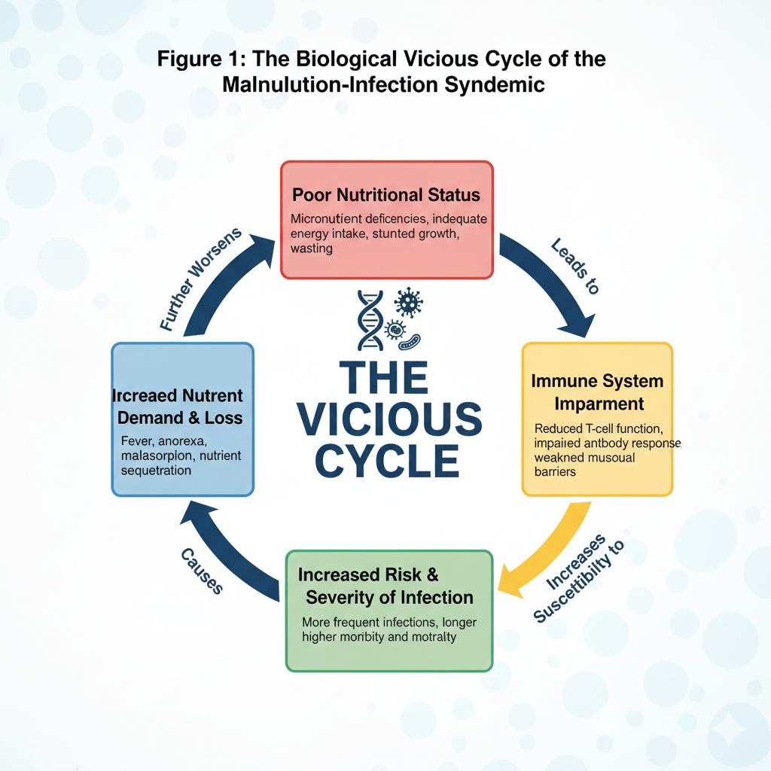
4. Unravelling the Contextual Drivers in Katsina State
The biological vicious cycle is activated and sustained by a tapestry of underlying socio-economic, environmental, and political drivers that constitute the root causes of the syndemic in Katsina. A primary driver is the state's fragile food system and pervasive livelihood insecurity. Katsina's economy is predominantly agrarian, reliant on rain-fed subsistence farming, which makes nutritional outcomes highly vulnerable to seasonal and climatic variations. Over 70% of the population in Northwest Nigeria lives in poverty, which severely limits dietary diversity and forces a reliance on carbohydrate-based staples like sorghum and millet, with minimal consumption of animal-source foods, fruits, and vegetables (Adeyemi et al., 2022). This is compounded by low agricultural productivity, limited access to credit and inputs, and post-harvest losses, which collectively contribute to periods of seasonal hunger, locally known as "yunwa" (Boney & Omonona, 2023).
A second critical driver is the profound deficit in Water, Sanitation, and Hygiene (WASH). Katsina has some of the worst WASH indicators in Nigeria. The 2021 WASHNORM survey indicated that over 40% of the population practices open defecation, and only 10% have access to basic sanitation services (Federal Ministry of Water Resources [FMOWR], 2022). This creates a highly contaminated environment, perpetuating the cycle of diarrhoeal diseases and EED, which directly drive nutrient depletion and stunting (Dangour et al., 2018; Oluwole et al., 2022).
A third, often underestimated driver is gender inequity and its impact on maternal and child health. The low status of women has direct consequences; undernourished women are more likely to give birth to low birth weight babies, who are at a higher risk of stunting and infection (Fadare et al., 2019). Furthermore, low rates of exclusive breastfeeding and inadequate complementary feeding practices, often linked to low maternal education and decision-making power, are prevalent. High domestic burdens and time poverty also limit women's capacity for optimal child care and feeding practices.
The syndemic is further exacerbated by conflict, displacement, and general state fragility. The escalating insecurity in Northwest Nigeria, driven by banditry and farmer-herder conflicts, has created a humanitarian crisis. This has led to mass displacement, disrupting livelihoods, agriculture, and access to healthcare. The collapse of services is evident in the closure or understaffing of health facilities, and market disruptions impede the flow of food and goods, intensifying food insecurity and limiting access to care (Oguntade & Muthoni, 2023).
Acting as a threat multiplier for all other drivers is climate change. The Sahelian region is experiencing increased climate variability, with more frequent droughts and unpredictable rainfall. This exacerbates water scarcity, reduces agricultural yields, and contributes to resource-based conflicts, creating a feedback loop that deepens vulnerability (Ezeh et al., 2024). Finally, all these challenges are compounded by inherent weaknesses in the health system itself. The health system in Katsina is fragile, with limited capacity to manage the syndemic due to low coverage of essential services like routine immunization and management of severe acute malnutrition, critical shortages of skilled health personnel in rural areas, and weak supply chains leading to frequent stock-outs of essential medicines and therapeutic foods.
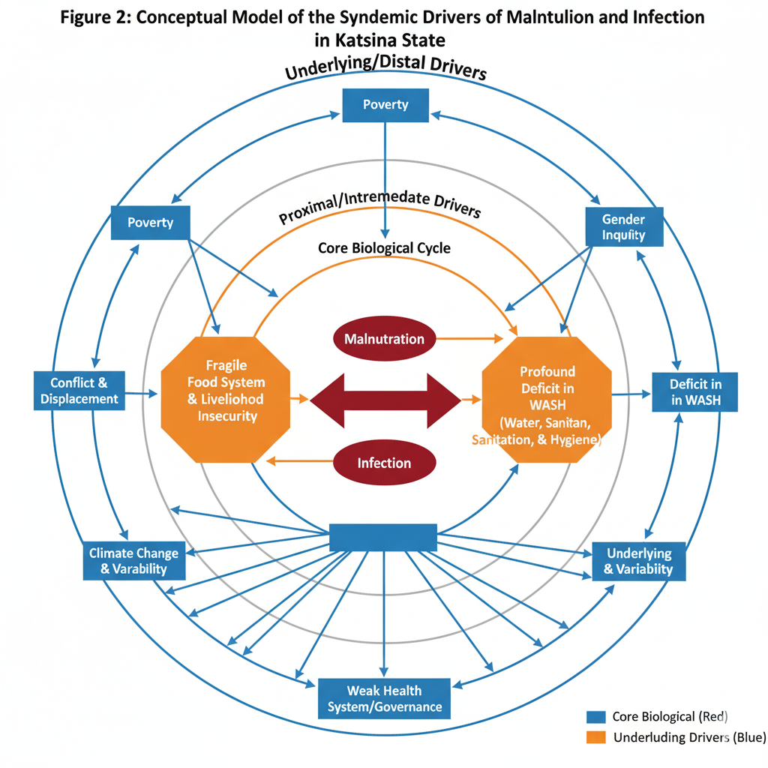

5. The Failure of Siloed Approaches and the Evidence for Integration
Historically, the response in Katsina and similar contexts has been characterized by vertical, single-sector programs. A nutrition program may provide lipid-based nutrient supplements, while a separate health program distributes bed nets and treats malaria. While these interventions have intrinsic value, their impact is often limited and unsustainable because they fail to disrupt the underlying syndemic dynamics (Gillespie et al., 2019). The fundamental limitation of a siloed approach is its focus on a single outcome, implemented through separate funding, leadership, and monitoring systems, which inevitably misses the root causes of the problem. For example, providing Ready-to-Use Therapeutic Food (RUTF) to a severely malnourished child without addressing the contaminated water source that causes the recurrent diarrhoea leading to relapse is a quintessential example of a siloed intervention that yields suboptimal results.
In contrast, a multi-sectoral approach focuses on holistic well-being and breaking the syndemic cycle through joint planning, pooled funding, and shared accountability. This would involve bundling RUTF with WASH kits containing water filters and soap, alongside nutrition-sensitive agriculture support for the household. A robust body of evidence supports the superiority of such integrated, multi-sectoral strategies. A landmark review demonstrated that nutrition-sensitive programs in agriculture, social safety nets, and WASH can significantly improve nutritional outcomes (Ruel & Alderman, 2019). While early WASH trials showed mixed results, more recent studies targeting the first 1000 days with high-quality interventions show a significant impact on reducing stunting and diarrhoea (Dangour et al., 2018; Noor et al., 2024). Furthermore, social protection mechanisms like conditional cash transfers have been shown to improve dietary diversity and reduce stunting by empowering households to access better food and health services (Chirwa & Ngalawa, 2023). Ultimately, systematic reviews confirm that coordinated action across sectors is more effective and cost-efficient in reducing stunting than single-sector interventions (Torlesse et al., 2023).
6. The Katsina Multi-Sectoral Action Framework (K-MSAF)
Based on the syndemic analysis and the evidence for integration, we propose the Katsina Multi-Sectoral Action Framework (K-MSAF). This framework is designed to provide a coherent structure for government, partners, and communities to collaboratively break the malnutrition-infection cycle. The framework, depicted in Figure 3, is structured around three concentric pillars, with the child and household at the center as the ultimate unit of change.
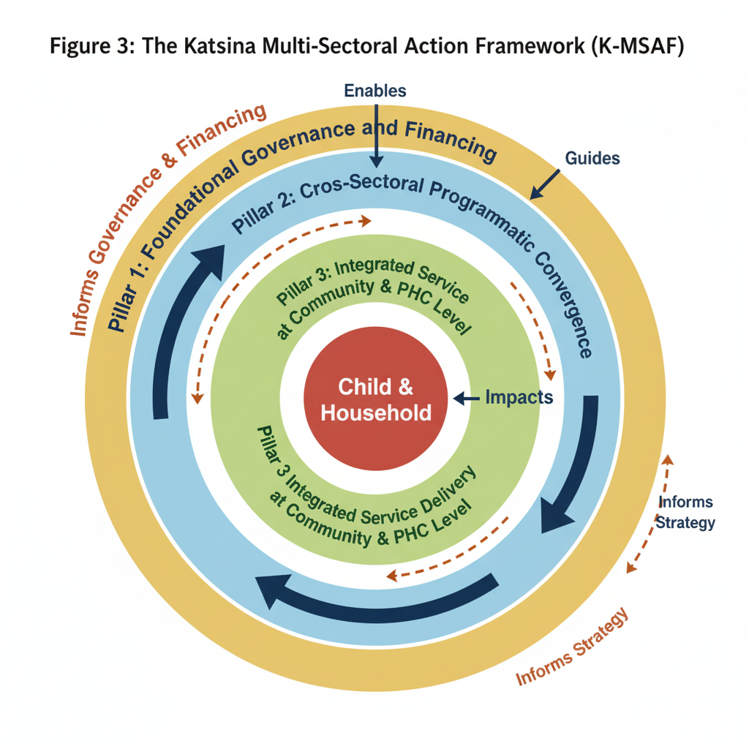The first pillar, Foundational Governance and Financing, establishes the necessary enabling environment. This begins with high-level political commitment, which could be operationalized through a State-Level Syndemic Task Force chaired by the Governor and involving commissioners from key ministries alongside traditional and religious leaders to provide strategic direction and resolve bureaucratic bottlenecks. This must be supported by dedicated and pooled financing, such as a Katsina Syndemic Response Fund, where donors and government allocations for nutrition, health, and WASH are pooled to finance integrated programs, thereby reducing duplication and encouraging collaboration. Finally, a unified data and accountability system, featuring a common results framework and dashboard that tracks cross-sectoral indicators, is essential for promoting shared accountability and measuring synergistic impact.
The second pillar, Integrated Service Delivery at the Community and Primary Healthcare Level, serves as the implementation engine. This involves the co-location and bundling of services at points of contact with beneficiaries. For instance, every vaccination contact could include a MUAC screening for the child and counselling on infant and young child feeding (IYCF) for the mother, an approach known as "Vaccination Plus." Similarly, antenatal care visits could be expanded to include the distribution of insecticide-treated nets, micronutrient supplements, and counselling on hygiene. Strengthening the frontline workforce is also crucial; training Community Health Extension Workers (CHEWs) as "Syndemic Frontline Workers" would equip them to provide basic education and services across nutrition, WASH, and common illnesses. Intensifying Community-Led Total Sanitation (CLTS) programs with explicit links to nutrition outcomes can further empower communities to become open-defecation-free.
The third pillar, Cross-Sectoral Programmatic Convergence, defines the specific intervention packages where sectors deliberately reinforce each other. This includes creating robust Agriculture-Nutrition (Ag-Nut) Linkages by promoting the production and consumption of bio-fortified crops like vitamin A maize and iron-rich beans, supporting homestead gardening, and integrating nutrition education into agricultural extension services. It also entails WASH-Nutrition Convergence by targeting "WASH-Nut First 1000 Days Packages" to pregnant women and mothers of children under two, which would bundle nutrition counselling and micronutrient powders with a household water filter and soap. Furthermore, Social Protection-Health Linkages can be designed by creating cash transfer programs with "soft" conditions, such as requiring attendance at health and nutrition education sessions, and using social registries to identify the most vulnerable households for integrated support.
7. Discussion
This review has argued that the persistent crisis of child health in Katsina State is best understood and addressed through the lens of a syndemic. The synergistic interaction of malnutrition and infection, fuelled by deep-rooted socio-economic and environmental drivers, creates a burden that demands a radical departure from business-as-usual approaches. The proposed Katsina Multi-Sectoral Action Framework (K-MSAF) offers a structured pathway for such a shift.
For policymakers in Katsina State and development partners, the implications are clear. First, there must be a decisive end to working in silos, mandating joint planning and budgeting across ministries of Health, Agriculture, Water Resources, and Women's Affairs. Second, investment must be directed toward the foundational elements of governance and unified data systems, which are as critical as specific interventions. Third, all convergent actions should prioritize the first 1000 days of life, which represents the period of greatest vulnerability and potential for impact. Finally, programs must explicitly address gender inequity and leverage community structures to ensure sustainable and culturally resonant change.
While the evidence for multi-sectoral action is strong, operationalizing it in a complex, conflict-affected state like Katsina requires context-specific learning. Key research priorities include implementation science studies to understand how the K-MSAF can be effectively rolled out, identifying key barriers and facilitators. Cost-effectiveness analyses are needed to quantify the return on investment of a multi-sectoral approach compared to vertical programming. Research into conflict-sensitive programming is essential to determine how integrated services can be delivered safely and effectively to insecure and displaced populations. Furthermore, new metrics must be developed to monitor synergistic effects and capture the added value of integration, such as measuring reductions in the co-prevalence of stunting and recurrent diarrhoea.
This review has limitations inherent to the narrative methodology. The selection and interpretation of literature are subjective, though we have striven for comprehensiveness and balance. Furthermore, the K-MSAF is a conceptual model derived from synthesis and requires piloting and rigorous evaluation to test its efficacy and adaptability in the field.
8. Conclusion
The children of Katsina State are trapped in a biological and social trap of malnutrition and infection. Viewing this not as two separate problems but as one intertwined syndemic is the first step toward a more effective response. The evidence is clear: vertical, siloed programs have reached their limit of effectiveness. The path forward lies in bold, integrated, multi-sectoral action that confronts the root causes of this crisis. The Katsina Multi-Sectoral Action Framework (K-MSAF) provides a blueprint for such action. By strengthening governance, integrating service delivery, and fostering programmatic convergence across agriculture, WASH, social protection, and health, stakeholders in Katsina can begin to dismantle the drivers of the syndemic. The time for rhetoric is over; the time for coordinated, determined, and synergistic action is now. The future of an entire generation depends on it.
REFERENCES
Adeyemi, O., Amoo, E. O., & Fadare, O. A. (2022). Food insecurity and coping strategies among households in Northwestern Nigeria. Food and Energy Security, 11(2), e390. https://doi.org/10.1002/fes3.390
Boney, O. A., & Omonona, B. T. (2023). Agricultural productivity and child nutritional outcomes in rural Nigeria: A spatial analysis. Journal of Agricultural Economics, 74(1), 123-145. https://doi.org/10.1111/1477-9552.12512
Bourke, C. D., Berkley, J. A., & Prendergast, A. J. (2021). Immune dysfunction as a cause and consequence of malnutrition. Trends in Immunology, 43(5), 399-411. https://doi.org/10.1016/j.it.2022.03.002
Chirwa, E. W., & Ngalawa, H. (2023). Social protection and child nutrition in Sub-Saharan Africa: A meta-analysis. World Development, 161, 106089. https://doi.org/10.1016/j.worlddev.2022.106089
Dangour, A. D., Watson, L., Cumming, O., Boisson, S., Che, Y., Velleman, Y., Cavill, S., Allen, E., & Uauy, R. (2018). Interventions to improve water quality and supply, sanitation and hygiene practices, and their effects on the nutritional status of children. Cochrane Database of Systematic Reviews, 2018(11), CD009382. https://doi.org/10.1002/14651858.CD009382.pub3
Ezeh, O. K., Abiodun, G. J., & Awoyemi, O. (2024). Climate change, household vulnerability and child malnutrition in rural Nigeria. Environmental Research Letters, 19(3), 034045. https://doi.org/10.1088/1748-9326/ad2a1c
Fadare, O., Amare, M., Mavrotas, G., Akerele, D., & Ogunniyi, A. (2019). Women’s empowerment and nutrition status of children in Nigeria. World Development, 122, 38-55. https://doi.org/10.1016/j.worlddev.2019.05.010
Federal Ministry of Health (FMOH). (2020). *National Strategic Health Development Plan II (2018-2022)*. Federal Republic of Nigeria.
Federal Ministry of Water Resources (FMOWR). (2022). Water, Sanitation and Hygiene: National Outcome Routine Mapping (WASHNORM) III Report. Federal Republic of Nigeria.
Gillespie, S., van den Bold, M., & Hodge, J. (2019). The politics of reducing malnutrition: Building commitment and accelerating progress. The Lancet, 393(10184), 1992-2007. https://doi.org/10.1016/S0140-6736(19)32590-3
Gomes, M. F., de Oliveira, M. T., & de Souza, R. A. (2019). The association between malaria and malnutrition in children: A systematic review and meta-analysis. PLOS ONE, 14(8), e0221273. https://doi.org/10.1371/journal.pone.0221273
Greenhalgh, T., Thorne, S., & Malterud, K. (2018). Time to challenge the spurious hierarchy of systematic over narrative reviews? European Journal of Clinical Investigation, 48(6), e12931. https://doi.org/10.1111/eci.12931
Jones, K. D., & Berkley, J. A. (2018). Severe acute malnutrition and infection. Paediatrics and International Child Health, 38(sup1), S1-S29. https://doi.org/10.1080/20469047.2017.1409453
Katona, P., & Katona-Apte, J. (2018). The interaction between nutrition and infection. Clinical Infectious Diseases, 66(10), 1583-1589. https://doi.org/10.1093/cid/cix1075
Koyuncu, A., & Gültekin, F. (2023). The relationship between vaccine response and nutritional status in children. Journal of Immunology Research, 2023, 1549452. https://doi.org/10.1155/2023/1549452
National Population Commission (NPC) and ICF. (2019). Nigeria Demographic and Health Survey 2018. NPC and ICF.
Noor, R. A., Donowitz, J. R., & Prendergast, A. J. (2024). Diarrheal pathogens and environmental enteric dysfunction in stunted children in Kenya and Nigeria: A case-control study. Nature Communications, 15, 1256. https://doi.org/10.1038/s41467-024-45485-8
Oguntade, A. S., & Muthoni, C. (2023). The interlinkages between conflict, displacement and child wasting in Northeast Nigeria. Conflict and Health, 17(1), 12. https://doi.org/10.1186/s13031-023-00507-w
Oluwole, E. O., Ogunyemi, O. J., & Sule, A. (2022). Drivers of open defecation and its effects on public health in Nigeria: Implications for Sustainable Development Goals. Journal of Water, Sanitation and Hygiene for Development, 12(5), 383-394. https://doi.org/10.2166/washdev.2022.125
Ruel, M. T., & Alderman, H. (2019). Nutrition-sensitive interventions and programmes: How can they help to accelerate progress in improving maternal and child nutrition? The Lancet, 401(10363), 291-312. https://doi.org/10.1016/S0140-6736(19)32593-9
Schaible, U. E., & Kaufmann, S. H. (2018). Malnutrition and infection: Complex mechanisms and global impacts. PLOS Medicine, 4(5), e115. https://doi.org/10.1371/journal.pmed.0040115
Singer, M., Bulled, N., Ostrach, B., & Mendenhall, E. (2017). Syndemics and the biosocial conception of health. The Lancet, 389(10072), 941-950. https://doi.org/10.1016/S0140-6736(17)30003-X
Singer, M., & Erickson, P. I. (2019). Syndemics. In M. Singer & P. I. Erickson (Eds.), A companion to medical anthropology (pp. 231-248). Wiley-Blackwell.
Torlesse, H., Banda, C., & Kaguongo, W. (2023). The effectiveness of multisectoral approaches to prevent stunting: A systematic review and meta-analysis. The American Journal of Clinical Nutrition, 117(2), 364-372. https://doi.org/10.1093/ajcn/nqac244
United Nations Children's Fund (UNICEF). (2023). The state of the world's children 2023: For every child, vaccination. UNICEF.

