EVALUATION OF HOMOGENEITY AND STRUCTURING OF PHENOTYPIC DIVERSITY OF MAIZE (ZEA MAYS L.) LINES OF THE FOURTH GENERATION DERIVED FROM INDUCED MUTATION IN DALOA (CÔTE D'IVOIRE)

ABSTRACT
In Côte d’Ivoire, maize is one of the most extensively grown cereal crops. Its importance extends beyond its contribution to human and animal diets, as it also provides essential raw material for various agro-industrial applications. Today, the impacts of climate change severely constrain maize production, primarily through water deficits that affect the crop throughout its developmental stages. To mitigate this limitation and enhance maize productivity sustainably, mutant lines were developed by subjecting the EV8728 variety to gamma irradiation. This study aimed to evaluate the phenotypic homogeneity within fourth-generation maize lines and to structure the genetic diversity among them. A total of 49 mutant lines, along with the non-irradiated EV8728 variety as a control, were evaluated using a randomized complete block design. Line homogeneity was assessed through the mean coefficient of variation for all traits, using a 20% threshold. The results revealed strong phenotypic stability across all studied lines, with mean coefficients of variation well below 20%. In addition, substantial genetic variability was detected among the lines. Principal Component Analysis (PCA) structured this variability into four distinct groups, each representing an important genetic pool for the improvement of maize in Côte d’Ivoire.
Keywords : maize, gamma irradiation, mutant lines, homogeneity, genetic diversity

1. INTRODUCTION
Maize (Zea mays L.) is one of the major staple crops in sub-Saharan Africa, playing a vital role in food security and the livelihoods of rural populations (FAO, 2021). In Côte d’Ivoire, maize occupies a prominent place within agricultural systems, with demand steadily increasing due to population growth and urbanization (Coulibaly et al., 2020 ; Dosso et al., 2023). In the context of growing challenges such as climate change, soil degradation, and demographic pressure, the development of high-yielding and resilient varieties has become a strategic priority (Mba et al., 2025). However, conventional breeding approaches, though widely used, are often constrained by the limited genetic variability present within local germplasm. In this regard, induced mutation has emerged as a promising complementary strategy for expanding the genetic base of maize, particularly when existing gene pools display narrow variability (Babagana et al., 2020). This technique relies on the artificial induction of mutations using chemical or physical mutagenic agents, thereby generating novel genetic variations exploitable in breeding programs. Mutation breeding has contributed to the development of thousands of crop varieties worldwide (Thenuja et al., 2024), including in Côte d’Ivoire (Sarsu, 2021).
Nevertheless, the success of mutation-based breeding programs depends critically on the genetic stabilization and homogeneity of the derived lines, especially from the fourth generation (M4), which represents a key stage for assessing trait fixation (FAO/IAEA, 2020). Moreover, a comprehensive analysis of phenotypic diversity among lines is essential to identify promising agronomic profiles suitable for integration into advanced breeding schemes. In this context, the present study aimed to evaluate the intra-line phenotypic homogeneity of 49 fourth-generation maize lines derived from gamma-ray-induced mutations and to characterize inter-line diversity based on key morpho-agronomic traits.
2. MATERIALS AND METHODS
2.1 Experimental site
This study was carried out at Jean Lorougnon Guédé University, located in the city of Daloa, in the west-central region of Côte d’Ivoire. Daloa, the capital of the Haut Sassandra region, is situated at 6°53'38'' N latitude and 6°27'0'' W longitude. The area was formerly covered by dense forest, which has now largely disappeared in favor of various cash crops (Sangaré et al., 2009). The relief of the study area consists mainly of ferrallitic soils. The climate is tropical, with an average temperature of 27.5°C and annual rainfall ranging from 1000 to 1500 mm. The soil at the experimental site is predominantly ferrallitic in nature (Soro et al., 2015).
2.2 Plant material
The plant material used in this study consisted of fourth-generation maize plants obtained from seeds of the EV8728 variety, which were irradiated with gamma rays at doses of 200 and 300 grays at the Genetic and Plant Breeding Laboratory of the International Atomic Energy Agency (IAEA) in Seibersdorf, Austria. After irradiation, the EV8728 seeds were sown, and the G1 plants (first mutant generation) derived from these seeds were self-pollinated to produce G2 seeds (second generation). A phenotypic selection was then carried out on the plants grown from these G2 seeds to identify individuals exhibiting traits different from the non-irradiated EV8728 control. The process of sowing, self-pollination, and selection was repeated successively until the G4 seeds (fourth generation lines) were obtained.
2.3 METHODOLOGY
2.3.1 Experimental design
An experimental plot (Fig. 1) with a total area of 1,216 m² (121.6 × 10 m) was used for setting up the trial. The Fisher experimental design with three completely randomized blocks spaced 2 meters apart was adopted. Each block, measuring 39.2 m in length and 10 m in width, consisted of 50 rows spaced 0.8 m apart. Each row corresponded to a single maize line or the control variety. Within each row, 26 hills were established, spaced 0.4 m apart. Each hill contained two plants, resulting in 52 plants per row. In total, the experimental plot comprised approximately 7,800 plants.
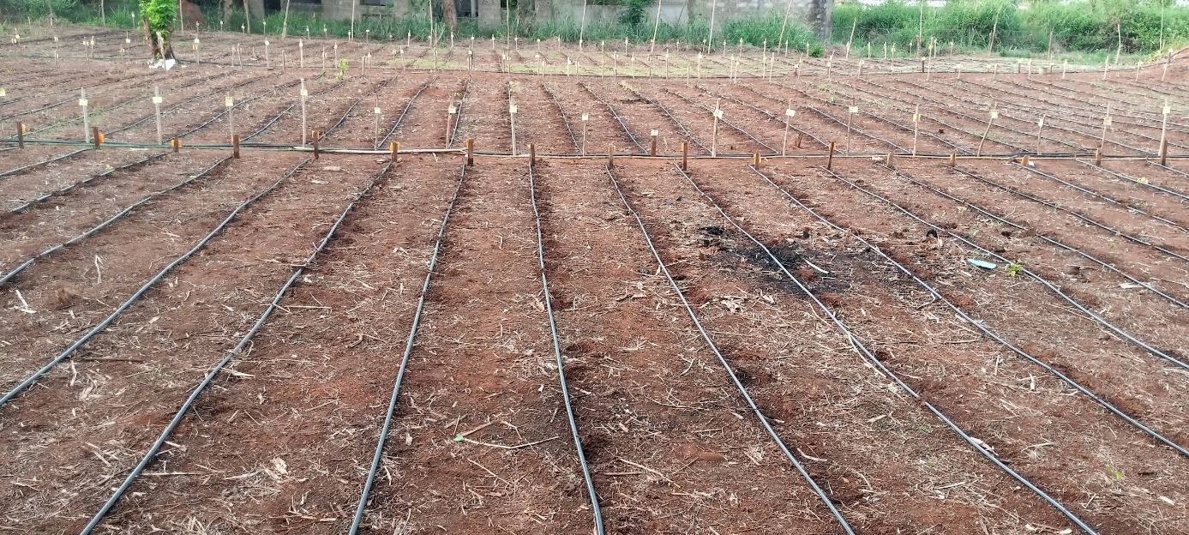
Fig. 1. Experimental Design

2.3.2 Plot establishment and maintenance
Sowing was carried out by placing three maize seeds per hill. Two weeks after germination, thinning was performed to leave two plants per hill. The plot and its surroundings were regularly weeded manually to maintain cleanliness (Fig. 2). Irrigation was provided every two days during the cooler hours of the day using a drip irrigation system, except when rainfall occurred.
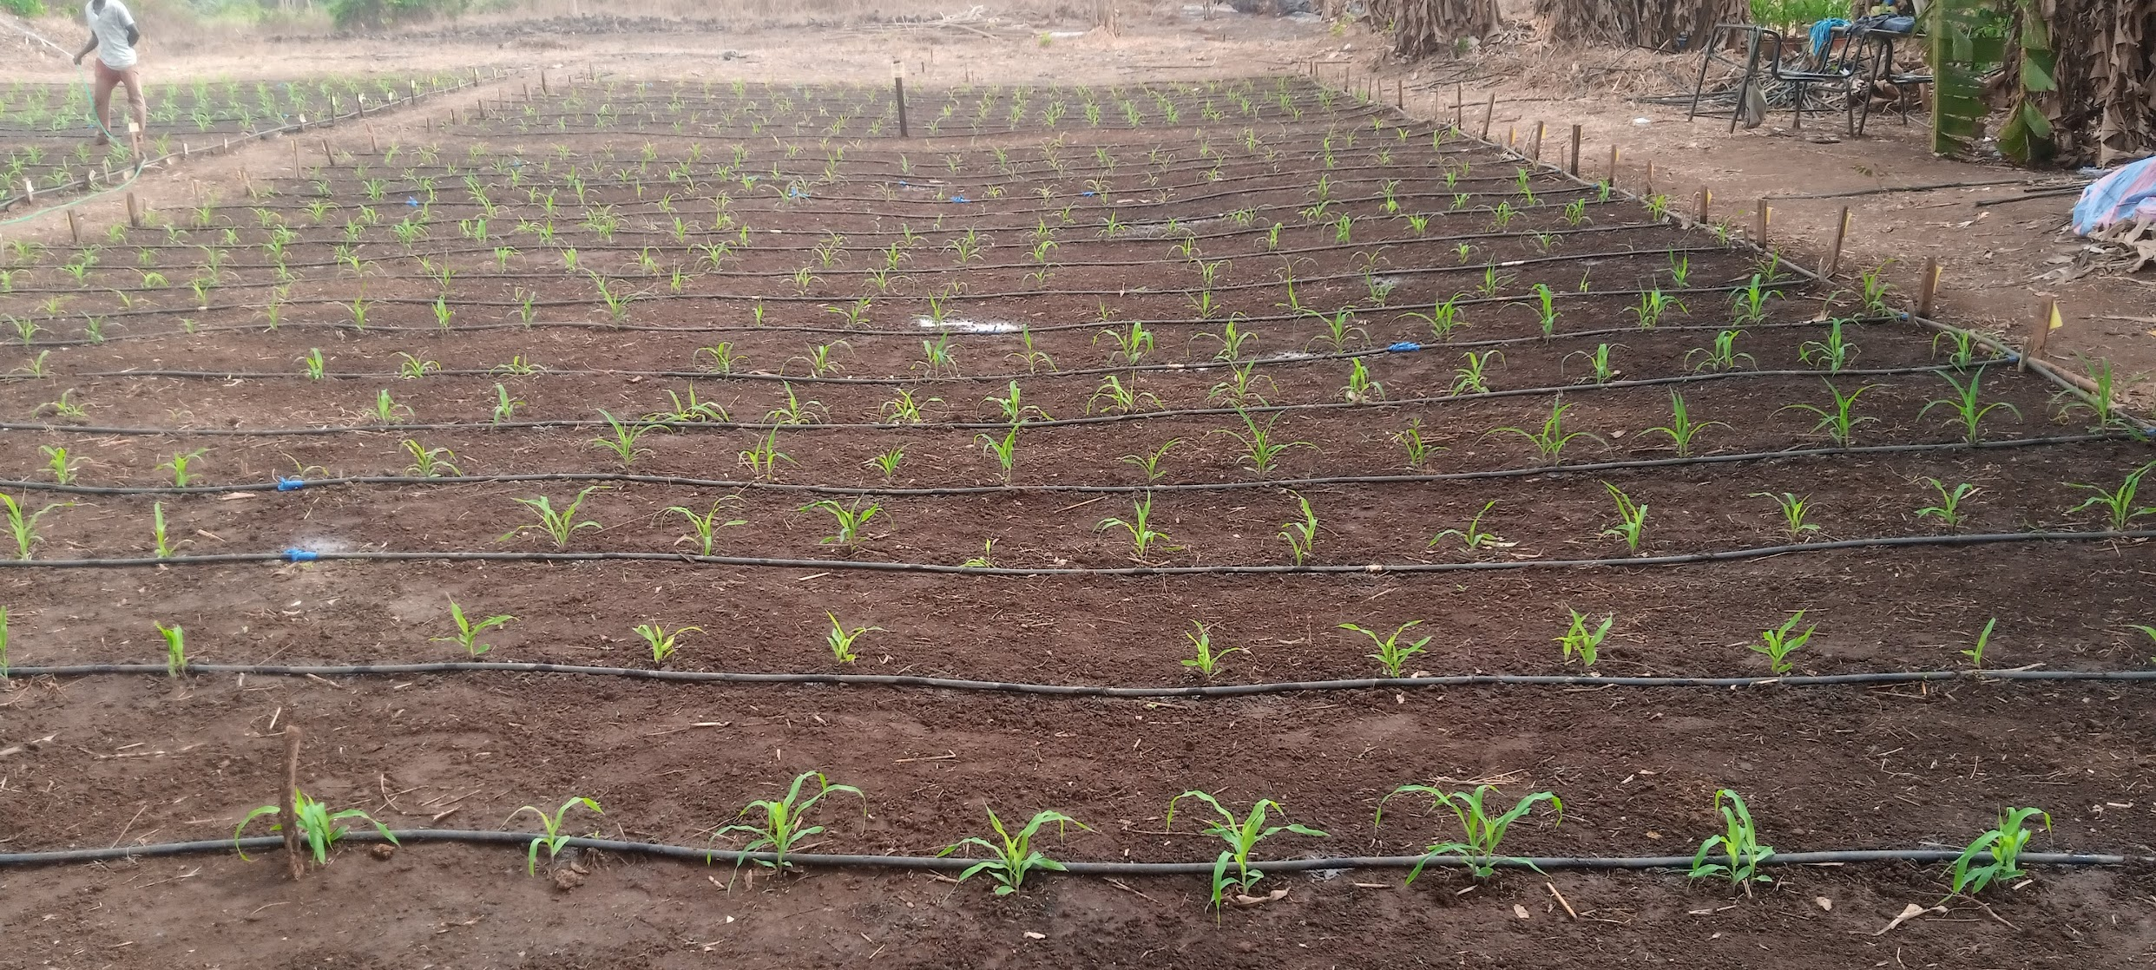
Fig. 2. Overview of the plot two weeks after sowing

2.3.3 Measured parameters
Data were collected from 20 plants per line and per block, making a total of 60 plants per line or control across the entire plot. The following parameters were measured : plant height (PH), ear height (EH), stem diameter at base of the plante (SDB), days to anthesis (DA), days to silking (DS), number of leaves per plant (NL), length of the ear leaf (LL), width of the ear leaf (WL), length of the panicle of plant (LP) and number of spikelets per panicle (NS).
2.3.4 Statistical analysis of data
The Microsoft Excel software was used to compile the collected data. It was also employed to calculate the coefficients of variation (CV) of the different lines in order to identify those that were homogeneous.The degree of homogeneity of each line was evaluated using the mean coefficient of variation of the various quantitative variables measured, according to the following formula :
$$\text{Mean CV}=\frac{∑\text{CV}}{N}$$CV is the coefficient of variation and N is the number of parameters considered.
The coefficient of variation provides information on the level of dispersion of the quantitative variables for each studied line. Thus, lines whose mean coefficient of variation was less than 20 % showed low variability for the measured traits and were therefore considered homogeneous. The SPSS software (version 27.0) was used, at a 5 % probability level, to assess the factorability of the collected data through the correlation matrix, by calculating the Kaiser-Meyer-Olkin (KMO) index and performing Bartlett’s test of sphericity. A Principal Component Analysis (PCA) was then carried out, and the generated factors were used to structure the diversity of the studied lines.
3. RESULTS AND DISCUSSION
3.1 Homogeneity of the Studied Lines
The homogeneity within each maize line was assessed using the coefficient of variation (CV) of the measured parameters presented in Table 1. Analysis of the mean CV values obtained for each line under study provided an effective means to evaluate the degree of homogeneity among the fourth-generation maize lines. All recorded CV values were below the 20 % threshold, indicating strong intra-line phenotypic stability and low phenotypic variability among individuals derived from the same line. This result suggests that the selection program implemented from the first to the fourth generation was effective in reducing heterozygosity caused by gamma-ray exposure and in substantially fixing desirable alleles. These findings are consistent with those of Ballesteros et al. (2021), who reported that the coefficient of variation is a key statistical indicator for evaluating not only the precision and reliability of agronomic trials but also the degree of phenotypic stability among lines. Fritsche-Neto et al. (2011) established an empirical classification based on maize experiments, in which CV values below 10% are considered low, those between 10 and 20 % moderate, and those above 20 % high. Accordingly, a CV ≤ 20 % is regarded as an acceptable threshold ensuring sufficient homogeneity in genotype performance evaluation.
The observed homogeneity (Fig. 3) likely reflects a combined effect of both selection and mutagenic pressure. Gamma mutagenesis can induce numerous point or chromosomal mutations ; however, most deleterious mutations are eliminated during the early generations through natural or artificial selection (FAO/IAEA, 2020). Successive generations allow the fixation of beneficial alleles, leading to the stabilization of desirable phenotypes (Dwivedi et al., 2023). After four selfing cycles, the selected lines thus exhibited reinforced genetic integrity and stable phenotypic expression. Similarly, Magar et al. (2021) reported that, in maize genetic variability studies, CV values below 20 % are generally associated with relatively stable and heritable traits.
Table 1 : Coefficients of variation for the various parameters measured
Lines | PH | HE | SDB | NL | LL | WF | LP | NS | DA | DS | MeanCV (%)
L27 | 7.8 | 10.8 | 6.7 | 4.6 | 4.7 | 8.8 | 11.2 | 11.1 | 4 | 2 | 7.17
L19 | 5.9 | 11.6 | 9.9 | 3.4 | 7 | 8.6 | 8.6 | 18.9 | 1.2 | 3 | 7.81
L21 | 6.7 | 14.3 | 10.4 | 3.2 | 8.3 | 8.3 | 8.1 | 15.5 | 3 | 2.3 | 8.01
L47 | 6.9 | 15.5 | 8.2 | 7.4 | 9.1 | 19.6 | 3.5 | 7.3 | 1.2 | 2 | 8.07
L34 | 7 | 13.2 | 5 | 7.2 | 17.8 | 10.8 | 5.6 | 13.2 | 2 | 1 | 8.28
L6 | 5.7 | 9.5 | 10.5 | 4.9 | 9.9 | 7 | 20 | 13.6 | 1 | 2.2 | 8.43
L35 | 12 | 15.8 | 13.3 | 4.7 | 9.9 | 12.7 | 3.9 | 8.9 | 1.7 | 2 | 8.49
L3 | 6.5 | 11.9 | 12.6 | 6.7 | 9.3 | 10.5 | 10.7 | 11.7 | 3.4 | 3 | 8.63
L25 | 4.9 | 13.5 | 6.7 | 4.6 | 5.5 | 7.5 | 11.8 | 27.1 | 2.9 | 2 | 8.65
L48 | 8.1 | 15.6 | 14.7 | 6.8 | 8.3 | 17.7 | 6 | 8 | 2 | 1 | 8.82
L38 | 5.9 | 9.6 | 10.8 | 7.3 | 8.7 | 29.3 | 3.5 | 10.6 | 3 | 1 | 8.97
L31 | 9.4 | 9.3 | 6.4 | 6 | 9.9 | 9.6 | 11.1 | 25.1 | 1.2 | 2 | 9
L44 | 11.8 | 19.1 | 10.9 | 8.8 | 7.7 | 15.7 | 3.8 | 7.7 | 3 | 1.7 | 9.02
L24 | 8.1 | 11.4 | 12.2 | 3.1 | 10 | 10.3 | 12.2 | 21.2 | 1.5 | 1 | 9.1
L11 | 9.4 | 13.5 | 7.9 | 5.9 | 12.4 | 10.3 | 7.4 | 20.2 | 2.1 | 2 | 9.11
L9 | 7.2 | 7.4 | 15.2 | 4 | 6.7 | 12.1 | 11.8 | 23.5 | 1.2 | 2 | 9.11
L13 | 7.8 | 14.7 | 12.5 | 6 | 8.8 | 11.8 | 10.3 | 17.6 | 1 | 1 | 9.15
L49 | 7.2 | 16.6 | 15.8 | 7.3 | 9.2 | 19.5 | 5 | 8.9 | 1 | 2 | 9.25
L22 | 11.8 | 19.5 | 9.6 | 4.7 | 7.5 | 8 | 6.6 | 22.4 | 2.1 | 2 | 9.42
T0 | 6 | 9.5 | 16.3 | 6.4 | 7.5 | 8.7 | 13.3 | 20.9 | 2.6 | 3 | 9.42
L23 | 11.1 | 16.5 | 13.3 | 3.4 | 6.5 | 11 | 11.8 | 17.7 | 2 | 1 | 9.43
L45 | 4.8 | 20.9 | 14.2 | 6.7 | 13.8 | 17 | 3.3 | 9.8 | 1 | 2.9 | 9.44
L46 | 10.2 | 18 | 11.8 | 10.3 | 11.5 | 17.8 | 3 | 8.9 | 2 | 1 | 9.45
L41 | 10.5 | 12.2 | 10.4 | 8.9 | 22 | 11.6 | 6.5 | 11.5 | 1 | 3.1 | 9.77
L40 | 9.5 | 22.6 | 13.2 | 4 | 9.8 | 24.1 | 4.6 | 7.9 | 1.2 | 1 | 9.79
L28 | 13 | 12.9 | 16.2 | 8.7 | 8.7 | 11.5 | 10.2 | 12.9 | 1.8 | 3.2 | 9.91
L7 | 7.5 | 10.5 | 14.9 | 7.3 | 8.3 | 11 | 13.4 | 21.5 | 2 | 3 | 9.94
L18 | 10.5 | 11.4 | 13.3 | 5.7 | 13.5 | 7.6 | 14 | 17.2 | 3.4 | 3 | 9.96
L16 | 9.8 | 15.2 | 13.9 | 5.8 | 8.5 | 6.7 | 16.5 | 19.1 | 3 | 2.2 | 10.07
L12 | 11.1 | 16.2 | 15.3 | 8 | 7.8 | 14.3 | 10 | 16.4 | 2 | 1 | 10.21
L2 | 9.3 | 15.8 | 16.9 | 7.7 | 8 | 11.8 | 12.4 | 14.8 | 3.2 | 2.5 | 10.24
L8 | 11.2 | 16.9 | 13 | 8.8 | 9 | 7.5 | 10.1 | 22.5 | 3 | 2.1 | 10.41
L4 | 9.7 | 19 | 14.5 | 6.9 | 6.4 | 7.4 | 18.2 | 19.1 | 1 | 4 | 10.62
L10 | 8 | 11.6 | 18.1 | 4.2 | 8.1 | 14.2 | 11.6 | 24.8 | 3.1 | 3 | 10.67
L20 | 11.7 | 21.2 | 13.1 | 3.1 | 10.3 | 12 | 12.1 | 19.1 | 2.1 | 2 | 10.67
L26 | 11 | 14.7 | 18.3 | 8.2 | 6.7 | 11.8 | 10.2 | 20.9 | 3.1 | 2 | 10.69
L17 | 9.9 | 18.3 | 16.5 | 7 | 10.6 | 7.6 | 13.3 | 25.8 | 2 | 1 | 11.2
L5 | 8.2 | 14.2 | 15.3 | 8.4 | 10.5 | 13 | 13.5 | 27.5 | 2.3 | 2 | 11.49
L30 | 10.5 | 25.2 | 14.4 | 4.2 | 7.2 | 8.7 | 11.1 | 29.5 | 2.1 | 3 | 11.59
L14 | 11.1 | 20.8 | 17.1 | 7.9 | 13.3 | 11.9 | 10.8 | 24.3 | 2 | 1 | 12.02
L39 | 5.6 | 17.9 | 18.2 | 11.9 | 23 | 19.9 | 9.6 | 15.5 | 2 | 3 | 12.66
L43 | 9.3 | 17.3 | 7.8 | 8.4 | 29.7 | 17.9 | 15.7 | 17.2 | 2.1 | 2 | 12.74
L29 | 14.9 | 23 | 9.7 | 16.1 | 17.1 | 13.8 | 20.3 | 13.6 | 2 | 1.1 | 13.16
L32 | 17.7 | 23.1 | 18.9 | 9.1 | 22.8 | 14.5 | 9 | 11.7 | 2 | 3 | 13.18
L33 | 9.5 | 30.2 | 18.8 | 11.7 | 11.4 | 18 | 20.5 | 11.1 | 1 | 2 | 13.42
L42 | 10.7 | 23.9 | 12.2 | 8.5 | 20.1 | 18.2 | 22.5 | 13.9 | 2 | 3 | 13.5
L1 | 16.8 | 17.2 | 23 | 8.4 | 12 | 15.6 | 16.6 | 19.9 | 2 | 4 | 13.55
L15 | 16.7 | 27.9 | 20.5 | 7.4 | 14.6 | 11.5 | 11.3 | 22.6 | 1 | 2.1 | 13.56
L36 | 11.3 | 26.5 | 11.7 | 16.6 | 22.3 | 21.3 | 12.4 | 13 | 1 | 1 | 13.71
L37 | 16.6 | 18.9 | 15.4 | 13.1 | 18.7 | 24.1 | 11.7 | 15.1 | 2.1 | 3 | 13.87
PH : plant height, EH : ear height, SDB : stem diameter at base of the plante, DA : days to anthesis, DS : days to silking, NL : number of leaves per plant, LL : length of the ear leaf, WL : width of the ear leaf, LP : length of the panicle of plant and NS : number of spikelets per panicle. mean CV : mean coefficient of variation.

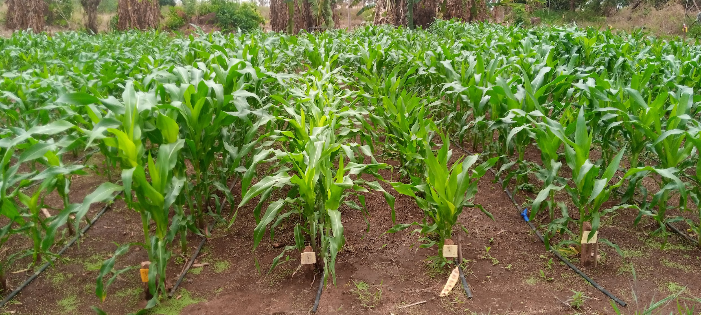
Fig. 3. Illustration of the phenotypic uniformity observed among the maize lines
3.2 Structuring of Inter-Lineage Diversity
3.2.1 Data Factorability
To assess whether the collected data were suitable for Principal Component Analysis (PCA), an examination of the data structure, along with several preliminary tests and analyses, was conducted. Table 2 shows the Pearson correlation matrix for the traits studied. The matrix revealed highly significant correlations (both positive and negative) with $∣r∣>0.7$ between certain trait pairs. The strongest positive correlations were observed between length of the panicle of plant and length of the ear leaf (r = 0.973), and between male and female flowering times (r = 0.94), while the strongest negative correlation occurred between number of leaves per plant and length of the panicle of plant. The Kaiser-Meyer-Olkin (Table 3) measure of sampling adequacy was 0.69, indicating an acceptable level of adequacy for PCA. According to Kaiser (1974), a KMO value between 0.6 and 0.7 reflects moderate correlations among variables, suggesting that the dataset is reasonably suitable for reliable dimensionality reduction. Furthermore, Bartlett’s test of sphericity yielded χ² = 573.617 with a p-value < 0.001, confirming that the correlation matrix is appropriate for exploratory factor analysis (Bartlett, 1950). These results support the use of PCA to reduce redundancy among variables, identify the main axes of variation, and characterize the phenotypic diversity of the studied lines.
Table 2. Correlation matrix between measured variables
 | PH | HE | SDB | NL | LL | WF | LP | NS | DA | DS
PH | -
HE | 0.881 | -
SDB | 0.339 | 0.23 | -
NL | 0.135 | -0.07 | 0.41 | -
LL | 0.211 | 0.391 | -0.28 | -0.89 | -
WF | 0.158 | 0.036 | 0.424 | 0.8 | -0.68 | -
LP | 0.132 | 0.295 | -0.26 | -0.93 | 0.973 | -0.7 | -
NS | -0.02 | 0.132 | -0.1 | -0.7 | 0.659 | -0.57 | 0.653 | -
DA | -0.19 | -0.27 | 0.033 | 0.45 | -0.55 | 0.297 | -0.55 | -0.48 | -
DS | -0.22 | -0.31 | -0.03 | 0.441 | -0.52 | 0.277 | -0.53 | -0.42 | 0.94 | -
PH : plant height, EH : ear height, SDB : stem diameter at base of the plante, DA : days to anthesis, DS : days to silking, NL : number of leaves per plant, LL : length of the ear leaf, WL : width of the ear leaf, LP : length of the panicle of plant and NS : number of spikelets per panicle.

Table 3. Sampling adequacy and sphericity tests

Measure | Value
Kaiser-Meyer-Olkin (KMO) measure of sampling adequacy | 0.69
Bartlett’s test of sphericity Approx. χ² |  | 573.617
Degrees of freedom (df) |  | 45
Significance (p-value) |  | < 0.001

3.2.2 Selection and Analysis of Axes
The eigenvalues and the percentage of variance explained by each axis are presented in Table 4. In total, ten axes were extracted. According to Kaiser’s criterion (1974), any axis with an eigenvalue greater than 1 should be retained for analysis. Consequently, the first three axes, whose eigenvalues exceed 1, were considered relevant for describing the overall variability among the lines. However, the first two axes alone accounted for 72.68 % of the total inertia of the dataset, representing 49.445 % and 23.231 % for axis 1 and axis 2, respectively. This indicates that 72.68 % of the total variability in the distribution of the lines (or variables) is captured within this two-dimensional plane (axes 1–2). These results suggest that the first two axes contain sufficiently informative data to support this analysis. Therefore, the first two axes were selected to structure the diversity among the maize lines included in this study.

Table 4. Eigenvalues and percentage of variance explained by the principal components
 | Initial eigenvalues
Components | Eigenvalues | % of variance | Cumulative %
1 | 4.945 | 49.445 | 49.445
2 | 2.323 | 23.231 | 72.677
3 | 1.128 | 11.28 | 83.957
4 | 0.728 | 7.281 | 91.238
5 | 0.366 | 3.657 | 94.895
6 | 0.299 | 2.988 | 97.883
7 | 0.104 | 1.039 | 98.922
8 | 0.063 | 0.626 | 99.548
9 | 0.032 | 0.324 | 99.872
10 | 0.013 | 0.128 | 100

3.2.3 Contribution of Traits to Axis Construction
Table 5 presents the contribution of the different traits to the construction of the axes. Examination of the variable coordinates in the factorial plane revealed that, with the exception of collar diameter, plant height, and ear insertion level which were correlated with axis 2, the other traits contributed predominantly to the formation of axis 1.

Table 5. Contribution of traits to the construction of the principal axes
 | Component
Traits | 1 | 2
LP | -0.946 | -0.033
LL | -0.944 | 0.036
NL | 0.913 | 0.308
NS | -0.762 | -0.091
WF | 0.751 | 0.406
DA | 0.71 | -0.3
DS | 0.687 | -0.349
PH | -0.133 | 0.889
HE | -0.314 | 0.828
SDB | 0.297 | 0.604

PH : plant height, EH : ear height, SDB : stem diameter at base of the plante, DA : days to anthesis, DS : days to silking, NL : number of leaves per plant, LL : length of the ear leaf, WL : width of the ear leaf, LP : length of the panicle of plant and NS : number of spikelets per panicle.

3.2.4 Projection of Variables on the Correlation Circle
Fig. 4 illustrates the projection of the variables onto the correlation circle. Analysis of this circle confirmed the correlations previously observed in the Pearson correlation matrix. Specifically, the closer two variables are correlated, the smaller the angle between their vectors. Furthermore, the correlation circle demonstrated that most traits made a significant contribution to the discrimination of the lines, with the exception of collar diameter, which exhibited a cos² value below 0.5, indicating a relatively low representation on the principal plane.
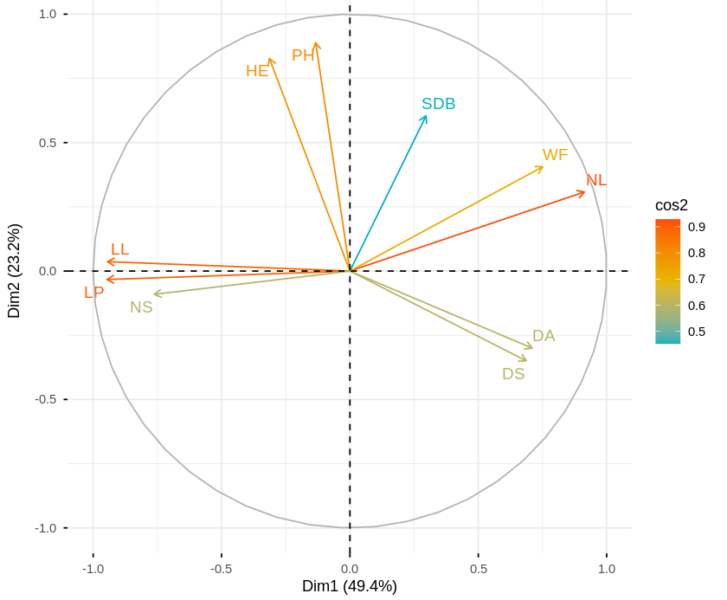

Figure 4. Correlation circle of variables on the principal components

3.2.5 Projection of Lines on the Factorial Plane
Fig. 5 shows the distribution of the studied maize lines in the factorial plane defined by principal components 1 and 2. Lines are grouped into four distinct clusters based on key phenotypic traits. Group 1 (L1, L2, L6, L9, L17, L18, L19, L24, L27, L31, and control T0) consisted of lines with longer leaves and panicles, taller plants with higher ear insertion, earlier development, fewer leaves, and narrower leaf width. Group 2 (L3–L5, L7–L8, L10–L16, L20–L23, L25–L26, L28–L30) comprised lines with smaller collar diameters, shorter leaves, reduced plant height, and lower ear insertion. Group 3 (L33–L40, L42–L49) included lines with thicker stems, the highest number of leaves, and the widest leaves in the population. Group 4 (L32 and L41) contained later-developing lines.
The observed structuring of variability into four groups highlights the effectiveness of gamma irradiation in inducing heritable genomic modifications in the parental variety EV8728. Gamma rays, as reported by Zafar et al. (2022), randomly induce multiple DNA-level modifications, generating the phenotypic diversity observed. These results are consistent with previous studies reporting gamma ray-induced variability in rice (Chauhan et al., 2025), peanut (Saibari et al., 2023), teak (Ahmad et al., 2022), and Fraké (Larekeng et al., 2022).

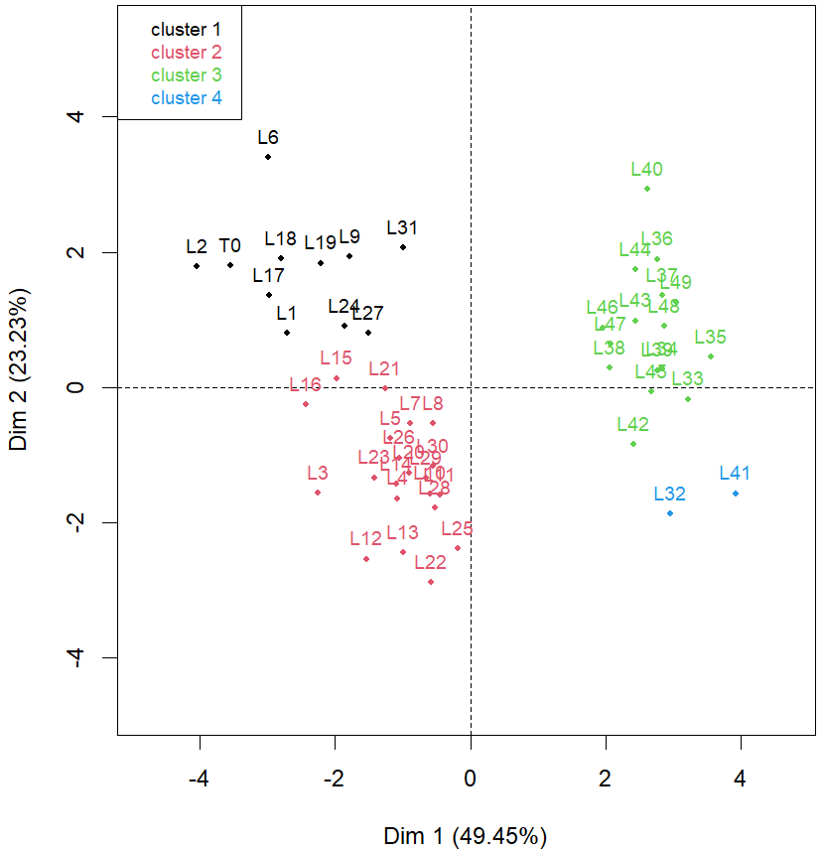
Figure 5. Projection of lines on the factorial plane (Axes 1–2)

4. CONCLUSION
This study assessed the homogeneity and genetic diversity of fourth-generation maize lines obtained via gamma ray induction. Results revealed high genetic stability within lines and significant variability among lines, structured into four distinct groups through Principal Component Analysis. Each group represents a valuable genetic pool for maize improvement, providing a strong foundation for breeding programs in Côte d’Ivoire.

REFERENCES
Ahmad P., Supriyanto S. & Arum S.W. (2022). Effects of Gamma Ray Irrad iation to Induce Genetic Variability of Teak Planlets (Tectona grandis L.). Journal of Sylva Indonesiana, 5(1): 10-21. https://doi.org/10.32734/jsi.v5i01.6166.
Babagana, M., Ndabokun, A. A., Alhassan, M., Shehu, H., & Alfa, K. M. (2020). A review on the role of induced mutation in crop improvement. International Journal of Recent Research in Life Sciences (IJRRLS), 7(3), 29–36. https://www.researchgate.net/publication/343880320.
Ballesteros, R., Moreno, M. A., Barroso, F., González-Gómez, L., & Ortega, J. F. (2021). Assessment of Maize Growth and Development with High- and Medium-Resolution Remote Sensing Products. Agronomy, 11(5) : 1-15. https://doi.org/10.3390/agronomy11050940.
Bartlett, M. S. (1950). Tests of significance in factor analysis. British Journal of Psychology, 3(2), 77–85. https://doi.org/10.1111/j.2044-8317.1950.tb00285.
Bigul, T., M., Subash A., Bibek, G., Kiran, T., Jharana, U. & Jiban, S. (2021). Genetic variability and trait association in maize (Zea mays L.) varieties for growth and yield traits. Heliyon, 7 :1-5. https://doi.org/10.1016/j.heliyon.2021.e07939.
Chauhan, A., Checker, R., Sahu, P. K., Patel, R. S., Baghel S., Sharma, D. & Bikram, K. D. (2025). Agronomic improvement using gamma ray induced mutagenesis is associated with changes in phytochemical and phytohormonal profiles in functional rice variety ‘Gathuwan’. BMC Plant Biology 25, 1-17. https://doi.org/10.1186/s12870-025-07036-1.
Coulibaly, M., Kouadio, L., & Kassi, A. (2020). Production et rentabilité du maïs en Côte d’Ivoire : contraintes et perspectives. Revue Ivoirienne de Sciences Agronomiques, 11(2), 55–64.
Dosso, M., Koffi, A., Glou, B. I., Traoré, A. & Avadí, A. (2023). Analyse fonctionnelle de la filière maraîchère périurbaine en Côte d’Ivoire (2021-2022). Rapport du WP2 – Diagnostique et évaluation du projet MARIGO. CIRAD et ESA/INP-HB, Yamoussoukro, Côte d’Ivoire. 102 pp + Annexes.
Dwivedi, S. L., Heslop-Harrison, P., Spillane, C., McKeown, P. C., Edwards, D., Goldman, I., & Ortiz, R. (2023). Harnessing induced mutations and genomic tools for crop improvement: Integrating old and new approaches. Trends in Plant Science, 28(6), 685–697. https://doi.org/10.1016/j.tplants.2023.01.006.
FAO (2021). Statistiques agricoles mondiales. Organisation des Nations Unies pour l’alimentation et l’agriculture. https://www.fao.org/faostat/fr/.
FAO/AIEA. (2020). Manuel d’amélioration des plantes par mutation- Troisième édition. Sous la supervision de M.M. Spencer-Lopes, B.P. Forster & L. Jankuloski. Vienne, Autriche, 270p.
Fritsche-Neto, R., Vieira, R. A., Scapim, C. A., Miranda, G. V., & Rezende, L. M. (2011). Updating the ranking of the coefficients of variation from maize experiments. Acta Scientiarum. Agronomy, 34(1) : 99–101. https://doi.org/10.4025/actasciagron.v34i1.13115.
Kaiser, H. F. (1974). An index of factorial simplicity. Psychometrika, 39(1), 31–36. https://doi.org/10.1007/BF02291575.
Larekeng S., Qalbi N., Rachmat A., Iswanto I. & Restu M., (2022). Effect of gamma iradiated seeds of Jabon Merah (Neolamarckia macrophylla Wall.) Bosser) to genetic diversity. IOP Conference Series. Earth and Environmental Science. 1115 :1-8. https://doi.org/10.1088/1755-1315/1115/1/012027.
Mba, P. C., Njoku, J. N. & Uyeh, D. D. (2025). Enhancing resilience in specialty crop production in a changing climate through smart systems adoption. Smart Agricultural Technology, 11, 1-23. https://doi.org/10.1016/j.atech.2025.100897.
Saibari I., Barrijal S., Mouhib M., Belkadi N. & Hamim A. (2023), Gamma irradiation induced genetic variability and its effects on the phenotypic and agronomic traits of groundnut (Arachis hypogaea L.). Frontiers in Genetics, 14 : 1-11. https://doi.org/10.3389/fgene.2023.1124632.
Sangaré A., Koffi E., Akamou F & Fall C. (2009). État des ressources phytogénétiques pour l’alimentation et l’agriculture : Second rapport national. Rapport national sur l'état des ressources phytogénétiques pour l'alimentation et l'agriculture Ministère de l’Agriculture République de Côte d’Ivoire, 71p.
Sarsu, F. (2021). Contribution of induced mutation. ACI Avances En Ciencias E Ingenierías, 12(3) : 1-10. https://doi.org/10.18272/aci.v12i3.2031.
Soro, D., Ayolié K., Gohi-Bi, Z. F., Yao, Y. F., Konan-Kan, K. H., Sidicky, B., Téhua, A. P & Yatty, K. J. (2015). Impact of organic fertilization on maize (Zea mays L.) production in a ferralitic soil of centre west Côte d’Ivoire. Journal of Experimental Biology and Agricultural Sciences, 3 (6), 556-565. http://dx.doi.org/10.18006/2015.3(6).556.565.
Thenuja, M., Sutharsan, S. & Rifnas L.M. (2024). Effects of Different Levels of Gamma Radiation on Growth and Yield Characteristics of Groundnut. Asian Journal of Research in Agriculture and Forestry, 10(1), 1-10. https://doi.org/10.9734/ajraf/2024/v10i1264.
Zafar A.S., Aslam M., Albaqami M., Ashraf A., Hassan A., Iqbal J., Maqbool A., Naeem M., Al-Yahyai R., & Tan Kee Z.A. (2022). Gamma rays induced genetic variability in tomato (Solanum lycopersicum L.) germplasm. Saudi journal of biological sciences, 29(5): 3300–3307. https://doi.org/10.1016/j.sjbs.2022.02.008.

