Insecticidal effect of wood vinegars on agronomic performance and yield of open-field tomatoes in Côte d'Ivoire

Abstract
Background: Tomato production in Côte d'Ivoire faces significant yield losses due to insect infestations, often controlled with synthetic pesticides that pose environmental and health risks. Wood vinegar, a byproduct of biomass pyrolysis, contains bioactive compounds with potential insecticidal and biostimulant properties. This study investigated the effectiveness of locally produced wood vinegars as eco-friendly insecticides in tomato cultivation.
Methods: The experiment was carried out during the 2024 rainy season in Yamoussoukro, Côte d'Ivoire, on a 250 m² field characterized by slightly acidic soil (pH 6.5), low nitrogen (0.04 %), and high phosphorus (37 ppm). Two wood vinegars (WCV1 and VCV2) were tested at three dilutions (1:100, 1:200, 1:300) against a synthetic insecticide (K-Optinal 35 EC) and an untreated control. Agronomic and physiological parameters including insect attack rate, collar diameter, stem development, leaf area, and yield were measured at 18, 32, and 46 days after transplanting (DAT).
Results: Both wood vinegars significantly reduced insect infestation, with VCV2 (1:100) showing the highest efficacy (0 – 16.67 % infestation), although less effective than the synthetic control (0 – 4.17 %). Treatments with WCV1 (1:300) and VCV2 (1:300) promoted greater collar diameter and leaf expansion, indicating biostimulant effects. Tomato yields doubled compared to untreated plants but remained lower than those treated with synthetic insecticide. Additionally, vinegar applications extended fruit shelf life (21 – 25 days versus 7 days in control) and lowered moisture content (55 – 61 % versus 72 %).
Conclusion: Wood vinegars represent a promising, sustainable alternative to chemical insecticides by enhancing pest control, growth, and post-harvest quality in tomato cultivation. However, their effectiveness depends on concentration and exhibits shorter persistence compared to synthetic treatments. Further optimization of formulation and application frequency is required for large-scale agricultural integration.
Key words: Wood vinegar, Tomatoe, Biostimulant, Insect repellent, Insecticide

- Introduction
The tomato (Solanum lycopersicum L.) is one of the most important vegetable crops in Côte d'Ivoire for both local consumption and the subsistence economy. Due to its high vitamin, mineral, and antioxidant content, it is an essential food in the diets of urban and rural populations (FAO, 2021). However, cultivating tomatoes in open fields presents many challenges, including insect pest attacks, which can result in significant yield losses, sometimes exceeding 80 % (Adhikari et al., 2017 ; Osei et al., 2025).
The main insect pests include Helicoverpa armigera, Tuta absoluta, Bemisia tabaci, and various beetles. These pests attack the leaves, fruits, and stems of tomato plants, thereby compromising their growth and quality (Aynalem, 2018 ; Poudel et Kafle, 2021). To combat these pests, producers widely use synthetic insecticides, often applying them excessively or inappropriately. This practice poses significant environmental and health problems, including soil contamination, reduced entomological biodiversity, and the presence of toxic residues on food (Aktar et al., 2009 ; Meda et al., 2022).
In response to these concerns, interest in natural and ecological alternatives has grown, particularly in the context of sustainable agriculture. One such alternative is wood vinegar, which is a liquid byproduct resulting from the condensation of fumes and vapors from wood carbonization (Chalermsan et Peerapan, 2009). Wood vinegars consist of up to 90 % water and a complex mixture of organic compounds, including aldehydes, alcohols, esters, furan and pyran derivatives, heterocyclic compounds, hydrocarbons, ketones, nitrogen compounds, organic acids, and phenolic compounds. The main compounds are organic and phenolic acids (De Souza Araújo et al., 2018 ; Mansur et al., 2013 ; Souza et al., 2012 ; Young-Hee et al., 2005). This composition gives wood vinegars insect repellent and fungistatic properties (Baimark et Niamsa, 2009 ; Mmojieje et Hornung, 2015 ; Ouattara et al., 2023).
Several studies have demonstrated the repellent or toxic effects of wood vinegars on certain agricultural insects. For instance, Mmojieje and Hornung (2015) assessed the efficacy of pyroligneous acid derived from mixed woody biomass against the green peach aphid (Myzus persicae), achieving over 90 % mortality of these pests. Regnault-Roger (1997) applied a 1 % dilution of pyroligneous acid to eggplant plants (Solanum melongena). The results showed that the extract reduced aphid populations by 95 %. Purnama et al. (2024) studied the use of wood vinegar derived from roasted coconut shells as a botanical pesticide to manage Spodoptera frugiperda infestations, testing five concentrations (0 %, 3 %, 5 %, 8 %, and 10 %). The results demonstrated that wood vinegar concentration significantly impacted larval mortality; 10 % concentration was the most effective, achieving an 80 % mortality rate.
Although in vitro applications of wood vinegars as insecticides have been carried out, little data is currently available. In particular, there is a lack of data on the effects of natural conditions on insects affecting tomatoes. In other words, the effect of pyroligneous acid insect repellent properties on tomato productivity in real conditions, such as in a tropical field in Côte d'Ivoire, remains to be explored.
Therefore, this study aims to evaluate the effect of wood vinegar as a natural insect repellent on the agronomic parameters of tomatoes grown in open fields in Côte d'Ivoire. This study is part of an approach to promote the use of natural resources and reduce the use of chemical pesticides while contributing to food security and the sustainability of vegetable production in Côte d'Ivoire. To this end, foliar spray tests were conducted on tomato plants after a soil analysis prior to cultivation.
- Material et methods
  - Sample site
The experiment was conducted on the northern site of the experimental farm of the Félix Houphouët-Boigny National Polytechnic Institute (INP-HB) in Yamoussoukro. The work was carried out on a 500 m² plot of land located on the edge of the lake, which was carefully cleared by hand. This site is geographically located at coordinates 6°53'17.43" North latitude and -5°13'17.50" West longitude. The experiment lasted from mid-April to mid-July 2024, during the rainy season. During this period, climatic conditions revealed average temperatures ranging from 32 °C in the morning to 22.5 °C in the evening, with relative humidity of 60 %.
  - Natural extracts used
The study used two wood vinegars produced in Côte d’Ivoire with a Casamance kiln at the N’gokro charcoal training site (Alepé, Mé region) at 3°38'24" west longitude and 5°21'17" north latitude. Wood logs were stacked and carbonized for 7–12 days at 380–500 °C. The resulting pyroligneous liquid was stored for over a year, yielding three phases after decantation: an oily layer, a middle layer of wood vinegar, and tar at the bottom. The process of collecting these wood vinegars is shown in Figure 1. The wood vinegars were purified through repeated centrifugation and filtration to obtain clear, stable solutions following standard methods (Fagernäs et al., 2012 ; Wada, 1997). Additional technical details on the wood species, carbonization process, and wood moisture are provided in Table 1.
  - Plant material
The experiment used the COBRA F1 26 tomato variety, known for its high yield, early and extended production, and adaptability to diverse soils and climates. It shows strong resistance to major diseases (fusarium and verticillium wilts, mosaic virus) and good tolerance to drought and heat. Its uniform, bright red fruits have excellent post-harvest durability, suitable for both fresh consumption and processing. Economically efficient due to its low input requirements, COBRA F1 26 is ideal for maximizing field productivity.
  - Experimental Setup and treatments
The experiment was conducted on a 250 m² plot to evaluate wood vinegars as biopesticides in tomato cultivation. Soil samples were collected, dried, and analyzed to determine their physicochemical characteristics before planting (Table 2). These parameters were interpreted according to Bunasols, (1990) (Tables 3 and Table 4). Tomato seedlings were first raised in a germination chamber built near the experimental site (Figure 2), where seeds were treated with nematicide and insecticide to ensure healthy emergence. After 21 days of regular watering and care, vigorous seedlings with at least four leaves were transplanted onto 24 elementary plots arranged in a completely randomized block design (Figure 3), each containing 12 plants. The treatments included a synthetic insecticide (K-Optinal 35EC, CALLIVOIR, Yamoussoukro, Côte d’Ivoire), two types of wood vinegar (WCV1 and VCV2) at three dilutions (1:100, 1:200, 1:300), and an untreated control (UC). Applications were made three times at 14-day intervals once insect infestations appeared, with three replicates per treatment, while regular weeding was carried out to promote healthy plant growth. The Figure 4A, 4B, 4C and 4D summarize the experiment.
  - Agronomic parameters
Because tomatoes have a short growth cycle and are highly sensitive to handling, agronomic data were collected early in the morning to reduce contamination risks. Observations focused on central plants within each subplot to avoid edge effects, with measurements taken at 18, 32, and 46 days after transplanting corresponding to emergence, flowering, and ripening stages. Parameters such as insect attack rate (Eq. 1), stem height and development (Eq. 2), leaf area (Eq. 3), number of leaves, collar diameter, and duration of effectiveness were recorded on eight representative plants. At harvest, fruit yield per stem was calculated (Eq. 4), and three fruits per treatment were stored at room temperature to assess shelf life. Fruit moisture content was determined by weight loss after drying at 105 °C for 24 hours (Eq. 5). All measurements were conducted in four replicates to ensure reliable and representative results.
$ATQ \left(\%\right)=\frac{Nombre de plants attaqués}{Nombre total de plants}×100$ (1)
With, ATQ, insect attack rate per board
$SD \left(cm\right)=H_{f}-H_{d}$ (2)
With SD, stem development stage in cm, H_{f}, stem length at the end of the stage in cm, and H_{d}, stem length at the beginning of the stage in cm.
$LA \left({cm}^{2}\right)=L_{l}×W_{l}$ (3)
Where LA is the leaf area in cm², L_{l} is the leaf length in cm, and W_{l} is the leaf width in cm.
$Yield \left(kg/ha\right)=\frac{M_{f}}{Sp}×10.000$ (4)
Where Yield is the yield in kilograms per hectare, M_{f} is the mass of fruit harvested from a plot in kilograms, and Sp is the surface area of a plot in square meters.
$Water content \left(\%\right)=\frac{M_{0}-M_{1}}{M_{0}}×100$ (5)
Where M₀ is the mass of the tomato before drying in the oven in g, and M₁ is the mass of the tomato after drying in the oven in g.
  - Statistical analysis
SPSS 16.0 was used as the statistical tool. Statistical analysis was performed using analysis de variance (ANOVA) procedures on the whole of results. A post-hoc test was used to separate the averages according to Duncan's test. All results were assessed at the 5% significance.
- Results and discussion
  - Experimental soil
Soil fertility depends on several key physicochemical parameters that determine its ability to support plant growth. Before planting, essential soil characteristics including pH, organic carbon, total nitrogen, organic matter, assimilable phosphorus, cation exchange capacity (CEC), and exchangeable bases (Ca²⁺, Mg²⁺, K⁺, Na⁺) were analyzed (Table 2). The soil showed a slightly acidic pH of 6.5, favorable for nutrient availability (N, P, K) and reduced metal toxicity (Al³⁺, Mn²⁺) (Brady, 1984 ; Bunasols, 1990), while also promoting microbial activity and organic matter decomposition (Sylvia, 2005). Organic matter and organic carbon contents were moderate (1.27 % and 0.74 %, respectively) (Bunasols, 1990), contributing to soil structure and water retention (Lehmann et Kleber, 2015). Total nitrogen was low (0.04 %) (Bunasols, 1990), resulting in a high C/N ratio (16.46), which reflects limited biological activity and slow organic matter decomposition (Paul, 2014 ; Cotrufo et al., 2019). Assimilable phosphorus reached 37 ppm, indicating high availability beneficial for root growth and flowering (Schachtman et al., 1998 ; Vance et al., 2003). However, both CEC (4.16 cmol/kg) and exchangeable bases (1.07 cmol/kg) were low, suggesting poor nutrient retention capacity (Tan, 2010) and base depletion that may limit fertility (Bose et al., 2011). To improve soil quality, organic amendments and nitrogen fertilization are recommended to enhance nutrient storage and productivity.
  - Insect attack rate for 18, 32, and 46 days after transplanting (DAT)
The data collected on tomato plants were used to calculate the percentage of insect damage (Table 5). The different doses of wood vinegar extracts significantly affected (P < 0.05) insect attack rates at 18, 32, and 46 days after transplanting (DAT). All treatments reduced pest attacks compared with the untreated control. Among them, VCV2 (1:100) was the most effective (0.00–16.67 ± 1.67 %), followed by WCV1 (1:100) (8.33 ± 7.21 – 25.00 ± 12.50 %), though both were less efficient than the synthetic reference K-Optinal (0 – 4.17 ± 2.00 %).
The attack rate serves as a key indicator of treatment efficacy (Gisder et Genersch, 2017 ; Ferracini et al., 2021). K-Optinal’s high effectiveness is attributed to its two active ingredients notably lambda-cyhalothrin (15 g/L), a pyrethroid with knock-down action, and acetamiprid (20 g/L), a neonicotinoid active against sucking insects (Kashyap et Sharma, 2016 ; Dai et al., 2024). Compared with untreated plants, VCV2 (1:100) reduced pest attacks by more than threefold, while the synthetic control was over 13 times more effective. This efficiency likely stems from the higher concentration of bioactive compounds (acetic acid, phenols, and esters) known for their insecticidal properties. Previous studies have also demonstrated the repellent and lethal effects of wood vinegar on various pests, including rice weevils (LC₅₀ = 77.62 ppm) (Prianto et al., 2022 ; Othman et al., 2023), aphids, and mites, achieving up to 90 % mortality (Mmojieje et Hornung, 2015 ; Silva et al., 2021). Depending on concentration, pyroligneous acid can reduce pest populations by up to 95 %, supporting its potential as an eco-friendly alternative to synthetic insecticides (Prianto et al., 2022 ; Iacomino et al., 2024).
  - Collar diameter for 18, 32, and 46 days after transplanting (DAT)
The collar diameters data of tomato plants are presented in Table 6. The different extract doses significantly affected (P < 0.05) collar diameter at 18, 32, and 46 days after planting (DAT). All treatments positively influenced collar diameter compared to the untreated control, which showed the lowest values (4.00–9.11 ± 0.96 mm). Regardless of the evaluation period, wood vinegar treatments significantly increased collar diameter compared to the reference product. Growth improvement was more pronounced at lower concentrations, particularly with WCV1 and VCV2 (1:300) at 32 DAT, and with WCV1 (1:200 and 1:300) at 46 DAT.
Collar diameter reflects plant vigor, root stability, and resistance to stress (Ponce-Figueroa et al., 2024) and helps assess nutritional or pest-related deficiencies (Grossnickle et MacDonald, 2018). The significant increases obtained with WCV1 (1:300) and VCV2 (1:300) at 18–32 DAT, and VCV2 (1:200) at 46 DAT, indicate a biostimulant effect of these extracts. The Appropriate Technology Association of Thailand recommends dilutions of 1:500–1:1000 (v/v) for growth stimulation (Rick, 2010), though lower dilutions were required here due to the high-water content of the vinegars. Several studies confirm the growth-promoting effect of wood vinegar. Kulkarni et al. (2007, 2008) reported improved tomato growth and yield, while (Mungkunkamchao et al., 2013) found that wood vinegar (1:800) and fermented bio-extract (1:500) similarly stimulated tomato cv. Delta growth. Tomatoes appear sensitive to smoke-derived regulators such as karrikinolide and karrikins, which promote germination and seedling development -Kulkarni et al., 2007, 2008). Wood vinegar also contains bioactive organic acids (acetic, propionic, butyric) and alcohols (methanol, ethanol) that enhance nutrient absorption, microbial activity, and metabolic processes like glycolysis and the Krebs cycle (Salehi et al., 2008).
  - Stem development for 18, 32, and 46 days after transplanting (DAT)
The vegetative development stage, representing variations in tomato stem height, is summarized in Table 7. Overall, treatments showed no significant effects (P ≥ 0.05) on stem development, although the reference product induced a notable increase at the early stages (4.67 ± 2.08 cm at 18 DAT; 24.00 ± 2.00 cm at 32 DAT).
Stem development reflects plant vigor and growth rate. The reference product promoted better development, likely due to its synthetic insecticidal compounds protecting plants and enhancing growth. At 32 DAT, when vegetative growth is most active, wood vinegar treatments, particularly VCV2 (1:300), showed moderate stimulation compared to the untreated control, suggesting greater efficacy at low concentrations and supporting recommendations for high dilutions. At 18 DAT and 46 DAT, no significant differences (P ≥ 0.05) were observed among treatments except for the reference product at 18 DAT. This may be due to plant resource allocation: during early growth, roots develop to optimize nutrient uptake, whereas after 46 DAT (flowering and fruiting phases), energy shifts to reproductive structures (Wenk et Falster, 2015). Previous studies indicate that smoke-derived extracts enhance tomato seedling development (Van Staden et al., 2006) and foliar growth (Kulkarni et al., 2007). The bioactive compounds in wood vinegars (acetic and propionic acids, alcohols, and phenolics) act as growth stimulants. Phenolic acids like ferulic and caffeic acid promote cell division and elongation (Ramzan et al., 2024), while their antioxidant properties improve tolerance to abiotic stress and reinforce plant defenses. Moreover, they enhance soil microbial activity and nutrient availability, making wood vinegars effective natural biostimulants.
  - Leaf area for 18, 32, and 46 days after transplanting (DAT)
Leaf length and width measurements were used to determine tomato leaf area, as presented in Table 8. Treatments significantly affected (P < 0.05) the average leaf area at each developmental stage. Untreated plants had the smallest values (161.67 ± 20.21 cm² and 786.22 ± 71.66 cm²), while all vinegar treatments positively influenced leaf expansion. The reference product promoted the greatest growth at 18 and 32 DAT, but at 46 DAT, VCV2 (1:300) showed the highest leaf area. Generally, leaf area increased with decreasing vinegar concentration, except for WCV1 at 46 DAT.
Leaf area is a key indicator of photosynthetic capacity, directly influencing growth and yield (Saito et al., 2020). A larger leaf area enhances light capture, sugar production, transpiration, and nutrient uptake (Hoek van Dijke et al., 2020). The highest values obtained with the reference product and VCV2 (1:300) suggest that wood vinegar–based biostimulants could rival chemical treatments, offering sustainable crop alternatives. VCV2 (1:300) consistently improved multiple growth parameters (collar diameter, leaf number, and stem development) likely due to bioactive compounds such as karrikinolide and karrikins, known to promote germination and seedling growth in tomatoes (Kulkarni et al., 2007, 2008). This sensitivity may explain the increase in above-ground biomass and leaf area. Although GC–MS analysis did not confirm these compounds in the previous studies (Ouattara et al., 2024), LC–MS could verify their presence (Singh et al., 2023). Nonetheless, GC–MS identified organic acids (acetic, propionic) and alcohols, which may also stimulate leaf expansion in tomato plants.
  - Yield, effective time, storage time, and water content
Additional parameters such as yield, effective time, storage time, and moisture content are presented in Table 9. All treatments significantly affected (P < 0.05) tomato yield. Wood vinegars positively influenced production, doubling yield compared to untreated plants, whereas the reference product performed best, producing yields four times higher than untreated tomatoes and 1.5 times higher than the lowest yield among wood vinegar treatments. However, no significant difference (P > 0.05) was observed among vinegars regarding effectiveness, storage time, or moisture content. Despite this, wood vinegar treatments extended tomato shelf life nearly three times longer than untreated fruits and 1.5 times longer than those treated with the reference product. Moreover, vinegar-treated tomatoes showed a notable reduction in moisture content, up to 1.2 times lower than untreated and 1.3 times lower than reference-treated fruits, indicating higher dry matter content and potentially improved post-harvest quality.
Yield is a fundamental indicator of agricultural productivity, reflecting crop health and management efficiency (Tadele, 2017 ; Liu et al., 2021). In this study, tomato yield varied significantly by treatment due to pest pressure. Although it was lower than that obtained with the synthetic reference product K-Optimal, wood vinegars doubled the yield of untreated plants, demonstrating promising biocontrol potential. This improvement likely results from the presence of bioactive compounds (organic acids, phenols, furfurals, aldehydes) with insecticidal, antifungal, and repellent properties (Grewal et al., 2018 ; Prianto et al., 2022 ; Urrutia et al., 2022 ; Othman et al., 2023), which reduced pest damage and preserved photosynthetic organs and flower integrity, favoring pollination and fruiting. Reduced biotic stress may also have enhanced resource use efficiency, as reported for biostimulants (Yakhin et al., 2017). Treatments WCV1 and VCV2 (1:100) showed the most promising results, confirming their potential as eco-friendly alternatives for yield improvement (Mungkunkamchao et al., 2013 ; Sun et al., 2021 ; Zhu et al., 2021). At lower concentrations, these extracts also stimulate microbial activity by providing carbon sources (Mattos et al., 2019 ; Fan et al., 2022 ; Ray et al., 2022). In the context of quasi-organic farming, which integrates natural inputs and sustainable practices (Ponisio et al., 2015 ; Reganold et Wachter, 2016 ; Mie et al., 2017), wood vinegar plays a strategic role thanks to its insecticidal, antifungal, and biostimulant properties. However, its shorter persistence (14.33–16.00 days vs. 21.33 ± 1.53 days for K-Optimal) reflects its lower chemical stability and faster environmental degradation (Global Market Insights Inc., 2023 ; Mordor Intelligence, 2024). This limitation can be offset by regular applications in integrated management systems. Notably, wood vinegar also extended fruit shelf life (21–25 days vs. 15 days for K-Optimal and 7 days for untreated fruit) and reduced fruit moisture content (55.34–60.68 % vs. 72.28 % for untreated and 80.22 % for K-Optimal), likely due to its drying and antimicrobial effects, which limit microbial growth and post-harvest decay. Finally, while synthetic products remain more effective in terms of immediate action, their use is short-term and can lead to resistance or long-term environmental impacts. Conversely, wood vinegar-based treatments, integrated into agroecological crop management, offer multiple benefits such as improved fruit quality, extended shelf life, reduced use of chemicals, and the promotion of locally available natural resources. This makes them tools for the future in the transition to more resilient and environmentally friendly agriculture.
- Conclusions
This study demonstrates that wood vinegars (WCV1 and VCV2) can serve as effective biopesticides and biostimulants for tomato cultivation, offering a sustainable alternative to synthetic insecticides. The application of VCV2 (1:100) significantly reduced insect attack rates, while lower concentrations (1:300) enhanced plant growth parameters such as collar diameter, leaf area, and yield doubling productivity compared to untreated plants. Additionally, wood vinegar treatments improved post-harvest quality by extending shelf life (21 to 25 days vs. 7 days for control) and reducing fruit moisture content, indicating better preservation. However, while wood vinegars showed promising biostimulant and pest-repellent properties, their efficacy was still lower than that of synthetic insecticides like K-Optinal 35EC, which provided superior pest control and yield. The shorter duration of effectiveness (14–16 days vs. 21 days for synthetic treatment) suggests that more frequent applications may be necessary for optimal results.
These findings highlight the potential of wood vinegar as an eco-friendly tool in integrated pest management (IPM) and organic farming systems. Future research should focus on optimizing application methods, concentrations, and synergistic combinations with other natural inputs to enhance performance while maintaining sustainability. By integrating wood vinegars into agroecological practices, farmers could reduce reliance on chemical pesticides, improve crop resilience, and promote environmentally friendly agriculture.
Disclaimer (artificial intelligence)
Author(s) hereby declare that NO generative AI technologies such as Large Language Models (ChatGPT, COPILOT, etc.) and text-to-image generators have been used during the writing or editing of this manuscript.

References
Adhikari, P., Oh, Y. et Panthee, D. R. (2017). Current Status of Early Blight Resistance in Tomato: An Update. International Journal of Molecular Sciences, 18(10), 2019. https://doi.org/10.3390/ijms18102019
Aktar, M. W., Sengupta, D. et Chowdhury, A. (2009). Impact of pesticides use in agriculture: their benefits and hazards. Interdisciplinary toxicology, 2(1), 1‑12. https://doi.org/10.2478/v10102-009-0001-7
Aynalem, B. (2018). Tomato leafminer [(Tuta absoluta Meyrick) (Lepidoptera: Gelechiidae)] and its current ecofriendly management strategies: A review. Journal of Agricultural Biotechnology and Sustainable Development, 10(2), 11‑24. https://doi.org/10.5897/JABSD2018.0306
Baimark, Y. et Niamsa, N. (2009). Study on wood vinegars for use as coagulating and antifungal agents on the production of natural rubber sheets. Biomass and Bioenergy, 33(6), 994‑998. https://doi.org/10.1016/j.biombioe.2009.04.001
Bose, J., Babourina, O. et Rengel, Z. (2011). Role of magnesium in alleviation of aluminium toxicity in plants. Journal of experimental botany, 62(7), 2251‑2264. https://doi.org/10.1093/jxb/erq456
Brady, N. C. (1984). The nature and properties of soils. (9e éd.). MacMillan Publishing Company.
Bunasols. (1990). Manuel pour l’évaluation des terres (Documentation technique n°6). Bureau National des Sols (BUNASOLS).
Chalermsan, Y. et Peerapan, S. (2009). Wood vinegar: by-product from rural charcoal kiln and its role in plant protection. Asian Journal of Food and Agro-Industry, vol.2.
Cotrufo, M. F., Ranalli, M. G., Haddix, M. L., Six, J. et Lugato, E. (2019). Soil carbon storage informed by particulate and mineral-associated organic matter. Nature Geoscience, 12(12), 989‑994. https://doi.org/10.1038/s41561-019-0484-6
Dai, X., Lin, Q., Liu, Y., Wang, R., Su, L., Yin, Z., Zhao, S., Zhang, F., Chen, H., Zheng, L., Zhai, Y. et Zhang, L. (2024). Precise Control and Prevention Methods for Whitefly in Greenhouse Vegetables. Agronomy, 14(5), 989. https://doi.org/10.3390/agronomy14050989
De Souza Araújo, E., Pimenta, A. S., Feijó, F. M. C., Castro, R. V. O., Fasciotti, M., Monteiro, T. V. C. et De Lima, K. M. G. (2018). Antibacterial and antifungal activities of pyroligneous acid from wood of Eucalyptus urograndis and Mimosa tenuiflora. Journal of Applied Microbiology, 124(1), 85‑96. https://doi.org/10.1111/jam.13626
Fagernäs, L., Kuoppala, E., Tiilikkala, K. et Oasmaa, A. (2012). Chemical Composition of Birch Wood Slow Pyrolysis Products. Energy & Fuels, 26(2), 1275‑1283. https://doi.org/10.1021/ef2018836
Fan, Q., Fan, X., Fu, P., Li, Y., Zhao, Y. et Hua, D. (2022). Anaerobic digestion of wood vinegar wastewater using domesticated sludge: focusing on the relationship between organic degradation and microbial communities (archaea, bacteria, and fungi). Bioresource Technology, 347, 126384. https://doi.org/10.1016/j.biortech.2021.126384
FAO. (2021). Intégration de la nutrition dans le secteur de la foresterie de la théorie à la pratique. FAO. https://doi.org/10.4060/cb6788fr
Ferracini, C., Blandino, M., Rigamonti, I. E., Jucker, C., Busato, E., Saladini, M. A., Reyneri, A. et Alma, A. (2021). Chemical-based strategies to control the western corn rootworm, Diabrotica virgifera virgifera LeConte. Crop Protection, 139, 105306. https://doi.org/10.1016/j.cropro.2020.105306
Gisder, S. et Genersch, E. (2017). Viruses of commercialized insect pollinators. Journal of Invertebrate Pathology, 147, 51‑59. https://doi.org/10.1016/j.jip.2016.07.010
Global Market Insights Inc. (2023). Vinaigre en bois Part de marché: Rapport d analyse, 2024-2032. Global Market Insights Inc. https://www.gminsights.com/fr/industry-analysis/wood-vinegar-market
Grewal, A., Abbey, Lord et Gunupuru, L. R. (2018). Production, prospects and potential application of pyroligneous acid in agriculture. Journal of analytical and applied pyrolysis, 135, 152‑159.
Grossnickle, S. C. et MacDonald, J. E. (2018). Why seedlings grow: influence of plant attributes. New Forests, 49(1), 1‑34. https://doi.org/10.1007/s11056-017-9606-4
Hoek van Dijke, A. J., Mallick, K., Schlerf, M., Machwitz, M., Herold, M. et Teuling, A. J. (2020). Examining the link between vegetation leaf area and land–atmosphere exchange of water, energy, and carbon fluxes using FLUXNET data. Biogeosciences, 17(17), 4443‑4457. https://doi.org/10.5194/bg-17-4443-2020
Iacomino, G., Idbella, M., Staropoli, A., Nanni, B., Bertoli, T., Vinale, F. et Bonanomi, G. (2024). Exploring the Potential of Wood Vinegar: Chemical Composition and Biological Effects on Crops and Pests. Agronomy, 14(1), 114. https://doi.org/10.3390/agronomy14010114
Kashyap, L. et Sharma, D. C. (2016). Efficacy of Insecticides and Bio-pesticides for Control of Greenhouse Whitefly on Tomatoes in Greenhouses in India1. Journal of Agricultural and Urban Entomology, 32(1), 40‑49. https://doi.org/10.3954/1523-5475-32.1.40
Kulkarni, M. G., Ascough, G. D. et Van Staden, J. (2007). Effects of foliar applications of smoke-water and a smoke-isolated butenolide on seedling growth of okra and tomato. HortScience, 42(1), 179‑182. https://doi.org/10.21273/HORTSCI.42.1.179
Kulkarni, M. G., Ascough, G. D. et Van Staden, J. (2008). Smoke-water and a smoke-isolated butenolide improve growth and yield of tomatoes under greenhouse conditions. HortTechnology, 18(3), 449‑454. https://doi.org/10.21273/HORTTECH.18.3.449
Lehmann, J. et Kleber, M. (2015). The contentious nature of soil organic matter. Nature, 528(7580), 60‑68. https://doi.org/10.1038/nature16069
Liu, X., Zhan, Y., Li, X., Li, Y., Feng, X., Bagavathiannan, M., Zhang, C., Qu, M. et Yu, J. (2021). The use of wood vinegar as a non-synthetic herbicide for control of broadleaf weeds. Industrial Crops and Products, 173, 114105. https://doi.org/10.1016/j.indcrop.2021.114105
Mansur, D., Yoshikawa, T., Norinaga, K., Hayashi, J., Tago, T. et Masuda, T. (2013). Production of ketones from pyroligneous acid of woody biomass pyrolysis over an iron-oxide catalyst. Fuel, 103, 130‑134. https://doi.org/10.1016/j.fuel.2011.04.003
Mattos, C., Veloso, M. C. C., Romeiro, G. A. et Folly, E. (2019). Biocidal applications trends of bio-oils from pyrolysis: Characterization of several conditions and biomass, a review. Journal of Analytical and Applied Pyrolysis, 139, 1‑12. https://doi.org/10.1016/j.jaap.2018.12.029.
Meda, N.-S.-B. R., Bande, M., Kpoda, D. S., Meda, N. S. D., Savadogo, S., Nacoulma, A. P., Kangambega, T. M. O., Compaore, M. K. A., Bazie, B. S. R., Sourabie, B. P. O., Hien, M. H. et Kabre, E. (2022). Pesticide residues in commonly consumed food from five localities of Burkina Faso: occurrence and health risk assessment. Environmental Monitoring and Assessment, 195(1), 160. https://doi.org/10.1007/s10661-022-10672-x
Mie, A., Andersen, H. R., Gunnarsson, S., Kahl, J., Kesse-Guyot, E., Rembiałkowska, E., Quaglio, G. et Grandjean, P. (2017). Human health implications of organic food and organic agriculture: a comprehensive review. Environmental Health, 16(1), 111. https://doi.org/10.1186/s12940-017-0315-4
Mmojieje, J. et Hornung, A. (2015). The Potential Application of Pyroligneous Acid in the UK Agricultural Industry. Journal of Crop Improvement, 29(2), 228‑246. https://doi.org/10.1080/15427528.2014.995328
Mordor Intelligence. (2024). Vinaigre de Bois Taille du Marché | Mordor Intelligence. https://www.mordorintelligence.com/fr/industry-reports/wood-vinegar-market
Mungkunkamchao, T., Kesmala, T., Pimratch, S., Toomsan, B. et Jothityangkoon, D. (2013). Wood vinegar and fermented bioextracts: Natural products to enhance growth and yield of tomato (Solanum lycopersicum L.). Scientia Horticulturae, 154, 66‑72. https://doi.org/10.1016/j.scienta.2013.02.020
Osei, M. K., Oppong, A., Adjebeng-Danquah, J., zohoungbobo, H. P. F., Prempeh, R., Melomey, L. D., Adomako, J., Agyare, R. Y., Opoku, J. A. et Adjei, E. A. (2025). Production de légumes en Afrique de l’Ouest: les défis des maladies virales et leur gestion. Dans Les maladies des plantes et leur prise en charge.
Othman, N., Elias, N. H. et Zainalabidin, N. (2023). Wood Vinegar as an Alternative Insecticide in Controlling Rice Weevil, Sitophylus oryzae (Coleoptera: Curculionidae). Advances in Agricultural and Food Research Journal, 4(1). https://doi.org/10.36877/aafrj.a0000315
Ouattara, H. A. A., Niamke, B. F., Ahoke, M. E. M. F., N’guessan, J. L. L., Yao, J., Amusant, N. et Dumarcay, S. (2024). Physicochemical characterization, chemical composition and antioxidant activities of pyroligneous acids from cocktails of wood and agricultural residues from Ivory Coast. Journal of Analytical and Applied Pyrolysis, 106629. https://doi.org/10.1016/j.jaap.2024.106629
Ouattara, H. A. A., Niamké, F. B., Yao, J. C., Amusant, N. et Garnier, B. (2023). Wood Vinegars: Production Processes, Properties, and Valorization. Forest Products Journal, 73(3), 239‑249. https://doi.org/10.13073/FPJ-D-23-00021
Paul, E. A. (2014). Soil microbiology, ecology, and biochemistry: an exciting present and great future built on basic knowledge and unifying concepts. Soil microbiology, ecology, and biochemistry, 1‑13.
Ponce-Figueroa, J. A., Antúnez, P., Hernández-Díaz, J. C., Prieto-Ruíz, J. Á., Carrillo-Parra, A., López-Serrano, P. M. et Wehenkel, C. (2024). Effect of seedling size on post-planting growth and survival of five Mexican Pinus species and their hybrids. PeerJ, 12, e18725. https://doi.org/10.7717/peerj.18725
Ponisio, L. C., M’Gonigle, L. K., Mace, K. C., Palomino, J., de Valpine, P. et Kremen, C. (2015). Diversification practices reduce organic to conventional yield gap. Proceedings of the Royal Society B: Biological Sciences, 282(1799), 20141396. https://doi.org/10.1098/rspb.2014.1396
Poudel, A. et Kafle, K. (2021). Tuta absoluta; a devastating pest of tomato: a review. International Journal for Research in Applied Sciences and Biotechnology, 8(5), 193‑197. https://doi.org/10.31033/ijrasb.8.5.29
Prianto, A. H., Yulizar, Y. et Simanjuntak, P. (2022). Wood vinegar as a supporting active ingredient and neem oil dispersant in a nanoemulsion system and their bioactivity. Rasayan Journal of Chemistry, 15(2). https://doi.org/10.31788/RJC.2022.1526881
Purnama, I., Lestari, S. D., Lidar, S., Mutamima, A., Suri, A., Nelvia, N. et Malhat, F. M. (2024). Effectiveness of Wood Vinegar from Torrefied Coconut Shells as an Eco-friendly Pesticide against Fall Armyworm (Spodoptera frugiperda J.E Smith). E3S Web of Conferences, 593, 03004. https://doi.org/10.1051/e3sconf/202459303004
Ramzan, M., Haider, S. T. A., Hussain, M. B., Ehsan, A., Datta, R., Alahmadi, T. A., Ansari, M. J. et Alharbi, S. A. (2024). Potential of kaempferol and caffeic acid to mitigate salinity stress and improving potato growth. Scientific Reports, 14(1), 21657. https://doi.org/10.1038/s41598-024-72420-0
Ray, A., Ganguly, S. et Sankar, A. (2022). Chapter 23 - Biocides through pyrolytic degradation of biomass: potential, recent advancements and future prospects. Dans A. Rakshit, V. S. Meena, P. C. Abhilash, B. K. Sarma, H. B. Singh, L. Fraceto, M. Parihar et A. K. Singh (dir.), Biopesticides (p. 337‑352). Woodhead Publishing. https://doi.org/10.1016/B978-0-12-823355-9.00025-0
Reganold, J. P. et Wachter, J. M. (2016). Organic agriculture in the twenty-first century. Nature Plants, 2(2), 15221. https://doi.org/10.1038/nplants.2015.221
Regnault-Roger, C. (1997). The potential of botanical essential oils for insect pest control. Integrated Pest Management Reviews, 2, 25‑34. https://doi.org/10.1023/A:1018472227889
Rick, B. (2010). An Introduction to Wood Vinegar. ECHOcommunity. https://www.echocommunity.org/resources/01ccd8a8-aa01-44c0-bd61-d62d8206eb26
Saito, T., Mochizuki, Y., Kawasaki, Y., Ohyama, A. et Higashide, T. (2020). Estimation of Leaf Area and Light-use Efficiency by Non-destructive Measurements for Growth Modeling and Recommended Leaf Area Index in Greenhouse Tomatoes. The Horticulture Journal, 89(4), 445‑453. https://doi.org/10.2503/hortj.UTD-171
Salehi, M. R., Ashiri, F. et Salehi, H. (2008). Effect of different ethanol concentrations on seed germination of three turfgrass genera. Advances in Natural and Applied Sciences, 2(1), 6‑9.
Schachtman, D. P., Reid, R. J. et Ayling, S. M. (1998). Phosphorus uptake by plants: from soil to cell. Plant physiology, 116(2), 447‑453. https://doi.org/10.1104/pp.116.2.447
Silva, A. V., da Silva, C. M., Oliveira, M. C., Ribeiro, A. V. et Picanço, M. C. (2021). Pyroligneous Acid Controls Aphis craccivora (Hemiptera: Aphididae) and Increases Cowpea [Vigna unguiculata (L., Walp)] Productivity. American Scientific Research Journal for Engineering, Technology, and Sciences (ASRJETS), 79(1), 147‑153.
Singh, S., Uddin, M., Khan, M. M. A., Chishti, A. S., Singh, S. et Bhat, U. H. (2023). The role of plant-derived smoke and karrikinolide in abiotic stress mitigation: An Omic approach. Plant Stress, 7, 100147. https://doi.org/10.1016/j.stress.2023.100147
Souza, J. B. G., Ré-Poppi, N. et Raposo Jr., J. L. (2012). Characterization of pyroligneous acid used in agriculture by gas chromatography-mass spectrometry. Journal of the Brazilian Chemical Society, 23, 610‑617. https://doi.org/10.1590/S0103-50532012000400005
Sun, X., Guo, Y., Zeng, L., Li, X., Liu, X., Li, J. et Cui, D. (2021). Combined urea humate and wood vinegar treatment enhances wheat–maize rotation system yields and nitrogen utilization efficiency through improving the quality of saline–alkali soils. Journal of Soil Science and Plant Nutrition, 21(2), 1759‑1770. https://doi.org/10.1007/s42729-021-00477-1
Sylvia, D. M. (dir.). (2005). Principles and applications of soil microbiology (2nd ed). Pearson Prentice Hall.
Tadele, Z. (2017). Raising Crop Productivity in Africa through Intensification. Agronomy, 7(1), 22. https://doi.org/10.3390/agronomy7010022
Tan, K. H. (2010). Principles of Soil Chemistry (4e éd.). CRC Press. https://doi.org/10.1201/9781439894606
Urrutia, R. I., Gutierrez, V. S., Stefanazzi, N., Volpe, M. A. et Werdin González, J. O. (2022). Pyrolysis liquids from lignocellulosic biomass as a potential tool for insect pest management: A comprehensive review. Industrial Crops and Products, 177, 114533. https://doi.org/10.1016/j.indcrop.2022.114533
Van Staden, J., Sparg, S. G., Kulkarni, M. G. et Light, M. E. (2006). Post-germination effects of the smoke-derived compound 3-methyl-2H-furo [2, 3-c] pyran-2-one, and its potential as a preconditioning agent. Field Crops Research, 98(2‑3), 98‑105.
Vance, C. P., Uhde-Stone, C. et Allan, D. L. (2003). Phosphorus acquisition and use: critical adaptations by plants for securing a nonrenewable resource. New Phytologist, 157(3), 423‑447. https://doi.org/10.1046/j.1469-8137.2003.00695.x
Wada, T. (1997). Charcoal Handbook" Forest Management Section, Agriculture, Forestry and Fisheries Division. Japan: Bureau of Labour and Economic Affairs, Tokyo Metropolitan Government.
Wenk, E. H. et Falster, D. S. (2015). Quantifying and understanding reproductive allocation schedules in plants. Ecology and Evolution, 5(23), 5521‑5538. https://doi.org/10.1002/ece3.1802
Yakhin, O. I., Lubyanov, A. A., Yakhin, I. A. et Brown, P. H. (2017). Biostimulants in Plant Science: A Global Perspective. Frontiers in Plant Science, 7. https://doi.org/10.3389/fpls.2016.02049
Young-Hee, H., Yoh-Ichi, M., Kazuhiro, S. et Takanao, M. (2005). Antimicrobial Effect of the Wood Vinegar from Cryptomeria japonica Sapwood on Plant Pathogenic Microorganisms. Journal of Microbiology and Biotechnology, 15(5), 1106‑1109. https://koreascience.kr/article/JAKO200507521914860.page
Zhu, K., Gu, S., Liu, J., Luo, T., Khan, Z., Zhang, K. et Hu, L. (2021). Wood Vinegar as a Complex Growth Regulator Promotes the Growth, Yield, and Quality of Rapeseed. Agronomy, 11(3), 510. https://doi.org/10.3390/agronomy11030510

TABLES
Table 1: Details on the oven and wood used to produce pyroligneous extracts (Ouattara et al. 2024)
 | Casamance millstone 1 | Casamance millstone 2
Wheel volume | 22 steres | 17 steres
Weight of wood | 5,440 kg | 11,079 kg
Wood moisture content | 23% | 25%
Yield of pyroligneous extracts | 25% | 25%
Carbonization duration | 7 days | 12 days
Species used | Cola nitidae (Colatier)  Terminalia ivorensis (Framire)  Hevea brasiliensis (Rubber wood)  Acacia mangium (Acacia)  Petersianthus macrocarpus (Dabema) | Cola nitidae (Colatier)  Hevea brasiliensis (Hevea)  Piptadeniastrum africanum (Dabema)
Pyroligneous extracts | Wood cocktail vinegar (WCV1) | Wood cocktail vinegar (VCV2)

Table 2: Chemical composition of the experimental soil
sample | pH | Chemical parameter (%) |  |  |  | Phosphorus (ppm) | Absorbent complex (cmol/kg)
sample | pH | C | N | C/N | M.O | P. ass | CEC | Ca²⁺ | Mg²⁺ | K⁺ | Na⁺ | Sum
Experimental soil | 6.50 | 0.74 | 0.04 | 16.46 | 1.27 | 37.00 | 4.16 | 0.61 | 0.27 | 0.07 | 0.12 | 1.07
* C: Organic carbon, N: Total nitrogen, M.O: Organic matter, P. av: Available phosphorus, CEC: Cation exchange capacity, Sum: Sum of exchangeable bases (Ca²⁺, Mg²⁺, K⁺, Na⁺)

Table 3: Classification of soil pH and C/N ratio according to Bunasols (1990)
pH-H₂0 | < 4.5 | 4.6-5.0 | 5.1-5.5 | 5.6-6.0 | 6.1-7.3 | 7.4-7.8
pH-H₂0 | Extremely acidic | Very strongly acidic | Strongly acidic | Moderately acidic | Slightly acidic to neutral | Slightly alkaline
C/N ratio | 6 | 8 | 9 – 10 | 11 – 12 | 13 – 14 | 15 – 20
C/N ratio | Very low | Low | Normal | Slightly low | High | Very high
C/N ratio | Rapid organic matter decomposition |  | Good organic matter decomposition |  | Soil with reduced biological activity and slow organic matter decomposition

Table 4: Classification of soil chemical parameters according to Bunasols (1990)
Soil parameter | Very Low | Low | Medium | High | Very High
Organic Matter (%) | < 0.5 | 0.5 – 1.0 | 1.0-2.0 | 2.0-3.0 | > 3.0
Total Nitrogen (%) | < 0.02 | 0.02-0.06 | 0.06-0.10 | 0.10-0.14 | > 0.14
Available phosphorus (ppm) | < 5 | 5 - 10 | 10-20 | 20- 30 | > 30
CEC (meq/100g) | < 5 | 5 - 10 | 10 – 15 | 15 - 20 | > 20
Base Saturation (meq/100g) | < 1 | 1 - 6 | 6 – 11 | 11 - 16 | > 16

Table 5: Insect attack rate per tomato plant depending on treatment
Treatment | Tomato infestation/Plank at 18, 32, and 46 days after transplanting (%)
Treatment | 18 DAT | 32 DAT | 46 DAT
WCV1 (1:100) | 25.00 ± 12.50^{bc} | 20.83 ± 0.58^{c} | 08.33 ± 7.21^{ab}
WCV1 (1:200) | 33.33 ± 7.21^{cd} | 37.50 ± 1.15^{f} | 29.17 ± 7.21^{c}
WCV1 (1:300) | 41.67 ± 7.21de | 41.67 ± 0.58^{g} | 33.33 ± 7.21^{c}
VCV2 (1:100) | 16.67 ± 7.21^{b} | 16.67 ± 1.53^{b} | 00.00 ± 0.00ª
VCV2 (1:200) | 29.17 ± 7.21^{bcd} | 25.00 ± 1.00^{d} | 12.50 ± 0.00^{b}
VCV2 (1:300) | 33.33 ± 7.21^{cd} | 33.33 ± 0.58e | 12.50 ± 0.00^{b}
UC | 50.00 ± 0.00e | 54.17 ± 2.00^{h} | 50.00 ± 12.50^{d}
RC (K-optinal) | 0.00 ± 0.00ª | 4.17 ± 2.00ª | 0.00 ± 0.00ª
The values are the means of three determinations ± standard deviation for each parameter. Values in the same column followed by the same alphabetical letter are not significantly different from each other according to Duncan's multiple range test at the 5% significance level. DAT: Days after transplanting, WCV (1:Y): Wood cocktail vinegar diluted Y times, UC: Untreated control, RC: Reference control.

Table 6: Collar diameter of the tomato stem depending on the treatments
Traitements | Collar diameter of tomato stem at 18, 32, and 46 days after transplanting (mm)
Traitements | 18 DAT | 32 DAT | 46 DAT
WCV1 (1:100) | 5.66 ± 0.58^{bc} | 8.33 ± 0.58^{ab} | 12.67 ± 1.20^{bc}
WCV1 (1:200) | 6.00 ± 0.00^{bc} | 9.33 ± 0.58^{abc} | 10.78 ± 1.58^{ab}
WCV1 (1:300) | 6.33 ± 0.58^{c} | 10.50 ± 0.50^{c} | 10.56 ± 1.02^{ab}
VCV2 (1:100) | 5.00 ± 0.00^{b} | 9.50 ± 0.50^{bc} | 11.89 ± 0.51^{bc}
VCV2 (1:200) | 5.33 ± 0.58^{bc} | 9.50 ± 0.50^{bc} | 13.56 ± 1.39^{c}
VCV2 (1:300) | 6.33 ± 0.58^{c} | 10.00 ± 1.00^{c} | 11.56 ± 1.07^{bc}
UC | 4.00 ± 0.00ª | 8.00 ± 1.00ª | 09.11 ± 0.96ª
RC (K-optinal) | 6.00 ± 1.00^{bc} | 10.00 ± 1.00^{c} | 10.89 ± 0.96^{ab}
The values are the means of three determinations ± standard deviation for each parameter. Values in the same column followed by the same alphabetical letter are not significantly different from each other according to Duncan's multiple range test at the 5% significance level. DAT: Days after transplanting, WCV (1:Y): Wood cocktail vinegar diluted Y times, UC: Untreated control, RC: Reference control.

Table 7: State of development of the stem according to treatments
Traitements | Tomato stem growth at 18, 32, and 46 days after transplanting (cm)
Traitements | 18 DAT | 32 DAT | 46 DAT
WCV1 (1:100) | 1.00 ± 1.00ª | 15.22 ± 2.04ª | 2.11 ± 0.51ª
WCV1 (1:200) | 1.67 ± 1.33ª | 16.89 ± 1.83^{ab} | 2.45 ± 0.20ª
WCV1 (1:300) | 1.67 ± 0.58ª | 19.00 ± 1.80^{ab} | 3.22 ± 0.48ª
VCV2 (1:100) | 1.33 ± 0.29ª | 16.33 ± 1.26^{ab} | 2.50 ± 0.44ª
VCV2 (1:200) | 1.33 ± 1.26ª | 16.22 ± 1.07^{ab} | 2.28 ± 0.26ª
VCV2 (1:300) | 1.67 ± 0.58ª | 19.83 ± 2.02^{b} | 3.06 ± 0.35ª
UC | 0.58 ± 0.33ª | 15.33 ± 3.79ª | 3.00 ± 1.20ª
RC (K-optinal) | 4.67 ± 2.08^{b} | 24.00 ± 2.00^{c} | 3.00 ± 1.58ª
The values are the means of three determinations ± standard deviation for each parameter. Values in the same column followed by the same alphabetical letter are not significantly different from each other according to Duncan's multiple range test at the 5% significance level. DAT: Days after transplanting, WCV (1:Y): Wood cocktail vinegar diluted Y times, UC: Untreated control, RC: Reference control.

Table 8: Tomato leaf surface area according to treatments
Traitements | Tomato leaf area at 18, 32 and 46 days after transplant (cm²)
Traitements | 18 DAT | 32 DAT | 46 DAT
WCV1 (1:100) | 262.33 ± 39.63^{b} | 612.67 ± 101.12ª | 1245.74 ± 295.69^{cd}
WCV1 (1:200) | 282.00 ± 17.09^{bc} | 619.33 ± 98.43ª | 944.52 ± 30.31^{ab}
WCV1 (1:300) | 302.67 ± 4.62^{bc} | 703.67 ± 48.09ª | 931.30 ± 30.01^{ab}
VCV2 (1:100) | 288.33 ± 10.41^{bc} | 623.67 ± 55.32ª | 1040.40 ± 88.47^{abc}
VCV2 (1:200) | 290.00 ± 8.66^{bc} | 628.67 ± 86.63ª | 1149.37 ± 239.98^{bc}
VCV2 (1:300) | 317.33 ± 33.56^{cd} | 731.00 ± 95.83ª | 1453.79 ± 190.09^{d}
UC | 161.67 ± 20.21ª | 616.00 ± 61.61ª | 786.22 ± 71.66ª
RC (K-optinal) | 345.00 ± 27.18^{d} | 875.00 ± 69.76^{b} | 1252.41 ± 56.99^{cd}
The values are the means of three determinations ± standard deviation for each parameter. Values in the same column followed by the same alphabetical letter are not significantly different from each other according to Duncan's multiple range test at the 5% significance level. DAT: Days after transplanting, WCV (1:Y): Wood cocktail vinegar diluted Y times, UC: Untreated control, RC: Reference control.

Table 9: Yield, effective time, storage time and water content of the tomato depending on the treatments
 | Yield (T/ha) | Effective time (days) | Storage time (days) | Water content (%)
WCV1 (1:100) | 19.54 ± 3.65^{b} | 15.00 ± 1.00ª | 23.00 ± 1.00^{c} | 60.68 ± 2.08ª
WCV1 (1:200) | 14.88 ± 1.83^{ab} | 14.66 ± 1.52ª | 23.00 ± 2.00^{c} | 60.00 ± 4.00ª
WCV1 (1:300) | 15.23 ± 4.87^{ab} | 14.33 ± 1.15ª | 21.00 ± 2.00^{c} | 58.00 ± 2.00ª
VCV2 (1:100) | 18.25 ± 1.76^{b} | 16.00 ± 0.00ª | 25.00 ± 1.00^{c} | 55.67 ± 2.33ª
VCV2 (1:200) | 16.56 ± 8.35^{b} | 14.66 ± 0.58ª | 24.00 ± 2.00^{c} | 56.34 ± 3.58ª
VCV2 (1:300) | 14.17 ± 4.17^{ab} | 14.66 ± 0.58ª | 23.00 ± 1.00^{c} | 55.34 ± 3.58ª
UC | 7.62 ± 0.88ª | - | 7.00 ± 1.00ª | 72.28 ± 5.34^{b}
RC (K-optinal) | 32.92 ± 2.48^{c} | 21.33 ± 1.53^{b} | 15.00 ± 2.00^{b} | 80.22 ± 5.08^{c}
The values are the means of three determinations ± standard deviation for each parameter. Values in the same column followed by the same alphabetical letter are not significantly different from each other according to Duncan's multiple range test at the 5% significance level. DAT: Days after transplanting, WCV (1:Y): Wood cocktail vinegar diluted Y times, UC: Untreated control, RC: Reference control.
FIGURES

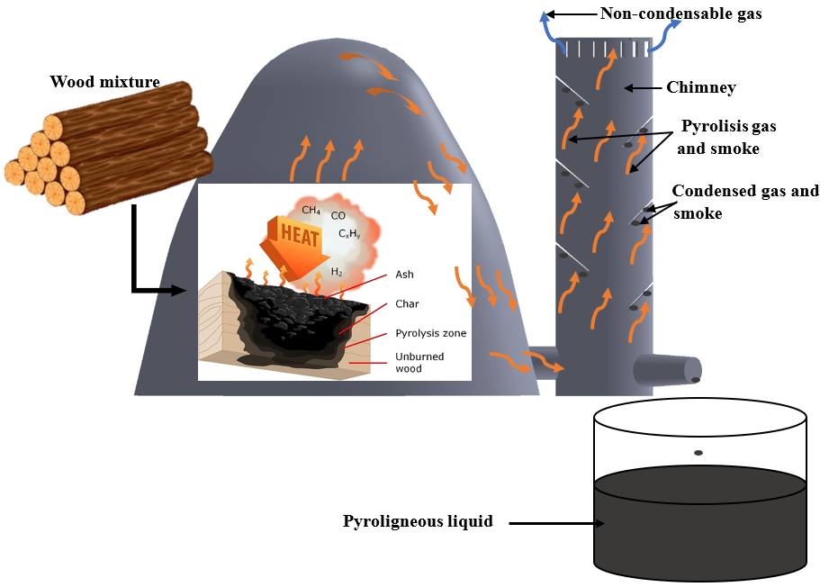
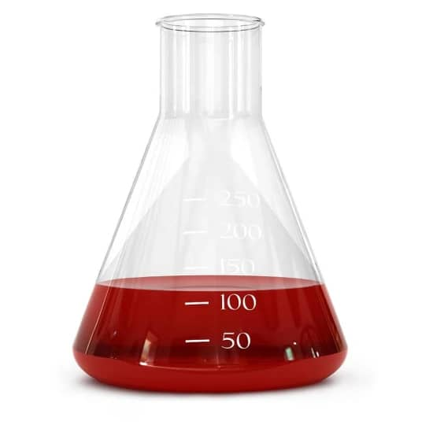
Figure 1: Collecting Process of wood vinegars used
Light oil
Wood vinegar
Wood tar
After 12 months
After Centrifugation and filtration
Wood vinegar purified

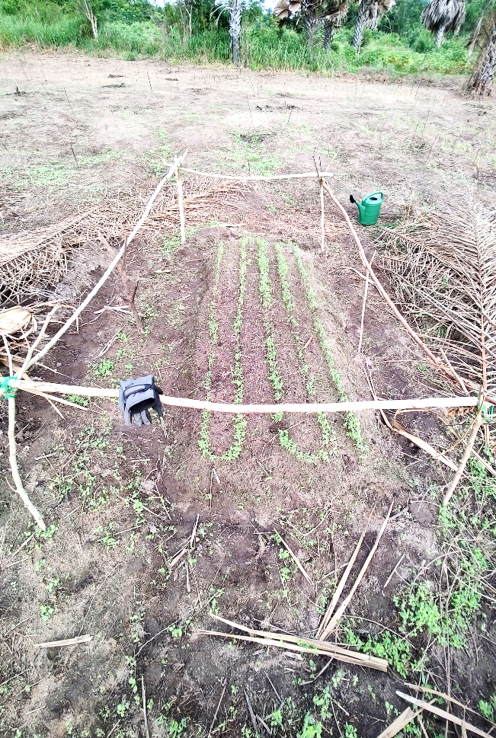
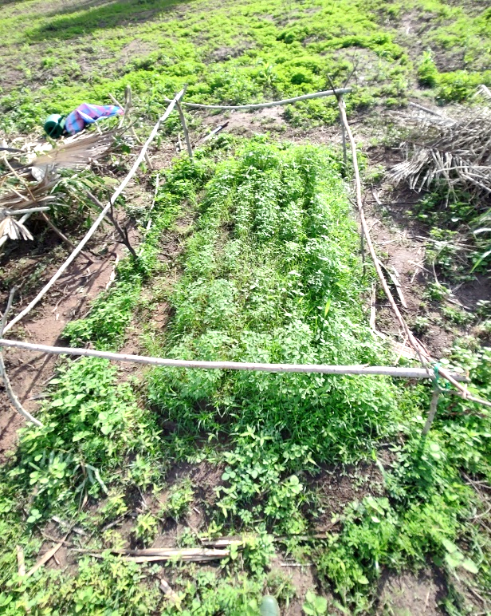
A
B
Figure 2: Tomato sprouter from A) one week to B) 3 weeks after sowing
Planks or elementary plot
Plot of tomato
width of the board: W = 1.5m
Length of the boeard : L = 2.5m
Space between the boards: s = 0.5m
Figure 3: Plan of the experimental setup for tomato

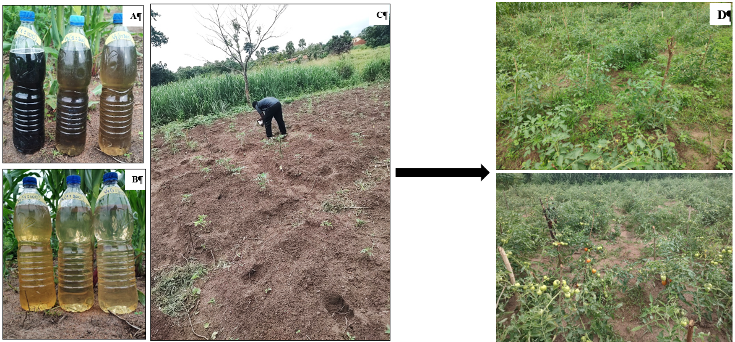
Figure 4: Diluted wood cocktail vinegars A) WCV1 (1:100, 1:200, 1:300); B) VCV2 (1:100, 1:200, 1:300), C) Treatment of tomato plants and Flowering phase and D) Ripening phase of the tomato

B

