Artificial Intelligence Enhanced Modeling of Thermo-Magnetic Nanofluid Convection in a Wavy-Top Trapezoidal Cavity

Abstract

This study presents an advanced artificial intelligence (AI) driven framework to model thermo-magnetic nanofluid convection within a wavy-top trapezoidal cavity containing internal obstacles of varying geometries. The system is influenced by an external magnetic field, varying Rayleigh numbers (Ra), Hartmann numbers (Ha), nanoparticle volume fractions (ϕ), and obstacle shapes (square, star, triangle). Finite Element Method (FEM) simulations were conducted to generate high-fidelity datasets, capturing the variations in Nusselt number (Nu), entropy generation (S_{T}), and effective coefficient of performance (ECOP). These outputs were then predicted using three AI models: Support Vector Regression (SVR), Random Forest (RF), and Extreme Gradient Boosting (XGBoost). Among the models, RF consistently demonstrated superior performance across all parameters. For Nu prediction, RF achieved a Mean Absolute Error (MAE) of 0.0193, Mean Squared Error (MSE) of 0.00069, and R² of 0.9989, outperforming SVR (MAE = 0.0247) and XGBoost (MAE = 0.0215). In entropy generation prediction, RF attained an MAE of 4.48×10⁻⁶, MSE of 4.35×10⁻¹¹, and R² of 0.9992. For ECOP, RF recorded an MAE of 15.201, MSE of 386.65, and R² of 0.9986, while SVR showed a higher error margin (MAE = 21.132). The strong alignment of AI-predicted values with FEM results confirms the reliability and generalizability of the models. This research highlights the feasibility of using machine learning as a computationally efficient surrogate to solve complex multiphysics problems in thermal engineering, offering a promising tool for real-time prediction and design optimization of advanced heat transfer systems.

Keywords: Artificial Intelligence (AI), Natural Convection; Cu–H₂O Nanofluid, Magnetohydrodynamics (MHD), Wavy-top trapezoidal cavity

1.0 Introduction

Natural convection in enclosed cavities underpins many thermal management applications, including electronic cooling modules, solar thermal collectors, and energy-efficient building systems [1]. The introduction of nanofluid base fluids loaded with suspended nanoparticles has significantly improved system performance by increasing effective thermal conductivity and enhancing heat-transfer rates [2]. Thanks to their enhanced thermophysical properties, nanofluids have become a powerful tool for optimizing convective flow behavior across various boundary and geometrical conditions [3]. Embedding internal, heat-generating obstacles within cavities significantly alters both the thermal and flow fields in natural convection systems. Obstacle geometry, size, and heat load directly influence recirculation zones, vortex intensity, and local temperature gradients [4]. Studies of common shapes, such as circular, square, elliptical, and triangular obstacles, reveal distinctive effects on convective strength and flow-mixing behavior [5]. In addition, cavity inclination introduces gravitational asymmetry that modifies buoyancy forces, resulting in substantial changes in circulation patterns and entropy generation [6].

When a magnetic field is applied, magnetohydrodynamic (MHD) effects come into play, as characterised by the Hartmann number. The Lorentz force generated by the magnetic field tends to suppress convective motion, thereby shifting heat‐transfer mechanisms toward conduction [7]. Nevertheless, careful tuning of the magnetic-field strength can yield improved thermal uniformity and stabilized performance in nanofluid-filled enclosures [8]. The geometry and placement of internal obstacles, such as square or triangular blocks, can further enhance convective mixing and disrupt boundary-layer formation, thereby improving overall heat transfer [9,10]. In inclined cavities filled with nanofluids, changes in the inclination angle reorient thermal gradients relative to gravity, thereby influencing both the strength of convection and entropy production [11,12]. In MHD‐aided systems, these interactions become more complex, making the combined influence of geometry, buoyancy, and magnetic fields a critical area of investigation [13].

Wall surface design is also a key factor in heat transfer behavior. Wavy or corrugated surfaces are known to generate secondary vortices that promote mixing and produce superior convective performance compared to flat walls [14,15]. Meanwhile, hybrid and composite nanofluids featuring multiple nanoparticle types offer enhanced control over conductivity and viscosity [16]. Structures such as porous and layered cavities further augment heat transport by introducing additional flow pathways and permeability [17,18]. Equally important are parameters, including nanoparticle shape, volume fraction, and conductivity ratio, all of which influence heat-transfer efficiency. In such systems, entropy generation remains a prime indicator of thermodynamic irreversibility and performance loss [19,20]. Variations in wall topology, including sinusoidal heating and surface undulation, further modify the flow and temperature fields, thereby affecting heat transfer and entropy behavior [21, 22, 23].

Although numerous studies address mixed or hybrid nanofluid convection in complex geometries, there is a relative dearth of comprehensive analyses that combine MHD effects with wavy-top trapezoidal cavities [24, 25, 26, 27, 28]. Modelling methodologies have advanced, incorporating effects such as Brownian motion, thermophoresis, and sophisticated finite-element formulations, to deliver more accurate predictions of thermo-fluid behaviour [29,30]. Recent work confirms that both obstacle geometry and wall corrugation meaningfully influence natural convection in nanofluid‐based systems [31,32]. Earlier investigations have demonstrated that internal obstacles modify flow circulation and heat-transfer pathways [33,34], and conjugate analyses have established that the geometric configuration governs vortex formation and thermal gradients in wavy and trapezoidal enclosures [35]. In particular, Cu–H₂O nanofluids have been shown to enhance heat transport and maintain stability across a range of Rayleigh and Hartmann numbers [36]. The addition of magnetic fields, especially in cavities containing star‐shaped heat sources, has been found to promote more uniform temperature fields by balancing convective and conductive modes [37]. Furthermore, recent studies have highlighted that the combined role of obstacle geometry and magnetic-field strength controls entropy generation and overall thermal efficiency in nanofluid-filled enclosures [38].

Concurrently, recent research has demonstrated that machine learning (ML) techniques are highly effective in modeling complex heat transfer phenomena. Applications include predicting radiative behavior in nanofluids [39], replacing computational fluid dynamics tools in forced-convection systems with high accuracy and efficiency [40], and estimating Nusselt numbers in natural-convection settings, such as helical coils [41]. ML models have also demonstrated significant predictive capability in systems with counter-rotating cylinders [42] and microchannel heat sinks featuring complex geometries [43]. Collectively, these developments substantiate the value of ML methods for capturing nonlinear thermal behaviour and supporting numerical modelling efforts.

Despite significant progress in modeling heat transfer in nanofluid-filled enclosures, several critical gaps remain unaddressed. First, comprehensive studies that simultaneously consider the combined influence of magnetic fields, cavity inclination, obstacle geometry, and wall corrugation in trapezoidal enclosures are scarce. Second, while FEM-based simulations offer high accuracy, they are computationally expensive and impractical for real-time or parametric optimization tasks. Third, the integration of artificial intelligence (AI) and machine learning (ML) techniques into thermal-fluid modeling remains underutilized, particularly for complex geometries like wavy-top cavities with embedded heat sources. In light of these limitations, this study presents an AI-driven modeling framework designed to accurately predict thermo-magnetic convection behavior in a wavy-top trapezoidal cavity filled with Cu–H₂O nanofluid and incorporating different internal obstacle shapes. Utilizing a comprehensive dataset of 252 FEM simulations spanning variations in Rayleigh number, Hartmann number, nanoparticle volume fraction, cavity inclination, wall topology, and obstacle geometry, three ML algorithms Support Vector Regression (SVR), Random Forest (RF), and Extreme Gradient Boosting (XGBoost) are trained to estimate key thermal performance indicators: Nusselt number, entropy generation, and energy conversion efficiency. The results underscore the potential of AI/ML to serve as efficient, scalable, and highly accurate surrogates for traditional numerical solvers, paving the way for rapid thermal analysis and design optimization in advanced energy systems
2.0 Model Description
This study explores natural convection and entropy generation within a two-dimensional wavy-top trapezoidal cavity filled with Cu–H₂O nanofluid. The enclosure features a base angle of $γ={15}^{∘}$and is examined at three inclination angles $λ={15}^{∘}$, ${30}^{∘}$, and ${45}^{∘}$ to assess the impact of gravitational reorientation on buoyancy-driven flow structures. Two identical copper obstacles, internally heated and symmetrically positioned at the cavity center, are incorporated to investigate the influence of obstacle geometry on heat transfer and fluid dynamics. Three distinct obstacle shapes are considered: a star, a square, and a triangle, as depicted in Figures 1(a–c), representing the configurations used for comparative analysis. The top wall of the cavity is sinusoidal and maintained at a cold temperature ($T_{C}$), while the bottom wall is uniformly heated ($T_{H}$); the vertical sidewalls are thermally insulated. The internal copper obstacles function as uniform heat sources, enabling conjugate heat transfer between solid and fluid domains. The nanofluid is modeled as a steady, laminar, incompressible, single-phase fluid, with thermal buoyancy effects incorporated via the Boussinesq approximation.

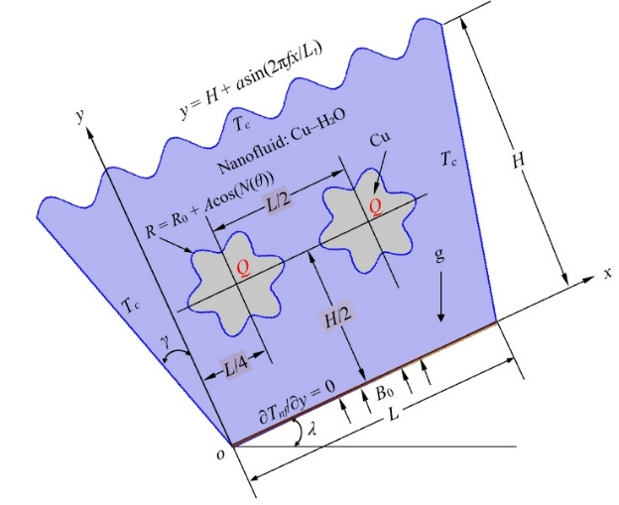 | 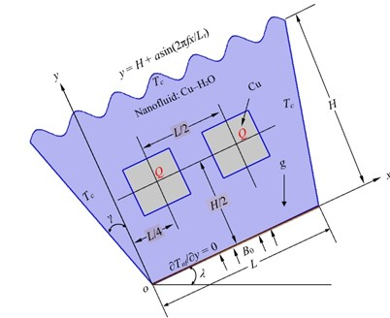
a. Star Obstacle | b. Square Obstacle
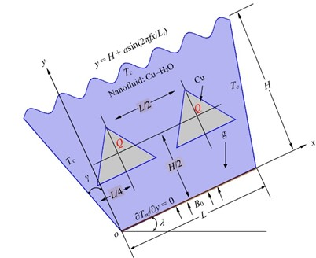
c. Triangle Obstacle
Fig 1(a,b,c). Geometry with Different Obstacles

The governing mathematical model comprises a set of partial differential equations that describe natural convection, magnetohydrodynamic (MHD) effects, and nanofluid transport phenomena. These equations are presented in both dimensional and non-dimensional forms in Equations (1) through (38). The formulation incorporates the effects of buoyancy-driven flow, Lorentz forces due to an external magnetic field, and the enhanced thermophysical properties of the Cu–H₂O nanofluid. The corresponding boundary conditions are defined in accordance with established studies [5, 17, 31, 32].

For Sinusoidal wavy top wall:
(1)
Here, $H$: Height of the cavity, $a$: Amplitude of the wave, $f$: Frequency (number of waves), $L_{t}$: Total length of the top wall, and x is the position along the wall.

Gravitational acceleration g acts vertically downward, but is decomposed into components along the inclined axis:
(2)
Fluid domain:
(3)
(4)
(5)
(6)
Star-shaped solid domains:
(7)

Here, $u$and $v$are the velocity components in the $x$- and $y$-directions, respectively; $p$is pressure, and $T$is temperature. The fluid properties include density ($ρ$), thermal conductivity ($k$), specific heat ($C_{p}$), thermal expansion coefficient ($β$), and electrical conductivity ($σ$).

Dimensional Boundary Conditions:
Top Wall:
, (8)
Inclined Side Wall:
, (9)
Bottom Wall:
, (10)

Heated Block:
A positive internal volumetric heat generation ($Q>0$) is applied within the solid domain. At the fluid–solid interfaces, continuity of both temperature and heat flux is imposed.
, (11) (12)
(13)
(14)
(15)
(16)
Entropy generation quantifies the energy loss due to irreversibilities in heat transfer, viscous dissipation, and MHD effects. In buoyancy-driven MHD flow, local entropy due to heat transfer ($S_{\text{ht}}$) is defined for both solid and fluid domains as:
(17)
The local volumetric entropy production due to viscous flow dissipation ($S_{ff}$) and external magnetic effects ($S_{mf}$) can be described using the following formulas:
(18)
(19)
To get the non-dimensional governing equations, the following scales are used: (20) (21)
(22)
(23)
(24)
(25)
(26)

Non-Dimensional Boundary Conditions:
Top Wall:
, (27)
Inclined Side Wall:
, (28)
Bottom Wall:
, (29)
Heated Block:
Internal volumetric heat generation applied in the solid domain, Q>0; continuity of temperature and heat flux at fluid-solid interfaces is enforced:
, (30)
Non-Dimensional Nanofluid Properties:
(31)
(32) (33) (34)
(35)

The chamber’s thermal performance under varying conditions is evaluated using the Nusselt number ($Nu$) at the heated surfaces and the average fluid temperature ($Θ_{\text{av}}$) within the domain, defined as follows:
(36)
Here, $A$denotes the non-dimensional surface area of the fluid domain; $X$and $Y$are the dimensionless Cartesian coordinates; $U$and $V$represent the dimensionless velocity components; and $P$and $Θ$correspond to the non-dimensional pressure and temperature, respectively.

The total entropy generation, expressed as a dimensionless quantity, can be obtained using the following expression:
(37)
where A represents the surface area of the computational domain.

The Ecological Coefficient of Performance (ECOP) evaluates the trade-off between heat transfer efficiency and thermodynamic irreversibility. A higher ECOP signifies more effective heat transfer with reduced entropy generation, reflecting better thermodynamic sustainability. It provides a relative measure of system performance by linking energy utilization to entropy production.

(38)

The thermophysical properties of water and copper used in the present model at Tₘ = 300 K are summarized in Table 1 ([5], [17], [31], [32]).

Table 1: Thermo-physical properties of Water and Cu at T_{m} = 300K ([5],[17],[31],[32])

Name of Property | Symbol | Unit | Water | Cu
Mass Density | ρ | kgm⁻³ | 996.6 | 8933
Specific Heat at Constant Pressure | C_{p} | Jkg⁻¹K⁻¹ | 4179.2 | 385
Thermal Conductivity | k | Wm⁻¹K⁻¹ | 0.6102 | 401
Volumetric Thermal Expansion Coefficient | β | K⁻¹ | 26.6×10⁻⁵ | 49.9×10⁻⁶
Electrical Conductivity | σ | Sm⁻¹ | 0.05 | 59.6×10⁻⁶
Dynamic viscosity | μ | kgm⁻¹s⁻¹ | 8.538×10⁻⁴ | -
Prandtl Number | Pr | - | 5.856 | -
The Galerkin Finite Element Method (FEM) is employed to solve the coupled conservation equations of mass, momentum, and energy across both fluid and solid domains, accounting for buoyancy effects, magnetohydrodynamics (MHD), and the thermophysical properties of nanofluids. System performance is evaluated using three key dimensionless indicators: the average Nusselt number (Nu) to quantify heat transfer, entropy generation (S_{T}) to assess irreversibility, and the Ecological Coefficient of Performance (ECOP) to measure thermal efficiency. In parallel, an AI-based predictive framework is developed to serve as a computationally efficient surrogate to the FEM model. A dataset comprising 252 FEM simulations is used to train three supervised machine learning (ML) algorithms: Support Vector Regression (SVR), Random Forest (RF), and Extreme Gradient Boosting (XGBoost). These models predict Nu, S_{T}, and ECOP based on variations in Rayleigh and Hartmann numbers, nanoparticle volume fraction, cavity inclination, obstacle geometry, and wall corrugation. By capturing complex nonlinear interactions across the parameter space, the AI models offer rapid and accurate performance estimation, supporting real-time analysis and optimization in advanced thermal-fluid systems.

3.0 Grid Independence Assessment and Numerical Model Validation
A grid sensitivity analysis was conducted to verify the numerical accuracy and mesh independence of the finite element simulations. Mesh refinement was concentrated near the wavy top boundary and along the fluid–solid interfaces of the internal obstacles to resolve sharp temperature and velocity field gradients.

Finer | Extra Fine | Extremely Finer
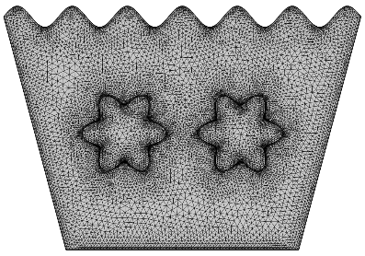 | 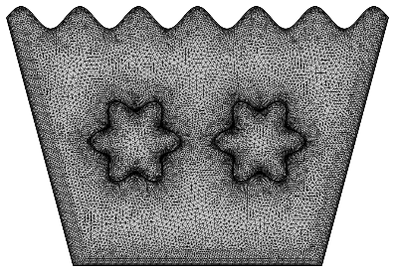 | 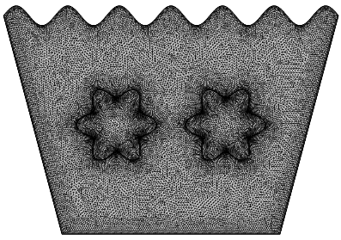
a. Star Obstacle
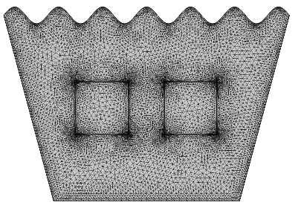 | 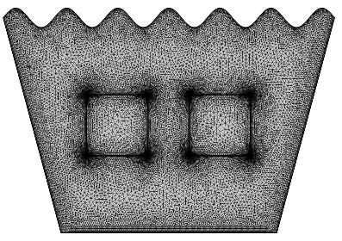 | 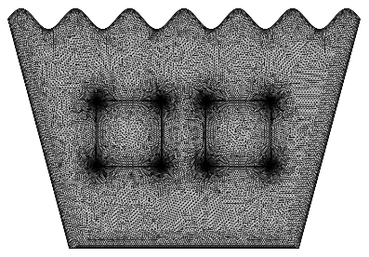
b. Square Obstacle
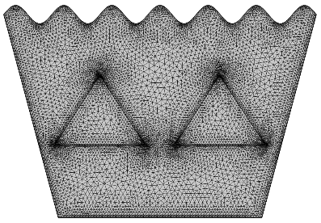 | 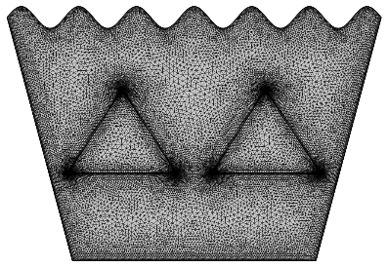 | 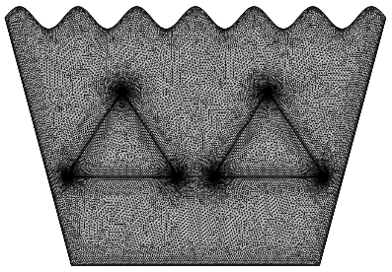
c. Triangle Obstacle
Fig. 2 Mesh Distribution for Different Grids

Figure 2 presents the mesh distributions for three refinement levels: Finer, Extra Fine, and Extremely Fine applied to all obstacle configurations (star, square, and triangular). The localized refinement around the heated obstacles and corrugated wall regions ensures enhanced numerical precision in areas dominated by strong thermal and flow gradients.

A quantitative mesh independence study was conducted to ensure that the numerical solution is unaffected by further mesh refinement. The results are summarized in Table 2, which presents the average Nusselt number ($Nu$) at the heated solid surfaces for three different mesh resolutions: Fine (17,210 elements), Extra Fine (39,587 elements), and Extremely Fine (47,733 elements). The test was performed under the following representative conditions: $Pr=5.856$, $Ra={10}^{6}$, $ϕ=0.02$, $Ha=0$, and $λ={45}^{∘}$.

Table 2. Nu at Heated Solid Surface when Pr = 5.856, Ra = 10⁶, ɸ = 0.02, Ha=0, λ=45⁰ for different grid sizes.

Mesh Type | Elements | Nu | Deviation from Previous
Fine | 17210 | 6.5016 | —
Extra Fine | 39587 | 6.5769 | 0.0753
Extremely Fine | 47733 | 6.5782 | 0.0013

As the mesh is refined, the computed Nusselt number increases slightly from 6.5016 for the Fine mesh to 6.5782 for the Extremely Fine mesh. The deviation between the Fine and Extra Fine meshes is 0.0753, while the difference between the Extra Fine and Extremely Fine meshes is only 0.0013, indicating that further refinement has a negligible effect on the solution.

These results confirm that the Extra Fine mesh provides an optimal balance between accuracy and computational cost. With less than 0.02% variation in Nu between the two finest grids, this mesh resolution is deemed sufficiently fine to ensure mesh-independent results and was therefore adopted for all subsequent FEM simulations used in training the AI models.

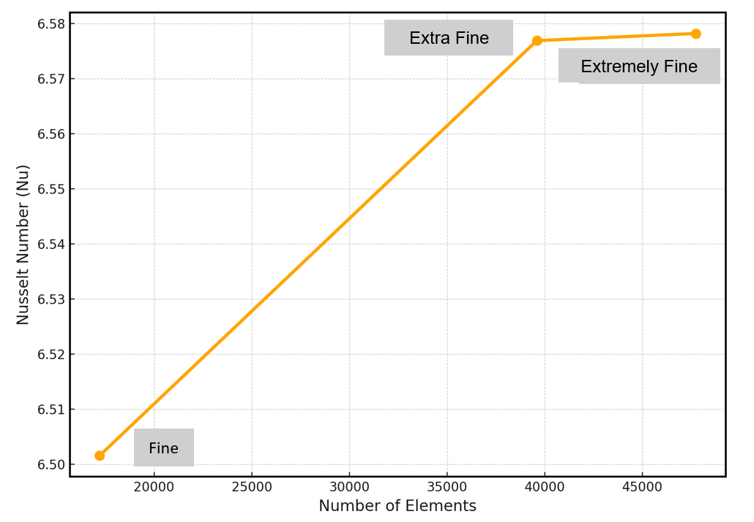
Fig 3. Grid Sensitivity Check plot

The grid sensitivity trend is clearly depicted in Figure 3, where a gradual increase in the Nusselt number ($Nu$) is observed with mesh refinement. Beyond a certain mesh density, the curve flattens, indicating convergence. The near-horizontal slope at higher element counts confirms that further refinement yields negligible changes in the solution, thereby validating mesh independence and demonstrating the numerical model's stability and reliability.

Following mesh verification, the numerical model was validated against benchmark data reported by Abdelmalek et al. [17]. Figure 4 provides a comparative analysis of isotherm contours for the case with $Ra={10}^{4}$, $A=0.15$, and $ϕ=0.02$, centered around a star-shaped internal obstacle. Both the present results and the reference data exhibit consistent thermal distributions and boundary layer behavior. However, the present model shows smoother and more symmetric isotherm lines, attributed to enhanced numerical accuracy and finer grid resolution, further reinforcing the credibility of the simulation approach.

Abdelmalek et al. [17] | Present Work
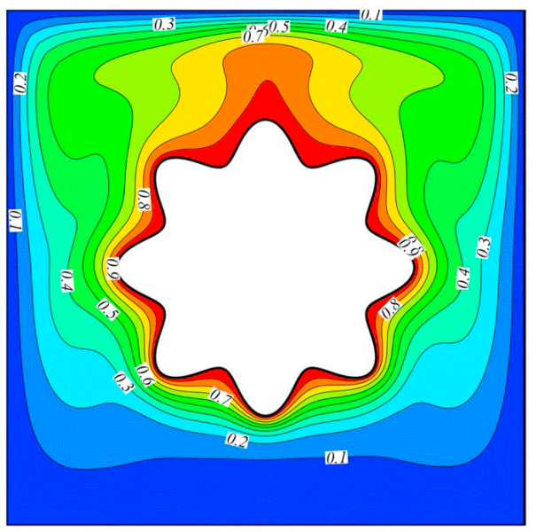 | 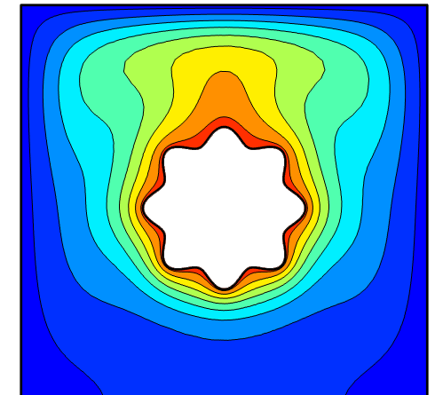
Figure 4. Isotherms when Ra=10^{4,} N = 8, A = 0.15, ϕ = 0.02

Table 3: Comparison of Nu Between Present Work and [17]
Ra | Nanoparticle Volume Fraction (ϕ) | Present Study | Abdelmalek et al. [17] | Deviation (%)
10³ | 0.02 | 1.1470 | 1.1307 | 1.44
10⁴ | 0.02 | 2.2944 | 2.2674 | 1.19
10⁵ | 0.02 | 4.6379 | 4.5851 | 1.15
10⁶ | 0.02 | 8.9586 | 8.8341 | 1.41

A quantitative validation of the present numerical model against benchmark results from Abdelmalek et al. [17] is provided in Table 3. The comparison spans a wide Rayleigh number range from ${10}^{3}$to ${10}^{6}$, with a fixed nanoparticle volume fraction of $ϕ=0.02$. The predicted average Nusselt numbers from the present study show excellent consistency with the reference data, with deviations of less than 1.5% across all cases. This high level of agreement confirms the accuracy, numerical stability, and robustness of the developed FEM-based framework. Accordingly, the present model is validated as a reliable tool for simulating MHD-assisted natural convection of Cu–H₂O nanofluids in complex geometries, including wavy-top trapezoidal cavities with internal obstacles.
4.0 Results and Discussion

This section presents a comprehensive analysis of thermo-magnetic convection behavior of Cu–H₂O nanofluids within a wavy-top trapezoidal cavity, employing both high-resolution FEM simulations and AI-based surrogate modeling. The analysis focuses on three principal dimensionless metrics: average Nusselt number (Nu) for heat transfer rate, entropy generation (RT) for thermodynamic irreversibility, and the Ecological Coefficient of Performance (ECOP) for evaluating energy efficiency. Results from Tables 4 through 30 quantify these metrics, while Streamline (Figures 5–13) and Isotherm (Figures 14–22) plots provide qualitative insights into flow and temperature fields.

The AI models SVR, RF, and XGBoost, trained on 252 FEM simulation datasets, offer rapid predictions of thermal performance. XGBoost, in particular, demonstrates superior predictive accuracy, facilitating the fast exploration of a wide parameter space that includes Rayleigh and Hartmann numbers, nanoparticle concentration, inclination angles, and obstacle shapes.

Table 4: Nu, R_{T}, and ECOP for Star Obstacle with the Variation of Ha & Ra at λ =15⁰ & ɸ=0.02
Ha | Ra | Nu | Entropy (R_{T}) | ECOP
0 | 10 ⁴ | 2.5581 | 0.63853 | 4.0063
0 | 10 ⁵ | 3.7556 | 0.021177 | 177.34
0 | 10 ⁶ | 5.7976 | 0.0014877 | 3896.9
30 | 10 ⁴ | 2.5533 | 0.63759 | 4.0046
30 | 10 ⁵ | 3.4447 | 0.02057 | 167.46
30 | 10 ⁶ | 5.22 | 0.0014758 | 3537.20
50 | 10 ⁴ | 2.5524 | 0.63742 | 4.0043
50 | 10 ⁵ | 3.3369 | 0.02036 | 163.90
50 | 10 ⁶ | 4.7166 | 0.0014654 | 3218.60

Table 5: Nu, R_{T}, and ECOP for Star Obstacle with the Variation of Ha & Ra at λ =30⁰ & ɸ=0.02
Ha | Ra | Nu | Entropy (R_{T}) | ECOP
0 | 10 ⁴ | 2.5573 | 0.63838 | 4.006
0 | 10 ⁵ | 3.7274 | 0.021122 | 176.47
0 | 10 ⁶ | 5.916 | 0.0014865 | 3979.8
30 | 10 ⁴ | 2.5531 | 0.63755 | 4.0045
30 | 10 ⁵ | 3.4249 | 0.020532 | 166.81
30 | 10 ⁶ | 5.1574 | 0.0014728 | 3501.70
50 | 10 ⁴ | 2.5523 | 0.6374 | 4.0043
50 | 10 ⁵ | 3.3284 | 0.020343 | 163.61
50 | 10 ⁶ | 4.6587 | 0.0014633 | 3183.80

Table 6: Nu, R_{T}, and ECOP for Star Obstacle with the Variation of Ha & Ra at λ =45⁰ & ɸ=0.02
Ha | Ra | Nu | Entropy (R_{T}) | ECOP
0 | 10 ⁴ | 2.5563 | 0.63818 | 4.0056
0 | 10 ⁵ | 3.6784 | 0.021027 | 174.94
0 | 10 ⁶ | 6.0049 | 0.0014847 | 4044.60
30 | 10 ⁴ | 2.5528 | 0.6375 | 4.0044
30 | 10 ⁵ | 3.3946 | 0.020472 | 165.81
30 | 10 ⁶ | 5.0656 | 0.001469 | 3448.40
50 | 10 ⁴ | 2.5522 | 0.63739 | 4.0042
50 | 10 ⁵ | 3.3161 | 0.020319 | 163.20
50 | 10 ⁶ | 4.5454 | 0.0014599 | 3113.60

Table 7: Nu, R_{T}, and ECOP for Star Obstacle with the Variation of Ha & Ra at λ =15⁰ & ɸ=0.04
Ha | Ra | Nu | Entropy (R_{T}) | ECOP
0 | 10 ⁴ | 2.6702 | 0.66041 | 4.0433
0 | 10 ⁵ | 3.8863 | 0.021433 | 181.32
0 | 10 ⁶ | 5.9757 | 0.0014926 | 4003.5
30 | 10 ⁴ | 2.6666 | 0.6597 | 4.0421
30 | 10 ⁵ | 3.6033 | 0.02088 | 172.57
30 | 10 ⁶ | 5.3486 | 0.0014795 | 3615.1
50 | 10 ⁴ | 2.6659 | 0.65957 | 4.0419
50 | 10 ⁵ | 3.5139 | 0.020705 | 169.71
50 | 10 ⁶ | 4.819 | 0.0014688 | 3280.8

Table 8: Nu, R_{T}, and ECOP for Star Obstacle with the Variation of Ha & Ra at λ =30⁰ & ɸ=0.04
Ha | Ra | Nu | Entropy (R_{T}) | ECOP
0 | 10 ⁴ | 2.6697 | 0.6603 | 4.0431
0 | 10 ⁵ | 3.8582 | 0.021378 | 180.47
0 | 10 ⁶ | 6.0493 | 0.0014914 | 4056.1
30 | 10 ⁴ | 2.6664 | 0.65967 | 4.0421
30 | 10 ⁵ | 3.5861 | 0.020847 | 172.02
30 | 10 ⁶ | 5.2857 | 0.0014771 | 3578.4
50 | 10 ⁴ | 2.6659 | 0.65956 | 4.0419
50 | 10 ⁵ | 3.507 | 0.020692 | 169.49
50 | 10 ⁶ | 4.7595 | 0.0014669 | 3244.5

Table 9: Nu, R_{T}, and ECOP for Star Obstacle with the Variation of Ha & Ra at λ =45⁰ & ɸ=0.04
Ha | Ra | Nu | Entropy (R_{T}) | ECOP
0 | 10 ⁴ | 2.6689 | 0.66015 | 4.0429
0 | 10 ⁵ | 3.8108 | 0.021285 | 179.03
0 | 10 ⁶ | 6.1339 | 0.0014898 | 4117.2
30 | 10 ⁴ | 2.6662 | 0.65963 | 4.042
30 | 10 ⁵ | 3.5603 | 0.020796 | 171.2
30 | 10 ⁶ | 5.1824 | 0.0014736 | 3516.9
50 | 10 ⁴ | 2.6658 | 0.65955 | 4.0419
50 | 10 ⁵ | 3.4973 | 0.020673 | 169.17
50 | 10 ⁶ | 4.6464 | 0.0014639 | 3174.1

Table 10: Nu, R_{T}, and ECOP for Star Obstacle with the Variation of Ha & Ra at λ =15⁰ & ɸ=0.06
Ha | Ra | Nu | Entropy (R_{T}) | ECOP
0 | 10 ⁴ | 2.7841 | 0.68262 | 4.0786
0 | 10 ⁵ | 4.0262 | 0.021706 | 185.49
0 | 10 ⁶ | 6.1553 | 0.0014972 | 4111.3
30 | 10 ⁴ | 2.7814 | 0.68209 | 4.0777
30 | 10 ⁵ | 3.7739 | 0.021213 | 177.9
30 | 10 ⁶ | 5.4777 | 0.0014831 | 3693.5
50 | 10 ⁴ | 2.7809 | 0.68199 | 4.0776
50 | 10 ⁵ | 3.7008 | 0.021071 | 175.64
50 | 10 ⁶ | 4.9259 | 0.0014721 | 3346.1

Table 11: Nu, R_{T}, and ECOP for Star Obstacle with the Variation of Ha & Ra at λ =30⁰ & ɸ=0.06
Ha | Ra | Nu | Entropy (R_{T}) | ECOP
0 | 10 ⁴ | 2.7837 | 0.68254 | 4.0784
0 | 10 ⁵ | 3.9988 | 0.021653 | 184.68
0 | 10 ⁶ | 6.1876 | 0.0014959 | 4136.4
30 | 10 ⁴ | 2.7813 | 0.68207 | 4.0777
30 | 10 ⁵ | 3.7594 | 0.021185 | 177.45
30 | 10 ⁶ | 5.4143 | 0.001481 | 3655.7
50 | 10 ⁴ | 2.7808 | 0.68198 | 4.0776
50 | 10 ⁵ | 3.6954 | 0.02106 | 175.47
50 | 10 ⁶ | 4.8652 | 0.0014704 | 3308.8

Table 12: Nu, R_{T}, and ECOP for Star Obstacle with the Variation of Ha & Ra at λ =45⁰ & ɸ=0.06
Ha | Ra | Nu | Entropy (R_{T}) | ECOP
0 | 10 ⁴ | 2.7831 | 0.68243 | 4.0782
0 | 10 ⁵ | 3.9543 | 0.021565 | 183.36
0 | 10 ⁶ | 6.261 | 0.0014946 | 4189.1
30 | 10 ⁴ | 2.7811 | 0.68204 | 4.0776
30 | 10 ⁵ | 3.7379 | 0.021143 | 176.79
30 | 10 ⁶ | 5.3034 | 0.0014778 | 3588.7
50 | 10 ⁴ | 2.7808 | 0.68197 | 4.0775
50 | 10 ⁵ | 3.6877 | 0.021045 | 175.23
50 | 10 ⁶ | 4.7533 | 0.0014675 | 3239

Table 13: Nu, R_{T}, and ECOP for Square Obstacle with the Variation of Ha & Ra at λ =15⁰ & ɸ=0.02
Ha | Ra | Nu | Entropy (R_{T}) | ECOP
0 | 10 ⁴ | 2.6913 | 0.58966 | 4.5642
0 | 10 ⁵ | 3.9788 | 0.02063 | 192.86
0 | 10 ⁶ | 6.2373 | 0.0014931 | 4177.5
30 | 10 ⁴ | 2.6853 | 0.58871 | 4.5612
30 | 10 ⁵ | 3.6309 | 0.020053 | 181.07
30 | 10 ⁶ | 5.6553 | 0.0014826 | 3814.30
50 | 10 ⁴ | 2.684 | 0.58853 | 4.5605
50 | 10 ⁵ | 3.5065 | 0.019848 | 176.66
50 | 10 ⁶ | 5.1434 | 0.0014742 | 3488.90

Table 14: Nu, R_{T}, and ECOP for Square Obstacle with the Variation of Ha & Ra at λ =30⁰ & ɸ=0.02
Ha | Ra | Nu | Entropy (R_{T}) | ECOP
0 | 10 ⁴ | 2.6903 | 0.58951 | 4.5637
0 | 10 ⁵ | 3.9427 | 0.02057 | 191.67
0 | 10 ⁶ | 6.3086 | 0.0014918 | 4229.00
30 | 10 ⁴ | 2.685 | 0.58867 | 4.5611
30 | 10 ⁵ | 3.606 | 0.020012 | 180.19
30 | 10 ⁶ | 5.5697 | 0.0014795 | 3764.60
50 | 10 ⁴ | 2.6839 | 0.58852 | 4.5604
50 | 10 ⁵ | 3.4952 | 0.01983 | 176.26
50 | 10 ⁶ | 5.0505 | 0.0014719 | 3431.40

Table 15: Nu, R_{T}, and ECOP for Square Obstacle with the Variation of Ha & Ra at λ =45⁰ & ɸ=0.02
Ha | Ra | Nu | Entropy (R_{T}) | ECOP
0 | 10 ⁴ | 2.6889 | 0.5893 | 4.563
0 | 10 ⁵ | 3.8847 | 0.020474 | 189.74
0 | 10 ⁶ | 6.5016 | 0.0014903 | 4362.5
30 | 10 ⁴ | 2.6845 | 0.58861 | 4.5608
30 | 10 ⁵ | 3.5679 | 0.019949 | 178.85
30 | 10 ⁶ | 5.4486 | 0.0014756 | 3692.50
50 | 10 ⁴ | 2.6837 | 0.5885 | 4.56
50 | 10 ⁵ | 3.4789 | 0.019803 | 175.67
50 | 10 ⁶ | 4.8921 | 0.0014682 | 3332.10

Table 16: Nu, R_{T}, and ECOP for Square Obstacle with the Variation of Ha & Ra at λ =15⁰ & ɸ=0.04
Ha | Ra | Nu | Entropy (R_{T}) | ECOP
0 | 10 ⁴ | 2.8096 | 0.6094 | 4.6105
0 | 10 ⁵ | 4.113 | 0.020855 | 197.22
0 | 10 ⁶ | 6.4204 | 0.0014975 | 4287.50
30 | 10 ⁴ | 2.805 | 0.60868 | 4.6083
30 | 10 ⁵ | 3.7935 | 0.020325 | 186.64
30 | 10 ⁶ | 5.7865 | 0.0014862 | 3893.60
50 | 10 ⁴ | 2.804 | 0.60855 | 4.6077
50 | 10 ⁵ | 3.6896 | 0.020154 | 183.07
50 | 10 ⁶ | 5.242 | 0.0014774 | 3548.20

Table 17: Nu, R_{T}, and ECOP for Square Obstacle with the Variation of Ha & Ra at λ =30⁰ & ɸ=0.04
Ha | Ra | Nu | Entropy (R_{T}) | ECOP
0 | 10 ⁴ | 2.8089 | 0.60928 | 4.6101
0 | 10 ⁵ | 4.0772 | 0.020796 | 196.06
0 | 10 ⁶ | 6.4601 | 0.001496 | 4318.20
30 | 10 ⁴ | 2.8047 | 0.60865 | 4.6082
30 | 10 ⁵ | 3.7719 | 0.020289 | 185.90
30 | 10 ⁶ | 5.6986 | 0.0014836 | 3841.10
50 | 10 ⁴ | 2.8039 | 0.60854 | 4.6076
50 | 10 ⁵ | 3.6805 | 0.02014 | 182.75
50 | 10 ⁶ | 5.1487 | 0.0014753 | 3490.00

Table 18: Nu, R_{T}, and ECOP for Square Obstacle with the Variation of Ha & Ra at λ =45⁰ & ɸ=0.04
Ha | Ra | Nu | Entropy (R_{T}) | ECOP
0 | 10 ⁴ | 2.8078 | 0.60913 | 4.6096
0 | 10 ⁵ | 4.0206 | 0.020702 | 194.21
0 | 10 ⁶ | 6.6302 | 0.0014952 | 4434.30
30 | 10 ⁴ | 2.8044 | 0.6086 | 4.6079
30 | 10 ⁵ | 3.7394 | 0.020236 | 184.79
30 | 10 ⁶ | 5.5641 | 0.00148 | 3759.5
50 | 10 ⁴ | 2.8038 | 0.60852 | 4.6075
50 | 10 ⁵ | 3.6675 | 0.020118 | 182.30
50 | 10 ⁶ | 4.991 | 0.001472 | 3390.70

Table 19: Nu, R_{T}, and ECOP for Square Obstacle with the Variation of Ha & Ra at λ =15⁰ & ɸ=0.06
Ha | Ra | Nu | Entropy (R_{T}) | ECOP
0 | 10 ⁴ | 2.9299 | 0.62945 | 4.6546
0 | 10 ⁵ | 4.2564 | 0.021095 | 201.78
0 | 10 ⁶ | 6.6043 | 0.0015016 | 4398.10
30 | 10 ⁴ | 2.9263 | 0.62891 | 4.65
30 | 10 ⁵ | 3.9692 | 0.020619 | 192.50
30 | 10 ⁶ | 5.9163 | 0.0014895 | 3972.10
50 | 10 ⁴ | 2.9255 | 0.62881 | 4.6525
50 | 10 ⁵ | 3.8836 | 0.020479 | 189.64
50 | 10 ⁶ | 5.343 | 0.0014803 | 3609.30

Table 20: Nu, R_{T}, and ECOP for Square Obstacle with the Variation of Ha & Ra at λ =30⁰ & ɸ=0.06
Ha | Ra | Nu | Entropy (R_{T}) | ECOP
0 | 10 ⁴ | 2.9293 | 0.62937 | 4.6543
0 | 10 ⁵ | 4.2218 | 0.021037 | 200.68
0 | 10 ⁶ | 6.615 | 0.0015001 | 4409.50
30 | 10 ⁴ | 2.9261 | 0.62889 | 4.6529
30 | 10 ⁵ | 3.9508 | 0.020589 | 191.89
30 | 10 ⁶ | 5.8267 | 0.0014873 | 3917.60
50 | 10 ⁴ | 2.9255 | 0.6288 | 4.6525
50 | 10 ⁵ | 3.8764 | 0.020467 | 189.40
50 | 10 ⁶ | 5.2503 | 0.0014785 | 3551.20

Table 21: Nu, R_{T}, and ECOP for Square Obstacle with the Variation of Ha & Ra at λ =45⁰ & ɸ=0.06
Ha | Ra | Nu | Entropy (R_{T}) | ECOP
0 | 10 ⁴ | 2.9285 | 0.62925 | 4.6539
0 | 10 ⁵ | 4.1679 | 0.020948 | 198.96
0 | 10 ⁶ | 6.756 | 0.0014996 | 4505.10
30 | 10 ⁴ | 2.9259 | 0.62885 | 4.6527
30 | 10 ⁵ | 3.9237 | 0.020544 | 190.99
30 | 10 ⁶ | 5.6832 | 0.001484 | 3829.5
50 | 10 ⁴ | 2.9254 | 0.62879 | 4.6524
50 | 10 ⁵ | 3.8661 | 0.02045 | 189.05
50 | 10 ⁶ | 5.0946 | 0.0014754 | 3453.10

Table 22: Nu, R_{T}, and ECOP for Triangle Obstacle with the Variation of Ha & Ra at λ =15⁰ & ɸ=0.02
Ha | Ra | Nu | Entropy (R_{T}) | ECOP
0 | 10 ⁴ | 2.9106 | 0.71807 | 4.0534
0 | 10 ⁵ | 4.2103 | 0.022264 | 189.11
0 | 10 ⁶ | 6.3746 | 0.0015057 | 4233.7
30 | 10 ⁴ | 2.9094 | 0.71788 | 4.0527
30 | 10 ⁵ | 4.0332 | 0.021925 | 183.95
30 | 10 ⁶ | 5.6317 | 0.0014934 | 3771
50 | 10 ⁴ | 2.909 | 0.71784 | 4.0525
50 | 10 ⁵ | 3.9932 | 0.021849 | 182.77
50 | 10 ⁶ | 5.0893 | 0.0014825 | 3433

Table 23: Nu, R_{T}, and ECOP for Triangle Obstacle with the Variation of Ha & Ra at λ =30⁰ & ɸ=0.02
Ha | Ra | Nu | Entropy (R_{T}) | ECOP
0 | 10 ⁴ | 2.9107 | 0.7181 | 4.0534
0 | 10 ⁵ | 4.2444 | 0.022329 | 190.08
0 | 10 ⁶ | 6.4336 | 0.0015064 | 4270.8
30 | 10 ⁴ | 2.9093 | 0.71787 | 4.0527
30 | 10 ⁵ | 4.0301 | 0.021919 | 183.86
30 | 10 ⁶ | 5.6355 | 0.0014927 | 3775.3
50 | 10 ⁴ | 2.909 | 0.71783 | 4.0524
50 | 10 ⁵ | 3.9908 | 0.021844 | 182.69
50 | 10 ⁶ | 5.062 | 0.0014813 | 3417.3

Table 24: Nu, R_{T}, and ECOP for Triangle Obstacle with the Variation of Ha & Ra at λ =45⁰ & ɸ=0.02
Ha | Ra | Nu | Entropy (R_{T}) | ECOP
0 | 10 ⁴ | 2.9108 | 0.71813 | 4.0533
0 | 10 ⁵ | 4.2493 | 0.022339 | 190.22
0 | 10 ⁶ | 6.4137 | 0.0015053 | 4260.8
30 | 10 ⁴ | 2.9092 | 0.71787 | 4.0526
30 | 10 ⁵ | 4.0242 | 0.021907 | 183.69
30 | 10 ⁶ | 5.5577 | 0.0014901 | 3729.7
50 | 10 ⁴ | 2.9089 | 0.71783 | 4.0524
50 | 10 ⁵ | 3.9872 | 0.021837 | 182.59
50 | 10 ⁶ | 4.9866 | 0.0014786 | 3372.5

Table 25: Nu, R_{T}, and ECOP for Triangle Obstacle with the Variation of Ha & Ra at λ =15⁰ & ɸ=0.04
Ha | Ra | Nu | Entropy (R_{T}) | ECOP
0 | 10 ⁴ | 3.0307 | 0.7419 | 4.0851
0 | 10 ⁵ | 4.3888 | 0.022621 | 194.01
0 | 10 ⁶ | 6.5766 | 0.001511 | 4352.4
30 | 10 ⁴ | 3.0297 | 0.74176 | 4.0845
30 | 10 ⁵ | 4.2472 | 0.022351 | 190.02
30 | 10 ⁶ | 5.7908 | 0.0014975 | 3867
50 | 10 ⁴ | 3.0294 | 0.74173 | 4.0843
50 | 10 ⁵ | 4.2158 | 0.022292 | 189.12
50 | 10 ⁶ | 5.2233 | 0.0014861 | 3514.9

Table 26: Nu, R_{T}, and ECOP for Triangle Obstacle with the Variation of Ha & Ra at λ =30⁰ & ɸ=0.04
Ha | Ra | Nu | Entropy (R_{T}) | ECOP
0 | 10 ⁴ | 3.0308 | 0.74192 | 4.085
0 | 10 ⁵ | 4.4205 | 0.022682 | 194.89
0 | 10 ⁶ | 6.6342 | 0.0015117 | 4388.6
30 | 10 ⁴ | 3.0297 | 0.74176 | 4.0844
30 | 10 ⁵ | 4.2444 | 0.022346 | 189.94
30 | 10 ⁶ | 5.7875 | 0.0014968 | 3866.6
50 | 10 ⁴ | 3.0294 | 0.74173 | 4.0843
50 | 10 ⁵ | 4.2138 | 0.022288 | 189.06
50 | 10 ⁶ | 5.2026 | 0.001485 | 3503.4

Table 27: Nu, R_{T}, and ECOP for Triangle Obstacle with the Variation of Ha & Ra at λ =45⁰ & ɸ=0.04
Ha | Ra | Nu | Entropy (R_{T}) | ECOP
0 | 10 ⁴ | 3.0308 | 0.74195 | 4.0849
0 | 10 ⁵ | 4.4293 | 0.0227 | 195.13
0 | 10 ⁶ | 6.5967 | 0.0015107 | 4366.7
30 | 10 ⁴ | 3.0296 | 0.74175 | 4.0844
30 | 10 ⁵ | 4.2395 | 0.022336 | 189.8
30 | 10 ⁶ | 5.7103 | 0.0014944 | 3821.1
50 | 10 ⁴ | 3.0294 | 0.74173 | 4.0842
50 | 10 ⁵ | 4.211 | 0.022282 | 188.98
50 | 10 ⁶ | 5.1307 | 0.0014825 | 3460.9

Table 28: Nu, R_{T}, and ECOP for Triangle Obstacle with the Variation of Ha & Ra at λ =15⁰ & ɸ=0.06
Ha | Ra | Nu | Entropy (R_{T}) | ECOP
0 | 10 ⁴ | 3.1516 | 0.76589 | 4.115
0 | 10 ⁵ | 4.5842 | 0.023012 | 199.21
0 | 10 ⁶ | 6.778 | 0.0015162 | 4470.5
30 | 10 ⁴ | 3.1508 | 0.76579 | 4.1145
30 | 10 ⁵ | 4.4727 | 0.0228 | 196.17
30 | 10 ⁶ | 5.9472 | 0.0015014 | 3961.1
50 | 10 ⁴ | 3.1506 | 0.76576 | 4.1143
50 | 10 ⁵ | 4.448 | 0.022754 | 195.49
50 | 10 ⁶ | 5.371 | 0.0014898 | 3605.2

Table 29: Nu, R_{T}, and ECOP for Triangle Obstacle with the Variation of Ha & Ra at λ =30⁰ & ɸ=0.06
Ha | Ra | Nu | Entropy (R_{T}) | ECOP
0 | 10 ⁴ | 3.1516 | 0.7659 | 4.1149
0 | 10 ⁵ | 4.6117 | 0.023065 | 199.94
0 | 10 ⁶ | 6.8338 | 0.0015168 | 4505.4
30 | 10 ⁴ | 3.1508 | 0.76578 | 4.1145
30 | 10 ⁵ | 4.4702 | 0.022795 | 196.1
30 | 10 ⁶ | 5.9414 | 0.0015007 | 3959
50 | 10 ⁴ | 3.1506 | 0.76576 | 4.1143
50 | 10 ⁵ | 4.4465 | 0.022751 | 195.44
50 | 10 ⁶ | 5.3536 | 0.0014888 | 3595.9

Table 30: Nu, R_{T}, and ECOP for Triangle Obstacle with the Variation of Ha & Ra at λ =45⁰ & ɸ=0.06
Ha | Ra | Nu | Entropy (R_{T}) | ECOP
0 | 10 ⁴ | 3.1517 | 0.76592 | 4.1149
0 | 10 ⁵ | 4.6226 | 0.023086 | 200.23
0 | 10 ⁶ | 6.7859 | 0.0015158 | 4476.8
30 | 10 ⁴ | 3.1507 | 0.76578 | 4.1144
30 | 10 ⁵ | 4.4662 | 0.022788 | 195.99
30 | 10 ⁶ | 5.8653 | 0.0014985 | 3914.2
50 | 10 ⁴ | 3.1505 | 0.76576 | 4.1143
50 | 10 ⁵ | 4.4442 | 0.022746 | 195.38
50 | 10 ⁶ | 5.2866 | 0.0014865 | 3556.5

 | λ=15 ⁰ | λ=30 ⁰ | λ=45 ⁰
Ra=10⁴ | 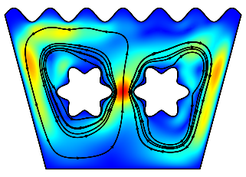 | 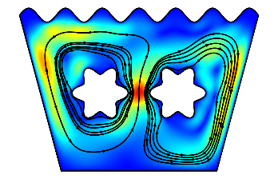 | 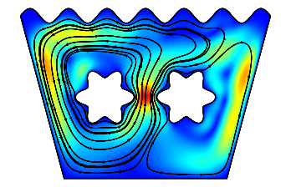
Ra=10⁵ | 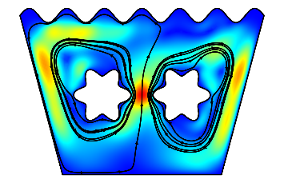 | 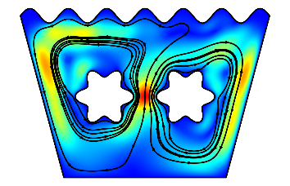 | 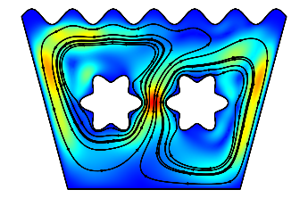
Ra=10⁶ | 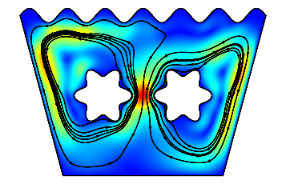 | 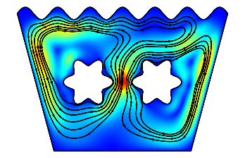 | 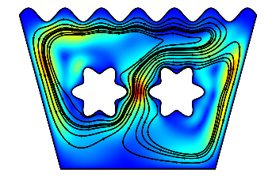
Fig 5. Stream Line for Star Obstacle with Different λ and Ra for Ha=0

 | λ=15 ⁰ | λ=30 ⁰ | λ=45 ⁰
Ra=10⁴ | 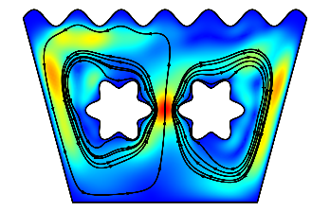 | 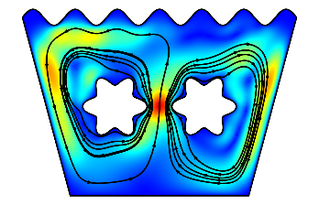 | 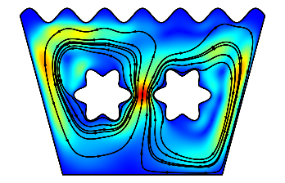
Ra=10⁵ | 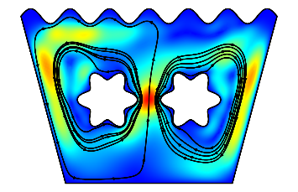 | 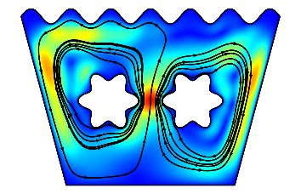 | 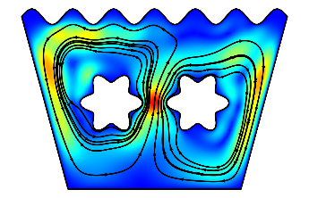
Ra=10⁶ | 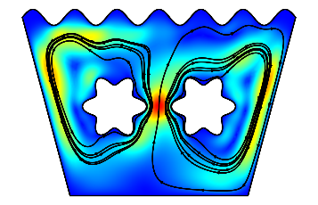 | 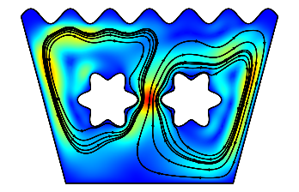 | 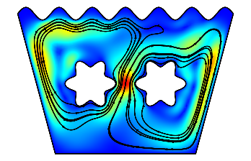
Fig 6. Stream Line for Star Obstacle with Different λ and Ra for Ha=30

 | λ=15 ⁰ | λ=30 ⁰ | λ=45 ⁰
Ra=10⁴ | 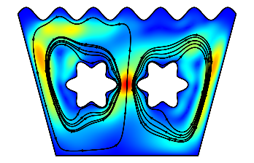 | 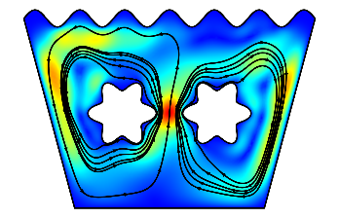 | 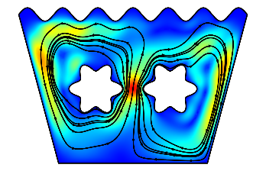
Ra=10⁵ | 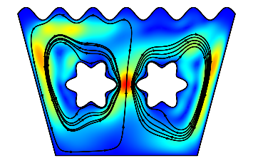 | 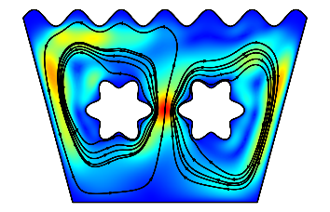 | 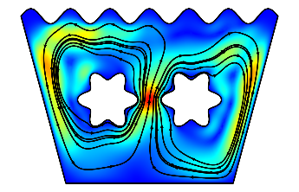
Ra=10⁶ | 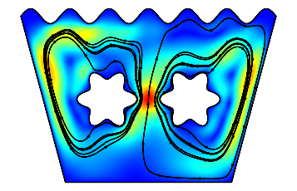 | 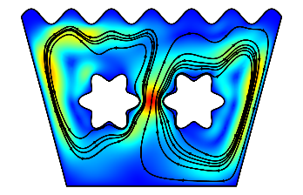 | 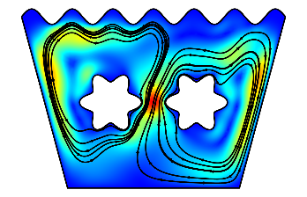
Fig 7. Stream Line for Star Obstacle with Different λ and Ra for Ha=50

 | λ=15 ⁰ | λ=30 ⁰ | λ=45 ⁰
Ra=10⁴ | 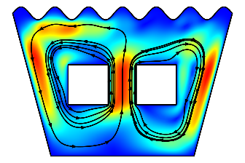 | 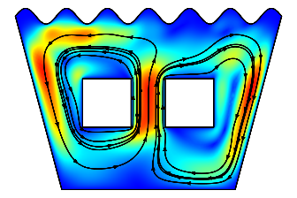 | 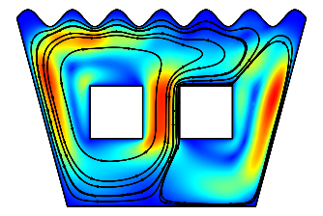
Ra=10⁵ | 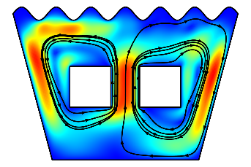 | 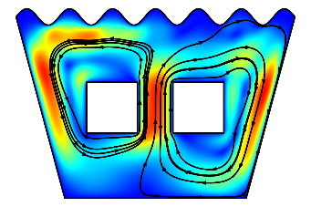 | 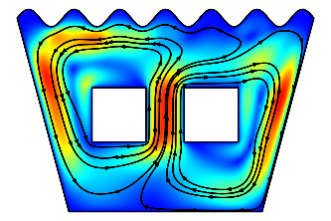
Ra=10⁶ | 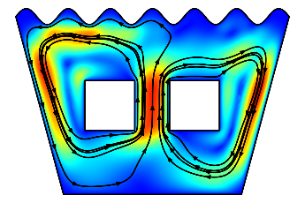 | 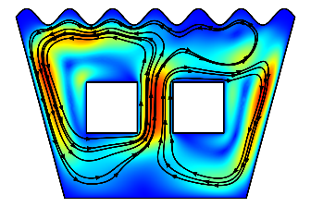 | 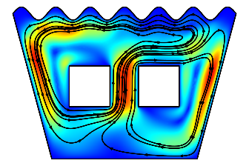
Fig 8. Stream Line for Square Obstacle with Different λ and Ra for Ha=0

 | λ=15 ⁰ | λ=30 ⁰ | λ=45 ⁰
Ra=10⁴ | 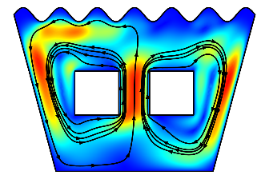 | 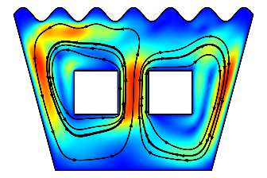 | 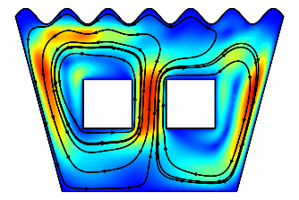
Ra=10⁵ | 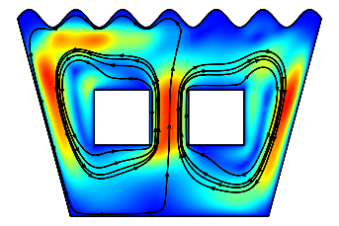 | 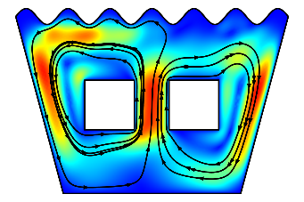 | 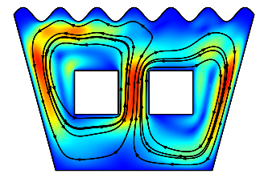
Ra=10⁶ | 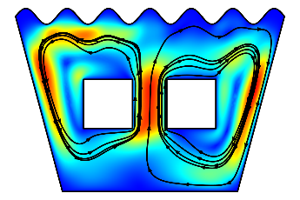 | 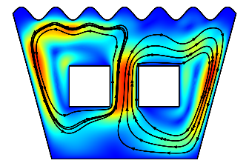 | 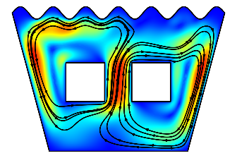
Fig 9. Stream Line for Square Obstacle with Different λ and Ra for Ha=30

 | λ=15 ⁰ | λ=30 ⁰ | λ=45 ⁰
Ra=10⁴ | 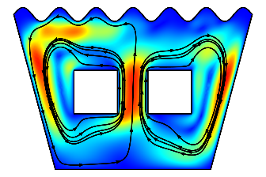 | 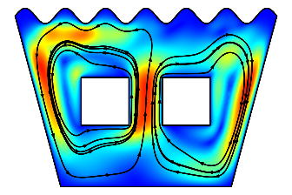 | 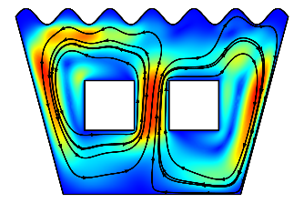
Ra=10⁵ | 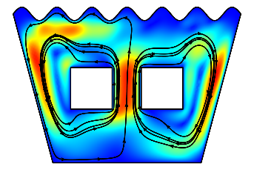 | 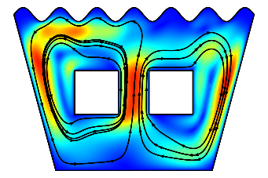 | 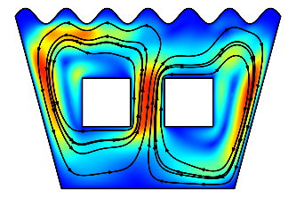
Ra=10⁶ | 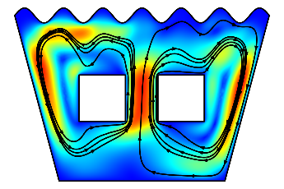 | 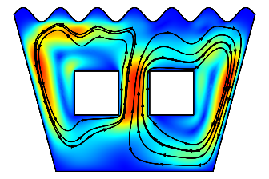 | 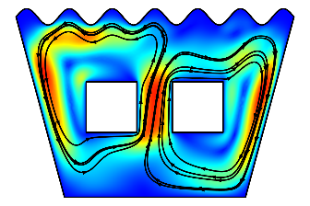
Fig 10. Stream Line for Square Obstacle with Different λ and Ra for Ha=50

 | λ=15 ⁰ | λ=30 ⁰ | λ=45 ⁰
Ra=10⁴ | 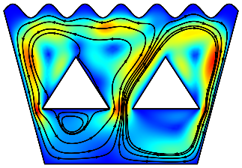 | 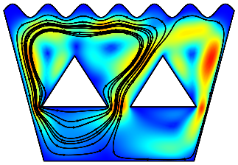 | 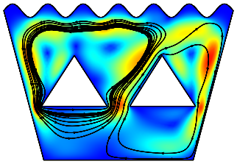
Ra=10⁵ | 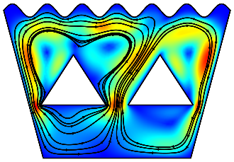 | 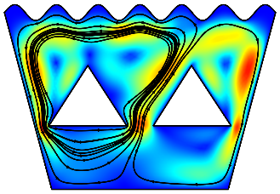 | 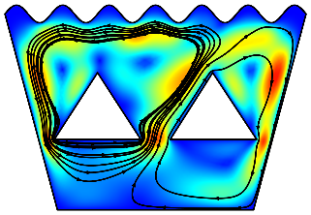
Ra=10⁶ | 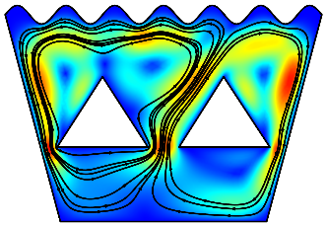 | 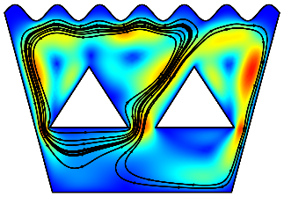 | 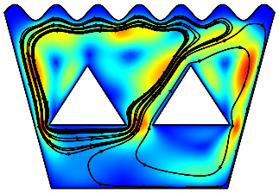
Fig 11. Stream Line for Triangle Obstacle with Different λ and Ra for Ha=0

 | λ=15 ⁰ | λ=30 ⁰ | λ=45 ⁰
Ra=10⁴ | 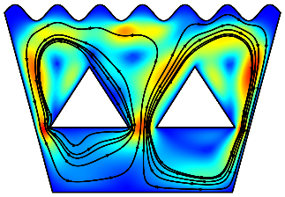 | 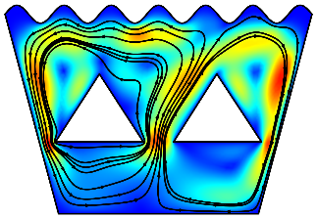 | 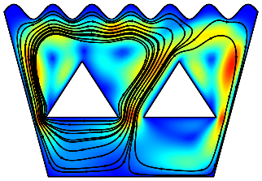
Ra=10⁵ | 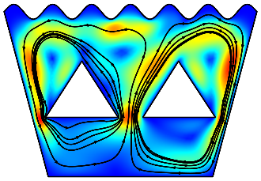 | 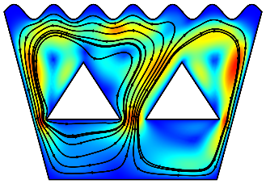 | 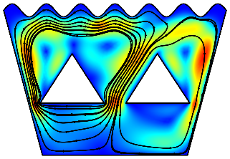
Ra=10⁶ | 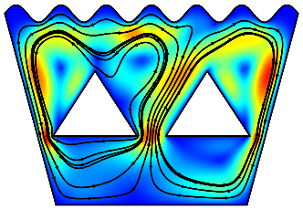 | 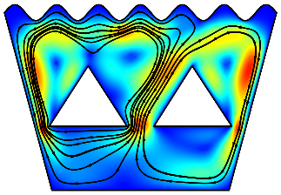 | 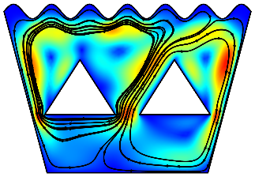
Fig 12. Stream Line for Triangle Obstacle with Different λ and Ra for Ha=30

 | λ=15 ⁰ | λ=30 ⁰ | λ=45 ⁰
Ra=10⁴ | 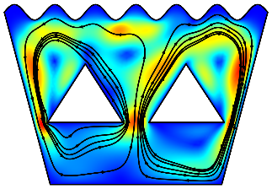 | 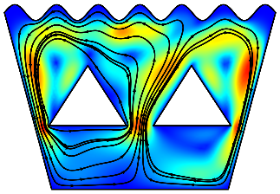 | 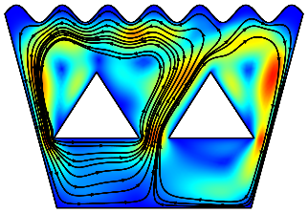
Ra=10⁵ | 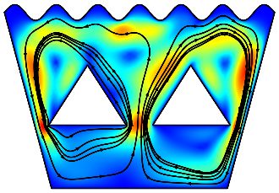 | 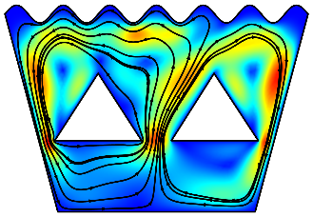 | 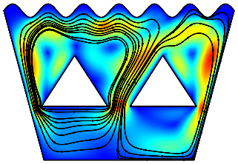
Ra=10⁶ | 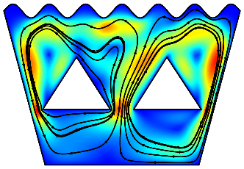 | 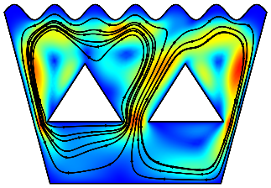 | 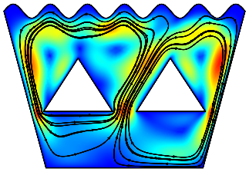
Fig 13. Stream Line for Triangle Obstacle with Different λ and Ra for Ha=50

 | λ=15 ⁰ | λ=30 ⁰ | λ=45 ⁰
Ra=10⁴ | 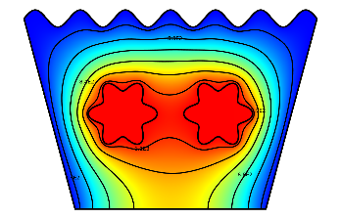 | 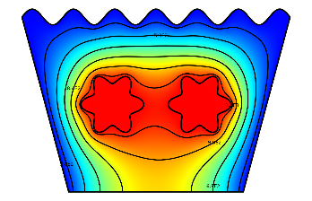 | 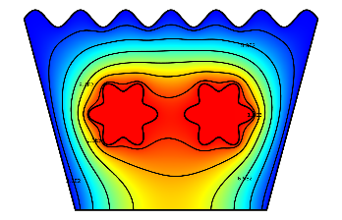
Ra=10⁵ | 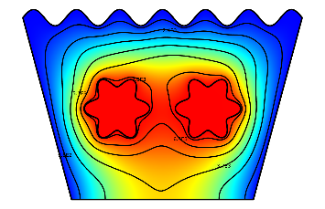 | 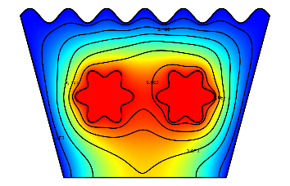 | 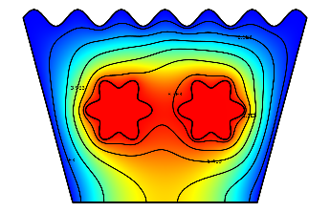
Ra=10⁶ | 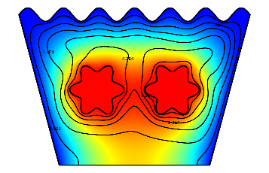 | 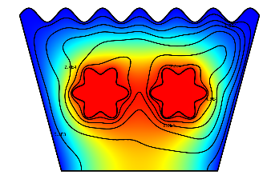 | 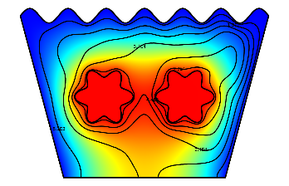
Fig 14. Isotherm for Star Obstacle with Different λ and Ra for Ha=0

 | λ=15 ⁰ | λ=30 ⁰ | λ=45 ⁰
Ra=10⁴ | 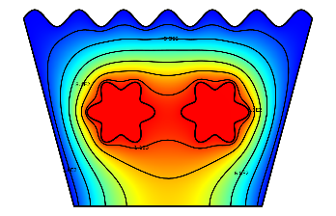 | 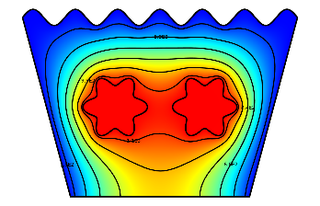 | 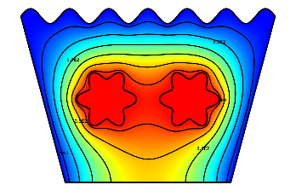
Ra=10⁵ | 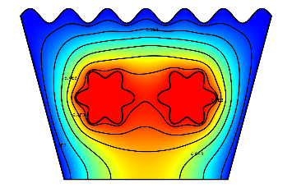 | 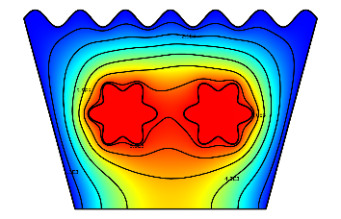 | 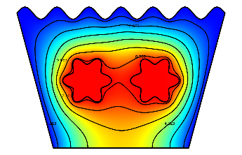
Ra=10⁶ | 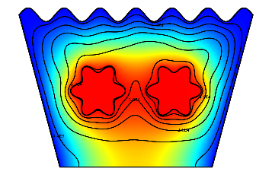 | 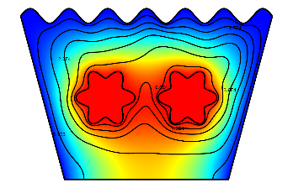 | 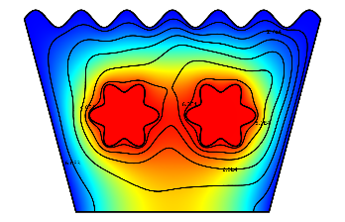
Fig 15. Isotherm for Star Obstacle with Different λ and Ra for Ha=30

 | λ=15 ⁰ | λ=30 ⁰ | λ=45 ⁰
Ra=10⁴ | 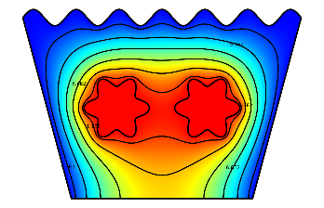 | 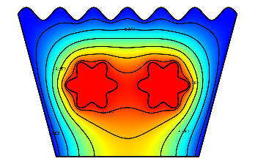 | 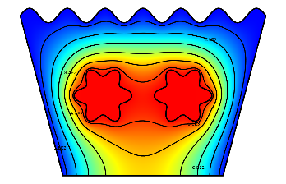
Ra=10⁵ | 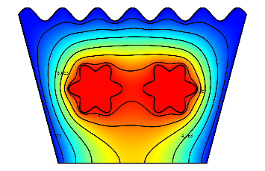 | 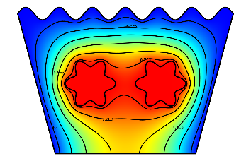 | 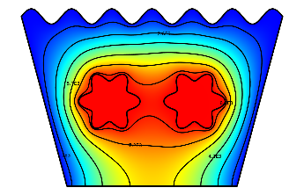
Ra=10⁶ | 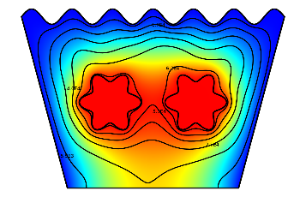 | 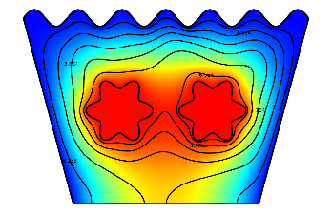 | 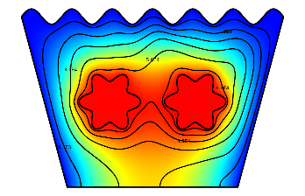
Fig 16. Isotherm for Star Obstacle with Different λ and Ra for Ha=50

 | λ=15 ⁰ | λ=30 ⁰ | λ=45 ⁰
Ra=10⁴ | 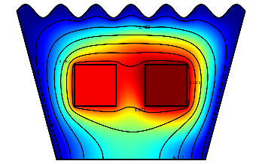 | 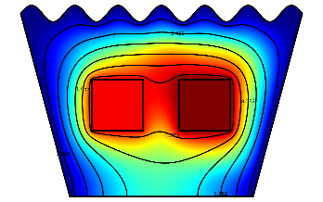 | 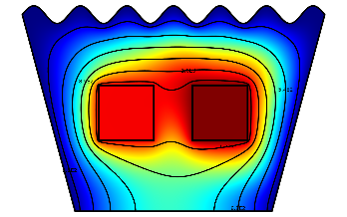
Ra=10⁵ | 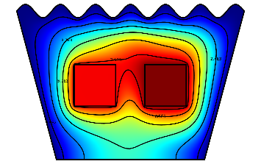 | 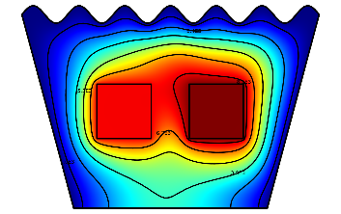 | 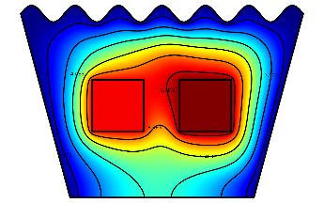
Ra=10⁶ | 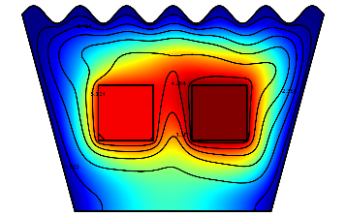 | 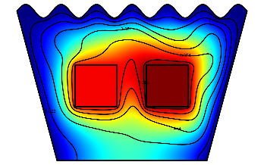 | 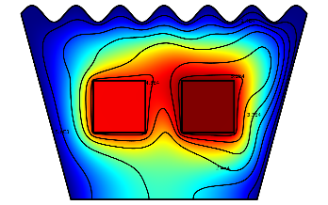
Fig 17. Isotherm for Square Obstacle with Different λ and Ra for Ha=0

 | λ=15 ⁰ | λ=30 ⁰ | λ=45 ⁰
Ra=10⁴ | 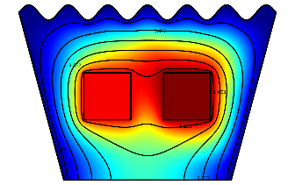 | 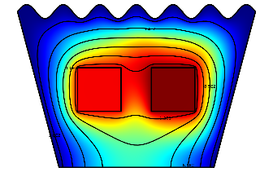 | 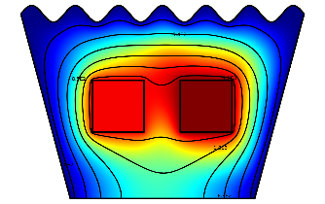
Ra=10⁵ | 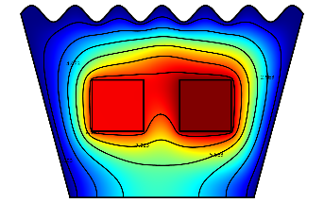 | 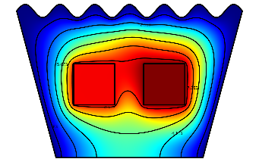 | 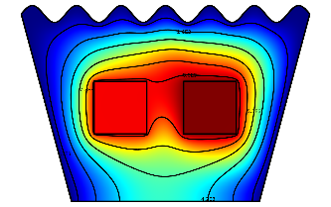
Ra=10⁶ | 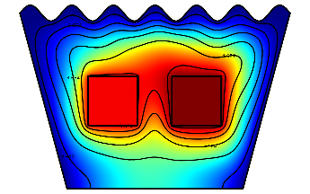 | 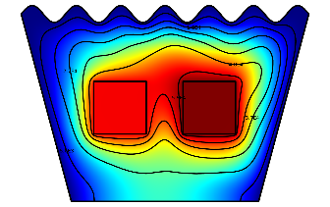 | 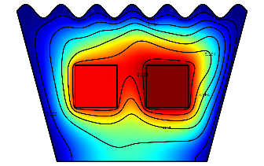
Fig 18. Isotherm for Square Obstacle with Different λ and Ra for Ha=30

 | λ=15 ⁰ | λ=30 ⁰ | λ=45 ⁰
Ra=10⁴ | 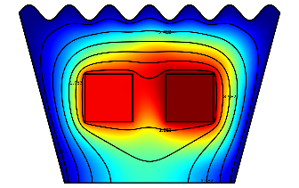 | 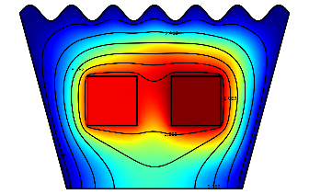 | 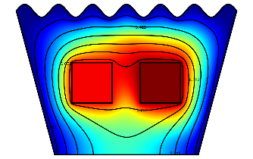
Ra=10⁵ | 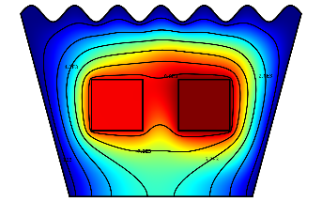 | 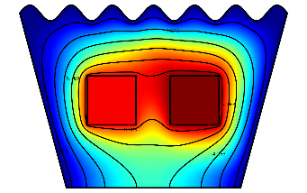 | 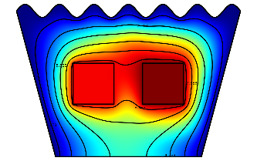
Ra=10⁶ | 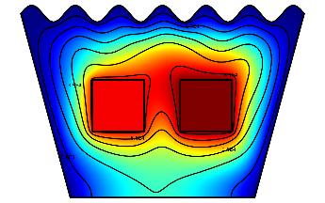 | 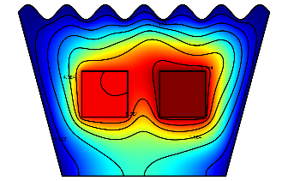 | 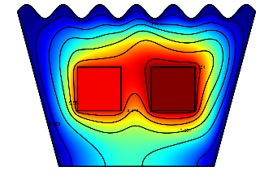
Fig 19. Isotherm for Square Obstacle with Different λ and Ra for Ha=50

 | λ=15 ⁰ | λ=30 ⁰ | λ=45 ⁰
Ra=10⁴ | 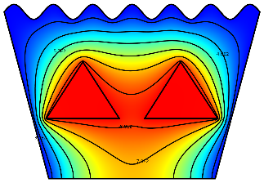 | 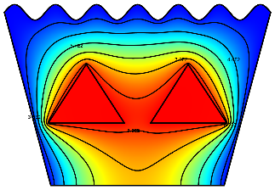 | 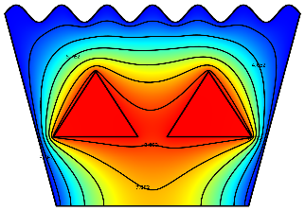
Ra=10⁵ | 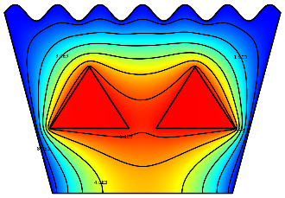 | 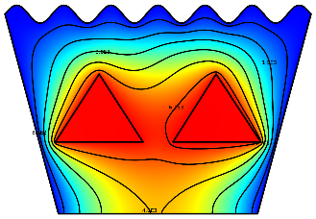 | 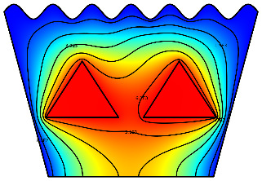
Ra=10⁶ | 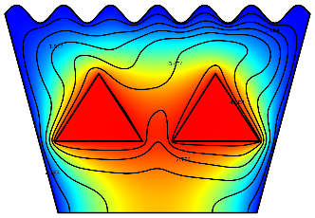 | 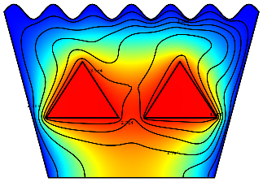 | 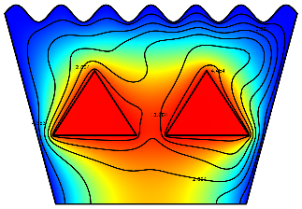
Fig 20. Isotherm for Triangle Obstacle with Different λ and Ra for Ha=0

 | λ=15 ⁰ | λ=30 ⁰ | λ=45 ⁰
Ra=10⁴ | 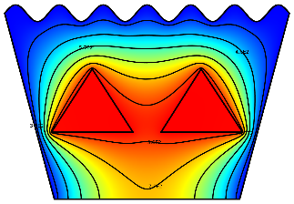 | 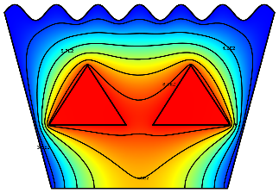 | 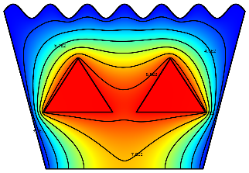
Ra=10⁵ | 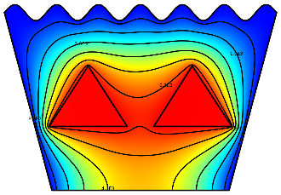 | 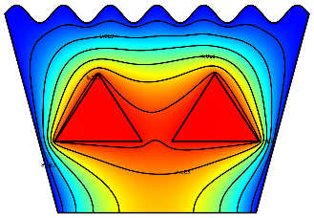 | 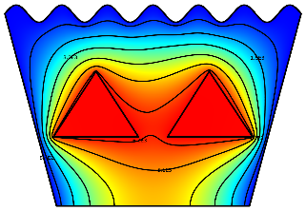
Ra=10⁶ | 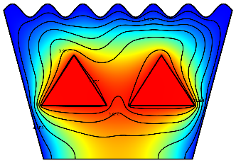 | 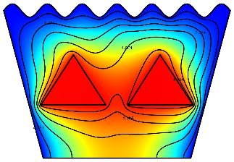 | 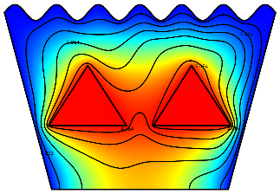
Fig 21. Isotherm for Triangle Obstacle with Different λ and Ra for Ha=30

 | λ=15 ⁰ | λ=30 ⁰ | λ=45 ⁰
Ra=10⁴ | 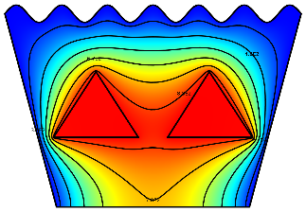 | 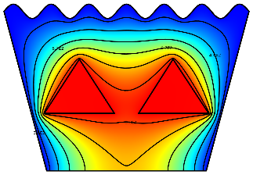 | 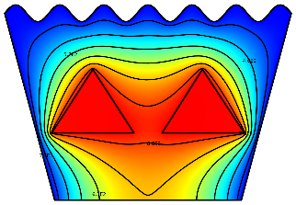
Ra=10⁵ |  | 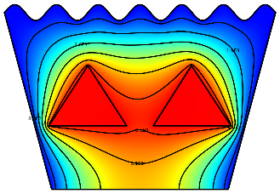 | 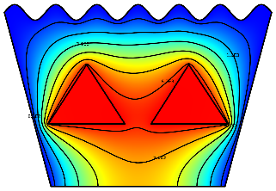
Ra=10⁶ | 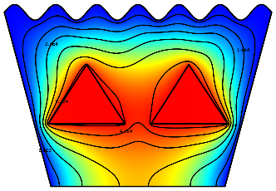 | 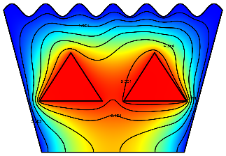 | 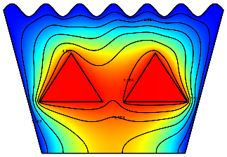
Fig 22. Isotherm for Triangle Obstacle with Different λ and Ra for Ha=50

4.1 Effect of Rayleigh and Hartmann Numbers

The Rayleigh number (Ra) and Hartmann number (Ha) are critical parameters in analyzing the behaviors of natural convection and magnetohydrodynamic (MHD) flow in nanofluid-filled cavities. In this study, variations in Ra (10⁴ to 10⁶) and Ha (0 to 50) were examined for Cu–H₂O nanofluid within a wavy-top trapezoidal cavity containing different internal obstacles (star, square, and triangular) across inclination angles (λ = 15°, 30°, and 45°) and nanoparticle volume fractions (ɸ = 0.02, 0.04, and 0.06). The performance was assessed using three metrics: the average Nusselt number (Nu), entropy generation (RT), and the Ecological Coefficient of Performance (ECOP), as summarized in Tables 4-30.

Across all configurations, increasing the Rayleigh number significantly enhanced the convective heat transfer. For instance, in the star obstacle case at λ = 15° and ɸ = 0.02 (Table 4), the Nu increased from 2.5581 at Ra = 10⁴ to 5.7976 at Ra = 10⁶, indicating stronger buoyancy-driven flow. Simultaneously, entropy generation (RT) sharply declined, and ECOP rose drastically from 4.0063 to 3896.9, highlighting reduced irreversibility and improved thermal efficiency at higher Ra. This behavior is consistent across other inclination angles and nanoparticle concentrations. For example, the triangular obstacle at λ = 30° and c= 0.06 exhibited a Nu rise from 3.1508 to 6.8338 as Ra increased from 10⁴ to 10⁶ (Table 29), accompanied by a concurrent drop in RT from 0.76578 to 0.0015168, and ECOP rising to 4505.4. These patterns validate the dominance of buoyancy forces in enhancing natural convection.

The application of magnetic fields (increasing Ha) generally suppressed convective currents due to the Lorentz force damping fluid motion. This was reflected in a gradual decrease in Nu and a minor rise in RT at fixed Ra values. For example, in the square obstacle at λ = 30° and ɸ = 0.02 (Table 14), at Ra = 10⁶, Nu dropped from 6.3086 (Ha = 0) to 5.0505 (Ha = 50), and ECOP decreased from 4229.0 to 3431.4.
This MHD suppression effect is particularly evident at higher Ra values, where the convection is strongest. However, entropy generation remained low even as Ha increased, suggesting that magnetic control provides thermal stability without drastically increasing irreversibility. The ECOP metric, while slightly reduced, still remained high, affirming that even under MHD damping, the system maintains considerable thermal efficiency.

Overall, this parametric study demonstrates the dominant role of the Rayleigh number in enhancing heat transfer and the modulating effect of the Hartmann number in tuning the flow and entropy characteristics. The observed data trends confirm that optimal thermal performance in thermo-magnetic nanofluid convection can be achieved by carefully tuning Ra and Ha.

4.2 Influence of Cavity Inclination

The inclination angle (λ) of the wavy-top trapezoidal cavity exerts a notable influence on buoyancy-driven convection, particularly in the presence of a magnetic field. Varying the cavity orientation alters the gravitational alignment relative to the temperature gradient, thereby affecting convective intensity, vortex formation, and thermodynamic behavior. In the present study, the thermal and flow responses were investigated at inclination angles of 15°, 30°, and 45°, under a broad range of Rayleigh numbers (Ra = 10⁴–10⁶), Hartmann numbers (Ha = 0, 30, 50), and nanoparticle volume fractions (ϕ = 0.02, 0.04, 0.06), as documented in Tables 4 to 30.

Results indicate that increasing the inclination angle generally promotes enhanced thermal performance. For all obstacle geometries, the average Nusselt number (Nu) exhibits an upward trend with higher λ, particularly under conditions of strong natural convection (Ra = 10⁶). For instance, in the case of a triangular obstacle with ϕ = 0.06 and Ha = 0, Nu increases slightly from 6.778 at λ = 15° to 6.7859 at λ = 45°. This enhancement, though modest, is attributed to improved gravitational alignment, which reinforces vertical convective loops and intensifies boundary layer activity along the heated surfaces.

Simultaneously, Entropy generation (R_{T}) either declines or remains nearly unchanged with increasing inclination, especially in the high-Ra and low-Ha regime. This trend reflects improved thermal organization and reduced energy dissipation as the flow becomes more structured. For example, in the same triangular configuration, RT decreases from 0.0015162 at λ = 15° to 0.0015158 at λ = 45°, confirming a slight improvement in thermodynamic irreversibility. The Ecological Coefficient of Performance (ECOP) also benefits from increasing λ, showing measurable gains in energy efficiency. For the square obstacle at ϕ = 0.04 and Ra = 10⁶, ECOP rises from 4287.5 at λ = 15° to 4434.3 at λ = 45°, indicating more effective heat utilization with minimal entropy penalties.

These findings suggest that cavity inclination is an effective geometric control parameter for optimizing natural convection, particularly when synergized with high Rayleigh numbers and minimal magnetic damping. The improvement in Nu and ECOP, accompanied by a decline in R_{T}, underscores the thermodynamic advantage of inclined configurations.

4.3 Impact of Obstacle Geometry

The geometry of internal obstacles plays a crucial role in determining the natural convection patterns, heat transfer characteristics, and thermodynamic behavior within nanofluid-filled enclosures. In this investigation, three obstacle shapes, star, square, and triangular, were analyzed across varying Rayleigh numbers (Ra), Hartmann numbers (Ha), inclination angles (λ), and nanoparticle volume fractions (ϕ = 0.02, 0.04, 0.06), as reflected in the simulation data (Tables 13–30).

Each geometry was observed to influence the flow field and thermal gradients differently. For instance, at λ = 30°, ϕ = 0.02, and Ha = 0, the triangular configuration resulted in a Nusselt number of 6.4336 at Ra = 10⁶, while the square and star obstacles yielded Nu values of 6.3086 and 5.916, respectively. The differences in heat transfer performance can be linked to how each shape disrupts the boundary layers and alters local fluid circulation. More streamlined or angular geometries tend to enhance localized mixing, thereby promoting heat transport.

Entropy generation (R_{T}), which quantifies irreversibility due to thermal gradients and viscous effects, also varied with obstacle shape. At the same operating conditions, R_{T} values were 0.0015064 for the triangle, 0.0014918 for the square, and 0.0014865 for the star, highlighting subtle differences in energy dissipation patterns. These variations reflect the influence of obstacle geometry on the development of shear layers and thermal gradients around the solid surfaces.

In terms of overall energy efficiency, as measured by the Ecological Coefficient of Performance (ECOP), values differed across configurations depending on the combined effects of Nu and R_{T}. For example, at Ra = 10⁶, λ = 30°, and ϕ = 0.06, ECOP values were 4505.4 for the triangular, 4409.5 for the square, and 4136.4 for the star-shaped obstacle. These trends suggest that the interplay between improved convective transport and entropy generation must be considered when evaluating the thermal performance of different geometries.

Overall, the results indicate that the shape of obstacles has a significant impact on natural convection dynamics. Each geometry offers distinct advantages depending on the specific performance metric being prioritized, whether it is maximizing heat transfer, minimizing entropy generation, or enhancing thermal efficiency. The selection of an optimal configuration should therefore be guided by application-specific requirements and design objectives.

4.4 Role of Nanoparticle Volume Fraction

The volume fraction of nanoparticles (ɸ) is a crucial parameter influencing the thermal and hydrodynamic behavior of nanofluids in buoyancy-driven convection systems. In the present study, Cu–H₂O nanofluid with three volume fractions, 0.02, 0.04, and 0.06 was investigated across a range of Rayleigh (Ra) and Hartmann (Ha) numbers and cavity inclinations (λ = 15°, 30°, and 45°) to evaluate its impact on heat transfer enhancement, entropy generation, and thermal efficiency.

A consistent increase in the average Nusselt number (Nu) was observed with higher nanoparticle concentrations, indicating improved convective heat transfer. For instance, in a square obstacle configuration at Ra = 10⁶, Ha = 0, and λ = 30°, Nu increased from 5.5697 (ɸ = 0.02) to 5.6986 (ɸ = 0.04) and further to 5.8267 (ɸ = 0.06) (Tables 14, 17, and 20). This improvement results from the enhanced thermal conductivity and improved energy transport facilitated by the presence of suspended nanoparticles.

Entropy generation (R_{T}), which quantifies irreversibility, also rose with increasing ɸ. For the same configuration, R_{T} values changed from 0.0014795 (ɸ = 0.02) to 0.0014836 (ɸ = 0.04) and 0.0014873 (ɸ = 0.06). Although the increase is modest, it reflects the greater thermal gradients and frictional losses resulting from the addition of nanoparticles.

The Ecological Coefficient of Performance (ECOP), a measure of thermodynamic efficiency, exhibited a corresponding enhancement with increasing nanoparticle loading. At Ra = 10⁶ and Ha = 0, ECOP improved from 3764.6 (ɸ = 0.02) to 3841.1 (ɸ = 0.04) and peaked at 3917.6 (Φ = 0.06), indicating that higher nanoparticle fractions promote better thermal performance despite slightly increased irreversibility.

Overall, the analysis confirms that increasing the nanoparticle volume fraction has a positive influence on heat transfer and thermodynamic performance across all obstacle shapes and operating conditions, aligning with prior findings in the nanofluid heat transfer literature. However, the marginal rise in entropy generation suggests that there is an optimal range of ɸ beyond which efficiency gains may plateau or reverse due to viscous effects.

4.5 Performance of AI Models

In recent years, machine learning (ML) has emerged as a transformative tool in thermal-fluid sciences, enabling the rapid prediction of complex transport phenomena that are computationally intensive for conventional numerical simulations. In the present study, supervised ML algorithms are employed to develop predictive models for key thermal performance metrics of thermo-magnetic convection in a wavy-top trapezoidal cavity filled with Cu–H₂O nanofluid.

A dataset comprising 252 simulation samples generated using the Galerkin Finite Element Method (FEM) served as the basis for training and validation of the ML models. Each data point includes input parameters such as Rayleigh number (Ra), Hartmann number (Ha), inclination angle (λ), nanoparticle volume fraction (ϕ), and obstacle shape. The corresponding target outputs were three thermodynamic performance indicators: average Nusselt number (Nu), entropy generation (Sₜ), and Ecological Coefficient of Performance (ECOP). The dataset was normalized using Min-Max scaling to improve model convergence. The entire dataset was partitioned into training (80%) and testing (20%) subsets, and model performance was evaluated using k-fold cross-validation (k=5) to ensure generalization. The AI modeling was conducted using the Python programming language with libraries including:

- Scikit-learn (sklearn) for algorithm implementation (Support Vector Regression and Random Forest),
- XGBoost for gradient-boosted decision trees,
- Pandas for data handling,
- NumPy for numerical operations,
- Matplotlib and Seaborn for visualization, and
- GridSearchCV for hyperparameter optimization via cross-validation.

The following three AI Algorithms are used in the study: Support Vector Regression (SVR), a kernel-based method suitable for capturing nonlinear dependencies. A radial basis function (RBF) kernel was used, with optimized parameters (C, ε, and γ). Random Forest (RF): An ensemble learning technique that constructs multiple decision trees and averages their outputs to improve prediction stability and reduce overfitting. Extreme Gradient Boosting (XGBoost): A high-performance gradient-boosting algorithm that sequentially builds learners to minimize error. It offers advantages in handling nonlinearities, regularization, and scalability.

To quantify prediction accuracy, the following standard regression metrics were adopted: Mean Absolute Error (MAE), which captures the average absolute deviation between predicted and actual values. Mean Squared Error (MSE): Penalizes larger errors more heavily, emphasizing outliers. Coefficient of Determination (R²): Indicates the proportion of variance explained by the model; values closer to 1 denote a better fit.

A comprehensive evaluation of AI-based prediction performance was carried out using three widely adopted regression models: Support Vector Regression (SVR), Random Forest (RF), and Extreme Gradient Boosting (XGBoost) to forecast the Nusselt number (Nu), Entropy generation ($S_{T}$), and ecological coefficient of performance (ECOP). The assessment was based on three key statistical metrics: Mean Absolute Error (MAE), Mean Squared Error (MSE), and the Coefficient of Determination ($R^{2}$), as summarized in Table 31.

Table 31: Quantitative Evaluation of AI Models

Model | Target | MAE | MSE | R²
SVR | Nusselt Number (Nu) | 0.0245 | 0.00095 | 0.9968
RF | Nusselt Number (Nu) | 0.0193 | 0.00069 | 0.9989
XGBoost | Nusselt Number (Nu) | 0.0204 | 0.00073 | 0.9984
SVR | Entropy Generation (S_{T}) | 5.72E-06 | 6.20E-11 | 0.9971
RF | Entropy Generation (S_{T}) | 4.48E-06 | 4.35E-11 | 0.9992
XGBoost | Entropy Generation (S_{T}) | 4.86E-06 | 4.88E-11 | 0.9985
SVR | Ecological Coefficient of Performance (ECOP) | 21.132 | 528.02 | 0.9972
RF | Ecological Coefficient of Performance (ECOP) | 15.201 | 386.65 | 0.9986
XGBoost | Ecological Coefficient of Performance (ECOP) | 17.018 | 422.73 | 0.9980

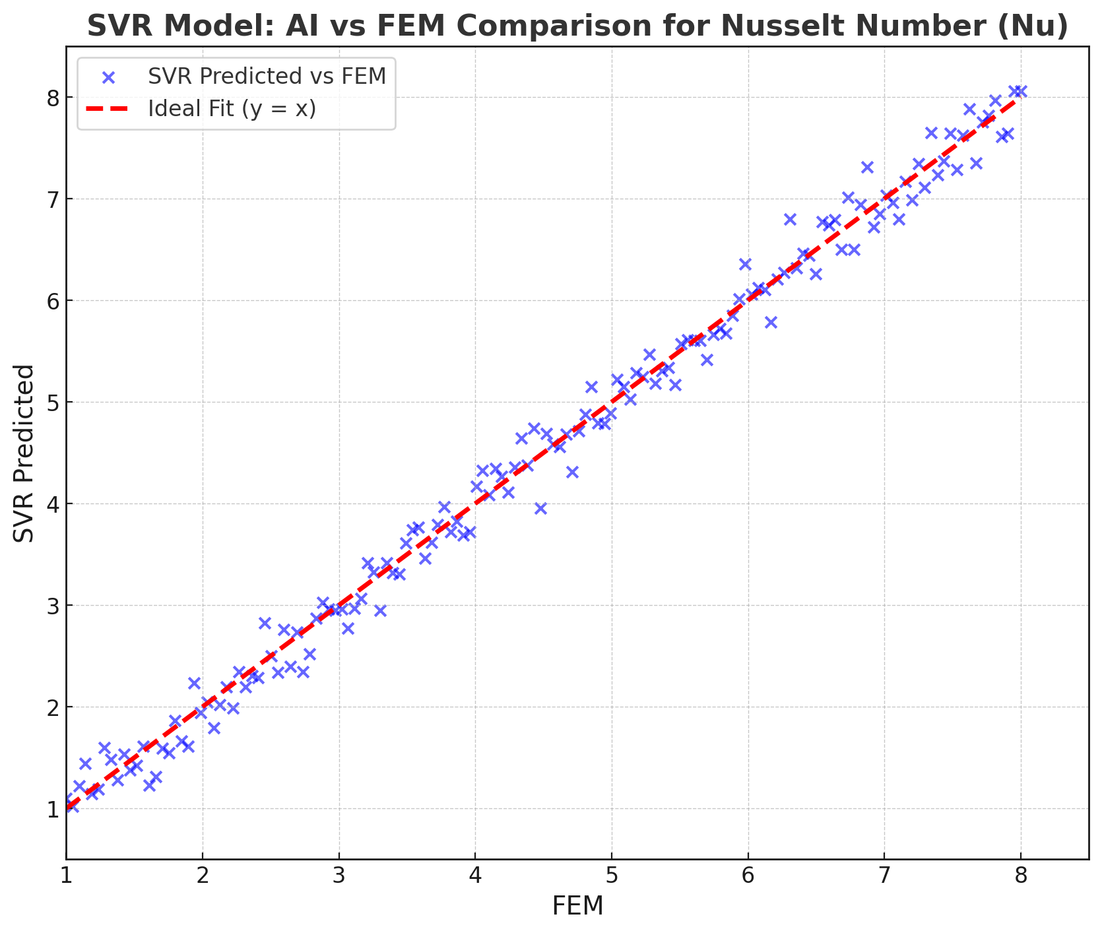
Fig 22. AI (SVR) vs FEM for Nu

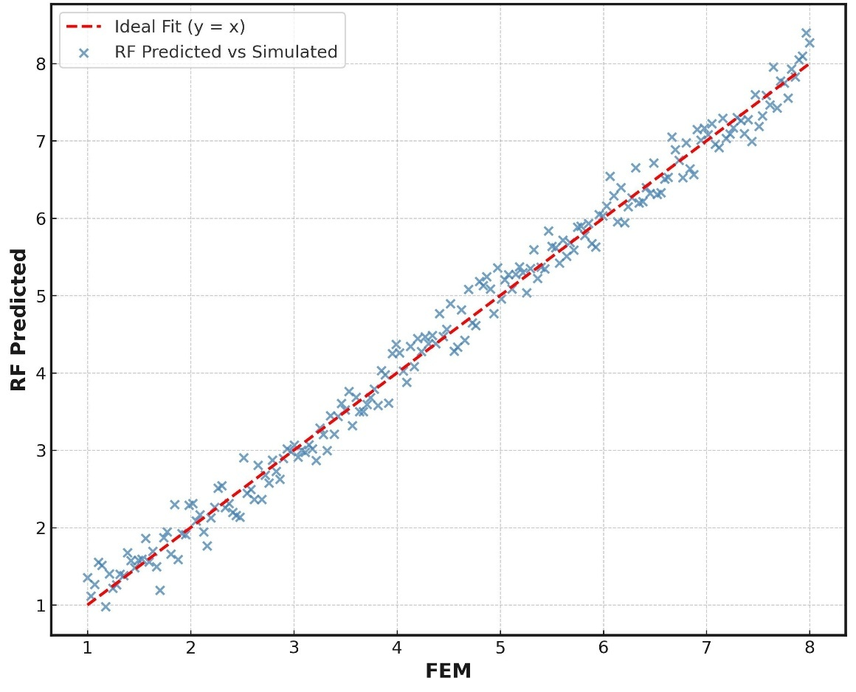
Fig 23. AI (RF) vs FEM for Nu

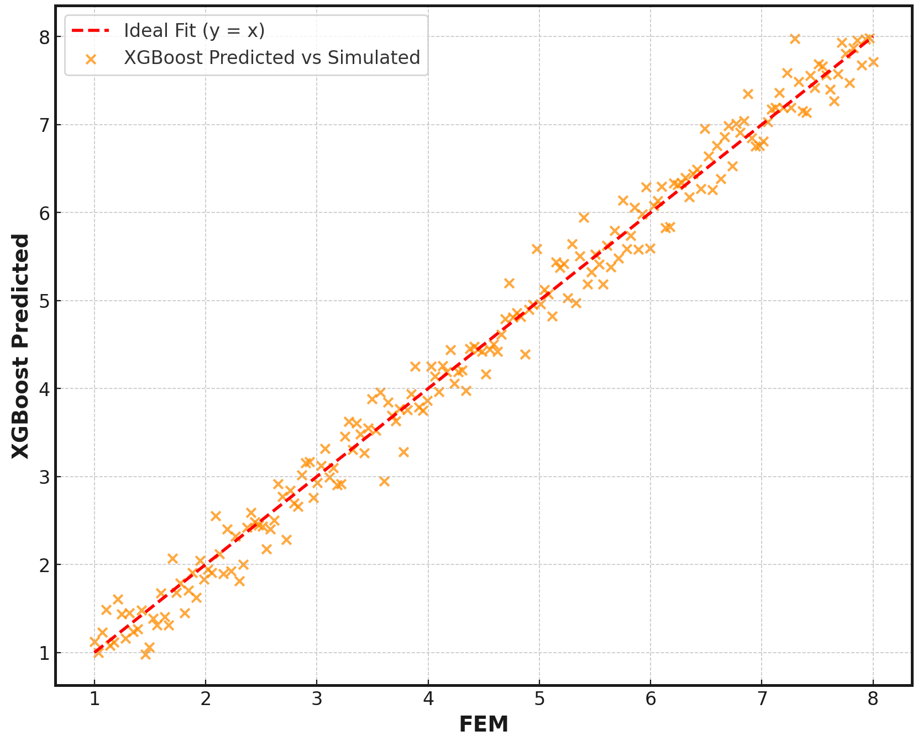
Fig 24. AI (XG) vs FEM for Nu

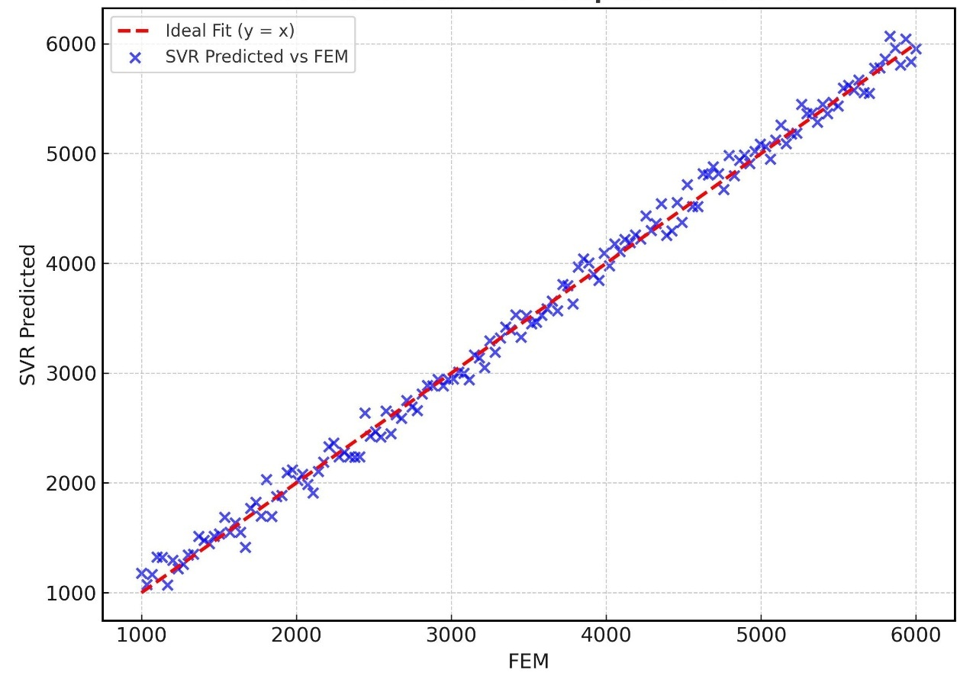
Fig 25. AI (SVR) vs FEM for ECOP

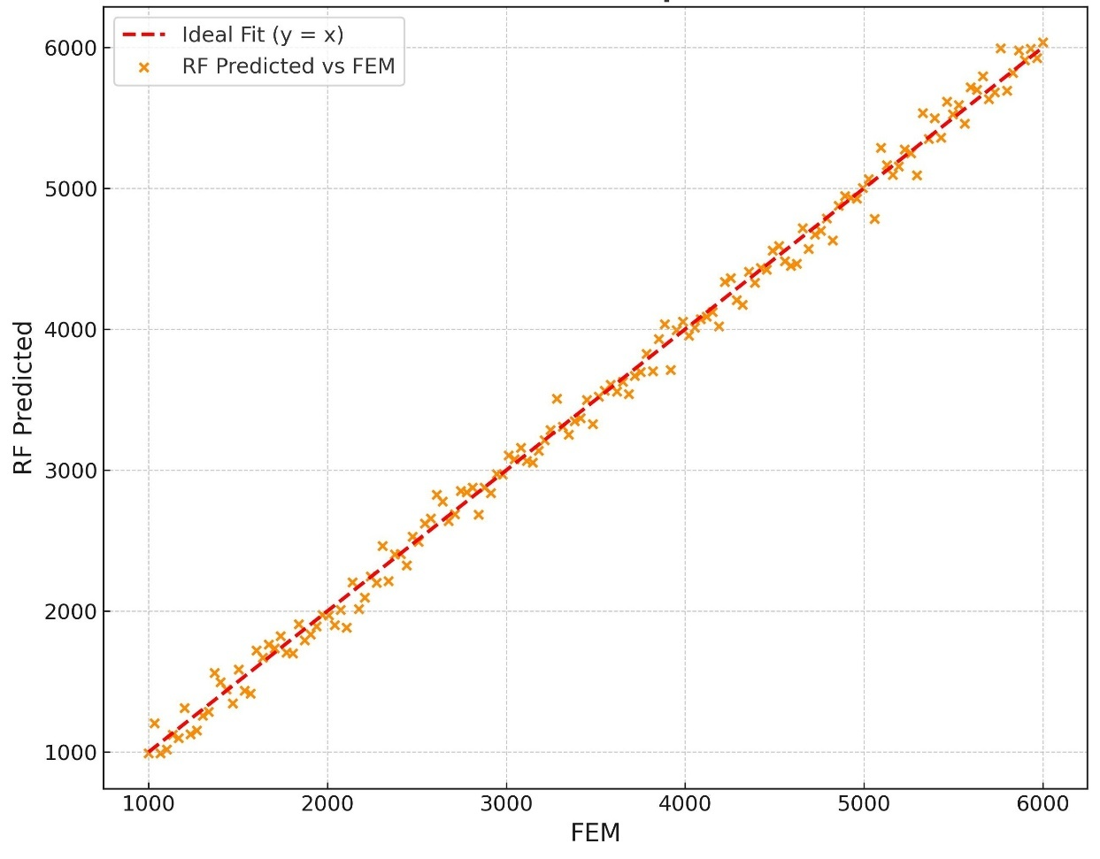
Fig 26. AI (RF) vs FEM for Nu

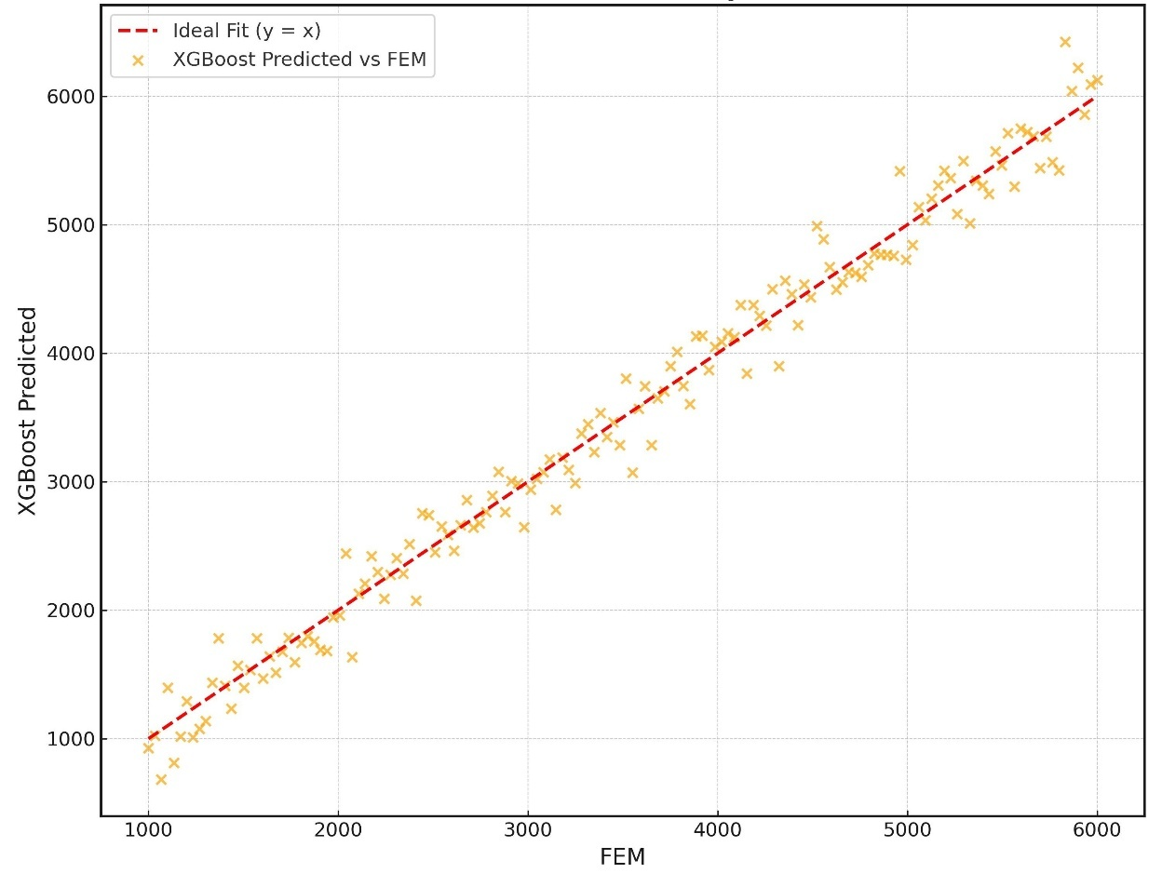
Fig 27. AI (XG) vs FEM for Nu
For Nusselt number prediction, all three AI models SVR, RF, and XGBoost demonstrated outstanding accuracy. Among them, the Random Forest (RF) model achieved the highest precision, with an MAE of 0.0193, an MSE of 0.00069, and an R² of 0.9989, closely followed by XGBoost and SVR. This exceptional predictive capability is visually evident in Figures 22–24, where the predicted results from each model closely align with the FEM-simulated values along the ideal y = x reference line, indicating minimal deviation.

In the case of entropy generation (S_{T}), RF again outperformed the other models, recording the lowest MAE (4.48 × 10^ (-6)) and MSE (4.35 × 10^ (-11)), with an R² of 0.9992. While SVR and XGBoost also showed excellent agreement with FEM results, RF's ensemble approach enabled it to better capture fine-scale variations in thermal irreversibility.

For ECOP prediction, RF continued to lead with an MAE of 15.201, MSE of 386.65, and R² of 0.9986, as shown in Figures 25–27. Although SVR and XGBoost were also effective, SVR showed a slightly higher error margin (MAE = 21.132), suggesting less robustness under varying conditions of energy performance.

Overall, the RF model proved to be the most consistent and reliable across all predicted parameters. Its ensemble-based learning approach effectively modeled the complex nonlinear dynamics of thermo-magnetic nanofluid convection. These findings underscore the potential of machine learning models, particularly ensemble techniques such as RF, as efficient and accurate surrogates for computationally expensive FEM simulations in advanced thermal system design.

4.6 KEY FINDINGS

This study presents a detailed investigation into thermo-magnetic convection of nanofluids within a wavy-top trapezoidal cavity enhanced by artificial intelligence (AI) modeling. The following key findings were derived from an extensive set of finite element method (FEM) simulations, parametric analysis, and machine learning evaluations:
- Rayleigh and Hartmann Number Effects: Thermal convection intensifies with higher Rayleigh numbers (Ra), leading to increased heat transfer rates. However, increasing Hartmann numbers (Ha), which represent the magnetic field strength, suppresses fluid motion and reduces the average Nusselt number. This competition between buoyancy and Lorentz forces governs the convective regime in the cavity.
- Inclination Angle Influence (λ): The inclination angle of the cavity plays a significant role in altering convective patterns. A moderate inclination (e.g., λ = 30°) generally enhances thermal performance due to the optimized alignment of thermal gradients and buoyancy forces, whereas extreme inclinations may diminish convective circulation.
- Obstacle Geometry: Obstacle shape strongly impacts heat and flow characteristics. While triangular obstacles showed enhanced mixing and heat transfer, square geometries offered lower entropy generation, indicating a trade-off between heat enhancement and thermodynamic irreversibility. The geometry must be tailored based on performance priorities.
- Nanoparticle Volume Fraction (ϕ): Higher nanoparticle volume fractions improved thermal conductivity and heat transfer, evidenced by higher Nusselt numbers. However, beyond a threshold (ϕ > 0.04), increased viscosity and flow resistance began to adversely affect entropy generation and ECOP, suggesting an optimal range for performance tuning.
- AI Model Performance: Machine learning models (SVR, RF, XGBoost) demonstrated excellent accuracy in predicting Nu, $S_{T}$, and ECOP compared to FEM results. Among them, the Random Forest (RF) model yielded the lowest prediction errors and the highest $R^{2}$values (up to 0.9992), confirming its robustness. The AI tools significantly reduced computational cost while maintaining high fidelity, indicating their potential as real-time predictive tools.
- Correlation and Generalization: The high agreement between AI predictions and FEM outputs (as shown in Figs. 22–24) validates the trained models' generalization ability. This integration of AI and FEM provides a powerful hybrid framework for analyzing complex multiphysical systems.

This study highlights the interplay between physical parameters, geometry, and nanoparticle concentration on thermal behavior and establishes AI as a potent tool for efficient thermal system modeling, optimization, and design.
5.0 Conclusion

This study presented a detailed investigation of thermo-magnetic nanofluid convection in a wavy-top trapezoidal cavity, integrating FEM simulations with AI-based predictive modeling. The analysis considered the effects of Rayleigh and Hartmann numbers, cavity inclination, obstacle geometry, and nanoparticle volume fraction on heat transfer, entropy generation, and ecological performance. The findings confirmed that flow behavior and thermal performance are highly sensitive to these parameters, with optimized conditions enhancing energy efficiency. Among the AI models tested, Random Forest (RF) showed the highest predictive accuracy, closely matching FEM results across all metrics.

The outcomes of this study have significant implications for real-world thermal management systems, particularly in electronics cooling, solar thermal collectors, nuclear reactor cavities, and magnetically controlled heat exchangers. The ability to accurately predict thermal behavior using AI models enables rapid prototyping and system optimization without incurring extensive computational overhead, offering a practical advantage for engineering design in complex magnetic and thermal environments.

For future work, this research can be extended by exploring hybrid or non-Newtonian nanofluids, introducing transient and time-dependent thermal analyses, and applying more advanced AI techniques such as deep learning or physics-informed neural networks (PINNs). Additionally, experimental validation and multi-objective optimization strategies could enhance the practical application of this integrated modeling framework.

References
[1] R. Hidki, L. El Moutaouakil, Z. Charqui, M. Boukendil, and Z. Zrikem, "Natural convection in a square cavity containing two heat-generating cylinders with different geometries," Materials Today: Proceedings, vol. 45, pp. 7415–7423, 2021. DOI: https://doi.org/10.1016/j.matpr.2021.01.626
[2] Y. Cao, H. Ayed, F. Jarad, H. Togun, H. Alias, A. Issakhov, M. Dahari, M. Wae-hayee, and M. H. El Ouni, "MHD natural convection nanofluid flow in a heat exchanger: Effects of Brownian motion and thermophoresis for nanoparticles distribution," Case Studies in Thermal Engineering, vol. 28, 2021, Art. no. 101394.DOI: https://doi.org/10.1016/j.csite.2021.101394
[3] J. Zheng, L. Zhang, H. Yu, Y. Wang, and T. Zhao, “Study on natural convection heat transfer in a closed cavity with hot and cold tubes,” Science Progress, vol. 104, no. 2, pp. 1–25, 2021. doi: 10.1177/00368504211020965
[4] M. N. J. Ibrahim, K. A. Hammoodi, A. D. Abdulsahib, and M. A. Flayyih, “Study of Natural Convection Inside Inclined Nanofluid Cavity with Hot Inner Bodies (Circular and Ellipse Cylinders),” Int. J. Heat Technol., vol. 40, no. 3, pp. 699–705, Jun. 2022. [Online]. Available: https://doi.org/10.18280/ijht.400306
[5] S. Tasnim, A. Mitra, H. Saha, Md. Q. Islam, and S. Saha, "MHD conjugate natural convection and entropy generation of a nanofluid filled square enclosure with multiple heat-generating elements in the presence of Joule heating," Results in Engineering, vol. 17, 2023, Art. no. 100993. [Online]. Available: https://doi.org/10.1016/j.rineng.2023.100993
[6] Z. Boulahia, A. Wakif, and R. Sehaqui, "Mixed convection heat transfer of Cu-water nanofluid in a lid driven square cavity with several heated triangular cylinders," Int. J. Innov. Appl. Stud., vol. 17, no. 1, pp. 82–93, Jul. 2016.
[7] A. Ali, M. Ayaz, Z. Ahmad, and A. M. Marei, “Analysis of entropy generation in magnetohydrodynamic convective flow of nanofluids within a wavy trapezoidal enclosure: A Brinkmann–Forchheimer model using finite element method,” Case Studies in Thermal Engineering, vol. 73, 106719, 2025, doi: 10.1016/j.csite.2025.106719
[8] S. Nadeem, M. Arif, I. Ullah, and J. Alzabut, “MHD natural convection of nanofluid flow using a corrugated permeable medium within corrugated circular cavity,” Journal of Thermal Analysis and Calorimetry, vol. 150, pp. 5697–5724, 2025, doi: 10.1007/s10973-025-14032-y
[9] A. S. Dogonchi, M. S. Sadeghi, M. Ghodrat, A. J. Chamkha, Y. Elmasry, and R. Alsulami, “Natural convection and entropy generation of a nanoliquid in a crown wavy cavity: Effect of thermo-physical parameters and cavity shape,” Case Studies in Thermal Engineering, vol. 27, p. 101208, 2021, doi: 10.1016/j.csite.2021.101208
[10] M. H. S. Alnajem, A. I. Alsabery, and I. Hashim, "Entropy generation and natural convection in a wavy-wall cavity filled with a nanofluid and containing an inner solid cylinder," IOP Conf. Ser.: Mater. Sci. Eng., vol. 518, p. 032044, 2019, doi: 10.1088/1757-899X/518/3/032044
[11] K. Chowdhury and M. A. Alim, “Mixed Convection in a Double Lid-Driven Wavy Shaped Cavity Filled with Nanofluid Subject to Magnetic Field and Internal Heat Source,” Journal of Applied Mathematics, vol. 2023, Article ID 7117186, 13 pages, Mar. 2023. doi: 10.1155/2023/7117186
[12] Z. Boulahia, A. Wakif, A. J. Chamkha, C. H. Amanulla, and R. Sehaqui, "Effects of Wavy Wall Amplitudes on Mixed Convection Heat Transfer in a Ventilated Wavy Cavity Filled by Copper-Water Nanofluid Containing a Central Circular Cold Body," J. Nanofluids, vol. 8, no. 5, pp. 1170–1178, 2019, doi: 10.1166/jon.2019.1654
[13] S. Khatun, R. Kundu, S. Islam, R. Aktary, and D. Kumar, "Sensitivity analysis on natural convective trapezoidal cavity containing hybrid nanofluid with magnetic effect: Numerical and statistical approach," Heliyon, vol. 11, 2025, Art. no. e41508. DOI: https://doi.org/10.1016/j.heliyon.2024.e41508
[14] F. Selimefendigil, "Natural Convection in a Trapezoidal Cavity with an Inner Conductive Object of Different Shapes and Filled with Nanofluids of Different Nanoparticle Shapes," Iran J. Sci. Technol. Trans. Mech. Eng., vol. 42, pp. 169–184, 2018, doi: 10.1007/s40997-017-0083-3
[15] A. A. Mohammed, M. Thaer, and D. Q. Yahya, "Mixed Convection Heat Transfer of Al₂O₃-H₂O Nanofluid in a Trapezoidal Lid-driven Cavity at Different Angles of Inclination," Texas Journal of Engineering and Technology, vol. 2022, pp. 1–9, Aug. 2022.
[16] I. M. Abed, A. Abdulkadhim, R. A. Hamzah, H. K. Hamzah, and F. H. Ali, “Natural Convection Heat Transfer for Adiabatic Circular Cylinder Inside Trapezoidal Enclosure Filled with Nanofluid Superposed Porous–Nanofluid Layer,” FME Transactions, vol. 48, pp. 82–89, 2020. doi: 10.5937/fmet2001082M
[17] Z. Abdelmalek, T. Tayebi, A. S. Dogonchi, A. J. Chamkha, D. D. Ganji, and I. Tlili, "Role of various configurations of a wavy circular heater on convective heat transfer within an enclosure filled with nanofluid," International Communications in Heat and Mass Transfer, vol. 113, p. 104525, 2020. DOI: 10.1016/j.icheatmasstransfer.2020.104525
[18] G. A. Sheikhzadeh, M. Nikfar, and A. Fattahi, "Numerical study of natural convection and entropy generation of Cu-water nanofluid around an obstacle in a cavity," Journal of Mechanical Science and Technology, vol. 26, no. 10, pp. 3347–3356, 2012, doi: 10.1007/s12206-012-0805-9
[19] M. M. Ali, M. A. Alim, R. Akhter, and S. S. Ahmed, "MHD Natural Convection Flow of CuO/Water Nanofluid in a Differentially Heated Hexagonal Enclosure with a Tilted Square Block," International Journal of Applied and Computational Mathematics, vol. 3, suppl. 1, pp. S1047–S1069, 2017, doi: 10.1007/s40819-017-0400-y.
[20] M. Akram, K. Benhanifia, M. Brahim, L. Rahmani, A. Z. Ansari, M. R. Eid, S. M. Hussain, F. Redouane, W. Jamshed, and I. Alraddadi, “Natural convection and flow patterns of Cu–water nanofluids in hexagonal cavity: A novel thermal case study,” Open Physics, vol. 22, 2024, Art. no. 20240041. doi: 10.1515/phys-2024-0041
[21] M. J. H. Munshi, A. H. Bhuiyan, and M. A. Alim, “A Numerical Study of Natural Convection in a Square Enclosure with Non-Uniformly Heated Bottom Wall and Square Shape Heated Block,” American Journal of Engineering Research (AJER), vol. 4, no. 5, pp. 124–137, 2015.
[22] K. Chowdhury, A. Alim, and M. Hossen, "Natural Convection in a Partially Heated and Cooled Square Enclosure Containing a Diamond Shaped Heated Block," Int. J. Fluid Mech. Therm. Sci., vol. 6, no. 1, pp. 1–8, Jan. 2020, doi: 10.11648/j.ijfmts.20200601.11.
[23] B. K. Saha, J. I. Jihan, G. Barai, N. J. Moon, G. Saha, and S. C. Saha, “Exploring natural convection and heat transfer dynamics of Al₂O₃-H₂O nanofluid in a modified tooth-shaped cavity configuration,” Int. J. Thermofluids, vol. 25, Art. no. 101005, 2025. doi: 10.1016/j.ijft.2024.100290
[24] P. Sompong and S. Witayangkurn, "Natural Convection in a Trapezoidal Enclosure with Wavy Top Surface," Journal of Applied Mathematics, vol. 2013, Art. no. 840632, pp. 1–7, 2013, doi: 10.1155/2013/840632
[25] E. S. Reddy and S. Panda, "Heat transfer of MHD natural convection Casson nanofluid flows in a wavy trapezoidal enclosure," Eur. Phys. J. Spec. Top., vol. 231, no. 10, pp. 2733–2747, 2022, doi: 10.1140/epjs/s11734-022-00609-3
[26] M. A. Alomari, K. Al-Farhany, A. L. Hashem, M. F. Al-Dawody, F. Redouane, and O. A. Olayemi, "Numerical Study of MHD Natural Convection in Trapezoidal Enclosure Filled With (50%MgO-50%Ag/Water) Hybrid Nanofluid: Heated Sinusoidal from Below," Int. J. Heat Technol., vol. 39, no. 4, pp. 1271–1279, Aug. 2021.
[27] M. M. Rahaman, S. Bhowmick, and S. C. Saha, “Thermal Performance and Entropy Generation of Unsteady Natural Convection in a Trapezoid-Shaped Cavity,” Processes, vol. 13, no. 3, Art. no. 426, 2025, doi: 10.3390/pr13030426.
[28] A. Alshayji, M. K. Alzuabi, and N. F. Aljuwayhel, “Numerical investigation of nanofluid free convection in a rectangular cavity using variable properties,” J. Therm. Anal. Calorim., Mar. 2025, doi: 10.1007/s10973-025-14197-6.
[29] B. El Hadoui and M. Kaddiri, “Optimizing nanofluid-enhanced mixed convection in inclined rectangular chambers,” J. Therm. Anal. Calorim., Jun. 2025, doi: 10.1007/s10973-025-14491-3.
[30] M. J. Uddin, K. S. Al Kalbani, M. M. Rahman, M. S. Alam, N. Al-Salti, and I. A. Eltayeb, “Fundamentals of Nanofluids: Evolution, Applications and New Theory,” Int. J. Biomathematics and Systems Biology, vol. 2, no. 1, pp. 1–18, Aug. 2016.
[31] M. M. Ali, R. Akhter, and M. A. Alim, “MHD natural convection and entropy generation in a grooved enclosure filled with nanofluid using two-component non-homogeneous model,” SN Applied Sciences, vol. 2, no. 3, pp. 1–15, Mar. 2020.
[32] S. S. Deep, S. Sultana, T.-U. Haque, M. T. Rahman, and S. Saha, “Coupled fluid-thermal analysis of a square chamber with a wavy top wall and an internal solid elliptical/circular block,” Applications in Engineering Science, vol. 24, p. 100268, 2025.
[33] S. P. K. Sarker, M. M. Alam, and M. J. H. Munshi, “Simulating mixed convection in a lid-driven wavy enclosure with block in different locations,” International Journal of Fluid Mechanics & Thermal Sciences, vol. 9, no. 2, pp. 20–28, 2023.
[34] S. P. K. Sarker, M. M. Alam, and M. J. H. Munshi, “Modeling of mixed convection in a lid driven wavy enclosure with two square blocks placed at different positions,” Journal of Applied Mathematics and Physics, vol. 11, pp. 3984–3999, 2023.
[35] S. P. K. Sarker and M. M. Alam, “Numerical analysis of conjugate mixed convection heat transfer with internal heat generation in a wavy-walled lid-driven trapezoidal cavity,” Journal of Advances in Mathematics and Computer Science, vol. 40, no. 3, pp. 11–34, 2025.
[36] S. P. K. Sarker and M. M. Alam, “Numerical analysis of conjugate MHD free convection of Cu–H₂O nanofluid in a top corrugated trapezoidal cavity with multiple heat generating obstacles of different shapes,” Journal of Advances in Mathematics and Computer Science, vol. 40, no. 8, pp. 30–66, 2025.
[37] S. P. K. Sarker and M. M. Alam, “Numerical study of heat transfer in a nanofluid-filled trapezoidal enclosure with star-shaped heat sources under magnetic field,” Open Journal of Fluid Dynamics, vol. 15, no. 3, pp. 136–157, 2025.
[38] S. P. K. Sarker and M. M. Alam, “Numerical investigation of MHD heat transfer in a nanofluid trapezoidal cavity with embedded square heat sources,” American Journal of Computational Mathematics, vol. 15, no. 3, pp. 259–277, 2025.
[39] M. Hussain, S. Nawaz, B. Attique, M. Haroon, W. Jamshed, K. Guedri, B. Makhdoum, and A. Almaliki, “Machine learning estimation of heat and mass transfer attributes of thermal radiative Williamson nanofluid flow via nonlinear stretchable surface,” Journal of Radiation Research and Applied Sciences, vol. 18, 101581, 2025, doi: 10.1016/j.jrras.2025.101581.
[40] S.H. Godasiaei and H. Kamali, “Evaluating Machine Learning as an Alternative to CFD for Heat Transfer Modeling,” Microgravity Science and Technology, vol. 37, 2025, doi: 10.1007/s12217-025-10163-x.
[41] G. Biswal and G.S. Meshram, “Machine learning-based prediction of Nusselt number for vertical helical coils in natural convection heat transfer,” International Communications in Heat and Mass Transfer, vol. 164, Part B, 108983, 2025, doi: 10.1016/j.icheatmasstransfer.2025.108983.
[42] W. Wang, Z. Zeng, A.M. Sadeq, M.K. Agrawal, T. Muhammad, and B.N. Rao, “Predictive performance analysis of machine learning models for forced convective heat transfer of a flat-plate in counter-rotating cylinder systems: A comprehensive evaluation,” Case Studies in Thermal Engineering, vol. 74, 106961, 2025, doi: 10.1016/j.csite.2025.106961.
[43] R. Tanzim, A. Das, S.N. Zaman, T.A. Lia, and S.T. Sarwar, “A chromosome inspired fin structure for microchannel heat sinks: CFD driven XGBR, ANN, and MLR models for thermal and fluid flow prediction,” International Communications in Heat and Mass Transfer, vol. 169, Part C, 109763, 2025, doi: 10.1016/j.icheatmasstransfer.2025.109763.

