Case report
Vaginal delivery of an extremely macrosomic baby: A case report

Abstract
Background: Fetal macrosomia is a condition where a baby is born weighing more than 4000g. The prevalence of this condition in India is estimated to be around 3% of births. Macrosomia can lead to various complications in mother as well as the baby.
Case: A multigravida woman with no known previous comorbidities admitted in labour at term, she progressed normally to full dilatation and delivered a macrosomic male baby of 5925g. We encountered shoulder dystocia during the delivery. Traditional McRoberts manoeuvre failed to deliver the shoulders and was managed by delivery of the posterior arm.
Conclusion: All clinicians should have the expertise of dealing with shoulder dystocia when it happens unexpectedly. We should be well versed with the drills and manoeuvres and should have a great presence of mind when shoulder dystocia is encountered during a delivery.

Key words: Foetal macrosomia, Shoulder dystocia, Vaginal Delivery

Introduction
Macrosomia is an obstetric condition associated with potentially life-threatening complications to both the mother and the baby¹. RCOG defines macrosomia as birth weight above 4.5kg in women with diabetes. Actually, it is a term that refers to a fetus growing beyond a certain threshold, which is regardless to the gestational age. Some other definitions include a birth weight above 4000g and a birth weight above the 90th centile of weight for gestation². The prevalence of macrosomia varies by region and country, but it is around 3-15% globally. There has been a rise of 15-20% in the last two decades³.
Predisposing factors for macrosomia include maternal diabetes, obesity, excessive weight gain during pregnancy, previous macrosomic baby, male fetus, post term pregnancy and genetic factors. Macrosomia can lead to various complications to both the mother and the baby like preterm birth, post-partum haemorrhage, birth canal trauma, higher risk of caesarean delivery, shoulder dystocia, fetal asphyxia, neonatal hypoglycaemia etc^{4,5}. The conduct of labor in a pregnancy complicated with macrosomia could be distressing to the mother, fetus and to the obstetrician as well. We present a case of a multigravida woman with no known such comorbidities who came to us in spontaneous labour and had a successful outcome at our hospital.
Informed consent was taken from the patient before publication of this case report and the institutional ethics committee has approved the study.

Case Presentation
Mrs X (pseudonym), is a 32 yrs old G2P1L1 lady, who had a previous full term normal delivery 7 years back. She had an uneventful delivery that time with a female baby of 2.7kg. Her LMP was 15 Mar 2021 and the EDD was calculated to be 22 Dec 2021 as per Naegele’s formula. An ultrasound performed at 13 weeks was consistent with the menstrual dating. All the regular prenatal laboratory tests including the blood sugars were within normal limits. Anomaly scan done at 21 weeks was corresponding to the gestational age as per LMP and was normal. After 24 weeks she had her 75g oral glucose tolerance test, which came out to be within the normal range (89/172/132 mg/dl – fasting, 1,2 hours post 75g glucose). She continued her prenatal care with regular follow ups as per norms. Third trimester ultrasound done at 33 weeks 3 days showed an estimated fetal weight of 3033g +/- 600g. At this point of time also her blood sugars were normal. Her pre pregnancy weight was 75kg and at 39 weeks it was 88kg with a weight gain of 13kg during pregnancy.
At 39 weeks 1 day she was admitted to the labour room in active labour with history of leaking since 2 hrs. Her general physical examination was within normal limits, and the symphysio-fundal height was 40.5cm with cephalic presentation. Cervical examination revealed 4cm dilation, 50-60% effacement, head station -2 with absent membranes. She was getting 3 contractions for about 30-35sec. Fetal heart rate and the CTG tracings were reassuring. She was allowed to progress normally and became fully dilated in the next 4hrs. Cervical examination after 1 hour revealed a fully dilated and effaced cervix with a head station of 0. Oxytocin augmentation was started at this point keeping the operation theatre and staff ready for an emergency caesarean if needed. After about 25 min of starting oxytocin the head of the baby was delivered but encountered shoulder dystocia. The traditional Mc Roberts manoeuvre was applied but couldn’t deliver the shoulder. Immediately delivery of the posterior arm was tried and we were successful in doing so. A male baby of 5.925kg was delivered and the baby cried immediately after birth (Fig 1). The mother sustained 3A perineal tear despite giving a good episiotomy. The tear was repaired under aseptic precautions.
The anthropometry of the neonate revealed a length of 56cm, head circumference of 41cm and chest circumference of 38cm. Neonate had few episodes of hypoglycaemia post-delivery, which was managed with dextrose injections and became stable over a few days. Evaluations for macrosomia syndromes were done and came out to be normal. Mrs X’s post-natal period was unremarkable. Her post-partum laboratory tests were within normal limits. She was discharged to home on the 4th post-natal day in a stable condition and was reviewed in the clinic after 2 weeks and 6 weeks post-partum. Her perineal wound healed well and had no history of any incontinence. Now after 3 years the baby is weighing 19kg and the mother and baby are doing well.

Discussion
Although establishing a universally accepted definition for macrosomia is challenging, the term implies growth beyond an absolute birth weight of 4000g or 4500g regardless of the gestational age⁶. The U.S. vital statistics report of the year 2015 indicates that seven percent of infants had a birth weight greater than 4000 grams, while one percent had a birth weight greater than 4500 grams. Other factors, such as age, race, genetics, ethnic groups are noted to also contribute to macrosomia. Hispanic pregnant women are observed to have a higher risk of fetal macrosomia compared to other races.
Findings from the Hyperglycemia and Adverse Pregnancy Outcomes study show a strong linear relationship between maternal glucose concentration and large for gestational age (LGA) fetuses, fetal adiposity and fetal hyperinsulinemia¹. However, in our case all the investigations were suggestive of maternal normoglycemia throughout the pregnancy. In a cohort of nearly 13,000 women, LGA newborns occurred in 29 percent of women with GDM type A1, 30 percent of women with GDM type A2, and 38 percent of women with preexisting diabetes⁷.
Shoulder dystocia is an infrequently encountered obstetric emergency varying in incidence from 0.15 to 0.60% of all deliveries⁸. Previously identified risk factors include maternal obesity, previous infants weighing greater than 4 kg, maternal diabetes, and fetal macrosomia (greater than 4 kg). But it is difficult to predict shoulder dystocia in low-risk women. A study done by Antonio M et al tried to develop and validate risk score for shoulder dystocia based on fetal ultrasound and maternal data on 15000 deliveries, concluded that cesarean delivery for prevention of shoulder dystocia should not be recommended because of the high number needed to treat to avoid 1 case of shoulder dystocia. Also, they found that in 40% of the cases there were no risk factors present⁹. Similarly in our study we couldn’t find any predictable risk factors.

Conclusion
Obstetricians should have the expertise of dealing with shoulder dystocia when it happens unexpectedly. We should be well versed with the drills and manoeuvres and should have a great presence of mind when shoulder dystocia is encountered during a delivery.

COMPETING INTERESTS DISCLAIMER:
Authors have declared that they have no known competing financial interests OR non-financial interests OR personal relationships that could have appeared to influence the work reported in this paper.

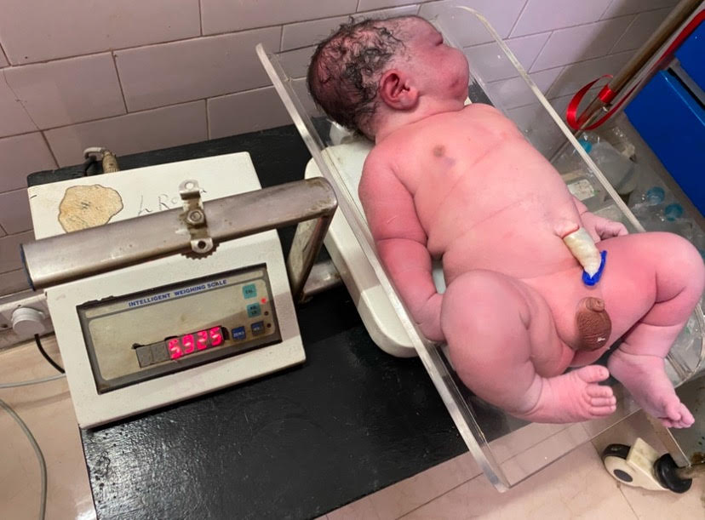
Fig 1: Male macrosomic baby weighing 5.925kg delivered vaginally

References
- Akanmode AM, Mahdy H. Macrosomia. [Updated 2023 May 16]. In: StatPearls [Internet]. Treasure Island (FL): StatPearls Publishing; 2024 Jan-. Available from: https://www.ncbi.nlm.nih.gov/books/NBK557577
- Modzelewski J, Pokropek A, Jakubiak-Proć M, Muzyka-Placzyńska K, Filipecka-Tyczka D, Kajdy A, Rabijewski M. Large-for-gestational-age or macrosomia as a classifier for risk of adverse perinatal outcome: a retrospective cross-sectional study. J Matern Fetal Neonatal Med. 2022 Dec;35(25):5564-5571. doi: 10.1080/14767058.2021.1887127. Epub 2021 Feb 18. PMID: 33602007.
- Adugna DG, Enyew EF, Jemberie MT. Prevalence and Associated Factors of Macrosomia Among Newborns Delivered in University of Gondar Comprehensive Specialized Hospital, Gondar, Ethiopia: An Institution-Based Cross-Sectional Study. Pediatric Health Med Ther. 2020 Dec 16;11:495-503. doi: 10.2147/PHMT.S289218. PMID: 33364874; PMCID: PMC7751438.
- Zheng W, Wang J, Li Y, Shang X, Ma K, Yuan X, Zhang K, Yang R, Ma Y, Li G. The association between gestational weight trajectories in women with gestational diabetes and their offspring's weight from birth to 40 months. Diabetol Metab Syndr. 2024 Jan 13;16(1):17. doi: 10.1186/s13098-023-01239-y. PMID: 38217060; PMCID: PMC10790252.
- Manske MC, Wilson M, Wise B, Hedriana H, Melnikow J, Tancredi D. Are Racial and Ethnic Disparities in Brachial Plexus Birth Injuries Explained by Known Risk Factors? Res Sq [Preprint]. 2024 Nov 21:rs.3.rs-5363261. doi: 10.21203/rs.3.rs-5363261/v1. PMID: 39606470; PMCID: PMC11601867.
- Birene B, Ferreira A, Raimond E, Graesslin O, Ishaque U, Gabriel R. Impact of screening for large-for-gestational-age fetuses on maternal and neonatal outcomes: a prospective observational study. J Perinat Med. 2024 Dec 19. doi: 10.1515/jpm-2024-0522. Epub ahead of print. PMID: 39689027.
- Macrosomia: ACOG Practice Bulletin, Number 216. Obstetrics & Gynecology 135(1):p e18-e35, January 2020. | DOI: 10.1097/AOG.0000000000003606
- Tsikouras P, Kotanidou S, Nikolettos K, Kritsotaki N, Bothou A, Andreou S, Nalmpanti T, Chalkia K, Spanakis V, Peitsidis P, Iatrakis G, Nikolettos N. Shoulder Dystocia: A Comprehensive Literature Review on Diagnosis, Prevention, Complications, Prognosis, and Management. J Pers Med. 2024 May 30;14(6):586. doi: 10.3390/jpm14060586. PMID: 38929807; PMCID: PMC11204412.
- Duewel AM, Doehmen J, Dittkrist L, Henrich W, Ramsauer B, Schlembach D, Abou-Dakn M, Maresh MJA, Schaefer-Graf UM. Antenatal risk score for prediction of shoulder dystocia with focus on fetal ultrasound data. Am J Obstet Gynecol. 2022 Nov;227(5):753.e1-753.e8. doi: 10.1016/j.ajog.2022.06.008. Epub 2022 Jun 11. PMID: 35697095.

