Performance Evaluation of Some Tomato Genotypes Based on Multivariate Analysis

ABSTRACT
Tomato (Solanum lycopersicum L.) is an economically important and nutritionally rich crop, serving as a key source of vitamins, minerals, and antioxidants. Enhancing genetic potential is essential to improve yield, disease resistance, and adaptability. This study evaluated fourteen diverse tomato genotypes to assess their morphological and yield performance. The experiment followed a Randomized Complete Block Design (RCBD) with three replications. Significant genotypic variability was observed across all traits, indicating broad potential for selection. PCA explained 47.2% of total variability through the first two components, grouping genotypes into three distinct clusters. Strong positive correlations were found among fruit length, weight, and yield traits, while fruit number showed a trade-off with yield per plant. Genotypes G5, G7, G10, and G11 demonstrated superior yield, desirable fruit characteristics, and low wilt incidence, making them promising for future breeding programs. The results highlight substantial genetic diversity and provide a strong basis for developing high-yielding, disease-tolerant tomato varieties.
Keywords: Tomato, performance, Multivariate analysis, PCARADAR plot

- INTRODUCTION
Tomato (Solanum lycopersicum L.) is one of the world’s most widely cultivated vegetable crops, valued for its nutritional richness, global popularity, and economic importance (Fuad et al., 2019; Kayess et al., 2016, 2020; Mahmudul et al., 2020; Sohag et al., 2023). Originating from the Andean region covering parts of Bolivia, Chile, Colombia, Ecuador, and Peru—it was later domesticated in Mexico and subsequently disseminated to Europe and beyond, resulting in its present global distribution (Blanca et al., 2012). Commonly referred to as the “Golden apple” or “Love apple,” tomato performs optimally at 21–24 °C in slightly acidic soils (pH 5.5–6.8) (Polin et al., 2024).
Nutritionally, tomato is a rich source of vitamins, minerals, antioxidants, and bioactive compounds such as carotenoids, tocopherols, phenolics, and ascorbic acid (Hasan et al., 2024). Lycopene, its predominant carotenoid, is recognized for its potent antioxidant properties that reduce oxidative stress and lower risks of cardiovascular diseases and cancer (Boulaajine & Hajjaj, 2024).
Globally, tomato ranks third among vegetable crops after potato and sweet potato. In Bangladesh, the cultivated area increased from 73,000 acres in 2020–21 to 77,000 acres in 2022–23, while production rose from 448,000 to 469,000 metric tons. Despite this growth, national productivity remains below that of neighboring countries due to limited high-yielding and hybrid varieties, inadequate quality seed supply, and heavy losses from pests and diseases (Das et al., 2024).
Tomato cultivation in Bangladesh is mainly confined to the winter season, when climatic conditions are most suitable for fruit set and yield. However, consumer demand remains constant year-round. Although several heat-tolerant cultivars allow summer production, the monsoon’s excessive rainfall and windstorms often hinder establishment and yield stability (Das et al., 2024). Hence, adaptive breeding and improved management practices are necessary to ensure a steady year-round supply and enhance farmer income.
The adoption of hybrid varieties has recently increased among Bangladeshi farmers, offering benefits such as early maturity, disease tolerance, and superior fruit quality. Successful hybrid development relies on the morphological and physiological characterization of parental lines to ensure the stability of desirable traits in subsequent generations (Das et al., 2024).
Bacterial wilt (BW), caused by Ralstonia solanacearum, is one of the most destructive diseases affecting tomato worldwide, causing significant yield reductions (Hong et al., 2018). Although chemical, cultural, and biological control measures exist, they offer limited and inconsistent results. Thus, breeding for genetic resistance remains the most reliable, cost-effective, and environmentally sustainable approach. The process requires identifying resistant sources through systematic germplasm screening, which is fundamental for maintaining genetic diversity and advancing crop improvement.
Accordingly, this study aimed to evaluate diverse tomato germplasm based on morphological and yield-related attributes, along with their responses to bacterial wilt infection, to identify promising genotypes suitable for sustainable tomato production under local agro-climatic conditions in Bangladesh.

- MATERIALS AND METHODS

2.1. Location and Climate
The experiment was conducted from October to January at the experimental field located in Gazipur Sadar, Bangladesh. The site belongs to Agro-Ecological Zone 28 (Madhupur Tract) and experiences a subtropical monsoon climate, characterized by warm, humid summers and mild, dry winters. During the growing period, mean air temperatures ranged from 15.4 °C to 28.6 °C, and relative humidity varied between 72% and 82%. Occasional rainfall was recorded during the fruit development and harvesting stages.

2.2. Experimental Materials and Design

A total of 14 tomato genotypes with diverse genetic backgrounds were evaluated. This germplasm obtained from the Bangladesh Agricultural Research Institute (BARI), Joydebpur, Gazipur. Three released varieties BARI Tomato 8, BARI Tomato 10, and BARI Tomato 11 were used as standard checks for comparison. The experiment followed a Randomized Complete Block Design (RCBD) with three replications to ensure statistical accuracy and minimize environmental variation. Each plot measured 2.0 m × 4.0 m, accommodating 26 plants in a double-row system. The plant-to-plant spacing was 60 cm, and row spacing was 40 cm, with 55cm between blocks and 75 cm between adjacent plots to reduce border effects.

2.3. Crop Husbandry

The experiment was arranged in a Randomized Complete Block Design (RCBD) with three replications to ensure accuracy and reduce environmental variation. Three seedbeds measuring 3.0 m × 2.0 m were prepared, each representing one replication. The field layout consisted of unit plots measuring 1.5 m × 4.8 m, organized in a double-row planting system. Each row contained 12 plants, resulting in 24 plants per plot. Spacing between individual plants and rows was maintained at 50 cm and 45 cm, respectively, to promote optimal growth and ease of management. A buffer distance of 60 cm between adjacent blocks and 70 cm between plots was maintained to facilitate movement and minimize inter-plot interference.
Seeds were first sown in well-prepared seedbeds to ensure uniform germination and healthy seedling development. Throughout the growing period, the crop was protected under a polytunnel to safeguard against heavy rainfall and unfavorable weather conditions. Thirty-day-old seedlings were then transplanted into the main experimental field.
Prior to transplanting, the field was enriched with 10 tons ha⁻¹ of well-decomposed cow dung and a chemical fertilizer mixture supplying 100–34–104–27–1.5–1.3 kg ha⁻¹ of N–P–K–S–Zn–B, using urea, triple superphosphate, muriate of potash (MOP), gypsum, zinc sulfate, and boric acid as nutrient sources. The full amount of organic manure, along with complete doses of phosphorus, sulfur, zinc, and boron, and one-third of MOP, was applied during the final land preparation to ensure adequate nutrient supply during early growth. The remaining urea and MOP were top-dressed in two equal splits at 27 and 42 days after transplanting (DAT), followed by light irrigation to aid nutrient absorption.
Routine agronomic practices such as irrigation, pruning, mulching, weeding, and pest management were performed as required to maintain healthy crop growth. Occasional infections of tomato leaf curl virus and tomato mosaic virus were managed through the application of Dithane M45, followed by the removal and destruction of severely infected plants to limit disease spread. Insect pests were effectively controlled by applying Malathion 57 EC twice, at 26 and 33 DAT.
Observations were recorded on a range of agronomic and yield-related traits, including days to first flowering (DFF), fruit length (FL), fruit diameter (FD), standard fruit weight (FWS), number of locules (NL), plant height (PH), days to first harvest (DHF), days to last harvest (DHL), number of fruit clusters per plant (FC), number of fruits per plant (NFPP), yield per hectare (YPP), shelf life (SL), and plant damage by wilt disease (Wilt).
The incidence of wilt was recorded based on its natural occurrence under field conditions, as no artificial inoculation was carried out. Data for all yield-contributing traits were collected at crop maturity after harvest, and the summarized results are presented in Table 1.

2.5. Statistical Analysis

All data were analyzed using R statistical software (version 4.2.3) and Microsoft Excel. The correlation analysis, Principal Component Analysis (PCA), hierarchical clustering, heatmap visualization, and radar graph analysis to evaluate genetic divergence and trait associations. The R packages ‘metan’, ‘FactoMineR’, ‘factoextra’, and ‘ggplot2’ were used for statistical and graphical interpretations.

- RESULTS AND DISCUSSION

Exploring genotypic diversity is essential for developing improved tomato genotypes with desirable traits, especially amid global population growth and climate change challenges (Zannat et al., 2023). The present study revealed substantial genetic variation among the evaluated genotypes, with high heritability and genetic advance for several key traits, indicating strong potential for effective selection and breeding. Traits with high heritability are particularly valuable because they are reliably transmitted to subsequent generations, thereby accelerating genetic improvement. These findings align with previous reports showing considerable genotypic and phenotypic variations and high heritability for important yield-related traits such as number of fruits per plant, plant height, and fruit weight (Reddy et al., 2023).
The Table 1 presents the morphological and yield-related performance of fourteen tomato genotypes, demonstrating substantial phenotypic variability across most traits, suggesting a wide scope for selection and genetic improvement. The days to flowering (DFF) ranged from 14 days (G11) to 24 days (G2), with a mean of 18.7 days, indicating that the experimental materials included both early- and late-flowering types. The fruit length (FL) and fruit diameter (FD) also showed noticeable diversity, varying from 4.22 cm to 8.24 cm and 4.76 cm to 6.7 cm, respectively. These variations reflect genotypic differences in fruit morphology, which are crucial for consumer preference and processing suitability.
Regarding fruit weight, the standard fruit weight (FWS) ranged between 68.0 g (BARI Tomato 4) and 163.0 g (G2), with an overall mean of 125.23 g, while plant height (PH) varied from 107.6 cm to 156.6 cm, averaging 123.68 cm. Such variations imply differing growth vigor and yield potential among the genotypes. The days to first and last harvest (DHF and DHL) averaged 60.77 and 89.60 days, respectively, showing moderate differences in crop duration, which is advantageous for staggered harvesting and extended market supply. The reproductive traits number of fruit clusters (FC) and fruits per plant (NFPP) also exhibited high variability, with means of 6.39 and 15.20, respectively. The yield per plant (YPP), a major economic trait, ranged widely from 0.58 kg (G2) to 1.42 kg (G11), with a mean of 0.97 kg. This finding indicates the existence of both high- and low-yielding genotypes within the tested population. Notably, BARI Tomato 10 and G11 produced comparatively higher yields, highlighting their potential for commercial production. Shelf life (SL) ranged from 6 to 8 days (mean = 7.2 days), suggesting moderate postharvest longevity among the evaluated lines. Conversely, wilt incidence (Wilt) varied markedly from 16% to 57.69%, with an average of 29.82%, revealing substantial differences in disease resistance. Genotypes with lower wilt percentages, such as BARI Tomato 10 (16%) and G5 (18.51%), can be considered more tolerant to wilt disease and hence suitable for cultivation under disease-prone conditions. The significant morphological variation observed across genotypes highlights the presence of ample genetic diversity within the studied tomato population. The wide range in flowering time indicates adaptability to different growing seasons, which is valuable for breeding programs targeting both early- and late-harvesting types. Differences in fruit dimensions and weights suggest strong genetic control of these yield components, offering opportunities to select for both consumer-preferred and processing-friendly types. The variability in wilt incidence further emphasizes the availability of resistant genotypes that can be used to strengthen disease tolerance in future breeding lines. Collectively, this diversity provides a broad genetic base for yield improvement and stress resilience in tomato. The significant morphological variation observed across genotypes highlights the presence of ample genetic diversity within the studied tomato population. Such diversity provides a broad genetic base for yield improvement and stress resilience in tomato, aligning with the conclusions of earlier studies (Heiba et al., 2023). The wide range in flowering time indicates adaptability to different growing seasons, which is valuable for breeding both early- and late-harvesting types. Differences in fruit dimensions and weights suggest strong genetic control of yield components, offering opportunities to select for consumer-preferred and processing-friendly types. The variability in wilt incidence further emphasizes the availability of resistant genotypes that can strengthen disease tolerance in future breeding lines.
The scree plot of principal components illustrated the genetic diversity among the tomato genotypes. The first principal component (PC1) accounted for 15.6% of the total variance, while the second principal component (PC2) explained 8.5%, cumulatively capturing 47.2% of the genetic variation (Figure 1). The distribution of variance among multiple components implies that the traits are polygenically controlled, with no single trait dominating variability. This balanced contribution ensures that selection can be based on multiple attributes simultaneously—enhancing breeding efficiency. Similar findings were reported by Alghamdi (2025), who emphasized the utility of PCA in reducing data dimensionality and identifying key traits driving diversity.
Three distinct genetic clusters were identified in the PCA biplot, each represented by different colors. Cluster 1 (blue), located on the left side with negative PC1 values, comprised G1, G11, and BARI Tomato 4. This group showed distinct divergence from the rest, indicating unique genetic characteristics possibly associated with early flowering and moderate yield traits. Cluster 2 (black), positioned toward the right side of the plot with predominantly positive PC1 values, included G2, G3, G4, G6, G7, G8, G9, and G10. This cluster represented the majority of genotypes, reflecting a broad genetic base characterized by high plant vigor and diverse yield-related attributes. Cluster 3 (red), situated in the lower-left quadrant with slightly negative PC1 and PC2 values, consisted of BARI Tomato 10, BARI Tomato 8, BARI Tomato 11, and G5. These genotypes were closely associated, suggesting similar performance profiles in fruit yield and disease resistance. The spatial separation among the three clusters along PC1 and PC2 indicates substantial genetic differentiation among the evaluated tomato genotypes, although minor overlaps suggest some shared genetic backgrounds (Figure 2). The spatial separation among clusters indicates substantial genetic differentiation, consistent with observations by Nankar et al. (2020), who demonstrated the utility of cluster analysis in classifying tomato germplasm.
The variable PCA biplot revealed that Dim1 (54.5%) primarily accounted for variation associated with fruit morphology and yield attributes, whereas Dim2 (15.6%) represented variation related to disease response and developmental traits (Figure 3). Traits such as fruit weight (FWS), fruit length (FL), and days to flowering (DFF) contributed strongly to Dim1, as indicated by their long vectors and high cos² values, reflecting their major influence on the overall genotype differentiation. Similarly, days to first harvest (DHF) and days to last harvest (DHL) were also positively aligned with Dim1, demonstrating their close relationship with fruit development and maturation patterns. On the other hand, fruit clusters per plant (FC), number of fruits per plant (NFPP), and yield per plant (YPP) were positioned on the negative side of Dim1, highlighting their contrasting influence relative to fruit size traits. Shelf life (SL) and plant height (PH) showed moderate contributions, projecting toward the lower quadrants, suggesting their limited but notable influence on Dim2. Meanwhile, fruit diameter (FD) and wilt incidence (Wilt) exhibited strong associations with Dim2, indicating that this dimension primarily captured the variation due to disease tolerance and fruit shape characteristics. The variable PCA biplot provides valuable insights into the complex interrelationships among traits influencing tomato performance. This reflects trade-offs between yield components and stress tolerance, as also reported by Greenacre et al. (2022).
Figure 4 represents the traits and genotype-based cluster analysis and cluster 2 revealed most of the yield related traits are associated within this cluster. But yield was mainly greatly interlinked with cluster 3.
The correlation matrix revealed several significant associations among the studied traits (Figure 5). DHL exhibited strong positive correlations with DHF (0.72**) and FL (0.52*). PH recorded strong association with DHF (0.64*). DHF showed a strong positive association with FL (0.83***), and FWS (0.61*) while YPP demonstrated significant negative relationships with NFPP (−0.73**), FC (−0.71**), and YPP (−0.77*). FL was significantly correlated with FWS (0.82***), while showing strong negative associations with NFPP (−0.86***), FC (−0.81***), and YPP (−0.77***). FWS exhibited strong positive correlations with FD (0.52*), while SL, wilt, and FD did not demonstrate any significant relationships with other traits. NFPP recorded significant association with FC (0.94***) and YPP (0.83***). Correlation analysis revealed strong positive and negative interrelationships among the traits, indicating potential pathways for indirect selection. The positive association between fruit length, weight, and harvest duration suggests that genotypes with extended growth periods tend to produce larger fruits. Conversely, the negative correlations of yield per plant with fruit number and clusters indicate a trade-off between fruit quantity and size, an essential consideration for optimizing yield components. The independence of wilt and shelf life from other traits implies that these can be improved without adversely affecting yield traits, enabling breeders to develop high-yielding yet disease-tolerant cultivars. The negative relationship between YPP and NFPP highlights the classic yield-size trade-off common in tomato breeding.
The dendrogram illustrated the hierarchical clustering of the tomato genotypes into three distinct groups based on trait similarity (Figure 6). Cluster 1 included G1, G2, G3, G4, G5, G6, and G7, representing a group of genotypes with close genetic resemblance and relatively shorter linkage distance. Cluster 2 comprised G8, G9, G10, and G11, forming a moderately distant subgroup with partial overlap in trait performance. Cluster 3, the most distinct group, contained BARI Tomato 4, BARI Tomato 8, BARI Tomato 10, and BARI Tomato 11, which were clearly separated from the other genotypes, indicating unique phenotypic characteristics likely related to yield and fruit quality traits. These distinct clusters suggest clear genetic structuring, supporting their potential for parental selection in hybridization programs (Nankar et al., 2020).
A RADAR plot was used to evaluate the mean performance of clusters across the studied traits (Figure 7). Cluster 1 (G2, G3, G4, G6, G8) showed relatively higher scores for FD and FWS, indicating strong fruit development and size attributes, while maintaining moderate values across most other traits. Cluster 2 (G7) occupied a distinct position with high overall area, characterized by superior values for PH, DHF, DHL, and FL, suggesting robust plant growth and late flowering behavior. Cluster 3 (G5, BARI Tomato 8, BARI Tomato 10, BARI Tomato 11) demonstrated remarkable performance for YPP and NFPP, signifying its strong yield potential and fruit productivity. Cluster 4 (G1, G11, BARI Tomato 4) attained higher mean values for Wilt, SL, and FD, reflecting good stress tolerance and shoot development. In contrast, Cluster 5 (G9, G10) exhibited moderate to high values across most traits but performed best for DFF and FL, indicating balanced performance with relatively early flowering characteristics. Such visual integration of trait performance confirms PCA and clustering outcomes, demonstrating the power of multivariate tools in genotype evaluation (Das et al., 2024).
Performance evaluation of tomato genotypes in Bangladesh is crucial for identifying high-yielding, disease-resistant, and climate-adapted varieties suited for local conditions. In this study, genotypes such as G5, G7, G10, and G11 exhibited strong yield potential, desirable fruit morphology, and better wilt tolerance. These results align with previous findings by Das et al. (2024) who reported significant varietal differences in yield and disease resistance among tomato lines. Particularly, G11 and BARI Tomato 10 outperformed several checks, suggesting superior genetic potential and adaptability. Similar to Phiri et al. (2024), who identified multiple resistant accessions against Ralstonia solanacearum, this study identified genotypes (e.g., G5, BARI Tomato 10) with low wilt incidence, representing valuable breeding material for bacterial wilt resistance. The higher productivity observed in this study relative to previous reports (Gotame et al., 2021) underscores the enhanced genetic potential and improved genotype × environment interaction of the evaluated materials.

- CONCLUSION
This study aimed to evaluate the morphological and yield-related diversity among fourteen tomato (Solanum lycopersicum L.) genotypes to identify superior lines for future breeding. Significant variability was observed across key traits such as days to flowering, fruit length, fruit diameter, fruit weight, number of fruits per plant, yield per plant, and wilt incidence, indicating wide phenotypic diversity. Multivariate analyses, including principal component analysis and RADAR plotting, revealed clear genotype groupings and identified several high-performing genotypes—particularly G5, G7, G10, and G11 which exhibited strong yield potential, desirable fruit morphology, and better wilt tolerance. Strong positive correlations among fruit length, fruit weight, and yield components suggest that these traits can serve as effective selection criteria in breeding programs. Overall, the findings provide a solid genetic basis for developing high-yielding, disease-tolerant, and quality-enhanced tomato varieties suitable for diverse growing conditions.

DISCLAIMER (ARTIFICIAL INTELLIGENCE)

Author(s) hereby declare that NO generative AI technologies such as Large Language Models (ChatGPT, COPILOT, etc) and text-to-image generators have been used during writing or editing of this manuscript.

COMPETING INTERESTS DISCLAIMER:
Authors have declared that they have no known competing financial interests OR non-financial interests OR personal relationships that could have appeared to influence the work reported in this paper.

REFERENCES

Alghamdi, A. (2025). Evaluating factors influencing learner satisfaction in massive open online course selection: A data-driven approach using machine learning. Arab Journal of Science and Engineering, 50(10), 7139–7164. https://doi.org/10.1007/s13369-024-09183-3
Blanca, J., Cañizares, J., Cordero, L., Pascual, L., Diez, M. J., & Nuez, F. (2012). Variation revealed by SNP genotyping and morphology provides insight into the origin of the tomato. PLoS ONE, 7(10), e48198. https://doi.org/10.1371/journal.pone.0048198
Boulaajine, S., & Hajjaj, H. (2024). Food science and technology. Food Science and Technology, 12(1), 1–14. https://doi.org/10.13189/fst.2024.120101
Das, S. B., Islam, M. S., Uddin, M. N., Goswami, B. K., Abedin, S. M. S., & Baki, M. A. (2024). Evaluation of the performance of summer tomato lines in Bangladesh conditions. Journal of Bio-Science, 31(2), 13–23. https://doi.org/10.3329/jbs.v31i2.74142
Fuad, M. A., & Nurhasan, M., & Kayess, M. O. (2019). Impact of integrated pest management (IPM) practices on tomato cultivation in Gazipur District of Bangladesh. Advances in Entomology, 7(2), 33–46. https://doi.org/10.4236/ae.2019.72004
Gotame, T. P., Gautam, I. P., Ghimire, D., & Shrestha, S. L. (2021). Performance evaluation of exotic and local landraces of tomatoes for the mid-hill conditions of Nepal. Turkish Journal of Agriculture - Food Science and Technology, 9(8), 1426–1435. https://doi.org/10.24925/turjaf.v9i8.1426-1435.4250
Greenacre, M., Groenen, P. J. F., Hastie, T., D’Enza, A. I., Markos, A., & Tuzhilina, E. (2022). Principal component analysis. Nature Reviews Methods Primers, 2(1), 1–21. https://doi.org/10.1038/s43586-022-00184-w
Hasan, G. N., Mahmudul, M., Khan, H., Faisal, A. H. A., Hussain, J., Islam, M., & Mahmudul, M. (2024). Mulching and drip irrigation to mitigate soil salinity on tomato (Lycoperscon esculentum L.) production in coastal area. Trends in Horticulture, 7(1), 3951. https://doi.org/10.24294/th.v7i1.3951
Heiba, H. E. S. S., Mahgoub, E. M. I., Mahmoud, A. A. E. S., Ibrahim, M. A. E. M. M., & Mansour, E. (2023). Combining ability and gene action controlling chocolate spot resistance and yield traits in faba bean (Vicia faba L.). Journal of Agricultural Science, 29(1), 77–88. https://doi.org/10.15832/ankutbd.973781
Kayess, H. M., Rahman, M., Kayess, M. O., Hasanuzzaman, M., Rahman, M. W., Uddin, M. J., & Author, C. (2016). Identification of tomato (Lycopersicon esculentum L.) genotypes for salt tolerance during emergence. International Journal of Biosciences, 9(4), 297–304. https://doi.org/10.12692/ijb/9.4.297-304
Kayess, M. O., Rahman, M. L., Ahmed, K., Khan, M. R., Hossan, M. S., Hossain, M. S., & Chandra Pal, D. (2020). Effect of salinity stress on different root and shoot traits of selected tomato cultivars. Asian Journal of Advanced Research and Reports, 8(1), 1–9. https://doi.org/10.9734/ajarr/2020/v8i130188
Mahmudul, H., Basudeb, R., Nurhasan, K., Kawsar, A., & Omar, K. (2020). Genetic diversity analysis and construction of selection index of selected tomato genotypes. African Journal of Agricultural Research, 16(10), 1437–1441. https://doi.org/10.5897/ajar2020.14907
Nankar, A. N., Tringovska, I., Grozeva, S., Todorova, V., & Kostova, D. (2020). Application of high-throughput phenotyping tool Tomato Analyzer to characterize Balkan Capsicum fruit diversity. Scientia Horticulturae, 260, 108862. https://doi.org/10.1016/j.scienta.2019.108862
Nisa, K. U., & Khan, N. (2020). Detection of heavy metals in fruits and vegetables available in the market of Quetta city. Al-Nahrain Journal of Science, 23(1), 47–56.
Phiri, T. M., Bhattarai, G., Chiwina, K. E., Fan, Q., Xiong, H., Alatawi, I., & Shi, A. (2024). Evaluation of bacterial wilt (Ralstonia solanacearum) resistance in tomato germplasm from USDA. Agronomy, 14(2), 350. https://doi.org/10.3390/agronomy14020350
Polin, J. A., Hasan, N., Habib, M. T., Rahman, A., Vasha, Z. N., & Sharma, B. (2024). Tomato pest recognition using convolutional neural network in Bangladesh. Bulletin of Electrical Engineering and Informatics, 13(1), 619–627. https://doi.org/10.11591/eei.v13i1.6073
Reddy, B. R., Pratapa Reddy, M., Reddy, D. S., & Begum, H. (n.d.). Correlation and path analysis studies for yield and quality traits in tomato (Solanum lycopersicum L.). IOSR Journals. Retrieved from www.iosrjournals.org
Sohag, M. A., Rahman, H. M., Kayess, M. O., & Ifty, M. F. (2023). Effect of pre-harvest fruit bagging on yield, postharvest quality and shelf life of tomato (Solanum lycopersicum L.) cv. BARI Tomato-2. Journal of Applied and Natural Science, 15(1), 220–226. https://doi.org/10.31018/jans.v15i1.4261
Zannat, A., Hussain, M. A., Abdullah, A. H., Hossain, M. I., Saifullah, M., Safhi, F. A., & Hossain, M. S. (2023). Exploring genotypic variability and interrelationships among growth, yield, and quality characteristics in diverse tomato genotypes. Heliyon, 9(8), e18958. https://doi.org/10.1016/j.heliyon.2023.e18958

Table 1. Morphological nad yield contributing performance of tomato genotypes

Genotype | DFF | FL | FD | FWS | PH | DHF | DHL | FC | NFPP | YPP | SL | Wilt
G1 | 17 | 5.04 | 6.38 | 132.4 | 117 | 50 | 83 | 5 | 16 | 1.22 | 7 | 40.38
G2 | 24 | 7.26 | 6.46 | 163 | 127 | 69 | 93 | 3 | 7 | 0.58 | 7 | 29.62
G3 | 18 | 6.82 | 5.86 | 143.8 | 135 | 70 | 95 | 3 | 8 | 0.64 | 8 | 22.22
G4 | 19 | 7.48 | 6.38 | 162.4 | 107.6 | 58.5 | 90 | 2 | 7 | 0.61 | 6 | 27.77
G5 | 18 | 5.46 | 5.04 | 128.2 | 128 | 49.5 | 88 | 9 | 19 | 1.36 | 8 | 18.51
G6 | 19 | 6.7 | 6.08 | 158.2 | 130 | 65 | 86 | 3 | 10 | 0.81 | 7 | 24
G7 | 22 | 8.1 | 4.76 | 145 | 156.6 | 81 | 96 | 3 | 9 | 0.75 | 7 | 26.47
G8 | 19 | 6.18 | 5.5 | 103.2 | 134 | 66 | 86 | 4 | 13 | 0.84 | 8 | 23.33
G9 | 21 | 6.3 | 6.7 | 147.4 | 122 | 71 | 95 | 4.6 | 11 | 0.85 | 8 | 50
G10 | 21 | 8.24 | 5.26 | 158.4 | 118 | 70 | 90 | 3 | 9 | 0.8 | 8 | 57.69
G11 | 14 | 4.26 | 5.64 | 109.8 | 120 | 50 | 86 | 8 | 20 | 1.42 | 6 | 30
BARI Tomato 4 | 16.5 | 4.22 | 4.94 | 68 | 110 | 49 | 85 | 12 | 29 | 1.17 | 6 | 33.33
BARI Tomato 8 | 16 | 4.26 | 5.22 | 94.5 | 118 | 56.5 | 91 | 10 | 21 | 1.27 | 7 | 26
BARI Tomato 10 | 17.5 | 5.06 | 5.44 | 78.4 | 108 | 57 | 92 | 13 | 28 | 1.23 | 8 | 16
BARI Tomato 11 | 18.5 | 4.9 | 5.5 | 85.8 | 124 | 49 | 88 | 13.2 | 21 | 1.04 | 7 | 22
LSD | 2.44 | 1.34 | 0.59 | 31.60 | 12.12 | 9.90 | 3.90 | 3.93 | 7.18 | 0.28 | 0.75 | 11.11
CV (%) | 13.06 | 22.30 | 10.31 | 25.23 | 9.80 | 16.30 | 4.35 | 61.52 | 47.21 | 28.40 | 10.39 | 37.26

Here, DFF: Days to flowering, FL: Fruit length (cm), FD: Fruit diameter (cm), FWS: Standard fruit weight (g), NL: Number of locules, PH: Plant height (cm), DHF: Days to first harvest, DHL: Days to last harvest, FC: Number of fruit clusters plant⁻¹, NFPP: Number of fruits plant⁻¹, YPP: Yield ha⁻¹ (ton), SL: Shelf life (days), and Wilt: Plant damage by wilting disease (%).

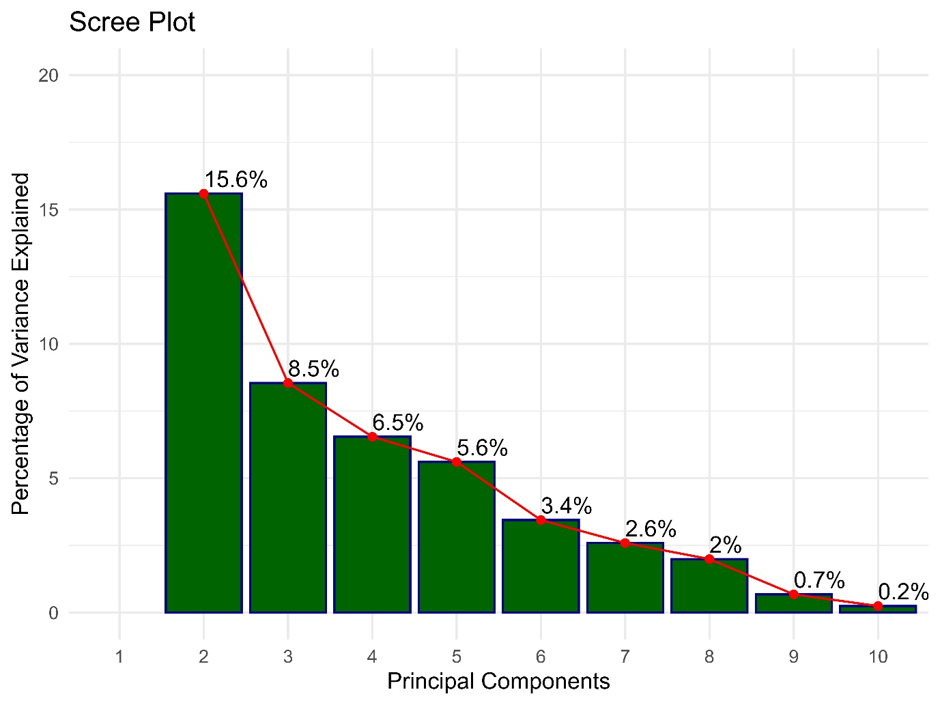
Fig. 1 Scree plot of principal components

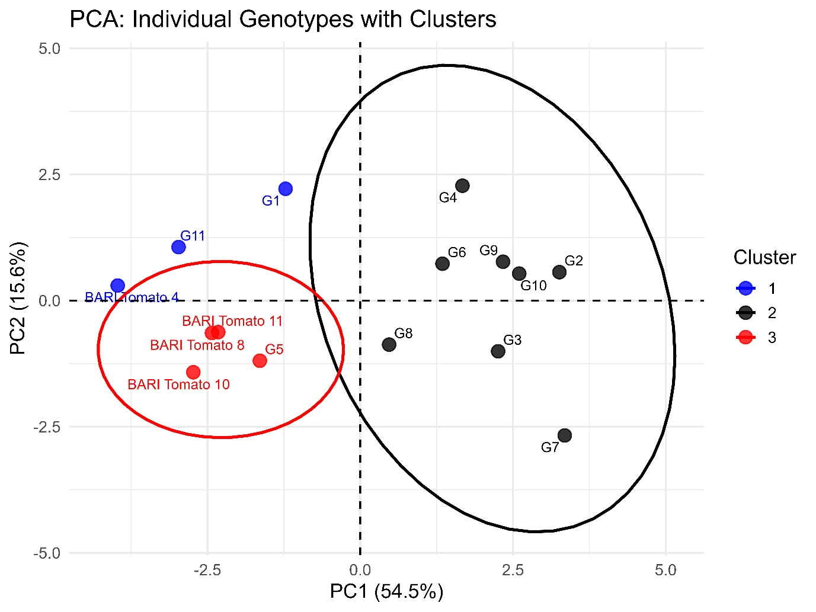
Fig. 2 PCA based cluster analysis of individual genotypes

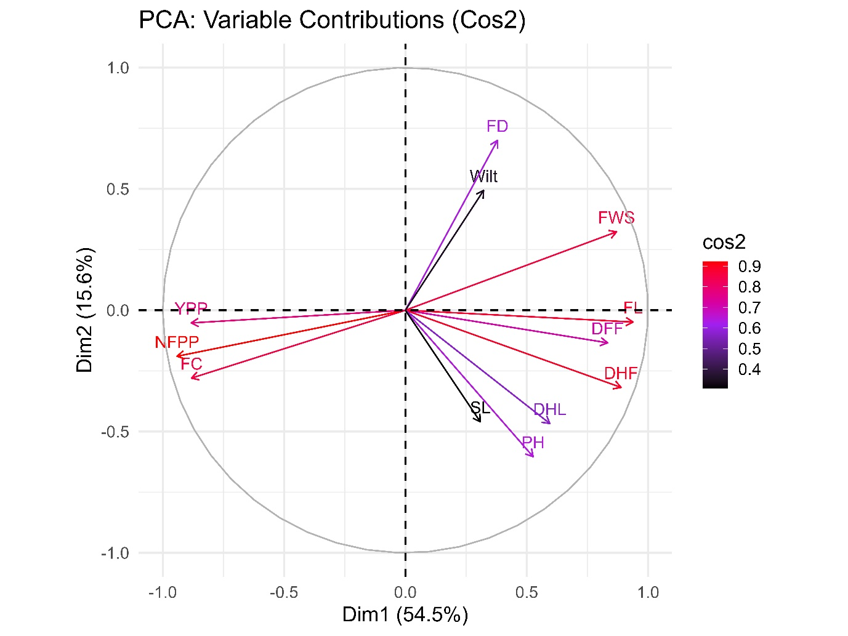

Here, DFF: Days to flowering, FL: Fruit length (cm), FD: Fruit diameter (cm), FWS: Standard fruit weight (g), NL: Number of locules, PH: Plant height (cm), DHF: Days to first harvest, DHL: Days to last harvest, FC: Number of fruit clusters plant⁻¹, NFPP: Number of fruits plant⁻¹, YPP: Yield ha⁻¹ (ton), SL: Shelf life (days), and Wilt: Plant damage by wilting disease (%).

Fig. 3 PCA biplot analysis of individual traits

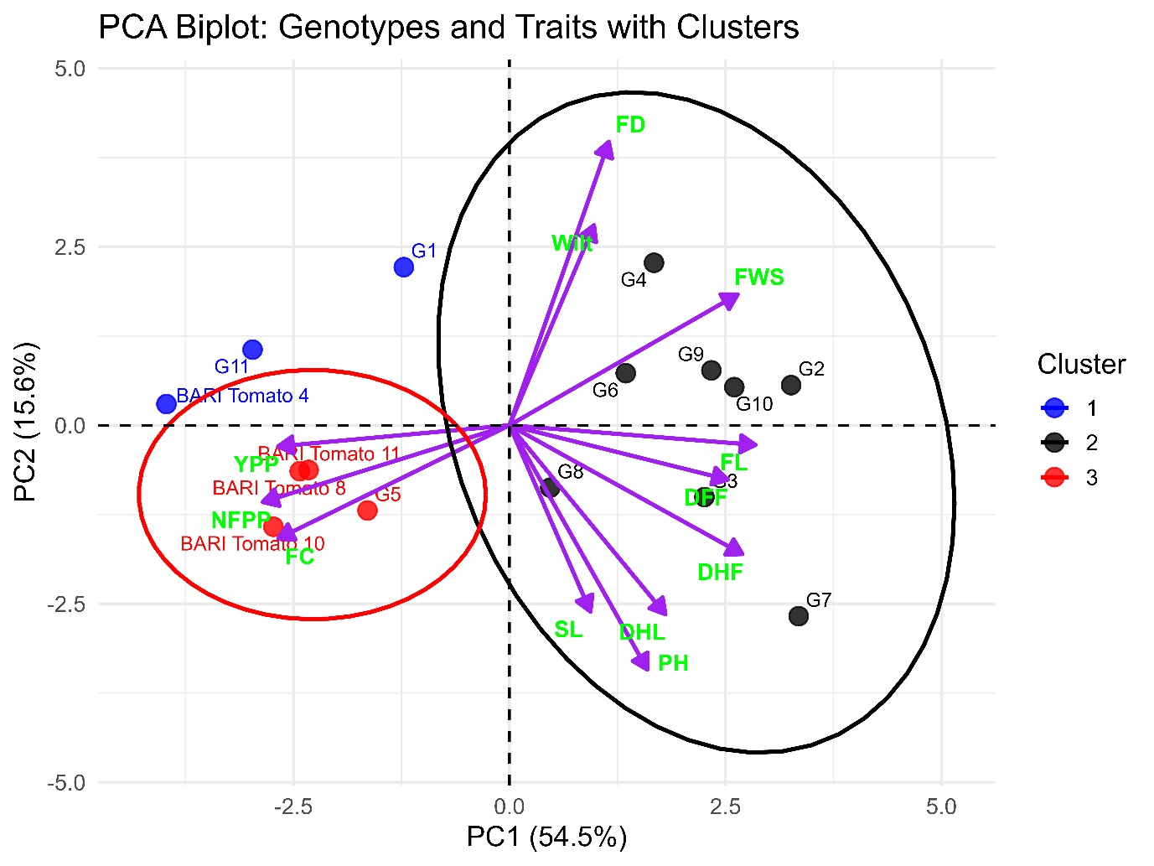
Here, DFF: Days to flowering, FL: Fruit length (cm), FD: Fruit diameter (cm), FWS: Standard fruit weight (g), NL: Number of locules, PH: Plant height (cm), DHF: Days to first harvest, DHL: Days to last harvest, FC: Number of fruit clusters plant⁻¹, NFPP: Number of fruits plant⁻¹, YPP: Yield ha⁻¹ (ton), SL: Shelf life (days), and Wilt: Plant damage by wilting disease (%).

Fig. 4 PCA biplot analysis of genotypes and traits with cluster

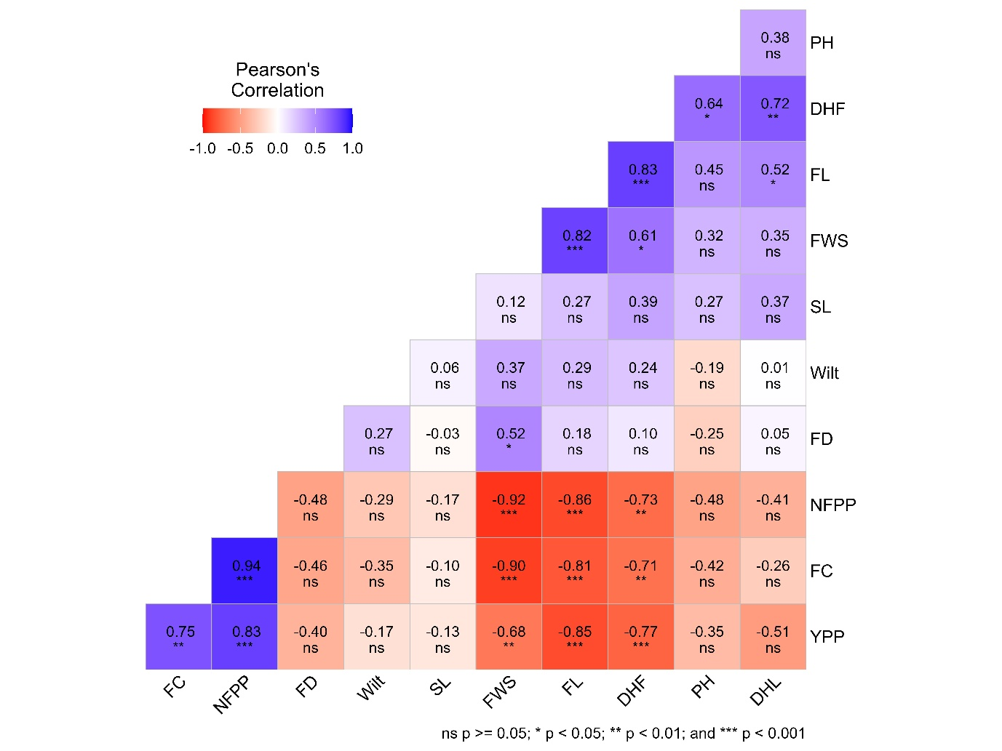
Here, DFF: Days to flowering, FL: Fruit length (cm), FD: Fruit diameter (cm), FWS: Standard fruit weight (g), NL: Number of locules, PH: Plant height (cm), DHF: Days to first harvest, DHL: Days to last harvest, FC: Number of fruit clusters plant⁻¹, NFPP: Number of fruits plant⁻¹, YPP: Yield ha⁻¹ (ton), SL: Shelf life (days), and Wilt: Plant damage by wilting disease (%).

Fig. 5 Pearson’s correlation analysis of the investigated traits

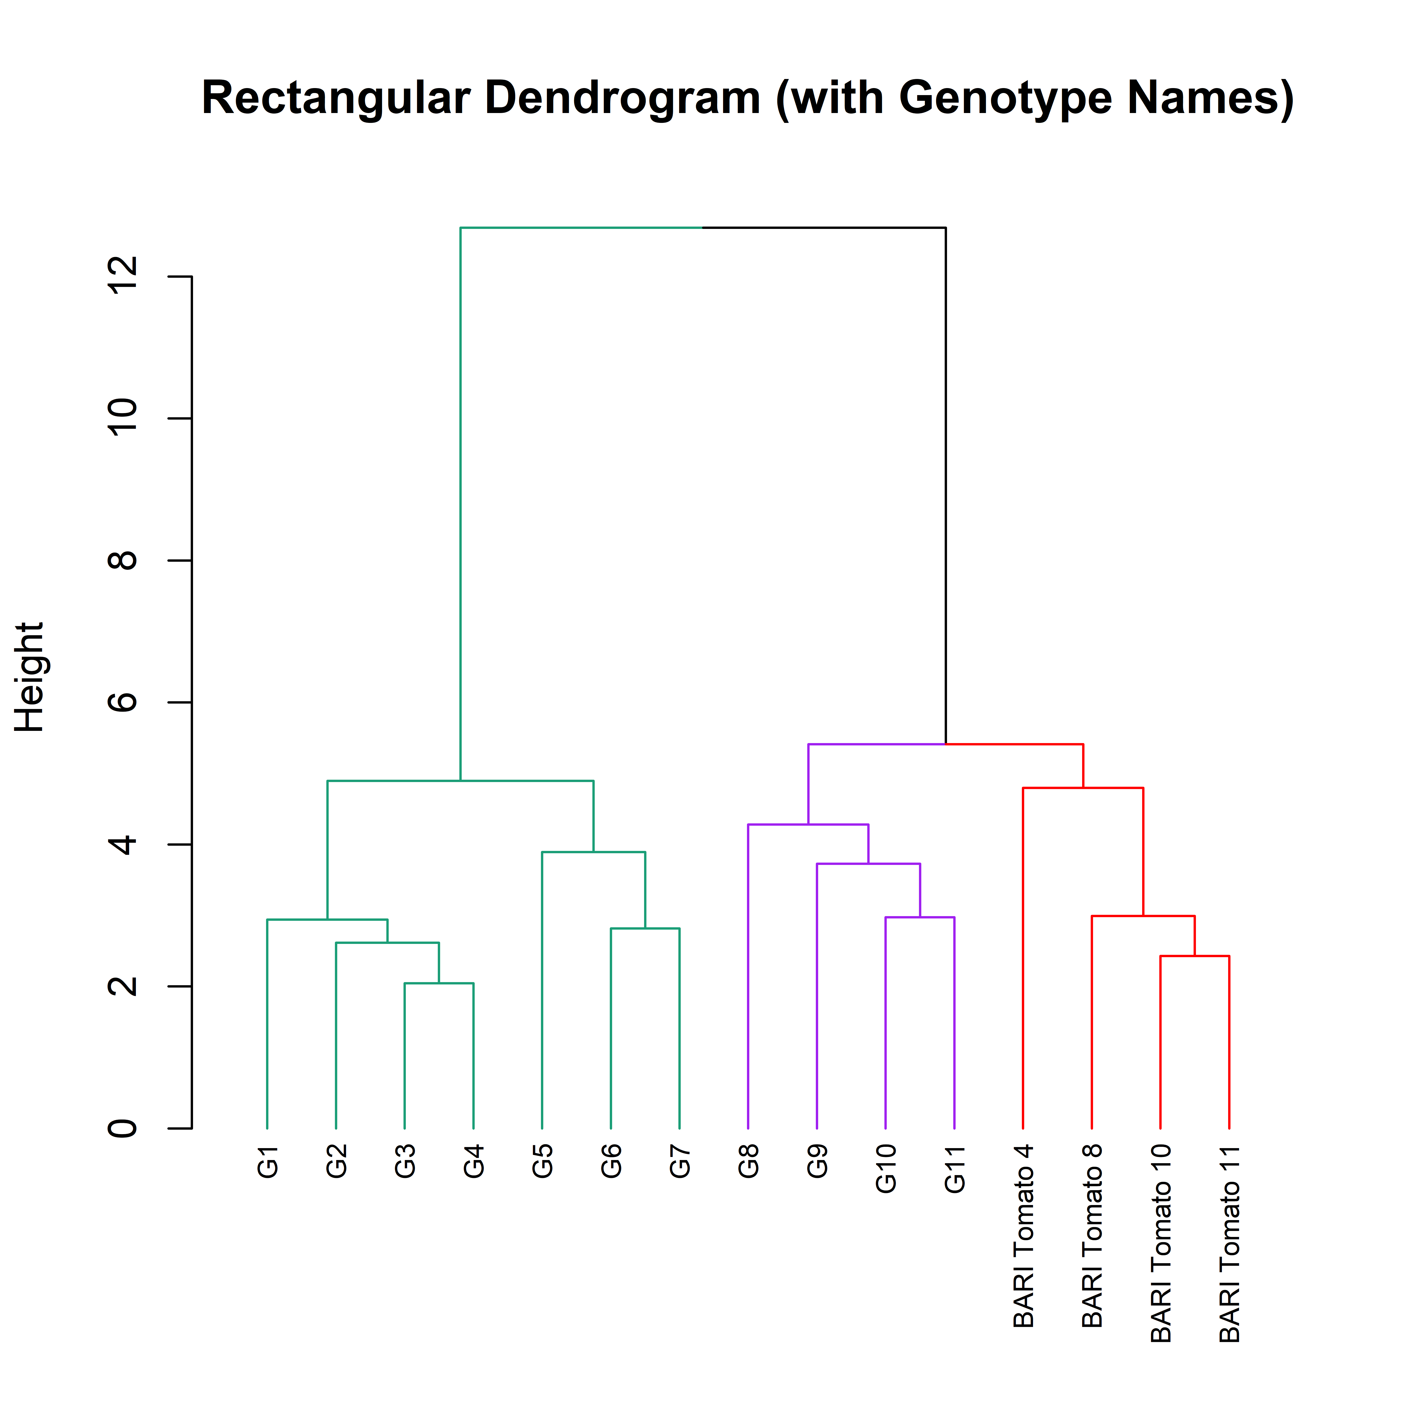
Fig. 6 Hierarchical cluster analysis depicting the grouping of the genotypes

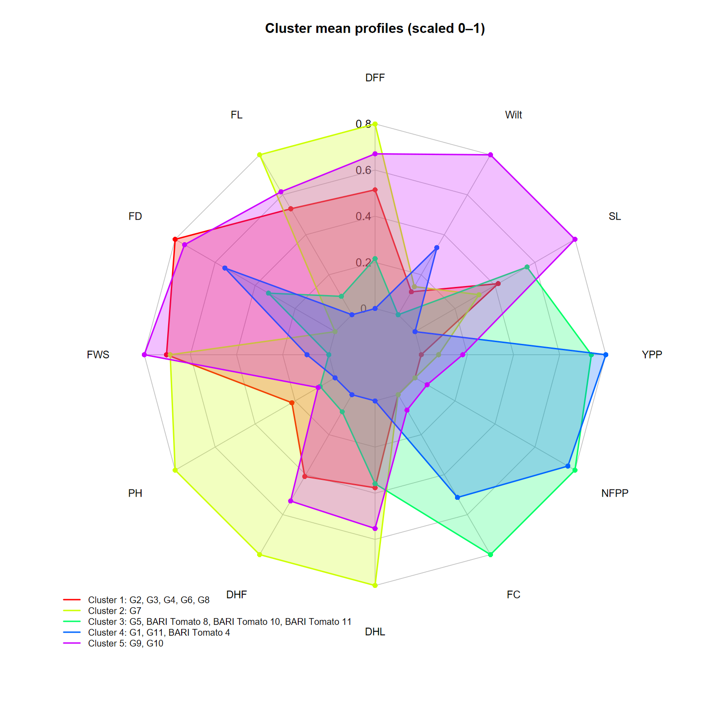
Here, DFF: Days to flowering, FL: Fruit length (cm), FD: Fruit diameter (cm), FWS: Standard fruit weight (g), NL: Number of locules, PH: Plant height (cm), DHF: Days to first harvest, DHL: Days to last harvest, FC: Number of fruit clusters plant⁻¹, NFPP: Number of fruits plant⁻¹, YPP: Yield ha⁻¹ (ton), SL: Shelf life (days), and Wilt: Plant damage by wilting disease (%).

Fig. 7 RADAR plot-based cluster analysis displaying the grouping of the traits and genotypes

