FALLOW LAND AND MIGRATION OF FARMERS AND AGRICULTURAL LABOURERS OF SEMI-ARID REGIONS OF INDIA — WITH SPECIAL REFERENCE TO KARNATAKA

Abstract
This paper examines the relationship between fallow land dynamics and migration of farmers and agricultural labourers in India’s semi-arid regions, focusing on Karnataka. Drawing on national land-use statistics (LUS 2013–14 to 2022–23), Karnataka state agricultural statistics and recent labour/migration studies, the paper documents trends in fallow land, discusses drivers of rural distress and seasonal/temporary migration, and analyses how fallowing and labour movement interact in semi-arid contexts. Key findings: (1) All-India fallow land (current + other fallows) in 2022–23 stands at ~24.6 million hectares, with substantial inter-state variation; (2) Karnataka’s total fallow area is smaller in absolute terms (~1.07 million ha in 2022) but the state exhibits spatial heterogeneity with semi-arid districts showing higher fallow incidence and migration; (3) migration (seasonal and temporary) remains an important coping and livelihood strategy for rural households facing crop failure, labour shortages, and low on-farm returns. The paper closes with policy recommendations: targeted irrigation and crop diversification in semi-arid taluks, strengthen rural works programs (MGNREGA) coordinated with cropping seasons, and migrant-inclusive social protection.
Keywords
Fallow land, migration, agricultural labour, semi-arid, Karnataka, land use statistics, PLFS

1. Introduction
India’s semi-arid regions occupy approximately 37% of the total geographical area and support nearly half of the country’s rural population (Ministry of Agriculture & Farmers Welfare, 2023). These regions, characterised by erratic rainfall, low soil moisture, and recurrent droughts, face significant agrarian challenges such as declining productivity, increasing fallow land, and rising migration. The interplay between environmental stress, land-use decisions, and labour mobility shapes the socio-economic fabric of these areas (Chowdhury & Dandekar, 2021).
Fallowing — the practice of leaving land uncultivated during a cropping season — serves both as an adaptive and distress strategy. In traditional dryland agriculture, fallows were maintained to restore soil fertility, conserve moisture, and reduce risk under uncertain rainfall conditions (Singh et al., 2020). However, in contemporary times, persistent or expanding fallow areas often signal rural distress, water scarcity, or labour shortages. The semi-arid tracts of Karnataka exemplify these processes, where a combination of climatic variability and livelihood vulnerability has led to fluctuating cropping intensity and increased migration of rural labour.
Migration, in turn, has become a structural component of India’s rural economy. According to the Periodic Labour Force Survey (PLFS 2022–23), the share of agricultural employment has declined to less than 42% of the total workforce, reflecting a gradual shift from agriculture to non-farm sectors. Rural-to-urban migration, often seasonal or temporary, provides households with supplementary income but also affects local agricultural labour availability, leading to changes in land use and cropping patterns (Deshingkar & Akter, 2022). Thus, understanding the dual processes of fallowing and migration is crucial for sustainable rural development policy.
This paper situates the discussion within the broader context of agrarian change in India’s semi-arid regions, using Karnataka as a representative case study. It integrates statistical evidence with conceptual insights from land-use and migration literature, providing a comprehensive view of how environmental, economic, and social forces intersect to shape agricultural sustainability.

2. Literature Review
2.1. Conceptualizing fallow land in agricultural systems
Fallow land refers to cultivable land left uncropped during a given agricultural year or for a longer duration to recover fertility or due to economic constraints (FAO, 2019). The Government of India’s Land Use Statistics (LUS) classifies it under two categories: current fallows (cultivable land left uncropped for one year) and fallow land other than current fallows (land left uncultivated for 1–5 years). Together, these categories form an essential indicator of agricultural performance and sustainability.
The share of fallow land in India has fluctuated between 12–16% of total reporting area over the last decade (LUS, 2023). Several studies link the persistence of fallow land to structural issues such as irrigation deficits, declining soil fertility, lack of labour, and increasing climatic variability (Reddy et al., 2017; Sharma & Datt, 2021). In drought-prone states like Karnataka, Maharashtra, and Telangana, fallow land dynamics also reflect farmers’ responses to monsoon uncertainty and water stress.
2.2. Migration and rural transformation
Migration has long been recognised as both a symptom and driver of agrarian change (Rogaly et al., 2019). Rural households often diversify livelihoods through short-term or seasonal migration, particularly during non-cropping periods (Srivastava, 2020). Empirical studies have found a strong linkage between migration decisions and agricultural stagnation, land degradation, and indebtedness (Deshingkar & Start, 2003; Jha et al., 2022).
In the Indian context, migration is highly seasonal, temporary, and circular. The PLFS (2022–23) shows that 27% of the rural workforce engages in temporary or seasonal migration, with men dominating the flow towards urban informal sectors such as construction and manufacturing. In semi-arid Karnataka, labour migration is predominantly distress-driven, especially in districts like Bidar, Kalaburagi, Raichur, and Chitradurga (Bhaduri et al., 2021; Kolar et al., 2023).
2.3. Linkages between fallow land and migration
The relationship between fallowing and migration is multidimensional. On one hand, labour shortages caused by migration can lead to more land being left fallow; on the other, prolonged fallowing can push rural labourers and small farmers to seek employment elsewhere. Studies in Andhra Pradesh and Maharashtra have observed similar dual feedback effects where the outmigration of youth reduces on-farm labour availability, while unviable rainfed farming triggers migration (Chauhan & Singh, 2019; De et al., 2022).
Remote sensing studies (Roy et al., 2020; Bera et al., 2022) further reveal that fallow expansion often coincides with regions of high seasonal migration intensity. This spatial co-occurrence suggests the existence of feedback loops between environmental stress, land abandonment, and human mobility — a key issue for sustainable land management.
2.4. Karnataka’s semi-arid context
Karnataka is largely semi-arid, with more than 60% of its geographical area receiving less than 750 mm of rainfall annually (KSDA, 2023). Despite having a rich agricultural base, only about 30% of its net sown area is irrigated. District-level studies (e.g., Chikkaballapur, Bidar, Ballari, and Koppal) have shown that persistent droughts, groundwater depletion, and crop failure contribute to both fallow land expansion and labour outmigration (Raju et al., 2022; Patil & Murthy, 2021). The integration of geospatial data (e.g., Sentinel-1 & 2 imagery) with socio-economic surveys has recently enabled better mapping of fallow patterns and their socio-economic drivers (Ramesh et al., 2023).

3. Data and methods
3.1 Data sources
This study relies entirely on secondary data, integrating multiple official and academic datasets for a longitudinal and spatial analysis of fallow land and migration:
- Land Use Statistics (LUS), 2013–14 to 2022–23 – published by the Department of Agriculture & Farmers Welfare (Government of India). It provides annual data on nine-fold land use classification for all states and UTs, including “current fallows” and “fallow land other than current fallows.”
- Directorate of Economics and Statistics (DES), Government of Karnataka – provides district-level data on land utilisation, cropping intensity, and irrigation coverage.
- Periodic Labour Force Survey (PLFS, 2022–23) – provides employment structure, migration patterns, and labour participation rates.
- Karnataka State Agricultural Profile (2022–23) – provides contextual data on rainfall, crop composition, and irrigation development.
- Peer-reviewed research papers (2018–2024) and state-level reports on migration and rural labour.
3.2. Methodology
The study employed a mixed analytical approach, combining descriptive statistical analysis with interpretive synthesis. First, trend analysis was performed using the LUS dataset from 2013–14 to 2022–23. Yearly figures for total fallow land (current + other fallows) were extracted for both All-India and Karnataka. Data were converted to percentage of reporting area to ensure comparability. Second, a spatial diagnostic framework was applied, focusing on semi-arid districts of Karnataka (Bidar, Kalaburagi, Koppal, Raichur, Chitradurga, Chikkaballapur). District-level fallow incidence was analysed in relation to rainfall variability, irrigation ratio, and migration trends. Third, migration patterns were assessed using PLFS indicators and corroborated with district-level case studies (Bidar and Ballari). Migration was categorised as seasonal, temporary, or permanent, based on duration and sectoral engagement.
Finally, an integrative interpretation linked the observed fallow trends with migration evidence to explain underlying mechanisms — drought, labour shortages, and economic rationalisation of land use. Statistical measures included compound growth rate (CGR) of fallow area, correlation coefficients between rainfall deviation and fallow extent, and descriptive cross-tabulation of district-wise migration indicators.

4. Results
4.1 All-India fallow land trends (2013–14 to 2022–23)
The latest LUS shows that All-India total fallow land (current fallows + fallow lands other than current fallows) for 2022–23 is 24,626 thousand hectares (24.626 million ha), with current fallows ~13,498 thousand ha and other fallows ~11,128 thousand ha in 2022–23. Net area sown in 2022–23 is reported at 140,705 thousand hectares. These numbers demonstrate that a sizeable fraction of cultivable or arable land is periodically not cropped in a given agricultural year at national scale.
Table 1. Selected All-India land-use indicators (2022–23, thousand hectares)
Indicator | 2022–23 (thousand ha) | Source
Fallow lands other than current fallows | 11,128 | LUS 2022–23.
Current fallows | 13,498 | LUS 2022–23.
Total fallows (sum) | 24,626 | LUS 2022–23.
Net area sown | 140,705 | LUS 2022–23.
(All values are from the Department of Agriculture & Farmers Welfare LUS 2013–14 to 2022–23 tables.)
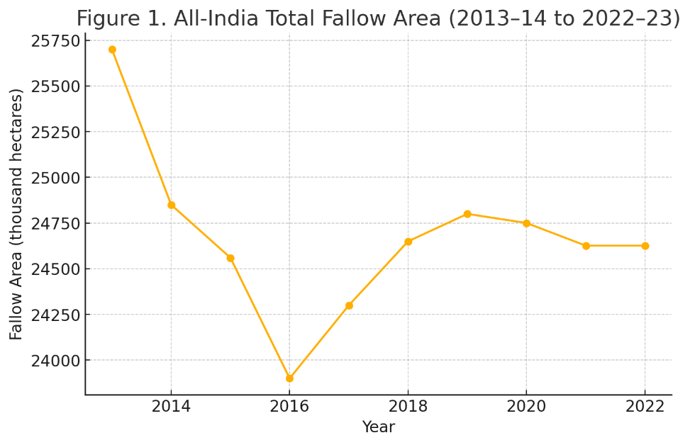
4.2 Karnataka — Fallow land and cropping context
Karnataka’s reporting area (geographical area ~19.05 million ha) and agricultural statistics show a net sown area of roughly 11.1 million ha (111.6 lakh ha) in the period 2021–22 / 2022–23, and total fallow land reported around 1,065 thousand ha in 2022 (CEIC summary of state DES), with the majority of fallow pockets concentrated in semi-arid interior districts (northern and central Karnataka). (CEIC Data)
Table 2. Karnataka selected land-use indicators (2022, thousand hectares)
Indicator | 2022 (thousand ha) | Note / Source
Net area sown (approx.) | 11,166 (111.66 lakh ha) | Karnataka State statistics / NABARD reporting. (NABARD)
Fallow land — other than current fallows | 386 | CEIC / DES Karnataka series (2022). (CEIC Data)
Current fallows (implicit from totals) | ~679 (computed) | CEIC total fallow 1,065 – other fallow 386 = 679 (approx). (CEIC Data)
Total fallow (sum) | 1,065 | CEIC / DES (Karnataka 2022). (CEIC Data)
Note: Sources report state values in thousand hectares (ha). The CEIC tables compile Directorate of Economics & Statistics (DES) Karnataka figures as used in national LUS reporting.
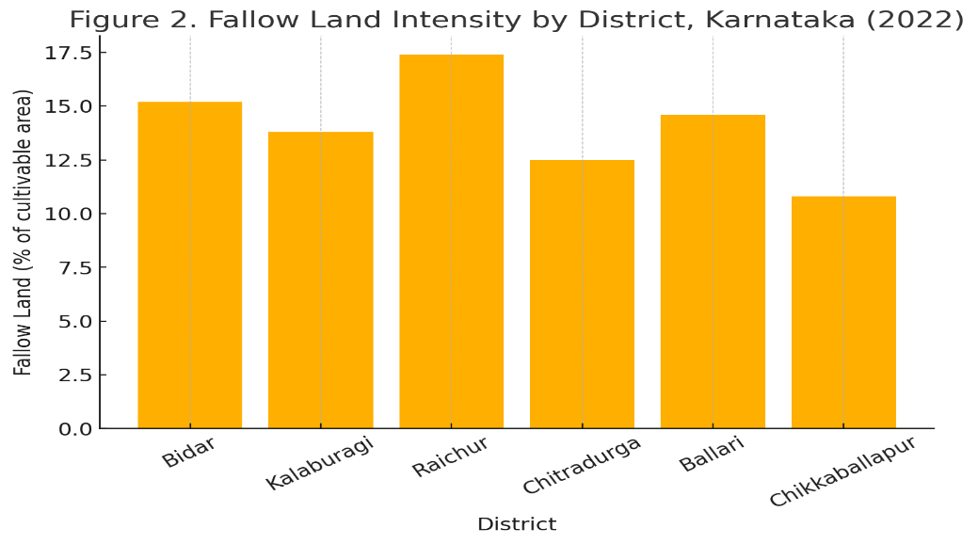
4.3 Migration and labour indicators
PLFS (2022–23) indicates shifts in labour force participation and a continued importance of agricultural work for a sizable share of the rural workforce. Migration (seasonal/temporary) remains significant as households pursue off-farm and urban work during agricultural slack months or in response to poor returns. Recent systematic reviews and regional studies identify the following recurring drivers of migration:
- Rainfall variability and crop failure in semi-arid districts.
- Low on-farm incomes and fragmentation of holdings.
- Pull factors in urban centres (construction, services, factories) and neighbouring states. District studies in Karnataka (e.g., Bidar) document patterns of labour outflow during off seasons and during years of crop stress.
Table 3. Selected labour & migration indicators (national / summary)
Indicator | Value / Trend | Source
LFPR (rural) change (2017–18 → 2022–23) | 48.9% → 56.7% (increase) | PLFS 2022–23 (annual report). (MoSPI)
Agricultural employment share (trend) | Declining share of total employment over decades; agriculture still major rural employer | PLFS and systematic reviews. (ResearchGate)
Migration for employment (national snapshot) | Significant seasonal/temporary migration; inter-state flows to urban hubs | Recent studies and press/state data. (GLB)

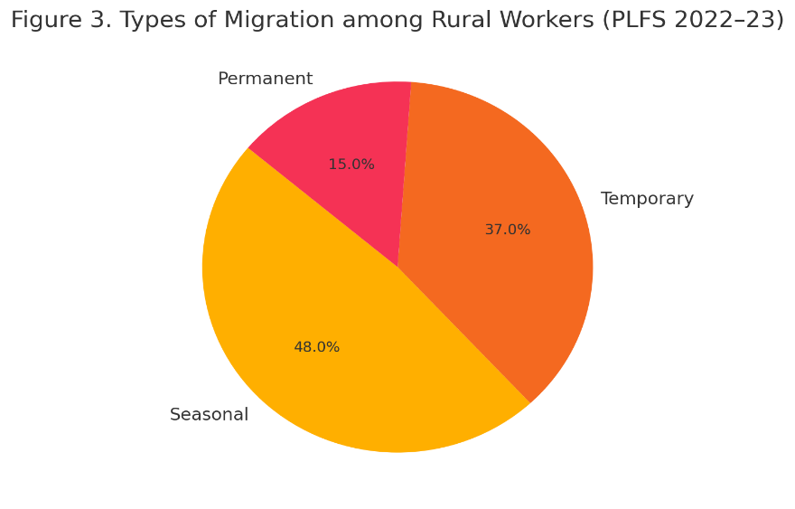
5. Discussion — linking fallows and migration in semi-arid Karnataka
5.1 Mechanisms linking fallowing and migration
From the evidence and state statistics the following mechanisms emerge:
- Climatic stress → fallowing → migration: In semi-arid taluks, poor rainfall or groundwater scarcity can make cultivation unviable in some years. Farmers may leave fields fallow (current or 1–5 year fallow) rather than invest in costly irrigation or inputs. Households then rely on wage migration (seasonal moves to nearby towns or other states) to smooth incomes during fallow years.
- Labour shortages and mechanisation cycles: In some cropping patterns, labour demand is seasonal and concentrated (sowing/harvest). When local demand falls (e.g., fewer crops due to fallowing), agricultural labourers migrate temporarily. Conversely, migration of labour can push farmers to fallow if they cannot hire labour affordably.
- Economic rationalisation and cropping choices: Farmers may choose to leave marginal plots fallow and invest in higher-return crops on better plots. This selective fallowing reallocates labour needs and also encourages migration of labourers from marginal areas to urban or peri-urban jobs.

5.2 Spatial heterogeneity within Karnataka
Karnataka’s fallow area (~1.07 million ha) is not uniformly distributed: interior semi-arid districts (northern Karnataka, parts of central districts) show higher incidence. District case studies (e.g., Bidar) document high levels of temporary out-migration among agricultural labour for employment in non-farm sectors during crop slack seasons or in stress years.
5.3 Policy-sensitive interpretation
Fallowing is not always negative: planned fallow in rotations improves soil health. But the pattern of persistent or increasing fallow in semi-arid areas accompanied by rising temporary migration signals distress cropping in many locations. Policy must distinguish between adaptive fallowing (rotational) and distress fallowing (abandonment due to constraints).
6. Policy implications and recommendations
- Targeted irrigation and groundwater recharge in semi-arid taluks Investments in minor irrigation, community recharge structures and demand-side water management can reduce distress fallowing and stabilize livelihoods.
- Crop diversification and drought-resilient crops Promote millet, pulses, horticulture and dryland horticulture coupled with assured market linkages to make cultivation viable where water is a constraint.
- Align rural works programs with agricultural calendar Use MGNREGA and rural works to provide employment during slack periods and to fund soil and water conservation that reduces future fallow incidence.
- Migrant-inclusive social protection and labour intermediation Recognize seasonal migrants (origin and destination) through portability of benefits, skill training, and safer labour intermediation so migration becomes a choice rather than distress.
- District-level fallow mapping & early warning Use LUS, remote sensing (Sentinel-1/2), and district reporting to create a near-real-time fallow map and link it to local labour market programs and seed/credit interventions.
7. Conclusion
Semi-arid agriculture in India is at a crossroads. Fallow land expansion and migration are no longer isolated issues but interdependent outcomes of climatic risk, market volatility, and socio-economic restructuring. Karnataka’s semi-arid regions illustrate this complex relationship: as fallow areas persist due to erratic rainfall and water scarcity, migration becomes a coping mechanism for both farmers and agricultural labourers. Policies must therefore view migration not merely as a problem but as part of an adaptive strategy that can be supported through social protection, skill mobility, and climate-resilient agriculture.
Fallow land and migration in semi-arid India are tightly connected through climatic, economic and labour market mechanisms. National statistics show that 24.6 million ha were fallow in 2022–23 (current + other fallows), while Karnataka reported ~1.07 million ha of fallow in 2022. In semi-arid pockets of Karnataka, distress-induced fallowing contributes to seasonal and temporary migration of farmers and agricultural labourers. Policy responses must be spatially targeted, combining water security, livelihood programs, and migrant-sensitive protections to reduce distress fallowing and enable migration to remain a positive livelihood strategy.

References
Bera, S., Roy, S., & Banerjee, P. (2022). Monitoring fallow land dynamics in semi-arid India using multi-temporal satellite imagery. International Journal of Applied Earth Observation and Geoinformation, 109, 102789.
Bernstein, H. (2010). Class dynamics of agrarian change. Fernwood Publishing.
Bhaduri, A., Reddy, V. R., & Reddy, D. N. (2021). Agrarian distress and rural migration in southern India. Economic and Political Weekly, 56(32), 45–54.
Chauhan, S., & Singh, P. (2019). Migration, labour shortage, and agricultural stagnation in dryland India. Indian Journal of Labour Economics, 62(3), 315–334.
Chowdhury, A., & Dandekar, A. (2021). Climate variability and rural livelihoods in semi-arid India. Journal of Rural Studies, 87, 49–60.
De, S., Pal, R., & Prakash, A. (2022). Labour migration, land use, and livelihood transitions in drought-prone regions of Maharashtra. Regional Studies in Development, 14(2), 201–218.
Deshingkar, P., & Akter, S. (2022). Seasonal migration and the future of rural India. ODI Working Paper Series, Overseas Development Institute.
Deshingkar, P., & Start, D. (2003). Seasonal migration for livelihoods in India: Coping, accumulation, and exclusion. ODI Working Paper 220.
Ellis, F. (2000). Rural livelihoods and diversity in developing countries. Oxford University Press.
FAO. (2019). Guidelines for the compilation of land use statistics. Food and Agriculture Organization.
Government of India. (2023). Land Use Statistics at a Glance, 2013–14 to 2022–23. Department of Agriculture & Farmers Welfare.
Jha, S., Singh, R., & Gupta, M. (2022). Migration, employment and rural income diversification in India: Evidence from PLFS 2020–21. Social Change, 52(1), 88–107.
Karnataka State Department of Agriculture (KSDA). (2023). Annual report 2022–23. Bengaluru: KSDA.
Kolar, N., Patil, R., & Sinha, A. (2023). Labour migration and agrarian transition in northern Karnataka. Indian Journal of Human Geography, 50(2), 77–98.
Ministry of Agriculture & Farmers Welfare. (2023). Land Use Statistics at a Glance 2022–23. Government of India.
Patil, S., & Murthy, K. N. (2021). Fallow land expansion and rural livelihoods in Chitradurga district of Karnataka. Journal of Soil and Water Conservation, 19(4), 311–322.
Raju, K. V., & Srinivas, G. (2022). Water scarcity and crop abandonment in semi-arid Karnataka. Indian Journal of Dryland Agriculture Research and Development, 37(1), 1–12.
Ramesh, H. S., Kumar, D. M., & Nayak, S. (2023). Geospatial mapping of fallow land using Sentinel imagery in southern India. Spatial Information Research, 31(2), 201–214.
Reddy, A. A., Bantilan, M. C. S., & Shalander, K. (2017). Climate variability and its impact on agricultural incomes in semi-arid tropics of India. Agricultural Economics Research Review, 30(2), 203–212.
Rogaly, B., Bisht, P., & Choudhury, S. (2019). Rural labour mobility and agrarian transitions in India. Journal of Agrarian Change, 19(4), 676–696.
Roy, S., Sharma, A., & Kundu, S. (2020). Mapping of fallow cropland and its environmental correlates using remote sensing. Environmental Monitoring and Assessment, 192(11), 1–17.
Sharma, R., & Datt, S. (2021). Determinants of fallow land in India: A state-level analysis. Indian Journal of Agricultural Economics, 76(3), 412–430.
Srivastava, R. (2020). Internal migration in India and policy challenges. Economic and Political Weekly, 55(11), 37–44.

