Original Research Article
An Integrated Model for Postpartum Depression Awareness: Overcoming Cultural Barriers through Strategic Information Sourcing in Niger State

Abstract
Background: Postpartum depression (PPD) is a significant global maternal mental health issue often overlooked, particularly in Northern Nigeria, where the total fertility rate of 7.2 amplifies PPD risks and vulnerability due to repeated multiple childbirths at short intervals, which contributes to emotional and physical stress. Purpose: This study examines how culturally relevant information sources and risk communication influence knowledge and help-seeking behaviours related to PPD in Niger State. Methods: The study adopted a mixed research design of a survey (n-384) and a Focus Group Discussion (n-32). A multistage and purposive sampling technique was used. Kobo Toolbox was used to collect data, SmartPLS-SEM, and Yin (2009)’s thematic explanation was used for analysis. Results indicate PDK = β₁HP + β₂SM + β₃RD + β₄NP + β₅FF + β₆TV + ζ, meaning that information from healthcare providers is the single strongest driver of PPD knowledge. Further results revealed that social media and radio were other major sources of knowledge, while family, friends, and television had minimal significance. Also, Indigenous media such as community radio and storytelling played key roles. Conclusion/Practical implication: The study recommends integrating PPD education into maternal health policies and leveraging digital platforms and community radio for culturally sensitive communication to reduce stigma and promote early help-seeking. Recommendation: To mitigate stigma and promote early intervention, we recommend co-designing public health communication that synergises clinical authority with the cultural resonance of indigenous and digital media
Keywords: Risk communication techniques, Information sources, Postpartum depression, Maternal mental health, Help-seeking behaviour.
Introduction
Postpartum depression (PPD) is a significant global maternal mental health issue, yet it remains critically overlooked in regions like Northern Nigeria (Tsiga-Ahmed et al., 2024). In Niger State, a high total fertility rate of 7.2 amplifies PPD risks, as women experience repeated childbirths at short intervals, contributing to profound emotional and physical stress. The cultural context further complicates this picture, where PPD is often stigmatized and attributed to spiritual causes rather than recognized as a treatable medical condition (Adegboyega, 2022; Jaiyeola & Abdulrazaq, 2022). This stigma creates a formidable barrier to open discussion and help-seeking, leaving many women to suffer in silence.
Effective communication is the cornerstone of bridging this gap between medical knowledge and public understanding. As Burgener (2020) and Finset et al. (2020) argue, communication enhances the connection between clinical services and patient needs, enabling necessary health adjustments. In the specific case of PPD, communication is not merely a method but a transformative tool that can convert awareness into action and directly challenge associated stigma (Wang & Pavelko, 2025). This is where the specialised field of risk communication becomes vital.
Risk communication is a strategic process of exchanging information about potential health risks, their nature, significance, and management, empowering individuals to make informed, protective decisions (Lundgren & McMakin, 2018; World Health Organisation, 2018). While traditionally applied to epidemics and pandemics with notable results (World Health Organisation, 2018), its principles are equally crucial for non-communicable public health crises like PPD. Effective risk communication involves delivering topical, useful, and easily understood information so people can mitigate health risks (Ben-Enukora, Adeyeye, Adesina, Ajakaïye, & Adekanye, 2022). For PPD, this means crafting messages that equip women, families, and communities with the knowledge to recognise symptoms and seek appropriate care, thereby raising awareness, challenging stigma, and promoting early intervention.
However, the application of risk communication to maternal mental health, particularly in Northern Nigeria, remains underexplored. The success of this approach hinges on how effectively specialists can translate research on PPD into comprehensible public messages, a process that must be culturally attuned to the needs of the target population (Omale et al, 2024; Ogunwale, Fadipe, & Bifarin, 2023). Government and non-governmental organisations are increasingly utilising risk communication, but their effectiveness in influencing help-seeking behaviour for PPD in Niger State is not well understood. This study, therefore, seeks to investigate how culturally relevant information sources and risk communication techniques influence women's knowledge and help-seeking behaviours related to PPD, addressing a critical gap in the literature and practice.
Research Gap and Objectives
Despite the high prevalence of PPD in Niger State, little is known about how culturally relevant information sources and risk communication influence women’s knowledge and help-seeking behaviours. This study aims to close this gap by investigating the role of these factors in promoting PPD awareness in alignment with Sustainable Development Goals (SDGs) 3 and 17. The specific objectives were to:
- To what extent do specific information sources, particularly healthcare providers, social media, and radio, influence women's knowledge of postpartum depression in Niger State?
- How do culturally rooted subjective norms mediate the relationship between risk communication and help-seeking behaviours for postpartum depression?
Hypothesis
The hypothesis was stated in the null form:
H₀₁: There is no significant relationship between the influence of various information sources on Postpartum Depression Knowledge among women in Niger State.

Conceptual Framework
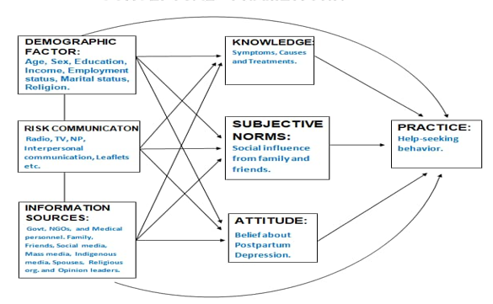
Figure 1 presents the contextual framework of the study
Source: Omale (2025)

Interpretation of the Conceptual Framework
This conceptual framework visually maps the pathway to improving postpartum depression (PPD) awareness and management. It begins by acknowledging that a woman's background, such as her age, education, and marital status, forms the foundation of her perceptions and actions.
The model then posits that Risk Communication (from government, NGOs, and health workers) and various Information Sources (from doctors and social media to family and community leaders) serve as the primary drivers, or independent variables. These inputs are designed to directly shape a mother's Knowledge, Attitudes, and Practices (KAP) regarding PPD, the dependent variables we aim to improve.
Crucially, the framework recognises that this process does not happen in a vacuum. The relationship between receiving information and changing one's behaviour is moderated by Subjective Norms, the powerful social influences from one's family and community. These norms can either amplify the message or act as a barrier, determining whether knowledge successfully translates into help-seeking action.
Literature Review
Information Sources and Cultural Barriers in Postpartum Depression Awareness
To understand the landscape of postpartum depression (PPD) in Niger State, it is essential to examine the information ecosystems women navigate. The sources from which women acquire knowledge about PPD and the cultural frameworks that shape their interpretation fundamentally influence their recognition of symptoms, their attitudes towards the condition, and their subsequent help-seeking behaviours (Adegboyega, 2022).
Formal Healthcare Sources: A Trusted but Inaccessible Channel
Healthcare providers are universally recognised as a primary and most reliable source of formal information regarding PPD (Fisher et al., 2012). Evidence consistently shows that women who receive guidance from medical professionals are significantly more likely to accurately identify symptoms and pursue appropriate care (O'Hara & McCabe, 2013). However, in the Nigerian context, and particularly in rural areas like many parts of Niger State, access to these formal services is severely constrained (Adegboyega, 2022). This creates a critical gap; for instance, Fisher et al. (2012) reported that only 30% of women in rural Nigeria had ever received any information about PPD from a healthcare provider, highlighting a vast chasm in the dissemination of accurate medical knowledge.
Informal and Traditional Networks: Support Tempered by Misconception
In the vacuum left by formal healthcare, women often turn to informal sources such as family, friends, religious leaders, and traditional healers for support and explanation (Abdulmalik, Kola, & Gureje, 2016). While these networks provide crucial emotional support, they frequently propagate cultural misconceptions that pathologise PPD. As noted by Adegboyega (2022) and Jaiyeola and Abdulrazaq (2022), traditional healers in Northern Nigeria often attribute PPD symptoms to witchcraft, evil spirits ('Iscar' in Hausa), or other supernatural causes. This framing leads women to seek spiritual remedies rather than medical treatment, a situation that can dangerously delay appropriate care and reinforce stigma by preventing the recognition of PPD as a treatable health condition (O'Hara & McCabe, 2013). This reliance is further exacerbated by socioeconomic factors, as unemployment and a lack of financial capacity often make traditional or spiritual consultations the only viable option for many (Omale et al, 2024; Ogunwale, Fadipe, & Bifarin, 2023).
The Dual Role of Modern and Indigenous Media
The media, in its various forms, plays an increasingly pivotal role. Mass media and digital platforms have become important conduits for PPD information, particularly among younger and more educated women (Sawyer, Ayers, & Smith, 2010). Social media platforms, online forums, and health websites offer accessible and anonymous spaces for women to learn and share experiences (Fisher et al., 2012). However, this digital landscape is a double-edged sword; the quality of online information varies dramatically, and exposure to misinformation can create confusion and deter women from seeking professional help (Aluko, Oyesomi, Amodu, Adesina, & Omole, 2024; O'Hara & McCabe, 2013).
Alongside modern media, indigenous media channels such as community radio, storytelling, and local proverbs remain vital, trusted sources of information, especially in rural communities (Meadows & Foxwell, 2011). These culturally embedded channels hold immense potential for disseminating relatable health messages. However, as with informal networks, they can also be conduits for harmful beliefs. Therefore, their effectiveness depends on deploying culturally tailored communication strategies that skilfully integrate current medical knowledge with local practices to spur early help-seeking behaviours (Tefera, Ali, & Woldearegay, 2024; Turner & Friesen, 2024).
Bridging the Gaps: The Role of NGOs and Community Initiatives
Non-governmental organizations (NGOs) and community-based groups are pivotal in bridging these information gaps. These entities often conduct awareness campaigns, workshops, and support groups designed to provide accurate PPD information and link women to formal health services (Abdulmalik, Kola, & Gureje, 2016; Fisher et al., 2012). The success of such community-driven interventions is demonstrated by research such as Adegboyega's (2022), which found that women who participated in community-based education programs were more likely to identify PPD symptoms and express an intention to seek help.
In conclusion, Nigerian women access information about PPD through a complex web of formal, informal, modern, and traditional sources. While some channels, like healthcare providers and certain NGO initiatives, offer accuracy, others can perpetuate misinformation and deepen social stigma, a problem acutely felt in rural and underserved communities like those in Niger State. This reality underscores the urgent need for targeted, multi-channel interventions that leverage healthcare providers, NGOs, and both digital and indigenous platforms to deliver information that is not only accurate but also culturally sensitive and contextually resonant.
Relevance of the Study to SDGs
This study is intrinsically linked to the global pursuit of the Sustainable Development Goals, particularly SDG 3 (Good Health and Well-being) and SDG 17 (Partnerships for the Goals). At its heart, SDG 3 calls for ensuring healthy lives and promoting well-being for all at all ages. The silent struggle of mothers with postpartum depression (PPD) represents a critical, yet often overlooked, challenge to this goal. When PPD goes unrecognized and untreated, it doesn't just affect one individual; it can cast a long shadow over a child's development, family stability, and the overall health of a community. By investigating the communication pathways that can break the silence around PPD, this research directly addresses a key barrier to maternal mental health. It seeks to equip women, families, and communities with the knowledge to seek timely care, thereby contributing to reduced health disparities and improved outcomes for both mothers and their children.
Furthermore, the complex nature of PPD means that no single entity can solve it alone. This is where the study’s alignment with SDG 17 becomes clear. Effectively tackling PPD requires a tapestry of collaboration. The findings from this work provide a common ground for a health communication perspective that can unite diverse actors. It invites researchers from medicine and psychology, healthcare providers like midwives and nurses, media professionals, policymakers, and community leaders to co-create and implement strategies. By fostering these essential partnerships, the study supports the development of a coordinated, multi-sectoral response to promote maternal mental health, turning isolated efforts into a powerful, collective force for change.
2.5 Theoretical Framework
The study was anchored on the theory of planned behaviour (TPB) by Ajzen (1985). It deals with subjective norms and perceived control of behavioural intention. The theory explores how subjective norms rooted in deep cultural and societal influences impact the behavioural intention of women to seek help for postpartum depression. The relevance of the behavioural theory to the study is that it explains health behaviour within the context of beliefs, attitudes, and social influences. Theoretically, there is no known study that has applied TPB in the context of postpartum depression in Nigeria’s socio-cultural context and from a communication perspective, particularly in Niger State. There is minimal exploration of how this theory could be used to guide postpartum depression communication and how this theory operates in a non-Western setting, potentially leading to modification of TPB or leading to new theoretical development. The application of the theory to the findings from this study is further expounded in the discussion section of the paper.
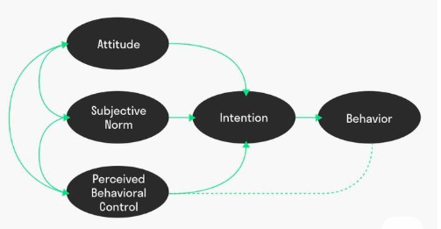
Figure 2 presents a diagram of the Theory of Planned Behaviour
Source: (Ajzen, 1985)
Materials and Methods
3.1 Research Design
In this study, a mixed-methods approach was used in order to capture both the breadth of women’s knowledge about PPD via quantitative surveys and the depth of their experiences and perceptions through qualitative focus group discussion (FGD). The essence is such that the role of risk communication and information sources is more comprehensively understood.
3.2 Area of Study
The area of study is Niger State, and the 3 senatorial districts are well represented in the study

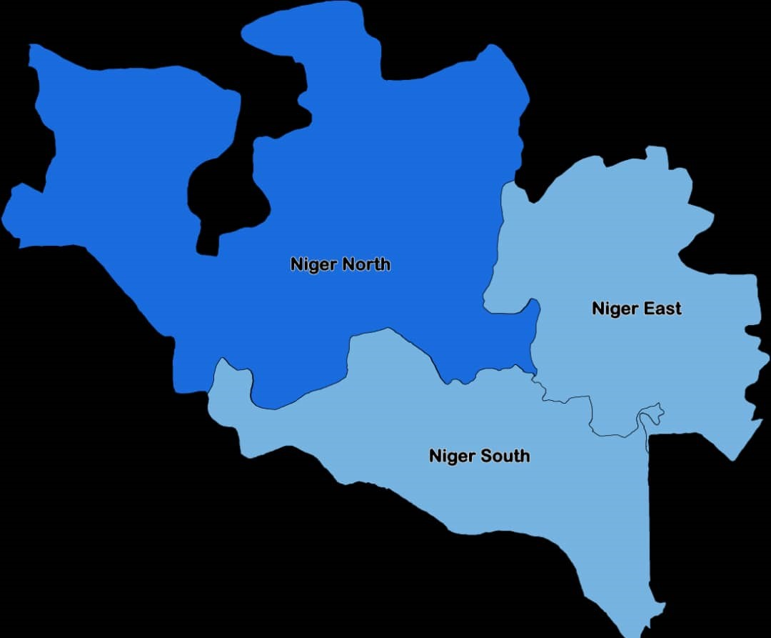
Figure 3: Map Showing the 3 Senatorial Districts in Niger State, Nigeria
Source: Umar, 2017
3.3 Population of the study
Nigeria is the seventh most populous country in the world; it is projected to move up to be the fourth largest by 2050 due to its high fertility rate Oladosun, Akanbi, Fasina, & Samuel, 2019). Similarly, the scope of the study area, Niger state, located in North-central happens to be characterised by a fertility rate (TFR) of 4.4 children per woman (Nigeria Population Commission, 2019). Specifically, the population of the study comprises women of childbearing age (WCBA), (18-49 years), which is 134,752 (Bosso LGA 75,573, and Bida LGA 59,179) (one hundred and thirty-four thousand, seven hundred and fifty-two) (NPC, 2019) Hence, women in this region are exposed to PPD risk and therefore vulnerable due to repeated multiple childbirths at short intervals, thereby increasing their physical, emotional, and financial stress.
3.4 Sample Size and Techniques
The Krejcie and Morgan (1970) table for sample size determination was used to arrive at a sample size of 384 at a 95 percent confidence level and a 5% margin of error for the survey. A seven-stage multistage sampling technique was used to select respondents for the survey through stratified random sampling, simple random sampling techniques, and lottery. Niger State was stratified into 3 senatorial districts, which were further stratified into local government areas (LGA) and further stratified into wards and streets until the required number was achieved.
Table 1: Population, Sample Size, and Proportional Distribution of Women of Childbearing Age (WCBA) in Bosso and Bida LGAs
LGA | Population | Sample | Proportional Distribution (%)
Bosso | 75,573 | 215 | 56
Bida | 59,179 | 169 | 44
Total | 134.752 | 384 | 100
Source: Omale et al (2025)
Furthermore, a probability sampling technique was used to select a sub-sample of 32 survey respondents. Whose consent was first sought, and who were willing to participate in focused group discussion (FGD) sessions. A total of 4 FGD sessions, comprising 8 participants each, were conducted. These 4 sessions were further split into two categories: older women and younger women, and according to age bracket (18-29 years and 30-49 years), for cultural reasons, which will allow for open discussion about their experiences. The FGD was conducted in an open place, specifically, at a primary healthcare centre (PHC) during the compulsory immunisation of their baby and postpartum check-ups.
Method of Data Analysis
The Smart Partial Least Squares (PLS) was used to analyse quantitative data (survey), while Yin (2009)’s thematic model was used to analyse qualitative data from the Focus Group Discussion (FGD).
Ethical Considerations
Ethical consideration was strictly taken into cognisance to ensure respondents’ informed consent, confidentiality, and the right to withdraw from the study at any time. This clearance was obtained from the Covenant University Health Research Ethics Committee (CHREC).

Presentation of Results (Quantitative)
Table 2: Demographic Characteristics of Respondents (N = 384)
Variable | Category | Frequency(n) | Percentage (%)
Age | 18-24 years | 102 | 26.6
 | 25-34 years  35-49 years | 156  126 | 40.6  32.8
Total  Marital Status  Total  Educational Level  Total  Employment Status  Total  Area of Residence  Total  Parity (number of children)  Total | Married  Single/Divorced/Widowed  No formal Education  Primary  Secondary  Tertiary  Unemployed  Informal work (trading, etc.)  Formal employment  Urban  Rural  1-2 Children  3-4 Children  5 and above | 384  328  56  384  58  70  122  134  384  148  122  114  384  212  172  384  86  164  134  384 | 100  85.4  14.6  100  15.1  18.2  31.8  34.9  100  38.5  31.8  29.7  100  55.2  44.8  100  22.4  42.7  34.9  100
Source: Omale et al (2025)
The demographic profile of the 384 survey respondents from the two LGAs is presented in Table 2. The data reveals that the largest group of respondents (40.6%) was aged 25-34 years, with a further 32.8% aged 35-49. The vast majority were married (85.4%) and had attained at least a secondary level of education (66.7%). A significant proportion were unemployed (38.5%), and slightly more than half resided in urban areas (55.2%). Critically, 77.6% had three or more children, a demographic reality that underscores their heightened vulnerability to PPD due to the physical and emotional stresses associated with multiple births. These characteristics provide essential context for understanding variations in help-seeking behaviour, as access to information and social support is often mediated by such factors.

Table 3: Factor Loading, Construct Reliability, and Validity
 | Loading | AVE | Composite Reliability | Cronbach’s Alpha
Constructs (Information Sources) | > 0.7 | >0.5 | > 0.8 |  | > 0.7
Family/Friends (FF) |  | 0.740 | 0.895 |  | 0.824
FF1 | 0.822
FF2 | 0.822
FF3 | 0.875
Healthcare Providers (HP) |  | 0.736 | 0.892 |  | 0.819
HP1 | 0.872
HP2 | 0.938
HP3 | 0.751
Newspapers (NP) |  | 0.702 | 0.876 |  | 0.788
NP1 | 0.834
NP2 | 0.862
NP3 | 0.816
Radio (RD) |  | 0.675 | 0.861 |  | 0.761
RD1 | 0.816
RD2 | 0.857
RD3 | 0.790
Social media (SM) |  | 0.798 | 0.922 |  | 0.873
SM1 | 0.884
SM2 | 0.924
SM3 | 0.871
Television (TV) |  | 0.620 | 0.830 |  | 0.791
TV1 | 0.725
TV2 | 0.826
TV3 | 0.808
Postpartum Depression Knowledge (PDK) |  | 0.592 | 0.879 |  | 0.827
PDK1 | 0.739
PDK2 | 0.838
PDK3 | 0.820
PDK4 | 0.729
PDK5 | 0.713
Source: Field study (Omale et al, 2025)

Table 3 presents the metrics for factor loadings, Average Variance Extracted (AVE), Composite Reliability (CR), and Cronbach’s Alpha (CA) for the constructs measuring information sources and postpartum depression knowledge (PDK), following the thresholds established by Ramayah, Cheah, Chuah, Ting, and Memon (2018). The results confirm the robustness of the measurement model. All factor loadings exceed 0.7, indicating that each survey item is a strong indicator of its intended concept. Furthermore, all constructs demonstrate sufficient convergent validity (AVE > 0.5) and high internal consistency (CR > 0.8, CA > 0.7). In practical terms, this means our survey reliably measured what it set out to measure. While television (TV) shows the lowest scores among the sources, they remain within acceptable limits. Conversely, social media (SM) emerges as the most statistically reliable construct in our model (AVE = 0.798, CR = 0.922, CA = 0.873). This statistical confidence allows us to proceed with certainty in examining the relationships between these variables.
Table 4 Discriminant Validity of Constructs Using Fornell-Larcker Criterion
 |  | FF |  | HP | NP | PDK | RD |  | SM |  | TV
FF
HP | 0.544  [0.456; 0.611]
NP | 0.434  [0.386; 0.539] |  | 0.554  [0.431; 0.658]
PDK | 0.449  [0.301; 0.509] |  | 0.434  [0.372; 0.544] |  | 0.507  [0.432; 0.612]
RD | 0.543  [0.455; 0.669] |  | 0.590  [0.468; 0.690] |  | 0.457  [0.366; 0.572] | 0.468  [0.354; 0.545]
SM | 0.638  [0.537; 0.700] |  | 0.377  [0.269; 0.471] |  | 0.480  [0.367; 0.545] | 0.544  [0.433; 0.676] |  | 0.433  [0.340; 0.539]
TV | 0.411  [0.321; 0.567] |  | 0.500  [0.488; 0.658] |  | 0.507  [0.490; 0.652] | 0.502  [0.487; 0.655] |  | 0.487  [0.377; 0.548] |  | 0.473  [0.333; 0.549]
FF: Family and Friends, HP: Healthcare Providers, NP: Newspapers, PDK: Postpartum Depression Knowledge, RD: Radio, SM: Social Media, TV: Television

Through the evaluation of the level of correlation between the constructs in a study, discriminant validity ensures that each one is unique. Therefore, Table 4 shows the correlation coefficients between several postpartum depression knowledge sources, including radio (RD), social media (SM), newspapers (NP), healthcare providers (HP), family and friends (FF), and television (TV). The values show the confidence intervals for these associations in brackets. If each construct is sufficiently distinct from the others, a model exhibits excellent discriminant validity; correlations across variables should not be excessively high (usually less than 0.85).
Furthermore, social media (SM) and healthcare providers (HP) have the strongest connections with postpartum depression knowledge (PDK), according to the data, with 0.544 and 0.434, respectively. This implies that, despite being separate constructs, these two sources contribute significantly to the dissemination of information on postpartum depression. Similarly, radio (RD) and newspapers (NP) show moderate associations with PDK (0.468 and 0.507, respectively), suggesting their importance in the spread of knowledge. Although not as significant as social media or medical professionals, family and friends (FF) also exhibit a moderate association of 0.449 with PDK, indicating that personal networks have a role in raising awareness of postpartum depression.
Furthermore, television has been discovered to have the poorest association with PDK (0.502), but it is still a source of valuable information. However, its impact is weaker compared to newspapers, social media, and healthcare professionals. Additionally, the relatively low correlations between TV and other variables indicate minimal overlap with other sources of information. The results show that the most significant sources of information about postpartum depression are newspapers, social media, and healthcare professionals; radio, television, family, and friends are less important but still significant. These findings emphasise the necessity for public health programs to use medical experts and online media to enhance postpartum depression awareness campaigns.
In a nutshell, the results confirm that the constructs, while sometimes related, measure unique concepts. The correlation analysis reveals the relative strength of different information sources in relation to PPD knowledge. This tells us that while many sources contribute to knowledge, they do so in distinct ways. Social media (SM) and healthcare providers (HP) show the strongest associations with PDK (0.544 and 0.434, respectively), underscoring their paramount importance in disseminating PPD information. Radio (RD) and newspapers (NP) also show moderate, meaningful associations (0.468 and 0.507), confirming their relevance. While family and friends (FF) and television (TV) demonstrate weaker links to knowledge (0.449 and 0.502), their values are not negligible, suggesting they still play a role, albeit a less decisive one, in raising awareness.

In order to determine the relationships between the variables, the path coefficients, the t-statistic values, the p-values, and the r-square value were used as the basis for the interpretation, taking into consideration the minimum thresholds as established in the literature. The PLS bootstrapping model with β and P values is also displayed in Figure 4. It shows the path coefficient values that describe the strength of the relationship between information sources on postpartum depression knowledge. The greater the coefficient values, the more substantial the effect on postpartum depression knowledge. The R-squared value indicates the percentage of variation in postpartum depression knowledge that can be explained by information sources.

Table 5: Summary of Hypotheses Tested
Variables | Path Co-efficient | Standard Deviation | R-Squared | T Statistics | P Values | Remark
FF $→$ PDK | 0.124 | 0.127 | 0.015 | 1.885 | 0.067 | Not Significant
HP $→$ PDK | 0.711 | 0.078 | 0.506 | 6.168 | 0.000 | Significant
NP $→$ PDK | 0.374 | 0.059 | 0.140 | 2.681 | 0.000 | Significant
RD $→$ PDK | 0.522 | 0.066 | 0.272 | 3.124 | 0.000 | Significant
SM $→$PDK | 0.538 | 0.078 | 0.289 | 4.476 | 0.000 | Significant
TV $→$ PDK | 0.117 | 0.117 | 0.014 | 1.564 | 0.077 | Not Significant
FF: Family and Friends, HP: Healthcare Providers, NP: Newspapers, PDK: Postpartum Depression Knowledge, RD: Radio, SM: Social Media, TV: Television

The core findings of the hypothesis test are summarised in Table 5 and illustrated in Figure 4 below. The path coefficients reveal the direct influence of each information source on PPD knowledge, with higher values indicating a stronger positive effect.
The results are decisive. Healthcare Providers (HP) have the most substantial impact on PPD knowledge, with a path coefficient of 0.711 and a highly significant p-value (0.000). This signifies that healthcare providers are, by a considerable margin, the most powerful and influential source of PPD knowledge for women in this study. Their influence is so pronounced that this single source explains over half (50.6%) of the variance in knowledge levels (R² = 0.506).
Social Media (SM) and Radio (RD) are the next most influential channels, with strong, nearly identical path coefficients (0.538 and 0.522, respectively) and high statistical significance (p = 0.000). This clearly establishes digital and radio platforms as critical secondary pillars for public health awareness, effectively reaching women and shaping their understanding of PPD.
Newspapers (NP) also demonstrate a statistically significant relationship with PPD knowledge (path coefficient = 0.374, p = 0.000). However, its more modest effect and lower explanatory power (R² = 0.140) suggest that while print media contributes, its role is less central than that of healthcare professionals, social media, or radio.
In contrast, the analysis shows that Family and Friends (FF) and Television (TV) do not have a statistically significant influence on PPD knowledge in this population (p-values of 0.067 and 0.077, respectively). Their path coefficients are low (0.124 and 0.117), and they account for very little of the variation in knowledge (R² = 0.015 and 0.014). This key finding indicates that, in the context of Niger State, personal social networks and television programming, in their current forms, are not effective channels for transmitting reliable knowledge about postpartum depression.
In summary, the quantitative data paint a clear picture: to increase knowledge about PPD in Niger State, public health efforts must prioritize information dissemination through healthcare providers, social media, and radio. The minimal impact of television and interpersonal networks suggests a need for alternative strategies, such as structured community health campaigns, to bridge this knowledge gap.

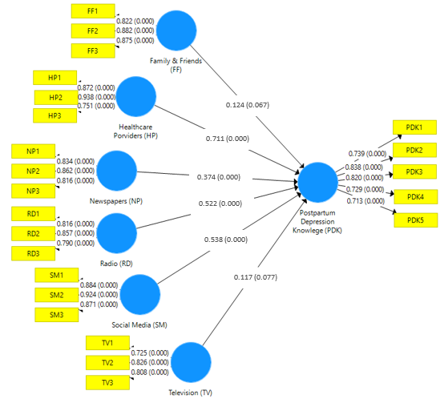

Figure 4: FF: Family and Friends, HP: Healthcare Providers, NP: Newspapers, PDK: Postpartum Depression Knowledge, RD: Radio, SM: Social Media, TV: Television
Source: Omale et al (2025)
Data Presentation (Qualitative Data from FGD)
The Focus Group Discussions provided profound, context-rich insights that illuminate the "why" behind the quantitative statistics. The analysis revealed two central themes that shape the landscape of PPD awareness and help-seeking in Niger State (1) The mediating role of stigma and source credibility, and (2) Indigenous media as a double-edged sword.
Theme 1: The Mediating Role of Stigma and Source Credibility
This theme explores how the perceived credibility of an information source and the pervasive fear of social judgment directly influence women's willingness to accept information about PPD and consider seeking help.
Sub-Theme Religious and Clinical Authority as Stigma-Reduction Tools
The FGDs revealed that information is not judged on content alone, but heavily on the authority of the messenger. When trusted, non-stigmatising figures frame PPD as a medical condition, it can powerfully reshape community perceptions.
Below are the responses from participants in the FGD
In our community, most women hear about postpartum depression through health talks at clinics, radio programs, and sometimes religious sermons. When an imam or pastor explains that it is a medical condition, people start seeing it differently, instead of just calling it 'madness' or 'spiritual attack (Younger Women, 18-29 years).
This excerpt highlights a critical pathway for effective risk communication. The reframing of PPD from a moral or spiritual failing ("madness") to a biomedical issue ("medical condition") by figures of immense social and spiritual authority (imams, pastors) acts as a powerful antidote to stigma. It suggests that the efficacy of a message is contingent on the cultural legitimacy of the messenger, a finding that aligns with the Theory of Planned Behaviour's emphasis on subjective norms (Ajzen, 1985). The convergence of religious and clinical authority creates a rare, trusted space where new understandings can be formed.
Sub-Theme Generational Norms and the Culture of Silence
In stark contrast, the data shows that deeply ingrained generational beliefs can reinforce stigma and enforce silence, making informal networks ineffective.
I don’t believe in postpartum depression. I think a woman should just be strong and pray. Social media could be useful in helping younger women learn more, but we, our mothers, and grandmothers rely on word-of-mouth or traditional healers. Some health talks help, but many women are still afraid of being judged, so they keep quiet even when they are suffering. We cope with our problems silently. Excerpt (Older Woman, 30-49 age group)

This testimony is pivotal. It explicitly names the generational chasm in belief systems and directly explains the quantitative finding that family and friends were not significant sources of PPD knowledge. The ethos of "strength," prayer, and silent coping constitutes a powerful subjective norm that actively suppresses help-seeking. The phrase "afraid of being judged" encapsulates the social cost of deviating from this norm. This finding corroborates the work of Mohamed et al. (2024), who identified negative attitudes as a critical impediment to early diagnosis. It demonstrates that informal networks, while providing other forms of support, can be active sites of misinformation and enforcement of stigmatizing norms regarding mental health.
Theme 2: Indigenous Media as a Double-Edged Sword
This theme captures the immense potential and inherent risks of using culturally embedded communication channels to discuss PPD. These channels are trusted but can be used to convey both accurate health information and harmful misconceptions.
Sub-Theme Narrative Persuasion and Cultural Resonance
Participants articulated how indigenous media, through storytelling and drama, can bypass resistance and make health messages relatable and memorable.
Yes, in the village, many women listen to Hausa radio dramas and storytelling where elders share wisdom through proverbs. If they include messages about PPD, it helps women understand that it is not a curse but a condition that can be treated. For example, when old women tell stories about a mother who suffered sadness after childbirth but later found healing,’ young women pay attention. (Mixed FGD Group)
This insight underscores the unique power of narrative persuasion. Unlike didactic health messages, stories and proverbs embedded within radio dramas or oral traditions provide a culturally coherent framework for understanding illness. They offer a narrative arc from suffering to healing that fosters identification and hope. This aligns with Meadows and Foxwell's (2011) advocacy for community broadcasting in enhancing well-being. By situating PPD within a familiar narrative structure, indigenous media can effectively decouple it from supernatural causes and re-couple it with the concept of achievable "healing," thereby increasing perceived behavioural control.
Sub-Theme The Risk of Reinforcing Stigma through Traditional Beliefs
However, the same FGDs revealed that these cultural channels are not inherently positive; they can also be conduits for the very stigma public health campaigns seek to dismantle.
"But the problem is that some traditional beliefs blame the woman, saying she is lazy or cursed. If we mix these cultural ways of teaching with real medical advice from nurses and trusted religious leaders, more women will accept that PPD is real and can be treated (Mixed FGD Group).
This qualification is crucial. It positions indigenous media not as a panacea, but as a contested space where competing narratives about PPD medical vs. moral are fought. The participant herself proposes the solution, a strategic syncretism. Her suggestion to "mix these cultural ways of teaching with real medical advice" is a profound recommendation for a hybrid communication model. It calls for the integration of modern medical knowledge into traditional communication forms, leveraging the reach and trust of the latter while ensuring the accuracy of the former, a approach supported by Tefera, Ali, and Woldearegay (2024). This directly informs policy, suggesting that interventions must not merely use indigenous media, but must actively curate and co-create content with cultural custodians and health professionals to ensure messages are both culturally resonant and medically sound.

Discussion of Findings and Interpretations
This study provides a comprehensive understanding of the complex interplay between information sources, cultural norms, and knowledge of postpartum depression (PPD) among women in Niger State. The findings, viewed through the lens of the Theory of Planned Behaviour (TPB), reveal a communication landscape where the credibility of the messenger is as important as the message itself, and where deep-seated subjective norms powerfully moderate the pathway to help-seeking (Omale and Asemah, 2024).
For instance, in terms of the primacy of healthcare providers and digital media, the most striking finding is the overwhelming influence of healthcare providers on PPD knowledge, demonstrated by a robust path coefficient of 0.711. This underscores their role as the most authoritative and impactful source of health information. This aligns perfectly with the TPB's emphasis on the formation of behavioural intentions through credible information (Ajzen, 1985) and corroborates global evidence that clinician-delivered guidance is a critical predictor of appropriate help-seeking (O’Hara & McCabe, 2013; Obioha, Balogun, Olubodun, & Okafor, 2021). When a doctor or nurse explains PPD as a medical condition, it significantly shapes women's attitudes towards it, framing it as a legitimate health issue rather than a personal or spiritual failing.
Complementing this, the significant influence of social media (path coefficient = 0.538) and radio (path coefficient = 0.522) highlights a rapidly evolving information ecology. The potency of social media resonates with Fisher et al. (2012), who noted the role of digital platforms in providing accessible information on PPD. The demographic profile of our sample, where a large proportion were aged 25-34, helps explain this finding; this cohort is more likely to be digitally literate and use online platforms for information seeking. Social media, therefore, may enhance perceived behavioural control by offering anonymous, immediate access to information and peer support, lowering the barrier to initial inquiry. Radio, meanwhile, remains a steadfast and trusted medium, particularly in semi-urban and rural areas, effectively bridging the digital divide to disseminate vital health messages.
Furthermore, based on the limited role of interpersonal networks and television, there is a significant divergence from some existing literature; our study found that family, friends, and television had minimal and statistically nonsignificant influence on PPD knowledge. This contrasts with Abdulmalik, Kola, and Gureje (2016), who emphasised the role of informal networks in shaping health perceptions in rural settings. This divergence is not a contradiction but a critical insight. It can be explained by the qualitative data, which revealed that these very networks are often the conduits of stigma and misconceptions. The FGDs with older women revealed a culture of silence and a belief that women should "be strong and pray," indicating that the subjective norms propagated through interpersonal channels actively discourage the recognition of PPD, thereby suppressing open discussion and knowledge acquisition within personal networks.
Similarly, the limited impact of television (path coefficient = 0.117) challenges the view of mass media as a universally potent health communication tool (Sawyer, Ayers, & Smith, 2010). This suggests that context-specific factors such as cultural irrelevance of content, low penetration in rural households, or the preferred consumption of entertainment over educational programming may curtail its effectiveness in this specific setting (Zou, Huang, & Zhang, 2024). In the TPB framework, television, in its current form, fails to alter the salient beliefs and norms that govern help-seeking behaviour for PPD in Niger State.
The moderating role of subjective norms and stigma is not left out in this study as the TPB posits that behavioural intention is shaped not only by personal attitudes but also by perceived social pressure, or subjective norms (Ajzen, 1985). Our findings powerfully illustrate how these norms, rooted in culture and religion, act as a powerful brake on help-seeking. The qualitative data is particularly illuminating here. The fear of being labelled "possessed" or "spiritually weak" creates a profound social pressure to suffer in silence or seek traditional and spiritual remedies instead of medical care. This explains the paradox of why informal networks, typically a source of support, are ineffective for PPD: the prevailing subjective norm is one of stigma and silence. This moderating effect is so potent that it can override positive attitudes formed through other channels, creating a behavioural intention gap where knowledge does not translate into action due to the perceived social cost.
Talking about Indigenous media as a culturally resonant channel, the findings point towards a promising pathway for intervention: the strategic use of indigenous media. The FGDs revealed that channels like Hausa radio dramas, storytelling, and proverbs are not only accessed but deeply trusted. This aligns with Meadows and Foxwell (2011), who advocated for the integration of traditional and modern communication to address health issues effectively. The power of these channels lies in their ability to deliver messages in a culturally coherent format, using narrative and metaphor that resonate with community worldviews. As one participant astutely noted, the key is to "mix these cultural ways of teaching with real medical advice." This represents a call for a syncretic approach, where the credibility of medical science is fused with the cultural legitimacy of indigenous media to create messages that can effectively reframe deep-seated beliefs and reduce stigma, thereby positively influencing both attitudes and subjective norms.
In conclusion, this study demonstrates that advancing maternal mental health in this context requires a multi-pronged communication strategy. It must leverage the authority of healthcare providers, the reach of digital and radio platforms, and the cultural resonance of indigenous media, all while consciously designing interventions to directly counter the stigmatizing subjective norms upheld within interpersonal networks. This integrated approach is essential for translating knowledge into positive health-seeking behaviour, thereby contributing meaningfully to the achievement of SDG 3 and fostering the partnerships outlined in SDG 17.
Policy and Practice Implications
The findings of this study illuminate clear, actionable pathways for policymakers, healthcare administrators, and community leaders to improve postpartum depression (PPD) outcomes in Niger State and similar contexts. The implications are structured to first outline the overarching strategic principles, followed by concrete operational recommendations.
Theoretical Contribution to Knowledge
This study moves the Theory of Planned Behaviour (TPB) from a static map of decision-making to a dynamic engine for social change. By introducing Information Source Credibility & Cultural Resonance and showing how specific sources differentially influence attitudes, norms, and control, our model explains not just how intentions are formed, but how the very social environment that shapes them can be actively and strategically transformed.

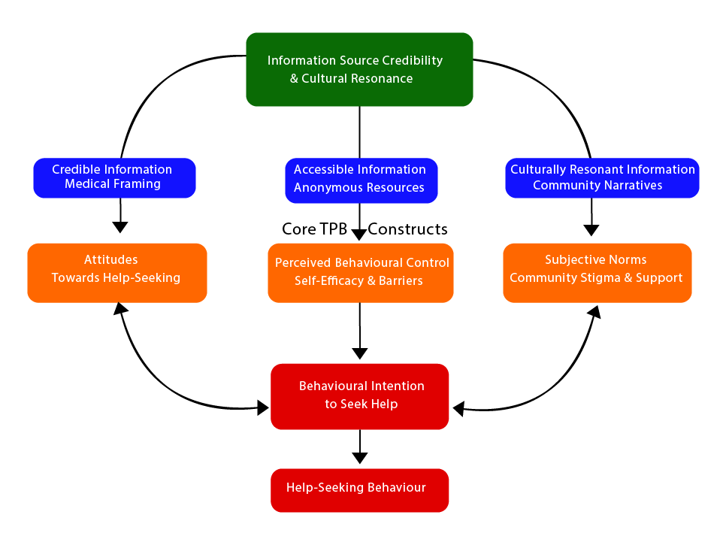
Source: The Integrated Model of Culturally-Mediated Health Behaviour
(Author’s work, 2025)

FIG 5. Flow diagram

The standard Theory of Planned Behaviour (TPB) provides a useful but incomplete map for navigating health decisions in contexts rich with cultural nuance. Our research in Niger State revealed a critical missing piece: the map is useless if you don't trust the cartographer. This insight led to the development of the Integrated Model of Culturally-Mediated Health Behaviour.
This model elevates the sources of information from background noise to central actors. It introduces the construct of "Information Source Credibility & Cultural Resonance," recognising that a message about postpartum depression is received differently when it comes from a medical professional versus a community elder, a social media feed, or a family member. The power of a message is inextricably linked to the perceived trustworthiness and cultural congruence of its messenger.
The model's sophistication lies in its differential pathways. It does not assume all good information has the same effect. Instead, it proposes that distinct types of sources target specific psychological levers:
Credible, clinical sources (like healthcare providers) are uniquely equipped to reshape personal Attitudes, directly challenging misconceptions by reframing PPD as a medical condition rather than a spiritual affliction.
Culturally resonant sources (like religious leaders or indigenous radio dramas) possess the social legitimacy to directly engage and reconfigure Subjective Norms. They can transform community conversations, reducing stigma and creating new, supportive social expectations.
Accessible, anonymous sources (like social media) empower an individual's sense of agency, directly strengthening Perceived Behavioural Control by offering private, on-demand knowledge that makes seeking help feel more feasible.
The most transformative element of this model is its reimagining of Subjective Norms not as a static barrier, but as a dynamic, changeable force. We propose a reciprocal relationship between norms and intention. While existing stigmas undoubtedly suppress help-seeking (the standard TPB view), our model shows that a strengthened intention fueled by the right information from the right sources can empower individuals to challenge the status quo. This creates a virtuous cycle: as more women, influenced by these strategic communications, begin to seek help, they themselves become living proof that challenges the old stigma, thereby gradually rewriting the social narrative itself.
In essence, this model moves beyond simply telling people what to do. It provides a blueprint for how to ethically and effectively change the social and informational environment in which they make their decisions. It argues that sustainable change in maternal mental health requires not just educating women, but orchestrating a coherent, multi-voiced campaign that synergises clinical authority, cultural wisdom, and private access to knowledge to empower individual agency and transform community culture.
Empirical Implication
This research provides actionable evidence that public health initiatives cannot treat all information channels as equal. To effectively combat postpartum depression, interventions must strategically prioritize and invest in credible healthcare providers as the primary educators, while simultaneously leveraging the unique strengths of social media for empowerment and community radio for cultural persuasion. This targeted, multi-source approach is empirically shown to be essential for building knowledge and dismantling the stigma that prevents help-seeking.
Broader Policy Implications
The results advocate for a fundamental shift in how maternal mental health is integrated into public health strategy. Three core policy principles emerge:
1. Integration of Mental Health into Primary Maternal Care: The unparalleled influence of healthcare providers underscores that maternal health consultations are the most critical touchpoint for PPD intervention. Policy must therefore move beyond a siloed approach and mandate the systematic integration of mental health education and routine, culturally-appropriate screening into all antenatal and postnatal care protocols. This aligns directly with the pursuit of SDG 3 (Good Health and Well-being) by addressing a critical determinant of maternal and infant health.
2. Adoption of a Culturally Syncretic Communication Model: The effectiveness of indigenous media and the limitations of impersonal broadcasts call for a strategic pivot in health communication. Public health campaigns must adopt a model that deliberately blends biomedical knowledge with culturally resonant communication forms. This involves co-designing messages with communities, not just for them, leveraging trusted channels like community radio and religious leaders to reframe PPD as a treatable condition rather than a spiritual affliction.
3. Leveraging Multi-Platform Digital and Traditional Outreach: Given the significant impact of social media and radio, policy must recognize and invest in a diversified media strategy. This entails officially endorsing and funding the use of these platforms for targeted, evidence-based PPD awareness campaigns to reach women across urban and rural divides, and of different age groups.

Conclusion
Social media, radio, newspapers, and healthcare providers have all played a major role in raising awareness of postpartum depression, while family, friends, and television have had less impact. These findings are in line with other research that emphasises the credibility of professional healthcare sources and the increasing role of digital media in health communication. Optimising these information channels is very crucial to ensuring that accurate and easily accessible content reaches the intended audience, especially considering the growing concerns around postpartum depression and its implications on the health of mothers and children. It is possible to greatly increase awareness of postpartum depression and, eventually, improve maternal mental health outcomes in Nigeria by utilising technology, improving healthcare education, and putting specific legislative measures into place.
Limitations and Future Research
This study is limited to a cross-sectional design. Future research should examine the long-term impact of culturally sensitive risk communication strategies and compare their impact across several regions in Nigeria to determine what constitutes the most effective method for handling PPD.

Recommendations For Practice and Policy
To translate these policy principles into tangible action, the following specific measures are recommended:
For Healthcare Systems:
1. Mandate Routine Screening: The Niger State Ministry of Health should issue guidelines mandating the use of validated, context-adapted tools like the Edinburgh Postnatal Depression Scale (EPDS) during routine 6-week postnatal check-ups and at key antenatal visits.
2. Build Capacity of Frontline Providers: Implement mandatory training programs for nurses, midwives, and community health extension workers (CHEWs) on PPD identification, patient-centred communication, and the delivery of brief psychosocial interventions.
3. Develop Integrated Educational Materials: Create standardised, pictogram-based educational materials on PPD in local languages for distribution in antenatal clinics, ensuring every expectant and new mother receives clear information.
For Public Health Communication:
1. Launch Co-Designed Media Campaigns: Partner with local radio stations, social media influencers, and cultural storytellers to produce and broadcast serialised dramas (e.g., Hausa radio dramas) and social media content that depict relatable stories of PPD and recovery.
2. Engage Religious and Traditional Institutions: Formally engage with bodies like the Jama'atu Nasril Islam (JNI) and the Christian Association of Nigeria (CAN) to train religious leaders on PPD, encouraging them to incorporate de-stigmatising messages into sermons and community talks.
3. Revitalise Television Content: Rather than abandoning television, public health officials should work with broadcasters to develop engaging talk shows and public service announcements that feature healthcare professionals and community leaders discussing maternal mental health
For Community and NGO Action:
1. Establish Community Support Networks: NGOs should facilitate the creation of peer-support groups for new mothers, providing a safe space for sharing experiences outside of familial pressures, thereby creating new, positive subjective norms.
2. Implement Family-Centred Education: Develop community-based awareness programs specifically designed for the wider family unit, educating husbands, mothers-in-law, and other relatives on how to recognize PPD and provide appropriate support, thereby transforming informal networks from a barrier into an asset.
Conflict of Interest
There is no conflict of interest among authors; all authors consent to the submission of this article.
Informed Consent
Participants for the study were duly informed, gave their consent, and were presented with a consent form before participating in the study.

COMPETING INTERESTS DISCLAIMER:
Authors have declared that they have no known competing financial interests OR non-financial interests OR personal relationships that could have appeared to influence the work reported in this paper.
References
Adegboyega, O. A. (2022). "The Influence of Communication and People’s Perception Towards Postpartum Depression in Yoruba Land, South West, Nigeria" Ogun State Institute of Technology, Igbesa Academic Staff Union of Polytechnic (ASUP), 2022 Journal of Contemporary Issues on Innovations (JCII) First Edition, Issue 1, August 20220058.
Abdulmalik, J., Kola, L., & Gureje, O. (2016). Mental health system governance in Nigeria: challenges, opportunities, and strategies for improvement. Global Mental Health, 3, e9.
Ajzen, I. (1985). From intentions to actions: A theory of planned behaviour. Action control (pp. 11- 39): Springer. Ajzen, I. (1991). The theory of planned behaviour. Organizational behaviour and human decision processes, 50(2), 179.
Aluko, A. G. A., Oyesomi, K., Amodu, L., Adesina, E., & Omole, F. (2024). The Impact of Online Information Seeking Behaviour and Quality Healthcare of Women During Pregnancy.
Ben-Enukora, C. A., Adeyeye, B. K., Adesina, E., Ajakaiye, O. O. P., & Adekanye, O. (2022). Risk communication sources and knowledge of Lassa fever in Nigeria: An impact analysis. Heliyon, 8 (11), e11335. https://doi.org/10.1016/j.heliyon.2022.e11335
Burgener, A. M. (2020). Enhancing communication to improve patient safety and increase patient satisfaction. The health care manager, 39(3), 128-132.
Finset, A., Bosworth, H., Butow, P., Gulbrandsen, P., Hulsman, R. L., Pieterse, A. H., & van Weert, J. (2020). Effective health communication–a key factor in fighting the COVID-19 pandemic. Patient education and counselling, 103(5), 873.
Fisher, J., Mello, M. C. D., Patel, V., Rahman, A., Tran, T., Holton, S., & Holmes, W. (2012). Prevalence and determinants of common perinatal mental disorders in women in low- and lower-middle-income countries: a systematic review. Bulletin of the World Health Organization, 90, 139-149.
Jaiyeola, B. O., & Abdulrazaq, O. O. (2022). Knowledge and attribution of postpartum depression by nursing mothers attending Federal Medical Centre, Yola, Adamawa State, Nigeria. Journal of Professional Counselling, 5(2), 270-279.
Lundgren, R. E., & McMakin, A. H. (2018). Risk communication: A handbook for communicating environmental, safety, and health risks. John Wiley & Sons.
Meadows, M., & Foxwell, K. (2011). Community broadcasting and mental health: The role of local radio and television in enhancing emotional and social well-being. Radio Journal: International Studies in Broadcast & Audio Media, 9(2), 89-106.
National Population Census (2023). https://nationalpopulation.gov.ng/O'Hara, M. W., & McCabe, J. E. (2013). Postpartum depression: current status and future directions. Annual review of clinical psychology, 9(1), 379-407.
Obioha, E. G., Balogun, M. R., Olubodun, T., & Okafor, I. (2021b). Knowledge, Attitude, and Prevalence of Postpartum Depression among Postnatal Mothers in Southwest Nigeria. African Journal of Health Sciences, 34(6), 779-792.
O'Hara, M. W., & McCabe, J. E. (2013). Postpartum depression: current status and future directions. Annual review of clinical psychology, 9(1), 379-407.
Omale, G. E., & Asemah, E. S. (2024). Communication Relationship Between Physicians and Post-partum Depressed Mothers in Select Public and Private Hospitals in Minna, Niger State, Nigeria. GVU Journal of Research and Development. Vol. 1, No. 1, April 2024, Maiden Edition. Retrieved from http://repository.futminna.edu.ng:8080/jspui/handle/123456789/27882

Omale, G. E., Ijei. J. I., Emejor, B., Odunfa, E. O., Dagaci, M. S. K., & Ibiwoye, S O. (2024). Healing Through Dialogue: Exploring Culturally Sensitive Physician-Patient Communication in Urban and Peri-urban Minna, Niger State, Nigeria, for Addressing Postpartum Depression. Journal of Global Research in Education and Social Science, 18(4), 89-102. ISSN: 2454-1834.
Sawyer, A., Ayers, S., & Smith, H. (2010). Pre and postnatal psychological well-being in Africa: a systematic review. Journal of Affective Disorders, 123(1-3), 17-29.
Tefera, Y., Dagne, Ali, A., Chanie, & Woldearegay, A., Gebru. (2024). A Study on communication practices in reducing non-communicable diseases in Bahir Dar City, Ethiopia-PMC. Retrieved May 24, 2024, from https://www.ncbi.nlm.nih.gov/pmc/articles/PMC11005850/
Tsiga-Ahmed, F. I. I.., Umar, M. U., Adamu, A. L., Sulaiman, S. K., Gboluwaga, A. T., Jalo, R. I., ... & Galadanci, H. S. (2024). Incidence of postpartum depression among women with postpartum hemorrhage in Kano, northern Nigeria. npj Women's Health, 2(1), 32
Turner, J., & Friesen, S. (2024). Mapping education leadership of mental health promotion in one school district in British Columbia: A strength-based case study—ScienceDirect. Retrieved May 24, 2024, from https://www.sciencedirect.com/science/article/pii/S2773233924000056
Wang, T., & Pavelko, R. (2024). Increasing social support for women via humanising postpartum depression. Health Communication, 1-11.
World Health Organisation. (2017). Recommendations. In Communicating risk in public health emergencies: A WHO guideline for emergency risk communication (ERC) policy and practice [Internet]. World Health Organisation. Retrieved from https://www.ncbi.nlm.nih.gov/books/NBK540733/.

Zou, W., Huang, L., & Zhang, N. (2024). Support-Seeking Strategies, Family Communication Patterns, and Received Support Among Chinese Women with Postpartum Depression: A Content Analysis of Zhihu Posts. Health Communication.

.

