Assessing the Viability of Nigeria's Energy Transition: Analyzing Challenges, Policy Initiatives, and Future Prospects.

Abstract
This paper made an attempt to critically assess Nigeria's energy transition from a fossil fuel dependent energy system to a renewable energy source. The topic is of utmost significance in the field of energy security as it offers valuable insights government officials, Civil society organizations, academicians and other relevant stakeholders in the area Energy studies. The primary aim is to identify challenges, policy initiatives and future opportunities with regards to Nigeria's energy transition. The research utilizes the qualitative research approach, through the usage of analysis in the presentation and interpretation of data. The research concludes that Nigeria possess abundant of renewable energy sources in her domain which could be used to achieve carbon neutrality by 2060.

- Introduction
Energy transition from a fossil fuel based system of production and consumption to a renewable energy sources is a new normal for most countries of the globe, having affordable and clean energy is one of the goals of Sustainable development goals, which is Goal 7 of the sustainable development goals. One of the factors that made Nigeria to establish a commission on energy transition is the 2021 United Nations Climate Change Conference, more commonly referred to as COP26, this was the 26th United Nations Climate Change conference, held at the SEC Centre in Glasgow, Scotland, United Kingdom, from 31 October to 13 November 2021, one of the aim of the COP26 was to make countries to become fully committed to the reduction of greenhouse gases emission in other to manage climate impact. Different countries aims to achieve carbon neutral in some coming years i.e China aims to become carbon neutral by 2060, European union by 2050, India by 2070 (Frayer, 2021)
Furthermore, At COP26, the former President of Nigeria, Muhammadu Buhari announced Nigeria’s commitment to carbon neutrality by 2060, after outlining the effort of achieving this program by 2060, the Nigerian parliament signed the climate change act 2021 which resulted in unveiling of the national energy transition plan (ETP). (Nigeria Energy Transition Plan, 2022). This national energy Transition plan is a gateway to reduction of carbon emission and to power development. The Nigeria ETP sets out a timeline and framework for the attainment of emissions’ reduction across five key sectors as follows: Power, Cooking, Oil and Gas, Transport and Industry.
Nevertheless, there are various literatures that are published in this area, some vital ones will be discussed as follows, One relevant article is Global energy transition and its implications on energy security in Nigeria : A critical review published by Isah Samaila Nitte. The paper discusses the need for energy diversification for a plethora of renewable energy potential while emphasizing the need for energy equity as the country improves the adoption of natural gas as its transition fuel. (Nitte, 2023). Also, Nwozo et al (2021) undertakes a systematic appraisal of the subsisting opportunities, pitfalls and dilemmas surrounding Nigeria's quest for alternative clean energy development. The authors argued that despite Nigeria's pledge in different international fora on renewable energy and carbon reduction, Nigeria is yet to begin its journey of energy transition.
In addition, In the course of this research, the qualitative method of research was employed, through the usage of policy analysis in the presentation and interpretation of data. Moreover, the gathered information underwent rigorous analysis that is data analysis, which is a technique for an objective, systematic and qualitative examination of the acquired data.
- Overview of Energy in Nigeria
Nigeria is one of the energy giants in Africa due to its abundance of natural resources. According to Enerdata, Nigeria account for 3% of Liquefied Natural Gas export worldwide, and it’s the second crude oil producer in Africa, and Nigeria possessed the ninth proven gas reserve in the world. Other energy that Nigeria produces are, lignite, bitumen, tar sands hydroelectric power, and biomass. As a result, the country has been able to generate significant revenue from energy exports and the development of local industries. However, despite all the abundance of this energy resources Nigeria is facing energy supply crises, which is the inability of the country to provide energy to its population, in the area of electricity supply, only 45% of Nigeria's population is connected to the energy grid whilst power supply difficulties are experienced around 85% of the time and almost nonexistent in certain regions (Aliyu, Ramli, Saleh, 2013). Which means others that tend to have electricity resort to sourcing it by the usage of generators powered by diesel.

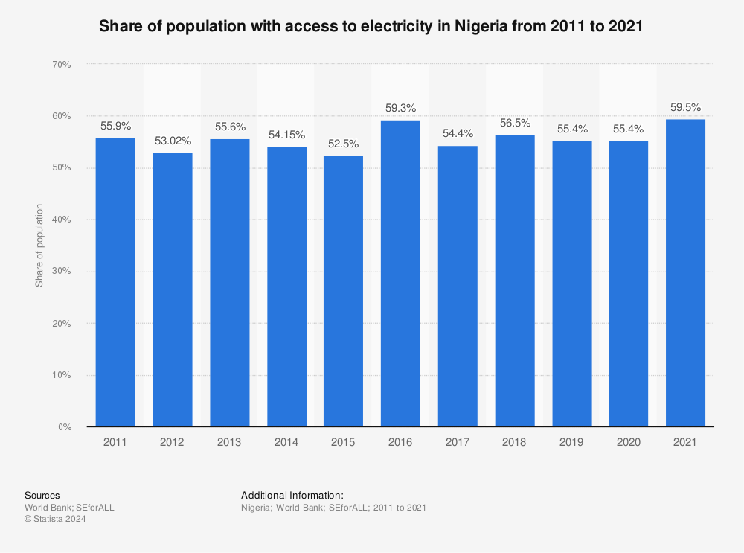Fig 1: Share of population with access to electricity in Nigeria from 2011-2021(Statista, 2024).
Essentially table one shows the share of Nigeria's populace that have access to electricity from 2011-2021, over this eleven years period the percentage of the number with access to electricity fluctuates from 52.5% to 59.5, the lowest time was in 2015 with 52.5% while the highest time was in 2021 with 59.5% having access to electricity. According to macrotrend Nigeria's population as at 2011 was 165,463,745 people while at 2021 Nigeria have 213,401,323 people. This clearly shows that there is an increase regarding populace that have access to electricity in the country from 2011-2021 as shown in figure one.
The energy situation in rural areas is particularly dire, with more than 70% of rural dwellers relying on fuel wood (firewood) as their primary source of energy particularly in cooking of food. This has led to deforestation and desertification of the arid zone, as well as erosion in the southern zone, where firewood is used for both domestic and commercial purposes. (Abdallah and odeleke, 2023)
- Challenges in Nigeria's Energy Transition
One of the challenges of energy transition in Nigeria is inadequate funds, the state and domestic private investors lack the desired fund needed in realizing of this transition. Transition from a fossil fuel source foam of energy to a renewable source foam of energy is expensive that requires huge funding. According to United Nations conference of trade and investments (UNCTD) Achieving the energy transition is projected to cost about $5.8 trillion annually from 2023 to 2030 for the 48 developing economies studied, equal 19% of their GDP. According to Nigeria Energy Transition plan $1.9 Trillion is required to get to Net Zero by 2060, including $410 Billion above projected usual spending, this additional cost translates to about $10 billion annually. Nevertheless, in the 2024 budget of Nigeria with a total expenditure of ₦27.50 trillion, only ₦20,000,000 was budgeted for Development and management of Energy transition plan and Management of Net zero Emissions target each. (Budget office, 2024). The total budget of the country was ₦27.50 trillion while specifically Development and management of Energy transition plan as an agency of the government and Management of Net zero Emissions target as agency of the government as well were budgeted ₦20,000,000 each for their operations, this amount is very small for such an important organizations, despite the paucity of funds, the country needs to raise more funds to this agencies for a smooth transition by the target time.
Technological know how barrier: Another key Challenge is lack of technological know how and expertise to produce the necessary equipment needed for the transition to renewable energy, the tools and equipment are mostly produced in industrialized nations, therefore, Nigeria has to import this equipment and tools which poses a great challenge to the country. (Hachimenum, A & Onyebuchi, 2024). The technological know how deficit in Nigeria is due to lack of Research and development (R&D), though this is a general problem in most of global south countries, since Nigeria cannot developed the technological tools needed in this transition, the next option is to seek for technological transfer from industrialized nations, this option itself is a barrier because this industrialized nations will not transfer their technology to another country unless they have a great interests in the other state.
Lack of policy continuity: Another key challenge to Nigeria energy transition plan is lack of policy continuity and implementations by a successive government. The key target is to achieve net zero emission by 2060, however, a President that might not prioritize the transition plan as part of his agenda might abandon the transition plan in the future or will be dealing with the transition effort issue with less relevance, and this will surely undermine the effort in realizing the goal.
Population growth: According to worldometers the current population of Nigeria is 228,394,504 as of 2024, based on Worldometer elaboration of the latest United Nations data, which is equivalent to 2.78% of the total world population, and with 2.4% growth rate per annum. This data places Nigeria as a powerhouse of population in Africa and the world at large. Meanwhile in the course of transitioning to renewable energy, Nigeria must as a matter of importance be conscious of her population growth rate which is a barrier to the transition, because more population equals to more provision of resources.
- Policy initiatives
Climate change act: Former President Muhammad Buhari signed the climate change bill on 18th, November, 2021. According to Udoma and Osagie (2021) the CCA main aim is to develop and implement apparatus that will foster low carbon emission and develop a sustainable environment in the country, the CCA establishes the National Council on Climate Change, this council is vested with the powers to develop policies and make decisions on all matters concerning climate change in Nigeria. In addition, the Act is expected to provide ways that will make sure that climate change policies and actions are integrated with related policies to promote economic, political and social as well as environmental development.
Nationally determined contributions: According to article 4 of the Paris agreement, it requires all attending state to prepare and communicate their plans towards climate change mitigation and greenhouse gas emissions reduction. Nigeria prepared and communicated her first plan in the year 2015, and later updated it in the year 2021, it outlines measures, plans, strategies, and actions proposed by the Federal Government of Nigeria towards greenhouse gas emissions reduction and climate change mitigation. (Dike, 2023)
National Renewable Energy & Energy Efficiency Policy (NREEEP): The Nigerian government released NREEEP in 2015, This National Policy provides for improving energy supply across the country and utilization of renewable energy sources, shifting from the thought and consideration that rural areas are remote and have a little demand for power and depend on off-grid energy solutions, as the economies of on-grid deployment do not favor rural electrification. Moreover, the Policy acknowledges that Nigeria is endowed with abundant renewable energy resources such as average of 9 hours of sunlight daily, hydro, biomass, and, to a lesser degree, wind, energy. Despite all this, there has not been a nationally acceptable renewable energy and energy efficiency policy drawn out to harness these resources to improve energy access in the country. (Ministry of power, 2024)
Nigeria Energy Transition plan: In August 2022, Nigeria launched the Nigeria Energy Transition Plan (NETP), which espoused the country’s pathway to achieving net-zero GHG emissions by 2060. The 2060 timeline is very fascinating because it portrays a middle point of the 2050-2070 timeline set by the 2021 Climate Change Act. The Plan demonstrates Nigeria’s readiness to play a leading role in facilitating a just and equitable climate future for Africa, particularly in articulating the transition strategy and mobilizing climate financing for the country and the rest of Africa. In addition, the NETP has been described as a home-grown, data backed, multi-dimensional strategy to achieve net-zero emissions by 2060 (NETP, 2024). It succinctly articulated Nigeria’s climate change commitment and the decarbonisation pathway. The plan identified power, cooking, oil and gas, transport, and industry as the sectors that will drive Nigeria’s unconditional decarbonisation agenda through energy consumption adjustment. (Dike, 2023)
5. Conclusion and Future Prospects
Nigeria has the necessary resources needed in the area of energy transition, the key fuel to be use is Liquefied natural gas which is also a fossil fuel, but it’s cleaner and produces lesser sulfur and carbon dioxide into the atmosphere (NETP, 2024). Nigeria has abundance of liquefied natural Gas in its domain, so therefore, Nigeria should as a matter of fact developed and harness its LNG for it local usage. Also Nigeria is blessed with abundance of solar energy potential due to its sunshine intensity, so, the country can make use of this natural opportunity to provide more energy to the citizens by investing in solar power plant.
In addition, another prospects for countries like Nigeria that are Intending of energy transition is that, the mass adoption and mass production of renewable energy tools like solar panels, batteries, inverters, wind energy tools are becoming less expensive, therefore it's an opportunity for Nigeria to purchase the necessary tools needed in its energy transition.
Also, the Ukrainian conflict has made some European state to start diversifying from purchasing Russian Fossil fuel, and Nigeria as one of the top producers of fossil fuel in the globe, can leverage it resources in getting the required tools, techniques and expertise needed in the transition and improvements of energy in its domain.
In addition, Nigeria can assess loans and grants from international organizations and foreign countries, since the issue of energy transition is an important issue in the plate of most countries and international organizations, they will quickly issue loan to Nigeria with respect to energy transition.
Also, another prospect is that Nigeria as a state that stick to American capitalism should encourage individuals to invest their money in provision of renewable energy plant such as solar power plant and so on and so forth.

Reference
Aliyu, A., Ramli, A., Saleh, M. (2013). Nigeria electricity crisis: Power generation capacity expansion and environmental ramifications. Energy, 61(8), 354-3
Abdullah, A.A, Odaleke, O.B (2023) Energy Security in Nigeria: Challenges and Prospects, journal of Arid zone economy.
Akuru, Udochukwu & Onukwube, Ifeanyichukwu & Okoro, O.I. & Obe, Emeka. (2017). towards 100% renewable energy in Nigeria. Renewable and Sustainable Energy Reviews.
Budget office (2024) https://www.budgetoffice.gov.ng/index.php/2024-appropriation-bill
Dike, O.C (2023) Framing Nigeria’s Energy Transition Strategy: Imperative of an Overarching Policy Direction
Frayer. L (2021) India pledges net-zero emissions by 2070 — but also wants to expand coal mining, https://www.npr.org/2021/11/03/1051805674/modi-india-cop26-coal-renewable-energy?t=1636899927203
Energy transition Plan (2024) https://www.energytransition.gov.ng/#Plan
Ministry of Power (2024) http://admin.theiguides.org/ Media/Documents/NEWER
Macrotrend (2024) https://www.macrotrends.net/global-metrics/countries/NGA/nigeria /population
Nigeria Energy Transition plan, (2024) https://www.energytransition.gov.ng/#Plan
Nitte, S. I (2023) GLOBAL ENERGY TRANSITION AND ITS IMPLICATIONS ON ENERGY SECURITY IN NIGERIA: A CRITICAL REVIEW, International Journal of Climate and Resource Economic Review.
Nwedu, Cosmos. (2020). Will a Transition to Renewable Energy Promote Energy Security Amid Energy Crisis in Nigeria
Nwozor, A, Oshewolo S, Owoeye, G, Okidu, O (2021) Nigeria's quest for alternative clean energy development: A cobweb of opportunities, pitfalls and multiple dilemmas.
United Nations (2021) Theme report on Energy transition towards the achievement of SDG7 and Net Zero Emissions.
United Nations Conference on trade and development (2024) https://unctad.org/sdg-costing/energy transition
Statista, (2024) https://www.statista.com/statistics/1307416/total-population-access-to-electricity-in-nigeria/
World Bank Group (2022) Nigeria's choice, Nigeria Development Update
Worldometers (2024) https://www.worldometers.info/world-population/Nigeria population /
Udoma, U and Osagie, B (2021) The climate change act 2021: key points for consideration.
Hachimenum, A & Onyebuchi, I (2024). Renewable Energy in Nigeria: Prospects and Challenges.

