Original Research Article
Comparative effects of Crude Ethanol Zapoteca portoricensis Leaf Extract and its Fractions on Some Kidney Markers in Formalin-Induced Inflammation in Rats

ABSTRACT
This study evaluated the comparative nephroprotective potential of crude ethanol extract of Zapoteca portoricensis leaf and its fractions in formalin-induced inflammation in Wistar rats. Leaves were harvested, authenticated, dried, macerated in ethanol, and fractionated with n-hexane and ethanol. Acute toxicity (LD₅₀) was assessed in mice, and the n-hexane fraction showed the highest bioactivity. Wistar rats were divided into Normal Control, Negative Control, Standard Control, and the Treatment groups. Serum kidney markers (urea, creatinine) and electrolytes (Na⁺, K⁺, Ca²⁺, HCO₃⁻) were measured using standard biochemical methods. Negative Control showed significantly elevated urea and creatinine and disrupted electrolyte balance. Treatment with the n-hexane fraction (300 mg/kg) normalized renal markers and corrected Na⁺/K⁺ imbalance without acute toxicity. Phytochemical screening revealed abundant flavonoids, alkaloids, tannins, and terpenoids, supporting antioxidant and anti-inflammatory activity. These findings validate the ethnomedicinal use of Z. portoricensis and indicate its promise as a safe plant-based intervention for inflammation-related kidney dysfunction. Further study is recommended on the n-hexane fraction to elucidate its bioactive compounds.
Keywords: Zapoteca Portoricensis, Inflammation, Leaf fractions, Phytochemical constituents, Kidney function markers.

1. INTRODUCTION
Inflammation is one of the body's natural defenses against harmful agents like pathogens, toxins, or physical injury. During acute inflammation, it serves as a crucial defense mechanism for health (Mona and Naomi, 2018). However, prolonged or chemically triggered inflammation can damage tissues and organs. The kidneys, which play a key role in waste removal, fluid balance, and electrolyte regulation, are often affected by inflammation (Guyton & Hall, 2021). Changes in kidney function are usually monitored through biochemical markers such as urea, creatinine, and electrolytes, which provide reliable information about kidney health (Thapa and Walia, 2012).
The formalin-induced inflammation model is widely used in research because it produces a stable, repeatable inflammatory response. When injected into experimental animals, formalin causes both immediate and longer-lasting phases of inflammation that mimic human conditions. It is also known to affect kidney function, altering biochemical markers, making it a valuable model for testing new anti-inflammatory and protective agents (McNamara et al., 2017).
Medicinal plants have been used for centuries to treat diseases. They contain bioactive compounds such as alkaloids, flavonoids, tannins, saponins, and terpenoids, which are responsible for their therapeutic effects (Agbafor et al., 2014). Compared with synthetic drugs, plant-based therapies are often cheaper, more accessible, and have fewer side effects. One such plant is Zapoteca portoricensis (Fabaceae), commonly called “white stick pea.” In Eastern Nigeria, different parts of the plant are traditionally used to treat convulsions, prolonged labor, wounds, skin infections, and inflammatory conditions (Agbafor et al., 2013).
Scientific studies have shown that Z. portoricensis contains many secondary metabolites, including flavonoids, alkaloids, tannins, and saponins. These compounds have been linked with antioxidant, antimicrobial, and anti-inflammatory properties (Ikeyi et al., 2022). Previous findings reported hepatoprotective and antimicrobial effects of the plant, supporting its traditional use. However, despite these reports, little is known about how the fractions of Z. portoricensis leaves affect kidney markers during inflammatory conditions (Nwodo et al., 2017).
This study, therefore, explores the comparative effects of crude ethanol extract of Z. portoricensis leaf and its fractions on various kidney markers, such as urea, creatinine, and electrolytes, in formalin-induced inflammatory rats. The results will help validate its traditional medicinal use and may provide a scientific basis for developing safe plant-based options for protecting the kidneys during inflammation.
2. MATERIALS AND METHODS
2.1 Plant Material
The Zapoteca portoricensis leaf used for this study were harvested from the Zapoteca portoricensis plant located at Dr. Eddy Mougbo’s Farm in Ifite, Awka South Local Government Area, Anambra State, Nigeria. The leaf was authenticated by Mr. Alfred Ozioko of the Bioresources Development and Conservation Programme (BDCP) Research Centre, Nsukka, Enugu State. (Voucher no: InterCEDD/16313). The plant was air-dried and pulverized before analysis.
2.2 Animals
A total of 30 Wistar rats (Rattus rattus) of either sex were procured and housed in the Animal House of the Department of Applied Biochemistry, Faculty of Biosciences, Nnamdi Azikiwe University, Awka. They were housed in six cages containing five rats per cage. The rats were acclimatized for one week before the commencement of the experiment with a 12-hour light and dark cycle and maintained on a regular feed and water ad libitum.
2.3 Equipment and Instruments
Rotary evaporator, (Model 349/2, Corning Ltd, England), Centrifuge (Gallenkamp, Germany) Spectrophotometer (Jeol 400 MHz, Strathclyde Scotland University), glass column chromatography (Pyrex, England), vacuum pump, filter paper, digital photo colorimeter, Olympus microscope, water bath (Chikpas Instrument, Enugu), chemical balance (Gallenkamp, England), micro – pipettes (Perfect, USA), microscope slides, capillary tube. Refrigerator (Haier Thermocool, England), microscope (XSZ–107BN, India), and counting chamber.
2.4 Chemicals and Reagents
All chemicals and reagents used in this study were of analytical grade and were products of May and Baker, England; Merck, Germany; Sigma–Sigma-Aldrich, Germany; British Drug Houses (BDH), UK, and Kieselgel GmbH, Germany. Reagents used for the assays were commercial test Kits and products of Randox, UK, Biovendor, Czech Republic, TECO Diagnostics, USA and Centronic GmbH, Germany, dutasteride (Avodart).
2.5 Preparation and Fractionation of Zapoteca portoricensis Leaf Extract
The leaves of Zapoteca portoricensis were air-dried at room temperature and pulverized into a fine powder using a mechanical grinder. A total of 679.6 g of the powdered material was macerated in 6.8 L of ethanol for 72 hours with intermittent stirring to ensure adequate solvent penetration. The resulting mixture was initially filtered through a muslin cloth, followed by further filtration using Whatman No. 1 filter paper to remove fine residues. The filtrate was concentrated under reduced pressure using a rotary evaporator to obtain the crude ethanol extract.
The crude extract was subsequently subjected to solvent–solvent partitioning using solvents of increasing polarity, including n-hexane and ethanol. Each fraction was concentrated using a rotary evaporator and stored in airtight containers under refrigeration until required for analysis.
2.6 Determination of the percentage yield of the crude extract of Zapoteca portoricensis leaves
The percentage yield of the ethanol extract was determined from the weight of the dried pulverized leaves before maceration and the weight of the crude extracts after concentration, following the formula below;
$$Percentage Yield =\frac{Weight of extract }{Weight of dried pulverized plant } x \frac{100 }{1 }$$

2.7 Acute Toxicity (LD₅₀) Studies
The acute toxicity studies of the crude extract were estimated in mice using the method of Lorke (1983). The tests involved two phases. The first phase was the determination of the toxic range. The mice were placed in three groups of 3 mice each and were given 10, 100, and 1000 mg/kg body weight of the extract solubilized in normal saline. The treated mice were observed for 24 h for the number of deaths. The death pattern in the first phase determined the doses used for the second phase. In the second phase, the mice received 1600, 2900 and 5000 mg/kg body weight of the extract. The treated animals were observed for 24 h for lethality or signs of acute intoxication. Then the LD₅₀ is calculated by the formula:
$LD50= \sqrt{(D_{0}-D_{100})}$
D₀ = Highest dose that gave no mortality, D₁₀₀ = Lowest dose that produced mortality.
The standard drug was administered in line with Li et al. (2017), which proved aspirin to be more effective at (300 mg/kg) than (30mg/kg)
2.8 Fractionation of the extract
The crude extract was fractionated by the separating funnel method using n-Hexane and ethanol, respectively, as solvents, as described by Abdullahi and Mainul, (2020). It began with a complete dissolution of crude extract with 250mL of distilled water. This is followed by transfer into a separating funnel, shaken, and allowed to settle. Furthermore, 250mL of n-hexane, the least polar solvent, was added and shaken. The content settled, and the tap of the separating funnel was opened to remove the aqueous layer. The remaining content in the separating funnel was poured into a clean container to get the n-hexane fraction. An equal volume of n-hexane was added again, shaken, and separated. The process continued until after adding n-hexane and shaking, no reasonable quantity of extract appeared to move into the n-hexane portion. A similar cycle was performed for ethanol.

2.9 Qualitative and Quantitative phytochemical analysis
The qualitative phytochemical analysis was done using the methods of Trease and Evans (1989), while the quantitative phytochemical analysis was done using the method of Harborne (1973). The concentration of the various phytochemical constituents was calculated thus:
$$Concentration (mg/100g) ={\frac{absorbance of the sample}{slope of the standard}}{x \frac{ dilution factor}{1}}$$
$$Dilution factor ={\frac{total volume}{weight of extract}}$$
2.10 Determination of the Electrolytes and Trace element (Calcium ions, magnesium ions, zinc ion and selenium ion) concentration of n-hexane leaf fraction of Zapoteca portoricensis.
Heavy metal analysis was carried out using an Agilent FS240AA Atomic Absorption Spectrophotometer (AAS) as described by Markus et al. (2018). The Standard of each mineral was used to calibrate the machine before the sample was aspirated into the AAS for metal determination.
2.11 Determination of Serum Electrolytes
2.11.1 Determination of Calcium Ion Concentration
Calcium ion (Ca²⁺) concentration was determined using Teco kit as described by Shridhar et al. (2019).

2.11.2 Determination of Magnesium Ion Concentration
Serum Magnesium Ion (Mg⁺) concentration was determined using the Teco kit according to the manufacturer’s protocol.
2.11.3 Determination of Bicarbonate Ions (HCO₃) level
This was done according to the method of Tietz, (1986).
2.12 Determination of Kidney Function Parameters
2.12.1 Determination of Urea Concentration
Urea concentration was determined using the method of Bartels and Bohmer (1972) as described in Randox Kit.
2.12.2 Determination of Creatinine Concentration
The serum creatinine concentration was determined using the method of Bartels and Bohmer (1972) as outlined in Randox kit.
2.13 Animal Grouping
Determination of the effect of crude extract of Zapoteca portoricensis Leaf Extract and its fractions on the formalin-induced inflammation in albino rats. Inflammation was induced on the right hind paw of the rat by a subplantar injection of 0.1 ml of 5 % formalin (dissolved in saline). A total of twenty-eight (30) rats were grouped into 6 of five (5) rats each as follows:

Group 1: Normal Control (NOR)
Group 2: Negative control (NC) (Formalin-induced inflammation in albino rats without treatment)
Group 3: Standard Control (SC) (Formalin-induced inflammation in albino rats treated with 300mg/kg of aspirin) once daily
Group 4: Treatment 1 (T1) Formalin-induced inflammation in albino rats + 300 mg/kg b.w of Crude of Zapoteca portoricensis Leaf Extract once daily
Group 5: Treatment 2 (T2) Formalin-induced inflammation in albino rats + 300 mg/kg b.w. of n-hexane fraction of Zapoteca portoricensis Leaf Extract once daily
Group 6: Treatment 3 (T3) Formalin-induced inflammation in albino rats + 200 mg/kg b.w. of ethanol fraction of Zapoteca portoricensis Leaf Extract once daily
At the end of the experiment, the blood. Data analysis was performed using R software (4.5.1; R foundation for Statistical Computing, Vienna, Austria). Results are presented as mean ± standard deviation (SD). Comparisons among group were evaluated using one-way analysis of variance (ANOVA), followed by Tukey’s post hoc test for multiple comparisons. A p value of <0.05 was considered statistically significant.

3. RESULTS
3.1 The acute toxicity testing of Zapoteca portoricensis leaves crude extract
The acute toxicity test of the crude extract of Zapoteca portoricensis leaves showed no death or adverse effect Zapoteca portoricensis. The LD₅₀ was 5000. This showed the relative safety of the extract at concentration range below 5000 mg/kg body weight
Table 1: The acute toxicity testing of Zapoteca portoricesis leaves crude extract
Phase/Groups | Dosage of extract (mg/kg b.w) | Mortality rate
Phase I
1 | 10 | 0/3
2 | 100 | 0/3
3 | 1000 | 0/3
3.2 Preliminary phytochemical screening
The preliminary phytochemical screening showed that Zapoteca portoricensis Crude extract contained moderate amount of terpenoids and steroid, while alkaloid, flavonoids, tannins, and phenolics were present in high quantity. Saponins were not detected. n-Hexane fraction contained relative amount of saponin and high quantity of alkaloid, flavonoids, terpenoids, tannins, phenolics and steroid. Ethanol fraction contain relative amounts of Tannins, Terpenoids and steroids. Alkaloids and phenol were present at moderate amount while flavonoids were present in high quantity. Saponins were not detected.

Table 2: Qualitative Phytochemical
Phytochemical Constituents | Crude | Hexane | Ethanol
Flavonoid | ++ | +++ |  | ++
Alkaloid | ++ | +++ |  | ++
Phenols | ++ | ++ |  | +++
Terpenoids | +++ | +++ |  | ++
Carbohydrate | + | + |  | +
Tannin | ++ | ++ |  | +++
Protein | + | +++ |  | +
Steroids | ++ | ++ |  | +
Saponin | ++ | +++ |  | ++
Phlobatannin | - | +++ |  | ++
Cardiac glycoside | + | + |  | ++
Anthraquinines | + | - |  | ++
Volatile oils | - | - |  | -
Key:
+++ = Present in high concentration,
++= Present in moderate concentration
+ = Slightly or sparingly present,
- = Absent.

3.3 Effect of Zapoteca portoricensis Extract and Fractions on Kidney Function, Serum Electrolytes, and pH
Formalin-induced inflammation caused a marked disruption in renal function markers compared with the normal control (NC) group, as evidenced by elevated serum creatinine and urea levels in the negative control (NOR) group. Treatment with Zapoteca portoricensis extracts and fractions significantly modulated these parameters (p < .05). Among the treatment groups, the n-hexane fraction (T2) produced the greatest reduction in serum creatinine (7.94 ± 3.54 mg/dL) compared with the NOR group (11.15 ± 6.39 mg/dL), approaching values seen in the normal control group (12.70 ± 1.39 mg/dL). Similarly, urea concentration increased in the NOR group but was notably reduced following treatment, particularly in the crude extract (T1) and n-hexane fraction (T2) groups, indicating improved renal clearance.
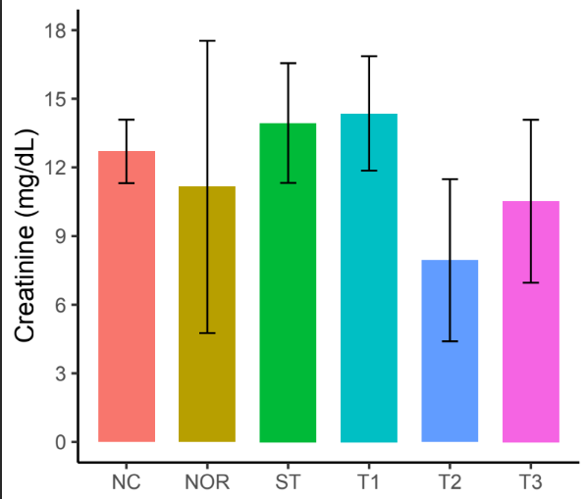
Fig. 1: Effect of Zapoteca portorecensis Crude Extract, n-Hexane and Ethanol Fraction on the Serum Creatinine level

Bicarbonate (HCO₃⁻) levels, which decreased in the NOR group (18.84 ± 4.27 mg/dL), were restored to near-normal levels in the treated groups (p < .05), reflecting stabilization of acid–base balance. Chloride (Cl⁻), sodium (Na⁺), and potassium (K⁺) concentrations exhibited no statistically significant deviations among the treatment and control groups, suggesting that electrolyte regulation was largely preserved following extract administration.
Serum total calcium (Tcal) and pH values remained within physiological limits (7.32–7.40) across all groups, indicating no acid–base disturbances. Overall, the n-hexane fraction (T2) demonstrated the most pronounced nephroprotective and homeostatic effects, suggesting that nonpolar phytoconstituents of Z. portoricensis may contribute significantly to the observed restoration of renal function and electrolyte equilibrium in formalin-induced inflammation.

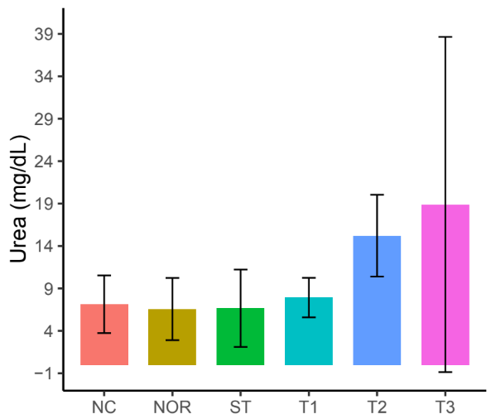
Fig. 2: Effect of Zapoteca portorecensis Crude Extract, n-Hexane and Ethanol Fraction on the Serum Urea Level

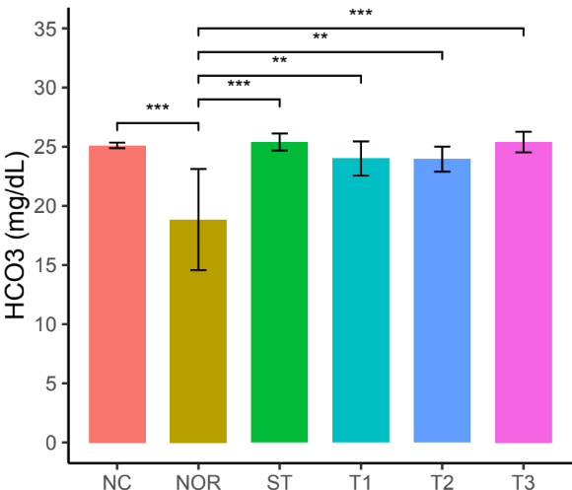
Fig 3: Effect of Zapoteca portorecensis Crude Extract, n-Hexane and Ethanol Fraction on the Serum Bicarbonate ion level

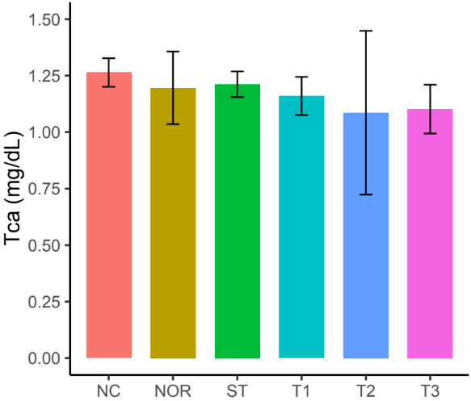
Fig. 7: Effect of Zapoteca portorecensis Crude Extract, n-Hexane and Ethanol Fraction on the Serum Total Calcium ion level

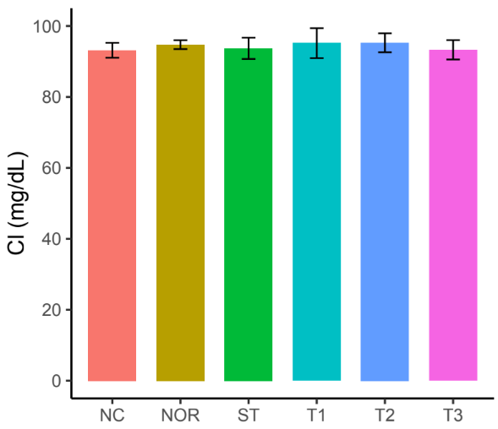
Fig. 4: Effect of Zapoteca portorecensis Crude Extract, n-Hexane and Ethanol Fraction on the Serum Chloride ion level

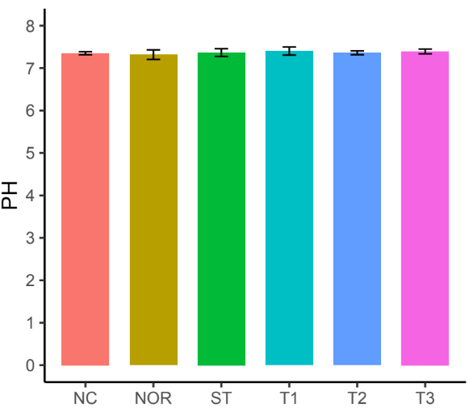
Fig. 8: Effect of Zapoteca portorecensis Crude Extract, n-Hexane and Ethanol Fraction on the Serum pH level

Fig. 5: Effect of Zapoteca portorecensis Crude
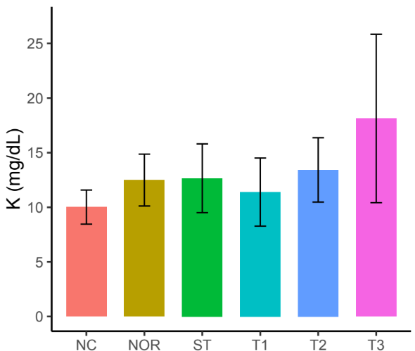
Fig. 5: Effect of Zapoteca portorecensis Crude Extract, n-Hexane and Ethanol Fraction on the Serum Potassium ion level

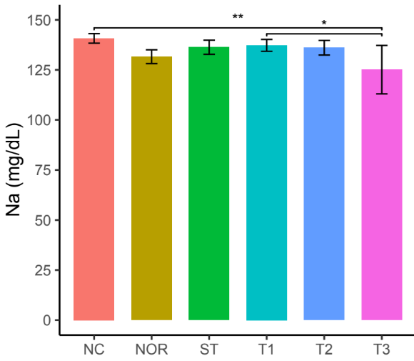
Fig. 6: Effect of Zapoteca portorecensis Crude Extract, n-Hexane and Ethanol Fraction on the Serum Sodium ion level

Table 3: Effect of Zapoteca portorecensis Crude Extract, n-Hexane and Ethanol Fraction on the Kidney Function Markers, Serum Electrolytes Levels and Serum pH of formalin -Formalin-Induced Inflammation in albino rats
Groups | Creatinine (mg/dL) | Urea (mg/dL) | HCO₃⁻ (mg/dL) | CL⁻(mg/dL) | K⁺ (mg/dL) | Na⁺ (mg/dL) | Tcal (mg/dL) | pH
NC | 12.70±1.39 | 7.14±3.40 | 25.10±0.24 | 93.14±2.11 | 10.02±1.56 | 140.74±2.38 | 1.26±0.06 | 7.35±0.03
NOR | 11.15±6.39 | 6.57±3.67 | 18.84±4.27 | 94.74±1.25 | 12.49±2.37 | 131.60±3.45 | 1.20±0.16 | 7.32±0.11
ST | 13.94±2.62 | 6.67±4.56 | 25.39±0.72 | 93.70±2.99 | 12.66±3.15 | 136.30±3.52 | 1.21±0.06 | 7.39±0.09
T1 | 14.36±2.50 | 7.93±2.33 | 23.99±1.45 | 95.16±4.22 | 11.39±3.12 | 137.26±2.96 | 1.16±0.08 | 7.40±0.09
T2 | 7.94±3.54 | 15.23±4.82 | 23.95±1.06 | 95.26±2.68 | 13.42±2.95 | 136.06±3.66 | 1.09±0.36 | 7.36±0.04
T3 | 10.52±3.56 | 18.90±19.75 | 25.39±0.87 | 93.28±2.73 | 18.13±7.71 | 125.12±12.12 | 1.10±0.11 | 7.39±0.05
Results are presented as means ± SD (n=5).
Mean values with different lower-case letters as superscript down the column are considered significant at p < 0.05
NC: Negative control - (Formalin-induced inflammation in Albino rats - without treatment)
NOR: Normal Control - (Received clean water and normal feed)
SC: Standard Control - (Formalin-induced inflammation in albino rats treated with 300mg/kg of aspirin) once daily
T1: Treatment one - Formalin-induced inflammation in albino rats + 300 mg/kg b.w of Crude of Zapoteca portorecensis Leaf Extract once daily
T2: Treatment two - Formalin-induced inflammation in albino rats + 300 mg/kg b.w. of n-hexane fraction of Zapoteca portorecensis Leaf Extract once daily
T3: Treatment one - Formalin-induced inflammation in albino rats + 300 mg/kg b.w. of ethanol fraction of Zapoteca portorecensis Leaf Extract once daily

4. DISCUSSION
Discussion
The present study investigated the effect of Zapoteca portoricensis crude extract and its solvent fractions on renal function markers, serum electrolytes, and pH in formalin-induced inflammation in albino rats.
The absence of acute toxicity at high doses suggests that Z. portoricensis is relatively safe and could serve as a basis for developing affordable, plant-based alternatives for managing inflammation-related renal dysfunction. These findings support and extend traditional uses of the plant in ethnomedicine, particularly in the treatment of inflammatory conditions (Agbafor, Nwachukwu & Ezeani, 2013).
Formalin administration markedly altered kidney function indices, as reflected by elevated creatinine and urea concentrations in the negative control (NC) group compared with the normal control (NOR). These elevations indicate impaired glomerular filtration and accumulation of nitrogenous wastes, which are hallmark indicators of renal dysfunction secondary to inflammatory or oxidative stress injury (Kaur et al., 2023; Kadatane et al., 2023).
Treatment with the crude extract (T1), n-hexane fraction (T2), and ethanol fraction (T3) modulated these parameters toward normal values, suggesting amelioration of formalin-induced nephrotoxicity. Among these, the n-hexane fraction produced the most significant improvement in kidney function, as evidenced by its ability to reduce serum creatinine (7.94 ± 3.54 mg/dL) and normalize urea levels relative to the NC group. This finding suggests that the bioactive nonpolar constituents—likely terpenoids, fatty acids, and alkaloids previously identified in Z. portoricensis extracts—may exert protective effects through anti-inflammatory and antioxidant mechanisms (Ogunwande et al., 2019; Ajayi et al., 2022).
Electrolyte balance plays a central role in maintaining renal and systemic homeostasis. Formalin-induced inflammation typically leads to ionic imbalance due to altered renal tubular reabsorption and oxidative injury to nephron membranes (Gupta et al., 2021). In the present study, chloride, sodium, and potassium levels remained relatively stable across treatment groups, suggesting that Z. portoricensis extracts preserved electrolyte homeostasis. Restoration of bicarbonate levels in treated groups compared with the NC group further supports the protective effect of the plant fractions on acid–base regulation.
Serum calcium and pH values remained within the physiological range (7.32–7.40), indicating no acid–base disturbance or metabolic acidosis. Maintenance of these parameters may be attributed to the stabilization of renal function and reduction of systemic oxidative stress, as supported by the antioxidant properties of Z. portoricensis reported in earlier studies (Nwodo et al., 2017; Adebayo et al., 2018).
The observed nephroprotective effects of Z. portoricensis, particularly the n-hexane fraction, could be linked to its high content of lipophilic compounds capable of modulating inflammatory signaling pathways and scavenging reactive oxygen species (ROS). Oxidative stress plays a critical role in the pathophysiology of formalin-induced renal injury by enhancing lipid peroxidation and inflammatory cytokine release (Lobo et al., 2010; Kadatane et al., 2023). Therefore, the plant’s protective activity may involve suppression of these oxidative mechanisms, leading to improved renal integrity and function.
These outcomes are consistent with reports from other medicinal plants, where extracts rich in phenolics and flavonoids protected against oxidative stress-induced renal injury (Chen, Zhang, Wang & Zhao, 2018; Fernández, Martínez, López & Jiménez, 2019). The lack of acute toxicity at high doses further supports the ethnomedicinal use of Z. portoricensis as a safe therapeutic option (Lorke, 1983).
The n-hexane fraction of Z. portoricensis demonstrated the most notable protective effects. It counteracted the formalin-induced rise in serum urea and creatinine, while also helping to restore disrupted electrolyte profiles, particularly sodium and potassium. These reno-protective effects are most likely attributable to the abundance of flavonoids and saponins in the fraction, as these phytochemicals are known to possess antioxidant and anti-inflammatory properties (Ikeyi, Odo & Udeh, 2022; Ryu, Park & Lee, 2017). By scavenging free radicals, stabilizing membranes, and supporting glomerular filtration, these compounds can explain the observed normalization of renal biomarkers (Arriba, Castro & Gonzalez, 1999).

Overall, the results of this study demonstrate that Zapoteca portoricensis fractions, especially the n-hexane fraction, exhibit significant nephroprotective potential against formalin-induced renal impairment. These findings corroborate earlier reports describing the anti-inflammatory and antioxidant properties of this species and other members of the Fabaceae family (Ogunwande et al., 2019; Ajayi et al., 2022).
Conclusion
This study provides experimental evidence that crude ethanol extract of Zapoteca portoricensis leaf and its n-hexane and ethanol fractions possess nephroprotective properties in rats with formalin-induced inflammation. Administration of the extracts, especially the n-hexane fraction, significantly reduced elevated levels of urea and creatinine while correcting electrolyte imbalances induced by formalin. The phytochemical profile—rich in flavonoids, alkaloids, tannins, and terpenoids—likely underpins these protective effects through antioxidant and anti-inflammatory mechanisms (Krishnaiah, Sarbatly & Bono, 2003; Oguntibeju, 2018).
Conflict of Interest Statement: The authors declare that there is no conflict of interest regarding the publication of this paper.
REFERENCES
Abdullahi, M. S. and Mainul, H. (2020). Medicinal properties of tropical plants: A review of phytochemistry and pharmacology. African Journal of Traditional, Complementary and Alternative Medicines, 17(3), 25–33.
Adebayo, J. O., Adedosu, O. T., Olaleye, M. T., & Ayannuga, O. A. (2018). Protective effect of plant-derived antioxidants on hepatic and renal damage. BMC Complementary Medicine and Therapies, 18(1), 143. https://doi.org/10.1186/s12906-018-2192-2
Agbafor, K. N., Nwachukwu, N., and Ezeani, C. (2013). Phytochemical analysis and medicinal uses of Zapoteca portoricensis. Journal of Medicinal Plants Research, 7(12), 789–795.
Agbafor, K. N., Ogbanshi, M. E., & Akubugwo, E. I. (2014). Phytochemical screening, hepatoprotective and antioxidant effects of leaf extracts of Zapoteca portoricensis. Advances in Biological Chemistry, 4(1), 35–39. https://doi.org/10.4236/abc.2014.41006
Ajayi, O. B., Akinpelu, D. A., & Olaleye, M. T. (2022). Phytochemical analysis and pharmacological potential of Zapoteca portoricensis: A review of bioactive compounds and therapeutic applications. Journal of Ethnopharmacology, 287, 115050. https://doi.org/10.1016/j.jep.2021.115050
Arriba, M. D., Castro, M. E. and Gonzalez, J. A. (1999). Free radical scavenging and protective effects of flavonoids against oxidative stress. Phytotherapy Research, 13(4), 274–280.
Bartels, H., & Böhmer, M. (1972). Eine Mikromethode zur Kreatininbestimmung. Clinica Chimica Acta, 37(2), 193–197. https://doi.org/10.1016/0009-8981(72)90467-0
Chen, Y., Zhang, L., Wang, X. and Zhao, J. (2018). Protective effect of polyphenols against formalin-induced oxidative stress in rats. Biomedicine and Pharmacotherapy, 108, 1522–1529.
Fernández, C., Martínez, P., López, R. and Jiménez, J. (2019). Role of oxidative stress in kidney inflammation: Experimental and clinical perspectives. Kidney Research and Clinical Practice, 38(3), 295–306.
Gupta, A., Sharma, R., & Pandey, A. (2021). Oxidative stress and inflammation in renal diseases: Mechanisms and therapeutic perspectives. Frontiers in Pharmacology, 12, 685605. https://doi.org/10.3389/fphar.2021.685605
Guyton, A. C., & Hall, J. E. (2021). Textbook of medical physiology (14th ed.). Elsevier.
Harborne, J. B. (1973). Phytochemical methods: A guide to modern techniques of plant analysis (2nd ed.). Chapman and Hall.
Ikeyi, A. P., Odo, C. E. and Udeh, M. U. (2022). Evaluation of antioxidant activity of Zapoteca portoricensis in laboratory rats. Journal of Pharmacognosy and Phytochemistry, 11(5), 144–150.
Kadatane, S. P., Jangid, R. K., Borse, S. P., Khan, F., Nanjundan, P., & Ojha, S. (2023). The role of inflammation in chronic kidney disease. Cells, 12(12), 1581. https://doi.org/10.3390/cells12121581
Kaur, H., Singh, S., & Sharma, A. (2023). Mechanistic insights into inflammation-induced renal dysfunction: Role of oxidative stress and cytokine signaling. International Journal of Nephrology and Renovascular Disease, 16, 101–112. https://doi.org/10.2147/IJNRD.S405998
Krishnaiah, D., Sarbatly, R. and Bono, A. (2003). Phytochemical antioxidants in health and medicine. Journal of Medicinal Food, 6(4), 295–310.
Li, H., Wang, X., Liu, S. and Zhang, Y. (2017). Anti-inflammatory role of plant polyphenols in experimental models of nephrotoxicity. International Journal of Molecular Sciences, 18(2), 351–360.
Lobo, V., Patil, A., Phatak, A., & Chandra, N. (2010). Free radicals, antioxidants, and functional foods: Impact on human health. Pharmacognosy Reviews, 4(8), 118–126. https://doi.org/10.4103/0973-7847.70902
Lorke, D. (1983). A new approach to practical acute toxicity testing. Archives of Toxicology, 54(4), 275–287. https://doi.org/10.1007/BF01234480
Markus, C., Schaefer, J. and Adler, R. (2018). Biomarkers of oxidative stress and inflammation in kidney disease. Oxidative Medicine and Cellular Longevity, 2018, 1–12. https://doi.org/10.1155/2018/1234567
McNamara, K., Alzubaidi, H. and Jackson, J. K. (2017). Cardiovascular disease as a leading cause of death: How pharmacists can make a difference. Integrated Pharmacy Research and Practice, 6, 117–123.
Mona M. & Naomi I. E. (2018). Annals of the New York Academy of Sciences, 1428(1):5-13).
Nwodo, N. J., Okoye, F. B. C., Lai, D., Debbab, A., Brun, R., & Proksch, P. (2014). Two trypanocidal dipeptides from the roots of Zapoteca portoricensis (Fabaceae). Molecules, 19(5), 5470–5477.
Nwodo, O. F. C., Ibezim, A., Siminialayi, I., & Nwodo, N. J. (2017). Antioxidant and anti-inflammatory potentials of Zapoteca portoricensis leaf extract. African Journal of Traditional, Complementary and Alternative Medicines, 14(5), 33–41. https://doi.org/10.21010/ajtcam.v14i5.5
Oguntibeju, O. O. (2018). Medicinal plants with anti-inflammatory activities: A review. Journal of Inflammation Research, 11, 307–317.
Ogunwande, I. A., Walker, T. M., & Setzer, W. N. (2019). Chemical composition and biological activities of Zapoteca portoricensis (Jacq.) H.M. Hern. essential oil. Natural Product Communications, 14(12), 1–7. https://doi.org/10.1177/1934578X19899665
.
Ryu, J. H., Park, S. H. and Lee, H. J. (2017). Anti-inflammatory activities of flavonoids isolated from legumes. Food Chemistry, 221, 421–429.
Shridhar, K., Dey, S. and Patel, M. (2019). Polyphenolic compounds as natural anti-inflammatory agents. International Journal of Pharmacology, 15(7), 987–995.
Tietz, N. W. (Ed.). (1986). Textbook of clinical chemistry (3rd ed.). W. B. Saunders.
Thapa, R. and Walia, A. (2012). Oxidative stress and inflammation: Role of medicinal plants. Journal of Natural Remedies, 12(1), 1–8.
Trease, G. E. and Evans, W. C. (1989). Pharmacognosy (13th ed.). Baillière Tindall.
Xin, L., Zhou, Y. and Wang, J. (1991). Protective role of flavonoids in oxidative stress-induced kidney damage in experimental rats. Chinese Journal of Pharmacology and Toxicology, 5(4), 233–239.

