RETROSPECTIVE STUDY ON DOSE TO THYROID GLAND, AND MEAN THYROID GLAND VOLUME IN BREAST CANCER PATIENTS RECEIVING ADJUVANT RADIOTHERAPY TO CHEST WALL AND SUPRACLAVICULAR AREA WITH 3D-CONFORMAL RADIATION THERAPY

ABSTRACT
Background: Breast cancer remains the most common malignancy among women and a major cause of cancer-related mortality worldwide. Management of advanced cases involves a multimodal approach, including surgery, chemotherapy, and adjuvant radiotherapy. During post-mastectomy chest wall and supraclavicular irradiation, a portion of the thyroid gland may inadvertently receive radiation exposure, potentially leading to hypothyroidism. This study aimed to evaluate thyroid gland dosimetry in patients undergoing post-mastectomy radiotherapy using 3D-CRT.
Materials and Methods: Thirty patients with histologically confirmed breast carcinoma who had undergone modified radical mastectomy were included. All received post-mastectomy radiotherapy to the chest wall and supraclavicular region using 3D-CRT, with a total dose of 50 Gy in 25 fractions (2 Gy per fraction, five fractions per week). The thyroid gland was contoured for each patient, and dosimetric parameters—thyroid volume, mean, minimum, and maximum doses, and percentage volume receiving 30 Gy were calculated and analyzed.
Results: The patients ranged in age from 37 to 71 years. The mean thyroid gland volume was 15.63 cc. The mean dose to the entire thyroid gland was 19.05 Gy, with mean minimum and maximum doses of 0.676 Gy and 52.67 Gy, respectively. The mean thyroid V30 was 32.98%, while the ipsilateral thyroid V30 averaged 66.36%.
Conclusion: Post-mastectomy radiotherapy involving the supraclavicular region exposes the thyroid gland to significant radiation doses, increasing the risk of hypothyroidism. The thyroid should be considered an organ at risk during treatment planning, and thyroid function should be regularly monitored to enable early detection and management of radiation-induced hypothyroidism.
KEY WORDS: Post Mastectomy Radiation Therapy, Supraclavicular region RT, Thyroid gland dosimetry, 3D conformal radiation therapy.
INTRODUCTION:
With more than 2.26 million new cases (11.7%) and approximately 0.68 million deaths estimated worldwide in 2020, breast carcinoma has become the most commonly diagnosed cancer globally. It remains the leading cause of cancer-related mortality among women and ranks as the fifth most common cause of cancer death overall.⁽¹⁾ In India, breast cancer accounts for approximately 0.17 million new cases annually, representing 13.5% of all newly diagnosed cancers and 10.6% of all cancer-related deaths.. ⁽¹⁾

Following the findings of the randomized studies from the Danish Breast Cancer Cooperative Group and the British Columbia Cancer Agency, post mastectomy chest wall radiation therapy in patients with node-positive or high-risk node-negative illness has changed all through the recent times.^{(2,3)} These studies have indicated that Post Mastectomy Radiation Therapy boosted survival and diminished locoregional recurrences (LRR’s). The 10-year recurrence risk was shown to be reduced with RT from 35.0% to 19.3% (P<0.0001). The observations of a meta-analysis carried out by the Early Breast Cancer Trialists' Collaborative Group (EBCTCG) have further substantiated the effect of Post Mastectomy Radiation Therapy on local control and overall survival.^{(4,5)}

The probability of a lone Supraclavicular Fossa recurrence was 4.5–7% in those who did not undergo RT but had affected axillary nodes. In axillary node positive patients receiving RT, this incidence has been reduced to 0-1%.^{(6,7)}

A portion of the thyroid gland may also be exposed to radiation in patients with breast malignancy undergoing adjuvant RT to the chest wall and the supraclavicular area. Evidence now available from Joensuu H et al, Bruning P et al, Reinertsen KV et al, has established that thyroid function decreased following supraclavicular field irradiation.⁽⁸⁻¹⁰⁾ The impact on thyroid function in all of these patients is therefore a concern.

The thyroid is typically not classified as a critical organ when RT is planned for patients with breast cancer. There is little research on the thyroid gland's importance as an Organ at Risk in RT of Indian breast cancer patients. Our study's objective was to retrospectively assess the thyroid doses administered to breast cancer patients in our facility who received post-mastectomy chest wall radiation therapy, including RT to the supraclavicular region.
MATERIAL AND METHODS:
a. General study details
This retrospective study was conducted in the Department of Radiotherapy at a tertiary cancer center between January 10, 2020 and June 15, 2022. Institutional Ethics Committee (IEC) approval was obtained on January 18, 2023. A waiver of informed consent was granted by the IEC, as there was no direct interaction between investigators and participants. The study was not registered in a public clinical trial registry, given its retrospective design, and no external funding was required. All procedures adhered to the ethical principles outlined in the Declaration of Helsinki, Good Clinical Practice (GCP) guidelines, and the Indian Council of Medical Research (ICMR) guidelines.
b. Participants
This retrospective study included 30 randomly selected patients with histologically confirmed carcinoma of breast who had undergone Modified Radical Mastectomy (MRM) and were planned for adjuvant chest wall radiotherapy (RT) along with supraclavicular lymph node irradiation between January 2020 and June 2022.
Inclusion criteria comprised patients aged 18–80 years with an Eastern Cooperative Oncology Group (ECOG) performance status of 0–2, who received adjuvant RT to the chest wall and supraclavicular region following MRM.
Exclusion criteria included patients with a history of thyroid surgery, prior radiation therapy to the thoracic region, bilateral breast cancer, or distant metastasis at presentation.

c. Objectives
To evaluate radiotherapy treatment plans of breast cancer patients receiving supraclavicular field radiotherapy (RT) along with chest wall irradiation, with specific focus on thyroid gland dose distribution and thyroid gland volume.

A total of 30 patients with histologically confirmed carcinoma of the breast who had undergone Modified Radical Mastectomy (MRM) and subsequently received adjuvant radiation therapy (RT) to the chest wall and supraclavicular region between January 2020 and June 2022 were included in this study.
Patients were positioned supine on an inclined breast board, with the ipsilateral arm elevated above the head and the head turned contralaterally. Thermoplastic moulds were used for immobilization, and patients were instructed to maintain a consistent position throughout treatment. Planning CT scans were acquired with a slice thickness of 5 mm. Target volumes were delineated in accordance with Radiation Therapy Oncology Group (RTOG) guidelines from the Breast Cancer Atlas for Radiation Therapy Planning using the Varian Eclipse Treatment Planning System (version 13). The mastectomy scar, marked with a radio-opaque wire, was included within the target volume.
All patients received adjuvant radiotherapy to a total dose of 50 Gy in 25 fractions (2 Gy per fraction, 5 fractions per week) using the three-dimensional conformal radiation therapy (3DCRT) technique delivered on a 6 MV photon linear accelerator. The chest wall was treated with parallel opposed tangential fields, and the supraclavicular region was treated using a single anterior field via a 3D portal.
The thyroid gland was contoured retrospectively, and dose–volume parameters, including thyroid gland volume and radiation dose to the thyroid, were obtained from the dose–volume histogram (DVH) for subsequent analysis.

e. Statistical analysis
A minimum of 30 patients were included in the study, determined based on the average number of eligible admissions in the institution during the study period. Data were recorded and organized using Microsoft Excel 2019, and statistical analysis was performed using Statistical Package for the Social Sciences (SPSS), version 23.0. Categorical variables were expressed as frequencies and percentages, while continuous variables were summarized using mean and standard deviation. The data were appropriately tabulated for analysis and interpretation.

RESULTS & DISCUSSION
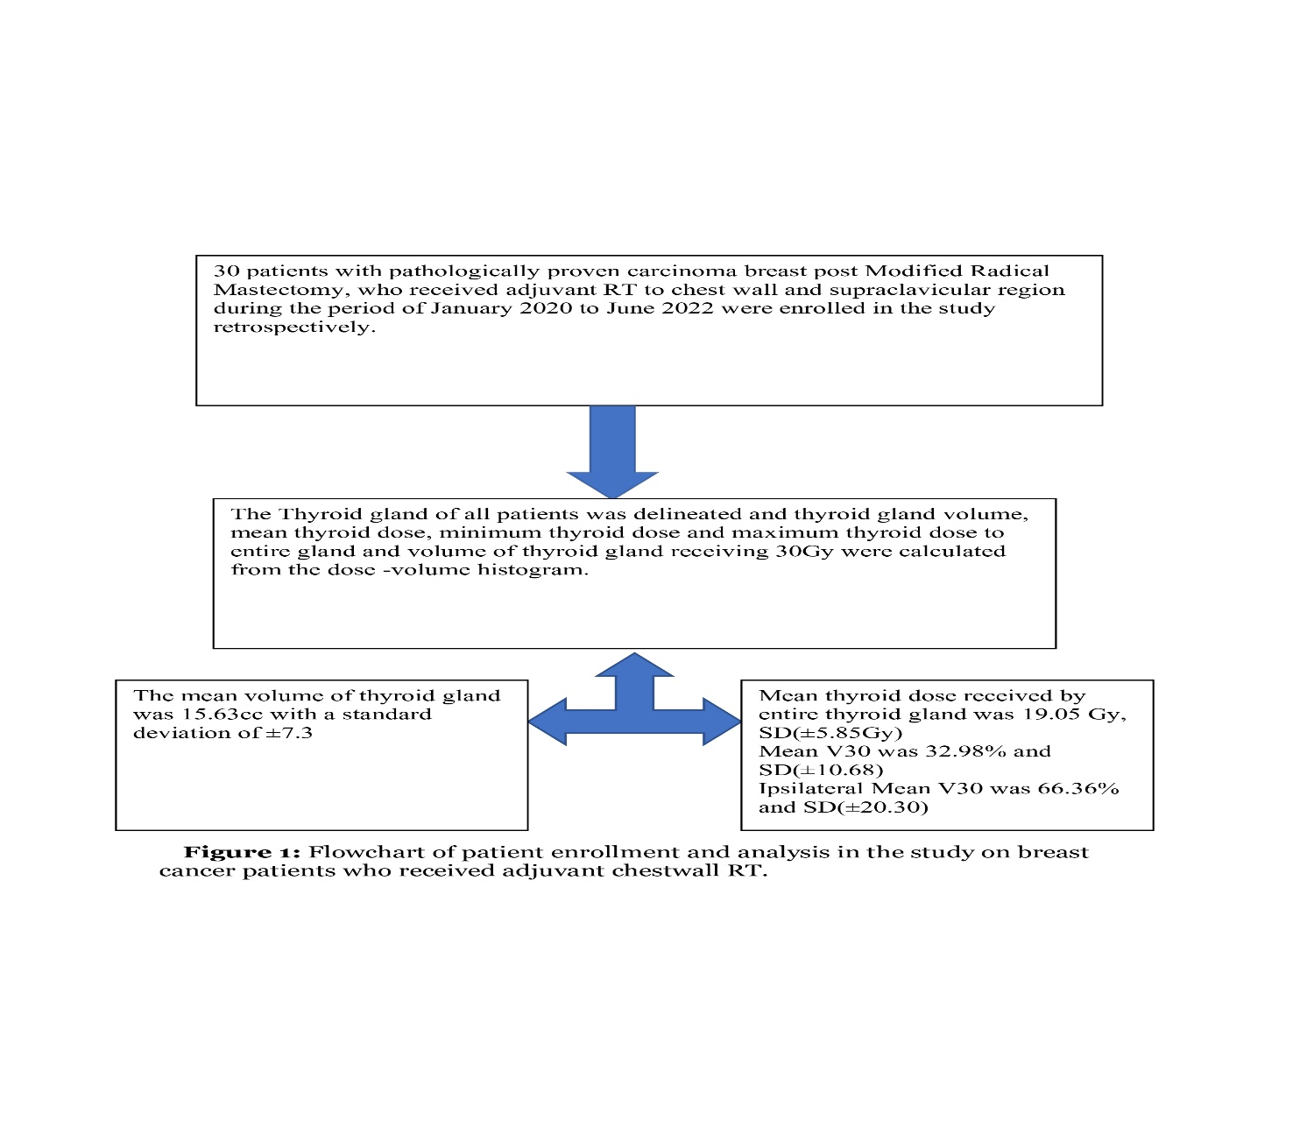

A total of 30 patients who had undergone post-mastectomy radiation therapy (PMRT) to the chest wall and supraclavicular region were included in this study. The age of the patients ranged from 37 to 71 years. Among them, 23.3% of patients were classified as Stage II, while 66.7% belonged to Stage III disease.
The thyroid gland volume was delineated for each patient, and dose parameters were derived from the Dose–Volume Histogram (DVH). The mean thyroid volume was 15.63 cc, with a standard deviation (SD) of ±7.29 cc.
Mean thyroid dose values calculated on Dose-Volume Histogram were as follows:
Table 1: Patients Characteristics and Dosimetry
Patient Characteristics
Variables |  | All patients (n=30)
Age |  | 49.93years(37-71)
Surgery |  | Modified Radical Mastectomy
Stage Grouping | II | 7(23.3%)
Stage Grouping | III | 23(66.7%)
Treatment Received |  | Adjuvant Radiotherapy
Radiotherapy Dose |  | 50Gy / 25 fractions
Radiotherapy Technique |  | 3D conformal radiation therapy
Mean Thyroid Volume in cc |  | 15.63cc, SD(±7.29)
Mean thyroid dose received by entire gland |  | 19.05Gy, SD(±5.85)
Mean value of minimum dose to thyroid gland |  | 0.67Gy, SD(±0.33)
Mean value of maximum dose to thyroid gland |  | 52.67Gy, SD(±1.51)
Mean V30 |  | 32.98%, SD(±10.68)
Ipsilateral Mean V30 |  | 66.36%, SD(±20.30)
SD- Standard Deviation, Gy- Gray, cc- Cubic Centimetres

It is evident that post-mastectomy radiation therapy is a crucial aspect among patients receiving combination therapy for breast cancer, suggesting that patients who receive adjuvant RT had decreased rates of local recurrence and mortality risk.

The fact that RT lowers the chance of local and regional recurrence as well as overall mortality is undeniable, but it can also cause long-term adverse effects include pneumonitis, cardiac toxicity, and radiation-induced hypothyroidism.

Because the thyroid gland is not considered a significant organ at risk for post-mastectomy radiation therapy and planning limits are frequently not imposed, this study was done to evaluate the thyroid dose volume parameters in patients undergoing RT to supraclavicular area.

In individuals receiving adjuvant RT, where the treatment fields cover the supraclavicular region and thyroid gland, there is documented evidence of post-RT hypothyroidism. Over a 9-year follow-up period, Joensuu et al found that 21% of the study subjects recruited had hypothyroidism after radiation therapy.⁽⁸⁾ According to Reinertsen KV et al, 6% of the general population had hypothyroidism, compared to 18% of the patients receiving combination therapy.⁽¹⁰⁾ Development of hypothyroidism after treatment was seen in 21% of individuals, with a mean dose of ≥36Gy being a major cause, in the research by Akyurek et al.⁽¹¹⁾

Given the rate of hypothyroidism observed, need for further studies looking at thyroid gland as Organ at Risk, and the incidence of hypothyroidism in Indian studies are required.

The average thyroid dose in our study was 19.05 Gy, which is less than the limitations described by Emami et al, who found that a dose of 45 Gy to the total thyroid gland would produce hypothyroidism in 8% of patients, at 5 years post completion of RT.⁽¹²⁾ The literature from previous studies also showed a mean thyroid dose of 26Gy to 36Gy are linked to a higher risk of hypothyroidism, which is much higher than the mean seen in our study 19.05Gy.^{(11,13,14)}

The volume of the thyroid gland receiving 30 Gy (V30) > 50% was revealed to be a risk factor for the development of hypothyroidism in patients undergoing supraclavicular RT in the study by Tunio MA et al, and 15% of patients developed hypothyroidism. the mean V30 observed in our study was 32.98%, and none of the patients had V30 >50% in our study.⁽¹⁵⁾
This indicated that the study participants in our research were at lower risk for developing hypothyroidism. In a subset analysis the mean V30 of ipsilateral thyroid gland was found to be 66.36%, which is significantly high.

Unnikrishnan AG et al, in his cross sectional epidemiological multi centre study reported in Indian population the risk of hypothyroidism is for 1 adult in every 10 adults, and female gender and old age as high risk factors.⁽¹⁶⁾
Hence it is justified to follow up patients receiving supraclavicular RT and set constraints for thyroid gland as Organ at Risk while planning RT.

Lack of baseline information on thyroid function tests and a lack of thyroid function tests on follow-up after therapy were the study's shortcomings. However, the aim was to assess the thyroid dosimetry in a standard 3D- conformal radiation therapy plan involving patients receiving supraclavicular RT.
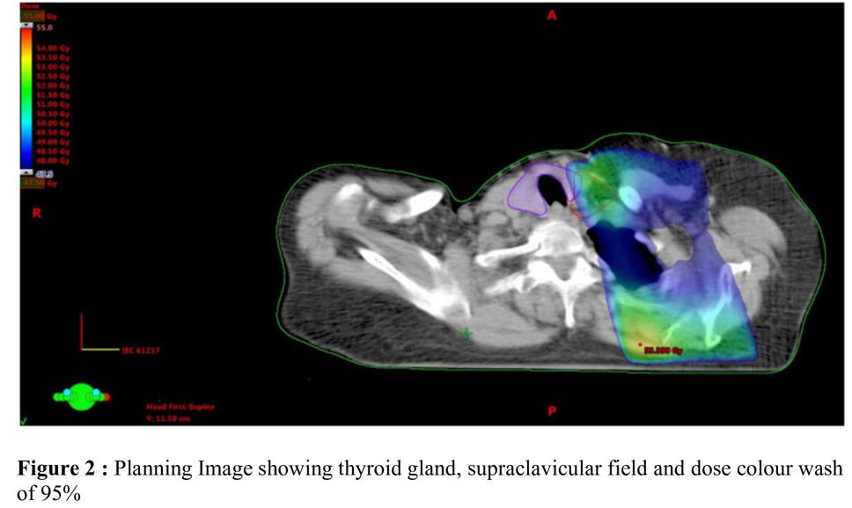
CONCLUSION:
The findings from the above studies indicate that post-radiation hypothyroidism is a recognized complication in breast cancer patients receiving supraclavicular radiotherapy using 3DCRT techniques. Consequently, the thyroid gland should be considered an organ at risk (OAR) during radiation planning. It is essential to adopt meticulous treatment planning strategies to minimize radiation exposure to the thyroid and keep the dose as low as reasonably achievable. Furthermore, regular thyroid function monitoring should be incorporated into post-treatment follow-up to enable early detection and management of radiation-induced hypothyroidism.

COMPETING INTERESTS DISCLAIMER:
Authors have declared that they have no known competing financial interests OR non-financial interests OR personal relationships that could have appeared to influence the work reported in this paper.

REFERENCES:
1.Ferlay J, Ervik M, Lam F, Colombet M, Mery L, Piñeros M et al., viewed
03 September 2021. Global Cancer Observatory: Cancer Today. Lyon, France:
International Agency for Research on Cancer.[online]. Available from: https://gco. iarc.
fr/today. 2020.
2.Overgaard M, Hansen PS, Overgaard J, Rose C, Andersson M, Bach F et al.,
Postoperative radiotherapy in high-risk premenopausal women with breast cancer who
receive adjuvant chemotherapy. New England Journal of Medicine. 1997 Oct
2;337(14):949-55.
3.Overgaard M, Jensen MB, Overgaard J, Hansen PS, Rose C, Andersson M et al., Postoperative
radiotherapy in high-risk postmenopausal breast-cancer patients given adjuvant tamoxifen:
Danish Breast Cancer Cooperative Group DBCG 82c randomised trial. The Lancet. 1999 May
15;353(9165):1641-8.
4.Early Breast Cancer Trialists' Collaborative Group. Early Breast Cancer Trialists'
Collaborative Group (EBCTCG): Effect of radiotherapy after breast-conserving surgery on 10-
year recurrence and 15-year breast cancer death: Meta-analysis of individual patient data for
10,801 women in 17 randomised trials. Lancet. 2011;378(9804):1707-16.
5.McGale P, Correa C, Cutter D, Duane F, Ewertz M, Gray R et al., Effect of radiotherapy after
mastectomy and axillary surgery on 10-year recurrence and 20-year breast cancer mortality:
meta-analysis of individual patient data for 8135 women in 22 randomised trials. The Lancet.
2014 Jun 21;383(9935):2127-35.
6.Leibel SA, Phillips TL. Textbook of radiation oncology. London: WB Saunders, 1998; 1998
Sep 20.
7.Fisher B, Redmond C, Fisher ER, Bauer M, Wolmark N, Wickerham DL et al., Ten-year
results of a randomized clinical trial comparing radical mastectomy and total mastectomy with
or without radiation. New England Journal of Medicine. 1985 Mar 14;312(11):674-81.
8.Joensuu H, Viikari J. Thyroid function after postoperative radiation therapy in patients
with breast cancer. Acta Radiologica: Oncology. 1986 Jan 1;25(3):167-70.
9.Bruning P, Bonfrer J, Jong-Bakker D, Nooyen W, Burgers M. Primary hypothyroidism in
breast cancer patients with irradiated supraclavicular lymph nodes. British journal of
cancer. 1985 May;51(5):659-63.
10.Reinertsen KV, Cvancarova M, Wist E, Bjøro T, Dahl AA, Danielsen T et al., Thyroid
function in women after multimodal treatment for breast cancer stage II/III: comparison
with controls from a population sample. International Journal of Radiation Oncology*
Biology* Physics. 2009 Nov 1;75(3):764-70.
11.Akyurek S, Babalioglu I, Kenan KO, GOKCE SC. Thyroid dysfunction following
supraclavicular irradiation in the management of carcinoma of the breast. International
Journal of Hematology and Oncology. 2014 Jan 1;32(4):139-44.
12.Emami B, Lyman J, Brown A, Coia L, Goitein M, Munzenrider JE, et al.
Tolerance of normal tissue to therapeutic irradiation. Int. J. Radiat.
Oncol. Biol. Phys. 1991 May 15;21(1):109-122.
13.Akın M, Ergen A, Unal A, Bese N. Irradiation doses on thyroid gland during the
postoperative irradiation for breast cancer. Journal of cancer research and therapeutics.
2014 Oct 1;10(4):942-4.
14.Yoden E, Maruta T, Soejima T, Nishimura H, Sasaki R, Yamada K, Sugimura K.
Hypothyroidism after radiotherapy to the neck. International Journal of Radiation
Oncology, Biology, Physics. 2001 Nov 1;51(3):337-8.

15.Tunio MA, Al Asiri M, Bayoumi Y, Stanciu LG, Al Johani N, Al Saeed EF. Is thyroid gland
an organ at risk in breast cancer patients treated with locoregional radiotherapy? Results of a
pilot study. Journal of cancer research and therapeutics. 2015 Oct 1;11(4):684-9.
16.Unnikrishnan AG, Kalra S, Sahay RK, Bantwal G, John M, Tewari N. Prevalence of
hypothyroidism in adults: An epidemiological study in eight cities of India. Indian J
Endocrinol Metab. 2013 Jul;17(4):647-52. doi: 10.4103/2230-8210.113755. PMID:
23961480; PMCID: PMC3743364.

