Case report
Cutaneous Squamous Cell Carcinoma: A Prelude to a Sinister
Outcome

ABSTRACT:

AIMS:

Cutaneous squamous cell carcinoma (C-SCC) is the second most frequent cutaneous cancer in humans, with an increasing incidence worldwide. Although it generally exhibits a benign course, C- SCC can be both locally invasive and metastatic. The lifetime risk of C-SCC is estimated at 9–14% for men and 4–9% for women, with 200,000–400,000 new cases and over 3,000 disease-related deaths occurring annually. This series aims to highlight diverse clinical presentations of CSCC that may be mistaken for common and benign dermatological conditions, emphasizing the importance of timely
and accurate diagnosis.

PRESENTATION OF CASE:

Five cases were observed:

• Case 1 – A 60-year-old female with a malodorous ulcer on a post-burn scar (Marjolin’s ulcer);
treated by surgical excision and grafting.

• Case 2 – A 57-year-old MSM with a painful ulcer in the groin and penile shaft (moderately differentiated SCC with metastases); succumbed during course of chemotherapy.

• Case 3 – A 70-year-old farmer with a hyperkeratotic, hyperpigmented plaque on the leg
(keratoacanthoma with surrounding SCC); treated with oral retinoids.

• Case 4 – A 43-year-old male with an asymptomatic inguinal lesion after hair-plucking trauma and systemic symptoms; diagnosed as well-differentiated SCC.

• Case 5 – A 26-year-old known case of condyloma acuminata presenting with penile lesions;
diagnosed as verrucous carcinoma; treated with partial penectomy.

DISCUSSION:

These cases demonstrate the variable clinical spectrum of C-SCC, including its occurrence over scars, infectious or traumatic sites, and pre-existing dermatoses. Despite early detection, such malignancies may mimic benign conditions, delaying diagnosis and treatment.

CONCLUSION:
Clinicians must maintain a high index of suspicion for atypical or non-healing lesions. Early histopathological confirmation and appropriate management are crucial to prevent metastasis and improve outcomes.

Keywords: Cutaneous squamous cell carcinoma, Skin neoplasm, Metastasis, Marjolin’s ulcer,
Histopathology, Case series, Biopsy

INTRODUCTION:

Cutaneous Squamous Cell Carcinoma (C-SCC) is one of the most prevalent non-melanoma skin
cancers originating from the keratinocytes of the epidermis¹. Major etiological factors include
prolonged sun exposure, chronic skin inflammation, and immunosuppression². Although most cases
are localized, some may metastasize to regional lymph nodes or distant organs if untreated. The
global incidence is estimated at approximately 1 million cases annually³⁻⁵. The number of C-SCC
cases has increased several-fold in the last three decades and is projected to double by 2030⁶. The
lifetime risk of developing C-SCC is estimated between 7 – 11% in Caucasians⁷ and varies from 9 –
14 % in men to 4 – 9 % in women⁸. However, similar epidemiologic data for Asian and Indian
populations remain limited.

Surgery remains the cornerstone of management, with radiotherapy as an adjunctive modality⁹. For patients with locally advanced or metastatic disease, systemic therapy may be beneficial¹⁰.

This case series presents five varied clinical manifestations of C-SCC, emphasizing diagnostic challenges and management approaches in different clinical scenarios.

PRESENTATION OF CASE:

Case 1: Marjolin’s Ulcer Variant of Squamous Cell Carcinoma

A 60-year-old female presented with discharging lesions over the right thigh for 10 months (Fig. 1). The lesions gradually increased in size. There was a past history of burns 27 years earlier involving >
50% of both lower limbs. The lesions were foul-smelling and sticky with clear discharge for 2 months, and bleeding occurred on pressure. Generalized pruritus was also present.

Examination revealed a single, well-defined ulcer with a necrotic base and everted edges measuring
9.3 × 6.3 cm, which was foul-smelling, tender, indurated, and non-mobile. Bilateral inguinal lymph nodes were palpable, firm, freely mobile, non-tender, and non-matted. Histopathology showed mixed cell infiltrate with keratin pearls; thus confirming the diagnosis (Fig. 2). PET-CT scan demonstrated active skin thickening and nodules in the right thigh, with possible right inguinal lymph-node involvement; no distant disease was detected.
Wide surgical excision and skin grafting were performed, followed by close monitoring for small satellite nodules to detect early malignancy relapse. The case underlines the need for premalignant- ulcer prophylaxis to prevent Marjolin’s ulcer formation.

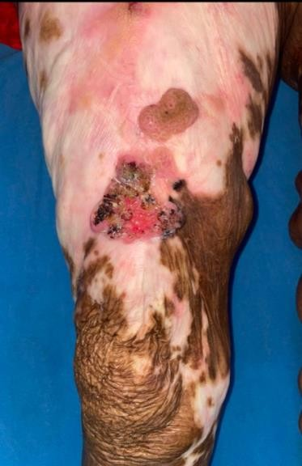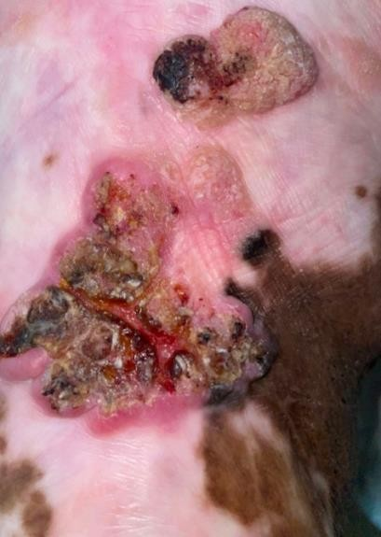Figure 1 : Single well-defined ulcer with necrotic base and everted edges over the right thigh.

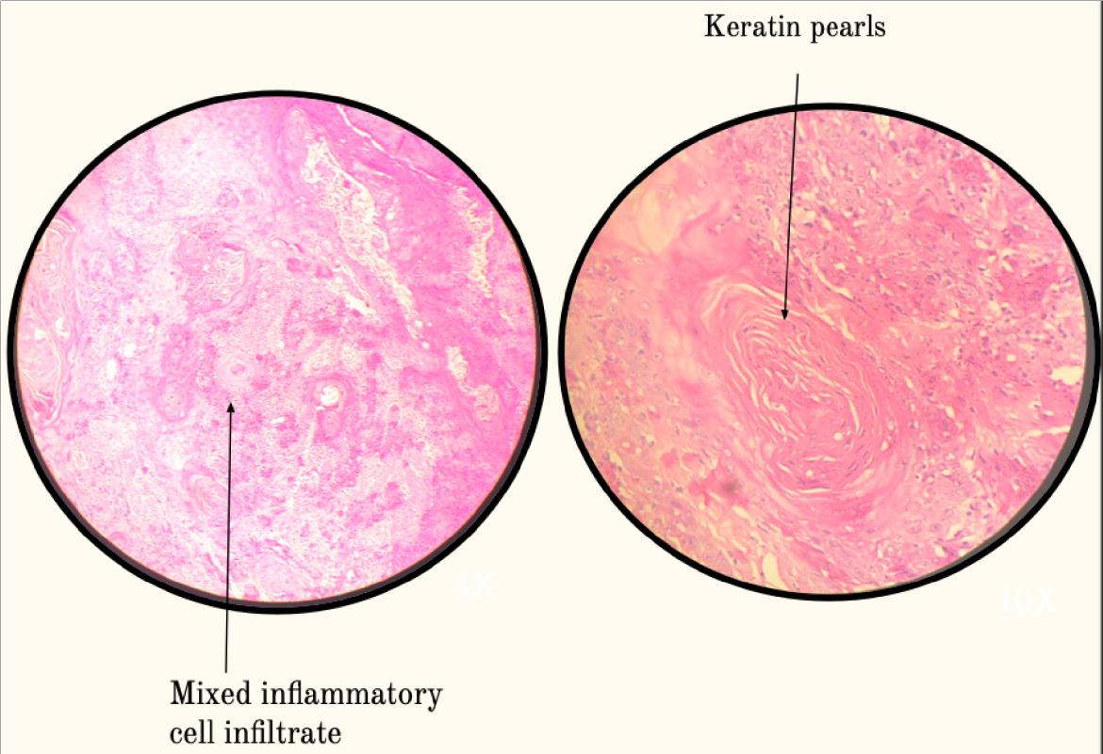
Figure 2 : Histopathology shows tumour cells arranged in nests , infiltrating the underlying stroma with formation of keratin pearls. There is large round to oval nuclei, vesicular chromatin, prominent nucleoli and moderate amount of eosinophilic cytoplasm

Case 2: Penile and Inguinal Squamous Cell Carcinoma

A 57-year-old male, a diagnosed case of moderately differentiated squamous cell carcinoma (T1a
cN3 pN2 M0), presented with painful red lesions over the left groin and penile shaft for 4 months. The lesions began as pea-sized swellings in the left inguinal region, gradually enlarging and eroding to form painful ulcers (Fig. 3). There was swelling of the penile shaft and difficulty retracting the foreskin, accompanied by foul-smelling, bloody discharge.

He reported unprotected heterosexual intercourse with multiple partners, last contact 2 years ago, and a history of tobacco smoking (20 cigarettes/day x 30 years) and alcohol consumption (90 ml/day × 25 years). There was no preceding history of fever, weight loss and no similar lesions were noted in the past or in partners.

Investigations for HIV, HbsAg, HCV, and VDRL were non-reactive.

Histopathology revealed areas of necrosis and inflammation arising from the epithelium and invading the stroma (Fig. 4). Pus culture showed pus cells and Gram negative bacilli, identified as Klebsiella pneumoniae and Pseudomonas aeruginosa. A crushed tissue smear was performed, which was negative for Donovan bodies and inflammatory cells. Chest X-ray showed fibrotic lesions and diaphragmatic tenting suggestive of chronic lung changes. PET-CT indicated increased FDG uptake in left external iliac and bilateral inguinal lymph nodes, and penile lesions, consistent with nodal metastasis (Fig. 5); no hepatic uptake was noted.

The patient received 3 cycles of IV Paclitaxel (260 mg) and Carboplatin (600 mg) every 21 days but succumbed a few months later.
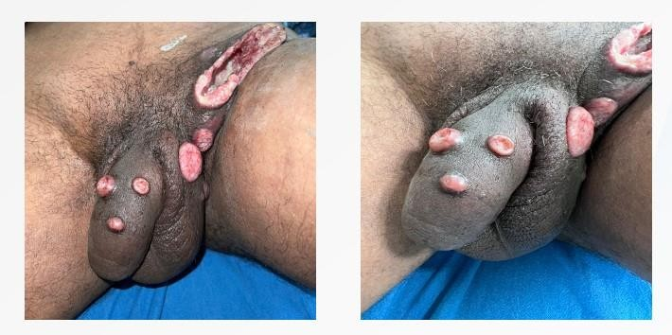

Figure 3 : Multiple well defined erythematous ulcers of size 3 X 2
cm with clear base, raised edges and indurated margins over shaft of the penis and scrotum

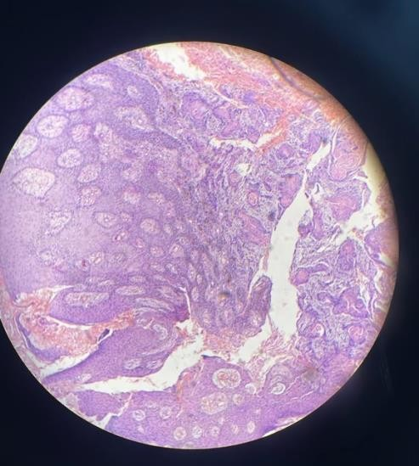
Figure 4 : Histopathology shows areas of necrosis, inflammation arising from the epithelium, and stromal invasion . Keratin pearls and cell keratinization seen.
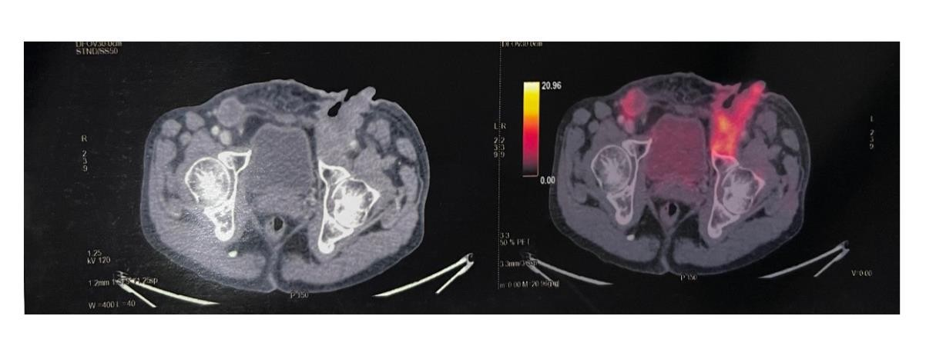

Figure 5 : PET -CT Scan showed increased FDG uptake in the left external
iliac, bilateral inguinal lymph nodes, cutaneous and subcutaneous lesions involving the penis indicating increased metabolic activity.

Case 3: Keratoacanthoma with Surrounding Squamous Cell Carcinoma

A 70-year-old male, farmer by occupation, presented with mildly itchy lesions over both legs for 2 months which were increasing in both, size and number (Fig. 6). The first lesion appeared on the left leg, followed by others. He had significant sun exposure but no history of photosensitivity or drug intake. No history of treatment taken in the past.

Examination showed diffuse xerosis of sun-exposed skin, as well as thick, indurated, hyperpigmented macules over lower aspect of both legs. A single hyperkeratotic crater-like plaque was also noted over the posterolateral aspect of the left leg. Dermoscopy revealed yellowish-white scales surrounded by white zones and peripheral brown discoloration (Fig. 8). Ultrasound showed architectural distortion and mild subcutaneous oedema. Histopathology demonstrated dense chronic inflammation without lymphovascular or perineural invasion, confirming the diagnosis of well-differentiated squamous cell carcinoma (Fig. 7).

After assessment of liver profile and serum triglycerides, the patient was started on oral retinoids, oral antihistamines, and topical steroids.
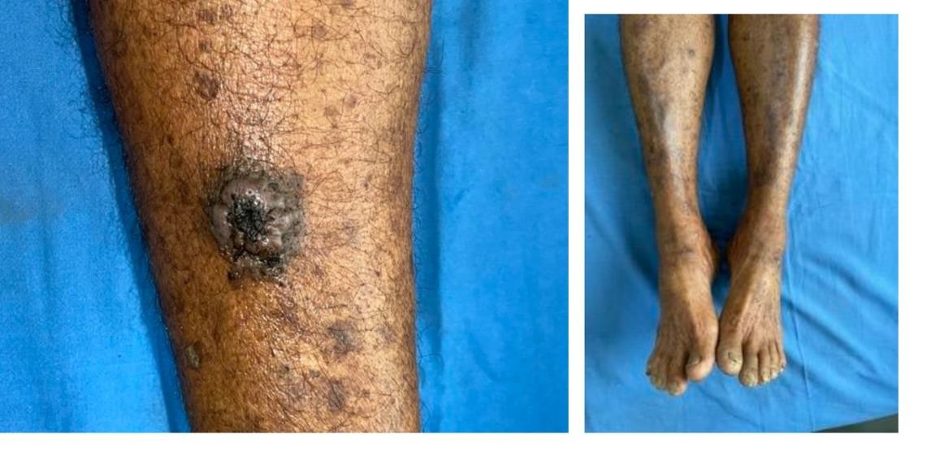

Figure 6: Multiple well-defined hyperpigmented, hyperkeratotic crater-
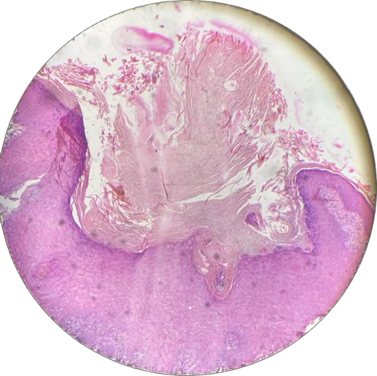like plaques seen over both legs

Figure 7: Histopathology showing necrotic keratinocytes with central keratotic plugs
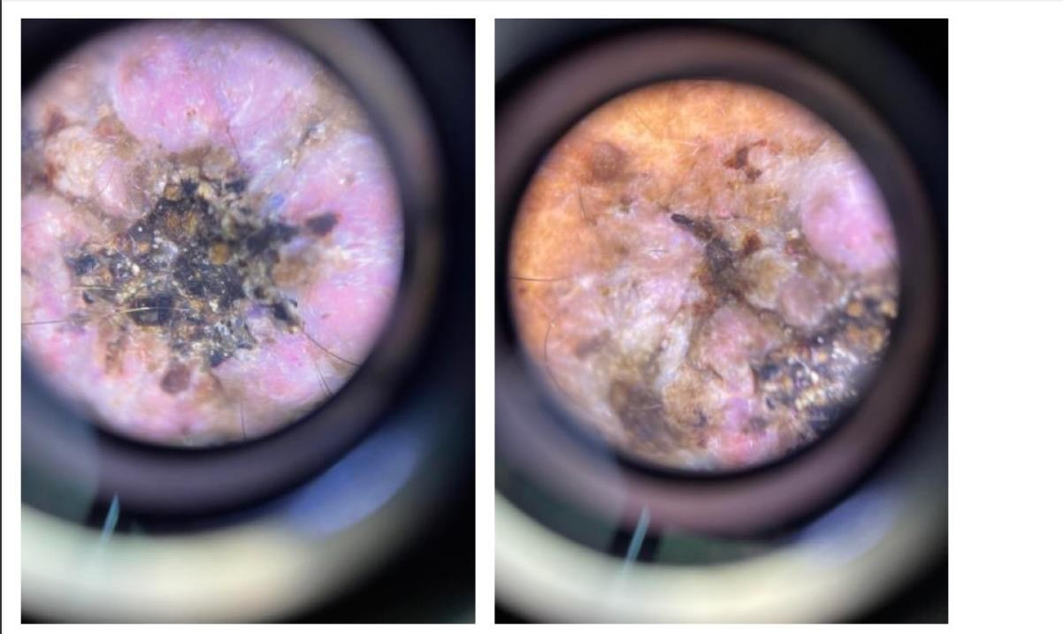

Figure 8: Dermoscopy showing yellowish-white scales surrounded by white structureless zones encircled by brownish discolouration.

Case 4: Inguinal Squamous Cell Carcinoma

A 43-year-old male widower, a diagnosed case of well differentiated squamous cell carcinoma, presented with a painful right-inguinal mass for 1 month (Fig. 9). The mass was increasing in size, accompanied by jaundice for 1 month and intermittent fever for 10 days. He reported 15 kg weight loss in 1 year. Patient also had history of similar lesions with pus discharge 1 year earlier with for which unknown treatment was taken. He was a chronic alcoholic (10 years) and hypertensive (8 years). No history of multiple sexual partners, diabetes, thyroid disease, tuberculosis, bronchial asthma.

Examination revealed a well-defined erythematous mass with adherent yellowish slough (5 × 3 cm) on an indurated base seen over the right inguinal region. Tenderness and serous discharge were noted. The lesions were associated with difficulty in retracting the prepuce, diffuse hyperpigmentation of the perianal region, bilateral pitting pedal oedema and hard, non-mobile inguinal lymphadenopathy.

Biopsy showed invasion of stratified squamous epithelium into stroma in the form of nests and trabeculae, with tumor cells showing nuclear enlargement and abundant eosinophilic cytoplasm. Keratin pearls were also noted. (Fig. 10). The patient was started on antihistamines, oral retinoids, and topical steroids.
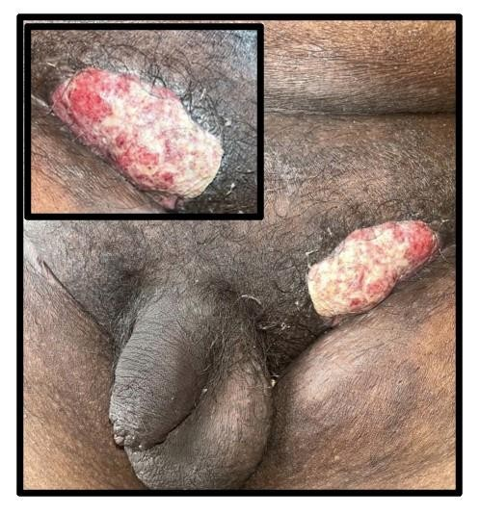

Figure 9: Single well-defined erythematous mass with adherent yellowish slough on an indurated base seen over the right inguinal region

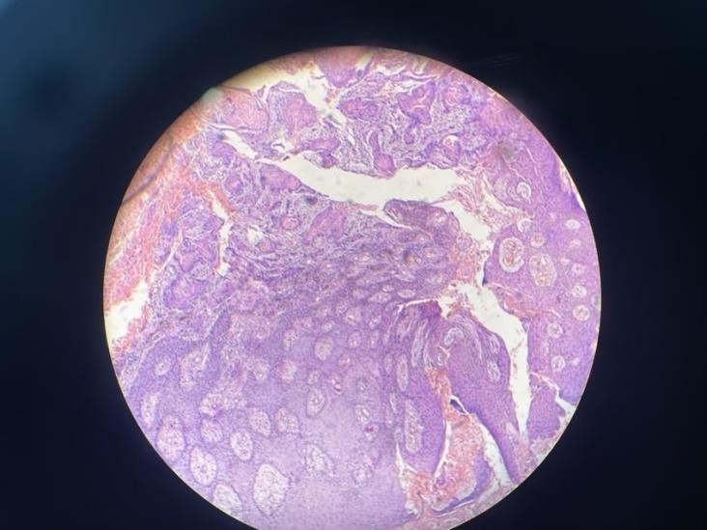

Figure 10 : Histopathology showing keratin pearls

Case 5: Verrucous Carcinoma of Penis

A 26-year-old male, diagnosed case of condyloma accuminata, presented with penile lesions for 1 year (Fig. 11). History of persistent non-healing wound after circumcision present, which gradually
increased in size. Associated burning sensation, bloody discharge noted. Patient had multiple sexual partners and history of tobacco chewing for 6 years. No history of fever or other systemic disease. Examination showed a well-defined verrucous growth with bleeding and slough over the glans, with tender right inguinal lymph nodes.
Histopathology showed a malignant tumour arising from ulcerated, dysplastic squamous epithelium, infiltrating deeper tissues (urethra, corpora spongiosum & cavernosum). Cells were spindle to polygonal with vesicular nuclei, prominent nucleoli, and moderate eosinophilic cytoplasm. Keratin pearls and individual cell keratinization were evident (Fig. 11). Intervening stroma showed desmoplastic reaction and necro-inflammatory infiltrate. No koilocytic change noted.
CT scan demonstrated a heterogeneously enhancing polypoidal soft-tissue lesion at the distal penile shaft without surrounding infiltration, suggestive of verrucous carcinoma. The CA 15-3 value was 12.1. Ultrasound showed a right inguinal lymph node (2.0 × 0.8 cm) with eccentric hilum and mixed vascularity. The patient was then referred to urosurgery for partial penectomy.

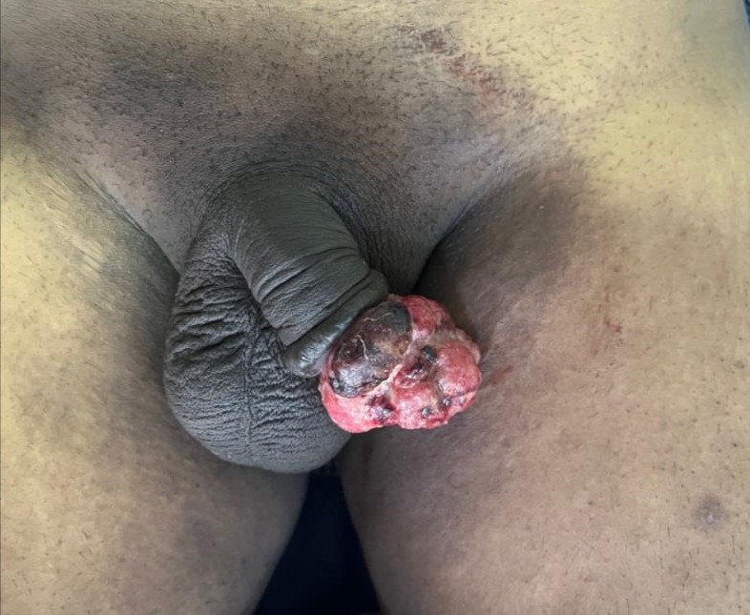

Figure 11: Well-defined verrucous growth with bleeding, discharge and slough present over the glans penis
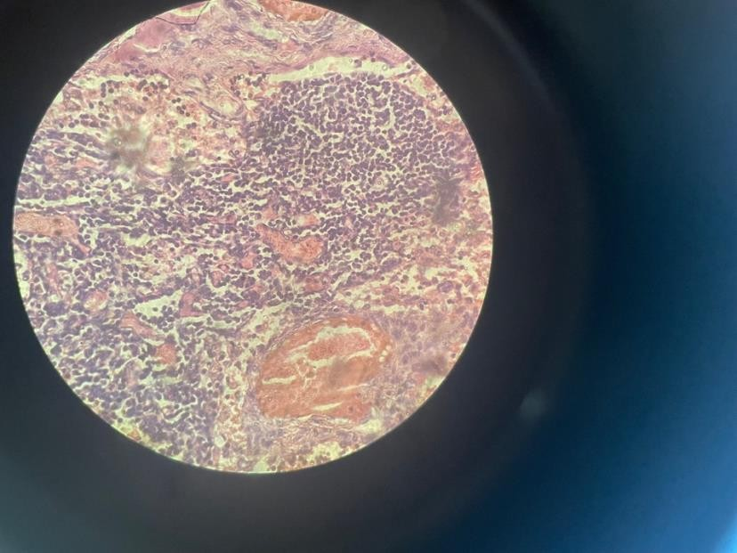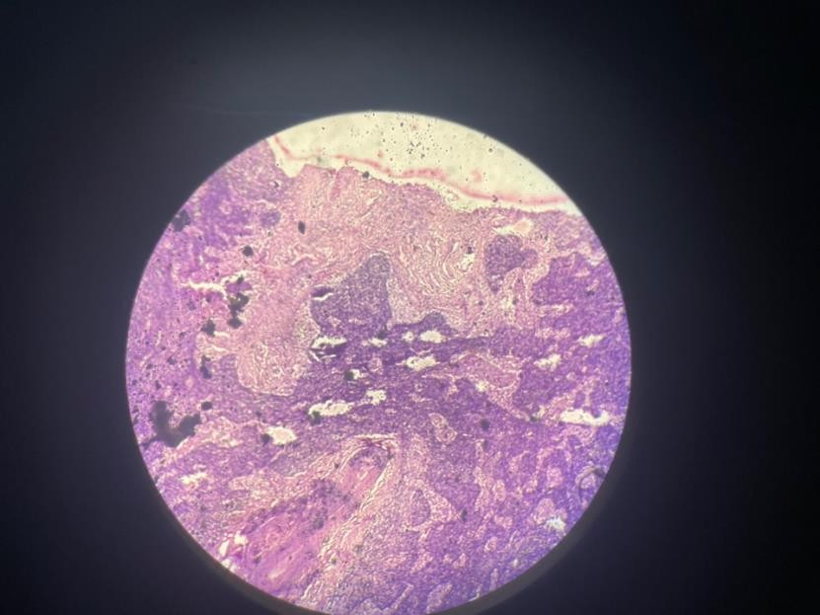

Fig 12: Tumor cells are arranged in fascicles, bundles, sheets, nests and pseudoglandular pattern. Individual tumor cells are spindle, round to polygonal shaped, pleomorphic with increased nuclear: cytoplasmic ratio, vesicular nuclei and prominent nucleoli with moderate eosinophilic cytoplasm. Keratin pearls and individual cell keratinization are also seen.

DISCUSSION:

These five cases illustrate the diverse presentations and histopathological variants of Cutaneous SCC. The disease spectrum ranges from indolent lesions such as keratoacanthoma to aggressive metastatic
forms. Early detection and timely management remain key determinants of prognosis. Cutaneous metastasis occurs through direct invasion, locoregional lymphatic spread, or hematogenous dissemination¹¹. The molecular basis involves complex interactions between chemokines, receptors, and epidermal-dermal components. The commonest sites are the head, neck, and scalp, followed by chest and abdomen. Clinically, lesions may present as solitary or multiple nodules, or inflammatory plaques.
C-SCC ranks as the second most common keratinocyte carcinoma after basal cell carcinoma¹². Chronic ultraviolet exposure, immunosuppression, and chronic inflammation remain key pathogenic triggers¹¹
At the molecular level, ultraviolet-induced p53 mutations initiate genomic instability; subsequent alterations in CDKN2A, NOTCH, and RAS genes activate NF-κB and PI3K/AKT/mTOR pathways, leading to EGFR overexpression¹³.

Diagnosis: Biopsy—punch, shave, or excisional—is the gold standard, ensuring adequate depth for histopathologic grading and margin assessment⁹˒¹⁰. Repeat biopsy is warranted if the first sample is inadequate.
Treatment: For low-risk lesions, curettage and electrodesiccation or standard excision (4–6 mm margin) to mid-subcutaneous fat is advised. High-risk lesions require wide excision or Mohs micrographic surgery⁹˒¹⁰ for margin control. Radiotherapy, including superficial or external-beam modalities, is indicated when surgery is unfeasible, though with lower cure rates⁹. Cryosurgery is reserved for low-risk cases where other options are contraindicated. Topical agents (imiquimod, 5-FU) and photodynamic therapy lack evidence for efficacy.
Marjolin’s Ulcer: A rare but aggressive SCC variant arising in chronic scars or burn wounds¹⁴⁻¹⁶.

Mutations in the Fas gene impair apoptosis, causing uncontrolled proliferation. Most cases arise in
burn scars decades after injury, as in Case 1.
Keratoacanthoma: Also termed self-healing primary SCC, a rapidly growing, dome-shaped lesion on sun-exposed skin of elderly males that can spontaneously regress but occasionally progresses to
invasive SCC¹⁷⁻¹⁹. Risk factors include UV exposure, trauma, HPV infection, chemical carcinogens,
and p53/H-RAS mutations [16]. In the farmer (Case 3), chronic sunlight exposure was the major
trigger. The clinical and histologic similarity between keratoacanthoma and SCC supports a shared pathogenesis related to actinic damage [17].
Genital SCC: Chronic venereal or ulcerative diseases such as donovanosis may rarely undergo malignant transformation; conversely, SCC can superimpose on such chronic infections²⁰˒²¹. Case 2 illustrated metastatic penile SCC, while Case 5 showed verrucous carcinoma—both highlighting diagnostic challenges where chronic non-healing genital ulcers persist despite therapy.

CONCLUSION:

Cutaneous SCC exhibits a broad clinical spectrum from chronic ulcers to rapidly evolving keratinizing tumours. Chronic inflammation, UV exposure, previous burns, and risky sexual practices are significant triggers. The cases emphasize meticulous clinical evaluation, histopathological confirmation, and individualized therapy to improve outcomes. Awareness of atypical presentations— especially Marjolin’s ulcer and genital lesions—can aid in early recognition and timely intervention.

Table 1: National Comprehensive Cancer Network stratification of low versus high risk cutaneous SCC
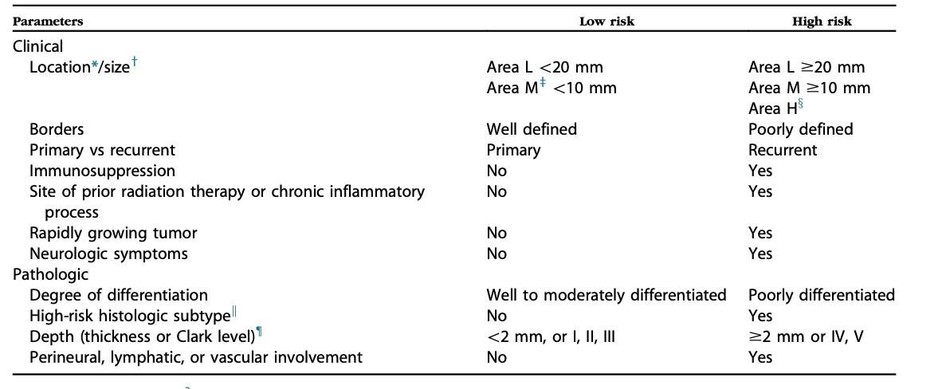

Reprinted with permission.3
cutaneous SCC, Cutaneous squamous cell carcinoma.
*Area L consists of trunk and extremities (excluding hands, feet, nail units, pretibia, and ankles); area M consists of cheeks, forehead, scalp, neck, and pretibia; and area H consists of central face, eyelids, eyebrows, periorbital skin, nose, lips, chin, mandible, preauricular and postauricular skin/sulci, temple, ear, genitalia, hands, and feet.
yGreatest tumor diameter, including peripheral rim of erythema. zLocation independent of size may constitute high risk.
xArea H constitutes high-risk on the basis of location, independent of size. kAdenoid (acantholytic), adenosquamous (showing mucin production),
desmoplastic, or metaplastic (carcinosarcomatous) subtypes.
{A modified Breslow measurement should exclude parakeratosis or scale/crust and should be made from base of the ulcer is present. If clinical evaluation of incisional biopsy suggests that microstaging is inadequate,
consider narrow-margin excisional biopsy.

CONSENT:
Informed consent for publication of clinical details and images was obtained from all patients.

ETHICAL APPROVAL:
The study was conducted in accordance with institutional ethical standards and the 1964 Helsinki declaration.

COMPETING INTERESTS DISCLAIMER:
Authors have declared that they have no known competing financial interests OR non-financial interests OR personal relationships that could have appeared to influence the work reported in this paper.

REFERENCES:

1. Alam M, Ratner D. Cutaneous squamous-cell carcinoma. N Engl J Med. 2001;344(13):975-983.

2. Que SKT, Zwald FO, Schmults CD. Cutaneous squamous cell carcinoma: incidence, risk factors, diagnosis, and staging. J Am Acad Dermatol. 2018;78(2):237-247.

3. Rogers HW, Weinstock MA, Feldman SR, Coldiron BM. Incidence estimate of nonmelanoma skin cancer (keratinocyte carcinomas) in the United States, 2012. JAMA Dermatol. 2015;151(10):1081-
1086.

4. Lomas A, Leonardi-Bee J, Bath-Hextall F. A systematic review of worldwide incidence of nonmelanoma skin cancer. Br J Dermatol. 2012;166(5):1069-1080.
5. Karia PS, Han J, Schmults CD. Cutaneous squamous cell carcinoma: estimated incidence of disease, nodal metastasis, and deaths from disease in the United States. J Am Acad Dermatol.
2013;68(6):957-966.

6. Madan V, Lear JT, Szeimies RM. Non-melanoma skin cancer. Lancet. 2010;375(9715):673-685.

7. Thompson AK, Kelley BF, Prokop LJ, Murad MH, Baum CL. Risk factors for cutaneous squamous cell carcinoma recurrence, metastasis, and disease-specific death: a systematic review and meta- analysis. JAMA Dermatol. 2016;152(4):419-428.

8. Stratigos AJ, Garbe C, Dessinioti C, et al. European interdisciplinary guideline on invasive squamous cell carcinoma of the skin: Part 1. Eur J Cancer. 2020;128:60-82.

9. National Comprehensive Cancer Network. NCCN Clinical Practice Guidelines in Oncology: Squamous Cell Skin Cancer. Version 2.2024.

10. Kim JYS, Kozlow JH, Mittal B, et al. Guidelines of care for the management of cutaneous squamous cell carcinoma. J Am Acad Dermatol. 2018;78(3):560-578.

11. Que SKT, Zwald FO, Schmults CD. Cutaneous SCC: risk factors, spread, and staging. J Am Acad
Dermatol. 2018;78(2):237-247.

12. Rogers HW, Weinstock MA, Feldman SR, Coldiron BM. Epidemiologic overview and ranking as second most common keratinocyte carcinoma. JAMA Dermatol. 2015;151(10):1081-1086.

13. Pickering CR, Zhou JH, Lee JJ, et al. Mutational landscape of aggressive cutaneous squamous cell carcinoma. Clin Cancer Res. 2014;20(24):6582-6592.

14. Tufaro AP, Choudhary S, McGirt LY, et al. Marjolin’s ulcer: modern analysis of an ancient problem.
Plast Reconstr Surg. 2011;127(1):340-347.
15. Kerr-Valentic MA, Samimi K, Rohlen BH, Agarwal JP, Rockwell WB. Marjolin’s ulcer: modern
analysis of an ancient problem. Plast Reconstr Surg. 2009;123(1):184-191.

16. Dasgupta T, Bowden L, Berg JW. Malignant neoplasms in scars. Cancer. 1964;17(7):1023-1032.

17. Schwartz RA. Keratoacanthoma: a clinicopathologic enigma. Dermatol Surg. 2004;30(2 Pt 2):326-
333.

18. Chandler AB, Dinehart SM, Nelson BR. Keratoacanthoma and squamous cell carcinoma: a continuum of differentiation. Am J Dermatopathol. 2000;22(3):212-218.

19. Wei EX, Rhee JS. Keratoacanthoma: an update on biology and management. Facial Plast Surg Clin
North Am. 2017;25(3):289-300.

20. Longatto-Filho A, Levi JE, Latorre MRDO, et al. Human papillomavirus infection and penile squamous cell carcinoma: correlation between viral detection and histopathological patterns. Histopathology. 2009;55(4):437-444.

21. Rajiah K, Jayaram G, Singhi M, et al. Penile carcinoma and chronic donovanosis: report of three cases and review of literature. Indian J Dermatol Venereol Leprol. 2007;73(1):51-53.

