Correlation and path analysis for yield and its Contributing traits in pigeonpea [Cajanus cajan
(L.) Mill Sp]

.
ABSTRACT

Aims: Correlation and association analysis for grain yield and its yield contributing characters so as to identify genotypes with desirable attributes for utilization in the crop improvement program.
Study design: The experiment was conducted in Randomized Complete Block Design (RCBD) with three replications.
Place and Duration of Study: The experiment was conducted at Agricultural and Horticultural Research station, Kathalagere during Kharif 2024.
Methodology: A total of thirteen genotypes of pigeonpea including check varieties were evaluated for ten characters namely days to 50 per cent flowering, days to maturity, plant height (cm), number of primary branches per plant, number of secondary branches per plant, number of pods per plant, number of seeds per pod, pod length (cm), 100 seed weight (g), protein content (g/100g) and seed yield per plant (g). Correlation and path analysis were estimated. Data was recorded and statistical analysis was carried out using R software.
Results: Association studies revealed that seed yield per plant showed significant positive correlation with the number of pods per plant and highest positive correlation with plant height followed by days to 50% flowering, days to maturity, number of secondary branches per plant and protein content. Direct selection for days to 50 per cent flowering, number of seeds per pod, pod length, number of pods per plant and plant height may be advantageous for selecting the high yielding genotypes in pigeonpea. Indirect effects of the number of seeds per pod on seed yield via the days to 50 per cent flowering, 100 seed weight, protein content, plant height and number secondary branches per plant. Hence, this character seems to be an important contributor to seed yield and must be considered in the selection for high seed yield.
Conclusion: Through this study, it is clear that yield improvement programs could prioritize traits like the number of secondary branches per plant, number of seeds per pod, number of pods per plant, plant height and seed yield per plant in breeding programmes.

Keywords: [Pigeonpea, correlation, path coefficient analysis, yield contributing traits, seed yield, genotypic association, breeding programme}

1. INTRODUCTION

Pigeonpea [Cajanus cajan (L.) Millsp.] is an important grain legume of tropical and subtropical rainfed regions. It belongs to the genus Cajanus in the family Leguminosae and is the only cultivated food crop in the sub-tribe Cajaninae. The crop is a diploid species (2n = 2x= 22), often cross-pollinated, with a genome size of 833.1 Mbp (Varshney et al., 2012). Globally, pigeonpea is grown on 6.03 million ha with a production of 5.32 million tonnes and an average productivity of 883.4 kg/ha. India contributes about 88% of world production, cultivating 4.90 mha with 4.22 mt and a productivity of 861.2 kg/ha (FAOSTAT, 2022). In Karnataka, it is mainly grown in the northern districts viz., Kalburgi, Vijayapur, Bagalkote, Yadgiri and Bidar known as the “Pulse Bowl of Karnataka,” covering 8.9 lakh ha with 8.2 lakh tonnes and a productivity of 1150 kg/ha (INDIASTAT, 2022). Pigeonpea is a perennial shrub with a strong, woody stem and a profuse, deep taproot system that can extend up to 2 meters beneath the soil. As a deep-rooted crop, it requires well-pulverized soil to thrive, which also allows it to withstand drought conditions. The crop prefers well-drained loamy soil and a moderately moist, warm climate during its vegetative growth phase. However, during flowering and fruiting, pigeonpea needs bright, sunny weather and a temperature range of 18-27°C for optimal fruiting. Pigeonpea can be cultivated in a variety of soil pH levels, ranging from 5.0 to 7.0. Botanically, pigeonpea is a perennial plant, but it is cultivated as an annual crop. It is primarily grown for its high-protein seeds, which are a popular staple in predominantly vegetarian diets, often consumed in the form of dal. Beyond its role in nutrition, pigeonpea plays a significant part in food security, providing a balanced diet and contributing to poverty alleviation. Its diverse uses extend to both food and fodder. The dry stalks are utilized as fuel and windbreaks, while the dried leaves, pod shells and seed coat serve as animal feed. Yield, is a complex character, is composed of several components some of which affect the yield directly, while, others affect indirectly. However, the inheritance of quantitative characters is often influenced by variation in other characters which may be due to pleiotropy or genetic linkage. Hence, knowledge of the association between yield and its components helps in formulating selection program. Correlation studies would provide estimates of the degree of association between grain yield and its various components and also among the components. While path co-efficient analysis further elucidates the intrinsic nature of the association of component traits by determining the direct or indirect contribution of these traits to yield.

2. material and methods

2.1 Experimental site

The experiment was conducted in Kharif 2024 at the Agricultural and Horticultural Research Station, Kathalagere

2.2 Experimental material

The experimental material comprised 13 pigeonpea genotypes along with three checks (TS-3R, BRG-5, PRG-175). The germplasm lines were obtained from the AICRP on pigeonpea, Zonal Agricultural Research Station (ZARS), UAS, GKVK, Bengaluru.

2.3 Experimental design

The experiment was laid out in a randomized complete block design with three replications

2.4 Planting and Management

Each genotype was sown in a row of 4 m length and 2.7 m width with a spacing of 90 cm between rows and 30 cm between plants. Recommended package of practices was followed to raise the crop.

2.5 Observations recorded

Observations were recorded on five randomly selected plants in each genotype for the traits days to 50 per cent flowering, days to maturity, plant height (cm), number of primary branches per plant, number of secondary branches per plant, number of pods per plant, number of seeds per pod, pod length (cm), 100 seed weight (g), protein content (g/100g) and seed yield per plant (g).

2.6 Statistical Analysis

The recorded data were subjected to statistical analysis following standard biometrical procedures. Correlation coefficients were computed to assess the degree of association among yield and its contributing traits. Path coefficient analysis was carried out according to the method proposed by Wright (1921) and later elaborated by Dewey and Lu (1959), in order to partition the correlation coefficients into direct and indirect effects of the component characters on seed yield.
The significance of correlation coefficients was tested at 5% and 1% probability levels. The residual effect was estimated to determine the adequacy of the characters included in the path analysis model. All computations were carried out using R software (4.5.1) with appropriate statistical packages.

3. results and discussion

3.1 Correlation analysis for yield and yield attributes

Correlation studies would provide reliable information on the degree and the direction of the association between the traits, especially when the plant breeder needs to combine high yield potential with other desirable agronomic traits correlation between these traits plays a potent role (Table 1). The phenotypic correlation analysis revealed the association of seed yield per plant with several other traits in pigeonpea. Seed yield per plant showed a highly significant positive correlation with the number of pods per plant (r = 0.424), indicating that pod number strongly influences seed yield. Positive correlations were observed with days to 50 per cent flowering (r = 0.265), days to maturity (r = 0.215), primary branches (r = 0.063), secondary branches (r = 0.190), number of seeds per pod (r = 0.014), protein content (r = 0.146) and plant height (r = 0.316), suggesting these traits moderately contribute to yield expression. However, correlation with 100-seed weight (r = -0.018) and pod length (r = -0.002) was negative indicating a limited influence of these traits on seed yield at the phenotypic level. which aligns with the findings of Sangoi et al. (2002), Rathore et al. (2020) and Satapathy et al. (2019). Correlations with other characters like number of seeds per pod (r = 0.308) and pod length (r = 0.117) were positive but mostly non-significant. Whereas protein content (r = -0.465) showed negative highly significant correlation with number of pods per plant. as earlier reported by Kumar et al. (2014), Ramasamy et al. (2021) and Saxena et al. (2021).

Table 1. Phenotypic correlation analysis for yield and its attributing traits in pigeonpea

Characters | DFF | DM | PH | NPB | NSB | NPP | 100SW | NSPP | PL | PRT | SYPP
DFF | 1.000
DM | 0.860** | 1.000
PH | 0.550** | 0.464** | 1.000
NPB | 0.187 | -0.104 | 0.325 * | 1.000
NSB | -0.037 | -0.075 | -0.390* | -0.230 | 1.000
NPP | 0.315 | 0.145 | -0.028 | -0.078 | -0.186 | 1.000
100SW | 0.145 | -0.022 | 0.311 | -0.051 | -0.062 | -0.036 | 1.000
NSPP | 0.550** | 0.593** | 0.303 | 0.371 * | -0.219 | 0.308 | -0.106 | 1.000
PL | 0.135 | 0.092 | 0.010 | -0.569 ** | 0.196 | 0.117 | 0.767** | -0.319 * | 1.000
PRT | -0.057 | -0.165 | -0.289 | 0.043 | 0.565** | -0.465 ** | 0.335* | -0.245 | 0.186 | 1.000
SYPP | 0.265 | 0.215 | 0.316 | 0.063 | 0.190 | 0.424 ** | -0.018 | 0.014 | -0.002 | 0.146 | 1.000

3.2 Path analysis for yield and yield attributes

Path coefficient analysis at the phenotypic level revealed that the number of seeds per pod exerted the highest positive direct effect on seed yield per plant (0.8120). The days to 50 per cent flowering (0.8950) and pod length (0.6792) also contributed positively and directly. Similarly, the number of pods per plant (0.4325) exerted a considerable positive direct effect (Table 2). In contrast, days to maturity (-0.9840) showed a very strong negative direct effect on seed yield. 100 seed weight (-0.9850) and number of primary branches (-0.9670) also recorded considerable negative direct effects. Number of secondary branches (-0.3257) and protein content (-0.3642) also contributed directly in a negative direction. Plant height (0.2654) exhibited a moderate positive direct effect which aligns with the findings of Chavan et al. (2024), Hanumanthappa et al. (2020), Tharageshwari and Hemavathy, (2020) and Chauhan et al. (2020).

Table 2: Path coefficient analysis matrix of direct and indirect effects of seed yield per plant and its attributing traits in pigeonpea

Sl. No. | Characters | DFF | DM | PH | NPB | NSB | NPP | 100SW | NSPP | PL | PRT | Correlation with SYPP
1 | DFF | 0.8950 | -0.4720 | 0.1461 | -0.3096 | 0.0123 | -0.6789 | -0.1770 | 0.7777 | 0.0917 | 0.0209 | 0.3062
2 | DM | 0.4580 | -0.9840 | 0.1233 | 0.1725 | 0.0246 | -0.4580 | 0.0280 | 0.7690 | 0.0631 | 0.0602 | 0.2568
3 | PH | 0.9300 | -0.6590 | 0.2654 | -0.5387 | 0.1272 | 0.0521 | -0.3999 | 0.4284 | 0.0067 | 0.1053 | 0.3166
4 | NPB | 0.5380 | 0.3589 | 0.0864 | -0.9670 | 0.0750 | 0.1579 | 0.0623 | 0.5249 | -0.7700 | -0.0159 | 0.0505
5 | NSB | -0.1544 | 0.3217 | -0.1036 | 0.3808 | -0.3257 | 0.3992 | 0.0766 | -0.3103 | 0.1337 | -0.2061 | 0.2119
6 | NPP | 0.6180 | -0.8670 | -0.4230 | 0.1242 | 0.0618 | 0.4325 | 0.0486 | 0.318 | 0.0807 | 0.0867 | 0.4811**
7 | 100SW | 0.5927 | 0.0977 | 0.0828 | 0.0843 | 0.0204 | 0.0837 | -0.9850 | -0.3880 | 0.5213 | -0.1221 | -0.0122
8 | NSPP | 0.9580 | -0.5460 | 0.0805 | -0.6146 | 0.0716 | -0.6654 | 0.1299 | 0.8120 | -0.2168 | 0.0893 | 0.0985
9 | PL | 0.5520 | -0.3960 | 0.0026 | 0.9428 | -0.0641 | -0.2497 | -0.9373 | -0.4508 | 0.6792 | -0.0681 | 0.0107
10 | PRT | -0.2349 | 0.7039 | -0.0767 | -0.0724 | -0.1843 | 1.0008 | -0.4093 | -0.3463 | 0.1269 | -0.3642 | 0.1594

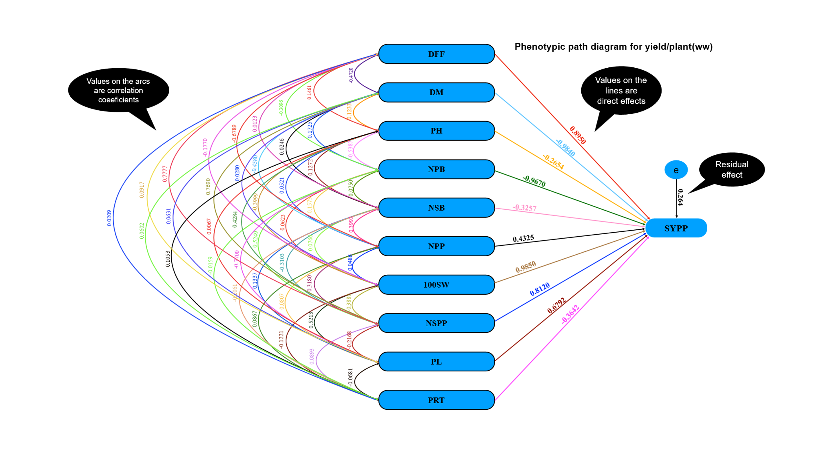

Fig 1: Phenotypic path diagram showing the direct and indirect effect of different yield contributing characters on seed yield per plant (g) along with residual effect.

4. Conclusion

Correlation analysis revealed that number of pods per plant had the strongest positive association with yield, supported by positive association with days to 50 per cent flowering, days to maturity, plant height, branching, pod length and number of seeds per pod. A significant trade-off was observed between pod number and protein content, reflecting resource partitioning. Pod length and 100-seed weight showed a strong positive linkage, confirming their developmental association. Flowering and maturity were closely synchronized, while secondary branches were positively correlated with protein content but negatively with yield traits, highlighting their dual influence on both productivity and nutritional quality. These results indicate that yield performance in pigeonpea is largely governed by a combination of reproductive efficiency and balanced vegetative growth. Genotypes with moderate maturity duration, optimum branching and higher pod-bearing capacity are therefore desirable for sustainable yield improvement under variable environments. Path coefficient analysis further clarified these relationships. Pods per plant, number of seeds per pod and pod length exerted strong positive direct effects on yield, establishing them as critical determinants of productivity. In contrast, maturity duration had a strong negative direct effect, suggesting that prolonged crop duration under rainfed conditions reduces yield. Number of branches and 100-seed weight had small negative direct effects, suggesting these traits influence yield indirectly through their effect on pod development and assimilate partitioning.

References

Chauhan, C., Prasad, J., & Yadav, B. S. (2020). Character association and path coefficient analysis for yield and its contributing traits in pigeonpea (Cajanus cajan L.), Journal of Agricultural Science, 33(1), 10–16.
Chavan, P. R., Ambhore, S. P., & Jadhav, J. P. (2024). Studies on correlation and path coefficient analysis for yield and its attributing traits in pigeonpea (Cajanus cajan L.), International Journal of Current Microbiology and Applied Sciences, 13(1), 1234-1245.
Dewey, D. R., & Lu, K. H., (1959). A correlation and path-coefficient analysis of components of crested wheatgrass seed production, Agronomy Journal, 51(9), 515–518.
Faostat, (2022). Food and Agriculture Organization of the United Nations, Rome, Italy. www.fao.org.
Hanumanthappa, M., Shivalingegowda, K., & Nagaraja, G., (2020). Variability and association studies for yield and yield related traits in pigeonpea (Cajanus cajan (L.) Millsp.), Legume Research, 43(2), 213-218.
Indiastat, (2022). Ministry agriculture and farmers welfare, Government of India. www.indiastat.com
Kumar, S., Bharathi, M., Reddy, V. N., & Eswari, K.B., (2014). Genotype × environment interaction and stability analysis in long-duration pigeonpea, Journal of Food Legumes, 27(2), 160–165.
Ramasamy, S. P., Aswini, M. S., & Hemavathy, A. T., (2021). Correlation and path analysis in pigeonpea [Cajanus cajan (L.) Millsp.], Indian Journal of Pure and Applied Biosciences, 9(6), 1-7.
Rathore, T., Srivastava, A. K., Kushwaha, C., & Kumar, B., (2020). Genetic variability and character association for yield and its contributing characters in pigeonpea [Cajanus cajan (L.) Millsp.] in central plain agroclimatic region of Uttar Pradesh (India), International Journal of Current Microbiology and Applied Sciences, 11(5), 3297-3308.
Sangoi, L., Stringheta, P. C., Silva, A. B., & Santi, A. L., (2002). Stability analysis and genotype environment interaction for plant height in maize. Pesquisa Agropecuaria Brasileira, 37(1), 93-99
Satapathy, B., Panigrahi, K. K., Panigrahi, P., Mohanty, A., Mandal, P., & Dash, A., (2019). Genetic divergence, traits association, path analysis and harvest index in pigeonpea (Cajanus cajan L.), Electronic Journal of Plant Breeding, 10(3), 1223-1233.
Saxena, K. B., Sultana, R., Mathur, P. B., Saxena, R. K., Chauhan, Y. S., Kumar, R. V., Singh, I. P., & Raje, R. S., (2021). Pigeonpea breeding: Achievements and challenges, Crop Breeding and Applied Biotechnology, 21(7), 38642115.
Varshney, R. K., Chen, W., Li, Y., Bharti, A. K., Saxena, R. K., Schlueter, J. A., & Jackson, S. A. (2012). Draft genome sequence of pigeonpea (Cajanus cajan), an orphan legume crop of resource-poor farmers, Nature Biotechnology, 30(1), 8315- 8325.
Wright, S., (1934). The method of path coefficients, Annals of Mathematical Statistics, 5(3), 161–215.

Tharageshwari, L. M., & Hemavathy, A. T., (2020). Correlation and path analysis in pigeonpea [Cajanus cajan (L.) Millsp.], International Journal of Current Microbiology and Applied Sciences, 9(1), 80-86.

