Case report

Frontal sinus mucocele with intraorbital involvement: A case report

.
ABSTRACT

Mucoceles are unusual cystic lesions filled with mucoid secretion. They result from the obstruction of the sinus drainage pathway. Although benign, their progressive growth can cause bone erosion and compression of adjacent structures. The frontal sinuses are most involved. Managing sinus mucocele consists of surgical removal and sinus drainage.
We present the case of a 38-year-old male patient, who presented with a painful swelling of the left upper eyelid, causing ptosis. Radiological assessment suspected frontal mucocele with orbital and bone involvement. The tumor was removed through a trans ciliary incision. Reconstruction of the defect was performed with fat grating and Titanium mesh.

Keywords: Mucocele, sinus, frontal, cyst, tumor, orbit

1. INTRODUCTION

Frontal sinus mucoceles are benign, slow growing, expansile mucus-filled cavities resulting from the obstruction of normal sinus drainage or chronic mucus overproduction (1). While inherently non-neoplastic, their growth can have significant clinical consequences due to the anatomical proximity of the frontal sinus with orbital and intracranial structures. Orbital involvement may lead to periorbital swelling, ptosis, proptosis, diplopia, or in advanced cases a compressive optic neuropathy. (1,2)
Radiological evaluation is crucial, with computed tomography (CT) providing detailed information on bony erosion and magnetic resonance imaging (MRI) delineating soft tissue involvement and potential intracranial or intraorbital extension (3,4). Surgical management remains the mainstay of treatment, requiring, in some cases, an interdisciplinary collaboration involving maxillofacial, otorhinolaryngological and neurosurgical expertise. (5)
This study highlights a case of frontal sinus mucocele with orbital involvement, emphasizing the clinical presentation, imaging findings, surgical management, and reconstructive approach, offering practical guidance for the management of similar cases.

2. CASE STUDY

1- Case History/examination:
We report the case of a 38-year-old male patient, with no prior medical history, who presented with a painful swelling of the left upper eyelid, which had been gradually increasing in size for one year causing ptosis and subsequently disturbing vision. (Fig. 1)
Upon questioning, he revealed a history of untreated facial trauma that occurred in early childhood.
Clinical examination revealed a tender swelling of the left upper eyelid, measuring 2 centimeters, adherent to deep plane and to the upper orbital rim.
The ophthalmologic assessment revealed ptosis of the left eye. The fundus examination showed no signs of optic disc edema or atrophy. No diplopia was noted.
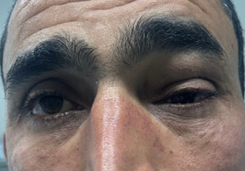
Fig1. Swelling of the left upper eyelid causing ptosis.

2- Investigations and treatment:
An ultrasound examination was performed, showing a well-defined cystic lesion, avascular on Doppler, in intimate contact with the superior rectus muscle, causing displacement of the globe (Fig. 2)
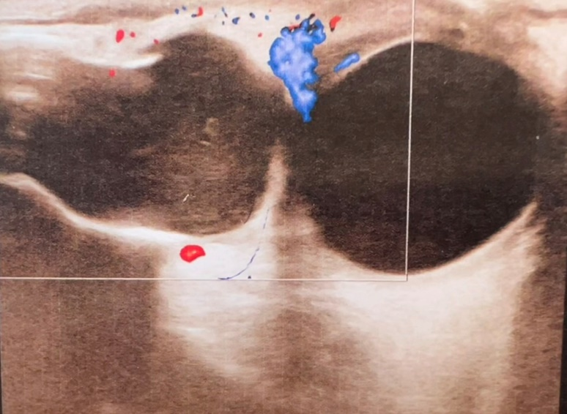
Fig. 2 Ultrasound image: A non-vascular cystic lesion displacing the globe.

An MRI was performed as a complementary investigation showing a well-defined lesion with orbito-palpebral extension, associated with an erosion of the anterior and posterior wall of the frontal sinus. No abnormal meningeal or parenchymal signal abnormalities were detected. (Fig. 3)
CT-Scan showed bone erosion. (Fig. 3)
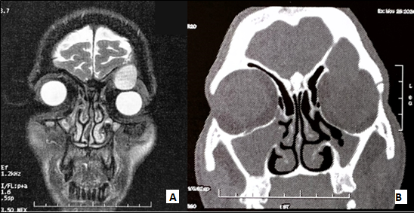
Fig. 3 A: MRI Image showing a well-defined lesion with high T2 signal displacing the eyeball downward. B. CT Image showing bone resorption.

Surgical access to the mucocele was achieved through a trans ciliary incision.
Dissection was carried out to expose the frontal bone which was eroded. A small frontal bone window was created.
Mucocele was exposed. It was situated in a cavity, separated from the frontonasal duct by a membrane. The lesion was meticulously separated from the surrounding tissue. (Fig. 4)
Afterwards, the anterior bone defect was reconstructed with a titanium plate. (Fig.5)
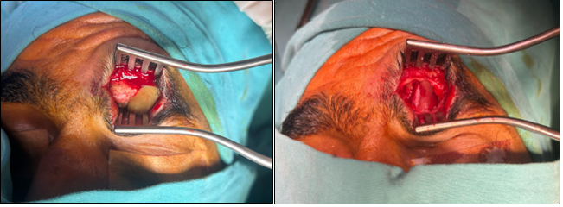
Fig 4. An intra-operative view demonstrating the trans ciliary approach, which provided direct access and removal of a frontal mucocele.

The mucocele was situated within a sinus cavity isolated from the frontonasal duct by a bony septum. Subsequently, the cavity was obliterated with fat graft, and the sinus was kept functional and included.

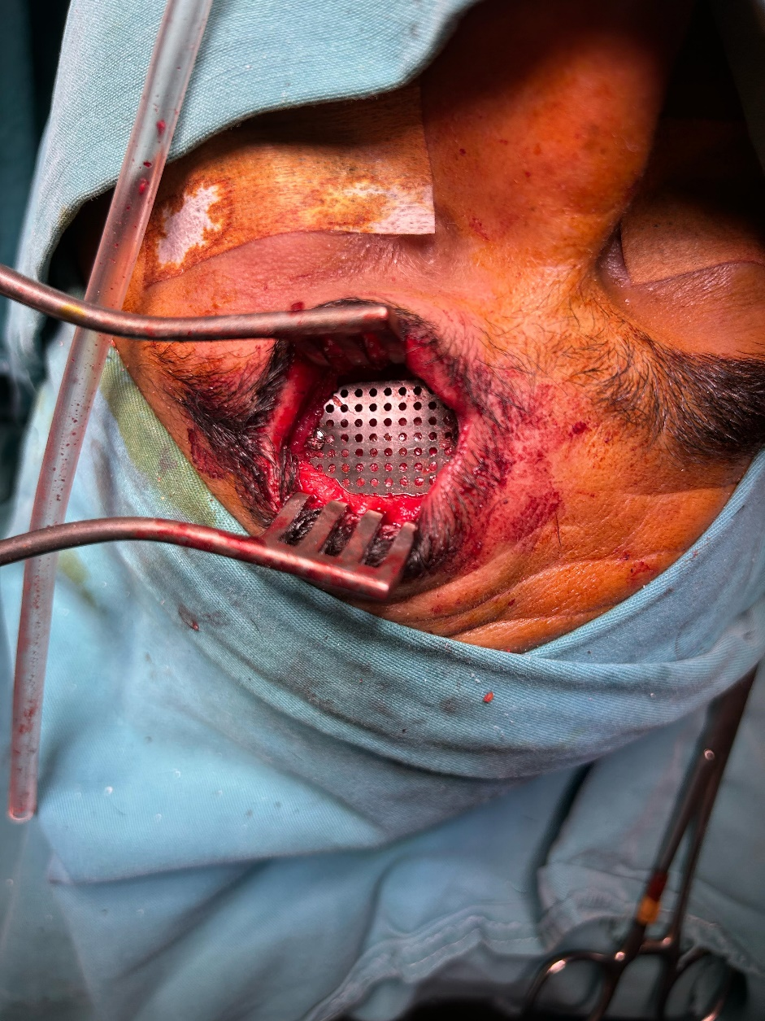
Fig5. An intra-operative image demonstrating the reconstruction of the frontal bone with titanium plate.

3- Outcome and follow-up:
Postoperatively, the patient showed favorable healing within 2 weeks. The surgical site showed appropriate healing with mild edema which improved over time. No signs of wound infection or neurological and ophthalmological complication were noted. Histopathological examination confirmed the diagnosis of sinus mucocele. At the five-month follow-up, the patient showed no signs of recurrence.

3. discussion

The paranasal sinuses are a four-pair of air-filled cavities within the bones of the face lined by respiratory mucosa and communicate directly with the nasal cavity. They serve functions such as lightening the skull, humidifying air, and aiding voice resonance. (6)
Sinus mucoceles result from an obstruction of the sinus ostium. The origin of obstruction can be primary or secondary. Primary mucoceles result mucus drainage block due to inflammation (Sinusitis, allergy...), mucous gland cystic dilation, tumoral obstruction or anatomical abnormality of the sinus ostium, while secondary occur after sinus injury (Trauma, surgery). (2,7,8)
Frontal mucoceles are the most common among all paranasal sinus mucoceles, accounting for approximately 60% of cases. (5) This may be explained by the high susceptibility of frontal sinus to trauma and the narrowness of the frontonasal duct. (1)
Post-traumatic mucoceles are well-documented, comprising 9-28% of cases and may develop years after initial trauma. (9,10)
Our patient’s childhood neglected trauma aligns with this latency pattern and likely contributed to mucocele formation.
Frontal mucoceles predominantly occur in adults aged between 30 and 70 years with no statistically significant gender predilection. (11)
The clinical significance of mucoceles lies not in their histological behavior, which is non-neoplastic, but in their capacity to cause substantial morbidity through local mass effect. (2)
The local mass effect causes an increase in pressure and stress-induced bony remodeling. At this same time, the chronic inflammation within the obstructed sinus leads to the release of inflammatory mediators, which stimulate osteoclastic bone resorption. (11)
Clinical manifestations often depend on the extent and direction of mucocele expansion. Frontal mucoceles have close relation to the orbit and brain. Posterior extension may result in intracranial complications such as meningitis. While inferior or medial expansion can cause orbital symptoms including proptosis, ptosis, diplopia, oculomotricity impairment or reduced vision. (2,12)
Radiological imaging is essential in diagnosis and preoperative planning.
CT imaging is the modality of choice for initial assessment. It provides excellent delineation of bony changes. (3)
MRI is complementary to CT. Mucocele usually appear as a well-defined expansive mass with variable signal in T2 and T1 depending on mucocele proportions of water, mucus and protein. MRI adds value in differentiating mucoceles from other neoplastic lesions and in evaluating soft tissue involvement and intracranial or intraorbital spread. (3,4)
Treatment of mucoceles is surgical and the access routes are either external or endonasal. The choice between endonasal, endoscopic, and open surgical techniques for the management of frontal sinus mucoceles remains guided by the extent of disease, anatomical accessibility, and the surgeon’s expertise. (13)
Endonasal approach represents the modality of choice of treating an uncomplicated frontal mucocele. It is a mini-invasive technique and offers highly effective treatment with reduced postoperative morbidity and shorter hospital stay. (12)
Conversely, open approach retains an essential role in the treatment of extensive mucoceles with intraorbital or intracranial extension where endoscopic access may be technically limited. Open approaches offer direct access for complete resection and facilitate simultaneous reconstruction of bony defects. (14)
A combined technique (external technique and endoscopy) may be used in more advanced cases. (15)
A meta-analysis conducted by Courson et al. have demonstrated that both approaches achieve comparable recurrence rates. Recurrence in endonasal approach is likely to happen when complicated cases are attempted endoscopically. (13)
In our case, the orbital involvement and the need for direct visualization informed our decision to use an open trans ciliary approach.
By following the natural curve of the eyebrow, this approach provides direct, cosmetically favorable access to the frontal sinus with excellent exposure of the frontal sinus floor and anterior wall. It enables precise resection of the mucocele, sinus obliteration and reconstruction of the bony defect. (16,17)
Among the various techniques used for defect obliteration, synthetic materials such as hydroxyapatite cement and acellular dermal matrix may be used but are associated with notable limitations. These alloplastic materials may increase the risk of infection, inflammatory reaction, or poor long-term integration. Moreover, techniques using bone grafts and bone flaps can be performed but are associated with donor site morbidity and prolonged surgery time. (18)
In contrast, autologous fat grafting is a widely used technique due to its biocompatibility, reproducibility, ease of harvesting, and low complication rate. (19)
Titanium mesh offers multiple advantages in craniofacial reconstruction. Its excellent biocompatibility results in minimal inflammatory response, making it well tolerated by surrounding tissues. Moreover, the mesh is highly malleable, allowing precise shaping and contouring and causes negligible artifact on both MRI and CT-Scan. (20)
The combination of autologous fat grafting and titanium mesh is a cost-effective technique, widely accessible that ensures rigid structural support and reinforcement and avoids donor-site morbidity, while achieving favorable long-term outcomes with low complication rates. (19,20)
Courson et al stated that major complications such as cerebrospinal fluid leak, hemorrhage and orbital injury were statistically comparable between endoscopic and open surgical techniques. However, minor complications such as supraorbital nerve injury, bad scarring, alopecia and infection are more frequent in open approach. (13)
These minor complications are not life threatening and could be, in most cases, avoided or minimized.
Nerve injury is generally temporary with spontaneous recovery. It can be mitigated with a good understanding of anatomy, gentle use of retraction, and limited use of monopolar electrocautery.
Alopecia can be avoided by aligning the incision with the hair follicles and minimizing electrocautery to avoid damage to the hair follicles and blood vessels.
In our case, no complication was noted.
In summary, this case report provides a holistic view on the diagnosis and surgical management of a frontal sinus mucocele with orbital involvement, emphasizing clinical, radiological findings, and surgical approach. This study describes the trans ciliary approach and the combined use of autologous fat graft and titanium mesh for reconstruction, which yielded favorable outcome. However, further studies involving larger patient cohorts are needed to validate these findings. Long term follow-up is essential to evaluate the risk of recurrence and durability of the reconstruction.

4. Conclusion

Frontal sinus mucoceles, while benign, can lead to significant complications due to their potential for local tissue destruction and functional impairment. In complicated cases with bone erosion and orbital involvement, an open surgical approach via a trans ciliary incision can provide excellent exposure for complete excision and reconstruction. The use of autologous fat grafting in combination with titanium mesh is a reliable solution after mucocele removal.

DISCLAIMER (ARTIFICIAL INTELLIGENCE)
Author(s) hereby declare that NO generative AI technologies such as Large Language Models (ChatGPT, COPILOT, etc) and text-to-image generators have been used during writing or editing of manuscripts.
Author(s) hereby declare that NO generative AI technologies such as Large Language Models (ChatGPT, COPILOT, etc) and text-to-image generators have been used during writing or editing of manuscripts. Haut du formulaireBas du formulaire
Consent
As per international standards or university standards, patient(s) written consent has been collected and preserved by the author(s).

Ethical approval
As per international standards or university standards, written ethical approval has been collected and preserved by the author(s).

COMPETING INTERESTS DISCLAIMER:
Authors have declared that they have no known competing financial interests OR non-financial interests OR personal relationships that could have appeared to influence the work reported in this paper.

References

1. Chowdhury R, Aldajani A, Almhanedi H, Al Majid D, Tewfik MA, Himdi L. Paranasal Sinus Mucoceles With Intraorbital and Intracranial Involvement: A Case Series Analysis and Surgical Outcomes Assessment. Ann Otol Rhinol Laryngol. 2025 Mar;134(3):225–33.
2. Varghese L, Bright RR, Gunturi AVA, Rebekah G, Kurien R. Do Variations in Frontal Recess Anatomy Predispose to Mucocele Formation? Int Arch Otorhinolaryngol. 2025 Jan;29(01):001–6.
3. Tsitouridis I, Michaelides M, Bintoudi A, Kyriakou V. Frontoethmoidal Mucoceles: CT and MRI Evaluation. Neuroradiol J. 2007 Oct;20(5):586–96.
4. Bouatay R, Aouf L, Hmida B, Korbi AE, Kolsi N, Harrathi K, et al. The role of imaging in the management of sinonasal mucoceles. Pan Afr Med J [Internet]. 2019 [cited 2025 Apr 21];34. Available from: http://www.panafrican-med-journal.com/content/article/34/3/full/
5. Ali E. Post Traumatic Frontal Sinus Mucocele with Subcutaneous Extension: A Case Report and Literature Review. Int Med Case Rep J. 2023 Sep;Volume 16:599–604.
6. Cappello ZJ, Minutello K, Dublin AB. Anatomy, Head and Neck, Nose Paranasal Sinuses. In: StatPearls [Internet]. Treasure Island (FL): StatPearls Publishing; 2025 [cited 2025 Apr 21]. Available from: http://www.ncbi.nlm.nih.gov/books/NBK499826/
7. Kim YS, Kim K, Lee JG, Yoon JH, Kim CH. Paranasal Sinus Mucoceles with Ophthalmologic Manifestations: A 17-year Review of 96 Cases. Am J Rhinol Allergy. 2011 Jul;25(4):272–5.
8. Cagigal BP, Lezcano JB, Blanco RF, Cantera JMG, Antonio L, Cuéllar S, et al. Frontal sinus mucocele with intracranial and intraorbital extension. Med Oral Patol Oral Cir Bucal.
9. Vishwakarma S, Subramaniam AS, Agrawal D. Mucocele of Frontal Sinus: 20 Years Post-Injury; A Case Report. 2017;
10. Moniakis A, Malli A, Smponias V, Kasapas K. Delayed Post-traumatic Frontal Mucocele Occurrence: A Case Report. Cureus [Internet]. 2024 Aug 18 [cited 2025 Jun 21]; Available from: https://www.cureus.com/articles/279633-delayed-post-traumatic-frontal-mucocele-occurrence-a-case-report
11. Aladeyelu OS, Burge PM, Atiba PM, Madaree A, Lazarus L. Paranasal sinus mucoceles and its distortion of craniofacial-orbital anatomy: a narrative synthesis. Eur Arch Otorhinolaryngol [Internet]. 2025 Jan 17 [cited 2025 Apr 25]; Available from: https://link.springer.com/10.1007/s00405-024-09174-y
12. Suri A, Mahapatra AK, Gaikwad S, Sarkar C. Giant mucoceles of the frontal sinus: a series and review. J Clin Neurosci. 2004 Feb;11(2):214–8.
13. Courson AM, Stankiewicz JA, Lal D. Contemporary management of frontal sinus mucoceles: A meta-analysis: Frontal Mucocele Management: A Meta-Analysis. The Laryngoscope. 2014 Feb;124(2):378–86.
14. Ali E. Post Traumatic Frontal Sinus Mucocele with Subcutaneous Extension: A Case Report and Literature Review. Int Med Case Rep J. 2023 Sep;Volume 16:599–604.
15. Santos PLD, Chihara LL, Alcalde LFA, Masalskas BF, Sant’Ana E, Faria PEP. Outcomes in Surgical Treatment of Mucocele in Frontal Sinus. J Craniofac Surg. 2017 Oct;28(7):1702–8.
16. Aggarwal S, Bhavana K, Keshri A, Kumar R, Srivastava A. Frontal sinus mucocele with orbital complications: Management by varied surgical approaches. Asian J Neurosurg. 2012 Sep;7(03):135–40.
17. Robinow ZM, Peterson C, Riestenberg R, Waldau B, Yu N, Shahlaie K. Cosmetic Outcomes of Supraorbital Keyhole Craniotomy Via Eyebrow Incision: A Systematic Review and Meta-Analysis. J Neurol Surg Part B Skull Base. 2023 Oct;84(05):470–98.
18. Petruzzelli GJ, Stankiewicz JA. Frontal Sinus Obliteration With Hydroxyapatite Cement. The Laryngoscope. 2002 Jan;112(1):32–6.
19. Eledeissi A, Ahmed M, Helmy E. Frontal Sinus Obliteration Utilizing Autogenous Abdominal Fat Graft. Open Access Maced J Med Sci. 2018 Jul 20;6(8):1462–7.
20. Lakhani RS, Shibuya TY, Mathog RH, Marks SC, Burgio DL, Yoo GH. Titanium Mesh Repair of the Severely Comminuted Frontal Sinus Fracture. Arch Otolaryngol Neck Surg. 2001 Jun 1;127(6):665.

