Original Research Article

Association of Semen Quality, Lifestyle Factors, and Thyroid Dysfunction with Sperm DNA Fragmentation Index: A Retrospective Cross-sectional Study

Abstract
Background:
Male infertility accounts for nearly half of all infertility cases and is influenced by multiple biological and environmental factors. Conventional semen analysis provides limited information on sperm function. The sperm DNA fragmentation index (DFI) has emerged as a key biomarker reflecting sperm chromatin integrity and fertilizing potential. Evidence from Indian men remains scarce and inconsistent.
Aim:
To evaluate the association of semen quality, lifestyle habits and systemic conditions with sperm DNA fragmentation among infertile men.
Study Design and place:
A retrospective cross-sectional study conducted at birthright fertility by rainbow hospitals.
Materials and Methods:
Records of 326 men evaluated between January 2023 and May 2025 were reviewed. Clinical details including age, body mass index (BMI), infertility type and duration, lifestyle factors, and comorbidities were collected. Semen analysis followed WHO 2021 guidelines. Sperm DFI was assessed using the Sperm Chromatin Dispersion method (Sperm Chroma kit, Cryolab International, India). Correlation and logistic regression analyses identified predictors of poor DFI (>25%).
Results:
The median (IQR) DFI was 24% (19–28%), with 39% showing poor DFI. DFI correlated negatively with sperm count (ρ = –0.313, p < 0.001), motility (ρ = –0.233, p < 0.001), and morphology (ρ = –0.137, p = 0.0135), but not with age or BMI. Hypothyroidism (adjusted OR 4.624, p = 0.007) and low sperm count (adjusted OR 0.979, P = 0.003) independently predicted higher DFI.
Conclusion:
Sperm DNA fragmentation was primarily influenced by semen quality and systemic factors, especially hypothyroidism, rather than age or lifestyle habits. Incorporating DFI and thyroid testing with routine semen analysis may improve evaluation and management of male infertility.
Keywords:
Sperm DNA fragmentation, hypothyroidism, semen parameters, male infertility

1. INTRODUCTION
Infertility affects approximately 10–15% of couples globally, with male-related causes contributing to nearly half of all cases (Agarwal et al., 2015). While conventional semen analysis remains a standard component of male infertility evaluation, it provides limited insight into the sperm’s fertilizing potential and chromatin quality (Esteves et al., 2021). In recent years, the sperm DNA fragmentation index (DFI) has been recognized as a valuable indicator of sperm nuclear integrity and functional competence (Khandhedia et al., 2025; Cho et al., 2018). Elevated DFI levels have been linked to recurrent implantation failure, miscarriage, and suboptimal outcomes following assisted reproductive technology (Evenson et al., 2012; Simon et al., 2017).
A range of biological and lifestyle factors including increasing paternal age, obesity, smoking, alcohol consumption, systemic diseases, and reproductive pathologies such as varicocele have been implicated in sperm DNA damage (Deenadayal et al., 2020; Al Omrani et al., 2018; Khosravi et al., 2023; Ajayi et al., 2025). However, data from Indian men remain limited, and findings across regional studies have been inconsistent (Deenadayal et al., 2020; Al Omrani et al., 2018; Chua et al., 2023).
The present retrospective study was therefore designed to examine the relationships between semen characteristics, lifestyle factors, and systemic health conditions with sperm DFI among Indian men seeking infertility assessment.

2. MATERIALS AND METHODS
This retrospective study was conducted at tertiary fertility centre. Data of 326 male patients evaluated between January 2023 and May 2025, who underwent both semen analysis and sperm DNA fragmentation (DFI) testing, were included. Clinical details such as age, body mass index (BMI), duration and type of infertility, lifestyle habits (smoking and alcohol use), and comorbidities including diabetes, hypertension, hypothyroidism, and varicocele were retrieved from medical records.Semen samples were obtained after 3–5 days of sexual abstinence and evaluated following the World Health Organization (WHO) 2021 recommendations. The measured parameters included semen volume, sperm concentration, total motility, and morphology.Sperm DNA fragmentation was determined using the Sperm Chromatin Dispersion (SCD) technique with the Sperm Chroma kit (Cryolab International, India). To ensure consistency, samples for DFI analysis were collected within 24–36 hours of abstinence, minimizing variability and reducing oxidative stress from prolonged abstinence. Inclusion criteria were men aged 20 years or older who provided a fresh ejaculate sample with complete semen analysis and valid DFI results.Exclusion criteria were men with a history of febrile illness within the preceding three months, those who tested positive for HIV, hepatitis B, or hepatitis C, patients with a history of chemotherapy or radiotherapy and those with known genetic or chromosomal disorders were excluded from the analysis.

3. STATISTICAL ANALYSIS
Descriptive analysis was carried out by frequency and percentage for categorical variables and median (IQR) for continuous variables due to non-normal data. The chi-square test was used to test the statistical significance of cross-tabulation between categorical variables. Mann-Whitney U test was used to compare median (IQR) of continuous variables between two groups. Spearman correlation coefficient (rho) was used to assess correlation between two continuous variables. Binary logistic regression was used to assess factors associated with binary outcome. For logistic regression, univariate analyses were initially performed, and predictors with a P-value < 0.05 were included in the multivariable model. For univariate regression analyses, the Haldane–Anscombe correction was applied when any one of the cells contained zero events.
P value < 0.05 was considered statistically significant. RStudio Desktop latest version was used for statistical analysis. (Reference: RStudio Team (2025). RStudio: Integrated Development for R. RStudio, PBC, Boston, MA URL http://www.rstudio.com/.)

4. RESULTS & DISCUSSION
Table 1: Baseline characteristics and semen parameters in the study population (N=326)
Variables | Summary statistics
Age (years), Median (IQR) | 36 (34, 39)
Age group, n (%)
<30 years | 9 (2.8%)
30 to 34 years | 95 (29.1%)
35 to 39 years | 151 (46.3%)
≥40 years | 71 (21.8%)
BMI (kg/m²), Median (IQR) | 28 (26, 31)
BMI group, n (%)
Normal | 59 (18.1%)
Overweight | 159 (48.8%)
Obese | 108 (33.1%)
Duration of infertility (years), Median (IQR) | 3 (1, 5)
Type of infertility, n (%)
Primary | 175 (53.7%)
Secondary | 151 (46.3%)
Smoking, n (%)
Yes | 63 (19.3%)
No | 263 (80.7%)
Alcohol, n (%)
Yes | 147 (45.1%)
No | 179 (54.9%)
Varicocele, n (%)
Yes | 37 (11.3%)
No | 289 (88.7%)
Chronic illness, n (%)
Diabetes | 51 (15.6%)
HTN | 44 (13.5%)
Hypothyroid | 17 (5.2%)
Hydrocele | 3 (0.9%)
Hernia | 1 (0.3%)
Microcalcification | 1 (0.3%)
Semen volume (ml), Median (IQR) | 2 (1.5, 2.5)
Sperm count (M/ml), Median (IQR) | 34 (15, 53)
Total motility (%), Median (IQR) | 52 (40, 60)
Morphology (%), Median (IQR) | 1 (1, 1)

A total of 326 males with median (IQR) age of 36 (34, 39) years were included in the study. The baseline characteristics and semen parameters are presented in Table 1.

Figure 1: DFI in the study population (N=326)
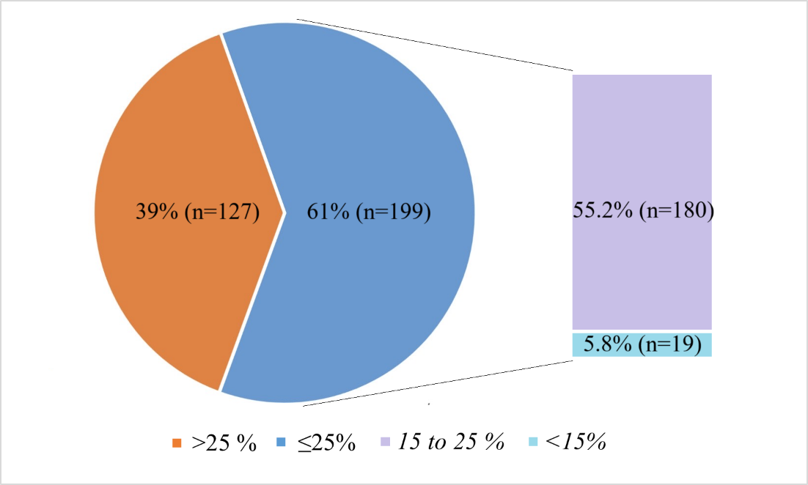

The median (IQR) DFI in the study population was 24 (19, 28) %. 39% (n=127) had poor DFI (>25%) and 61% (n=199) had good to excellent DFI (≤25%); 55.2% (N=180) had good DFI (15 to 25%) and 5.8% (n=19) had excellent DFI (<15%).

Table 2: Spearman correlation coefficient of DFI with different variables
Variables | Spearman correlation (rho) | P-value
Age (years) | 0.016 | 0.775
BMI (kg/m²) | -0.0002 | 0.997
Duration of infertility (years) | 0.122 | 0.0279
Semen volume (ml) | -0.0924 | 0.0958
Sperm count (M/ml) | -0.313 | <0.001
Total motility (%) | -0.233 | <0.001
Morphology (%) | -0.137 | 0.0135

There was statistically insignificant correlation of DFI with age (ρ = 0.016, P-value = 0.775), BMI (ρ = -0.0002, P-value = 0.997) and semen volume (ρ = -0.0924, P-value = 0.0958). A very weak but statistically significant positive correlation was observed between duration of infertility and DFI (ρ = 0.122, P-value = 0.0279). In contrast, DFI showed a moderate negative correlation with sperm count (ρ = –0.313, P-value < 0.001), a weak negative correlation with total motility (ρ = –0.233, P-value < 0.001) and a very weak negative correlation with morphology (ρ = –0.137, P-value = 0.0135).

Figure 2: Scatter plot depicting correlation of DFI with age and BMI
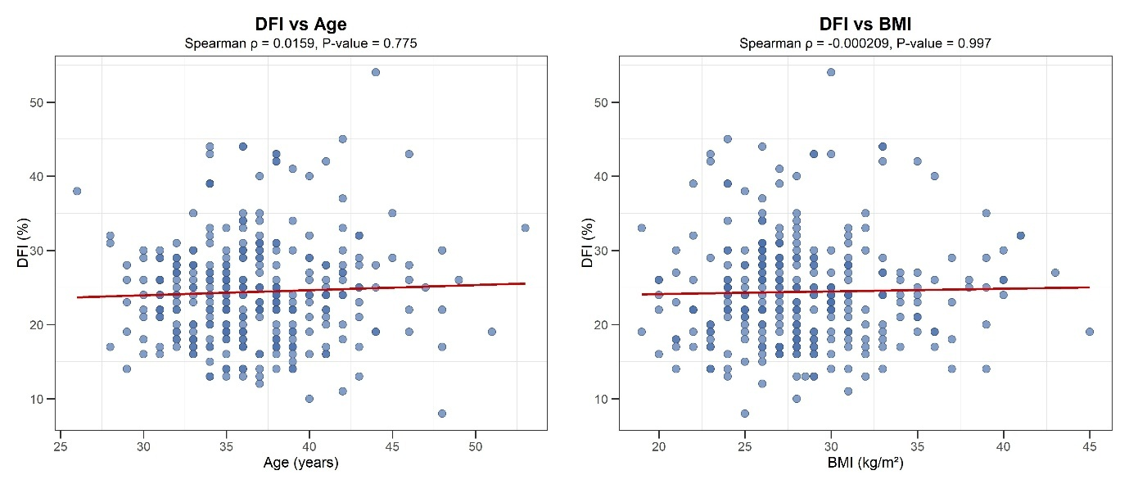

Figure 3: Scatter plot depicting correlation of DFI with duration of infertility
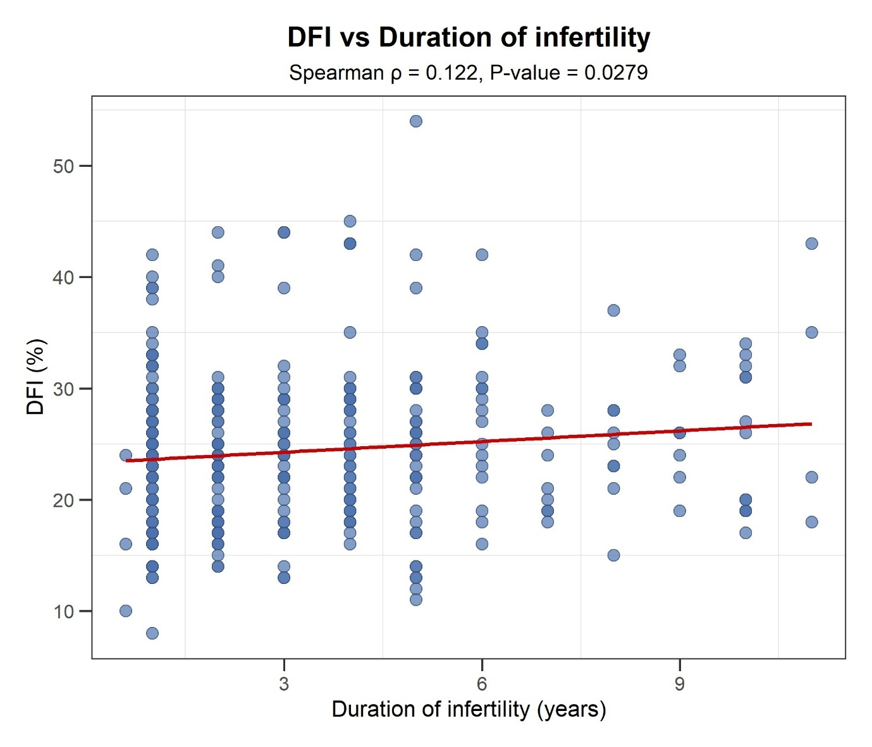

Figure 4: Scatter plot depicting correlation of DFI with semen parameters

Table 3: Association of baseline characteristics and semen parameters with DFI
Variables | DFI |  | P-value
Variables | ≤25% | >25% | P-value
Age (years), Median (IQR) | 36 (34, 39) | 36 (34, 40) | 0.653
Age group, n (%)
<30 years (n=9) | 4 (44.4%) | 5 (55.6%) | 0.193
30 to 34 years (n=95) | 55 (57.9%) | 40 (42.1%) | 0.193
35 to 39 years (n=151) | 101 (66.9%) | 50 (33.1%) | 0.193
≥40 years (n=71) | 39 (54.9%) | 32 (45.1%) | 0.193
BMI (kg/m²), Median (IQR) | 28 (25, 30) | 27 (26, 31) | 0.714
BMI group, n (%)
Normal (n=59) | 39 (66.1%) | 20 (33.9%) | 0.273
Overweight (n=159) | 90 (56.6%) | 69 (43.4%) | 0.273
Obese (n=108) | 70 (64.8%) | 38 (35.2%) | 0.273
Duration of infertility (years), Median (IQR) | 2 (1, 4) | 3 (1, 5) | 0.021
Infertility type, n (%)
Primary (n=175) | 103 (58.9%) | 72 (41.1%) | 0.384
Secondary (n=151) | 96 (63.6%) | 55 (36.4%) | 0.384
Smoking, n (%)
Yes (n=63) | 39 (61.9%) | 24 (38.1%) | 0.876
No (n=263) | 160 (60.8%) | 103 (39.2%) | 0.876
Alcohol, n (%)
Yes (n=147) | 91 (61.9%) | 56 (38.1%) | 0.772
No (n=179) | 108 (60.3%) | 71 (39.7%) | 0.772
Varicocele, n (%)
Yes (n=37) | 17 (45.9%) | 20 (54.1%) | 0.045
No (n=289) | 182 (63%) | 107 (37%) | 0.045
Diabetes, n (%)
Yes (n=51) | 34 (66.7%) | 17 (33.3%) | 0.37
No (n=275) | 165 (60%) | 110 (40%) | 0.37
HTN, n (%)
Yes (n=44) | 27 (61.4%) | 17 (38.6%) | 0.963
No (n=282) | 172 (61%) | 110 (39%) | 0.963
Hypothyroid, n (%)
Yes (n=17) | 5 (29.4%) | 12 (70.6%) | 0.006
No (n=309) | 194 (62.8%) | 115 (37.2%) | 0.006
Hydrocele, n (%)
Yes (n=3) | 1 (33.3%) | 2 (66.7%) | 0.694
No (n=323) | 198 (61.3%) | 125 (38.7%) | 0.694
Hernia, n (%)
Yes (n=1) | 1 (100%) | 0 (0%) | 1.000
No (n=325) | 198 (60.9%) | 127 (39.1%) | 1.000
Microcalcification, n (%)
Yes (n=1) | 0 (0%) | 1 (100%) | 0.821
No (n=325) | 199 (61.2%) | 126 (38.8%) | 0.821
Semen volume (ml), Median (IQR) | 2 (1.5, 2.5) | 2 (1.5, 2.5) | 0.407
Sperm count (M/ml), Median (IQR) | 40 (20, 56) | 21 (10, 45) | <0.001
Total motility (%), Median (IQR) | 55 (45, 60) | 49 (30, 59) | 0.001
Morphology (%), Median (IQR) | 1 (1, 2) | 1 (1, 1) | 0.064

There was statistically significant association of DFI with duration of infertility, varicocele, hypothyroid, sperm count and total motility (p<0.05). The median (IQR) duration of total infertility was 2 (1, 4) years for males with DFI ≤25% and 3 (1, 5) years for males with DFI >25%. Among those with varicocele, 45.9% had DFI ≤25% and 54.1% had DFI >25% whereas among those without varicocele, 63% had DFI ≤25% and 37% had DFI >25%. Among those with hypothyroid, 29.4% had DFI ≤25% and 70.6% had DFI >25% whereas among those without hypothyroid, 62.8% had DFI ≤25% and 37.2% had DFI >25%. The median (IQR) sperm count was 40 (20, 56) M/ml for males with DFI ≤25% and 21 (10, 45) M/ml for males with DFI >25%. The median (IQR) total motility was 55 (45, 60) % for males with DFI ≤25% and 49 (30, 59) % for males with DFI >25%.

Table 4: Binary logistic regression to assess predictors associated with poor DFI
Variables | Univariate analysis |  | Multivariable analysis
Variables | Unadjusted OR  (95% CI) | P-value | Adjusted OR  (95% CI) | P-value
Age (years) | 0.998 (0.948 to 1.052) | 0.949
BMI (kg/m²) | 1.007 (0.958 to 1.059) | 0.779
Duration of infertility (years) | 1.106 (1.016 to 1.204) | 0.020 | 1.087 (0.994 to 1.188) | 0.068
Secondary infertility | 0.82 (0.524 to 1.283) | 0.384
Smoking | 0.956 (0.543 to 1.683) | 0.876
Alcohol | 0.936 (0.598 to 1.465) | 0.772
Varicocele | 2.001 (1.004 to 3.987) | 0.049 | 1.238 (0.585 to 2.619) | 0.577
Diabetes | 0.75 (0.399 to 1.408) | 0.371
HTN | 0.985 (0.513 to 1.89) | 0.963
Hypothyroid | 4.049 (1.391 to 11.785) | 0.010 | 4.624 (1.51 to 14.158) | 0.007
Hydrocele | 3.168 (0.284 to 35.303) | 0.349
Hernia | 0.519 (0.021 to 12.839) | 0.689
Microcalcification | 4.731 (0.191 to 117.049) | 0.342
Semen volume (ml) | 0.844 (0.604 to 1.178) | 0.319
Sperm count (M/ml) | 0.975 (0.965 to 0.986) | <0.001 | 0.979 (0.965 to 0.993) | 0.003
Total motility (%) | 0.974 (0.96 to 0.989) | 0.001 | 0.995 (0.976 to 1.01) | 0.637
Morphology (%) | 0.714 (0.498 to 1.025) | 6.761

According to univariate analysis, higher duration of infertility, varicocele, hypothyroid, lower sperm count and lower motility were statistically significantly associated with poor DFI (P<0.05).
The variables found statistically significant (i.e. P-value <0.05) were taken into final multivariable model. According to multivariable analysis, hypothyroid and lower sperm count were statistically significantly associated with poor DFI (P<0.05). Males with hypothyroid had 4.624 times (adjusted OR: 4.624; 95% CI: 1.51 to 14.158) higher odds of poor DFI as compared to males without hypothyroid. With each M/ml increase in sperm count, the odds of poor DFI decreased by 2.1% (adjusted OR: 0.979; 95% CI: 0.965 to 0.993).

This study demonstrates that sperm DNA fragmentation (DFI) is more strongly related to intrinsic semen quality and underlying systemic disorders than to paternal age or body mass index (BMI). The lack of a significant correlation between DFI and age aligns with the findings of Winkle and Chua et al., who reported minimal variation in sperm DNA integrity across age groups among infertile men (Winkle et al., 2009; Chua et al., 2023). In contrast, Deenadayal Mettler et al. (2020) identified an age-dependent rise in DFI using the sperm chromatin structure assay (SCSA). The narrow age distribution in our study population may have reduced the ability to detect age-related changes in sperm DNA integrity.
Sperm count and motility emerged as the principal determinants of sperm DNA integrity, showing moderate negative correlations with DFI. This pattern mirrors previous studies demonstrating that poorer semen parameters are often associated with higher DNA fragmentation (Khandhedia et al., 2025; Al Omrani et al., 2018). These results highlight that conventional semen analysis alone may not fully reflect genomic competence, supporting the complementary use of DFI testing for a comprehensive evaluation of male fertility potential (Cho et al., 2018; Evenson et al., 2012).
An important observation in this study was the independent association between hypothyroidism and higher DFI. Thyroid hormones regulate testicular development, spermatogenesis, and sperm maturation; their deficiency may impair chromatin condensation and promote oxidative stress, leading to DNA damage (Agarwal et al., 2005). This emphasizes the need to evaluate thyroid function during the assessment of male infertility.
The observed link between varicocele and increased DFI supports the hypothesis that oxidative stress contributes significantly to sperm DNA damage in affected individuals. Earlier studies have also shown that varicocelectomy can improve sperm genomic stability (Cho et al., 2018; Agarwal et al., 2023).
Lifestyle factors such as smoking, alcohol use, and BMI did not significantly affect DFI in our data. Comparable findings were noted by Khosravi et al. (2023) and Chua et al. (2023). Differences in methodology, sample demographics, and exposure accuracy may explain inconsistent results across studies.
Overall, these findings suggest that sperm DNA integrity is more reflective of underlying testicular and systemic health than demographic characteristics alone. Although routine semen analysis remains useful, integrating DFI testing may enhance diagnostic precision in idiopathic male infertility and help tailor interventions such as antioxidant therapy, hormonal correction, or varicocele repair (Cho et al., 2018; Agarwal et al., 2023).
While the retrospective design and limited age variability restrict causal inferences, the large sample size and consistent methodology strengthen the reliability of the associations observed. Further prospective, multicenter studies are warranted to explore the combined impact of age, endocrine function, and oxidative stress on sperm DNA integrity.

6. CONCLUSION
Sperm DNA fragmentation in this study was more closely related to semen quality and systemic conditions such as hypothyroidism and varicocele rather than to age, BMI, or lifestyle habits. These findings highlight the importance of integrating sperm DNA integrity assessment and thyroid testing into routine male infertility evaluation, particularly in cases with borderline semen parameters or unexplained infertility, to improve diagnostic accuracy and treatment outcomes.
CONSENT
Not applicable.
ETHICAL APPROVAL
this study was approved by institutional ethics committee (Reg.No. RCHBH/EC/OCT/25-IVF-05).
COMPETING INTERESTS
Authors have declared that no competing interests exist.

ABBREVIATIONS
DFI: DNA fragmentation index
DNA: deoxyribonucleic acid
ART: Assisted Reproductive Technology
BMI: body mass index
SCD: sperm chromatin dispersion
WHO: world health organization
SCSA: sperm chromatin structure assay

COMPETING INTERESTS DISCLAIMER:
Authors have declared that they have no known competing financial interests OR non-financial interests OR personal relationships that could have appeared to influence the work reported in this paper.

REFERENCES
Agarwal A, Mulgund A, Hamada A, Chyatte MR. A unique view on male infertility around the globe. Reprod Biol Endocrinol. 2015;13:37.
Esteves SC, Roque M, Garrido N. Sperm DNA fragmentation testing: the evidence base for clinical use. J Hum Reprod Sci. 2021;14(3):217–231.
Khandhedia P, Pandey S. Comparative analysis of sperm DNA fragmentation index with sperm chromatin dispersion in varied infertility types: a retrospective study. Int J Reprod Contracept Obstet Gynecol. 2025;14(3):820–824.
Cho CL, Agarwal A. Role of sperm DNA fragmentation in male factor infertility: a systematic review. Arab J Urol. 2018;16(1):21–34.
Evenson DP, Wixon R. Clinical aspects of sperm DNA fragmentation detection and male infertility. Ther Adv Urol. 2012;4(2):109–123.
Simon L, Emery BR, Carrell DT. Sperm DNA damage or progressive motility: which is the better predictor of fertilization in IVF? Syst Biol Reprod Med. 2017;63(3):159–168.
Deenadayal Mettler A, Govindarajan M, Srinivas S, et al. Male age is associated with sperm DNA/chromatin integrity. Aging Male. 2020;23(5):822–829.
Al Omrani B, Al Eisa N, Javed M, et al. Associations of sperm DNA fragmentation with lifestyle factors and semen parameters of Saudi men and its impact on ICSI outcome. Reprod Biol Endocrinol. 2018;16(1):49.
Khosravi P, Rouzbahani AK, Yeganeh BY, et al. Association between demographic characteristics and sperm DNA fragmentation index in infertile men. Nephro-Urol Mon. 2023;15(3):e133856.
Ajayi AB, Osuolale KA, Obasa-Gbadebo R, et al. Understanding the impact of lifestyle and demographic factors on DNA fragmentation index among infertile men. BMC Urol. 2025;25:198.
Agarwal A, Gupta S, Sharma RK. Role of oxidative stress in male infertility. Reprod Biol Endocrinol. 2005;3:28.
Winkle T, Rosenbusch B, Zoller N, et al. The correlation between male age, sperm quality and sperm DNA fragmentation. J Assist Reprod Genet. 2009;26(1):41–46.
Chua SC, Yovich SJ, Hinchliffe PM, Yovich JL. Male clinical parameters (age, stature, BMI, smoking, alcohol) bear minimal relationship to sperm DNA fragmentation. J Pers Med. 2023;13(5):759.
Agarwal A, Cho CL. Varicocele and male infertility: role of oxidative stress and DNA damage. Reprod Biomed Online. 2023;47(4):665–678.
Evenson DP. The sperm chromatin structure assay and other sperm DNA fragmentation tests for evaluation of sperm nuclear DNAintegrity as related to infertility. Anim Reprod Sci. 2016;169:5675
Szabo A, Vancsa S, Hegyi P, Varadi A, Forintos A, Filipov T, et al. Lifestyle, environmental and additional health factors associated with an increased sperm DNA fragmentation: a systematic review and meta analysis. Reprod Biol Endocrinol. 2023;21(5)
Farkouh A, Salvio G, Kuroda S et al. Sperm DNA integrity and male infertility: a narrative review and guide for the reproductive physicians Tansl Androl Urol. 2022;11(7):1023–1044
Henriques MC, Santiago J, Patricio A, Herdeiro MT, et al. Smoking induces a decline in semen quality and the activation of stress response pathways in sperm. Int J Reprod BioMed. 2016;14(4):231–40
Hassan MA, Killick SR. Effect of male age on fertility: evidence for the decline in male fertility with increasing age. Fertil Steril. 2003;79:1520–7.
Campos AGL, Requejo CL, Minano CA, Loyaga OJ E.C. and, Comejo GL. Correlation between sperm DNA fragmentation index and semen parameters in 418 men seen at our fertility centre. JBRA Assist Reprod. 2021;25(3):349–57.
Sharma R, Agarwal A. Spermatogenesis: An overview. In: Zini A, Agarwal A, editors. Sperm Chromatin for the Researcher: A Practical Guide. 1st ed. New York: Springer; 2013. p. 127-60.
Sakkas D, Alvarez JG. Sperm DNA fragmentation: Mechanisms of origin, impact on reproductive outcome, and analysis. Fertil Steril 2010;93:1027-36
Erenpreiss J, Elzanaty S, Giwercman A. Sperm DNA damage in men from infertile couples. Asian J Androl 2008;10:786-90.
Giwercman A, Richthoff J, Hjøllund H, Bonde JP, Jepson K, Frohm B, et al. Correlation between sperm motility and sperm chromatin structure assay parameters. Fertil Steril 2003;80:1404-12.
Lopes S, Jurisicova A, Sun JG, Casper RF. Reactive oxygen species: Potential cause for DNA fragmentation in human spermatozoa. Hum Reprod 1998;13:896-900.
Bungum M. Sperm DNA integrity assessment: A new tool in diagnosis and treatment of fertility. Obstet Gynecol Int 2012;2012:531042.
Tamburrino L, Marchiani S, Montoya M, Elia Marino F, Natali I, Cambi M, et al. Mechanisms and clinical correlates of sperm DNA damage. Asian J Androl 2012;14:24-31.
Schmid TE, Eskenazi B, Baumgartner A, Marchetti F, Young S, Weldon R, et al. The effects of male age on sperm DNA damage in healthy non-smokers. Hum Reprod 2007;22:180-7.
Sergerie M, Laforest G, Bujan L, Bissonnette F, Bleau G. Sperm DNA fragmentation: threshold value in male fertility. Hum Reprod. 2005;20(12):3446–51.
Singh NP, Muller CH, Berger RE. Effects of age on DNA double-strand breaks and apoptosis in human sperm. Fertil Steril. 2003;80(6):1420–30.
Cohen-Bacrie P, Belloc S, Ménézo YJR, Clement P, Hamidi J. Correlation between DNA damage and sperm parameters: a prospective study of 1,633 patients. Fertil Steril. 2009;91(5):1801–5.
Muratori, M.; Marchiani, S.; Tamburrino, L.; Baldi, E. Sperm DNA Fragmentation: Mechanisms of Origin. Adv. Exp. Med. Biol. 2019, 1166, 75–85.

