Original Research Article

Asian Trends in Attitudes and Strategies for Myopia Management in Clinical Practice

.
ABSTRACT

Aims: To assess trends in attitudes and strategies for myopia management among Asian eye care practitioners between 2015 and 2024, focusing on concern levels, treatment preferences, prescribing patterns, and barriers.
Study design: Cross-sectional, online survey-based study.

Place and duration of study: Data were collected from 2,473 practitioners across multiple Asian countries in surveys conducted in 2015, 2019, 2022, and 2024.

Methodology: A 15-item questionnaire, translated into 18 languages, was distributed via professional organizations to optometrists, ophthalmologists, and other practitioners. Items evaluated concern about childhood myopia, perceived treatment efficacy, prescribing frequency, initiation thresholds, and barriers. Non-parametric analyses compared responses between countries and over time.

Results: Concern about childhood myopia was consistently high, peaking in 2019 and 2022 (mean 9.0 ± 1.5) and slightly declining in 2024 (8.5 ± 1.9, p < 0.05). Vietnam reported the highest concern (10.0 ± 0.2) and Turkey the lowest (7.4 ± 1.9, p < 0.001). In 2024, combination therapy (orthokeratology + atropine) was rated most effective (64.0 ± 24.3), followed by orthokeratology (56.1 ± 22.6) and outdoor time (48.7 ± 26.7). Single-vision spectacles declined in use, while myopia control spectacles, contact lenses, and atropine increased. Minimum thresholds for initiating treatment were lowest in China (−0.5 ± 0.5D) and highest in Turkey (−1.6 ± 0.9D, p ≤ 0.001). Main barriers were cost (30.4%), accessibility (14.3%), and safety concerns (12.7%). Myopia management enhanced patient loyalty (67.5%) and job satisfaction (75.2%), with variable impact on revenue (53.4%).

Conclusion: Evidence-based myopia control strategies are increasingly adopted across Asia, especially in China and Singapore. However, economic and accessibility barriers remain. Proactive myopia management improves patient retention and professional satisfaction, underscoring the need for broader implementation and support.

Keywords: myopia control, eye care practitioners, paediatric myopia, children, treatment
1. INTRODUCTION

Myopia is a refractive error that has reached epidemic proportions worldwide, with estimates projecting that by 2050, nearly half of the global population could be affected (Holden et al., 2015). This has led to myopia becoming a significant public health issue in Asia, with prevalence rates far exceeding those of other regions of the world (Morgan et al., 2012). In countries such as China, South Korea, Japan, and Singapore, the prevalence of myopia among adolescents and young adults has reached alarming levels, surpassing 80% in many Asian cities (Jonas et al., 2021). Whilst the prevalence of myopia in young adults in Asia has been estimated to range from 6.8% to 21.6%, in non-Asian populations it estimated to be between 2.0% and 2.3% (Wong & Saw, 2016). This increase in the prevalence of myopia has been proposed to be largely driven by environmental and educational factors, such as intense academic pressure and prolonged engagement in near-vision activities (Xiang & Zou, 2020). To control this epidemic, some Asian countries, such as China and Singapore, have implemented comprehensive national programs to combat the rising prevalence of myopia among children (Jan et al., 2020; Karuppiah et al., 2021). In China, a school-based national program emphasizes increasing outdoor activities, with research showing that adding 1–2 hours of outdoor time daily can reduce myopia incidence by 25–50% over 1–3 years, particularly in children under 12. Despite its low cost and additional health benefits, such as addressing childhood obesity, concerns persist that increased outdoor time may compromise academic performance, although evidence does not support this claim. Additionally, China’s “Double Reduction” policy, introduced in 2021, aims to alleviate academic pressure by limiting homework and after-school tutoring, which has shown a significant positive impact on reducing myopia progression in schoolchildren (Jan et al., 2020). Similarly, Singapore established a national myopia prevention programme in 2001 to delay myopia onset and progression through annual vision screenings, public education campaigns, and school-based interventions. This initiative promotes increased outdoor activities, reduces near-work tasks, and educates parents and teachers on good eye care habits. Since its launch, the program has achieved measurable success, with myopia prevalence among Primary 1 students decreasing from 37.7% in 2004 to 31.6% in 2015 (Karuppiah et al., 2021). The main barrier to implementation is the concern among parents and educators that more time outdoors will compromise educational outcomes, despite lack of evidence for such an undesirable effect. In addition to increased time outdoors, evidence suggests that the use of other treatment options, such topical atropine, red-light therapy, custom-designed spectacles, dual-focus contact lenses, multifocal soft lenses, and overnight orthokeratology, may slow the onset and/or the progression of myopia (Lawrenson et al., 2025; Zaabaar et al., 2024). The uptake of these myopia management treatment option is, however, not well understood. Furthermore, barriers for implementation of these treatments may include issues related safety and cost as well as the lack of approval/availability of some of these myopia control strategies. To better understand trends in myopia management in clinical practice, a number of survey-based studies have been conducted by Wolffsohn and colleagues to assess differences primarily between continents, but little information was provided with regards to differences between countries within the same continent (Wolffsohn et al., 2016, 2020, 2023). The first study, conducted in 2015, revealed that Asian eye care practitioners expressed one of the highest levels of concern globally regarding the rapid increase in childhood myopia. However, despite this concern, most practitioners in this region continued to prescribe single-vision lenses as the primary option for children with progressive myopia, citing cost and lack of information about alternative therapies as the main barriers to adopting effective strategies (Wolffsohn et al., 2016). In 2019, the survey was again distributed among eye care practitioners worldwide, given the rapid advancements in knowledge in the field (Wolffsohn et al., 2020). This study found that concern about childhood myopia remained high in Asia, and there was an increase in the adoption of methods with proven efficacy, particularly orthokeratology and pharmacological interventions. China, Hong Kong, and Singapore emerged as the regions with the highest implementation of advanced strategies, while other Asian countries still showed reluctance due to limited accessibility to certain treatments and the perception of high costs. Additionally, Asia exhibited a greater use of bifocal and progressive addition lenses for myopia control compared to other regions, reflecting differences in clinical practice across continents. In 2022, a new study confirmed a growing trend in Asia toward the use of combination therapies to enhance myopia control efficacy (Wolffsohn et al., 2023). Although the use of single-vision lenses declined, they remained widely prescribed, and significant differences persisted in the perceived effectiveness of various strategies among Asian countries. China continued to lead in the adoption of advanced treatments, with greater implementation of orthokeratology and pharmaceutical options such as atropine; countries such as India and the Philippines showed a more moderate adoption, influenced by economic factors and the availability of specialized treatments. Since the latter survey-based studies have not examined variations in attitudes and strategies for myopia management across Asian countries in detail or how these trends have evolved over time, this study seeks to update the 2024 findings while analysing changes in clinical approaches from 2015 to 2024, identifying specific trends and challenges within Asia.

2. material and methods

An online, self-administered, cross-sectional survey was conducted in 18 languages (simplified and traditional Chinese, Danish, Dutch, English, French, Greek, Hebrew, Italian, Japanese, Norwegian, Polish, Portuguese, Russian, Spanish, Swedish, Turkish, and Vietnamese) using the SurveyMonkey platform (Palo Alto, California, USA). The initial survey and its later revisions were developed in English before being translated into multiple languages by skilled bilingual speakers. It was then disseminated globally through professional organizations to reach eye care professionals, including optometrists, dispensing opticians, ophthalmologists, and other specialists. The questionnaire comprised 15 questions addressing clinical practices and practitioners' perspectives on myopia management (Appendix 1). Between 2015 and 2022, the survey was updated in response to scientific advancements in myopia research. Revisions included:
- The addition of myopia control spectacles and combination therapy (using two or more treatments simultaneously).
- The inclusion of a general question about the minimum level of myopia required to consider myopia control interventions.
- The addition of "treatment accessibility" as a possible barrier to prescribing myopia control options.
- Review and refinement of new questions by the International Myopia Institute advisory board, indicated with an asterisk.
Ethical approval for the study was granted by the Research Ethics Committee at Aston University in Birmingham, United Kingdom. The survey invitation outlined the study's purpose and data collection methods. By submitting their responses, participants provided informed consent. Participation was voluntary and anonymous, with no collection of personally identifiable information, although respondents were asked to provide basic demographic details regarding their years of professional experience and daily work environment.
2.1 Statistical Analysis
Responses from eye care practitioners were categorized by country for individual analysis. Ordinal variables are summarized using medians and interquartile ranges, while continuous variables are expressed as means ± standard deviations. The Shapiro-Wilk test was applied to assess normality, revealing that the data did not follow a normal distribution. Consequently, the Kruskal-Wallis test, a non-parametric alternative, was employed to compare responses across countries. All statistical analyses were performed using IBM SPSS 27.0 software (SPSS Inc., Chicago, Illinois), with statistical significance established at P < 0.05.
3. results

Overall, 2,473 responses were collected across the four surveys conducted between 2015 and 2024 (Table 1). In 2015, data was obtained from three Asian markets, primarily from China (57.9%), followed by Hong Kong (26.4%) and India (15.7%). In 2019, participation was led by China (20.3%), Hong Kong (32.4%), India (15.4%), Malaysia (7.1%), and Pakistan (8.2%). Among the four surveys conducted, the highest response rate was obtained in 2022 with the major contribution obtained from China (72.7%), but there were contributions from new countries that did not participate in previous surveys, including Israel (3.1%), the Philippines (4.2%), Turkey (5.6%) and Vietnam (7.3%). In 2024, China (34.1%), followed by Vietnam (21.0%) and Turkey (15.7%), were the countries with the highest response rates. Overall, 33.4% of the respondents reported being optometrists, 63.2% ophthalmologists, 0.1% contact lens specialists, and 3.2% other eye care-related practitioners in Asia in 2024, although there were differences across Asian countries (Table 2). Among the Asian eye care practitioners that participated in the 2024 survey, 9.8% reported having over 31 years of experience, 19.6% between 21 and 30 years, 29.7% between 11 and 20 years, 19.8% between 6 and 10 years, 19.9% between 1 and 5 years, and 1.2% reported no previous experience. Additionally, 2.5% of respondents did not provide information regarding their years of professional experience.
Table 1. Distribution of responses obtained to the survey by country and year.

Country | 2015 | 2019 | 2022 | 2024 | Total
China | 136 | 37 | 1001 | 232 | 1406
Hong Kong | 62 | 59 | 1 | 0 | 122
India | 37 | 28 | 67 | 39 | 171
Israel | 0 | 0 | 42 | 0 | 42
Philippines | 0 | 4 | 58 | 0 | 62
Turkey | 0 | 0 | 78 | 107 | 185
Vietnam | 0 | 0 | 101 | 143 | 244
Malaysia | 0 | 13 | 7 | 65 | 85
Pakistan | 0 | 15 | 4 | 0 | 19
Singapore | 0 | 15 | 2 | 35 | 52
Taiwan | 0 | 11 | 15 | 59 | 85
Total | 235 | 182 | 1376 | 680 | 2473

Table 2. Distribution of responses obtained by eye care practitioner type in 2024. N, number of responses; %, percentage.

Country | Optometrists  N (%) | Ophthalmologists  N (%) | Contact lens specialists  N (%) | Other  N (%)
China | 83 (35.8%) | 139 (59.9%) | 0 (0.0%) | 10 (4.3%)
India | 35 (89.7%) | 2 (5.1%) | 0 (0.0%) | 2 (5.1%)
Turkey | 0 (0.0%) | 107 (100.0%) | 0 (0.0%) | 0 (0.0%)
Vietnam | 54 (37.8%) | 80 (55.9%) | 1 (0.7%) | 8 (5.6%)
Malaysia | 18 (27.7%) | 47 (72.3%) | 0 (0.0%) | 0 (0.0%)
Singapore | 35 (100.0%) | 0 (0.0%) | 0 (0.0%) | 0 (0.0%)
Taiwan | 2 (3.4%) | 55 (93.2%) | 0 (0.0%) | 2 (3.4%)
Total | 227 (33.4%) | 430 (63.2%) | 1 (0.1% | 22 (3.2%)

3.1 Self-reported concern about the increasing frequency of childhood myopia
Concern among eye care practitioners regarding the rising prevalence of childhood myopia in clinical practice varied significantly across Asian countries (p≤0.001), being highest in Vietnam (10.0±0.2, all p≤0.001) and lowest in Turkey (7.4±1.9, all p≤0.001, except for Singapore) (Figure 1). This level of concern increased significantly between 2015 (8.3±1.8) and subsequent years, peaking in 2019 and 2022 (2019: 9.0±1.5; 2022: 9.0±1.5; 2024: 8.5±1.9; all p<0.05).
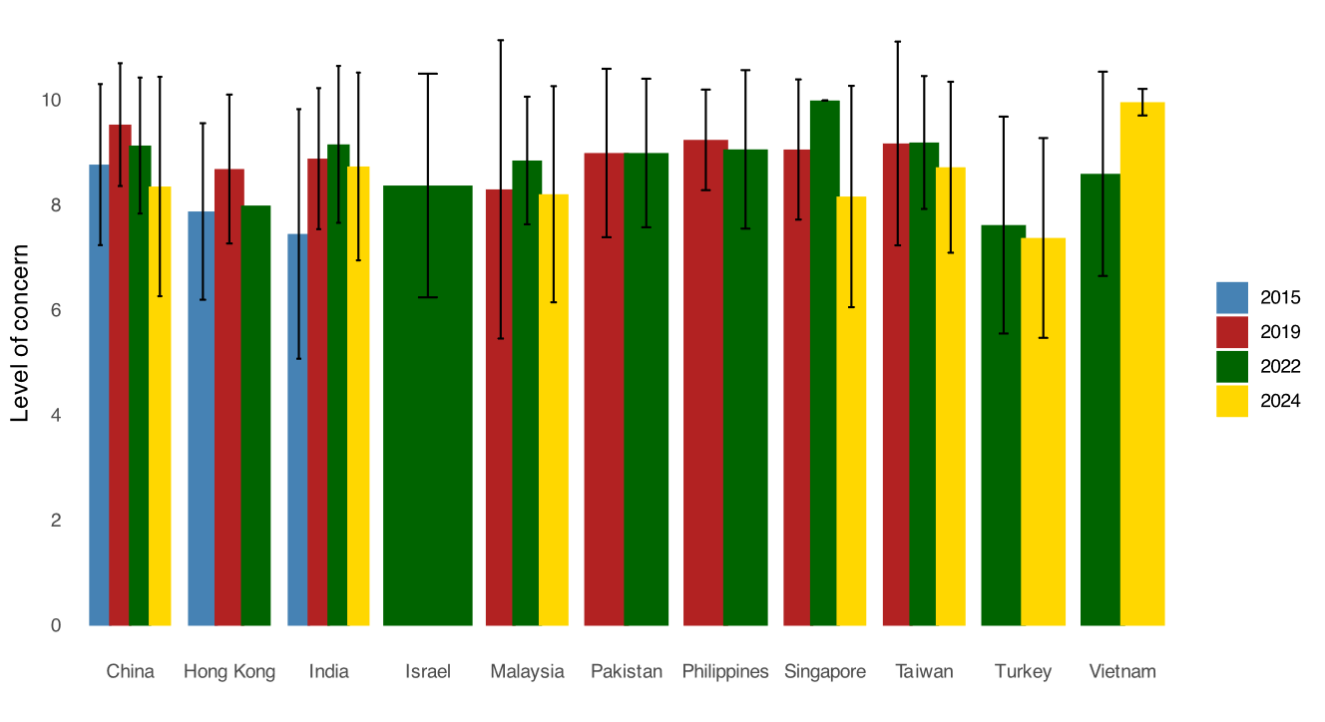
Figure 1. Level of concern (rated from 0 [lowest] to 10 [highest]) by country and year. Error bars represent one standard deviation

3.2 PRACTITIONERS’ PERCEIVED EFFECTIVENESS OF MANAGEMENT OPTIONS FOR MYOPIA CONTROL
In 2024, Asian practitioners identified combination therapy (orthokeratology + atropine) as the myopia treatment they perceived to be most effective, followed by orthokeratology, atropine, and increased outdoor time. In contrast, undercorrection and single-vision glasses were reported as the least effective treatments (Table 3). Singaporean practitioners reported undercorrection (all p<0.05, except for Vietnam) and single-vision spectacles (all p≤0.001) as the least effective methods, while they considered approved myopia control spectacles to be more effective compared to other Asian countries (all p<0.05, except for Turkey and Malaysia). Among Asian countries, Turkey reported the lowest perceived effectiveness for various contact lens treatments, including rigid corneal lenses (all p < 0.05, except for Taiwan), single-vision soft lenses (all p < 0.05, except for Taiwan, Singapore, and Vietnam), multifocal soft contact lenses (all p < 0.05, except for Malaysia), and orthokeratology (all p≤0.001), as well as for combination therapy (all p<0.05). Regarding the use of different concentrations of atropine for myopia control, Malaysia identified 0.01% atropine as the most effective concentration (all p<0.05), whereas Taiwan considered concentrations above 0.5% to be the most effective treatment compared to other Asian countries (all p<0.05, except for Singapore). China considered red light therapy and alternative treatment methods to be the most effective compared to the other Asian countries (all p≤0.001). Increasing outdoor time was considered less effective by Vietnamese practitioners compared to practitioners from the other Asian countries (all p<0.05). No significant differences were found between countries with regards to the perceived effectiveness of bifocal and progressive addition spectacles, approved myopia control soft contact lenses, or 0.05% atropine (all p>0.05).
Over time, the perceived effectiveness of undercorrection was found to decline after 2022 (p ≤ 0.001), while the perceived efficacy of single-vision spectacles increased between 2019 and 2022 (p = 0.002), but declined again in 2024 (p = 0.016). The perceived efficacy of bifocal and progressive addition lenses increased between 2015 and 2019 (p≤0.001), decreased in 2022 (p≤0.001), and remaining stable thereafter in 2024 (p>0.05). The perceived efficacy of approved myopia control spectacles increased between 2015 and 2022 (p=0.012). The perception efficacy of rigid corneal lenses increased between 2019 and 2022 (p≤0.001), remaining stable thereafter. The perception efficacy of soft contact lenses increased between 2015 and 2022 (p=0.013), remaining stable thereafter. The perception of the efficacy of multifocal soft contact lenses increased between 2015 and 2019 (p≤0.01), remaining stable thereafter. The perceived efficacy of approved myopia control soft contact lenses, orthokeratology lenses, and outdoor time were reported to increase from 2015 onwards (p≤0.001). The perceived efficacy of combined therapies, such as orthokeratology together with atropine, decreased between the years 2022 and 2024 (p<0.001). No significant differences were found in the perceived efficacy of refractive surgery over the years (p>0.05).
3.3 PRACTITIONERS PERCEIVED LEVEL OF CLINICAL ACTIVITY IN MYOPIA CONTROL
In 2024, significant differences were found in the clinical activity reported by practitioners across Asian countries (p<0.001), with the highest levels reported in Turkey (3.8±1.1, all p<0.05, except for Malaysia), followed by Vietnam (3.3±1.1, all p≤0.001). No significant differences were found among the remaining countries (p>0.05) (Figure 2). Overall, the level of concern was found to decrease over time (2015: 3.6±1.1; 2019: 3.2±1.0; 2022: 3.4±1.2; 2024: 3.0±1.3; p=0.018).

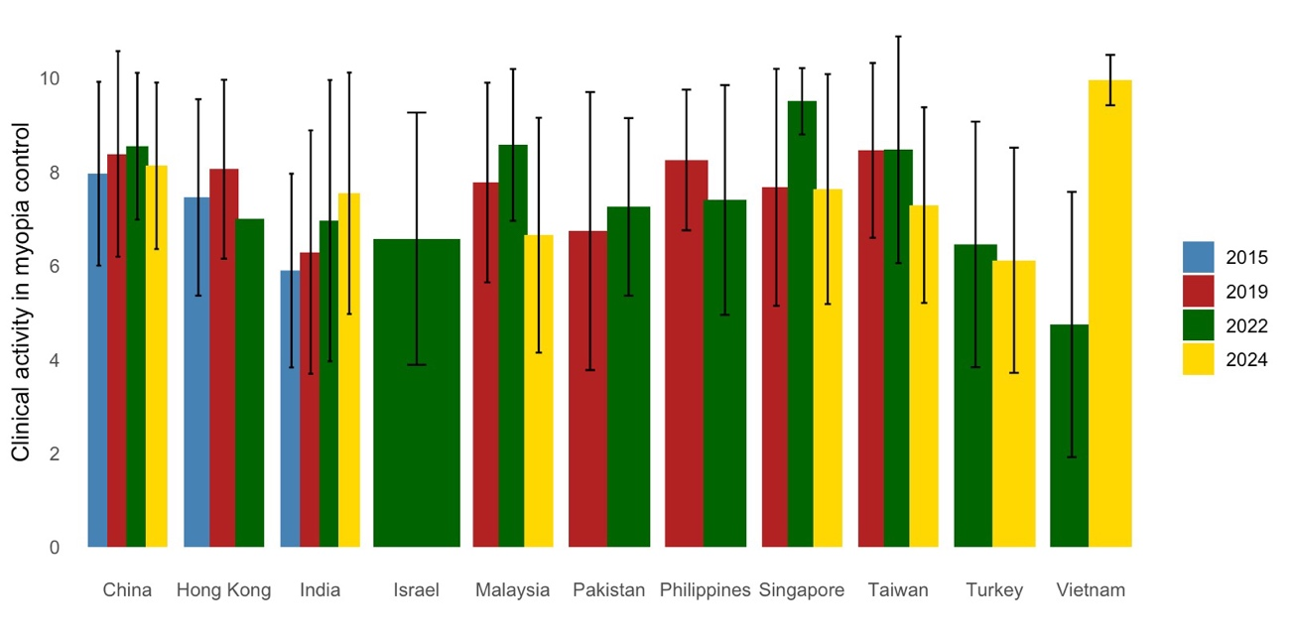
Figure 2. Perceived clinical activity (rated from 0 [low] to 10 [high]) by country and year. Error bars represent one standard deviation.

  - RELATIVE FREQUENCY OF PRESCRIBING DIFFERENT MYOPIA CORRECTION/CONTROL METHODS BY PRACTITIONERS
In 2024, single-vision spectacles and 0.01% atropine were the most commonly prescribed myopia correction/control methods (Table 4). However, in China (all p≤0.001) and Taiwan (all p<0.001, except for Singapore), single-vision spectacles were reported to have the lowest prescription frequency. Approved myopia control spectacles were prescribed relatively more frequently in Singapore and less frequently in Vietnam compared to the other Asian countries (all p≤0.001). Progressive addition spectacles were prescribed relatively more frequently in China and Singapore compared to the other countries (all p<0.05). Rigid contact lenses (all p≤0.001), multifocal contact lenses (all p<0.05, except for India and Singapore), approved myopia control soft reusable contact lenses (all p<0.05), red light therapy (all p≤0.001), and combination therapy (all p≤0.001) were prescribed relatively more frequently in China compared to other countries. Single-vision soft contact lenses were prescribed relatively more frequently in India compared to the other countries (all p<0.05, except for Singapore). Approved myopia control soft daily disposable lenses were fitted relatively more frequently in Singapore (all p<0.05), whereas orthokeratology lenses were prescribed relatively less frequently in Turkey (all p≤0.001) compared to the other countries. Atropine at different concentrations was prescribed relatively more frequently in Taiwan compared to other countries (all p≤0.001). No significant differences were found between countries in the relative frequency of prescribing bifocal spectacles (p>0.05).
Regarding trends over time, the relative prescription frequency of undercorrection increased between 2015 and 2019 (p=0.016), then decreased again in 2022 (p≤0.001) and remained stable thereafter (p>0.05). The relative prescription frequency of bifocal spectacles increased between 2015 and 2019 (p=0.013), then decreased again in 2024 (p≤0.001). The relative prescription frequency of progressive addition spectacles increased between 2015 and 2019 (p≤0.001) and decreased again in 2024 (p≤0.001). The relative prescription frequency of rigid corneal lenses and single-vision soft contact lenses decreased over the years (both p≤0.001). The relative prescription frequency of multifocal soft contact lenses increased between 2015 and 2022 (p≤0.001), but decreased in 2024 (p≤0.001). The relative prescribing of orthokeratology increased between 2019 and 2022 (p≤0.001), but decreased in 2024 (p≤0.001). No significant differences were found over time in the relative prescription frequency of bifocal spectacles, combination therapy, and refractive surgery (p>0.05).

  - MINIMUM AGE OF PRESCRIBING MYOPIA MANAGEMENT OPTIONS BY PRACTITIONERS
In 2024, myopia control spectacles were the myopia control method prescribed at the youngest age, while approved myopia control soft reusable contact lenses were prescribed at the oldest age (Table 5). Regarding myopia control spectacles, they were prescribed at an older age in China compared to other countries (all p<0.05). Rigid corneal lenses were prescribed at a younger age in Singapore (all p<0.05, except for China) and Vietnam (all p≤0.001, except for China) compared to the other countries. Approved myopia control soft daily disposable contact lenses were prescribed at an older age in Malaysia in comparison with the other Asian countries (all p≤0.001, except for Taiwan). On the other hand, specific myopia control soft reusable contact lenses were prescribed at a younger age in Singapore and Taiwan in comparison with the remaining countries (all p<0.05). Atropine was prescribed at an older age in China in comparison with the other Asian countries (all p<0.05). No significant differences were found between Asian countries in red light therapy (p>0.05). Regarding trends over time, the age at which spectacles were prescribed decreased between 2022 and 2024 (p<0.001). The age for prescribing rigid corneal lenses decreased between 2015 and 2022, but it increased in 2024 (both p<0.001). The age at which atropine was prescribed increased significantly from 2015 to 2019 (p<0.001); returned to 2015 levels in 2022 (p<0.001); and then it remained stable compared to 2024 (p>0.05).

  - MINIMUM DEGREE OF MYOPIA TO BEGIN MYOPIA CONTROL
In 2024, the minimum level of myopia required to prescribe a myopia control treatment varied significantly across Asian countries (p≤0.001). Turkey (-1.6 ± 0.9; all p≤0.001, except for India) and Malaysia (-1.5 ± 0.8; all p≤0.001, except for India) reported the highest thresholds, whereas China had the lowest threshold (-0.5 ± 0.5; all p≤0.001, except for Taiwan). No significant differences were found among the other Asian countries in the minimum degree of myopia to begin myopia control treatment (Figure 3). No significant differences were found in the minimum degree of myopia to begin myopia control treatment over the 2015 to 2024 time period (p>0.05).
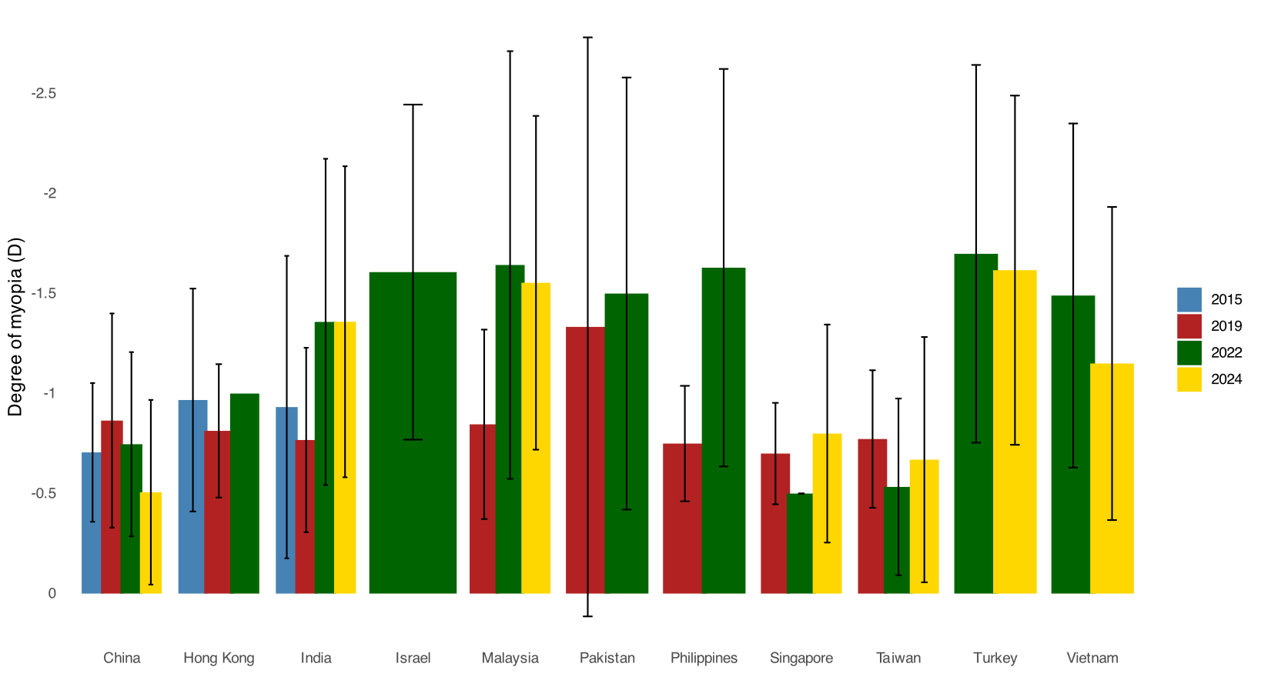
Figure 3. Minimum degree of myopia presents in a child to justify the adoption of a myopia control treatment by country and year. Error bars represent one standard deviation.

  - MINIMUM LEVEL OF MYOPIA PROGRESSION THAT NECESSITATES MYOPIA CONTROL
The average rate of myopia progression that justified the prescription of a myopia control method in 2024 varied between countries, ranging from −0.51 to −0.75D for most of them, except for China and Taiwan, where a preference for −0.26 to −0.50D was reported (all p≤0.001). Between 2019 and 2024, the reported median minimum level of myopia progression required to initiate a myopia control treatment decreased significantly (all p≤0.001).

  - USING UNDERCORRECTION AS STRATEGY TO CONTROL MYOPIA
In 2024, most eye care practitioners reported not prescribing undercorrection as a myopia control method (78.2%), with only 18.7% and 3.1% reporting using it “sometimes” and “always”, respectively. Taiwan reported the highest rate of using it "sometimes" (27.1%), followed by India (25.6%) and China (25.4%) (all p≤0.001). Between 2015 and 2024, no significant changes were observed in the frequency of undercorrection prescribing (p>0.05).

  - REASONS FOR NOT PRESCRIBING AN ALTERNATIVE METHOD TO SINGLE-VISION CORRECTION
Several reasons were cited by practitioners from different Asian countries for not prescribing myopia control treatments in 2024 (Figure 4). Concern regarding lack of effectiveness as a reason for hindering the prescription of myopia control treatment was significantly higher in Turkey (23.1%) compared with the other Asian countries (p≤0.001). Similarly, concern regarding unpredictable outcomes was highest in Turkey and Singapore compared to the other countries (p≤0.001). In Malaysia, 31.6% of practitioners reported safety concerns as the major reason for not prescribing a myopia control approach; this proportion was significantly higher compared to the other countries (p≤0.001). Cost concerns were a significantly greater barrier to adopting myopia control treatments in China, India, and Singapore compared to other assessed countries (p ≤ 0.001); however, no significant differences were observed among these three countries (p > 0.05). Additional chair time was a significantly greater concern among practitioners in Vietnam (34.9%) compared to other countries (p≤0.001); however, no significant differences were observed among the remaining Asian countries relating to this reason. The concern related to inadequate information or lack of knowledge varied significantly across countries (p ≤ 0.001), ranging from 7.1% in Singapore to 29.2% in Turkey. Pairwise comparisons showed that Turkey reported significantly higher concerns than Singapore (p≤0.001), but differences among the other countries were not statistically significant (p>0.05). The perception of an unfavourable benefit/risk ratio differed significantly across countries (p ≤ 0.001), ranging from 4.3% in India to 39.8% in Vietnam. Practitioners in Vietnam expressed significantly higher concerns about this factor compared to India and Singapore (p≤0.001), while no significant differences were found among other countries. Regarding the lack of accessibility to treatment options, Vietnam (44.6%) and Malaysia (39.5%) were the leading countries expressing this concern, with significantly higher rates compared to other assessed countries (p≤ 0.001). However, no significant difference was found between Vietnam and Malaysia (p > 0.05).
Overall, the reasons for not prescribing a myopia control method decreased between 2015 and 2024 (p≤0.001). However, cost to the patient and additional chair time significantly increased as barriers to prescribing a myopia control approach between 2019 and 2024 (both p≤0.001).
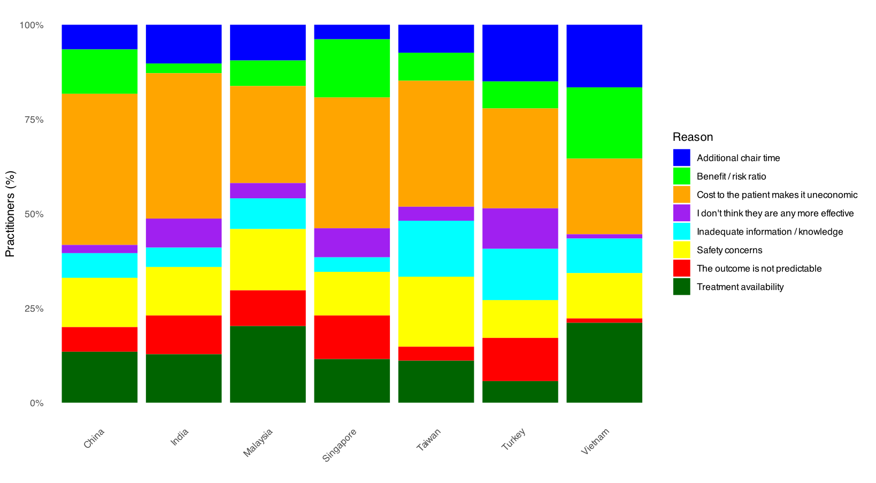
Figure 4. Reasons cited by practitioners from different Asian countries for not prescribing myopia control treatments in 2024.
  - RANKED CRITERIA FOR STARTING MYOPIA CONTROL IN A YOUNG PROGRESSING MYOPE
In 2024, refractive error (2.2±1.6) and age (3.1±2.1) were reported as the most influential criteria (lowest values) for prescribing a myopia control treatment, followed by the rate of myopia progression (4.4±2.3) and the presence of two myopic parents (5.6±2.6). Conversely, patient pressure (10.3±2.6) and parent/guardian pressure (10.8±2.9) were reported as the least influential criteria (highest values) for initiating myopia control treatment (Figure 5). Refractive error was more influential in Malaysia (1.7±0.9) and Turkey (2.1±1.4) compared to other countries (all p≤0.001). In Vietnam, the presence of one (7.3±2.8) or two myopic parents (6.9±1.7) was less influential for starting myopia control in a young progressing myope compared to other Asian countries (all p≤0.001, except for Singapore). Conversely, in India, the presence of two myopic parents had the greatest influence (4.1±2.4; all p≤0.001, except for Singapore and Turkey). Axial length had a greater influence in China (3.6±2.0; all p≤0.001, except for India) and Vietnam (3.8±1.9; all p≤0.001, except for India) compared to other countries. The rate of myopia progression had less influence in China (4.3±2.3) compared to other countries (all p≤0.001). Choroidal thickness had less influence in Singapore (10.1±2.4) compared to other countries (all p<0.05, except for Taiwan and Malaysia). The AC/A ratio (8.7±2.6; all p<0.05, except for India) and lifestyle (9.4±2.7; all p<0.05, except for China) were more influential in Vietnam compared to other countries. No significant differences were found between countries regarding age, binocular vision status, patient pressure, and parent/guardian pressure (all p>0.05).
Comparing 2022 with 2024, the influence of all factors decreased (all p≤0.001), except for refractive error, which increased (p≤0.001), and age and the presence of one myopic parent, which remained constant (p>0.05).
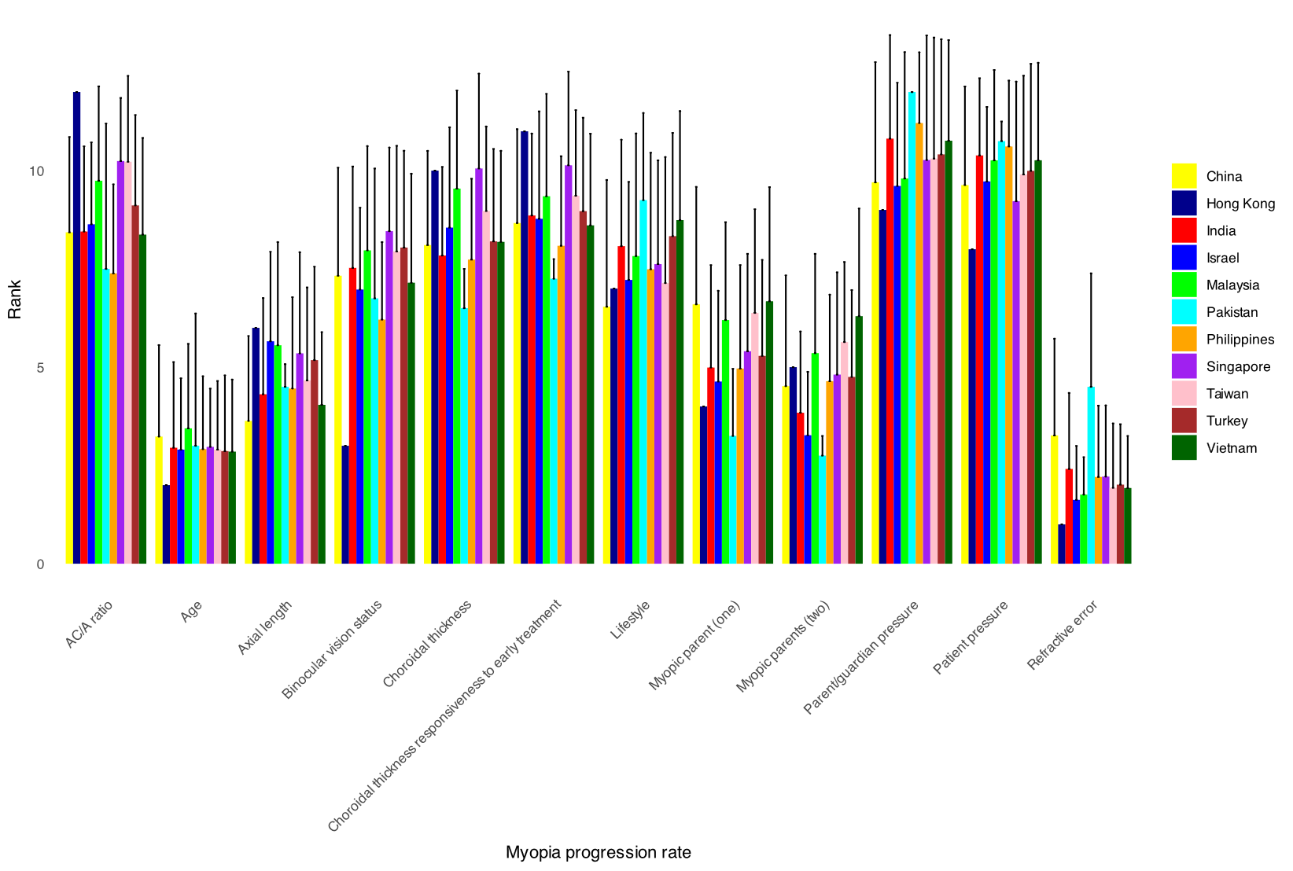
Figure 5. Hierarchized criteria (rated from 0 [highest] to 10 [lowest]) for initiating myopia control in young progressive myopes reported by Asian countries in 2024. Error bars represent one standard deviation.

  - FACTORS CONSIDERED WHEN CHOOSING WHICH MYOPIA MANAGEMENT STRATEGY TO USE FIRST
The factors for selecting the initial myopia management strategy based on their importance in 2024 were as follows: myopia progression rate (13.6%), age (12.7%), cycloplegic refraction (11.9%), axial length (11.4%), risk factors such as parental myopia/lifestyle (10.1%), refractive error (non-cycloplegic) (8.5%), parent/guardian preference (7.7%), binocular vision status (6.7%), patient preference (6.4%), corneal topography (5.2%), choroidal thickness (2.5%), only comfortable/trained to use one treatment (1.6%), and only have one treatment available to me (1.6%). The factor "only have one treatment available to me" was reported as most important in Vietnam (18.9%) and India (17.4%); the latter two proportions were significantly higher compared to other countries (p≤0.001). Significant differences were found among Asian countries with regards to the factor "only comfortable/trained to use one treatment", which ranged from 16.2% in Turkey to 0% in Vietnam (p≤0.001). Although age was considered the most important factor when choosing which myopia management strategy to use first in most countries, particularly in Singapore (85.7%) and India (82.4%), there were significant differences found between Asian countries with regards to this factor (p≤0.001). The factor "refractive error (non-cycloplegic)" was most commonly considered in Singapore (60.0%) and China (60.4%) compared to the other countries (p≤0.001). Significant differences were found between Asian countries in cycloplegic refraction (p≤0.001), with this factor ranging from 78.3% in Vietnam to 20.0% in Singapore. The factors “corneal topography” (47.1%) and “axial length” (88.5%) were used more frequently to choose a myopia control treatment in China compared to the other countries (all p≤0.001). The factor "myopia progression rate" was more frequently used in Turkey (85.7%), Malaysia (84.6%), and China (83.3%) compared to other Asian countries (all p≤0.001). The factor "choroidal thickness" varied significantly between countries, from 30.8% in China to 2.9% in Singapore (p≤0.001). The factor "binocular vision status" was reported more frequently in India (56.8%) and China (55.5%) compared to the other Asian countries (p≤0.001). The factor "patient preference" was reported more frequently in Vietnam (47.1%) and Singapore (42.9%) compared to the remaining Asian countries (p≤0.001). The factor "parent/guardian preference" was selected more frequently by practitioners in Vietnam (57.2%) and Malaysia (52.3%) compared to the other Asian countries (p≤0.001). The factor "risk factors such as parental myopia/lifestyle" was used most frequently in Singapore (74.3%) compared to other Asian countries (p≤0.001). Between 2022 and 2024, there was a significant decrease in the importance of the factors "only comfortable/trained to use one treatment", "only have one treatment available to me", and "binocular vision status" (all p<0.05). Conversely, the factors "age", "refractive error (non-cycloplegic)", "cycloplegic refraction", "corneal topography", "axial length", "myopia progression rate", "choroidal thickness", "patient preference", "parent/guardian preference", and "risk factors such as parental myopia/lifestyle" were reported to be more important with regards to choosing which myopia management strategy to use first in 2024 in comparison with 2022 (all p<0.05).

  - TRIGGERS TO ADJUST MYOPIA MANAGEMENT STRATEGY
In general, Asian practitioners reported that the main factors triggering adjustments in myopia management strategies were the progression of refractive error (22.2%), progression of axial length (18.2%), and faster-than-expected eye growth for age (13.2%). Factors such as changes in choroidal thickness (3.4%) and treatment comfort (9.3%) were considered less important for adjusting the myopia management strategy.
When analysing the data by country, progression of refractive error was the most frequently reported criterion in Turkey (97.1%), while it was the least considered in Singapore (80.0%, all p<0.05). Progression of axial length was the most important criterion in China (90.5%) and the least relevant in Malaysia (47.6%, all p<0.05). Changes in choroidal thickness were most considered in China (25.5%), while Taiwan (1.7%) had the lowest rate of consideration for this criterion (all p<0.05). Faster-than-expected eye growth for age was a key criterion in China (74.9%) and had the least weight in Malaysia (38.1%, all p<0.05). A new treatment with a scientifically reported better efficacy was more influential in Turkey (60.2%) and the least relevant in Vietnam (24.6%, all p<0.05). Poor compliance was the most important reason for adjustment in Singapore (71.4%) and the least considered in Turkey (31.1%, all p<0.05). Treatment comfort had more influence in Vietnam (48.6%) and the least in India (27.0%) (all p<0.05). Treatment-related complications were more relevant in Vietnam (47.9%) and less important in Malaysia (30.2%) (all p<0.05).
Between 2022 and 2024, the number of factors influencing decision-making changed, with an increase in all except for “a new treatment with a scientifically reported better efficacy", which decreased (p≤0.001).

  - IMPACT OF MYOPIA MANAGEMENT ON YOUR PRACTICE
Overall, myopia management was regarded as a beneficial factor in enhancing patient loyalty, increasing practice revenue, and improving job satisfaction. More specifically, practitioners reported that myopia management somewhat improved patient loyalty (much more: 25.0%; more: 42.5%; no change: 22.4%; less: 6.5%; much less: 3.7%), increased practice revenue (much more: 14.7%; more: 38.7%; no change: 38.5%; less: 5.0%; much less: 3.1%), and enhanced job satisfaction (much more: 26.2%; more: 49.0%; no change: 20.0%; less: 3.7%; much less: 1.2%). Practitioners in India reported that offering myopia control treatments had a lower impact on patient loyalty (much more: 23.1%; more: 48.7%), whereas practitioners in China reported a significantly higher impact (much more: 43.5%; more: 33.2%) compared to other countries (all p ≤ 0.001). Significant differences were found between Asian countries in practice revenue, with Singapore reporting myopia management having the highest positive impact in practice revenue (much more: 8.6%; more: 68.6%, p<0.05), whereas Turkey showed the lowest impact in practice revenue as a result of offering myopia management in clinical practice (much more: 0.9%; more: 10.3%, p<0.05). Significant differences were also found between Asian countries regarding the impact of myopia management in job satisfaction (p<0.05), with the highest impact reported by Vietnamese (much more: 18.2%; more: 60.8%) and Singaporean practitioners (much more: 31.4%; more: 54.3%, all p<0.05), and the lowest impact in Turkish practitioners (much more: 12.1%; more: 50.5%, all p<0.05).
Between 2022 and 2024, differences were only found in patient loyalty, which decreased over time (p≤0.001).

Table 3. Perceived efficacy (defined as the expected level of reduction in childhood myopia progression in percentage) of myopia control options reported by practitioners in different Asian countries over time. Data reported as mean ± standard deviation. PAL, progression addition lenses; RCL, rigid corneal lens.

 | Country/Technique | China | Hong Kong | India | Israel | Malaysia | Pakistan | Philippines |  | Singapore | Taiwan | Turkey | Vietnam | Overall mean
2015 | Spectacle
2015 | Under-correction | 2.7±7.2 | 3.9±7.7 | 20.3±24.6 | - | - | - | - | - |  | - | - | - | 5.8±13.3
2015 | Single vision | 14.4±22.4 | 7.8±15.8 | 35.2±31.1 | - | - | - | - | - |  | - | - | - | 16.0±24.1
2015 | Bifocals | 10.9±17.4 | 21.1±17.9 | 16.4±21.1 | - | - | - | - | - |  | - | - | - | 14.5±18.6
2015 | PALS | 13.6±17.7 | 24.8±18.4 | 22.1±25.2 | - | - | - | - | - |  | - | - | - | 17.9±19.8
2015 | Contact lenses |  |  |  |  |  |  |  |  |  |  |  |  |  |  |  |  | Contact lenses
2015 | RCL | 23.2±25.6 | 15.1±23.2 | 29.7±30.5 | - | - | - | - | - |  | - | - | - | 22.1±26.2
2015 | Single vision soft | 9.0±16.7 | 6.6±15.2 | 30.2±33.7 | - | - | - | - | - |  | - | - | - | 11.7±21.5
2015 | Multifocal soft | 11.4±19.0 | 15.3±17.1 | 17.6±24.3 | - | - | - | - | - |  | - | - | - | 13.4±19.5
2015 | Approved myopia control soft | 16.3±23.4 | 32.3±22.8 | 29.1±32.4 | - | - | - | - | - |  | - | - | - | 22.5±25.8
2015 | Orthokeratology | 45.1±28.4 | 56.8±24.6 | 26.6±30.4 | - | - | - | - | - |  | - | - | - | 45.3±29.2
2015 | Pharmaceutical | 28.7±28.0 | 39.4±24.0 | 16.5±20.0 | - | - | - | - | - |  | - | - | - | 29.6±26.8
2015 | Refractive Surgery | 17.5±30.8 | 9.0±21.9 | 23.4±30.6 | - | - | - | - | - |  | - | - | - | 16.2±29.0
2015 | Increased time outdoors | 39.6±30.1 | 36.3±22.8 | 28.4±24.6 | - | - | - | - | - |  | - | - | - | 36.9±27.7
2019 | Spectacle
2019 | Under-correction | 34.3±28.9 | 3.1±9.1 | 7.3±13.5 | - | 6.9±20.9 | 25.2±28.9 | 12.5±25.0 | 1.7±5.2 |  | 5.4±13.3 | - | - | 11.7±21.6
2019 | Single vision | 40.5±25.3 | 6.7±12.5 | 16.6±24.7 | - | 11.5±24.7 | 33.6±38.7 | 6.3±12.5 | 6.3±10.4 |  | 17.5±26.8 | - | - | 17.6±25.1
2019 | Bifocals | 44.8±23.5 | 30.4±18.0 | 28.8±26.8 | - | 35.0±24.6 | 24.5±29.6 | 45.0±39.7 | 36.7±13.3 |  | 15.3±15.4 | - | - | 33.1±22.9
2019 | PALS | 43.2±30.0 | 27.5±15.4 | 35.7±28.3 | - | 31.4±18.3 | 27.5±30.7 | 51.7±22.5 | 32.3±16.9 |  | 24.2±20.6 | - | - | 32.7±23.4
2019 | Contact lenses
2019 | RCL | 31.3±28.1 | 13.8±22.1 | 33.3±30.8 | - | 28.8±29.5 | 40.5±32.2 | 16.3±22.9 | 22.7±25.8 |  | 18.5±17.8 | - | - | 24.2±27.2
2019 | Single vision soft | 35.0±26.6 | 6.7±14.3 | 24.0±26.9 | - | 15.8±20.4 | 33.7±33.0 | 6.3±12.5 | 11.0±17.7 |  | 10.6±19.0 | - | - | 17.4±23.9
2019 | Multifocal soft | 33.9±26.5 | 28.2±19.3 | 34.2±30.7 | - | 29.2±16.9 | 22.3±29.8 | 51.3±36.6 | 35.4±14.4 |  | 30.5±16.3 | - | - | 31.2±23.5
2019 | Approved myopia control soft | 48.6±28.2 | 43.3±17.7 | 50.7±30.8 | - | 39.6±20.0 | 34.3±35.0 | 58.8±23.2 | 49.9±17.4 |  | 35.0±19.8 | - | - | 45.0±24.1
2019 | Orthokeratology | 63.5±22.7 | 61.6±15.1 | 55.4±31.6 | - | 63.8±20.6 | 49.2±32.2 | 82.5±9.6 | 55.2±16.2 |  | 69.7±16.4 | - | - | 60.9±22.0
2019 | Pharmaceutical | 50.5±25.7 | 56.4±19.2 | 47.3±30.4 | - | 61.2±22.8 | 45.5±26.6 | 77.5±22.2 | 54.9±16.9 |  | 65.1±14.8 | - | - | 54.3±23.5
2019 | Refractive Surgery | 30.0±37.5 | 9.6±24.8 | 27.8±33.2 | - | 21.2±38.9 | 30.3±32.7 | 18.8±37.5 | 6.7±20.6 |  | 9.4±19.8 | - | - | 18.6±31.4
2019 | Increased time outdoors | 59.7±25.4 | 37.0±25.3 | 49.9±28.2 | - | 41.5±30.2 | 35.4±28.2 | 43.8±31.5 | 30.7±27.3 |  | 46.6±29.2 | - | - | 43.8±28.0
2022 | Spectacle
2022 | Under-correction | 10.2±18.5 | - | 17.3±28.3 | 4.1±10.0 | 8.6±22.7 | 27.7±30.3 | 14.9±18.6 | 0.0±0.0 |  | 12.3±24.9 | 10.5±16.4 | 19.1±26.0 | 11.2±19.6
2022 | Single vision | 18.9±20.0 | - | 25.7±31.4 | 6.1±18.7 | 8.6±14.6 | 44.0±39.2 | 26.1±28.5 | 1.0±1.4 |  | 25.0±26.6 | 17.0±26.1 | 31.0±27.7 | 19.9±22.2
2022 | Bifocals | 22.0±19.0 | - | 27.3±25.1 | 18.4±16.7 | 31.4±16.8 | 44.0±30.0 | 37.0±25.0 | 12.5±10.6 |  | 35.4±30.7 | 21.0±21.7 | 31.9±22.7 | 23.5±20.3
2022 | PALS | 29.3±22.2 | - | 29.8±27.4 | 21.7±17.7 | 31.4±14.6 | 38.0±15.7 | 44.3±28.6 | 12.5±10.6 |  | 41.9±24.8 | 22.3±23.4 | 32.8±23.5 | 29.8±23.0
2022 | Approved myopia control | 42.7±22.8 | - | 50.1±27.0 | 43.1±24.9 | 51.4±6.9 | 65.0±21.2 | 51.1±28.6 | 55.0±7.1 |  | 55.6±26.6 | 30.1±25.2 | 48.9±25.6 | 43.4±23.8
2022 | Contact lenses
2022 | RCL | 30.2±25.7 | - | 26.6±28.8 | 14.6±19.9 | 27.1±20.6 | 60.0±17.3 | 39.3±30.7 | 30.0±28.3 |  | 34.4±30.3 | 12.9±19.9 | 40.0±29.8 | 30.1±26.5
2022 | Single vision soft | 20.4±24.9 | - | 24.7±31.2 | 6.6±19.2 | 20.0±24.5 | 50.7±43.9 | 30.7±30.5 | 2.5±3.5 |  | 15.0±16.7 | 15.4±23.7 | 31.8±28.8 | 21.2±25.8
2022 | Multifocal soft | 35.2±24.8 | - | 34.4±32.0 | 33.4±22.3 | 34.3±14.0 | 45.3±22.0 | 38.7±25.8 | 45.0±21.2 |  | 44.5±13.8 | 15.9±20.6 | 35.1±26.4 | 34.7±25.2
2022 | Approved myopia control soft | 42.3±25.8 | - | 49.8±29.1 | 51.4±21.4 | 54.3±7.9 | 50.0±21.8 | 49.7±25.9 | 60.0±0.0 |  | 56.5±20.6 | 23.0±27.0 | 48.9±26.3 | 43.1±26.2
2022 | Orthokeratology | 63.8±20.1 | - | 49.6±28.6 | 45.9±24.6 | 65.7±12.7 | 48.0±9.8 | 57.8±25.2 | 80.0±0.0 |  | 59.4±25.5 | 27.1±24.8 | 60.0±24.1 | 60.6±22.8
2022 | Pharmaceutical | 52.9±24.1 | - | 47.5±28.3 | 52.4±24.1 | 54.3±23.7 | 58.5±24.3 | 51.4±25.0 | 80.0±0.0 |  | 50.7±21.4 | 36.0±28.0 | 54.3±22.6 | 51.9±24.6
2022 | Combination therapy | 68.7±24.7 | - | 56.0±30.2 | 60.5±28.0 | 72.7±18.7 | 71.7±11.9 | 62.4±28.0 | 85.0±7.1 |  | 66.2±21.0 | 40.9±29.2 | 67.8±23.8 | 66.5±25.9
2022 | Increased time outdoors | 60.1±27.3 | - | 43.6±32.4 | 41.6±28.0 | 39.3±23.5 | 61.8±18.0 | 54.0±29.6 | 30.0±28.3 |  | 46.3±27.9 | 43.7±31.0 | 50.9±27.2 | 56.7±28.4
2024 | Spectacle
2024 | Under-correction | 8.7±14.2 | - | 14.3±25.1 | - | 7.4±18.1 | - | - | 1.9±6.8 |  | 9.6±17.1 | 9.0±17.9 | 4.7±14.4 | 7.8±16.2
2024 | Single vision | 21.7±21.6 | - | 34.5±32.0 | - | 24.5±34.1 | - | - | 7.5±18.0 |  | 13.5±18.8 | 11.5±20.3 | 18.2±22.3 | 18.8±24.0
2024 | Bifocals | 25.4±21.2 | - | 27.5±22.1 | - | 24.6±27.4 | - | - | 29.5±22.0 |  | 18.7±15.9 | 23.8±20.6 | 24.2±21.3 | 24.6±21.6
2024 | PALS | 29.8±22.3 | - | 29.2±22.5 | - | 29.5±26.9 | - | - | 31.4±21.3 |  | 22.7±18.0 | 24.9±21.4 | 26.5±21.9 | 27.8±22.2
2024 | Approved myopia control | 44.5±20.6 | - | 52.3±20.8 | - | 48.1±27.8 | - | - | 55.1±17.6 |  | 44.4±20.3 | 46.4±24.2 | 45.3±21.2 | 46.4±22.1
2024 | Contact lenses
2024 | RCL | 39.6±26.3 | - | 31.1±25.8 | - | 35.5±33.6 | - | - | 30.1±28.1 |  | 26.8±25.5 | 19.1±25.1 | 30.2±29.6 | 32.4±28.4
2024 | Single vision soft | 26.9±25.2 | - | 26.1±29.3 | - | 23.6±30.5 | - | - | 12.4±21.8 |  | 14.7±19.7 | 11.6±18.6 | 17.6±24.0 | 20.5±24.9
2024 | Multifocal soft | 39.4±22.2 | - | 29.3±22.0 | - | 25.9±29.4 | - | - | 34.5±19.4 |  | 29.0±21.9 | 20.3±20.8 | 28.0±22.6 | 31.3±23.6
2024 | Approved myopia control soft | 48.3±20.3 | - | 51.6±25.3 | - | 42.3±31.1 | - | - | 53.2±17.6 |  | 49.1±19.9 | 36.3±24.0 | 46.1±21.5 | 46.0±22.9
2024 | Orthokeratology | 60.4±19.5 | - | 54.9±22.4 | - | 51.8±28.9 | - | - | 62.9±19.5 |  | 63.4±17.3 | 39.3±24.5 | 57.2±20.2 | 56.1±22.6
2024 | Atropine 0.01% | 43.6±21.4 | - | 42.5±26.8 | - | 54.9±26.7 | - | - | 39.7±26.5 |  | 34.3±20.4 | 39.2±23.3 | 37.6±23.1 | 41.7±23.6
2024 | Atropine 0.05% | 46.5±23.2 | - | 40.9±24.0 | - | 51.5±29.2 | - | - | 53.7±23.6 |  | 46.9±17.7 | 42.5±25.4 | 52.7±18.9 | 47.8±23.2
2024 | Atropine ≥0.5% | 48.3±26.9 | - | 38.9±26.4 | - | 48.0±34.5 | - | - | 54.3±27.1 |  | 61.5±24.6 | 37.0±26.8 | 43.4±30.1 | 47.0±28.8
2024 | Light therapy | 43.3±28.0 | - | 32.5±12.6 | - | 11.3±20.8 | - | - | 21.0±24.9 |  | 19.7±24.2 | 21.7±23.5 | 30.6±25.0 | 31.8±27.8
2024 | Combination therapy | 68.1±21.3 | - | 51.8±27.0 | - | 60.9±31.8 | - | - | 68.2±22.7 |  | 71.9±19.2 | 52.2±27.5 | 64.6±20.8 | 64.0±24.3
2024 | Alternating treatments | 50.5±27.0 | - | 35.3±24.5 | - | 24.9±31.5 | - | - | 23.8±25.8 |  | 40.9±24.1 | 29.7±28.0 | 21.3±24.7 | 36.5±29.3
2024 | Increased time outdoors | 53.6±26.3 | - | 42.4±21.6 | - | 54.6±29.1 | - | - | 41.4±26.8 |  | 51.3±24.3 | 48.5±27.9 | 40.3±25.1 | 48.7±26.7

Table 4. Prescription frequency of myopia control options (as percentage of the different myopia correction given to progressing/young myopes during a typical month) reported by practitioners in different Asian countries over time. Data reported as mean ± standard deviation. PAL, progression addition lenses; RCL, rigid corneal lens; CL, contact lens.

 | Country/Technique | China | Hong Kong | India | Israel | Malaysia | Pakistan | Philippines | Singapore | Taiwan | Turkey | Vietnam | Overall mean
2015 | Spectacle
2015 | Single vision | 45.8±37.8 | 57.8±32.8 | 47.9±27.6 | - | - | - | - | - | - | - | - | 49.3±35.3
2015 | Bifocals | 1.1±3.3 | 1.7±7.0 | 8.4±12.1 | - | - | - | - | - | - | - | - | 2.4±7.0
2015 | PALS | 3.1±10.2 | 9.6±15.2 | 6.1±10.8 | - | - | - | - | - | - | - | - | 5.3±12.1
2015 | Contact lenses
2015 | RCL | 6.0±9.0 | 1.4±5.4 | 5.6±9.2 | - | - | - | - | - | - | - | - | 4.7±8.4
2015 | Single vision soft | 1.9±4.4 | 5.5±9.2 | 17.0±14.5 | - | - | - | - | - | - | - | - | 5.3±9.8
2015 | Multifocal soft | 0.3±2.0 | 0.8±3.7 | 1.1±2.9 | - | - | - | - | - | - | - | - | 0.6±2.7
2015 | Approved myopia control soft | 0.3±1.4 | 5.7±14.9 | 2.1±5.3 | - | - | - | - | - | - | - | - | 2.0±8.3
2015 | Orthokeratology | 11.4±19.3 | 9.6±12.1 | 1.7±8.2 | - | - | - | - | - | - | - | - | 9.4±16.6
2015 | Pharmaceutical | 9.1±17.7 | 1.0±4.2 | 0.8±2.3 | - | - | - | - | - | - | - | - | 5.6±14.2
2015 | Refractive surgery | 2.3±10.5 | 0.4±3.5 | 3.8±6.6 | - | - | - | - | - | - | - | - | 2.1±8.6
2019 | Spectacle
2019 | Single vision | 57.6±27.6 | 55.2±30.3 | 57.9±32.4 | - | 63.6±30.3 | 74.6±34.6 | 22.4±24.1 | 33.0±30.9 | 56.3±34.7 | - | - | 55.9±31.8
2019 | Bifocals | 0.8±2.0 | 2.7±7.4 | 2.0±3.3 | - | 6.3±9.3 | 6.1±9.0 | 3.3±6.7 | 7.3±13.7 | 0.3±0.9 | - | - | 3.0±7.2
2019 | PALS | 14.4±14.9 | 13.6±18.0 | 1.4±2.8 | - | 12.0±18.3 | 4.6±9.2 | 32.7±20.9 | 14.8±15.0 | 1.8±2.9 | - | - | 10.7±15.5
2019 | Contact lenses
2019 | RCL | 2.9±5.8 | 0.7±2.2 | 2.4±4.7 | - | 0.5±1.0 | 2.2±8.3 | 0.4±0.8 | 2.2±6.7 | 3.1±3.2 | - | - | 1.7±4.7
2019 | Single vision soft | 11.8±18.8 | 3.6±6.6 | 16.3±18.8 | - | 4.6±9.0 | 1.1±1.8 | 4.3±6.3 | 7.4±8.8 | 0.6±1.0 | - | - | 7.2±13.2
2019 | Multifocal soft | 0.9±2.7 | 0.7±2.3 | 2.2±4.9 | - | 1.7±3.7 | 0.8±3.2 | 12.1±16.5 | 1.6±4.7 | 2.9±9.5 | - | - | 1.5±4.8
2019 | Approved myopia control soft | 1.0±4.4 | 5.5±8.8 | 4.4±13.5 | - | 0.3±1.0 | 0.8±3.2 | 3.3±6.7 | 7.6±11.3 | 0.2±0.5 | - | - | 3.5±8.6
2019 | Orthokeratology | 7.1±18.5 | 15.6±22.3 | 3.6±7.6 | - | 3.3±5.4 | 1.4±3.5 | 19.8±27.3 | 25.5±28.0 | 28.6±31.6 | - | - | 11.6±20.8
2019 | Pharmaceutical | 3.3±10.7 | 2.5±9.4 | 7.8±13.1 | - | 7.7±27.7 | 4.1±7.3 | 1.7±3.3 | 0.6±2.3 | 5.7±9.8 | - | - | 4.0±12.0
2019 | Refractive surgery | 0.1±0.5 | 0.0±0.4 | 2.1±6.3 | - | 0.0±0.0 | 4.2±8.3 | 0.0±0.0 | 0.0±0.0 | 0.6±2.2 | - | - | 0.8±3.7
2022 | Spectacle
2022 | Single vision | 25.6±23.9 | - | 47.1±34.0 | 26.6±36.6 | 39.9±23.6 | 29.1±12.7 | 31.6±31.7 | 12.6±4.2 | 31.7±37.4 | 59.1±38.8 | 54.5±34.8 | 31.1±29.3
2022 | Bifocals | 3.0±8.4 | - | 5.6±10.3 | 1.5±2.8 | 2.7±4.7 | 11.8±9.2 | 6.6±11.5 | 3.1±4.4 | 0.5±1.5 | 2.7±10.5 | 0.9±2.9 | 3.0±8.4
2022 | PALS | 6.5±12.3 | - | 5.6±9.6 | 4.1±9.4 | 7.5±11.3 | 10.5±7.8 | 19.8±25.4 | 4.8±6.8 | 3.6±9.7 | 1.9±7.8 | 0.8±3.5 | 6.3±12.7
2022 | Approved myopia control | 19.4±18.8 | - | 7.8±15.3 | 7.5±15.3 | 14.3±9.2 | 6.4±7.5 | 17.0±25.5 | 34.9±5.1 | 4.3±6.1 | 11.3±27.6 | 1.6±8.3 | 16.4±19.5
2022 | Contact lenses
2022 | RCL | 4.7±10.7 | - | 2.1±5.9 | 3.0±8.7 | 1.5±2.4 | 2.1±2.4 | 1.4±6.9 | 0.0±0.0 | 0.0±0.0 | 0.1±0.3 | 0.4±1.7 | 3.7±9.6
2022 | Single vision soft | 2.2±8.8 | - | 6.1±10.2 | 7.0±14.4 | 8.8±11.6 | 2.3±2.7 | 6.5±9.6 | 0.0±0.0 | 0.8±2.2 | 8.5±16.1 | 1.0±3.2 | 3.0±9.6
2022 | Multifocal soft | 2.2±7.6 | - | 1.7±4.1 | 5.1±11.4 | 2.1±4.9 | 4.0±8.0 | 3.4±9.0 | 1.0±1.4 | 3.6±7.5 | 0.2±1.0 | 0.1±0.4 | 2.1± .2
2022 | Approved myopia control soft | 3.1±9.2 | - | 3.6±7.5 | 19.9±27.3 | 6.9±9.6 | 2.8±5.7 | 2.3±5.7 | 16.6±20.7 | 9.2±11.1 | 0.9±7.8 | 0.1±0.6 | 3.4±10.2
2022 | Orthokeratology | 17.5±18.4 | - | 3.5±10.6 | 7.5±16.5 | 7.2±9.2 | 3.0±4.6 | 3.7±11.3 | 27.0±16.1 | 10.5±10.2 | 1.1±4.8 | 6.4±15.0 | 14.0±17.9
2022 | Pharmaceutical | 7.4±12.8 | - | 6.7±11.5 | 7.1±20.1 | 4.1±10.8 | 23.8±31.9 | 3.4±10.8 | 0.0±0.0 | 26.5±28.6 | 5.6±14.5 | 20.9±24.4 | 8.3±15.1
2022 | Combination therapy | 6.1±9.8 | - | 4.2±9.8 | 1.3±4.9 | 5.1±13.5 | 4.1±4.9 | 1.0±3.5 | 0.0±0.0 | 9.2±10.8 | 1.0±5.9 | 2.5±6.4 | 5.1±9.3
2024 | Spectacle
2024 | Single vision | 21.1±27.2 | - | 48.1±37.1 | - | 41.0±34.0 | - | - | 31.4±23.9 | 8.5±14.6 | 54.8±39.3 | 50.1±35.4 | 35.4±35.2
2024 | Bifocals | 2.1±6.2 | - | 1.4±3.7 | - | 1.7±5.5 | - | - | 0.3±1.1 | 0.6±2.7 | 1.6±6.2 | 0.8±3.0 | 1.5±5.1
2024 | PALS | 5.6±14.2 | - | 3.4±13.2 | - | 2.2±7.4 | - | - | 6.6±13.1 | 0.8±3.0 | 0.7±3.6 | 0.7±2.6 | 3.0±10.1
2024 | Approved myopia control | 14.3±18.7 | - | 8.4±10.8 | - | 10.9±16.3 | - | - | 27.6±22.9 | 2.3±4.8 | 16.1±22.7 | 2.3±6.1 | 11.0±17.6
2024 | Contact lenses
2024 | RCL | 3.2±8.9 | - | 0.6±2.6 | - | 0.4±1.2 | - | - | 0.9±2.9 | 0.7±2.5 | 0.1±0.4 | 0.5±4.3 | 1.4±5.8
2024 | Single vision soft | 0.8±2.1 | - | 6.6±12.3 | - | 0.8±3.1 | - | - | 5.7±8.6 | 0.5±1.7 | 4.9±10.9 | 0.3±1.7 | 1.9±6.2
2024 | Multifocal soft | 1.2±3.3 | - | 0.8±2.7 | - | 0.4±2.0 | - | - | 1.2±3.4 | 0.4±1.6 | 0.2±1.6 | 0.1±0.6 | 0.6±2.4
2024 | Specific myopia control soft daily disposable CLs | 1.5±3.8 | - | 1.2±3.4 | - | 1.5±6.1 | - | - | 6.0±7.1 | 2.3±4.2 | 0.5±2.7 | 0.3±1.7 | 1.4±4.0
2024 | Specific myopia control soft reusable CLs | 1.1±4.8 | - | 0.1±0.8 | - | 0.4±1.7 | - | - | 0.7±2.2 | 1.1±4.4 | 0.5±2.9 | 0.2±1.1 | 0.7±3.4
2024 | Orthokeratology | 10.5±14.8 | - | 3.2±8.7 | - | 2.6±7.3 | - | - | 10.6±14.8 | 4.6±6.3 | 0.7±4.6 | 3.6±6.8 | 5.8±11.2
2024 | Atropine 0.01% | 11.8±14.9 | - | 5.6±12.9 | - | 23.8±27.0 | - | - | 2.3±8.8 | 26.2±20.4 | 7.2±14.9 | 12.0±18.9 | 12.7±18.6
2024 | Atropine 0.05% | 2.1±8.3 | - | 1.9±8.3 | - | 1.7±4.8 | - | - | 1.3±5.7 | 22.2±21.5 | 3.9±11.4 | 9.2±15.7 | 5.5±13.3
2024 | Atropine ≥0.5% | 0.9±3.3 | - | 0.3±1.7 | - | 0.1±0.6 | - | - | 0.9±5.3 | 14.0±22.9 | 0.0±0.0 | 0.3±1.6 | 1.7±8.1
2024 | Light therapy | 3.2±10.6 | - | 0.3±1.6 | - | 0.3±2.3 | - | - | 1.1±6.3 | 0.6±2.8 | 0.0±0.1 | 1.6±8.2 | 1.6±7.5
2024 | Combination therapy | 7.3±11.6 | - | 2.8±8.3 | - | 1.5±4.9 | - | - | 0.8±1.9 | 6.8±10.1 | 1.2±4.5 | 1.9±6.1 | 4.0±8.9

Table 5. Minimum recommended age for the prescription of different myopia control options reported by practitioners in different Asian countries over time. Data reported as mean ± standard deviation. PAL, progression addition lenses; RCL, rigid corneal lens; CL, contact lens.
 | Country/Technique | China | Hong Kong | India | Israel | Malaysia | Pakistan | Philippines | Singapore | Taiwan | Turkey | Vietnam | Overall mean
2015 | Spectacle
2015 | Single vision | 5.5±1.5 | 5.5±1.4 | 6.2±2.3 | - | - | - | - | - | - | - | - | 5.6±1.6
2015 | Bifocals | 6.9±2.8 | 7.2±1.9 | 7.6±3.1 | - | - | - | - | - | - | - | - | 7.1±2.6
2015 | PALS | 8.5±3.2 | 7.8±2.2 | 8.2±2.8 | - | - | - | - | - | - | - | - | 8.2±2.9
2015 | Contact lenses
2015 | RCL | 9.5±3.2 | 10.4±2.8 | 11.7±3.4 | - | - | - | - | - | - | - | - | 10.0±3.3
2015 | Single vision soft | 13.6±4.3 | 10.0±2.7 | 11.1±3.6 | - | - | - | - | - | - | - | - | 11.9±4.0
2015 | Multifocal soft | 11.5±4.4 | 10.0±3.0 | 11.8±2.9 | - | - | - | - | - | - | - | - | 11.2±3.8
2015 | Approved myopia control soft | 10.8±3.9 | 8.7±2.3 | 10.6±3.4 | - | - | - | - | - | - | - | - | 10.0±3.4
2015 | Orthokeratology | 8.7±2.4 | 7.4±1.6 | 13.2±3.8 | - | - | - | - | - | - | - | - | 8.9±3.0
2015 | Pharmaceutical | 5.8±1.8 | 7.3±2.2 | 7.7±4.1 | - | - | - | - | - | - | - | - | 6.3±2.4
2015 | Refractive surgery | 17.6±2.0 | 17.0±2.4 | 16.9±3.0 | - | - | - | - | - | - | - | - | 17.4±2.2
2019 | Spectacle
2019 | Single vision | 6.5±2.2 | 6.6±4.3 | 6.4±4.2 | - | 7.1±5.2 | 7.3±4.7 | 13.5±8.7 | 8.3±6.6 | 5.3±0.7 | - | - | 6.9±4.4
2019 | Bifocals | 7.5±2.4 | 11.0±6.8 | 12.3±7.2 | - | 8.8±7.0 | 11.1±7.3 | 13.0±9.2 | 6.7±4.1 | 9.8±2.4 | - | - | 10.2±6.5
2019 | PALS | 9.1±3.1 | 8.6±4.3 | 11.7±6.5 | - | 6.6±2.4 | 14.3±6.1 | 5.8±1.5 | 7.4±4.1 | 7.5±2.1 | - | - | 9.3±4.9
2019 | Contact lenses
2019 | RCL | 13.7±3.6 | 17.6±5.0 | 14.5±5.4 | - | 13.8±6.9 | 16.0±4.0 | 17.0±8.0 | 13.7±6.3 | 9.1±4.7 | - | - | 15.3±5.5
2019 | Single vision soft | 12.7±3.3 | 14.1±5.7 | 11.1±4.5 | - | 11.2±5.4 | 15.9±3.7 | 17.0±8.0 | 11.3±5.4 | 15.8±4.0 | - | - | 13.2±5.2
2019 | Multifocal soft | 11.0±2.9 | 15.4±6.2 | 13.6±5.6 | - | 11.8±6.1 | 16.5±4.2 | 9.5±7.7 | 11.5±6.3 | 9.3±1.5 | - | - | 13.8±5.9
2019 | Approved myopia control soft | 10.6±2.8 | 10.5±4.7 | 11.4±5.6 | - | 11.0±6.0 | 15.1±4.2 | 9.5±7.7 | 7.6±1.9 | 8.8±2.9 | - | - | 10.8±4.8
2019 | Orthokeratology | 8.3±2.0 | 8.9±5.0 | 11.1±5.8 | - | 11.3±6.6 | 15.6±5.3 | 6.5±1.0 | 7.8±3.9 | 9.0±2.1 | - | - | 9.8±5.2
2019 | Pharmaceutical | 6.2±1.7 | 17.6±6.3 | 9.8±7.0 | - | 12.5±8.1 | 9.2±6.0 | 17.3±7.5 | 14.8±7.9 | 5.9±1.8 | - | - | 13.1±7.6
2019 | Refractive surgery | 18.0±0.0 | 20.3±2.2 | 19.7±1.7 | - | 20.5±1.2 | 18.7±3.0 | 21.0±0.0 | 20.2±2.4 | 18.0±0.0 | - | - | 20.0±2.1
2022 | Spectacle
2022 | Single vision | 7.7±4.6 | - | 7.1±3.8 | 5.9±1.8 | 5.3±0.8 | 8.8±4.8 | 6.6±3.0 | - | 5.4±1.1 | 6.2±2.9 | 7.1±3.5 | 7.4±4.3
2022 | Bifocals | 8.8±5.4 | - | 7.6±3.5 | 6.3±2.0 | 5.7±1.3 | 8.3±0.6 | 6.9±3.0 | - | 6.6±2.3 | 7.3±3.0 | 8.2±4.1 | 8.5±5.1
2022 | PALS | 8.5±4.7 | - | 8.8±4.3 | 7.2±2.8 | 6.8±1.8 | 9.0±1.4 | 8.0±3.9 | - | 6.9±2.8 | 8.1±3.5 | 8.9±4.3 | 8.4±4.6
2022 | Approved myopia control | 6.9±3.1 | - | 7.8±3.8 | 6.4±1.3 | 6.9±2.0 | 7.0±1.4 | 6.3±2.6 | - | 5.5±0.7 | 7.1±3.1 | 8.4±3.1 | 6.9±3.0
2022 | Contact lenses
2022 | RCL | 8.5±4.3 | - | 10.8±4.3 | 11.9±2.4 | 10.0±3.6 | 10.5±3.1 | 12.1±4.2 | - | 10.1±2.3 | 11.0±3.4 | 10.0±3.8 | 8.9±4.3
2022 | Single vision soft | 10.8±5.8 | - | 10.4±4.2 | 10.0±2.6 | 9.2±4.0 | 12.0±5.4 | 10.9±3.9 | - | 9.8±2.4 | 12.8±3.2 | 11.3±3.8 | 10.8±5.5
2022 | Multifocal soft | 9.2±4.9 | - | 9.5±4.2 | 9.1±2.4 | 8.5±3.3 | 9.7±2.1 | 11.0±4.0 | - | 9.8±2.3 | 12.4±3.9 | 10.5±3.8 | 9.3±4.8
2022 | Approved myopia control soft | 8.9±4.5 | - | 9.2±4.0 | 8.2±2.1 | 8.3±3.0 | 11.0±4.8 | 10.2±3.4 | - | 8.8±1.9 | 11.8±3.9 | 9.6±2.8 | 9.0±4.3
2022 | Orthokeratology | 8.4±2.8 | - | 9.9±4.2 | 9.7±2.8 | 8.4±3.0 | 8.8±1.0 | 9.9±3.8 | - | 8.3±1.4 | 9.8±3.9 | 9.3±3.2 | 8.6±3.0
2022 | Pharmaceutical | 6.8±3.1 | - | 7.3±3.4 | 6.6±2.0 | 6.0±2.2 | 6.0±1.4 | 6.7±3.4 | - | 5.5±1.0 | 6.9±2.7 | 7.0±2.4 | 6.8±3.0
2022 | Combination therapy | 7.9±2.9 | - | 8.8±3.5 | 8.5±2.9 | 8.8±3.3 | 9.3±2.2 | 9.1±4.3 | - | 8.4±2.1 | 9.2±3.9 | 8.2±2.6 | 8.0±3.0
2024
2024 | Spectacle | 6.4 ± 2.5 | - | 6.1±2.8 | - | 5.4±1.8 | - | - | 5.3±0.7 | 5.6±1.7 | 5.3±0.7 | 5.5±0.9 | 5.8±1.8
2024 | Contact lenses
2024 | RCL | 9.1±2.8 | - | 12.2±4.1 | - | 12.3±4.1 | - | - | 9.6±3.5 | 11.3±3.7 | 13.8±3.4 | 8.9±2.6 | 10.0±3.5
2024 | Soft daily disposable CL | 10.5±3.9 | - | 11.5±3.6 | - | 11.7±4.0 | - | - | 8.9±2.5 | 10.4±3.3 | 13.0±2.9 | 9.6±2.8 | 10.8±3.6
2024 | Soft reusable CL | 11.4±3.9 | - | 12.9±3.6 | - | 12.7±4.0 | - | - | 10.7±3.6 | 12.1±3.5 | 13.2±2.6 | 10.2±3.0 | 11.7±3.6
2024 | Atropine | 6.7±2.3 | - | 6.6±3.7 | - | 5.7±1.6 | - | - | 5.8±1.5 | 5.5±2.0 | 6.3±1.8 | 5.9±1.4 | 6.2±2.1
2024 | Light therapy | 7.0±2.4 | - | 8.2±3.5 | - | 6.5±2.2 | - | - | 6.8±2.9 | 7.9±4.3 | 7.4±3.2 | 7.4±3.6 | 7.2±3.0

4. DISCUSSION

This study examines the self-reported attitudes and strategies of eye care professionals in Asia regarding myopia management in 2024, as well as trends from 2015 to 2024. A total of 2,473 practitioners participated, revealing significant regional variations in concern, treatment preferences, and perceived effectiveness. While concern about childhood myopia increased significantly until 2019 and then stabilized, its intensity varied by country, with Vietnam reporting the highest concern and Turkey the lowest (Figure 1). Treatment preferences also differed; combination therapy (orthokeratology + atropine) was regarded as the most effective in 2024, followed by orthokeratology alone, outdoor time, and atropine (Table 3); this is expected, given that these interventions are backed by strong scientific evidence demonstrating their effectiveness (Lawrenson et al., 2025; Zaabaar et al., 2024). In contrast, undercorrection and single-vision spectacles were considered the least effective. Singaporean practitioners ranked myopia control spectacles highly, while Turkey showed lower confidence in contact lens-based interventions. Although single-vision spectacles remained the most prescribed intervention (35.4%), the use of approved myopia control spectacles (11.0%) and 0.01% atropine (12.7%) was also significant (Table 4). Taiwan had the highest rates of atropine prescriptions across different concentrations, with Malaysia favouring 0.01% atropine, and Taiwan preferring concentrations above 0.5%. These findings align with global trends emphasizing a shift toward evidence-based myopia control strategies and a decline in outdated methods (Sankaridurg et al., 2023).
Variations were also observed in prescribing thresholds and treatment initiation. Spectacles were introduced at younger ages, while myopia control soft lenses were prescribed later. China tended to delay spectacle prescriptions, whereas Singapore and Taiwan initiated myopia control-specific contact lenses at younger ages. Similarly, the minimum level of myopia required for treatment initiation varied, with Turkey and Malaysia setting higher thresholds (-1.6D and -1.5D, respectively), and China having the lowest (-0.5D). However, although China reported the lowest minimum level of myopia required to initiate treatment, spectacle lenses were prescribed at an older age—possibly reflecting a greater preference for initiating myopia management with contact lenses. Most countries required a myopia progression rate of -0.51 to -0.75D for treatment initiation, except China and Taiwan, where the threshold was -0.26 to -0.50D. The threshold for prescribing myopia control methods decreased between 2019 and 2024, in line with evidence supporting early intervention (Bullimore & Brennan, 2024).
While evidence-based myopia control methods are increasingly adopted, several barriers persist. Cost remains the primary limitation, especially in China, India, and Singapore, while accessibility is a major concern in Vietnam and Malaysia. Safety concerns were most prevalent in Malaysia (31.6%), and Turkey exhibited the most scepticism about treatment effectiveness (23.1%). Additional chair time was cited as a key deterrent in Vietnam (34.9%). Although barriers to myopia control decreased overall between 2015 and 2024, cost and chair time concerns increased from 2019 to 2024. Decision-making factors varied by region, with refractive error, patient age, and myopia progression rate being the most influential criteria for treatment initiation. Malaysia and Turkey placed more emphasis on refractive error, while Vietnam assigned less importance to parental myopia. Compared to 2022, most decision-making factors became less influential in 2024, except for refractive error, which gained importance. The impact of myopia management in clinical practice was generally positive, with most practitioners reporting improvements in patient loyalty (much more/more: 67.5%), practice revenue (much more/more: 53.4%), and job satisfaction (much more/more: 75.2%). However, while China reported the greatest increase in patient loyalty, Singapore practitioners saw the highest financial benefits, and Vietnam and Singapore reported the highest job satisfaction. Turkey reported the lowest impact on both patient loyalty and job satisfaction.
Certain limitations of this study should be acknowledged. As a survey-based study, results rely on self-reported data, which may introduce some response bias. Practitioners already engaged in myopia management may have been more inclined to participate, potentially overrepresenting these practices. Additionally, survey distribution varied across countries, leading to differences in response rates among countries. Another limitation is the influence of practice settings and access to diagnostic tools on prescribing patterns. Practitioners in primary care or those lacking specialized equipment (e.g., axial length biometers, corneal topographers) may depend more on spectacles or soft contact lenses, while specialists with advanced technology may favour orthokeratology, and atropine and light therapies. Furthermore, economic and healthcare system differences likely influence treatment accessibility. Countries with higher healthcare expenditures or national myopia programs (e.g., Singapore, China) may have greater adoption of advanced treatments, whereas those with fewer resources may rely on more conventional interventions. Despite these limitations, this study provides a comprehensive analysis of myopia management trends across Asia, highlighting regional disparities, evolving attitudes, and key barriers. The results emphasize the importance of education, accessibility improvements, and policy support to optimize myopia control strategies across different healthcare systems in Asia.
5. Conclusion
In conclusion, although concern over childhood myopia has stabilized in recent years, interest in effective management strategies continues to grow. Combination therapy (orthokeratology + atropine) remains the most widely regarded approach, followed by orthokeratology alone, myopia control spectacles, and outdoor time. The prescription of ineffective methods (undercorrection, single-vision spectacles) has declined, reflecting a shift toward more evidence-based strategies. However, treatment availability and cost remain significant obstacles. Despite regional differences, most practitioners adopt a proactive approach, intervening at lower myopia levels and using refractive progression as the primary criterion for adjusting treatment strategies.

COMPETING INTERESTS DISCLAIMER:
Authors have declared that they have no known competing financial interests OR non-financial interests OR personal relationships that could have appeared to influence the work reported in this paper.

References

- Holden, B.A., Jong, M., Davis, S., Wilson, D., Fricke, T. & Resnikoff, S. (2015). Nearly 1 billion myopes at risk of myopia-related sight-threatening conditions by 2050 – time to act now. Clinical and Experimental Optometry, 98(6), 491–493. https://doi.org/10.1111/cxo.12339
- Morgan, I., Ohno-Matsui, K. & Saw, S. (2012). Myopia. The Lancet, 379(9827), 1739–1748.
- Jonas, J.B., Ang, M., Cho, P., Guggenheim, J.A., He, M.G., Jong, M. et al. (2021). IMI prevention of myopia and its progression. Investigative Ophthalmology & Visual Science, 62(5), 6. https://doi.org/10.1167/iovs.62.5.6
- Wong, Y.L. & Saw, S.M. (2016). Epidemiology of pathologic myopia in Asia and worldwide. Asia-Pacific Journal of Ophthalmology, 5(6), 394–402. https://doi.org/10.1097/APO.0000000000000234
- Xiang, Z.Y. & Zou, H.D. (2020). Recent epidemiology study data of myopia. Journal of Ophthalmology, 2020, 4395278. https://doi.org/10.1155/2020/4395278
- Jan, C., Li, L., Keay, L., Stafford, R.S., Congdon, N. & Morgan, I. (2020). Prevention of myopia, China. Bulletin of the World Health Organization, 98(6), 451–459. https://doi.org/10.2471/BLT.19.240903
- Karuppiah, V., Wong, L., Tay, V., Ge, X. & Kang, L.L. (2021). School-based programme to address childhood myopia in Singapore. Singapore Medical Journal, 62(7), 325–330. https://doi.org/10.11622/smedj.2019144
- Zaabaar, E., Asiamah, R., Kyei, S. & Ankamah, S. (2024). Myopia control strategies: A systematic review and meta-meta-analysis. Ophthalmic and Physiological Optics. https://doi.org/10.1111/opo.13417
- Lawrenson, J.G., Huntjens, B., Virgili, G., Ng, S., Dhakal, R., Downie, L.E. et al. (2025). Interventions for myopia control in children: a living systematic review and network meta-analysis. Cochrane Database of Systematic Reviews, 2025(2), CD014758. https://doi.org/10.1002/14651858.CD014758.pub3
- Wolffsohn, J.S., Calossi, A., Cho, P., Gifford, K., Jones, L., Li, M. et al. (2016). Global trends in myopia management attitudes and strategies in clinical practice. Contact Lens and Anterior Eye, 39(2), 106–116. https://doi.org/10.1016/j.clae.2016.02.005
- Wolffsohn, J.S., Calossi, A., Cho, P., Gifford, K., Jones, L., Jones, D. et al. (2020). Global trends in myopia management attitudes and strategies in clinical practice – 2019 update. Contact Lens and Anterior Eye, 43(1), 9–17. https://doi.org/10.1016/j.clae.2019.11.002
- Wolffsohn, J.S., Whayeb, Y., Logan, N.S. & Weng, R. (2023). IMI—Global trends in myopia management attitudes and strategies in clinical practice—2022 update. Investigative Ophthalmology & Visual Science, 64(6), 6. https://doi.org/10.1167/iovs.64.6.6
- Sankaridurg, P., Berntsen, D.A., Bullimore, M.A., Cho, P., Flitcroft, I., Gawne, T.J. et al. (2023). IMI 2023 Digest. Investigative Ophthalmology & Visual Science, 64(6), 7. https://doi.org/10.1167/iovs.64.6.7
- Bullimore, M.A. & Brennan, N.A. (2024). Juvenile-onset myopia—who to treat and how to evaluate success. Eye, 38, 1–8. https://doi.org/10.1038/s41433-023-02722-6

APPENDIX 1- Survey details
Questions included in the survey related to the self-reported clinical management behaviors of practitioners for progressing myopia and practitioner’s current opinions on myopia-related clinical care. *New questions refined by the International Myopia Institute advisory board
Survey Component | Description
Level of concern about childhood myopia | Rated from “not at all” to “extremely” on a 10-point scale.
Perceived effectiveness of myopia control methods | Rated as the expected level of reduction in childhood myopia progression (0% to 100%).
Activity level in myopia control practice | Rated from “not at all” to “fully” on a 10-point scale.
Frequency of prescribing myopia control options | Reported for different treatments during a typical month.
Minimum age for myopia control treatment | Assumes average handling skills and child/parent motivation.
Minimum amount of myopia required for treatment | Specified in half-diopter steps.
Minimum level of myopia progression prompting treatment | Specified in quarter-diopter steps.
Use of single-vision under-correction | Reported as “no,” “sometimes,” or “always.”
Barriers to prescribing alternative myopia control methods | Multiple-choice: lack of belief in effectiveness, unpredictability, safety concerns, cost, chair time, lack of knowledge, benefit/risk ratio, treatment accessibility, other.
Criteria for starting myopia control treatment* | Ranked from 1 to 10: refractive error, age, parental myopia, axial length, choroidal thickness, binocular vision status, AC/A ratio, lifestyle, patient/guardian pressure.
Factors influencing the choice of myopia management strategy* | Options include treatment availability, training, age, refractive error, corneal topography, axial length, progression rate, choroidal thickness, binocular vision, patient/guardian preference, risk factors.
Triggers for adjusting myopia management strategy* | Options include progression of refractive error/axial length, changes in choroidal thickness, new scientifically validated treatments, poor compliance, complications.
Impact of myopia management on practice* | Assessed in terms of patient loyalty, practice revenue, and job satisfaction (rated from “much less” to “much more”).
Additional comments | Open-ended section for respondents.

