Micronucleus Test in Swiss Albino Mice Exposed to Cadmium and Ameliorating effect of Nyctanthes arbortristis

ABSTRACT

Aims: The present study aimed to assess the genotoxic effects of cadmium chloride (CdCl₂) and the protective efficacy of Nyctanthes arbortristis using the micronucleus assay in Swiss albino mice.
Study design: Experimental, controlled in vivo study using laboratory mice as the animal model.
Place and Duration of Study: The experiment was conducted in the Department of Zoology, T.M.B.U. Mice were divided into four groups: control, CdCl₂-treated (CD), N. arbor-tristis alone (NA) and co-treatment group (CD + NA).
Methodology: Bone marrow smears were prepared and stained for the micronucleus test, and the PCE/NCE ratio was calculated as an indicator of cytotoxicity. Data were analyzed using ANOVA followed by Tukey’s test.
Results: Significant increase in the frequency of micronucleated PCEs and NCEs in the CdCl₂-treated group (total 11.75%) compared to control, confirming cadmium induced genotoxicity. Co-treatment with N. arbortristis significantly reduced the micronucleus frequency to 3.54%, indicating effective protection. The PCE/NCE ratio, reduced to 0.93 in the Cd group, increased to 1.10 in the CD + NA group.
Conclusion: Cadmium chloride induced marked genotoxic and cytotoxic effects in mice bone marrow, while N. arbortristis exhibited significant antigenotoxic and antioxidant activity, restoring bone marrow function, indicating its potential as a natural protective agent against cadmium-induced damage.

Keywords: Cadmium chloride; Nyctanthes arbortristis; Micronucleus test; Antioxidant; Cytoprotection; Bone marrow; PCE/NCE ratio; Heavy metal toxicity.
1. INTRODUCTION

Industrialization has raised our standards of living at the cost of destruction of our environment. Annually, industries are emanating tons of waste materials in liquid, solid and gaseous forms in the environment indiscriminately without proper treatment. Such industrial waste contains toxic and carcinogenic elements out of which our major concern is the heavy metal pollutants. On the global scale, heavy metal pollution has become a serious environmental issue (Briffa et al., 2020).
Heavy metals are defined as metallic elements that have a relatively high density compared to water (Ali & Khan, 2018). In recent years, there has been an increasing ecological and global public health concern associated with environmental contamination by these metals. Also, human exposure has risen dramatically as a result of an exponential increase of their use in several industrial, agricultural, domestic and technological applications (Rehman et al., 2018; Mitra et al., 2022)
Although heavy metals occur naturally in the Earth’s crust, most ecological pollution and human exposure result from anthropogenic activities such as mining, smelting, industrial production, and the use of metal based compounds in agriculture and domestic applications (Tchounwou et al., 2012; Acharya, 2024). These metals can disrupt the structure and function of vital cellular components, including membranes, mitochondria, the endoplasmic reticulum, nucleus and lysosomes. They interfere with key enzymes responsible for metabolism, detoxification and cellular repair. Moreover, metal ions may bind to DNA and nuclear proteins, causing strand breaks, conformational alterations and changes in gene expression that can impair cell cycle regulation and induce apoptosis or carcinogenesis (Parida & Patel, 2023).
Among these, cadmium (Cd) is regarded as one of the most hazardous heavy metals due to its high toxicity, lack of biological function, non-biodegradability and long environmental persistence with a half-life of about 30 years (Tchounwou et al., 2012). Earth’s crust is rich in Cd sources, found generally in combination with ores of copper, zinc and lead (Naja & Volesky, 2017), however its prevalence in huge amounts are due to anthropogenic activities such as electroplating, mining, stabilizing plastics, alloy, cement, pigment, manufacturing batteries, fossil fuel combustion, high phosphate fertilizers and municipal and sewage sludge incineration (Guo et al., 2024).Some natural processes including weathering of rock, volcanic eruption, wind dust, marine aerosol, forest fire and erosion are major contributing factors of environmental Cd pollution (Zhang & Wang, 2020).
Several studies have highlighted the antigenotoxic potential of herbal antioxidants in mitigating heavy metal induced toxicity. N. arbortristis (commonly known as Night Jasmine, Harsinghar or Parijat) is a well-known medicinal plant belonging to the family Oleaceae, typically found as a hardy shrub or small tree native to tropical and subtropical regions (Jain & Pandey, 2016; Chamoli et al., 2019; Thapa & Kumar, 2024). This plant is a rich source of diverse phytochemicals distributed throughout its different parts. The leaves are particularly abundant in tannic acid, benzoic acid, methyl salicylate, carotene, resinous compounds, glucose, ascorbic acid, fructose, flavanol glycosides and oleanolic acid (Rani et al., 2012; Jain & Pandey, 2016). In traditional Indian medicine, N. arbor-tristis has long been valued for its wide therapeutic applications. Pharmacological investigations have demonstrated that it possesses a broad spectrum of biological activities, including antiviral, antihistaminic, antioxidant, antileishmanial, antipyretic, antimalarial, antifungal and anti-inflammatory effects. Therefore, the present study aims to investigate the genotoxic effects of cadmium on the bone marrow cells of Swiss albino mice using the micronucleus assay. It specifically focuses on evaluating the frequency of micronuclei formation in polychromatic erythrocytes (PCEs) and normochromatic erythrocytes (NCEs) following cadmium exposure and further examines the protective efficacy of N. arbortristis leaf extract in mitigating cadmium-induced genotoxicity.

2. material and methods

2.1. Chemicals:
All biochemical reagents used in this study were procured from Loba Chemie Pvt. Ltd., Mumbai. Cadmium chloride was acquired from Himedia Laboratories Pvt. Ltd., Mumbai. The CdCl₂ was administered orally to the mice by dissolving it in distilled water and delivering it via gavage.

2.2. Test Animal:
Four to five week (25-30g) old Swiss albino mice were maintained in the animal house of the Mahavir Cancer Sansthan & Research Centre, Patna under the standard laboratory condition. Animals are divided into 4 groups (n=6) in each group and were acclimatized for 10 days before experiment.

2.3. Plant Material:
Fresh N. arbortristis leaves were collected from University Department of Zoology, T.M.B.U., Bhagalpur. The N. arbortristis leaves were washed properly three times with distilled water. The materials were air dried under hot air oven at 55°C for 3 hours and was grinded well in the grinder. Fine powder of the plant material was collected by filtering the grinder content with thin cloth. Powdered sample was then stored in airtight containers until the time of the extraction.

2.4. Plant Extract Preparation
100gms of powdered N. arbortristis were soaked in double distilled water for 72 hours with occasional shaking. Afterwards both the extracts were filtered using Whatman filter paper No. 1 and Buchner funnel. The solvents were removed under pressure in rotatory evaporator at 50˚C and the dried N. arbortristis seed powder was stored at 4˚C for further study.
2.5. Experimental Protocol

Table 1 : The Effects of Cadmium and N. arbortristis on Experimental Animals

Groups Application

Group I (C) Control
Group II (CD) Cadmium (3mg/kg.b.wt)
Group III (NA) N.arbortristis (400mg/kg.b.wt.)
Group IV (CD+NA) Cadmium (3mg/kg.b.wt)+N.arbortristis (400mg/kg.b.wt.)

Treatment duration of this work was 35days

2.6. Experimental Protocol:
. The slides were prepared following the methodology suggested by Schmid (1976), with slight modifications as described by Das and Kar (1986) and Salamone and Heddle (1983). A drop of suspension was placed on clean, grease-free slides, which were kept on a damp cloth to prevent cell rupture. The suspension was then evenly spread to create a uniform smear. The slides were air-dried and fixed in absolute methanol for 10 minutes. After fixation, the slides were dried again, coded and stored for staining.

2.7. Slide Screening:
Micronucleated PCEs and NCEs were recorded, but micronuclei in transition-phase cells were not counted. For each animal in the experimental groups, 1,000–2,000 PCEs and an equivalent number of NCEs were counted to determine the presence of micronuclei. Most affected cells contained a single micronucleus, though cells with two or three micronuclei were also noted, albeit rarely. The percentage frequencies of micronucleated PCEs and NCEs were calculated.
Newly formed RNA-containing erythrocytes, known as polychromatic erythrocytes (PCEs), stained blue, while older erythrocytes lacking RNA, referred to as normochromatic erythrocytes (NCEs), appeared pink. PCEs gradually differentiated into NCEs over time.
2.8. Statistical Analysis:
Statistical evaluations were conducted using One-way Analysis of Variance (ANOVA) followed by Tukey's Honest Significant Difference (HSD) post hoc test.

3. results and discussion
Analysis of variance (ANOVA) revealed a statistically significant difference among all experimental groups for the frequency of total micronucleated cells, with an F-value of 431.08 (p<0.05). Similarly, highly significant differences were observed in the frequencies of micronucleated polychromatic erythrocytes (PCEs) and normochromatic erythrocytes (NCEs), with corresponding F-values of 315.85 and 93.93, respectively.
According to Tukey’s post hoc test, the group treated with cadmium chloride (CD) exhibited a marked and significant elevation in the total micronucleus frequency, reaching 11.75%, compared with the control. In this group, the percentage of micronucleated PCEs increased substantially from 1.15% in the control to 10.81%, while micronucleated NCEs rose from 0.95% to 11.53%. This pronounced increase indicates the genotoxic potential of cadmium chloride, reflecting its ability to induce chromosomal damage in bone marrow erythrocytes. The marked elevation in total micronucleated cells, as well as in PCEs and NCEs, reflects chromosomal breakage and spindle apparatus disruption, leading to the formation of acentric fragments or lagging chromosomes during cell division. These findings are consistent with earlier reports that cadmium induces clastogenic and aneugenic effects in mammalian bone marrow cells (El-Ghor et al., 2010).
Co-administration of N. arbortristis (CD+NA) with cadmium chloride, however, significantly reduced the total micronucleated cell frequency to 3.54% (p<0.05), suggesting a marked protective effect (Fig.1). The individual frequencies of PCEs and NCEs were also significantly decreased to 3.76% and 3.21%, respectively, compared with the cadmium-only group. The group treated with N. arbortristis alone did not differ significantly from the control (p > 0.05), confirming that extracts are non-genotoxic by themselves.
The relative PCEs/NCEs ratio, an important indicator of cytotoxicity, was also affected. In the cadmium chloride-treated group (CD), this ratio decreased markedly from 1.21 in the control to 0.93, signifying bone marrow cytotoxicity and suppression of erythropoiesis due to cadmium exposure. This reduction can be attributed to cadmium-induced oxidative stress, which impairs hematopoietic stem cell proliferation and differentiation (Rani et al., 2014). Cadmium is known to generate reactive oxygen species (ROS) and interfere with the cellular antioxidant defense system, leading to lipid peroxidation, DNA strand breaks, and chromosomal aberrations (Genchi et al., 2020).
In contrast, co-treatment with N. arbortristis restored the PCEs/NCEs ratio toward normal values, increasing it to 1.10, indicating a reversal of cadmium induced cytotoxic effects and improved bone marrow cell proliferation. As N. arbortristis is rich in phytoconstituents such as flavonoids, iridoid glycosides and phenolic compounds, which possess potent free radical–scavenging properties. These bioactive compounds may neutralize ROS and prevent oxidative damage to DNA, thereby reducing chromosomal fragmentation and micronucleus formation.

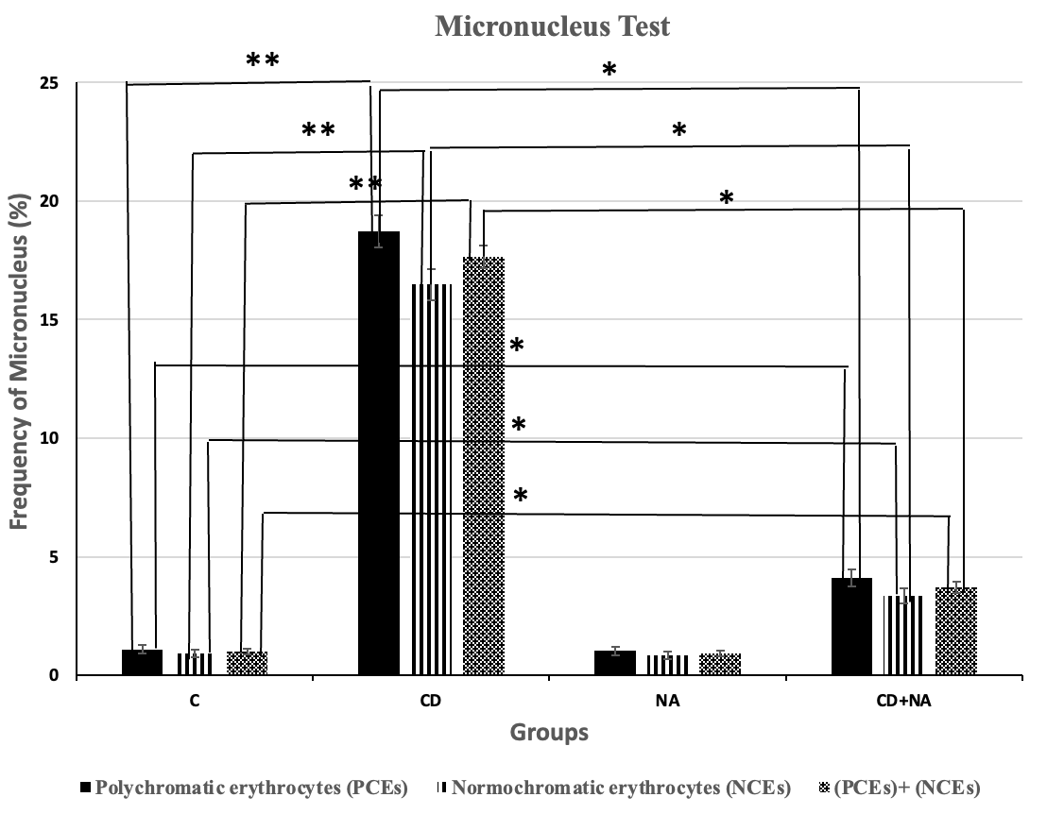
Fig. 1. Frequency of PCEs, NCEs and total micronucleated cells in mice treated with CdCl₂ (CD), N. arbortristis leaf extract.
Test drugs: significant from normal control, * P < 0.05; ** P < 0.001
Mean% ± S.E.M = Mean% values ± Standard error of means% of four experiments

4. Conclusion

The present study clearly demonstrates the genotoxic and cytotoxic potential of cadmium chloride as evidenced by the significant increase in the frequency of micronucleated PCEs and NCEs and the concomitant reduction in the PCE/NCE ratio. These findings confirm that cadmium exposure leads to chromosomal damage and suppression of erythropoietic activity in bone marrow cells, primarily through oxidative stress–mediated mechanisms. Co-treatment with N. arbortristis significantly ameliorated cadmium induced genotoxicity by reducing the frequency of micronucleated cells and restoring the PCE/NCE ratio toward normal values. The protective efficacy of plant extract may be attributed to its phytochemical constituents, which possess potent antioxidant, anti-inflammatory and metal-chelating properties that counteract free radical mediated DNA damage. Overall, the results indicate that natural antioxidants from medicinal plants can serve as effective protective agents against cadmium induced genotoxicity, thereby emphasizing their potential role in preventive and therapeutic strategies against environmental and occupational exposure to toxic metals.

Ethical approval
This work was approved by the Committee on the Ethics of Animal Experiments of Mahavir Cancer Sansthan & Research Centre, Patna with IAEC No. 2023/1B-01/11/23

References
Acharya, S. (2024). Heavy Metal Contamination in Food: Sources, Impact, and Remedy. In Food Safety and Quality in the Global South. Springer Nature 233-261.
Ali, H., & Khan, E. (2018). What are heavy metals? Long-standing controversy over the scientific use of the term ‘heavy metals’–proposal of a comprehensive definition. Toxicological & Environmental Chemistry, 100(1), 6-19.
Briffa, J., Sinagra, E., & Blundell, R. (2020). Heavy metal pollution in the environment and their toxicological effects on humans. Heliyon, 6(9), 2405-8440.
Chamoli, R. T., Minj, S., & Singh, V. (2019). Phytochemical chemical characters of Nyctanthes arbor-tristis Linn.: A promising medicinal plant. Journal of Medicinal Plant Research, 7(6): 141-143.
Das, R. K., & Kar, R. N. (1986). Genotoxic effects of three benzodiazepine tranquilizers in mouse bone marrow as revealed by the micronucleus test. Caryologia, 39(2), 193-198.
El-Ghor, A. A., Noshy, M. M., El Ashmaoui, H. M., Eid, J. I., & Hassanane, M. S. (2010). Microsatellite instability at three microsatellite loci (D6mit3, D9mit2 and D15Mgh1) located in different common fragile sites of rats exposed to cadmium. Mutation Research/Genetic Toxicology and Environmental Mutagenesis, 696(2), 160-166.
Genchi, G., Sinicropi, M. S., Lauria, G., Carocci, A., & Catalano, A. (2020). The effects of cadmium toxicity. International journal of environmental research and public health, 17(11), 3782.
Guo, S., Wang, H., Liu, X., Zhang, Z., & Liu, Y. (2024). Approaches for the treatment and resource utilization of electroplating sludge. Materials, 17(7), 1707.
Jain, P. K., & Pandey, A. (2016). The wonder of Ayurvedic medicine-Nyctanthes arbortristis. International Journal of Herbal Medicine, 4(4), 9-17.
Mitra, S., Chakraborty, A. J., Tareq, A. M., Emran, T. B., Nainu, F., Khusro, A., ... & Simal-Gandara, J. (2022). Impact of heavy metals on the environment and human health: Novel therapeutic insights to counter the toxicity. Journal of King Saud University–Science, 34, 1018-3647.
Naja, G. M., & Volesky, B. (2017). Toxicity and sources of Pb, Cd, Hg, Cr, As, and radionuclides in the environment. In Handbook of advanced industrial and hazardous wastes management (pp. 855-903). Crc Press.
Parida, L., & Patel, T. N. (2023). Systemic impact of heavy metals and their role in cancer development: a review. Environmental Monitoring and Assessment, 195(6), 766.
Rani, C., Chawla, S., Mangal, M., Mangal, A. K., Kajla, S., & Dhawan, A. K. (2012). Nyctanthes arbortristis Linn.(Night Jasmine): A sacred ornamental plant with immense medicinal potentials. Indian Journal of Traditional Knowledge, 11(3), 427-35.
Rehman, K., Fatima, F., Waheed, I., & Akash, M. S. H. (2018). Prevalence of exposure of heavy metals and their impact on health consequences. Journal of cellular biochemistry, 119(1), 157-184.
Salamone, M. F., & Heddle, J. A. (1983). The bone marrow micronucleus assay: rationale for a revised protocol. Chemical Mutagens: Principles and Methods for Their Detection, Springer, 8, 111-149.
Schmid, W. (1976). The micronucleus test for cytogenetic analysis. Chemical mutagens: principles and methods for their detection, Springer, 31-53.
Tchounwou, P. B., Yedjou, C. G., Patlolla, A. K., & Sutton, D. J. (2012). Heavy metal toxicity and the environment. Molecular, clinical and environmental toxicology, 3, 133-164.
Thapa, P., & Kumar, A. (2024). Phytochemicals and Pharmacological Properties of Nyctanthes arbortristis: A Review. International Journal of Pharmaceutical Sciences and Medicine, 9(7), 1-10.
Zhang, Q., & Wang, C. (2020). Natural and human factors affect the distribution of soil heavy metal pollution: a review. Water, air, & soil pollution, 231(7), 350.

