Cholera Outbreak in Chad in 2025: Epidemiological, Clinical, and Outcome Profile of the First Patients Managed in Cholera Treatment Centers

Abstract
Background: Cholera remains a public health emergency in sub-Saharan Africa, where access to safe drinking water and sanitation infrastructure is limited. Since July 2025, the eastern region of Chad has been facing a cholera outbreak. The objective of this study was to describe the epidemiological, clinical, and outcome profile of the first patients managed in cholera treatment centers.
Methods: This was a cross-sectional study based on data from the epidemiological situation report of the Ministry of Public Health, No. 34 dated August 30, 2025. All suspected cholera cases and those confirmed by microbiological tests were included in the study.
Results: During the study period (July–August 2025), 1,331 cholera cases were reported across three provinces in eastern Chad. The Chokoyane health district was the most affected, accounting for 46.2% of cases (n = 1,226). The median age was 23 years. The 5–14-year age group was the most represented (34.79%, n = 463). Females predominated (62.5%, n = 1,660), with a sex ratio of 0.4. Clinically, diarrhea was present in all patients, complicated by moderate to severe dehydration in 88% (n = 2,338). Vomiting occurred in 76% (n = 2,019). Laboratory analyses isolated Vibrio cholerae O1 Ogawa. The case fatality rate was 5.6% (n = 149). The response measures included case management in treatment centers, antibiotic prophylaxis for contacts, cholera vaccination, household disinfection, and chlorine distribution.
Conclusion: The current outbreak’s epidemiological and clinical profile is similar to that of previous years, with the particularity of a higher incidence among children. Its re-emergence is linked to the limited capacity of the health system and the massive influx of people displaced by armed conflict. Strengthening health system capacities and epidemiological surveillance is essential to control this epidemic.
Keywords: outbreak, cholera, public health, Ouaddaï, Sila, Chad

Introduction
Cholera is an acute diarrheal intestinal toxinfection that is both endemic and epidemic, highly contagious, and a notifiable disease caused by a Gram-negative bacillus, Vibrio cholerae [1,2]. It remains a public health emergency and a persistent disease of global concern. Cholera is a severe illness with a high mortality rate in the absence of appropriate management [3,4]. It is a vaccine-preventable disease and is among the notifiable diseases targeted by the Expanded Program on Immunization (EPI) [4,5].
In 2022, WHO estimated approximately 535,321 cases and 4,007 deaths across 45 countries. Since 2021, there has been a resurgence in the number of cholera cases, along with an expanding geographical distribution. In 2021, 23 countries—mainly in the WHO African and Eastern Mediterranean Regions reported cholera outbreaks. This trend continued in 2022, with more than 29 countries reporting cases or outbreaks. As of November 30, 2022, 16 of these countries were experiencing prolonged outbreaks. Many reported higher case numbers or case fatality rates than in previous years. The global average cholera case fatality rate in 2021 was 1.9% (2.9% in Africa), well above the acceptable level (<1%) and the highest recorded in over a decade. Although cholera can be easily treated with oral rehydration salts, it remains a global threat due to its high morbidity and mortality among vulnerable populations with limited access to adequate healthcare.
Cholera outbreaks have been reported in Mali, Côte d’Ivoire, Niger, and Senegal. It is a fecal-oral disease that thrives in contexts of poverty, disasters (wars, floods), and refugee camps. It remains a public health problem in countries with low vaccination coverage and periodic epidemic peaks [5–9].
Chad, a Sahelian country facing chronic humanitarian instability, has experienced several previous cholera outbreaks (2010, 2017, 2021). A new epidemic was declared in mid-July 2025, with the first confirmed case reported on July 24 in Ouaddaï Province [10]. The epidemic then spread to two other eastern provinces bordering Sudan.
The objective of this study was to describe the epidemiological, clinical, bacteriological, and outcome profiles of the first patients managed in the various cholera treatment centers (CTCs).
Methodology
Description of Chad
Chad is a landlocked country in Central Africa bordered by Libya to the north, Sudan to the east, the Central African Republic to the south, Cameroon to the southwest, Nigeria to the west-southwest, and Niger to the west. Its capital, N'Djamena (formerly Fort-Lamy), is also its most populous city. The three provinces affected by the epidemic are located in the east, along the border with Sudan.
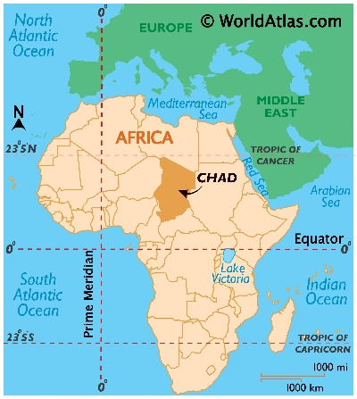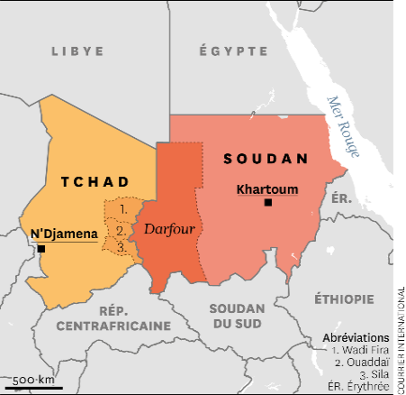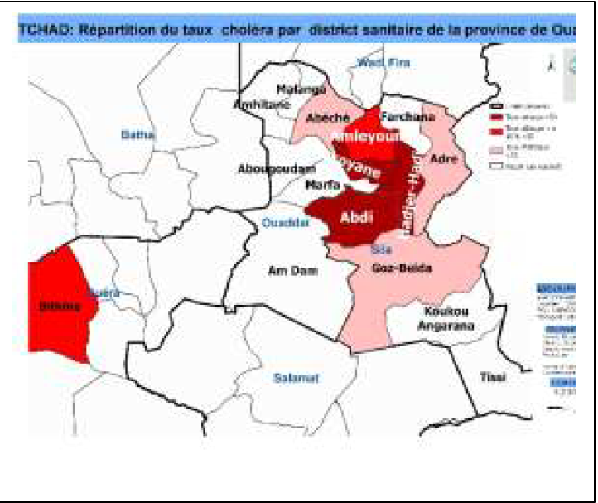
Fig. 1: Geographical location of Chad, Fig. 2: Darfour, Fig. 3: cholera infected districts
In 2024, the humanitarian context was marked by three types of shocks: conflict, climatic events, and health emergencies. Since the outbreak of armed conflict in Sudan in April 2023, the humanitarian situation in Chad—particularly in the east—has worsened, with the arrival of 712,288 refugees and 209,153 Chadian returnees as of November 2024. These populations arrived in areas where the health system was already fragile or overwhelmed by epidemics such as measles, chickenpox, hepatitis E, and yellow fever. Over 800,000 people lacked access to safe drinking water, compounded by a food crisis.
Study Design: this was a descriptive cross-sectional study including all cholera cases reported between July and August 2025 in the two affected provinces (Ouaddaï and Sila). Data were obtained from the national line list of notifiable diseases and the Ministry of Public Health situation report (SITREP) [10].
Case Definitions
- A suspected case was defined as acute watery diarrhea in a person aged >5 years in the context of an outbreak.
- A confirmed case was defined by isolation of V. cholerae through culture or a positive rapid diagnostic test (RDT).
Bacteriological Analysis: for each patient, stool samples were collected and analyzed according to standard bacteriological procedures. Stool samples were obtained either in sterile wide-mouth containers or via rectal swabs (sterile cotton swabs inserted 3–4 cm beyond the anal margin) and placed in alkaline peptone water. Samples were transported immediately under cold chain using the triple packaging system; if delayed, they were stored at ambient temperature for a maximum of 24 hours before transport in alkaline peptone water or Cary-Blair medium.
Microbiological analysis included direct Gram staining, culture, identification, serogrouping, and antibiotic susceptibility testing. The antibiogram was performed according to EUCAST 2024 recommendations using the disk diffusion method on agar medium [11]. Bacteriological results were communicated daily. In some cases, confirmation was established through rapid diagnostic testing.
Results
Patient characteristics: during the study period (July–August 2025), 1,331 cholera cases were reported in the two affected provinces (Ouaddaï and Sila). Among the seven affected districts, Chokoyane and Hadjer Haddid accounted for 57.3% (n = 763) and 34.2% (n = 455) of cases, respectively. The median age was 23 years. The 5–14-year age group was the most represented (34.8%, n = 463). Females predominated (69.1%, n = 920), with a sex ratio of 2.
Table I. Distribution of cholera cases by age group
Age group | n | %
0–11 months | 28 | 2.1
1–4 years | 118 | 8.8
5–14 years | 463 | 34.8
15–29 years | 233 | 17.4
30–44 years | 190 | 14.3
≥45 years | 299 | 22.4
Total | 1331 | 100

Table II. Distribution of cholera cases by district of origin
Health District | n | %
Abdi | 43 | 3.2
Abéché | 3 | 0.2
Adré | 33 | 2.5
Amleyouna | 26 | 1.9
Chokoyane | 763 | 57.3
Farchana | 5 | 0.4
Goz Beïda | 3 | 0.2
Hadjer Haddid | 455 | 34.2
Total | 1331 | 100

Clinical Findings
Table III. Clinical characteristics of cholera cases
Clinical features | n (1331) | %
Watery diarrhea | 1331 | 100.0
Vomiting | 1012 | 76.0
Muscle cramps | 313 | 23.5
Moderate to severe dehydration | 1211 | 91.0
Cardiovascular collapse | 562 | 42.2
Oligo-anuria | 690 | 51.8

Diarrhea was present in all patients, complicated by moderate to severe dehydration in 91%. Other symptoms included vomiting (76%), abdominal cramps (23.5%), cardiovascular collapse (42%), and oligo-anuria (51.8%).
Paraclinical Findings : microbiological confirmation was performed on 269 stool samples. Among the cultured samples (n = 84), 45 (53.6%) were positive. Of 356 RDTs performed, 224 were positive. Vibrio cholerae O1, serogroup Ogawa, was isolated from two samples and was sensitive to cyclins, fluoroquinolones and macrolides.

Figure 4 : Paraclinical data (RDT and culture)
Treatment and Outcomes : all patients received rehydration therapy according to national guidelines, adjusted to disease severity. Antibiotics were prescribed in most cases.
Complications included acute functional renal failure with oligo-anuria (51.8%, n = 690), cardiovascular collapse (42.2%, n = 562), and severe dehydration (34.2%, n = 433). The overall case fatality rate was 6.7% (n = 89).
Discussion
This study demonstrates that cholera remains an endemic-epidemic disease in Chad, predominantly affecting populations with low socioeconomic status, mainly in Chokoyane District, characterized by high population density and poor sanitation. Most affected individuals were indigenous populations living in unsanitary environments due to poverty or displacement linked to armed conflict.
The cholera outbreak that began in July 2025 in eastern Chad fits within a broader pattern of recent African epidemics associated with acute humanitarian and climatic vulnerability. The concentration of cases in Chokoyane and the predominance among women and children reflect a combination of structural and immediate determinants already reported in regional and global literature [8,12–15].
Several factors explain the observed intensity of transmission. Poor WASH (Water, Sanitation, and Hygiene) conditions remain the primary determinant, closely correlated with cholera burden [1,16]. Population movements (refugees and displaced persons from Sudan) weakened the local health system and created human networks conducive to V. cholerae dissemination, as shown in similar contexts [8,17,18]. The rainy season likely amplified transmission by contaminating unprotected water sources, consistent with analyses linking heavy rainfall events to outbreaks [14,19,20]. Informal food practices identified through case-control surveys and patient reports correspond to findings from other studies showing that street food contributes significantly to exposure in urban and peri-urban settings [21]. This combination made Chokoyane the epicenter of cholera in Chad.
Clinically, symptoms were typical of cholera, including watery diarrhea, vomiting, and occasionally muscle cramps. V. cholerae O1, biotype El Tor, was the pathogen isolated—similar to strains identified in previous epidemics in Chad and the subregion [15,22–24].
Therapeutically, patients were managed according to WHO-recommended oral and parenteral rehydration protocols (Plans A, B, and C) and received bactericidal antibiotic therapy.
The observed case fatality rate exceeded the WHO target (<1%), indicating delays in access to care, shortages of medical supplies, and lack of pre-hospital management—factors known to drive mortality according to systematic reviews and response evaluations. Experience shows that staff training and rapid establishment of cholera treatment centers (CTCs) can drastically reduce fatality when implemented promptly [25].
In terms of prevention, the inactivated oral cholera vaccine (OCV) remains a strategic tool. Recent studies show that a single dose confers substantial protection, especially among previously exposed populations, while the two-dose regimen provides longer-lasting protection and is preferred for preventive campaigns. The Chadian response took place amid a global vaccine shortage, prompting agencies to recommend a single-dose strategy for immediate outbreak response. The entry of new manufacturers and additional vaccines may soon alleviate supply constraints [5,26–30].
Genomic and microbiological surveillance remain underutilized tools in Chad. Comparative African studies show that integrating sequencing into surveillance helps identify introductions, track cross-border spread, and detect antimicrobial resistance markers [14,15]. In Chad, the lack of effective environmental sampling limits source tracing, emphasizing the need to strengthen sampling methods and regional laboratory logistics.
This study also highlights the weaknesses of Chad’s health system. Persistent insecurity around the Lake Chad Basin—particularly linked to Boko Haram—has led to major population displacements toward Ouaddaï, which has hosted thousands of refugees from conflict zones [31]. These displacements have further weakened an already fragile health system, widening the gap between healthcare demand and supply [32,33]. Children in refugee camps have limited access to vaccination services [17]. In addition, the region faces migration of women—especially in Chokoyane District—who, accompanied by small children and engaged mainly in begging, may remain without vaccination for months or years [34]. The COVID-19 pandemic further disrupted healthcare delivery due to vaccine supply shortages caused by border closures and public reluctance to visit health facilities [35].
Conclusion
The cholera outbreak in eastern Chad illustrates the consequences of insufficient vaccination coverage. The optimal approach to preventing future epidemics lies in strengthening vaccination campaigns, improving access to healthcare, and increasing community awareness to significantly reduce cholera incidence and mortality in Chad. This outbreak underscores the country's persistent vulnerability to waterborne health emergencies. The high case fatality rate calls for urgent reinforcement of healthcare access, WASH infrastructure, OCV vaccination, and epidemiological surveillance.
Ethical and Deontological Considerations
This study was conducted in accordance with ethical and deontological principles, following authorization from the Ministry of Public Health and Prevention.

REFERENCES
1. Bush, Maria T. Vazquez-Pertejo, Brenda L.Tesini. Cholera - Infectious Diseases - MSD Manual Professional Edition. Larry M., 2024. Accessed September 13, 2025.
2. Jacques MORVAN. Cholera cases in Burkina Faso originating from Niger. My Vaccines, 2023, Available at: https://www.mesvaccins.net/web/news/17899. Accessed September 13, 2025.
3. Jean-Michel Fournier, Marie-Laure Quilici. Cholera. The Medical Press, 2007; 36 (4) : 727-739
4. Pasteur Institute of Lille. Cholera: symptoms, treatment, prevention, 2025. Accessed October 31, 2025. Available at: https://www.pasteur.fr/fr/centre-medical/fiches-maladies/cholera
5. Lévy-Bruhl D. Epidemiology of vaccine-preventable diseases in 2017. Acad J.2017;13(3):103.
6. ePILLY Trop 2022. 3ème édition. 2022. 1029 p.
7. Bompangue D. Dynamics of cholera epidemics in the African Great Lakes region: the case of the Democratic Republic of Congo [Internet] [PhD Thesis]. University of Franche-Comté; 2009. Medical Thesis; 265p
8. WHO AFRO. Cholera surveillance in Africa, 2020-2022. Wkly Epidemiol Rec. 2023;98(24):309-20.
9. Lina Patricia Villate Torres. From contagious disease to the end of time in "The Magic Mountain," "The Plague," "Love in the Time of Cholera," and "Nemesis." Literature. University of Strasbourg, 2018. French. NNT: 2018STRAC032.
10. Ministry of Public Health and Prevention of Chad. SITREP 035 of August 31, 2025. Accessed September 13, 2025. Available at: https://www.afro.who.int/sites/default/files/2025
11. Sophie-Amélie C, Pauline M, Motet C, Florence Q. Are our prescribers receptive to the new EUCAST guidelines for interpreting antibiograms? Conference: 35th AFPHB Day; 2024. Namur, Belgium. DOI: 10.13140/RG.2.2.26275.46888.
12. Mengel MA, Delrieu I, Heyerdahl L, Gessner BD. Cholera outbreaks in Africa. Curr Top Microbiol Immunol. 2014; 379:117‑44.
13. Bwire G, Debes AK, Orach CG, et al. Cholera outbreak in Uganda, 2016: epidemiology and molecular characterization. PLoS Negl Trop Dis. 2018 ; 12(3) :e0006492.
14. Cheung WA, Chiyangwa B, Mwaba J, et al. Genomic insights into the 2022–2023 Vibrio cholerae outbreak in Malawi. Nat Commun. 2024 ; 15(1) :4521.
15. Mageto LM, Aboge GO, Mekuria ZH, Gathura P, Juma J, et al. Genomic characterization of Vibrio cholerae during the 2022–2023 outbreak in Kenya. Front Microbiol. 2025 ; 16:1603736.
16. Page AL, Alberti KP, Mondonge V, et al. Evaluation of a rapid test for the diagnosis of cholera. PLoS One. 2012;7(5):e37360.
17. Ramadan M, Tappis H, Uribe MV, Brieger W. Access to primary healthcare Services in Conflict-Affected Fragile States: a subnational descriptive analysis of educational and wealth disparities in Cameroon, Democratic Republic of Congo, Mali, and Nigeria. Int J Equity Health. 11 déc 2021;20(1):253.
18. Kohnert D. On the socio-economic impact of pandemics in Africa: Lessons learned from COVID-19, trypanosomiasis, HIV, yellow fever, cholera. 2021; 46p.
19. Janny T. Cholera epidemics in Africa: Analysis of a multifactorial etiology. Thesis. National School of Public Health; Rennes 2004, 61p. 20. Boloweti DB. Analyse écologique des points chauds de choléra en Afrique. Thèse PhD. Université Bourgogne Franche-Comté. Université de Kinshasa, 2021 ; 177p.
21. Heyerdahl LW. Multi-sited anthropology of cholera risk economies. Knowledge, practices, and technologies (Ivory Coast). Social anthropology and ethnology. University of Lyon, 2019. FFNNT: 2019LYSEN073ff. fftel-02612648
22. Djouma FN, Minsili NS, Nola M, et al. Cholera outbreak in Cameroon, 2018: epidemiological and molecular characteristics. Pan Afr Med J. 2020 ; 36:187.

23. Moukénet A, Djona Atchénémou A. Free healthcare in Chad: evaluation and perspectives. 2016; Ed. L’Harmattan; 181p.
24. Pabamé Sougnabé, Frédéric Réounodji. Conflict prevention and management mechanisms in Chad. Afrique contemporaine 2022; 2(274): 123-145. DOI 10.3917/afco1.274.012

25. MSF. Management of a CHOLERA OUTBREAK. In: Practical guideline for doctors, nurses, laboratory technicians, health workers, sanitation technicians and logisticians. Ed. 2018; ISBN: 978-2-37585-022-0

26. Azman AS, Lessler J, Luquero FJ, et al. Oral cholera vaccine coverage and effectiveness in South Sudan. PLoS Negl Trop Dis. 2019 ; 13(5) :e0007269.
27. Ciglenecki I, Sakoba K, Luquero FJ, et al. Feasibility of mass vaccination with oral cholera vaccines in Guinea. PLoS Med. 2013; 10(9):e1001512.
28. Espoir Bwenge Malembaka, Patrick Musole Bugeme, Chloe Hutchins, Hanmeng Xu, Juan Dent Hulse, Maya N Demby, and al. Effectiveness of one dose of killed oral cholera vaccine in an endemic community in the Democratic Republic of the Congo: a matched case-control study. A Lancet Infect Dis 2024; 24: 514–2229.
29. World Health Organization. Comprehensive review on the use of oral cholera vaccine. Clin Infect Dis. 2024; 79(1):S20‑31.
30. Qadri F, Wierzba TF, Ali M, et al. Efficacy of a single-dose, inactivated oral cholera vaccine in Bangladesh. N Engl J Med. 2016 ; 374(18) :1723‑32.
31. UNHCR. Leo Dobbs. Thousands of new Boko Haram displaced persons in Niger. 2016. Accessed March 9, 2025. Available at: https://www.unhcr.org/fr.
32. Ministry of Public Health and Prevention of Chad. Bulletin of Immunization Activities and Surveillance of Vaccine-Preventable Diseases. 2023.
33. Antarou L, Ridde V, Kouanda S, Queuille L. Health staff workload in a context of user fees exemption policy for health care in Burkina Faso and Niger. Bull Soc Pathol Exot 1990. oct 2013 ; 106(4) :264‑71.
34. Souley K, Illou M, Ali S. Causes and consequences of the migration of women from Kantche to Algeria. CAMES Review. 2017;(9):337-56.
35. Dubey S, Biswas P, Ghosh R, Chatterjee S, Dubey MJ, Chatterjee S, et al. Psychosocial impact of COVID-19. Diabetes Metab Syndr Clin Res Rev. 2020 ; 14(5) :779‑88.

