Case report

Blaschkoid dermatosis in Childhood: A Clinical Perspective on Linear Porokeratosis

ABSTRACT

Linear porokeratosis is a rare genodermatosis with childhood onset characterized by keratinization disorders. We present the case of an 8-year-old female schoolgirl with scaly lesions on her left upper extremity that had lasted for 5 years. Physical examination revealed a localized dermatosis on the extensor region of the left arm characterized by multiple pink annular plaques of various sizes with raised, keratotic borders and an atrophic, depressed center that converged in a linear distribution and extended to the back of the ipsilateral hand. A skin biopsy revealed thin columns of parakeratotic cells forming the cornoid lamella with underlying hypogranulosis. A diagnosis of linear porokeratosis was made and topical treatment with tretinoin 0.025% OD and simvastatin 2% OD was initiated, with clinical improvement after 4 weeks. Linear porokeratosis usually manifests in childhood due to postzygotic genetic mosaicism, which explains its distribution along Blaschko lines. This form presents the highest risk of malignant transformation, with rates as high as 19%, with squamous cell carcinoma predominating. Treatment is complex, with a low complete response rate (16%). In this context, topical statins have emerged as a promising therapeutic alternative. Conclusion: Linear porokeratosis should be suspected in Blaschkoid lesions of childhood onset. Furthermore, it requires follow-up due to its risk of malignant transformation (19%). Regarding treatment, topical statins emerge as a safe and effective alternative, although further studies are needed to validate their long-term use. patients. These predictors, however, need further work to validate reliability.

Keywords: Linear porokeratosis, genodermatosis, simvastatin.

1. INTRODUCTION

Porokeratosis constitutes a clinically heterogeneous group of dermatoses, whether acquired or hereditary, characterized by a clonal disorder of keratinization, the etiology of which remains uncertain. It was first described by Neumann in 1875. The term "porokeratosis" was later coined by the Italian dermatologist Mibelli, who mistakenly assumed that the cornoid layers originated in the sweat pores; this hypothesis was later refuted. The linear variant was described by Truffi in 1905._{1, 2}
Clinically, porokeratosis is classified into localized and generalized forms, encompassing several variants depending on the number, size, and distribution of lesions. The most common localized forms include: classic Mibelli porokeratosis, linear porokeratosis, punctate porokeratosis, facial solar porokeratosis, and genital porokeratosis. Generalized variants include disseminated superficial porokeratosis, disseminated superficial actinic porokeratosis, and disseminated palmoplantar porokeratosis. Unusual forms have also been described, such as hyperkeratotic, pruritic papular, verrucous, and reticulated porokeratosis.₂
Regarding epidemiology, the exact incidence and prevalence are unknown. It generally predominantly affects adults, with a higher frequency in men. However, certain variants, such as linear porokeratosis, are more common in childhood and may occasionally present in adulthood, with a female predisposition ratio of 1.6:1._{3,4}
Clinically, the lesions manifest as erythematous plaques delimited by a well-defined hyperkeratotic border. Histopathologically, the characteristic finding is the cornoid lamella, formed by columns of parakeratosis associated with foci of dyskeratosis in the stratum granulosum.₃
Multiple therapeutic options have been described for the different clinical variants of porokeratosis, including topical, systemic, and surgical treatments. However, due to the lack of randomized controlled studies, there are no international guidelines establishing agreed therapeutic standards.₅

2. Presentation of Case

This is an 8-year-old female schoolgirl from Valencia, Carabobo. The child of a 30-year-old mother, with a low-grade IGI (IGI), has no personal or family history contributing to the case. The patient's current illness began in 2020, characterized by a scaly lesion on the left arm. Due to its progressive growth, she visited a doctor in February 2025, where she began treatment with a high-potency topical corticosteroid, with no clinical improvement. Therefore, her mother brought her to the pediatric dermatology clinic at the "Dr. Enrique Tejera" Hospital City in May 2025.
The physical examination revealed the patient to be afebrile, with appropriate weight and height for her age, and skin phototype III/VI according to the Fitzpatrick scale. The dermatosis was located in the extensor region of the left arm, characterized by multiple pinkish annular plaques of varying sizes with raised, keratotic borders and an atrophic, depressed center. which converge with each other, adopting a linear distribution (Figure 1) and extending to the back of the ipsilateral hand (Figure 2).

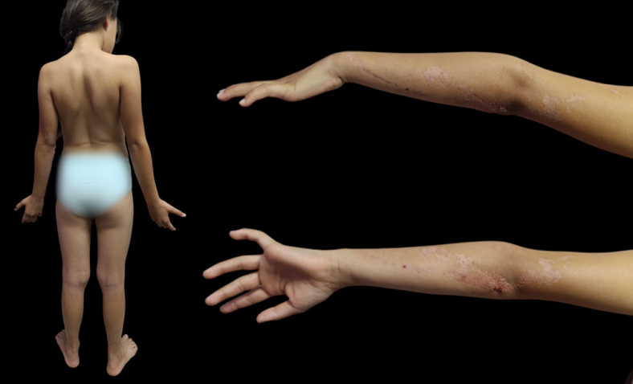
Figure 1: Annular plates of linear distribution in the extensor region of the left arm
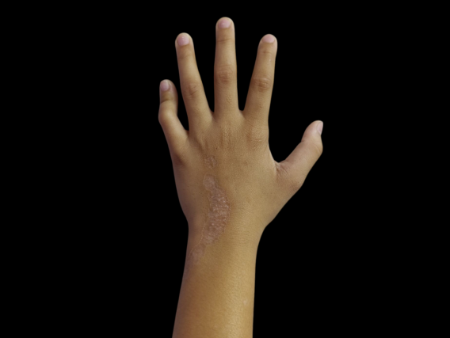
Figure 2: Extension of the lesion to the back of the left hand

Based on these clinical findings, the presumptive diagnoses of linear porokeratosis, linear lichen striatus, and linear inflammatory verrucous epidermal nevus (LINEV). Dermoscopy reveals a white, hyperkeratotic, double-tracked peripheral border, a central area of ​​white dots, and an erythematous background (Figure 3).

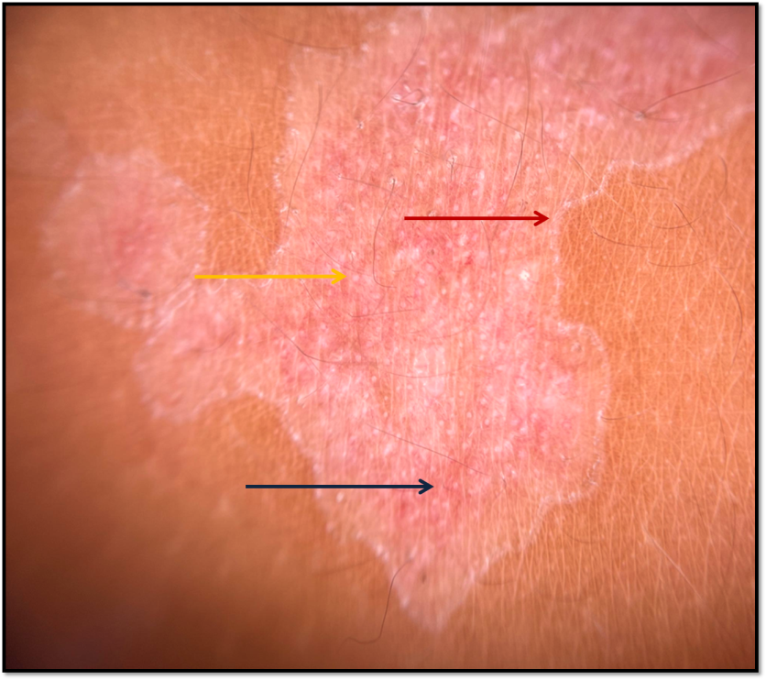
Figure 3: Dermoscopy with evidence of a white hyperkeratotic peripheral border in a “double rail” (red arrow), central area with white dots (yellow arrow) and erythematous background (blue arrow).

A histopathological study of the skin was performed, with H-E staining at 10x and 40x, irregular hyperkeratosis was observed, thin columns of parakeratotic cells that form the cornoid lamella and hypogranulosis underlying the cornoid lamella with lymphocytic inflammatory infiltrate in the dermis. Evidence of findings consistent with Porokeratosis (Figure 4).

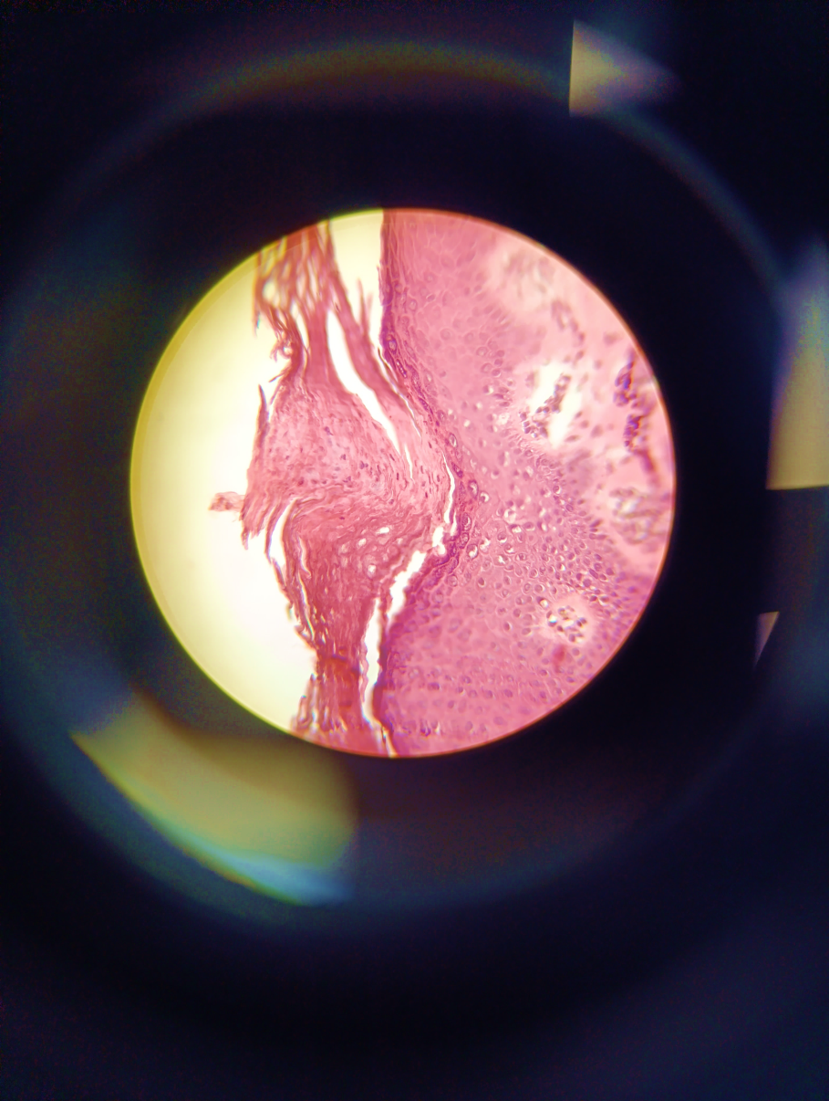
Figure 4: Skin biopsy with H-E staining, under an optical microscope with 40x magnification the cornoid lamella is evident.

Based on the clinical, dermatoscopic, and histopathological features, a definitive diagnosis of linear porokeratosis was made. The following therapeutic plan was established with topical tretinoin: 0.025% OD 4 pm, simvastatin 2% OD 9 pm, and strict sunscreen every 3 hours. Clinical improvement was observed after 4 weeks of treatment (Figure 5).
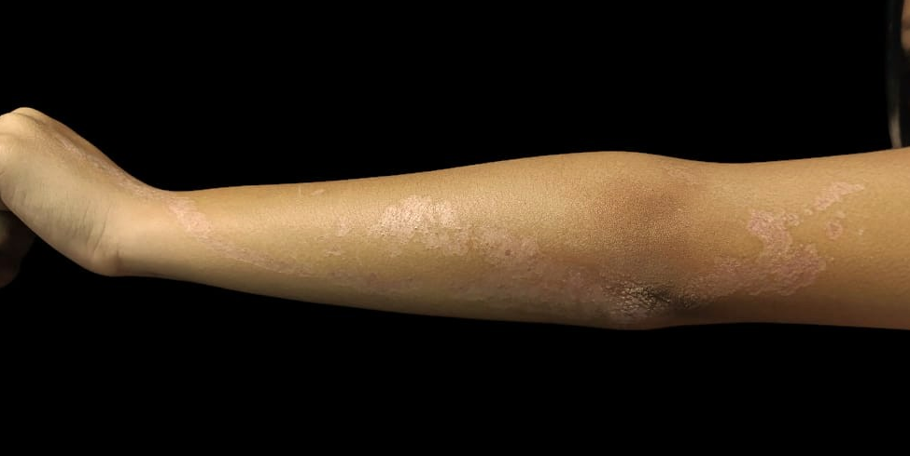
Figure 5: Evolution at 4 weeks of treatment.

3. Discussion

Linear porokeratosis is a rare genodermatosis that begins during childhood, particularly in the first years of life. Its relative frequency is estimated at 13%; however, there are no comprehensive epidemiological studies or robust prevalence records for this condition.₁
This predilection for pediatric age is associated with a postzygotic genetic mosaicism phenomenon, which is explained by the loss of heterozygosity, resulting in a homozygous mutated clone occurring in a cutaneous progenitor cell that migrates along Blaschko's lines, a characteristic distribution of linear porokeratosis.₂
Furthermore, it is the variant with the greatest potential for malignant transformation, reaching rates of up to 19%, with squamous cell carcinoma being the most common. Risk factors include sun exposure, immunosuppression, prolonged duration, and extent of lesions.₁
Clinically, it is characterized by grouped lesions that follow a linear pattern along Blaschko's lines, which may be clinically reminiscent of epidermal nevus or lichen striatus. It presents in two forms: the more common localized form manifests with unilateral lesions limited to a single extremity, usually distal, as seen in the patient presented, with involvement of the left arm; in contrast, the less common generalized form presents with multiple lesions affecting several extremities, the trunk, and may adopt a zosteriform pattern.₄
Therapeutic approaches are often challenging due to the poor response to conventional treatments. With a tendency to have a chronic course where only 16% of cases show a complete response.₁ In this context, the application of topical statins, drugs with pleiotropic properties, including anti-inflammatory and immunomodulatory effects, has emerged as a promising alternative and this has been supported by the study conducted by Santa Lucia et al, who conducted a randomized clinical trial and compared 2% lovastatin cream alone vs. Combined with 2% cholesterol in disseminated actinic porokeratosis, the study showed similar efficacy in both groups, suggesting that the addition of cholesterol is not essential. _{6,7}
Furthermore, this lovastatin monotherapy was also demonstrated in the publication by Diep et al., which documented the successful use of topical lovastatin in a 61-year-old patient with an unusual presentation of bilateral linear porokeratosis, with significant clinical improvement and no adverse effects. This study suggests that the most likely cause of linear porokeratosis is mevalonate accumulation rather than altered cholesterol synthesis. 8 Furthermore, the case of a patient with porokeratosis treated with topical simvastatin is reported, highlighting its anti-inflammatory effect and its ability to modulate the mevalonate pathway as a therapeutic basis, published by Byth et al. ₉
The pathway of action of topical statins in porokeratosis is explained by the fact that statins act through a mechanism that goes beyond their classic lipid-lowering effect. Topically, they act by inhibiting the HMG-CoA (hydroxymethylglutaryl-CoA) reductase enzyme in the mevalonate pathway.10 This pathway is altered in hereditary forms of porokeratosis by mutations in genes such as PMVK and MVD.₁₁
These mutations generate accumulation of toxic metabolites and cholesterol insufficiency, causing keratinocyte apoptosis. By reducing these pro-apoptotic metabolites, statins attenuate dyskeratosis and the inflammatory process. Their effect on the skin does not depend on systemic lipid modulation, but rather on a localized action on epidermal cellular metabolism.₁₁

4. Conclusion

It is emphasized that linear porokeratosis is an uncommon presentation, however its clinical appearance is more common in childhood than in adulthood, so the diagnosis should be considered in keratotic lesions that follow a Blaschkoid pattern of onset in childhood. Furthermore, clinical follow-up is important for the early detection of malignant transformation to squamous cell carcinoma, which can occur in 19% of patients. Finally, the favorable clinical response observed with topical statin should be highlighted, suggesting an alternative therapy that could offer a safe and effective route, especially when conventional treatments show little efficacy.

DISCLAIMER (ARTIFICIAL INTELLIGENCE)

Author(s) hereby declare that NO generative AI technologies such as Large Language Models (ChatGPT, COPILOT, etc.) and text-to-image generators have been used during the writing or editing of this manuscript.

CONSENT

As per international standards, parental written consent has been collected and preserved by the author(s)

ETHICAL APPROVAL

As per international standards or university standards written ethical approval has been collected and preserved by the authors.

References

- Vargas-Mora P, Morgado-Carrasco D, Fustà-Novell X. Poroqueratosis. Revisión de su etiopatogenia, manifestaciones clínicas, diagnóstico y tratamiento. Actas Dermosifiliogr.2020;111(7):545–60. Disponible en: http://dx.doi.org/10.1016/j.ad.2020.03.005.
- Das A, Vasudevan B, Talwar A. Porokeratosis: An enigma beginning to unravel. Indian J Dermatol Venereol Leprol. 2022;88(3):291-299. doi:10.25259/IJDVL_806_20.
- Sertznig P, von Felbert V, Megahed M. Porokeratosis: present concepts: Porokeratosis. J Eur Acad Dermatol Venereol [Internet]. 2012;26(4):404–12. Disponible en: http://dx.doi.org/10.1111/j.1468-3083.2011.04275.x.
- Eicher L, Flaig MJ, Senner S, Betke M. Lineare Porokeratose [Linear porokeratosis]. Hautarzt. 2020;71(Suppl 1):54-56. doi:10.1007/s00105-020-04641-z.
- Williams GM, Dreyer MA, Fillman EP. Porokeratosis. En: StatPearls. Treasure Island (FL): StatPearls Publishing; 2025.
- Gimeno Castillo J, de la Torre Gomar FJ. Formulación tópica de estatinas y colesterol como tratamiento de poroqueratosis. Actas Dermosifiliogr. 2023;114(6):533–535.
- Santa Lucia G, Snyder A, Lateef A, et al. Safety and Efficacy of Topical Lovastatin Plus Cholesterol Cream vs Topical Lovastatin Cream Alone for the Treatment of Disseminated Superficial Actinic Porokeratosis: A Randomized Clinical Trial. JAMA Dermatol. 2023;159(5):488-495. doi:10.1001/jamadermatol.2023.0205.
- Diep D, Pyatetsky IA, Barrett KL, Kannan KS, Wright K, Baker W. Bilateral Linear Porokeratosis Treated With Topical Lovastatin 2% Monotherapy. Cureus. 2023;15(8):e43657. doi:10.7759/cureus.43657.
- Byth LA, Byth J. Topical simvastatin-cholesterol for disseminated superficial actinic porokeratosis: An open-label, split-body clinical trial. Australas J Dermatol. 2021;62(3):310-313. doi:10.1111/ajd.13601.
- Atzmony L, Lim YH, Hamilton C, et al. Topical cholesterol/lovastatin for the treatment of porokeratosis: A pathogenesis-directed therapy. J Am Acad Dermatol. 2020;82(1):123-131. doi:10.1016/j.jaad.2019.08.043.
- Zhao A, Wang X, Pan C, et al. Epidermal second-hit mutation in MVK gene associated with linear porokeratosis. Genes Dis. 2024;12(1):101314. doi:10.1016/j.gendis.2024.101314.

