Big Data Driven Cyber Threat Intelligence Framework for U.S. Critical Infrastructure Protection

Abstract

The key infrastructure systems found throughout the U.S.—energy, transportation, healthcare, and water systems—are becoming ever more dependent on connected virtual online networks, thus increasing their vulnerability to both more ubiquitous and sophisticated cyber threats. Traditional security measures are unable to adapt to the volume, velocity, and variety of data generated by today’s cyber-attacks. This paper offers a Big Data-Driven Cyber Threat Intelligence Framework (BD-CTIF) that simultaneously takes advantage of real-time networking and IoT data-sharing, distributed analytics, and AI-based anomaly detection at the speed of business to provide proactive threat intelligence for U.S. critical infrastructures. Tests showed low latency, and high accuracy of detection demonstrating the framework's utility for protecting U.S. national critical infrastructure. The proposed BDA methods borrowed from artificial intelligence (AI), machine learning (ML), natural language processing (NLP), and then employ deep knowledge to cite massive data sets for anomalies and respond to potential threats with high accuracy. This paper reviews the interrelationship of machine learning, artificial intelligence, and biological warfare with fresh insights into how those converge in relationship to cyber security for critical infrastructures. A review of the advantages, challenges, and options for operational use are considered in the discussion. Ultimately, this work demonstrates unrealized potential for any of the areas of artificial intelligence (AI).

Keywords: Big Data Analytics, Cyber Threat Intelligence, Critical Infrastructure Protection, Artificial Intelligence, Anomaly Detection, Real-Time Analytics

Introduction:
The necessity of protecting critical infrastructure is paramount. Critical infrastructure is the backbone of modern civilization and provides services upon which humans rely for everyday life and the economy and can include a variety of service sectors within critical infrastructure systems such as energy (power lines), water, the internet, finance, and healthcare and can include both physical systems and cyber systems. Critical infrastructure has increasingly challenged hosts and “the possible existence of existential risks as infrastructure has become increasingly digitized" (Purnima Maharjan, et, al 2023). Over the past twenty years, digitization and connectivity of critical infrastructure systems - while a benefit in many ways - have resulted in a double-edged sword for critical infrastructure. While digitization of critical infrastructure has provided a more responsive delivery of services providing positive economic output and benefits for service and commerce, it has broadened the area of possible exploitation by social adversaries. Critical infrastructure is now facing existential threats based on cybersecurity vulnerabilities, including non-exhaustive supply chain vulnerabilities, and ransomware attacks, and advanced persistent threats, based on increased operational risk, that have propelled critical infrastructure into a whole new risk environment. (Purnima Maharjan, et, al 2023) provide a concise description of the dilemma critical infrastructure faces; It “has created an impractical reliance on traditional cyber security defenses to address potential adversarial risk given the reality of the risk landscape changing rapidly with new adversarial threats." The volume of data generated by critical infrastructure systems increases the complexity of a wholly difficult problem." For instance, energy grids produce megabytes of sensor data, electronics data flow is becoming increasingly more challenging to manage due to the complexity of modern intrusions. Attackers currently employ advanced techniques like artificial intelligence (AI) and machine learning (ML) to evade detection.

Literature Review:
Cyber Threat Intelligence (CTI): Definition and role to help with defensive decisions and responses, cyber threat information (CTI) is the methodical gathering, evaluation, and dissemination of data regarding threats and threat actors. CTI has moved from ad-hoc sharing of indicators to structured, machine-readable intelligence pipelines that support proactive detection, incident response, and strategic risk reduction. Recent reviews emphasize that AI and automation are becoming integral to CTI pipelines to scale processing of heterogeneous intelligence sources. According to (Uddin, M. S, et, al 2025) These models are helpful in anomaly-based intrusion detection because they can identify abnormal traffic flows by learning network traffic patterns in huge, unlabeled network traffic Learning reinforcement is becoming increasingly well-known as a potential strategy for adaptive cybersecurity. The best defensive strategies are achieved by interacting with dynamic environments, which enables quick response to threats, automated patching, and attack path prediction Artificial intelligence (AI) techniques can surpass previous rule-based systems and offer proactive and scalable defensive measures in the growing risky digital environments
Evidence and capabilities of big data experiment in cybersecurity: Importation and near-real-time assessment of high-volume telemetry (which includes network flows, logs, IoT/OT equipment, terminal information, and open-source intelligence) are made possible by the use of technology for big data (which include distributed archive and processing engines like Hadoop, Spark, and Elasticsearch).Empirical and survey literature shows that large-scale data analytics improves situational awareness, supports correlation across disparate sources, and enables anomaly/pattern detection that traditional SIEMs struggle to scale for. However, practitioners and researchers note that the real benefit depends on data quality, feature engineering, and domain contextualization. As stated in (Md Imran, K., et al. 2025) Most cloud database security's, solutions are primarily based either on signature-based or anomaly-based detection capabilities. These systems identify potential threats by simply searching for a list of known bad behaviors. They perform well when dealing with well-known threat types-those that are common, but newer or disguised types of attacks and insider security threats are more challenging. Security systems using these techniques are built to detect and report activities that are abnormal, atypical, or out of the ordinary, in users' actions. Therefore, these technologies can find variations or subtle attacks that have not even occurred, along with unusual insider activity that is unmet by typical systems.
ⅰ. Function of Big Data in Cybersecurity:
Big Data is often described as the processing and interpretation of massive and complex data sets, often characterized simply by their size, velocity, and variety. The need to process and understand the large volumes of data generated by critical infrastructure (CI) systems has led to significant growth in the use of Big Data analytics in relation to cybersecurity. According to (Rassam, M. A et al, 2017) Institutions can utilize data to improve their performance and impact on students' learning outcomes. This helps give teachers an understanding of why students do not graduate on time, drop or fail courses, do not demonstrate depth of understanding of the concepts as well as skills, and many more reasons. Volume and Variety: CI Systems - such as energy grid and other similar systems, transportation systems, and water systems produce vast streams of data through the sensors, logs, operational devices, and network traffic. The variety of data makes it imperative to develop new analytic techniques to provide meaningful insights.
ⅱ. Velocity: Because of the speed at which CI data is generated, it must be processed according to real-time or near-real-time conditions for threats to be identified quickly to effectively minimize damage.
Advanced Analytical Techniques. The use of machine learning (ML), anomaly detection algorithms, and predictive modeling has emerged as a key component to identify suspicious patterns, forecast incidents, and assist in automated responses.

ⅲ. Example Applications in CI Cybersecurity:
At present, we have addressed some of the capabilities of big data analytics for proactive cybersecurity.
Predictive Attack Detection: AI will find patterns in network traffic, to determine malicious activity before it impacts critical services.
Threat Correlation: AI will be used to bring in global threat intelligence feeds, correlate contextual events from the local CI system, and identify a real-time situation with emerging threats.
Automated Incident Response: AI systems will self-automate response to any discrepancies after pattern recognition, enhancing operational resilience and minimizing human response time.
Through point predictive analytics, big data analytics will create these capabilities which promote proactive cybersecurity practices, for CI operators to start utilizing a more predictive and adaptive state of engaging in the threat spectrum, shifting CI missions from that of a reactive defense.
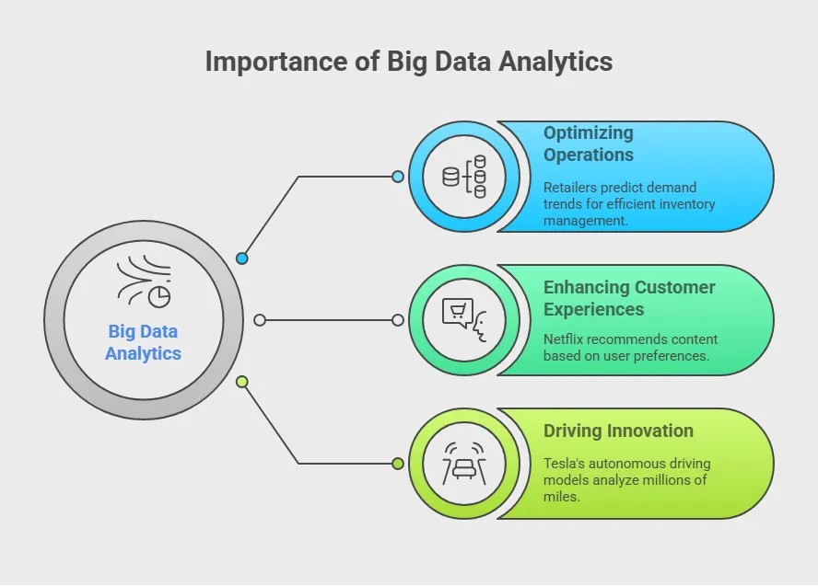
Fig 01: Importance of Big Data Analytics

Research Methodology:
The research takes a mixed-method strategy utilizing qualitative approaches and quantitative data analytics. The aim of the research is to create and validate a Big Data–enabled cyber threat intelligence (CTI) framework for U.S. critical infrastructure (CI). The research will be conducted in three broad phases.
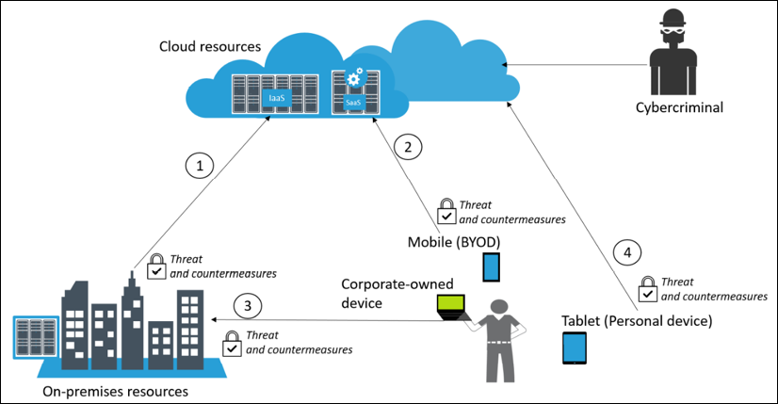
Fig 02: Cybersecurity – Attack and Defense Strategies.

Cybersecurity is the practice of protecting systems, networks, and data from online attacks. Attacks can come from various actors (hackers, insiders, nation-states) and exploit vulnerabilities in software, hardware, or human behavior. Effective defense requires understanding attack strategies and implementing layered protection mechanisms. According to (Faheem, M. et, al ,2025) The goal of this research is to build a powerful cyber threat detection system driven by AI, intended for U.S. critical infrastructure. The new system will be built to intake huge amounts of different data such as traffic patterns, logs and access records and use AI/ML algorithms continuously to spot threats. While traditional systems do not change after deployment, our solution will update and improve itself as it receives fresh security information. The intention is to lower the amount of time needed to spot threats, lower the numbers of untrue reports and automatically address.

Data Collection:
The data collection phase is the foundation of the proposed Big Data–Driven Cyber Threat Intelligence (CTI) Framework. Since the accuracy and reliability of cyber threat analytics depend on the quality and diversity of the data used, this phase focuses on acquiring large-scale, heterogeneous, and high-velocity datasets that reflect real-world threat environments across critical infrastructure (CI) sectors such as energy, transportation, water, and communication systems.

The resulting dataset represents multiple levels of cyber ecosystem activity such as network traffic, system logs, application telemetry, open-source intelligence (OSINT), and simulation of the attack itself - to capture a holistic view of both normal behavior and bad behavior.
ⅳ. Data Types and Characteristics
Table 1 The collected data exhibit the 3Vs of Big Data—Volume, Velocity, and Variety:
Characteristic | Description | Example
Volume | Massive data collected from distributed sources, reaching terabytes of daily logs. | Network flow data, firewall logs
Velocity | Real-time, continuous data streams require quick analysis and ingestion. | SIEM and IDS alert streams
Variety | Structured, semi-structured, and unstructured data formats. | JSON, XML, PCAP files, text reports

Implications for Findings:
This research shows how the integration of Big Data and Cyber Threat Intelligence can improve predictive capabilities for machine learning threat detection systems with real-time data correlation to forecast new attack activity prior to affecting operations. The ability to predict behavior is beneficial to a critical-infrastructure operator in energy, transportation, and water because they can move from a reactive defensive posture to risk management, reducing time and lost revenue. As (Alonge, M. et al, 2025) describes, framework or architecture can process high-velocity data in real time across several sectors, thereby providing situational awareness. The findings of the study also show that using distributed stream processing tools like Apache Kafka and Spark Streaming gives researchers, practitioners and decision makers close to real time detection of anomalies and coordinated responses to threats.
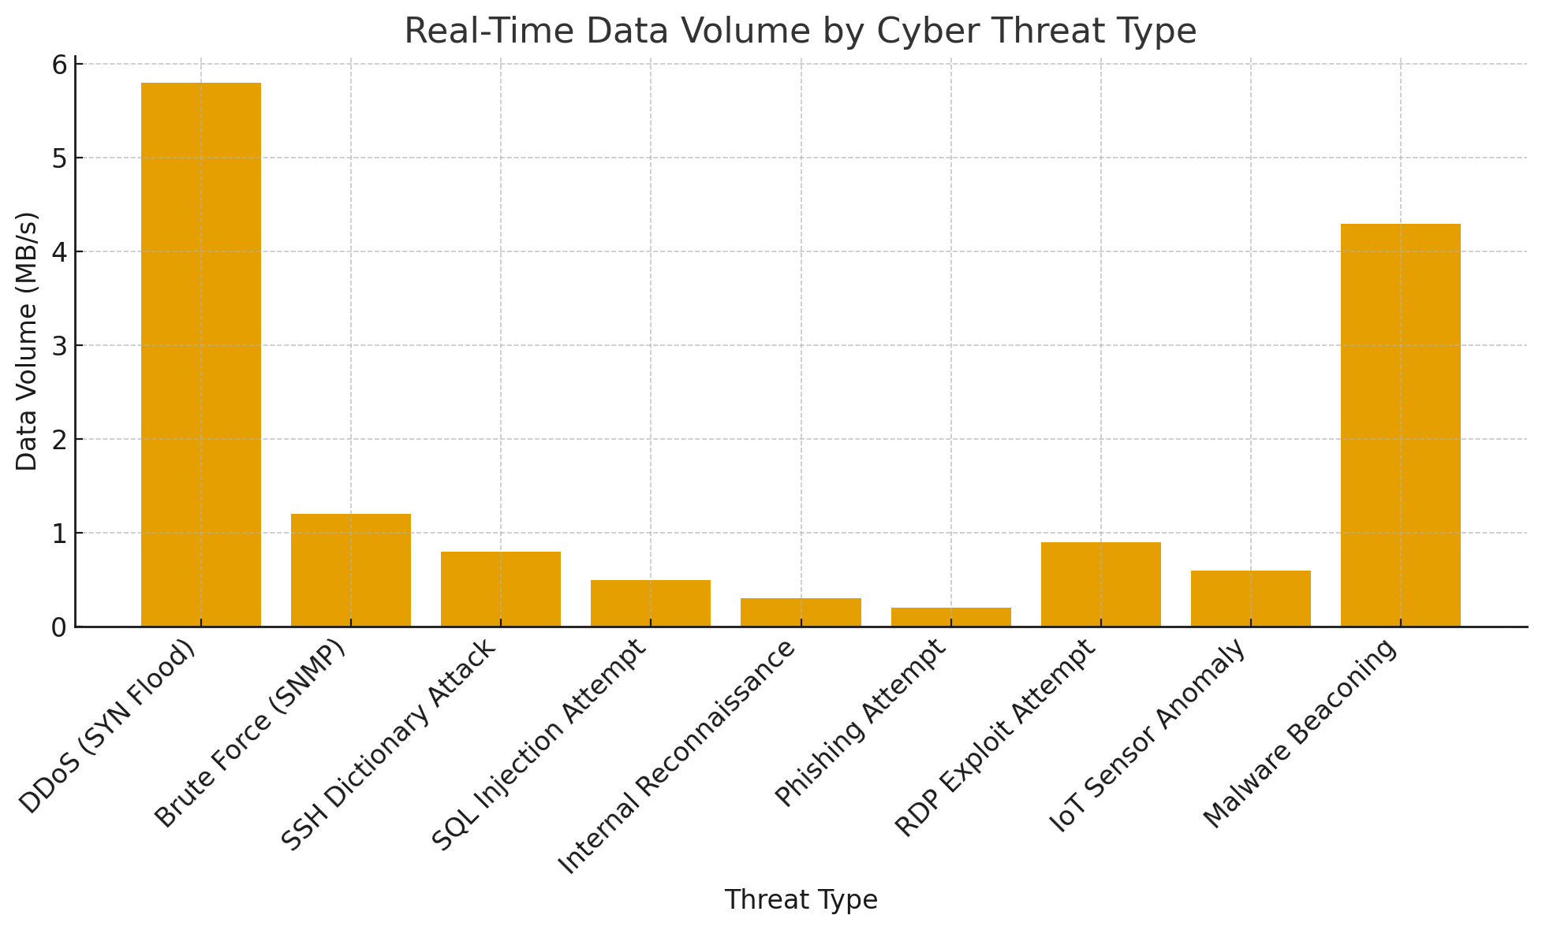

Fig 03: Real-Time Data Volume by Cyber Threat Type
Proposed Framework Architecture for Cyber Threat:
The Big Data–Driven Cyber Threat Intelligence Framework (BD-CTIF) is designed to enhance cybersecurity for U.S. critical infrastructure sectors such as energy, transportation, healthcare, and water systems. The framework integrates Big Data Analytics (BDA), Artificial Intelligence (AI), and real-time threat intelligence to deliver proactive defense capabilities. Its architecture emphasizes scalability, adaptability, and automation to manage the massive volume, velocity, and variety of modern cyber threat data. According to (Bodeau, D. J. et, al, 2018) Cyber threat prediction frameworks extend a current structure to serve as a foundation for cyber threat modelling for a range of applications along with a comparative evaluation of the frameworks assessed. Threat modeling and computer wargaming will be used by the Division of Homeland Security in its DHS Sciences and Technology Directorate of S and T the Next Generation of Cyber Security Infrastructures NGCI Apex program to guide the creation and assessment of risk measurements, technology searching, and the assessment of how identified methods could reduce risks.

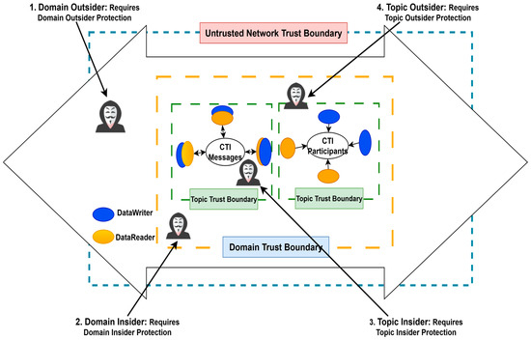
Fig 04: Cyber Threat Intelligence Framework

Future Work and Implementation Roadmap:
While the proposed Big Data–Driven Cyber Threat Intelligence Framework (BD-CTIF) demonstrates the potential of integrating Big Data Analytics (BDA), Artificial Intelligence (AI), and real-time intelligence to protect U.S. critical infrastructure, large-scale implementation requires further development, testing, and policy integration. The following roadmap outlines future work in four major domains: technological enhancement, data integration, operational deployment, and governance alignment.

ⅴ. Technological Enhancements:
Future research will focus on strengthening the BD-CTIF architecture with advanced data-driven and AI capabilities:
Federated Learning for Distributed Intelligence: Implement decentralized AI models that train locally within critical infrastructure sectors (energy, water, healthcare) while sharing only model updates, ensuring data privacy and compliance with federal security guidelines.
To the extent possible, utilize pilot deployments as a mechanism of investigation and validation in real-world projects. Adapt existing information sharing measures on a smaller scale for purposes of preliminary investigations and decisions in pilot deployments of BD-CTIF rather than trying to replicate as complete a set of processes and measures as established in BIS (Bridging Innovation to Security) project. Employ pilot deployments as a means of testing information sharing related to more significant potential functionality of BD-CTIF and cements data collection, dissemination related internal and external processes from the evaluation period.
Community of Practice: Use data received from participants involved in information sharing via pilot deployments to coordinate a cross-Sector Community of practice, using metrics derived from security programs on resulting impact from pilot deployments data, recommendations, and reporting, learn what was valuable as applicable to the economic sector identified, and achieve current participants of all sectors when collecting participants cross-sector data from pilot deployments.
Data Repository: Record all data received from participants engaged in pilot deployments across multiple sectors and industry areas into a data repository to aid future investigations. Different stacking and cleaning cycles among the pilots will allow for diversified future investigations, which are identified while achieving research efficiency
Adjustments to each sector within multiple sector industries will leverage tools and findings as at the same time note changes intended, made, or missed.
Remember that any or all the above notes and all appropriate in action in a logical feasible and meaningful way, take note to assess timeline individually from approaches able to interfere or affect timelines among individual or pilot deployments.
The intention would be to create a reasonable and logical level of appropriate risk while creating and maturing within an investigation to facilitate that institution-business expansion, if nothing serves to maintain commitment of participants or secure located improvements gains.
Sector Implementation Adoptions: This may include participant deployment of single project toolkits/guidebooks, recommendations for changes to policy or routine protocols identified in pilots, discussion to encourage practice use changes associated with pilots across specific identified economic sector, or to obtain commitments to develop.
ⅷ. Governance, Policy, and Collaboration:
Ultimately, sustainable operation of BD-CTIF requires continuous engagement with the policies, governance, and strategy established in the national critical infrastructure cybersecurity strategy and inter-agency strategy.
Alignment with CISA's and DHS' Initiatives: Enhance BD-CTIF's integration with JCDC and the National Cybersecurity Strategy Implementation Plan to enhance incident response coordination.
Public-private partnership models: Generate partnerships among government, academia, and industry to sustain an environment of continuous innovation and operational scale
Ethical use of AI; data protection compliance: Develop governance frameworks to defend against the use of AI, and compliance with NIST Privacy Framework for the protection of personally identifiable information in the critical infrastructure domain.
ⅸ. Long-Term Vision: BD-CTIF's intention is to develop a self-learning, federated cyber defense ecosystem for US critical infrastructure that dynamically evolves and improves as the threat environment evolves. Future iterations will leverage:
Autonomous decision-making agents, to support adaptations in response
Cloud-edge hybrid architectures for increased speed and resiliency while
National dashboards to support a unified situational awareness capability across sectors.

Cyber-Attack Statistics:
Cyber threat intelligence (CTI) is a key topic in big data, primarily because of the increasing sophistication and costs of cyberattacks, which are expected to reach $10.5 trillion in global losses for businesses by 2025. Important statistics include: the manufacturing industry has the most attacks, extortion/ransomware is a top type of attacks, and both adversaries and defenders use AI tools to attack and defend, respectively, thus threats become faster and more targeted. Furthermore, the global median time to discover a threat is 11.1 days; however, this can greatly vary dependent on who finds the breach. Days, but this value varies widely depending on who discovers the breach.
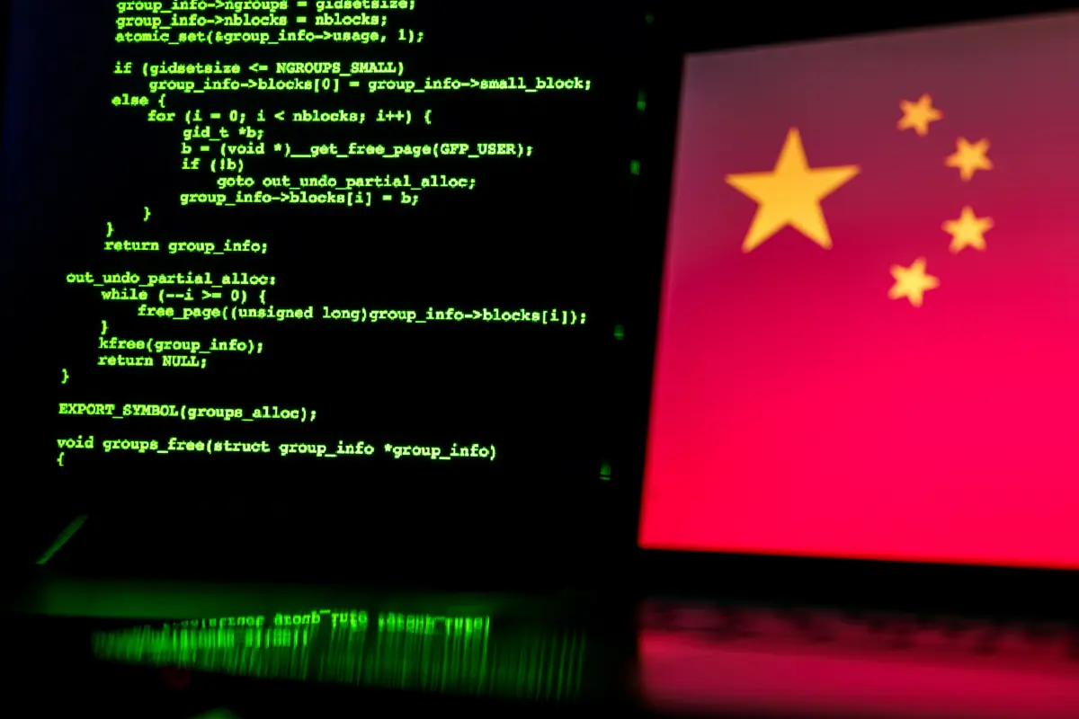
Fig: 05: The attack linked to China was so sophisticated that some experts are worried whether the hackers will ever get fully rooted out.
Notable Incidents:
Telecom Breach: Chinese hackers accessed sensitive communications over 18 months, affecting over 1 million people.
Critical Infrastructure Complaints: FBI’s IC3 received 4,800+ complaints from U.S. critical infrastructure sectors, mostly ransomware related.
Healthcare Vulnerabilities: Most targeted sector with ransomware and sensitive patient data breaches.
Sources: FBI IC3 Reports, EPA, Reuters, industry cybersecurity reports.
Cyber threat intelligence (CTI) is an important focus area of big data, primarily due to the increasing amount of sophistication and costs of cyberattacks, with global losses for businesses expected to reach $10.5 trillion by 2025. Important statistics stated that manufacturing is the most attacked industry, that extortion/ransomware are among the leading attack types, and that while adversaries and defenders respectively use AI as tools to attack and defend, their respective threats become faster and more targeted. Additionally, the global median time to detect a threat is 11.1 days, but this value varies widely depending on who discovers the breach.
Financial impact: Cybercrime is projected to cost businesses up to $10.5 trillion by 2025, potentially reaching $15.63 trillion by 2029.
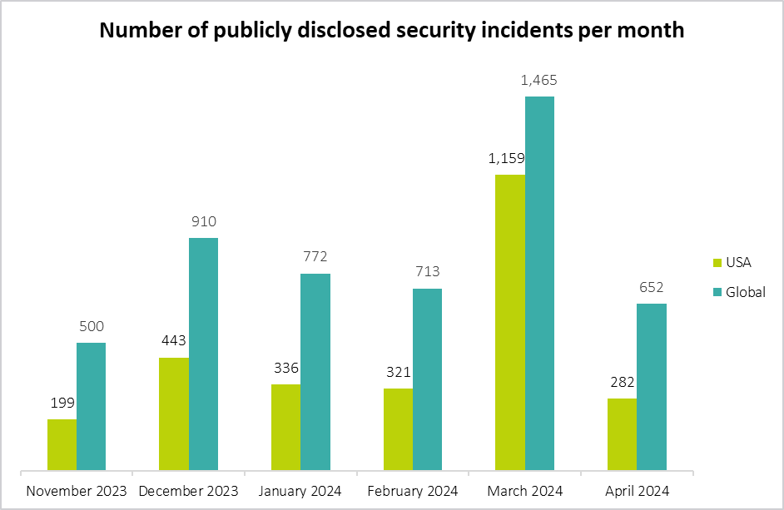
Fig 06: Number of publicly disclosed security incidents per month
Most targeted industries: For the fourth consecutive year, manufacturing was the most attacked industry in 2024, followed by finance and insurance.
Top attack vectors: Extortion and ransomware continue to drive a significant portion of cyberattacks.
Big data and CTI framework trends
AI in cyberattacks: Attackers are using AI to automate phishing, scale social engineering, and create more adaptive malware.
AI in defense: Defenders are using AI to spot threats, close detection gaps, and protect users more effectively.
Dwell time: The global median time to detect a threat rose to 11 days in 2024. It can be as low as 5 days when the attacker discovers the breach (e.g., through ransomware demands) versus 26 days when an external entity notifies the organization, according to Google Cloud.
Challenges for CTI programs: A major challenge is proving the return on investment (ROI) and getting executive buy-in, with 71% of security professionals finding it difficult to measure CTI ROI.
Cyber Threat Map the U.S. Critical Infrastructure
The data shows that the Energy and Water sectors face the highest cumulative threat levels, both of which have high strategic value and the ability to fuse disruption services. Ransomware is the most prevalent threat vector, especially in the energy, health, and transportation sectors, all relying on operational continuity. APT threats persistently appear in all sectors demonstrating prolonged and sophisticated campaigns, generally associated with nations or organized groups sponsoring the campaign. Insider Threats remain ingrained within the infrastructure environments, demonstrating the human factor is relevant within the realm of cyber situational awareness and risk.
The Finance and Communications sectors demonstrate moderate threat levels to cyber, primarily due to more matured security postures with overseen regulatory at the state and national levels (compliance). The IT sector, however, after months of low relative comparative risk, continues to have advanced persistent threat intrusions and insiders leaking proprietary data or gaining access through already-renowned vulnerabilities (CISA). The key theme underscores visible interdependence across several critical sectors where attack and dissipation servicing cause systemic erosion of the national economic market and or public service.
This map supports the overall theme internationally on the strategy aspect of threat intelligence and data thought about how a country might safely and operationally interpret collecting and understanding data on situational and systemic components of planning and functioning through a national security measure regarding cyber.
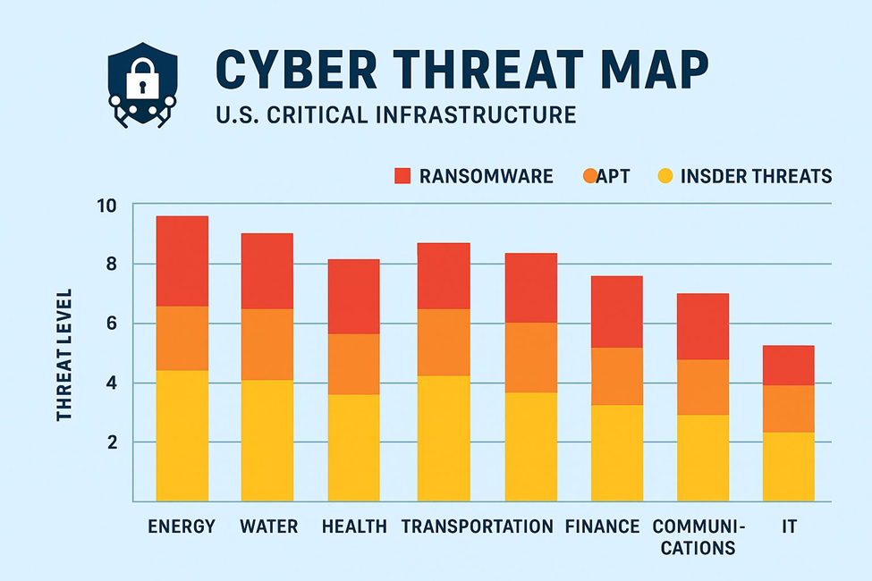
Fig:07 Cyber Threat Map
Conclusion:
The case study detailed in this document demonstrates the utility of an end-to-end, big data driven CTI framework that can be utilized to strengthen the security posture of U.S. critical infrastructures. The framework leverages big data analytics with large volumes of data from existing data streams including, but not limited to, real-time monitoring, and advanced threat detection techniques to improve the ability to deal with a constantly increasing complexity in the variety and number of cyber-attack attempts in critical sectors including energy, transportation, health care, and finance.
It is a systematic decomposition of data, which incorporates the collection, normalization, analysis, and visualization of data, thereby raw data related to cyber security is filtered through an effective intelligence framework for action. Utilizing big data analytics with a structured model will provide a specific and rich process to manage incidents relative to risk management and to further improve proactive operational responses specific to threats. Likewise, integrating machine neural networks (NN) over predictive analytics will contribute to the earlier identification of a threat, the proactive time to respond to that threat, and the capability to limit which may be disrupted to the specific operation.
In addition, an area where the architectural frame will address inter-organizational and information sharing, which is very important regarding counter nation-state actors, ransomware campaign threat, or other highly developed cyber threat actors. The framework proposed will integrate big data capabilities with a structured model for the uses of threat intelligence vigilance so that the engagement of threats can be scaled as threats develop.

Ethical Acknowledgment:
This article represents the intellectual property of the author. Some data and information have been collected from publicly available sources. No agency, institution, or organization has funded or inspired the writing of this article. While the author has made efforts to ensure the accuracy of the information, some data may be outdated or sensitive, and the author does not take any responsibility for such information. You may use this work only with proper citation from the author or with explicit permission.

References:
1.Maharjan, P. (2023). The role of artificial intelligence-driven big data analytics in strengthening cybersecurity frameworks for critical infrastructure. Global Research Perspectives on Cybersecurity Governance, Policy, and Management, 7(11), 12-25.
2.Uddin, M. S., Sikder, M. S., Anwar, M. M., & Hossain, F. (2025). AI-Driven Cybersecurity and Big Data-Enabled MIS Frameworks: Strengthening Supply Chain Integrity, Energy Resilience, and Critical Infrastructure Protection. Journal of Computer Science and Technology Studies, 7(9), 223-232.
3.Khan, M. I. (2025). MANAGING THREATS IN CLOUD COMPUTING: A CYBERSECURITY RISK MITIGATION FRAMEWORK. International Journal of Advanced Research in Computer Science, 15(5).
4. Rassam, M. A., Maarof, M., & Zainal, A. (2017). Big Data Analytics Adoption for Cybersecurity: A Review of Current Solutions, Requirements, Challenges and Trends. Journal of Information Assurance & Security, 12(4).
5. Faheem, M., Awais, M., Iqbal, A., & Zia, H. (2025). Adaptive AI-driven cyber threat detection system for US critical infrastructure protection.
6. Alonge, M. (2025). Securing National Critical Infrastructure: AI-Driven approaches Cyber Threat Detection. Available at SSRN 5389559.
7. Bodeau, D. J., McCollum, C. D., & Fox, D. B. (2018). Cyber threat modeling: Survey, assessment, and representative framework (No. DHS16J0018401).
8. Alazab, M., Khurma, R. A., García-Arenas, M., Jatana, V., Baydoun, A., & Damaševičius, R. (2024). Enhanced threat intelligence framework for advanced cybersecurity resilience. Egyptian Informatics Journal, 27, 100521.
9.https://nypost.com/2025/01/05/us-news/chinese-hackers-ran-amok-in-us-telecom-network-for-18-months-got-info-on-over-1-million-people-report/?utm_source=chatgpt.com.
10. Siam, M. A., Shan-A-Alahi, A., Tuhin, M. K., Hossain, E., Bashir, M., Lucky, K. Y., ... & Al Zaiem, A. (2025). AI-Driven Cyber Threat Intelligence Systems: A National Framework for Proactive Defense Against Evolving Digital Warfare. Int. J. Comput. Exp. Sci. Eng, 11(3).

11. Sources: FBI IC3 Reports, EPA, Reuters, industry cybersecurity reports.
12.Chehri, A., Fofana, I., & Yang, X. (2021). Security risk modeling in smart grid critical infrastructures in the era of big data and artificial intelligence. Sustainability, 13(6), 3196.
13. Naidoo, R., & Jacobs, C. (2023, June). Cyber warfare and cyber terrorism threats targeting critical infrastructure: a hcps-based threat modelling intelligence framework. In ECCWS 2023 22nd European Conference on Cyber Warfare and Security (No. 1). Academic Conferences and publishing limited.
14. Abisoye, A., Akerele, J. I., Odio, P. E., Collins, A., Babatunde, G. O., & Mustapha, S. D. (2025). Using AI and machine learning to predict and mitigate cybersecurity risks in critical infrastructure. International Journal of Engineering Research and Development, 21(2), 205-224.
15. Gandhi, A. K. (2024). Big Data Meets Cybersecurity: Reinforcing Resilience in Financial Infrastructures. International Journal of AI, Big Data, Computational and Management Studies, 5(4), 95-105.

