Survey on Evolution of Java Web Technologies and Best Practices: From Servlets to Microservices

Abstract—The evolution of Java web technologies represents a significant change in the creation and design of, and deployment of web applications. Starting with servlets and JSP, which enabled dynamic content generation and server-side scripting, the path continued through the Struts, Spring, and Hibernate frameworks, which brought order to the design, modularity, and efficiency. Enterprise Java frameworks also added more capabilities, enabling scalable and multitier architectures to handle the needs of business-critical applications as they grew. With time, flexibility, maintainability and reuse in web solutions were improved as persistence frameworks were integrated and also as service-oriented practices were adopted. Application development has since become revolutionized by the appearance of the concept of lightweight, loosely-coupled microservices that are well-optimized to be used in both cloud-native and distributed settings. This survey is a synthesis of how Java web technologies have evolved from their inception to current practices, highlighting the best practices that guarantee robustness, scalability, and adaptability. Through the analysis of this transition, the study highlights the importance of Java in creating reliable and efficient web applications. It also provides developers and researchers with insightful information to pursue sustainable methods for developing and enhancing web technology in the future.
Keywords—Java Web Technologies, Spring Framework, Hibernate, Enterprise Java, Microservices, Web Development.

Introduction
The rapid development of web technologies has changed the environment of software engineering [1]. Java has emerged as one of the most flexible and long-lasting applications. Since its inception, Java has been a stable platform for the development of reliable, scalable and secure web applications. Java can change and evolve according to the industry's needs, serving from small applications to complex enterprise applications. This paper is an exploration of Java web technologies and best practices that have evolved over the years, from servlets to microservices.
The history of Java web technologies, spanning from the servlets of the previous century to the microservices of the current ecosystem, encompasses best practices [2]. In such a way that they can determine the features of Struts and Spring frameworks, the challenges, and the opportunities in which the Java web community has progressed. It also indicates how best practices have evolved over the years to enable Java-based solutions to offer more efficient, reusable, and modular solutions to the increasing challenges of web applications in modernity.
The usability of Java Enterprise Edition (JEE) was expedited as a result of enterprise demands and needs, which necessitated a multitier architecture in the enterprise setups [3]. Moreover, JEE frameworks enabled the enterprise sector to handle the complexity in related applications, including tools for best practices in scalability, transaction management, and integration with relational models, where concurrency and data consistency are guaranteed. All these advancements fundamentally influenced the design of large systems in a way that allowed for separating business logic and presentation layers, thereby decreasing complexity and increasing flexibility.
As cloud computing and distributed computing evolved, microservices changed the role of Java in web development [4]. Microservices were made possible by the emergence of lightweight containers, such as Docker, and RESTful web services, which enabled the flexible and continuous deployment of independently assignable, cross-cutting services [5]. While Java microservices have evolved into an extensive and integrated ecosystem of distributed, polyglot, web-based services, the prevalent Java frameworks have created well-defined approaches to microservice development. Among the most widely adopted frameworks for Java microservices are Spring Boot and Spring Cloud [6]. The change in Java web development reflects an evolution in perspective on developing and implementation of web applications, detailing a framework for defining autonomous, resilient, and independent services.
Web Development in Java initially centred around servlets and Java Server Pages (JSP). These technologies enabled easier server-side programming and better dynamic content delivery. Servlets and JSP positioned developers for a transition away from static web applications toward applications that were interactive and data-driven [7]. Java also quickly gave rise to frameworks such as Struts, Hibernate, and Spring, which created a structured approach to web application development.

Early Java Web Technologies
Software development or framework advancement in programming building is a fundamental concept used to design, plan, and implement the process of building a data system [8]. The Java improvement technique is separated into four parts. In the e-learning system design, based on past writings on data frameworks and achievements, six progress elements are identified, specifically: framework quality, data quality, benefit quality, utilization, client satisfaction, and net benefit, which are consolidated into a comprehensive display of achievement [9]. Figure 1 illustrates the Development Method at its core, supported by four elements: Practical Knowledge (real‐world expertise), Robust Logic (structured reasoning), New Techniques (innovative practices), and Continuous Practices: Broad Room Discussion (ongoing collaborative refinement).

- Java Development

JDBC Architecture
The Java Database Connectivity (JDBC) For database access, API supports both two-tier and three-tier processing models; however, the JDBC Architecture typically has two layers [10]:
- JDBC API: This provides the application-to-JDBC Manager connection.
- JDBC Driver API: This supports the JDBC Manager-to-Driver Connection.
The JDBC API offers seamless connection to heterogeneous databases through the use of database-specific drivers and driver management. The JDBC driver manager ensures that each data source is accessed using the appropriate driver [11]. The driver management can support multiple drivers connected to various heterogeneous databases concurrently. Figure 2 of the architecture below illustrates the location of driver management in relation to the Java application and JDBC drivers.
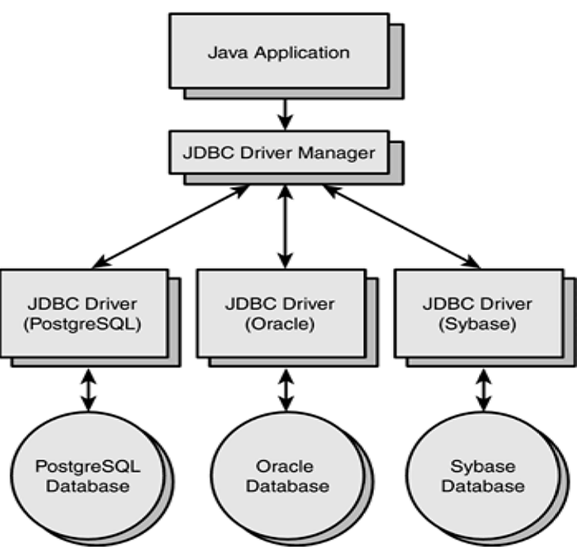
- JDBC Architecture

Java Server Pages (JSP)
Java Server Pages (JSPs) add Java source code to markup documents so that they may be used, for example, to dynamically add application-specific data to a Web page. Template text, which can be in any format, makes up a JSP. This is often HTML code, although it can also be in other forms (WML, TeX, etc.). Additionally, a JSP uses so-called script lets to include Java source code. The embedded Java statements are executed in response to each HTTP request made by a JSP [12]. The markup page is updated with their return values, and the entire page is then sent back to the client. The outcome of combining Java statements with template text is source code that is complicated to understand. To eliminate the Java statements, they might be extracted into certain classes that are accessible in a JSP using so-called custom tags.
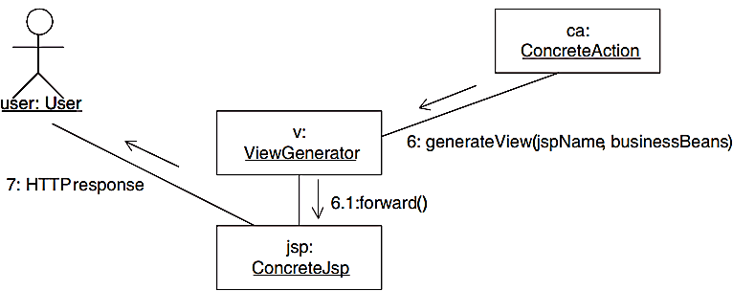
- Universal Architecture with JSPs.
The concrete action class in the JSP variation is in charge of choosing the JSP and exchanging data with the business logic. Because JavaBeans may be used in a simpler format by a JSP, they are typically used for data interchange. The dynamic content can also be sent to a JSP in other methods, for as by including data in the HTTP request object. The control flow of an HTTP request using JSPs is depicted in Figure 3.

Early Web Frameworks
As web applications grew in complexity, the limitations of Servlets and JSP became evident [13]. Developers required frameworks that could simplify application development, enforce design patterns, and provide reusable components. This need led to the emergence of early Java web frameworks, such as Apache Struts and JavaServer Faces (JSF).
- Struts 1.x: Apache Struts, introduced in 2000, was among the first widely adopted Java web frameworks. It implemented the Model-View-Controller (MVC) design paradigm, which divides presentation and business logic, as well as navigation. Struts offered centralized configuration through struts-config.xml, reusable UI tags, and form handling. Its XML-based configuration and lack of flexibility, however, were a threat to growth due to the applications.
- Java Server Faces (JSF): JSF, which is a Java EE standard, was unveiled as a structure of components for creating user interfaces. It offered a reusable User Interface, event handling, and integration with tools such as Facelets. Whereas JSF minimized boilerplate code over Servlets and JSP, its high level of abstraction and high entry barrier decreased its use in agile development environments.
These issues notwithstanding, Struts and JSF established the basis for enterprise-worthy frameworks and paved the way for the creation of more sophisticated frameworks, such as Spring MVC, which ultimately improved scalability and developer productivity more efficiently.

Enterprise Java and Framework Evolution
Enterprise Java was developed beginning with Enterprise JavaBeans (EJB). On the simplest level, EJB offered a standard for both distributed and transactional applications. But as a person who applied it to production and assisted customers with its application, it failed in a lot of aspects [14]. However, this led to the emergence of the Spring Framework as a lightweight and flexible alternative to EJB and other frameworks found in JEE, where it introduced Inversion of Control (IoC) and Dependency Injection (DI), encouraging developers to build modular applications and ultimately creating a new model of application development [15]. Spring provided the first MVC architecture for web applications and allowed for more flexibility and change from earlier frameworks of the time, such as Struts and JSF. With SOA emerging around the same time, the rise of RESTful Web Services, using JAX-RS implementations like Jersey and REST Easy, allowed for scalable, stateless, and interoperable communication with a loosely coupled application model. The shift from EJB to Spring and REST allowed for the creation of a modern microservices-based system.

Enterprise JavaBeans (EJB)
The business logic of an application is encapsulated in server-side components called enterprise JavaBeans. For instance, an enterprise bean may access a relational database for banking applications or compute interest payments for a loan application. A remote invocation across a network may occur when a client requesting information contacts business methods in the EJB. EJBs provide several advantages. They make it easier for bean developers to create huge applications with dispersed components, to start. Each bean deployed in a J2EE application server receives system-level services from the EJB container, as you may remember. Because of this, bean developers are spared from dealing with intricate problems like resource pooling, transaction management, security, and multithreaded programming. Rather, their bean approaches are only focused on business logic [16]. EJBs help clients at the presentation level as well. Because they employ EJBs for their business processes and solely perform display logic, clients get slimmer. Additionally, EJBs are portable components, meaning that they may be used to create various corporate applications and run them on any J2EE application server.

MVC Architecture in Spring
Spring is a lightweight container framework with seven clearly defined modules that combine aspect-oriented programming (AOP) with inversion of control (IoC) features. One of the seven modules, Spring MVC, is a feature-rich, low-weight implementation of MVC for creating Web applications [17]. The fundamental ideas and characteristics of MVC are flawlessly realised by Spring MVC, which dynamically configures components through straightforward configuration. This is how Spring MVC operates: Upon receiving an HTTP request from the client, the dispatcher servlet, which is the core controller, looks up the handle mapping based on the URL and forwards the request to the relevant controller. After processing the request by calling the relevant business logic, the Controller delivers the view name, Model, and View object to the Dispatcher Servlet. The View Resolver then renders the supplied Model and View to the appropriate view. The Spring MVC Request-Handling Pipeline is depicted in Figure 4.
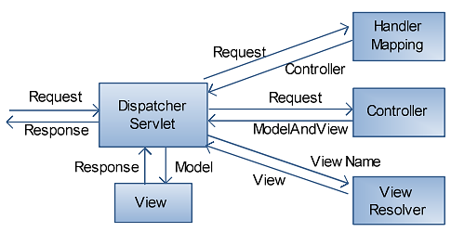
- Request-Handling Pipeline of Spring MVC

RESTful Web Services
The shift from traditional SOAP-based services to RESTful Web Services marked a significant milestone in Java web development [18]. The architectural approach known as Representational State Transfer (REST) utilises the standard HTTP methods—GET, POST, PUT, and DELETE — to manipulate resources represented by URIs.
- Transition from SOAP to REST: Enterprise applications frequently employed SOAP (Simple Object Access Protocol) because of its standardized communications and protocol support. However, its complexity, reliance on XML, and heavy overhead limited its adoption in lightweight, web-centric environments. REST gained popularity as a simpler, stateless, and scalable alternative, particularly well-suited for distributed systems and microservices.
- JAX-RS and Jersey: In the Java ecosystem, Java API for RESTful Web Services, or JAX-RS, is the main tool used to develop RESTful services, which provides annotations for simplifying resource definitions and request handling. Implementations such as Jersey and REST Easy made it easier for developers to build REST endpoints with minimal configuration. These libraries supported JSON and XML serialization, enabling seamless data exchange between clients and servers.
RESTful web services thus became a foundational element for modern Java frameworks and microservices architecture, enabling interoperability, scalability, and ease of integration with front-end applications and third-party systems.

Modern Java Web Development and Microservices
Java web development has seen a shift in focus towards lightweight frameworks and cloud-ready architecture [19]. Spring Boot became a dominant option by simplifying configurations, including an embedded Server, and enabling fast deployment, positioning it as ideal for microservices [20]. Microservices architecture breaks applications into distinct and independently deployable services that communicate through RESTful APIs, whereas monolithic architectures combine all the application's functionality into one unit. Other frameworks, such as Play and Vert.x, introduced reactive and event-driven programming models, enhancing scalability and efficiency for applications designed to handle numerous concurrent workloads. The introduction of containerization tools, such as Docker, along with orchestration tools like Kubernetes, has helped improve portability, resilience, and automation. All of these new concepts challenged the Java programming paradigm and the technology landscape alike to shift towards a more powerful foundation for developing distributed, scalable, and cloud-native applications.

Spring Boot Application Architecture
The database, Postman, Controller, Service, and DAO (Data Access Object) are all crucial parts of a Spring Boot application that help create the organized and useful backend shown in Figure 5.
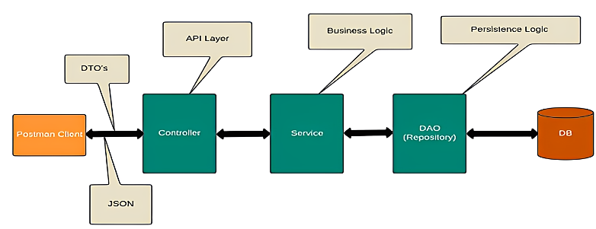
- Spring Boot Application Architecture

Postman
The Spring Boot application does not include Postman, but is an excellent external tool used to test and interact with the RESTful API of the application. Postman also allows developers to make an HTTP request to the API endpoints of the application, which is why it is easier to ensure the functionality of the API. Postman makes it possible to test several HTTP methods (GET, POST, PUT, and DELETE) and examine the results that are returned, which makes it an essential tool in the process of API building and debugging.

Controller
In a Spring Boot application, the Controller layer is the layer that receives the incoming HTTP requests and manages the application's data flow and operations. The controllers have labels with Spring annotations, such as @Controller or a REST controller annotation, which enables the controllers to receive and send responses [21]. Request mappings are defined, and what methods are to be implemented on particular HTTP methods and endpoints (URI). To accept data, process requests, and provide outcomes to the client, controllers and the service layer communicate with each other.

Service
The Service layer separates the Controller and the DAO (Data Access Object) layers. It includes service actions, application-specific rules, and business logic. Services are identified as Spring-managed components by being annotated with @Service. By keeping business logic and the web layer apart, they aid in maintaining a clear separation of concerns. Data is usually aggregated and processed at the service layer before being sent to the DAO for database operations.

Other Modern Frameworks
In addition to Spring Boot, several modern Java frameworks emerged to address the growing demand for lightweight, high-performance, and developer-friendly solutions for web applications and services [22]. Two notable examples are the Play Framework and Vert.x.
- Play Framework: Play is a reactive web application framework inspired by Ruby on Rails and designed for modern, cloud-based applications. It emphasizes developer productivity by offering features such as hot-reloading, asynchronous programming using Akka, and RESTful support. Play follows a stateless, non-blocking model, making it well-suited for applications requiring scalability and real-time interactions.
- Vertex: Vertex is a set of tools for creating JVM-based reactive apps. Because of its event-driven, non-blocking architecture, developers can manage many requests at once with less resource use. Vert.x offers modules for messaging, clustering, and microservices and supports several programming languages, including Java, Kotlin, and Groovy. It's polyglot nature and lightweight design make it highly flexible for distributed systems.
These frameworks complement traditional Java EE and Spring approaches by offering reactive programming models, scalability, and real-time responsiveness. They gained popularity in scenarios such as streaming platforms, messaging systems, and IoT applications, where conventional synchronous models were less efficient.

Microservices Architecture
A method for building a single application out of several little services that each run in a different process and communicate with one another via simple means, usually an HTTP API, is the definition of microservices architectures that is most commonly used. Unlike monoliths, microservices can be designed with multiple technology stacks and provide independent deploy ability and scalability [23]. However, this term may also be used for RESTful or conventional services, which contributes to the controversy surrounding SOA and microservices. Despite being a development of SOA, microservices vary fundamentally in how they handle sharing and reuse. The concept of promoting reuse, or a share-as-much-as-possible architecture style, is the cornerstone of service-oriented architecture (SOA). In contrast, microservices architecture is founded on the notion of a share-as-little-as-possible architecture style. A microservices architecture with an API Gateway is shown in Figure 6, through which the client interacts, managing routing, authentication, and load balancing. Each microservice independently handles a specific function with its own database, while orchestration tools like Kubernetes ensure deployment, monitoring, and scaling, making the system more flexible, fault-tolerant, and scalable than monolithic architectures.
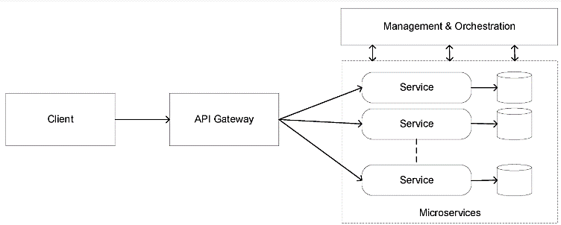
- Microservices Architecture

Literature Review
The reviewed literature highlights the progressive evolution of Java web technologies, with an emphasis on MVC frameworks, design patterns, enterprise solutions, and microservices. Collectively, these studies address scalability, modularity, and best practices, while identifying challenges and proposing future research directions.
Thakur and Pandey (2019) the most widely used and effective programming paradigm for creating dynamic, large-scale online applications. MVC enables developers to create software that is modular, reusable, and adaptable by utilizing design patterns that are often recognized as solutions for recurring issues. The MVC design pattern is consequently more difficult to use in Web applications since modern technologies urge developers to divide the application as early as the design stage. An online program developed using the MVC framework and Java Web Architecture [24].
Raghavendra and Pushpanjali (2018) the usage of web design frameworks as a conceptual approach to improve the likelihood of Web application reuse. It first illustrated the necessity of developing reusable and abstract directive design frameworks using a range of Web information systems. For countless databases, the Hibernate Framework Technology is a unique and organized resource. It also describes how to provide object-oriented systems with permanent features. It provides a denotation of both and shows how design patterns and frameworks relate to one another. Java supports the MVC Model's N-tier framework in addition to EJB, Struts WEB Framework, and Hibernate technologies [25].
Majeed and Rauf (2018) the most important information about MVC layers, applications, benefits, and best practices for developing web apps. Describe the functions of each of the three levels in detail. The main objective of the study is to provide a thorough comprehension of every MVC layer, as well as the primary features and benefits of the MVC. In particular, describe the recommended practices for developing web apps based on MVC. Additionally, describe the associated technologies that are utilized with web applications that are built on MVC [26].
Lupaşc (2017) the benefits of developing internet technologies for project management software and the effects they have on people and organizations. Consequently, an information system for project management is based on and implements a client-server architecture. JavaScript is utilised on the client side of the system to build dynamic web pages and enhance the user experience. In contrast, the server side uses Java Web Technologies, such as JSP and servlets. The purpose of this project management information system is to assist managers in making decisions throughout the project planning process, coordination, and supervision [27].
Pahl and Jamshidi (2016) The microservices architectural method seems to be a wonderful fit for container technology at the PaaS level. However, there isn't yet a secondary study to gather this data. This research aims to determine, classify, and compare the body of research on microservices and their use in the cloud. From the beginning of the microservices pattern two years ago till the end of 2015, they conducted thorough mapping study on twenty-one selected studies. A characterization framework was used to classify and compare the selected publications [28].
D. D. Sarkar, A. Jaiswal (2015) This framework is used to construct MVC, which separates presentation logic from business logic. There are three different Java platforms, or flavours, that each cater to different programming requirements. J2EE provides a multitier architecture environment for developing business services or applications. In an increasingly demanding technological world, scalable, efficient, and fast information management solutions are becoming more and more important. It is possible to meet these demands with JEE technology, which is suitable. This study has demonstrated that building a Java application using multiple frameworks and MVC concepts is easier than using a single framework. More and more study papers have been published on the latest trends that bypass frameworks and develop Web architecture using a quick and innovative method [29].
A Table I is a chronological synthesis of review studies on Java web technologies describing approaches, results, difficulties, and future directions, in which a shift in evolution is evident towards microservices starting with servlets

- Summary of a Study on Evolution of Java Web Technologies and Best Practices
Author | Study On | Approach | Key Findings | Challenges | Future Directions
Akinyede (2019) | MVC in Large-Scale Dynamic Web Applications | MVC-based design in Java Web Architecture | MVC ensures modular, reusable, and flexible web applications | Partitioning complexity during design phase | Simplify MVC integration with microservices and DevOps
Raghavendra & Pushpanjali (2018) | Web Design Frameworks & Hibernate | Review of reusable design structures and ORM frameworks | Hibernate improves persistence; MVC with EJB and Struts enhances flexibility | Complexity in N-tier frameworks | Optimize ORM performance; integrate with modern frameworks
Majeed & Rauf (2018) | MVC Layers in Web Development | Analytical study of MVC functionalities and practices | Detailed explanation of MVC layers, advantages, and best practices | Limited focus on integration with new frameworks | Extend MVC practices with microservices and reactive frameworks
Lupaşc (2017) | Java Web Technologies for Project Management Tools | Implemented client-server system using Servlets, JSP, and JavaScript | Java Web tech improves usability and decision-making in project management | Integration with modern UI technologies | Enhance with responsive design and cloud support
Pahl & Jamshidi (2016) | Microservices in Cloud Computing | Systematic mapping study of 21 papers | Classified and compared microservices research; identified cloud suitability | Lack of consolidated secondary studies; evolving practices | Refine taxonomies, extend studies with containerization trends
D. D. Sarkar & A. Jaiswal (2015) | MVC in Java Web Applications | Multi-framework integration using J2EE for enterprise applications | Separation of business and presentation logic improves scalability and efficiency | Complexity in handling multiple frameworks | Explore lightweight frameworks and improved integration methods

Conclusion and Future Work
The history of Java web technologies demonstrates a gradual shift from the principles of early servlets and JSP to new, sophisticated paradigms of microservices. This evolution is a sign of the ongoing efforts to achieve scalability, modularity, and efficiency in web-based systems. Structures, such as Struts, Spring, and Hibernate, improved the concept of reusability and design consistency, and JEE created a powerful, multi-tier framework for enterprise-scale applications. Moreover, containerization and cloud-native practices, facilitated by Spring Boot and microservices, are reinventing application development, with a focus on distributed and flexible architectures. Together, this survey highlights the maturity of Java as a web technology platform, providing solid practices in contemporary software engineering. However, the complexity of managing service interactions and ensuring security across distributed systems remains a limitation that requires further innovation and strategic attention.
Future research should explore improved orchestration methods, advanced security frameworks, and AI-driven automation to simplify microservice management, enabling Java web technologies to achieve greater resilience, adaptability, and scalability in evolving digital ecosystems. Additionally, there is scope to investigate the integration of serverless computing and edge computing paradigms, which could further optimize performance and resource utilization. Exploring interoperability between Java and polyglot microservices will also open new opportunities for seamless, heterogeneous system development

COMPETING INTERESTS DISCLAIMER:
Authors have declared that they have no known competing financial interests OR non-financial interests OR personal relationships that could have appeared to influence the work reported in this paper.

References
- [1] Y. Zhou and S. Zhang, “Research on the Web Application System Development Course Group for the Training of Innovation Talents,” vol. 184, no. Icesem, pp. 515–519, 2018, doi: 10.2991/icesem-18.2018.119.
- [2] M. Bayani, “Web-based Decision Support Systems: A conceptual performance evaluation,” INES 2013 - IEEE 17th Int. Conf. Intell. Eng. Syst. Proc., vol. 6, no. 2, pp. 21–26, 2013, doi: 10.1109/INES.2013.6632824.
- [3] I. Baldini et al., “Serverless Computing: Current Trends and Open Problems,” in Research Advances in Cloud Computing, Singapore: Springer Singapore, 2017, pp. 1–20. doi: 10.1007/978-981-10-5026-8_1.
- [4] Geeta, S. Gupta, and S. Prakash, “quality of service and load balancing in cloud Computing access for Performance Enhancement Using agent based Software,” Int. J. Innov. Technol. Explor. Eng., vol. 8, no. 11 S, pp. 641–644, 2019.
- [5] A. Arcuri, “RESTful API automated test case generation,” Proc. - 2017 IEEE Int. Conf. Softw. Qual. Reliab. Secur. QRS 2017, no. 1, pp. 9–20, 2017, doi: 10.1109/QRS.2017.11.
- [6] S. S. S. Neeli, “Serverless Databases: A Cost-Effective and Scalable Solution,” Int. J. Innov. Res. Eng. Multidiscip. Phys. Sci., vol. 7, no. 6, p. 7, 2019.
- [7] B. Doyle and C. V. Lopes, “Survey of Technologies for Web Application Development,” vol. 2, no. 3, pp. 1–43, 2005.
- [8] T. Singh, “A Survey on Java Programming Language and Methods of Improvisation,” Int. J. Innov. Adv. Comput. Sci., vol. 6, no. 12, p. 11, 2017.
- [9] O. Zavala-Romero, A. Ahmed, E. P. Chassignet, J. Zavala-Hidalgo, A. Fernández Eguiarte, and A. Meyer-Baese, “An open source Java web application to build self-contained web GIS sites,” Environ. Model. Softw., vol. 62, pp. 210–220, Dec. 2014, doi: 10.1016/j.envsoft.2014.08.029.
- [10] M. P. Walimbe, “Review on Java Database Connectivity,” Int. Res. J. Eng. Technol., vol. 5, no. 3, pp. 549–550, 2018.
- [11] O. Al-Debagy and P. Martinek, “A Comparative Review of Microservices and Monolithic Architectures,” in 2018 IEEE 18th International Symposium on Computational Intelligence and Informatics (CINTI), IEEE, Nov. 2018, pp. 000149–000154. doi: 10.1109/CINTI.2018.8928192.
- [12] J. Dunkel, R. Bruns, and A. Holitschke, “Comparison of JavaServer Pages and XSLT: A software engineering perspective,” Softw. - Pract. Exp., vol. 34, no. 1, pp. 1–13, 2004, doi: 10.1002/spe.555.
- [13] M. Sultan, “Angular and The Trending Frameworks of Mobile and Web-Based Platform Technologies: A Comparative Analysis,” Futur. Technol. Conf., 2017.
- [14] C. Richardson, “Untangling Enterprise Java,” Queue, vol. 4, no. 5, pp. 36–44, Jun. 2006, doi: 10.1145/1142031.1142045.
- [15] S. Gupta, N. Agrawal, and S. Gupta, “A Review on Search Engine Optimization: Basics,” Int. J. Hybrid Inf. Technol., vol. 9, no. 5, pp. 381–390, May 2016, doi: 10.14257/ijhit 2016.9.5.32.
- [16] P. Pathak, A. Shrivastava, and S. Gupta, “A Survey on Various Security Issues in Delay Tolerant Networks,” J. Adv. Shell Program., vol. 2, no. 2, pp. 12–18, 2015.
- [17] D. Zhang, Z. Wei, and Y. Yang, “Research on lightweight MVC framework based on Spring MVC and MyBatis,” Proc. - 6th Int. Symp. Comput. Intell. Des. Isc. 2013, vol. 1, pp. 350–353, 2013, doi: 10.1109/ISCID.2013.94.
- [18] P. Giessler, M. Gebhart, D. Sarancin, R. Steinegger, and S. Abeck, “Best Practices for the Design of RESTful Web Services,” Int. Conf. Softw. Adv., no. April 2016, pp. 392–297, 2015.
- [19] L. E. Lwakatare et al., “DevOps in practice: A multiple case study of five companies,” Inf. Softw. Technol., vol. 114, no. April, pp. 217–230, Oct. 2019, doi: 10.1016/j.infsof.2019.06.010.
- [20] D. Namiot and M. Sneps-Sneppe, “On Micro-services Architecture,” Int. J. Open Inf. Technol. ISSN, vol. 2, no. September, 2014.
- [21] C. R. Kasaram, “Spring Boot And Microservices : Engineering Modular And Scalable Back-End Architectures,” Int. J. Comput. Sci. Eng. Res. Dev. ISSN, vol. 9, no. 1, pp. 1–10, 2018.
- [22] Y. K. Xing, J. P. Huang, and Y. Y. Lai, “Research and analysis of the front-end frameworks and libraries in e-business development,” ACM Int. Conf. Proceeding Ser., no. February 2019, pp. 68–72, 2019, doi: 10.1145/3313991.3314021.
- [23] M. Garriga, “Towards a taxonomy of microservices architectures,” Lect. Notes Comput. Sci. (including Subser. Lect. Notes Artif. Intell. Lect. Notes Bioinformatics), vol. 10729 LNCS, pp. 203–218, 2018, doi: 10.1007/978-3-319-74781-1_15.
- [24] R. N. Thakur and U. S. Pandey, “A Study Focused on Web Application Development using MVC Design Pattern,” Int. Res. J. Eng. Technol., vol. 6, no. 8, pp. 237–244, 2019.
- [25] G. Raghavendra and P. Pushpanjali, “A Review on Java Frameworks for Web Applications,” Int. J. Sci. Res. Comput. Sci. Eng. Inf. Technol. © 2018 IJSRCSEIT, vol. 3, no. 3, pp. 615–619, 2018.
- [26] A. Majeed and I. Rauf, “MVC Architecture: A Detailed Insight into the Modern Web Applications Development,” Peer Rev. J. Sol. Photoenergy Syst., vol. 1, no. 1, pp. 1–7, 2018.
- [27] A. Lupaşc, “Project Management Information System Based on Web Technologies,” May 2017, pp. 1008–1015. doi: 10.15405/epsbs.2017.05.02.124.
- [28] C. Pahl and P. Jamshidi, “Microservices: A systematic mapping study,” in CLOSER 2016 - Proceedings of the 6th International Conference on Cloud Computing and Services Science, SCITEPRESS - Science and Technology Publications, 2016, pp. 137–146. doi: 10.5220/0005785501370146.
- [29] D. D. Sarkar, A. Jaiswal, and A. Saxena, “Understanding architecture and framework of J2EE using web application,” Int. J. Comput. Sci. Inf. Technol., vol. 6, no. 2, pp. 1253–1257, 2015.

- Chundru, S. K., Vangala, S. R., Polam, R. M., Kamarthapu, B., Kakani, A. B., & Nandiraju, S. K. K. (2024). A Machine Learning-Based Framework for Predicting and Improving Student Outcomes Using Big Educational Data (Approved by ICITET 2024 Conference Proceedings). Available at SSRN 5315635.
- Nandiraju, S. K. K., Chundru, S. K., Vangala, S. R., Polam, R. M., Kamarthapu, B., & Kakani, A. B. (2025). Towards Early Forecast of Diabetes Mellitus via Machine Learning Systems in Healthcare. European Journal of Technology, 9(1), 35-50.
- Chalasani, R., Gangineni, V. N., Pabbineedi, S., Penmetsa, M., Bhumireddy, J. R., & Tyagadurgam, M. S. V. (2025). Big Data-Driven Approach for Lung Cancer Identification via Advanced Deep Transfer Learning Models. European Journal of Technology, 9(1), 51-67.
- Vattikonda, N., Gupta, A. K., Polu, A. R., Narra, B., Buddula, D. V. K. R., & Patchipulusu, H. H. S. (2024). Machine Learning-Based Approaches for Detecting and Mitigating Distributed Denial of Service (DDoS) Attacks to Improved Cloud Security. European Journal of Technology, 8(6), 28-48.
- Polu, A. R., Narra, B., Buddula, D. V. K. R., Hara, H., Patchipulusu, S., Vattikonda, N., & Gupta, A. K. Analyzing The Role of Analytics in Insurance Risk Management: A Systematic Review of Process Improvement and Business Agility.
- Madhura, R., Varshitha, P., Nikitha, S., Niveditha, K. M., & Bhat, M. (2024, December). RTL design of 16-bit RISC Processor Using Vedic Mathematics. In 2024 IEEE 33rd Asian Test Symposium (ATS) (pp. 1-4). IEEE.
- Harinandan, R., Kumar, M., Vamshi, P., Padma, C. R., Krishnappa, K. H., & Raghunandan, J. R. (2024, August). Design and Development of a Real-time Monitoring System for ACL Injury Prevention. In 2024 2nd International Conference on Networking, Embedded and Wireless Systems (ICNEWS) (pp. 1-6). IEEE.
- Krishnappa, K. H. (2024). Traffic pattern analysis for malicious node detection in NoC design. Journal of Communications, 9, 12.
- Mukund Sai Vikram Tyagadurgam, Venkataswamy Naidu Gangineni, Sriram Pabbineedi, Mitra Penmetsa, Jayakeshav Reddy Bhumireddy, et al. (2024) AI-Powered Cybersecurity Risk Scoring for Financial Institutions Using Machine Learning Techniques. Journal of Artificial Intelligence & Cloud Computing. SRC/JAICC-482. DOI: doi.org/10.47363/JAICC/2024(3)452
- Penmetsa, M., Bhumireddy, J. R., Chalasani, R., Vangala, S. R., Polam, R. M., & Kamarthapu, B. (2025). Adversarial Machine Learning in Cybersecurity: A Review on Defending Against AI-Driven Attacks. European Journal of Applied Science, Engineering and Technology, 3(4), 4-14.
- Tyagadurgam, M. S. V., Gangineni, V. N., Pabbineedi, S., Kakani, A. B., Nandiraju, S. K. K., & Chundru, S. K. (2025). Using Artificial Intelligence-Based Machine Learning Regression Models for Predictions of Home Prices. European Journal of Applied Science, Engineering and Technology, 3(3), 404-416.
- Nandiraju, S. K. K., Chundru, S. K., Tyagadurgam, M. S. V., Gangineni, V. N., Pabbineedi, S., & Kakani, A. B. (2025). Enhancing Cybersecurity: Zero-Day Attack Detection in Network Traffic with Deep Learning Model. Asian Journal of Research in Computer Science, 18(7), 262-273.
- Polam, R. M., Kamarthapu, B., Penmetsa, M., Bhumireddy, J. R., Chalasani, R., & Vangala, S. R. (2025). Advanced Machine Learning for Robust Botnet Attack Detection in Evolving Threat Landscapes. Asian Journal of Research in Computer Science, 18(8), 1-14.
- Kamarthapu, B., Penmetsa, M., Reddy, J., Chalasani, R., Vangala, S. R., & Polam, R. M. Data-Driven Detection of Network Threats using Advanced Machine Learning Techniques for Cybersecurity.
- Chundru, S. K., Vikram, M. S., Naidu, V., Pabbineedi, S., Kakani, A. B., & Nandiraju, S. K. K. Analyzing and Predicting Anaemia with Advanced Machine Learning Techniques with Comparative Analysis.
- Gangineni, V. N., Tyagadurgam, M. S. V., Pabbineedi, S., Kakani, A. B., Nandiraju, S. K. K., & Chundru, S. K. (2025). Preventing Phishing Attacks Using Advanced Deep Learning Techniques for Cyber Threat Mitigation. Journal of Data Analysis and Information Processing, 13(03), 10-4236.
- Kalla, D., Mohammed, A. S., Boddapati, V. N., Jiwani, N., & Kiruthiga, T. (2024, November). Investigating the Impact of Heuristic Algorithms on Cyberthreat Detection. In 2024 2nd International Conference on Advances in Computation, Communication and Information Technology (ICAICCIT) (Vol. 1, pp. 450-455). IEEE.
- Gangineni, V. N., Penmetsa, M., Bhumireddy, J. R., Chalasani, R., Tyagadurgam, M. S. V., & Pabbineedi, S. (2025). Big Data and Predictive Analytics for Customer Retention: Exploring the Role of Machine Learning in E-Commerce. Available at SSRN 5478047.
- Polu, A. R., Narra, B., Buddula, D. V. K. R., Patchipulusu, H. H. S., Vattikonda, N., & Gupta, A. K. (2025). The Role of the Internet of Things in Smart Cities: Current Implementations and Pathways for Future Development. Universal Library of Engineering Technology, 2(2).
- Narra, B., Gupta, A. K., Buddula, D. V. K. R., Patchipulusu, H. H. S., Vattikonda, N., & Polu, A. R. (2025). Applications of Blockchain in Software Engineering: Enhancing Security, Traceability, and Transparency. International Journal of Innovative Computer Science and IT Research, 1(02), 63-75.
- Vattikonda, N., Gupta, A. K., Polu, A. R., Narra, B., Buddula, D. V. K. R., & Patchipulusu, H. H. S. (2025). Leveraging Deep Learning for Personalized Fashion Recommendations Using Fashion MNIST. International Journal of Emerging Trends in Computer Science and Information Technology, 6(2), 36-46.
- Buddula, D. V. K. R., Patchipulusu, H. H. S., Vattikonda, N., Gupta, A. K., Polu, A. R., & Narra, B. (2025). Machine Learning-Based Detection and Prevention of Anti-Money Laundering (AML) in the Financial Sector. International Journal of Innovative Computer Science and IT Research, 1(02), 53-63.
- Polu, A. R., Narra, B., Vattikonda, N., Gupta, A. K., Buddula, D. V. K. R., & Patchipulusu, H. H. S. AI-POWERED SYNTHETIC COGNITION NETWORKS Leveraging Multi-Agent Machine Learning to Simulate and Optimize Human Decision-Making in Complex Crisis Scenarios. Global Pen Press UK.
- Mitra Penmetsa, Jayakeshav Reddy Bhumireddy, Rajiv Chalasani, Mukund Sai Vikram Tyagadurgam, Venkataswamy Naidu Gangineni, Sriram Pabbineedi. (2025) Big Data and Predictive Analytics for Customer Retention: Exploring the Role of Machine Learning in E-Commerce. International Journal of Computers, 10, 260-267
- Penmetsa, M., Bhumireddy, J.R., Chalasani, R., Vangala, S.R., Polam, R.M. and Kamarthapu, B. (2025) Effectiveness of Deep Learning Algorithms in Phishing Attack Detection for Cybersecurity Frameworks. Journal of Data Analysis and Information Processing, 13, 331-346. https://doi.org/10.4236/jdaip.2025.133021

- Prabakar, D., Iskandarova, N., Iskandarova, N., Kalla, D., Kulimova, K., & Parmar, D. (2025, May). Dynamic Resource Allocation in Cloud Computing Environments Using Hybrid Swarm Intelligence Algorithms. In 2025 International Conference on Networks and Cryptology (NETCRYPT) (pp. 882-886). IEEE.

- Nagaraju, S., Johri, P., Putta, P., Kalla, D., Polvanov, S., & Patel, N. V. (2025, May). Smart Routing in Urban Wireless Ad Hoc Networks Using Graph Attention Network-Based Decision Models. In 2025 International Conference on Networks and Cryptology (NETCRYPT) (pp. 212-216). IEEE.

- NR, A. R., Rajasri, T., Praveen, R., Kalla, D., Bendale, S. P., & Venu, N. (2025, April). CAC Training-A Unified Cybersecurity Training Program for Military Staff. In 2025 3rd International Conference on Communication, Security, and Artificial Intelligence (ICCSAI) (Vol. 3, pp. 569-573). IEEE.

- Kalla, D., Smith, N., & Samaah, F. (2025). Deep Learning-Based Sentiment Analysis: Enhancing IMDb Review Classification with LSTM Models. Available at SSRN 5103558.

- Sreeramulu, M. D., Mohammed, A. S., Kalla, D., Boddapati, N., & Natarajan, Y. (2024, September). AI-driven Dynamic Workload Balancing for Real-time Applications on Cloud Infrastructure. In 2024 7th International Conference on Contemporary Computing and Informatics (IC3I) (Vol. 7, pp. 1660-1665). IEEE.

- Kalla, D., & Samaah, F. (2023). Exploring Artificial Intelligence And Data-Driven Techniques For Anomaly Detection In Cloud Security. Available at SSRN 5045491.

