Case report

Timolol-Induced Atrioventricular Block in a Glaucoma Patient: A Case Report

.
ABSTRACT

Aims: This case report aims to highlight the potential cardiovascular risks associated with timolol, a commonly used medication for the treatment of glaucoma, and to discuss the management of medication-induced atrioventricular (AV) block. It also emphasizes the importance of a multidisciplinary approach in addressing both ophthalmic and cardiovascular issues in patients with comorbidities.
Presentation of Case: A 55-year-old woman with a two-year history of primary glaucoma presented to the emergency department (ED) after experiencing dizziness, generalized clonic seizure, and syncope lasting approximately 10 minutes while awaiting a routine ophthalmology appointment. The patient had undergone bilateral trabeculectomy within the past year and had been using timolol 0.5% eye drops twice daily for glaucoma management. On arrival at the ED, the patient was found to have hypotension (85/45 mmHg), bradycardia (34 beats/min), and a 12-lead ECG showed complete AV block with a ventricular escape rhythm. After excluding other causes, including electrolyte imbalances and coronary artery disease, a temporary transvenous pacemaker (TPM) was inserted due to persistent hemodynamic instability. Coronary angiography revealed no significant stenosis, and bedside echocardiography showed normal ventricular function with mild diastolic dysfunction. The patient was ultimately diagnosed with timolol-induced AV block. Given the persistent AV block, a permanent pacemaker was implanted to prevent further episodes of syncope and hemodynamic collapse.
Discussion and Conclusion This case underscores the potential systemic cardiovascular effects of timolol. Timolol, although effective in managing intraocular pressure in glaucoma, can be absorbed systemically and lead to serious side effects such as AV block. The management of AV block in this case required urgent intervention with a temporary pacemaker, followed by permanent pacemaker implantation after the patient's condition remained unstable. A multidisciplinary approach, involving both ophthalmology and cardiology, was crucial in addressing the patient's complex needs. The case also highlights the need for careful monitoring and consideration of alternative glaucoma therapies for patients at risk of medication-induced cardiovascular complications. Timolol's potential risks emphasize the importance of patient education and close monitoring, particularly in vulnerable populations.

Keywords: Timolol, Atrioventricular Block, Glaucoma, Pacemaker, Medication-Induced Side Effects

1. INTRODUCTION

Glaucoma is a group of ocular disorders characterized by progressive damage to the optic nerve, typically associated with elevated intraocular pressure (IOP). It is one of the leading causes of blindness worldwide, affecting millions of individuals (Pratt et al., 2015). Glaucoma treatment primarily aims to reduce IOP to prevent further optic nerve damage, and several medications are available to manage this condition. Among the most commonly prescribed are beta-blockers, such as timolol, which reduce aqueous humor production and lower IOP by blocking β-adrenergic receptors in the eye (Bonnin et al., 2012; Uusitalo et al., 2005).
Timolol, a non-selective beta-blocker, is widely used for glaucoma management. Despite its efficacy in controlling IOP, timolol has known systemic effects due to its absorption into the bloodstream through the ocular surface (Bonnin et al., 2012; Uusitalo et al., 2005). These systemic effects can lead to cardiovascular complications such as bradycardia, hypotension, and AV block, especially in individuals with pre-existing heart conditions or those on other medications that affect the cardiovascular system (Wang et al., 2019). Although these side effects are well-documented in systemic use of beta-blockers, their occurrence in topical administration, particularly for ocular conditions like glaucoma, is less frequently discussed. The potential for serious adverse cardiovascular events from timolol underscores the need for vigilance when prescribing this medication, event in patients without underlying cardiovascular risk factors.
Atrioventricular block, a disruption in the electrical conduction system of the heart, can be particularly concerning in glaucoma patients on timolol. AV block can range from partial to complete, with complete block potentially leading to life-threatening bradycardia and syncope (Özcan et al., 2015). Timolol-induced AV block is a rare but serious complication, and managing such cases presents significant challenges, especially when it involves balancing the need for effective glaucoma treatment with the risk of cardiovascular complications.
This case report presents a 55-year-old woman with primary glaucoma who developed complete AV block after using timolol eye drops, requiring the implantation of a permanent pacemaker. This case highlights the potential cardiovascular risks of timolol, the challenges of managing glaucoma in patients with cardiovascular conditions, and the importance of a multidisciplinary approach in such complex cases. Through this report, we aim to emphasize the need for healthcare providers to consider the systemic effects of topical medications and to be vigilant in monitoring for potential adverse cardiovascular events in glaucoma patients.

2. PRESENTATION OF CASE

A 55-year-old woman with a 2-year history of primary glaucoma presented to the ED after experiencing dizziness, a generalized clonic seizure, and syncope lasting approximately 10 minutes while awaiting a routine ophthalmology appointment. She had undergone bilateral trabeculectomy within the past year and had been using timolol 0.5% eye drops twice daily as part of her ongoing glaucoma management. Prior to her first surgery, she had undergone a normal cardiology evaluation, including a baseline ECG that showed normal sinus rhythm. Her cardiovascular history was unremarkable, and she had no prior symptoms suggestive of heart disease.
Upon arrival at the ED, her vital signs were concerning: blood pressure 85/45 mmHg, heart rate 34 beats/min (weak), respiratory rate 20 breaths/min, and oxygen saturation (SpO₂) 99% on 3 L/min of nasal cannula oxygen. A 12-lead ECG revealed complete AV block with a ventricular escape rhythm (Fig. 1), which was consistent with the patient’s hemodynamic instability. Laboratory tests, including electrolytes (K, Mg, Ca), renal function, thyroid function, and cardiac enzymes, were all within normal limits, ruling out electrolyte disturbances or metabolic causes. Given the patient’s bradycardia and AV block, a TPM was inserted to stabilize her heart rate and improve hemodynamic.
Further diagnostic investigations, including bedside echocardiography, were performed. The echocardiogram showed normal left and right ventricular systolic function, grade I diastolic dysfunction, and global normokinesis. Subsequently, coronary angiography was performed to rule out obstructive coronary disease or acute coronary syndrome as potential contributors to the conduction disturbance. The coronary angiogram revealed normal coroner (Fig. 2), thus excluding ischemia as the underlying cause of the AV block and supporting the diagnosis of medication-induced AV block, rather than structural heart disease.
Despite successful stabilization with temporary pacing, the AV block persisted when the pacing was temporarily turned off, confirming the need for long-term pacing support. After careful multidisciplinary consultation, including input from the ophthalmologist, the team determined that the patient’s AV block was likely induced by the systemic absorption of timolol, which had been continued after her ocular surgeries. The ophthalmologist emphasized the importance of maintaining IOP control to prevent glaucoma progression, which led to the continued use of timolol eye drops. Given the persistent conduction disturbance and the risks of recurrent syncope or hemodynamic collapse, the decision was made to proceed with the implantation of a permanent pacemaker.
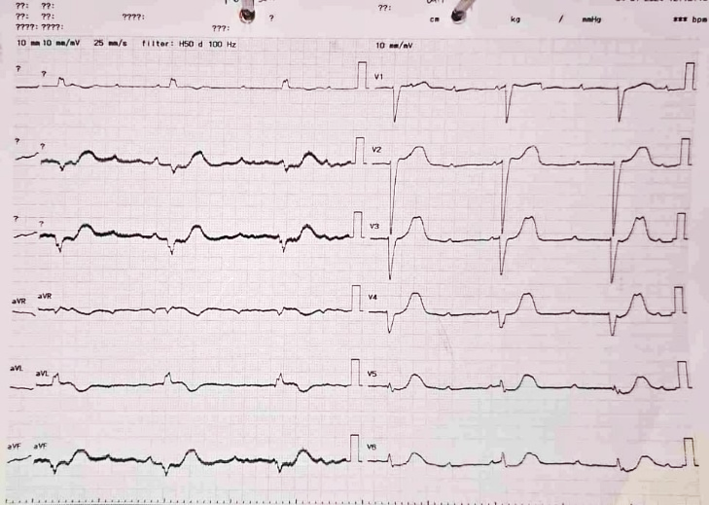
The permanent pacemaker was implanted without complications (Fig. 3), and the patient was closely monitored post-procedure for stable pacing capture. At follow-up, the patient remained pacemaker-dependent, with no recurrence of conduction disturbances or other complications. Plans for her ongoing glaucoma management were discussed, with the need for careful monitoring of her heart function while managing intraocular pressure.

Fig. 1. The ECG on arrival at the Emergency Department (ED) showed complete atrioventricular (AV) block with a ventricular escape rhythm
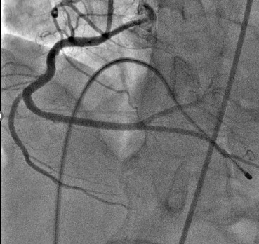
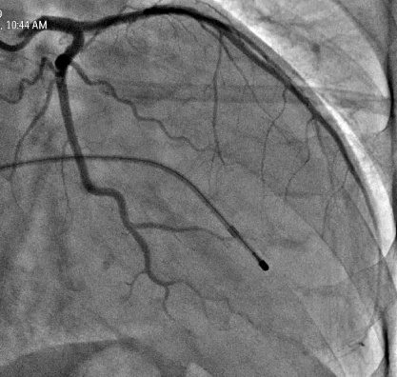

Fig. 2. Coronary angiography demonstrating normal coronary arteries, excluding ischemic etiology for the atrioventricular (AV) block
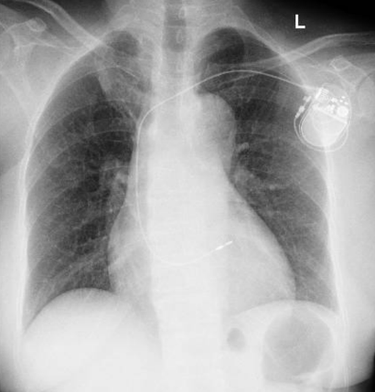

Fig. 3. Chest X-ray showing proper lead placement after permanent pacemaker implantation

3. discussion

This case underscores the systemic cardiovascular risks associated with timolol, a commonly prescribed beta-blocker used for the management of glaucoma. While timolol is an effective treatment for reducing IOP, its non-selective beta-blocking effects can result in unintended cardiac side effects, even in patients without pre-existing cardiovascular vulnerabilities. Despite its ocular application, timolol can be absorbed into the bloodstream, where it has the potential to induce bradycardia, hypotension, and in severe cases, AV block, as observed in this patient (Bonnin et al., 2012; Uusitalo et al., 2005). This case highlights the need for clinicians to be aware of the systemic effects of ocular medications.
Timolol works by blocking both β1 and β2 adrenergic receptors, primarily affecting the heart's electrical conduction system through its action on the AV node. In susceptible individuals, this blockade can slow or completely block the electrical impulses between the atria and ventricles, leading to high-degree AV block (Pratt et al., 2015). In this case, the patient had no prior cardiac symptoms or risk factors for AV block, yet after starting timolol therapy, she developed a complete AV block with hemodynamic instability. This emphasizes the need for caution when prescribing beta-blockers to patients even without cardiovascular risk factors, as even topical medications like timolol can lead to systemic effects (Wang et al., 2019).
The diagnosis of medication-induced AV block was supported by the patient's presentation and a thorough workup. Electrolyte imbalances, renal and thyroid function abnormalities, and coronary artery disease were ruled out by normal laboratory results and a coronary angiogram. This highlights the importance of conducting a comprehensive differential diagnosis when evaluating patients with AV block, particularly in those with complex medical histories. While ischemic heart disease is a common cause of AV block, this patient's negative coronary angiogram and lack of significant cardiac risk factors pointed towards timolol as the likely etiology. The absence of other contributing factors reinforces the need for clinicians to consider the systemic effects of ocular medications in their diagnostic approach.
The patient's hemodynamic instability and persistent bradycardia necessitated immediate intervention with a TPM. Temporary pacing is commonly used in cases of high-degree AV block to stabilize the patient while the underlying cause is addressed. In this case, the patient was closely monitored in the iCVCU, where her condition remained stable with temporary pacing. However, the persistence of complete AV block despite temporary pacing led to the decision to implant a permanent pacemaker. Permanent pacemaker implantation is often recommended for patients with persistent or recurrent high-degree AV block, especially when the cause is irreversible or requires long-term management (Özcan et al., 2015). The patient responded well to the pacemaker, with stable pacing capture and no further arrhythmias or syncope.
While timolol is a mainstay in glaucoma treatment, alternative therapies with fewer systemic side effects, such as prostaglandin analogs (e.g., latanoprost), may be more appropriate for patients with cardiovascular risk factors. Prostaglandin analogs offer effective IOP control with minimal systemic absorption and a lower risk of cardiovascular side effects compared to beta-blockers (Özcan et al., 2015). This case raises the question of how best to manage glaucoma in patients with cardiovascular comorbidities. A more individualized approach is required to ensure both the effective management of glaucoma and the prevention of medication-induced side effects. In this patient, the continued use of timolol posed a significant risk, and a switch to alternative glaucoma medications may have been considered to reduce the likelihood of future cardiac complications.
This case highlights the importance of a multidisciplinary approach in managing complex cases involving both ophthalmologic and cardiovascular concerns. Coordination between cardiology, ophthalmology, and critical care teams was essential in determining the most appropriate treatment plan for the patient. Shared decision-making, where the risks and benefits of each treatment option are discussed with the patient, ensures that care is aligned with the patient’s values and goals (Özcan et al., 2015). This approach not only enhances patient safety but also ensures that all aspects of the patient's care are addressed comprehensively.
This case also raises important ethical considerations regarding the management of medication-induced side effects. The decision to continue timolol therapy while addressing the AV block with a pacemaker was made after careful consideration of the risks and benefits. Patients with chronic conditions like glaucoma often face difficult decisions about their treatment regimens, and it is essential to provide them with clear, comprehensive information about the potential risks and alternatives. In this case, patient-centered care and shared decision-making were critical in determining the best course of action for both managing glaucoma and minimizing the risk of further cardiac complications.

4. Conclusion

Timolol, while effective in managing glaucoma, can have serious cardiovascular side effects, including AV block, particularly in patients with pre-existing cardiovascular risk factors. This case highlights the need for clinicians to be vigilant in monitoring for medication-induced side effects, even with topical medications like timolol. A comprehensive and multidisciplinary approach to patient care, along with a careful evaluation of the risks and benefits of treatment options, is essential for optimizing outcomes. Given the potential for serious adverse effects, clinicians should consider alternative glaucoma medications for patients at high risk for cardiovascular complications, ensuring that both ocular and systemic health are carefully managed.

Consent

All authors declare that ‘written informed consent was obtained from the patient (or other approved parties) for publication of this case report and accompanying images. A copy of the written consent is available for review by the Editorial office/Chief Editor/Editorial Board members of this journal.

Ethical approval

It is not applicable.

Abbreviations

AV: Atrioventricular
ED: Emergency Department
TPM: Temporary Transvenous Pacemaker
iCVCU: Intensive Cardiovascular Care Unit
IOP: Intraocular Pressure
ECG: Electrocardiogram

References

Bonnin, N., Nezzar, H., Dubray, C., Renault, D., Olmiere, C., & Chiambaretta, F. (2012). Plasma levels and systemic safety of 0.1% unpreserved Timolol maleate gel, 0.5% Timolol aqueous solution and 0.5% Timolol maleate gel. Journal Francais d’Ophtalmologie, 35(1), 9–16. https://doi.org/10.1016/j.jfo.2011.03.012
Özcan, K. S., Güngör, B., Osmonov, D., Tekkeşin, A. I., Altay, S., Ekmekçi, A., Toprak, E., Yildirim, E., Çalik, N., Alper, A. T., Gürkan, K., & Erdinler, I. (2015). Management and outcome of topical beta-blocker-induced atrioventricular block. Cardiovascular Journal of Africa, 26(6), 210–213. https://doi.org/10.5830/CVJA-2015-030
Pratt, N. L., Ramsay, E. N., Kalisch Ellett, L. M., Nguyen, T. A., & Roughead, E. E. (2015). Association between ophthalmic timolol and hospitalisation for bradycardia. Journal of Ophthalmology, 2015. https://doi.org/10.1155/2015/567387
Uusitalo, H., Niño, J., Tahvanainen, K., Turjanmaa, V., Ropo, A., Touminen, J., & Kähönen, M. (2005). Efficacy and systemic side-effects of topical 0.5% timolol aqueous solution and 0.1% timolol hydrogel. Acta Ophthalmologica Scandinavica, 83(6), 723–728. https://doi.org/10.1111/j.1600-0420.2005.00562.x
Wang, Z., Denys, I., Chen, F., Cai, L., Wang, X., Kapusta, D. R., Lv, Y., & Gao, J. (2019). Complete atrioventricular block due to timolol eye drops: A case report and literature review. BMC Pharmacology and Toxicology, 20(1). https://doi.org/10.1186/s40360-019-0370-2

