Original Research Article
Comparative Analysis of Bamboo Growth and Carbon Sequestration Across Major Forest Types in Cambodia

.
ABSTRACT

This study investigated bamboo growth and carbon sequestration across three major forest types in Cambodia: deciduous, evergreen, and semi-evergreen forests. Structural attributes (diameter, height, clump size, stem density, and mortality) and biomass-related variables (volume, carbon (Mg ha⁻¹), and CO₂ (Mg ha⁻¹)) were analyzed using descriptive statistics, ANOVA, correlation analysis, and principal component analysis (PCA). Results revealed significant variation among forest types. Bamboo in deciduous forests exhibited the largest mean diameter (5.03 cm) and highest median volume (17 m³), contributing to greater but variable carbon stocks (median ≈ 8 Mg ha⁻¹; range = 3–15). Evergreen forests displayed moderate and more stable growth, with average diameters of 4.18 cm, volumes around 11 m³, and carbon stocks between 4–6 Mg ha⁻¹. Semi-evergreen forests were dominated by smaller bamboo clumps (mean diameter = 2.97 cm; median volume ≈ 8 m³) and consistently lower carbon accumulation (median ≈ 4 Mg ha⁻¹), though occasional tall outliers (> 20 m) were recorded. Correlation analysis showed strong positive relationships between diameter, volume, and carbon/CO₂ stocks (r = 0.50–1.00), whereas clump density and dead stems were only weakly associated with biomass. PCA indicated that PC1 (46.5%) represented size and biomass gradients, while PC2 (21.7%) captured height and mortality, together explaining 68.2% of total variation. Overall, the findings demonstrate that forest type strongly influences bamboo structural growth and carbon storage, with deciduous forests holding the highest potential for carbon sequestration, followed by evergreen and semi-evergreen forests.
Keywords: Comparative analysis; bamboo growth; carbon sequestration; forest types

1. INTRODUCTION
Bamboo is among the fastest-growing plant groups on Earth, capable of elongating up to 91 cm within a single day due to its distinctive rhizome-based growth system (Ahmad et al., 2021; Emamverdian et al., 2020). This exceptional growth capacity, coupled with its resilience on marginal lands, positions bamboo as a promising species for afforestation, carbon sequestration, and climate change mitigation (Pan et al., 2023; Singh et al., 2020). Recent reviews emphasize bamboo’s multifaceted role as a nature-based solution (NbS) (Dutta et al., 2023). Pan et al. (2023) further highlight bamboo’s contributions as a biomass carbon sink, a provider of durable products that store carbon, and a driver for carbon credit initiatives. Despite these opportunities, global research remains disproportionately focused on a limited number of species—particularly Phyllostachys pubescens and Bambusa vulgaris—and is geographically concentrated in Asia, with limited representation from Africa and South America (Pan et al., 2023). Empirical field studies have also demonstrated bamboo’s substantial potential for carbon sequestration (Yiping et al., 2010). In northwestern Ethiopia, highland bamboo (Oldeania alpina) plantations exhibited substantial variability in above-ground biomass, ranging from 150 to 191 Mg ha⁻¹, and corresponding carbon stocks between 87.5 and 111.6 Mg C ha⁻¹, depending on management conditions (homestead vs. riverbank) (Jember et al., 2023). In Cambodia, despite the country’s ecological diversity encompassing evergreen, deciduous, semi-evergreen, and bamboo-dominated landscapes, bamboo ecosystems remain underrepresented in carbon stock assessments and forest reference emission level (REDD+) inventories (Kaam et al., 2023; Sasaki et al., 2016). Given bamboo’s unique structural and carbon dynamics, understanding its growth and sequestration potential across forest types is crucial for designing targeted conservation and climate mitigation strategies (Yiping et al., 2010). Accordingly, this study aims to conduct a comparative analysis of bamboo structural growth and carbon sequestration across three major forest types in Cambodia—deciduous, evergreen, and semi-evergreen forests. By examining structural attributes (diameter, height, clump size, stem density, and mortality) alongside biomass parameters (volume, carbon, and CO₂ stocks), and applying statistical techniques including descriptive analysis, ANOVA/Kruskal–Wallis tests, correlation analysis, and principal component analysis (PCA), this study seeks to elucidate how forest context shapes bamboo’s ecological performance and carbon storage capacity. The findings are expected to support bamboo-inclusive forest management and contribute to the development of effective climate policies.

2. MATERIALS AND METHODS
2.1 Study Area
The study was conducted across three major forest types in Cambodia: deciduous, evergreen, and semi-evergreen forests. These forest types represent the dominant vegetation cover in the country and differ markedly in their structural characteristics, species composition, and ecological functions. Sampling sites were selected to ensure the inclusion of bamboo-dominated areas within each forest type, where bamboo forms a significant component of both the understory and canopy structure.
2.2 Data Collection
Field surveys were conducted using a stratified random sampling approach across the three forest types. Within each forest type, 20 x 20 m plots were established. In each plot, bamboo clumps were identified and measured for key structural variables as follows:
- Diameter at Breast Height (DBH, cm): Measured at 1.3 m above ground level for representative culms.
- Height (m): Recorded for dominant culms within each clump.
- Clump Diameter (cm): Measured across the widest point at the base of the clump.
- Number of Stems per Clump: Counted directly to assess clump density.
- Number of Dead Stems per Clump: Counted to estimate mortality rates.
From these measurements, secondary variables were derived as follows:
- Volume (m³): Estimated using the formula:
V = G x H x f
where G is the basal area, H is the height, and f is the form factor.
- Carbon Stock (C, Mg ha⁻¹): Calculated as
C = 0.5 x biomass
following the IPCC (2006) default value for bamboo and woody biomass.
- CO₂ Equivalent (CO₂, Mg ha⁻¹): Derived by multiplying the carbon stock by 3.67.
2.3 Data Analysis
All collected data were compiled and analyzed using R and Python statistical software. The following analyses were performed:
- Descriptive Statistics: Mean, median, range, and standard deviation were computed for all structural and biomass-related variables within each forest type.
- Comparative Tests: One-way ANOVA was applied to test differences among forest types. When assumptions of normality or homogeneity of variance were not met, the non-parametric Kruskal–Wallis test was used.
- Correlation Analysis: Pearson’s correlation coefficients were calculated to examine relationships among structural variables (DBH, height, and clump diameter) and biomass variables (volume, carbon, and CO₂).
- Principal Component Analysis (PCA): Conducted to identify major axes of variation and determine which structural and biomass attributes contributed most to differentiation among forest types.
- Visualization: Boxplots, pair plots, correlation heatmaps, and PCA biplots were generated to illustrate the distribution patterns and relationships among forest types.
2.4 Ethical Considerations
All fieldwork was conducted with prior permission from local forestry authorities and in full compliance with national forestry regulations. Data collection was entirely non-destructive, and no bamboo clumps were cut or harvested during the study.
3. results
3.1 Descriptive & Statistical Assumptions of variables
Table 1. Summarizes the results of variance and non-parametric tests for growth and carbon variables across forest types (n = 14).
Variable | F (ANOVA) | p (ANOVA) | p (Levene) | H  (Kruskal–Wallis) | p (Kruskal–Wallis) | Sig.
Number of dead stems in clump | 2.378 | 0.139 | 0.269 | 8.008 | 0.018 | *
Diameter (cm) | 2.312 | 0.145 | 0.652 | 3.947 | 0.139 | ns
Volume (m³) | 1.135 | 0.356 | 0.439 | 0.876 | 0.645 | ns
CO₂ (Mg ha⁻¹) | 1.134 | 0.357 | 0.437 | 0.876 | 0.645 | ns
C (Mg ha⁻¹) | 1.134 | 0.357 | 0.429 | 0.876 | 0.645 | ns
Total number of stems in clump | 1.041 | 0.386 | 0.432 | 2.835 | 0.242 | ns
Height (m) | 0.215 | 0.810 | 0.475 | 1.119 | 0.571 | ns
Diameter of clump (cm) | 0.079 | 0.924 | 0.838 | 0.535 | 0.765 | ns
Note: ns = not significant (p > 0.05)

Table 1 summarizes the results of one-way ANOVA and Kruskal–Wallis tests performed to evaluate differences in bamboo growth and carbon-related variables across the three forest types (n = 14). Prior to conducting ANOVA, the assumptions of normality and homogeneity of variances were tested using the Shapiro–Wilk and Levene’s tests, respectively. For several variables—including number of dead stems per clump, diameter (cm), and diameter of clump (cm)—the Shapiro–Wilk test indicated significant deviations from normality (p < 0.05). Therefore, non-parametric Kruskal–Wallis tests were additionally applied as a more robust alternative to ANOVA under these conditions. Across all measured parameters, ANOVA results showed no statistically significant differences among forest types (p > 0.05). For example, diameter (F = 2.312, p = 0.145), volume (F = 1.135, p = 0.356), and height (F = 0.215, p = 0.810) exhibited no meaningful variation between groups. Similarly, carbon stock (C, Mg ha⁻¹) and CO₂ equivalent (Mg ha⁻¹) also showed non-significant results (p > 0.05), indicating comparable biomass and carbon accumulation across forest types. The Levene’s test results confirmed the homogeneity of variances for all variables (p > 0.05), validating the ANOVA assumption of equal variance. However, in cases where normality was violated, results from the Kruskal–Wallis test were prioritized. Among all variables, only the number of dead stems per clump showed a statistically significant difference among forest types (H = 8.008, p = 0.018), suggesting variations in mortality rates or stem turnover. Overall, the statistical analyses indicate that most structural and biomass-related characteristics—such as diameter, height, volume, and carbon content—did not differ significantly among forest types, reflecting a general structural similarity of bamboo stands. The exception was stem mortality, which varied significantly and may reflect differences in ecological conditions, site management, or environmental stressors influencing bamboo survival across forest types.
3.2 Descriptive Analysis of Clump Diameter Across Forest Types
Table 2 presents the descriptive statistics of bamboo clump diameter (cm) across the three major forest types in Cambodia. Noticeable differences were observed in the size distribution of bamboo clumps among forest types.
Table 2. Descriptive statistics of clump diameter (cm) across different forest types.
Forest Type | n | Mean | SD | Min | Max (cm) | Median
Deciduous Forest | 3 | 5.03 | 0.75 | 4.3 | 5.8 | 5.0
Evergreen Forest | 5 | 4.18 | 1.53 | 3.0 | 6.6 | 3.3
Semi-evergreen Forest | 6 | 2.97 | 1.54 | 1.6 | 5.6 | 2.6
Note: n = number of samples; SD = standard deviation.

Bamboo clumps in deciduous forests exhibited the largest mean diameter (5.03 cm) with relatively low variability (SD = 0.75), indicating uniform growth conditions and structural stability. The diameter ranged narrowly from 4.3 to 5.8 cm, suggesting limited size heterogeneity among individuals within this forest type. In contrast, evergreen forests showed slightly smaller clump diameters on average (mean = 4.18 cm) but greater variability (SD = 1.53), with diameters ranging from 3.0 to 6.6 cm. This wider range reflects a more heterogeneous structure, possibly influenced by species composition or microhabitat variation. Semi-evergreen forests contained the smallest bamboo clumps (mean = 2.97 cm) and exhibited high variability (SD = 1.54), with a broad range from 1.6 to 5.6 cm. This suggests that bamboo in semi-evergreen forests is generally less developed, with size distribution influenced by environmental stressors or competition with surrounding vegetation. Overall, the results demonstrate a clear size gradient among forest types, with deciduous forests supporting consistently larger clumps, evergreen forests showing intermediate diameters and variability, and semi-evergreen forests characterized by smaller and more heterogeneous clump sizes. These differences may reflect variations in light availability, soil fertility, or water retention across forest ecosystems.
3.3 Comparative Analysis of Variables Across Forest Types
Fig. 1. presents boxplots comparing key structural and biomass-related variables—carbon stock, CO₂ equivalent, height, diameter, and volume—across the three major forest types in Cambodia. Distinct patterns were observed, indicating variation in growth and carbon accumulation potential among forest types.
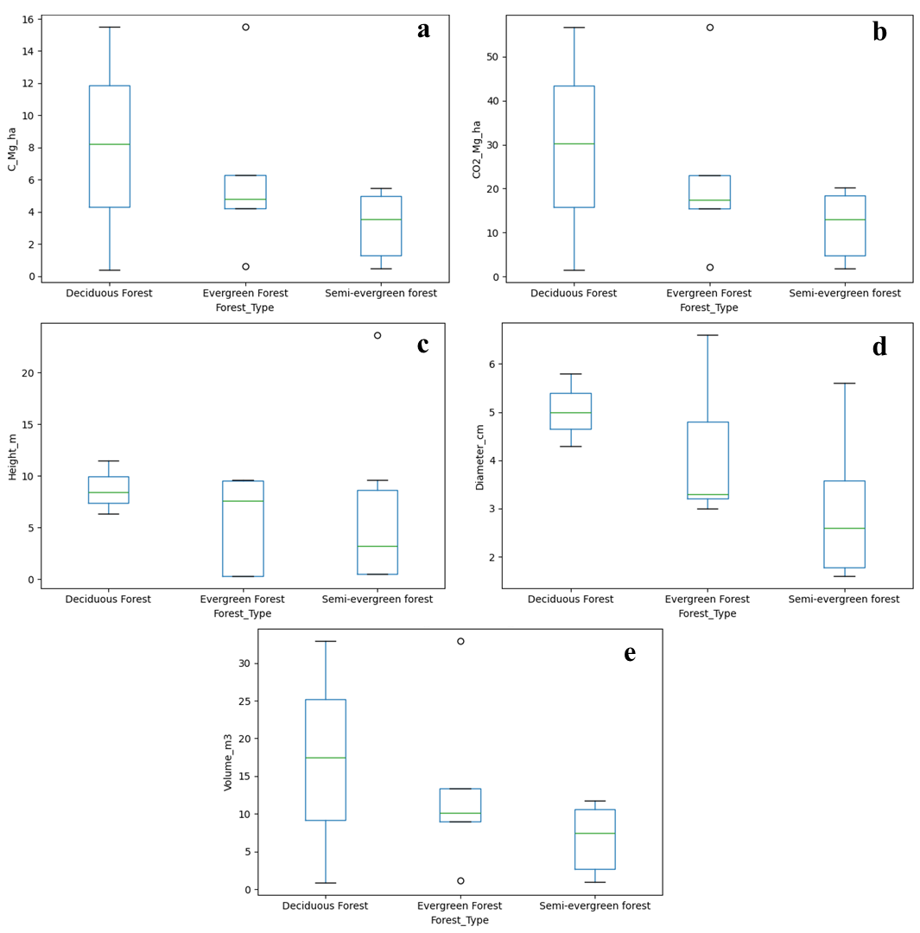
Fig.1. Boxplots comparing key bamboo growth and carbon-related variables across forest types: (a) carbon stock (Mg ha⁻¹), (b) CO₂ equivalent (Mg ha⁻¹), (c) height (m), (d) diameter (cm), and (e) volume (m³).
3.3.1 Carbon Stock (C, Mg ha⁻¹)
The distribution of carbon stock varied noticeably among forest types (Fig. 1a). Deciduous forests exhibited the highest and most variable carbon stocks, with values extending up to approximately 15 Mg ha⁻¹ and a median around 8 Mg ha⁻¹. This indicates both greater carbon accumulation and substantial variability among plots. Evergreen forests showed a narrower distribution, with most values clustered between 4–6 Mg ha⁻¹ and a median near 5 Mg ha⁻¹, suggesting more stable yet moderate carbon storage. Semi-evergreen forests displayed the lowest median (approximately 4 Mg ha⁻¹) and a relatively narrow range, reflecting consistently lower carbon stocks. Overall, these results suggest that deciduous forests possess the greatest potential for carbon sequestration, albeit with higher spatial variability, while evergreen and semi-evergreen forests exhibit more uniform but lower carbon storage capacity.
3.3.2 CO₂ Equivalent (Mg ha⁻¹)
The pattern of CO₂ equivalent mirrored that of carbon stock (Fig. 1b), as both metrics are directly related. Deciduous forests again recorded the highest CO₂ levels (up to 50 Mg ha⁻¹), followed by evergreen forests with moderate but consistent values, and semi-evergreen forests with the lowest storage potential.
3.3.3 Tree Height (m)
Tree height distributions differed notably among forest types (Fig. 1c). Deciduous forests exhibited relatively consistent heights, typically between 6 and 11 m, with a median around 9 m, indicating uniform and stable growth. Evergreen forests showed greater variability, with heights ranging from near 0 to about 10 m and a median close to 9 m, suggesting heterogeneous stand structure. Semi-evergreen forests recorded the lowest median height (~3 m) but displayed the widest variability, including an extreme outlier exceeding 20 m, likely representing sporadic growth of tall individuals within otherwise shorter stands. Overall, deciduous forests maintained taller and more uniform bamboo growth, whereas semi-evergreen forests exhibited stunted yet heterogeneous structures.
3.3.4 Diameter (cm)
As shown in Fig. 3d, deciduous forests had the largest mean diameters, ranging mostly between 4.5–6.0 cm, reflecting mature and vigorous culms. Evergreen forests exhibited a broader distribution (approximately 3–6 cm), indicating greater size heterogeneity. Semi-evergreen forests, in contrast, contained the smallest and most variable culms, mostly below 4 cm, consistent with less favorable growth conditions.
3.3.5 Volume (m³)
The distribution of bamboo volume followed a similar trend to diameter and height (Fig. 3e). Deciduous forests supported the highest and most variable volumes, ranging from near zero to above 30 m³, with a median around 17 m³. Evergreen forests showed moderate and consistent volumes (median ≈ 11 m³) with limited outliers, while semi-evergreen forests had the smallest volumes (median ≈ 8 m³; range = 1–12 m³). These findings indicate that deciduous forests promote the most productive bamboo growth, evergreen forests maintain moderate biomass, and semi-evergreen forests sustain lower but more variable growth performance.
Overall, the boxplot analysis demonstrates a consistent ecological gradient in bamboo productivity, with deciduous forests exhibiting superior structural development and carbon storage, followed by evergreen and semi-evergreen forests, which exhibit progressively lower biomass accumulation and growth uniformity.
3.4 Correlation Analysis Among All Variables
Fig. 2 presents the correlation heatmap illustrating relationships among the structural and biomass variables of bamboo across the three forest types. Distinct patterns of association were observed, reflecting the interdependence between growth attributes and biomass accumulation. Diameter (cm) showed a moderate positive correlation with clump diameter (r = 0.61), volume (r = 0.50), and carbon and CO₂ stocks (r = 0.50). This indicates that larger bamboo culms tend to have broader clumps and greater biomass accumulation, thereby contributing more substantially to total carbon storage. In contrast, height exhibited only weak correlations with other structural and biomass parameters (r < 0.40), suggesting that height alone is not a strong predictor of biomass in these forest stands. The total number of stems per clump was positively correlated with the number of dead stems (r = 0.56), indicating a possible density-dependent mortality effect, where clumps with higher stem density experience greater natural stem loss. Meanwhile, the diameter of clump correlated weakly with most variables (r < 0.40), suggesting variability in clump structure not directly linked to growth size or biomass accumulation. As expected, volume, carbon stock (C, Mg ha⁻¹), and CO₂ equivalent (Mg ha⁻¹) were perfectly correlated (r = 1.00), confirming that these variables represent the same underlying biomass pool and were derived directly from one another. Overall, the correlation analysis demonstrates that diameter and clump size are the primary structural drivers of bamboo biomass and carbon storage, whereas stem density and mortality primarily reflect stand dynamics and ecological stress rather than growth potential. These results highlight the importance of basal diameter as a reliable indicator of bamboo productivity and carbon sequestration capacity across forest types.
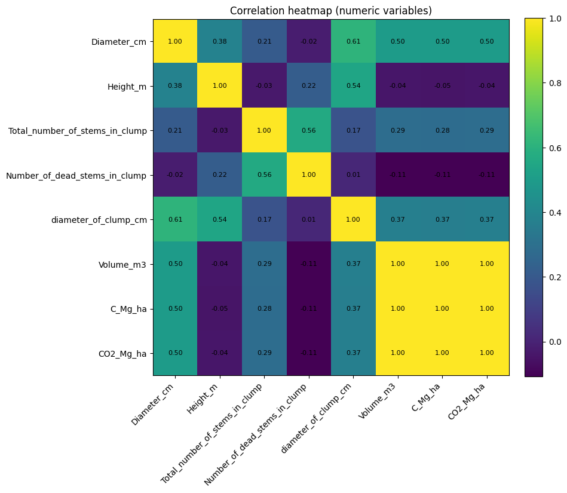
Fig. 2. Correlation heatmap showing relationships among structural and biomass variables of bamboo across three forest types. The strength of correlation is indicated by color intensity, with yellow representing strong positive correlations and dark tones indicating weak or negative relationships.
3.5 Principal Component Analysis (PCA) of Structural and Biomass Variables
Fig. 3 presents the results of the Principal Component Analysis (PCA) used to explore the relationships among structural and biomass-related variables and to assess the differentiation of bamboo stands across the three forest types. The first two principal components explained a substantial portion of the total variation, with PC1 accounting for 46.5% and PC2 for 21.7%, together capturing approximately 68.2% of the total variance in the dataset.
Fig. 3a shows the ordination of samples along the two principal components. Deciduous forests are mainly distributed along the positive axis of PC1, indicating strong associations with larger bamboo culms, higher volumes, and greater carbon accumulation. Evergreen forests cluster closer to the origin and slightly on the negative side of PC1, representing moderate and relatively uniform structural traits. In contrast, semi-evergreen forests display a wider dispersion, extending mainly along PC2, suggesting higher variability in structural characteristics such as height and mortality. Overall, this pattern highlights clear differentiation among the three forest types, with deciduous forests characterized by high growth and carbon storage potential, evergreen forests exhibiting stable but moderate traits, and semi-evergreen forests reflecting structural variability and generally smaller bamboo culms.
Fig. 3b presents the explained variance of the first two principal components. PC1, which explains nearly half of the total variance (46.5%), represents a gradient of bamboo size and biomass accumulation, driven primarily by variation in diameter, clump size, and volume. PC2 (21.7%) captures secondary variation associated with height and stem mortality, reflecting vertical structural differentiation and clump vitality. The cumulative contribution of PC1 and PC2 confirms that these two components are sufficient to describe the major structural and functional differences among the forest types.
Fig. 3c illustrates the PCA loadings plot, showing how each variable contributes to the two main components. Variables such as diameter (cm), diameter of clump (cm), and total number of stems per clump load strongly and positively on PC1, suggesting that this component primarily represents bamboo structural size and clump density. Similarly, volume (m³), carbon stock (C, Mg ha⁻¹), and CO₂ equivalent (Mg ha⁻¹) also load heavily on PC1, confirming their close relationship with structural attributes and their role in defining biomass accumulation and carbon sequestration potential. Conversely, height (m) and number of dead stems per clump load more prominently on PC2, indicating that this axis reflects variation in vertical growth patterns and mortality dynamics rather than overall biomass production.
Overall, the PCA results demonstrate that PC1 represents a structural–biomass gradient, linking bamboo size and clump characteristics to carbon storage capacity, while PC2 captures variability related to stand height and stem survival. These findings suggest that bamboo carbon sequestration in Cambodian forest ecosystems is largely governed by structural parameters such as stem diameter and clump size, whereas height and mortality contribute to internal stand heterogeneity.
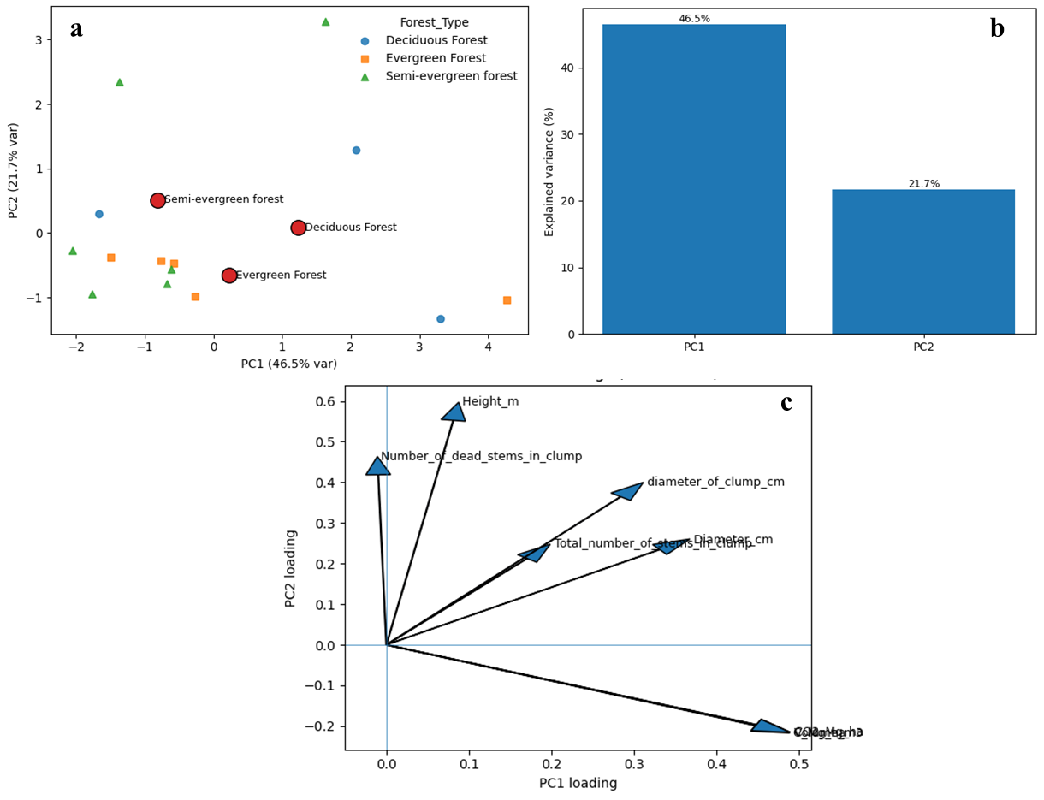
Fig. 3. Principal Component Analysis (PCA) of bamboo structural and biomass variables across three forest types. (a) PCA ordination plot showing forest-type separation along PC1 and PC2; (b) Scree plot showing the proportion of variance explained by the first two components; (c) PCA variable loadings plot illustrating contributions of individual structural and biomass variables to PC1 and PC2.

4. DISCUSSION
The results of this study reveal meaningful differences in bamboo structural traits and carbon sequestration across deciduous, evergreen, and semi-evergreen forests in Cambodia. Bamboo in deciduous forests exhibited the largest diameters and volumes, corresponding to the highest—but most variable—carbon stocks. In contrast, evergreen forests displayed moderate and stable structural and carbon values, while semi-evergreen forests were characterized by smaller clumps and consistently lower carbon stocks, although occasional tall outliers were observed. These findings align with those of Yiping et al. (2010), who reported that bamboo’s carbon storage capacity varies significantly depending on forest type, stand structure, and management context. Similarly, Yuen et al. (2017) estimated total ecosystem carbon in bamboo forests ranging from 94 to 392 Mg C ha⁻¹, depending on species composition and environmental conditions, underscoring bamboo’s substantial potential as a carbon sink. The present study also supports the results of Devi and Singh (2021), who reported aboveground biomass stocks up to 150 Mg ha⁻¹ and carbon stocks up to 65 Mg ha⁻¹ in bamboo species in northeastern India. These findings collectively demonstrate that bamboo can sequester considerable amounts of carbon, particularly when structural attributes such as culm diameter, density, and age structure are favorable. The correlation analysis from this study reinforces these broader patterns: diameter and clump size were strongly associated with carbon and CO₂ stocks (r = 0.50–1.00), whereas stem density and mortality exhibited weaker correlations. This pattern is consistent with findings from other forest ecosystems, where basal area and culm diameter are robust predictors of biomass and carbon storage (Ahirwal et al., 2021; Kothandaraman et al., 2020). The PCA results further emphasized this trend: the first principal component (PC1), explaining 46.5% of the total variance, was dominated by size- and biomass-related variables, whereas the second component (PC2, 21.7%) was more strongly influenced by height and mortality. These axes reflect meaningful ecological differentiation among forest types. Deciduous forests are aligned with higher biomass accumulation and structural uniformity, while semi-evergreen forests exhibit greater structural variability, possibly driven by disturbances and heterogeneity in growth conditions (Souza et al., 2023). The variability observed in semi-evergreen forests—where a few exceptionally tall individuals coexist with generally small clumps—may reflect differences in resource availability, microhabitat conditions, or successional stages. Similar context-dependent structural divergence has been documented in other bamboo systems, where site conditions and management regimes influence stand structure and carbon allocation (Jember et al., 2023). Importantly, these findings have practical implications for forest management and carbon accounting in Cambodia, consistent with recommendations by Yuan et al. (2023). Recognizing that bamboo’s carbon sequestration potential is mediated by forest type, management strategies should be forest-type-specific. For example, in deciduous forests, protection and sustainable harvesting could enhance existing carbon reservoirs, while in semi-evergreen forests, interventions promoting clump development and growth vigor could help unlock underutilized carbon potential. Such targeted management approaches are in line with Zhou et al. (2011), who emphasized the importance of adaptive forest management to optimize carbon benefits under varying ecological conditions. In summary, this study demonstrates that bamboo plays a variable yet significant role in forest carbon dynamics across Cambodia’s major forest types. By revealing the structural and carbon-based differentiation among forest ecosystems, these findings contribute to a nuanced understanding of bamboo’s ecological function and provide empirical evidence supporting its inclusion in climate-smart forest management and carbon accounting frameworks.

5. CONCLUSION
This study demonstrated distinct differences in bamboo structural attributes and carbon sequestration potential across deciduous, evergreen, and semi-evergreen forests in Cambodia. Bamboo in deciduous forests exhibited the largest diameters, highest volumes, and greatest carbon stocks, albeit with considerable variability among sites. Evergreen forests showed more moderate but stable structural and carbon characteristics, while semi-evergreen forests were dominated by smaller clumps and lower carbon storage, with occasional tall individuals contributing to structural heterogeneity. Correlation and principal component analyses confirmed that diameter and clump size are the primary determinants of bamboo biomass and carbon accumulation, whereas height and mortality reflect broader structural dynamics rather than direct contributions to carbon storage. These results highlight that forest type plays a decisive role in shaping bamboo growth patterns and carbon sequestration capacity. Overall, the findings underscore the importance of considering ecological context in the management and utilization of bamboo resources. By elucidating the structural and carbon dynamics of bamboo across Cambodia’s major forest types, this study provides valuable insights to support the integration of bamboo into sustainable forest management and climate change mitigation strategies.

REFERENCES
Ahirwal, J., Nath, A., Brahma, B., Deb, S., Sahoo, U. K., & Nath, A. J. (2021). Patterns and driving factors of biomass carbon and soil organic carbon stock in the Indian Himalayan region. Science of the Total Environment, 770, 145292. https://doi.org/10.1016/j.scitotenv.2021.145292
Ahmad, Z., Upadhyay, A., Ding, Y., Emamverdian, A., & Shahzad, A. (2021). Bamboo: Origin, habitat, distributions and global prospective. In Z. Ahmad, Y. Ding, & A. Shahzad (Eds.), Biotechnological advances in bamboo: The “Green Gold” on the earth (pp. 1–31). Springer Singapore. https://doi.org/10.1007/978-981-16-1310-4_1
Devi, A. S., & Singh, K. S. (2021). Carbon storage and sequestration potential in aboveground biomass of bamboos in North East India. Scientific Reports, 11, 837. https://doi.org/10.1038/s41598-020-80887-w
Dutta, S., Gorain, S., Roy, J., Das, R., Banerjee, S., Gorai, S. K., Choudhury, M. R., & Das, S. (2025). Bamboo for global sustainability: A systematic review of its environmental and ecological implications, climate action, and biodiversity contributions. Environmental Reviews, 33, 1–26. https://doi.org/10.1139/er-2025-0032
Emamverdian, A., Ding, Y., Ranaei, F., & Ahmad, Z. (2020). Application of bamboo plants in nine aspects. The Scientific World Journal, 2020, 7284203. https://doi.org/10.1155/2020/7284203
Jember, A. A., Taye, M. A., Gebeyehu, G., Mulu, G., Long, T. T., Jayaraman, D., & Abebe, S. (2023). Carbon stock potential of highland bamboo plantations in northwestern Ethiopia. Carbon Balance and Management, 18, 3. https://doi.org/10.1186/s13021-023-00224-2
Kaam, R., Nfornkah, B. N., Chimi, C. D., Nguefack, J. A., Tchamba, M., & Zapfack, L. (2023). Bamboo biomass: A strategy for climate change mitigation and adaptation, and forest landscape restoration (FLR) in Cameroon. In F. L. Palombini & F. M. Nogueira (Eds.), Bamboo science and technology (pp. 397–428). Springer Nature Singapore. https://doi.org/10.1007/978-981-99-0015-2_14
Kothandaraman, S., Swamy, P. S., Sundarapandian, S. M., & Chandrasekaran, S. (2020). Ecosystem-level carbon storage and its links to diversity, structural attributes, and environmental factors in tropical forests of the Western Ghats. Scientific Reports, 10, 13444. https://doi.org/10.1038/s41598-020-70313-6
Pan, C., Zhou, G., Shrestha, A. K., Chen, J., Kozak, R., Li, N., Li, J., He, Y., Sheng, C., & Wang, G. (2023). Bamboo as a nature-based solution (NbS) for climate change mitigation: Biomass, products, and carbon credits. Climate, 11(9), 175. https://doi.org/10.3390/cli11090175
Sasaki, N., Chheng, K., Mizoue, N., Abe, I., & Lowe, A. J. (2016). Forest reference emission level and carbon sequestration in Cambodia. Global Ecology and Conservation, 7, 82–96. https://doi.org/10.1016/j.gecco.2016.05.004
Singh, L., Sridharan, S., Thul, S. T., Kokate, P., Kumar, P., Kumar, S., & Kumar, R. (2020). Eco-rejuvenation of degraded land by microbe-assisted bamboo plantation. Industrial Crops and Products, 155, 112795. https://doi.org/10.1016/j.indcrop.2020.112795
Souza, R. R. de, Cargnelutti Filho, A., Toebe, M., & Bittencourt, K. C. (2023). Sample size and genetic divergence: A principal component analysis for soybean traits. European Journal of Agronomy, 149, 126903. https://doi.org/10.1016/j.eja.2023.126903
Yiping, L., Yanxia, L., Buckingham, K., Henley, G., & Guomo, Z. (2010). Bamboo and climate change mitigation: A comparative analysis of carbon sequestration. International Network for Bamboo and Rattan (INBAR). https://www.inbar.int/wp-content/uploads/2020/05/1489457789.pdf
Yuan, N., Wang, E., Lv, S., Tang, X., Wang, T., Wang, G., Zhou, Y., Zhou, G., Shi, Y., & Xu, L. (2023). Degradation reduces greenhouse gas emissions while weakening ecosystem carbon sequestration of Moso bamboo forests. Science of the Total Environment, 877, 162915. https://doi.org/10.1016/j.scitotenv.2023.162915
Yuen, J. Q., Fung, T., & Ziegler, A. D. (2017). Carbon stocks in bamboo ecosystems worldwide: Estimates and uncertainties. Forest Ecology and Management, 393, 113–138. https://doi.org/10.1016/j.foreco.2017.03.015
Zhou, G., Meng, C., Jiang, P., & Xu, Q. (2011). Review of carbon fixation in bamboo forests in China. The Botanical Review, 77(3), 262–270. https://doi.org/10.1007/s12229-011-9082-z

