Original Research Article

DIETARY HABITS ASSOCIATED WITH ANEMIA IN PREGNANT WOMEN ATTENDING ANTENATAL CLINIC (ANC) IN IFO REFUGEE CAMP, DADAAB, KENYA

.
ABSTRACT

Aims: To establish the dietary habits associated with anemia in pregnant women attending ANC in IFO Refugee Camp, Dadaab.
Study design: Analytical cross-sectional study .
Place and Duration of Study: The research location was at ANC clinic of IFO Refugee Camp located in Daadab Sub-County, Garissa County, Kenya. Between January 2025 and June 2025in the two dispensaries (health post 1 and health post 7).
Methodology: Encompassed pregnant women aged between 18-49 years who are attending the ANC at IFO Health posts. A purposive method was deployed for the study to select 368 participants drawn from the health post 1 (228 respondents) and 7 (140 respondents). The study included consenting pregnant women aged 18–49 attending ANC or postpartum (<3 months). It excluded those refusing participation or with chronic conditions like chronic kidney disease, cancer, lupus, or bleeding disorders.
Results: Out of 368 questionnaires, 361 were returned (98.1% response rate). The majority of respondents were married women aged 24–34 years with low education and income levels. The prevalence of anemia among pregnant women attending ANC in Ifo Refugee Camp was 73.4%, with 46% mild, 37% moderate, and 17% severe cases. Bivariate correlation analysis revealed significant associations between anemia and education level (r = 0.115, P < .05), ANC visits (r = 0.109, P < 0.05), and Women Dietary Diversity Score (r = –0.269, P < .001). Multivariate regression analysis showed that age (OR = 1.3; 95% CI: 1.023–1.717; P < .05) and gravidity (OR = 1.4; 95% CI: 1.079–1.927; P < .05) increased anemia risk, while higher dietary diversity reduced it significantly (OR = 0.25; 95% CI: 0.151–0.426; P < .001).
.
Conclusion: Anemia among pregnant women in Ifo Refugee Camp is highly prevalent and significantly influenced by age, gravidity, and dietary diversity, underscoring the need for improved maternal nutrition interventions

Keywords: Dietary Habits, Anemia, Pregnant Women, Antenatal Clinic (ANC), Ifo Refugee Camp, Dadaab

1. INTRODUCTION

Anemia is a condition marked by a reduction in red blood cell count or hemoglobin concentration, leading to a diminished capacity of blood to transport oxygen to body tissues (WHO, 2025). According to the World Health Organization, a pregnant woman is considered anemic when her hemoglobin (Hb) level falls below 11g/dl, with moderate anemia ranging between 7–9.9g/dl and severe anemia below 7g/dl (WHO, 2024). Iron Deficiency Anemia (IDA) is the most prevalent form and often results from inadequate dietary intake of iron-rich foods such as red meat and green leafy vegetables, poor absorption of dietary iron, and consumption of inhibitors like tea and phytates (Bhadra & Deb, 2020; Gibore et al., 2021).

Globally, anemia affects approximately 30% of women of reproductive age, with 37% of pregnant women being anemic (WHO, 2024). The highest prevalence occurs in Africa (40.4%) and South Asia (46.6%) (WHO, 2019). In Kenya, the prevalence among pregnant women stands at 28.7% (WHO, 2019), though regional disparities exist. A study in Garissa County revealed an alarming 57% prevalence, with 72% of cases classified as severe (Osman et al., 2024). Poor nutrition, food insecurity, and sociocultural beliefs contribute significantly to the persistence of the problem. Pregnant women’s increased physiological demands, including blood volume expansion, fetal development, and losses during childbirth, further increase vulnerability to anemia (Means, 2020).

In Ifo Refugee Camp, maternal anemia is a serious public health concern. According to the 2021 Standardized Expanded Nutrition Survey (SENS), 46.3% of women of reproductive age in Ifo Camp were anemic—24.3% mildly, 21.5% moderately, and 0.5% severely anemic. The World Health Organization categorizes anemia prevalence above 40% as a severe public health problem (WHO, 2024). Despite 84% enrollment in the Outpatient Therapeutic Program (OTP), only 78% of pregnant women received Iron and Folic Acid Supplementation (IFAS). Poor dietary diversity remains a leading cause of anemia in Ifo Camp, where most households lack access to iron- and vitamin-rich foods (MOH, 2021). Food insecurity has driven families to adopt negative coping strategies—91.7% rely on less preferred foods, 88.3% reduce adult meal portions to feed children, and 81.8% limit food intake. Furthermore, 70.1% of the population rarely consumes haem iron sources, while 18% never eat protein-rich foods. These behaviors, combined with psychological distress from forced displacement, increase the risk of malnutrition and anemia among pregnant women. However, the relationship between dietary habits and anemia in refugee settings remains under-documented, necessitating further investigation.

The purpose of this study was to examine the dietary habits associated with anemia among pregnant women attending antenatal clinics in Ifo Refugee Camp. By identifying specific dietary deficiencies, consumption patterns, and influencing factors, the research aims to inform nutritional interventions tailored for this vulnerable group. The findings are expected to guide humanitarian agencies, health practitioners, and policymakers in improving dietary education, enhancing food diversity, and strengthening supplementation programs to reduce anemia prevalence.

Previous studies have consistently shown that limited intake of iron-rich foods, poor dietary diversity, and consumption of iron absorption inhibitors contribute significantly to anemia during pregnancy (Zulfiqar et al., 2021; Petry, 2019). Cultural beliefs, economic hardship, and low education levels exacerbate poor dietary practices, leading to insufficient iron bioavailability. Research by Mekonnen et al. (2018) and Omar et al. (2020) highlights maternal factors such as age, education, income, and parity as key determinants of anemia. Younger and older mothers are particularly vulnerable due to increased nutritional demands and declining iron stores. The WHO recommends interventions such as iron and folic acid supplementation, food fortification, deworming, malaria prevention, and nutrition education to combat anemia (WHO, 2017). Kenya has adopted these measures, yet progress remains slow in marginalized areas like refugee camps due to persistent food insecurity, poor compliance with IFAS, and limited awareness (Omar et al., 2020).

This study focused on pregnant women aged 18–49 years attending ANC in Ifo Refugee Camp, Dadaab, to assess the magnitude of anemia, identify dietary factors, and analyze dietary habits influencing anemia levels. It aligns with global and national health goals, including the World Health Assembly’s target of reducing anemia by 50% by 2025 and the Sustainable Development Goals aimed at eradicating malnutrition and improving maternal health (WHO, 2017). The findings will fill existing knowledge gaps on the link between diet and anemia in refugee settings and provide evidence-based insights for effective policy and program development. Ultimately, this research sought to promote optimal maternal nutrition and reduce the burden of anemia among pregnant women in humanitarian contexts, contributing to healthier mothers and infants in Ifo Refugee Camp and similar settings.

2. methodology

2.1 Research design
Analytical cross-sectional study design was utilized as the research design. This type of research design enables provision of data based on the magnitude of anemia cases as well as providing insights into the link between dietary habits and anemia at period of time (Wang & Cheng, 2020).

2.2 STUDY SITE

The research location was at ANC clinic of IFO Refugee Camp with a longitude of 0.1104 degrees North and a latitude of 40.3140 degrees East. The camp is located in Daadab Sub-County, Garissa County, Kenya. Currently, two dispensaries (health post 1 and health post 7) act form an auxiliary part of the IFO Hospital. The two facilities were purposely selected since they are the only ones providing primary health care services including ANC, immunization, and post-natal services for pregnant women.

2.3 Targeted Population

This study encompassed pregnant women aged between 18 and 49 years who are attending the ANC clinic at IFO Health posts. Pregnant women attend ANC clinic at peripheral facilities of IFO Camp. These are health posts 1 and 7. An analysis of the antenatal register and summary MOH 711 revealed that approximately 12 and 9 expectant mothers visit the health post 1 and health post 7 ANC facilities daily. The study included consenting pregnant women aged 18–49 attending ANC or postpartum (<3 months). It excluded those refusing participation or with chronic conditions like chronic kidney disease, cancer, lupus, or bleeding disorders.

2.4 Sampling Technique and Size Determination

The study adopted a purposive non-probability sampling technique, which enabled the selection of participants possessing information relevant to the study objectives (Yadav et al., 2019). Sampling was conducted at Health Post 1 and Health Post 7 — the only two facilities offering antenatal care (ANC) services in Ifo 1 Refugee Camp, Dadaab Sub-County. These facilities were purposively chosen due to their high ANC attendance and the camp’s high anemia prevalence of 46.3% among women of reproductive age (Van Haute, 2021). Using Cochran’s formula for populations below 10,000, a sample size of 368 pregnant women was determined, based on a 95% confidence level, 5% margin of error, and 46.3% anemia prevalence. The sample was proportionately distributed according to facility catchment populations, with 228 participants from Health Post 1 and 140 from Health Post 7. To avoid duplication, participants were asked if they had previously been interviewed before inclusion in the study.

2.5 Data Collection Process/Instruments

Data were collected using a structured questionnaire comprising both closed- and open-ended questions adapted from a similar Ethiopian study (Gibore et al., 2021). Additional qualitative data were obtained through focus group discussions, while hemoglobin levels were extracted from antenatal mother and child booklets.To ensure data quality, the questionnaire was pre-tested with 37 participants (10% of the target sample size) and validated for accuracy and clarity (Surucu & Maslakci, 2020). Reliability was confirmed using Cronbach’s alpha (≥0.7). Data were collected through pick and drop method for the questionaire, 24-hour dietary recalls, and focus group discussions. Secondary data, including hemoglobin levels, were extracted from mother–child health booklets and clinic records, ensuring comprehensive and reliable data collection.

2.6 Data Analysis

Data were coded and analyzed using SPSS after checking for completeness and accuracy. Dietary diversity was assessed using the Minimum Dietary Diversity for Women (MDD-W) and Food Consumption Score–Nutritional Quality (FCS-N). Anemia levels were classified per WHO cut-offs. Descriptive, bivariate, and multivariate analyses, including logistic regression and correlation tests, determined associations between dietary habits and anemia. Qualitative FGD data were transcribed, analyzed thematically, and triangulated with quantitative findings.

- results and discussion

Out of 368 distributed questionnaires, 361 were correctly completed and returned, yielding a strong response rate of 98.1%, well above the 70% benchmark for high participation (Daikeler et al., 2020). Most respondents (61.5%) were from Health Post 1, while 38.5% were from Health Post 7.

3.1 Demographic Characteristics of the Study Subjects

The demographic analysis examined respondents’ age, marital status, education level, employment status, monthly income, number of pregnancies, and interpregnancy spacing to contextualize factors influencing maternal health outcomes.
The study revealed that most respondents (32.4%) were aged 24–34 years, with the majority (93.4%) being married. Nearly half (45.2%) had no formal education, while 55.4% were housewives. About 29.6% earned KES 4,001–8,000 monthly. Most women (36.3%) were in their second trimester, and 40.7% were experiencing their third pregnancy. Among multiparous mothers, 60.2% had good child spacing (over two years). Regarding ANC attendance, 40.2% were on their second visit, 24.9% on their third, and 24.4% were first-time attendees, reflecting varying levels of maternal healthcare engagement across the population.
Table 1: Socio demographic Characteristics of the pregnant women
Age in years (n=361)
 | Frequency | Percentage
18-23 years | 80 | 22.2
24-29 years | 117 | 32.4
30-34 years | 105 | 29.1
35 years and above | 59 | 16.3
Marital status (n=361)
Married | 337 | 93.4
Single mother | 19 | 5.3
Widowed | 2 | .6
Divorced | 3 | .8
Level of education (n=361)
Did not attend school | 163 | 45.2
Primary school | 151 | 41.8
Secondary school | 26 | 7.2
Tertiary level | 21 | 5.8
Occupation (n=361)
Self-employed | 86 | 23.8
Casual laborer | 68 | 18.8
House wife | 200 | 55.4
Permanent employee | 7 | 1.9
Monthly income in Kenyan shillings (n=361)
<4000 | 84 | 23.3
4001-8000 | 107 | 29.6
8001-12000 | 101 | 28.0
Above 12000 | 69 | 19.1
Pregnancy in weeks (n=361)
From conception to 12 weeks (first trimester) | 73 | 20.2
Between 13 to 27 weeks (second trimester) | 131 | 36.3
Between 28 to 37 weeks (third trimester) | 101 | 28.0
Between 38-42 weeks (fourth trimester) | 56 | 15.5
Number of pregnancies (Gravidity) (n=361)
First pregnancy | 46 | 12.7
Second pregnancy | 89 | 24.7
Third Pregnancy | 147 | 40.7
Fourth pregnancy and above | 79 | 21.9
Child spacing (n=315)
<2years | 127 | 40.3
>2years | 188 | 59.7
ANC visits attended in the current pregnancy (n=361)
First time | 88 | 24.4
2 times | 145 | 40.2
3 times | 90 | 24.9
>4 times | 38 | 10.5
Source: (Researcher, 2025)

3.2 The magnitude of anemia among pregnant women attending ANC in IFO Refugee Camp.

Hemoglobin levels recorded in the mothers’ antenatal profiles and clinic registers were used to determine anemia prevalence. Findings (Figure 1) showed that 73.4% of pregnant women were anemic, while only 26.6% had normal hemoglobin levels, indicating a high burden of anemia among ANC attendees in Ifo Refugee Camp.
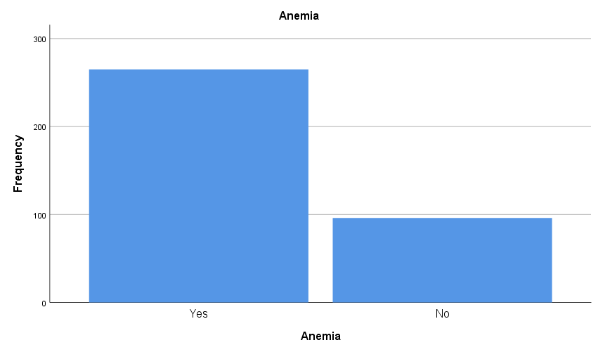
Fig. 1. The magnitude of anemia among pregnant women attending ANC in IFO Refugee Camp.
Source : (Researcher, 2025)

3.3 Severity of Anaemia

Among the 265 anemic mothers, 46% had mild anemia (Hb 10.0–10.9 g/dL), 37% had moderate anemia (Hb 7.0–9.9 g/dL), and 17% suffered from severe anemia (Hb <7.0 g/dL), highlighting varying degrees of anemia severity among participants.
Table 2: Severity of Anaemia

Anemia category (n=265) |  | Frequency | Percent
 | Mild Hb (10.0-10.9 g/dL) | 122 | 46
 | Moderate Hb (7.0-9.9 g/dL) | 98 | 37
 | Severe Hb (<7.0 g/dL) | 45 | 17
 |  | 265 | 100.0
Source : (Researcher, 2025)
3..4 Dietary habits associated with anemia among pregnant women attending ANC in IFO Refugee Camp

This section sought to establish the dietary habits associated with anemia of pregnant mothers in IFO refugee camp, Dadaab, Kenya. The dietary factors were first analyzed and link with anemia determined.

3.4.1 Dietary habits among pregnant women attending ANC in IFO Refugee Camp

The study found that 62.6% of mothers consumed more than three meals daily, while 37.4% ate fewer. Although 70.4% did not skip meals, 29.6% did, mainly due to inadequate household food (46.7%) or lack of appetite (29%). Most mothers (40.2%) took all meals to ensure essential nutrient intake. Regarding beverage habits, 42.7% consumed tea or coffee during meals, potentially affecting iron absorption. Food avoidance during pregnancy was reported by 31% of respondents, and 34.6% experienced cravings for non-food items—primarily soil (42.4%), edible clay (32.8%), and charcoal (24.8%)—indicating prevalent pica practices among pregnant women.
Table 3: Dietary habits among pregnant women

Meals per day (n=361)
 | Frequency | Percent
< 3 meals | 135 | 37.4
> 3 meals | 226 | 62.6
Skipping any meal per day (n=361)
 | Frequency | Percent
Yes | 107 | 29.6
No | 254 | 70.4
Reason for skipping meals (n=107)
 | Frequency | Percent
Lack of adequate HH food | 50 | 46.7
Busy schedules and work commitments | 22 | 20.6
Lack of appetite | 31 | 29
Unable to cook | 4 | 3.7
Motivation behind taking all the meals (n=254)
 | Frequency | Percent
Ensure essential nutrients for well-being during pregnancy | 102 | 40.2
Routine/lifestyle with scheduled meal times | 101 | 39.8
Total | 254 | 100
Consumption of Coffee/Tea During Meals (n=361)
 | Frequency | Percent
During meals | 154 | 42.7
Within 2 hours before or after meals | 138 | 38.2
More than 2 hours before and after meals | 69 | 19.1
Food Avoidance During the Current Prenatal Period (n=361)
 | Frequency | Percent
Yes | 112 | 31
No | 249 | 69
Craving for nonfood items (n=361)
 | Frequency | Percent
Yes | 125 | 34.6
No | 236 | 65.4
The type of non-food craving (n=125)
 | Frequency | Percent
Soil | 53 | 42.4
Edible clay | 41 | 32.8
Charcoal | 31 | 24.8
Source : (Researcher, 2025)
Focus group discussions revealed that most mothers ate three meals per day, with some consuming more. Overall, participants reported an increased frequency of daily food intake during pregnancy. The qualitative data revealed the following key responses:
"Most of us eat three times a day. It has become a routine for breakfast, lunch, and dinner. We believe eating regularly helps maintain energy levels throughout the day, especially when we have busy schedules or need to take care of our families." (Health post 1, expectant mother 3)

"During pregnancy, I find myself skipping meals. Sometimes I just lose my appetite, and other times, the smell of food makes me nauseous and want to vomit. It's really difficult to eat consistently during this time." (Health post 7, expectant mother 8)

"One of the reasons some of us skip meals is the cost and availability of food. When food is too expensive or hard to find, we have to adjust and sometimes go without. It’s not that we want to skip meals, but circumstances make it hard to eat regularly." (Health post 7, expectant mother 3)

Through the FGDs, the study also sought to evaluate food avoidance during pregnancy.

“We have a high preference for rice and spaghetti as compared to sorghum as a cereal and a source of carbohydrate. Thus, most of the households may avoid eating sorghum. Sorghum has been distributed severally in the in-kind food assistance” (Health post 7, expectant mother 10).
Accessibility was also cited as a key reason for not taking some foods. The responses were as follows;
"We choose foods that are easily available around us. Sometimes, it is not about what we prefer, but what we can easily find in the market or from local vendors. When the food we want is not available, we go for alternatives that are within reach." (Health post 1, expectant mother 5)

"The price of food matters a lot. Most of us consider how affordable the food is before buying. We stick to foods that will not strain our budgets, especially during tough economic times." (Health post 1, expectant mother 5)

Besides, conditions such as diabetes and hypertension were also identified as key reasons for avoiding some foods. Pregnancy side effects were also mentioned as reasons for avoiding some foods.
"During pregnancy, I had to stop eating certain foods because they made me nauseous or caused me to vomit. It was hard to keep some things down because of the changes in my body, so I avoided foods that triggered this reaction." (Health post 7, expectant mother 6)

3.5 Inferential Analysis
3.5.1 Bivariate Correlation Analysis
Correlation analysis of the different variables including dietary factors and socio-demographics was conducted to determine their relationship with anemia. Dietary habits with significant associations were consequently reported as seen in Table 4. Pearson product correlation of anemia and level of education (r = .115, p < .05), number of FANC/ANC visits attended (r = .109, p < .05), Women Dietary Diversity Score (r = -.269, p < .001) were found to be statistically significant.
Table 4: Bivariate Correlation Analysis

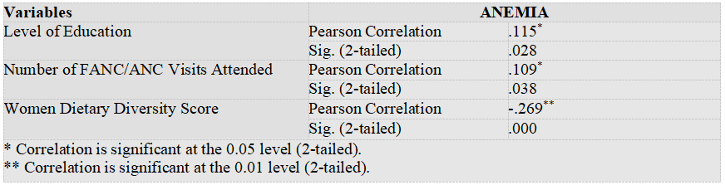

3.5.2 Multivariate Regression Analysis

Using multivariate logistic regression analysis, the dependent variable (anemia) was regressed on both the sociodemographic, and dietary habits and WDDS. The WDDS (p<0.001), gravidity (p<0.05), and age (P < 05) were significant. Thus, Age and gravidity were associated with an increased likelihood of exhibiting anemia, but increasing WDDS was associated with a reduction in the likelihood of exhibiting anemia. Older women had higher odds of anemia (OR 1.3; 95% CI: 1.023, 1.717; P < .05). Women with more pregnancies (gravidity) (OR 1.4; 95% CI: 1.079, 1.927; P < .05) were likely to be anemic compared to women with less pregnancies. Women with adequate dietary diversity scores were less (OR 0.25; 95% CI: 0.151, 0.426; P < .001) likely to be anemic compared to women with inadequate dietary diversity as seen in Table 5 below.

Table 5: Multivariate Logistic Regression

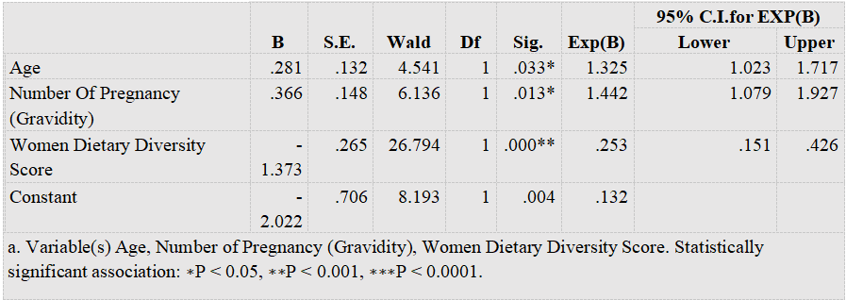

4. Conclusion

The study concludes that anemia remains a significant public health concern among pregnant women attending ANC in Ifo Refugee Camp, with over two-thirds affected, primarily by mild and moderate anemia. Dietary habits, including meal frequency, food diversity, and consumption of iron-inhibiting substances like tea and coffee during meals, were closely linked to anemia prevalence. Limited access to nutrient-rich foods, meal skipping due to food insecurity, and cultural practices further exacerbate the condition. Strengthening nutrition education, promoting diversified diets, and enhancing access to iron-rich and fortified foods are crucial to improving maternal health and reducing anemia among pregnant women in the camp

Consent

All authors declare that written informed consent was obtained from all participants prior to their inclusion in the study. Participants were fully informed about the purpose, procedures, and confidentiality of the research before giving their consent. A copy of the written consent is available for review by the Editorial office/Chief Editor/Editorial Board members of this journal."

Ethical approval

Approval and ethical clearance to conduct the study was requested from the Kenyatta University Ethics and Review Committee. A research permit was sought from the National Commission for Science, Technology, and Innovations (NACOSTI). Additionally, approval to conduct the research was sought from the Department of Refugee Services (DRS), which oversees the management of the camp, United Nations High Commissions for Refugees (UNHCR), Kenya Red Cross Society (UNHCR partner for implementing health and nutrition services in IFO Camp). Respondents were given information concerning the research. Written consent was obtained from the women before data collection. Their names were not captured in the questionnaires with the confidentiality of their information assured. Immediate medical referral was initiated for women found to be having severe forms of anemia.
This affirms that the study adhered to all applicable ethical standards, aligned with the public interest, and that the disclosure of information was conducted in accordance with relevant legal and regulatory requirements.

COMPETING INTERESTS DISCLAIMER:
Authors have declared that they have no known competing financial interests OR non-financial interests OR personal relationships that could have appeared to influence the work reported in this paper.

References
- Bhadra, P., & Deb, A. (2020). A review on nutritional anemia. Indian Journal of Natural Sciences, 10(59), 18466-18474.
- Gibore, N. S., Ngowi, A. F., Munyogwa, M. J., & Ali, M. M. (2021). Dietary habits associated with anemia in pregnant women attending antenatal care services. Current developments in nutrition, 5(1), nzaa178.
- Means, R. T. (2020). Iron deficiency and iron deficiency anemia: implications and impact in pregnancy, fetal development, and early childhood parameters. Nutrients, 12(2), 447.
- Mekonnen, F. A., Ambaw, Y. A., & Neri, G. T. (2018). Socio-economic determinants of anemia in pregnancy in North Shoa Zone, Ethiopia. PloS one, 13(8), e0202734.
- MoH (2021): National Policy Guideline on combined iron and folic acid (IFA) supplementation for pregnant mothers in Kenya. Division of Nutrition ed. Nairobi;2013.Omar, M., Midigo, R., & Okeyo, I. (2020). Anaemia in Pregnancy: Assessing the Role of Socio-demographic. J Obst Gynecol Surg, 1(1), 1-7.
- Osman, M. M., Keles, E., Bektemur, G., Eker, H. H., Karaketir, Ş., & Ozer, O. (2024). Determinants of anemia among pregnant women attending a tertiary hospital, Mogadishu, Somalia: unmatched case-control study. Revista da Associação Médica Brasileira, 70(5), e20231376.
- Petry, N., Jallow, B., Sawo, Y., Darboe, M. K., Barrow, S., Sarr, A., ... & Wirth, J. P. (2019). Micronutrient deficiencies, nutritional status and the determinants of anemia in children 0–59 months of age and non-pregnant women of reproductive age in the Gambia. Nutrients, 11(10), 2275.
- Sürücü, L., & MASLAKÇI, A. (2020). Validity and reliability in quantitative research. Business & Management Studies: An International Journal, 8(3), 2694-2726.
- Van Haute, E. (2021). Sampling techniques. Research Methods in the Social Sciences: An AZ of Key Concepts; Oxford University Press: Oxford, UK, 247.
- Wang, X., & Cheng, Z. (2020). Cross-sectional studies: strengths, weaknesses, and recommendations. Chest, 158(1), S65-S71.
- WHO (2024) Prevalence Of Anemia In Women Of The Reproductive Age. https://www.who.int/data/gho/data/indicators/indicator-details/GHO/prevalence-of- anaemia-in-women-of-reproductive-age-(-) (accessed on 5th November 2022)
- WHO (2019) prevalence of anemia, 2019. https://www.who.int/health- topics/anaemia#tab=tab_1 (accessed on 5th November 2024)
- World Health Organization. (2017). Nutritional anaemias: tools for effective prevention and control.
- Zulfiqar, H., Shah, I. U., Sheas, M. N., Ahmed, Z., Ejaz, U., Ullah, I., ... & Akbar, B. (2021). Dietary association of iron deficiency anemia and related pregnancy outcomes. Food Science & Nutrition, 9(8), 4127-4133.

