Original Research Article

Ensemble Machine Learning Application and Feature Importance Detection in Stock Price Prediction

Abstract
In this study the performance of some ensemble machine learning techniques for stock price prediction in volatile financial markets were investigated. Random Forests, Gradient Boosting and Stacking techniques alongside feature importance evaluation methods like Least Absolute Shrinkage and Selection Operator (LASSO), Shapley Additive Explanations (SHAP) and Gini Feature Importance were employed to forecast stock prices for major companies - Google and the S&P 500 index - using historical data varying differently from 2004 to 2023. Specifically, Stacking model achieved a lower Mean Absolute Error (MAE) and an R-squared (R²) closer to 1, slightly surpassing both Random Forests and Gradient Boosting across all the datasets. Feature importance analysis and Shapley Additive Explanations identified the features ‘High’, ‘Open’ and ‘Low’ as key contributors to stock price predictions. They further enhanced the models by improving robustness and reducing over fitting. This study highlights that ensemble methods not only improve predictive accuracy but also offer valuable interpretability which is crucial for financial analysts and decision-makers. Overall, this study demonstrates the potential of combining ensemble techniques with feature importance analysis for stock price prediction, offering a framework that can be adapted for other financial forecasting applications.
Keywords: Stock price, machine learning, prediction, feature importance, robustness
- Introduction
Time series forecasting has become more essential in diverse fields, including energy, healthcare, finance, and environmental science. Because time-dependent data are intrinsically difficult to handle, high-level predictive modeling methods are required. Effective prediction models have been important research topics, and data scientists and researchers from all over the world have been working to improve the prediction techniques that are now in use. It is periodically challenging for traditional time series forecasting techniques to grasp the complexity and non-linearity inherent in many real-world datasets. The stock market is an unpredictable and complex environment influenced by a wide range of factors. Every day, it generates billions of data points—both structured and unstructured—from markets worldwide. This leads to massive increases in the volume, speed, diversity, and uncertainty of the data, making it challenging to interpret and analyze effectively [1, 2].
In analyzing stock market data, two primary approaches are commonly used: fundamental and technical analysis. Fundamental analysis looks at factors like economic trends, market sentiment, financial reports, political conditions, and company relationships. On the other hand, technical analysis relies on statistical methods, using past price data and various indicators such as moving averages, dead crosses, and golden crosses to predict future market movements [3]. Machine learning (ML) advancements, particularly in ensemble methods, offer significant potential for boosting prediction accuracy and robustness in stock forecasting. Ensemble learning, a framework that amalgamates the predictions of multiple models, combines these individual machine learning models together. Thus, it yields more accurate results in most of the cases [4]. However, its application in time series forecasting is an area with considerable potential that has not been widely explored.
This research work intends to utilize SHAP, LASSO and Gini Feature Importance Index to determine the most prominent features for stock price prediction and give the key indicator in predicting future stock prices. This study explores ensemble techniques to enhance robustness in stock market predictions. It aims to investigate ensemble learning methods for stock price prediction by exploring bagging, boosting, and stacking techniques; analyzing interpretability and adaptability. This research contributes to knowledge on ensemble-based stock prediction, offering financial analysts and investors reliable tools. Through SHAP, LASSO, and Gini analysis, the study highlights key factors influencing stock prices, supporting models that are accurate and easily interpreted. Using historical stock data from companies like Google and the S&P 500, this study evaluates bagging, boosting, and stacking ensemble algorithms. Model performances are determined with metrics such as MAE and R-squared and interpretability is examined using SHAP and LASSO to discover the more prominent features.
The models’ accuracy depends on historical data quality. Ensemble models’ computational demands may limit usability and factors like geopolitical events may not be taken into consideration, raising the risk of overfitting. Acknowledging these limitations provides a realistic perspective on the capabilities and constraints of ensemble methods for stock prediction.
- Review of Related Work
In the field of stock price prediction, the introduction of ML approach marked a change in basic assumptions. Existing literature recognizes the presence of market anomalies, sudden shocks and external factors that can impact stock prices challenging the assumptions of predictive models. Researchers began exploring the capabilities of algorithms to discern intricate patterns in historical data [5]. Ensemble learning emerged as a promising technique for improving the robustness and accuracy of prediction models. The techniques, such as Random Forest (RF), Gradient Boosting and Bagging gained attention for their ability to mitigate overfitting and improve generalization. Zhang et al. [6] presented the advantages of ensemble methods in capturing complex relationships within financial data.
Feature engineering has a vital role in stock price prediction. Researchers like Tsantekidis et al. [7] emphasized the importance of carefully selecting appropriate features including technical indicators, macroeconomic variables, and sentiment analysis from news and social media. The integration of multiple data sources has become a widespread practice to enhance predictive models. Despite the advancements, stock price prediction remains challenging. The Efficient Market Hypothesis (EMH) suggests that stock prices incorporate all available information, meaning that predicting future price movements is inherently difficult.
The reviewed literature highlights ensemble learning's significance in stock price prediction, rooted in foundational principles established by Dasarathy & Sheela [8], who proposed partitioning feature space through multiple component classifiers to enhance predictive power. Their work serves as a cornerstone for combining diverse models in financial forecasting. Other studies demonstrate the efficacy of many ensemble techniques for robust predictions. For instance, [3] found that stacking and blending ensembles outperformed other techniques with prediction accuracy reaching up to 100% and lower RMSE, displaying their strength in high-accuracy applications.
Dynamic ensemble strategies have also proven effective. Lin et al. [9] developed a deep-reinforcement-learning-based ensemble that adapts weights in real-time based on market feedback, yielding superior mean square error (MSE) reductions and performance gains on SSE 50 and NASDAQ 100 datasets. Zhao et al.[10] advanced weighted averaging by optimizing weights for individual models (Long Short-Term Memory (LSTM), Support Vector Machine (SVR), and Light Gradient Boosting Machine (GBM)) within an ensemble, demonstrating that adaptable weights can improve model precision and reduce errors.
Moreover, feature selection emerges as a key factor for accuracy in high-dimensional data. Nezhad & Rezaei [11] integrated genetic algorithms and particle swarm optimization to optimize ensemble model inputs, which improved the predictive reliability of their ensemble approach in complex market conditions.
Sohangir et al. [12] explored the use of deep learning methods, specifically LSTM and Convolutional Neural Networks (CNN), to enhance stock prediction accuracy by analyzing public sentiment. Their findings showed that CNN performed better than traditional machine learning models such as logistic regression and Doc2vec—a neural network technique that learns document representations. The simulation results highlighted the effectiveness of their proposed ensemble approach, showing it to be more promising than traditional models like ARIMA (Auto-Regressive Integrated Moving Average) and GARCH (Generalized Autoregressive Conditional Heteroscedasticity). Similarly, [13] focused on using deep learning for forecasting market returns, employing a deep neural network approach to predict prices. They found that deep learning techniques outperformed neural networks in terms of accuracy. They also proposed an ensemble of ML methods, combining deep neural networks, RF, and gradient-boosted trees, to predict the next day's stock price on the S&P 500 index. Their results were promising, indicating that the use of ML technique can lead to advantages in short-term profit maximization, even in developed markets. Qiu et al. [14], in their ML work on the S&P 500 index, introduced a model for stock prediction using an ensemble ν-Support Vector Regression (ν-SVR) approach.
Likewise, other studies proposed ensemble methods combining Bayesian Model Averaging (BMA), LASSO, Weighted-Average Least Squares (WALS), with AdaBagging to enhance market return predictability and improve stock price forecasting. Pasupulety et al. [15] combined ensemble learning and sentiment analysis, using a stacked model of extra tree and support vector regressors for stock price prediction. Htun et al. [16] identified random forests, correlation-based methods, PCA and autoencoders as the most effective techniques for feature selection and extraction in market forecasting. Mahjouby et al. [17] applied various ML algorithms to “CoinMarketCap” and “CryptoCurrency” datasets to evaluate end-of-day stock market prediction accuracy.
In summary, the literature review highlights the growing interest in the application of ensemble machine learning algorithms for predicting stock prices and converges on the notion that ensemble learning is invaluable for stock price prediction. Factors such as ensemble type, number of models, and base model optimization through strategies like weighted averaging, feature selection, and reinforcement learning are critical for developing robust predictive frameworks in finance. Feature importance analysis is added in the current work to further enhance stock price prediction and help investors or decision makers in determining the prominent stock features that influence stock price movement.
- Materials and Methods
This study utilized ensemble ML algorithms, including RF, Boosting and Bagging, to predict stock prices. Two key model performance evaluation metrics, MAE and R² , were employed, allowing for the assessment of each model’s predictive accuracy and robustness. Also, Feature importance analysis, including SHAP and Gini Importance, are applied to find out the key feature(s) affecting stock prices.
The study was based on the historical daily stock price data for Google(from 19th August, 2004 to 27th March, 2022) and S&P 500 index (from 7th May, 2018 to 1st May, 2023), chosen for their global recognition and financial stability. The stock price data were sourced from a reliable financial database - Yahoo Finance. The data encompass many stock price features such as opening price, high price, low price, closing price and volume. Missing values were imputed using the SimpleImputer in scikit-learn, replacing missing values with the mean of each respective feature. MinMaxScaler was used to normalize the features within the range of 0 to 1, improving model performance and convergence. The data were split into training data, making 80%, and testing data, making 20%, where the training dataset was used to build the models and the testing set evaluated model accuracy. Python language was used for the implementation. In addition, we have used python libraries Numpy, Pandas, Matplotlib, SHAP, Sci-Kit Learn for machine learning, [18, 19].
3.1. Ensemble Machine Learning Models for Stock Price Prediction
3.1.1. Random Forests
Random Forests are ensemble ML technique where decision trees are utilized as the base model [20]. The algorithm trains multiple decision trees on random subsets of the datasets. This randomness stems from bootstrap sampling - where trees are trained on subsets of the dataset sampled with replacement - and from random feature selection - where a random subset of features is chosen at each segment, improving diversity among trees.
The prediction for each stock forecast horizon k is the average response from all p trees in the forest:
$⨍_{k}\left(x\right)=\frac{1}{p}\sum_{j=1}^{p}{τ_{k,j}(x)}$ (1)
where $τ_{k,j}(x)$ is the response from the j-th tree. The major parameters include the number of trees (p) and maximum depth, controlling the complexity and overfitting risk.
3.1.2. Gradient Boosting
Gradient Boosting is a sequential ensemble method where decision trees referred to as weak learners are added to reduce the error of previous models. Each new model is a learning process that seeks to improve on the errors of the previous ensemble; that is, every new model relies on the previous model to improve predictive accuracy, [21].
The gradient boosting process follows these steps:
- Work out an initial model $F_{0}$, say, with an anticipated response variable y, such that $({y-F}_{0})$ is the corresponding residual.
- Fit a new model ${\text{h}}_{\text{1}}$ to $\text{(}{\text{y}\text{-}\text{F}}_{\text{0}}\text{)}$ and combine the result with ${\text{F}}_{\text{0}}$ to obtain an improved model ${\text{F}}_{\text{1}}$ from ${\text{F}}_{\text{0}}$ such that, in terms of error:
$F_{1}\left(x\right)≤$ $F_{0}\left(x\right)+h_{1}(x)$ (2)
- Likewise, $h_{2}$ can be defined on $F_{1}$ to obtain an improved model $F_{2}$ such that, in terms of error:
$F_{2}\left(x\right)≤$ $F_{1}\left(x\right)+h_{2}(x)$ (3)
- In this way, the residual error is minimized until the converging point of minimization at, say, m iteration, where we have:
$F_{m}\left(x\right)≤$ $F_{m-1}\left(x\right)+h_{m}(x)$ (4)

The general algorithm of Gradient Boosting follows the following procedure:
Let the training data be S = $(x_{1},y_{1}$),...,$(x_{2},y_{2})$,...,$(x_{m},y_{m})$, a differential loss function be L(y; F(x)) (in the current work L(y; F(x)) is the MAE) and T, the number of iterations.
Procedure:
1) Perform model initialization using
$$F_{0}={argmin}_{α}\sum_{i=1}^{N}{L(y_{i},α) (5)}$$
2) For m = 1,……,M:
(i) Calculate the false residuals showing the direction of maximum change (descent) in loss for each training procedure i, $i=1,….,N$, as
$$r_{mi}= -{\left[\frac{∂L\left(y_{i},F\left(x\right)\right)}{∂F\left(x\right)}\right]}_{F\left(x\right)=F_{m-1}\left(x\right)} (6)$$Note that $r_{mi}$ is predicted by a corresponding weak learner $h_{m}(x)$. So, using MAE for loss function, $L\left(y,F\right)=\left|y-F\right|$ and then, $r_{i}=sign\left(y_{i}-F(x_{i})\right)$.
(ii) Obtain the optimal multiplier, $ρ_{m}$, by line search optimization method, as:
$$ρ_{m}={argmin}_{ρ}\sum_{i=1}^{N}{L\left(y_{i},F_{m-1}\left(x_{i}\right)+ρh_{m}(x_{i})\right)} (7)$$
(iii) Obtain the updated model by:
$F_{m}\left(x\right)=$ $F_{m-1}\left(x\right)+{sρ}_{m}h_{m}(x) (8)$
Where $s ϵ (0,1]$ is a learning rate used to control for overfitting
(iv) For the M iterations, the final model is reached as:
$$F_{M}(x)= F_{0}(x)+\sum_{m=1}^{M}{{sρ}_{m}h_{m}(x)} (9)$$

3.1.3. Stacking
Stacking uses predictions from multiple models as inputs for a second-stage meta-model, so as to improve the predictive ability of a classifier [22]. This two-stage approach leverages the strengths of different algorithms:
- Stage 1 (Base Models): Models $(h_{1}...,h_{p})$ are trained on the data and predictions made.
- Stage 2 (Meta-Learner): A meta-model (in this case, linear regression) combines these predictions, learning with weights $a_{i}, i=1, ..., p$, to produce the final stacked output:
$$f_{STK}\left(x\right)=\sum_{i=1}^{p}{a_{i}f_{i}(x) (10)}$$A summary of the stacking procedure is as follows:
Choose training data, $D={\left\{(x_{i},y_{i})\right\}}_{i=1}^{n}$
Step 1: Using D, obtain base learners ${\text{h}}_{\text{p}}$ for $p=1, ..., P$:
Step 2: From D, and for $p=1, ..., P$, obtain a new dataset $D^{ˊ}={\left\{({\hat{x}}_{i},y_{i})\right\}}_{i=1}^{n}$, where ${\hat{x}}_{i} = \{h_{1}(x_{i}), h_{2}(x_{i}),…, h_{P}(x_{i})\}$
Step 3: Train the meta-model $\hat{h }$on $D^{ˊ}$
Step 4: Obtain the final stacked model H by $H(x)= \hat{h} \{h_{1}(x_{i}), h_{2}(x_{i}),…, h_{P}(x_{i})\}$
So, for any new data $x^{n}$ the meta-model gives the final predicted value by:
$\hat{y}= \hat{h} \{h_{1}(x^{n}), h_{2}(x^{n}),…, h_{P}(x^{n})\}$

3.2. Evaluation Metrics
The metrics utilized for model performances in this work are MAE and R² measures. MAE is a statistical model performance evaluation tool that measures the average absolute difference between the predicted values and the observed data values, thereby indicating, on the average, the error magnitude, but not the direction. The MAE formula is as follows:
$$MAE=\frac{1}{n}\sum_{i=1}^{n}{|Y_{i}-{\hat{Y}}_{i}|} (11)$$Where n represents the sample size, $Y_{i}$is the true value and ${\hat{Y}}_{i}$ is the predicted value. MAE is particularly useful for assessing model effectiveness without emphasizing over- or under-predictions.
The metric R² measures how close the data are to the fitted linear regression line. Its values can range between 0% and 100%, and is calculated as:
$$R^{2}=1-\frac{\sum_{i=1}^{n}{{(Y_{i}-{\hat{Y}}_{i})}^{2}}}{\sum_{i=1}^{n}{{(Y_{i}-{\overline{Y}}_{i})}^{2}}} (12)$$
A higher R² generally indicates better model fit, though residual plots should also be checked to ensure unbiased results.
3.3. Feature Importance Analysis
3.3.1. Least Absolute Shrinkage and Selection Operator
LASSO is used for feature selection by penalizing coefficients. It shrinks some regression coefficients toward zero, selecting a subset of variables that provides stronger prediction accuracy. Consider the usual regression data $\left(x^{i},y_{i}\right), i=1,2,….,N,$ where $x^{i}={(x_{i1},…,x_{ip}) }^{T}$ is the vector of regressors and $y_{i}$are the response for the ith observations. The LASSO shrinks some coefficients and set others to zero and tries to retain the good features of both subset selection and ridge regression [23].
In the current work, we want to select important features for greater prediction accuracy of the closing prices using LASSO. Given the $x_{ij'}s$, the responses $y_{i}^{'}s$ are assumed to be independent. Let regression parameters be $(α, β),$ where $β$ is a vector of p parameters. The ordinary least square estimate of the parameters is defined by (13):
$$(\hat{α},\hat{β})=\arg{\min\left\{\sum_{i=1}^{N}{{\left(y_{i}-α-\sum_{j=1}^{p}{β_{j}x_{ij}}\right)}^{2}}\right\} (13)}$$But , LASSO adds a penalty, $\sum_{j}{{|β}_{j}|}$, which is sum of the absolute values of the coefficients, to the expression in (13) to give the LASSO estimate of $(α, β)$ defined by, (14):
$$(\hat{α},\hat{β})=\arg{\min\left\{\sum_{i=1}^{N}{{\left(y_{i}-α-\sum_{j=1}^{p}{β_{j}x_{ij}}\right)}^{2}+ t\sum_{j=1}^{p}{{|β}_{j}|}}\right\} (14)}$$
In (14), $t≥0$ is a tuning or regularization parameter. Larger value of $t$ indicates stronger penalty, which means more coefficients shrink to zero. In this way LASSO selects important features by setting unimportant ones to zero.
3.3.2. Gini Feature Importance
Gini Importance indicates feature relevance. The optimal split at each node ƞ in the T binary trees of the RF is identified using the Gini impurity i(ƞ), which measures the ability of a split to separate well the the two-classed samples in this particular node.
Let $f_{k}=\frac{n_{k} }{n}$ be the proportion of the $n_{k}$ samples out of the total of n samples at node τ, where class k = {0,1}, the Gini impurity i(ƞ) is calculated as:
$i\left(ƞ\right)=1-f_{1}^{2}-f_{0 }^{2} (15)$
When the samples are split, according to $f_{l}=\frac{n_{l} }{n}$ and $f_{r}=\frac{n_{r} }{n}$ , and send to the two sub-nodes $ƞ_{l}$ and $ƞ_{r}$ , the resulting decrease in i, Δi , from $t_{ω}$ , a threshold on variable feature $ω$ , is defined by (16):
$$∆i\left(ƞ\right)=i\left(ƞ\right)-f_{l}^{i}\left(ƞ_{l}\right)-f_{r}^{i}(ƞ_{r}) (16)$$
Instead of a complete search over all variables $ω$ at the node, RF considers a random subset of the available features [20], to determine the pair {$ω$, $t_{ω}$ } leading to a maximal $∆i$ from all possible thresholds $t_{ω}$. For all features $ω$, the $∆i$ that results from this optimal split ${∆i}_{ω}(ƞ,T)$ is taken note of and summed for all nodes $ƞ$ and for all trees T to obtain the Gini importance, $I_{G}\left(ω\right)$, as:
$$I_{G}\left(ω\right)=\sum_{T}{\sum_{ƞ}{{∆i}_{ω}(ƞ,T)}} (17)$$
The quantity $I_{G}\left(ω\right)$ shows the rate of selection of a given feature $\text{ω}$ for a split. It also indicates the extent of the overall discrimination value of $ω$ for the classification problem under study.
3.3.3. SHAP Analysis
SHAP is a game-theoretic approach used to explain how much each feature contributes to a particular prediction output of any ML model. It uses Shapley values to attribute contributions from each feature to individual predictions [24]. Shapley values, $ϕ_{i}$, are calculated as:
$$ϕ_{i}=\sum_{S⊆N∖\{i\}}{\frac{\left|S\right|!\left(\left|N\right|-\left|S\right|-1\right)!}{\left|N\right|!}\left(⨍(S⋃\left\{i\right\})-⨍\left(S\right)\right) (18)}$$
Where: $\text{S}$ is any subset of features excluding i, $\left|S\right|$ is the number of features in $\text{S}$, $\left|N\right|$ is the total number of features, $⨍\left(S\right)$is the prediction when only the features in $\text{S}$ are present, $⨍(S⋃\left\{i\right\})$ is the prediction when the features in $\text{S}$ and i are present.
SHAP provides local explanations that details the contribution of each feature on predictions, supporting interpretability of the model.
4. Analysis, Results and Discussions
The datasets considered in this work comprise historical records of financial instruments, including daily Opening, High, Low and closing prices and trading volumes. The time span covered, and the frequency of observations (daily) were critical considerations. Though all data points in the datasets considered were used in the analysis, for the purpose of showing the structure of the data, Tables 1 and 2 show samples of two items on the Google and S&P 500 datasets, respectively.
Table 1: Sample Points from Google Dataset
S/N | Date | Opening | High | Low | Closing | Volume
0 | 8/19/2004 | 50.050049 | 52.082081 | 48.028027 | 50.220219 | 44659096
.  .  . | .  .  . | .  .  . | .  .  . | .  .  . | .  .  . | .  .  .
4430 | 3/24/2022 | 2784.000000 | 2832.379883 | 2755.010010 | 2831.439941 | 1317900

Table 2: Sample Points from S&P 500 Dataset
S/N | Date | Opening | High | Low | Closing | Volume
0 | 5/7/2018 | 2680.340088 | 2732.860107 | 2655.199951 | 2727.719971 | 17181050000
.  .  . | .  .  . | .  .  . | .  .  . | .  .  . | .  .  . | .  .  .
260 | 5/1/2023 | 4166.790039 | 4186.919922 | 4048.280029 | 4136.250000 | 23630535000

4.1. Time Trends
A visualization of the time series plots on the datasets using the closing prices, with the aim of identifying long-term trends, seasonality, and potential outliers is essential for understanding the dynamics of the financial data. Figures 1 and 2 are the plots of closing prices of the datasets.
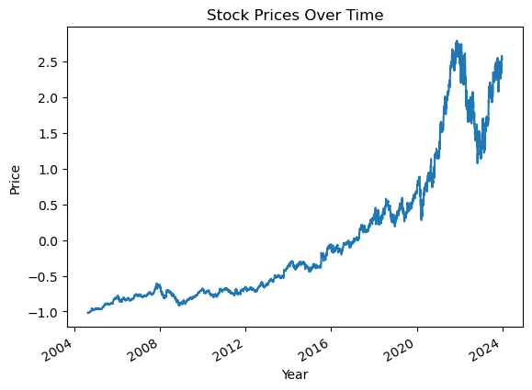
Figure 1: Closing Prices of Google Dataset
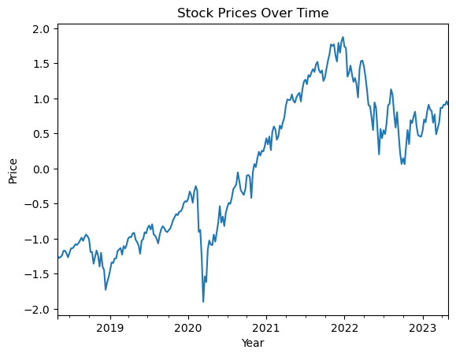
Figure 2: Closing Prices of S&P 500 Dataset
4.2. Performance Evaluation of Ensemble Models
Three primary ensemble methods are implemented: Bagging (Random Forest), Boosting (Gradient Boosting Machines), and Stacking. The chosen models were used to evaluate the stock prices for Google and the S&P 500 index. The algorithms were implemented using the scikit-learn library. The datasets were split into two - training and testing sets (80:20 ratio), and each model performance was evaluated using MAE and R² metrics. Tables 3 and 4 present the performance metrics for each ensemble model across the datasets:

Table 3: Performance Metrics for Ensemble Models for Google Dataset
Model | MAE | R-squared | Execution Time
0 Random Forest | 0.006981 | 0.999824 | 3.341179
1 GBM | 0.008729 | 0.999798 | 1.634579
2 Stacking | 0.006980 | 0.999825 | 24.562004

Table 4: Performance Metrics for Ensemble Models for S&P 500 Dataset
Model | MAE | R-squared | Execution Time
0 Random Forest | 0.008521 | 0.999809 | 2.567530
1 GBM | 0.011357 | 0.999726 | 1.139303
2 Stacking | 0.008488 | 0.999809 | 17.268853

The results show that Stacking slightly lowered MAE but took longer period to execute. On the other hand, GBM has the highest MAE but shortest execution time.
4.3. Overfitting and Generalization
To evaluate the risk of over fitting, the performance of the models on both training and testing datasets were analyzed. The goal was to ensure that the models generalize well to unseen data and do not merely memorize the training data. The training and testing errors for each model were computed and compared. A significant gap between training and testing errors would indicate over fitting. The results are shown in Table 5.
Table 5: Ensemble Models Performance across Train and Test Datasets
Dataset | Model | Training MAE | Testing MAE
GOOGLE | Random Forest | 0.0024 | 0.0070
GOOGLE | GBM | 0.0063 | 0.0087
GOOGLE | Stacking | 0.0025 | 0.0070
SP500 | Random Forest | 0.0233 | 0.0731
SP500 | GBM | 0.0200 | 0.0733
SP500 | Stacking | 0.0216 | 0.0721
Table 5 shows relatively small differences between training and testing errors. This is an indication that the models are not over fitting and generalize well to new data.
4.4. Robustness and Sensitivity Analysis
The sensitivity of the ensemble models to different hyper parameters, datasets attributes, and temporal structures were examined. This analysis helps identify methods to enhance the robustness of the models. Using a grid search approach, the impact of different hyper parameters on model performance were evaluated. Table 6 shows the results for the GBM model for Google dataset:
Table 6: Sensitivity Analysis Results for Hyper Parameter for the GBM Model .
Learning Rate | Number of Estimators | MAE | R²
0 0.01 | 50 | 0.483659 | 0.999966
1 0.01 | 100 | 0.294179 | 0.999966
2 0.01 | 200 | 0.109233 | 0.999966
3 0.10 | 50 | 0.006909 | 0.999966
4 0.10 | 100 | 0.004456 | 0.999966
5 0.10 | 200 | 0.003955 | 0.999966
6 0.20 | 50 | 0.007901 | 0.999966
7 0.20 | 100 | 0.006022 | 0.999966
8 0.20 | 200 | 0.004141 | 0.999966
The results indicate that the learning rate and the number of estimators significantly impact the performance of the GBM model. A balanced approach to hyper parameter tuning is therefore necessary to achieve optimal performance. So, a moderate learning rate of 0.10 was used and number of estimators set at 100.
4.5. Feature Importance
Here, feature selection techniques and ensemble machine learning methods are employed to evaluate predictive models for the stock prices. Two Gradient Boosting models - one with LASSO-selected features and one with all features - were trained and evaluated using MAE and R² performance metrics. The analysis includes visualizing feature importance through Gini importance and interpreting model predictions using SHAP values, providing insights into the most influential factors driving the models’ predictions.
4.5.1. Feature Importance Analysis for Google Dataset
Model performance with selected features using LASSO - MAE: 0.0069, R²: 0.9998.
Model performance with all features - MAE: 0.0070, R²: 0.9998.
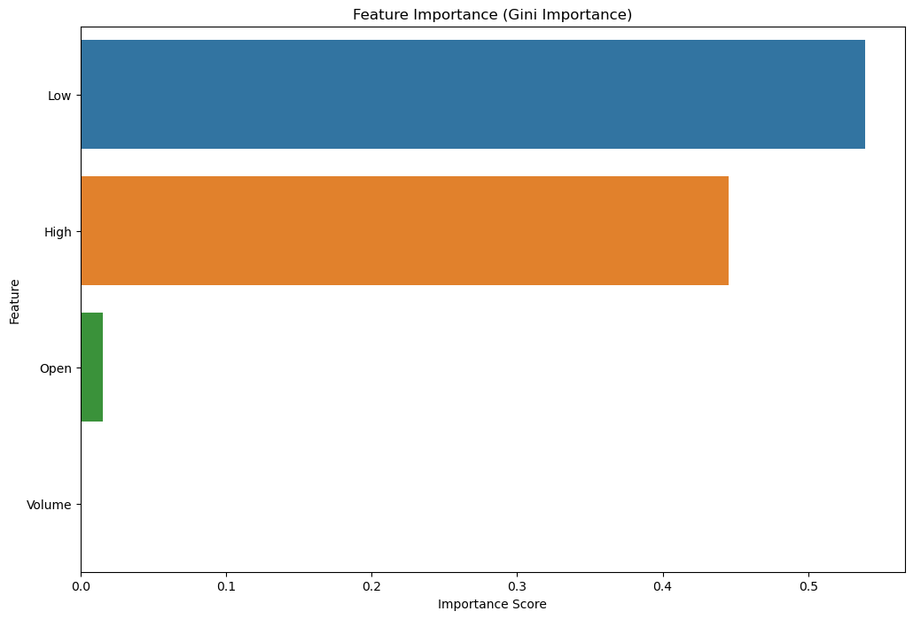
Figure 3: Gini Importance Index for the Google Dataset

From Figure 3 the feature importance of various features based on Gini importance has "Low" with importance score of about 0.55 and "High" with a score of about 0.4 as the most influential features, while "Open" with an importance score of about 0.05 has minimal impact. "Volume" has no impact in this model.
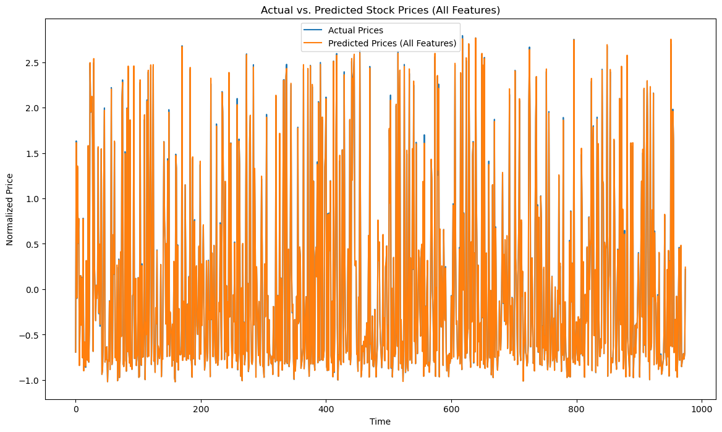
Figure 4: Actual vs. Predicted Stock Prices
Figure 4 shows that the model seems effective at predicting stock prices over time as displayed by the close alignment between actual and predicted prices. Minor discrepancies are visible but overall the model performs well in capturing the trend and variability of the stock prices.
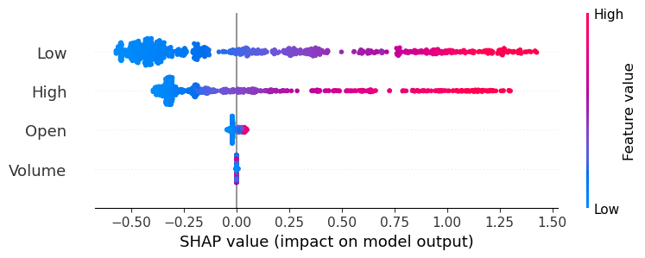
Figure 5: SHAP Plot for Google Dataset

Figure 5 shows a SHAP summary plot which visualizes each feature’s impact on the output of the model. The SHAP values are represented on the x-axis showing the extent to which each feature contributes to pushing the model’s prediction higher or lower. The color gradient represents the feature values. The features "Low" (blue) and "High" (red) are the most influential in the model, with higher values of these features positively impacting the predictions. "Open" has minimal impact, while "Volume" has virtually no impact on the predictions. This aligns with the previous Gini importance chart which also showed "Low" and "High" as the most important features.
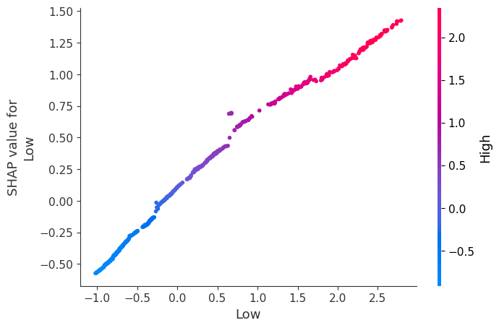
Figure 6: SHAP Analysis for Important Feature for Google Dataset
Figure 6 is a dependence plot which shows the relationship between the feature "Low" and its corresponding SHAP values. The color gradient shows the values of another feature "High" from low to high. The dependence plot shows that higher values of "Low" generally contribute positively to the output of the model, with the impact being stronger when "High" is also high. This suggests an interaction between "Low" and "High" in the model where both features positively reinforce each other’s contribution to the prediction.
4.5.2. Feature Importance Analysis for S&P 500 Dataset
Model performance with selected features using LASSO - MAE: 0.0085, R²: 0.9998.
Model performance with all features - MAE: 0.0085, R²: 0.9998.
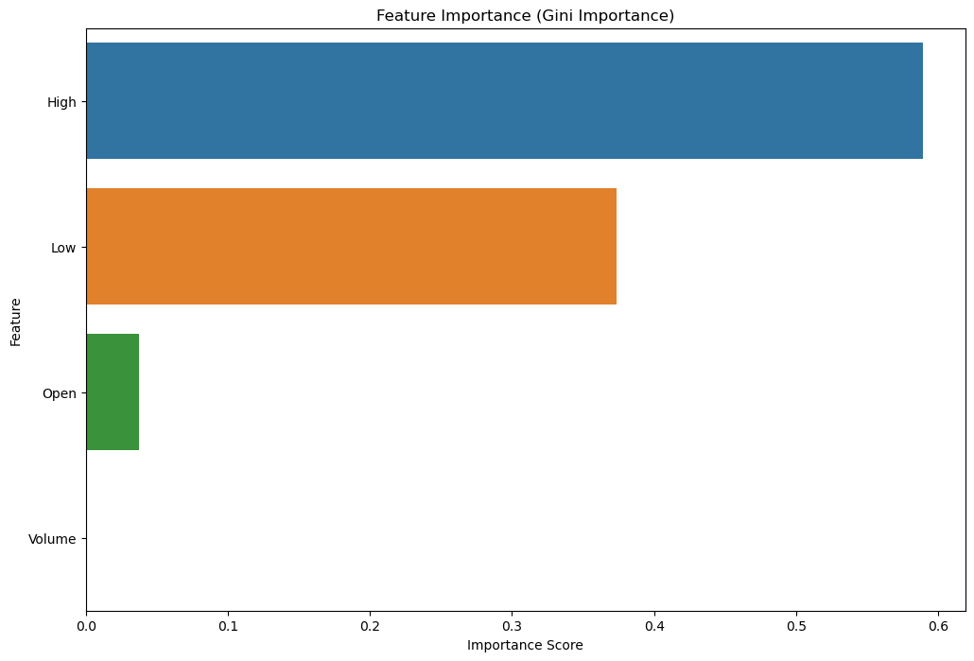
Figure 7: Gini Importance for S&P 500 Dataset
From Figure 7 the results of the feature importance of various features based on Gini importance shows "High" with importance score of about 0.55 and "Low" with a score of about 0.4 as the most influential features. "Open" with an importance score of 0.04 has minimal impact while "Volume" has no impact in the model.
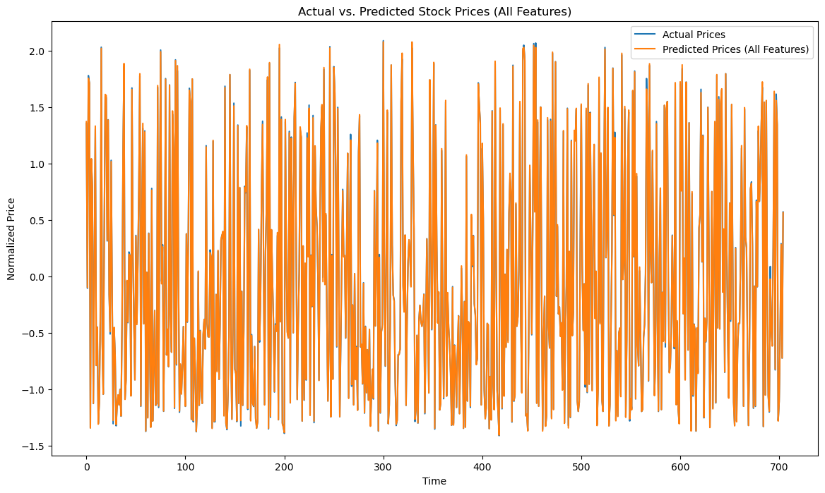
Figure 8: Actual vs. Predicted Stock Prices for the S&P 500 Dataset
Figure 8, like in the Google dataset, shows also that the model seems effective at predicting stock prices over time as displayed by the close alignment between actual and predicted prices. Again, minor discrepancies are visible but in all the model performs well in capturing the trend and variability of the stock prices.
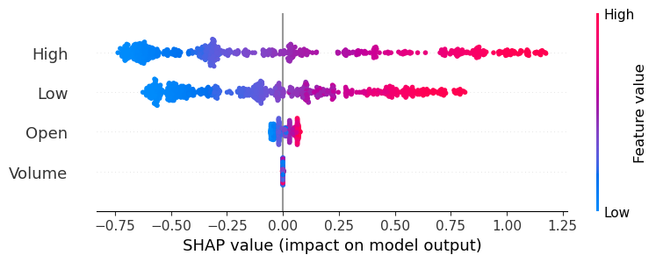
Figure 9: SHAP Summary Plot for the S&P 500 Dataset
Similarly, Figure 9 shows that the features "High" and "Low" are the most influential in the model with higher values of these features positively impacting the predictions. "Open" has minimal impact, while "Volume" has virtually no impact on the model's predictions. This aligns with the previous Gini importance chart which also showed "High" and "Low" as the most important features.

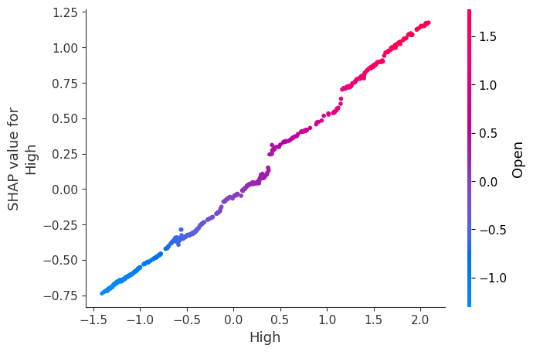
Figure 10: SHAP Analysis for Important Feature for the S&P 500 Dataset

The SHAP dependence plot for the S&P 500 dataset, from Figure 10, shows that higher values of "High" generally contribute positively to the output of the model with the impact being stronger when "Open" is also high.
5. Conclusion
This study focused on enhancing stock price prediction using ensemble ML techniques, specifically Bagging (Random Forest), Boosting (GBMs), and Stacking, with datasets from two prominent companies: Google and S&P 500 index. The research demonstrated that ensemble models like Stacking and Boosting exhibited higher R² values and lower MAE showcasing their ability to capture complex patterns in stock price movements. Moreover, these ensemble models proved robust across different datasets and market conditions.
A key contribution of the study was the interpretability provided by feature importance analysis. SHAP analysis highlighted that features such as "High" and "Low" prices had the most significant impact on predictions, with occasional importance given to "Open" prices. Similarly, Gini importance applied to Google and S&P 500 datasets validated the findings, ranking "High," "Low," and "Open," as the primary contributors to stock price movements. This dual feature analysis not only improved prediction accuracy but also provided insights into the driving factors behind stock price changes, adding practical value for financial analysts and market participants.

References
[1] Bousoño-Calzón, C., Bustarviejo-Muñoz, J., Aceituno-Aceituno, P., & Escudero-Garzás, J. J. (2019). On the economic significance of stock market prediction and the no free lunch theorem. IEEE Access, 7, 75177–75188. https://doi.org/10.1109/ACCESS.2019.2921092
[2] Nti, I. K., Adekoya, A. F., & Weyori, B. A. (2019). A systematic review of fundamental and technical analysis of stock market predictions. Artificial Intelligence Review. https://doi.org/10.1007/s10462-019-09754-z
[3] Nti, I. K., Adekoya, A. F., & Weyori, B. A. (2020). A comprehensive evaluation of ensemble learning for stock-market prediction. Journal of Big Data, 7(1). https://doi.org/10.1186/s40537-020-00299-5
[4] Asad, M. (2015). Optimized stock market prediction using ensemble learning. In 2015 9th International Conference on Application of Information and Communication Technologies (AICT) (pp. 263–268). IEEE. https://doi.org/10.1109/ICAICT.2015.7338559
[5] Indika, A., Warusamana, N., Welikala, E., & Deegalla, S. (2021). Ensemble stock market prediction using SVM, LSTM, and linear regression. In Proceedings of the 2021 International Conference on Data Science and Applications (ICDSA). https://api.semanticscholar.org/CorpusID:239072695
[6] Zhang, G., Patuwo, B. E., & Hu, M. Y. (1998). Forecasting with artificial neural networks: The state of the art. International Journal of Forecasting, 14(1), 35-62
[7] Tsantekidis, A., Passalis, N., Tefas, A., Kanniainen, J., Gabbouj, M., & Iosifidis, A. (2017). Forecasting stock prices from the limit order book using convolutional neural networks. IEEE Conference on Business Informatics.
[8] Dasarathy, B. V., & Sheela, B. V. (1979). A composite classifier system design: Concepts and Methodology. Proceedings of the IEEE, 67(5), 708–713. https://doi.org/10.1109/PROC.1979.11321
[9] Lin, W., Xie, L., & Xu, H. (2023). Deep-reinforcement-learning-based dynamic ensemble model for stock prediction. Electronics, 12(21). https://doi.org/10.3390/electronics12214483
[10] Zhao, J., Takai, A., & Kita, E. (2022). Weight-training ensemble model for stock price forecast. 2022 IEEE International Conference on Data Mining Workshops (ICDMW), 1–6. https://doi.org/10.1109/ICDMW58026.2022.00024
[11] Nezhad, M. T. F., & Rezaei, M. (2022). Stock price prediction using intelligent models, ensemble learning and feature selection. 2022 Second International Conference on Distributed Computing and High-Performance Computing (DCHPC), 15–25 https://doi.org/10.1109/DCHPC55044.2022.9732101
[12] Sohangir, S., Wang, D., Pomeranets, A., & Khoshgoftaar, T. M. (2018). Big data: deep learning for financial sentiment analysis. Journal of Big Data, 5, 3. https://doi.org/10.1186/s40537-017-0111-6
[13] Abe, M., & Nakayama, H. (2018). Deep learning for forecasting stock returns in the cross-section. In D. Phung, V. Tseng, G. Webb, B. Ho, M. Ganji, & L. Rashidi (Eds.), advanced techniques in knowledge discovery and data mining: PAKDD 2018 lecture notes in computer science (pp. 273–284). Springer. https://doi.org/10.1007/978-3-319-93034-3_22
[14] Qiu, X., Zhu, H., Suganthan, P. N., & Amaratunga, G. A. J. (2017). Stock price forecasting with empirical mode decomposition-based ensemble v-support vector regression model. In J. Mandal, P. Dutta, & S. Mukhopadhyay (Eds.), Computational Intelligence, Communications, and Business Analytics: Communications in Computer and Information Science (pp. 22–34). Springer. https://doi.org/10.1007/978-981-10-6427-2_2
[15] Pasupulety, U., Abdullah Anees, A., Anmol, S., & Mohan, B. R. (2019). Predicting stock prices using ensemble learning and sentiment analysis. In Proceedings of IEEE 2nd International Conference on Artificial Intelligence and Knowledge Engineering (AIKE), 215–222. https://doi.org/10.1109/AIKE.2019.00045
[16] Htun, H. H., Biehl, M., & Petkov, N. (2023). Survey of feature selection and extraction techniques for stock market prediction. Financial Innovation 9, 26. https://doi.org/10.1186/s40854-022-00441-7
[17] Mahjouby, M. E., Bennani, M. T., Lamrini, M., Bossoufi, B., Alghamdi, T. A., & Far, M. E. (2024). Predicting market performance using machine and deep learning techniques. IEEE Access, 12, 82033–82040.
[18] Chollet, F. (2015). Keras. https://github.com/keras-team/keras
[19] Scikit-learn.org (2021). sklearn.linear_model. Linear Regression-sci-kit-learn 0.24.2documentation. Retrieved from: https://scikit-learn.org/stable/modules/generated/sklearn.linear_model.LinearRegression.html
[20] Breiman, L. (2001). Random forest. Machine Learning, 45(1), 5–23. https://doi.org/10.1023/A:1010933404324
[21] Mayr, A., Binder, H., Gefeller, O., & Schmid, M. (2014). The evolution of boosting algorithms from machine learning to statistical modelling. Methods of Information in Medicine, 53, 419427.
[22] Khairalla, M. A. E., Ning, X., & Al-Jallad, N. T. (2018). Modelling and optimisation of effective hybridisation model for time-series data forecasting. The Journal of Engineering, 2018, 117–122. https://api.semanticscholar.org/CorpusID:125944055
[23] Tibshirani, R. (1996). Regression shrinkage and selection via the lasso. Journal of the Royal Statistical Society: Series B (Methodological), 58, 267-288.
[24] Shapley, L. S. (1953). A value for N-person games. In H. W. Kuhn & A. W. Tucker (Eds.), Annals of mathematical studies: Contributions to the theory of games (pp. 307–317). Princeton University Press

