Time Series Modeling of Nigerian Monthly Demand Deposits

Abstract
This paper analyzed the model performances and reviewed the features of monthly demand deposits in Nigeria during the period of economic diversification in 2016 to 2022 and the data set were originally collected through the Central Bank of Nigeria (CBN). However, the model accuracy measure was used to determine the adequacy of the model and best fit model associated to a time series GARCH and ARIMA model which was chosen and applied to actually investigate, identify, predict and forecast suitable model to describe the monthly activities on Nigerian demand deposits towards economic system that would provide major clue to liquidity in the Nigerian financial system. The GARCH (1,1) and ARIMA (2,1,2) models were estimated accordingly and diagnostic tests was also conducted to reveal the efficient and reliable model to effectively describe the state of the Nigerian economy and proffer positive solution to it. The result of figure 1 plot clearly identified linear pattern with an upward trend and non-stationarity. The result from figure 2 identified heteroscedasticity and volatility, it also describes the figure as a regular pattern of variation of an error term hence the data is stationary. The study proves that GARCH (1,1) and ARIMA (2,1,2) in table 1, 2. 3 and 4 respectively have close range of AIC and SIC values and conclude that the monthly Demand Deposits in Nigeria are not efficiently predictable over the period of time indicating that their respective variations might be caused not by pure time-series processes, but by structural ones to predict effective Nigerian economy at large.
Keywords: Modeling, ARIMA, GARCH, Demand deposits

Introduction
Bank liabilities that are paid out on demand are central elements of monetary systems. They constitute a significant portion of narrow money (M1) in Nigeria and hence an insight into the transactional aspect of the economy, financial intermediation, and trust of the economy in the banking system. Precise determination and prediction of demand deposits are thus significant in the short run liquidity management and conduct of the monetary policy, oversight and macro prudential control of the banks (Central Bank of Nigeria (CBN]). Nigeria’s financial environment has undergone pronounced structural change over the last decade. Episodes such as the 2015 oil-price shock and naira adjustment, banking consolidation and regulatory episodes, the COVID-19 economic shock of 2020, and subsequent exchange-rate and subsidy reforms have altered deposit behavior and the transmission of macroeconomic shocks to bank liabilities. These regime shifts increase the difficulty of unconditional time-series forecasting and emphasize the need for careful structural diagnostics. Empirically, Nigerian monetary series often display mixed dynamics. Some monetary aggregates and reserve series fit well with Box–Jenkins ARIMA specifications, providing reasonable short-term forecasts (e.g., external reserves modeling), while other aggregates show volatility clustering that GARCH-type models capture better (Umoh et al., 2023; Bolarinwa & Bolarinwa, 2022). Work focused specifically on demand deposits finds that they can respond to domestic macro conditions and to foreign interest-rate differentials — foreign deposit substitutes have tangible effects on domestic deposit behavior in Nigeria. This suggests that demand deposits may be jointly determined by domestic policy variables and external financial incentives, and that univariate forecasting may miss important drivers. The autoregressive model specifies that the output variable depends linearly on its own value and on a stochastic term (an imperfectly predictable term); thus, the model is in the form of stochastic difference equation or recurrence relation which should not be confused with differential equation. AR model predicts future behavior based on pass behavior it is used for forecasting when there is correlation between values in a time series and the values that precede and succeed them. Moving average model is a common approach of measuring univariate time series. It specifies that the output variable depends linearly on the current and various past values of a stochastic term. Given a time series of data X_{t}, the ARMA model is a tool for understanding and, perhaps, predicting future values in the series. The AR part involves regressing the variable on its own lagged (ie,past)values. The MA parts involves modeling the error term as a linear combination of error terms according contemporaneously and add at various times in the past. The model is usually referred to as the ARMA (P,q) model where P is the order of the AR part and q is the order of the MA part. Autoregressive moving average ARMA or autoregressive integrated moving average ARIMA models is use to find, the best fitted model to series. This paper investigates the time-series properties of monthly Nigerian demand deposits (Jan 2016–Mar 2022) and evaluates a parsimonious forecasting strategy. Because demand deposits may combine high short-frequency noise with occasional structural shifts tied to policy events or crises, the study employs a modelling strategy that emphasizes diagnostic testing: stationarity and unit-root checks, autocorrelation diagnostics, ARCH effects testing, and structural-break detection. Interpretation of results where possible is based on macroeconomic events and previous empirical results of the monetary aggregates in Nigeria.
Related Literatures
Teriba (2006) broke down M1 to examine demand-deposit behavior and discovered that demand deposits react greatly to the foreign interest differentials both in the short and long term. Manasseh et al. (2021) used the Autoregressive Distributed Lag (ARDL) technique to study money demand in Nigeria, focusing on short and long run determinants such as income, interest, and price levels. The analysis found cointegration (a consistent long-run link) between broad money demand, income, interest rates, real exchange rates, and inflation (1981Q1-2018Q4). The ECM/short-run adjustment term is negligible, thus short-run correction to disequilibrium is limited; nonetheless, the velocity of money is predictable, signaling that money-supply targeting might be useful for policy.
Akinlo (2024) investigated the asymmetric impacts of the global uncertainty index on money demand in Nigeria, employing both linear and nonlinear ARDL (NARDL) to demonstrate asymmetric short- and long-run effects. The study discovered that uncertainty is a long-run phenomenon for Nigeria's money demand, that drops in uncertainty are more important than increases (that is, negative and positive shocks have unequal long-run implications), and that money demand is unstable in both linear and nonlinear frameworks. According to Doguwa et al. (2014) investigated structural breakdowns, cointegration, and money demand in Nigeria, finding that real money balances are cointegrated with real GDP, real monetary policy rate, and exchange rate indicators, although there is a structural break in 2007Q1. Approximately 23.4% of a disequilibrium is rectified within a quarter. CUSUM/CUSUMSQ tests show parameter instability during the global financial crisis, but stability before and after the crisis; generally, the long-run money-demand relationship remains (with regime transitions accounted for).
Doguwa et al. (2014) investigated structural breakdowns, cointegration, and money demand in Nigeria, and found that real money balances are cointegrated with real GDP, real monetary policy rate, and exchange rate indicators, however there is a structural break in 2007 Q1. Within one quarter, approximately 23.4% of a disequilibrium has been rectified. CUSUM/CUSUMSQ tests show parameter instability during the global financial crisis, but stability before and after the crisis. Overall, the long-run money-demand relationship maintains (with regime transitions taken into account). Oyadeyi (2025) researched financial innovation and money demand, and his findings demonstrated that fintech/digital payments affect money-demand linkages (lowering cash demand and altering volatility). Umoh et al. (2023) applied GARCH models to the narrow money in Nigeria to measure volatility and found out that there is conditional heteroscedasticity. Bolarinwa and Bolarinwa (2022) showed that ARIMA models can be used to predict the external reserves of Nigeria. According to Ogoke (2024) demonstrated, demand deposits have a significant effect on the GDP growth in Nigeria. As a recent study on demand-deposit contracts (2024) emphasizes, the bank-run risk can prevail in the dynamics of deposit.CEIC Data and other foreign providers verify that there are high swings in money aggregates in Nigeria over the past few years.
Methodology
The data included monthly demand deposits between 2016 to 2022 and the data set was originally obtained in the official statistics portal of the Central Bank of Nigeria (CBN). This was accomplished using the time plot and the graph of the sample Autocorrelation Function and PACF acquired from the series. The AC (Box-Jenkins 1976) Function is used for the following purposes;
- To detect non-randomness in data.
- To identify an appropriate time series model if the data are not random.
The correlogram of the ACF and PACF indicate the degree of correlation within the series for lags 1, 2, 3, 4… k which denote the value of a time series at time t. The ACF of the series gives the correlations between X_{t ,} X_{t-h} for h = 1,2,3…. For a time series X_{t},, as t = 1,2,3, the ACF at lag k is given by
$ρ_{k}=\frac{Cov(X_{t},X_{t+k})}{\sqrt{Var\left(X_{t}\right)Var(X_{t+k})}}=\frac{γ_{k}}{γ_{0}}$ (3.1)
where$Var\left(X_{t}\right)=Var\left(X_{t+k}\right)=γ_{0}$ as a function of k
$γ_{k }$is the autocovariance function and the autocorrelation function. where -1≤${ ρ}_{k}$≤1.
Since both the covariance and variance are measured in the same units of measurement, ${ ρ}_{k}$ will give a pure number. If ${ ρ}_{k}$ is plotted against k, we obtain a graph of population correlation. The PACF on the other hand measures the correlation between an observation k period in the past and the present observation. The PACF is given by
$ϕ_{k+1,k+1}=\frac{ρ_{k+1}-\sum_{j=1}^{k}{ϕ_{k,j}ρ_{j+k-1}}}{1-\sum_{j=1}^{k}{ϕ_{k,j}ρ_{j}}}$ (3.2)
where: $ϕ_{k+1,j}=ϕ_{k,j}-ϕ_{k+1,k+1}ϕ_{k,k+1-j, } j=1,2,…,k.$
The graph of ACF indicates the degree of correlation within the series for the lags (k). It is defined with lag k as:
$ρ_{k}=\frac{Cov(X_{t},X_{t+k})}{\sqrt{Var\left(X_{t}\right)Var(X_{t+k})}}=\frac{γ_{k}}{γ_{0}}$ (3.3)
where$Var\left(X_{t}\right)=Var\left(X_{t+k}\right)=γ_{0}$ as a function of k
$γ_{k}$is the autocovariance function
$ρ_{k}$is the autocorrelation function.
Similarly, the PACF indicates the degree of correlation at a given lag after accounting for the correlation from the intervening lags. The PACF is denoted by:
$ϕ_{k+1,k+1}=\frac{ρ_{k+1}-\sum_{j=1}^{k}{ϕ_{k,j}ρ_{j+k-1}}}{1-\sum_{j=1}^{k}{ϕ_{k,j}ρ_{j}}}$ (3.4)
where:
$$ϕ_{k+1,j}=ϕ_{k,j}-ϕ_{k+1,k+1}ϕ_{k,k+1-j, }=1,2,…,k.$$
Checks performed on diagnosing showed that the series did not have any pronounced autocorrelation and deterministic components. Rather, it was most aptly described as a white noise process, i.e. variations were basically random and could not be forecasted through historical trends. In practice, many economic time series are non-stationary and they can be modeled only by removing the non-stationary source of variation. Often, this is done by differencing the series.
Suppose Y_{t} is non-stationary in mean, the idea is to build an ARMA model on the series X_{t} definable as the result of the operation of differencing the series of d times (in general
d= 1) :X_{t}=$∇$^{d}Y_{t}.
The ARIMA model called ARIMA(p,d,q) model is written as
$Φ$(B) $∇$^{d}X_{t} = θ(B) ɛ_{t}(3.12)

Where $Φ$(B) = (1 –$Φ$₁B-$Φ$₂B²-…-$Φ$_{p}B^{p}) $and$
$ɵ$(B) = (1 + θ₁B+ θ₂B² +…
A GARCH (Generalized Autoregressive Conditionally Heteroscedastic) model uses values of the past squared observations and past variances to model the variance at time t. This is a non-linear model used for predicting future variance using past variances and predictions of variances as the predictors. A GARCH (1,1) is given as:
$σ_{t}^{2}=α_{0}+α_{1}X_{t-1}^{2}+β_{1}σ_{t-1}^{2}$ (3.16)
GARCH (p, q) is written as
$σ$_{t}² = $α$₀ + $α$₁Y²_{t -1}+ $α$₂Y²_{t -2} +…+ $α$_{p}Y²_{t –p}+β₁$σ$²_{t-1}+…+β_{q}$σ$² _{t-q} (3.5)
This can be written as: $σ_{t}^{2}=α_{0}+\sum_{i=1}^{p}{α_{i}}Y_{t-i}^{2}+\sum_{j=1}^{q}{β_{j}σ_{t-j}^{2}}$ (3.18)
$X_{t}=σ_{t}Z_{t}, { Z}_{t}\sim N(0,1)$. $σ$_{t}² is the dependent variable, $α$_{0,}$α$_{1…}$α$_{p} are parameters to be estimated and β₁… β_{q} are explanatory variables/independent variables.
Results
FIGURE 1: Time plot of Nigerian Monthly Demand Deposits
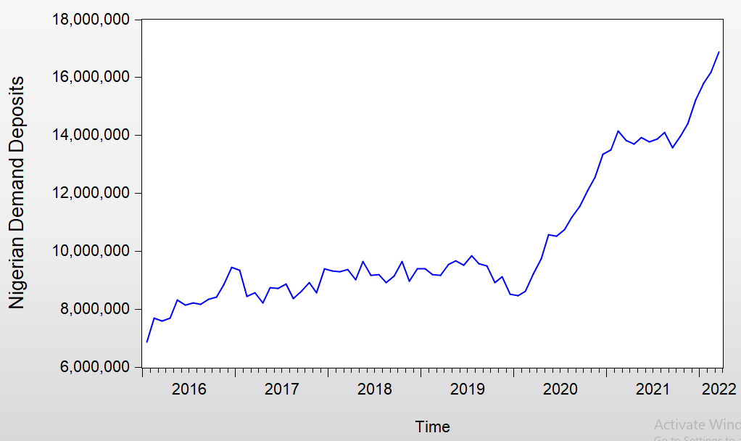

TABLE 1: Stationarity Test 1 for NGDD
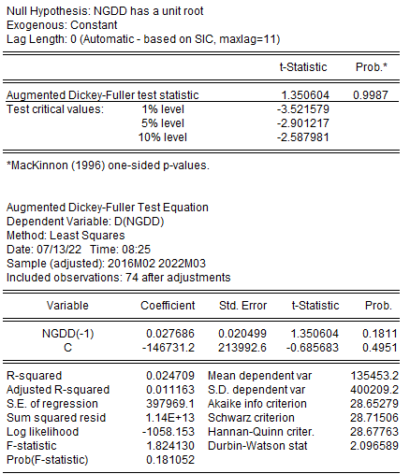

FIGURE 2: First Difference of Nigerian Demand Deposit (NGDD)
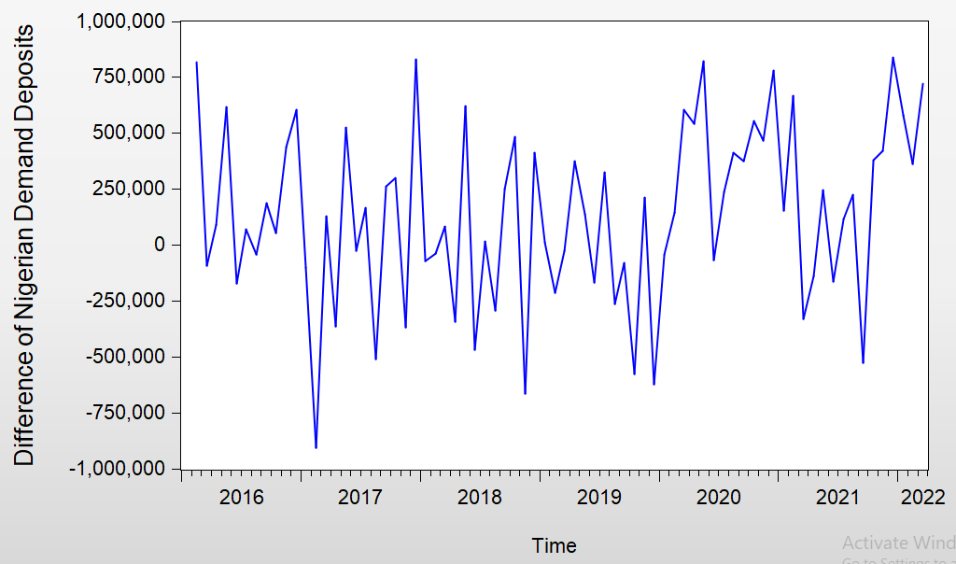

TABLE 2: Stationarity Test 2 for DNGDD
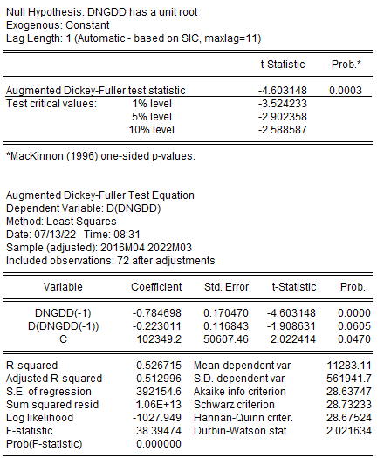

Table 3: ACF and PACF of an ARIMA (2,1,2) Fit.
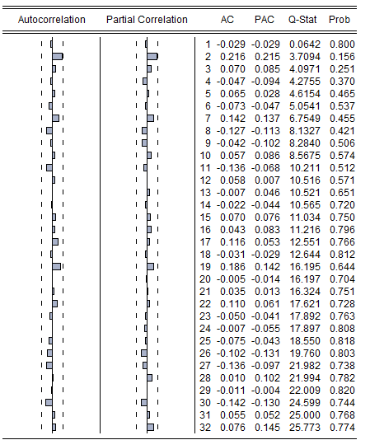
TABLE 4: Estimation of ARIMA Model For DNGDD
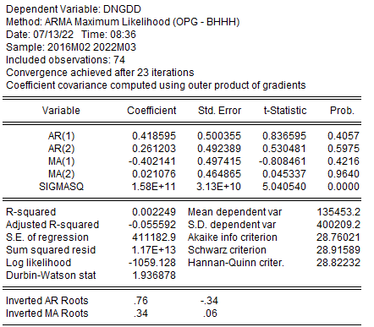

TABLE 5: Estimation of GARCH (1,1) Model For DNGDD
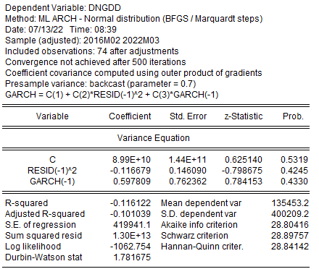

Discussion
Teriba (2006) carried out a research on the demand deposits behavior using a time series model, the AIC and SIC was used to determine the effectiveness of the models. The results show that the demand deposits reacted very high to the foreign differentials on both short and long term. Another scientist who used GARCH models to determine the demand deposits was Ugoke in 2024, according to him that the demand deposits had a significant effect on the GDP growth in Nigerian economic activities but this study also used a time series model to estimate the activities of the Nigerian monthly demand deposits and to determine the efficient model that captured the dataset. The results displayed in figure 1 represent a time plots of the Nigerian Demand Deposits without differencing. The plots clearly identified linear pattern with upward trend and a non-stationarity. The time plots revealed that the series is non-stationary as it tends to posse a general upward trend almost every. Table 2 which represent the first differencing of the Nigerian Demand Deposits observed the presence of the heteroscedasticity as there is no presence of linear pattern. It was found that the behavior of the Nigerian monthly demand deposits between 2016 and 2022 was like a white noise process which implies the previous values did not have any predictive ability on future movements. Stationarity test was conducted in Table 1 and 2 respectively using Augmented Dickey-Fuller test method but Table 3 and 5 respectively took the estimation of ARIMA (2,1,2) and GARCH (1,1) as their AIC and SIC model adequacy measures where compared to determine the efficient model to the series. The results displayed that ARIMA (2,1,2) and GARCH (1,1) on Table 1 ,2 ,3 and 4 respectively have close range AIS and SIC values. Then, the study conclude that the Monthly Demand Deposits in Nigerian are not efficiently predictable over the period of time indicating that variation might be caused not by pure time series process but by structural ones. However, changes are more likely to be caused by external shocks, policy measures and structural economic events. The time plot of monthly demand deposits most likely exhibited random ups and downs, with no continuous upward or negative trend. This visual impression corroborated the diagnostic test findings, indicating that the series behaved like a white-noise process, which means that the data varied randomly around a mean value, with no recognizable pattern from month to month. Any apparent movements were the result of external shocks or policy changes, not internal time series dynamics. As a result, the time plot shows that demand deposits in Nigeria during this era were primarily erratic and random, rather than trend-driven or autoregressive. When differencing was performed to Nigerian monthly demand deposit data, no obvious autocorrelation pattern emerged, implying that the data was already stable or behaved randomly, confirming that the differencing did not disclose any underlying predictability which means there was no structure. Essentially, the series was white noise, and differencing did not enhance stationarity since there was no intrinsic pattern to remove. The time graphic illustrates the evolution of monthly demand deposits. The diagnostic tests and ocular inspection both indicated a white-noise process, which implies unpredictability. As a result, no ARIMA model could improve predictions the best forecast was just the latest observed number {₦16,896,282.81). The outcome is contrary to the research in which ARIMA or GARCH could identify important dynamics in financial series in Nigeria. In the case of demand deposits, unpredictability represents the changes in the Nigerian financial environment and the possible effect of exogenous shocks like changes in the exchange rate and pandemic-related disturbances. The ARIMA model failed because all AR and MA parameters were statistically insignificant, and the GARCH estimation found no significant ARCH or GARCH effect, implying that there was no volatility clustering, deposit variance did not change over time, and the data behaved like homoscedastic white noise (constant variance). For the Nigerian monthly demand deposits, the fitted model is expressed as:
Yₜ = 16,896,282.81 + ε. This implies that the monthly variations in demand deposits are purely random around a mean level of ₦16,896,282.81. Hence, the best forecast for any future period is simply the most recent observed value. This observation has significant policy implications. In the case of Central Bank of Nigeria, it might not be effective depending on mechanical time-series predictions of deposits. Rather, more focus should be directed to structural modeling which involves the macroeconomic drivers of interest rates, inflation and changes in regulation. The paper examined a statistical model of the monthly demand deposit of Nigeria (2016-2022). The series turned out to be white noisy meaning that it is uncertain to make a short-term forecast and the best way to do it is to use the latest observation. Nigeria demand deposits change randomly from month to month and the past values do not predict future values (ARIMA failed). Shock effects do not persist, and there is no volatility pattern (GARCH failed). As a policy maker, the results indicate the inefficiency of just using statistical forecast in settings characterized by structural volatility. Liquidity management should be effectively extended to include wider macroeconomic indicators and models based on policies. Further studies are advised on hybrid models of structural variables with statistical methods and more extended datasets with more economic cycles.
References
Adekoya, O. B. (2020). Portfolio balance approach to asymmetries, structural breaks and stock–exchange rate nexus in Nigeria. Central Bank of Nigeria Journal, 5, 87–110.
Akinbobola, T. O. (2012). The dynamics of money supply, exchange rate and inflation in Nigeria. Journal of Applied Finance & Banking, 2(4), 117–141.
Akinlo, A.E ( 2024).Asymmetric effects of world uncertainty index on the demand for money in Nigeria.SN Business and Econometrics. https://doi.org/10.1007/s43546-024-00696-5.
Bolarinwa, B. T., & Bolarinwa, I. A. (2022). Time series modeling of Nigeria’s external reserves using Box–Jenkins ARIMA approach. African Scholar Journal of Science and Technology, 25(9), 112–128.
Datmaz, S.& Central Bank of Nigeria Research (2020). Determinants of Deposit and lending rates in Nigeria: Evidence from bank-level data.CBN occasional paper 72
Doguwa, S.I. (2014). Structural breaks, cointegration and demand for money in Nigeria. Central Bank. CBN working paper/Journal of applied Statistics. CBN publications.
Deebom, Z.D & Tuaneh, G.L. (2019). Modeling exchange rate and Nigerian deposit money market dynamics using triradiate multivariate GARCH (BEKK). Asian Journal of Economics, Business and Accounting 10(2),1-18
Fasanya, I. O., & Akinwale, O. A. (2022). Exchange rate shocks and sectoral stock returns in Nigeria: Do asymmetry and structural breaks matter? Cogent Economics & Finance, 10(1), 2045719.
Ikoku, A .(2014).Modeling and forecasting currency in circulation for liquidity management in Nigeria. CBN Journal of applied statistics, 5(1),79-104.
Manasseh C.O.,Nwakoby,I.C., & Abada, F.C.(2021) Money demand in Nigeria: Application of Autoregressive distribution lag (ARDL) approach. Asian economic and financial review 11(4),308-321
Odior, E. S., &Banuso, F. B. (2016). Monetary policy, exchange rate dynamics and inflation in Nigeria. Covenant Journal of Business and Social Sciences, 7(2), 1–18.
Ogoke, S. I. (2024). Demand deposits and economic growth, A time series analysis, International Journal of Economics, Finance and Management, 9(7),18–45. https://doi.org/10.56201/ijefm.v9.no7.2024.pg18.45.
Oyadeyi, O.O. ( 2025 ). Financial innovation and money demand in Nigeria: Exploring the impact of banking innovations, fintech developments and digital payment channels on the money demand. Social Sciences and Humanities open 12, 2025,102057.https://doi.org/10.1016.
Pepple, S. U. (2019). Comparative performance of GARCH and SARIMA techniques in financial time series forecasting. Journal of Statistics and Econometrics, 8(2), 250–262.
Teriba, A. (2006). Demand for Demand Deposits in Nigeria. Available at SSRN 874450. https://papers.ssrn.com/sol3/papers.cfm?abstract_id=874450
Umoh, I. M. (2023). GARCH and SARIMA modelling of Nigerian narrow money. Faculty of Natural and Applied Sciences Journal of Scientific Innovations, 5(2), 122-128.

