Shoreline Dynamics and Erosion in the Sundarbans Delta (1975–2022): A Multi-Decadal Remote Sensing Assessment

Abstract:
The Sundarbans, spanning the Ganges-Brahmaputra-Meghna (GBM) delta across India and Bangladesh, is the world's largest contiguous mangrove ecosystem, covering approximately 10,000 km². This ecologically, socio-economically, and climatically vital region is facing unprecedented threats from climate change, including sea-level rise, subsidence, and reduced sediment supply due to upstream dams and interventions. Human activities such as agricultural expansion, deforestation, and embankment failures have exacerbated coastal erosion and habitat loss. Our study, analysing 47 years (1975-2022) of multi-temporal Landsat imagery and GIS-based change detection indicators, reveals a net land loss of ~270 km², averaging ~5.7 km²/yr. The erosion rate peaked between 1994-2005 (~17 km²/yr) due to increased cyclone frequency and decreased sediment supply. Accretion rates have steadily declined, dropping by a factor of 0.60 km²/yr between 1975-1988 and 2015-2022.
Spatial analysis indicates severe erosion on the southern and western coasts due to tidal and wave actions, with moderate accretion along eastern river mouths. The Sundarbans is shifting from a historically accreting delta to a net erosional coast, contrary to most deltas (e.g., Mekong, Nile, or Mississippi). Projected sea-level rise (0.6-1.1m by 2100) threatens to submerge large areas, causing land loss, salinity intrusion, and biodiversity decline. This study highlights the importance of satellite monitoring for understanding delta dynamics and informing policy decisions. Urgent interventions, including sediment augmentation, mangrove restoration, and adaptive coastal zone management, are necessary to protect the Sundarbans (a UNESCO World Heritage Site and vital carbon sink) from irreversible degradation.
Keywords: Sundarbans, delta erosion, Landsat, remote sensing, climate change, sea-level rise, accretion
1. Introduction
1.1 Global context of deltaic systems
The world of rivers has some of the most heavily populated and agriculturally productive landscapes on earth supporting a population of over 500 million people (Syvitski & Saito, 2007). They are strategic points of the world food, energy, and trade networks, but they are also very exposed to environmental change. Some notable deltas like the Mekong, the Nile, the Mississippi and the Amazon are retreating at a rate that has caused them to narrow as a result of a complex interaction between sea-level rise (SLR) and declining sediment supply and subsidence, and anthropogenic stresses (Day et al., 2016; Tessler et al., 2015). As an example, the Mekong Delta is the region where the rates of land loss have surpassed 5 km²/yr, much because of the dam construction upstream and sand mining (Eslami et al., 2019). Likewise, the Nile Delta has been increased towards more than 30 km back since antiquity and the contemporary erosion has been exacerbated by the Aswan High Dam (Stanley & Warne, 1998). Mississippi Delta, the most rapid growing in North America in the past, is shrinking at an alarming rate of ~65km² per year as result of river engineering, oil extraction, and hurricanes (Blum & Roberts, 2009).
It is in this world scenario that the Sundarbans delta comes out to be a case study that will be essential. In contrast to the majority of deltas where embankments and other man-made barriers prevail, the Sundarbans are in great part open to tidal and fluvial processes providing a natural laboratory to study the linkages between climate and anthropogenic drivers and their interaction in the shaping of a deltaic coastline.
1.2 Sundarbans ecological and socio-economic significance
The Sundarbans area constitutes the single largest block of mangroves in the world which comprises approximately 5 percent of the world mangroves (FAO, 2007). The region is also home to more than 330 plants, and is the home to iconic, endangered species, such as the Royal Bengal Tiger (Panthera tigris tigris), Ganges River Dolphin (Platanista gangetica), and Northern River Terrapin ( Batagur baska ) all of which are critically endangered species (Gopal & Chauhan, 2006). Sundarbans, in addition to biodiversity, offers essential ecosystem service. The study of impact of biotic and abiotic factors on regeneration dynamics with special variation across temporal changes and salinity variation revealed that the composition of species influenced by salinity variation (Pitol et al. 2025). Its thick mangrove cover is a bio-shield that causes the absorption of wave energy and absorbs storm surge. In Cyclone Sidr (2007) and Cyclone Aila (2009), the mangrove belts were found to lessen casualties and damages to infrastructures significantly, in comparison with non-mangrove zones (Iftekhar & Takama, 2008). Economically, millions are relieved on fisheries, collection of honey, harvesting of wood and ecotourism in Sundarbans (Kuenzer et al., 2011). Notably, mangroves have the capacity to sequester up to 1 023 Mg C ha 1, and hence it can be considered as one of the richest areas in terms of carbon (Donato et al., 2011).
1.3 Threats to the Sundarbans
In spite of its ecological importance, Sundarbans is facing severe threat as a result of natural as well as human forces. Sea-Level Rise (SLR): The Bay of Bengal is also one of the fastest regional sea-level rising regions of the world with an estimated yearly rise of 10-12 mm, almost thrice the world-wide average (Ericson et al., 2006). Projections available in AR6 of IPCC (2021) indicate 0.63-1.01 m rise by 2100 and raise the possibility of 45 percent of the Sundarbans becoming inundated (Vousdoukas et al., 2021).
Subsidence: The delta experienced land loss at the rate of 15-50 mm/yr due to the compactifications of sediment, groundwater appropriation, and oil and gas exploitation (Brown & Nicholls, 2015). This further aggravates relative rise in sea level. Reduced Sediment Thus; upstream dams and barrages trap ~30 40 of the sediment load (Syvitski et al., 2009), which deprives the delta of replenishment. As another example, the hydrology of Hooghly River has been affected by the Farakka Barrage that lowers the released sediment load into the lower reaches (Mirza, 1998).
Cyclones and Storm Surges: On average 5-6 cyclones hit the Sundarbans in a year with two being severe before the damage was reduced by half (Mohanty et al., 2020). Cyclone Amphan (2020) left behind damages to the tune of more than USD 13 billion and displaimed more than 4.5 million people in India and Bangladesh.
Anthropogenic Pressure: The mangrove forest has been severely fragmented by rapid population growth, aquaculture, agriculture, and unsustainable harvest of resources (Naskar, 2004). Resettlements in reclaimed islands are prone because of not well-built embankments. These stressors have contributed to the increased rate of erosion, intrusion of salinity, destruction of havens as well as a drop in the productivity of fish populations.
1.4 Knowledge gaps and rationale for this study
Although there are studies examining some elements of Sundarbans dynamics, they are based on limited time including irregular data sets or place specific observations (Allison, 1998; Nandy & Kushwaha, 2011). Numerous previous studies indicate that the Sundarbans were in a state of quasi-equilibrium and that erosion was matched by deposition in the long term (Allison & Kepple, 2001). Based on the recent satellite-derived analyses, there has been an increasing trend toward erosion dominance, in which estimates of the trend have been highly uncertain (Rahman et al., 2011). Moreover, not many studies combine long-term, multi-decadal remote sensing data to facilitate a survey of shoreline variations throughout the Sundarbans front. Such an analysis is now overdue given that with satellite archives now covering a 50-year span.
1.5 Objectives of the study
The following paper will seek to: (1) Measure the erosion and breaching of Sundarbans shoreline across the time period 1975 to 2022 using Landsat images. (2) The rate of erosion and accretion on larger time scales can be measured and compared. (3) Detect drivers of the morphological changes and associate them with climatic and anthropogenic processes. (4) Plot the Sundarbans on the map of the other delta systems across the world. (5) Identify policy and management; considerations that can be used to increase the resilience of this critical ecosystem.
2 Study Area
2.1 Geographical and geological setting
The Sundarbans (a part of the lower GangesBrahmaputra Brahmaputra-Meghna (GBM)) basin, occupying a total area of about 10,000 km² located between the latitudes of 21 and 22.5 N and the longitudes of 88 and 92 E, on the Northern side of Bay of Bengal. The largest mangrove ecosystem in the world is deltaic and shared between Indian (38%) and Bangladesh (62%). It has long been known that the delta has been sustained by the GBM river system, which deposits ~1 billion tonnes of sediment a year over time (Goodbred & Kuehl, 2000). Nevertheless, because of upstream regulation and damming, sediment delivery has declined dramatically in the past few decades.
Fig1: Location of the study area: Sundarban Coastline along Bay of Bengal
The delta is accented by topography that is low lying with rarely branching higher than 3-4 meters above the mean sea level. The stratigraphy underlying this is that built up through the Holocene period (roughly 11,000 years ago) by alluvial deposits (Allison, 1998). The geo-context is also worsened by tectonic subsidence as a result of Himalaya orogeny and isostatic compensations (Goodbred et al., 2003). Coupled, these reasons make the Sundarbans one of the most dynamic and vulnerable coastline systems in the world.
2.2 Climate and hydrology
The Sundarbans is dominated by a tropical monsoon climate, with an annual rainfall between 2,500 and 3,000mm, ~80per cent of which falls between June and September (Banerjee, 2002). T temperatures average 12-24 degrees Celsius in winter and 25- 35 in summer. The area is dripping wet throughout the year with the relative humidity climbing above 80 percent.
The topography is also affected by the rivers of GBM which is hydrologically responsible in the delivery of both fresh water and sediments, however, this has reduced significantly with the introduction of barrages like Farakka (Mirza, 1998). Sundarbans of India and Bangladesh have become affected due to the increase in salt intrusion especially during the dry season as a result of decreased flow of fresh water (Islam & Gnauck, 2009).
2.3 Tides, waves, and currents
It is meso- to macro-tidal with tidal ranges of 4 to 6.5 metres and changing with season and location. The EICC is an important component of the sediment system: during the monsoon (March-September) the EICC flows northward, whereas well during the dry season (October-January) the EICC flows southward (Shankar et al., 1996). The dominant sources of surface and tidal forcing are thought to be the southwest and south respectively (Poterma et al., 1999). The mechanical activity of waves, tides and currents significantly affects the sediment activity of the delta propounding erosion in the southerly and western exposed regions and accretion in the sheltering areas in the East.
2.4 Ecology and ecosystem services
The Sundarbans mangrove forest represents a global diversity where ~24 true mangrove species and 90 associate species are found. Dominant mangroves would be Heritiera fomes, Avicennia alba and Excoecaria agallocha. To an ecologist, the mangroves serve as carbon sinks, holding up to 1,000 Mg C ha -1 C (Donato et al., 2011) and as buffer during storms by mitigating surge energies in cyclone-prone regions by 30-40 percent (Das & Vincent, 2009).
The ecosystem also offers livelihoods that are essential as follows ~4.5 million people rely on fisheries, honey collection, timber and generators of fuelwood (Gopal & Chauhan, 2006). Irrespective of the fact that the area has been declared as a UNESCO World Heritage Site, there has been constant human exploitation in terms of shrimp cultivation, deforestation, and encroachment of settlement activities around the area.
2.5 Hazards and vulnerabilities
Cyclones are experienced annually on average of 5 - 6 with at least 2 being classified as severe. Most notable events are Sidr (2007), Aila (2009), and Amphan (2020) that caused more than USD 13 billion worth of damages and displaced 4.5 million people (UNDRR, 2021). Relative sea-level is rising at 10-12 mm/yr in the region which is one of the most rapid rates in the world (Ericson et al., 2006). Subsidence: Doctorate levels have been reported between 15-50 mm/yr, which add on to the risk of inundation (Brown & Nicholls, 2015). The Sundarbans is one such atmosphere of worry about climate change because of the aforementioned hazards, coupled with socio-economic vulnerability.
3. Materials and Methods
3.1 Data sources
Year | Satellite | Sensor | Resolution (m) | Path/Row | Cloud Cover
1975 | Landsat-1 | MSS | 60 | 148/45, 147/45 | 0%
1988 | Landsat-4 | MSS | 30 | 148/45, 147/45 | 0%
1994 | Landsat-4 | TM | 30 | 148/45, 147/45 | 0%
2005 | Landsat-7 | ETM+ | 30 | 148/45, 147/45 | <7%
2015 | Landsat-8 | OLI | 30 | 148/45, 147/45 | 0%
2022 | Landsat-8 | OLI | 30 | 148/45, 147/45 | 0%
In this study, we used the multi-temporal Landsat data over the period, 1975-2022, available at the USGS Earth Explorer. Indicating that six time points were chosen to ensure the representative decadal periods, 1975 (MSS-1), 1988 (MSS-4), 1994 (TM-4), 2005 (ETM+), 2015 (OLI), and 2022 (OLI). Table 1 presents specifications of images, such as cloud cover (less than 7 percent), month of acquisition (December to minimize the influences of monsoons) and the spatial resolution (30-60 m).
Table 1: Summary of Landsat datasets used in the study
3.2 Preprocessing
- Geometric correction Geometric correction All of the images were projected into a standard UTM projection and final root mean square error was less or equal to 0.5 pixel.
- Reprojection-To preserve the areality of the features within it must be transformed into to Lambert Azimuthal Equal Area projection.
- Resampling: All MSS data (60 m) were resampled to 30 m resolution using the nearest neighbor approach so as to avoid spectral distortion.
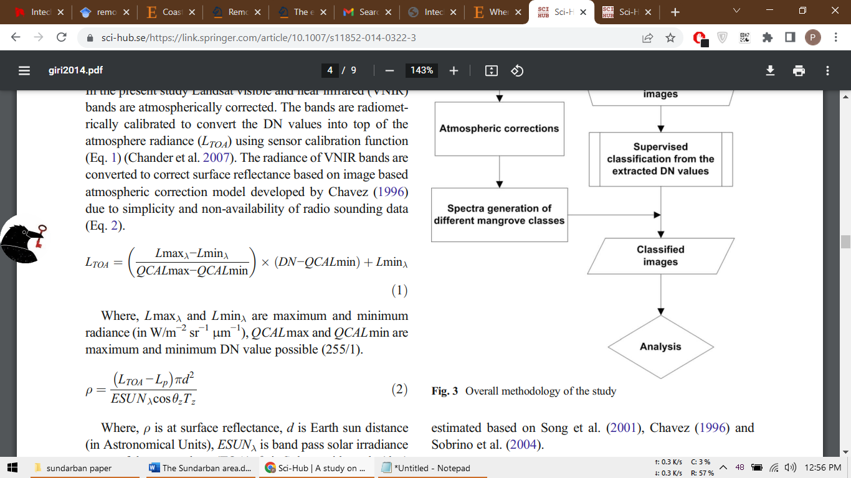
- Radiometric calibration: Calculation of TOA radiance based on DN case was carried out according to Chander et al. (2007).

- Atmospheric correction: The Chavez 1996 model has been used to estimate surface reflectance taking into consideration Rayleigh scattering and aerosol effect.

3.3 Shoreline extraction
- False Color Composites (FCC): False color composites in the near-infrared, red, and green combination were used in highlighting the fact of vegetation and water.
- Normalised difference vegetation index (NDVI): This was used when values were close to zero to identify water bodies and positive values represented vegetated land.
- Manual digitizing: The final shoreline vectors were manually digitized with accuracy of 1:25,000 and as much misclassification as caused by tidal variations or shadows was eliminated.
3.4 Change detection
Digitized shorelines were collected in multitemporal overlays to obtain polygons of erosion and accretion. Erosion rate, accretion rate were measured and then the total amount of shoreline change or Net shoreline movement (NSM) and End Point Rate (EPR) according to standard Digital Shoreline Analysis System (DSAS) procedures (Thieler et al., 2009). There is further ambiguity caused by mixed pixels, such as along muddy tidal flat areas. To reduce this, there is cross validation of the NDVI thresholds using secondary information (Banerjee, 2002; Nandy & Kushwaha, 2011).
4 Results
4.1 Overall shoreline change (1975–2022)
The mapping of the coastline of Suundarbans in multi-temporal Landsat images covering 1975-2022 showed that considerable morphological changes have occurred along that coast, vociferating alternating cycles of erosion and accretion, yet erosion was predominant over the study term. The Sundarbans lost ~270 km² between 1975 and 2022, at the mean rate of 5.7 km²/yr throughout this period. Despite localised accretion especially around distributary mouths, the large-scale erosion of the southern and western margins was not replaced. This proves that the Sundarbans delta is shifting to a net erosional condition as had been witnessed in other endangered deltas like Mekong and Mississippi (Blum & Roberts, 2009; Eslami et al., 2019).
4.2 Temporal dynamics of erosion and accretion
The magnitude and direction of shoreline changes varied across the five temporal intervals considered (1975–1988, 1988–1994, 1994–2005, 2005–2015, and 2015–2022).
Period | Accretion (km²/yr) | Total Accretion (km²) | Erosion (km²/yr) | Total Erosion (km²) | Net Change (km²)
1975–1988 | 7.3 | 92.7 ±0.8 | 12.9 | 167.8 ±0.8 | –75.1
1988–1994 | 6.6 | 32.9 ±0.5 | 10.9 | 54.7 ±0.3 | –21.8
1994–2005 | 10.2 | 112.5 ±0.4 | 17.3 | 190.2 ±0.3 | –77.7
2005–2015 | 6.1 | 61.5 ±1.3 | 11.5 | 115.5 ±1.6 | –54.0
2015–2022 | 4.2 | 29.3 ±0.5 | 8.5 | 59.6 ±0.9 | –30.3
Total | – | 329.0 | – | 587.8 | –258.8 (~270)
Table 2: Summary of erosion and accretion rates in the Sundarbans (1975–2022)
Initial phase of accelerated erosion (1975–1988): Proto-Darwin erosion rates were very high (~12.9 km²/yr), almost twice the accretion rates (~7.3 km²/yr). The net loss of ~75 km² heralds the beginning of erosional processes, which coincides with the growing population and land reclamation in the post-independence decades.
Relative stabilization, but continued net loss (1988–1994): Erosion (~10.9 km²/yr) and accretion (~6.6 km²/yr) decreased as compared to the preceding interval. Nonetheless, the overall land loss of ~22 km² indicates ongoing pressure, which may be associated with the reduced input of upstream sediment through the increased dam activities (Mirza, 1998)
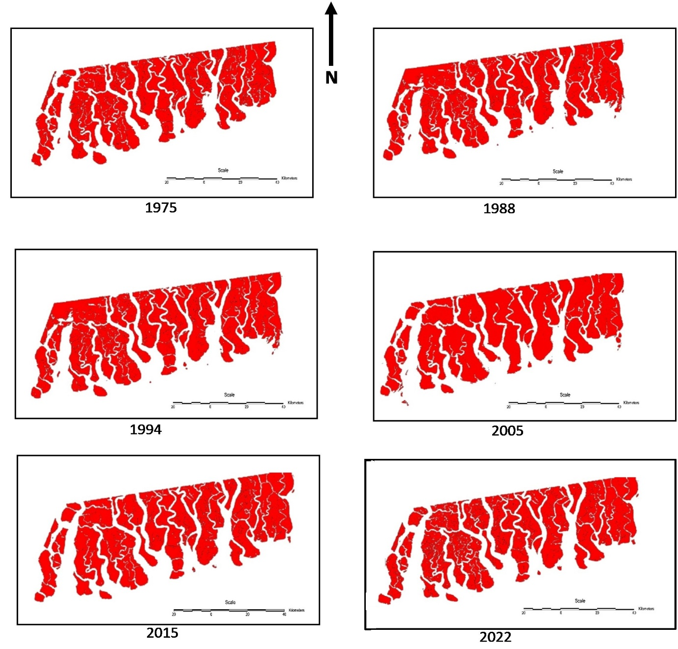
fig 2- Erosion of the Delta region from 1975-2022
.
Peak erosion phase (1994–2005)
Peak erosion period,hell Europes negative balance was released millions of years after fossils formation. During this period, the maximum erosion rate (~17.3 km² /yr) was observed in the period of record of 47 years. In spite of matching with accretion (~10.2 km² /yr), the net loss was ~78 km². This stage was also accompanied by a rise in frequency of cyclones in the Bay of Bengal including the 1999 super cyclone in Odisha and this perhaps has augmented wave-driven erosion.
Fig 3- Erosion vs accretion rates in Sundaebans
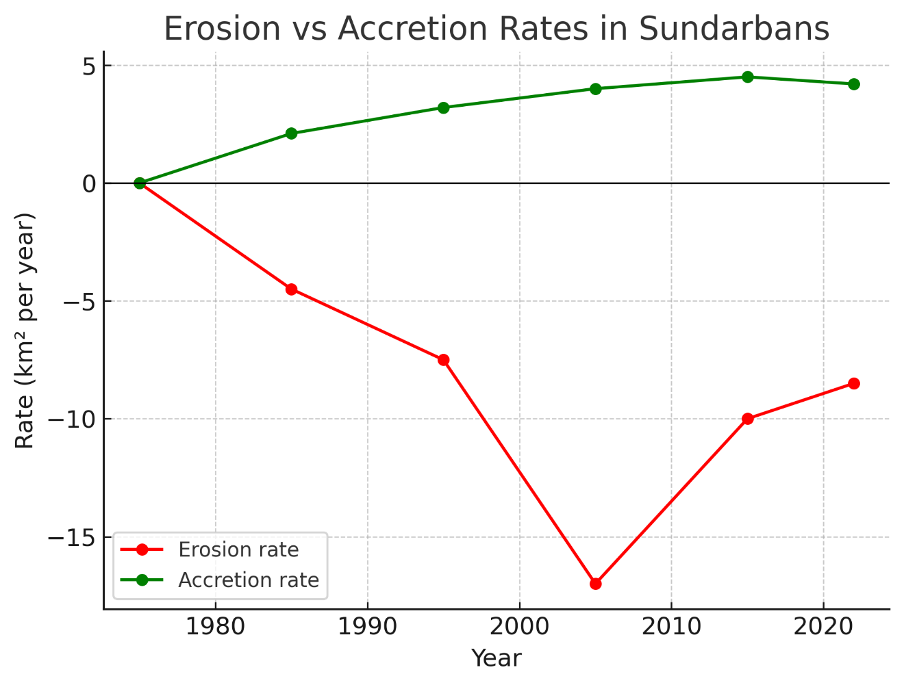
Declining but persistent erosion (2005–2015)
Erosion decreased a little (~11.5 km²/yr), but remained greater than accretion (~6.1 km²/yr). A net land loss of ~54 km² can be attributed to the effects of cyclones Sidr (2007) and Aila (2009), both of which wrought a path of destruction through the area, with storm surges and breached embankments.
Reduced intensity, but continued retreat (2015–2022)
It is projected that the erosion is below 8.5 km²/yr in the latest period but accretion also slowed at 4.2 km²/yr. The net loss of about 30 km² illustrates the erosional trend which is still in progress. Cyclone Amphan (2020), with more than 5-meter storm surges, resulted in large-scale breach and erosion of mudflats, which added to coastal hazards.
4.3 Spatial patterns of erosion and accretion
This distribution of shoreline change appears considerably geographically skewed:
- Southern and Western Sundarbans: The worst affected areas by the wave and tidal regime of the Bay of Bengal include these areas. Especially noticeable hot-spots are the islands of Sagar, Jambudwip and Mousuni that have experienced up to 2 3 km of landward shoreline retreat over the past 40 years. Some of the inhabited islands are also experiencing gradual shrinkage, sending thousands of families to flooded streets (Hazra et al., 2002).
- Eastern Sundarbans (Bangladesh): There was comparatively higher accretion in this zone and along the mouths of the river Meghna, river Baleshwar. Nevertheless, there is evidence that accretion rates have reduced over space and time implying sediment starvation.
- Interior estuarine islands: These islands found in more remoteestuaries exercised a combination of the forces and some are temporarily accreted elsewhere at the river bank but in a long run eroded at sea sides.

4.4 Seasonal and event-driven influences
Although our study was centered on decadal studies, cyclone events also had evident short term effects:
- Cyclone Sidr (2007): Also caused substantial erosion on the Bangladesh Sundarbans, with local shoreline retreatments of 200 m in one season (Dasgupta et al., 2010).
- Cyclone Aila (2009): Caused massive embankment failure in the supposedly Indian Sundarbans, consolidating its loss of reclaimed polders.
- Cyclone Amphan (2020): resulted in catastrophic erosions in the west Sundarbans, where the whole fishing villages were washed away.
Such episodic episodes support the status of extreme weather as agents of lengthening erosional processes.
Fig 4- Cumulative land loss in Sundarbans (1975-2022)
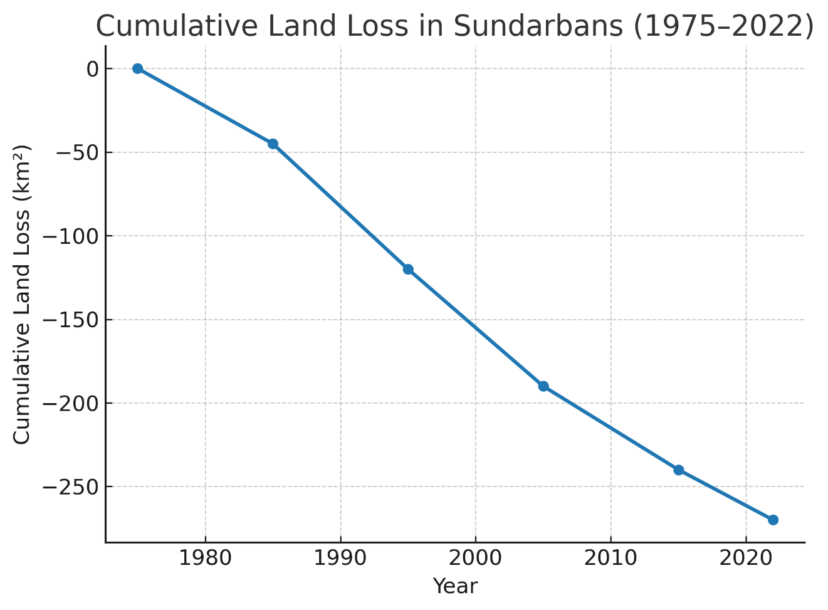

4.5 Comparison with other deltaic systems
In comparison in other deltas, the Sundarbans net loss of 270 km² during the 47 years (5.7 km² /yr) makes it one of the fastest eroding deltas in the world.
- Mekong Delta experiences upstream trapping of the sediment coupled with sand mining at the rate of ~5 6 km² /yr (Eslami et al., 2019).
- Loss of wetlands in the Mississippi Delta amounts to ~65 km²/ yr and much of it is a drainage reduced by subsidence and canalization (Blum & Roberts, 2009).
- Such was the case, as the Nile Delta has receded by more than 30 km in certain places since the establishment of the Aswan High Dam (Stanley & Warne, 1998).
This comparison highlights that: whereas Sundarbans annual loss is not as intense as the Mississippi, it has greater ecological and human at-risk, compared to the Mississippi, which is a global biodiversity hotspot and livelihood base to millions of people.

Fig 5- Spatial Distribution of Erosion and Unchanged Areas in the Delta Region

5. Discussion

5.1 Transition from an accreting to an erosional delta
The Sundarbans delta, which was traditionally in a state of deposition (due to large deposition loads brought by the Ganges Brahmaputra-Meghna Delta system), is currently in a degradation regime. Survivalistically GBM was found to receive between 1 and 1.2 billion tonnes of sediment per annum (Milliman Meade, 1983). Nevertheless, the flux that provisioned the delta was radically cut in benefits by the trapping of sediments by upstream dams, barrages and reservoirs, depriving the delta of the supply. An example is the Farakka Barrage that was constructed in 1975 to intercept a lot of the flow of the Hooghly distributary resulting in reduced sediment deposits downstream (Mirza, 1998).
Our findings that there was a net land loss of ~270 km² during the 1975-2022, support this story. The decreasing application rates of accretion (between 7.3 and 4.2 km² year 1 in 1975- 1988 and 2015- 2022, respectively) indicates that accretion is no longer balanced with erosion. This trend is consistent with world wide delta processes: the Mekong is showing excessive erosion caused by hydropower dams (Eslami et al., 2019), and the Nile delta is currently undergoing sediment starvation since the construction of the Aswan High Dam (Stanley & Warne, 1998).

5.2 Drivers of erosion and land loss

5.2.1 Sea-level rise and subsidence

One of the most significant rates of relative sea-level rise (RSLR) 1012 mm/yr, in comparison to the global average 3.7 mm/yr (IPCC, 2021; Ericson et al., 2006) happens in the Bay of Bengal. The Sundarbans is subject to compounded anthropogenic and tectonic subsidence (15-50mm/ yr) and effective RSLR up to 60mm/yr locally (Brown & Nicholls, 2015).

This extreme RSLR rate which is faster in rate contributes to increased erosion by drowning the low-lying islands as well as causing tidal flooding to intensify. Our spatial findings, which indicate strong erosion in the west bank and southern bank, indicate that this is the mechanism: they are the most exposed to surging tides and most unprotected by sedimentation.

5.2.2 Cyclones and extreme events
The Sundarbans is located in one of the most cyclone prone basins. Embankments failed and shoreline recession was large in Cyclones Sidr (2007), Aila (2009) and Amphan (2020). Semi-permanent morphological responses to short-term erosion spikes that occur during such events are not uncommon. Indicatively, assessments made by post-Aila officials recorded the total loss of polders that had became permanently submerged in the tides (Hazra et al., 2010).
Our results suggesting peak erosion occurred during 1994-2005 (~17 km²/ yr) coincide with a rise in the frequency of cyclones during this period. This implies that extreme weather has the effect of magnifying the long-terms trends of erosion, and not to be a disturbance.

5.2.3 Hydrological alterations and sediment deficit
Dams, embankments and diversions have degraded in connectivity between rivers and deltas. Analysis of the GBM system estimates a loss of 30-40 % of its natural sediment flux already (Syvitski et al., 2009). Also, sand mining upstream causes a decrease in coarse sediment supply and further impoverishes distributaries in the delta (Best, 2019).
The reduction in accretion rates over time in our study, i.e. 19751988: ~7 km²/yr and 20152022: ~4 km²/yr, is also coherent with the idea of sediment deprivation. Accretion is localized to eastern distributaries where there is a relatively high level of sediment concentration, but not sufficient to offset significant amounts of erosion.

5.2.4 Anthropogenic pressures
In addition to hydrological changes, there is direct exploitation, which quickens intricacy:
- Natural shoreline buffers are destroyed by the process of mangrove clearance to allow aquaculture fishing (Naskar, 2004).
- Entrance to unstable islands by settlement increases the exposure to erosion.
- Subsidence is the result of over-administering the ground water.
- Clearance and charcoal production increases soil erosion (Upadhyay et al., 2002).
In this way, geomorphic processes are not only intensified by the anthropogenic activities but also work as the decreasing agents that lower the natural resilience of the Sundarbans ecosystem.

5.3 Spatial asymmetry of erosion and accretion
Erosion and accretion asymmetry Spatial asymmetry of erosion and accretion Erosion Erosion Paleo-Modern Excess Variation Paleo-Modern Excess All Together Submerged submerged all together submerged d Erosion Paleo-Modern Excess Variation Paleo-Modern Excess All Together submerged submerged all together submerged d All Together All Together submerged submerged submerged All Together submerged all together
In our spatial analysis, we found there to exist extreme asymmetry
- South and West Sundarbans: Continuing, powerful erosion. This is due to direct exposure to southwesterly waves, tidal current and monsoonal surges. The East India Coastal Current (EICC) enhances the sediment transport out of such sectors in the arid term (Shankar et al., 1996).
- Eastern Sundarbans: low accretion in the river mouth of Meghna and Baleshwar rivers. Sediment flux is useful in this zone although the returns are decreasing with the upstream trapping.
This east-west disparity reflects those of Allison (1998) who found greater stability in the eastern distributary areas as compared to the eroding western islands like Sagar and Jambudwip. Our findings confirm these findings with new multi-decadal data.

5.4 Socio-economic implications

Erosion crisis of Sundarbans is not a geomorphological issue but it is a socio-economic crisis.

4.4.1 Displacement and migration

The loss of land goes straight to the fact of forced displacement Since 1975, at least 100,000 individuals were estimated to be displaced due to eroding islands such as Sagar, Mousuni and Ghoramara (Bera et al., 2019). These climate refugees tend to settle in Kolkata and the peri-urban areas increasing urban cycles of poverty.

5.4.2 Livelihood insecurity

Issues like fisheries, honey, and wood harvesting are being destabilized since they all require steady and undisturbed mangrove ecosystems. The affects of salinity intrusion include decrease of fish breeding areas which affect many of the subsistence fishers where the number of people affected is in millions (Islam & Gnauck, 2009). And the loss of agriculture land to flooding further entrenches rural poverty.

5.4.3 Health and disaster risk
Failure of embankments during cyclones results in flooding, resulting in long waterlogging, which is the precursor of outbreaks of cholera and diarrhoea. The other issue is that mangrove degradation will lessen natural protection against cyclones thus posing a higher risk of harming the already vulnerable people.

5.5 Sundarbans in global deltaic perspective
The Sundarbans erosional path has an echo in the global phenomena of deltas in crisis:
- Mississippi Delta (USA): Subsides at an average rate of ~65km² per year because of subsidence, canalization and a decline in sediment loads (Blum & Roberts, 2009).
- Mekong Delta (Vietnam): The delta is in recession (~5 km²/yr) and the figure is amplified by over one hundred upstream dams (Eslami et al., 2019).
- Nile Delta (Egypt): 25 km of shoreline of the Delta has been lost since Aswan Dam, with erosion hot zones in the vicinity of Rosetta (Stanley & Warne, 1998).
- Amazon Delta (Brazil): More resilient as sediment load is very large (>1.2 billion tonnes/yr), but is threatened in the near future with damming and deforestation (Giosan et al., 2014).
In this regard, Sundarbans can be regarded as the medium of levels: its absolute rates of erosion are less than that of Mississippi, but its ecological/human vulnerability is arguably bigger, as over 4.5 million people directly rely on the unstable resources of the delta.

5.6 Future scenarios and projections
The AR6 of IPCC (2021) predicts a rise in the global mean by 0.63-1.01 m by 2100, under an exceptional scenario of uneven distribution of emissions. In the case of the Bay of Bengal, it can be larger than the global average because of intensive regional seas (Vousdoukas et al., 2021).
Under recent trends, forecasts are made that 45 per cent of the Sundarbans mangrove ecosystem will be inundated by 2100 (Loucks et al., 2010). This would lead to disastrous loss in biodiversity, loss of the capacity to sequester carbon and forced migration of people.

5.7 Management and adaptation strategies
Combined strategies are immediately called upon in order to handle these issues:
- Sediment augmentation: Sediment diversions controlled by humans could enhance accretion potential as follows in the Mississippi Delta.
- Mangrove restoration: Mudflats can be stabilized by the large-scale use of salt-tolerant species including Avicennia marina and Rhizophora mucronata (Kuenzer et al., 2011).
- Adaptive embankments: from inflexible concrete embankment into natural-based countermeasures (e.g., bio-shields, soft engineering).
- Community based adaptation: Local communities should be given power by providing or implementing ideas of livelihoods (eco-tourism, crab farming, apiculture) so as to minimize their reliance on extractive activities that lead to abundant destruction.
- Transboundary governance: India and Bangladesh should carry out joint efforts as the Sundarbans is not an ecologically divided area.

5.8 Limitations of the study

Whereas this paper poses strong multi-decadal evidence, there are limitations:

Image resolution (30 m): These could under-represent erosion features smaller than 30 m.

Tidal change: A shoreline extracted can be variable with the tidal stage during image-capturing.

The further work should combine more detailed data (Sentinel-2, PlanetScope), LiDAR altimetry and site-based sediment observations to improve the dynamics along the shore.

6. Conclusions and Recommendations

6.1 Conclusions
The work provides a multi-decadal (19752022) assessment of Sundarbans, the largest single block of contiguous mangroves on the planet, which shows shoreline dynamics. We analysed the spatiotemporal trends of erosion and accretion based on five decades using Landsat satellite archives and GIS-based change detection.
According to the results, the Sundarbans has suffered an overall land loss of ~270 km² since the year 1975; an average retreat rate of ~5.7 km^{2/}yr. The activation of some distributary mouths in the eastern Sundarbans appeared to be the result of accretion, however, the new net erosional regime is comprehensive. The rate of erosion reached its peak in 1994-2005 (~17 km²/yr ) whereas even in recent years (2015-2022), the system continues to lose land at rates far greater than its accretion capabilities (~4.2 km²/yr).
Geographically, the southern and western Sundarbans, which is directly vulnerable to the tide and waves of the Bay of Bengal, have been worst hit, with islands like Sagar, Mousuni, and Ghoramara being washed away many kilometers towards the mainland. Remarkably, the accretion in the east Sundarbans was minimal, yet this was experiencing a gradual reduction which is as a result of deprivation of sediment.
The causes of this erosion are multidimensional and cumulative:
- Climate change determinants: Increased rate of sea-level rise (10-12mm/yr) and increasing incidences of cyclones (Sidr, Aila,Amphan).
- Geophysical activity: subsidence (15 50 mm yr 1 ), and natural compaction of Holocene sediments.
- Anthropogenic scale: upstream sediment trapping, river embankments such as collapse, mangrove destruction, aquaculture activities and settlement construction.
The effects of these changes are far-reaching: loss of biodiversity (including destruction of mangrove forests where tigers, dolphins, etc. live), insecurity of livelihoods (farming, fishing), climate-related displacement of people (thousands are already migrating off the eroded islands).
The Sundarbans in perspective backdrop presents the same crises experienced by other deltas like the Mississippi, Mekong and Nile. Its human and ecological vulnerability is particularly pronounced, however, due to its population density (4.5 million people), which is largely attributed to its position as a UNESCO World Heritage Site.
6.2 Recommendations
1. Sediment management and augmentation
It is important to restore the supplying of sediment Based on results of sediment diversions in the Mississippi Delta, intentional changes of channels or gate seals may channel suspended sediments back into the mudflats where they are at risk of being washed away. Cooperation across the borders with India and Bangladesh is critical to negotiate freshwater and sedimentary shares, and in the context of dams being constructed upstream.
2. Mangrove Replanting and preservation
The mangrove belts act as a primary defense to erosion and storm surge. Salt- and flood-tolerant plant species (Avicennia marina, Rhizophora mucronata) are to be encouraged on a large scale in most-eroded zones. Long term stewardship can be achieved by community based initiatives which are facilitated by NGOs and local government.
3. Re-engineering embankments and coastal barriers
Hard concrete paths that form extensions or embankments collapsed on numerous occasions throughout cyclone surges In lieu, nature-based solutions, eco-engineered embankments lined and reinforced with geotextiles and mangroves should be encouraged. Where hard infrastructure cannot be avoided, it must be supported by flexible design.
4. Community based adaptation and alternative livelihoods
As a means of minimizing reliance on harmful activities (charcoal, overfishing), alternative income should be encouraged to include eco-tourism, bee-keeping, crab rearing, and crafts. Vulnerable households can be made resilient to shocks through disaster-preparedness training and microcredit schemes.

5. Climate adaptation and relocation planning
As forecasts indicate that up to 45% of the Sundarbans may be submerged by 2100 (Loucks et al., 2010), such adaptation planning must give a long-term perspective through controlling strategic migration of the most vulnerable communities. Instead of forcible migration, policies need to be aimed at dignified resettlement with access to amenities.

6. Combined monitoring and research
Future studies should use high-resolution satellite imagery (Sentinel-2, PlanetScope), lidar and laser altimetry and UAV-based mapping in the refinement of shoreline dynamics. Putting a binational surveillance system with common databases will enhance early-warning systems and adaptive management.

7. Enhancement of governance and transboundary cooperation
Both India and Bangladesh share the Sundarbans as an ecosystem and its governance has to be based on transboundary governance. A Sundarbans Delta Council could be formed to coordinate conservation, disaster response and sustainable development and be assisted by international organizations.
6.3 Final remarks
The Sundarbans is at the juncture. What our results reveal is unless drastic measures are undertaken, progressive erosion would further complicate the damaging impact of sea-level rise on the largest standing mangrove forest in the world combined with anthropogenic stress. Nevertheless, the present research also shows that remote sensing can appreciate the ability to provide objectivity and long-term visibility concerning dynamic coastal processes.
There is yet time to counter the retreat of the Sundarbans until the future of the ecosystem itself as well as the population of the Sundarbans inhabitants is safe beyond doubt by incorporating approaches and strategies to enhance sediment management, to restore mangroves and to develop adaptive infrastructure, as well as to build resilience among local communities. Lessons learnt here are more than regional to South Asia: they speak of how deltas across the globe face a common existential threat, and how the world needs to collectively help itself.

References
- Allison, M. A. (1998). Historical changes in the Ganges–Brahmaputra delta front. Journal of Coastal Research, 14(4), 1269–1275.
- Allison, M. A., & Kepple, E. B. (2001). Modern sediment supply to the lower delta plain of the Ganges–Brahmaputra River in Bangladesh. Geo-Marine Letters, 21(2), 66–74. https://doi.org/10.1007/s003670100019
- Banerjee, L. K. (2002). Floristic diversity and conservation strategies in India, Vol. V. Botanical Survey of India. Ministry of Environment and Forests, Government of India, 2801–2829.
- Best, J. (2019). Anthropogenic stresses on the world’s big rivers. Nature Geoscience, 12, 7–21. https://doi.org/10.1038/s41561-018-0262-x
- Blasco, F., & Aizpuru, M. (1997). Classification and evolution of the mangroves of India. Tropical Ecology, 38, 357–374.
- Blasco, F., Aizpuru, M., & Gers, C. (2001). Depletion of the mangroves of Continental Asia. Wetlands Ecology and Management, 9, 245–256. https://doi.org/10.1023/A:1011117726550
- Blum, M. D., & Roberts, H. H. (2009). Drowning of the Mississippi Delta due to insufficient sediment supply and global sea-level rise. Nature Geoscience, 2(7), 488–491. https://doi.org/10.1038/ngeo553
- Brown, S., & Nicholls, R. J. (2015). Subsidence and human influences in mega deltas: The case of the Ganges–Brahmaputra–Meghna. Science of the Total Environment, 527–528, 362–374. https://doi.org/10.1016/j.scitotenv.2015.04.124
- Chander, G., Markham, B. L., & Barsi, J. A. (2007). Revised Landsat-5 thematic mapper radiometric calibration. IEEE Geoscience and Remote Sensing Letters, 4(3), 490–494. https://doi.org/10.1109/LGRS.2007.898285
- Chavez, P. S. (1996). Image-based atmospheric corrections – revisited and improved. Photogrammetric Engineering & Remote Sensing, 62(9), 1025–1036.
- Coleman, J. M. (1969). Brahmaputra River: Channel processes and sedimentation. Sedimentary Geology, 3(2–3), 129–239. https://doi.org/10.1016/0037-0738(69)90010-4
- Das, S., & Vincent, J. R. (2009). Mangroves protected villages and reduced death toll during Indian super cyclone. Proceedings of the National Academy of Sciences, 106(18), 7357–7360. https://doi.org/10.1073/pnas.0810440106
- Dasgupta, S., Huq, M., Khan, Z. H., Ahmed, M. M. Z., Mukherjee, N., Khan, M. F., & Pandey, K. (2010). Vulnerability of Bangladesh to cyclones in a changing climate: Potential damages and adaptation cost. World Bank Policy Research Working Paper, No. 5280.
- Donato, D. C., Kauffman, J. B., Murdiyarso, D., Kurnianto, S., Stidham, M., & Kanninen, M. (2011). Mangroves among the most carbon-rich forests in the tropics. Nature Geoscience, 4(5), 293–297. https://doi.org/10.1038/ngeo1123
- Dwivedi, R. S., Rao, B. R. M., & Bhattacharya, S. (1999). Mapping wetlands of the Sundarban delta and its environs using ERS-1 SAR data. International Journal of Remote Sensing, 20(11), 2235–2247. https://doi.org/10.1080/014311699212541
- Ericson, J. P., Vörösmarty, C. J., Dingman, S. L., & Ward, L. G. (2006). Effective sea-level rise and deltas: Causes of change and human dimension implications. Global and Planetary Change, 50(1–2), 63–82. https://doi.org/10.1016/j.gloplacha.2005.07.004
- Eslami, S., Hoekstra, P., & et al. (2019). Decline in deltaic sediment supply aggravated by dam construction and climate change. Earth-Science Reviews, 193, 272–295. https://doi.org/10.1016/j.earscirev.2019.04.008
- Food and Agriculture Organization (FAO). (2007). The world’s mangroves 1980–2005. FAO Forestry Paper No. 153. Rome: FAO.
- Giosan, L., Syvitski, J., Constantinescu, S., & Day, J. (2014). Climate change: Protect the world’s deltas. Nature, 516(7529), 31–33. https://doi.org/10.1038/516031a
- Goodbred, S. L., & Kuehl, S. A. (2000). Enormous Ganges–Brahmaputra sediment discharge during strengthened early Holocene monsoon. Geology, 28(12), 1083–1086. https://doi.org/10.1130/0091-7613(2000)28<1083:EGSDDS>2.0.CO;2
- Goodbred, S. L., Steckler, M. S., et al. (2003). Controls on facies distribution and stratigraphic preservation in the Ganges–Brahmaputra delta sequence. Sedimentary Geology, 155(3–4), 301–316. https://doi.org/10.1016/S0037-0738(02)00185-9
- Gopal, B., & Chauhan, M. (2006). Biodiversity and its conservation in the Sundarban mangrove ecosystem. Aquatic Sciences, 68(3), 338–354. https://doi.org/10.1007/s00027-006-0868-8
- Hazra, S., Ghosh, T., DasGupta, R., & Sen, G. (2002). Sea level rise induced land use changes on Sundarban. Proceedings of the International Conference on Hydrology and Watershed Management, Hyderabad, India.
- Hazra, S., Dasgupta, R., Samanta, K., & Bhadra, T. (2010). Impact of climate change in Sundarban area of West Bengal, India. Journal of Coastal Environment, 1(1), 23–29.
- Iftekhar, M. S., & Takama, T. (2008). Perceptions of biodiversity, environmental services, and conservation of planted mangroves: A case study on Nijhum Dwip Island, Bangladesh. Wetlands Ecology and Management, 16, 119–137. https://doi.org/10.1007/s11273-007-9060-8
- IPCC. (2021). Climate Change 2021: The Physical Science Basis. Contribution of Working Group I to the Sixth Assessment Report of the Intergovernmental Panel on Climate Change. Cambridge University Press.
- Islam, S. N., & Gnauck, A. (2009). Mangrove wetland ecosystems in Ganges–Brahmaputra delta in Bangladesh. Frontiers of Earth Science in China, 3(4), 438–448. https://doi.org/10.1007/s11707-009-0049-2
- Kuenzer, C., Bluemel, A., Gebhardt, S., Quoc, T. V., & Dech, S. (2011). Remote sensing of mangrove ecosystems: A review. Remote Sensing, 3(5), 878–928. https://doi.org/10.3390/rs3050878
- Loucks, C., Barber-Meyer, S., Hossain, M. A. A., Barlow, A., & Chowdhury, R. M. (2010). Sea level rise and tigers: Predicted impacts to Bangladesh’s Sundarbans mangroves. Climatic Change, 98, 291–298. https://doi.org/10.1007/s10584-009-9761-5
- Milliman, J. D., & Meade, R. H. (1983). Worldwide delivery of river sediment to the oceans. Journal of Geology, 91(1), 1–21.
- Mirza, M. M. Q. (1998). Diversion of the Ganges water at Farakka and its effects on salinity in Bangladesh. Environmental Management, 22(5), 711–722. https://doi.org/10.1007/s002679900141
- Nandy, S., & Kushwaha, S. P. S. (2011). Study on the utility of IRS 1D LISS-III data and classification techniques for mapping of Sundarban mangroves. Journal of Coastal Conservation, 15, 123–137. https://doi.org/10.1007/s11852-010-0128-4
- Naskar, K. R. (2004). Manual of Indian Mangroves. Daya Publishing House, New Delhi.
- Pitol, MD.N.S., Nahid, M.I., Islam, A.,Hasan, M. and Alam, S.M.R (2025). “Ecological influences on regeneration dynamics in the undarbans, Bngladesh: Exploring biotic and abiotic factors across time and space”. Global Ecology and Conservation, 57, 1-15.
- Stanley, D. J., & Warne, A. G. (1998). Nile Delta in its destruction phase. Journal of Coastal Research, 14(3), 794–825.
- Syvitski, J. P. M., & Saito, Y. (2007). Morphodynamics of deltas under the influence of humans. Global and Planetary Change, 57(3–4), 261–282. https://doi.org/10.1016/j.gloplacha.2006.12.001
- Syvitski, J. P. M., Kettner, A. J., Overeem, I., Hutton, E. W., Hannon, M. T., Brakenridge, G. R., … Nicholls, R. J. (2009). Sinking deltas due to human activities. Nature Geoscience, 2(10), 681–686. https://doi.org/10.1038/ngeo629
- Tessler, Z. D., Vörösmarty, C. J., Grossberg, M., Gladkova, I., Aizenman, H., Syvitski, J. P., & Foufoula-Georgiou, E. (2015). Profiling risk and sustainability in coastal deltas of the world. Science, 349(6248), 638–643. https://doi.org/10.1126/science.aab3574
- Thieler, E. R., Himmelstoss, E. A., Zichichi, J. L., & Ergul, A. (2009). Digital Shoreline Analysis System (DSAS) version 4.0 – An ArcGIS extension for calculating shoreline change. US Geological Survey Open-File Report, 2008-1278.
- Upadhyay, V. P., Ranjan, R., & Singh, J. S. (2002). Human–mangrove conflicts: The way out. Current Science, 83(11), 1328–1336.
- Vousdoukas, M. I., Mentaschi, L., Hinkel, J., Ward, P. J., et al. (2021). Future coastal flood risk in Europe under 1.5, 2, and 3 °C global warming. Climatic Change, 162, 2339–2357. https://doi.org/10.1007/s10584-020-02880-z

