HYDROGEOCHEMICAL AND GEOPHYSICAL INVESTIGATIONS OF GROUNDWATER IN THE UMUAWULU-ISIAGU AREA, SOUTHEASTERN NIGERIA

ABSTRACT
This study integrates hydrogeochemical and geophysical investigations to evaluate the groundwater quality, aquifer characteristics, and subsurface geology of Umuawulu-Nibo-Isiagu area in Awka South Local Government, southeastern Nigeria. A combination of physicochemical analysis and Vertical Electrical Sounding (VES) using the Schlumberger array was employed to characterize groundwater quality and delineate aquifer units. The hydrogeochemical results show that groundwater in the study area is generally fresh and dominated by the Ca-Mg-HCO₃ water type, as revealed by both Piper (1944) and Durov (1948) diagrams. This facies reflects carbonate weathering, silicate dissolution, and rock-water interactions as the dominant natural processes influencing groundwater chemistryin the area. The pH and electrical conductivity, major anion and cation values fall within World Health Organization (WHO, 2022) permissible limits, indicating suitability for domestic use. However, trace metal analyses revealed elevated concentrations of lead (Pb), mercury (Hg) and cadmium (Cd) in several samples, suggesting anthropogenic contamination from waste disposal, agricultural runoff, and metal corrosion. The geophysical survey revealed a multi-layered subsurface sequence consisting of lateritic sands, sandstone, and shaly units. Correlation of VES data from six stations shows that the Nanka Formation in the Umuawulu and Nibo areas is characterized by high resistivity, water saturated sandstone aquifers with good groundwater potential, while the Imo Formation in the Isiagu area comprises low resistivity wet and silty shales, acting as aquitards with limited productivity. The aquifer depths range between 65 m and 120 m, increasing southward and eastward with lithologic transitions from sand dominated to shale dominated strata. The integration of hydrogeochemical and geophysical data demonstrates that groundwater in the area is geogenically stable and recharged through the permeable Nanka sands, but is vulnerable to surface contamination from human activities. The study recommends periodic water quality monitoring, controlled waste management, and geophysically guided well siting to ensure sustainable groundwater development in the region.
Keywords: Groundwater quality, Geophysical survey, Hydrogeochemical facies, Nanka Formation, Imo Formation, Aquifer characteristics, Southeastern Nigeria

1. Introduction
Groundwater serves as a vital source of drinking and irrigation water in many developing regions, including Nigeria, where rapid population growth and unreliable surface water supplies increase dependence on subsurface reserves. However, the quality of groundwater is increasingly threatened by both natural hydrogeochemical processes and anthropogenic influences, such as agricultural runoff, industrial discharge, and poor waste management (Adimalla & Wu, 2020; Singh et al., 2022). These processes can modify the geochemical composition of aquifers, affecting their suitability for domestic and agricultural purposes (Verma et al., 2025).
The chemical characteristics of groundwater are shaped by interactions between water and the surrounding geological materials (Madu, et. al., 2022). These rock-water interactions determine the concentrations of major ions and trace elements in aquifers and help define the hydrogeochemical facies that characterize specific groundwater systems (Srinivasamoorthy et al., 2021; Li et al., 2024). Hydrogeochemical facies analysis provides an effective framework for identifying the origin and evolution of groundwater chemistry, while distinguishing between influences from natural mineral dissolution, ion exchange, and human induced contamination (Shah et al., 2023).
However, hydrochemistry alone cannot fully reveal the subsurface architecture, spatial continuity, layer thickness, and aquifer geometry that control groundwater occurrence. For that, geophysical methods, especially electrical resistivity (Vertical Electrical Sounding, VES), are indispensable. Recent studies employing integrated hydrogeochemical and geophysical approaches have successfully delineated groundwater potential zones, identified protective cover thickness, and supported well siting in heterogeneous terrains (Ikpe et al., 2025; Obiadi et. al., 2024; Alao et al., 2024; Emecheta et al., 2023; Maju-Oyovwikowhe et al., 2021).
This study combines hydrogeochemical analysis with geophysical VES surveys across Umuawulu, Nibo, and Isiagu to attain a holistic understanding of the groundwater system. The hydrogeochemical analysis will determines water types, major controlling processes, and trace metal contamination while the geophysical survey reveals subsurface layering, aquifer thickness, continuity, and depth to water. Together, these techniques allow for mapping both water quality and aquifer potential, improving the reliability of groundwater development and protection strategies in the study area.

Location and Accessibility of the Study Area
The study area lies within the Umuawulu–Isiagu region of Awka South Local Government Area (LGA), Anambra State, southeastern Nigeria. Geographically, it extends between latitudes 6° 07′ 30′′N and 6° 12′ 00′′N and longitudes 7° 04′ 00′′E and 7° 07′ 30′′E, covering an estimated area of approximately 45 square kilometres. The area is bordered by Mbaukwu to the north, Nibo to the northeast, Agulu to the west, and Obulunze to the south. Prominent local markets include the Afor Isiagu Market, Nkwo Umuawulu, and Eke Mbaukwu, which serve as commercial centers for agricultural produce, building materials, and domestic goods.
The transportation network in the area is well developed and enhances accessibility for socioeconomic purposes. The major road networks include the Awka-Enugu Expressway and the Umuawulu-Isiagu-Mbaukwu Road, which serve as primary arteries linking the area to nearby towns such as Awka, Enugu-Ukwu, Agulu, and Nibo. Several minor and feeder roads, though untarred, extend into surrounding villages. These roads are particularly important for the movement of agricultural produce and materials between communities (Okeke et al., 2023).
Topographically, the terrain is gently undulating, with elevations ranging from 120 m to 230 m above sea level, and is drained by several seasonal streams that ultimately feed into the Idemili River system. The climate of the area is tropical, characterized by two distinct seasons: a wet season from April to October and a dry season from November to March, with an average annual rainfall of about 1,800 mm and mean temperature of 27°C (NIMET, 2023; Ezeh et al., 2021).
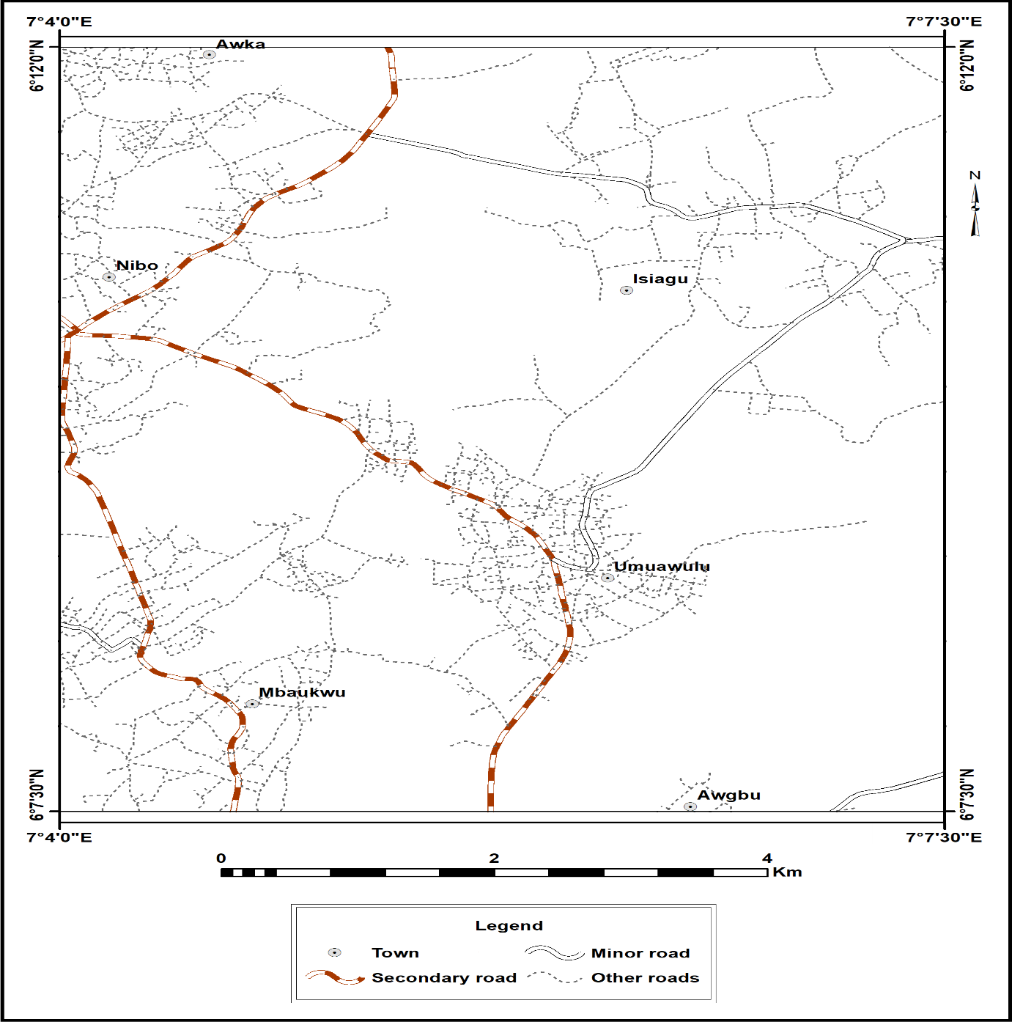
Fig. 1: Location and accessibility map of the study area
The geology of the study area.
The study area lies within the Niger Delta Basin located in southern Nigeria and extending into the Gulf of Guinea. It is intimately tied to the rifting process that shaped the Benue Trough system (Reyment, 1965; Whiteman, 1982). Geologically, the Niger Delta Basin evolved during the Late Cretaceous to Recent as a product of the separation of the African and South American plates and subsequent opening of the South Atlantic Ocean. The basin is composed of a thick sequence of marine and continental sediments deposited in various depositional environments, including fluvial, deltaic, and shallow marine systems (Short & Stauble, 1967; Reijers, 1996).
The local geology of the study area is dominated by two major lithostratigraphic units: the Nanka Formation and the Imo Formation. The Nanka Formation, also known as the Nanka Sands, underlies Umuawulu and Nibo areas. It consists predominantly of medium to coarse grained, poorly consolidated sandstones interbedded with siltstones and thin clay layers. The sands are highly permeable and form the principal aquifer unit in the area, providing significant groundwater yield. However, their loose and porous nature also makes them susceptible to contamination from surface and anthropogenic sources (Ofoma et al., 2022).
The Imo Formation, which underlies the Isiagu area, consists mainly of dark grey shales and sandstones lenses. It represents marine depositional environments and serves as a confining bed or aquitard within the sedimentary sequence. The shales of the Imo Formation are rich in organic matter and pyrite, often influencing groundwater chemistry through reduction processes and trace metal mobilization (Reijers, 1996; Ezeh et al., 2021).
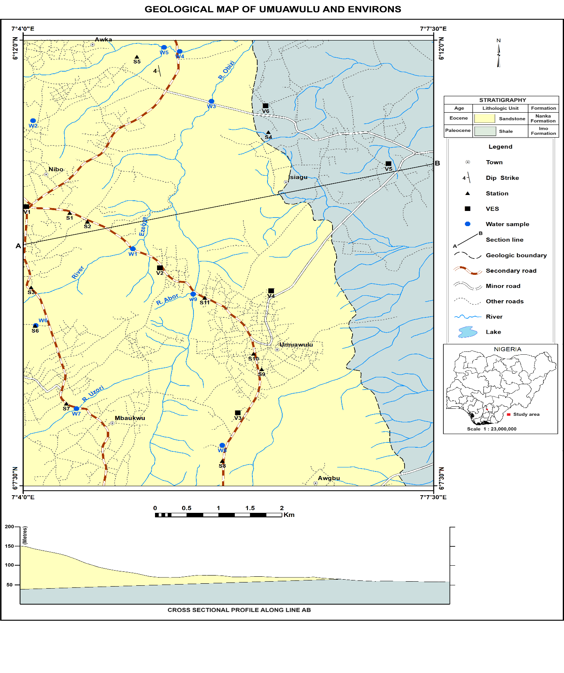
Fig. 2: The geology map of the study area showing the sampling and VES points.
Methodology
A preliminary reconnaissance survey was conducted to gain an overview of the hydrogeological setting, accessibility of sampling points, and general environmental conditions of the study area. During this phase, existing borehole locations, hand dug wells, drainage networks, and lithologic exposures were identified through field visits and local consultations. This stage also enabled the identification of potential contamination sources such as refuse dumps and agricultural lands (Ezeh et al., 2021).
Fieldwork was conducted and a total of ten (10) water samples were collected from boreholes, hand dug wells and surface water distributed across Umuawulu, Isiagu, and Nibo communities. The selection ensured spatial coverage across residential, agricultural, and peri-urban zones. Each sampling point was purged for 3-5 minutes before collection to ensure representative samples of aquifer water. Samples were collected in 1-liter pre-washed polyethylene bottles, rinsed thrice with the sample water prior to filling, and tightly capped to prevent gas exchange. For heavy metal analysis, separate 250-ml aliquots were acidified with 1 ml of concentrated HNO₃ to a pH below 2 to stabilize the metals and prevent adsorption on container walls (APHA, 2017). pH, and electrical conductivity (EC) were measured in-situ using a Hanna HI98129 portable multiparameter meter. The collected samples were transported in ice packed coolers to the Laboratory, where analyses were conducted following APHA (2017) and WHO (2022) standards. Hydrochemical data were graphically interpreted using Piper and Durov diagrams plotted in Grapher software. This helped to classify the hydrogeochemical facies and delineate the dominant processes influencing water chemistry (Srinivasamoorthy et al., 2021; Li et al., 2024).
The geophysical component of the study involved the use of the Vertical Electrical Sounding (VES) technique based on the Schlumberger configuration, which is well suited for delineating subsurface resistivity variations with depth (Okolo et al., 2024). A total of six (6) VES stations were distributed across Umuawulu, Nibo, and Isiagu to ensure adequate spatial coverage and correlation of subsurface lithologic units. The field data were acquired using a Terrameter SAS 1000 resistivity meter, with electrode spacing (AB/2) ranging from 1 to 200 meters, depending on the terrain and target depth. At each VES location, apparent resistivity values were obtained from current and potential electrode measurements. These values were plotted against half current electrode spacing on a logarithmic scale to produce VES curves. Quantitative interpretation of the VES data was conducted using IP2WIN software, which applies iterative 1D inversion modeling to derive layer resistivities and thicknesses from field curves. The interpreted parameters were validated through curve matching and constrained by field geological observations. The processed results were used to delineate the subsurface lithologic sequence, identify aquifer bearing horizons, and estimate depth to groundwater. The results from all six VES stations were correlated laterally to construct geoelectric sections, which depict the spatial variation in resistivity and layer geometry across the study area.

Results and Discussion

The physicochemical parameters of groundwater in the Umuawulu-Isiagu area reveal values that generally fall within the World Health Organization (WHO, 2019) permissible limits, indicating that the water is chemically suitable for domestic use in most locations. However, localized deviations in specific parameters, particularly pH, chloride, lead (Pb), mercury (Hg) and cadmium (Cd) suggest minor variations in groundwater quality due to geogenic and anthropogenic influences.
Table 1: Physicochemical parameters of water

Samples | pH | EC | SO₂⁻ | HCO₃⁻ | CO₃²⁻ | Cl⁻ | Ca²⁺ | Mg²⁺ | Na⁺ | K⁺ | Pb | Hg | Cd
A1 | 7.24 | 140.22 | 80.27 | 12.5 | 6.25 | 40 | 9.06 | 5.14 | 8.27 | 8.08 | - | 0.022 | 0.065
A2 | 7.19 | 183.94 | 96.12 | 20 | 10.00 | 40 | 9.01 | 8.21 | 8.27 | 8.08 | - | 0.016 | 0.052
A3 | 6.41 | 134.16 | 95.95 | 25 | 12.50 | 41 | 9.31 | 9.32 | 8.27 | 7.07 | - | 0.019 | 0.043
A4 | 7.10 | 124.30 | 107.25 | 17.5 | 8.75 | 39 | 8.51 | 8.21 | 7.67 | 7.06 | 1.37 | 0.016 | 0.035
A5 | 7.04 | 156.10 | 86.68 | 12.5 | 6.25 | 53 | 7.31 | 10.31 | 7.43 | 6.25 | - | 0.034 | 0.089
A6 | 6.42 | 204.12 | 83.31 | 35 | 17.50 | 35 | 8.21 | 8.21 | 4.79 | 9.06 | - | 0.006 | 0.091
A7 | 7.78 | 184.10 | 88.53 | 37.5 | 18.75 | 31 | 8.11 | 8.11 | 6.37 | 8.18 | 0.50 | 0.012 | 0.061
A8 | 7.84 | 192.30 | 39.29 | 22.5 | 11.25 | 25 | 8.23 | 9.23 | 2.90 | 9.06 | 0.06 | 0.004 | 0.024
A9 | 7.64 | 201.02 | 75.04 | 5 | 2.50 | 50 | 10.03 | 11.21 | 8.43 | 8.05 | - | 0.035 | 0.059
A10 | 7.59 | 144.10 | 76.39 | 12.5 | 6.25 | 50 | 7.84 | 9.33 | 0.02 | 9.26 | 0.24 | 0.022 | 0.022
WHO (2019) | 6.5-8.5 | 500 | 250 | 250 | 250 | 200 | 75 | 150 | 200 | 50 | 0.01 | 0.01 | 0.05

pH and Electrical Conductivity (EC)
The pH values range between 6.41 and 7.84, with an average of 7.33, which lies within the WHO acceptable range of 6.5-8.5. This indicates that the groundwater is neutral to slightly alkaline, a condition typical of aquifers undergoing carbonate buffering through interactions between infiltrating rainwater and carbonate rich sediments (Ezeh et al., 2021). The mildly alkaline nature also suggests that acidic inputs from organic decay or anthropogenic sources are effectively neutralized by the aquifer minerals.
Electrical Conductivity (EC) values range from 124.3 to 204.12 µS/cm, which is far below the WHO limit of 500 µS/cm, indicating low dissolved ion concentration and freshwater character. Such low EC values signify minimal salinity and low mineral dissolution, implying that the water has undergone limited geochemical evolution and remains relatively pristine (Adimalla & Wu, 2020).

Major Anions
Sulfate (SO₄²⁻) value ranges between 39.29 and 107.25 mg/L, which is below the WHO limit of 250 mg/L. This indicates that sulfate sources such as gypsum or oxidation of sulfide minerals contribute minimally to groundwater chemistry. Bicarbonate (HCO₃⁻) values range from 5 to 37.5 mg/L, suggesting active CO₂ dissolution from soil and organic matter during infiltration. These moderate levels indicate water that has undergone carbonation and silicate weathering, common in recharge areas. Carbonate (CO₃²⁻) concentrations (2.5–18.75 mg/L) are consistent with shallow aquifers in tropical climates, where CO₂ equilibrates rapidly with groundwater. Chloride (Cl⁻) values vary between 25 and 53 mg/L, remaining below the WHO standard of 200 mg/L. Chloride sources may include rainfall input and minor anthropogenic influences such as domestic waste and leachate from refuse dumps. Thus, the dominant anions occur in the order: SO₄²⁻ > HCO₃⁻ > CO₃²⁻ > Cl⁻ and the low anion concentrations confirm that rock-water interaction and natural weathering dominate groundwater chemistry rather than industrial or saline intrusion.

Major Cations
Calcium (Ca²⁺) value ranges from 7.31 to 10.03 mg/L, and magnesium (Mg²⁺) varies between 5.14 and 11.21 mg/L, both well below WHO limits of 75 and 150 mg/L, respectively. These low concentrations indicate limited dissolution of carbonate and silicate minerals. Sodium (Na⁺) concentrations range from 0.02 to 8.43 mg/L, and potassium (K⁺) values vary from 6.25 to 9.26 mg/L, also below permissible levels. The low Na⁺ and K⁺ content suggest weak cation exchange reactions, implying that groundwater flow is relatively young and less mineralized. Thus, the major cations occur in the order: Ca²⁺ > Mg²⁺ > Na⁺ > K⁺.

Trace Metals (Lead, Pb)
Among all the parameters analysed, lead (Pb), mercury (Hg) and cadmium (Cd) presents the most notable deviation from WHO standards (0.01 mg/L, 0.01 mg/L and0.05 mg/L respectively). Pb was detected in samples A4 (1.37 mg/L), A7 (0.5 mg/L), A8 (0.06 mg/L), and A10 (0.24 mg/L), all exceeding the permissible limit. Mercury concentration was also observed to be above the permissible limit in 70% of the samples (A1, A2, A3, A4, A5, A9, and A10) while the remaining 30% (A6, A7, and A8) were within the WHO, 2019 acceptable limit for mercury. Cadmium was also observed to be above the permissible limit in 50% of the samples (A1, A5, A6, A7, and A9). The elevated Pb, Hg and Cd concentrations likely originate from anthropogenic sources, including corrosion of old pipes, improper waste disposal, lead-based paint residues, or battery waste leachate. Exposure to heavy metal contaminated water poses severe health risks, including neurological, renal, and cardiovascular disorders, emphasizing the need for continuous monitoring and public awareness (WHO, 2022; Shah et al., 2023).
Hydrogeochemical Facies
The interpretation and classification of the groundwater types presented in the Durov diagram were carried out according to the hydrochemical facies classification of Piper (1944), as applied through the Durov (1948) graphical model. This approach allows for the simultaneous identification of major ion dominance and geochemical processes such as mixing, ion exchange, and mineral dissolution that influence groundwater composition.
The Piper trilinear diagram (Fig. 3) classifies groundwater based on the relative proportions of major cations (Ca²⁺, Mg²⁺, Na⁺ + K⁺) and anions (HCO₃⁻ + CO₃²⁻, SO₄²⁻, Cl⁻), allowing for the identification of hydrogeochemical facies and dominant processes influencing groundwater composition. In the cation triangle, most of the samples plot toward the Ca²⁺-Mg²⁺ field, indicating that alkaline earth elements dominate the cationic composition. This dominance reflects the dissolution of carbonate and silicate minerals, which are abundant in the sandy and clayey layers of the Nanka Formation which dominates most parts of the study area. The proximity of the points toward the Ca-Mg axis suggests limited contribution from sodium or potassium-bearing minerals, implying minimal cation exchange or anthropogenic influence.
In the anion triangle, the samples cluster toward the HCO₃⁻-CO₃²⁻ corner, indicating that bicarbonate is the predominant anion. This pattern is typical of recharge zones, where groundwater interacts with soil CO₂ and carbonate minerals, producing bicarbonate-rich water through carbonation reactions. The minor presence of chloride and sulfate implies that processes such as evaporation, industrial pollution, or saline intrusion are not significant in the area.
When the two triangles are projected onto the central diamond field, the samples group within the Ca-Mg-HCO₃ facies according to Piper (1944), signifying that the groundwater is fresh, recently recharged, and dominated by rock-water interaction processes. This facies is characteristic of groundwater that has not undergone extensive geochemical evolution or mixing with more saline or contaminated water types (Srinivasamoorthy et al., 2021; Adimalla & Wu, 2020).
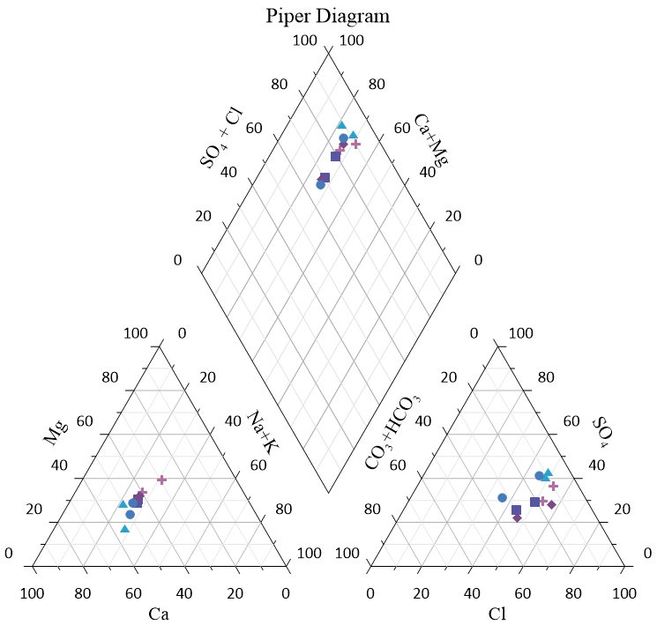
Fig. 3: Piper diagram of the water samples
The Durov diagram (Fig. 4) also classifies groundwater based on the relative concentrations of major cations (Ca²⁺, Mg²⁺, Na⁺ + K⁺) and anions (HCO₃⁻ + CO₃²⁻, SO₄²⁻, Cl⁻). It was developed by Durov (1948) to identify hydrochemical facies and the dominant geochemical processes influencing groundwater evolution. The diagram extends the Piper approach by allowing the recognition of mixing, ion exchange, and dissolution mechanisms that affect groundwater composition.
In the present study, most groundwater samples plot within the Ca-Mg-HCO₃ field of the Durov diagram, similar to their distribution in the Piper plot. This indicates that the groundwater is primarily controlled by carbonate weathering and rock-water interaction. The dominance of calcium and magnesium cations and bicarbonate anions suggests that the main hydrogeochemical process is the dissolution of calcite and dolomite minerals, which enriches the groundwater with Ca²⁺, Mg²⁺, and HCO₃⁻ ions. This approach allows for the simultaneous identification of major ion dominance and geochemical processes such as mixing, ion exchange, and mineral dissolution that influence groundwater composition.
A few samples plot slightly toward the Na⁺ + K⁺ and Cl⁻ + SO₄²⁻ fields, implying minor ion exchange and anthropogenic influences, possibly from domestic waste, fertilizers, or surface leachates. However, the distribution pattern shows that the groundwater remains fresh, low in salinity, and largely influenced by natural geochemical processes rather than extensive contamination. This agrees with the low electrical conductivity (EC) values obtained in the physicochemical analysis. This interpretation is consistent with the Piper diagram results, highlights that the groundwater in the Umuawulu-Isiagu area is chemically immature, dominated by natural mineral dissolution, and suitable for domestic use.
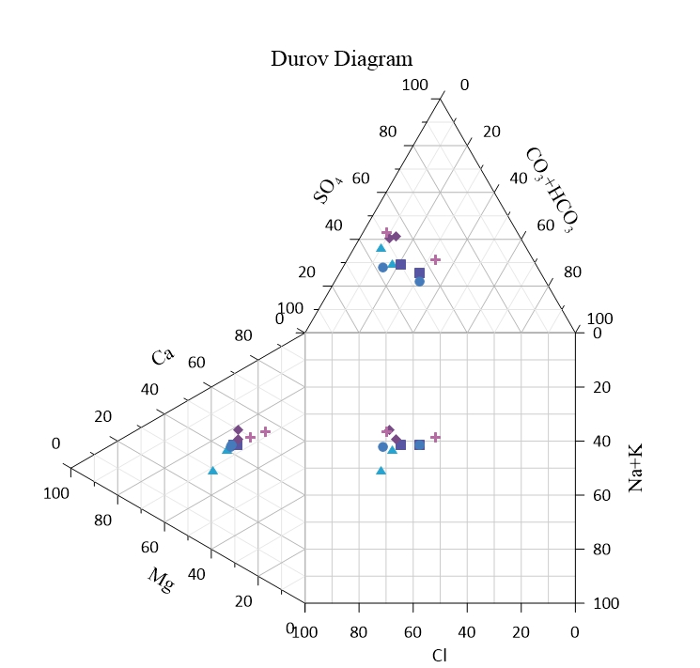
Fig. 4: Durov diagram of the water samples
Geophysical Analysis
Vertical Electrical Sounding (VES) was conducted in the study area in six (6) locations using the Schlumberger electrode configuration to determine the subsurface lithology, aquifer characteristics, and depth to groundwater across selected locations. The results revealed variable subsurface layering that reflects the contrasting geological settings of the Nanka Formation in Umuawulu and Nibo, and the Imo Formation in Isiagu.
At Eke Nibo (Station 1), the subsurface is composed of five geoelectric layers dominated by sandstone. A thick, water saturated sandstone layer with resistivity values around 183 Ωm and a thickness of about 49 m overlies a silty shale unit, with the groundwater table encountered at approximately 110 m. This suggests a productive aquifer system underlain by a confining shale layer.
Table 2: Geoelectrical layers for Station 1
Layers | Apparent Resistivity(ohm-m) | Thickness (m) | Depth (m) | Inferred Lithology
1 | 76.7 | 2.0 | 2.0 | Shaly silty sandy lateritic soil
2 | 371.7 | 8.6 | 10.6 | Lateritic Silty sandstone
3 | 943.2 | 47.4 | 58.0 | Sandstone
4 | 182.8 | 49.2 | 107.2 | Water saturated Sandstone
5 | 78.7 | ∞ | ∞ | Water saturated silty shale
At Zion City, Umuobobo (Station 2), five layers were identified, consisting of shallow sands underlain by a wet silty shale and a water saturated silty-shaly sandstone with resistivity values around 94 Ωm. Groundwater was encountered between 70 and 80 m, indicating a relatively shallow water table within a moderately productive aquifer zone.
Table 3: Geoelectric layers at Station 2 (Zion City, Umuobobo, Nibo)
Layers | Apparent Resistivity  (ohm-m) | Thickness  (m) | Depth  (m) | Inferred Lithology
1 | 130.5 | 0.6 | 0.6 | Shaly silty sandy lateritic soil
2 | 167.5 | 9.3 | 9.9 | Lateritic Silty sandstone
3 | 37.2 | 25.5 | 35.5 | Wet Silty shale
4 | 94.3 | 34.8 | 70.3 | Water saturated Silty shaly sandstone
5 | 47.3 | ∞ | ∞ | Water saturated silty shale
At the NYSC Orientation Camp, Umuawulu (Station 3), six layers were delineated. The upper part consists of highly resistive dry lateritic sands, followed by thick sandstone with resistivity values above 2000 Ωm, and a water-saturated silty-shaly sand with resistivity around 427 Ωm. The aquifer occurs at depths between 95 and 105 m, indicating a well-developed, productive sandstone aquifer beneath a thick unsaturated zone.
Table 4: Geoelectric layers at Station 3 (Nysc Orientation Camp, Umuawulu)
Layers | Apparent Resistivity  (ohm-m) | Thickness  (m) | Depth  (m) | Inferred Lithology
1 | 645.1 | 2.4 | 2.4 | Shaly silty sandy lateritic soil
2 | 4569.1 | 3.6 | 6.0 | Lateritic sandstone
3 | 1331.1 | 9.8 | 15.8 | Silty sandstone
4 | 2233.6 | 48.3 | 64.1 | Sandstone
5 | 426.5 | 44.6 | 108.8 | Water saturated silty shaly sand
6 | 214.1 | ∞ | ∞ | Water saturated silty shale

The Enugwu Village, Umuawulu (Station 4) section also displayed six layers characterized by very high resistivity dry sands (above 12,000 Ωm) overlying a water-saturated silty-shaly sand layer (approximately 2996 Ωm). The groundwater level occurs between 90 and 100 m, suggesting a thick unsaturated zone and a strong water-bearing formation at depth.
Table 5: Geoelectric layers at Station 4 (Enugwu Village, Umuawulu)
Layers | Apparent Resistivity  (ohm-m) | Thickness  (m) | Depth  (m) | Inferred Lithology
1 | 643.7 | 1.9 | 1.9 | Shaly silty sandy lateritic soil
2 | 19450.8 | 1.0 | 2.9 | Lateritic sandstone
3 | 3989.0 | 7.2 | 10.1 | Silty shaly sandstone
4 | 12006.0 | 47.1 | 57.2 | Loose / Dry Sandstone
5 | 2996.0 | 42.3 | 99.5 | Water saturated silty shaly sand
6 | 1054.0 | ∞ | ∞ | Water saturated silty shale
In contrast, the Obulunze Village, Isiagu (Station 5) section revealed seven layers dominated by low-resistivity shale materials ranging from 12.4 to 3.8 Ωm. These represent wet silty sandy shales with minor sandy interbeds, with groundwater occurring between 65 and 75 m. This reflects a shale-dominated environment with limited and discontinuous aquifer horizons.
Table 6: Geoelectric Layers at Station 5 (Obulumze Village, Isiagu)
Layers | Apparent Resistivity  (ohm-m) | Thickness  (m) | Depth  (m) | Inferred Lithology
1 | 78.8 | 0.8 | 0.8 | Shaly silty soil
2 | 1460.5 | 1.4 | 2.2 | Sandstone
3 | 129.2 | 1.8 | 4.1 | Silty sandstone
4 | 37.5 | 7.7 | 11.7 | Silty shaly sandstone
5 | 12.4 | 25.1 | 36.9 | Wet silty sandy shale
6 | 6.0 | 40.7 | 77.6 | Wet shale
7 | 3.8 | ∞ | ∞ | Wet shale
Similarly, the Pinesoof Estate, Isiagu (Station 6) revealed five layers consisting mainly of silty sands and shales. The lower layers are characterized by resistivities between 10.9 and 6.9 Ωm, corresponding to water-saturated silty sandy shale and wet shale, respectively. The groundwater level is encountered between 110 and 120 m, indicating a deep aquifer system within a predominantly fine-grained sequence.
Table 7: Geoelectric Layers at Station 6 (Pinesoof Estate, Isiagu)
Layers | Apparent Resistivity  (ohm-m) | Thickness  (m) | Depth  (m) | Inferred Lithology
1 | 719.1 | 3.5 | 3.5 | Silty sandy soil
2 | 112.0 | 9.3 | 12.8 | Silty shaly sandstone
3 | 34.7 | 24.0 | 36.7 | Sandy shale
4 | 10.9 | 76.2 | 112.9 | Water saturated silty sandy shale
5 | 6.9 | ∞ | ∞ | Wet shale
Based on the observed VES data, the Nanka Formation sections (Umuawulu and Nibo) are characterized by high resistivity sandstones, reflecting permeable, productive aquifers with good groundwater potential. The overlying sands exhibit high resistivity when dry and moderate resistivity when saturated, confirming good infiltration and recharge capacity. Conversely, the Imo Formation section (Isiagu) show low resistivity values indicative of shale rich layers with limited permeability and localized sand lenses that yield small quantities of water.
Depth to groundwater varies from approximately 65 m to 120 m across the area, being shallower in Nibo and deeper in Umuawulu and Isiagu. This variation likely reflects differences in topography, lithology, and local recharge conditions. The basal shales in both formations act as aquitards, restricting vertical percolation and helping to confine groundwater within the sandy layers above. Thus, the geophysical results indicate that the best aquifer zones occur within the Nanka Sands in Umuawulu and Nibo, which are thick, laterally extensive, and capable of sustaining domestic and small-scale industrial water supply. In contrast, the aquifers within the Imo Formation are discontinuous and less productive, owing to the dominance of shale layers.
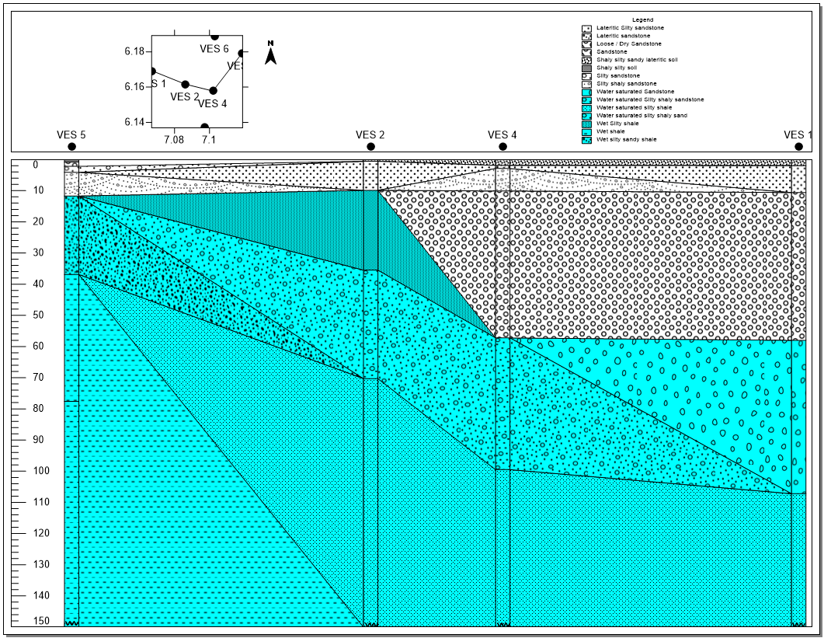
Fig. 5: Correlation of the geoelectric sections of the VES points.
Conclusion
This study has revealed that the groundwater in the study area is generally fresh, mildly mineralized, and dominated by Ca–Mg–HCO₃ hydrochemical facies, as shown in both the Piper (1944) and Durov (1948) diagrams. This indicates that carbonate weathering and rock–water interaction are the major natural processes influencing groundwater composition. Physicochemical parameters such as pH and electrical conductivity fall within WHO (2022) acceptable limits, suggesting that the water is suitable for most domestic purposes. However, trace metal analysis indicates elevated concentrations of lead (Pb) in several samples, signifying anthropogenic contamination likely derived from waste disposal, agricultural inputs, and metal corrosion.
The results of the geophysical investigation further support the hydrogeochemical interpretations, revealing a multi layered subsurface structure dominated by sandy and silty-sandy units of the Nanka Formation and shale-rich layers of the Imo Formation. The correlation of the Vertical Electrical Sounding (VES) data indicates that the Nanka Formation hosts thick, laterally extensive water-saturated sandstone aquifers with high resistivity values and good groundwater potential, while the Imo Formation is characterized by low-resistivity wet shales that act as aquitards, limiting groundwater yield. The aquifer depth ranges from approximately 65 m to 120 m, becoming deeper and less productive towards the Isiagu area, where shales dominate. Therefore, continuous monitoring of water quality, improved waste management, and stricter regulation of agricultural and domestic activities are therefore recommended to safeguard the aquifer.
References
Adimalla, N., & Venkatayogi, S. (2021). Hydrogeochemical processes and groundwater quality assessment for drinking and irrigation in semi-arid regions. Applied Water Science, 11(1), 23–35. https://doi.org/10.1007/s13201-020-01344-7
Adimalla, N., & Wu, J. (2020). Groundwater quality and associated health risks in India: Current status and future challenges. Environmental Science and Pollution Research, 27(36), 44630–44654. https://doi.org/10.1007/s11356-020-10953-3
APHA. (2017). Standard Methods for the Examination of Water and Wastewater (23rd ed.). American Public Health Association.
Durov, S. A. (1948). Classification of natural waters and graphical representation of their composition. Doklady Akademii Nauk SSSR, 59(1), 87–90.
Emecheta, C.I., Okolo, C.M., Okpara, A. O., Ifeanyichukwu, K. A., and Madu, F. M. (2023). Potential Impacts of Okpuno Egbu Dumpsite on Groundwater Resources in Parts of Nnewi, Southeastern Nigeria. Journal of Geography, Environment and Earth Science International 27 (8):51–72. https://doi.org/10.9734/jgeesi/2023/v27i8701.
Ezeh, H. N., Onu, N. N., & Nwankwor, G. I. (2021). Hydrogeochemical characteristics and groundwater quality assessment in southeastern Nigeria. Environmental Earth Sciences, 80(5), 210. https://doi.org/10.1007/s12665-021-09430-3
Li, Z., Liu, Y., & Chen, J. (2024). Hydrogeochemical evolution and water quality assessment in arid regions of northern China. Journal of Hydrology, 636, 131043. https://doi.org/10.1016/j.jhydrol.2024.131043
Madu, F.M., Okoyeh, E.I., Okolo, C.M., Aseh, P., Elomba, U.F. (2022). Irrigation Water Quality Assessment and Hydrochemical Facie of Oguta Lake, Southeastern Nigeria. European Journal of Environment and Earth Sciences, 3(1), 1-6. https://doi.org/10.24018/ejgeo.2022.3.1.221
Obiadi, I.I., Emenaha, T.O., Onyebum, T.E., Amasiani, E.J., Mgbolu, C.C., Madu, F.M., and Okeke, G.C. (2024). Groundwater potential assessment in parts of Nnewi Industrial Zone: Implications for sustainable development and conservation. Cleaner Water. Volume 1, June 2024, 100014
Ofoma, A. E., Nwosu, M. O., & Nnaji, S. N. (2022). Hydrogeological and geotechnical characteristics of Nanka Formation sediments in Anambra State, Nigeria. Journal of Earth System Science, 131(9), 272. https://doi.org/10.1007/s12040-022-01893-8
Okolo C. M., Emecheta C. I., and Madu F. M. (2024). Assessment of Aquifer Vulnerability and Groundwater Prospects Using Electrical Resistivity Method in Parts of Nnewi Southeastern Nigeria. Asian Journal of Geological Research 7 (1):1–20. https://journalajoger.com/index.php/AJOGER/article/view/152.
Piper, A. M. (1944). A graphic procedure in the geochemical interpretation of water analyses. Transactions, American Geophysical Union, 25(6), 914–928. https://doi.org/10.1029/TR025i006p00914
Shah, K., Patel, H., & Sinha, R. (2023). Hydrogeochemical facies and groundwater quality evaluation for drinking and irrigation. Environmental Earth Sciences, 82(2), 47. https://doi.org/10.1007/s12665-023-10992-4
Srinivasamoorthy, K., Rajiv Gandhi, R., & Prakash, R. (2021). Hydrogeochemical processes and water quality assessment of groundwater. Environmental Monitoring and Assessment, 193(2), 86. https://doi.org/10.1007/s10661-020-08831-8
World Health Organization (WHO). (2019). Guidelines for Drinking-Water Quality (4th ed.). Geneva: WHO Press.
World Health Organization (WHO). (2022). Guidelines for Drinking-Water Quality (5th ed.). Geneva: WHO Press.

