Sediment Characterization of the Gorai River in the pre-monsoon and post-monsoon period: Effects of decreased Ganges flow

Abstract
Grain size and ionic composition of the sediments of the Gorai riverbed were investigated. The majority of the Gorai riverbed sediments' particle size distribution falls between 101 and 250 µm (0.1-0.25 mm). The light fraction makes up 80–85% of the Gorai riverbed's sediment. The post-monsoon season has a higher concentration of cations in the sediments than the pre-monsoon season. In all sample seasons and at all sampling stations, the Sulphate (SO₄²⁻) level is much greater than the phosphate (PO₄²⁻) content. Nonetheless, the post-monsoon season has a lower PO₄²⁻ content than the pre-monsoon season in the majority of the locations. An abundance of minerals that include PO₄²⁻ and the release of PO₄²⁻ from agricultural land and urban areas following the monsoon season in the catchment region might lead to high levels of PO₄²⁻. The reduced Ganges flow most likely alters the concentration and composition of various chemical components, negatively impacting the environment. According to the study, the Gorai River system has silt pollution as a result of the Ganges' decreased flow. These changes may further harm the groundwater resources in the region under study. Sedimentation impacts fish and aquatic creature habitats, modifies stream flow, diminishes irrigation water consumption, and presents challenges for recreational and navigational activities.

Keywords: Sediment; Gorai riverbed; pre-monsoon; post monsoon; cations and anions

1. Introduction
The Ganges-Brahmaputra River system is one of the world’s largest river systems and transports a large amount of sediment and discharges a huge amount of water annually. Among three major river systems of South Asia, namely the Ganges-Padma, the Brahmaputra-Jamuna and the Meghna-Barak, Bangladesh is one of the lowest riparians (BUP, 1994). The rivers draining from the Himalaya contribute significantly to the global sediment and water discharge (Milliman and Meade, 1983). In this vicinity, the flow of water causes some sediment loading and, in some cases, water transport problems. The Padma is the major river of Bangladesh and most important in the cases of international water resources sharing issues (Ecofile, 2003; BUP, 1994; BWDB, 2001).The Gorai River is one of the largest perennial distributaries of the Padma. Most of the water in the Southwest region of Bangladesh is supplied from the two major rivers, namely Padma and Gorai. This freshwater flow is the key to maintaining environmental, social, and ecological balance in the region (BWDB, 2001; Rahman et al., 2000). The Ganges originates from the Gangetic iceberg of the Himalaya and enters Bangladesh as Padma via West Bengal of India at Rajshahi district (Rahman et al., 2000).
The major rivers and their distributaries discharge into the Bay of Bengal at peak periods about 5 million cubic feet of water per second. The sediment load has been estimated to be between 1.5 and 2.4 billion tonnes of the rivers annually (Rahman et al., 2000). The rivers contribute to the general economy, industry, and agriculture of the country by providing navigation, fisheries, water for irrigation, and fresh alluvial sediment that replenishes the soil (Rahman et al., 2000; Shamsad et al., 1999). Water column and bottom sediments contain complex combinations of minerals, organic compounds, and biota. Their sizes range from coarse grains and gravel to fine, clay-rich mud. Although produced from soils and rocks, sediments tend to behave differently from terrestrial ones. Microbial activity on organic and inorganic sediment materials and oxidation and reduction processes may explain this behaviour. Which alters sediment grain surface coatings (Baldwin et al., 2002).
This investigation characterises the sediment's chemical composition, cations, and anions, since these ions are important for the sediment particles to form larger aggregates and affect transport. Sediment deposition may be an important pathway for the removal of a pollutant from the water column (Baldwin et al., 2002). Sedimentation occurs when soil particles are eroded and carried by water or other media to reservoirs and rivers. Watershed sediment supply, transportation pace, and deposition manner all play a complex role (Ezugwu, 2013).Since 1975, Bangladesh has seen a dramatic shift due to the effects of the Farakka barrage on water levels and discharges. The post-Farakka period significantly lowered minimum discharges in February–May, median outflows in December–May, and maximum discharges in February–May (Rahman and Rahman, 2018). This cause-and-effect relationship between sedimentation and sediment characteristics is influenced by seasonal variations, especially the post- and pre-monsoon seasons after the installation of the Farakka barrage.
Numerous tributaries of the Ganges are obstructed owing to the diversion of water at the upstream Farakka Barrage, constructed in 1975. The Ganges River is vital for agriculture, fishery, forestry, industry, and potable water resources.The alteration in water flow has caused substantial modifications in the hydrology of the Ganges River system in Bangladesh. Due to the water scarcity in the Gorai basin, saltwater is intruding upstream. The river system in the southwest area of Bangladesh begins to be impacted by coastal salty water intrusion around November, peaking in April and May (Mirza and Sarker 2004).
Sediment seems to be the single greatest polluter of water (Waters, 1995), although it has not been regarded as important in Bangladesh. In the past there has been little attempt to monitor sediment quality management in Bangladesh, especially in the very high watercourse of the Padma-Gorai region (BWDB, 2001). The Ganges River is crucial to the socioeconomic well-being of the co-basin nations (Gain and Hoque 2013), and Bangladesh is the country that is most downstream in the basin. The water supply of the Ganges is partially dependent on the monsoon-dominated rainfall that occurs from July to October and the melting of Himalayan snow during the summer months of April to June (Rouillard et al., 2014); however, to the best of the author's knowledge, none of the research deliberately focused on the sediment characteristics in the post-Farakka effect in this region, even though this Ganges-Brahmaputra River system is critical for agriculture and other economic activities of the country. This study evaluated sediment size fractions and chemical properties and established criteria for assessing the overall effect of decreasing Ganges flow on downstream material.

2. Materials and methods
The research field lies in the southwestern part of Bangladesh, approximately between latitude 23°40΄30˝ and 24°89΄ N and longitude 88°42΄ and 89°21΄30˝. Being a deltaic part of the Gangetic deltaic plain, it is bounded in the north by the Padma River, separating it from Natore and Pabna districts; in the east by Pabna district; and in the south by Meherpur, Chuadanga and Jhenaidah.Figure 1 depicts the map of the studied area. The study site (Figure 1) and sampling techniques were followed according to the previous literature that measured the surface water quality (Shamsad et al., 2014).
In this investigation on the basis of a preliminary survey, twenty-three (23) sediment samples at the Kushtia Point of Gorai River (Talbaria: upstream to Muragacha:downstream) were collected from various locations to make a total study of the site (Shamsad et al. 2014). Sampling sites for sediment were selected as per sampling techniques (Chhatwal et al. 1992; Shamsad et al., 2014) which represents the whole area of the Kushtia region of Gorai River. The pots used for sediment sampling were thoroughly cleaned by rinsing with 8M HNO₃ followed by repeated washing with water sampled to avoid contamination (Chhatwal et al., 1992; Shamsad et al., 2014). The sampling pots stored under airtight condition and properly labeled for further identification (Shamsad et al., 2014).
The riverbed sediments at different depths along the Gorai River system were collected by the specially designed Ekman Dredge (25 sq. cm US Pat). Acidification of the collected sample was done in the field for Fe determination. Aeration during sampling was avoided as far as possible. Each sample was a composite of 10 sub-samples to minimize errors and heterogeneity (Shamsad et al., 1999). Samples collected from the study area were carefully transported to the laboratory, preserved in a refrigerator and were immediately analyzed for finding intended parameters of sediment and mineralogical composition of sediment or bed materials.
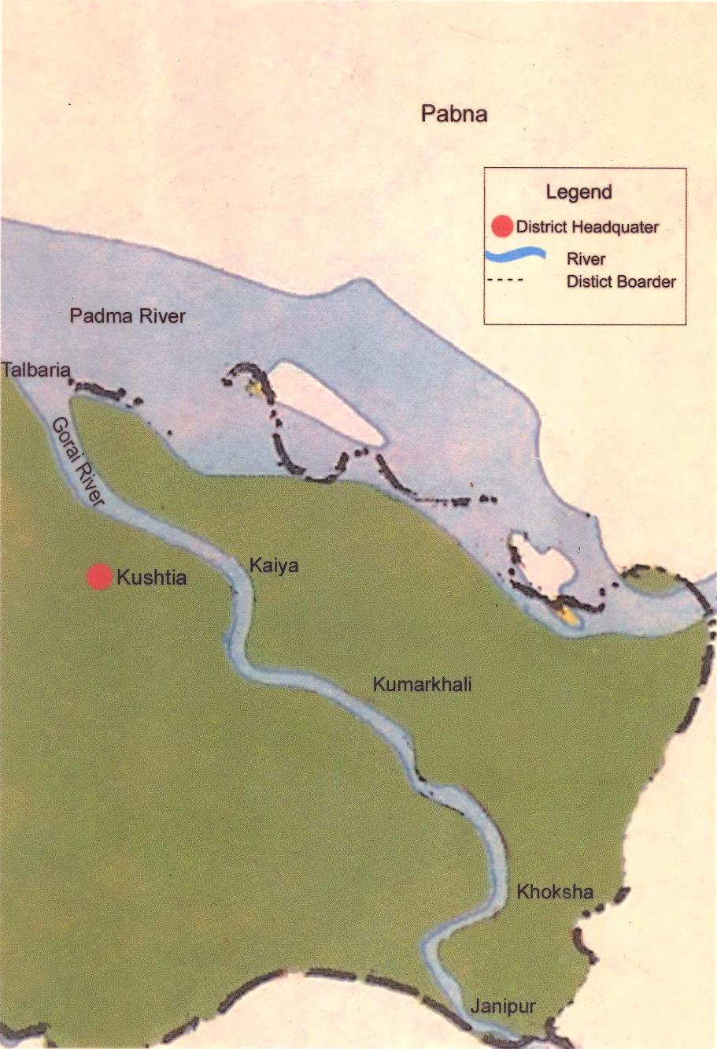
Figure 1. Map of the study area

  - Chemical composition of sediment:
The chemical parameters of the sediments of Gorai River were carried out in the laboratory. Sodium and potassium content of the samples were determined by flame photometry at 589 nm and 766 nm of wavelength respectively (Jackson, 1967) and calcium (Ca), magnesium (Mg), iron (Fe), manganese (Mn), zinc (Zn) and copper (Cu) concentrations were measured by atomic absorption spectrophotometer (Page et al. 1982). The sulphate (SO₄²⁻) and phosphate (PO₄³⁻) content were determined by spectrophotometer (Jackson, 1967).

2.2 size fraction of river sediment:
Dried sample of sediment aggregate were crushed and sieved in different size fractions (Samad and Ali, 1968; Samad, 1977). The sieving was done by an automatic sieving machine for 30 minutes (Samad, 1977). The numbers of grains in each size fractions were measured and entered data were expressed as the percentage of individual sediment size fractions. Heavy and light mineral separation was done using bromoform having a specific gravity of 2.85-2.88 (Belka et al., 2016) and then the fractions were dried in an electric oven at a temperature of 100°C for 5 hours.

3.Result and Discussion
3.1 Size fractions of sediment in Gorai riverbed
Due to the diminished upstream water flow following the construction of the Farakka Barrage on the Ganges River, substantial sediment loads are accumulating on the Gorai riverbed, obstructing the safe passage of flow and altering the hydrodynamic and morphological characteristics of the Gorai River (Rahman and Yunus, 2016). Abundance of different sized sediments in both pre- and post-monsoon season and distribution of the lowest size class (50-100 µm) along the sampling points are presented in figure 2.
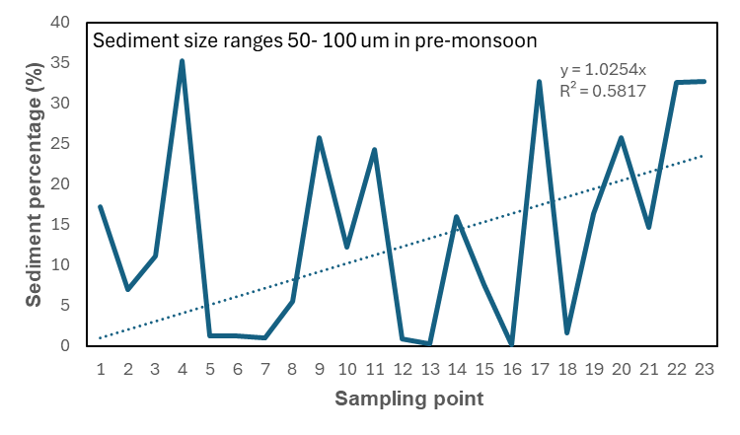  A1 | 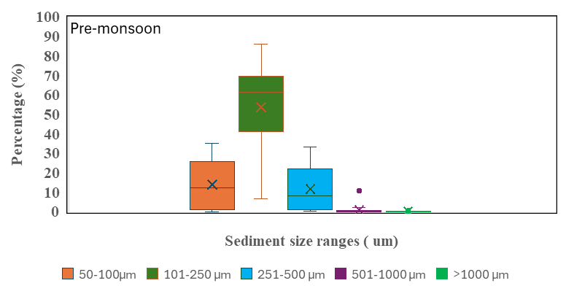  A2
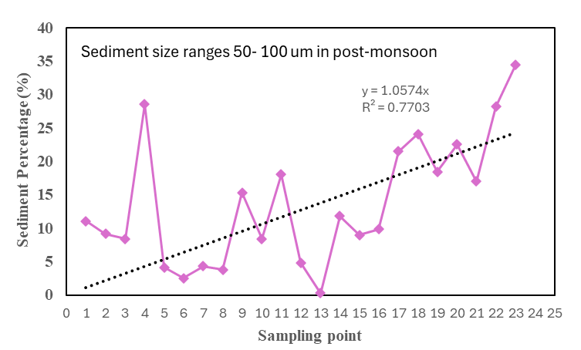  B1 | 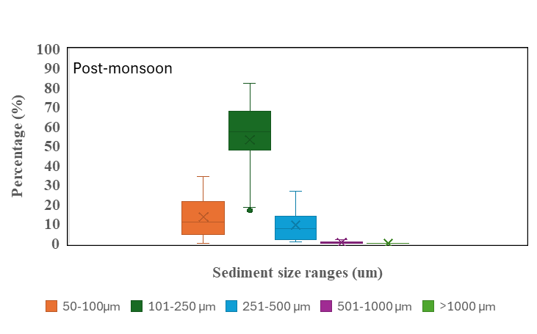  B2
Figure 2. Sediment sizes (%) of Gorai River bed in the pre- and post-monsoon period
The trend line distribution in the lowest size class indicates the higher linearity value. This comparative linearity indicates the particles are mostly deposited in the downstream with the increase of water flow and rainfall in post-monsoon than pre-monsoon season (Fig. 2 A1 and B1). And the percentage range in the box plot graphs shows the post-monsoon season has low range of sediment particles in any size class (Figure 2 A2 and B2), indicates the higher water level and waterflow drag them out of the sampling area and deposit in the surrounding depression (Vercruysse et al., 2020). Lower settling velocity of finer particles might be the cause of lower values at the beginning which gradually increases with the increase in width of the river as it approaches downstream (Dana 1985).
3.2 Cationic composition of the river sediments
Figure 3 represents the seasonal variation in cationic composition of the river sediments. The sediments contain higher concentration of cations in post-monsoon than in pre-monsoon season. In both seasons Fe shows the highest range among the cations (Figure 3 A and B). Carbonate weathering plays the dominant part in the ion chemistry of the upstream rivers of Ganges Brahmaputra River system. The rise in water volume and increased flow of water from up to downstream rivers result in the higher concentration of cations in the downstream rivers during post-monsoon periods. Weathering of silicate and contribution from saline/alkaline soils and groundwater may also act as a source of cations in the river water (Sarin et al., 1989).

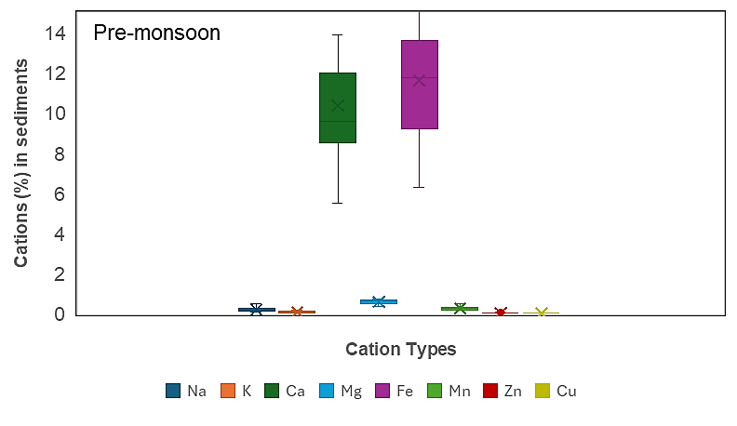  A | 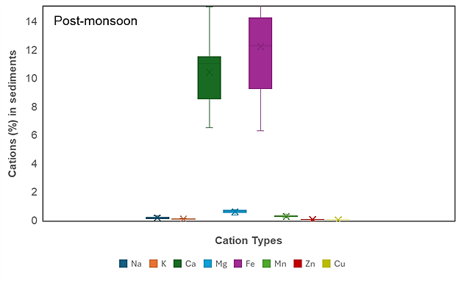  B
Figure 3. Cationic composition of Gorai River sediments in pre- and post-monsoon periods
Heavy rainfall in monsoon period causes increased erosion of soil and as a result iron-rich particles are transported from terrestrial sources into rivers (Babu et al., 2019). Release of iron from decomposition of organic matter in soil and water is stimulated by monsoon rains (Sharma et al., 2017). Soluble iron can be released by dissolution of iron oxides due to change water level and availability of oxygen in the monsoon seasons (Singh et al., 2020). All of these processes lead to an increase in iron concentration in rivers during post-monsoon periods.

3.3 Linear relationship of cations and anions in the sediments
Figure 3 Describe the increasing and decreasing trend of ionic relation of cations and anions. The relationship between cations (Fe, Mg and Ca) and PO4 concentrations show increasing trend both in pre-monsoon and post-monsoon seasons while it is more prominent in pre-monsoon season than in post-monsoon season (Figure 4 A1, A2, A3 and B1, B2, B3). The result shows mixed relationships between cations (Fe, Mg and Ca) and SO₄²⁻ concentrations (Figure 4 C1, C2, C3 and D1, D2, D3). In case of Calcium, the trend is decreasing in both the seasons while it is completely opposite when Mg is in concern. The relationship between Fe and SO₄²⁻ concentration shows increasing trend in pre-monsoon but it goes other way in post-monsoon season. Factors influencing the interactions between the elements are pH, redox potential, microbial activity and organic matter content. Solubility of PO₄²⁻ minerals and binding of PO₄²⁻ by Fe can be significantly affected by the changes in pH. Mobility of Fe and SO₄²⁻ can be influenced by redox conditions. Release and immobilization of PO₄²⁻ can be significantly regulated by microbial activity (House and Denison, 2002; Franciskovic-Bilinski and Sakan, 2021).
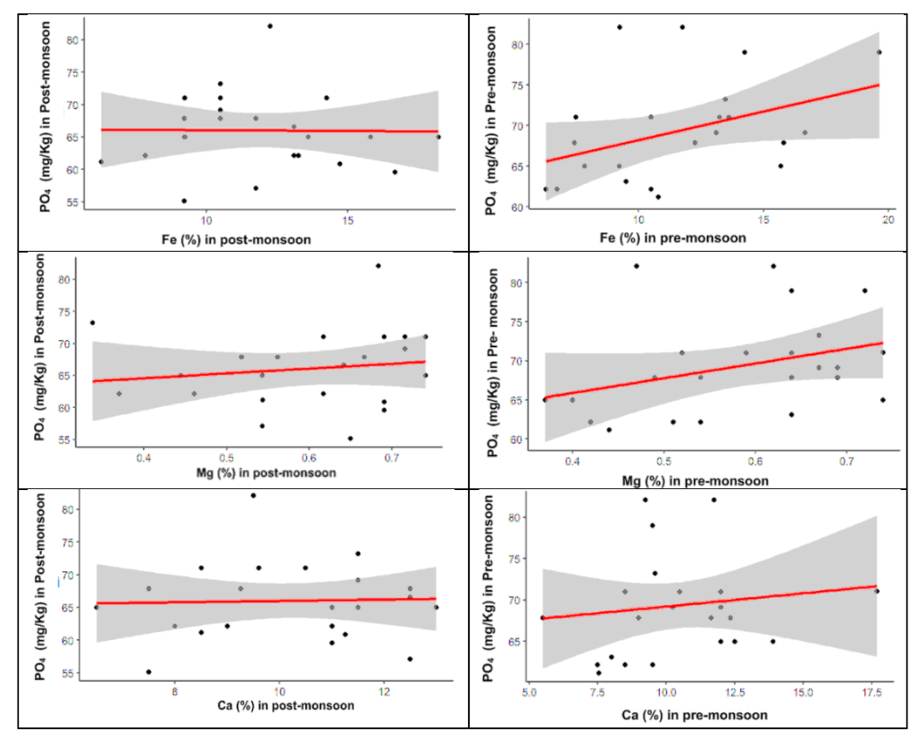
B3
B2
B1
A3
A2
A1
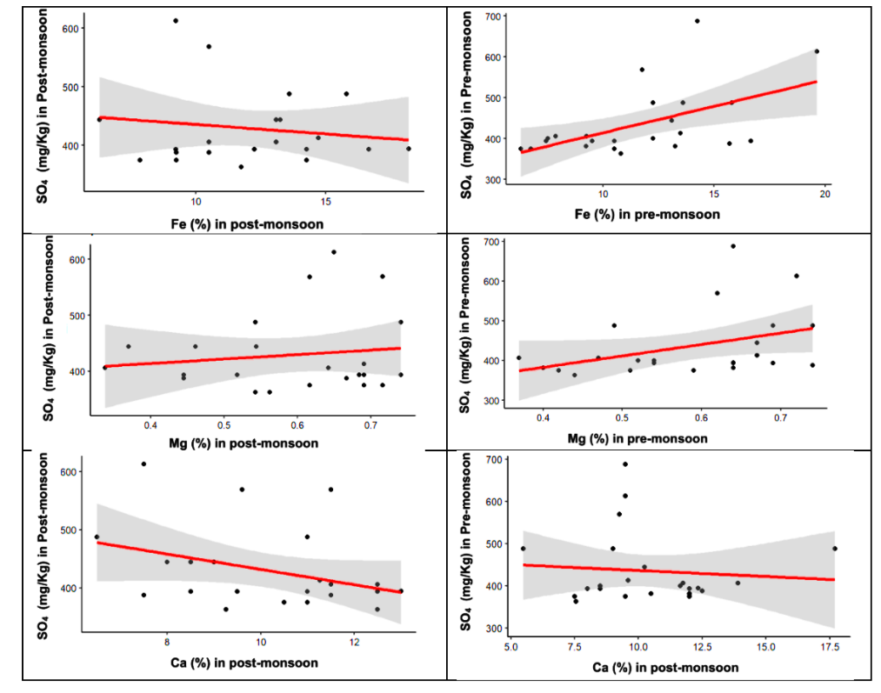
D3
D2
D1
C3
C2
C1
Figure 4. Trend of pre-monsoon and post-monsoon sediment cation and anion relation with confidence interval.

3.4 Sulphate (SO₄²⁻) and phosphate (PO₄²⁻) in the sediment’s samples
Sulphate (SO₄²⁻) and phosphate (PO₄²⁻) content at different sampling points in pre- and post-monsoon seasons are presented in figure 5. Sulphate content is much higher than that of PO₄²⁻ in all sampling points and in both the sampling seasons. However, PO4²⁻ content, in most of the points, is lower in post-monsoon than in pre-monsoon season. When SO₄²⁻ content is in concern, there is no particular trend in seasonal variation. The major sources of PO₄²⁻ in sediment are weathering of rocks and minerals, mineralisation of organic debris, and waste products from agricultural and anthropogenic activities (Watson et al. 2018). Abundance of PO₄²⁻ containing minerals along with discharge of PO₄²⁻ from agricultural land and urban places in the catchment area can result in high PO₄²⁻ concentration (Ravi et al., 2022). Atmospheric deposition, agricultural and urban runoff, as well as dissolution of SO₄²⁻ containing minerals, like gypsum and anhydrite, in the catchment area account for the SO₄²⁻ ion in the river sediment (Lucassen et al., 2004). These trend of mineralogical composition might be due to the decrease in the flow of Ganges Rriver, which changes the biodiversity in water environment (Uddin et al., 2013).
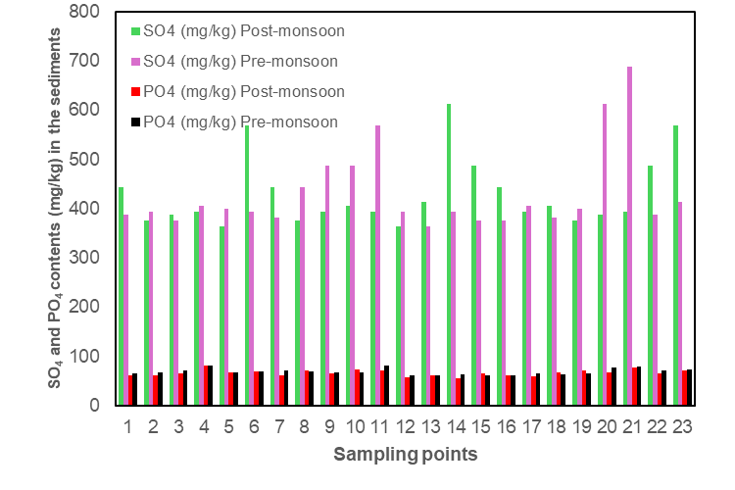
Figure 5. Sulphate (SO₄²⁻) and phosphate (PO₄²⁻) content (mg/kg) in the sediments of Gorai River bed

4. Conclusion
The grain size distribution of the sediments of the Gorai riverbed falls mainly into 101-250µm (0.1-0.25mm) and this class of sands is more than 50%. About 80-85% of the sand size fractions in the sediment of the Gorai riverbed belong to the light fraction. Fluctuation in the composition and concentration of different chemical constituents due to decreased Ganges flow tends to deviate from the natural condition of the environment. The upstream barrages reduce the adequate supply of sediment and freshwater flow to the delta and its associated coastal regions. Therefore, for effective future development and sustainable management of agricultural production and water supply in this region, it is essential to acquire comprehensive, credible information and improve our current understanding of river dynamics, hydrodynamics, morphological changes, and anthropogenic activities to mitigate the loss of public assets, agricultural land from salinity, water supply due to siltation, and other invaluable resources.

Conflict of interest
The authors declare that they have no conflict of interest.

References
Babu, P. V. R. et al. (2019). Impact of Monsoon Rainfall on Major and Trace Element Concentrations in Surface Waters of a Tropical River Basin. Environmental Monitoring and Assessment, 191(2), 109.
Baldwin, D. S., Mitchell A. M., & Olley, J. M. (2002). Pollutant-Sediment Interactions: Sorption, Reactivity and Transport of Phosphorus. In Agriculture, Hydrology and Water Quality. Eds P.M. Haygarth and S.C. Jarvis. CAB International, Oxon, UK.
Belka, Z., Skompsk, S., & Waksmundzki, B. (2016). A new interfacial method for conodont separation. Journal of Paleontology, 63(2), 253 – 255. https://doi.org/10.1017/S002233600001 9338
Berry, L.G., Mason, B., & Dietrich R. V. (1983). Mineralogy. 2nd ed. W. H. Freeman, San Francisco, USA.
BUP (Bangladesh Unnayan Parishad) (1994). Resources, Environment and Development in Bangladesh with particular References to the Ganges, Brahmaputra and Meghna Basin. Academic publishers, Dhaka. p. 79.
BWDB (Bangladesh Water Development Board) (2001). Environmental and Social Impact Assessment of Gorai River Restoration Project. Main Report. Environmental and GIS Support Project for Water Sector Planning, Ministry of Water Resources, GOB, Dhaka. p. 185.
Carvery, R.E. (1971). Procedures in Sedimentary Petrology. John Wiley and Sons, USA. p. 653.
Chhatwal, G. R., Mehra, M. C., Sataka, M., Katyal, T., Katyal, M., & Nagahiro T. (1992). Encyclopidia of environmental pollution and its control. Vol. II, water pollution. Anmol Publications, New Delhi, India. p. 254.
Dana, J. D. (1985). Manual of Mineralogy. 20th ed. Revised by C. S. Hurlbut Jr. and C. Klein. John Wiley and Sons, New York, USA.
Ecofile (2003). Periodical on Life and Nature. Vol. 3 & 4. Unnayan Shamannay, Dhaka, Bangladesh. pp. 9-39
Ezugwu, C. (2013). Sediment Deposition in Nigeria Reservoirs: Impacts and Control Measures. Innovative Systems Design and Engineering, 4, 54–62
Franciskovic-Bilinski, S., & Sakan, S. (2021). Geochemistry of Water and Sediment. Water, 13(5), 693. https://doi.org/10.3390/w13050693.
Gain, A. K., & Hoque, M. M. (2013). Flood risk assessment and its application in the eastern part of Dhaka City, Bangladesh. J Flood Risk Manag, 6, 219–228.
House, W. A., & Denison, F. H. (2002). Total phosphorus content of river sediments in relationship to calcium, iron and organic matter concentrations. Sci Total Environ, 23, 282-283, 341-351. https://doi.org/10.1016/s0048-9697(01)00923-8.
Jackson, M. L. (1967). Soil Chemical Analysis. Prentice Hall, Englewood Cliffs, N.J., USA. pp. 227-261.
Krumbein, W. C., & Pettijohn F. J. (1938). Manual of Sedimentary Petrography. Appleton Centurey-Crofrs Inc., New York, USA. p. 549.
Lucassen, E. C. H. E. T., Smolders, A. J. P., Van der Salm, A. L., & Roelofs J. G. M. (2004). High groundwater nitrate concentrations inhibit eutrophication of sulfate-rich freshwater wetlands. Biogeochemistry, 67(2), 249-267.
Milliman, J. D., & Meade, R. H. (1983). World-wide delivery of sediments to the oceans. J. Geol., 91, 1–21.
Milner, H. B. (1962). Sedimentary Petrography. Vol. I, 4th ed. George Allen and Unwin Ltd., London, UK. p. 634.
Mirza, M. M. Q., & Sarker, M. H. (2004). Effects of Water Salinity in Bangladesh, In Mirza, M. M. Q. (eds.), The Ganges Water Diversion: Environmental Effects and Implications. Kluwer Academic Publishers, the Netherlands, pp. 81-102.
Montgomery, C.W. (2005). Environmental Geology. 7th ed. McGraw Hill Higher Education, New York, USA. pp. 26-41.
Page, A. L., Miller, R. H., & Keeney, D. R. (1982). Methods of Soil Analysis (ed.), Part 2. Am Soc Agron Soil Sci. Madison, Wisconsin, USA. pp. 159-446.
Perkins, D. (2002). Mineralogy. 2nd ed. Prentice Hall, New York, USA. pp. 51-64.
Rahman, M. M., & Rahaman M. M. (2018). Impacts of Farakka barrage on hydrological flow of Ganges River and environment in Bangladesh. Sustain. Water Resour Manag, 4, 767–780.
Rahman, A. A., Huq, S., & Conway, G. R. (2000). Environmental Aspect of Surface Water system of Bangladesh. The University Press Limited, Dhaka, Bangladesh. pp. 7-265.
Ravi, N. K., Gautam, S. K., Tiwari, J., & Jha, P. K. (2022). Assessment of Seasonal and Spatial Variation of the Organic Carbon and Nutrients in the Ghaghara River Sediment. Asian Journal of Water, Environment and Pollution, 19(3), 59-67. https://doi.org/10.3233/AJW220040
Rouillard, J. J., Benson, D., & Gain, A. K. (2014). Evaluating IWRM implementation success: are water policies in Bangladesh enhancing adaptive capacity to climate impacts. Int J Water Resour Dev, 30, 515–527.
Samad, A., & Ali S. A. (1968). Study of Geochemical Parameters and Reservoir Properties of Miocene sediments of Part of Chittagong Hill Tracts. E Pakistan Jour Sci Ind Res, 2(3), 317-324.
Samad, A. (1977). The mineralogy of Alluvial Sediments of the River Tamer, South West England. Unpublished Ph.D Thesis, University of London, UK.
Sarin, M. M., Krishnaswami, S., Dilli, K., Somayajulu, B. L., & Moore, W. S. (1989). Major ion chemistry of the Ganga-Brahmaputra river system: Weathering processes and fluxes to the Bay of Bengal. Geochimica et Cosmochimica Acta, 53(5), 997-1009. https://doi.org/10.1016/0016-7037(89)90205-6.
Shamsad, S. Z. K. M., Islam, K. Z., Mahmud, M. S., & Hakim, A. (2014). Surface water quality of Gorai River of Bangladesh. Journal of Water Resources and Ocean Sciences, 3(1), 10-16.
Shamsad, S. Z. K. M., Islam, M. S., & Hassan, M. Q. (1999). Ground water quality and hydrochemistry of Kushtia district, Bangladesh. J Asiat Soc Bangladesh (Sci.), 25 (1), 1-11.
Sharma, A. K. et al. (2017). Impact of Monsoon on Chemical Weathering and Element Export in a Tropical River. Southern India Journal of Asian Earth Sciences, 147, 252-263.
Singh, A. et al. (2020). Influence of Rainfall on the Water Chemistry and Iron Geochemistry of a Tropical River during the Monsoon Season. Environmental Earth Sciences, 79(5), 213.
Tickell, F.G. (1965). Developments in Sedimentology, IV, The Techniques of Sedimentary Mineralogy. Elsevier, Amsterdam, The Netherlands. p. 220.
Uddin, M. J., Mohiuddin, A. S. M., Hossain, S. T., & Hakim, A. (2013). Ecoenvironmental Changes of Wetland Resources of Hakaluki Haor in Bangladesh Using GIS Technology. J Biodivers Endanger Species, 1, 103. https://doi.org/10.4172/2332-2543.1000103
Vercruysse, K., Grabowski, R. C., Hess, T., & Lexartza-Artza, I. (2020). Linking temporal scales of suspended sediment transport in rivers: towards improving transferability of prediction. Journal of Soils and Sediments, 20, 4144-4159. https://doi.org/10.1007/s11368-020-02673-5].
Waters, T.F. (1995). Sediment in Streams: Source, Biological Effects and Controls. American Fisheries Society, Bethesda, Maryland, USA. p. 252.
Watson, S. J., Cade-Menun, B. J., Needoba, J. A., & Peterson, T. D. (2018). Phosphorus forms in sediments of a river-dominated estuary. Frontiers in Marine Science, 5, 302.

