Review Article
Effects of Inorganic Compounds on the Environment and Their Control: A Review

Abstract
Heavy metals, salts, acids, bases, and oxides is an inorganic compound that play a vital role in development of industrial and agricultural areas but it also responsible for increasing of pollutants in environment. Their bioaccumulative, toxicity and persistence characteristics are caused extensive contamination in soil, air and water system. In this review author emphasised about the variety of inorganic pollutants, their production, environmental impact mechanism and their adverse effects on living organisms. Furthermore, it précises recent strategies about monitoring, stoppage and remedy, of used process which controlled the pollutions and their impact on environments such as adsorption, precipitation, phytoremediation, membrane filtration, and advanced oxidation processes. The review paper illustrated on the need for supportable industrial activities and policy involvements to mitigate environmental risks associated with inorganic pollutants.
Key words: Inorganic pollutants, heavy metals, inorganic oxides, bioaccumulations, toxicity
- Introduction
The spontaneous development of industrialization urbanization (Voumik et.al. 2022 & Nath et.al. 2021) and advanced practices in agricultural fields that enhanced the significantly discharge of inorganic compounds in to the atmosphere (Buss et.al.2024 & Kashaudhan 2024). Heavy metals (Dobre et.al. 2024), salts, (Kim et.al.2025), oxides, sulfates (Furiness et.al. 1998, Gupta et.al. 2003 & Karuama et.al. 2024), nitrates (Wang et.al.2023) and some other mineral based inorganic chemical are frequently applied in commercial scale as mining, extraction of metal (Kasongo et.al.2024), electroplating (Rajoria et.al.2021), fertilizers (Zang et.al. 2025) and energy production industries (Ajayan et.al.2025). The nature of inorganic materials is usually non - biodegradable and it persist in atmosphere for prolonged time (Tripathi et.al. 2023) that shows important to long term ecological and biological health concerns.
The availability of inorganic compounds as above recommended concentration in air, water and soil caused adverse effects on ecosystems and living being. The lead (Pb) (Generalova et.al. 2025), cadmium (Cd) (Davidova et.al. 2024), mercury (Hg) (Wu et.al. 2024), arsenic (As) (Genchi et.al. 2022) and chromium (Cr) (Khatua et.al. 2023) heavy metals easily accumulate in biological system as stored in biological tissues that increased to the bioaccumulation biomagnification into the tropic levels (Oros 2025). The toxic level of these elements affects the biochemical and physiological system in living being that caused retardation of growth, letdown the reproduction and even mortality in living being (Bharti et.al. 2021). Likewise extreme level of nitrates and phosphates nutrients subsidised eutrophication of aquatic systems as a results algal blooming occurs (Prasad et.al.2019), depletion of oxygen, and also reduction of biodiversity occurs (Zhou et.al. 2024). However, the inorganic gasses like sulfur dioxide (SO₂) and oxides of nitrogen (NO_{x}) mainly caused acid rains and environmental pollution (Guo et.al. 2022).
The persistence of inorganic compounds and toxicity produced effective control and redress action has makes universal priority (Escher et.al.2023). Some approaches like chemical precipitation, ion exchange, adsorption, phytoremediation (Lone et.al. 2008 & Acharya et.al. 2025), membrane filtration and treatment through electrochemical process (Nath et.al. 2021 & Nath 2.25) have been developed to manage their effects.
Advance developments also emphasise toward green and supportable methods that applied as biosorbents, nanomaterials and microbial technology (Okoro et.al. 2022) toward removal or alteration of inorganic pollutants.
In this reviews author precise about the inorganic compounds in context of their sources, categories and effects on environments and also emphasized about the recent developing control action used to reduced its influence and it also expressed on the pursuing of improved knowledge about the environmental hazards that liked with inorganic contaminants and promote justifiable management policies for environmental safety.
- Sources of Inorganic Pollutants
There are following main sources of inorganic pollutants as-
2.1. Industrial activities
Industrial activities as mining, electroplating (Rajoria et.al. 2021), metal refining (Yang et.al.2024), manufacturing of batteries (Degen et.al. 2025) and chemical refining produced huge amount of lead (Generalova et.al. 2025), cadmium (Davidova et.al. 2024), chromium, (Khatua et.al. 2023) mercury (Wu, Yuan-S., 2024), arsenic (Genchi et.al. 2022) etc. heavy metals in to the soils and emission of sulfur oxides and nitrogen oxides (Guo et.al. 2022) occurs through thermal power plants which responsible for acid rains and caused atmospheric pollution. The industrial source of pollutants shown in Figure 1.
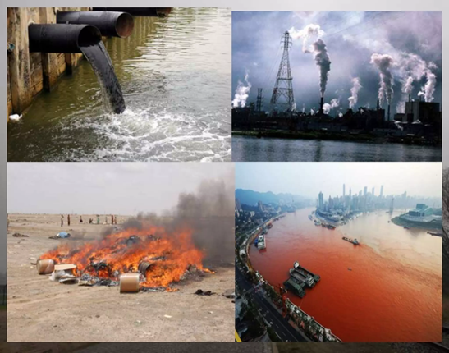
Figure1: Industrial source of pollutants
2.2. Agricultural Practices
Increasing of populations and reducing of agricultural land every county faced problem for the sufficient food’s requirement. Due to this enhancing the crop production for the sufficient foods, farmers used various types of inorganic fertilizers and pesticides (Hussain et.al. 2025) which have main constituents of nitrates, phosphates and metallic salts hence residues of above inorganic substance passed into the atmosphere and increased pollutions which are given in Figure 2. The phosphate containing fertilizers caused eutrophication (Markad et.al. 2024), while nitrates leached into the soil and pollutes groundwater (Pan et.al.2024).
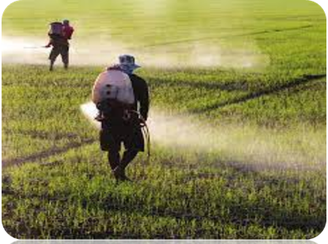
Figure 2: Pollutants source by agricultural activites
2.3. Domestic and Municipal Sources
Urbanization development produced large amount of sewage and wastage of houses passed into the atmosphere in untreated form so that the chlorides, sulfates and ammonia which are main constituents of above wastage constitutes aquatic system. The sources of pollutants are as-
2.3.1. Household waste
- The increasing of population increased the shelter or hoses of human being hence a variety of house hold activities as kitchens, packaging, cleaning of houses are developed (Khaiwal et.al. 2017). After the used some unused substances are directly released in atmosphere such released pollutants contributes to landfills and pollute soil and water.
- The domestic used also discharge wastewater viz sewage produce from toilets, kitchens and organic materials (Bahuguna et.al. (2022) available in bathrooms which pollutes the water bodies if it discharges directly in water reservoir represents in Figure 3 (Ramadan et.al.2023).
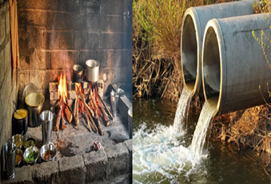
Figure 3: Pollutants source by household activities
2.3.2. Air pollutions
- The emission of smokes and gasses by burning of solids fuels the applied in cooking and heating of substances and atmosphere, smokes generated by smoke, some other gasses that produced by household appliances and equipment also contributes the air pollutions (Manisalidis et.al. 2020). Some very minute solid particles that have size in microns also spread into the industrial sources given in Figure 4.
- Various chemicals like paints, cleaning agents and building materials are used in domestic region which also released chemical directly in atmosphere which are responsible for air pollutions (Kumar et.al. 2023).
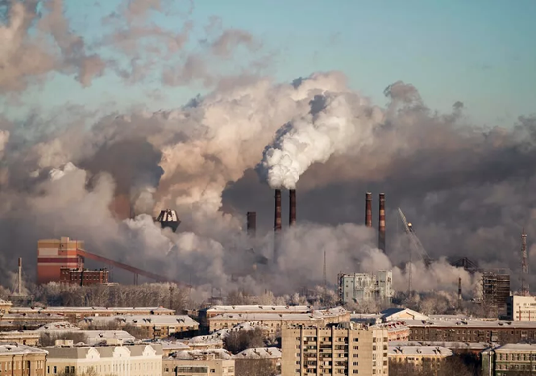
Figure 4: Industrial source of air pollution
2.3.3. Pollutants produced by municipality
Solid waste produced by the municipal area as trash from houses, industries and some others organization
wastage with food scarps, paper, plastics, and some other unused materials released into the atmosphere ii untreated form that caused pollution in environment. The vehicle emissions are also a main source of air pollution, because of much density of vehicle likes cars, trucks and buses are present in urban areas source of pollutants form municipal activities given in Figure 5. The municipal sewage and household unused substances mainly chlorides, sulfates and ammonia passed into the aquatic bodies. The concentrations of heavy metals ions also produced by unsafely disposed wastage of electronic materials (Pekdogan et.al.2024 & Jonidi et.al. 2021).
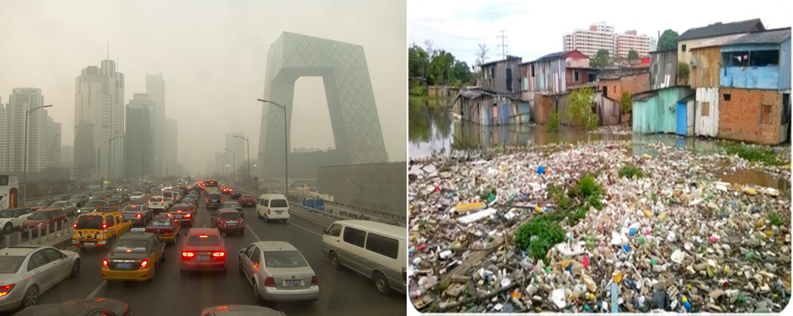
Figure 5: Pollutants source of urban and municipal activities.
2.3.4. Natural Sources
- Naturally inorganic pollutants as are produced by volcanic eruptions that released significant amounts of sulfur dioxides, heavy metals and other gasses released into the atmosphere (Glasow et.al. 2009).
- The naturally rocks weathering and soil erosion also released radionuclides and heavy metals like lead and mercury are produced by the naturally breaking of rocks having sufficient number of metals and minerals by weathering that contaminate the soil and aquatic systems. It also produces some other pollutants which caused soil and water pollutions (Angon et.al. 2024).
- Natural dust storms are acts as carrier of suspended and sea spray a natural procedure also a source of pollutants. Mostly dust produced form areas as Sahara which contains inorganic particles so that inorganic polluted particles spread in the air. The sea spring produce salt as sodium chloride and some other inorganic constituents (Glasow et.al. 2009).
- Some others sources like interruption geological materials likes phosphates produced by the breakdown of phosphorus rich rock (Ogwu et.al.2025). Source of pollutants by natural activities given in Figure 6.

Figure 6: Pollutant source by natural activities
3. Environmental Effects of Inorganic Compounds
3.1 Soil Contamination: inorganic pollutants that reached into the soil which easily passed entered into the plants trough routs and in easily accumulate in plants cells. The animals which are depends on plants so these pollutants are reach into animals and the ecosystem and it caused following effects as:
3.1.1. Effects on plants:
- Generally, pollutants affect the chemical properties which are essential for life of living being. So that such pollutants reduce the fertility of soil and crop production yields in agricultural fields (Nuruzzamam et.al.2025).
- As the concentration of salts and toxic metal ions increases into the soil that that alter the soil structure and it enhanced the salinity of soil and it caused compaction and crusting of soil surface so that soil become unfriendly for the development of plants. The pollutants like aluminium show directly toxic behaviour to the plants it interferes the cellular activities hence retardation occurs in plants (Nuruzzamam et.al.2025).
- The pollutants that contaminate the soil that responsible for the degradation of soil hence it damages the soil biodiversity which also damage the microorganism vital for a vigorous soil’s ecosystem (Panneerselvam et.al. 2022).
- Pollutants which are reached in the water bodies as rivers, lakes, sea etc. that caused the adverse effects on aquatic life that degrade the quality of surface and ground water (Nuruzzamam et.al.2025).
- The pollutants are passed into the food chain by herbivores which eats the contaminated plants. So that the food chains caused adverse effects on entire ecosystems that responsible for the reducing of species (Panneerselvam et.al. 2022). Effects of soil pollutions on the plants is represented in Figure 7.

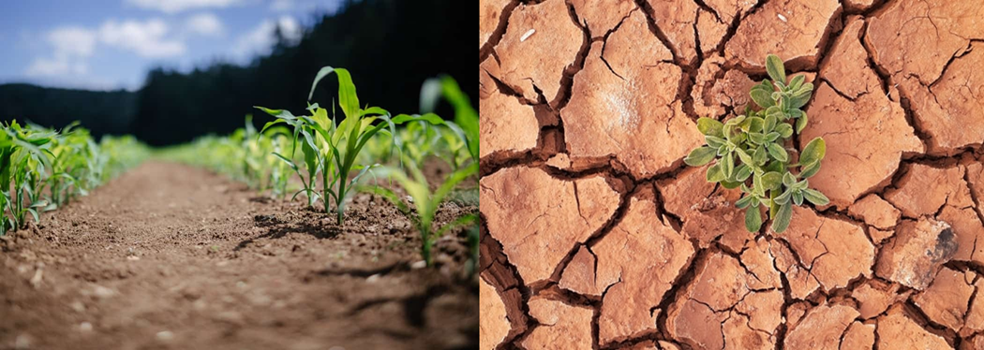
Figure 7: Effect of soil pollutants on plants
3.1.2. Effects on human being: the human being also a part of food chains, the human life are depended of the plants and animals so they also received pollutants through foods. These pollutants cause adverse effect on human life given in Figure 8 as (Shetty et.al.2023):
- The heavy pollutants like lead and cadmium (Davidova et.al. 2024) reached into the human being which destroyed the vital organs as liver and kidneys.
- The concentration of lead (Generalova et.al. 2025) above as required concentration in human being destroying the nervous system permanently and developed mental retardation and depression of central nervous system.
- Inorganic pollutants have carcinogenic character which are responsible for the development cancer and some crucial diseases as congenital disorder and mutations in gene (Genchi et.al. 2022).
- Pathogens that produced by inorganic pollutants present in soil that caused tetanus diseases, it can be constricted by children while they play in contaminated soil (Sahu et.al.2024 & Iqbal et.al.2020).

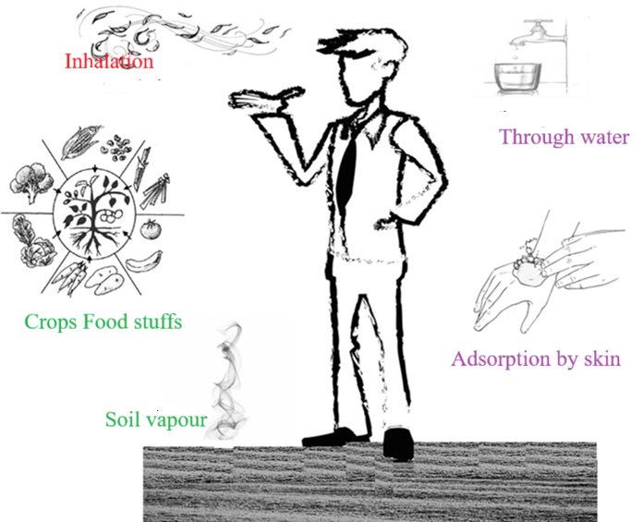
Figure 8: Effects of soil pollutants of human
3.2. Water Pollution
Inorganic elements are present in ionic form which can easily soluble in water, it produced by the waste of industrial, domestic, municipal activities. These wastages are directly passed in to the water system so that water become polluted by inorganic and some other pollutants. This polluted water directly or indirectly reaches into the living being including plants and human and caused adverse effect on both shown in Figure 9 as-
- The concentration of arsenic (Genchi et.al. 2022) in water reaches above as desired level it causes several cancers and other pollutants are responsible for other chronic disease including diabetes and obesity etc.
- Some toxins have tendency for accumulation in organs such as liver, kidneys and spleen that cause damage kidney or pulmonary emphysema (Davidova et.al. 2024).
- The lead (Generalova et.al. 2025) and mercury (Wu et.al. 2024) pollutants in water which reaches into the human bodies it causes neurological disorder and affects the metal growth and behavior of children.
- Exposure of inorganic pollutants in leaving being can damaged the fertility and response birth imperfection or destroy to reproductive systems in progenies (Tissera et. al. 2025).
- Inorganic pollutants also affect gastrointestinal sicknesses; respiratory complication produced asthma and also damage to the immune and circulatory organs (Shetty et.al. 2023).
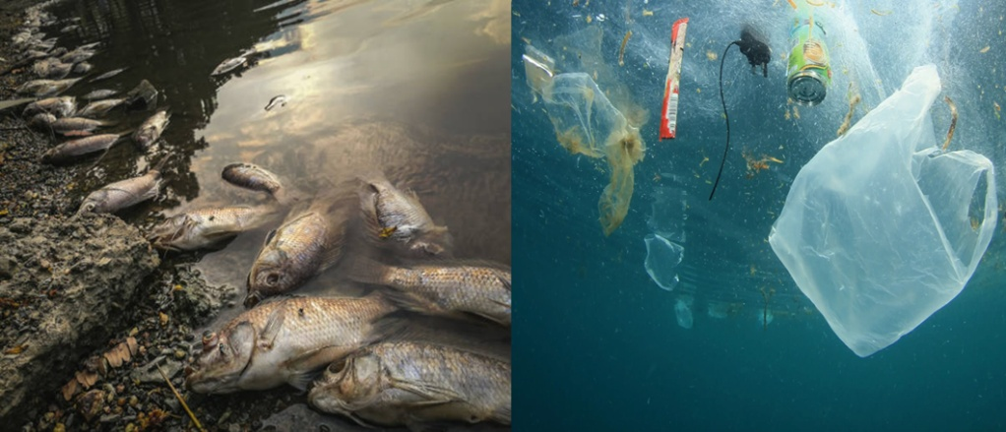
Figure 9: Effect of water pollution of aquatic life
3.2.1. Effects on water quality and aquatic ecosystem
- Availability of heavy metals in water bodies that have toxic nature for aquatic life hence it directly affects to the aquatic organism and kill fish present that water system (Panneerselvam et.al. 2022).
- Inorganic pollutants disrupt the aquatic ecosystem that maintained natural equilibrium so that in also cause adverse impact on food chain and habitats of aquatic life (Bhadarka et.al.2024).
- High exposure of inorganic pollutants in water reservoir produces water pollution and reduce water quality that water unsuitable of drinking and released of wastewater by industrial activities cause aesthetic problems as taste discoloration or generation of harmful residue after used (Bhadarka et.al.2024).
3.2.2. Some other inorganic pollutants and their effects
- Arsenic pollutants cause ulcer, skin lesions and situation affects to bladder, kidneys and lungs.
- Lead metal has neurotoxic nature that affects to the growth and behavior of tissues.
- Cadmium metal is responsible to the development of kidney stones and it also damage renal tubules.
- Chromium salts or chromium ions caused affects to the liver and spleen.
- Mercury heavy metal has more toxic nature it easily accumulates in living tissues and responsible for mercury poisoning.
3.3. Air Pollution
Air pollution is a serious problem that caused more critical adverse effects on living being as compare to the soil and water pollution. Because no existence of life occurs without air which are directly uptake by living being. More of the pollutant’s particle passed into the living organism through air and caused various adverse effects on living being shown in Figure 10 as (Manisalidis et.al. 2020& Kumar et.al. 2023): -
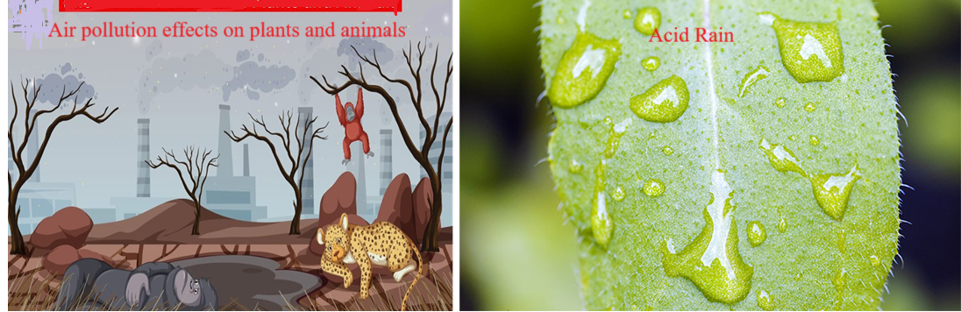
Figure 10: Effects of air pollution on plants and animals
- Inorganic pollutants containing cause major risk factor for premature death, there are word wide millions of early deaths annually reported (Adhikary et.al.2024).
- There are some chronic diseases as heart disease, stroke, lungs cancer and chronic obstructive pulmonary diseases are increases by air pollutions (Adhikary et.al.2024).
- Exposure of inorganic pollutants in air responsible for asthma, pneumonia and other respiratory disorder (Adhikary et.al.2024).
- Black carbon and ground level ozone are “super pollutants” present in air. These pollutants are responsible for increasing of global warming that contributes to enhancing global temperature hence changing of climate occurs day by day (Lelieveld 2020).
- The oxides of sulfur and nitrogen passed into the atmosphere through burning of fossil fuels produces acid rain that affect to the ecosystems, contaminates water and destroy building, plants and animals (Manisalidis et.al. 2020).
- Now a days some emission of gases as chlorofluorocarbons (CFCs) and halons responsible for the ozone layer depletion which are protective layer of ultra violet rays for the earth (Thangavel et.al. 2011).
- Air pollution also damages the forest, wildlife and agriculture it contributes to ocean and contamination of water (Manisalidis et.al. 2020& Kumar et.al. 2023).
3.3.1. Effects on Flora and Fauna
Inorganic pollutants are frequently spread into the air that adverse effects on flora and fauna. It causes by involving of mechanism as bioaccumulation that disrupt physiological process as photosynthesis, respiration and enzyme function so that in cause the alteration of habitat properties. These effects show a series of refined variations in behavior and growth to severe damage of organ, failure of reproductivity and ultimate cause death (Nkansah et.al.2025 & Acwin 2023).
3.3.1.1. Effects on Flora (Plants)
First of all, plants are affected by air pollution because their environments are fixed and it easily absorbed pollutants from all sources as air, water and soil. It damaged by the involving phenomenon as-
3.3.1.1.1. Destruction of Biochemical and physiological process
- Pollutants like lead and cadmium heavy metals and sulfur dioxide and ozone constituents of air pollution the photosynthesis and carbon fixation that restrict the plants growth and minimize the crop yields (Lahiri et.al.2023).
- Concentrations of pollutants raised at desirable level caused damage of tissue therefore affects visible damage like due to degradation of chlorophyll similarly called chlorosis in which plants leave become yellow in colour, necrosis i.e. death of tissue and drops of premature leaf i.e. abscission (Manisalidis et.al. 2020& Kumar et.al. 2023).
- The acid rains cause nutrients disruption because calcium, potassium and magnesium essential nutrient leaches from the soil so that nutrients are unavailable to the plants hence cause mineral deficiencies.
- The pollutants destroyed cuticles of leaves and alter the stomatal activity that weakening the ability of plants that regulate gas and water exchange i.e. cause water stress (Manisalidis et.al. 2020& Kumar et.al. 2023).
- Various inorganic pollutants encourage the development of reactive oxygen species (ROS), that destroyed to lipid, proteins and DNA present in plant cells (Kubo 2002).
3.3.1.1.2. Alteration of Ecosystem
- Excess concentrations of pollutants caused Eutrophication because of excess nitrogen act as fertilizer that obtain from and air pollution that favoured rapid growing of “nitrophillic” plants and algae. Hence it responsible to development of algal blooms in water system, that deplete oxygen and generate “dead zones” and alter the equilibrium of ecosystem and biodiversity.
- Pollutants changed the physiological and biochemical process hence it interrupts the communication of insects that received by some chemicals and affect the locating foods or matting grounds and it also affects the pollination and dynamics of pest.
3.3.1.2. Effects of Fauna
The faunas are affected through inhaling contaminated air, using polluted water and foods or directly contact with pollutants. It caused advised effect on animals in various process as (Rajput et.al. 2024): -
- Mercury, lead and aluminium inorganic pollutants have non-biodegradable properties hence it can easily accumulate into the organism’s tissues over time (bioaccumulation). Increasing of the concentration of heavy metals ion become hazardous as it goes into the food chain i.e. biomagnification which cause severe affects to top predators as eagles and bears.
- Heavy metal in pollution forms that cause critical destroying to vigorous organs as liver, kidneys. Nervous system and lungs.
- Metallic pollutants cause endocrine disruptors by interfering functions of hormones. It shows main factor that reduced reproductive achievements, birth defect, male fish feminization, diminishing of bird’s eggshell and offspring developmental problems.
- Pollutants contains heavy metals that responsible for neurological defects that cause abnormal behaviours, decrease coordination and movements and also retard capability and avoid predators.
- Particulate matter and sulfur dioxide that constituents of air pollutants responsible for damaging of lunge, effects on respiratory system, and also damage the cardiovascular problems.

- Control and Remediation Strategies
The various process is involved for the controlling of environmental pollution through the involving of some process for isolation of pollutants particles form the pollutions (Liu et.al.2024 & Tripathi et.al. 2024). Such as: -

  - Physical and Chemical Methods
- Adsorption process is used for the removal of pollutants in which activated carbon, zeolites and biosorbents that excellently remove heavy metals form contaminated water.
- Using of precipitation and coagulation process in which dissolved heavy metal coveted into the insoluble precipitate with precipitating agent likes lime and ferric salts.
- For the removal of selective ions by the using of ion exchange and membrane filtrations process while this process is costly but shows effectively removal of ions.
- The electrochemical treatment process applied for the removal of metal ions by using reduction process in which suitable reducing used in this process, after that it can easily recovered and reuse.
4.2 Biological Methods
In this process some plants are used for the removal of metal ions from environment as: -
- Phytoremediation process in which hyperaccumulator plants likes Brassica juncea or Helianthus annuus having super absorbing of metal ions used.
- Microbial remediation methods in which metal resistant bacteria as e.g. Pseudomonas, Bacillus which have capability to transform or immobilize the metallic pollutants.
- For the removal of the pollutants from the various polluted source by construction of wetlands which designed an ecosystem in which plants and microbes both are used together it acts as natural source for purification of wastewater.

  - Preventive Measures
- Green chemistry implementation in which cleaner production technologies are used.
- Stringent implementation of environmental regulations and standardised unused wastage discharge.
- Promotion of recycling waste materials and minimization of waste in industrial activities.
- Systematic monitoring and environmental impact assessments.
5. Future Perspectives
Sustainable management of pollutants of inorganic materials responded for the integration of science, technology, and policy. Development of technologies like adsorbents with nanomaterials, electrospun membranes, and biochar alterations expressed ability for active elimination of pollutant. Likewise, globular economy models that stimulate source recapture from waste streams can abate environmental problem. Interdisciplinary research and worldwide cooperation are important for emerging eco-friendly, economical control strategies.
6. Conclusion
Inorganic compounds, whereas essential for industrial growth, characterize an obstinate risk to environmental and human health when unsuitably achieved. Their complex interactions within ecosystems mandate multifaceted control tactics uniting physical, chemical, and biological approaches. Strengthening policies that controlled the pollution by advancing of green technologies, and raising awareness towards environmental are significant to mitigating their long-term effects.
References:
Acharya, A., Bellaloui, N., Pilipovic, A., Perez, E., Maddox-Mandolini, M., & Fuente, H. D. L. (2025). Current Assessment and Future Perspectives on Phytoremediation of Heavy Metals. Plants, 14(18), 2847.
Acwin Dwijendra N K, Mohammadi M J, Aravindhan S, Turki Jalil A, Taherian M, et al. (2023).Investigating the Effects of Air Pollution on Plant Species Resistance in Urban Areas.Health Scope.12(1), e129786.https://doi.org/10.5812/jhealthscope-129786.
Adhikary, M., Saikia, N, Purohit,P., Canudas-Romo,V. & Schöpp, W. (2024).Air Pollution and Mortality in India: Investigating the Nexus of Ambient and Household Pollution Across Life Stages. GeoHealth, 8(8), e2023GH000968, doi.org/10.1029/2023GH000968
Ajayan, J., Sreejith, S., Mounika, B. Fletcher, A.S.A. Mathew, R., Saravanan. & Sharma. (2025). Inorganic nano catalysts for energy systems, environmental/industrial processes and healthcare applications: A comprehensive review. Materials Today Sustainability,32,101233.
Angon, P.B., Islam, Md. S., Shreejana, K.C., Das, A., Anjum, N., Poudel, A. (2024). Sources, effects and present perspectives of heavy metals contamination: Soil, plants and human food chain. Heliyon, 10, (7), e28357,
Bahuguna, A.S., Sharma,S., Arvind,S.,Pandey, A. D.,Yadav,B., Barthwal, B. et.al.(2022). Soil Pollution Due to Sewage Sludge and Industrial Effluents. 10.1007/978-3-031-09270-1_14.
Bharti, K., Sharma, R. & Renu. (2021). Effect of heavy metals: An overview. Materials Today: Proceedings, 51. 10.1016/j.matpr.2021.06.278.
Bhadarka, M., Vaghela, D., Kamleshbhai, B., Sikotariya, H., Kharadi, N. Bamaniya, M. et.al.(2024). Water Pollution: Impacts on Environment. In book: Sustainable Aquaculture: A Step Towards A Green Future in Fish Farming (pp.163-181) Publisher: SATISH SERIAL PUBLISHING HOUSE
Buss, W., Hasemer, H., Sokol, N.W. et al. (2024). Applying minerals to soil to draw down atmospheric carbon dioxide through synergistic organic and inorganic pathways. Communictions Earth and Environment, 5, 602.
Damiati, S., AlMashrea, B.A., Rabiei, N., Sujatha, A.P., Sabir, D.K., Alhosani, M. & Kodzius, R. (2025). Aerosol Pollutants and Health: Role of Size and Chemical Composition. Public Health Chall. 4(4), e70134.
Davidova S., Milushev V. & Satchanska G. (2024). The Mechanisms of Cadmium Toxicity in Living Organisms. Toxics, 12(12), 875.
Degen, F., Palm, J. & Mitterfellner, M. (2025). Direct emissions to air, water and soil from a battery gigafactory. Commun Earth Environ 6, 408.
Dobre, T., Isopencu, G. O., Bdaiwi Ahmed, S., & Deleanu, I. M. (2024). Heavy Metal Pollution and Solutions for Its Control: General Aspects with a Focus on Cobalt Removal and Recovery from Aqueous Systems. Chem Engineering, 8(6), 118. https://doi.org/10.3390/ chemengineering 8060118.
Escher, B.I., Altenburger, R., Blüher, M., Colbourne, J.K., Ebinghaus, R., Fantke, P. et.al. (2023). Modernizing persistence-bioaccumulation-toxicity (PBT) assessment with high throughput animal-free methods. Arch Toxicol, 97(5),1267-1283.
Furiness, C., Smith,L., Ran, L. & Ellis Cowling, E.(1998). Comparison of emissions of nitrogen and sulfur oxides to deposition of nitrate and sulfate in the USA by state in 1990,Environmental Pollution, 102 (1),313-320.
Genchi, G., Lauria, G., Catalano, A., Carocci, A., & Sinicropi, M. S. (2022). Arsenic: A Review on a Great Health Issue Worldwide. Applied Sciences, 12(12), 6184.
Generalova A, Davidova S, Satchanska G. (2025). The Mechanisms of Lead Toxicity in Living Organisms. J Xenobiot. 215(5),146.
Glasow, R.B., Nicole, K. & Christoph. (2009). The Effects of Volcanic Eruption on Atmospheric Chemistry. Chemical Geology. 263. 131-142. 10.1016/j.chemgeo.2008.08.020.
Guo,Y., Zhu,L., Wang,X.,Qiu, X.,Qian, W. & Wang,L.(2022). Assessing environmental impact of NOX and SO2 emissions in textiles production with chemical footprint. Science of The Total Environment, 831,154961.
Gupta, A.K., Patil, R. & Gupta, S. (2003). A Long-Term Study of Oxides of Nitrogen, Sulphur Dioxide, and Ammonia for a Port and Harbor Region in India. Journal of environmental science and health. Part A, Toxic/hazardous substances & environmental engineering, 38. 2877-94. 10.1081/ESE-120025838.
Hussain, F., Ahmed, S., Muhammad Zaigham Abbas Naqvi, S., Awais, M., Zhang, Y., Zhang, H., Raghavan, V., Zang, Y., Zhao, G., & Hu, J. (2025). Agricultural Non-Point Source Pollution: Comprehensive Analysis of Sources and Assessment Methods. Agriculture, 15(5), 531.
Iqbal, M.S. et al. (2020). Impacts of Soil Pollution on Human Health with Special Reference to Human Physiognomy and Physiology. In: Singh, P., Singh, S.K., Prasad, S.M. (eds) Plant Responses to Soil Pollution. Springer, Singapore. https://doi.org/10.1007/978-981-15-4964-9_10
Jonidi Jafari A, Charkhloo E, Pasalari H. (2021). Urban air pollution control policies and strategies: a systematic review. J Environ Health Sci Eng. 19(2), 1911-1940.
Lahiri,M. & Krishna, K. (2023). Effect of air pollution on plant secondary metabolites in selected trees of Delhi. Environmental Quqality Management, 33(3), 399-409.
Lelieveld, J.(2020).Reducing Air Pollution: Avoidable Health Burden.n book: Health of People, Health of Planet and Our Responsibility (pp.105-117)doi = {10.1007/978-3-030-31125-4_9.
Liu,X., Sathishkumar,K.,Zhang, H.,Saxena,K.K., Zhang,F., Naraginti,S., et.al.(2024).Frontiers in environmental cleanup: Recent advances in remediation of emerging pollutants from soil and water.Journal of Hazardous Materials Advances,16,100461.
Karuana, F., Prismantoko, A., Putra, H. P., Ruhiyat, A. S., Darmawan, A., Adi Saputra, I. N. A., … Hariana, H. (2024). Experimental Investigation of Sulfur and Nitrogen Oxide Emissions and Corrosion Propensity During the Combustion of Coals and Biomass Fuels. Combustion Science and Technology, 197(17), 5002–5024.
Kashaudhan, K., Pande, P. P., Sharma, J., Shankar, R., Nath, A., Chaurasiya, A., & Kushwaha, N. (2024). Synthesis and characterization of Xanthan Gum Xanthates and their application for toxic metal ion removal from synthetic wastewater. Journal of Dispersion Science and Technology, 46(12), 1954–1968.
Kasongo, J., Alleman, L.Y., Kanda, Jean-M., Kaniki, A. & Riffault,V. (2024), Metal-bearing airborne particles from mining activities: A review on their characteristics, impacts and research perspectives. Science of The Total Environment,951,175426.
Khaiwal, R., Mor, S. & John, S. (2017). Household air pollution from various types of rural kitchens and its exposure assessment. Science of The Total Environment. 586. 10.1016/j.scitotenv.2017.01.051.
Khatua, S. & Dey, S.K. (2023). The Chemistry and Toxicity of Chromium Pollution: An Overview. Asian Journal of Agricultural and Horticultural Research.10(2),1-14.
Kim, Chang-H., Kim, Min-J., Jeon, Kyung-W., Jeon, I-Je., Yoon Chae-M., Gong,Ji-Hy. et.al. (2025). Advancing sustainable treatment of sodium sulfate (Na2SO4)-containing wastewater: Recent advances in electrochemical technologies. Chemical Engineering Journal,524,169100.
Kubo, A. (2002). Effects of Air Pollutants on Gene Expression in Plants. In book: Air Pollution and Plant Biotechnology (pp.121-139). doi 10.1007/978-4-431-68388-9_6.
Kumar, R., Verma, V., Thakur, M., Singh, G.& Bhargava, B.(2023). A systematic review on mitigation of common indoor air pollutants using plant-based methods: a phytoremediation approach. Air Qual Atmos Health. 11.1-27. doi: 10.1007/s11869-023-01326-z.
Lone, M.I., He Z.L., Stoffella, P.J.& Yang X.E. (2008). Phytoremediation of heavy metal polluted soils and water: progresses and perspectives. J Zhejiang Univ Sci B., 9(3), 210-20.
Manisalidis, I., Stavropoulou, E.,Stavropoulos, A. & Bezirtzoglou E.(2020) Environmental and Health Impacts of Air Pollution: A Review.Front. Public Health, 8,14.doi: 10.3389/fpubh.2020.00014.
Markad, A. T., Kulkarni, A.S., Sutar, V.,Meshre,S.& Bansode, V.V.(2024). Impact of phosphate fertilizers to aquatic ecosystem: A case study. International Journal of Research in Agronomy, 7(3S),370-376.
Nath, A. (2025). Hydrogels for Wastewater Treatment: A Review. International Journal of Science and Research (IJSR),14(10),696-702. DOI: https://dx.doi.org/10.21275/SR251015100948.
Nath, A., Mishra, A.& Pande, P.P. (2021). A review natural polymeric coagulants in wastewater treatment. Materials Today: Proceedings, 46 6113–6117.
Nkansah, F.K. (2025). Air pollution and plant responses: a study on morphological and anatomical changes in roadside trees along traffic-dense roads. BMC Environ Sci 2, 16. https://doi.org/10.1186/s44329-025-00031-9
Nuruzzaman, Md., Bahar, Md. M.& Naidu, R. (2025). Diffuse soil pollution from agriculture: Impacts and remediation. Science of The Total Environment, 962,178398.
Ogwu M.C., Patterson, M.E. & Senchak, P.A. (2025). Phosphorus mining and bioavailability for plant acquisition: environmental sustainability perspectives. Environ Monit Assess, 197(5), 572.
Okoro, H. K., Pandey, S., Ogunkunle, C. O., Ngila ,C. J., Zvinowanda, C. et.al. (2022). Nanomaterial-based biosorbents: Adsorbent for efficient removal of selected organic pollutants from industrial wastewater. Emerging Contaminants, 8, 46-58.
Oros A. Bioaccumulation and Trophic Transfer of Heavy Metals in Marine Fish: Ecological and Ecosystem-Level Impacts. (2025) J Xenobiot, 15(2),59.
Pan,Y., She, D., Ding,J., Abulaiti,A., Zhao,J.,Wang,Y. et.al.(2024).Coping with groundwater pollution in high-nitrate leaching areas: The efficacy of denitrification.Environmental Research, 250,118484.
Panneerselvam, P., Mitra, D., Mohanty, B, Mondal, R. & Shadangi, S. (2022). Soil pollution and their impact on soil microorganisms.70-85, Edition: AZRA-2022-EPLT Book Chapter: 5 Publisher: AZRA India.
Pekdogan, T., Yildizhan, H., & Ameen, A. (2024). Unveiling the Air Quality Impacts of Municipal Solid Waste Disposal: An Integrative Study of On-Site Measurements and Community Perceptions. Atmosphere, 15(4), 410. https://doi.org/10.3390/atmos15040410
Prasad, R, & Prasad, S. (2019). Algal Blooms and Phosphate Eutrophication of Inland Water Ecosystems with Special Reference to India. International Journal of Plant and Environment. 5. 10.18811/ijpen. v5i01.1.
Rajput, P., Singh, A., Agrawal, S. et al. (2024). Effects of environmental metal and metalloid pollutants on plants and human health: exploring nano-remediation approach. Stress Biology 4, 27. https://doi.org/10.1007/s44154-024-00156-y.
Rajoria, S. Vashishtha, M.& Sangal, V. (2021). Review on the treatment of electroplating industry wastewater by electrochemical methods. Materials Today: Proceedings. 47. 10.1016/j.matpr.2021.04.165.
Ramadan, B.S., Rosmalina, R.T., Syafrudin, Munawir, Khair, H., Rachman, I., Matsumoto, T. (2023). Potential Risks of Open Waste Burning at the Household Level: A Case Study of Semarang, Indonesia. Aerosol Air Qual. Res. 23, 220412. https://doi.org/10.4209/aaqr.220412.
Sahu, S. & Sahu, K. (2024). A review of soil pollution, causes, and health effects. Sustainability Agri Food and Environmental Research.12(2) No. 2.doi 10.7770/safer-V13N1-art733
Shetty, S. S., Deepthi, D., Harshitha, Shipra Sonkusare, S., Naik, P.B., Suchetha, K. N. & Madhyastha, H. (2023). Environmental pollutants and their effects on human health. Heliyon, 9(9), e19496.
Thangavel, S S. & Reddy, K.K.Siva. (2011). Ozone Layer Depletion and Its Effects: A Review. International Journal of Environmental Science and Development. 2. 30-37. 10.7763/IJESD. 2011.V2.93.
Tissera, W.G.M., Mallawaarachchi K.P. & Desai P. (2025). Association of Environmental Pollution and Infertility – A Mini-Review. Fertil Sci Res.12, 25. doi: 10.25259/FSR_15_2025.
Tripathi, S., Pande, P. P., Chaurasiya A.& Nath, A. (2023). Synthesis and Characterisation of Pentaerythritol Xanthate Co-Polymeric Hydrogel and its Application for Toxic Metal Removal. International Journal of Innovative Science and Research Technology, 8(6),3550.
Tripathi, V., Edrisi,S.A., Aloo, B.N., Fraceto, L.F.,Srivastava, V. & Pant, G.(2024). Editorial: Environmental remediation strategies of new and emerging chemical contaminants.Front. Environ. Chem.,Sec. Organic Pollutants, 5 - 2024 | https://doi.org/10.3389/fenvc.2024.1500489
Voumik, L.C. & Sultana, T. (2022). Im pact of urbanization, industrialization, electrification and renewable energy on the environment in BRICS: fresh evidence from novel CS--ARDL mode. Heliyon, 8(11), e11457.
Wang, J., Sharaf, F. & Kanwal, A. (2023). Nitrate pollution and its solutions with special emphasis on electrochemical reduction removal. Environmental Science and Pollution Research, 30(4), pp.9290-9310.
Wu, Yuan-S., Osman, A I., Hosny, M., Elgarahy, A. M., Elta Weil, A. S. & Rooney, D. W. et.al. (2024). The Toxicity of Mercury and Its Chemical Compounds: Molecular Mechanisms and Environmental and Human Health Implications: A Comprehensive Review. ACS Omega, 9(5), 5100-5126.
Yang, Q., Liu, G., Falandysz, J., Yang, L., Zhao, C., Chen, C. et.al. (2024). Atmospheric emissions of particulate matter-bound heavy metals from industrial sources. Science of The Total Environment,947,174467.
Zhang, K., Wan, X. & Li, C. et al. (2025). The effects of the combined application of organic and inorganic fertilizers on the annual balance of nitrogen and phosphorus in farmlands. Sci Rep. 15, 35657.
Zhou, J. Mogollón, J. M., van Bodegom, P. M., Beusen, A. H.W. & Scherer, L. (2024). Global regionalized characterization factors for phosphorus and nitrogen impacts on freshwater fish biodiversity. Science of The Total Environment, 912,169108.

